
Fact sheet

“Who is going to be that voice?”
What we know about parents killing their children in the context of domestic and family violence
Ensuring the wellbeing and safety of children is paramount. Yet filicide, the killing of one’s own child, is the second most common type of domestic homicide in Australia after intimate partner homicide. Despite overall domestic homicide rates decreasing, filicide remains consistent.
A sizeable 76 per cent of filicides in Australia occur within the context of domestic and family violence (DFV), involving a history of child abuse, intimate partner violence (IPV) or both. This finding highlights the importance of safeguarding children through better understanding and effective interventions.

About this resource
This resource shares findings from the ANROWS and Australian Domestic and Family Violence Death Review Network study on filicides.
You’ll find information on:
- what we know about these cases
- the ways in which both child abuse and intimate partner violence featured in families’ lives
- the various services involved with families prior to a child being killed
- key actions we all can take.
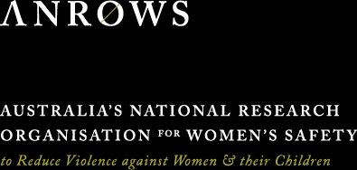

The data
Between 1 July 2010 and 30 June 2018, the study identified
113 filicide cases
across Australia.
138 children
were victims of filicide.
86 (76%)
of all filicide cases featured an identifiable history of domestic and family violence. We call this DFV-context filicide.
106 children
were victims of DFV-context filicide.
This study focused on these
86 DFV-context filicide cases
All figures below relate to these DFV-context filicides

What we mean by identifiable history of domestic and family violence
Domestic and family violence could involve any combination of:
- Child abuse: any physical, emotional or sexual violence towards the filicide victim or their siblings.
- Intimate partner violence: any intimate partner violence involving the child’s parents.
Identifiable history means there was evidence of domestic and family violence in the data reviewed as part of this project. Data sources included briefs of evidence, police reports, inquest findings, autopsy and toxicology reports, sentencing remarks, service case notes, witness statements and case reviews.

What we mean by “parent”
The term “parent” is used to refer to the filicide victim’s father, mother, and any other person with parental responsibility for the child on a more than temporary basis (for example, an adoptive or foster parent, a step-parent, a parent’s partner or a grandparent who is the child’s primary carer). For a child who identifies or is identified as Aboriginal and/or Torres Strait Islander, this also includes a person who is regarded as the child’s parent under Aboriginal tradition or Island custom. The terms “father”, “mother”, “men” and “women” are used in this resource to reflect the gendered nature of offending and the relationship between parents and children.

We need to see and respond to children as victims of domestic and family violence in their own right
Failure can be fatal
It was common for there to be a history of intimate partner violence, child abuse or both in the weeks, months or years leading up to a parent killing their child
In 9 in 10 cases we found a history of intimate partner violence
When fathers killed their children, it often followed a history of perpetrating intimate partner violence.
When mothers killed their children, it often followed a history of experiencing intimate partner violence.
In 8 in 10 cases we found a history of child abuse
This included physical, sexual or emotional violence perpetrated by parents towards their children, which includes the filicide victims and their siblings.
Despite high rates of child abuse, none of the filicide offenders had prior convictions for offences against their children.

What does this mean?
- When it comes to domestic and family violence, we need to take children’s safety seriously.
- Approaches must balance children’s and women’s unique experiences and safety needs while also acknowledging the interconnected nature of their lives.
- Any intimate partner violence needs to be seen as a risk to children’s safety.

Filicide offending following a history of domestic and family violence looks different for men and women
Understanding these patterns can help inform responses to children and their families
The data shows gender does not affect who becomes a victim of filicide. However, when it comes to committing filicide, offenders are predominately men. No transgender or non-binary parents were identified.
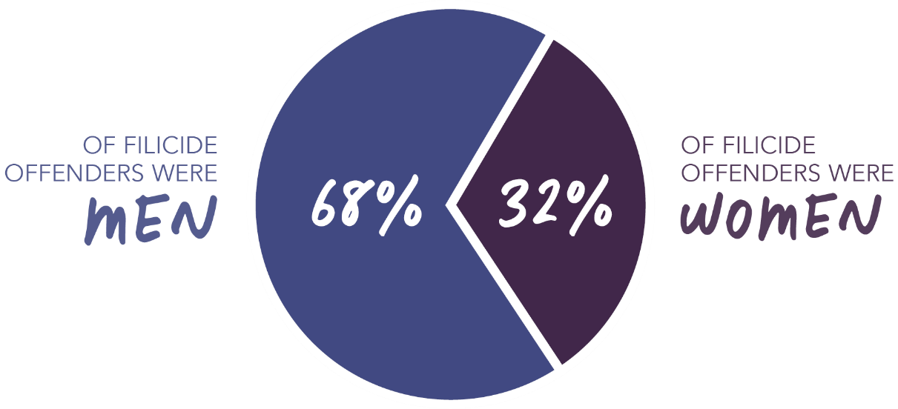

How many filicide offenders were the primary perpetrator of intimate partner violence


How many filicide offenders were the primary victim of intimate partner violence?
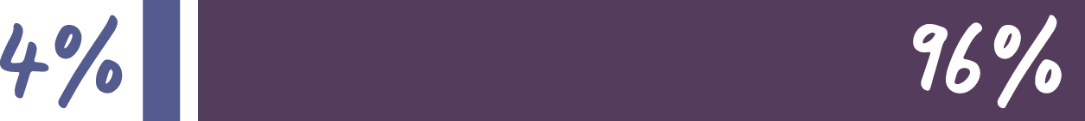

In what ways were other co-occurring issues gendered?
Although not implying causation, this information is crucial for understanding children’s lives and family experiences, as well as identifying avenues for better support.
Experiencing mental health issues
Experiencing issues with alcohol and other drugs
Experienced childhood domestic and family violence
Had a violent criminal history*

Key messages
7 in 10 DFV-context filicide offenders were men, either the child’s biological father or stepfather
Nearly all filicide offenders identified as the primary perpetrator of intimate partner violence were men
Nearly all filicide offenders identified as the primary victim of intimate partner violence were women

Parents who kill their children
following a history of domestic and family violence are
Perpetrating child abuse
87% of 67 cases with prior violence towards children
Perpetrating intimate partner violence
59% of offenders
Mostly the father or stepfather of the filicide victim
68% of offenders
Living with the filicide victim on a full-time basis at the time of the filicide
83% of offenders
Experiencing mental health issues at the time of the filicide
56% of offenders
Experiencing alcohol and other drug issues, especially with illicit and prescription drugs
55% of offenders
Have a known criminal history, often involving both violent and nonviolent offending
56% of offenders
Between 20 and 29 years old
44% of offenders
Born in Australia
74% of offenders
Not engaged in paid employment including some who were fulfilling home duties
57% of offenders
Did not die by suicide concurrently with or after the killing of the child
78% of offenders
Rarely named as a defendant in a final DFV order involving the filicide victim
8% of offenders
Occasionally named as the defendant in a final DFV order involving a partner
23% of offenders

 A deeper look at regional and remote Australia
58% of filicide offenders live in a major city
Compared to
72% of the general population
It was less common for filicide offenders to live in a major city than expected.
Living in rural locations is associated with increased frequency and severity of DFV.
Policy and practice responses often assume DFV victims and perpetrators will be visible to community services, but services may not be as available in regional locations.
Close-knit communities can also make it hard for individuals to discreetly access victim or perpetrator services.
Reporting violence while living in a smaller community may be uncomfortable or unsafe due to lack of anonymity.
Incentives (including financial, housing, reduced tenure) may need to be considered to encourage specialist practitioners to take up employment in locations outside major cities where access to face-to-face support services may be limited.
Reflections from a Specialist DFV Police Officer

Children killed by their parents
in the context of domestic and family violence are:
Almost equal numbers of boys and girls
45% female
55% male
Nearly always born in Australia
93% of all filicide victims
Aged under 2 years old at the time of their death
46% of all filicide victims
Known to be experiencing physical violence
84% of 67 cases with prior violence towards children
Known to be experiencing emotional violence
81% of 67 cases with prior violence towards children
Known to be experiencing sexual violence
19% of 67 cases with prior violence towards children
Experiencing violence within the 3 months prior to the filicide
72% of 67 cases with prior violence towards children
Often not reported as a victim of violence to authorities
There was no report of violence towards the children in 45% of cases where there was a history of child abuse
More often reported to child protection than police as a victim of violence
51% compared to 33% of cases where there was a history of child abuse
Rarely subject to a court order placing them under the supervision of the state via child protection
14% of filicide cases
Are often survived by one or more siblings
Victims of filicide are survived by a total of 122 siblings*
This is likely a significant underestimate
These children are victims and survivors in their own right

A deeper look at the experiences of Aboriginal and Torres Strait Islander children and families
26% of filicide victims were identified as Aboriginal and/or Torres Strait Islander
1 in 5 (21%) Aboriginal and/or Torres Strait Islander filicide victims were killed by a non-Indigenous parent
16% of filicide offenders were identified as Aboriginal and/or Torres Strait Islander
Aboriginal and Torres Strait Islander children are disproportionately killed in filicide cases. This issue is rooted in racism, colonisation and intergenerational trauma.
Aboriginal and Torres Strait Islander families may hesitate to seek help due to a lack of culturally safe DFV services. Aboriginal and Torres Strait Islander-led services are better positioned to provide support, but often face resource shortages.
The intergenerational trauma and ongoing structural violence that sits behind DFV within Aboriginal and Torres Strait Islander communities can create a distrust of non-Indigenous services.
The safety of Aboriginal and Torres Strait Islander children and women needs to be prioritised through urgent investment in Aboriginal-led solutions and services.
… I think that there just needs to be some kind of service system that responds to Aboriginal kids … something that’s more tailored to provide really intensive support for Aboriginal families.
Reflections from a CEO of an Aboriginal Legal Service

A deeper look at disability
Less than 1 in 10 filicide victims were recorded as having a disability (6%)
This is likely an underestimate reflecting limitations in identifying disability in service data and the very young age of many of the victims. Children with disability are over-represented as victims and survivors of domestic and family violence and often face distinct barriers to receiving safety and healing responses.
The ages of these kids, they’ve got no voice. So who is going to be that voice?
Reflections from a CEO of an Aboriginal Legal Service

Multiple services, multiple opportunities
The study examined families’ last known service interactions to identify how many families had contact with each service and how recent that contact was

How often are families and services in contact

Over half of the DFV-context filicide cases contained a record of prior contact with:
71% General health services
65% Police
60% Child protection services

Between a third and a half of the DFV-context filicide cases contained a record of prior contact with:
49% Mental health services
44% Maternal health services
43% Schools

Less than a third of the DFV-context filicide cases contained a record of prior contact with:
13% AOD services
19% DFV services
20% Legal practitioners
23% Early childhood education
27% Courts and tribunals

How recent is family and service contact in the period before the filicide?

High recency contact
In more than half of the cases where families had been in contact with a service, they had been in touch in the 3 months before the filicide, indicating a high level of recent interaction.
- Schools
- General health services
- Early childhood education
- Legal practitioners
- Child protection
- Maternal health services

Low recency contact
In less than half of the cases where families had been in contact with a service, they had been in touch in the 3 months before the filicide, indicating a low level of recent interaction.
- AOD services
- DFV services
- Mental health services
- Courts and tribunals
- Police

Other key points of contact

Workplaces
2 in 5 offenders were engaged in paid employment at the time of the filicide
Research has found that workplaces and employers can be a key point of intervention for those experiencing or perpetrating DFV.

Family court
15% of DFV filicide cases had known family law proceedings
Continuing to strengthen child-centred and DFV-informed reforms, such as greater information sharing between the courts, police and child welfare agencies, and the introduction of Court Child Experts, can contribute to further supporting children and families.

What action can I take?
Icon | Action
 | Recognise children as domestic and family violence victims in their own right and centre them in responses, including those focused on intimate partner violence
 | See any risk of intimate partner violence towards women as a risk of violence towards their children
 | Promote community-wide education to acknowledge the effects of domestic and family violence on children and provide actionable guidance for enhancing their safety
 | Focus on the role of fathers and stepfathers in children’s lives. As caregivers, they are critical to the safety and wellbeing of children, and they need the skills and supports to thrive in that role
 | Identify and address the obstacles families encounter in accessing services – ensuring they are tailored to meet diverse cultural, linguistic, location, family and disability requirements – and clarify the eligibility criteria for service acceptance
 | Invest in integrated, holistic and multi-agency approaches when responding to families experiencing the complex co-occurrence of DFV alongside, for example, alcohol and other drug use and mental health issues
 | Business as usual cannot continue. All governments need to take urgent action to overhaul how they work with Aboriginal and Torres Strait Islander people. Self-determination needs to be the ultimate goal, and this can only be achieved through sharing power and investing in the safety and cultural connections of all Aboriginal and Torres Strait Islander children

Read the report
View the media resources

Source
Australian Domestic and Family Violence Death Review Network, & Australia’s National Research Organisation for Women’s Safety. (2024). Australian Domestic and Family Violence Death Review Network data report: Filicides in a domestic and family violence context 2010–2018 (1st ed.; Research report, 06/2024). ANROWS.
Suggested citation
Australia’s National Research Organisation for Women’s Safety. (2024). “Who is going to be that voice?” What we know about parents killing their children in the context of domestic and family violence [Fact sheet]. ANROWS.

