
#SPEAKINGOUT@WORK:

Sexual harassment of LGBTQ young people in the workplace and workplace training
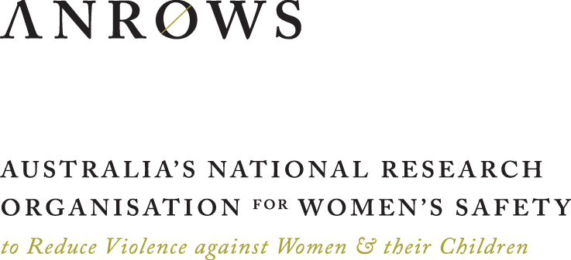 | Kerry H. Robinson | Kimberley Allison  Emma F. Jackson | Cristyn Davies | Erika K. Smith  Alex Hawkey | Jane Ussher | Jacqueline Ullman  Brahmaputra Marjadi | Paul Byron  Research Report | Issue 10 | December 2024
ANROWS acknowledgement
This material was produced with funding from the Australian Government Department of Social Services. Australia’s National Research Organisation for Women’s Safety (ANROWS) gratefully acknowledges the financial and other support it has received from the government, without which this work would not have been possible. The findings and views reported in this paper are those of the authors and cannot be attributed to the Australian Government Department of Social Services.
Acknowledgement of Country
ANROWS acknowledges the Traditional Owners of the land across Australia on which we live and work. We pay our respects to Aboriginal and Torres Strait Islander Elders past and present. We value Aboriginal and Torres Strait Islander histories, cultures and knowledge. We are committed to standing and working with First Nations people, honouring the truths set out in the Warawarni-gu Guma Statement.
Acknowledgement of lived experiences of violence
ANROWS acknowledges the lives and experiences of the LGBTQ people and young people affected by domestic, family and sexual violence who are represented in this report. We recognise the individual stories of courage, hope and resilience that form the basis of ANROWS research.
Caution: Some people may find parts of this content confronting or distressing. Recommended support services include QLife (1800 184 527), Twenty10 (02 8594 9555) 1800RESPECT (1800 737 732), Lifeline (13 11 14) and, for Aboriginal and Torres Strait Islander people, 13YARN (13 92 76).
Peer-review process
The quality of ANROWS publications is ensured through a rigorous peer-review process that is consistent with the principles of the Committee on Publication Ethics (COPE) Ethical Guidelines for Peer Review. This report has been assessed by at least two peer reviewers with relevant academic expertise.

© ANROWS 2024
With the exception of the ANROWS branding, content provided by third parties, and any material protected by a trademark, all material presented in this publication is licensed under a Creative Commons Attribution-NonCommercial 3.0 Australia (CC BY-NC 3.0 AU) licence.
The full licence terms are available at creativecommons.org/licenses/by-nc/3.0/au/legalcode
Published by
Australia’s National Research Organisation for Women’s Safety Limited (ANROWS)
PO Box Q389, Queen Victoria Building, NSW 1230 | www.anrows.org.au
ABN 67 162 349 171
ISBN: 978-1-922645-95-1 (paperback)
ISBN: 978-1-922645-94-4 (PDF)
Please note that there is the potential for minor revisions of this report.
Please check the online version at
www.anrows.org.au for any amendment.
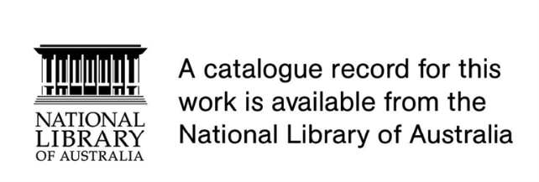
Western Sydney University
Locked Bag 1797
Penrith NSW 2751

The University of Sydney
NSW 2006

University of Technology Sydney
PO Box 123
Ultimo NSW 2007

Author acknowledgement
The #SpeakingOut@Work research team would firstly like to extend its gratitude to all the LGBTQ young people who offered their time to contribute to this study. The team would also like to thank members of the advisory committee who generously gave their time and expertise to this project. A particular thank you to the young people who were members of that group – your insights have been invaluable.

#SPEAKINGOUT@WORK:
Sexual harassment of LGBTQ young people in the workplace and workplace training
Prepared by
Professor Kerry H. Robinson
Principal Chief Investigator, School of Social Sciences, Western Sydney University
Dr Kimberley Allison
Research Officer, School of Social Sciences, Western Sydney University
Dr Emma F. Jackson
Research Officer, School of Social Sciences, Western Sydney University
Dr Cristyn Davies
Chief Investigator, Specialty of Child and Adolescent Health, Faculty of Medicine and Health, The University of Sydney; Adjunct, School of Social Sciences, Western Sydney University
Dr Erika K. Smith
Research Officer, School of Social Sciences, Western Sydney University
Dr Alex Hawkey
Chief Investigator, Translational Health Research Institute (THRI),
Western Sydney University
Professor Jane Ussher
Chief Investigator, School of Medicine, Western Sydney University
Associate Professor Jacqueline Ullman
Chief Investigator, School of Education, Western Sydney University
Associate Professor Brahmaputra Marjadi
Chief Investigator, School of Medicine, Western Sydney University
Dr Paul ByroN
Chief Investigator, Digital & Social Media, University of Technology Sydney
This report addresses work covered in the ANROWS research project “Sexual harassment of LGBTQ young people in the workplace and workplace training”. Please consult the ANROWS website for more information on this project.
ANROWS research contributes to the vision of the National Plan to End Violence against Women and Children 2022–2032: ending violence in one generation. This research addresses the Prevention domain – stopping violence before it starts, and the Response domain – efforts to address existing violence.
Suggested citation
Robinson, K. H., Allison, K., Jackson, E. F., Davies, C., Smith, E. K., Hawkey, A., Ussher, J., Ullman, J., Marjadi, B., & Byron, P. (2024). #SpeakingOut@Work: Sexual harassment of LGBTQ young people in the workplace and workplace training (Research report, 10/2024). ANROWS.

Contents
#SPEAKINGOUT@WORK: 1
Sexual harassment of LGBTQ young people in the workplace and workplace training 1
Contents 5
Definitions and concepts 10
Executive summary 15
Background 15
Aims/objectives 15
Methodology 15
Results 16
LGBTQ young people’s experiences of workplace sexual harassment 16
LGBTQ young people’s perspectives, definitions and understandings of workplace sexual harassment 17
Intersectionality and workplace sexual harassment 18
LGBTQ young people’s safety and inclusion in the workplace 18
LGBTQ young people’s awareness of workplace sexual harassment policies and reporting pathways in their workplaces 18
Impact of workplace sexual harassment on LGBTQ young people 19
LGBTQ young people’s experiences of workplace training regarding workplace sexual harassment 19
Summary of report recommendations 19
Recommendations 20
Conclusion 20
Chapter 1 An introduction to #SpeakingOut@Work: LGBTQ young people’s experiences of sexual harassment at work 21
1.1 Introduction 21
1.2 An explanation of key terms and concepts 22
1.3 Background 24
1.4 Literature review 25
1.5 Aims of the research project 31
1.6 Structure of the report 31
Chapter 2 #SpeakingOut@Work study methodology 33
2.1 Introduction 33
2.2 Research design 33
2.3 Theoretical framework 34
2.4 Participants and recruitment 35
2.5 National online survey exploring the prevalence of workplace sexual harassment and related experiences 38
2.6 Individual semi-structured interviews to explore understandings and experiences of workplace sexual harassment 40
2.7 Photo story exercises to elicit participant-driven discussions of LGBTQ workplace safety and sexual harassment 41
2.8 Data analysis 43
2.9 Reflexivity statement 44
2.10 Ethical considerations 45
2.11 Chapter summary 46
Chapter 3 Participant profile and workplace sexual harassment prevalence 47
3.1 Introduction 47
3.2 Participant characteristics 47
3.3 Workplace sexual harassment prevalence 55
3.4 Characteristics of workplace sexual harassment 61
3.5 Chapter summary 62
Chapter 4 Definitions of workplace sexual harassment, awareness of policies and reporting pathways, and experiences of anti-workplace sexual harassment training 63
4.1 Introduction 63
4.2 What is workplace sexual harassment? The perceptions of LGBTQ young people 64
4.3 Ambivalence about, or struggling to know, what constitutes workplace sexual harassment 69
4.4 Workplace sexual harassment, curiosity, and behaviour boundaries 71
4.5 Sexual harassment and intersectionality 72
4.6 LGBTQ young people’s awareness of rights and reporting options related to workplace sexual harassment 74
4.7 Negative experiences of workplace sexual harassment training 77
4.8 Positive experiences of workplace sexual harassment training 79
4.9 Chapter summary 79
Chapter 5 Workplace sexual harassment: LGBTQ young people’s experiences of commonly recognised sexual harassment 81
5.1 Introduction 81
5.2 Experiences of workplace sexual harassment steeped in misogyny 81
5.3 Physical experiences of workplace sexual harassment: Touched, hugged, groped, slapped and sexually assaulted 83
5.4 Sexual harassment of young (feminine) women 85
5.5 Sexual harassment related to LGBTQ young people’s queer identity 86
5.6 Online workplace sexual harassment 88
5.7 Chapter summary 89
Chapter 6 Workplace sexual harassment: LGBTQ young people’s experiences of queer-specific sexual harassment 91
6.1 Introduction 91
6.2 Undermining identity: Intersections between homophobia, biphobia, transphobia and workplace sexual harassment 91
6.3 Cisgender- and heterosexual-entitled curiosity: Intrusive questioning of LGBTQ identities, bodies and relationships 94
6.4 The fetishisation of LGBTQ identities: When curiosity becomes sexual 97
6.5 The spectre of the LGBTQ predator and the justification of policing identities 99
6.6 Chapter summary 100
Workplace sexual harassment, intersectionality and disability 101
Workplace sexual harassment, intersectionality and racism 104
Chapter 7 LGBTQ young people’s responses to sexual harassment in the workplace: Seeking support and reporting 107
7.1 Introduction 107
7.2 In-the-moment responses to workplace sexual harassment 109
7.3 Support-seeking and reporting: Disclosure of workplace sexual harassment experiences 111
7.4 Barriers to making a formal report of sexual harassment in the workplace 115
7.5 Outcomes of LGBTQ young people’s sexual harassment reporting 121
7.6 Chapter summary 123
Workplace sexual harassment, intersectionality and bonded positions 124
Chapter 8 Impacts of workplace sexual harassment on LGBTQ young people 126
8.1 Introduction 126
8.2 Work-related impacts 126
8.3 Mental and physical health impacts 128
8.4 LGBTQ identity impacts: Intimate relationships and gender dysphoria 129
8.5 LGBTQ and women perpetrators: Betrayed allyship 130
8.6 Chapter summary 131
Chapter 9 Facilitators of workplace sexual harassment 132
9.1 Introduction 132
9.2 Physical facilitators 132
9.3 Cisheteronormative infrastructures 133
9.4 Industry facilitators 134
9.5 Workplace cultures of sexual harassment 139
9.6 Power and age 140
9.7 Employment position 141
9.8 Friendship as a facilitator 142
9.9 Chapter summary 143
Chapter 10 Facilitators of and barriers to LGBTQ young people’s support, safety and inclusion in the workplace 144
10.1 Introduction 144
10.2 Positive workplace cultures: Fostering supportive, safe and inclusive workplaces for LGBTQ young people 144
10.3 Shortfalls in fostering LGBTQ safety at work: From indifferent to hostile workplaces 147
10.4 Chapter summary 155
Chapter 11 Disclosure of LGBTQ identities in the workplace 156
11.1 Introduction 156
11.2 Identity disclosure in the workplace 156
11.3 Reactions to identity disclosure 159
11.4 Social steganography and the indirect disclosure of queerness 161
11.5 Wanting to disclose identity but disallowed: LGBTQ does not equal professionalism 165
11.6 The labour of identity concealment in the workplace 165
11.7 Effort of education when coming out at work 169
11.8 Personal impact of not disclosing gender and/or sexuality identity in the workplace 170
11.9 Not needing to disclose LGBTQ identities in the workplace: Keeping personal and professional lives separate 171
11.10 Gender transition and being “outed” at work 172
11.11 Chapter summary 173
Chapter 12 Discussion, implications and recommendations 174
12.1 Workplace cultures, infrastructures, systemic practices and workplace sexual harassment 174
12.2 Is that workplace sexual harassment? 175
12.3 Intersectional risk factors for workplace sexual harassment 176
12.4 Workplace sexual harassment disclosure and reporting 176
12.5 Workplace sexual harassment training 177
12.6 Implications and recommendations 177
12.7 Limitations of this research 182
12.8 Strengths of this research 182
12.9 Future research 183
Chapter 13 Conclusion 184
Author contributions 185
References 186
APPENDIX A: Advisory committee members 196
APPENDIX B: Recruitment materials 198
Promotional posts shared on project social media accounts 198
Promotional material provided to community-based LGBTQ, educational and professional organisations for distribution 200
Materials distributed in hard copy at in-person LGBTQ community events 201
APPENDIX C: Project landing page 202
Sexual Harassment of LGBTQ Young People in the Workplace and Workplace Training 202
APPENDIX D: Survey participant information sheet 204
Sexual Harassment of LGBTQ Young People in the Workplace & Workplace Training 204
APPENDIX E: National online survey 208
Eligibility and Consent 208
APPENDIX F: List of support services provided to participants seeking support 233
General support services 233
LGBTQ+ support services 234
Sexual harrassment/assault support services 235
Work-related support services 236
APPENDIX G: Interview and photo story participant demographics and occupations 239
APPENDIX H: Interview schedule 242
Preamble 242
Interview Questions 243
APPENDIX I: Photo story instructions 245
APPENDIX J: Photo story interview schedule 246
Preamble 246
APPENDIX K: Coding framework 248

Definitions and concepts
Some definitions have been drawn or modified from ACON (2024) and the Department of Social Services’ (2022) National Plan to End Violence against Women and Children 2022–2032 (the National Plan). Definitions drawn from ACON are indicated by a and those from the National Plan are indicated by b.
Acronym | Meaning
Abrosexual | Someone who experiences change and fluidity in their romantic/sexual attraction across romantic/sexual orientations.
Agender | A person who does not identify as having a gender.
Aromantic/aro | Someone who experiences little to no romantic attraction to others – this exists on a spectrum.a
Asexual/ace/aspec: | Someone who experiences little to no sexual attraction to others. This exists on a spectrum (“aspec”) and does not necessarily imply a lack of libido or sex drive.a
Aroace | Someone who identifies as both aromantic and asexual.
Assigned gender at birth (AGAB)/AFAB/AMAB | Refers to the gender identity recorded on a birth certificate as declared at birth – typically by the attending doctor. AGAB refers to “assigned gender at birth”, AFAB refers to “assigned female at birth”, and AMAB refers to “assigned male at birth”. These acronyms have been used to denote the gender presumed for an infant at birth and subsequently recorded on a birth certificate. The terms AMAB and AFAB are falling out of general use as some people find this language offensive.a
Binary | When referring to gender, the two binary genders are male/man and female/woman.a
Binding | A form of gender affirmation that involves flattening the chest with a tight top called a “binder”.a
Biphobia | Negative beliefs, prejudice and/or discrimination against bisexual people. This can include a dismissal of bisexuality, questioning whether bisexual identities are authentic, or an inappropriate focus on the sexual desires and practices of bisexual people.a
Bisexual/bi | Someone who is sexually and/or romantically attracted to people of the same gender and people of different genders, including people who are non-binary.a
Bisexual erasure/bi erasure | The tendency to ignore, remove, falsify or re-explain evidence of bisexuality in history, academia, the news media and other sources.a
Brotherboy | A term used by some Aboriginal and Torres Strait Islander people to describe trans people who have a masculine spirit and take on men’s roles within the community.a
Cisgender/cis | People whose gender is the same as their gender presumed at birth (male or female).a
Cisnormativity | Assumes that everyone is cisgender and that all people will continue to identify with the gender they were presumed at birth. Cisnormativity erases the existence of trans people.a
Cisheteronormativity | An extension of cisnormativity that assumes that everyone is both cisgender and heterosexual.
Deadname | The name a trans person was given and known as prior to affirming their gender. This term can also be used as a verb.
Demiboy | A term used to describe trans identities and/or experiences that are not binary but are in relation to the group of men or boys. Can be interpreted as “partially boy”.
Demigirl | A term used to describe trans identities and/or experiences that are not binary but are in relation to the group of women or girls. Can be interpreted as “partially girl”.
Enby | An alternative spelling of the word “non-binary”, originating from the vocalisation of the letters n(on)-b(inary).
FTM | An acronym for the phrase “female to male”, used to denote a binary gender transition from female to male. The term is falling out of general use as some people find it offensive.
Gay | A term used to describe a person whose primary romantic and/or sexual attraction is toward people of the same gender.b
Gender affirmation | An umbrella term for the range of actions and possibilities involved in trans people living, surviving and thriving as their authentic gendered selves.a
Gender dysphoria | The distress or unease some trans and gender diverse people may experience associated with their gender, their bodies, or how those around them perceive their gender.a
Genderfluid | A non-binary gender identity that denotes fluidity or change in gender experiences or expression.
Gender identity | A term used to describe one’s innermost concept of self – how individuals perceive themselves. This may be different to gender recorded at birth and may be different to what is indicated on legal documents. Man, woman and non-binary are common gender identities.a
Genderqueer | A non-binary gender identity that denotes fluidity, rejection of binary gender, and challenges common ideas of gender.
Heteronormativity | A suite of cultural, legal and institutional practices that work to explicitly privilege relationships between men and women as the only “normal” and “natural” form of relationship.b
Heterosexual | Someone who is sexually and/or romantically attracted to people of a different, typically binary, gender to themselves.
Homophobia | Negative beliefs, prejudices, stereotypes and fears that exist towards people with diverse sexualities. It can range from the use of offensive language to bullying, abuse and physical violence. It can also include systemic barriers, such as a person being denied housing or being fired due to their sexual orientation.a
HRT | Hormone replacement therapy, sometimes also known as gender affirming hormonal therapy or GAHT. This can consist of taking hormones and/or blocking existing hormones in the body.
Intersectionality | The ways in which different aspects of a person’s identity (such as gender, sexuality, race, ability) can expose them to overlapping forms of discrimination and marginalisation.
Legal name | A person’s name as listed on their birth certificate or other official documentation.a
Lesbian | A woman who is romantically and/or sexually attracted to women (noting that “woman” is understood loosely and can refer to non-binary people who also identify as lesbian).
Monosexual | A term used to describe romantic/sexual orientation towards one gender only, including exclusive heterosexuality.
Microaggression | A statement, action or incident regarded as an instance of subtle or unintentional discrimination against members of a marginalised group.a
Minority stress | A term used to describe the chronic stress people in minority groups experience because of a lifetime of harassment, maltreatment, discrimination, victimisation and limited access to care. This contributes in large part to the health disparities faced by minority communities, including LGBTQ+ communities.
Misgendering | Referring to a person by words or language that is incorrect for them, such as using a former name or pronoun, or making assumptions about their gender based on their appearance.a
Non-binary | A term used to describe genders that sit outside of the man/woman binary. This includes people whose gender is not exclusively female or male. A person might identify solely as non-binary or relate to non-binary as an umbrella term and consider themselves genderfluid, genderqueer, transmasculine, transfeminine, agender, bigender or something else.a
Pansexual | Someone who is romantically and/or sexually attracted to people regardless of their gender identity. This is often framed as attraction to all genders, or attraction to people based on specific traits unrelated to gender.a
Passing | A term used to describe when most others do not identify a person to have a minority identity until the person specifies this identity. The term can be applied to many minority identities, for example, a CALD person “passing” as white, a trans person “passing” as their gender identity, or a queer person “passing” as cisgender and heterosexual.
Plurisexual | Someone who is sexually and/or romantically attracted to people of more than one gender or multiple genders (used in this report as an umbrella term for bisexuality, pansexuality and multi-gender-attracted people).
Pronouns | Words we use to refer to people in the third person when we are not using their names. The most common pronouns include he/him/his, she/her/hers and they/them/theirs.a
Queer | Sometimes used as an inclusive umbrella term for sexual and gender minorities. “Queer” has been used as a slur, and some LGBTQ+ people will find it offensive, yet others, especially in younger generations, have reclaimed it as a term to capture multiple aspects of identity,a often as a reaction against pressures to be cisgender and heterosexual. b
Queerphobia | Negative beliefs, prejudices and stereotypes that exist about queer people. Queerphobia can range from the use of offensive language to bullying, abuse and physical violence. It can also include systemic barriers, such as a person being denied housing or being fired due to their sexual orientation.
Sexual orientation | A term used to describe one’s experience of attraction to others and/or whom they want to have relationships with. People can find others sexually, romantically and/or physically attractive. This does not always align with how a person describes their sexual identity or the sexual behaviours they engage in.a
Sistergirl | A term used by some Aboriginal and Torres Strait Islander people to describe trans people that have a female spirit and take on women’s roles within the community.a
T4T | A trans person who dates or is romantically/sexually oriented toward other trans people.
Transgender/trans | An umbrella term used to be as broad and comprehensive as possible in describing people with gender identities and expressions that differ from the gender they were presumed to be at birth. This includes people who have culturally specific and/or language-specific experiences, identities and expressions.a
Transfeminine/transfem | A term used to describe transgender identities and/or experiences that are feminine or draw on femininity.
Transmasculine/transmasc | A term used to describe transgender identities and/or experiences that are masculine or draw on masculinity.
Transphobia | Negative beliefs, prejudices and stereotypes that exist about trans people. Transphobia can range from the use of offensive language to bullying, abuse and physical violence. It can also include systemic barriers, such as a person being denied housing or being fired due to their sexual orientation.a

Executive summary

Background
Broad population studies on sexual harassment in the workplace show that this behaviour is equally pervasive in the workplace experiences of LGBTQ people. However, less is known about LGBTQ people’s experiences and responses to sexual harassment in the workplace and workplace training and the impacts of these encounters.
LGBTQ people can be subjected to sexual harassment, which is part of a continuum of violence they can experience due to discrimination underpinned by homophobia, transphobia and biphobia. Women and girls can experience sexual harassment, also part of a continuum of violence, which is based on misogyny, sexism and other socio-cultural values and attitudes associated with being women and girls. Sexual harassment can be used as a form of power to control people and to regulate their behaviours to conform to gender and sexuality norms.
LGBTQ young people are especially vulnerable to sexual harassment in the workplace and workplace training due to intersecting risk factors associated with cultural power, such as their LGBTQ identity and age, among significant others (e.g. disability, Indigeneity, ethnicity). Young people are often employed in casual, insecure employment, which can be poorly paid, and many are unaware of their workplace rights. LGBTQ young people can face restricted job choices, reduced progression, and an inability to be “out” about their gender and sexuality identities at work due to discrimination, harassment and bullying. These factors contribute to the precariousness of their employment experiences, operating as powerful deterrents to reporting sexual harassment.

Aims/objectives
- Understand the nature of sexual harassment experienced by LGBTQ young people in the workplace and workplace training sites (physical and online spaces), including the type of harassment, frequency, when and where, and perpetrator characteristics.
- Investigate LGBTQ young people’s perceptions of and responses to this harassment, including reporting, and perceived impacts.
- Explore how multiple social inequalities intersect in these experiences of sexual harassment among LGBTQ young people.
- Ascertain LGBTQ young people’s knowledge about their rights in the workplace and their access to and experiences of training related to workplace sexual harassment.

Methodology
Method: This national Australian research project employed mixed methods in a convergent parallel design, comprising: 1) a national online survey with both closed and open-ended items, completed by 1,001 respondents; 2) individual semi-structured qualitative interviews with 40 participants; and 3) 8 photo story interviews and images (conducted as an additional qualitative mode of data collection).
Recruitment: The project aimed to reach a large and representative population of LGBTQ young people, across identity groups, industries and locations. To be eligible, participants needed to: 1) be aged between 14 and 30 years; 2) be LGBTQ; and 3) have worked or completed workplace training in Australia. Participants were only included if they met these criteria. The study was advertised between August 2022 and June 2023. Multiple recruitment methods were used to maximise the number and diversity of LGBTQ young people participating.
Advisory committee: The research project employed an integrated knowledge translation framework, including key stakeholders’ contributions from conceptualisation to dissemination of research findings. The study’s advisory committee was formed at the beginning of the project and included representatives of LGBTQ community organisations and service providers, industry representatives, policymakers, and LGBTQ young people.

Results
The following results come from both the online survey and interviews. Where statistical information is given, the results are from the survey. All statistics reported below are calculated based on valid percentages, the number of participants who responded to each question, resulting in variations in total sample for each statistic.

LGBTQ young people’s experiences of workplace sexual harassment
- Of the LGBTQ young people who responded to the online survey questions regarding forms of workplace sexual harassment (n = 785), 77% experienced at least one of a broad range of behaviours that constituted workplace sexual harassment (WSH). The most common behaviours among participants who had experienced WSH (n = 607) were:
- sexually suggestive or explicit comments (66%)
- intrusive questions about their private lives (64%)
- unwelcome sexual jokes about their LGBTQ identities (58%)
- unwelcome questions/comments about their sex lives related to being LGBTQ (54%)
- inappropriate staring and leering (49%)
- inappropriate physical contact (35%)
- comments about anatomy related to LGBTQ identities (32%)
- comments about “correcting” LGBTQ identities through sexual assault (30%).
- Most study participants experienced WSH in person (73%), with a smaller percentage encountering it online and in person (27%). Only a few (0.3%) experienced WSH online only.
- 31% of LGBTQ young people experienced WSH more than 10 times.
- 58% of LGBTQ young people reported their most impactful experience of WSH was part of a series of incidents.
- Almost 12% (11.8%) of LGBTQ young people experienced sexual harassment in both their employment and during their employment training, with 2% reporting experiencing sexual harassment during employment training only.
- LGBTQ young people reported the reason they felt they were targeted for WSH was due to their gender (76%), age (59%), or sexual orientation (51%), with 70% of participants indicating that they felt they were targeted due to more than one of these factors.
- Although WSH occurred across all sectors, LGBTQ young people’s experiences of WSH most commonly occurred in the accommodation and food services (30%), retail trade (21%), administration and support services (13%), and financial and insurance services (11%) industries.
- In most cases, WSH was perpetrated by men (71%); in 15% of cases WSH was perpetrated by a group of men and women; and in 13% of WSH incidents the perpetrator was a woman. In 66% of cases, there was one perpetrator only; in 22% of cases, there were between two and three perpetrators; and 9% of cases involved more than three perpetrators. Most perpetrators were in the age group 20 to 29 years (35%). However, perpetrators ranged across the broad age group 20 to 64 years. A comparatively smaller number of perpetrators were in the age group 65+ (9%).
- Participants experiencing WSH perpetrated by clients/customers, especially those working in accommodation and food services, indicated they had little choice but tolerate the behaviours due largely to employer expectations, fears of losing their job, and potentially losing tips.
- A few (7.6%) LGBTQ young people reported experiencing WSH from LGBTQ perpetrators.
- The WSH that LGBTQ young people experienced was often explicitly related to their LGBTQ identities.
- Across the survey sample, participants presumed female at birth were significantly more likely to have experienced comments about “correcting” their LGBTQ identity compared to participants presumed male at birth (χ2[1] = 3.86, p = .05), as 23% of all participants who were presumed female at birth had experienced these comments, compared to 15% of participants presumed male at birth.
- At the time of their most impactful experience of workplace sexual harassment, participants were most commonly “out” to workplace peers (35% completely out), supervisors (33% completely out) and subordinates (33% completely out), but did not indicate whether this outness varied according to gender identity compared to sexuality identity. Comparatively, only 11% of respondents were completely out to customers or clients, and 21% were completely out to upper management. Overall, among participants who had experienced WSH, 32% indicated experiencing pressure to remain closeted.

LGBTQ young people’s perspectives, definitions and understandings of workplace sexual harassment
- Most of the LGBTQ young people in the survey and interviews had a basic general understanding of WSH. Interviews showed greater ambiguities for some young people who were uncertain if the WSH they had experienced was defined as sexual harassment, despite considering the behaviours to be inappropriate and unwelcome, and based on their sex, gender and/or sexuality. These uncertainties were often based on perceiving WSH within “traditional” heteronormative cisgender stereotypes.
- “Grey” areas associated with sexual harassment were also related to uncertainties regarding when boundaries were crossed from appropriate to inappropriate behaviours in the workplace.
- Some LGBTQ young people who were teachers viewed their WSH experiences from students in schools as not constituting WSH due to students’ young ages. However, work health and safety (WHS) regulations indicate that if sexual harassment is a workplace hazard, the age of the harasser is not relevant. WHS regulations also indicate that students can be defined as workers and undertake duties in a workplace.

Intersectionality and workplace sexual harassment
- Gender was the leading risk factor for experiencing WSH by LGBTQ young people. Cisgender young women and young people perceived to be female, regardless of their gender identity, were most frequently the targets of WSH, mostly perpetrated by cisgender men. Gender diversity, for example being trans (binary and non-binary), was a greater risk for WSH than sexuality diversity.
- Age was also a key risk factor in LGBTQ young people’s vulnerability to WSH.
- Disability was also a risk factor intersecting with gender, sexuality and age to increase LGBTQ young people’s vulnerability to WSH. 54% of the LGBTQ young people in this study reported having a disability of some kind that impacted them at work.

LGBTQ young people’s safety and inclusion in the workplace
- Many LGBTQ young people experienced culturally unsafe and non-inclusive workplaces. In these contexts, transphobia, homophobia and biphobia prevailed, and fostered WSH.
- LGBTQ young people were unlikely to use official reporting pathways for incidences of WSH or to seek organisational support due to a lack of trust in employers and the system. This was based on personal experiences and/or awareness of colleagues’ experiences of managers failing to intervene appropriately in their claims.
- LGBTQ young people were often expected to educate their co-workers and managers about their LGBTQ identities. This was often taxing and considered additional emotional labour. Some older LGBTQ people assumed these educative roles to support younger less experienced LGBTQ colleagues.
- LGBTQ young people felt that perpetrators often had a sense of entitlement to interrogate and make comments on their LGBTQ identities and relationships.
- Organisational systems can often non-consensually disclose employees’ LGBTQ identities, putting these employees at risk of experiencing WSH. This was especially the case for trans (binary and non-binary) young people.
- Survey and interview participants indicated that workplace infrastructure (e.g. lack of gender-neutral bathrooms), organisation operational practices (e.g. uniforms), administrative systems (e.g. not using chosen names or preferred pronouns, often leading to “outing” individuals), and physical workplace environments (e.g. isolated rooms, dark car parks) facilitated opportunities for WSH and other forms of violence to occur.

LGBTQ young people’s awareness of workplace sexual harassment policies and reporting pathways in their workplaces
- Survey and interview participants generally had limited awareness of workplace sexual harassment policies and reporting pathways in their workplaces.
- 75% of LGBTQ young people chose not to report their experiences of WSH formally. Instead, they often chose to leave their jobs.
- Survey and interview participants recognised that making a report would require them to “come out” in a potentially unsafe environment.
- LGBTQ young people indicated that those in the reporting line for WSH could be the perpetrator or a friend of the perpetrator.
- Notably, interview participants who reported WSH indicated that those people involved in the reporting process were often unable to conceive how LGBTQ young people experienced WSH. This required LGBTQ young people not only to report their experiences but also to explain how and why the harassment was inappropriate and impactful.
- For survey and interview participants, the most constructive workplace reporting outcomes did not originate from formal structures but from informal emotional and practical support from close co-workers.

Impact of workplace sexual harassment on LGBTQ young people
- The toll that experiencing WSH took on LGBTQ young people’s mental and physical wellbeing impacted both their work and personal lives.
- Anger, fatigue, fear, powerlessness, low self-esteem and suicidality were some of the ways that participants described the ongoing emotional effects of WSH.
- WSH experienced by trans (binary and non-binary) young people could have the additional impact of inducing gender dysphoria.
- WSH from cisgender heterosexual perpetrators that specifically targeted participants’ LGBTQ identity through intrusive and often sexually explicit jokes, comments and questions could evoke feelings of shame, objectification and alienation, as well as internalised homophobia, transphobia and biphobia.
- Participants described unique feelings of violation and betrayal when the perpetrator was also LGBTQ or a woman, feeling that these people should have instead been allies against the widespread queerphobia, discrimination and sexual harassment faced by women and LGBTQ people in the workplace.

LGBTQ young people’s experiences of workplace training regarding workplace sexual harassment
- Most LGBTQ young people had minimal training on WSH. Some had no training, especially those young people in casual employment.
- Overwhelmingly, LGBTQ young people who did have WSH training reported that it occurred mostly online, and that it was generally unhelpful, unengaging, unmemorable, and inappropriately pitched to LGBTQ young people due to its cisheteronormative focus. Most viewed it as a required tick-a-box process, especially for employers.
- A few LGBTQ young people spoke positively about the WSH training they received. They reported that it involved interactive, face-to-face group training facilitated by an expert, and addressed workplace rights, WSH definitions, prevalence, experiences, grey areas, and the complexities and nuances of WSH behaviours.

Summary of report recommendations
The recommendations from this research have direct relevance to the “positive duty” regulation required of business owners and workplace managers in addressing WSH, as well as aligning with the First Action Plan 2023–2027 (the First Action Plan) of the National Plan to End Violence against Women and Children 2022–2032 (the National Plan).

Recommendations

Government
- Create and run a national anti-sexual harassment campaign, with a focus on multiple contexts, such as in workplaces, in sports, in education, and in public spaces.
- Improve workplace sexual harassment literacy for employers and employees, including workplace sexual harassment experienced by LGBTQ young people.
- Review and improve workplace safety and security for casual, part-time and short-term contract workers, many of whom are LGBTQ young people.
- Review and address workplace sexual harassment in supported care services, in which many LGBTQ young people are employed.

Business owners and workplace managers
- Ensure workplace cultural safety for and inclusion of LGBTQ young employees.
- Review and evaluate sexual harassment policies, reporting procedures and training, with a focus on the inclusion of addressing LGBTQ young employees’ experiences and needs.
- Provide mandatory information on workplace sexual harassment at workplace inductions for all employees, including casual, part-time and short-term contract workers, and ensure these workers have easy access to this information on the workplace intranet.
- Address workplace sexual harassment experienced by young employees, including LGBTQ young people, from clients/customers.

Education sectors – Schools, universities, professional training institutions
- Review and address gaps in sexual harassment policies, reporting procedures and training across all school and post-school education sectors.
- Ensure the mandatory inclusion of anti-sexual harassment education in respectful relationships education in primary and secondary schools.

Conclusion
This research has identified key facilitators in the workplace that contribute to the persistently high rates of sexual harassment experienced by LGBTQ young people from co-workers, managers and clients/customers. Based on this evidence, the recommendations included in this executive summary propose core actions, which if adopted across a broad range of government, industry, non-government organisations and workplaces, would make a significant difference, not just for LGBTQ young people but for all employees.

Chapter 1
An introduction to #SpeakingOut@Work: LGBTQ young people’s experiences of sexual harassment at work

1.1 Introduction
Despite the introduction of anti-discrimination and work health and safety (WHS) legislation as well as gender equity and inclusion policies over many decades, discrimination on the grounds of gender, sexual orientation and age, among other factors, is still prevalent in many workplaces (Dahanayake et al., 2023; Gauci et al., 2022; P. Taylor et al., 2018). Workplace sexual harassment (WSH), a key target of these initiatives, continues to be pervasive, impacting employment security, career opportunities, and health and wellbeing, particularly for women and LGBTQ people (Australian Human Rights Commission [AHRC], 2022b). Workplace sexual harassment is a manifestation of socio-cultural dimensions of power, most frequently associated with gender and intersections with other categories such as sexuality, age, disability, Indigenous identity, ethnicity, employment and accommodation security (AHRC, 2020; Burn, 2019; Nash & Nielsen, 2020). To date, we have had limited awareness and understanding of the specific WSH experiences of LGBTQ people and the factors that facilitate these behaviours in workplaces. It is not surprising that LGBTQ young people sometimes find it challenging to disentangle sexual harassment from homophobic, biphobic and transphobic experiences, as these behaviours are so integral to and intertwined in much of the WSH these young people experience – an important issue identified in this report.
This report outlines the findings from the #SpeakingOut@Work research project, which examined LGBTQ young people’s experiences of WSH and sexual harassment experienced in workplace training. The research comprised a mixed methods design, including a national online survey completed by 1,001 LGBTQ young people, semi-structured interviews conducted with 40 LGBTQ young people, and a photo story exercise completed by eight young people in which they developed and shared images that represented or conveyed their feelings about their experiences of WSH. The images these young people produced are found throughout the report in relevant chapters to communicate their stories. The online survey was designed for this study to explore LGBTQ young people’s perceptions and experiences of WSH, as well as these experiences in workplace training sites, the impacts of and responses to this behaviour, workplace safety, awareness of relevant workplace policies and reporting pathways, and their access to and experiences of training related to WSH. The individual interviews with LGBTQ young people provided an opportunity to explore in greater depth their survey responses and to understand more fully their experiences of WSH.
This introduction provides a discussion of the key terminology and concepts used in the report, background to the problem of LGBTQ young people’s experiences of WSH, a review of the relevant literature in the area, the aims of the research, and an overview of the report structure.

1.2 An explanation of key terms and concepts

Workplace sexual harassment
In this study, we define WSH as any unwelcome sexual advances, requests for sexual favours, or other sexual behaviours that you could expect might make someone feel offended, humiliated or intimidated (AHRC, 2020). In the work context, this includes workplaces, working online, attending work-related social events, interacting with co-workers outside of work, seeking work, and participating in workplace training. This definition broadly reflects those used for sexual harassment in workplace policies. This definition was included in the online survey to provide LGBTQ young people with an explanation of what was considered WSH in the study. The following list of behaviours commonly identified as constituting sexual harassment (AHRC, 2018; Heywood et al., 2022) was also included in the survey:
- unwelcome touching, hugging, cornering or kissing
- inappropriate staring or leering that made you feel intimidated
- sexual gestures, indecent exposure, or inappropriate display of the body (e.g. “flashing”)
- sexually suggestive comments or jokes that made you feel offended or uncomfortable
- sexually explicit pictures, posters or gifts that made you feel offended or uncomfortable
- repeated or inappropriate invitations to go out on dates
- intrusive questions about your private life or physical appearance that made you feel offended or uncomfortable
- inappropriate physical contact
- being followed or watched, or someone loitering nearby
- requests or pressure for sex or other sexual acts
- indecent or sexually explicit phone calls or voicemails
- sexually explicit comments made in emails, text messages or on social media
- repeated or inappropriate advances in emails, text messages or on social media
- sharing or threatening to share intimate images or videos of you without your consent.

Workplace culture and safety
Workplace culture refers to the structural and social contexts influencing how people behave and the social and organisational norms accepted and expected in workplaces (Manley et al., 2011). In this study on LGBTQ young people’s experiences, workplace culture also includes support of or hostility toward LGBTQ workers. Feeling safe at work is related to workplace cultures, and LGBTQ employees, like all employees, are entitled to feel safe at work. Feeling safe at work means fully participating in the workplace without being subject to harassment, bullying or discriminatory behaviours or practices (Holman et al., 2019). Establishing and maintaining positive workplace cultures involves proactively supporting and including all employees, making everyone feel safe, and having relevant “living” policies and practices in place to ensure this happens.
Safe Work Australia develops national policies related to WHS, which are implemented, regulated and enforced by the Commonwealth, states and territories as law. Commonwealth, state and territory laws regulate WHS in Australia. The law is largely standardised through model WHS laws. However, Victoria has different legislation, albeit outlining similar duties. Workplaces have a duty of care to abide by approved codes of practice to comply with WHS regulations. However, WHS duties require that all workplace risks must be considered, not just those covered by codes of practice or regulations. Businesses have a positive duty of care to proactively work to eliminate, minimise and manage, as far as reasonable, health and safety risks in the workplace, including psychosocial and physical risks and hazards. WSH is a form of psychosocial hazard. New South Wales has a dedicated Respect at Work directorate that addresses these harms experienced at work. According to the model Code of Practice: Managing Psychosocial Hazards at Work developed by Safe Work Australia (2022), psychosocial hazards in the workplace are poor support, traumatic events or materials, violence and aggression, bullying, harassment (including sexual and gender-based harassment), racism, ableism, ageism, and conflict or poor workplace relationships and interactions that can cause psychological harm such as anxiety, depression, sleep disorders and post-traumatic stress disorder (PTSD; Safe Work Australia, 2022). As WHS regulations can vary, albeit slightly, across different states and territories, businesses and organisations need to be aware of laws and regulations relevant to their locations.

Legislation relevant to workplace sexual harassment
In addition to WHS legislation, workplaces are also subject to Australia’s anti-discrimination legislation, protecting individuals from discrimination based on gender, sexual orientation, race, disability and age. Anti-discrimination legislation addressing sex discrimination has existed in South Australia, New South Wales and Victoria since the 1970s. In 1984 the Australian Government introduced the Sex Discrimination Act 1984 (Cth), prohibiting WSH. This Act makes sexual harassment unlawful in certain areas of public life, including employment (AHRC, 2020; Davies et al., 2023). Based on recommendations made by the Australian Human Rights Commission’s (AHRC, 2020) Respect@Work report, the Act has been amended to include a positive duty requiring employers and persons conducting a business to take reasonable and proportionate measures to eliminate, as far as possible, certain discriminatory conduct, including sex discrimination, sexual harassment, sex-based harassment, and certain acts of victimisation in the workplace. The AHRC (2022a) was granted powers to enforce compliance with the positive duty in December 2023.
It is important to note that some actions or behaviours can meet criteria under multiple legislation frameworks, such as WHS and discrimination laws and other employment laws. For example, a behaviour or action can simultaneously be sexual harassment, workplace bullying, and unreasonable management action/constructive dismissal.

LGBTQ – Sexuality and gender diversity
LGBTQ is used in this report to include a broad range of diverse genders and sexualities. Where research referred to a different term, or a different term was used by participants – such as “LBTQ”, “LGBT” or “LGBTQ+” – the different term has also been used in the report when referring to that study or quoting participants. Terminology associated with gender and sexuality diversity is frequently changing and can be culturally specific, as well as differ across cultures (Davies et al., 2021).
Diverse sexualities is an umbrella term referring to non-heterosexual identities, generally including descriptors such as lesbian, gay, bisexual, pansexual, asexual and queer. Sexuality is about people’s attraction sexually and romantically. Young people may use other terms to describe their sexualities. Heteronormativity refers to the everyday interactions, practices, policies, and socio-cultural values and structures that construct sexuality norms as naturally heterosexual, privileging heterosexuality and constituting non-heterosexuality as “abnormal” and “unnatural”. Homophobia refers to negative beliefs, prejudices and stereotypes that prevail about people who identify as non-heterosexual, such as lesbian, gay and queer people. This list also includes bisexual people, but biphobia is also used and often preferred by bisexual people to describe the negative beliefs, prejudices and stereotypes that are specifically related to being bisexual – that is, being romantically and sexually attracted to more than one gender (Davies et al., 2021).
Gender diversity is also an umbrella term, and it characterises a group of people whose gender differs from what they were presumed to be at birth, including being trans, non-binary, genderqueer, gender fluid, or Sistergirl or Brotherboy (terms used by First Nations people). As is the case with sexuality diversity, young people may use terms other than “gender diverse” to describe their gender. A trans woman (also trans female, transfeminine, transfem) is a woman or has a “present experience of womanhood” and was presumed male at birth. A trans man (also trans male, transmasculine, transmasc) is a man or has a “present experience of manhood” and was presumed female at birth. Non-binary refers to people who are not exclusively male/man or female/woman or do not identify with male/man or female/woman in any way. Gender diversity also includes people who identify as agender, meaning they have no gender (TransHub, 2021).
In addition to gender and sexuality demographic choices in the survey, LGBTQ young people were given the opportunity to also describe their gender and sexuality more broadly to capture the complexities of their gender and sexuality identities. When quotes from young people are used in the report, the identifier used for each participant shows the terms that they used to self-describe their gender and sexuality. Like other studies with LGBTQ young people, this research reflects the broad range of genders and sexualities with which young people identify. These different gender and sexuality identities are defined in the “Definitions and Concepts” section of this report.

Intersectionality
Intersectionality is a theoretical concept that informed this project’s research design, data collection and data analysis. Intersectionality refers to how multiple and intersecting socio-cultural forms of power inherent in structural and institutional inequalities compound experiences of discrimination (Hill Collins & Bilge, 2016). The importance of using an intersectional lens in sexual harassment research is discussed in the next chapter, which outlines the methodologies used in this study.
Intersections between LGBTQ identity and ethnic/cultural background were explored in this study; however, no statistically significant differences in the prevalence of WSH between ethnic/cultural groups was identified. Qualitative survey, interview and photo story data from culturally and linguistically diverse (CALD) participants did indicate that they had distinct experiences of harassment, which are described in the subsection “Workplace Sexual Harassment, Intersectionality and Racism” at the end of Chapter 6. In brief, these participants experienced not only “general” sexual harassment behaviours but also behaviours specifically targeting their ethnicity or culture, such as the sexualisation or fetishisation of their ethnic/cultural background. However, as CALD participants were a minority among study participants and not all reported experiences of sexual harassment targeting their ethnic/cultural backgrounds, there was limited data on these experiences.

1.3 Background
Since the early 1970s, there has been a considerable body of research that has addressed WSH (Farley, 1978; MacKinnon, 1979). This research has primarily examined the WSH experienced by cisgender and heterosexual women, including young women, showing that this behaviour continues to be a pervasive problem impacting their employment equality, opportunities, security, and health and wellbeing in the workplace. Much of this research has argued that sexual harassment stems from socio-cultural and entrenched gender inequalities inherent in patriarchal societies (Dalton, 2019). In this context, women and girls are sexualised, and men’s sense of entitlement to comment on and access women’s bodies, both publicly and privately, is perpetuated through everyday practices and interactions and through social, economic, educational and political structures, of which the workplace is part (Kelly, 1988; Phipps et al., 2017). Since the mid 1980s, sexual harassment has been recognised to be part of a continuum of violence predominantly targeting women and girls, and primarily perpetrated by men and boys (AHRC, 2020; Stanko, 1985). Sexual harassment has also been viewed as a technology of power, regulating and maintaining adherence to patriarchal gender norms (Namuggala & Oosterom, 2023). It is a practice in which gender inequalities intersect with other sites of cultural power and inequalities (such as sexual orientation, race, ethnicity, social class, disability and age), compounding vulnerabilities to sexual harassment.
As research is beginning to show, sexual harassment and other forms of sexual violence experienced by LGBTQ people in the workplace are equally pervasive (AHRC, 2022). However, less is known about LGBTQ people’s experiences and responses to these behaviours. Like women, LGBTQ people are subjected to power inequalities related to cisheteronormative patriarchal values and social structures in which they are discriminated against, stigmatised and regulated through overt and covert misogynistic, homophobic and transphobic practices (Hill et al., 2021; Robinson et al., 2014; E. Smith et al., 2014). Workplaces, including educational sites, as social institutions often reflect and reinforce these values and practices, becoming hostile and unsafe spaces for LGBTQ people.
LGBTQ young people are especially vulnerable to discrimination and harassment in the workplace due to intersecting risk factors associated with cultural power, such as their LGBTQ status and age, among significant others (e.g. disability, race and ethnicity; Willis, 2011). Young people are often employed in casual, insecure employment, which can be poorly paid, and many are unaware of their workplace rights (Lam et al., 2022). LGBTQ young people can face restricted job choices, reduced progression, and an inability to be “out” about their gender and sexuality identities at work due to discrimination and potential sexual harassment and bullying (AHRC, 2017, 2018). All these factors contribute to the precariousness of their employment experiences, operating as powerful deterrents to reporting sexual harassment.
The findings of this world-first research provide new evidence about WSH experienced by LGBTQ young people, filling a significant gap in the literature critical for informing workplace policy and practice specific to LGBTQ young people.

1.4 Literature review
Research specifically addressing WSH of LGBTQ young people is limited. These experiences tend to be captured in broad population-based surveys of WSH prevalence (AHRC, 2022), or in sexual harassment surveys of students in higher education (Heywood et al., 2022), or in surveys exploring LGBTQ people’s health and wellbeing and equality more broadly (Hill et al., 2021; Government Equalities Office, 2018). For younger LGBTQ people, experiences of sexual harassment are most often reported in schooling contexts (Lei et al., 2019; Robinson, 2005, 2012). The transition from school to work is important to consider when addressing WSH among young people as many of the attitudes underpinning this behaviour begin well before young people become employees (Hunt et al., 2024). Education settings can contribute significantly to the prevention of sexual harassment among young people in educational sites and in the workplace (Cahill et al., 2023). The following discussion of the literature includes LGBTQ people’s experiences of workplace cultures, which contribute to fostering environments in which sexual harassment can thrive; what is known about LGBTQ young people’s experiences of WSH to date; and a brief overview of prevalence and experiences in educational contexts.

1.4.1 Workplace experiences of LGBTQ people
As spaces largely constituted within patriarchal and cisheteronormative values and practices, workplaces are generally complex spaces for LGBTQ young people to negotiate (Köllen, 2016). Workplaces usually are microcosms of the broader society in which homophobia and transphobia prevail, negatively impacting workplace cultures that perpetuate sites in which discrimination against LGBTQ employees often exists unabated and operates both overtly and covertly (Hill et al., 2021; Government Equalities Office, 2018). Although inclusion and diversity policies are becoming more widespread in the workplace, research demonstrates that many workplaces are still discriminatory against employees who do not conform to cisheteronormative expectations (Donaghy & Perales, 2024). As such, some workplaces continue to be unwelcoming and unsafe environments for many LGBTQ people who are often marginalised and excluded, and become the targets of gender and sexuality discrimination, specific microaggressions and open hostility (Sue, 2010). LGBTQ people’s experiences of sexual harassment are core to these microaggressions and open hostilities in the workplace.
Nadal and colleagues (2010) developed a taxonomy of sexual orientation–specific microaggressions reported in workplaces, which fell into seven broad areas:
- encountering heterosexist and transphobic terminology (e.g. being called “faggot”, “dyke”, “tranny”)
- endorsement of heteronormative or gender-normative cultures and behaviours (e.g. enforcing implicit dress codes based on binary gender)
- assumption of universal LGBTQ experiences (e.g. stereotyping of lesbians as butch, or gay men as being into fashion and design)
- exoticisation (e.g. implicit questions about sex and genitals)
- discomfort/disapproval of LGBTQ experience (e.g. LGBTQ people shouldn’t have kids)
- denial of societal heterosexism or transphobia (e.g. commenting that LGBTQ people are too sensitive about discrimination)
- assumptions of sexual pathology and abnormality of LGBTQ people (LGBTQ people, especially gay men, are positioned as predators; the perception is all gay men have HIV/AIDS).
A further point was introduced by Nadal and colleagues (2011), who acknowledged people’s denial of individual heterosexism and transphobia (e.g. claiming “I have gay friends” to refute accusations of homophobia). All these specific microaggressions contributed to unsafe and unwelcoming workplace cultures for LGBTQ people.
Baker and Lucas (2017) pointed out that to avoid these microaggressions, to remain safe, and to maintain their dignity as employees, many LGBTQ people developed workplace strategies, including:
- avoiding harm by seeking safe spaces
- increasing their knowledge about an organisation’s support, or lack of, for LGBTQ people (i.e. how “gay-friendly” it is) before seeking employment in the organisation
- seeking employment in organisations in gay-friendly geographical locations
- increasing awareness of workplace policies
- staying closeted or passing as heterosexual as much as possible (including in terms of appearance, clothing, behaviours)
- generating and emphasising their “instrumental value” as strong workplace performers in an organisation to be more immune to threats that LGBTQ employees may encounter
- engaging in resistance, advocacy and support to create safe spaces for themselves and other LGBTQ employees.
Workplaces in which microaggressions prevail can foster environments where sexual harassment of LGBTQ people can flourish. Systemic inequalities faced by many LGBTQ workers, such as having less access to available jobs and receiving lower pay and fewer opportunities for promotion compared to their cisgender and heterosexual co-workers, contributed to an increase in how many LGBTQ people viewed workplaces as unsafe and hostile (Baker & Lucas, 2017). Research exploring LGBT people’s (aged over 16) equality in the United Kingdom echoes these experiences, reporting that discrimination, harassment and bullying experienced by LGBT people in the workplace restricted their job choices, reduced progression, and meant they were unable to be “out” at work. People who identified with a minority gender and/or sexuality were particularly vulnerable (Government Equalities Office, 2018). The accumulation of these experiences can result in LGBTQ people having minimal trust in workplace management and structures and little faith that managers, supervisors and co-workers will support them, especially in times of need. How LGBTQ young people experience workplace cultures and if and how these impact their experiences of sexual harassment is a gap in the literature that the findings of this report address.
Research based on data from the 2020 Australian Workplace Equality Index (AWEI) highlights that within LGBTQ communities, gay and lesbian cisgender men and women generally reported better outcomes in the workplace than employees who were gender diverse or those who were attracted to more than one gender (Donaghy & Perales, 2024). Cisheteronormativity in the workplace operates at both the organisational and individual levels through gendered bathrooms, the use of gendered language or incorrect pronouns, workplace forms that limit and regulate gender identity selection, and co-workers’ assumptions about identity (Resnick & Galupo, 2018).

1.4.2 Sexual harassment experienced by LGBTQ young people: What does the school-based and higher education-based evidence tell us?
School-based research and broad population surveys in university contexts show that sexual harassment is prevalent among LGBTQ people, especially lesbians, bisexual women, and non-binary and transgender people (Heywood et al., 2022; Kiekens et al., 2021; Kosciw et al., 2022). Kosciw and colleagues (2022) indicate disproportionately higher levels of sexual harassment for LGBTQ youth than for cisgender and heterosexual populations. Like workplaces, school environments can also be hostile environments for LGBTQ young people because of the homophobia and transphobia prevalent in school cultures (Ullman, 2021). LGBTQ young people learn early that schools and other relevant institutions (e.g. sporting clubs) do little to intervene in and address these behaviours in an effective and sustained manner (Ferfolja & Ullman, 2020; Storr et al., 2021).
In Australian schools, behaviours that constitute student-to-student sexual harassment are addressed by anti-bullying and safety policies (Lei et al., 2019). However, research in other countries highlights the prevalence of sexual harassment experienced by LGBTQ young people in schools. This research shows trans and non-binary students experience sexual harassment at higher rates than their cisgender and heterosexual peers (Hill et al., 2021; Peter et al., 2021). Gruber and Fineran’s (2008) research in the United States found that 71% of LGB students and those students questioning their sexuality indicated being sexually harassed during the school year, compared to 32% of their heterosexual peers. Kiekens and colleagues (2021) reported bisexual students experiencing higher rates of sexual harassment (and other forms of violence such as dating violence and assault) than their cisgender peers.
The Teen Health and Technology study, conducted by Mitchell and colleagues (2014) in the United States, included an examination of the sexual harassment experiences of 5,542 young people aged 13 to 18. Lesbian and/or queer-identifying girls reported the highest rates (72%) of sexual harassment in the past year, followed by bisexual girls (66%) and gay and/or queer-identifying boys (66%). Heterosexual boys reported the lowest rates (23%) of sexual harassment experiences. The GLSEN 2021 National School Climate Survey in the United States (Kosciw et al., 2022), completed by 22,298 LGBTQ+ students, found that 53.7% had been sexually harassed at school, with 12.2% experiencing these behaviours often or frequently. Pansexual students reported higher levels of sexual harassment, followed by bisexual students. The Canadian Second National Climate Survey (Peter et al., 2021) found that 20% of LGBTQ students, compared to 4% of cisgender and heterosexual students, reported experiencing sexual harassment at their school due to either being gender and sexuality diverse or being perceived to be by other students. Trans students in this research also reported higher rates of sexual harassment (25%) than all other students.
Higher education sites are also environments in which sexual harassment prevails despite the introduction of policies and interventions over the past decade or so to try to curb and prevent this behaviour. The most recent Australian National Student Safety Survey (NSSS; Heywood et al., 2022) found that in the context of Australian universities, 16.1% of students had been sexually harassed since starting at university and 8.1% had been sexually harassed in the past 12 months. Female students (10.5%), trans students (14.7%) and non-binary students (22.4%) were more likely to have had these experiences in a university context in the past 12 months compared with male students (3.9%). Other key relevant findings included the following:
- Sexuality diverse students, including pansexual (21.5%), bisexual (17.7%) and gay and lesbian students (12.3%), were more likely to have experienced sexual harassment in the past 12 months compared to heterosexual students (6.4%).
- Students aged 18 to 21 (11.7%) were more likely to have experienced sexual harassment compared to those aged 22 to 24 years (8.4%), or those aged 25 to 33 years (5.5%).
- Students with disability (13.7%) were more likely to have these experiences than students without disability (7%).
- Intersections of gender, sexuality and age increased students’ vulnerabilities to sexual harassment.
- Only 1 in 30 (3%) of all students experiencing sexual harassment had made a formal complaint about their experience to the university.
- Just over half (51%) had no or limited knowledge about formal reporting processes for harassment.
- Under half (46.7%) had no or limited knowledge about where to seek support or assistance for harassment. Support was most commonly sought by victims and survivors from outside the university because they thought they did not need help, others would not consider it serious enough, and it would be too hard to prove.
Similarly, previous research conducted in Australian universities by the AHRC and reported in Change the Course: National Report on Sexual Assault and Sexual Harassment at Australian Universities (2017) suggests that minority groups of young people, Aboriginal and Torres Strait Islander people, LGBT people, people from CALD backgrounds and people with disability may experience higher rates of sexual assault and sexual harassment broadly than the general Australian population. The AHRC report also acknowledged that people who had not “come out” as gay or bisexual did not feel comfortable reporting sexual assault and sexual harassment (2017, p. 146). Socio-cultural patriarchal attitudes that increase women’s vulnerabilities to sexual harassment and other forms of sexual violence were acknowledged as normalised among university students participating in the research. The sexualisation of women and men’s entitlement to women’s bodies were prevalent attitudes, particularly among post-secondary students. These misogynistic attitudes also perpetuate cisheteronormativity and heterosexism, which also increase the vulnerabilities of LGBTQ people.
In a systematic review of the key literature on sexual harassment in higher education, Bondestam and Lundqvist (2020) raise several crucial and relevant points: in research that includes an investigation of sexual harassment online, prevalence is alarmingly high; few studies address intersectionality, but the evidence shows that people from marginalised backgrounds, including LGBTQ people, experience sexual harassment at higher rates; policy and interventions are weakened if they do not take into account the complexity of experiences that an intersectional lens provides; and organisation-specific features (e.g. more egalitarian workplaces/greater job security/more significant number of women in leadership) are crucial to the prevention of sexual harassment.

1.4.3 Sexual harassment of LGBTQ young people in the workplace
The prevalence of LGBTQ young people’s experiences of sexual harassment in schools and higher education, highlighted above, may suggest similar prevalence in the workplace. Broad Australian population workplace surveys in recent years have found that sexual harassment experienced by LGBTQ people is prevalent, especially for lesbians, bisexual women and trans women (AHRC, 2018, 2022). These studies also show that sexual harassment is disproportionately higher among LGBTQ people than among cisgender and heterosexual populations. The latest AHRC report into WSH, Time for Respect: Fifth National Survey on Sexual Harassment in Australian Workplaces (2022), indicated that young people and LGBTQ people continue to experience WSH at rates disproportionate to the total population, as do people with an intersex variation, people who are Aboriginal and Torres Strait Islander, and people with disability. This report also suggested that non-binary people are particularly vulnerable to WSH.
Although research into sexual harassment overwhelmingly highlights women, especially young women, as predominantly the victims of sexual harassment (AHRC, 2017, 2018, 2020, 2022), less is known about LBTQ young women’s experiences, their perceptions of sexual harassment, the impacts of these behaviours and their reporting practices. The AHRC reports stress gender inequality as foundational to workplace sexual harassment, referring to the unequal distribution of power, resources, opportunities and value afforded to men and women in society due to prevailing gendered norms and structures (AHRC, 2020). Equally, this understanding of gender inequality can also pertain to the experiences of people who have diverse genders, such as trans women, trans men and non-binary people, who, as the research shows, are equally, if not more, impacted by WSH as women. They, too, encounter unequal access to power, resources and opportunities not just in the workplace but in broader society due to prevailing societal cisgender norms. These reports from the AHRC also highlight young people’s vulnerabilities to WSH pointing out their greater vulnerabilities as employees based on many being casual workers, often being poorly paid, generally having lower seniority and authority, having less workplace training, and being less aware of their workplace rights.
Research by Brown and colleagues (2020) highlighted the vulnerability of young people to violence in the workplace by exploring the different experiences of young people aged 15 to 17 and those aged 18 to 24. Both groups of young people indicated that it was difficult when working in customer-oriented workplaces where much of the sexual harassment came from customers. They pointed out the difficulty of saying no to customers’ unwanted advances when they were employees primarily there to serve them and that businesses relied on customer satisfaction and retention. Young people also relied on customer tips to supplement low wages, so their personal boundaries were often diminished in interactions with customers.
Brown and colleagues (2020) also found that the younger group experienced more verbal sexual harassment and witnessed sexual harassment of co-workers. The older group experienced more severe types of WSH and physical violence and witnessed inappropriate touching. The older group was more likely to report their experiences to managers and human resources, while the younger group was more likely to speak with co-workers and parents. Most young people across both groups experienced or witnessed some degree of physical aggression and/or assault. Participants in the younger group had less involvement with social media and did not report experiencing WSH through this means. Participants in the 18 to 24 age group were more likely to experience WSH and/or commit WSH through social media. The older group also discussed the lack of managerial support and managers’ focus on customer satisfaction versus employee safety. In comparison, the younger group did not communicate an awareness of these issues (Brown et al., 2020). The workplace precarities these young people face raise some critical issues relevant to training young people across varying age groups and identities.
Writing Themselves In 4 (Hill et al., 2021), an Australian national research report exploring the health and wellbeing of gender and sexuality diverse young people aged 14 to 21, points out that sexual harassment and assault based on sexuality or gender identity is a significant experience among LGBTQA+ participants. Out of the 6,418 participants who responded to the survey, 22.8% reported experiencing sexual harassment and/or assault across diverse contexts in their lives in the 12 months prior to completing the survey. Sexual harassment was highest for trans women (44.8%), followed by non-binary young people (27.7%) and trans men (23.2%). With regard to sexuality, sexual harassment was experienced most frequently by queer-identifying young people (27.4%), followed by those who identified as lesbian (25.3%), pansexual (24.2%), “something else” (23.5%), gay (21.9%), bisexual (21.4%), and finally asexual (15.6%). Although not all incidents of sexual harassment may have been experienced in the workplace, the research highlights the vulnerability of LGBTQA+ young people to these behaviours across different aspects of their lives.
One of the few specific research projects undertaken into WSH of LGBT people was commissioned by the Trades Union Congress in the United Kingdom (Trades Union Congress, 2019). A survey was completed by 1,151 LGBT people, with findings showing that 68% of LGBT workers (7 in 10) experienced sexual harassment at work. Respondents experienced a range of behaviours specifically targeting LGBT identities, including comments and questions about their sex lives, which were far more intrusive and explicitly sexualised than those experienced by their cisgender and heterosexual colleagues, and inappropriate touching of bodies out of “curiosity”, such as touching trans women’s breasts. Two thirds of survey respondents indicated they did not report the sexual harassment, with one in four not reporting due to fears of “outing” themselves at work. The research also highlighted trans women, trans men and LGBTQ people with disability as most vulnerable to WSH.
Research conducted by Blackstone and colleagues (2014) highlighted that young people, generally, can initially not recognise their experiences of WSH as such. When older and reflecting on their workplace experiences, Blackstone and colleagues (2014) point out that some young people in their study redefined the behaviours of other co-workers that made them feel uncomfortable when they were younger as sexual harassment. Some young people viewed the sexualised behaviours they experienced in the workplace as important “normal” interactions, not just contributing to their socialisation into adulthood but also to their roles as workers. Interestingly, some sexualised behaviours were considered appropriate for adolescents but not for adults. Blackstone and colleagues (2014) comment that understanding which behaviours get redefined as sexual harassment and which do not is complex and related to the cultural expectations of adolescent behaviours. They assert that time, age, maturity, experience and cultural contexts contribute to this process. This raises important implications for WSH training specifically targeting young people.
Many of the issues raised in this review of the literature relevant to the WSH experiences of LGBTQ young people are addressed in this report. The findings of this study make a significant contribution to addressing the gaps that prevail in understanding the WSH experienced by LGBTQ young people by offering a more nuanced, complex and in-depth intersectional overview of their perceptions and experiences and the impacts of these behaviours.

1.5 Aims of the research project
The aims of the project were as follows:
- Understand the nature of sexual harassment experienced by LGBTQ young people in the workplace and workplace training sites (physical and online spaces), including the type of harassment, frequency, when and where, and perpetrator characteristics.
- Investigate LGBTQ young people’s perceptions of and responses to this harassment, including reporting, and perceived impacts.
- Explore how multiple social inequalities intersect in these experiences of sexual harassment among LGBTQ young people.
- Ascertain LGBTQ young people’s knowledge about their rights in the workplace and their access to and experiences of training related to workplace sexual harassment.
The research questions for the project were as follows:
- What is the nature of sexual harassment experienced by LGBTQ young people in the workplace and in workplace training?
- What discourses contribute to the vulnerability of LGBTQ young people to sexual harassment in the workplace and in workplace training?
- How do sexual harassment experiences differ when sexism and heterosexism intersect with homophobia, transphobia, biphobia, racism, age, class and other sites of social inequalities?
- How do LGBTQ young people negotiate sexual harassment in the workplace?
- What is the impact of sexual harassment experienced in the workplace and in workplace training on LGBTQ young people?
- What policies and practices can workplace managers employ to improve reporting, management and prevention of sexual harassment of LGBTQ young people in the workplace?
- What resources would best support LGBTQ young people who experience sexual harassment in these contexts?
- What strategies and resources can workplaces use to better manage and prevent sexual harassment against LGBTQ young people?

1.6 Structure of the report
The report includes 13 chapters. The first chapter is an introduction to the study, providing a summary of the study approach, an overview of the key concepts and terminology used in the report, a review of the relevant literature related to the WSH of LGBTQ young people, and the aims of the research project, and concluding with an overview of the report structure. The second chapter outlines the methodology and the theoretical frameworks: feminist poststructuralist theory and intersectionality.
The third chapter provides an overview of participant demographics and the quantitative findings from the national online survey. These findings show the prevalence of sexual harassment among this sample of LGBTQ young people, the nature of their experiences, their employment status, the workplace sector where the most significant experience of sexual harassment occurred, the impacts of and responses to the behaviours, and experiences of WSH training.
The qualitative findings are presented in Chapters 4 through 11. These chapters provide some discussion rather than just reporting on the findings. This was necessary to highlight and clarify key points made by LGBTQ young people when sharing their narratives, and to appropriately address intersectionality and the specificity and complexities of the experiences being discussed. Chapter 4 provides an overview and analysis of how LGBTQ young people understand WSH, their awareness of relevant policies and reporting pathways in their organisations, and access to and experiences of WSH. Chapter 5 discusses WSH experiences. Chapter 6 examines the WSH that was explicitly linked to participants’ LGBTQ identities. Chapters 7 and 8 provide an overview of LGBTQ young people’s responses to WSH and the impacts of these behaviours on young people. Chapter 9 focuses on the key facilitators of WSH. Chapters 10 and 11 address the impact of workplace cultures on LGBTQ young people’s feelings of safety and their vulnerabilities in the workplace that impact disclosures of WSH. Chapter 12 provides a discussion of the findings, the implications for policy and practice, and recommendations. Chapter 13 includes a brief final summary of the key findings.

Chapter 2
#SpeakingOut@Work study methodology

2.1 Introduction
Understanding the WSH experiences of LGBTQ young people through an intersectional theoretical framework remains a significant gap in the literature. This approach has generated invaluable data to inform sexual harassment interventions that are inclusive and responsive to identified needs.
This chapter outlines the methods used in the #SpeakingOut@Work project. We describe the research design and theoretical framework, recruitment methods, study procedures and materials, and the quantitative and qualitative analyses conducted. We conclude by reflecting on the ethical considerations associated with this research.

2.2 Research design
This research project employed mixed methods in a convergent parallel design, comprising: 1) a national online survey with both closed and open-ended items; 2) individual semi-structured qualitative interviews; and 3) photo story as an additional qualitative mode of data collection. Quantitative survey items indicated the prevalence of WSH and related experiences, enabling the exploration of relationships between these factors across a large and diverse group of LGBTQ young people. Qualitative data from the surveys, interviews and photo story exercises provided more in-depth information about the nature and impact of WSH, providing participants with space to elaborate on the factors they felt shaped their experiences. Combined, the quantitative and qualitative data provide a more comprehensive and nuanced understanding of the experiences of LGBTQ young people. Additionally, offering multiple modes of participation is a feminist practice, allowing participants to contribute at different rates depending on their time constraints and allowing for varying depths of involvement, anonymity and means of expression (Hesse-Biber & Griffin, 2016). This approach allowed the project to reach and represent a more extensive and more diverse population of LGBTQ young people, including those with limited English proficiency or disability, for whom some forms of participation may be inaccessible.
The research project employed an integrated knowledge translation framework (Kothari & Wathen, 2017), including key stakeholders’ contributions from conceptualisation to dissemination of research findings. The study’s advisory committee was formed at the beginning of the project and included representatives of LGBTQ community organisations and service providers, industry representatives, policymakers, and LGBTQ young people. The committee was involved in all stages of the research, including identifying and supporting recruitment avenues, designing study materials and methods, confirming and providing feedback on findings, and developing the study’s recommendations and resources. The committee’s involvement helped to ensure that the study adequately recruited and represented the views of a broad range of young people across LGBTQ identities, demographic groups and industries, and supported the cultural safety and meaningfulness of research and knowledge translation outcomes.
Different strategies were employed to recruit: 1) community organisation and industry representatives; and 2) LGBTQ young people to the advisory committee. Community organisation and industry representatives were recruited by identifying and approaching LGBTQ services and support organisations, professional bodies from key industries employing young people, and government workplace safety bodies (using existing researcher networks and connections where appropriate). Initial contact with these organisations through email introduced the project, outlined what participating in the advisory committee involved, and invited the nomination of a representative to be part of the committee. Throughout the study, several of these representatives left their organisational positions; in these instances, the organisations were invited to nominate a successor to represent them on the committee. LGBTQ community organisations were provided with $500 (paid at the end of the project) to support the involvement of their representatives in the project.
To recruit LGBTQ young people to the advisory committee, advertisements were circulated via the researchers’ personal and professional networks, calling for expressions of interest in June and July 2022. Interested young people were invited to complete a short survey on how they identified and why they would like to be part of the advisory committee. The research team reviewed these applications and invited six young people to join the advisory committee. One young person who participated in the study and expressed interest in remaining involved in the project was later invited to join the advisory committee. The LGBTQ young people on the advisory committee received a $50 Prezzee voucher for each of the four committee meetings they attended, recognising their time and contributions.
The final advisory committee comprised 29 members (see Appendix A): 2 representatives from partner organisations; 5 community organisation representatives; 15 industry representatives; and 7 LGBTQ young people representatives.

2.3 Theoretical framework
This research is framed by feminist poststructuralist theory (Gavey, 1997). Core to feminist theory is attention to gender and power, social norms, and social relations inherent in heteronormative and patriarchal societies that underpin and perpetuate social, political and economic inequalities faced primarily by women and girls, but also by other marginalised groups, including LGBTQ young people (Wigginton & Lafrance, 2019). Sexual harassment is a part of a continuum of violence used against these communities as an expression of power and a means of regulation and social control (AHRC, 2020). Feminist poststructuralism offers a lens to explore the relationship between discourse, subjectivity and power, particularly analysing how gender and sexuality are socially constructed through language (Weedon & Hallak, 2021). Dominant understandings of gender, sexuality and race, for example, shape socio-cultural values and institutions such as the family, the legal system, the education and health sectors, and the workforce. These socio-cultural values underpin understandings of LGBTQ young people and impact their agency and autonomy in the workplace.
This research also draws on intersectionality theory (Hill Collins, 1999; Hankivsky et al., 2009), which enables us to recognise that multiple intersecting identities impact the working lives of LGBTQ young people. Developed by Kimberlé Crenshaw in the late 1980s, intersectionality provides a lens to understand how social identities interact to form and perpetuate social justice issues among historically oppressed or marginalised populations (Crenshaw, 1989). Intersectionality demands consideration for the impact of more than a single identity or typical category of analysis (e.g. gender, race, class) to identify how the collective impact of simultaneous, interacting identities shape power, inequality and oppression, including racism, homophobia, transphobia, heteronormativity and ageism (Bowleg, 2008; Hankivsky et al., 2010). Equally, one cannot reduce identity or experience to the summary or addition of social positions that one occupies or is placed within (Warner & Shields, 2018). Instead, particular attention must be paid to how social identities intertwine to create experiences of marginalisation that cannot be explained by looking at any one social identity alone (Bowleg, 2008; Warner, 2008).
Workplace experiences of LGBTQ young people are shaped by both age and sexual and/or gender identity, creating potentially different challenges to those faced by an older LGBTQ person, for example. These could include younger employees occupying workplace roles with less power and being within a developmental phase characterised by sexual and gender identity formation. For LGBTQ young people who may also belong to other marginalised groups, such as people of colour, the interaction of multiple marginalised identities can amplify experiences of harassment or result in different forms of sexual harassment (Ussher et al., 2020). Identities such as age and sexual/gender identity are inseparable because they create experiences that are inherently influenced by the combination of both age and sexual and/or gender identity (Bowleg, 2008).
Using an intersectional approach helps to provide a more nuanced and comprehensive analysis of the ways in which LGBTQ young people might be vulnerable to sexual harassment, as well as the barriers they experience in accessing support (Hankivsky et al., 2010). It also means preventative interventions and support programs avoid a “one-size-fits-all” approach and are more likely to address the broader systemic factors that contribute to experiences of sexual harassment (Bowleg, 2012).

2.4 Participants and recruitment
The project aimed to reach a large convenience sample of LGBTQ young people, with the aiming of achieving representation across identity groups, industries and locations. To be eligible, participants needed to: 1) be aged between 14 and 30 years; 2) be LGBTQ; and 3) have ever worked or completed workplace training in Australia. Participants were only included if they met these criteria.
The study was advertised between August 2022 and June 2023. Multiple recruitment methods were used to maximise the number and diversity of LGBTQ young people participating. The three primary recruitment strategies were placing paid advertisements on social media (Facebook, Instagram and Twitter); sharing promotional materials with community-based LGBTQ, professional and educational groups (e.g. Teachers Federation, Pride in Law, university LGBTQ societies); and promoting the study through partner organisations (LGBTIQ+ Health Australia, Twenty10), funding bodies (ANROWS) and the researchers’ personal and professional networks.
However, social media recruitment proved more challenging than anticipated on several platforms. For example, Facebook rejected several paid advertisements as they were considered not to comply with the platform’s “ads about social issues, elections or politics” policy (despite the post clearly relating to research), and appeals against this decision were unsuccessful. By contrast, paid advertisements on Twitter resulted in a larger proportion of respondents returning malicious or non-serious responses, including those appearing to be motivated by the monetary compensation offered to interview and photo story participants. As a result, the remainder of social media promotions took place on Instagram, as well as through personal, professional and organisational sharing of promotional posts. These methods were supplemented by in-person promotion of the study at LGBTQ community events (e.g. WorldPride, Fair Day). See Figure 2.1 for examples of recruitment materials used (additional recruitment materials are included in Appendix B).
Figure 2.1: Example materials used to recruit participants via social media
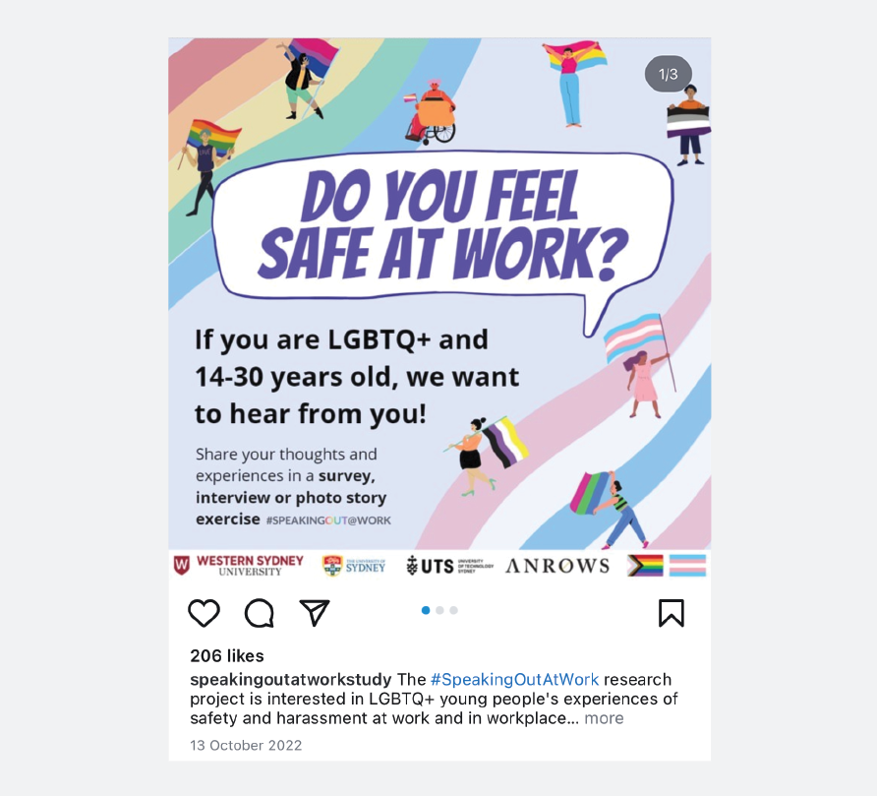
All recruitment posts and materials contained a link to the project landing page (see Appendix C), hosted on Qualtrics. After viewing information about the study (including a link to the participant information sheet; see Appendix D), potential participants could indicate their interest in completing the survey, interview and/or photo story exercise; those interested in the survey were then redirected to questions about eligibility and consent, and subsequently to the main survey. Young people who only wanted to complete the interview and/or photo story exercise rather than the survey were redirected to the form collecting expressions of interest for interviews.
Survey respondents who were also interested in an interview or photo story exercise first completed the survey. The survey invited participants to provide their contact details, which would allow their survey responses to be used to inform the interview questions. Alternatively, they were provided a link to a separate form collecting expressions of interest for interviews if they preferred their survey responses and interviews not to be linked. See Figure 2.2 for a participant flow diagram.
Figure 2.2: Participant flow diagram
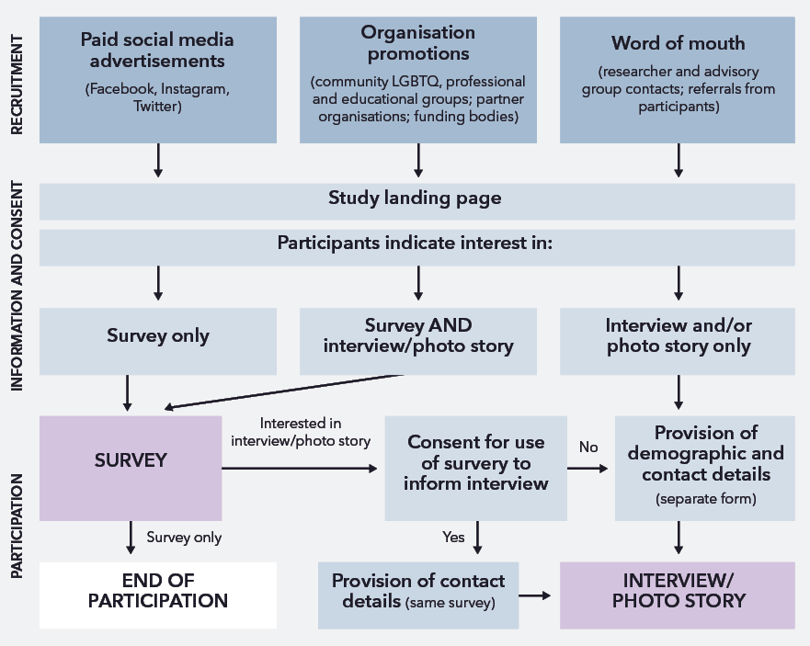
Text alternative for the figure above
A flow chart with three sections: ‘Recruitment’, ‘Information and consent’ and ‘Participation’.
There are three boxes that all point to a box labelled ‘Study landing page’. The first box is labelled ‘Paid social media advertisements (Facebook, Instagram, Twitter). The second box is labelled ‘Organisation promotions (community LGBTQ, professional and educational groups; partner organisations; funding bodies)’. The third box is labelled ‘Word of mouth (researcher and advisory group contacts; referrals from participants)’.
Beneath the box labelled ‘Study landing page’ is a box that is labelled ‘Participants indicate interest in:’ with arrows pointing to three different boxes. The first box is labelled ‘Survey only’. The second box is labelled ‘Survey AND interview/photo story’. The third box is labelled ‘Interview and/or photo story only’.
The ‘Survey only’ and ‘Survey AND interview/photo story’ boxes both point to a box labelled ‘Survey’. From the ‘Survey’ box there is an arrowed labelled ‘Survey only’ pointing to a box labelled ‘End of participation’. From the ‘Survey’ box there is a second arrow labelled ‘Interested in interview/photo story’ pointing to a box labelled ‘Consent for use of survey to inform interview’. From the ‘Consent for use of survey to inform interview’ there are two arrows, one is labelled ‘Yes’ and the other is labelled 'No’. The arrow labelled ‘Yes’ points to a box labelled 'Provision of contact details (same survey)’. The arrow labelled 'No’ points to a box labelled ‘Provision of demographic and contact details (separate form)’. This box points to a box labelled ‘Interview/Photo story’. The box labelled 'Interview and/or photo story only’ point to the box labelled ‘Provision of demographic and contact details (separate form)’.
End of text alternative.
Recruitment efforts were iterative; the research team monitored participants’ demographic and professional characteristics during the data collection period to identify under-represented groups and target subsequent advertisements to increase their participation. Figure 2.3 shows an example of targeted recruitment materials.
Figure 2.3: Example of targeted recruitment materials used to recruit men on social media
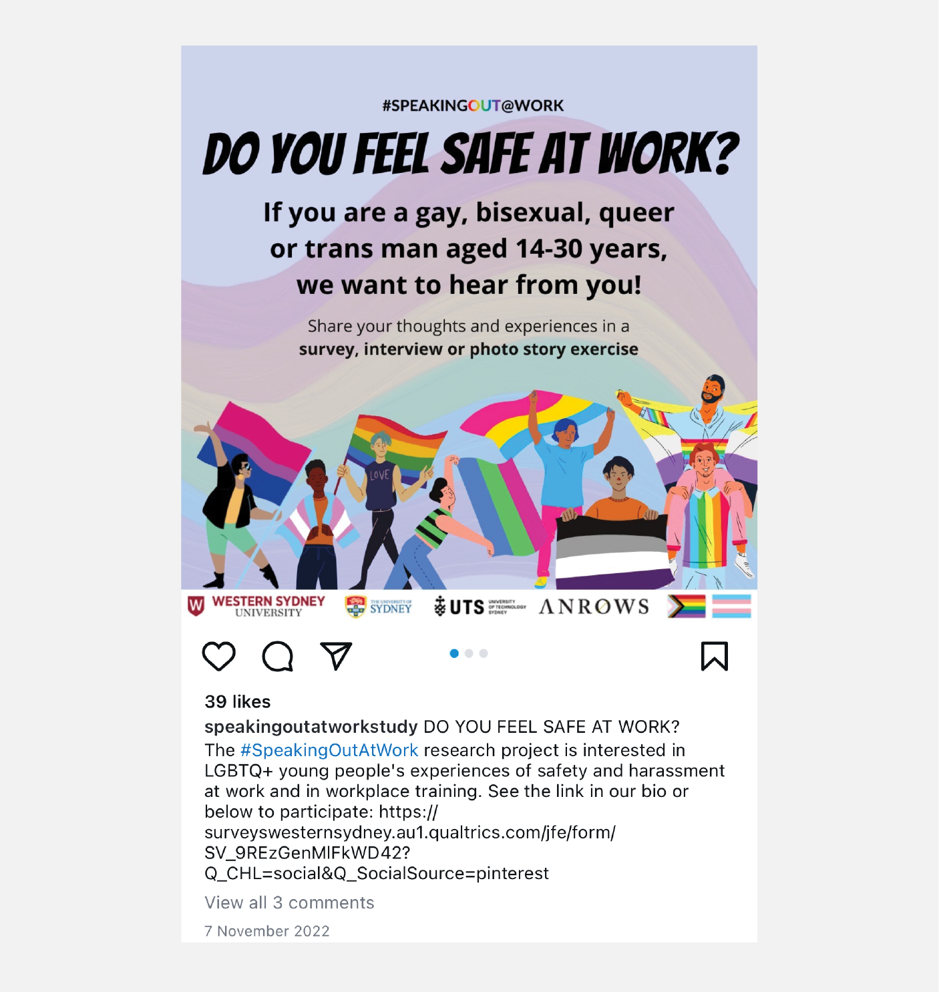

2.5 National online survey exploring the prevalence of workplace sexual harassment and related experiences
The national online survey aimed to establish the prevalence of and factors associated with WSH experienced by LGBTQ young people across identity groups, industries and locations. Hosted on Qualtrics, the survey covered demographic and professional characteristics; knowledge and understanding of WSH and relevant workplace rights; experiences of WSH, reporting and support-seeking; and impacts and outcomes. The survey provided a safe, convenient and confidential means for participants to share their perspectives and experiences.
The project aimed to survey 1,000 LGBTQ young people across various demographic and professional groups and locations. The target sample size was determined to allow sufficient statistical power to compare experiences between and within intersecting identities, based on previous research with LGBTQ young people (Robinson et al., 2014; Ussher et al., 2022). The survey was closed after this number of responses was reached.

2.5.1 Survey materials and procedure
The research team developed the online survey in collaboration with the advisory committee. The final survey included a combination of validated measures (Work Outness Inventory – Tatum, 2018; Kessler-5 distress scale – Australian Institute of Health and Welfare [AIHW], 2009); closed-ended items developed for the project or adapted from previous surveys (AHRC, 2018, 2020; Heywood et al., 2022; Hill et al., 2021; Human Rights Campaign, 2018; Trades Union Congress, 2019); and open-ended prompts allowing elaboration on closed-ended questions (see Appendix E for the entire survey). The online survey questions addressed the following areas and were adapted from the various sources acknowledged:
- Demographic information (14 items): age; gender, sexuality and sex recorded at birth (per ACON and Australian Bureau of Statistics [ABS] recommendations, with minor modifications); state/territory and postcode; ethnic/cultural background, Aboriginal and/or Torres Strait Islander origin, languages spoken at home and religion; financial situation (adapted from Williams et al., 2017); living situation; education; and disability.
- Vocational information (four items): time worked; current work and training situation; current employment situation; current job.
- Knowledge and understanding of workplace sexual harassment (WSH; 17 items): own definition of WSH; agreement with legal and behavioural definitions of WSH; modes of WSH; experiences of WSH training; awareness of rights at work related to WSH; knowledge of reporting and support pathways (adapted from Heywood et al., 2022); self-efficacy related to WSH.
- Prevalence of WSH (26 items): experience of WSH (self-report and behavioural definition; adapted from AHRC, 2018; Trades Union Congress, 2019); mode and location of WSH; number of harassment experiences; perceived reasons for harassment (adapted from Hill et al., 2021; Human Rights Campaign, 2018).
- Specific experiences of WSH (28 items): description of most impactful incident; repetition; location of WSH; perpetrator numbers, genders, ages, LGBTQ status and roles; witness presence and response; intimidation and perceived severity (all adapted from AHRC, 2018); workplace size; employment status, job at time; Work Outness Inventory (Tatum, 2018); items from the LGBT Climate Inventory (Liddle et al., 2004).
- Responses to WSH (15 items): reporting, outcomes, satisfaction and barriers (adapted from AHRC, 2018; Heywood et al., 2022); support-seeking, experiences and barriers; influences on reporting and support-seeking.
- Impacts and outcomes (14 items): impacts of WSH across various domains (adapted from AHRC, 2018); single item from Planned Happenstance Career Inventory – Career Optimism subscale (Kim et al., 2014); Kessler-5 Psychological Distress Scale (AIHW, 2009).
- Final comments (three items): suggestions for prevention of WSH; suggestions for support of LGBTQ young people experiencing WSH; other comments.
The majority of participants spent 10 to 35 minutes on the survey. After completing the survey, respondents were thanked for their time and contribution, and invited to share the study with others who may be eligible. At this stage, they were also reminded of available support organisations should they be experiencing distress or want to discuss their experiences further. Compensation of survey participants was not possible due to the anonymity of responses.

2.5.2 Survey data cleaning and preparation
All data cleaning and preparation was handled in Stata. After closing the survey, all responses (n = 1,244) were screened by participant eligibility for location (must be Australian) and completion rate (must have completed questions beyond demographic/vocational information); open-ended survey responses were examined then discussed for consistency, peculiarities in language and terminology, and nonsensical or malicious content; and responses from the same IP addresses were reviewed. This process identified and removed 227 ineligible responses, 13 false responses, and three multiple respondents. The final dataset contained 1,001 surveys for analysis.
Following data cleaning, responses to select survey questions were grouped as follows. Firstly, a gender variable was computed using participant-reported current gender identity and sex recorded at birth, considering open-ended descriptions of gender identity. An additional variable was then computed to indicate cisgender or transgender (including both binary and non-binary identities) status. Reported disabilities were categorised according to a classification derived from the National Disability Services (n.d.) and Australian Institute of Health and Welfare (2022) categories. Reported occupations were classified according to the Australian and New Zealand Standard Industrial Classification (Australian Bureau of Statistics, 2006) with the addition of two groups (Australian Defence Force and Personal Services) that corresponded to the AHRC Respect@Work categories. Required item reverse-scoring and scale totals were computed for the Work Outness Inventory (Tatum, 2018), the modified LGBT Climate Inventory (Liddle et al., 2004) and the 5-item Kessler Psychological Distress Scale (K-5; AIHW, 2009).

2.6 Individual semi-structured interviews to explore understandings and experiences of workplace sexual harassment
Individual, semi-structured interviews with LGBTQ young people allowed for nuanced exploration of the complexities of WSH, including understandings and perceptions of such incidents. Like the survey, the interviews covered the overall workplace experiences of LGBTQ young people, as well as understandings and experiences of WSH, reporting and support-seeking behaviours, and potential avenues for preventing and addressing WSH. However, this method allowed for more detailed elaboration and exploration of how individual and workplace characteristics shaped young people’s perspectives and experiences and the intersections of these factors. Where interviewees consented, survey responses were used to guide interview questions, allowing interviewers to explore experiences mentioned in the survey in greater depth or to ask about particular dynamics participants reported in their workplaces (e.g. how intersectional identities like cultural background or disability shaped experiences of safety and harassment; see Appendix H for examples of standard and tailored interview questions).
The project aimed to interview 40 LGBTQ young people, allowing for representation across demographic and professional groups.

2.6.1 Interview participants
In total, 42 young people were interviewed for the project (27 online, 14 by phone, one in person). One participant was subsequently excluded after examination of their responses and communications suggested that they were likely to be a false respondent and therefore ineligible. A second participant requested to withdraw their data from the study after participation.
Of the 40 eligible interviewees, the majority were cisgender women (40%) or non-binary people (32.5%); identified as bisexual (30%), queer (27.5%) or gay/lesbian (25%); and were Anglo-Australian (52.5%) or of mixed ethnic descent (20%). More than half (61.5%) had a disability or medical condition impacting their ability to work. A range of current work industries were represented, with the most common being professional, scientific and technical services (25%), education and training (22.2%), health care and social assistance (22.2%), and administration and support services (19.4%). See Appendix G for further details of interviewees’ demographics and occupations.

2.6.2 Interview procedure
Young people interested in being interviewed for the project were contacted and provided with further information about the interview procedure and consent process. Participants were offered the option to complete the interview online (via Zoom), by phone, or in person, depending on their location and preferences. These interviews were arranged at a time convenient to participants. All participants provided informed consent (written, email or verbal) to participate and have their information audio-recorded before beginning the interview.
Interviews were conducted by one of three researchers with significant experience in interviewing young and LGBTQ people about WSH and/or adjacent topics (e.g. online harassment, LGBTQ identity, sexual health). Interviews were semi-structured, allowing the interviewers to ask follow-up questions to prompt participants to elaborate on their responses. For interviewees who had previously completed the online survey, these responses were used to tailor interview questions where consent was given for this data linkage (see Appendix H for interview schedule and examples of tailored questions). It was found that tailoring and following up questions in this way helped to demonstrate interest in participants’ experiences, validate their responses as relevant and valuable, and facilitate the flow of conversation; this often led to longer interviews with more detailed and richer insights about LGBTQ young people’s experiences. Interviews lasted approximately 60 minutes and were audio-recorded for subsequent transcription and analysis. All participants received a $40 Prezzee voucher following interview completion, as a thank you for their involvement with the project.

2.6.3 Interview transcription and preparation
Interview recordings were transcribed by a paid transcription service (Rev.com). A research team member reviewed these transcripts for accuracy and removed potentially identifying information. Participants were allocated pseudonyms at this stage.

2.7 Photo story exercises to elicit participant-driven discussions of LGBTQ workplace safety and sexual harassment
Photo story invites participants to represent their experiences through photographs or other forms of visual media, which are then used to guide further discussion (Harper, 2002; Richard & Lahman, 2014; van Auken et al., 2010). This provides participants more agency in directing the focus of the conversation and elicits more detailed and different kinds of information than would otherwise be obtained. The method empowers participants by redressing potential power differentials between researchers and interviewees (Richard & Lahman, 2014; van Auken et al., 2010), which is particularly important when working with LGBTQ young people who are often marginalised in both the workplace and in research (Seiler-Ramadas et al., 2022; J. A. Smith et al., 2017).
Photo story participants were invited to take or select three to five images (photos or other visual media) that illustrated aspects of their experience of WSH or being a young LGBTQ person in the workplace. In a subsequent interview, these images were used to prompt discussion of participants’ thoughts and experiences about WSH experienced by LGBTQ young people. In contrast to the surveys and interviews, which covered predetermined topics set by the research team, the conversation in the photo story interviews was very much directed by the participants’ choice of images and how they chose to interpret them.
The project aimed to recruit 20 LGBTQ young people to complete photo stories.

2.7.1 Photo story participants
Nine participants completed photo story interviews (seven online, two by phone); one subsequently requested to withdraw their photo story and interview data from the project, leaving eight eligible photo story participants. These participants represented a range of ages, genders, sexualities and work industries. The majority were of mixed (50.0%) or Anglo-Australian (25.0%) background, and more than half had a disability or medical condition impacting their ability to work (62.5%). See Appendix G for further details of photo story participant demographics and occupations.
The number of photo story participants fell short of the original target of 20 LGBTQ young people, despite targeted social media recruitment efforts and follow-up contact with interviewees to promote the photo story exercise. These recruitment difficulties were not entirely unexpected; the number of participants recruited is comparable to a previous photovoice study of experiences of sexual violence among trans women of colour conducted by some members of the study team (Ussher et al., 2020), while another study by the team also found it more difficult to recruit younger participants to the photovoice component of the project (Power et al., 2022). It is thought that the time and effort required to take or compile photos for this project may have deterred LGBTQ young people from participating in this component of the study, particularly if they were also balancing study, work and other personal commitments – despite efforts to reassure potential participants that they could use existing photos, and that images did not have to be artistic. While the lower than anticipated number of photo story participants was not ideal, this was not considered to compromise data collection as photos were primarily used in combination with interview data, and to illustrate themes identified.

2.7.2 Photo story procedure
The research team contacted young people who expressed interest in the photo story exercise and provided them with more information about the procedure and consent process (see Appendix I). Specifically, they were asked to provide three to five images (e.g. photos, screenshots) that illustrated their experiences of WSH as an LGBTQ young person. Written, email or verbal consent was obtained from the young person to participate in the interview, to provide images to the research team and be audio-recorded, and from any person identifiable in the images. Participants were also asked to indicate if they consented to these images being used in the presentation of study findings (to be confirmed once specific uses are identified, e.g. publications or presentations).
During the subsequent phone or online interview, the images were used as prompts for the participant to discuss their experiences, with the interviewer primarily prompting elaboration through follow-up questions. In this way, participants had greater agency over the topic of discussion (see Appendix J for examples of questions). Interviews lasted approximately 30 to 60 minutes and were audio-recorded for later transcription and analysis. Participants received a $40 Prezzee voucher after the interview, recognising their contribution to the project.

2.8 Data analysis

2.8.1 Analysis of quantitative survey data
Descriptive statistics were obtained for quantitative survey data to determine the overall proportions of responses across variables. Further analysis was conducted to examine associations between key variables of interest. Cross-tabulation and chi-squares were used to assess associations between categorical variables, such as the association of prevalence WSH experiences with participant demographics. To further clarify these associations, logistic regression models were used to control for multiple predictors of categorical variables. T-tests and analysis of variance models were used for the few numeric variables, such as K-5 distress and overall outness at work.

2.8.2 Analysis of qualitative survey, interview and photo story data
All open-ended survey responses and interview transcripts (including photo story transcripts) were imported into NVivo (version 14 R14.23.0) for handling and analysis. These data were analysed using codebook thematic analysis, with the codebook development informed by reflexive thematic analysis principles (Braun & Clarke, 2019). A codebook thematic analysis approach was selected due to the size of the dataset. An initial codebook was inductively developed from a subset of interviews, and then applied to the full dataset.
The codebook was developed by four research team members, three of whom had conducted interviews and photo story exercises. Each read several interview transcripts and survey questions chosen to represent distinct demographic profiles across gender, sexuality and employment type. Before an initial meeting, researchers made notes on initial impressions of the data using an inductive approach wherein potential codes, topics and themes were generated from the data (Braun & Clarke, 2006, 2021). During the discussion, the selection of candidate codes was informed by project research questions alongside the knowledge and experiences of the research team. Candidate codes were primarily semantic, categorising the explicit details within the interviews.
The draft codebook was next circulated among the wider research team for feedback. To test the codebook, a larger team of researchers each read and coded the same two interviews using the draft codebook. This team then met to discuss the transcripts line by line to determine consistency in coding and discuss any additional codes generated. Following this meeting, the codebook was finalised and uploaded to NVivo (see Appendix K). In cases of discrepancies or disagreements, researchers discussed the specific quote to come to consensus agreement on the appropriate code. While quantitative data were analysed separately, they are brought together within the report: in discussing themes identified from qualitative interview and photo story data, relevant descriptive statistics from the survey are integrated where possible to illustrate the prevalence and nature of participants’ experiences.
Two researchers coded interview and open survey response data. Each researcher coded an independent section of the data – approximately half of all interviews, photo story interviews, and survey responses (divided by question). The researchers conducted most of this analysis in the same office, allowing for discussions regarding coding consistency and reflections. Any detailed reflections or responses were recorded in a separate journaling document throughout this process.
Following the completion of data coding, coding summaries were compiled. These summaries contained a name, an overview of the data contained in the code, and key examples for each code. In bringing together data to include in these summaries, codes were synthesised into topics that surrounded a specific subject matter, such as the workplace sexual harassment reporting process, and into themes that drew together larger ideas, such as how commonly recognisable workplace sexual harassment differed from queer-specific workplace sexual harassment.

2.9 Reflexivity statement
It was crucial to the project that the voices and perspectives of LGBTQ and young people be centred throughout the research process, from initial conceptualisation to the final write-up and presentation of findings. Both the research team and the stakeholder advisory committee included members of LGBTQ communities, including LGBTQ young people representing a range of identities and experiences, who were involved at all stages of the project. This involvement was crucial in ensuring that the study methods and materials worked for LGBTQ young people: that recruitment materials spoke to the population, that survey and interview questions sufficiently captured the breadth of their experiences, and that these experiences were accurately represented when analysing data and communicating findings. Consultations with the stakeholder advisory committee were also conducted at key stages of the project (e.g. during recruitment, when developing the survey, and during data analysis) to ensure that a diverse range of perspectives from LGBTQ communities were represented. Moreover, the research team and advisory committee represented diversity beyond LGBTQ identities – including different cultural, linguistic and religious backgrounds as well as disabilities. This helped the research team to ensure that these intersectional experiences were visible and captured during data collection.
The positionality of the researchers who collected and analysed the data was particularly prescient during these project phases. The topics discussed during the interviews and photo story exercises were often sensitive and emotional, and establishing a rapport between interviewers and participants was key in ensuring interviewees felt safe and comfortable sharing their thoughts and experiences openly. During the interviews, interviewers drew on commonalities between themselves and interviewees to help to facilitate rapport and establish a common language through which experiences could be more readily discussed (J. Taylor, 2011). Expressions of validation and empathy for participants’ experiences of workplace sexual harassment were another essential facet of the interview process. These expressions of care allowed interviewees to share their experiences safely and provided an opportunity to enact principles from the overarching feminist poststructuralist goals of this research. For example, one finding of this project was that LGBTQ young people sometimes struggled to recognise and validate their experiences as incidents of WSH (see Chapters 4 and 7). The interviewers’ explicit validation of and empathy with interviewees’ experiences allowed interviewees to begin to resist larger social discourses that invalidated their experiences.
The overarching framework included a lens of intersectionality throughout analysis. This analytic lens ensured that the intersections of cultural background and disability were reported in interviews and attended to during analysis of both survey and interview data. In attending to intersectionality, this project was able to give voice to participant experiences that might have otherwise been lost, as only a few participants were able to explicitly name and explain how these intersectional factors impacted their experiences.

2.10 Ethical considerations
The project received ethical approval from the Western Sydney University Human Research Ethics Committee (ref. no. H14942), with secondary approval from ACON (ref. no. 202212).
The primary ethical consideration of the project was the safety and wellbeing of participants, particularly around the potential for distress or re-traumatisation of young people when recalling past experiences of WSH, and for being identifiable in the publication or presentation of results. These risks were given particular weight given the vulnerabilities and power imbalances LGBTQ young people may experience, both in the workplace (AHRC, 2018, 2020; Trades Union Congress, 2019) and when participating in research (J. A. Smith et al., 2017).
All survey, interview and photo story participants were provided with information that clearly outlined the study procedure and their rights to participation (e.g. to share as much or as little as they wanted). It was made explicit that all participants had the right to skip questions or withdraw from the project at any point for whatever reason, without affecting their relationship with the research team or any organisations involved. For survey participants, this came in the form of written reminders during the consent process, in the participant information sheet, and at the beginning of each new survey page, accompanied by a document containing names and contact details for relevant support organisations should participants be experiencing distress (see Appendix F). For interviewees and photo story participants, this was iterated in participant information sheets and verbally when going over study procedures. Additionally, interviewers monitored participants throughout the interviews for verbal and non-verbal indicators of distress; where this occurred, interviewers offered participants the opportunity to pause or discontinue the interview and provided details of support services as appropriate. While several participants needed to take a break during the interview, no participant opted to completely withdraw from the interview or photo story during the session. However, one participant chose to withdraw their data after interview and photo story completion (for reasons not related to distress).
The risk of participants being identifiable in publishable data was also taken seriously, particularly where participants’ identities (gender or sexuality labels, pronouns), in combination with their age, industry and/or experiences, may be uniquely identifiable. The risk here was twofold: firstly, that participants’ sensitive accounts of their experiences may be linked to their identities; and secondly, that LGBTQ young people might be outed as LGBTQ should they be recognised as participants in this study. This risk was elevated for photo story participants, whose images sometimes portrayed identifiable people (e.g. faces, tattoos and visible names). For these participants, explicit consent was required for any identifiable person from the provided images, without which the images could not be used in the research process unless altered (e.g. blurring out the faces of people for whom consent could not be obtained). This consent was revisited in instances where the research team wanted to use photo story images in the communication of research findings; in these cases, participants were re-contacted and provided with details of the image and context of the proposed use and asked if they would consent to its use for this purpose. For both interview and photo story participants, young people were asked at the end of the exercise if they felt any information they had shared (including demographics, work characteristics and pronouns) would be potentially identifying and if they would prefer for this to be anonymised. This information provided by participants was supplemented by researcher discretion regarding potentially identifiable details shared in surveys, interviews and photo stories, which were anonymised as considered appropriate through discussion among the research team.
Consideration was also given to the potential for members of the research team to experience distress from extended exposure to accounts of harassment and discrimination through interviewing, coding and analysing data, potentially heightened in cases where interviewers had identities or experiences in common with participants. Both interviewers and coders had regular conversations that explicitly discussed their experiences of the research and encouraged one another to prioritise wellbeing. There was also a risk of distress for members of the research team reading and reviewing the study findings; where this was flagged to the study team, the chief investigator contacted them individually to check in on their wellbeing.
A final ethical consideration concerned the decision of whether to reproduce or censor slurs used by participants in their surveys and interviews, as well as more explicit descriptions of queerphobia and sexual harassment. As has been highlighted in previous work on online hate, replicating offensive content verbatim can be interpreted as a form of symbolic violence (Massanari, 2018) and risks normalising the use of this language – or, conversely, may distress readers (Allison, 2020). However, reproducing only milder experiences risks misrepresenting these behaviours as more benign than their reality (Jane, 2015). In presenting the findings of this study, we have attempted to strike a balance between these considerations: we have elected to include slurs, while providing context about the offensiveness of these terms; in describing instances of queerphobia and sexual harassment, we have retained participants’ descriptions to preserve the emotional impact of their testimony but have paraphrased to an extent to preserve their anonymity and lessen the risk of distressing readers.

2.11 Chapter summary
This chapter detailed the methodology used in the #SpeakingOut@Work study. The use of mixed methods, with quantitative and qualitative data collected via surveys, interview and photo stories, allows the project to provide population-representative insights as to the prevalence of workplace sexual harassment and related experiences, while also allowing rich and nuanced accounts of LGBTQ young people’s experiences in the workplace to be heard. These methodological choices also facilitated the exploration of how young people’s intersecting identities (including LGBTQ identity, gender, age, ethnic/cultural background and disability) shaped their experiences and perspectives. Finally, the involvement of researchers and advisory committee members from different positions within LGBTQ communities and work industries helped to ensure that the study methodology both elicited insights useful in guiding workplace reform and was sensitive and compassionate to the experiences and needs of the LGBTQ young people who participated in the project.

Chapter 3
Participant profile and workplace sexual harassment prevalence

3.1 Introduction
To contextualise the exploration of WSH experiences among LGBTQ young people across Australia, this chapter reports on participant characteristics and overall WSH prevalence. Overall, 1,244 individuals accessed the survey, and of these participants, a final 1,001 provided responses to the variables of interest and were thus included for analysis. However, only participants who responded to individual items were included in the corresponding analysis. All interview participants, except one, had also completed the survey and are included in the reporting below. The project aimed to reach a large convenience sample of LGBTQ young people, with the aim of achieving representation across identity groups, industries and locations.
All statistics reported in this chapter are calculated based on valid percentages, the number of participants who responded to each question, resulting in variations in total sample for each statistic.

3.2 Participant characteristics
Participants were able to specify their gender and sexuality as either or both a multiple-choice item and a written response. To illustrate the range of gender labels used by participants, any gender label that at least 10 participants used was grouped together, with the largest group identifying themselves as cisgender women (34%), followed by non-binary participants (23%; see Figure 3.1). Course categories were then created for analysis, grouping participants first into current gender identity groups of non-binary (40.7%), women (36.5%), men (21.7%), or unclear/unspecified (1.2%), and trans status then coded, with binary trans participants and non-binary participants included together in a broad “transgender” group. While efforts to ensure a balanced sample were undertaken in recruitment (see Section 2.4 above), there was a general under-representation of cisgender men. This may have been due to cisgender men not perceiving themselves as the target of the study due to dominant discourses that victims and survivors of sexual harassment are women and a general lack of survey uptake in cisgender male populations. Thus, the prevalence of WSH among men may be underestimated in this study. However, the qualitative data provided specific insight into the experiences of men.
Figure 3.1: Participant GENDERS
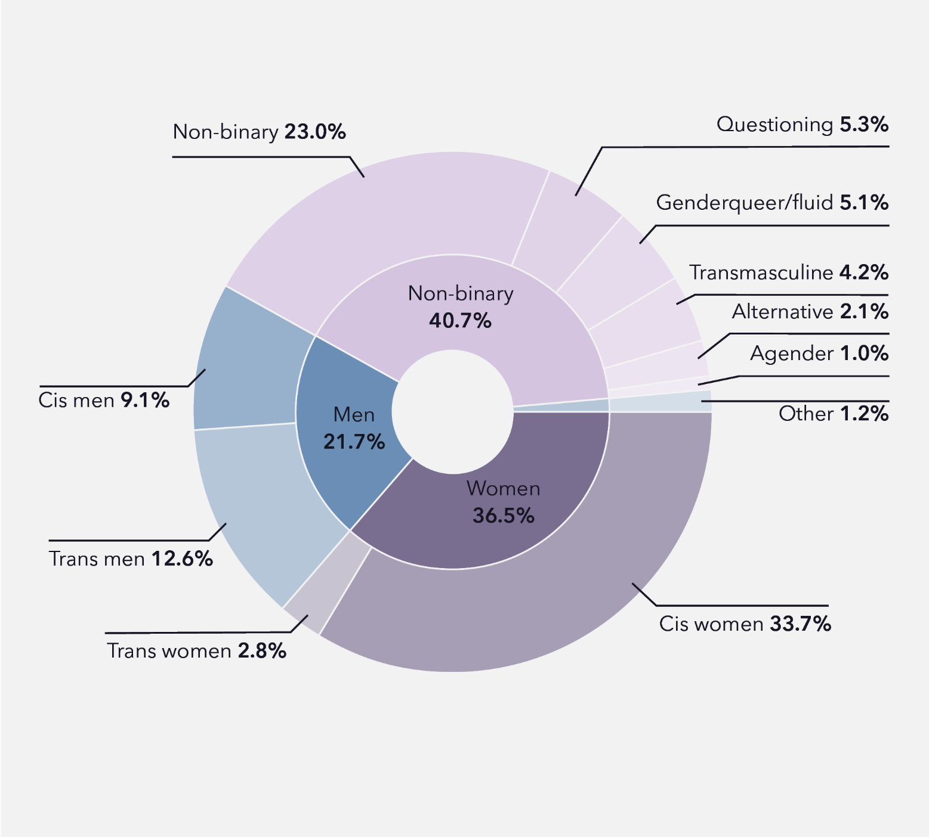
Data tables for figure 3.1
Non-binary
Participant gender | Percentage
Non-binary | 23.0%
Questioning | 5.3%
Genderqueer/fluid | 5.1%
Transmasculine | 4.2%
Alternative | 2.1%
Agender | 1.0%
Total | 40.7%
Women
Participant gender | Percentage
Cis women | 33.7%
Trans women | 2.8%
Total | 36.5%
Men
Participant gender | Percentage
Cis men | 9.1%
Trans men | 12.6%
Total | 21.7%
Other
People with a gender listed as ‘other’ made up 1.2% of participants.
Note: Percentages do not add up to 100% as numbers have been rounded.
Participants were able to self-describe their sexuality, and when specifying a single sexual and/or romantic orientation, approximately one quarter of participants described their orientation as each gay/lesbian (27%), bisexual (25%) and queer (25%; see Figure 3.2).
Figure 3.2: Participant sexual and/or romantic orientation
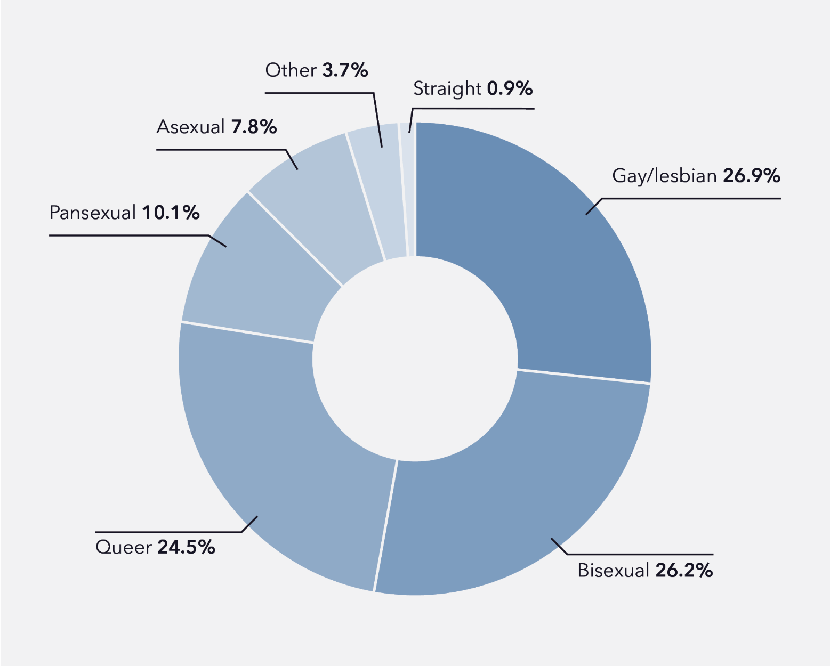
Data table for figure 3.2
Participant sexual and/or romantic orientation | Percentage
Gay/lesbian | 26.9%
Bisexual | 26.2%
Queer | 24.5%
Pansexual | 10.1%
Asexual | 7.8%
Other | 3.7%
Straight | 0.9%
Note: “Other” includes participants who specified “don’t know” (n = 6), “questioning” (n = 11), “a different term” (n = 16) and “prefer not to answer” (n = 4).
Percentages do not add up to 100% as numbers have been rounded.
Regarding ethnicity, the most commonly specified ethnicity was Anglo-Australian (81.7%; see Table 3.1), followed by European (23.5%) and Asian (9.9%), noting that participants could specify more than one identity. 4% of participants identified as Aboriginal, and 3% as Torres Strait Islander. The mean age of participants was 21.7 years old (SD = 4.7) and overall, the spread of participant ages was relatively consistent across the range of 14 to 30 years of age. Approximately half of all participants (52.8%) indicated they had a disability or medical condition that impacted their capacity to work. Almost one quarter of all participants reported a mental health condition (24.2%) and/or neurodevelopmental disability (22.4%).
Participants were employed in a range of industries at the time of completing the survey, with accommodation and food service, retail trade, and health care and social assistance the most represented industries (see Table 3.1). Participants could specify multiple types of work contracts, and at the time of survey completion, a casual work position was the most commonly held contract, with 46% of all participants holding a casual contract.
Table 3.1: Participant demographics
Participant demographics | M (SD) | Range
Age (years) | 21.7 (4.7) | 14–30

Gender | Percentage | N  (n = 1,001)
Cisgender men | 9.1% | 91
Transgender men | 12.6% | 126
Cisgender women | 33.7% | 337
Transgender women | 2.8% | 28
Non-binary | 23.0% | 230
Questioning | 5.3% | 53
Unclear/not specified | 1.2% | 12
Genderqueer/fluid | 5.1% | 51
Transmasculine | 4.2% | 42
Agender | 1% | 10
Alternative identity | 2.1% | 21
Sex recorded at birth | Percentage | N  (n = 1001)
Female | 82.2% | 823
Male | 15% | 150
Another term | 0.1% | 1
Prefer not to say | 2.7% | 27

Gender (cisgender or transgender) | Percentage | N  (n = 1001)
Cisgender | 42.8% | 428
Transgender – binary and non-binary | 57.3% | 573
 | % | N

Sexuality | Percentage | N  (n = 1001)
Straight | 0.9% | 9
Gay/lesbian | 26.9% | 269
Bisexual | 26.2% | 262
Pansexual | 10.1% | 101
Queer | 24.5% | 245
Questioning | 1.1% | 11
Asexuality spectrum | 7.8% | 78
Different term | 1.6% | 16
Don’t know | 0.6% | 6
Prefer not to answer | 0.4% | 4

State/territory | Percentage | N  (n = 1001)
ACT | 5.3% | 53
NSW | 32.7% | 327
NT | 0.9% | 9
Queensland | 19.4% | 193
SA | 7.8% | 78
Tasmania | 3.1% | 31
Victoria | 19.4% | 194
WA | 11.6% | 116

Regionality | Percentage | N  (n = 890)
Major city | 71.8% | 639
Inner regional | 17.8% | 158
Outer regional | 9.1% | 81
Remote | 1.0% | 9
Very remote | 0.3% | 3

Ethnic/cultural background | Percentage | N  (n = 993)
Aboriginal | 4.0% | 40
Anglo-Australian | 81.7% | 811
Asian | 10% | 99
European | 23.7% | 235
North African or Middle Eastern | 2.7% | 27
Pacific Islander | 0.6% | 6
South, Central or Latin American | 1.2% | 12
Torres Strait Islander | 0.3% | 3
Different identity | 1.7% | 17

Language(s) spoken at home | Percentage | N  (n = 999)
English only | 86.9% | 868
English and another language | 12.8% | 128
Other language(s) only | 0.3% | 3

Disability or medical condition* | Percentage | N  (n = 998)
Any | 52.8% | 527
Sensory or speech disability | 1.8% | 18
Neurodevelopmental disability | 22.3% | 223
Physical disability | 4.4% | 44
Mental health condition | 24.1% | 241
Neurological disability | 1.5% | 15
Chronic health condition | 8.1% | 81

Employment status* | Percentage | N  (n = 860)
Permanent full-time | 24.3% | 209
Permanent part-time | 22.1% | 190
Casual | 53.7% | 462
Temporary or fixed-term | 5.5% | 47
Freelance or self-employed | 4.2% | 36
Different arrangement | 0.9% | 8

Industry | Percentage | N  (n = 990)
Accommodation and food services | 19.4% | 192
None listed | 18.5% | 183
Retail trade | 16.6% | 164
Health care and social assistance | 11.5% | 114
Professional, scientific and technical services | 9.2% | 91
Education and training | 8.1% | 80
Administration and support services | 6.7% | 66
Arts and recreation services | 3.6% | 36
Public administration and safety | 1.2% | 12
Transport, postal and warehousing | 1.0% | 10
Agriculture, forestry and fishing | 0.9% | 9
Construction | 0.9% | 9
Information media and telecommunications | 0.7% | 7
Personal services | 0.7% | 7
Other services | 0.5% | 5
Australian Defence Force | 0.2% | 2
Financial and insurance services | 0.1% | 1
Mining | 0.1% | 1
Wholesale trade | 0.1% | 1
Note: * Participants could specify more than one option, percentages may add up to greater than 100%. A subset of these participants also completed an interview and/or a photo story exercise.

3.3 Workplace sexual harassment prevalence
When asked directly, 60% of participants reported at least one experience of WSH across their lifetime. In addition, 17% of participants indicated they had experienced at least one or more specific incident of WSH (i.e. intrusive questions), despite having indicated they had not experienced WSH.
Thus, 77% of participants indicated that they had experienced some form of WSH across their lifetime.
The discrepancy between responses to the direct question regarding a history of WSH experiences and the reporting of specific behaviours may be explained by participants’ written reflections on their past experiences. Some participants described how they did not realise their experience qualified as WSH until completing the survey: “I had no idea that interaction was considered [sexual] harassment until I started this survey. Thank you” (Survey participant, asexual non-binary young person, aged 21).
Figure 3.3: Previous experiences of workplace sexual harassment behaviours
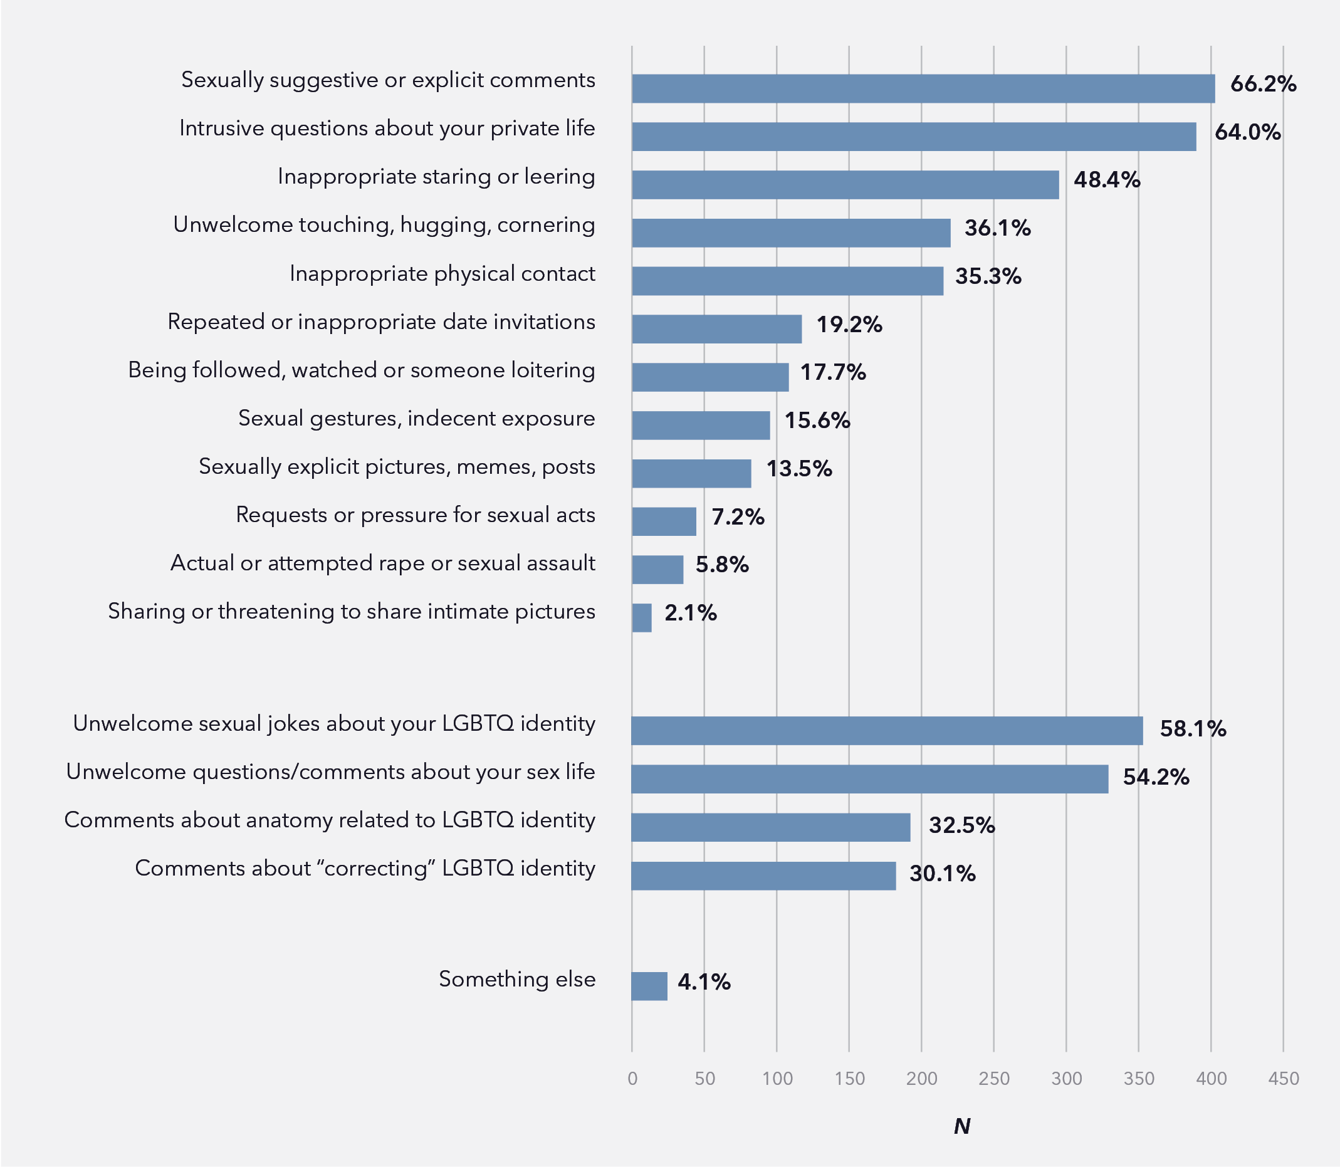
Data table for figure 3.3
Previous experience of workplace sexual harassment behaviour | Percentage
Sexually suggestive or explicit comments | 66.2%
Intrusive questions about your private life | 64.0%
Inappropriate staring or leering | 48.4%
Unwelcome touching, hugging, cornering | 36.1%
Inappropriate physical contact | 35.3%
Repeated or inappropriate date invitations | 19.2%
Being followed, watched or someone loitering | 17.7%
Sexual gestures, indecent exposure | 15.6%
Sexually explicit pictures, memes, posts | 13.5%
Requests or pressure for sexual acts | 7.2%
Actual or attempted rape or sexual assault | 5.8%
Sharing or threatening to share intimate pictures | 2.1%
Unwelcome sexual jokes about your LGBTQ identity | 58.1%
Unwelcome questions/comments about your sex life | 54.2%
Comments about anatomy related to LGBTQ identity | 32.5%
Comments about “correcting” LGBTQ identity | 30.1%
Something else | 4.1%

WSH behaviours that could be specific to participants’ LGBTQ identity were among the most common forms reported: among participants who had experienced at least one form of workplace sexual harassment, more than half had experienced sexually suggestive or explicit comments (66%), intrusive questions about their private lives (64%), unwelcome sexual jokes about their LGBTQ identity (58%), and unwelcome questions about their sex lives with regard to their LGBTQ identity (54%; see Figure 3.3). Further, when reporting on the frequency of experiences of WSH, the most common frequency among participants was “more than 10 times” (31.3%; see Figure 3.4). Crucially, 58% of participants reported their most impactful experience of WSH was part of a series of incidents.
Figure 3.4: Frequency of workplace sexual harassment experiences
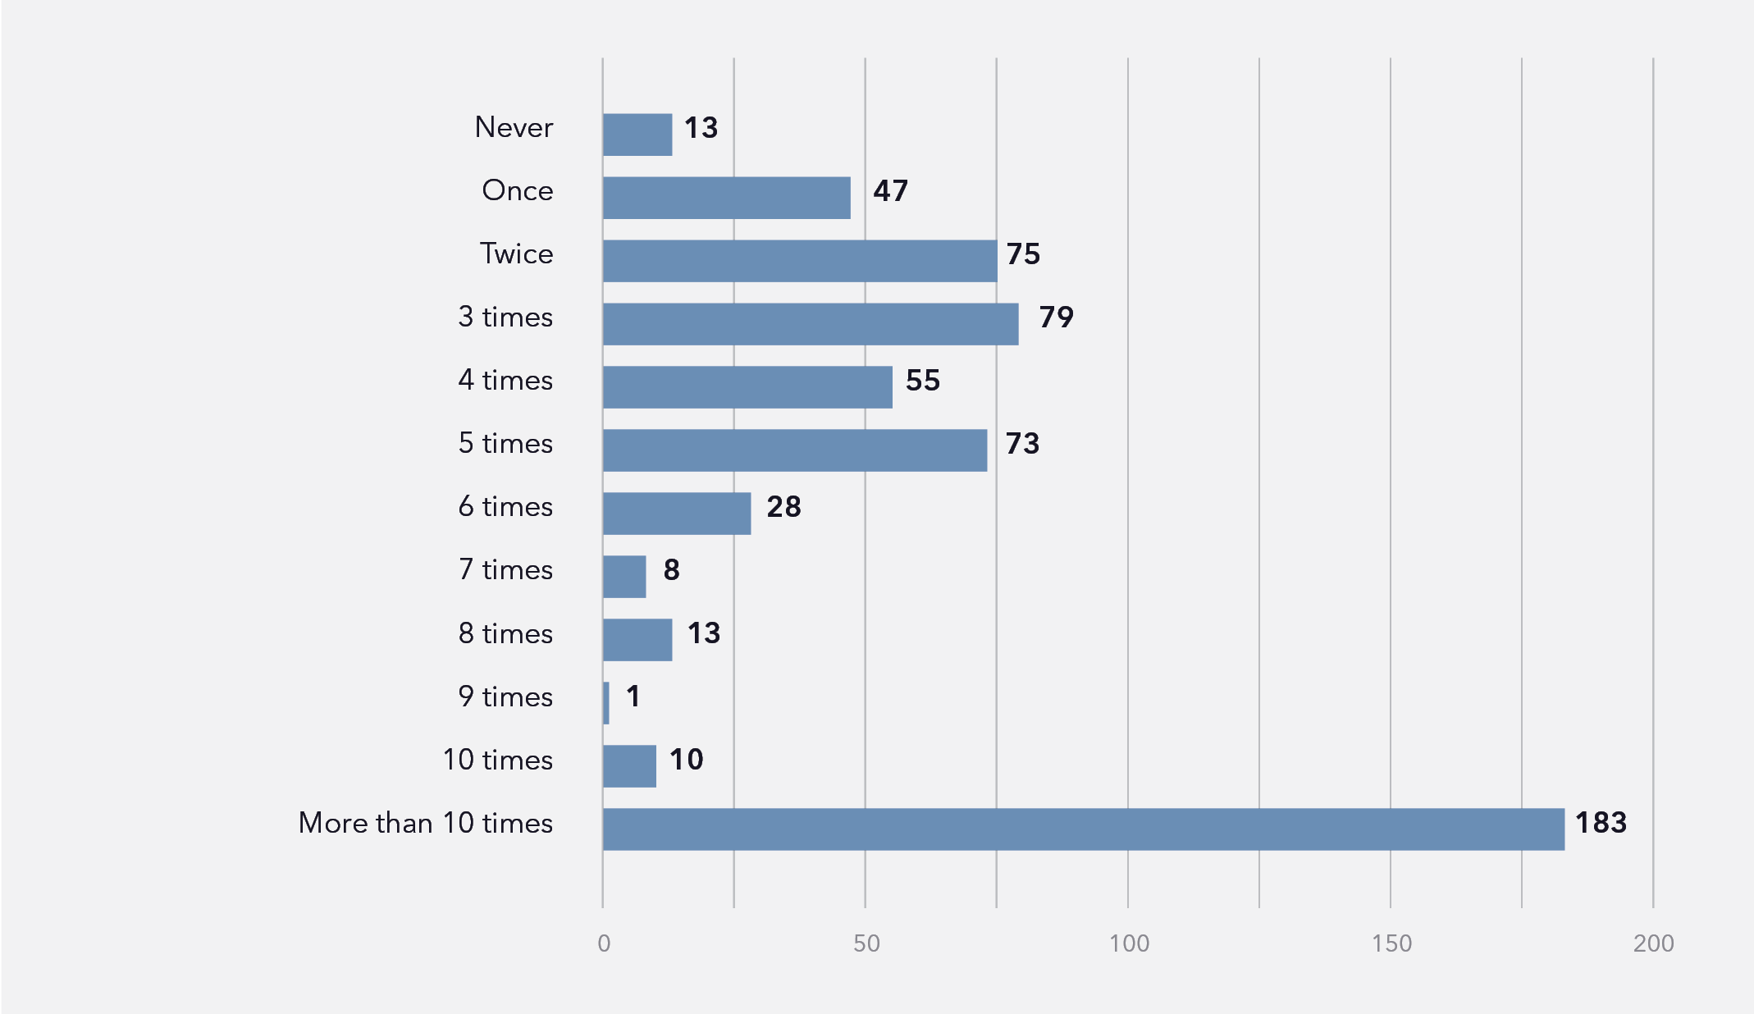
Data table for figure 3.4
Frequency of workplace sexual harassment experiences | Number of people
Never | 13
Once | 47
Twice | 75
3 times | 79
4 times | 55
5 times | 73
6 times | 28
7 times | 8
8 times | 13
9 times | 1
10 times | 10
More than 10 times | 183
Of those respondents who had reported experiences of WSH, 99.7% experienced harassment in person. Further, 27% of respondents experienced harassment online, and all but two of these respondents reported in-person harassment.
Various participant characteristics were found to be associated with having experienced at least one type of WSH behaviour. Older participants were significantly more likely to have experienced WSH (t[783] = -6.25, p < .001), but this may be due to having spent more time in the workplace. Indeed, participants who had spent more time working were significantly more likely to have experienced WSH (χ2[17] = 80.84, p < .001). Alternatively, younger participants may have been less likely to recognise specific incidents as WSH, as explored in Section 9.5.
Workplace sexual harassment prevalence significantly differed across participants’ sexual/romantic orientation (χ2[4] = 12.42, p = .0141). Specifically, queer and pansexual participants were more likely to have experienced WSH than other participants. Participants’ current gender identity was unrelated to the likelihood of lifetime workplace sexual harassment (χ2[3] = 2.11, p = .550). However, participants who were presumed female at birth were significantly more likely to have previously experienced WSH (χ2[1] = 7.25, p = .007), in accordance with qualitative data presented in Section 5.2 that outlines how perceived femininity is a common target of WSH, regardless of current gender.
Comparatively, 80% of transgender (binary and non-binary inclusive) participants had experienced WSH, which was significantly higher than the 74% of cisgender participants who had experienced WSH (χ2[1] = 4.75, p = .029; see Figure 3.5). Further, participants who had indicated a disability or medical condition were significantly more likely to have experienced WSH (χ2[1] = 16.76, p < .001). Specifically, 83% of participants with disability and/or a medical condition had reported a previous experience of WSH compared to 71% of participants without disability or a medical condition. To note, these analyses investigated associations between participants’ current sexuality, gender and disability status, and these may differ from their identity or experiences during the instances of WSH.
Figure 3.5: Workplace sexual harassment experiences across demographic factors
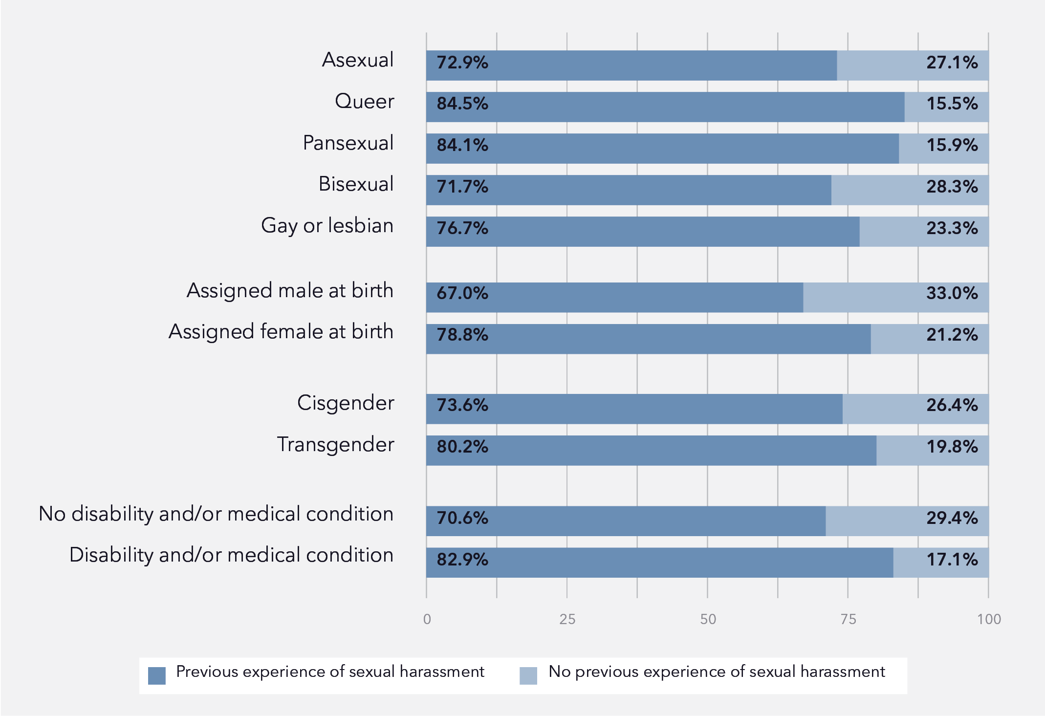
Data table for figure 3.5
Demographic factor | Previous experience of sexual harassment | No previous experience of sexual harassment
Asexual | 72.9% | 27.1%
Queer | 84.5% | 15.5%
Pansexual | 84.1% | 15.9%
Bisexual | 71.7% | 28.3%
Gay or lesbian | 76.7% | 23.3%
Assigned male at birth | 67.0% | 33.0%
Assigned female at birth | 78.8% | 21.2%
Cisgender | 73.6% | 26.4%
Transgender | 80.2% | 19.8%
No disability and/or medical condition | 70.6% | 29.4%
Disability and/or medical condition | 82.9% | 17.1%
There were some differences among participants in the types of WSH behaviours experienced. For example, binary and non-binary trans participants were significantly more likely than cisgender participants to experience intrusive comments about their anatomy (χ2[1] = 88.51, p < .001), as 30% of all trans participants in the sample had experienced these questions, compared to 6% of all cisgender participants. Comparatively, people who were presumed female at birth were more likely to have experienced comments about “correcting” their LGBTQ identity compared to participants presumed male at birth (χ2[1] = 3.86, p = .05), as 23% of all participants who were presumed female at birth had experienced these comments, compared to 15% of participants presumed male at birth.

3.4 Characteristics of workplace sexual harassment
Participants were asked a series of questions about their most impactful experience of WSH. They provided specific details about the nature of this event, including how it occurred, where it occurred, perpetrator characteristics, and responses to this event.
At the time of their most impactful experience of WSH, over half of the participants were casually employed (54%), a quarter (21%) were permanent full-time, 15% were permanent part-time, and the remaining 9% were temporary/fixed term, freelance, or had a different arrangement. Many of these participants were employed in a large (200 or more employees) workplace (37%), with respondents also employed in medium (20 to 199 employees) workplaces (26%), or small (5 to 19 employees) workplaces (27%). A small proportion of participants were employed in micro workplaces (2 to 4 employees; 6%), worked alone (0.6%) or did not know (3%).
This impactful incident most commonly occurred at a respondent’s workstation (65%), followed by in a work social area (12%) and at a work social event (8%). Correspondingly, 42% of participants indicated there had been a witness(es), with a further 24% of participants unsure if there had been a witness(es). Of those respondents who indicated there had been a witness(es), 67% indicated the witness(es) did nothing in response, 29% indicated they had received reassurance or support, and 18% indicated the witness(es) joined in the harassment, noting that the witness(es) may have responded in more than one manner.
Almost three quarters of reported incidents included solely male perpetrators (71%), with 14.7% involving a mix of perpetrator genders and 13% exclusively female perpetrators. Over half of the participants indicated that only one perpetrator was involved in the incident (66%), and almost an additional quarter indicated that two or three perpetrators were involved (22%). Notably, 7% of participants indicated the perpetrator was another LGBTQ person. Interestingly, there was no clear pattern of the age of perpetrators. In 35% of the incidents, a perpetrator aged 20 to 29 years was involved and a quarter of incidents each involved perpetrators aged 30 to 39 years (27%), 40 to 49 years (26%) and 50 to 64 years (25%), noting that multiple perpetrators of varying ages may have been involved. In one fifth (20%) of incidents, perpetrators were under 20 years old, and in 9% they were over 65 years old.
Most commonly, incidents involved perpetrators who were a co-worker at the same level as participants (46%). One third of incidents involved perpetrators who were clients or customers (31%), one quarter were a manager who was not the participants’ direct manager (27%), and in 20% of incidents perpetrators were participants’ direct manager. Further, 16% of perpetrators were a member of the public, 10% were the workplace head, and 7% were a junior co-worker.
When asked about the reporting of their most impactful experience of WSH, three quarters of participants indicated they had not made a report (75%). Only 15% of participants made a report to someone at work, 4% to someone outside of work, and 2% to the police. Further, when participants did lodge a report, 56% were not at all satisfied with the outcome, and only 9% indicated they were very or extremely satisfied.
Experiences of WSH impacted many areas of respondents’ lives, including mental health (80%), self-esteem (75%), outness regarding their LGBTQ identity (57%), employment or career (51%), health and wellbeing (42%), feelings regarding their LGBTQ identity (42%), relationships (28%) and finances (22%). Indeed, current distress levels were slightly elevated among respondents who had previously experienced WSH (t[599] = -2.54, p =.011).

3.5 Chapter summary
At a broad level, LGBTQ young people experience WSH at higher rates in comparison to the general Australian population and other young people at work, as pointed out by the AHRC research (2018, 2020). In our research, the forms of harassment experienced were highest for those that did or could be construed to specifically target participants LGBTQ identities, including questions and comments about LGBTQ young people’s sexuality, gender or private lives. Most commonly, participants reported repeatedly experiencing WSH. The specific facilitators, details, responses and outcomes of experiences of WSH are elaborated further in subsequent chapters.

Chapter 4
Definitions of workplace sexual harassment, awareness of policies and reporting pathways, and experiences of anti-workplace sexual harassment training

4.1 Introduction
This chapter reports on the survey and interview research findings related to LGBTQ young people’s perceptions of what constitutes WSH, their awareness of related policies and reporting pathways, and their experiences with relevant training. Clear, inclusive and plain-language definitions of what constitutes WSH are crucial to fostering effective prevention, identification and intervention responses for this behaviour.
In the workplace, definitions of sexual harassment are framed within legal discourses stemming from anti-discrimination legislation that makes it illegal to discriminate against or harass someone on the grounds of their gender, sexual orientation, race, ethnicity or disability. As such, these definitions are specific and underpinned by legal discourses of what constitutes sexual harassment in the workplace. However, legal definitions do not fully capture or relay the breadth and depth of experiences that constitute WSH, the circumstances in which these behaviours can arise and are perpetuated, or identify those individuals or groups that are most vulnerable to this behaviour. The findings of this study show that WSH for LGBTQ young people is often understood within the dominant discourses of WSH that focus on cisheteronormative relations of binary gender and power, and workplace hierarchies of institutional power relations related to employment status. Consequently, many LGBTQ young people are frequently uncertain if their experiences of inappropriate gender- and sexuality-based behaviours in the workplace constitute sexual harassment. They often view these behaviours as incidents of transphobia and/or homophobia and biphobia, rather than seeing these as foundational to experiences of sexual harassment. There is limited awareness of intersectionality and how it can be used to understand manifestations of sexual harassment among LGBTQ young people and among broader workplace populations.
Research shows that training related to workplace rights and WSH is critical to curbing this behaviour (AHRC, 2020). Workplaces are legally required to provide employees with WHS regulation information and training, including information on workplace discrimination and harassment (Safe Work Australia, 2022). From the findings of this study, how employers approach this requirement varies considerably regarding allocated time, quality and nature of the training. Indeed, only 46% of participants indicated that they had received any training regarding WSH and, more concerningly, only 8% of respondents reported that this training included LGBTQ-specific content. The training LGBTQ young people received in their workplaces, if they received any at all, was generally minimal, ineffective, unmemorable, unengaging, and considered more as a tick-a-box legal requirement for employers.

The following discussion of LGBTQ young people’s understanding of WSH, awareness of relevant policies and reporting pathways, and experiences of training highlight important issues for consideration in enhancing current prevention of and interventions into this workplace problem. To note, the following chapters integrate statistics from quantitative survey questions alongside description of themes derived from qualitative data that have no specific percentage prevalence in the sample.

4.2 What is workplace sexual harassment? The perceptions of LGBTQ young people
LGBTQ young people in this study were generally aware of sexual harassment in its most commonly understood terms, and their understandings of what constituted this behaviour were broadly consistent with legal and behavioural definitions. When provided the legal definition of WSH in the survey, 97% of participants indicated that this definition matched their own understandings of WSH. Most survey respondents provided their own definition of WSH when prompted; these definitions included a broad range of one-off or repeated, intentional or unintentional, verbal, written and physical behaviours of a sexual nature that are unwanted and make people feel uncomfortable, often reflecting general definitions and discourses of sexual harassment as discussed in Chapter 1. For example, Amanda defined WSH as:
… any unwanted interaction or discussion, comment, or any kind of unwanted sexual-related interaction. I would say it could be online, it could be an email, it could be a text message, it could be in person, it could be gossip even. I feel like anything that is just related to someone’s sexuality or their body or their interpersonal relationships that’s just unwanted, I suppose. Yeah, I think the unwanted aspect is where it becomes harassment, and then the sexual nature is related to identities or sexuality, for sure.
(Bisexual cis woman, UX designer, aged 28)
It is important to note, however, that it was relatively uncommon for participants’ definitions to comprehensively cover all the abovementioned elements (i.e. repetition, intention, behaviour type, impact on victims and survivors). Rather, most survey respondents provided definitions of WSH that were brief, vague and/or circular. For example, many participants’ definitions included “unwanted sexual advances” (Survey participant, multiple participants), “sexual harassment but in the workplace” (Survey participant, bisexual non-binary person, teacher and barista, aged 22) and “inappropriate behaviour of a sexualised nature” (Survey participant, queer-questioning [gender] person, education worker, aged 27). Comparatively, some survey respondents colloquially defined WSH in somewhat stereotyped terms, such as “people (mostly men) being creepy little spookers” (Survey participant, pansexual and ace trans male, unemployed, aged 16) or “gross men doing gross things” (Survey participant, queer cis woman, hospitality worker, aged 16). In other cases, the omission of some elements was intentional; as expressed by one survey respondent, “the person’s expectation of their behaviour is not always relevant – someone can sexually harass another person and claim they ‘didn’t expect’ that the person would not appreciate it” (Gay/lesbian cis woman, service design worker, aged 21). Others omitted mention of unwantedness or inappropriateness, as “I’d say the vast majority of workplaces, there’s pretty much no appropriate way for there to be sexual content or interaction in the workplace” (Jamie, queer and bisexual, non-binary transmasculine person, counsellor, aged 28). While broad definitions provided by many participants had the advantage of being encompassing and inclusive of a wide range of experiences, the idea of broad definitions was also criticised for being “impractically broad, subjective and reflect[ing] projected bias” (Survey participant, person questioning gender and sexuality, healthcare worker, aged 25) – specifically, not making visible and naming behaviours targeting LGBTQ young people for their identities as inappropriate.
Many survey respondents defined workplace sexual harassment in terms of specific behaviours (including in combination with the abovementioned broad definitions) – some of which appeared to be influenced by their own experiences of sexual harassment. This type of definition covered a broad range of behaviours reflecting the continuum of sexual violence most targeted at women and girls and LGBTQ people, including sexist comments, comments on appearance and bodies, comments about one’s gender expression, questions about personal and sexual lives, someone being overly attentive, repeatedly being asked out on dates, repeated requests to be friends on social media, leering, stalking, being threatened sexually, and being touched, grabbed, groped, assaulted or raped. Some behaviours (e.g. unwanted comments, advances and touching) were more commonly named in participants’ definitions:
WSH can be inappropriate staring, comments about someone’s body, making sexual comments, disclosing kinks without others’ consent and inappropriate touching when touching others isn’t needed for the job.
(Survey participant, gay trans male, hospitality worker, aged 20)

[When someone] touches you inappropriately without you consenting (e.g. in kitchens when someone touches you on your lower back when they don’t need to touch you or you’ve asked them to touch you on your shoulders instead); makes suggestive comments; stares/leers at you; repeatedly asks you out on dates after you refuse them.
(Survey participant, bisexual cis woman, administration worker, aged 22)
When provided with a behavioural definition of sexual harassment derived from measures commonly used in research (e.g. AHRC, 2018; see Appendix E), many participants noted that forms of harassment specifically targeting LGBTQ people for their identities were inadequately captured. Chief among those specific harassments were derogatory comments about LGBTQ people; intrusive questions about participants’ LGBTQ identities, bodies, and sexual practices; fetishisation and sexualisation of LGBTQ people (particularly queer women); and misgendering, deadnaming and outing of trans people:
I think that disparaging homophobic, transphobic, and misogynistic commentary should be included in sexual harassment, as although they are not based in engaging in sexual conduct, they are related to sex and sexual features of those targeted.
(Survey participant, bisexual non-binary woman, governance worker, aged 30)

Intrusive personal questions [listed in the behavioural definition] include questions about transition plans, hormones/surgery, if your partner is going to leave you, etc.
(Survey participant, gay non-binary person, unemployed, aged 27)

Use of [incorrect] names, pronouns, and prefixes to names in the workplace. These can be established and ignored intentionally, or drawn out with the intention to delegitimise, misgender or otherwise humiliate in the workplace.
(Survey participant, gay/lesbian cis woman, education worker, aged 30)
These comments highlight that even when official behavioural definitions are intended to be broad and comprehensive, they are not felt to be inclusive of harassment specifically targeting marginalised identities – which LGBTQ young people are frequently impacted by (see Chapter 8 for further discussion). Indeed, when participants were asked if they had ever experienced WSH, 60% of participants indicated any previous experience. However, when presented with a list of WSH behaviours that included behaviours that targeted participants’ LGBTQ identity, of participants who had initially indicated no previous experience of WSH, 44% indicated that they had experienced one or more of the specific behaviours. Thus, when accounting for all participants who indicated experiencing at least one specific WSH behaviour, the prevalence of a previous experience of WSH rose from 60% to 77%. This situation results in the misrecognition and under-reporting of WSH targeting LGBTQ young people for their identities, both in research and when experiencing these behaviours in the workplace.
Finally, a minority of participants defined WSH in terms of “discrimination or adverse treatment based on sex or sexuality” (Survey participant, gay/lesbian cis woman, education worker, aged 30). One survey respondent, comparing their own definition to the legal definition of WSH, wrote:
[My definition] is broader/bigger. In the US, they define sexual harassment to include gendered/sex-based harassment, and I think that’s better. The “sexiness” of the harassment is less important as the motive to demean/humiliate/punish people bc [because] of their gender or gender expression (which is sometimes done in a “sexy” way).
(Survey participant, queer cis woman, policy officer and sex worker, aged 28)
Such a definition can blur the line between sexual harassment and queerphobia (including homophobia, biphobia and transphobia), which otherwise presented challenges for many LGBTQ young people having difficulty labelling their experiences (see Section 4.5).
LGBTQ young people raised interesting points about the scope of WSH definitions and the difficulties that can arise in defining this behaviour. Some commented that the definitions needed to be broader to capture the wide range of behaviours they experienced relating to their gender and sexuality. LGBTQ young people reported being unsure if some of this behaviour would be classified as sexual harassment using official definitions. For others, what was considered sexual harassment was viewed as subjective. For Luca, definitions were generally too narrow:
I have been thinking about this, and I do think that the definition that most people are working with is too small … I think it would be [defined as] any, any, behaviour that makes anyone feel violated, in a sexual manner, or comment, that has sexual connotations, or has the potential to do that, in the context of a workplace.
(Luca, queer non-binary person, educator, aged 23)
Ramsey pointed out the difficulty they saw in concisely defining sexual harassment:
I think it refers to a really, really broad range of things … I think it can be really, really hard to define what sexual harassment is because it can be as, I don’t want to say “small”, because those things aren’t small, but I would use the word small ’cause I can’t think of a better word, but things as small as repeated compliments based on appearance or that kind of thing.
(Ramsey, queer gender nonconforming person, disability advocate, aged 24)
Lucy highlighted the need to include intrusive questioning about personal relationships in definitions of WSH – a comment that many others also articulated as it reflected a common experience among LGBTQ young people in the workplace. To exemplify the point, Lucy relayed an interaction she had with a co-worker, which she believed was sexual harassment:
[My co-worker asked:] “Do you have a boyfriend?” I said, “No.” Then, “Why?” And I was like, “Because I’m just not interested.” … “How will you have a child?” … And then she went into, “Rape is the only thing that has caused my friends in the past to be lesbian.”
(Lucy, lesbian cis woman, teacher, aged 25)
Lucy’s co-worker’s comment typifies lesbian stereotypes, in which sexual violence experienced by men is the reason why women are perceived to be attracted to and have intimate relationships with other women. Such stereotypes are offensive, constituting lesbian identities as damaged and lacking agency and legitimacy in their intimate relationships with women. This discourse also feeds into the stereotype that lesbians only need a good sexual relationship with a man to re-orient their sexuality toward heterosexuality (Rich, 2003).
Alexander, a 26-year-old bisexual trans man working in the legal field, raised the gendered differences often related to WSH:
Workplace sexual harassment can look like repeatedly asking someone on a date, or even being overly attentive in a way that a young man might think is beyond reproach but is slightly weird. And the woman can feel it. It’s typically a woman [being targeted]. They’ve got a bad gut feeling, but it’s designed to be innocuous, and that sucks …
(Alexander, bisexual trans man, lawyer, aged 26)
Alexander’s comments reflect a sophisticated yet pervasively heteronormative understanding of sexual harassment. This heteronormative discourse of sexual harassment, labelled as “traditional” by several young people in the study, reflected the dominant understandings of WSH that prevailed for many participants. This is discussed further in Section 4.3.
For some LGBTQ young people, WSH was clearly about power. Hazel commented about how her powerlessness and lack of capital in the workplace, associated with intersections of gender, sexuality and age, led to her vulnerability:
… that lack of power that I’ve had in a lot of those spaces, whether it was my age or my gender or sexuality; all of these people had more social currency than I did. And because of that, [they] got to say things to a young girl [that] in no other space they would’ve been allowed to.
(Hazel, pansexual cis woman, barista and social work student, aged 24)
Hazel makes the critical point that due to the power differences experienced by LGBTQ young people in the workplace, managers, supervisors and co-workers with more power and capital often escape punishment for behaviours that would not be tolerated outside the workplace. Hazel’s comment highlights that LGBTQ young people frequently negotiate multiple marginalised identities, further compounding their vulnerability to mistreatment in workplaces with unhealthy work cultures (Davies et al., 2021).
Zoe reinforced the point that WSH inherently includes people in more powerful positions in the workplace exerting control over others:
I just understand that [sexual harassment] as anything where someone uses sexuality to either exert control to make you uncomfortable or to take something from you … that includes if they’re stalking you, leering at you, whether they’re trying to be a bit more manipulative through that, exert their power if they’re in a higher position or something.
(Zoe, queer cis woman, researcher, aged 25)
Some explicitly reported that sexual harassment is not just perpetrated by co-workers, supervisors or managers but also by clients or customers.
When asked to indicate where they expected that WSH was most likely to occur, 61% of participants believed it was most likely to happen in person, 21% believed it was most likely to occur online or via phone, and 18% were unsure. However, not many survey participants expanded upon the idea of the “workplace” as a key component of the definition, and instead focused on the specific sexual harassment behaviours. In the cases where participants expanded upon the idea of the workplace, they pointed out that many spaces functioned as an extension of the workplace, including online spaces, work functions, and when travelling for work.
Ruby pointed out that the “workplace” “doesn’t just mean at the venue. It’s with your colleagues if they’re texting you outside of work hours and everything like that, as well as with clients. If I’m sexually harassed by a customer, that counts” (Ruby, gay transfem/transwoman, researcher, aged 27). Ruby’s observation highlights the insidiousness of WSH, which may continue outside the physical workplace and outside of working hours, intruding into employees’ private time. Importantly, many of these work-related spaces could blur the boundaries between a professional and personal environment and, by extension, cause confusion about whether incidents constituted WSH or another type of sexual violence. For example, several participants experienced harassment from intimate partners who were co-workers or relatives hired within a family business and were unclear whether their experiences would be classified as WSH, domestic and family violence, or both. The lack of explicit consideration and confusion about what constitutes the “workplace” in “workplace sexual harassment” suggests that many LGBTQ young people may not recognise harassment behaviours occurring outside of the physical workspace to be WSH, influencing their decisions about reporting and responding.

4.3 Ambivalence about, or struggling to know, what constitutes workplace sexual harassment
Despite most LGBTQ young people in this study indicating a general understanding of sexual harassment in the workplace, a level of uncertainty prevailed for some regarding whether what they encountered constituted this behaviour. Ava commented, “I feel really bad because I don’t know exactly what constitutes sexual harassment and stuff like that” (Ava, lesbian trans woman, administration worker, aged 25). Identifying what constituted this behaviour was not always straightforward. Lane spoke about the changing discourses they had noticed about WSH, which seemed to add a level of complexity for some to this behaviour:
I traditionally would always think about gross white men in their sixties and stuff, who are slapping you on the butt and that sort of thing. I feel like those are really obvious examples of it. I feel now it’s anything that’s even just unwanted discussions about anything related to sex or gender or anything that somehow still comes up a lot and seems to be more accepted.
(Lane, gay non-binary person, physiotherapist, aged 26)
Lane’s observation highlights how understandings of WSH have changed over time. The more “traditional” heteronormative stereotypes of sexual harassment articulated by Lane were viewed as being more evident. In contrast, those behaviours that are less obvious and more nuanced, and generally more accepted, tend to be less often noticed as sexual harassment.
Some of the inappropriate and uncomfortable comments and behaviours about sex, sexuality and gender encountered by LGBTQ young people at work occupied a “grey zone” of uncertainty for some participants or were dismissed altogether as not constituting WSH – despite being so. Unless the behaviours were recognisable within “traditional” heteronormative stereotypes, and organisational hierarchies of power, uncertainties about behaviours arose. Ramsey made the pertinent observation that there were diverse definitions of WSH that existed among people, stating:
I think why it’s a really, really hard thing to action is because your definition is so fluid, and it means different things to different people, and everyone has a very different idea about what constitutes sexual harassment.
(Ramsey, queer gender nonconforming person, disability advocate, aged 24)
Everyday behaviours and comments arising within workplace interactions and dialogues among colleagues that were sexualised and intrusive, were often perceived as inappropriate and experienced as uncomfortable by LGBTQ young people, but were less clearly understood as WSH by LGBTQ young people. For some, conversations with colleagues could shift and cross the boundary between appropriate and inappropriate behaviours. One participant, Clara, spoke about not being sure if some behaviours were WSH or better described as microaggressions. When asked about when conversations shift into sexual harassment, Clara commented:
I think it depends. If you are already having a conversation about it [gender preference], it’s okay. But suppose it’s really brought up as putting you on the spot, and they’re not sharing anything of their story. In that case, that’s not appropriate … If it’s among two people who are both queer and they’re talking about how they experience sexuality, then it’s fine. But if you are in an environment where no one else is queer, and they’re asking you these questions, I'm not sure I would consider it sexual harassment, but I would consider it like a microaggression, I guess … I wouldn’t describe it as sexual harassment unless it became graphic. If they started to ask things like, do you do penises or vaginas, that’s sexual harassment. But if they were to say, do you prefer to date men or women, that could be a microaggression, but not sexual harassment.
(Clara, bisexual cis woman, lawyer, aged 25)
Emily, a 29-year-old teacher, reported that when she initially experienced inappropriate behaviour from a principal in her school, she did not readily view it as sexual harassment, but more as “weird” or unusual behaviour:
[A principal was] a little bit touchy with me … It was weird, looking back on it, but at the time I didn’t really think much of it … I mean, I guess I think you didn’t really think of … I don’t know, it’s hard to tell. I’m not really uncomfortable with it, but it’s just weird.
(Emily, bisexual cis woman, teacher, aged 29)
Page also spoke about their difficulties in trying to understand what appropriate and inappropriate behaviours in the workplace were:
My experiences … sit in that grey area of is it, isn’t it? Because partly at the time I was like, I can’t really do anything, especially after we had that little yelling match, me and that guy. I feel like I’ve done things that were probably not appropriate. I probably shouldn’t have told him that I was bisexual. But then again, is that really inappropriate to talk about your sexual identity in your workplace? Maybe not. Maybe that’s fine. But then him going that step further and talking about, “Oh, I used to sleep with this lady and this lady,” trying to figure out the difference there is really tricky.
(Page, bisexual, non-binary and female-aligned person, receptionist, age 24)
For some, ambivalences were associated with behaviours signalling potential romantic relationships or jokes. Lane commented:
I guess I never really thought anything of it, because I’m like that’s not really … sexual harassment, I feel like, I’ve always been like, oh, they’re hitting on you. But I guess it can be like that’s just a weird thing that’s related to sex … I don’t know whether that counts or not … Yeah, as a joke, though, which is why … Yeah, I don’t know, which is why it makes it really tricky; I think it’s because I know it’s not in a vindictive way, but still, obviously, it’s not super appropriate. Yeah, it's a bit yuck.
(Lane, gay non-binary person, physiotherapist, aged 26)
Amanda raised concerns about ambiguous boundaries and the consequences of letting inappropriate jokes slide in the workplace while trying to build rapport with colleagues:
I think the hard thing about it, especially in the workplace, is that you want to build rapport with your colleagues, and so you let those jokes slide, but at what cost? We’re trying to have really good workplace relationships, but the cost is that you let some really gross behaviours slide or just slightly gross behaviour slide. These slightly gross jokes then become really, really gross jokes and really, really gross behaviours, so it’s hard.
(Amanda, bisexual cis woman, UX designer, aged 28)
Amanda’s observations highlight the challenges LGBTQ young people experience wanting to fit in and be accepted by their peers in the workplace and, therefore, feeling uncomfortable challenging inappropriate behaviours in the workplace. This has important implications for interventions into WSH, such as providing young people with strategies to negotiate these complex interactions and, more importantly, how best to address workplace cultures so young people are not placed in these difficult situations.

4.4 Workplace sexual harassment, curiosity, and behaviour boundaries
Other participants dismissed behaviours and comments constituting WSH as co-workers being “curious” about their LGBTQ identities and private lives. In an interview, Luca reflected on an earlier workplace experience when they were 16 and questioned by a manager about their non-binary gender and sexual practices:
I passed it off as curiosity at the time, but it was super inappropriate, asking about the way that I have sex, my genitals, and my partner’s genitals. My partner, at the time, was also transmasculine and was on T [testosterone], and asking a lot of questions about that and, “Have they had the surgery” and that type of thing.
(Luca, queer non-binary person, educator, aged 23)
Encountering these uncomfortable and invasive questions or incidents was considered annoying and anxiety-provoking for many LGBTQ young people. Trans and non-binary young people especially were the targets of these inquisitive interactions with co-workers, and sometimes managers. Archer, an agender transmasculine person, commented that “people feel weirdly entitled to ask those questions” (Archer, bisexual, transmasculine agender person, retail worker, aged 30). In some cases, the questions were not viewed as intentionally harmful, often depending on who was asking the questions. Inquisitive younger employees, for example, were perceived to lack an understanding of appropriate and inappropriate conversations, especially in the workplace. In these instances, some participants encountering these questions were anxious about finding their boundaries regarding whether to answer them. Tyler epitomised these concerns in the following discussion:
Sometimes, there are just funny questions, weird incidents, or uncomfortable things, but most of it comes from just a curious place, and they don’t mean any harm. Then every now and again, there’s just, I think … “Oh, you’re just doing this to be a dick; this is deliberate” [Tyler’s perception about two co-workers] … It’s when people are like, “Oh if you’re trans, who do you date? If you’re a trans guy, do you date women? Do you date men?” It’s just, why would you ask me that? I understand being curious, but how is that your business? It’s just questions like that, where people don’t understand and don’t really understand the boundaries of, “Oh, I can’t ask you that.”
(Tyler, bisexual trans man, administration worker, aged 20)
Tyler provided an example to explain his point further:
For example, one of my co-workers – she’s 15 or 16 years old. I don’t think she quite understands yet what’s an acceptable conversation to have with an adult, or I don’t know, she’s young, she doesn’t quite understand exactly what’s okay and what’s not okay to talk about yet … I try to tell her when that’s not okay, but I probably let it slide a little bit more than I should, I guess. I don’t know, I struggle with finding that boundary of like, “Oh, that’s not okay.” That’s something I really am terrible at, is telling people, “Oh, I don't want to answer that.”
(Tyler, bisexual trans man, administration worker, aged 20)
The ambiguities that many LGBTQ young people have associated with boundaries around what are considered appropriate and inappropriate behaviours at work raise some crucial issues for addressing WSH. Amanda, who previously spoke about the consequences of letting inappropriate jokes slide, made some further pertinent points in her interview about workplace boundaries more generally:
I have actually had a lot of those scenarios where I was like, “Oh, did I just get harassed?” Or, “Oh, was that inappropriate?” … I don’t know. Where are the boundaries there? … I think it’s part of the blurry boundaries … undefined boundaries remain that way because we actively leave things as ambiguous. I think if we want to have a cultural change around defining boundaries, then we really ought to start calling out some of those ambiguous behaviours as being not okay or okay …
(Amanda, bisexual cis woman, UX designer, aged 28)
Identifying boundaries between appropriate and inappropriate behaviours and “calling out” ambiguous behaviours as sexual harassment are important issues to address in training about WSH with LGBTQ young people. As Amanda aptly points out, these are complex issues and not always easy or straightforward, but these ambiguous behaviours need to be addressed to enact cultural changes in the workplace.

4.5 Sexual harassment and intersectionality
LGBTQ young people’s ambivalence around whether the discriminatory and inappropriate behaviours they encountered, based on their gender and sexuality, were sexual harassment often stemmed from the belief that it was homophobia and/or transphobia. The intersections of sexual harassment with homophobia and transphobia were not clearly understood by most of the young people. When speaking about his experiences in the workplace in an interview, Alexander, a trans man, commented on his uncertainties about whether the behaviour he experienced constituted WSH or transphobia:
Some of that crosses over into disability discrimination, fatphobia and transphobia. And I think that’s where my definition really breaks down. And I was reticent to do this interview because I felt like I was more just identifying garden-variety transphobia rather than sexual harassment. But I think it’s a Venn diagram. It is both. And I think, for me, transphobia crosses over into workplace sexual harassment when it is genitalia-focused, when it is relationship-focused, and where there is a weird aspect of fetishisation, however that looks.
(Alexander, bisexual trans man, lawyer, aged 26)
Similarly, Bailey experienced doubts when considering whether their workplace experiences were sexual harassment and if they were relevant to this study:
I wasn’t actually really even sure if it qualified fully. I almost didn’t send it [research survey] in because I was like, I don’t really know if this counts, I suppose. But I landed on it. It has bothered me enough that I feel harassed, I suppose. Whether it’s sexual harassment or not, I don’t really know, but I feel belittled and not good. So, I’m not sure it quite fits in the category, if that makes sense, but I think it’s close.
(Bailey, queer [gender and sexuality descriptor] person, academic, aged 24)
Blair considered the inappropriate workplace behaviours to be a mixture of queer and sexual harassment, commenting:
I felt like half of it was queer, then half of it was just sexual harassment as a whole. I feel like it’s purely because I haven’t experienced much queer-based sexual harassment, and that’s just because I am not openly out to a lot of people.
(Blair, bisexual non-binary person, office worker, aged 19)
However, some LGBTQ young people’s understandings of workplace sexual harassment did include how homophobia and transphobia intersected with and were integral to the manifestation of this behaviour. In an interview, Lucy, aged 25, spoke about how her experience of sexual harassment in the workplace intersected with homophobia. Lucy tried to explain the intersection:
I think any direct sexual questions about how you have sex … who you have it with, or any technical stuff like that, or comments on your body, that’s sexual harassment. And then it moves into homophobia when it goes into the social aspect … like why you’re dating a woman or a man, whichever.
(Lucy, lesbian cis woman, teacher, aged 25)
WSH is generally not adequately addressed in terms of intersectionality – that is, how multiple inequalities intersect to compound disadvantages, leading to greater vulnerability to discrimination and exploitation. For example, being a young and sexuality and/or gender diverse person increases one’s vulnerability to sexual harassment through intersections of ageism, homophobia, biphobia and/or transphobia. These vulnerabilities can be compounded further, for example, through intersections of ageism, homophobia, biphobia and/or transphobia with racism and/or ableism. (Hill Collins & Bilge, 2016; Verloo, 2006). Ava, a 25-year-old trans woman, explained why she was unsure about her definitions and understanding of WSH:
… from being in high school and stuff, they never really talked about what it meant, what sexual harassment is for gay people, bi people, trans people, intersex people, non-binary … They were always talking about cis males and females … I’ve always been told and taught, was that it had to do with one party coming on romantically to the other one or forcefully in a sexual manner … Especially for me with the trans side of things, it does branch out a little bit into more of those general questions around your gender and sexuality.
(Ava, lesbian trans woman, administration worker, aged 25)
Age can impact what is viewed as sexual harassment and how these behaviours are addressed – as raised by Emily, a teacher, who spoke about her experiences of WSH in schools:
I had a student make sexual comments about me. And because they’re underage, there’s not really much you can do about it because they’re not considered legally an adult … There are policies between students, like student to student, there are policies. There are policies for teachers doing stuff to students, like department policies. Because kids aren’t really considered, I guess, of age, that they have control over their own actions. There wasn’t really much that could be, that they could do. That student was still in my class after making those comments. And then I think the only thing that happened was I got called into the principal, and I got told to use the employee assistance helpline. So, he didn’t get removed from my class or anything until the next year.
(Emily, bisexual cis woman, teacher, aged 29)
Emily’s comment suggests that targeted interventions are required to prevent and intervene in sexual harassment behaviours in school settings. If young people continue with these behaviours without any consequences, this is not only distressing for teachers and other students, but this behaviour is also likely to continue in workplaces and further afield.
WSH for many LGBTQ young people in this study intersected with identity markers other than age, gender and sexuality, such as race, ethnicity, disability, social class, to name a few. These intersecting points of vulnerability to WSH were intensified when LGBTQ young people were casual employees. Stereotypes and multiple intersecting power inequalities experienced by LGBTQ young people make individuals and groups especially vulnerable to WSH. Intersectionality in the context of experiences of WSH is spoken about in depth throughout this report (see, particularly, Chapter 6).

4.6 LGBTQ young people’s awareness of rights and reporting options related to workplace sexual harassment
There was a significant lack of awareness of workplace rights and reporting options related to WSH among the LGBTQ young people participating in this research. While 99% of respondents indicated knowing that they had a right to a safe workplace, this dropped to 75% knowing that their employer must have plans in place to prevent harassment, and dropped again to 57% knowing that their employer was liable for incidents of harassment. Even fewer participants, 45%, indicated they knew how to make a report or complaint.
LGBTQ young people’s confidence in dealing appropriately and effectively with experiences of WSH varied greatly. Some LGBTQ young people perceived that larger workplaces provided more opportunities to educate employees about sexual harassment policies and reporting pathways than smaller organisations. However, this was not the case for all LGBTQ young people. When asked about workplace rights and reporting options, Danielle, who worked in higher education, stated:
I actually don’t know … I feel so bad. I should know this … I probably should know it … I think there definitely are services at the university, but I think it’s a different campus … I think it’s all located on the main campus.
(Danielle, lesbian AFAB person questioning if they are non-binary, Research Assistant, aged 29)
Kendal, who also worked in higher education as a receptionist, stated:
Right now, if it happened to me, I wouldn’t know what the fuck to do. I wouldn’t have a clue, which I think is a blind spot in a big organisation.
(Kendal, gay AFAB questioning non-binary person, receptionist, aged 29)
Lane, a physiotherapist who had experience working in both small and large workplaces, commented:
No idea. Yeah, probably in [my first job] because it was a small, relatively smallish team. The team I work with now is massive, and it’s a much bigger clinic, but there’s still nothing that I would … If I got physically injured, I still wouldn’t know what to do. I don’t even know where normal incident reports are and stuff.
(Lane, gay non-binary person, physiotherapist, aged 26)
In the absence of knowing about official WSH reporting procedures in their organisations, some indicated they might approach their HR or union. Archer, who had worked in multiple jobs but was currently unemployed, stated:
If something like that happened, I wouldn’t know what to do with it. I wouldn’t know where to go because everyone’s always busy. There’s no way online that I’m aware of to report it, except to the union itself.
(Archer, bisexual agender transmasculine person, retail worker, aged 30)
Those participants who had some knowledge of their rights and of reporting pathways in their workplaces were in the minority, with some still indicating a lack of knowledge about processes. They were sometimes critical of the information they received from employers on the subject, as Blair, an office worker, reported:
This current job, no. If you look through the employee agreement, it’s all very standardised, but it was a very basic sexual harassment claims page. It was half a page. There’s been no workshop on it or anything. There’s no generic announcement or forum or just this well-known thing that you can go to someone. It’s kind of not really spoken about.
(Blair, bisexual non-binary person, office worker, aged 19)
Evan, a logistics worker, was also critical of the limited written discussion of WSH and of the effectiveness of the information received, remembering very little of the large document provided by their employer despite having to sign off on it:
I don’t know if I remember how to report it in my current workplace; I assume that it would be talking to my manager and that they would escalate it because we kind of have a corporate aspect of the workplace as well. So that would probably be escalated to the higher-ups, and they do; I don’t know what they do about it, but yeah, that would be my understanding. Yeah, it’s the beginning thing where it’s a small part of a huge 30-page PDF that you got sent, and you have to read and sign off on it. So, it’s not outlined properly for someone to understand it
(Evan, lesbian non-binary person, logistics worker, aged 20)
Christine, a teacher, spoke about being much more aware of her role in mandatory reporting of incidences related to students’ welfare than regarding procedures relevant to her own wellbeing as a staff member:
Yeah, I feel like I don’t … I could probably look up and figure out and help support them [colleagues] through it, but if it happened to me, I don’t know that I have … that I’m, I guess, equipped with, off the top of my head … what would I do if that happened? Who would I talk to? Wh[ere] would I go? What would I even say? Yeah, I guess I don’t feel like that is sitting there for me as immediately as if, Oh, well, I know if a kid says this thing, then these are the things that I need to go and do as a staff member … but I think having said it out loud, and I’m now bothered that I feel like I would struggle to do that for myself. I’m going, Oh, why don’t I know that? Why don’t I have that in my arsenal of things? Again, especially like I said, because I could tell you what I need to do for mandatory reporting off the top of my head.
(Christine, queer cis woman, teacher, aged 24)
Some LGBTQ young people were reluctant to use official pathways if they encountered WSH. They were also critical of reporting procedures, having had or witnessed poor experiences with official reporting of incidences in organisations. The following comments by Ramsey, a disability advocate, and Lily, who was working in community services, exemplified these perspectives:
I think for me personally, I probably wouldn’t follow official pathways anyway, even if I did know what they were. I think I would choose very specifically who I would talk to, and I would want to report in my own way, and that might not be the official pathway anyway. I think it would be helpful to know about the official pathway, but whether or not I would actually use it is another different thing.
(Ramsey, queer gender nonconforming person, disability advocate, aged 24)
… I don’t know. I probably sound very cynical, but even if they’re [official pathways for formal complaint] there, I don’t feel like it would be followed through with or that it wouldn’t come back and be something that would follow me … I’ve not looked into it, so I couldn’t say. There’s nothing that’s overtly known to me, but there’s also nothing that I’ve sought out about it either.
(Lily, queer cis woman, community services worker, aged 27)
There were a few LGBTQ young people who indicated that they were aware of WSH policies and procedures and felt confident in being able to deal with experiences they may encounter. Amanda, despite not having had any training in the area, was very confident in her understanding of workplace rights and effectively dealing with workplace incidents that arose, either regarding herself or colleagues, having had previous experience working in domestic violence:
I used to work a little bit in domestic violence, so it is always top of mind for me around, I guess, what our rights are to feel safe and to have access to help if needed and things like that. I also have, I guess through my experience, a real strong sense in being able to have that self-confidence but also provide that to other people when they’re unsure of their rights and also that they should, if this is okay or if this is not okay, I have more experience there with being able to support them … maybe just from my experience, but also maybe just from my past experience of having sexual harassment or really gross interactions previously and wanting to not let that continue and hurt my colleagues when I know that from experience, I can provide some kind of support there that gets the best outcome.
(Amanda, bisexual cis woman, designer, aged 28)
This comment suggests that some workplace settings with expertise in gender-based violence effectively communicate this content to their young employees, as it is part of their core business. This experience promoted confidence and self-efficacy for Amanda, who was able to use this skill set in future workplaces.

4.7 Negative experiences of workplace sexual harassment training
Most LGBTQ young people participating in this study indicated having no substantial official training on workplace sexual harassment in their organisations or could not recall this training or its content. If sexual harassment prevention and reporting training were addressed in their organisation, little time and discussion were devoted to it. LGBTQ young people reported that many workplaces addressed the topic in passing when addressing broad workplace policies and codes of conduct during inductions. Training was predominantly held through one-off or annually repeated online modules and was inherently heteronormative. Casual workers easily missed training if it was scheduled on a day that they were not working, and there was either no expectation of catching up if it was missed or no follow-up by employers requesting that it be completed at another time. This was similar for employees who were sick on days when some workplace training was scheduled. The following were typical responses from interviewees about experiences of training on WSH:
I don’t think I have. At least, nothing that was substantial enough to remember it. I’m sure that I’ve been given lots of policies at my current work, lots of pieces of paper that are like, “Don’t do this,” and I’m sure it was in there, but it was not specific; it was just a code of conduct kind of thing. It’s never been workplace harassment–specific.
(Luca, queer non-binary person, educator, aged 23)

I may have had. I feel like the [name of workplace], which was my first job, might have had a couple of minutes … They did a lot of the online training things … They definitely had an OHS one, but I’m not sure if it … I think that was more just slipping on a loose tile or something like that. I don’t think it spoke about the OHS’s safety regarding sexual harassment in the workplace. I really can’t remember because I did it five years ago. Oh, not five years ago. I keep forgetting my age. Gone so quickly, but almost a decade ago now. But other than that, no. I haven’t had any formal sexual harassment training.
(Hazel, pansexual cis woman, barista and social work student, aged 24)

I don’t remember ever having a staff-centred sexual harassment training thing … Especially in teaching, it tends to be more like what’s happening if students get sexually harassed or sexually abused at home.
(Emily, bisexual cis woman, teacher, aged 29)
There were mixed feelings among those LGBTQ young people who did undertake training on WSH about its usefulness or effectiveness in terms of the information included, scenarios used, and how it was pitched. The training was often considered superficial and pitched at younger age groups. Thea’s training included a brief discussion consisting of, “This is illegal, and you don’t have to deal with it. Take up any concerns with your line manager” (Thea, lesbian queer [gender] person, retail worker, aged 24). Mandated online training modules were often considered superficial, were not taken seriously, and were viewed as a tick-a-box exercise:
I probably have done a few different modules. I’ve never paid much attention; it’s a bit of a tick-of-a-box exercise.
(Danielle, gay AFAB questioning non-binary person, researcher, aged 29)

It’s boring because it’s sitting at a desk clicking through answers, and I remember one of them; it was so stupid, it was like, “Which one is not sexual harassment?” … And it was a really dumb answer like Tom saying to Jill that she did really well at the meeting or something like that. And clearly, that’s a compliment. Or, “Which one of these is sexual harassment?” Jill asks Tom for a pen, and Tom says to Jill, “I like your body.” Something ridiculous. That is so clearly harassment. And I was just like, this is the dumbest thing I’ve ever done … it’s never anything helpful … no grey areas are discussed. It’s just very black and white … And I think another point is, it’s never like, this is what sexual harassment could look like for a same-sex-attracted person or a non-hetero person or a non-cis person even. Like, it’s always just for cis, hetero people, and that’s not very helpful.
(Mia, gay cis woman, unemployed, aged 29)
Bailey was critical of having to do unhelpful online training modules, which she was not paid to do as a casual academic:
I feel like I didn’t really absorb at all that much because I knew I wasn’t getting paid for it … It’s an online module, so you can do it without really absorbing what it has to say and engaging with it in a meaningful way, honestly. I’m guilty of just doing it half-assed.
(Bailey, queer [gender and sexuality descriptor] person, academic, aged 24)
Bailey continued with a critique, saying, “It didn’t really feel like the gravity of sexual harassment and the impact that it can have on people. It was more like, ‘These are the rules; don’t break them.’” Bailey was also sceptical about implementing sexual harassment policies and conducting training in service-based workplaces where the customer is key to the success of the company:
In terms of implementing sexual harassment policies in, I think, service-based workplaces, it’s really hard because ultimately, in customer service, you’re trying to either sell something or keep the customer happy. And so, a lot of workplaces, I think, say, “You know what? We’re just going to prioritise the customer’s comfort over the staff because we want to make a profit.” So, it really wouldn’t be in their best interest to train staff about sexual harassment because then they have to deal with actually responding to those claims. Whereas if someone isn’t even aware or doesn’t know how to address the things that they’ve experienced, it’s kind of “out of sight, out of mind”.
(Bailey, queer [gender and sexuality descriptor] person, academic, aged 24).
Other participants were also sceptical about the aims and benefits of the training they received, exemplified by Olivia, a manager in a large organisation, who commented:
It is ironic because I was being trained to be a manager at [organisation], so they brought us through bullying and harassment training for what happens if such and such is getting bullied and harassed … it felt very generic … it didn’t feel like a training of how to protect your employees so much, it was a training of how to protect the company from a lawsuit. It was like, “Make sure you report this so that if something happens, it can be brought up,” and stuff like that, so that didn’t feel good … A lot of their training was on, “Here’s how you handle the report, and here’s how you handle the complaint,” instead of, “Here’s how you actually get a problematic employee to stop that” … So yeah, a big part of that training was focused on the wrong areas; it was just on, “How do you make sure this doesn’t bubble over,” rather than how do you actually fix it.
(Olivia, bisexual trans woman, manager, aged 29)
Like Olivia, other LGBTQ young people believed that the training was primarily to protect the employers from any lawsuits rather than genuinely caring about the wellbeing of their employees.

4.8 Positive experiences of workplace sexual harassment training
A few LGBTQ young people viewed their experiences of WSH training positively. Positive aspects of this training included in-depth information about sexual harassment such as prevalence, types of behaviours, victims and survivors, and impact; addressing grey areas of sexual harassment; clearly outlined reporting procedures; using more complex scenarios to provide nuanced understandings of sexual harassment and different options for victims and survivors; and in-person workshops run by external experts in anti-sexual harassment training. Mei spoke at length about the training she received, which was not offered by her employer but was provided to interested people by a higher education institution. Mei pointed out the importance of being educated about workplace sexual harassment to understand the nuances of this phenomenon:
We learned … women [are] more [likely] to be victims in this situation, and trans women are more vulnerable in this situation. Women identify[ing] as bisexual more often experience sexual harassment. So those data and evidence do show there is an imbalance between gender, and gender and identity and sexual orientation does take place in [influence] that. So that training definitely [gave] me more insights about [how] your identity [is] going to create a vulnerability, place you in a really horrible situation … It’s extremely important to support LGBTQ+ young people in their experience, day-to-day life, and really elevate and educate that awareness of, it is not really allowed, it’s not okay, and it’s not your fault when it’s happened, and there is someone who care[s] about you and [is] going to help you throughout … We have to look in at a lot of data, and a lot of evidence-based support, and talking about the intersectionality of those identit[ies] and those … what is referred to, our race, our gender identity, or religious background. Those things are going to take place. Unfortunately, they are creating vulnerability for individual[s] to experience harassment in [the] workplace. So yeah, that is important, and I feel like it should be more. Yeah, people deserve to know more.
(Mei, pansexual trans woman, teacher and hospitality worker, aged 22)
It is important to point out that Mei’s positive experience of sexual harassment training was uncommon among the participants in this study. Reports of positive training experiences were less frequent than negative or neutral experiences.

4.9 Chapter summary
The findings discussed in this chapter show that most of the LGBTQ young people participating in this research had a basic general understanding of WSH. These understandings tended to reflect more traditional cisheteronormative discourses of power relations, as well as institutional hierarchical relations of power. Young people struggled more with identifying more subtle and complex behaviours of WSH. For example, the everyday conversations with co-workers that involved invasive questions from co-workers and/or managers about LGBTQ personal issues, relationships and sexual lives were often dismissed as curiosity on the part of co-workers and/or managers. Increasing awareness and understanding of the more nuanced behaviours of sexual harassment, such as those stemming from transphobia and homophobia, and those associated with other identity markers such as race, ethnicity, age, social class and so on, is crucial for more effective interventions in workplace sexual harassment. Taking an intersectional approach raises important implications for more inclusive definitions and policies related to WSH and training in this area. The lack of awareness of workplace rights, policies and reporting pathways pertaining to workplace sexual harassment among most of these young people reflects the poor, ineffective training that most receive in their workplaces.

Chapter 5
Workplace sexual harassment: LGBTQ young people’s experiences of commonly recognised sexual harassment

5.1 Introduction
Based on the findings of this research, LGBTQ young people experienced a broad range of behaviours that can be commonly recognised as WSH, for example sexual jokes and comments, leering, comments about bodies, stalking, inappropriate touching, and requests for sex. Sexual harassment was experienced by participants who were cisgender women or by participants who were perceived by perpetrators to be female (regardless of their gender identity). LGBTQ young people also reported incidents wherein the behaviour itself might not be identifiable as WSH within dominant discourses, but factors such as the gender or sexuality of the perpetrator shaped the impact and perception of the sexual harassment. LGBTQ young people further experienced WSH that was directly related to their LGBTQ identities and intersected with homophobic and transphobic discourses. These types of sexual harassment are not independent and mutually exclusive; they are intersecting experiences that form the WSH experiences of many LGBTQ young people. However, some forms of workplace sexual harassment that specifically target LGBTQ identities are often not considered sexual harassment by victims and survivors, perpetrators, employees and employers, as discussed in Chapter 4. The findings of this research so far presented have also highlighted how multiple and intersecting marginalised identities, such as those related to gender, sexuality, age, disability, race and ethnicity, impact experiences of WSH. These intersectional experiences can also be rendered invisible within workplaces.
This chapter provides an overview of the behaviours that are commonly recognised forms of sexual harassment. These experiences were not necessarily explicitly targeting participants’ LGBTQ identities. Instead, perpetrators were more frequently targeting females or individuals perceived to be female. Further, some perpetrators viewed these individuals as potential sexual partners. The following chapter (Chapter 6) explores WSH experiences that were directly related to LGBTQ identities. These chapters have important implications for understanding and addressing WSH faced by LGBTQ young people.

5.2 Experiences of workplace sexual harassment steeped in misogyny
For many young people in this study, it was their female identity, or the perpetrator’s perception of them being female, that specifically made them a target for WSH. This targeting is a manifestation of patriarchal gender power dynamics in which females are considered sexual objects. For example, Johanna stated, “It’s more about being female, honestly” (Bisexual cis woman, tutor/student support, aged 28), and a survey recipient said, “Some of the harassment I’ve experienced was related to me being gay, but lots of it was just because I’m female” (Lesbian AFAB questioning non-binary person, aged 29). This sentiment was echoed by a queer non-binary survey participant, aged 26, who commented, “Looking like a cishet woman … invites male attention.”
Some participants who were not “out” at work as sexuality or gender diverse, including non-binary and trans male participants, became targets in their workplaces because they were presumed to be female and heterosexual by perpetrators. Many LGBTQ people decide not to come out in the workplace to protect themselves from LGBTQ-targeted harassment (see Section 11.2). As described by a bisexual cis woman, aged 27, who responded to the survey, “The only reason being LGBTQ+ didn’t affect me in this instance was because I wasn’t out.” Occasionally, even when trans participants stated they were not cisgender, some perpetrators disregarded this identity, focusing on how they perceived the victims and survivors as female. An asexual trans man, aged 16, recalled in his survey response: “He thought I was lying about being trans to throw him off. I wasn’t. He was a straight guy and saw me as a woman.”
Overall, 76% of survey participants who had experienced workplace sexual harassment indicated they had been harassed due to their gender, and half of participants indicated the harassment was due to their sexual orientation. Some of the LGBTQ young people who responded to the survey recognised that sexual harassment of women was a broader pattern, evident within their workplace and on a broader societal level. A survey participant described how at their workplace, they “found out that every woman or femme-presenting person at this job either left or was pushed out by mistreatment and misogyny” (Queer non-binary person, aged 22). Zoe spoke about comments made by a taxi driver that she and her supervisor would regularly travel with:
The taxi driver will make a lot of comments … to me or about me. So, for example, this is a quote, basically. He said like, “Oh, I’m not going to drop you off straight outside his [the boss’s] house because his wife’s going to be like, ‘Oh, who’s that stunningly tall, beautiful woman in the back with you?’” And things like that makes me uncomfy.
(Zoe, queer cis woman, Research Assistant, aged 25)
Zoe further commented that the harassment that she had experienced from men resulted from men who “believe that they’re entitled to attention sexually” from women.
Gender-based sexism, including sexist workplace policies, can prevail in workplaces where sexual harassment is prevalent (Lall et al., 2021). Sexual harassment is instrumental to gender policing. Johanna, a tutor working in student support, lamented that “as soon as you are a woman in STEM [science, technology, engineering and mathematics] here, a lot of people also assume that you’re just here for easy hookups” (Johanna, bisexual cis woman, tutor, aged 28). Frankie spoke about the gender management that operated in their workplace and reinforced the discourse that women provoke sexual harassment through wearing inappropriate clothing:
They went out of their way to release a memo to everyone that was printed and left on everyone’s desk … It says that it’s reminding everyone that workplace dress is not to be distracting for the men. That there were no spaghetti straps or tight leggings and stuff.
(Frankie, pansexual cis woman, console operator, aged 24)
Frankie felt indirectly targeted and sexualised in terms of their style of dress. This incident could also be viewed as indirectly questioning Frankie’s and other women’s professionalism.
40% of all survey participants recalled instances of non-queer-specific sexually explicit jokes, comments or messages. These jokes and comments were commonly perpetrated by customers but also came from co-workers:
I had a customer tell me to “rub it real good” while I was cleaning his table. He kept staring at my chest.
(Survey participant, queer trans man, aged 15)

There were multiple incidents. The one that stands out the most is when my manager knew I was going out for a friend’s birthday, and he told me to “not spread my legs too much”.
(Survey participant, bisexual cis woman, aged 24)
Gossip also contributed to patterns of sexualised comments and jokes. For example, a queer transmasculine survey participant, aged 22, outlined that a sexual encounter with a co-worker had occurred prior to becoming co-workers, and that this person then gossiped about this encounter to other colleagues. As part of this encounter, the co-worker “took photos of [the survey participant’s] breasts without … consent” and subsequently denied doing so, making the experience of workplace gossip more fraught for the participant.
Incidents of staring, leering and stalking were experienced by 30% of LGBTQ young people who responded to the survey. An omnisexual non-binary survey participant, aged 15, described how “a forklift operator would frequently stare” at them, specifically at their thighs as they wore a skirt, noting that this co-worker was “sometimes neglecting safety protocols because he was so distracted”.
Similarly, 11% of all survey participants indicated they had been followed, watched or stalked. Many of these incidents consisted of customers watching LGBTQ young people from outside the workplace, and sometimes following them when leaving the workplace. One asexual non-binary survey participant, aged 19, described how after being followed by a customer, they “entered a store” for safety and as the perpetrator “walked past he said ‘Awww you’re safe now,’ in a disappointed tone”. In another instance, a survey participant wrote:
I had a customer continuously asking me on dates, following me when I left from work and coming into my workplace specifically to watch me. He was friends with my boss so she did not attempt to stop his behaviour. He at one point tried to guilt me into going on an overseas holiday alone with him. I was 18, and he was in his 30s.
(Survey participant, bisexual non-binary, aged 22)
While instances of leering, sexualised comments and stalking were not always perceived by participants as sufficiently severe to make a formal report (see Chapter 7), these instances of WSH created a foundation for a wider culture of WSH that predominantly targeted women.

5.3 Physical experiences of workplace sexual harassment: Touched, hugged, groped, slapped and sexually assaulted
Some LGBTQ young people experienced sexual harassment in their workplace in the form of groping or unwanted sexualised physical contact. Sometimes, these behaviours constituted sexual assault. Across the full sample, 22% of LGBTQ young people indicated they had experienced inappropriate physical contact or unwelcome touching, hugging or cornering. A survey participant (lesbian woman, aged 28) described multiple instances of unwanted sexual contact from both male and female customers while working in hospitality. She shared that she had “been licked by a man [on the arm] during a business lunch … because [she] looked ‘tasty’”, and a woman had grabbed her waist and “said she couldn't help herself because [the participant] was so good looking”. Other participants described experiences of co-workers and managers perpetrating unwanted physical contact, sometimes in workplace social events:
I was touched inappropriately and made to touch a male inappropriately when I was at a social/drinking event at a previous workplace. I was too drunk and scared to do anything about it at the time, but it makes me feel sick now.
(Survey participant, lesbian cis woman, aged 23)

A senior colleague made repeated sexual comments and then eventually slapped my ass and groped me in front of all staff at a work event; everyone laughed.
(Survey participant, bisexual gender questioning person, aged 25)
In a survey response, a bisexual non-binary woman, aged 30, working in a public sector role, emphasised that unwanted physical contact was pervasive, saying:
Me and most of my colleagues who were not white men were relieved that we had “only” been groped, and “only” been assaulted with unwanted kissing etc., rather than penetrative rape. It was so prevalent that many of us, although we could articulate those things as sexual harassment and assault in the abstract, did not identify ourselves as being victims of it. During my time in [the role], in an average … week, I was groped two to three times.
(Survey participant, bisexual non-binary woman, aged 30)
LGBTQ young people further experienced sexual assault–related jokes, threats, and attempts or incidents of rape or sexual assault, alongside other forms of workplace sexual harassment. These incidents were perpetrated by customers and co-workers alike, and sometimes were witnessed by other co-workers. A lesbian cis woman, aged 25, described her experience of sexual assault:
I was at a work social event one month after starting; I was told that my attendance was mandatory. It was the birthday of the man who had repeatedly expressed interest in me that I rejected because I was in a relationship. While at the party, this co-worker attempted to kiss me, successfully groped me, and tried to put his hand up my dress. My supervisor and co-workers all witnessed and told me to not make a big deal out of it. I left after an hour because of how unsafe I felt and got no assistance when I explicitly asked for help. On my way out he cornered me in the alleyway and pushed me up against the wall and tried to kiss me and sexually assaulted me. My supervisor was nearby and distracted the male co-worker enough for me to get in my car and drive off. Even after the incident, I received no help, and the situation was ignored even after reporting it to the manager as well.
(Survey participant, lesbian cis woman, aged 25)
Jamie, a queer/bisexual non-binary transmasc person, aged 28, described how he was “essentially coerced into romantic and sexual relationships with the employer” and that this harassment also happened to “multiple members of the workplace”. Some participants further explained how it became difficult to designate their experiences as WSH due to the continuation of harassment outside a workplace context such as in social gatherings, or because there had been an intimate relationship with co-worker/s before the harassment occurred.
A lesbian cis woman survey participant, aged 29, stated that she was “raped by a male colleague after a work Christmas party”, and other participants provided specific details regarding their experiences of sexual assault. Some cases were particularly extreme. A queer transmasculine participant described the sexual abuse they experienced while working as a retail assistant and presenting as a cisgender woman:
Some of the ongoing experiences I had with this employer were so horrific that a big part of my hesitation in discussing them was that they just don’t sound real or plausible. I was forced on an at least daily basis to perform oral sex on my employer while in the workplace, forced to stay at his house and share a bed with him on many occasions (and often sexually penetrated while asleep), the employer was a cigar smoker and used to burn me with his cigars, force me to put my hand out so he could use it as an ashtray, and occasionally force me to eat the cigar ash. For whatever reason, he had a fetish for used period products and used to make me keep and bring him my used pads or tampons. And possibly worst of all, at times he would force me to ingest his urine and faeces. It was a really horrific experience, and I felt completely unable to tell anyone what was going on at the time. Other co-workers who were receiving similar treatment were actively kept away from each other, so we couldn’t discuss anything that was happening. It’s something I still struggle a lot to talk about, so I really appreciate this opportunity to do so.
(Survey participant, queer transmasculine demiboy, aged 28)
This experience reflects a highly dysfunctional work setting in which young people are exploited and violated. In such dysfunctional work settings, LGBTQ young people are at a greater vulnerability to sexual violence that stems from misogynist and cisheteronormative power relations.
The experiences shared by LGBTQ young people demonstrate the broad range of sexual harassment and violence that young people encounter in the workplace. These behaviours were reported to be mainly misogynistic and revolved around the femininity of the victims and survivors.

5.4 Sexual harassment of young (feminine) women
The intersection of gender and age was found to be a key issue contributing to sexual harassment vulnerability in the workplace. The socio-cultural patriarchal power inequalities associated with being female combined with power inequalities related to discourses of age place young females in a vulnerable position to exploitation from more powerful and experienced older co-workers, supervisors and clients. This was especially the case if they were working in insecure casual employment. When asked why they felt they were targets of WSH, 59% of survey participants who had experienced WSH indicated that they believed they were targets due to their age. A survey participant who was a bisexual cis woman, aged 29, noted: “I have been belittled because of my age and gender, [called] ‘naughty little girl’ etc., propositioned for sex, and have received an anonymous sexually charged letter at my workplace.” A lesbian cis woman, aged 18, shared her harassment experience:
We had a workplace celebration and had a barbeque. During this I was fondled and kissed by two of my (much older) co-workers and they tried to get me to come home with them afterwards. This was right after I turned 18 so they said I “had no excuse anymore”.
(Survey participant, lesbian cis woman, aged 18)
Some perpetrators directly commented on participants’ young age and femininity. A lesbian cis woman survey participant, now aged 29, recalled that when she was aged 15, a 50-year-old man interviewed her and commented, “‘Yes, you would look good on the counter, very well developed for a young girl.’” This incident of harassment further reflects a larger pattern wherein managers would specifically hire young women “to bring in older men”, as described by a bisexual trans man survey participant, aged 19. This participant later affirmed his gender while in this job, and described the ramifications of this in his workplace:
When I cut my hair short at the start of my transition [my boss] would berate me and cut my shifts because I’m “not really a boy” and “don’t look like a pretty gurl anymore”.
(Survey participant, bisexual trans man, aged 19)
This experience highlights how young people are regulated by and expected to conform to cisgender and heterosexual norms of femininity. Although this cisgender expression is highly valued in workplaces, it is simultaneously exploited for perceived workplace benefits. The experience shared by the survey participant shows how transphobia and misogyny intersect to perpetuate discriminatory practices in the workplace. These intersections are discussed further in Chapter 6.
LGBTQ young people are vulnerable to sexual harassment and other forms of discrimination based on multiple factors, mediated by age. Charlie, a queer non-binary person, aged 22, explained that “when you’re 18 … and 17, it really feels like there’s a bit of a scent on you that predators and creeps seek out”, wherein perpetrators “seek out power dynamics for abuse, or young people that don’t have boundaries” due to lack of experience. The way that the age of victims and survivors and perpetrators facilitates harassment is discussed further in Section 9.6.

5.5 Sexual harassment related to LGBTQ young people’s queer identity
LGBTQ young people experience behaviours commonly recognised as WSH, but that are explicitly related to their queer identity. In some cases, perpetrators presumed that LGBTQ young people would automatically be open to sexual advances from a person of the same gender. Such advances came from co-workers and customers. A gay cis man, aged 16, who responded to the survey described how a male co-worker had groped him, asking, “You don’t like this?”, suggesting that he would enjoy this non-consensual sexual advance from another man. Similarly, another survey respondent, a lesbian cis woman, aged 30, described how straight women “think they wanna have a woman-to-woman experience” and “put their boobs in [your] face”, seemingly presuming that being a lesbian meant that the participant should be receptive to same-gender advances. Among survey participants who had experienced WSH, 13% indicated that the most impactful incident of sexual harassment was perpetrated by a woman, with a further 15% indicating that a group of perpetrators were of mixed genders. In these cases, participants experiencing sexual harassment were predominantly cisgender women, non-binary people and trans men.
Sexual harassment that targeted participants’ LGBTQ identity also originated from cis heterosexual male perpetrators and was motivated by queerphobic attitudes. In some cases, participants had experienced generalised WSH, but when perpetrators learned of participants’ LGBTQ identity, the harassment shifted to specifically target this queer identity. A queer cis woman described this shift in harassment:
One of the men would constantly make inappropriate remarks, ask me on dates, talk about sex … Once he found out I was gay and with a woman, these comments turned to LGBT-based sexual remarks.
(Survey participant, queer cis woman, aged 22)
Indeed, sexualised jokes about LGBTQ young people’s queer identities were noted by a cis lesbian woman, aged 29, to be “the most popular form of harassment”.
In other cases, male perpetrators indicated that seemingly heterosexual sex with the perpetrator would supposedly “fix”, change or “cure” LGBTQ young people’s queer identity. A queer non-binary survey participant recalled how at age 16 their drink was spiked by a male co-worker in his 50s, who commented that “he was trying to fix” the participant by sexually assaulting her. A bisexual cis woman survey participant, aged 22, described how she was cornered in a supply room and was “told that having sex with this person would stop [her] from being confused” about her bisexuality.
Hazel reflected that queer women were more commonly targeted by fetishised sexual harassment compared to gay men because heterosexual male perpetrators are “not turned on” by “what a man is doing with another man”, but that “straight men fetishise” the idea of women having sex with other women (Hazel, pansexual cis woman, barista, social work student, aged 24). Thea noted that she felt her queer sexuality posed a “challenge” for the perpetrator, who had “latched onto the fact that [she] was gay, and it made it more exciting for him” (Thea, lesbian/queer agender person, retail worker, aged 24). Across the sample, people who were presumed female at birth were significantly more likely to have experienced comments about “correcting” their LGBTQ identity compared to participants who were presumed male at birth (χ2[1] = 3.86, p = .05); 23% of all participants who were presumed female at birth had experienced these comments, compared to 15% of participants presumed male at birth.
Pervasive in the treatment of queer women and people presumed female at birth was the conceit of queerness as being an exciting challenge for men to conquer, reflecting underlying misogyny and homophobia. Participants identified that their perpetrators’ behaviour was influenced both by the perpetrators’ sexual interest in queer women and by the broader societal “narrative on lesbians and lesbian sex being a fantasy” (Survey participant, queer [sexuality] genderqueer/fluid person, aged 26). Carrie and Sadie describe typical experiences of having their queer identities fetishised and their relationships interrogated by male co-workers who were sexually interested in them:
It’s a vicarious thing. He’s asking questions because he’s interested in it in an inappropriate way, literally fetishising it, because he has made jokes before about me having sex with him. He’s just nasty, just an icky man.
(Carrie, queer non-binary person, operations coordinator, aged 22)

I had advised him [my boss] of my sexuality because he had made many, many remarks and questions in regard to my personal dating life, so I told him, and he made comments and jokes, jokes saying how lovely it would be to have myself and my partner to share him between us and how it’s every man’s dream to be with two women. And then the questions come off, “Oh, so what exactly happens?”
(Sadie, lesbian cis woman, Finance, aged 23)
Even in the absence of explicit commentary and questioning, the fetishisation of queer women was described as harmful by one survey participant:
People already harass women, and they think women together are “hot”. Our sexuality is so sexualised that people remove the love and connection and commitment from it and boil it down to sex. It’s hurtful, and untrue.
(Survey participant, lesbian cis woman, aged 28)
Likewise, bisexual women also experienced intrusive questions and commentary that combined elements of biphobia with misogynistic sexual harassment – particularly questions around same-gender sexual experiences, threesomes and gender (or genital) preferences. One bisexual survey participant (questioning gender, aged 25) reported there is a “consensus among my colleagues and boss” that “being bi was an invitation for harassment” as “it was probably the kind of thing I enjoyed, and I was obviously sexually promiscuous and open to anything anyway”. Lesbian and bisexual identities were therefore seen as not only inherently sexual but also as inviting sexual attention and advances.
The focus on presumed womanhood meant that trans men also faced comments and jokes that sex with the perpetrator would “correct” their transgender identity. A survey participant who was a bisexual trans man, aged 27, reported how his perpetrator implied that the participant would “rethink transitioning” due to sexual interest from a straight man. Another queer trans man described explicit references to his anatomy in jokes made by colleagues, wherein the perpetrators would joke about the participant “still having a vagina [and] can still be ‘fucked’ by a man” (Survey participant, queer trans man, aged 30). One non-binary survey participant who was presumed female at birth experienced an intensification of WSH that culminated in sexual assault after they informed the perpetrator of their non-binary identity.
Trans women participants reported that they would be targeted by perpetrators due to their femininity and indicated that “sexual harassment that targets women can become extremely violent to the point of death once the attacker finds out you are trans” (Survey participant, queer trans woman, aged 27). Ava, a lesbian trans woman, aged 25, described how she had begun dressing more feminine, and this meant she noticed “a bit more of the people staring … and then getting angry … it’s always the guys who get angry after” realising she was trans. Trans women also frequently report their identities being fetishised (Ussher et al., 2020). However, in this study, this was less commonly reported, perhaps due to the relatively small number of trans women participating.

5.6 Online workplace sexual harassment
Social media, phones and other online modes of communication provided an additional avenue for WSH alongside in-person harassment. 27% of participants in the study who had experienced WSH (N = 606) reported experiencing at least some of this WSH online. Only two participants (0.3%) experienced online harassment only. Most of the online sexual harassment reported by participants included unwanted sexual advances, sexually explicit messages or images, sexually explicit jokes, and stalking. One queer non-binary survey participant, aged 28, described how they received “persistent messages over social media and some in person”, including “comments about bodies, relationships, suggestions that I should wear tighter clothes to show off my body, comments about my appearance, unsolicited shirtless photos”. Another survey participant recalled how they were “being spammed” with “unsolicited dick pics” while doing sex work, and that clients would “get angry if I don’t answer immediately” (Survey participant, undecided/pansexual non-binary person, aged 18). Regarding the content of messages, a survey participant noted that “it might sound silly, but sexually suggestive messages can be sent with emojis and gifs and it’s easy for this to go unnoticed because it’s subtle” (bisexual Brotherboy, aged 28). Social media also enabled participants to be stalked by customers and co-workers:
A man [customer] in his late 30s was able to find me on social media using my name and workplace, he would then harass me via messaging, come into my store when I was alone and wouldn’t leave. Work told me to be polite.
(Survey participant, queer non-binary person, aged 30)

[A male co-worker] asked me for sex several times, found out where I lived through [Snapchat’s] Snap Maps [sic] and came to my house uninvited several times, asked me to cheat on my partner with him, constantly trying to touch me and made sexual jokes.
(Survey participant, pansexual non-binary person, aged 19)
Online modes of communication added complexity to WSH, in some cases by providing distance and protection for the perpetrator. Bailey explained:
I think it’s easy to facilitate [sexual harassment] online because there’s no one there to witness it. That being said, you can screenshot stuff and there’s other ways of making it known, but I guess – it’s not that there’s no one to witness it retrospectively, but there’s no one there to intervene online. If someone’s harassing you, there’s not going to be a staff member who walks into the staff lunchroom and sees what’s happening. It’s kind of behind closed doors.
(Bailey, queer [gender and sexuality descriptor] person, aged 19)
Perpetrators could thus be afforded a degree of deniability through a lack of witnesses online. A queer non-binary survey participant, aged 29, recalled how a heterosexual female co-worker had used social media to ask the participant to “come stay at a hotel with her and sleep with her”, perhaps using the distance of social media to hide this solicitation from the wider workplace. However, online spaces also created opportunities for LGBTQ young people to discover that sexually explicit comments had been made about them by co-workers. For example, a group of co-workers had “made a group chat on Microsoft Teams where they were talking explicitly about the girls in the workplace … [These co-workers were] not the brightest bunch” (Survey participant, queer genderfluid person, aged 22).
In-person harassment in the workplace could also follow LGBTQ young people home through social media. Participants reported “constant messaging or requests to add/follow colleagues that had made sexual innuendos” at work, but not feeling “comfortable declining [the online requests] because you have to work with them each day” (Survey participant, pansexual cis woman, aged 26). Online communication thus allowed harassment to continue outside of the workplace. Mia, a gay cis woman, aged 29, detailed how a female boss would call her at midnight, and they spent a lot of time texting in a blurring of professional boundaries. Mia explained that the out-of-work communication “allowed her [the boss] to just be the shitty person that she is to many other people a lot more than if she was to do it in person”. Social media further allowed perpetrators to persist in harassing victims and survivors after they left the workplace. Frankie commented on her perpetrator:
He added me on Facebook. And I wasn’t comfortable with it because I was like, “I didn’t work there anymore … This is weird.” And he kept adding me. He kept making new profiles. That happened when I was 18. I’m 24. A few weeks ago, I got a notification from a Snapchat account that had his name on it.
(Frankie, pansexual cis woman, console operator, aged 24)
An important consideration for LGBTQ young people who were not “out” as LGBTQ at work is the possibility that colleagues might find their online profiles and use this information to out the young person. Even when participants were open about their LGBTQ identities, finding information online through social media profiles was still seen as a “huge invasion of personal privacy”, as participants felt that social media provided a means for perpetrators to “investigate” people’s identities (Survey participant, lesbian cis woman, aged 20).

5.7 Chapter summary
LGBTQ young people face many of the same forms of workplace sexual harassment as heterosexual and cisgender female workers, including sexualised jokes and comments, unwanted sexual advances, groping, stalking, threats, and experiences of sexual assault. Many LGBTQ young people experienced workplace sexual harassment as the perpetrator viewed them as a woman or as feminine, regardless of participants’ stated gender. Incidents that involved behaviours that are commonly recognised as workplace sexual harassment were also reported by participants as targeting their LGBTQ identity. Women and people in LGBTQ communities perceived to be female were prime targets of threats by men that sex with a male perpetrator would “cure” or “fix” their queer identity. The next chapter outlines queer-specific types of WSH that are not commonly recognised as such.

Chapter 6
Workplace sexual harassment: LGBTQ young people’s experiences of queer-specific sexual harassment

6.1 Introduction
In addition to experiencing workplace sexual harassment that is commonly recognisable through dominant discourses of sexual harassment, LGBTQ young people experienced forms of harassment that specifically targeted their LGBTQ identity. While these queer-specific incidents met the definitions of sexual harassment – for example, intrusive questions about one’s private life or sexually suggestive/explicit comments or jokes – they were not typically recognised to be sexual harassment by participants themselves or by co-workers: “I didn’t fully realise it was sexual harassment at the time as it didn’t look the ‘traditional’ way you expect sexual harassment to be” (Survey participant, queer non-binary person, aged 26).
Much of this WSH took the form of comments or questions regarding participants’ LGBTQ identity. Within these questions and comments, four fundamental dynamics were identified as shaping these less recognisable forms of LGBTQ-targeted harassment: intersections between anti-LGBTQ prejudice and sexual harassment; the sense of curiosity about and entitlement to details of LGBTQ people’s identities, bodies and relationships; the fetishisation and sexualisation of LGBTQ identities; and the portrayal of LGBTQ people as predators. The failure to recognise such incidents as WSH can reframe these behaviours as appropriate for the workplace and normalise the sexual harassment of LGBTQ young people.

6.2 Undermining identity: Intersections between homophobia, biphobia, transphobia and workplace sexual harassment
A subset of WSH incidents experienced by participants were influenced by explicit homophobia, biphobia and transphobia. The behaviours seemed predominantly intended to invalidate, undermine or disprove LGBTQ identities; to ridicule or “other” LGBTQ people; or to express disgust, condemnation or hate. Generally, these behaviours contributed to an unsafe work climate for LGBTQ young people (discussed further in Section 10.3), while also constituting WSH due to the specific targeting of participants’ sexuality. These examples of sexual harassment appear similar to those described in Section 5.5, wherein participants described being the targets of threats and attempted or actual incidents of sexual assault that would “fix” their LGBTQ identity, and that a queer identity made women a more attractive target of sexual advances from men. Where the experiences of WSH described in Section 5.5 related to threats or comments about specific sexual contact between the participant and the perpetrator, other participants reported more generalised sexual comments regarding their LGBTQ identity. Specifically, perpetrators’ queerphobic comments served to delegitimise and shame LGBTQ young people for their queer identity in a more generalised way. For example, Blair reported:
Older people will snap back [at lesbians] and go, “Well, you just haven’t been with the right man.” And with bisexuals, they get the “Just choose,” or “You’re either one or the other. You either like girls or you like guys, or you have to choose, can’t have it all” and everything.
(Blair, bisexual non-binary person, office worker, aged 19)
In these incidents, perpetrators did not make specific comments about or allusions to sexual contact between the participant and themselves. Rather, queerphobic comments made by perpetrators became incidents of workplace sexual harassment due to the sexually explicit content of these comments. Generally, these comments suggested that queer women had not had sex with the right man; that bisexual people were confused; that trans men/women were not “real” or “normal” men/women; and that non-binary identities were "just young people wanting to be different” (Ashley, bisexual non-binary person, mental health nurse, aged 27).
Participants reported being questioned by others who aimed to disprove their identities. Co-workers argued with LGBTQ young people in the workplace, commenting that their sexuality and gender were incompatible, that their actions or choices undermined their LGBTQ identity, or that their LGBTQ identity and culture/religion were contradictory. For example, survey participants reported receiving “comments about how I’m really straight because I’m AFAB and my partner is AMAB” (Pansexual non-binary person, aged 30), or being “told if I don’t want [gender affirming] bottom surgery ‘I’m not actually trans’” (Asexual trans man, aged 21). Speaking about the experience of being interrogated in such incidents, Ashley commented:
It feels like questioning my existence as a person, almost … it’s almost like an attack. They’re trying to catch me out, trying to get me to contradict myself or something, so they can be like, “I knew it wasn’t real, because you said this …”
(Ashley, bisexual non-binary person, mental health nurse, aged 27)
Young trans people also frequently experienced invalidation in the form of deliberate misgendering and deadnaming. This invalidation often additionally served to “out” them as trans to others in their workplace, wherein instances of misgendering would serve to reveal that they were transgender to the wider workplace.
For some, misgendering and deadnaming were coupled with explicit disregard for their identity. One survey participant, a queer non-binary person, aged 26, reported being deadnamed “because ‘you look like a girl’”. While participants acknowledged that misgendering could be accidental, it was clear in some cases that it was done deliberately with the intention of making them uncomfortable. For example, Dale, a 16-year-old pansexual trans man, described having people:
... come up to me like, “Oh, how are … Isn’t she … Oh, wait. No, she’s a he now. She’s a he now. You’re a he now, right?” Just constant[ly] trying to get something out of me.
(Dale, pansexual trans man, hospitality worker, aged 16)
While less common, some participants in same-gender relationships also reported the misgendering of their partners as a means of erasing their LGBTQ identities. Likewise, people making comments about participants’ trans experience disqualifying them from being a “real man” or “real woman”, commenting on the perceived incongruences between their bodies and genders, or unfairly enforcing dress codes served to further invalidate their identities:
There’s also conversations that I overhear[d] from students as I walk past the hallway … for example, “She doesn’t have boobs,” or, “She doesn’t look like a woman, she’s too tall for a woman, why is she wearing heels?” Things like that.
(Mei, pansexual trans woman, tutor/teacher, aged 22)

I was told a lot by some of the co-workers that you’ve got to wear a button-up. You can’t wear blouses or jumpers like this. And I was like, “All the other girls wear jumpers and just tops or stuff. So why am I constantly being told I have to go home and put on a shirt or go and put a shirt on, a more masculine button-up shirt?”
(Ava, lesbian trans woman, office coordinator, aged 25)
Both cis and trans young people suspected that their young age factored into the dismissal and denial of their LGBTQ identities. Older co-workers’ perceptions that “the young are so modern, so different, so strange” (Sadie, lesbian cis woman, finance worker, aged 23) and that LGBTQ identities are “only a thing for young people” (Ashley, bisexual non-binary person, mental health nurse, aged 27) were reported by participants to have contributed to the rhetoric about young people’s LGBTQ identities being trivial and transient, justifying their dismissal.
Participants also reported explicit ridicule and offensive jokes about LGBTQ identities and bodies, and about participants’ attempts to have their identities made visible and respected. For example, a survey participant reported noticing people in their workplace “visibly laughing and pointing at my chest” while asking, “‘Is it a man or a woman?’” (Trans man preferring not to specify sexuality, aged 15). A teacher described finding students sharing gay pornography, laughing, and speculating about sexual acts the teacher engaged in.
Acts of identity affirmation and allyship were also mocked. One survey participant reported that after changing their legal name, their boss:
... told me, in front of several people, that she’ll “pay for my tits to be cut off and buy me a giant strap-on if that’s what it takes to be woke now”.
(Survey participant, queer non-binary person, aged 23)
In some cases, humour was used to disguise the offensiveness of comments, as was the case for a survey participant who reported being referred to as “a boy wannabe and genderfluid-looking ass in an attempt to joke around” (Bisexual genderqueer/gender nonconforming person, aged 17). While humour can be used to make anti-LGBTQ hostility seem more palatable and acceptable among co-workers, such “jokes” remain hurtful for the LGBTQ young people targeted. Alexander, a 26-year-old bisexual trans man, who is a lawyer, described one such incident when touring a healthcare facility when a tour leader “made a joke about swapping over the genitalia of these super lifelike mannequins”, which were used in medical simulations, to lighten the mood. For him, the implication that “it makes the mood lighter to think about if a trans person had been [seriously injured]” was extremely threatening, and he commented that “never have I felt more fucking worthless in my life”.
Finally, participants also experienced outright hate speech, slurs, and condemnation or expressions of disgust around LGBTQ identities, bodies and relationships. Being called (or witnessing the use of) slurs was perhaps most common, with one interviewee noting that they “lost count of the number of times I was called ‘fucking dyke’ at work” (Thea, lesbian/queer queer/agender person, retail worker, aged 24). Others reported being told that queer identities and sex were “disgusting”, “gross” and “shameful” or encountering co-workers or clients who became angry after finding out they were LGBTQ. Participants identified that several of these incidents were religiously motivated:
She [co-worker] was going on about how she is a good Christian so she is just letting me know it’s the wrong thing – assuming by IT she meant having sex with someone of the same gender – and I should try to have sex with men again for the sake of doing the right thing.
(Survey participant, lesbian cis woman, aged 25)
Alexander, by contrast, reported an incident in which a co-worker made their transphobia known in their destruction of his pronoun pin:
I left my blazer on the back of the chair, and when I got back the next day, the blazer had been damaged. Someone had grabbed the pronoun pin, pulled it out, and thrown it in the bin next to my desk. And, I’ve said this to you; it doesn’t sound that dramatic, but there’s nothing more threatening than, “I am so angry about calling you he/him when I think I shouldn’t have to, even though I’m not doing it anyway. I’m so angry that you’re even wanting me to do it, that I will …” Yeah. It was really cooked.
(Alexander, bisexual trans man, lawyer, aged 26)
These incidents were not clearly or consistently identified as constituting workplace sexual harassment, as participants would often speak about these experiences as context around incidents they did perceive as sexual harassment. This lack of recognition was perhaps because participants perceived the underlying motives to be hate or prejudice, and because the comments or behaviours were not always explicitly sexual. The presence of homophobia, biphobia and/or transphobia as a “distractor” can, therefore, be seen to dissuade LGBTQ young people from labelling their experiences as WSH, which may affect their decisions about reporting and accessing support related to such incidents.

6.3 Cisgender- and heterosexual-entitled curiosity: Intrusive questioning of LGBTQ identities, bodies and relationships
Two of the most common forms of queer-specific WSH reported by survey participants were unwelcome, intrusive questions or comments about their LGBTQ sex lives and their anatomy as LGBTQ people (40% and 25%, respectively, of participants who had experienced WSH). While some of these comments aimed to delegitimise and shame LGBTQ young people, as discussed above in Section 6.2, other questions and comments seemingly represented well-intentioned curiosity from ill-informed colleagues. Participants described being asked about their sexual and relationship history, including if, how and with whom they had sex; their and their partners’ genitals; and the effects of gender-affirming procedures like surgeries and hormones. These questions were typically invasive, explicit and repeated (from one or multiple perpetrators). Power imbalances were often involved in these questions or comments, which left LGBTQ young people feeling pressured to provide answers:
I often get asked about how my partner and I have sex, who takes what position, what toys we use, if I’d screw other people.
(Survey participant, bisexual non-binary person, aged 23)

… having three managers at work sit in the office with me and ask questions about my sexuality. And then some pushing for answers around my “transition” status and what my body looks like naked. Even when I was uncomfortable, they said it was necessary information.
(Survey participant, queer non-binary person, aged 19)
Trans participants (including binary and non-binary participants) were significantly more likely than cisgender participants to experience intrusive comments about their anatomy (30% vs 6%, respectively; χ2[1] = 88.51, p < .001). These intrusive questions were often combined with other sexual harassment behaviours, including inappropriate touching, commentary and speculation on bodies and sexual activities, and sharing of explicit materials:
I had a superior once who knew I was queer and asked me often about what my taste in women was like, asked me if I was the man or the woman in the relationship, and sent me girl-on-girl porn and asked if I liked it or not.
(Survey participant, queer agender person, aged 23)

A manager was stationed in the store where I work at for one day and found out I was a trans man … She proceeded to spend well over an hour asking me highly inappropriate questions such as what my genitals now look like due to the effects of HRT, why did I decide to seek medical transition, what size my chest is under my binder, how do I navigate my sex life as a trans gay man with cis gay men, made a statement that I am secretly a straight woman due to my attraction to men, also made a statement that any sexual relations I have with cis men would be “secretly straight”, asked whether HRT made me “hornier”, attempted to pressure me into sharing photos of myself pre transition with her, and tried to pressure me into telling her my deadname, despite the fact that it is not my current legal name.
(Survey participant, queer trans man, aged 23)
Crucially, participants identified that the questions perpetrators asked were ones that perpetrators “wouldn’t be comfortable with themselves and wouldn’t ask a straight person or couple” (Survey participant, queer cis woman, aged 16). Moreover, those questions were distinctly inappropriate for the workplace, particularly when directed at people whom perpetrators do not know:
I don’t really know these people, they’re just kind of co-workers. I don’t particularly want to talk about how I have sex with them, particularly not while we’re at work. This is kind of weird. I get that you’re curious, but yeah …
(Jamie, queer/bisexual non-binary transmasc person, counsellor, aged 28)
The perceived inappropriateness of these questions was compounded when participants were underage. While participants did not elaborate on this, implicit in their accounts was the sense that perpetrators’ curiosity about LGBTQ young people’s genitals and sexual experiences took on a particularly sinister and predatory tone when the young person in question was underage, as this could be read as sexualisation of a minor (see Section 9.6 for further discussion of how age shapes experiences of WSH).
Participants identified that in many cases, harassers’ lack of knowledge about LGBTQ identities contributed to them seeing LGBTQ employees as an “abnormality” or “novelty” (Survey participant, queer non-binary person, aged 26) and treating them as a “sideshow attraction” (Survey participant, queer trans man, aged 20). In this way, LGBTQ young people are objectified as curiosities with an obligation to educate their cisgender and heterosexual counterparts:
When people sense that you aren’t straight, they sometimes feel that you owe them an explanation.
(Survey participant, queer man with complicated feelings about masculinity, aged 20)

I think it’s a novelty to them. If they don’t have anyone in their life that’s like that, it’s almost as if it’s the new toy to play with: “I don’t know what this is and I’m going to ask so many questions.”
(Lucy, lesbian cis woman, teacher, aged 25)
Some participants felt like their decision to disclose their identity in the workplace had been interpreted as them consenting to and being comfortable with fielding questions about their sexuality or gender, no matter how intrusive. Tyler, a bisexual trans man, aged 20, working in customer service, speculated that inherent in these intrusive questions was a sense that perpetrators “don’t respect you as much, or they see you as less, just automatically, subconsciously, [so] that they are just fine just asking those questions”. That is, while participants may not consider the invasive questioning ingenuine or ill-intentioned, they identified these comments as discriminatory against them. Participants reported that “cishetero people, they don’t view my rights to privacy as equal to theirs” (Survey participant, queer trans man, aged 20), and that in the face of curiosity about LGBTQ people, “human decency goes out the window” (Evan, lesbian non-binary person, logistics assistant, aged 20). There was also a sense from participants that perpetrators “lacked the understanding that it [questioning] was inappropriate” (Survey participant, queer and homosexual transmasculine person, aged 25) and “don’t realise the potential harm that is happening, or that they are potentially causing” (Christine, queer cis woman, teacher, aged 24). The inappropriateness and impact were, however, obvious to the LGBTQ young people who were targeted. They positioned the curiosity of cisgender and/or heterosexual people in the workplace as being at the expense of the wellbeing of LGBTQ workers:
I think it was just clear how vulnerable I was and that older people didn’t give a shit. Their curiosity, their vapid and strange and fetishising curiosity was more important than anything else. And more important than me as an employee as well.
(Alexander, bisexual trans man, lawyer, aged 26)
Interestingly, some trans participants identified that they were also asked intrusive questions by cisgender queer people. For example, Dylan described being asked about being trans by their gay male co-workers:
They’re not necessarily in the full queer community. They’re just very specifically interested in the gay man community. So, most of their exposure to queerness is sort [of] being a cis gay man and being out in that way. And then they learn that there’s different identities and different attractions and that sort of thing, and their mind is blown … They understand the pain of being asked invasive questions about their sex life, and yet they forget those experiences when they ask other people.
(Dylan, pansexual/demisexual transmasc non-binary person, peer-education officer with LGBTQIA+ young people, aged 22)
While questions about bodies and intimacy were not always considered inappropriate or uncomfortable when coming from other LGBTQ people (e.g. among friends they were generally considered acceptable), it is important to recognise that LGBTQ people can harass each other. Indeed, for 37 survey participants, their most impactful experience of WSH involved a perpetrator who was also an LGBTQ person.
The apparent lack of malice or sexual advances underlying many experiences of intrusive questioning meant that these behaviours were often not recognised as being sexual harassment despite the explicit sexualised content. The lack of recognition could occur on the part of perpetrators or LGBTQ young people:
I think that does come down to intention probably, where they [perpetrators] think, “Oh, my intentions are innocent in a way. I’ve done nothing wrong because my intentions were fine.”
(Evan, lesbian non-binary person, aged 20)
The lack of malice or sexual advances on the part of the perpetrator made it particularly hard for LGBTQ young people subject to these questions to enforce their boundaries when they were uncomfortable. For example, Lucy discussed how her deflecting the invasive questions was met with hostility:
They don’t take no for an answer when you don’t want to talk about it. They’ll be like, “Can’t you just answer my question? What happens if this happens, and that happens?” … I’ll say, “I don’t want to talk about this.” And they’re like, “Why?” And then they’ll get annoyed.
(Lucy, lesbian cis woman, aged 25)
Moreover, when it came to reporting or seeking support for such instances of sexual harassment, participants found that they were “brushed off as ‘harmless curiosity’ or ‘well-intentioned’” (Survey participant, queer agender person, aged 23). What participants perceived as the framing/recasting of sexualised comments as innocent curiosity mirrors sexual harassment by men to women that involves praise and compliments (Kahalon et al., 2022). Moreover, some participants felt that the downplaying and dismissal of intrusive questions as being driven by innocent curiosity enabled malicious perpetrators to use this justification to excuse their actions. For example, Ava described being asked invasive questions under the “pretence” of curiosity, but “it didn’t feel like [the perpetrator] was genuinely interested, and more kind of ... poking fun”, noting that “as soon as they see that I’ve started getting uncomfortable, they just leave as if they’ve won the conversation” (Ava, lesbian trans woman, office coordinator, aged 25). Likewise, a survey participant reported being subjected to “invasive and repetitive” questions which she felt were “not out of curiosity or interest, it was straight up hurtful and vile. It was to degrade me” (Bisexual trans woman, aged 27). Perpetrators were said to deflect responsibility if called out on the inappropriateness of their behaviour by “play[ing] the cards like ‘Oh, I’m just trying to learn’” (Lucy, lesbian cis woman, teacher, aged 25), using the illusion of curiosity to disguise the nature of their harassment. Intrusive questioning of LGBTQ identities, bodies and relationships, therefore, posed unique challenges as a form of WSH as the (claimed) absence of malicious intent meant it was poorly recognised as both a form of sexual harassment and as inappropriate behaviour.

6.4 The fetishisation of LGBTQ identities: When curiosity becomes sexual
Participants identified that some perpetrators would extend seeming well-intentioned curiosity into more explicit sexualised questioning. This escalation of questioning contributed to the normalisation and justification of inappropriate questioning of LGBTQ young people. It was underpinned by the perception that LGBTQ identities (and, by extension, those who identify with these labels) are inherently sexual. By this logic, perpetrators viewed disclosure of LGBTQ identities as a breach of typical workplace conversational standards that invited more explicit questioning or commentary on relationships, sex practices and bodies. As one 26-year-old queer non-binary person wrote in their survey response:
Because your identity is inherently sexual to them, it’s therefore in line with or respectful of your identity in their eyes to be sexually inappropriate in how they talk to you about it.
(Survey participant, queer non-binary person, aged 26)
Luca elaborated on this, saying:
I think that there is an idea that because [I’m] saying that I’m queer, I’m talking about my sex life, and my relationships, and the way that my sex looks. At least, that’s what I think straight people see queerness as. And that, I think, is often viewed as an invitation to then talk about that. I guess. “Since we're talking about how you have sex, let’s talk about how you have sex.”
(Luca, queer non-binary person, before /after school care worker, aged 23)
In some cases, there was also an assumption that queerness was synonymous with kink (non-conventional sexual practices). One survey participant, a bisexual cis woman, aged 19, reported being questioned about “if being gay makes me a ‘freak’ sexually speaking”. While there was often overlap between these experiences and those of intrusive questioning of LGBTQ young people, participants made a distinction between questions driven by inappropriate and unrestrained curiosity (discussed in Section 6.3 above), and those seen to contain an element of sexual interest or gratification for the perpetrator.
Accounts about the sexualisation of LGBTQ women (especially lesbian and bisexual women) and those presumed female at birth highlighted that perpetrators fetishised these identities, and sexual harassment often resulted in explicit sexual advances (as described in Section 5.5). Christine, a 24-year-old queer cis woman, attributed this to a “palatability” of LGBTQ women to the (heterosexual) men who target them in the workplace, contrasting this to the crude jokes and homophobia that gay men are subject to. Nadine similarly speculated:
We do, as women, just inherently experience it [workplace sexual harassment] so much more. Is that because we’re more sexualised? Is that because we’re, I don’t know … Are we more fantasised about? And that’s why it kind of comes up more?
(Nadine, pansexual cis woman, aged 26)
Lesbian participants frequently reported being seen and treated as “sexualised object[s]” (Survey participant, 30-year-old queer trans man identifying as a lesbian at the time of the harassment) by men. One lesbian survey participant (cis woman, aged 24) described a “noticeable difference in how men treat me as soon as they find out I’m a lesbian. It’s like as soon as they know they see me in a sexual way.” Another wrote:
My sexual orientation was fetishised, painted in an explicit picture for others to joke about. I was asked what my partner and I get up to in the bedroom and if we use sex toys.
(Survey participant, gay/lesbian cis woman, aged 23)
Because they saw LGBTQ young people’s identity as inherently sexual, the questions and comments from perpetrators became sexually charged, with participants feeling objectified and sexualised by perpetrators.

6.5 The spectre of the LGBTQ predator and the justification of policing identities
Perpetrators’ anti-LGBTQ prejudice, sense of entitlement and sexualisation of LGBTQ young people’s identities would, in some cases, converge in the form of sexual harassment that aimed to police LGBTQ young people’s behaviours and identities. In these incidents of harassment, perpetrators would attempt to portray LGBTQ young people as sexual predators. For same- and multi-gender attracted people, perpetrators’ assumptions about participants’ romantic and/or sexual orientation not only made participants targets of harassment, including from women and other LGBTQ people, but also resulted in them being stigmatised as potential sexual predators. In part, this stigma reflects historical and contemporary panics about LGBTQ people preying on the cisgender and heterosexual public. As one survey participant noted, this stigma contributed to “a unique form of unsafety for us at work”, where non-LGBTQ people “assume that we are attracted to them and interpret all interactions with us as if it is a sexual advance” (Survey participant, queer asexual trans non-binary person, aged 26), leading to microaggressions and sexual harassment. For example, Ellen, a 25-year-old lesbian cis woman, working as a disability employment consultant, described an incident where she was asked to check a female colleague’s pants for stains, and had another co-worker comment, “Oh, she’d like to look at that.” Likewise, Lane, a 26-year-old gay non-binary health worker, reported having a female patient described to them as having “really good glutes, really hot, but hands off, because I think she’s got a boyfriend”, which left them feeling as though they’d been portrayed “like I’m some kind of predator [who was] going to go and hit on all of my patients” in front of their co-workers.
Several queer women and non-binary people also reported being expected to participate in “banter”, objectification, and harassment of other women by heterosexual male colleagues, as they were perceived to “perv on the same women” (Carrie, queer non-binary person, aged 22). LGBTQ young people who were romantically or sexually oriented toward women described an expectation from male co-workers to engage in the culture of casual sexual harassment of women. For example, some queer women participants described how their coming out at work was treated by male co-workers “as an invitation to be open about their thoughts on other women” (Survey participant, pansexual cis woman, aged 26). This expectation could also be extended towards LGBTQ young people who were only presumed to be romantically or sexually oriented towards women. While presenting as a cisgender man in the workplace, a survey participant recalled that male co-workers sent them soft pornography and that they were “shamed and called homophobic slurs” if they “expressed discomfort or didn’t perform lust correctly” by participating in ensuing sexual commentary on the content shared (Survey participant, non-binary transfem, aged 27).
Binary-gendered bathrooms and changerooms were a particularly fraught location for young LGBTQ workers, who struggled with navigating the decision between potentially “mak[ing] someone feel uncomfortable or put[ting] myself in danger” and found themselves having to “constantly prove you’re not a threat” (Ava, lesbian trans woman, office coordinator, aged 25). That is, the physical infrastructure of the workplace could make stereotypes about LGBTQ people being predators especially salient. One survey participant working in retail described a particularly fraught incident after their partner was cornered in a work bathroom:
My (transgender) partner was cornered by another [cisgender woman] employee in the bathroom and questioned. The employee insisted on asking about their genitalia, claiming she felt “unsafe” and insinuating they were a paedophile or a predator. She continued pushing them until they called me sobbing for the first time in the year that I have known them. I (also trans) confronted the employee myself … She interrupted me to make further transphobic comments (insisting that trans people are predators, making up stories about concerned parents complaining about my partner, etc.). It happened weeks ago, but I still think about it obsessively to this day. She traumatised my partner and had me fearing for my partner’s life. To this day, I worry she will approach one of us again.
(Survey participant, T4T non-binary person, aged 21)
Sexuality diverse young people likewise reported encountering assumptions that they would be “interested in other [people of the same gender] at work and in changerooms”, and thereby pose a sexual threat to their same-gender co-workers. The rhetoric present in these incidents positions LGBTQ young people as the aggressors despite being victims and survivors of workplace sexual harassment. Treating LGBTQ workers as sexual predators can enable and facilitate further workplace sexual harassment.

6.6 Chapter summary
WSH specifically targeting young people’s LGBTQ identities is particularly concerning due to its prevalence, unique impact, and poor recognisability. These behaviours often resulted in LGBTQ young people’s hesitance to be “out” in the workplace and fostered internalised discomfort in their identities. Managers’, supervisors’, co-workers’ and LGBTQ young people’s lack of recognition that these behaviours constitute WSH is concerning. Some young people considered these uncomfortable and unwanted behaviours as a “normal” aspect of workplace conversations among co-workers, or as an unavoidable part of being LGBTQ. Some viewed these incidents as homophobia, biphobia and transphobia, and while these dynamics were clearly present in participants’ experiences, framing incidents in this way appeared to inhibit some from recognising the sexual harassment element of their experiences. Consequently, young people were unlikely to report these incidents or to seek support (see Chapter 10 for further discussion). Importantly, this results in a lack of recognition of how prevalent the sexual harassment of LGBTQ young people is in the workplace.

Workplace sexual harassment, intersectionality and disability
Over half (n = 527, 52.8%) of participants reported having a disability or medical condition that impacted their ability to work. The most commonly reported type of disability was mental health conditions (24.2%), followed by neurodevelopmental disabilities (22.4%), chronic health conditions (8.1%) and physical disabilities (4.4%). These disabilities presented a variety of challenges in the workplace, including limiting the number of hours participants worked or the duties they performed; necessitating time away from work; requiring specific supports in the workplace; affecting motivation, focus and performance; and shaping communication and social interactions with others. These impacts were not always well understood or accommodated by workplaces; one survey participant reported that “most workplaces are inaccessible to neurodivergent, disabled and chronically ill people” (Survey participant, queer/homosexual transmasculine person, aged 25). Page (bisexual non-binary woman, client liaison officer, aged 24) commented regarding their ADHD, “I’ve been trying my whole life to express myself in a way that others understand, and they never really do, not a hundred per cent.” Several participants noted that work had exacerbated their physical and mental health conditions, including some who reported that co-workers had deliberately attempted to trigger their conditions. Neurodivergent participants (particularly those with autism) reported additional stress associated with “masking” in work settings, which one interviewee compared to having to conceal LGBTQ identities:
The anxiety was from masking my neurotype and masking my gender and the constant shaming and bullying and belittling that would happen when I wasn’t masking effectively … there’s masking in a double sense, which I know quite well, being autistic and ADHD as well, there’s a need to just constantly perform neurotypicality as well as heterosexuality, cisheterosexuality.
(Ruby, gay transfem/transwoman, researcher, aged 27)
Likewise, many of these participants reported concealing or not disclosing their disability/conditions to their employers and others in the workplace. Paralleling reasons for concealing LGBTQ identities, participants’ key concerns were fear of discrimination, bullying and being treated differently, and they did not expect employers to understand their needs, as exemplified in the following comments:
I lied on my application, and I said I didn’t have one [a disability]. They don’t know, because I don’t want to not get hired … I don’t tell people if I don’t have to, because I don’t really like being put in that box, because people treat you really differently when they find out you have a disability.
(Evan, lesbian non-binary person, aged 20)

I have ASD, schizophrenia and OCD which affect me greatly at work. I can’t be open and ask for accommodations because of the ridicule and bullying I’ll experience.
(Survey participant, gay trans man, aged 17)
Further, 6.3% of survey participants reported that they had been sexually harassed at work because of their illness or disability. Open-ended survey responses and interviews suggested these participants were explicitly sexually harassed about their disability, as well as being more vulnerable to more generic types of sexual harassment. Many participants (particularly those with autism) reported that they had difficulty interpreting the intentions and behaviours of other people in the workplace, as well as determining whether their actions were appropriate or inappropriate. These participants described how “autism means I often misread social situations and don’t understand social cues” (Survey participant, queer cis woman, aged 22) and how they “didn’t see or completely misread red flags”, only recognising later “how naive and vulnerable I was” (Survey participant, pansexual non-binary person, aged 28). This difficulty was reiterated in the following comment:
Because I’m autistic, it might be difficult for me to identify what is and isn’t sexual harassment. I might think something is not malicious (as I commonly do) when it is or miss innuendos. Autistic people are far more likely to be the victim of sexual assault because of this.
(Survey participant, panromantic asexual person, questioning gender, aged 28)
For some participants with autism and/or mental health conditions, it could also be difficult to identify sexual harassment behaviours based on their emotional responses like fear and discomfort. Participants explained that they often experienced these feelings in the workplace more generally. One young person described being “not able to recognise what was happening on an emotional level because [they were] emotionally exhausted” from masking their condition (Survey participant, bisexual non-binary and female-aligned person, aged 23), with another young person observing that they did not know “when I’m allowed to be uncomfortable with things (the autism again)” (Survey participant, pansexual and ace trans man, aged 16). Another survey respondent stated:
It felt really scary, but I experience a lot of social anxiety so when things like sexual harassment that isn’t explicitly attempted r*pe happen, it’s hard for me to understand if I’m having an anxious reaction to the situation as a result of my mental health or if it’s genuinely a very scary, serious situation.
(Survey participant, gay/lesbian cis woman, aged 26)
Participants with autism reported that difficulties in navigating social interactions were exploited by perpetrators who “take advantage of this to push my boundaries” (Survey participant, queer cis woman, aged 25). Finally, a small number of participants reported explicit sexual commentary about their disability or conditions, including speculation about their ability to engage in sexual activity, joking about their physical vulnerability to assault, and fetishisation:
Jokes were often made that because I had mobility issues, my old co-worker could do whatever if they took my walking stick away and I wouldn’t be able to do anything.
(Survey participant, gay/lesbian genderfluid person, aged 15)

One guy told me he “likes his girls damaged” referring to my mental illness. I’m not a woman either so he was blatantly misgendering me. I was also a minor at the time, and he was like 30 years old.
(Survey participant, queer non-binary person, aged 18)
Finally, participants with disability and other conditions impacting their ability to work may face additional barriers in responding to incidents of sexual harassment. For example, autism and anxiety reportedly made it difficult for some participants to respond to incidents of workplace sexual harassment (such as by diverting uncomfortable conversations, asserting boundaries and/or reporting experiences). Others found that their disability or condition was used to question or delegitimise their testimony; one survey participant reported being “told I was wrong” about their interpretation of the harassment because of their (undisclosed) disability/condition, which “left me confused about my feelings” and thinking “maybe I am wrong”:
I told someone I work with that it [harassment] made me feel uncomfortable and that I didn’t know what to say to make it stop. She told me that he [supervisor/perpetrator] is just a fun guy and means nothing and that I probably didn’t understand properly or I was confused because I have a disability.
(Survey participant, bisexual cis woman, AGED 19)
Additionally, reporting pathways were not always accessible as “many of the systems to report are inaccessible to those with visual/auditory or cognitive disabilities” (Survey participant, asexual non-binary person, aged 21). Likewise, a survey participant reported that workplace support systems might not be sensitive to the needs of people with disability, saying, “The employee assistance network is not useful for autistic people due to lack of training or just discrimination” (Queer agender person, aged 23). In her interview, Ruby, a 27-year-old gay transfem/transwoman researcher, emphasised the importance of having multiple and flexible reporting pathways to ensure that young people with disability can make reports; the same is true of support services, which need to be aware of and able to provide appropriate support to young people with disability. Finally, difficulties in finding jobs that would accommodate participants’ accessibility needs means that young people with disability may feel unable to speak up about their experiences for fear of jeopardising their work arrangements. Given that disability and health conditions impact a high proportion of LGBTQ communities, it is particularly important that measures taken to improve their safety at work (including addressing sexual harassment) also be situated within a disability justice framework.

Workplace sexual harassment, intersectionality and racism
The workplace sexual harassment experienced by culturally and linguistically diverse (CALD) and Aboriginal and Torres Strait Islander participants showed many parallels to queer-specific sexual harassment behaviours described in Chapters 5 and 6. These populations both experience “general” sexual harassment and LGBTQ-specific harassment and, for CALD and Aboriginal and Torres Strait Islander people, harassment targeting their cultural background. Overall, 6.5% of survey participants who had experienced WSH felt that they had been targeted because of their ethnic or cultural background. CALD participants described being subjected to sexualisation and fetishisation of their ethnic backgrounds (see also Ussher et al., 2020), and they felt that forms of sexual harassment targeting these backgrounds were often poorly recognised – particularly by those from non-CALD backgrounds.
CALD participants reported that their treatment and experiences of WSH were influenced by sexual stereotypes in the media and broader society, including Latina women being “portrayed to be dumb and sexy” (Ellen, lesbian cis woman, disability employment consultant, aged 25), or Asian people being “freaky in bed” (Survey participant, pansexual cis woman, aged 26). Amanda, a 28-year-old bisexual cis woman, UX designer, who described herself as Eurasian or mixed race, described being “constantly aware that people will treat you differently based on the assumptions that they may have about your sexuality, but also your ethnicity” – that is, she and other CALD participants felt sexualised on the basis of cultural stereotypes, which shaped the types of sexual harassment to which they were subjected. Amanda, for example, felt that her perpetrators’ assessment of her as “a small Asian girl” led them to infer, based on stereotypes, that “I can be creepy towards her, and she’ll be submissive because that’s what they’re all like.” Likewise, Mei, a 22-year-old Asian pansexual trans woman working as a teacher, described being harassed by a student whose interest in anime led them to stereotype her as “a male who liked to dress up as a woman … for males’ attention”. In her words, the students’ interpretation of her identity and appearance as “a sexual message for you [the student]” justified their unwanted advances and intrusive, non-consensual photography of her.
Moreover, non-CALD perpetrators reportedly displayed a similar sense of entitlement to the details of CALD participants’ identities as was evident in the intrusive questioning of LGBTQ identities (discussed in Section 6.3). Bailey, a 19-year-old queer (gender and sexuality descriptor) person, working in academia, describing themselves as mixed race, reported receiving “a lot of the typical ‘What are you? Where are you from? That’s so exotic.’” While this may not be immediately recognisable as sexual harassment or as having sexual connotations, Bailey considered these questions to be “an extension of the whole fetishisation thing because people feel really entitled to know these things and comment about them”. Frankie elaborated on how similar questions about their Asian background paved the way for further sexually charged commentary:
I’ve always had people be very fascinated and give me a significant amount of tension that seems quite inappropriate in a workplace space where they’re just asking and guessing what nationality I am and being pleased and satisfied with the answer that I give. Or being like, “I have a Filipino wife.” And you’re like, “Disgusting.”
(Frankie, pansexual cis woman, console operator, aged 24)
Nadine, who was from a Greek background, similarly noted that outwardly innocuous conversation about cultural background “opens the door” to more explicit sexual harassment:
People then feel comfortable to say, “Oh, you’ve got an unusual last name,” or, “Oh, you speak a second language.” And I think that then it’s a way that they feel that they can jump in [and that] can then translate into different kinds of harassment.
(Nadine, pansexual cis woman, roster analyst, aged 26)
With repeated incidents of escalations of conversations about cultural background into sexual harassment, participants grew to perceive questions about their ethnicity as fetishising and harassing. Thus, even when these questions were asked in apparent isolation, participants felt racialised and harassed due to expectations of escalation. However, this perception was not always understood or shared by others whose ethnicity had not been fetishised, who judged these questions as “a friendly thing what they’re doing. ‘Why do you feel uncomfortable with it?’” (Frankie, pansexual cis woman, aged 24). Likewise, an Aboriginal survey participant who described herself as white-passing reported being subject to racialised comments such as “‘you’re hot for an ab*’” and “‘I’ve never f***ed an Aboriginal before’” (Queer cis woman, aged 28; slurs and swearing self-censored by participant). This experience exemplifies sexual racism, which perpetuates whiteness as an ideal standard of beauty and fetishises other ethnic backgrounds, but again is not always recognisable to those who have not been similarly targeted. Other forms of fetishisation were more severe; one survey participant, a 28-year-old bisexual trans woman, described how:
… my Chinese ethnicity was heavily fetishised ... which then also intensified when I transitioned, as the harasser (a cis gay man) considered my transition to be invalid. [He] made repeated sexually based comments about dating and having sex with Asian men in vulnerable positions and his preference for them due to their perceived and stereotypical appearances/body shape.
(Survey participant, bisexual trans woman, aged 28)
In addition to being targeted for their background, participants highlighted that CALD young people might also be more vulnerable to the impacts of harassment and encounter difficulties in responding. For example, Amanda, a 28-year-old bisexual cis woman, described feeling that she and a co-worker had been targeted as recent migrants as they were unfamiliar with what constituted acceptable behaviour in Australian workplaces. Likewise, participants flagged that LGBTQ young people who were on work visas may be less able to avoid or confront workplace sexual harassment due to their need to maintain their job to stay in the country.
Harassment occurring in languages other than English was also reportedly more difficult for workplaces to address, especially where witnesses were unable to comprehend what was happening and, therefore, could not intervene. Conversely, young people who are not fluent in English may not recognise verbal instances of workplace sexual harassment that occur in English, particularly if there are no witnesses or records of the interactions. These factors combined to make LGBTQ young people from CALD backgrounds particularly vulnerable to both general incidents of workplace sexual harassment and behaviours specifically targeting their ethnic background.

Chapter 7
LGBTQ young people’s responses to sexual harassment in the workplace: Seeking support and reporting

7.1 Introduction
LGBTQ young people’s responses to incidents of WSH occurred both at the moment when these behaviours were perpetrated, and after considering and evaluating possible next steps (such as support-seeking or making a formal report). This chapter discusses the complex factors that shaped LGBTQ young people’s responses to their experiences of WSH – both in the moment and when engaging in support-seeking and reporting processes.
Of the survey participants who had experienced WSH, three quarters (75%) had not made a report following their most impactful experience. Only 15% of participants made a report to someone at work, 4% to someone outside of work, and 2% to the police. This reporting prevalence is comparable to the overall Australian population, where 18% of people who experienced WSH had gone on to make a formal report of WSH (AHRC, 2022). Further, when participants did lodge a report, 56% were “not at all satisfied” with the outcome, and only 9% indicated they were “very satisfied” or “extremely satisfied” (Figure 7.1). Corresponding to this low rate of reporting, only 27% of survey participants sought any support following their most impactful experience of WSH. Despite this low rate of support-seeking, 64% of participants who sought support rated the support they received as mostly or very positive, with only 7% rating this support as very negative.
Figure 7.1: Decision to report workplace sexual harassment and satisfaction with reporting outcomes
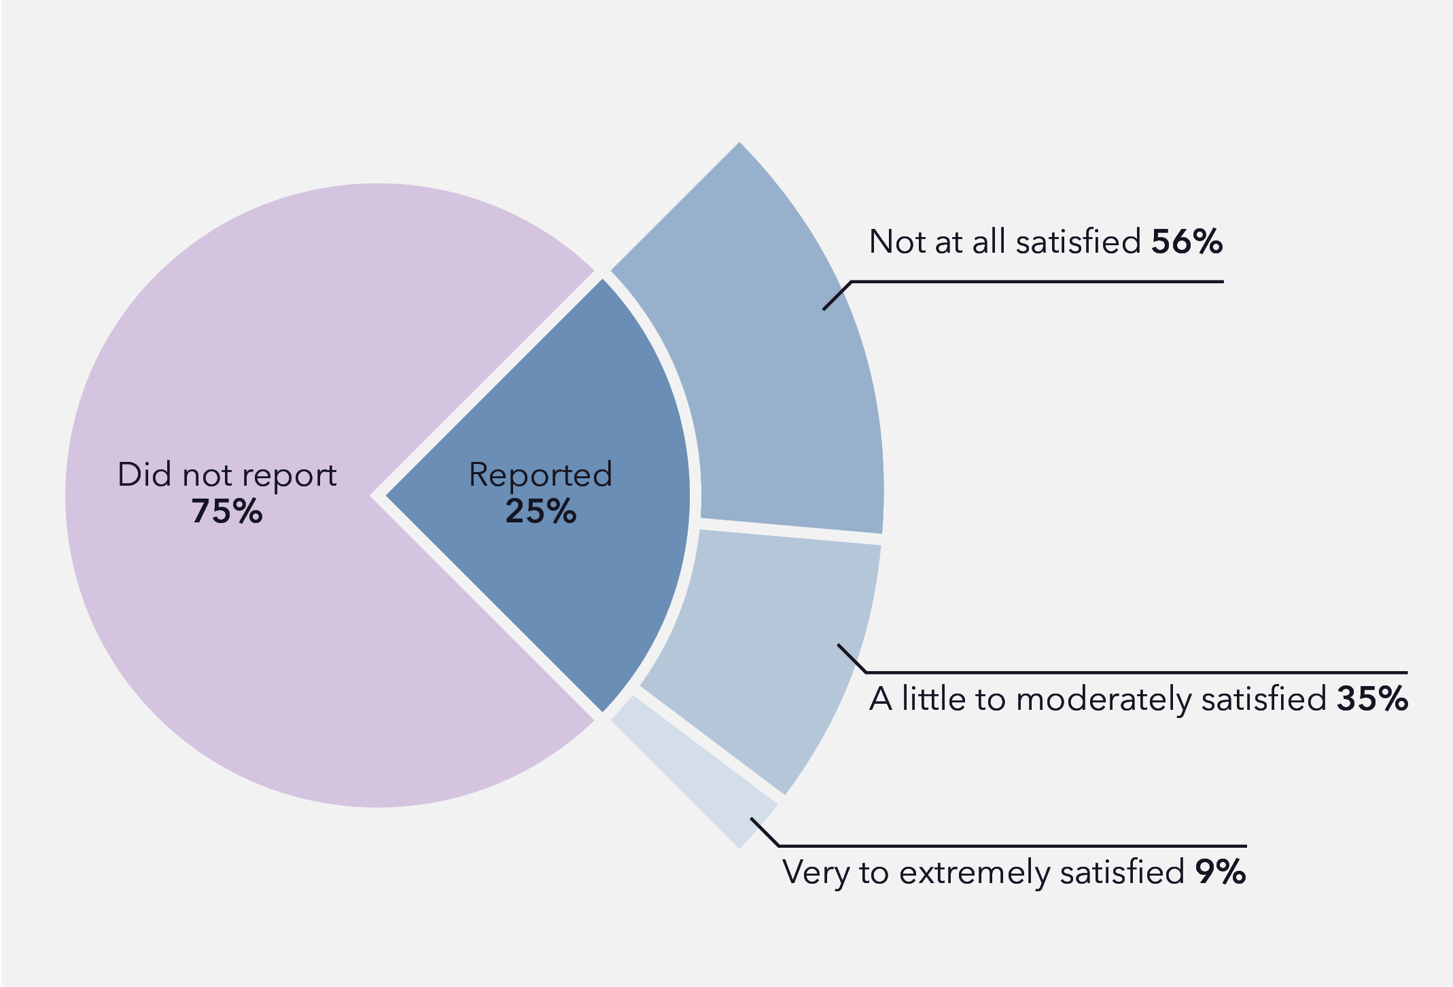
Data table for figure 7.1
Decision to report or not report sexual harassment
Reporting status | Percentage
Did not report | 75%
Reported | 25%
Level of satisfaction following reporting sexual harassment
Level of satisfaction | Percentage
Not at all satisfied | 56%
A little to moderately satisfied | 35%
Very to extremely satisfied | 9%

These low reporting and support-seeking rates contrast with participants’ knowledge and self-efficacy: 45% of all survey participants indicated they knew how to make a report or complaint, and 50% knew where to get support. Similarly, 53% of all participants felt able to report WSH, and 52% felt able to seek support. Encouragingly, 87% of participants felt they could support others who might experience WSH.
In open-ended survey responses and interviews, participants described immediate and short-term responses that were diverse and often informal, such as talking to others (e.g. friends and co-workers) about their experiences. These interactions allowed a collective appraisal of the seriousness of the incident and informed the next steps. Later responses to sexual harassment incidents ranged from seeking informal support from friends, family, partners and co-workers, to informal and formal reports to managers or within workplace structures, to seeking professional support from mental health professionals or compensation schemes. Participants identified that later responses (especially around reporting) were shaped by many factors, including knowledge about WSH, the accumulation of cues and responses from themselves (e.g. physical and emotional reactions) and others (e.g. witness responses), personal and workplace factors, and the nature of the harassment incident. It is particularly noteworthy that participants’ LGBTQ and other intersecting identities shaped their decisions and experiences around reporting and support-seeking. Participants who had experienced WSH identified that experiences of reporting and support had been influenced by their age (52%), gender (51%), sexual orientation (28%), illness or disability (18%) and ethnic/cultural background (1%). The different stages of LGBTQ young people’s responses to WSH, as well as the factors shaping these responses, are discussed in subsequent sections.

7.2 In-the-moment responses to workplace sexual harassment
A range of in-the-moment responses were described by participants, including compliance with harassment, deliberate inaction, avoidance, and challenging the perpetrator. Often, participants reported having different in-the-moment responses across different incidents of WSH, reflecting changing personal or contextual factors (such as mental health state, frustration with repeated harassment, or the presence of other co-workers). For example, Nadine described how she “blew up” after repeatedly experiencing and witnessing sexual harassment in her workplace:
This went on for a period of weeks too. So, you kind of stop, it happens, and then you go, “Oh see, it happens again.” Then you start to become a little more fearful and then “Oh, I start to feel really uncomfortable about it” and then you kind of explode. So it’s that build-up of emotion and then that’s kind of happened.
(Nadine, pansexual cis woman, roster analyst, aged 26)
Some participants “played along” with the perpetrator of WSH, especially when this harassment was normalised or not recognised as inappropriate by perpetrators and witnesses. For example, participants reported that they would “just answer the question” (Omar, personality-attracted non-binary trans man, occupation unknown, aged 20) when questioned intrusively about their sex lives and bodies, or “laugh it off or let it go” (Survey participant, bisexual cis woman, aged 23) or “play along” (Nadine, pansexual cis woman, roster analyst, aged 26) when co-workers passed off offensive queerphobic jokes as banter. Key reasons for using this strategy were professional and social pressures, including anticipating adverse consequences from colleagues or customers, such as losing a job, losing customers or business, or compromising a collegial environment. Amanda and Tyler described how they played along with the perpetrators:

I think the hard thing about, especially in the workplace is that you want to build rapport with your colleagues, and so you let those jokes slide, but at what cost? We’re trying to have really good workplace relationships, but the cost is that you let … slightly gross behaviour slide, slightly gross jokes that then become really, really gross jokes and really, really gross behaviours.
(Amanda, bisexual cis woman, UX designer, aged 28)

It completely came out of the blue, I wasn’t expecting those [intrusive] questions, that scenario, nothing about that at all. I really didn’t know how to handle it at the time, because I guess I’ve never really been included in men’s locker room, grotty talk before, because obviously I then socialised as a woman, I’m a trans guy, I’ve never been included in that … so I just answered the questions with as little detail as I could, while still participating I suppose.
(Tyler, bisexual trans man, customer service officer, AGED 20)
For Hazel, a 24-year-old pansexual cis woman, the pressure to “play along” was compounded by norms within her workplace, where “most of the female waitresses and front of house staff kind of knew just to banter with him [the perpetrator] for the sake of it because it was easier”. Other participants described answering intrusive questions about LGBTQ bodies and identities out of responsibility “to contribute to the education of others” (Rory, queer non-binary masculine person, fast food worker, aged 21), or accepting unwanted sexual or romantic advances for fear of retaliation if they were to reject the perpetrator. However, playing along with sexual harassment was emotionally difficult or uncomfortable, sometimes resulting in participants feeling that they were “participating in [their] own sexual harassment” (Hazel, pansexual cis woman, barista, social work student, aged 24).
Deliberate inaction was another common response to a range of different workplace sexual harassment behaviours. Participants described how they would “remain silent and [not] say anything at all” (Lily, queer cis woman, community services worker, aged 27) or “pretend it wasn’t happening” (Survey participant, pansexual transmasc person, aged 26). In the face of repeated, frequent sexual harassment, where confronting or reporting all incidents would be effortful and time-consuming, participants like Nadine reported choosing to “put up with it every day” saying, “It’s comments, it’s advances, it’s the whole thing” (Pansexual cis woman, roster analyst, aged 26). In some cases, inaction had similar motivations to compliance (discussed above) – the fear of provoking the harasser further, or an attempt to prevent further harassment. One gay/lesbian fem-leaning survey participant, aged 20, explained she would “pointedly ignore him [the perpetrator] at points so he’d leave me alone”. Potential work-related negative consequences also prevented some participants from speaking up:
You don’t want to do anything to impact your relationships with your co-workers. You don’t want to do anything to impact your shifts. You don’t want to do anything to impact whether or not you’re going to be employed by this company.
(Charlie, queer non-binary person, not-for-profit program facilitator, aged 22)
By contrast, other participants chose inaction because of apparent workplace benefits. The benefits may be financial, such as a workplace “paying me enough to put up with it” (Zoe, queer cis woman, research assistant, aged 25); offering flexible work hours; or being accepting of “tattoos and dyed hair and piercings” (Tyler, bisexual trans man, customer service officer, aged 20), whereas finding another workplace would mean compromising on these factors.
LGBTQ young people who had faced previous or repeated/ongoing harassment often employed avoidance strategies to reduce the likelihood of being victimised again, or of experiencing escalations of their harassment. For example, where possible, participants strategically avoided their harassers or the locations where harassment would typically occur. For online WSH, some participants “just blocked [perpetrators] on all [their] social media and moved on” (Survey participant, queer non-binary person, aged 18). One participant described how avoidance became defensive behaviour for him, stating, “I must reiterate I carried a weapon in the parking lot because I was scared he [the perpetrator] would assault me” (Survey participant, pansexual binary transgender male, aged 26).
When faced with sexualised, homophobic/biphobic and transphobic comments, jokes and questions, some participants would rebuke or challenge perpetrators. These direct challenges sometimes involved participants giving a “repeated and firm” statement of disinterest (Survey participant, queer non-binary person, aged 20); explanations that the “question was uncomfortable” (Survey participant, pansexual demi male, aged 16); or more robust challenges, such as telling perpetrators to “fuck off” (Survey participant, bisexual non-binary female-aligned person, aged 23). The strategies used to rebuke or challenge questions often differed according to “whether or not I have the mental energy” (Rory, queer non-binary masculine person, fast food worker, aged 21) or “depending [on] how upset” a joke or question made them feel (Lucy, lesbian cis woman, teacher, aged 25). Incorporation of humour into challenges of sexualised, homophobic/biphobic and transphobic comments was reported by several participants, including “roasting” perpetrators. Zoe intentionally used humour to challenge her perpetrator, saying:
I’ll joke about the exact location of where HR is or something like that and he seems to back off a bit. I’ll just be like, “Oh, do you want to take a walk down to building [number]? Go visit our buddies, HR.”
(Zoe, queer cis woman, research assistant, aged 25)
The outcomes of these in-the-moment responses were sometimes positive, as some harassers considered their behaviours when participants challenged their behaviour. Dylan reported that co-workers who had asked him intrusive questions subsequently apologised, saying they “didn’t mean to offend” but that they were “just really curious”, to which Dylan would say, “It’s fine. I’m just not comfortable answering that” (Dylan, a pansexual/demisexual non-binary transmasc person, peer education officer for LGBTQIA+ young people, aged 22). However, confronting these behaviours could also lead directly to escalating or continuing harassment. For instance, Mia described the time following her rejection of her boss’s advances as “absolute hell” due to multiple instances of retaliation wherein the boss targeted Mia’s medical condition to result in severe physical harm (Mia, gay/lesbian cis woman, unemployed, aged 29).

7.3 Support-seeking and reporting: Disclosure of workplace sexual harassment experiences
Following the immediate response/s to WSH, LGBTQ young people were faced with further decisions, namely whether to speak to others about their experience and/or make a formal report. For many participants who described speaking to others about their experiences of WSH, it was not always clear whether these conversations were about support-seeking, reporting the incident, or part of a broader conversation about workplace experiences (e.g. discussing impressions of a co-worker). For example, Amanda described how a casual conversation with a co-worker led to the realisation that they were being harassed by the same manager, which they then reported:

A week later, at my workplace, the girl who sat next to me was like … “Oh, [manager] is so annoying. He keeps messaging me on Instagram.” I was like, “Oh, what’s going on?” She goes, “He keeps flirting with me and asking inappropriate questions.” I was like, “Oh, you wouldn’t believe it. He did the exact same thing with me.” We shared our messages, and we were like, “Oh, this is so inappropriate.” … We were like, okay, well, we’ve got to band together. We’re going to take it to our manager, who’s a woman, and we’re like, “We need this to not happen.”
(Amanda, bisexual cis woman, UX designer, aged 28)
Support-seeking and reporting were often intertwined, with some participants describing an inability to seek formal support within their workplace as they had not made an internal report. In contrast, other participants credited the support they received from others as integral to their decision to lodge a formal report. Generally, there was no linear progression from seeking support to making a formal report. Moreover, both support-seeking and reporting processes were complicated in instances of harassment targeting LGBTQ identities, as this typically required the young people targeted to both disclose and feel safe to discuss their identities:
I didn’t feel comfortable discussing those types of issues [i.e. sexual harassment] with my co-workers as it was relatively clear that they weren’t particularly tuned in to LGBTQIA+ issues, and it didn’t feel serious enough for police action.
(Survey participant, queer gender diverse person, aged 19)
The complexities of how participants followed up their experiences of WSH are further explored in the following sections about barriers to support-seeking, informal reporting and lodging a formal report.

7.3.1 Reasons LGBTQ young people may not seek support
The most common reason participants did not seek support was because they did not perceive the event as serious enough to warrant support or felt they were coping without it. Among other responses, participants indicated that they “know how to handle these kinds of things” (Survey participant, pansexual binary transgender male, aged 26) and “just dealt with it” (Frankie, pansexual cis woman, console operator, aged 24). Others seemed to downplay the severity of the situation, and by extension, the appropriateness of support-seeking, stating that they “didn’t consider it to be a traumatic experience” (Survey participant, pansexual cis woman, aged 24) or that “it seemed trivial and like I was being overdramatic” (Survey participant, asexual cis woman, aged 23). However, one survey respondent since reflected that “it is so easy to think [WSH] is something you just have to grit your teeth and get past, but it has long-lasting consequences” (Survey participant, queer cis woman, aged 26), with others echoing that even these “trivial” incidents could have an unexpected or cumulative impact which meant they could benefit from support. Participants further reported that emotions such as embarrassment, shame and fear as well as feelings of invalidation prevented them from disclosing their experiences to others and seeking support. As one survey participant commented: “It’s hard to talk about, and I don’t always feel my experience was valid or real” (Survey participant, lesbian cis woman, aged 23). A lack of time, energy and money also impeded participants from seeking support (especially professional therapeutic support), particularly when they were already “very overworked … and very, very stressed” about the incident (Johanna, bisexual cis woman, tutor, student, aged 28).

7.3.2 Seeking informal support and informal reporting of sexual harassment: The importance of validation
Seeking support for experiences of WSH necessarily involves the disclosure of these experiences to others, both internal and external to the workplace. This involved many considerations, as outlined by Ramsey:
If I experienced something at work, there are a bunch of different decisions that I would make. One would be, do I want to share this? One would be, if I do want to share this, what do I want to happen? Who would I share this with? Who would I not share this with? I think there are a bunch of different questions I would ask myself and then make decisions depending on what the answers are.
(Ramsey, queer gender nonconforming person, aged 24)
When participants did disclose their experiences of WSH, the types of support that they received can be categorised as emotional and practical support, detailed in the subsections below.

Emotional support
A prevalent form of informal support was the emotional validation and care from others inside and outside the workplace. Participants often received emotional support from multiple sources, including co-workers, partners, family members, friends, pets and occasionally mental health professionals. Emotional care from people outside the workplace was particularly important for participants who could not seek support or make a report within their workplace. For example, one survey participant reported that they “don‘t necessarily feel that my workplace support options would understand my concerns as a queer trans person” (Survey participant, queer non-binary person, aged 24), while another participant stated, “If your harasser is your employer of a small business? Where would you go for support then?” (Survey participant, gay/lesbian non-binary person, aged 17). Participants noted that other LGBTQ people were able to provide more resounding empathic support, as Evan identified:
It’s really nice … I mean, it’s not nice, it’s upsetting, but when you meet other trans people or even other queer people, and they’re like, “Yeah, happened to me.” And you’re like, “Yeah, it sucks,” because there is that nice thing of knowing other trans people and being like, yeah, we experience the same thing, and that community really comes together
(Evan, lesbian non-binary person, logistics assistant, aged 20)
Comparatively, the expertise of external support people enabled some participants to make informed choices about their next steps, including Ava (lesbian transgender woman, office coordinator, aged 25), whose friend worked in a legal profession and was able to advise that “you don’t have to listen to any of the people telling you [to report the incident], regardless of who it is”. Participants sometimes sought support from mental health professionals (time and money permitting), with some participants saying this was helpful, whereas others found it difficult to initiate conversations about WSH with these professionals.
Perhaps the most critical part of emotional support was when others agreed the incident had been gross, inappropriate, “fucked” or uncomfortable, allowing participants to “feel validated in [their] discomfort” (Survey participant, lesbian cis woman, aged 26). Many participants’ positive feelings about the support centred on their experiences being validated: “It was overwhelming to be affirmed; to me, it felt like enough support to have someone tell me that what I had experienced was awful and not okay” (Survey participant, queer non-binary person, aged 22).
Peer validation is critical as many participants reported that they had not considered their experiences of sexualised and queerphobic intrusive questions, comments and jokes to constitute WSH, indicating a social component to the recognition of these behaviours.
Conversely, some LGBTQ young people reported that co-workers disbelieved the severity of intrusive questions regarding queer identities, invalidating their experiences and blocking them from receiving support:
Some of the concerns I expressed were shunned. Stuff like I don’t particularly want to answer questions from people that I don’t know. Their response to that was, “But if somebody’s asking you a question, shouldn’t you answer?” My response to that was, “Not if it’s about my personal life.”
(Lisa, pansexual cis woman, digital marketer, aged 23)
When LGBTQ young people’s disclosure of WSH was taken seriously, validation from co-workers was of particular importance for the young person’s continuation in that workplace. Specifically, this facilitated solidarity with others who had been similarly harassed and set up an environment where practical support could be implemented to manage ongoing instances of WSH.

Practical support
Disclosure of harassment experiences sometimes allowed workplaces to provide practical support to LGBTQ young people. These workplaces organised to protect LGBTQ young people from WSH – although it is notable that this often consisted of more junior employees stepping in to support each other rather than employers or managers using their power to effect change. For example, Ramsey described how all their co-workers in their retail workplace acted as a “well-oiled machine” to intercept harassers and provide emotional support:
There was a lot of support from people who were experiencing the same thing, people who were in the same job as me … there wasn’t actually that much that we felt we could do to stop it from happening, but just having people there who understood how you were feeling was really helpful … We would all kind of have a mental roster of who felt comfortable working with who, and if we saw that person come in, we would go and serve them if we felt comfortable serving … It was just us offering to help out where we could … Just being there and taking the worst parts of people’s day off their hands would be what we did, and it was really helpful.
(Ramsey, queer gender nonconforming person, disability advocate, ageD 24)
Practical support also extended beyond the physical workspace. Namely, when participants were concerned for their safety on their way to or from work, they would call on friends and family who “helped walk [them] home some nights” when things “didn’t feel right, call it a gut feeling” (Survey participant, pansexual cis woman, aged 23).
However, some LGBTQ young people reported that they received unhelpful or impractical advice when they disclosed experiences of WSH. The advice was considered unhelpful when it did not address someone’s specific needs – for example, being advised to leave a workplace when “at the time [I] didn’t feel like I was in a financial position to do so” (Survey participant, queer cisgender woman, aged 24), or conversely being “sympathised with but told not to quit my job as I get paid well and given perks” (Survey participant, pansexual cis woman, aged 15). The unhelpfulness of practical advice would often undermine emotional support, as pointed out by a queer AFAB non-binary survey participant, aged 24, who received a “mixture of empathy and validation”, but this was undermined by “a ‘well there’s nothing we can do’ attitude” from others. Notably, the practical support received by LGBTQ young people was limited in two key ways. Participants often did not receive support from people in their workplace who had the power (e.g. seniority) to take effective action to prevent or address WSH; instead, they had to rely on similarly aged friends, partners and co-workers, who were often not well-placed to protect them or give useful advice.

7.4 Barriers to making a formal report of sexual harassment in the workplace
LGBTQ young people who intended to report WSH formally often faced multiple barriers and found that the process was not straightforward. Overall, participants progressed through steps toward reporting, from identifying the behaviours as WSH to practical elements of lodging the report. Underpinning the reporting process was the participants’ trust in the institutional systems to acknowledge the incident, take it seriously, and manage it appropriately. A lack of trust in the systems could disrupt participants’ decision to lodge a formal report. Furthermore, there were a multitude of personal and structural barriers, including:
- LGBTQ young people’s uncertainty about whether the behaviours experienced were sexual harassment or other forms of harassment (e.g. transphobia or homophobia/biphobia) or bullying
- perceived lack of seriousness of the behaviours
- bias against LGBTQ identities resulting in behaviours not being recognised as sexual harassment
- LGBTQ young people’s age, gender, sexuality, transgender status
and neurodivergence
- lack of reporting pathways in organisations, or lack of awareness of such pathways if they existed
- fears of transphobia, homophobia and biphobia
- fears of losing one’s job
- fears of being ostracised by co-workers
- anti-LGBTQ workplace cultures.
The following discussion explores these barriers in more detail.

7.4.1 Identifying workplace sexual harassment: Is it sexual harassment?
A key barrier that LGBTQ young people faced in reporting their experiences was the uncertainty in identifying WSH, for both themselves and others. In some cases, this uncertainty was related to the complex nature of sexual harassment, as a queer transmasculine demiboy, aged 28, noted in a survey response: “At the time I’d still convinced myself I was ‘consenting’ to everything that happened.” The recognition of WSH was more difficult for instances of queer-specific WSH, such as sexualised questions, comments and jokes regarding LGBTQ identities. Some participants understood their experiences as other forms of harassment, for example, homophobic, transphobic or biphobic harassment, or for Johanna, something she “framed as bullying” (Bisexual cis woman, aged 28). Not identifying incidents as WSH was a commonly cited reason that participants did not formally report their experiences. Framing sexual harassment experiences as bullying rather than appropriately identifying their experiences as WSH ensured that participants did not progress with a formal report of WSH. Indeed, some participants expressed regret that they were unable to identify their experiences as WSH at the time of the incident and thus were unable to lodge a report.

7.4.2 Appraisal of sexual harassment as serious enough to report
LGBTQ young people evaluated whether their experiences of WSH were severe enough or worthy enough to lodge a formal report. In some cases, participants categorically stated that they “didn’t think it was serious enough” (Survey participant, gay/lesbian cisgender woman, aged 19). Participants further reported questioning whether their “experience was valid or real” (Survey participant, gay/lesbian cis woman, aged 23) or “didn’t think [the harassment] was intended with any malice” (Survey participant, bisexual trans man, aged 22). Participants often linked their own characteristics, such as age, gender, sexuality, transgender status and neurodivergence, to the appraisal of reported incidents by other staff. For example, participants’ young age was described as “a barrier to seeking advice or reporting to HR” because LGBTQ young people “may be ignored as ‘overly sensitive’ if the HR person is older and of a certain background” (Survey participant, bisexual non-binary female-aligned person, aged 23). Omar explained the intersection of age and queerness preventing trust in reporting:
I think especially being queer makes it a lot more difficult to stand up and say something … then if your manager’s not really taking into account that you’re a young person who doesn’t really know how to speak up for themselves yet, it can make it harder.
(Omar, personality-attracted non-binary trans man, occupation unknown, aged 20)
Other participants distrusted their workplace to appraise their experiences appropriately due to their own LGBTQ identity. A bisexual trans woman survey participant, aged 27, indicated that she anticipated negative stereotypes regarding transgender women, which “meant there was an implicit bias that [she] would have been ‘asking for it’”. A queer trans man, aged 22, also a survey participant, was “worried the police would blame [him] for the incident for being LGBTQ”. Another gay/lesbian non-binary survey participant, aged 28, described how queer-specific sexual harassment might not be appropriately appraised by others:
I’m able to identify it, but reporting it and getting support is hard. I work in a “female” (AFAB) dominate [sic] industry so when I brought an incident up a couple of times it was dismissed due to me being AFAB and the other person being AFAB. It’s almost like it wasn’t believed that another “female” could be causing discomfort for a gay person. I am also masculine presenting, so I find I get unwanted comments often, but it’s dismissed more frequently.
(Survey participant, gay/lesbian non-binary person, aged 28)
Neurodiverse participants reported anticipating that their neurodivergence would make the reporting process difficult. A queer non-binary survey participant, aged 22, said, “Being autistic I find communication difficult, particularly when it involves a subject that I have often been met with resentment, anger and conflict.” Further, Zoe had anticipated that her autism would be used by management to dismiss her report, as she expected management to say, “‘Oh, you can’t trust her. She’s autistic. She’s the one who took it wrong” (Zoe, queer cis woman, research assistant, aged 25).

7.4.3 Reporting pathways: Lack of awareness, non-existent pathways, transphobia, homophobia and biphobia
Many participants said they did not make a formal report due to not knowing how to lodge a report, whom to speak to within the workplace, or policies or systems to report sexual harassment in their workplace being limited and not transparent. According to Ava, workplaces “don’t necessarily have a very clear way of reporting sexual harassment” (Lesbian trans woman, office coordinator, aged 25). Various factors impacted the accessibility of reporting pathways. Many participants cited the size of their workplace as a barrier to effective reporting pathways, both for large and small workplaces. In larger workplaces, reporting structures could be obscured or depersonalised. Smaller workplaces often had limited, no or unclear pathways or structures. A non-binary asexual survey participant, aged 24, indicated they “wouldn’t know who to call or where to start [as the] workplaces do not have HR because they are such small businesses”.
For workplaces that included customer or client interaction, reporting pathways were sometimes ineffective in managing instances of customer- or client-perpetrated WSH. Emily elaborated on this point, saying, “anything that’s customer service–focused or … nursing or aged care, the focus is on the people that you have to look after rather than the staff” (Emily, bisexual cis woman, teacher, aged 29). The specific industry often shaped participants’ perceptions of the effectiveness of reporting pathways or participants’ expectations for how their report would be handled. A participant who was a teacher commented, “With teaching, there is no clear HR, instead it goes through other teachers that are higher up” (Survey participant, bisexual cis woman, aged 28). In the arts industries, a report of sexual harassment was perceived by Danielle to likely result in the sentiment “‘you’re such a square’” (Danielle, gay/lesbian AFAB questioning non-binary person, research assistant, aged 29), indicating that a report would not be taken seriously by supervisors due to the perception that arts workers should be okay with sexualised workplace interactions. Sex workers found reporting particularly difficult due to the stigma of “whorephobia”, as noted by a queer non-binary survey participant aged 25.
Adding complexity to reporting, the perpetrator of WSH was often a person within the reporting pathway or who was connected to individuals responsible for addressing reports of WSH. A pansexual femboy survey participant, aged 20, indicated that under such circumstances, reporting “doesn’t seem like a safe or reasonable choice”. Some participants further expressed the sentiment that “HR exists to support and protect the business, not the employees that work for that business” (Survey participant, lesbian cis woman, aged 26), and that this might be worse when “HR, managers and ‘contact’ people are not understanding or knowledgeable about the LGBTIQ+ community” (Survey participant, queer non-binary person, aged 28).
Finally, LGBTQ young people reported increased difficulty in accessing reporting pathways due to homophobia/biphobia and transphobia. At a practical level, “the forms rarely capture the nature of the behaviour, and [they are] limited to cis-het assumptions and terminology” (Survey participant, queer non-binary person, aged 26). At a cultural level, LGBTQ young people often did not “trust that the organisation has staff who can manage specific lgbtiq+ concerns (while they may be well-intentioned)” (Survey participant, queer non-binary person, aged 28) and believed that supposed “well-meaning transphobia wasn’t going to be addressed by a company that didn’t have a culture equipped to understand it and how to deal with it” (Survey participant, queer homosexual transmasculine person, aged 25).

7.4.4 Lodging a report: A lack of evidence
Participants described frustration that workplace systems were often not designed to prioritise victims and survivors of sexual harassment when lodging reports. A perceived lack of hard evidence of the harassment (especially non-physical harassment) prevented participants from lodging a report. For example, in her photo story, Zoe chose to capture the phone that her boss used to contact and sexually harass her (Figure 7.2), explaining how the inability to prove that the phone calls included harassing comments made it difficult to report them.
Figure 7.2
“… how the phone call feels. And also that kind of lack of evidence that it’s very … strategic.”
(Zoe, queer cis woman, research assistant, aged 25)
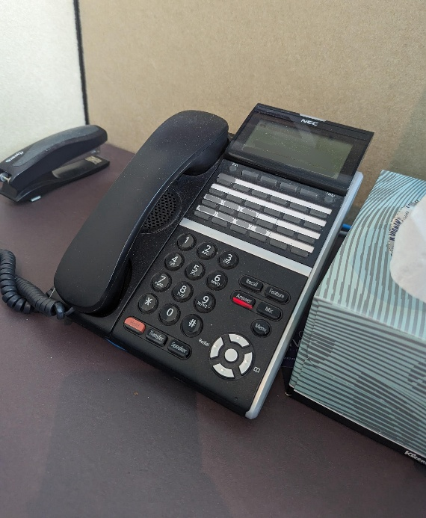
Rory explained that for verbal harassment, “there’s less evidence that they can bring higher up to actually do anything”, and a survey participant further explained that there is a “perception that physical is more serious than verbal” harassment (Queer non-binary masculine person, fast food worker, aged 21). A lack of evidence could thus compound concerns regarding others’ appraisal of the behaviours as sexual harassment. A lack of evidence for transphobic or homophobic forms of sexual harassment might lead to it being less likely to be perceived as a legitimate instance of WSH.

7.4.5 Lodging a report: Confidentiality and being “outed”
Barriers were intensified for LGBTQ young people who felt they could not trust their workplaces to manage their reports respectfully. A critical issue for LGBTQ young people when making a report of WSH is confidentiality concerns, as the details of themselves as queer or as having experienced queer-specific harassment would make them identifiable and potentially open them up to further harassment:
I feared it would come back to the perp, and they would be able to easily identify who reported them based on what they were told and would mean more harassment for myself and/or other people he targets.
(Survey participant, queer non-binary person, aged 24)
Lack of confidentiality made reporting experiences of WSH carry a risk of outing LGBTQ young people in an unsafe work culture. A bisexual non-binary female-aligned survey participant, aged 23, observed that workplaces often presume “you are a straight cisgender person from the get-go” and that this assumption serves as “a barrier [to reporting] because then your professional identity is irrefutably changed if you take action”.
Other participants knew that their supervisors or managers were conservative and outing themselves when making a report “wouldn’t be a great idea” as these managers would see the participants’ queer identity as “undesirable” (Survey participant, gay/lesbian trans woman, aged 20). Indeed, a pansexual cis woman survey participant, aged 26, specifically noted that “fear of discrimination from co-workers” resulting from coming out during a report was the central reason she had not formally reported her experience. Luca further described how reporting queer experiences of workplace sexual harassment would necessarily involve an explanation of their queer identity and the harassment:
I could have contacted HR, for sure, and asked them what to do. But saying it out loud, over the phone, and being like, “Hey.” I would have to come out, again, to be like, “Here’s what happened. It happened because I’m queer,” and I would have to explain it.
(Luca, queer non-binary person, before/after school care educator, aged 23)
Navigating coming out as LGBTQ through the process of reporting was thus an additional burden for participants to shoulder, including the effort of coming out, having to explain why the behaviour constituted sexual harassment, or balancing concerns regarding their future safety in the workplace. Disclosure of LGBTQ identities in the workplace is discussed further in Section 11.

7.4.6 Lodging a report: Hesitations associated with perpetrators’ identities
For LGBTQ young people, the perpetrators of WSH did not always fit the stereotypical profile of a perpetrator as an older man in a position of power, complicating the process of lodging a formal report. A gay cis man, aged 27, who participated in the survey noted that he doubted that “minor harassment by a woman towards a man would be treated very seriously”, and this prevented him from making a report about the harassment.
An integral component of the decision to make a formal report of WSH involved the anticipated consequences of the reporting on the perpetrators, especially if they had a marginalised identity. LGBTQ young people often distrusted that there would be appropriate outcomes for themselves and the perpetrator. Participants occasionally indicated that they had not reported their harassment as they “didn’t want to get [the] co-worker fired” (Survey participant, pansexual transgender man FTM, aged 20). Often, this feeling was informed by the perpetrator’s identity or position in the workplace. A survey participant (T4T non-binary person, aged 21) spoke in depth about the competing obligations that could arise “due to the harasser’s own marginalised identity”. Their perpetrator was a woman of colour who had harassed both the participant and the participant’s partner by asking a series of very transphobic questions and making comments “insisting that trans people are predators”. The participant elaborated:
My partner and I are both white, but the harasser is not. We had the option of going to the police, but decided against it in fear of her facing consequences based on her race rather than what she actually did. Because of the systemic oppression of several marginalised communities, my partner had to put aside their identity and trauma in order to keep their harasser safe … Workplace harassment, or any kind of crime, that is motivated by bigotry is extremely complex, especially when the harasser is not a straight, white, cisgender, able-bodied, rich man. People underestimate the weight of the choices you make when it comes to reporting incidents that happen to you.
(Survey participant, T4T non-binary person, aged 21)

Choices made about reporting sexual harassment are not always straightforward. Making decisions to report can be complicated when experiences do not fit typical scenarios of power relations and when perpetrators are also from marginalised communities resulting in concerns about the potential consequences on these perpetrators.

7.4.7 Lodging a report: Fears of workplace repercussions
LGBTQ young people also refrained from lodging a formal report when they did not trust their workplaces to prevent negative consequences for them. Some participants’ primary concern regarding unwanted outcomes was their workplace social culture. A queer cis woman, aged 30, who responded to the survey explained that “it was ingrained into the culture anyone who complained was ostracised, de[in]centivising anyone else from speaking up about it”. Many LGBTQ young people feared losing their jobs and financial security. Many participants were casual workers at the time of their most impactful experience of WSH, and “casual workers cop it the worst – you can lose your job at any time so you often can’t afford to risk … reporting sexual harassment” (Survey participant, gay/lesbian cis woman, aged 23). Indeed, this fear intensified for LGBTQ young people who may find it difficult to get alternative employment, as a bisexual trans woman survey participant, aged 27, wrote: “I had also been told as a trans woman that I should be grateful for any job I had because ‘not many people are going to hire someone like YOU’.” While not all participants feared losing their jobs or careers, participants also feared consequences such as “being scolded by [their] manager” (Survey participant, aroace transmasculine person, aged 20).

7.4.8 Lodging a report: Continued trauma in the process
The numerous barriers to lodging a formal report of WSH meant that making a report was difficult and required considerable effort for LGBTQ young people. A gay masc trans man survey participant, aged 17, emphasised that the reporting process “can be just as traumatising as getting sexually harassed – especially when they victim-blame”. Nadine spoke about how even though she had written many of the policies and procedures within her company, it was “funny that the person that has written [policies] and continues to manage them doesn’t feel comfortable acting on them” (Nadine, pansexual cis woman, roster analyst, aged 26), indicating that while policies might be in place, they can remain inaccessible due to compounding barriers. Considering the effort required to make a report, many participants felt it was not worth the time as they anticipated no consequences for perpetrators. One queer gender-questioning survey participant, aged 27, said, “I simply did not see it as a good use of my time to seek support that does not have any tangible follow through.”

7.4.9 Lack of trust in workplace reporting systems
At each step of the reporting process, participants’ decision to proceed with or halt a formal report might be affected by their overall trust and confidence in the reporting systems. A lack of trust meant that even when reporting structures were present, they were not always accessible to LGBTQ young people. A 28-year-old queer woman survey participant wrote: “I can report (literally I can send that email), but I also ‘can’t’ report (bc it would just go badly for me …).” The overall workplace culture shaped the trust that LGBTQ young people had in their workplace through reactions from co-workers and other staff members. Participants’ circumstances and personal characteristics further intensified distrust. A gender questioning queer survey participant, aged 27, reported that “the systems might be there in theory, but it rarely helps anyone, especially not a disabled, BIPOC [Black, Indigenous, or person of colour] person in the queer community”. An LGBTQ identity compounded participants’ concerns that their experiences of WSH would not be taken seriously or handled appropriately:
When you are LGBTQ+ at work, you fear not being supported by your co-workers and boss. The reaction [to reporting sexual harassment] could be supportive, or it could be dismissive because they don’t understand why something is hurtful and call it overreaction or “they didn’t mean it”. I feel stuck wondering if I should report it or try to deal with it alone to save from being treated differently.
(Survey participant, bisexual non-binary person, aged 24)
Often, participants would cite previous examples of the mismanagement of WSH complaints and the lack of tangible consequences for perpetrators due to their lack of trust in reporting systems. As noted by a survey participant, the mismanagement of previous reports of WSH discouraged victims from reporting their experiences in the future and may encourage perpetrators to continue harassing:
… especially when we see people be let off the hook time and time again regarding their behaviour. It fosters a distrust in the system, and so people simply stop attempting to use these resources.
(Survey participant, queer non-binary person, aged 21)
The perception that reports of WSH were mismanaged could also contrast with the apparent availability of reporting pathways or policies:
I would like to add that even though a workplace might stipulate the correct reporting pathway to take in a time where you need help; they often do not encourage and harness an organisational culture where it will 1) be taken seriously 2) remain confidential 3) actually act to ensure your wellbeing and safety.
(Survey participant, pansexual cis woman, aged 26)
Overall, making a formal report of WSH was commonly deemed too difficult by LGBTQ young people in comparison to the outcomes they anticipated.

7.5 Outcomes of LGBTQ young people’s sexual harassment reporting
The reports of WSH made by LGBTQ young people were sometimes taken seriously but were often dismissed. With the dismissal, the severity of reports was downplayed, reports were ignored, or no tangible outcomes resulted. When reports were taken seriously, sometimes workplaces responded with limited actions. Only in some cases did participants indicate that they felt appropriate action had been taken in response to their report of WSH, as shown in Figure 7.1 above. In cases where participants felt their report was appropriately actioned, perpetrators faced tangible consequences for their actions, including being “immediately asked to leave for the day, and [the participant] assured he would not be returning” (Survey participant, bisexual cis woman, aged 24). Other positive changes included implementation or updates to workplace training, banning problem customers, and changes to policy.

7.5.1 Dismissal of reports
The dismissal of participants’ reports was sometimes implicit, such as reports being “lost”, ignored or swept under the rug. In other cases, the reports were actively dismissed by managers, supervisors, HR or individuals within the reporting pathways. This dismissal was sometimes justified through victim blaming, and some participants were actively disbelieved or treated like they were paranoid. Further, a survey participant described their manager’s disbelief in their report of WSH:
The same coordinator, when introducing me to a new [client], asked me if I was “going to make up stories about this [client] too”. Who says that kind of thing after a disclosure of harassment?
(Survey participant, pansexual transmasc non-binary person, aged 22)
Other managers dismissed reports by prioritising workplace success over staff safety. A bisexual woman survey participant, aged 18, stated that reports, if made, were commonly dismissed in her workplace because it “was seen as an inconvenience to other staff members due to lack of time”. In other cases, workplaces prioritised customers over staff. An asexual and agender survey participant, aged 20, explained that their managers “shut down the conversation” and said, “[the perpetrators] were high-paying customers, implying they were more important than the safety of the staff”. When the perpetrator was friends with LGBTQ young people’s managers or someone within the reporting pathway, this familiarity increased the likelihood that the report would be dismissed. Lisa recalled that she was made to feel like she was “overstepping” when she reported her experience of sexual harassment to her manager as the manager and perpetrator were “really, really good friends” (Lisa, pansexual cis woman, digital marketer, aged 23).

7.5.2 Consequences for victims and survivors but not perpetrators
Dismissal of LGBTQ young people’s reports of WSH meant there were commonly no consequences for harassers and no changes made in the workplace. In many cases, participants were “not aware of [perpetrators] experiencing any consequences” (Survey participant, gay/lesbian woman, aged 25). Instead, LGBTQ young people themselves often bore the consequences of making a report when that report was dismissed. Participants who reported their experiences of WSH faced various work impacts, including a cut in shifts, being fired, and ostracism. One pansexual woman survey participant, aged 24, said she “was treated like the villain for saying something”. This ostracism impacted participants and often led to them quitting their jobs. Alternatively, participants sometimes reported encouragement to apologise to their perpetrator. One survey participant described how they had been told to apologise and “fix” the situation as the participant’s rejection of sexualised flirting and jokes had hurt the perpetrator’s feelings (Survey participant, bisexual non-binary female-aligned person, aged 23).
Importantly, it was not uncommon for the harassment to escalate or change the initial perpetrator’s behaviour after a report was made (and dismissed). A pansexual binary transgender male survey participant, aged 26, wrote: “After reporting someone for their inappropriate behaviour, the person then filed multiple customer complaints against me to jeopardise my employment.” Other co-workers were reported to join in the harassment of a pansexual cis woman survey participant, aged 26, after she reported her experience of workplace sexual harassment while working at a gym: “All of the trainers involved treated me poorly – threw money at me or verbally harassed me like I was an enemy.”

7.5.3 Poorly actioned reports
Some reports of WSH were taken seriously and actioned appropriately. These reports were investigated by people within the workplace or external bodies such as the police or industry regulation boards. Actioning outcomes sometimes led to meaningful and helpful results, but it was equally common for outcomes to be inconsistently implemented or unhelpful in addressing the behaviour. A clear example of this inconsistency is the changes to working arrangements when the perpetrator was not fired. For example, a gay/lesbian cis woman survey participant, aged 25, “was moved departments to avoid working directly with the harasser”. However, a bisexual cis woman emphasised changes to working arrangements disproportionally impacted her:
I also lost shifts because I asked that I wasn’t rostered on with the man who was harassing me. He got to keep all his normal shifts and my shifts were cut.
(Survey participant, bisexual cis woman, aged 22)
Similarly, perpetrator consequences were inconsistent, including firing the perpetrator, demoting or moving the perpetrator, and reprimanding the perpetrator. When perpetrators were reprimanded or moved, participants indicated that they felt this was insufficient. Even when perpetrators were fired, some participants stated that they were unhappy with how the situation had been handled, due to a lack of consideration for the needs of those who had been sexually harassed:
There was no private place to discuss it, no follow-up [with my wellbeing] after he was fired, and they had a meeting with him then I was in the lunch room where he walked into straight after being fired and I think more should have been done to ensure we didn’t cross paths [in the workplace].
(Survey participant, queer cis woman, AGED 27)

7.5.4 Poorly managed apologies from perpetrators
Participants frequently indicated that their workplace had forced the perpetrator to apologise, but this process was unsatisfactory as this denied participants’ anonymity. As part of the apology process, a few participants were made to feel guilty regarding the consequences perpetrators faced, and sometimes, the harassing behaviour continued after the formal apology. In disregard for LGBTQ young people’s safety, one workplace required the perpetrator to apologise to the victim and survivor (a bisexual cis woman, aged 24 survey respondent), who said: “I was put alone with him in a tiny office.”
Some workplaces made more general changes, such as updates to training, or the implementation of new policies. However, the implementation of new policies was not described by any participants as successfully preventing further harassment. Amanda recalled that her workplace implemented a policy where “no one’s allowed to follow each other online”, but that this only prompted the perpetrator to change his mode of harassment: “… then he harassed me in the lunchroom or made a gross joke. But of course, just not having each other on Instagram solves the problem, right?” (Amanda, bisexual cis woman, UX designer, aged 28)
Dissatisfaction with the outcomes of a formal report also arose in retrospect. Amanda, speaking about her workplace’s minimal changes, said: “I think at the time, we were like, ‘Oh my gosh, this is enough. This is so good.’ In hindsight, there could have been more done.” (Amanda, bisexual cis woman, UX designer, aged 28). As LGBTQ young people reflected on their experiences, spoke to others, and learned more about WSH more broadly, they were able to evaluate their past experiences in a new light and make new judgments about how their reports were handled.

7.6 Chapter summary
Following experiences of WSH, LGBTQ young people often faced further difficulties, such as ongoing harassment, victim blaming, and inadequate responses from management to reports of sexual harassment. In contexts where there was a lack of recognition of queer-specific forms of WSH and its unique impacts on LGBTQ individuals, participants’ in-the-moment responses often focused on maintaining the workplace status quo to ensure they were not vilified for calling out harassment or opening themselves up to further harassment. Consequently, many LGBTQ young people did not trust the systems of reporting within their workplaces. Instead, they preferred to try to address the sexual harassment within their circles of support, such as those developed with co-workers, and/or with friends and family.

Workplace sexual harassment, intersectionality and bonded positions
Apprenticeships, internships and workplace training programs are unique working circumstances due to the bonded nature of the contracts. Specifically, the combination of education and work obligations create additional consequences for individuals seeking to make a complaint or report of WSH or who seek to leave the position. Only a small number (4%) of participants in the current study indicated they were currently in an apprenticeship or in a workplace training program, but of those participants, 78% had experienced WSH. Participants who had experienced WSH while in a bonded position indicated that the nature of their work contract shaped the impact of and their responses to incidents of workplace sexual harassment. A gay cisgender woman, aged 22, who was undertaking training in a male-dominated industry described virulent sexist harassment designed to make the environment too hostile for her to continue her training. As part of this generalised harassment, she also experienced specific incidents of racism, WSH and threats of violence. As part of this continued harassment, she was “illegally told by a random staffer to not return to any [occupational training course] ever and exited from my course and career reputation in tatters”. As a result, she experienced a total “loss of career opportunities and delayed … financial goals” (Survey participant, gay cisgender woman, aged 22).
In another case, a queer cis woman felt pressure to not report her experiences of WSH in order to avoid these negative career impacts. She described having waited to enter vet school her “whole life” and had “made huge sacrifices” to enter the industry. She recalled that upon entering a placement, the owner of the vet practice “asked questions such as ‘How long have you been a homosexual?’ and ‘Have you ever tried dating a boy?’” She outlined her reasons for not reporting this incident:
We are under a lot of pressure to get placements done on time and there are not many options of places to go for some animal types. It can be hard to report workplace harassment, especially when it’s just one week. It feels like reporting it isn’t worth it and might ruin your career … or hurt my chances of finishing my degree on time by complaining.
(Survey participant, queer cis woman, aged 26)
Differing reporting pathways could also make reporting more difficult. A non-binary participant described how they met with other people in their course outside of formal work hours to complete a group project. In this meeting, they were asked intrusive questions about their body, but felt they had “no means to report [this WSH] because it happened outside of work hours” (Survey participant, non-binary person attracted to women, aged 26).
Even when participants’ careers had not been directly impacted, workplace sexual harassment could leave a lasting impression, as this was often participants’ first experience of employment. A 16-year-old transmasculine participant expressed that upon entering workplace training they were “so excited” because the supervisors made them feel “welcome and safe” by enabling the participant to fix their name tag and display their pronouns. However, another trainee made overt sexual comments about the participants’ body, saying “nice rack”. This incident was particularly impactful for this young participant due to their initial excitement at the apparent safety and trans inclusivity of the workplace, but after the incident they said, “I was quickly reminded that I’m never truly safe. I don’t know if I ever will be.”

Chapter 8
Impacts of workplace sexual harassment on LGBTQ young people

8.1 Introduction
Incidents of WSH could permeate every aspect of LGBTQ young people’s work and personal lives. At work, half of the participants (51%) experienced an impact on their employment or career following an experience of WSH, with 22% of participants experiencing a financial impact of WSH. By far, the greatest impact was on participants’ mental health, with 80% of LGBTQ young victims and survivors experiencing a negative impact on their mental health. Compounding this general impact on their mental health, three quarters (75%) of victims and survivors indicated that their self-esteem had been negatively impacted.
Alongside the impact on their mental health, participants described LGBTQ-related impacts. Participants experienced feelings of distress and disgust related to their LGBTQ identity being the target of sexual harassment. Incidents that targeted LGBTQ young people’s identities could be particularly hurtful, as noted by Luca:
Things being said about my gender [are] more hurtful, in that I’ve shared something vulnerable about myself, and I’m making myself a target. And then, for it to be like, “Actually yeah, I’m going to take that and I’m going to hurt you about it.”
(Luca, queer non-binary person, before/after school care educator, aged 23)
However, even when participants’ LGBTQ identities were not the direct target of harassment, for example in incidents of harassment where the perpetrator incorrectly assumed the victims and survivors were women, participants experienced impacts on their sense of LGBTQ identity. Overall, 40% of participants had indicated that their experience of WSH had impacted their feelings regarding their LGBTQ identity in some manner. This chapter will outline the major aspects of the impacts of WSH, including work-related impacts, mental and physical health impacts, LGBTQ identity impacts, and specific impacts when the perpetrator was a woman or another LGBTQ person.

8.2 Work-related impacts
Incidents of WSH impacted LGBTQ young people’s day-to-day work experiences and overall career. Many participants acted following their experience of WSH, which resulted in adverse work outcomes. For example, a pansexual cis woman survey participant, aged 26, explained that she would avoid taking shifts that coincided with the perpetrators’ shifts, resulting in financial stress, and changing how she was “viewed as reliable”. Similarly, a queer non-binary survey participant, aged 16, felt that because they reported the perpetrator, “moving up in the workplace has been made extremely hard/ impossible because [they are] not seen as a ‘team player’”. LGBTQ young people’s day-to-day work experiences could involve feeling “generally on edge and unsafe at work” (Survey participant, gay/lesbian non-binary person, aged 18). A bisexual non-binary survey participant, aged 26, explained that an incident of WSH made them “feel quite vulnerable” and “was partially why [they] quit that job”. In some cases, the “incident changed the way [the participant] dress[ed] at work” (Survey participant, queer cis woman, aged 29) to direct attention away from themselves.
LGBTQ young people also reported damage to relationships with co-workers, as their experience of WSH “dampened … comfort around other male employees” (Survey participant, bisexual androgynous woman, aged 24). A bisexual non-binary female-aligned person, aged 23, described why they avoid interactions with male co-workers: “because I don’t want to be perceived as letting it happen again/being at fault”. Some of the impacts of WSH extended beyond the workplace. One bisexual trans man, aged 26, explained how the harassment resulted in a general distrust in men:
I have completely sworn away [from] men after this incident. Even as a “man” myself, I no longer feel I can entrust my safety and emotional wellbeing to a cis man because of these experiences.
(Survey participant, bisexual trans man, aged 26)
Experiences of WSH that had directly targeted individuals’ queerness frequently impacted how “out” participants were in the workplace, with over half (57%) indicating a change in their “outness” following their experience of harassment. A few of these participants reported becoming more “out”, for example, as a strategy to avoid further harassment. As outlined by a queer gender-questioning survey participant, aged 30, this increased outness could involve being “almost obnoxiously queer from the beginning so they can decide whether or not having a queer … worker works for them”. Alternatively, participants indicated they intended to be more out as queer at work “in hopes it will avoid male staff members pursuing [them] sexually” (Survey participant, queer non-binary person, aged 22).
However, the more common response was to become more selective about disclosing LGBTQ identities. A lesbian cis woman explained the personal emotional impact of harassment and the corresponding change in her overall outness:
Made me feel like I have to shrink myself and be smaller and keep my queerness to myself to protect myself. This feels like hiding an enormous, core part of my identity and personhood, so I felt constantly anxious, subdued, and distressed.
(Survey participant, lesbian cis woman, aged 26)
While this lesbian participant remained closeted due to the emotions induced by harassment, another non-binary participant described a change in their attitudes towards others that resulted in a decision not to come out:
It feels like LGBTQ people are treated like a plaything for people, predominantly males, to use for their own self gain while not caring about how it affects us. This has made me try to conceal my sexuality to anyone I don’t know and trust.
(Survey participant, bisexual non-binary person, aged 19)
Experiencing forms of WSH targeting LGBTQ identities further made some participants broadly distrustful of others regarding potential queerphobia, frequently being “on edge” around people who they “don’t know well enough to judge how LGBT-friendly they are” (Survey participant, bisexual agender, aged 25). As observed by a bisexual cis woman survey participant, aged 21, these perpetrators may be “fine at home but as soon as they get to work, they just become transphobic, homophobic misogynists”. This distrust, in part, influenced many participants’ decisions to come out as LGBTQ only to those in their workplace who they had carefully assessed as being accepting of LGBTQ identities and communities.

8.3 Mental and physical health impacts
There was a discrepancy between LGBTQ young people’s perception of their most impactful incident of workplace sexual harassment and its impacts. Only a relatively small proportion of participants (17%) perceived their most impactful incident of WSH as very or extremely severe. However, a high proportion of participants reported feeling very or extremely intimidated by this incident (42%). This high level of intimidation demonstrated no differences across gender identities and sexualities. Many participants also reported serious impact on their health and wellbeing. 80% of participants indicated that their mental health had been impacted by WSH. Participants’ distress levels at the time of survey completion were elevated among participants who had previously experienced WSH compared to participants who had not (t[599] = -2.54, p = .011). Overall, these figures indicate that even when not severe, their most significant experience of WSH made LGBTQ young people feel very intimidated and negatively impacted their mental health and wellbeing.
When asked to write about the ways that WSH had impacted their lives, LGBTQ young people described impacts which ranged from lower-level distress, such as “mostly just felt annoyed and frustrated” (Survey participant, bisexual trans woman, aged 28), through to intense distress and suicidality: “I almost tried to kill myself over this, as I didn’t see any other way out” (Survey participant, queer transmasculine, aged 22). LGBTQ young people were specific in the emotions they grappled with following their experiences of WSH, often describing disgust, shame, and feelings of violation and objectification. Participants noted they felt “powerless” and had ongoing “fear of retaliation” (Survey participant, bisexual cis woman, aged 28). These emotions also impacted participants’ relationships with others, as “even close friends are affected by how irritable” participants felt (Survey participant, asexual transmasculine person, aged 16). Several participants noted that sexual harassment (both in and out of the workplace) was chronic in their lives, with the resultant distress linked more to the chronic nature of harassment rather than individual incidents. A bisexual trans man survey participant, aged 22, said of his experience of WSH:
Honestly it just makes me tired. It’ll never stop and it reminds me every time that to a large amount of the population I am at best a weird curiosity and at worst a disgusting freak. Not exactly lovely for my mental health and self-esteem.
(Survey participant, bisexual trans man, aged 22)
A queer transmasculine demiboy also linked facing ongoing WSH to feelings of poor self-esteem, saying: “It’s so hard to stay feeling full of worth when you feel uncomfortable at work … every day.” The complexity of these impacts was further noted by this participant, who said:
It’s kind of difficult to quantify exactly how much of an effect these experiences are still having on my current mental health, but it’s still something I think about semi-regularly and is undoubtedly having at least some form of ongoing impact.
(Survey participant, queer transmasculine demiboy, aged 28)
42% of LGBTQ young people also experienced impacts on their physical health and wellbeing. Some of this impact was the onset or intensification of distress-induced medical conditions, whereas other participants also experienced direct physical impacts from workplace sexual assault: “He gave me an STD, and I had to terminate a pregnancy. It ruined my life” (Survey participant, lesbian cis woman, aged 29). Other participants described how their experiences of sexual harassment had contributed to the onset or intensification of chronic physical health conditions, including a generalised “disconnection to your body” (Survey participant, lesbian cis woman, aged 28).

8.4 LGBTQ identity impacts: Intimate relationships and gender dysphoria
Crucially, 40% of participants had indicated that their experience of WSH had impacted their feelings regarding their LGBTQ identity in some manner. Some participants indicated that this impact was profoundly negative, making them feel “gross for not being cis and straight” (Survey participant, bisexual non-binary person, aged 20); making them “feel like a circus animal” (Survey participant, queer transmasculine person, aged 25); and “reinforc[ing] … that perception that being gay or otherwise gender nonconforming was inappropriate” (Survey participant, lesbian cis woman, aged 19). LGBTQ identity-related impacts were also not limited to the workplace, as participants described feeling “berated and unable to accept [their] identity all over again” (Survey participant, bisexual cis woman, aged 23), with one bisexual cis woman, aged 19, saying: “They made me very insecure about my sexual orientation and my public displays of affection to my girlfriend” (survey response). Some participants indicated how the impact of WSH also extended into their close and intimate relationships, such as a “reduced ability to have and enjoy healthy sex” that impacted their overall quality of life (Survey participant, queer asexual trans non-binary person, aged 26).
Non-binary participants and trans men could become targets of WSH as the perpetrator presumed they were a woman. In these incidents of WSH, participants described additional impacts related to being misgendered through harassment, including feeling “misunderstood and dysphoric” (Survey participant, bisexual non-binary person, aged 19). Luca specifically described the gender dysphoria they felt due to being perceived as a woman by perpetrators and therefore harassed:
There’s an added aspect of gender dysphoria to the harassment that I received, that is, because I’m perceived as a woman, because are they only doing that because they think I’m a woman, and because of the way that my body looks like a woman’s. And then, I get it all in my head about, agh, the gender. Gender is bad.
(Luca, queer non-binary person, before/after school care educator, aged 23)
This gender dysphoria could then be associated with a more generalised distress:
It also had a psychological impact, especially in the ways I viewed myself and my relationship with my body and gender. I would have a deep visceral reaction when people complimented me when I was female presenting and hated that I couldn’t present more androgynous or masculine due to my body shape.
(Survey participant, pansexual transmasculine non-binary, aged 22)
A women-attracted non-binary person, aged 26, also described the specific psychological impact of this dysphoria within their survey response: “I felt like I hated my body and wanted to harm myself.” Gender dysphoria was also experienced by LGBTQ young people who experienced harassment at a time before realising they were transgender:
It contributed to me spending another 10 years in confused frustration at my gender not working. If I wasn’t exposed to this heterosexual hazing and corrective bullying I might have started exploring my gender earlier and transitioned much earlier.
(Survey participant, gay/lesbian transfem person, aged 27)

8.5 LGBTQ and women perpetrators: Betrayed allyship
For 37 participants, their most impactful experience of WSH was perpetrated by another LGBTQ person. The perpetrators’ LGBTQ identity may have been a factor that made the incident most impactful for participants among everyday sexual harassment from cis heterosexual men. For example, in instances of sexual harassment perpetrated by a gay man toward another gay man, the perpetrators’ sexual identity complicated the impact of the harassment on LGBTQ young people. A gay cis man survey participant, aged 28, who worked as a consultant, recounted his experience of harassment perpetrated by a gay man when the participant had travelled interstate for work:
A senior team member that I had never met before pressured me to enter a long-distance relationship with him, made many unwanted sexual comments, a lot of unwanted physical contact, and a lot of pressure to go back to his house. I regret that I eventually gave in and went to his apartment. While at his house he grabbed me and kissed me, I pushed him off and told him that I did not want that. I left and messaged some friends and colleagues for support.
(Survey participant, gay cis man, aged 28)
This survey participant noted that this perpetrator was a leader in the company’s LGBTQIA+ ally network, and due to this position, the harassment constituted a “gross violation" of trust and was a “betrayal”. This was not the first time this participant had been harassed by more senior gay men in the workplace who had “made it clear they were particularly attracted to young white gay men”. The participant reflected on this pattern of behaviour he had observed:
My experience is that older gay men cross the line. In our queer circles, we love to tease and joke, but we remain professional and care about each other, but it’s the older gay men that take advantage and push too far.
(Survey participant, cis gay man, aged 28)
Indeed, another survey participant, also a gay cis man, aged 29, commented he had made “numerous reports of harassment to management” following harassment from a gay male co-worker, but these reports were disregarded, and this “led to [the participant] being sexually assaulted in the locker room”. The impact of this sexual harassment perpetrated by a gay man was uniquely impactful on this participant’s own experience of sexuality, as the participant said, “It has led me to hesitating about [disclosing or showing] me being gay until I am very comfortable/trust someone in the workplace.”
Incidents of workplace sexual harassment perpetrated by queer women were also difficult for LGBTQ young people to navigate emotionally and responsively. Frankie, a pansexual cis woman, aged 24, who worked as a console operator, described how a female customer who was “very tomboyish and … very openly lesbian” entered the shop and “immediately start[ed] coming onto [Frankie] … and making remarks about [Frankie’s] body”. This incident was troubling for Frankie, who was disappointed as this queer woman was “supposed to be an ally” regarding harassment of women. Alongside the complicated feelings that arose for some participants following instances of WSH perpetrated by queer women, participants were further unsure about appropriate responses. A lesbian cis woman survey participant, aged 22, recalled her experience of WSH, saying:

Most recently, there was a girl who I worked with who I went on one date with and decided it wasn’t for me. I set this boundary clearly, but she continued to make sexual comments and suggest “jokingly” that we hook up during work. She has still not stopped trying to contact me despite not working with me for months and me not replying to her.
(Survey participant, lesbian cis woman, aged 22)
This participant had made the decision not to report ongoing harassment as she did not want to out either herself or the perpetrator as queer due to a homophobic workplace culture.
The overall proportion of female perpetrators of sexual harassment was relatively low, with only 13% of participants who had experienced sexual harassment indicating that the perpetrator was a woman. However, participants described unique challenges in the appropriate responses when the perpetrator was a woman. A survey participant, an omnisexual non-binary person, aged 17, commented that the perpetrator was someone they “trusted and believed that as a woman ... would understand not to touch [them] without consent”, and this trust was broken when this co-worker touched their bottom and called them “a ‘good girl’ for fulfilling normal daily tasks at work”. Comparatively, a bisexual trans man survey participant, aged 16, described feeling embarrassed “as a young man being harassed by an older woman”, noting particularly that this woman would call him “gorgeous” and misgender him.
When a heterosexual cisgender woman perpetrated WSH, this complicated LGBTQ people’s responses to the incident. LGBTQ young people expressed concern that managers and colleagues would support the heterosexual cisgender woman. One bisexual cis woman survey participant, aged 25, explained how co-workers witnessed her experience of WSH at a work social event:
An older female colleague asked inappropriate questions when she found out I was bisexual … She also groped me on one occasion, and she would always find a way to direct the conversation towards something sexual when I was around.
(Survey participant, bisexual cis woman, aged 25)
Following this event, the participant described how they “didn’t want to talk about it too much” because they “didn’t want to be stigmatised as the gay person who complains all the time”. Participants’ fears that LGBTQ young people are perceived as overly sensitive impacted how they appraised whether their experience of WSH was worthy of reporting (see Section 7.4.2 for further discussion). When the perpetrator of harassment was a woman, participants feared that the severity of the incident would be further downplayed, and victims and survivors would be framed as overly sensitive or blamed for the incident themselves. After experiencing sexual harassment from a woman, one survey participant said they “felt ashamed and embarrassed, alienated” (Queer non-binary person, aged 29).

8.6 Chapter summary
The toll that WSH took on LGBTQ young people’s mental and physical wellbeing impacted both their work and personal lives. Anger, fatigue, fear, powerlessness, low self-esteem and suicidality were just some of the ways that participants described the ongoing emotional effects of workplace sexual harassment. Everyday work attendance and tasks became fraught with concerns about facing further sexual harassment, ostracism from co-workers in the event of lodging a report or being outed as LGBTQ, and decisions about whether to change shifts or cease employment.

Chapter 9
Facilitators of workplace sexual harassment

9.1 Introduction
When describing experiences of WSH, participants identified many factors that directly or indirectly facilitated this harassment. Several facilitators are common to non-LGBTQ and older workers’ experiences of sexual harassment – for example, physical workplace structures (e.g. dark or isolated work environments), professional and interpersonal dynamics (e.g. power imbalances associated with workplace hierarchies), and industries (e.g. dynamics related to customer service, teaching or caregiving). However, other factors uniquely or disproportionately affect LGBTQ young people in the workplace. This chapter explores how cisheteronormative infrastructures contribute to harassment of LGBTQ workers (with discussion continued in Chapter 10) and age-related power imbalances, which make young workers vulnerable to harassment. WSH rarely occurs in isolation. Participants identified that some workplaces are characterised by cultures that directly and indirectly promote and perpetuate sexual harassment to the point where it becomes normalised. Identifying facilitators of WSH is vital, as initiatives to prevent or reduce the incidence of harassment must address the systemic dynamics that give rise to these interactions if they are to have an enduring impact.

9.2 Physical facilitators
Participants who had reported experiences of WSH indicated that the incidents occurred most frequently at participants’ workstations (65%). This is a much higher rate than has been reported in the general Australian population, wherein 37% of people who had experienced WSH indicated that it had occurred at their workstation (AHRC, 2022). Fewer participants reported harassment occurring in a work social area (12%) or at a work social event (8%). Correspondingly, 58% of participants indicated there had not been a witness to their harassment, with a further 24% indicating they were unsure if there had been witnesses. A queer cis woman survey participant, aged 27, described where she was harassed: “alone in a quiet basement, where no-one could overhear us, and there are no security cameras to record sound or visuals”. Similarly, Thea emphasised that their workplace design had facilitated harassment while working in retail. The shop windows allowed a stalker to watch her, and the car park design made her feel “unsafe”, as shown in Figure 9.1.
Figure 9.1
“It’s very sort of sheltered. The car park also doesn’t have lights. The entire environment felt unsafe ... it allowed people to feel more or less they weren’t going to get caught.”
(Thea, lesbian queer [gender] person, aged 24)

* image redacted for safety with participant’s consent

9.3 Cisheteronormative infrastructures
LGBTQ young people were uniquely vulnerable to WSH through organisational infrastructure. Bathrooms are a key part of workplace infrastructure that have become a central point within social discourses about trans rights. Bathrooms were a fraught physical space for trans young people who had been “cornered by another employee in the bathroom and questioned” (Survey participant, non-binary person, T4T, aged 21, speaking about their trans partner). Ava, a lesbian transgender woman, aged 25, described her experience of cleaning bathrooms as a work task:
Outside of the workplace, I use all gender toilets if they’re available, but part of my job at work is that we have to go and clean the bathrooms and … females clean the female toilet, males clean the male toilet … I’ve also had someone try and stop me from going into the woman’s bathroom when I was just going in to clean because they thought I was a man walking in.
(Ava, lesbian trans woman, office coordinator, aged 25)
Here, the nature of the physical space and work tasks given to trans participants placed them at risk of harassment or being seen as a predator (see Section 6.5).
The cisheteronormativity present in physical infrastructures further extended to technological infrastructures, where invisible biases emerged when LGBTQ young people attempted to use these structures. For example, a survey participant recounted how their deadname was spread throughout their workplace due to poor system management, facilitating later harassment:
As I was inducted, I introduced and filled out forms using my correct name, excluding the tax forms, which I made clear to the person present that it is strictly private information, and only those who must know (payroll manager) should be made aware. Next week I’m told the payroll manager couldn’t find the matching name in my timesheet to calculate pay, so the entire company was told my deadname to clear any confusion. I’d then have a few other supervisors continue to allude to the mismatch, including repeatedly saying my deadname out loud where everyone could hear. They still didn’t pay me for that period.
(Survey participant, asexual demigirl, aged 23)
During an interview for security clearance, Alexander, a bisexual trans man, aged 26, who is a lawyer, encountered cisheteronormative infrastructures that facilitated specific harassment during his employment interview. The interview involved questions regarding Alexander’s identity which assumed that queer people “are on the outside of society, are more likely to use drugs, or are more likely to be shifty, engaging [in] risky sex, which means they could be blackmailed by people” and this placed a negative “value judgement” on his queerness. As such, Alexander felt that these interviews provided “a free slip to sexually harass people under the cover of it being necessary to determine whether they’re appropriate people to hold [workplace] secrets”. Further, Alexander emphasised that while individuals “may never see [the interviewer] again … they represent the organisation” and thus create a hostile environment for LGBTQ workers.

9.4 Industry facilitators
The survey data indicated that the proportion of LGBTQ young people who experienced WSH did not significantly vary across industry. Table 9.1 displays the industries that participants were employed in at the time of their most impactful incident of WSH, reflecting the industries in which LGBTQ young people were most likely to be employed. Qualitative responses revealed some specific industry-related work requirements that were unique facilitators of WSH for LGBTQ young people.
Table 9.1: Industry of employment at the time of participants’ most impactful experience of workplace sexual harassment
Industry of employment at time of most impactful workplace sexual harassment incident | % | N = 399
Accommodation and food services | 30.3 | 121
Retail trade | 21.3 | 85
Administration and support services | 12.8 | 51
Health care and social assistance | 11.3 | 45
Professional, scientific and technical services | 6.0 | 24
Education and training | 4.5 | 18
Arts and recreation services | 3.8 | 15
Transport, postal and warehousing | 2.5 | 10
Public administration and safety | 1.3 | 5
Agriculture, forestry and fishing | 1.3 | 5
Construction | 1.0 | 4
Personal services | 0.8 | 3
Other services | 0.8 | 1
Australian Defence Force | 0.3 | 1

9.4.1 Hospitality and service roles
Participants working in service roles, particularly those in retail and hospitality, noted that the dynamics inherent in server–customer interactions often facilitated sexual harassment behaviours – especially in combination with other factors like gender, age and LGBTQ identity. Participants working “in a customer-facing environment” described being expected to fulfil a servile role, feeling “like you always have to smile and be patient, even when the person you are serving is being derogatory and horrible” (Survey participant, bisexual cis woman, aged 29). This dynamic prioritised the needs and desires of customers which, according to survey participants, allowed male customers to “feel they have power over young women in service roles” (Bisexual cis woman, aged 28) and created environments where “harassment and unwanted advances were constant, weekly, even daily, from men of all ages” (Queer non-binary person, aged 30). This was compounded by the action (or inaction) of management, who were reluctant to address customers’ harassment of their staff for fear of impacting their business (also described in Section 7.5.1 responses):
Just about every day of the week, my co-workers will experience sexual comments, gestures, and questions from customers …
it will never stop since putting strict rules in place will prevent the pub from making money (the main demographic is misogynist older men).
(Survey participant, queer non-binary person, aged 19)

My current employer is incredibly blasé about how their retail employees are treated by customers (dismissed as “that’s how
retail is”).
(Survey participant, bisexual transgender male, aged 21)

Ramsey described how their employer actively played into this dynamic by “only seem[ing] to hire women that were conventionally attractive”, a decision which the employer “said was about the customers … the customer service experience that she wanted to create” (Ramsey, queer gender nonconforming person, disability advocate, aged 24). That is, the vulnerability of young women working in customer service was not only a by-product of the service industry but, in some cases, was actively produced. Alongside cisheteronormative and traditionally recognisable sexist harassment, LGBTQ young people also faced queerphobic comments and advances from customers, and in some cases, the workplace directly facilitated this harassment. A lesbian queer woman, aged 24, reported in the survey that, while marketing promotions for events such as Pride Month might work well in some communities, in her company they instead “gave an opening for customers to harass” the participant by calling attention to their queerness in a homophobic environment. This raises implications in terms of the need for organisations to improve workplace safety and inclusion of LGBTQ employees through initiatives that challenge homophobia, biphobia and transphobia in broader communities in which the organisation is located.
Like those in the service industry, participants working in hospitality also described work environments where they frequently experienced and were “expected to cope with harassment from customers as part of the job” (Survey participant, gay/lesbian cis woman, aged 23). However, for many hospitality workers, this was accompanied by a culture enabling workplace sexual harassment among the predominantly male kitchen staff. Hazel, who had worked multiple hospitality jobs, described how:
… that gendered separation [where] front of house is mostly women and back of house is mostly men, I think, causes those spaces where the back of house becomes this kind of boys’ club. And there becomes that kind of locker room banter where inappropriate things are said.
(Hazel, pansexual cis woman, barista, social work student, aged 24)
Several survey participants described how the sexual harassment of young female hospitality workers by male kitchen workers had become “an accepted part of the workplace culture” (Gay/lesbian cis woman, aged 28), and was “often encouraged or perpetrated by managers” (Queer, genderqueer feminine-presenting person, aged 22). In some cases, the expectation and normalisation of sexual harassment between hospitality workers made participants feel that they were complicit in their own harassment, or the harassment of others. Hazel, for example, described how sexual harassment was framed as joking or banter between chefs in her workplace, and reported that “if you didn’t participate in the jokes you are ostracised by the chefs and your job is made more difficult” (Hazel, pansexual cis woman, aged 24). The threat of retaliation for not complying with harassment reportedly pressured Hazel and her female co-workers to learn “the kinds of ways in which they had to behave in order to be treated fairly in that space”. The cumulative potential for harassment by both customers and co-workers in hospitality jobs led one participant to conclude that “it’s dangerous being a young woman in hospitality” (Survey participant, gay/lesbian cis woman, aged 23).

9.4.2 Teaching
For teachers, the potential perpetrators of WSH were principals, co-workers and students. It was reported by participants both in surveys and interviews that some perpetrators of WSH would raise their concerns about students’ exposure to LGBTQ identities, questioning the legitimacy, perpetuating shame among LGBTQ young people. A queer cis woman survey participant described this concern for the students:
I was the first openly out employee at a school with [multiple] campuses which has been operating for [many] years. It’s a … faith-based school with very conservative leaders (CEO and board), so it’s been tricky at times. I was told it was fine for me to be gay but to just not talk about it and maybe don’t mention it to the students. A chaplain also told me it was basically sinning and likened it to swearing.
(Survey participant, queer cis woman, aged 30)
Another survey participant, a bisexual cis woman teacher, aged 29, shared that the “focus on student safety and students not being targeted by paedophiles” could obscure the potential harm of sexual harassment directed toward teachers so that they “don’t feel comfortable when sexual comments are made about them”. Indeed, Christine noted how training would outline “how to avoid things happening for students, and then not necessarily for [teachers]” (Christine, queer cis woman, teacher, aged 24). For example, a lesbian cis woman teacher, survey participant, aged 30, recalled how “a student engraved into the lockers outside [her] classroom ‘gay’ with an arrow pointing to [her] classroom”, but despite feeling unsafe after this incident, she did not seek support due to a sense of pressure to “keep quiet”.
More generally, LGBTQ teachers described how their teaching could open the opportunity for queer-specific forms of WSH. Specifically, teachers are commonly asked “questions refer[ing] to your personal life” (Mei, pansexual trans woman, teacher, aged 22), and teachers can act as an “accidental advocate” for LGBTQ students (Christine, queer cis woman, teacher, aged 24). Christine described how “helping solve problems for students related to their sexuality” could result in “blurring some of the boundaries that [she] otherwise might’ve been able to more firmly hold for [her]self” regarding the appropriateness of questions about her private life. Comparatively, Emily noted that sexualised comments from students was “a way for them [students] to assert power in a way … [as] they don’t really have a lot of power or agency” (Emily, bisexual cis woman, teacher, aged 29).

9.4.3 Caregiving
Participants working in caregiving professions (including health care, aged care and disability support) noted that the physical nature of their work, coupled with the nature of their patients’ conditions, had contributed to their experiences of sexual harassment. For example, participants whose jobs involved physical contact described how this “enables people to push the boundaries a bit more … in a workplace where you can’t touch anyone, it’s a lot harder to break that boundary” (Bailey, queer [sexuality and gender descriptor], working in academia, aged 24). A survey respondent who worked as a disability support worker described a series of incidents that occurred while supporting a teenage boy, whose use of a wheelchair “meant he was more or less level with my bottom and crotch area” which made it easier to grope the participant while they were helping to move and shower him (Pansexual, demisexual transmasculine non-binary person, aged 22). Even when a specific work task did not involve direct physical touch, caregiving roles promoted conversations about the body that could provide opportunities for perpetrators to make queerphobic statements. Lane, a gay non-binary health care worker, aged 26, explained that working as a physiotherapist often necessitated conversations about clients’ bodies with colleagues, and that when speaking about a female client, Lane’s boss once commented “hands off”, implying that the nature of physiotherapy work would enable Lane to “hit on all of [the] patients”.
Compounding the increased opportunity for physical contact associated with care provision, many patients were reported to have cognitive conditions (e.g. dementia, intellectual disability), which meant they “don’t have capacity/understanding [that] what they are doing is wrong” (Survey participant, bisexual cis woman, aged 18). This extended to both traditionally recognisable cisheteronormative and LGBTQ-specific forms of sexual harassment, such as “wild” intrusive questions from aged care residents about “do you have a penis [and] what surgeries have you had” (Survey participant, heterosexual trans man, aged 20). Participants and their employers struggled to enforce consequences for these harassers; one survey respondent, who worked in aged care, described how “working with clients with dementia and other decision-impeding conditions meant that when you were assaulted – which happened regularly – there was little that could be done” (Bisexual genderfluid person, aged 27). Notably, these participants stated that the nature of their patients’ conditions did not excuse their actions – one survey respondent expressed that he was “TIRED of having to be okay with … people be[ing] allowed to get away with staring at my chest and ass and even touching me because they are severely disabled” (Pansexual transgender man, aged 26). Concerningly, participants noted that some of these perpetrators appeared to be using their conditions to “‘excuse’ their behaviour” (Survey participant, pansexual, demisexual transmasculine non-binary person, aged 22). Other survey participants also raised this point:
In my job [aged care], there are a lot of residents, male and female, who say inappropriate things or touch staff inappropriately. Sometimes, it’s dementia (which doesn’t excuse it); sometimes, it’s because they think age can make them get away with it.
(Survey participant, asexual genderfluid person, aged 28)

[Patient/perpetrator] had shown prior knowledge of consent, apparently acts similarly to the female staff at his school, had acknowledged that he can get away with it because he’s disabled and because he couldn’t be stressed before his surgery … when I asked to be rostered with someone else [work coordinator] said no, citing the boy[’]s upcoming heart surgery and that he can’t be in any distress or he wouldn’t be able to have the surgery.
(Survey participant, pansexual, demisexual transmasculine non-binary person, aged 22)
In these instances, participants were forced to compromise between the desire to avoid sexual harassment at work and the felt pressure to provide care for vulnerable patients.

9.4.4 Sex work and sex-adjacent industries
LGBTQ young people who worked in sex or sex-adjacent industries (e.g. in a video shop that also carried X-rated films) reported differing experiences in how the sexualised work environment could facilitate workplace sexual harassment. For some participants, the industry environment seemed to lessen stigma around bodies and queer identities, and they experienced less sexual harassment from co-workers. Frankie described her work as a nude life-model, saying that within the context of the class, students would “respect the model”:
I don’t even think that they even have that sexual filter on when they’re in that art space because they just have art-thinking brain. They turn it off when they’re in that space because you’re just viewing the body as a body.
(Frankie, pansexual cis woman, console operator, aged 24)
For other participants, the nature of the work meant they were isolated and more vulnerable to sexual harassment. Participants described the “icky or inappropriate comments” they would receive from members of the public when working in sex and sex-adjacent industries; in the above case, the work involved “handling X-rated films for customers to rent” (Survey participant, pansexual non-binary person, aged 28). Working in sex-related industries could also be isolating due to the stigma associated with sex work. A queer non-binary survey participant who worked as a sex worker in a brothel described how “it can be quiet [sic] isolating at times when you experience sexual harassment at work” as “people [outside the workplace] aren’t as supportive as they could be”. Indeed, this participant found that “peers have always been the most supportive” (Survey participant, queer non-binary person, aged 25).
A potential explanatory difference in these participants’ experiences may be the presence of members of the public who were not part of the workplace cultural norms. Kendal, a bisexual non-binary person, aged 26, who worked as a receptionist at a pole dance studio, outlined the difference between the positive workplace culture among co-workers and dance students and the sexual harassment they experienced from people outside of the workplace:
It’s also a pole dance studio run by sex workers, and I loved that atmosphere. I’m not a sex worker myself, but I have a lot of friends who are. I consider myself and try to be a big sex work ally … I would frequently wear a skirt with a mesh bodysuit and just pasties, and that would be my work outfit, or in summer, a bra and a pair of pants, a nice lingerie bra … That was one of the perks of the job for me … It did lead to the harassment. It was never colleagues, never students, never anyone actually involved in the workplace. I think partially, that’s because 95% of the people employed were women. The other 5% were non-binary. I would say probably 80% of our clientele were femme, and I always felt very safe inside. But the moment you go outside, a whole different world, a whole different world. Staring at, catcalling, sweared at. That one happened multiple times.
(Kendal, bisexual non-binary person, pole dance studio receptionist and medical receptionist, aged 26)
Interestingly, when participants indicated they did sex work alongside work in another industry, such as retail, most indicated that their most impactful experience of WSH did not occur in their sex work.

9.5 Workplace cultures of sexual harassment
Surrounding these infrastructure and work task–related facilitators was the overall workplace culture regarding sexual harassment. Many participants indicated that sexual harassment was so common it was normalised and carried a feeling of inevitability in their workplace wherein “everyone seemed to know about it, but no one did anything about it” (Survey participant, bisexual cis woman, aged 25). Across all survey participants, 30% of LGBTQ young people indicated that WSH was common in their workplace, with an additional 40% indicating that it happened sometimes. Participants felt the lack of meaningful action was present both at the individual and organisational levels, as workplaces would state “they’re against sexual harassment without actually educating” workers to prevent WSH (Ava, lesbian trans woman, office coordinator, aged 25). Indeed, only 46% of participants had received WSH training. Some perpetrators would take advantage of the seeming ubiquity of WSH to escalate or perpetrate harassment in the presence of witnesses or encourage other workers to participate in the harassment. Survey participants commented managers would “get the other males [employees] to join in the bullying” (Gay cis woman, aged 22), or conduct harassment in a group to “normalise their behaviour and avoid accountability” (Queer non-binary person, aged 22). One genderqueer survey participant described how their manager in hospitality had colluded with another worker in an incident of potentially homophobically motivated sexual harassment:
My manager, who had found out on shift that I was in a queer relationship, told a dishwasher at my work to follow me out to the car park where my partner was picking me up, the dishwasher asked for a lift home, he sat in the back and I was in the front with my partner, the dishwasher was touching my legs and breasts from the back seat, and I felt too scared to say anything. A few days after that … the same dishwasher put his hand up my skirt and penetrated me with his fingers.
(Queer genderqueer person, aged 22)
More generalised aspects of workplace culture facilitated queer-specific forms of WSH. Namely, the prevalence of questions regarding private lives and commentary on others’ bodies could combine with a lack of queer literacy or homophobia in the workplace to facilitate harassment that involves jokes, comments and questions about LGBTQ young people’s bodies and private lives. Page recalled how their older women co-workers “made lots of comments on [their] appearance and [their] body” that Page felt were “really invasive” (Page, bisexual non-binary woman, client liaison officer, aged 24). However, Page thought that these comments were “definitely a culture thing of an older generation” wherein co-workers’ comments on bodies and appearance were attempts to “relate to [Page] on the level that they [co-workers] knew best”. Similarly, conversations and jokes about sex and dating were also part of workplace culture. Omar noted that dating conversation “was just the very big culture to gossip [about] at work” (Omar, personality-attracted non-binary trans man, occupation unknown, aged 20), echoed by a survey participant who indicated that in their workplace, sexualised “casual comments … are participated in by the majority of staff” (Queer non-binary person, aged 21). In a culture where comments on bodies, appearance, dating and sex lives are normalised as acceptable small talk, LGBTQ young people have become uniquely vulnerable to queerphobic intrusive questions and comments. Indeed, when “the discussion of sexual natured things is common … often LGBTQ+ people are commented about in ways that [are] intrusive or unwanted but it isn’t noticed by people or seen as bad” (Survey participant, queer non-binary person, aged 21). As pointed out in Chapter 4, much sexual harassment, especially of LGBTQ young people, goes unacknowledged as sexual harassment.

9.6 Power and age
Specific characteristics of the victim and survivor and the perpetrator would work alongside workplace structures to facilitate WSH. LGBTQ young people identified that many of these interpersonal facilitators interlocked and related to power differences between the perpetrator and themselves as victims and survivors. Participants identified age, gender, sexuality and position in the workplace as creating a power imbalance:
I’ve only ever received unwanted behaviour from straight cisgender older men. When displaying this behaviour it feels as though they are comfortable doing so because they see me as weak and subordinate because of my gender, sexuality and age.
(Survey participant, queer transmasculine person, aged 26)

These weren’t my co-workers; these were my managers. And I was a teenager, so I was a minor, and it was power imbalance.
(Luca, queer non-binary person, before/after school care educator, aged 23)
LGBTQ young people indicated that age was central both to how perpetrators perceived them and how they were able to navigate incidents of WSH. Rory explained that in their experience, older people in their workplace had an attitude toward younger workers of, “I can do what I want, I can treat you how I want because I’m senior to you, I’ve been working here longer” (Rory, queer non-binary masculine person, fast food worker, aged 21). LGBTQ young people’s age would also be a specific target for some perpetrators. One queer cis woman survey participant, aged 28, recalled how her age seemed to be a motivating factor for perpetrators, who would then indicate confusion upon learning her age: “It [harassment] happens more before they know my age, usually followed by ‘You look so much younger.’”
Participants discussed the reasons they felt age was a factor targeted by perpetrators, saying that their youth meant they “couldn’t confidently create boundaries of what is appropriate and what is inappropriate” behaviour in the workplace (Survey participant, queer non-binary person, aged 26). Ramsey further pointed towards a lack of respect from older adults that prevented young people from speaking out against their experiences of harassment, saying:
I think that potentially some of the things that happened to me wouldn’t have happened to me if I was older if I was not a young person … because a lot of people just saw me as a young girl, they felt like I didn’t have any power to stop things from happening.
(Ramsey, queer gender nonconforming person, disability advocate, aged 24)
An important dimension of this power was that some younger participants “did not have a frame of reference for what was normal” (Survey participant, bisexual gender-questioning person, aged 25) and thus “in the moment … had no idea what was happening” (Survey participant, bisexual cis woman, aged 20). Here, perpetrators were able to take advantage of participants’ lack of knowledge to transgress boundaries of appropriate behaviour. As Jamie emphasised, participants’ young age could be a “really, really big factor” in their incapacity to advocate for their rights following workplace sexual harassment (Jamie, queer/bisexual non-binary transmasc person, counsellor, aged 28).

9.7 Employment position
LGBTQ young people also identified that perpetrators would target people who were more vulnerable through employment-related factors. For example, Zara recalled how a known male perpetrator in her workplace would approach new workers or workers with a “limited time contract for around two months or a month, [and] he’ll focus his attention on them” (Zara, bisexual cis woman, supermarket worker, aged 21). LGBTQ young people who were new, had limited contracts or casual work contracts often felt precarious in their work, and they were therefore unable to refuse unwanted sexual advances or cause trouble by refusing to comply with intrusive questions or jokes about their sexuality or gender. In particular, when LGBTQ young people were in an unstable financial position, they “had no choice but to stay working for [perpetrators], despite feeling scared and unsafe” (Survey participant, queer non-binary person, aged 26). Blair described how they were “really struggling to find another job” after facing sexual harassment in a new job:
It’s a lot of money for my age, and they’re understaffed, and I’m just really struggling to find another job. I struggled for so many years to find a job, and then I got a job, and then a year later, I left that job, and I joined this one, and I’ve been here six months, and I’ve wanted to leave for about four of them.
(Blair, bisexual non-binary person, office worker, aged 19)
At the time of their most impactful experience of workplace sexual harassment, over half of the participants were casually employed (54%), a quarter were permanent full-time (21%), 15% were permanent part-time, and the remaining 9% were temporary/fixed-term, freelance, or had a different arrangement.
The position of perpetrators within the workplace similarly facilitated harassment. For participants’ most impactful experience of WSH, perpetrators were most commonly a co-worker at the same level as participants (46%), followed by one third as clients or customers (31%). Almost one quarter (27%) were managers who were not the participants’ direct managers, and one fifth (20%) of perpetrators were participants’ direct managers. Further, 16% of perpetrators were a member of the public, 10% were the workplace head, and 7% were a junior co-worker. Rory suggested that the level of harassment from same-level colleagues was due to a higher proportion of time spent with these colleagues. While Rory had experienced harassment from “pretty much everyone”, they primarily experienced harassment from “other people on shift” (Rory, queer non-binary masculine person, fast food worker, aged 21). Participants who worked in the service industry noted that incidents of harassment “mostly … have come from customers” (Survey participant, aromantic and asexual non-binary person, aged 21), with one cisgender woman saying specifically that they “don’t get harassed by co-workers at all, only some customers” (Asexual cis woman, aged 16). Indeed, Charlie observed that workplaces could also function to provide older, often male, perpetrators “access [to] young people” (Charlie, queer non-binary person, not-for-profit program facilitator, aged 22). Comparatively, when the perpetrator did occupy a position of seniority in the workplace, participants noted that these often “senior male[s] in the company … clearly liked to pretend to be jokey but liked to exert … power” (Survey participant, queer cis woman, aged 26).
Facilitation of harassment further emerged through the ways workplaces allowed the continued perpetration of harassment. For example, when a senior staff member perpetrated the harassment, LGBTQ young people felt less able to report or respond to this harassment due to this direct power imbalance. Whereas, when the harassment was perpetrated by a colleague of a similar level to the LGBTQ young person, participants instead indicated that they did not report the harassment as they were unwilling to disrupt collegial social dynamics and risk ostracism (see Section 7.5.2 for more details). When LGBTQ young people did report harassment, these reports were more likely to be disregarded if the perpetrator held a position of seniority or respect in the workplace, and the workplace would allow the perpetrator to continue their harassing behaviours. A bisexual trans man, aged 19, recalled how the perpetrator was a friend of the manager and that this status allowed the perpetrator to continue perpetrating harassment:
The man who would follow us workers around and was friends with the manager was allegedly part of why the manager was fired from his previous job before this one because he allegedly helped the man sneak into the back and would make remarks and try and touch up other young people. I don’t know it for sure so I’m saying allegedly but I went to school with many people who worked there and others at my work and we all had the same story of him being a creep and our manager and bosses allowing him to get away with his behaviour.
(Survey participant, bisexual trans man, aged 19)
As pointed out by this survey participant, unsafe workplace cultures, including inappropriate management practices, can facilitate workplace sexual harassment, which can continue unabated.

9.8 Friendship as a facilitator
Comparatively, for queer-specific forms of sexual harassment, perpetrators were often described by participants as friends, as well-meaning or well-intentioned, or as an “over-sharer” in the workplace who would therefore ask intrusive questions regarding LGBTQ young people’s private lives or bodies. Existing friendships between co-workers were described to provide the opportunity and context for sexual harassment:
Mostly it has been done with no intent of harm, particularly by cisgender co-workers who I consider friends who then feel they are entitled to know about my personal life regarding my transition. It often happens after they’ve had a few drinks and are mostly just that they are curious as they do not know many trans people.
(Survey participant, bisexual trans man, aged 22)
The interpretation of these questions as sexual harassment was then shaped by how the LGBTQ young people perceived these friendships. Clara described how her perpetrator was an over-sharer who had made sexualised comments and asked intrusive questions of both Clara herself and her straight friend:
… she also asked some questions like that to my straight friend at work. She talks about stuff that we might think is not appropriate in the workplace all the time … she would ask my straight friend at work, “Oh, are you taking it up the clacker?” … She didn’t think that it was inappropriate. It didn’t occur to her.
(Clara, bisexual cis woman, lawyer, aged 25)
Shifts from workplace-appropriate conversations to workplace-inappropriate conversations can be facilitated by workplace cultures in which there is limited awareness of LGBTQ identities and their lives.

9.9 Chapter summary
Understanding the context in which sexual harassment occurs is integral for workplaces seeking to prevent and address the occurrence of sexual harassment. Some facilitators, such as the physical environment of the workplace, may be modifiable to reduce the opportunity for sexual and other forms of harassment affecting both LGBTQ and non-LGBTQ workers. Other facilitators can be unavoidable or inherent within specific industries or workplaces, such as power imbalances between managers and employees, or between employees and clients, patients or students. While these factors cannot be eliminated, the risk of these dynamics facilitating workplace sexual harassment can still be managed to prevent and address sexual harassment (see Chapter 12). Workplaces, employers and managers must be aware that these industry and workplace dynamics leave workers vulnerable to sexual harassment, and this disproportionately affects LGBTQ young people, particularly women, trans people and those with other intersecting marginalised identities.

Chapter 10
Facilitators of and barriers to LGBTQ young people’s support, safety and inclusion in the workplace

10.1 Introduction
This chapter addresses workplace cultures encountered by LGBTQ young people across the various sectors in which study participants worked, highlighting barriers to and facilitators of the safety and inclusion of LGBTQ young people in these workplaces. LGBTQ employees are entitled to feel safe at work – to fully participate in the workplace without being subject to harassment, bullying and discriminatory behaviours or practices. Among survey participants who had experienced WSH, a quarter (25%) reported a feeling of thinly veiled hostility towards LGBTQ people, and 66% reported a lack of LGBTQ awareness in their workplace. Feeling safe is a personal experience, always negotiated by individuals, and can never be assured. However, there are positive steps that organisations can take to provide workplace cultures that are aware, respectful, inclusive, do not perpetuate harmful stereotypes of LGBTQ people, and proactively and effectively intervene in cases of LGBTQ discrimination, harassment and bullying.
The following discussion is based on the survey and interview findings and explores workplace cultures that facilitate or hinder the safety and inclusion of LGBTQ young people as identified by participants. These findings can inform understandings of how workplaces can become more inclusive and safe spaces for LGBTQ employees. The findings also show the impact on LGBTQ young people when workplaces are not safe for or inclusive of LGBTQ employees.

10.2 Positive workplace cultures: Fostering supportive, safe and inclusive workplaces for LGBTQ young people
Positive workplace cultures identified by participants included those distinguished by a general acceptance and celebration of LGBTQ people and those that were receptive and open to LGBTQ workers disclosing and speaking about their identities. These were environments in which participants felt safe, supported and comfortable in their identities. Participants articulated several critical factors as facilitating safer and more inclusive workplaces for LGBTQ workers, notably:
- the presence of LGBTQ managers, co-workers and allies
- efforts to increase staff awareness and knowledge of LGBTQ identities to counteract discrimination, myths and stereotypes
- the development, monitoring and review of LGBTQ inclusive/supportive policies, systems and protections in workplaces
- effective interventions into sexual harassment and other discrimination, harassment and bullying experienced by LGBTQ employees.
The presence of other openly LGBTQ people was instrumental in making participants feel that a workplace was safe and inclusive, as it implied the workplace accepted LGBTQ identities. Workplaces that had “out” queer-identified leaders were also identified as proactively fostering safe and supportive workplace cultures:
One of the people on the [job interview] panels, who will be my direct supervisor, she’s openly gay and has a wife and kids and stuff, and in the interview was wearing a little rainbow badge and stuff, and asked me what my pronouns were and this and that, and I was just like, yeah, fuck yeah, I’m going to work for her. Yeah, it’s just instantly made it feel so much better.
(Lane, gay non-binary person, health care worker, aged 26)

It’s just nice to have other queer people around that are comfortable being out and stuff. You just feel safer, I think, because you can stay and talk about what you need to without fear of being questioned or anything like that.
(Ashley, bisexual non-binary person, mental health nurse, aged 27)
Industries that were known or socially stereotyped to have many LGBTQ workers (e.g. hairdressing and the arts industry) tended to be perceived as safer, with employees presumed to be “comfortable with being associated with queerness” (Bailey, queer [gender and sexuality], working in academia, aged 24), or knowledgeable, accepting and respectful of LGBTQ identities.
At the systems level, some participants reported that their workplaces had LGBTQ-inclusive and supportive policies, protections and structures that made them feel safer at work. Examples included allowing binary and non-binary trans employees to use their correct name rather than requiring them to use the name listed on legal paperwork; allowing choices of uniform instead of mandating binary-gendered uniforms; and having zero tolerance policies around anti-LGBTQ harassment and discrimination. Speaking about their job in fast food, Rory reported:
There’s a lot of corporate things in place to be accepting … There are procedures and rules in place to be supportive that I feel like they do follow, with things like providing whatever uniform is requested.
(Rory, queer non-binary PERSON, fast food worker, aged 21)
Particularly for trans participants, an unhindered choice of uniform can support gender affirmation, alleviate dysphoria, or allow them to conceal their trans identity if required; proactively providing this choice also enabled them to avoid “that conversation around ‘Can I wear a different uniform?’” (Lane, gay non-binary person, health care worker, aged 26). In Figure 10.1, Omar described the safety their uniform provided.
Figure 10.1
“… not having anybody know about my trans identity… I was able to rely on my clothes to give me that safety.”
(Omar, personality-attracted non-binary trans man, aged 20)
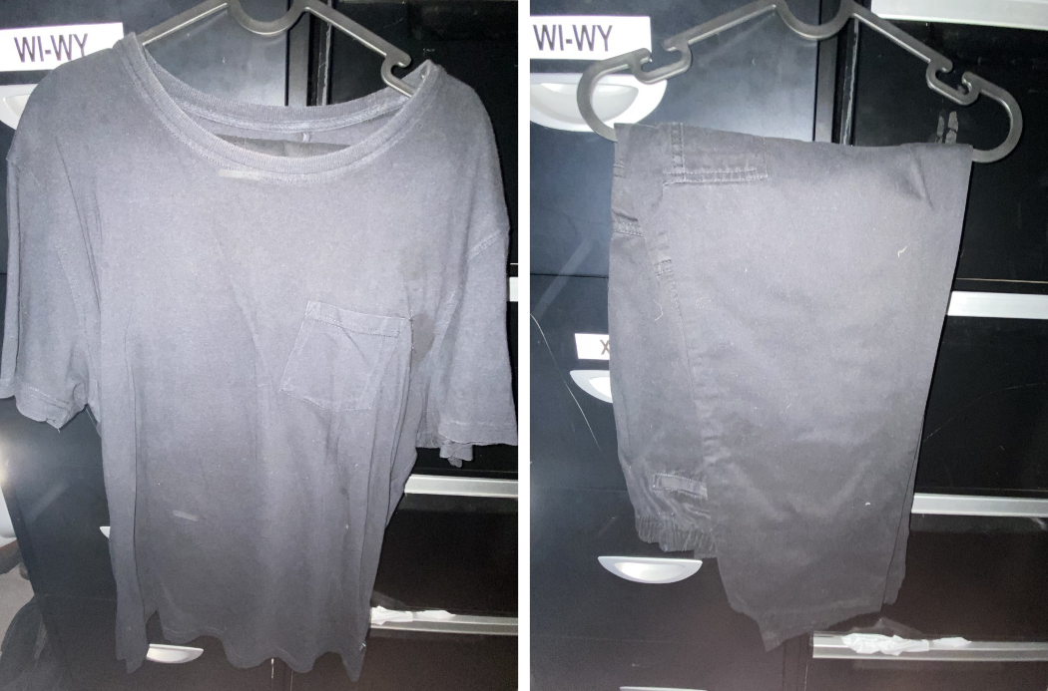
Other participants described how their workplaces provided LGBTQ-specific support services, LGBTQ and ally networks, or designated queer spaces open only to LGBTQ people and allies. Workplaces that were seen to have taken meaningful action to support LGBTQ communities also felt safer to participants:
My workplace at that time was actually a global business which is known as a pioneer in supporting the LGBTIQ+ community. It is a widely known brand who regularly caters towards their LGBTIQ+ community.
(Survey participant, bisexual/pansexual cis woman, aged 24)
The presence of allies who actively advocated for LGBTQ inclusion helped participants feel supported and, as Tyler, a 20-year-old bisexual trans man, customer service officer, stated, someone “definitely [had] my back at work”. Other trans participants spoke about the importance of allies in ensuring their gender identities and pronouns were respected, as reflected by Mei, a teacher:
In my past experience, my senior co-workers or other teachers from the same school did that so perfectly, really supported me and my identity. Often, they said [to students], “Mei would prefer to be called Miss, or referred to as Miss. Please when you have a question for Mei, you need to call out Miss.”
(Mei, pansexual trans woman, tutor/teacher, aged 22)
The use of rainbow lanyards and stickers in the workplace or colleagues wearing purple shirts on Wear It Purple Day (an annual LGBTIQA+ awareness day) were also helpful in communicating the presence of LGBTQ support in the workplace. However, visual displays of allyship did not always translate to safe workplaces, as discussed in the following section.

10.3 Shortfalls in fostering LGBTQ safety at work: From indifferent to hostile workplaces
Workplaces may endeavour to facilitate a safe working environment for LGBTQ employees but may fall short of LGBTQ employees’ needs in various ways. The following discussion highlights how participants identified that workplaces fell short in establishing LGBTQ-supportive, safe and inclusive workplace cultures, and were indifferent, passively hostile or actively hostile. These shortfalls included:
- erasure of LGBTQ identities in workplaces
- organisational tokenism or “performances” in addressing LGBTQ support, safety and inclusion
- differential treatment of young people across LGBTQ identities when addressing safety and inclusion
- differing perspectives between LGBTQ employees and workplace managers about what constitutes LGBTQ workplace safety and inclusion
- active hostility towards LGBTQ communities in the workplace.
Across survey participants who had experienced WSH, just over half indicated that they did not feel respected (55%) or accepted (55%) in their LGBTQ identity in their workplace.

10.3.1 Queer invisibility and erasure in the workplace
Some participants indicated implicit LGBTQ hostility in their workplaces as LGBTQ employees’ identities were made invisible or erased. LGBTQ young people reported finding themselves in workplaces with few other known LGBTQ co-workers and where “out” LGBTQ people were notably absent from leadership roles. For example, Olivia noted that “for the life of me, I can’t remember anyone in a management position who was openly queer” (Olivia, bisexual trans woman, manager, aged 29). Participants described the experience of being the only LGBTQ person in a workplace as daunting, inferring that it would not be safe to be out. As a result, some felt isolated in their workplace – especially if they experienced numerous points of difference to their co-workers:
As far as I know, I was the only [LGBTQ employee]. Everyone else was in a heterosexual relationship or looking for a heterosexual relationship. This, alongside my age difference and comparable lack of life experience, made me feel isolated.
(Survey participant, bisexual cis woman, aged 20)
The absence or invisibility of LGBTQ people in the workplace was compounded by a lack of discussion of LGBTQ identities and issues – as Christine reported, “sexuality and gender diversity literally was basically never talked about the entire time I was there” (Christine, queer cis woman, teacher, aged 24). While open hostility toward LGBTQ people may be absent in the workplace, “any visible support” may also be absent (Frankie, pansexual cis woman, console operator, aged 24) or any acknowledgement of LGBTQ existence. As one survey respondent summed up, there was “no explicit discrimination, but no explicit acceptance either” (Gay/lesbian cis woman, aged 23).
This invisibility raises a critical issue associated with the assumption that if LGBTQ young people are not “out” and known in their workplaces, they do not exist in those spaces; this results in a perception that LGBTQ safety and inclusion policies and practices are irrelevant or not necessary in these workplaces, or if they do exist, are not actively enforced (Robinson & Jones-Diaz, 2016). A “don’t ask, don’t tell” sentiment was reflected in participant accounts. For example:
It just wasn’t talked about, no one was openly queer. Nothing explicitly homophobic was said or occurred, but there was a lack of positive reinforcement or support that indicated LGBTQIA staff members would be respected or welcomed.
(Survey participant, queer non-binary person, aged 28)
In some cases, LGBTQ identities were rendered invisible at a systemic level – in particular, non-binary identities were not visible as a result of binary-gendered uniforms, changerooms and bathrooms, and staffing policies. Workplace data systems also presented issues, as pointed out by one survey respondent: “The market research task requires all surveys to be recorded as exclusively male or female, and to assume based on the voice of the other person on the line” (Asexual demigirl, aged 23).
The invisibilisation of LGBTQ identities from workplaces was at times linked to the idea of queerness being unprofessional or “inappropriate to display” at work (Survey participant, queer non-binary person, aged 23). Survey respondents described “an expectation to be ‘presentable’ and ‘professional’ which implicitly was in contradiction to queer presenting” (Queer [sexuality and gender] person, aged 24) and “to present a ‘polished’ image to clients, which in practice means straight and simple” (Gay cis man, aged 28). This phenomenon was described as occurring across various industries for different reasons, including education, law, nursing and childcare: “Nursing is such a feminine-geared industry that any gender expression for AFAB people that differs from typical femininity is seen as being ‘untidy’” (Survey participant, bisexual genderfluid person, aged 27).
Moreover, some participants described workplaces with active or anticipated pushback against initiatives that would support and make LGBTQ communities visible. For example, Ashley commented, “If I want them to put in the effort [to be more inclusive], then they get quite defensive about it” (Ashley, bisexual non-binary person, mental health nurse, aged 27). Likewise, Alexander was discouraged from engaging his colleagues in professional development related to LGBTQ issues, perceiving that his employer was “a really old school [company] and we just can’t be seen to be taking a position on this [LGBTQ issues]” (Alexander, bisexual trans man, lawyer, aged 26). Together, these factors contributed to the suppression of LGBTQ identities in the workplace, contributing to a lack of support for queer employees. Positioning LGBTQ identities as inherently inappropriate for the workplace may legitimise negative commentary (including sexual harassment) on expressions of queerness and discourage the reporting of harassment that targets LGBTQ people based on their gender or sexuality.

10.3.2 Tokenism and “corporate performances”: The optics of inclusivity
Where some participants indicated that their workplaces had erased LGBTQ visibility in their workplace, other participants, especially those who had worked for larger organisations, reported that their workplaces had taken actions to signal their acceptance and support for LGBTQ communities. These actions included displaying Pride flags, running promotions related to Mardi Gras or WorldPride, or providing Pride or pronoun pins. However, these signals of acceptance and support could be undermined by an everyday lack of LGBTQ support in the workplace. One way this inconsistency between organisational signals of support and lack of everyday LGBTQ safety manifested was in the continued misgendering of trans people or the ongoing use of binary language despite correction. For example, one survey respondent reported that, “for the most part, co-workers and management would say they support trans folks but then consistently misgender us” (Queer non-binary person, aged 19). Christine described a manager who repeatedly expressed interest in LGBTQ inclusivity initiatives but “consistently uses ‘ladies and gentlemen’ in every single staff meeting and every single assembly … despite me asking her [not to]” (Christine, queer cis woman, teacher, aged 24). In Lily’s case, the stated organisational commitment to inclusivity was even used to deflect criticism:
When a non-binary person is working there or accessing the service, they would just be constantly misgendered … I tried to speak to my manager about it, and then my manager was like, “Well, you know we are an inclusive team.” And I just cringed. I was like, I don’t think you get to decide.
(Lily, queer cis woman, community service worker, aged 27)
Several other participants were aware of managers or senior colleagues who expressed prejudices and actions that undermined organisational signals of inclusivity at work. These actions resulted in the perception that the stated LGBTQ support was a mere front to maintain an organisation’s reputation. This perspective was typified by a survey respondent who questioned those senior colleagues who “pretended to be for it but [were] not, behind closed doors” (Queer cis woman, aged 25). Employers’ lack of awareness of steps needed to make workplaces genuinely safer for young LGBTQ workers was interpreted by some participants as indicating a lack of sincere concern for their wellbeing, affecting their perception of a lack of safety in the workplace.
The perceived inconsistencies between corporate declarations of inclusivity and the actions (or lack thereof) of those within the workplace led some participants to believe the workplace was insincere about inclusion and acceptance. While some LGBTQ young people did take these as genuine indicators of inclusivity, acceptance and safety, others considered organisational displays of acceptance and support to be tokenistic and performative, or what Amanda, a bisexual cis woman, UX designer, aged 28, termed “corporate performances” of support and safety for LGBTQ employees. Specifically, participants considered the discrepancy between stated and enacted acceptance of LGBTQ people to be indicative of companies caring more about the optics of inclusivity than about the wellbeing of LGBTQ workers and clients. Participants described these superficial claims of acceptance as “virtue signalling” (Amanda, bisexual cis woman, aged 28), a “tick-box exercise” (Lily, queer cis woman, community service worker, aged 27), and “a slogan, but not really anything more than that” (Thea, lesbian/queer agender person, aged 24). Ellen (lesbian cis woman, disability employment consultant, aged 25) compared these tokenistic performances to a “shiny handbag that you can just throw over your shoulder and be like, Oh look, I accept queer rights”, suggesting these displays are more for show than out of genuine concern for LGBTQ employees. In Figure 10.2, Amanda has shown an explicit display of organisational LGBTQ inclusion in the Pride flag at her workplace, which she felt was not backed by her employer’s actions.
Figure 10.2
“I know you say you accept us, but I don’t really think you do, or I don’t really feel your actions say that.”
(Amanda, bisexual cis woman, UX designer, aged 28)
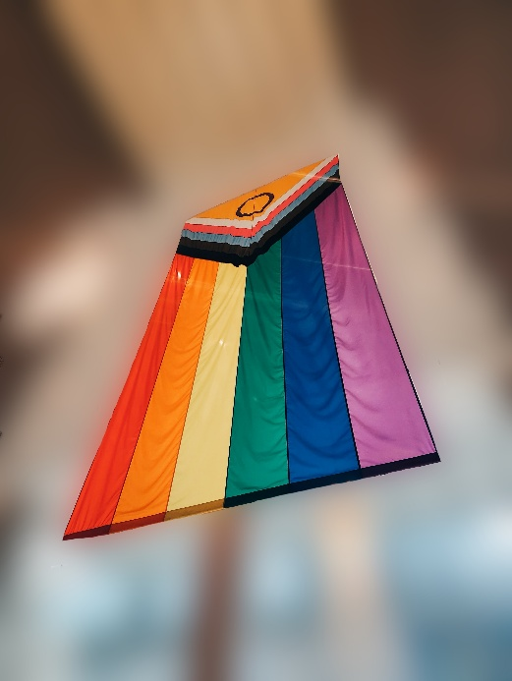
Participants also raised concerns about the reluctance of employers to take issues seriously when brought to their attention or to take meaningful action to prevent or address the harassment of LGBTQ workers despite blanket statements to the contrary. This inconsistency created further distrust in workplace claims of being LGBTQ-inclusive and accepting, as reflected in the following participant comments:
Despite [the workplace] being very into putting up posters for Pride Month and other performative actions, it is abundantly clear that a shocking percentage of the work staff are anti-LGBTQ. There has been no proper effort, to my knowledge, to rectify this.
(Survey participant, gay/lesbian cis woman, aged 22)

The company strives for inclusivity and shares stuff from their queer, disabled, employees of colour and female employees and days of “celebration”, but it more or so feels like a thing to pretend because there is not a single person who I work with who I would feel comfortable telling about my queerness. And there’s just a lot of casual bigotry, and most outward bigotry doesn’t get punished; it’s seen as a joke or [given] just a mild slap on the wrist.
(Survey participant, queer/demisexual/pansexual genderfluid/non-binary person, AGED 21)
Archer described his company’s presence at Mardi Gras/WorldPride as seeming to prioritise the appearance of inclusion over the actual inclusion of LGBTQ staff:
I saw my workplace’s Pride group [at Mardi Gras] and it was a lot of people who were there to party and stuff. I don’t think there were a lot of actual people who were in the queer community actually doing any of the stuff … It just felt like it was the company trying to be like, “Look, we are supportive.” But you’ve got people being pushed out or kept out of it who are your ground-level workers, who are the people who are in the shops and stuff, and then they’re not aware of it or can’t join.
(Archer, bisexual agender transmasc person, checkout operator, aged 30)
Amanda (bisexual cis woman, UX designer, aged 28) further highlighted the apparent time-limited nature of inclusivity campaigns in the wake of Mardi Gras/WorldPride, wondering, “where’s the energy gone?” at the end of the month, and suggesting corporate care for LGBTQ people is as transient and disposable as the signs displayed during the festivities (Figure 10.3).
Figure 10.3
“… where’s the energy gone? They put all this energy into printing out the sign, only for it to just, I don’t know, be thrown out.”
(Amanda, bisexual cis woman, UX designer, aged 28)

Organisational declarations of inclusion, acceptance and support are insufficient for LGBTQ safety at work when meaningful everyday practices of support and inclusion do not accompany these declarations. Indeed, such declarations might be detrimental to feelings of LGBTQ safety, as when contrasted with everyday hostility or indifference, the declarations may be perceived as evidence that the organisation prioritises a public image of LGBTQ acceptance over the safety of employees.

10.3.3 Differential treatment of individuals within the LGBTQ umbrella
Everyday workplace support and acceptance did not extend equally to all LGBTQ people. Both queer and non-queer workers could vary in their awareness, acceptance and understanding of different LGBTQ identities, and thus treat other LGBTQ employees differently. Survey participants specifically identified that plurisexual (attracted to multiple genders), asexual and trans workers can feel excluded in a workplace that other LGBTQ people may consider supportive and accepting. Bailey told us that “people tend to be more understanding of sexuality” while challenging binary understandings of gender could be “a lot more complicated and kind of confronting in some ways” (Bailey, identifying as both gender and sexuality queer, working in academia, aged 24). The following participant expanded on these different experiences among LGBTQ employees:
Whether an employee feels comfortable to be themselves, or feels accepted by co-workers, may differ based on where in the [LGBTQ] community they identify. The owners (who are regularly presently working) are gay men in their 40s–50s and show signs of subtle biphobia, transphobia and potential acephobia in their comments … While I do not believe my bosses would intentionally disrespect a transgender or an asexual employee, I’m unsure if [a transgender or asexual employee] would feel as comfortable and accepted as I, a gay guy, feel.
(Survey participant, gay biromantic questioning cis man, aged 16)
Indeed, plurisexual, asexual and trans participants often indicated a need for caution when assessing their workplace safety. Ramsey, a gender nonconforming person, commented:
While it’s comforting to have other queer people around, it doesn’t subdue all of my worries at all … that doesn’t necessarily mean that they [other LGBTQ people] know how to have conversations about gender identity.
(Ramsey, queer gender nonconforming person, disability advocate, aged 24).
LGBTQ employees’ comfort in accessing LGBTQ-designated support can be impacted if they have experienced discrimination or misrecognition from other LGBTQ colleagues.
Conversely, plurisexual and LGBTQ people who “pass” as cisgender and heterosexual were sometimes considered not “queer enough” (Johanna, bisexual cis woman, tutor, student, aged 28) to be counted as LGBTQ by other LGBTQ colleagues. Further, while one survey participant reported that “older, monosexual, gay or lesbian, cisgender team [members] experienced work very different[ly] and had a much more accepting environment” (Queer non-binary person, aged 26), another survey participant noted that at their workplace “gay men are accepted as long as they aren’t too flamboyant” (Asexual non-binary person, aged 24). Due to the differential treatment of LGBTQ employees depending on their specific identity, changes in the workplace to foster inclusion and safety that might suit one identity group might not be suited for other LGBTQ employees.

10.3.4 Different perspectives between employers and LGBTQ employees about what constitutes LGBTQ-safe and accepting workplaces
Some workplaces attempted to foster supportive or inclusive environments for LGBTQ employees and clients in their policies and everyday workplace practices. However, participants identified that there was often a clear gap between employers’ and LGBTQ young people’s perceptions of what constituted LGBTQ-safe and accepting workplace practices. This gap calls into question who “get[s] to decide” (Lily, queer cis woman, community service worker, aged 27) how the label of “LGBTQ-inclusive” is applied, and what initiatives are implemented in the name of achieving safety and inclusion. Participants explained that the voices and perspectives of LGBTQ young people, who typically lack the power and seniority to make such decisions, are not centred or acknowledged. Some participants felt that workplaces nominating themselves as having “LGBT-friendly” practices could override and invalidate many LGBTQ young people’s experiences:
It is not really queer people that are calling it [the service] LGBT-friendly. It’s cis-het people. They’re the ones determining it. Yet both people accessing it [the service] and employees are not feeling that it’s that way.
(Lily, queer cis woman, community services worker, aged 27)
Some participants believed this discrepancy reflected a genuine misunderstanding by well-intentioned individuals about what constituted LGBTQ safety. Lily commented that “organisations don’t quite realise the impact of what’s happening and how it’s received by people that are actually part of minority communities” (Lily, queer cis woman, community services worker, aged 27). Even ostensibly well-intentioned LGBTQ inclusion initiatives could be undermined. For example, Archer, a bisexual agender transmasc person, checkout operator, aged 30, was told that his workplace offered an LGBTQ network, on which he was never able to get information about how to join. There were also supposedly LGBTQ training and Pride pins, but Archer found that “no-one’s ever got them [Pride pins] for some reason”, and follow-up attempts received no response.

10.3.5 Hostility toward LGBTQ people in the workplace
Some participants described workplaces that made little to no effort to counter the active hostility that LGBTQ employees encountered at work. LGBTQ young people described being “exposed” to or witnessing “toxic” comments about LGBTQ people and identities, which were prevalent or even normalised in their workplaces. Such comments included hurtful stereotypes (for example, bisexual people being seen as greedy or LGBTQ people being seen as predators); condemnation of LGBTQ identities as sinners; dismissive and uninformed comments about LGBTQ identities and people; and opposition to LGBTQ rights movements. While these stereotypes were typically non-targeted, occasionally they were reported to segue into hostility towards LGBTQ young people. For example, one survey participant commented:
I feel like people think I’m not appropriate for children to be around or that my sexuality makes me hypersexual and inappropriate for the workplace. I guess what would help would be to get employers to understand that while I’m gay all the time, I’m not going to harass people or something. I’m not a predator, I’m not going to gay your kids.
(Survey participant, gay/lesbian cis woman, aged 19)
Negative commentary also emerged through workplace discussions of current events and media narratives surrounding them. A key example was the marriage equality plebiscite:
[T]he general consensus at the time was that it was very much OK to voice your opinion about being “anti” LGBT+, so this [time of the plebiscite] was a lot more hostile.
(Survey participant, bi, ace and queer non-binary or transmasculine person, aged 27)
Jamie reported that their boss would “specifically bring [the plebiscite] up with me and talk about all the reasons why he was voting No” (Queer and bisexual non-binary transmasc person, counsellor, aged 28). More recently, anti-trans media commentary has contributed to increased transphobic commentary and behaviour in workplaces. Amanda, who was not open about her bisexual identity at work, described how, despite not being directly targeted, these transphobic comments negatively impacted her, and potentially others: “Obviously, because you’re not out [as queer], you don’t really have that interpersonal confrontation [as the specific target of harassment], but … it affects you.” She further indicated that this situation eroded her trust in co-workers, and how it continued to impact her workplace experience: “Who can I trust? Just because I’m safe now, I still don’t trust you, and I still don’t want to be around you” (Amanda, bisexual cis woman, UX designer, aged 28).
Witnessing hostility towards other LGBTQ people, including co-workers, LGBTQ clients and service users, threatened participants’ sense of safety in the workplace and discouraged them from coming out at work. Examples included lewd comments, bullying, ostracising or not talking to openly LGBTQ colleagues, and speculating about whether other co-workers were queer:
The only other queer [employee] is still closeted, tried to come out, was bullied so bad by one colleague he pretended it was a joke and is now living very dangerously and unhappily.
(Survey participant, gay/lesbian non-binary transfem person, aged 27)

There was a trans woman early in her transition who they would make lewd comments about behind her back (“dude with tits”, “thinks he’s a woman”) and also a very openly lesbian medic who would also get really gross comments (“I could make her like men”).
(Survey participant, bisexual woman but slightly off [self-description], aged 21)
Participants described characteristics of people who were more hostile towards LGBTQ identities and individuals – typically those who were older, male, straight, religious or less educated. For example, one survey respondent described their co-workers as “typical cis-het men in this company, lots of which were from a different generation and had different understanding” (Queer cis woman, aged 22). With workplaces and management often seemingly reluctant to adequately address anti-LGBTQ attitudes and behaviours among staff, LGBTQ young people were left feeling like their identity “creates conflict due to [other people’s] discomfort” (Survey participant, sexuality and gender queer person, aged 24). When anti-LGBTQ hostility was prevalent in the workplace, participants described feeling that work for them was unsafe. The following participant who was a psychologist stated that in one workplace they felt:
… objectively unsafe. All of us were called slurs and harassed almost daily; some of us were assaulted for it. Most of us were bullied out of our positions until we quit. All of us took extra unpaid leave in order to maintain our mental health. Management did not give a single care.
(Survey participant, queer asexual trans non-binary person, aged 26)
Some participants made a distinction between the attitudes of management and co-workers who were “generally supportive”, compared to customers or service users who were “generally not supportive” (Survey participant, trans woman, aged 15). While some participants felt safe and supported by their immediate team, the workplace’s safety could still be compromised by hostile individuals, both co-workers and outsiders. The following participants’ comments typify this:
Customers particularly, they like to express a lot of their negative thoughts about the [LGBTQ] community and tend to single out [LGBTQ] people who might be in the store, around them.
(Lisa, pansexual cis woman, digital marketer, aged 23)

A farm worker [co-worker] at lunch went on a rant about trans students being unnatural and how their parents should have beat them and taught them to shoot guns rather than be how they are.
(Survey participant, queer cis woman, aged 26)
LGBTQ young people could face active hostility from many sources including employers, co-workers, and clients or customers. Importantly, even when the hostility was directed toward another LGBTQ person, LGBTQ young people were personally impacted in their feeling of safety in the workplace.

10.4 Chapter summary
Despite increasing social acceptance, inclusion and celebration of LGBTQ communities, many LGBTQ young people continue to encounter unsafe and unaccepting cultures within their workplaces. Participants who had experienced workplace cultures that felt safe and accepting identified factors that could help improve LGBTQ inclusion and acceptance in organisations. Such areas include hiring openly LGBTQ employees, allies and champions. These employees require support and skill development and leadership training. Workplaces need to implement LGBTQ-inclusive, supportive and anti-discriminatory policies and protections and ensure these are implemented. The deployment of visible indicators of inclusion and support for LGBTQ identities in workplaces, both physical and online spaces, is also an additional supplementary step to good practices, although insufficient on its own. Safe and inclusive cultures are likely to reduce the risk of encountering harassment and provide avenues of redress when it does occur.

Chapter 11
Disclosure of LGBTQ identities in the workplace

11.1 Introduction
Workplace cultures significantly influenced LGBTQ young people’s feelings of support, inclusion and safety at work, as outlined in the previous chapter. Workplace cultures can also directly impact LGBTQ young people’s decisions about the disclosure of their LGBTQ identities. The pervasiveness of cisheteronormative assumptions creates an environment where LGBTQ young people have to balance their desire to have their identities known and recognised either explicitly or through subtle hints, and the risk of victimisation or discrimination based on their gender and/or sexuality. Participants reported using different strategies to manage these disclosures of LGBTQ identities in a manner that aimed to preserve their safety and comfort in the workplace, with varying degrees of success. These strategies included openness regarding identity, selectively disclosing to specific others in the workplace, and encoding hints about their identities in their appearance and conversation.
Survey participants indicated varying levels of being “out” regarding their LGBTQ identity in their workplaces. At the time of their most impactful experience of workplace sexual harassment, participants were most commonly out to workplace peers (35% completely out), supervisors (33% completely out) and subordinates (33% completely out), but did not indicate whether this outness varied according to gender identity compared to sexuality identity. Comparatively, only 11% of respondents were completely out to customers or clients, and 21% were completely out to upper management. Overall, among participants who had experienced WSH, 32% indicated experiencing pressure to remain closeted. Qualitative data suggest that young people were typically more open about their sexuality than about being trans (either binary or non-binary). Binary and non-binary trans participants described that caution about disclosing their trans identity was due to anticipated hostility and poorer understanding of gender diversity among co-workers. Indeed, among survey participants who had experienced workplace sexual harassment, binary and non-binary trans participants reported more significant pressure to remain closeted in comparison to cisgender participants (t[458] = -2.89, p = .004). Participants also decided to conceal their LGBTQ identities or found that the disclosure of LGBTQ identities was out of their control. With every decision regarding disclosure, participants faced a laborious and emotionally burdensome process of assessing the potential risks and benefits of “out”. This burden became heavier with multiple disclosures. Participants also frequently faced the burden of the additional labour of educating “curious” others about their gender and/or sexuality, which deterred some from disclosing their identity in the workplace. The nature of the work also shaped how and if participants would disclose their LGBTQ identity, as the professional environment could shape expectations regarding outness in the workplace.

11.2 Identity disclosure in the workplace
For most participants, it was clear that disclosing LGBTQ identities was not a spur-of-the-moment decision but the result of careful consideration of the potential benefits, risks and outcomes. A lesbian cisgender woman, Ellen, commented on her decision-making process around workplace disclosure:
So, when I do come out, it is more often, and I have a few moments every single time to sit with myself and ask myself, do I feel safe right now? Do I think the person I’m speaking to is going to handle this well? Do I correct them? Do I not? Do I …? Yeah, every time it’s a bit of a battle. And I would say most times I make the decision to be out, but I’ve definitely decided against that sometimes as well.
(Ellen, lesbian cis woman, disability employment consultant, aged 25)
Even as someone who described themselves as being “open now” about her identity, Nadine described the lead-up to disclosure as:
Really hard. You overthink everything; you’re not sure how people might take it … You always are kind of walking on eggshells, whether you need it or not – you just have to be careful.
(Nadine, pansexual cis woman, roster analyst, aged 26)
Many participants described how they had explicitly disclosed their LGBTQ identity to others in the workplace while working together. These experiences of disclosure could involve becoming generally “known” as LGBTQ or ongoing conversations about being LGBTQ:
I am known in my locale for what I am, I’ve been in a few newspaper interviews about it (small town).
(Survey participant, pansexual transgender FTM, aged 26)

I have had multiple conversations with various colleagues about my queer identity, I have mentioned it at a presentation in front of my colleagues, it’s come up in conversation with some of my students and I would say that I “present” as very queer/gay now.
(Survey participant, queer cis woman, aged 30)
Some participants had taken on roles within their workplace that made their LGBTQ identities known, such as working for LGBTQ services or leading diversity and inclusion initiatives (e.g. queer–straight alliances or LGBTQ/ally networks). Dylan described their work in an LGBTQ service, commenting “half of my job is being out and proud and being a member of the community” (Dylan, pansexual/demisexual non-binary transmasculine person, peer education officer for LGBTQIA+ young people, aged 22). A minority of participants also reported having the option to disclose their trans or gender diverse identity at the systems level through official employment paperwork, such as listing pronouns when applying for a position, or identifying as non-binary on a company profile.
Those LGBTQ young people who were generally out and visible at work considered this important to them personally and politically. For some, this outness was a matter of affirming their own identity, deciding that “I should be free to be me without fear” (Survey participant, gay man, aged 28). Paralleling this was a refusal to conceal identities by changing pronouns or lying to be accepted, sometimes arising from a deep discomfort with being misperceived, as the following comments show:
I actually can’t change this [being non-binary trans]. Even if I were to pretend to just be a cis woman, I’m not going to be happy.
(Evan, lesbian non-binary person, logistics assistant, aged 20)

Gender and sexual orientation felt like things I did not want to/could not hide … as it’s always been an important affirming tactic for me that helps me feel better as I go through a particularly tricky stage in my transition. I tried to make it something I would not compromise on.
(Survey participant, queer transmasc enby :-), aged 21)
For a few participants, being out was also linked to increasing societal expectations or pressure for LGBTQ people to be openly and proudly queer in the workplace. Being visibly out, for others, was a way of communicating safety for and commonalities with other LGBTQ people, or as one survey respondent articulated, a way to “humanise queer people and experiences in an otherwise conservative environment” (Queer and homosexual transmasculine person, aged 25). However, by far the more common experience was for participants to be out in a more contained fashion; that is, some young people were not explicit about their LGBTQ identity and limited how much they publicly expressed it in the workplace, and to whom. These participants were typically open about their identities if they came up in conversation, such as when talking about partners and dates or correcting assumptions, as pointed out by Clara:
I’m happy to do it [correct assumptions about sexuality] because I like to make the point. I don’t like to let people just be mistaken because it’s not good for the relationship. If I let people think that I’m a lesbian and then I’m going on a date with a man, then they’re going to be under the impression that lesbians are available to men and sexually interested in men when actually that’s not the case. So, I don’t want to contribute to that misreading of women’s sexuality where people think that lesbians just haven’t met the right guy yet.
(Clara, bisexual cis woman, lawyer, aged 25)
When the decision was made to come out at work, there were secondary considerations for those with less understood identities – specifically, whether to simplify labels to reduce the risk of encountering hostility or uncomfortable questioning. This consideration was especially the case for young people who identified as non-binary. For example, Rory commented, “I’ve had people ask me who I am, but I’ve always just said female” (Rory, queer non-binary masculine person, fast food worker, aged 21). This choice of labels might be considered a balance between the internal desire or external pressure to be an “authentic self” at work and the very real possibility of facing harassment and discrimination from co-workers who may not understand these labels. The compromise between articulating an authentic self and potential harassment was further articulated by Ellen in a broader sense of LGBTQ acceptance:
For younger people, I think it’s a little bit, we’re young, we might be keen and eager in the environment we’re in. We’ve had older generations fight for our rights and tell us to be out and proud and be happy with who you are, and you know, you have the right to be who you are and fucking come out of the closet now because we just want to hug you and hold you. So, we did that. What we didn’t realise is that by doing that, there is [sic] still so many people that are not going to hold space for us to do that. And by doing that, we open ourselves up to a lot more risk.
(Ellen, lesbian cis woman, disability employment consultant, aged 25)
Young people often only disclosed their identities to a few select people with whom they felt safe after knowing them for a while or if they became friends. Participants also described being more open about their gender and sexuality with other queer people and known allies. Implicit in these decisions was a sense that other LGBTQ people and allies would be safe and accepting people to whom to disclose, although as discussed in Section 10.3.3 this assumption was not always true. At other times, participants inferred their co-workers’ acceptance of LGBTQ people from other demographic and personal characteristics, conversations or appearances:
I didn’t feel comfortable telling them or getting close to anyone about it apart from one new guy that we had come in. And he was hip, and he was cool like me … So, I think we might’ve discussed it maybe once or twice.
(Frankie, pansexual cis woman, console operator, aged 24)
For some participants, disclosing their identities to managers early in (or before) their employment was important. This strategy was primarily employed by trans people trying to ensure their prospective workplace would be safe. Ava, a lesbian trans woman, aged 25, described wanting to “give them a heads-up” to “try to alleviate any of the transphobia early on”. Alexander commented:
I came out in the job interview, because I’m that kind of dickhead. He kept saying, “You’re going to have to take your nose ring out if you come to work for us.” I was like, “Yeah. Sweet.” And he’d said “old school” three times, and on the third time, I was like, “Look, I’m going to say something that should stay confidential to this interview, but I need you to answer me honestly. I’m trans. You keep saying old school. Am I going to be safe working here? Because I’m just not interested if not.”
(Alexander, bisexual trans man, lawyer, aged 26)
Generally, navigation of disclosure could involve various considerations for LGBTQ young people’s safety and potential compromises to LGBTQ authenticity, which they managed through selective and strategic disclosure. However, this necessitated ongoing emotional and decision work in repeatedly navigating choices about disclosure, constituting a unique burden for young LGBTQ workers.

11.3 Reactions to identity disclosure
Reactions to the disclosure of LGBTQ identities were mixed, depending on how accepting and knowledgeable colleagues in workplaces were about LGBTQ identities. Within workplaces with many publicly LGBTQ employees, participants reported a sense of solidarity with others. For example, Kendal described their workplace as “a little bubble of queerness” where “queer identities were not just celebrated, they were the norm” and “staff members just always used my pronouns without even thinking about it” (Kendal, bisexual non-binary person, pole dance studio receptionist and medical receptionist, aged 26). Ashley’s disclosure was likewise enthusiastically welcomed:
The person that was going to be my boss, he referred to me as “she” and I said, “Oh, actually I’m non-binary, these are my pronouns.” And there was another staff member who happened to be queer that was also showing me around, and she got very, very excited, and she was just like, “Good to have someone different around here, some change, some young people,” or whatever. And everyone tried quite hard. They didn’t always get it right, but they tried in that environment, which was nice.
(Ashley, bisexual non-binary person, mental health nurse, aged 27)
One exceptionally supportive response to disclosure was reported by Tyler, whose managers worked together with him to develop a plan for coming out in the workplace after a co-worker had begun to “out” him as trans to others:
My manager, who I was great friends with, I loved him so much, I pulled him aside and I was like, “I don’t really know how to handle this. I don’t know how to come out as trans in the workplace.” He’s like, “I don’t either. Is it okay if I go to our centre manager and I’d ask her how are we going to handle this?” I was like, “Please do.” He had a meeting with her, and then they both spoke to me and were like, “Okay, this is what we think is the best way to move forward. Does that sound good to you, or how would you like to handle this?” I just had a sit-down meeting with my manager and his manager to figure out how we wanted to go forward so that I was comfortable the whole time. Yeah, so management was fantastic.
(Tyler, bisexual trans man, customer services officer, aged 20)
It is important to note that these positive examples represent the few instances of supportive and proactive workplace responses to an LGBTQ young person’s LGBTQ disclosure. More common seemingly positive responses were reports of disclosure being treated as a “non-issue” without “any weird reactions” (Clara, bisexual cis woman, lawyer, aged 25). This response allowed some people to feel they could relax or be open, and it was primarily framed positively due to a lack of prejudice or negativity around being LGBTQ.
In contrast to the positive experiences, many participants described being treated poorly after coming out. These negative experiences included experiencing homophobia, biphobia and transphobia; being treated differently or excluded at work and online; and being asked invasive questions by co-workers who, as Tyler pointed out, “don’t really know how to talk to trans people or queer people” (Tyler, bisexual trans man, customer service officer, aged 20). Negative experiences of disclosure also resulted in unwanted conversations and inappropriate comments, many of which were classified as workplace sexual harassment, as discussed in Chapter 6. Ava discussed encountering such a conversation:
When someone says, “He/him,” I’m like, “All good. She/her. Don’t worry about it.” And that’s been fine. But then, sometimes, when I’ve done that, people get very upset about being corrected. And they’re like, “Ugh. It’s just so new. All those concepts are so new. I’m just going to call you [Ava]. I’m not going to worry about pronouns at all.” I’m like, “Okay, cool. I didn’t ask. I just corrected you for what it means for me.”
(Ava, lesbian trans woman, office coordinator, AGED 25)
Like Ava’s experience, other participants reported that their identity disclosures were disregarded, dismissed or doubted – particularly for plurisexual and trans participants. Bisexual young people reported experiencing bi-erasure (Stewart, 2021) or “not [being] counted as ‘queer’ based on being bi” (Survey participant, bisexual cis woman, aged 28). Bisexual people experience higher rates of lifetime sexual harassment than other sexuality identities (AHRC, 2018) and high rates of poor mental health (Hill et al., 2021). Zoe commented:
It’s interesting because – date a guy and [co-workers are] like, “Oh, well, then you’re not really [queer]” kind of thing. And they just see you as heteronormative, but you date a girl, and it’s, “Oh, you don’t look like a lesbian.”
(Zoe, queer cis woman, research assistant, aged 25)
Trans young people likewise reported being misgendered and deadnamed and having their pronouns ignored, both intentionally and unintentionally. There were also several instances of co-workers misunderstanding participants’ disclosures, such as when Carrie was harassed for being a lesbian despite not identifying this way:
It’s odd because they all think I’m a lesbian, so they’ll make lesbian jokes about me. They’re being offensive, but they’re also just wrong as well. So, I don’t bother explaining my identity because they will, first of all, not really respect it, but also, they’ll just make jokes about it.
(Carrie, queer non-binary person, operations coordinator, aged 22)
These negative responses to the disclosure of LGBTQ identities gave weight to the reasons participants cited for not wanting or choosing to come out in the workplace (Ragins et al., 2007; Röndahl et al., 2007).

11.4 Social steganography and the indirect disclosure of queerness
Social steganography is the practice of hiding or communicating messages in plain sight by encoding them in a way that is only intelligible to specific audiences. Social steganography is a common practice that may include tattoos, wearing certain items of clothing or accessories, and sharing emotionally coded song lyrics or queer-coded messages on social media (Marwick & boyd, 2014; Duguay et al., 2016). Many participants’ dress and appearance provided visual clues to their LGBTQ identities without them explicitly disclosing this identity.
The most commonly reported ways of encoding LGBTQ identities were wearing rainbow or Pride flags or pronouns on badges, lanyards or other accessories – although these were also reported digitally (e.g. in email signatures). For some participants who were very out at work, multiple visual indicators were worn in combination, while they also explicitly disclosed and discussed queerness. One survey participant described themselves proudly as “a walking rainbow flag” at work (Gay/lesbian non-binary person, aged 28). Dylan photographed themself smiling with their “out and queer” accessories in Figure 11.1.
Figure 11.1
“I’m living my best life, I’ve got my coloured hair … my rainbow backpack … it’s also showing my disabled side [through headphones, a fidget toy and sunflower lanyard]. It’s about being visible.”
(Dylan, pansexual/demisexual non-binary transmasc person, peer education officer for LGBTQIA+ young people, aged 22)
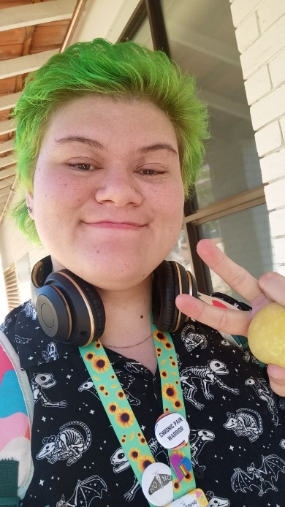
For other participants, social steganographic markers were a way of subtly visibilising LGBTQ identities that they had not explicitly disclosed but also did not want to conceal completely. For example, Kendal commented:
I haven’t said to anyone like, “I’m queer,” but I wear my Docs, which have a big old rainbow flag on them. My backpack has rainbow straps. I have a lanyard that’s the progress flag. I’m pretty sure if you looked at me, you’d be like, “Hmm, okay.”
(Kendal, bisexual non-binary person, pole dance studio receptionist and medical receptionist, aged 26)
An interesting trend noted by participants was the increasing prevalence of these markers in workplaces as a way of signifying LGBTQ acceptance and allyship, with one survey respondent commenting, “Who isn’t wearing a Pride badge nowadays?” (Bisexual cis woman, aged 28). This made social steganography somewhat ambiguous, as queer markers were often also worn by seeming cisgender and heterosexual allies. Rather than muddying the signals, this was seen by some participants as helpful as it allowed the expression of queerness with plausible deniability: where these markers might be read and understood by LGBTQ co-workers, they could also be played off as a show of allyship in situations where participants felt threatened or that it may not be safe to be openly queer. For example, Zoe stated and illustrated in Figure 11.2:
A lot of people do wear that [rainbow badges/lanyards] around [workplace], and it’s very much meant to be a sign of support and solidarity with the community. And I feel more comfortable doing that because it’s like I can still kind of show those aspects without explicitly being like that [disclosing queerness].
(Zoe, queer cis woman, research assistant, aged 25)
Figure 11.2
“… my lanyard that I wear to work … that’s kind of more how I express myself … in my own subtle way.”
(Zoe, queer cis woman, research assistant, aged 25)
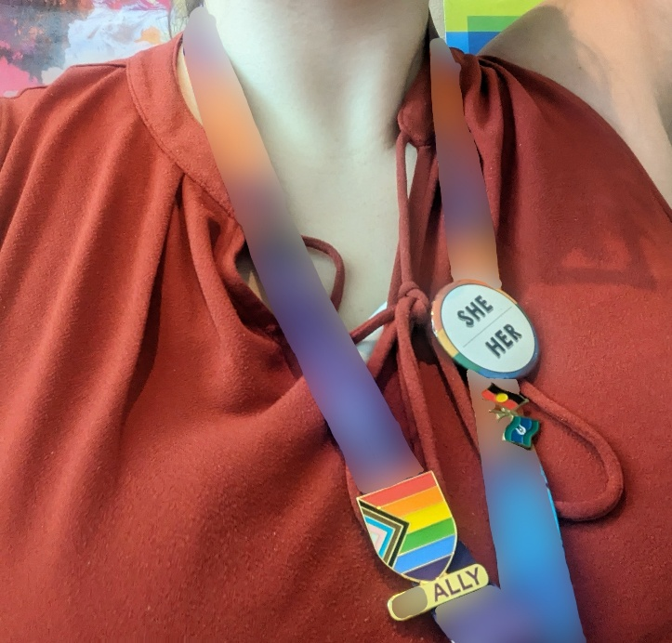
Dylan similarly reported that they would say, “I don’t identify as that [LGBTQ], but I support it” (Dylan, pansexual/demisexual non-binary transmasc person, peer education officer for LGBTQIA+ young people, aged 22) if questioned by an individual who was perceived to be unsafe within the workplace. For these young people, wearing LGBTQ symbols signalled their identities while enabling them to maintain safety in the workplace. Doing so could foster connection, allegiance and potential friendship with other LGBTQ employees.
Figure 11.3
“[For educational work] I could go all out … do my makeup super queer, and I’d wear my boots with the laces.”
(Dylan, pansexual/demisexual non-binary transmasc person, peer education officer for LGBTQIA+ young people, aged 22)
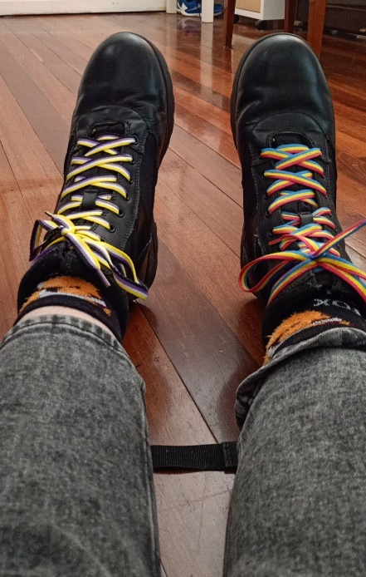
Queerness was also conveyed through more prominent stylistic choices for workplace participants, allowing this expression. For example, some participants described themselves as presenting in an alternative manner, referring to having multiple piercings, tattoos and coloured hair. Dylan showed off their rainbow shoelaces in Figure 11.3. The effectiveness of these stylistic choices as overt indicators of LGBTQ identity relied on observers sharing a visual vocabulary as to how queerness is presented, which Bailey described could be “contradictory”. They elaborated, “You can’t look queer like there’s no one way to look queer. But at the same time, I think there are certain markers that are associated with queerness” (Bailey, queer in sexuality and gender person, working in academia, aged 24). Likewise, other participants reported that being stereotypically gay or gender diverse meant that their identities were assumed without being explicitly open about it. The following comment by a survey participant typifies these experiences:
I wasn’t out insofar as I don’t bring obviously gay paraphernalia to work, and I’ve never spoken about being gay. However, I definitely don’t hide it, and if you have any gaydar at all, you’d pick me out of a crowd of a thousand as being a gay woman (I have short hair, I wear tradie-brand cargo pants to work).
(Gay cis woman, aged 19)
When navigating workplaces where LGBTQ acceptance was limited or unknown, social steganography could allow LGBTQ young people a greater degree of control and safety over their coming out that might not be otherwise possible with an explicit disclosure of an LGBTQ identity. In using social stenography, participants were able to remove the burden of naming their LGBTQ identity multiple times, could subtly indicate their identity to others who could understand the steganographic signals, and could provide plausible deniability by claiming the signals as allyship instead of a personal LGBTQ identity.

11.5 Wanting to disclose identity but disallowed: LGBTQ does not equal professionalism
Not all LGBTQ young people can signal queerness at work. Several participants described workplaces where their “implicit LGBTQ expression was stamped out ASAP” and “explicit expression, when permission [was granted] was carefully managed” (Survey participant, pansexual femboy, aged 20). As Ava described:
I had this little trans flag on my desk. And the lady from HR … came around to my desk, and she was like, “Hey, we just had some complaints where we just wanted to make sure the desk is completely tidy and no clutter on it. So, if you can, just take the flag down.” … I was like, “That’s weird. That’s a weird thing to say. That’s not okay.”
(Ava, lesbian trans woman, office coordinator, aged 25)
For others, workplace policies were “[not] anti-LGBT in intention but in practice it affected mostly [LGBTQ folks]” (Survey participant, gay/lesbian cis woman, aged 25), including workplaces with rigid expectations around gender presentation and professionalism, or rules against dyed hair and expressive dressing. That is, while visual expressions were an essential way for young LGBTQ workers to make visible their identities, workplace regulations meant that these expressions sometimes had to be suppressed.
Some participants articulated a double standard around notions of appropriate discussions about sexuality identities and relationships in the professional context. This discussion was particularly prevalent in teaching:
Given that we teach primary-aged kids, obviously, one is not to talk about their sexual orientation. However, many straight (female) teachers would talk about their husbands – I am not sure if I could be so free to talk about my partner in the same fashion.
(Survey participant, gay/lesbian cis woman, aged 29)
A double standard was noted by some LGBTQ young people with regard to speaking about their relationships in the workplace, which in comparison to colleagues talking about their relationships, were seen as inappropriate and unprofessional.

11.6 The labour of identity concealment in the workplace
Although most participants in this study had disclosed their LGBTQ identity to at least some people in their workplaces, concealing identities was a common experience; as one survey respondent stated, “I think most LGBTQ people mask themselves even a little bit at work” (Survey participant, gay cis man, aged 30). For some, concealing their identities involved considerable emotional work. Omar described the lengths to which he had to go to conceal his trans identity:
In every job, I’ve definitely tried to do the most to conceal my identity, whether that’s getting legal documents changed to suit a different name, changing my gender on a birth certificate so I don’t have to tick certain boxes at work. Just make sure that I stay sort of stealth and hidden in my queer identity.
(Omar, personality-attracted non-binary trans man, occupation unknown, aged 20)
In Figure 11.4, Omar captured the bracelet that he wore, allowing flexibility in when and where he could conceal his identity. Some participants reported taking active steps to appear straight and/or cisgender to others at work, including pretending to have a different-gender partner or spouse. For example, one survey respondent stated, “I was not out, and even wore a ring to make it appear that I was married because I could not handle the constant harassment from male-presenting customers” (Queer non-binary person, aged 30). Some participants additionally found that they were assumed to be cisgender and/or heterosexual by others; in these cases, identities were hidden by default unless they spoke up to correct these assumptions.
Figure 11.4
“This is just a bracelet that I always wear… I take it off to avoid people knowing that I’m trans and [them] having questions to ask at work … so I would always take it off for my shift.”
(Omar, personality-attracted non-binary trans man, occupation unknown, aged 20)
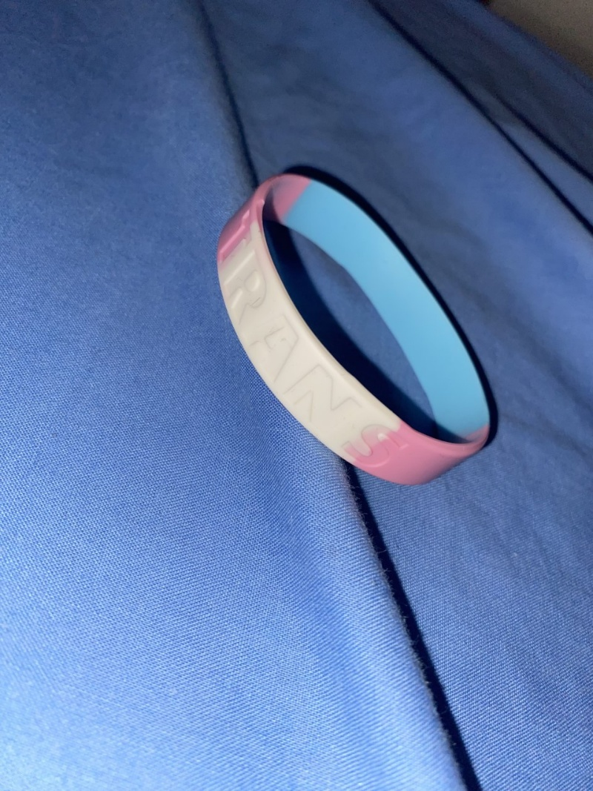
For a subgroup of participants, LGBTQ identity concealment related to their process of discovering, accepting and expressing their identities in life more broadly. Several participants reported not being aware that they were LGBTQ at the time of entering the workforce, describing how societal stigma and invisibilisation of queerness had prevented them from realising their identities. Ruby described her realisation:
I didn’t know that I was trans until I was at [later workplace]. So, it’s not like I didn’t feel safe to come out, but society was the main problem that stopped me realising … kept me from realising who I was.
(Ruby, gay transfem/transwoman, researcher, aged 27)
Figure 11.5
“I just wanted to represent the fact that I sort of hid my true self behind being straight at work because it was safer for me to do so.”
(Dylan, pansexual/demisexual non-binary transmasc person, peer education officer for LGBTQIA+ young people, aged 22)
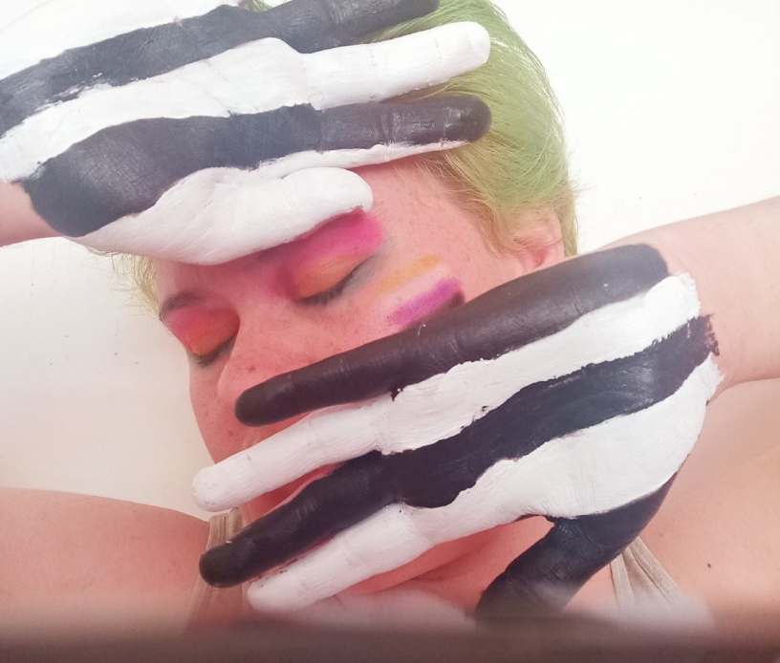
Participants’ reasons for hiding their identities included the fear of adverse reactions from others leading to potentially dangerous and unsafe situations. In Figure 11.5, Dylan represented their decision to “pass” as cisgender and heterosexual due to safety concerns while doing work in people’s homes. Fears of dangerous situations often stemmed from previous negative experiences and/or witnessing homophobia, transphobia or biphobia from others in the workplace. A typical experience was described by one survey respondent whose colleagues “have said homophobic comments in my presence [that], whilst not specially directed at me, have made me feel uncomfortable and unsafe to be open about my identity at work” (Gay/lesbian cis woman, aged 25). Other participants reported similar experiences:
Comments from middle-aged white cis women about not “getting” bisexuality or non-binary people while I am not even out at the workplace [made] me feel unsafe to come out, worthless, ashamed of my identity and hurt by people I considered to be good colleagues.
(Survey participant, bisexual non-binary and female-aligned woman, aged 23)

A few comments from two of my co-workers on using it as an insult, “That’s so gay,” made me stay closeted for 6 out of 10 months I’ve worked here.
(Survey participant, queer non-binary man, aged 16)
These comments echo the experiences of LGBTQ young people in schools, where “that’s so gay” is a common phrase used to denigrate objects, behaviours and ideas. This language adds to an unsafe and hostile climate for LGBTQ young people, whether in schools or the workplace (Hill et al., 2021; Robinson et al., 2014; E. Smith et al., 2014; Ullman, 2021).
Participants identified specific fears around the risk of discrimination, harassment (particularly sexual harassment), stereotyping, fetishisation, and being treated differently by others. These fears were often based on past experiences:
I was so nervous about coming out at work because the first time I ever came out at work, it was a trial for an apprenticeship, and they were ridiculously transphobic; they bullied me out of a job, and I quit in three days. That’s why I didn’t come out at the [sport/recreation facility] when I started here. I was just so nervous about coming out because I really love working for the [sport/recreation facility], because again, it’s an inclusive, good workplace with good pay. I really fit in with the team there, and I love working there, so I really didn’t want to fuck that up for myself.
(Tyler, bisexual trans man, customer services officer, aged 20)

I don’t often say to anyone that I’m bisexual or anything for the fear of just being sexualised instantly. Like, all those bi girls that have the story of, “Oh, as soon as I mentioned I was bi, they wanted a three-way,” kind of thing.]
(Blair, bisexual non-binary person, office worker, aged 19)
Although discrimination against LGBTQ people in the workplace is illegal, participants perceived discriminatory practices to be a genuine possibility. This risk was particularly true for those in precarious positions (e.g. casual employees) who felt they needed to remain on good terms with their superiors. The following comments typified these sentiments:
Being “out” as a student is difficult. I was unpaid; everyone was my superior and could grade me. Any single person had the power to screw me over with my grading. I could not be out because I did not know who was safe.
(Survey participant, asexual and aromantic non-binary person, aged 21)

I haven’t said directly to anyone, “Hi, I’m queer,” or I especially haven’t asked them to use my pronouns or told them that I’m non-binary because that’s just more headache than it’s worth being a casual employee. They could decide not to work with me for any fucking reason. So, I’m just trying to be as low-profile and unobtrusive as possible.
(Kendal, bisexual non-binary person, pole dance studio receptionist and medical receptionist, aged 26)
For LGBTQ young people who chose not to disclose their LGBTQ identity, identity concealment was laborious but essential in avoiding the potential harassment they would face as openly LGBTQ people in their workplaces.

11.7 Effort of education when coming out at work
Some participants pointed out that disclosing to others who lacked an understanding of LGBTQ identities often required them to step into an educational role. Some participants acknowledged this educational work as being beneficial for LGBTQ people coming into those workspaces, as articulated by Bailey (sexuality and gender queer person, working in academia, aged 24), who shared that “openly queer staff on the team who are already doing this stuff” had “paved the way for me” and other LGBTQ staff to be open about their identities. However, being the person doing this educational work was not always a positive experience. Many LGBTQ young people resented and wanted to avoid being placed into an educational role as it was often emotionally exhausting. This additional labour included justifying one’s identity and sharing aspects of one’s personal life that one did not wish to divulge to co-workers. For some young people, the risk of explaining, justifying or addressing inappropriate questions and comments often outweighed the potential benefits of disclosure, particularly if they did not expect others to be supportive or affirming in their response. Ashley typified this additional labour in the following comments:
I don’t feel unsafe being open; it’s just that I know that people are not necessarily going to respect my pronouns and things like that. It’s not that they have a problem with me as a person; they just don’t understand gender, and they’re not prepared to educate themselves about it.
(Ashley, bisexual non-binary person, medical health nurse, aged 27)
One interviewee, Page, described this additional labour as an “emotional or psychological risk”, reporting that their LGBTQ identities were not allowed to exist as is in the workplace but had to be justified and defended: “If you do talk about it, you become an advocate for it, and I don’t want to be fighting just to be who I am at my workplace” (Page, bisexual non-binary woman, client liaison officer, aged 24).
The lack of understanding of LGBTQ identities in the workplace often manifested in assumptions that participants were cisgender and/or heterosexual. They described how this placed them in a social bind, as correcting these assumptions risked awkward conversations requiring a level of delicacy that they did not always have the energy for, as indicated in the following comment:
I just don’t have the energy on a daily basis to advocate for myself to literally everyone I meet. It’s just not worth it … It’s just not a battle worth fighting for me, so I accept it. It’s fine … As someone who’s autistic, that added layer of, “This person just misgendered me. How do I go about correcting them in a socially appropriate way that’s correct for the workplace?” Way too much effort.
(Kendal, bisexual non-binary person, pole dance studio receptionist and medical receptionist, aged 26)
This additional labour was particularly the case for non-binary participants. Jett made the pertinent point that “the vast majority of cishet people, if they even know the word non-binary, just think it’s ridiculous” (Jett, bisexual non-binary transmasc person, occupation unknown, aged 28). The low level of understanding of gender and being non-binary meant that disclosure would “come with a lot of difficult comments and education work” (Survey participant, queer/questioning non-binary person, aged 24). Some viewed this issue as a generational matter, as Kendal’s comment highlighted:
For people of that [older] generation, gender was never a question. It was set in stone. So, when you come along and start asking questions, it breaks their brain. It’s like saying to them, “Oh, no. Gravity isn’t actually real, by the way. I can just float up in the air at any time,” and they’re like, “What the fuck?” It’s a guiding principle that has shaped their entire worldview for good or bad, and when you break that worldview, they can’t compute it.
(Kendal, bisexual non-binary person, pole dance studio receptionist and medical receptionist, aged 26)
Participants’ accounts of feeling timid, lacking confidence, or not having the energy to speak up and correct people about their perceptions of LGBTQ identities indicated a sense of danger to some participants, which influenced their decisions about disclosure in the workplace.

11.8 Personal impact of not disclosing gender and/or sexuality identity in the workplace
While participants had reasons for not disclosing their LGBTQ identities, which often related to preserving their safety and wellbeing (Ueno et al., 2024), it was evident that remaining closeted negatively impacted some LGBTQ young people (but not all; see Section 11.9). Participants described that not disclosing felt like keeping a secret and that they were not being authentic about who they were (Fletcher & Everly, 2021). Trans participants described a heightened discomfort when they were misperceived and misgendered, especially in contrast to other areas of their lives where they were affirmed in their gender: “[It’s] euphoric, in a way, when your pronouns are used correctly, and at work, you just don’t get that. They’re kind of pushed aside” (Blair, bisexual non-binary person, office worker, aged 19).
Dylan likewise drew a contrast between “who I actually am” and “who I say I am at work”, describing how:
… it was sometimes hard to switch from being super out, wearing the badges, wearing the pins, telling people about my identity to then I guess shoving it all back inside so that I could get on with the support work.
(Dylan, pansexual/demisexual non-binary transmasc person, peer education officer for LGBTQIA+ young people, aged 22)
Non-disclosure took a toll on some participants, who described how being misgendered “feels like shit because I know that’s not how I feel inside” (Blair, bisexual non-binary person, office worker, aged 19). Page described leaving a job because of the ongoing emotional toll of staying hidden:
That’s partly why I left, I think, because I was like, I can’t keep staying at this desk and people thinking I’m this person. It’s a lot about counselling and being authentic to yourself, and I was like, I can’t live like this just to pay the bills.
(Page, bisexual non-binary woman, client liaison officer, aged 24)
Participants who had concealed their sexuality also described additional stress around conversations where relationships or partners might be mentioned; they reported having to carefully navigate these discussions to steer away from potentially revealing topics without drawing attention to themselves:
It’s kind of annoying because I can’t just openly say. I just have to watch what I’m saying. It’s not exactly like walking on eggshells, but it’s just being careful of what I say.
(Blair, bisexual non-binary person, office worker, aged 19)
For some participants, this non-disclosure affected their relationships with others at work as they could not discuss the realities of their lives due to their cautiousness about what was shared about themselves. While LGBTQ young people often concealed their identities to preserve their safety, wellbeing and relationships, the hyper-caution required to stay “closeted” could itself compromise their comfort and connections with co-workers. Minority stress associated with homophobia and transphobia can also lead to feelings of shame among LGBTQ young people, impacting how safe they feel about being open about their identity in the workplace (Davies et al., 2021; Meyer, 2003).

11.9 Not needing to disclose LGBTQ identities in the workplace: Keeping personal and professional lives separate
For a significant subset of participants, the fact that they were not out at work was not due to the active concealment of LGBTQ identities. Instead, these respondents noted that details of their sexuality and/or gender had never been featured in workplace discussions. Mia commented, “It was not that I was choosing not to tell them; it just didn’t really ever come up” (Mia, gay cis woman, unemployed, aged 29). The reasons for this situation varied; for example, single people and those with different-gender partners found that casual disclosures through mentions of partners did not occur in the same way. Typically, these participants did not seem uncomfortable with either their lack of disclosure or the prospect of disclosing, should they be asked:
My thought was not like, “I’m going to deliberately hide myself because I don’t feel safe.” … I think if my colleagues asked me like, “Are you gay?” I’d probably be like, “No, but I’m bisexual.” I’ll happily talk about my sexuality. It’s just not come up in conversation, and I’m not going to be the one to broach it.
(Kendal, bisexual non-binary person, pole dance studio receptionist and medical receptionist, AGED 26)
For some participants, conversations with others at work never addressed LGBTQ identities because interactions were limited. Some workplaces were too busy for personal conversations or did not involve interacting with the same people for extended periods. Other participants did have ongoing working relationships but considered their LGBTQ identities irrelevant to their work and unnecessary to disclose. These participants spoke about preferring to keep their work and private lives separate, believing it was not anyone’s business and irrelevant to most people they worked with.
For some participants, the separation between professional and private lives was linked to workplace cultures that were impersonal, unfriendly and uncaring for workers. In more extreme examples, participants felt that management did not take staff seriously but cared more about making money. One participant felt pressured to “become a faceless blob to serve the needs of the large corporation” (Olivia, bisexual trans woman, manager, aged 29). A survey respondent who worked in a call centre reported being told by their supervisor that “individuality doesn’t exist and we are but robots” (Asexual demigirl, aged 23).
It is clear from the participant responses that the experience of not disclosing LGBTQ identities varies greatly between LGBTQ young people and between workplaces. While not all decisions about disclosure are related to safety and anti-LGBTQ hostility, and not all young people experience non-disclosure as a negative, concerns about safety and unsupportive responses discourage LGBTQ young people from being open about their identities. Many reported taking into consideration how LGBTQ-inclusive and affirming the workplace environment was when deciding whether to come “out” or be “out” in the workplace.

11.10 Gender transition and being “outed” at work
Despite participants’ careful considerations around the disclosure and concealment of their LGBTQ identities, the decision of whether to come out was not always under their control. Some participants found their identities were known by others in their workplace, having been disclosed (“outed”) by other people or systems, discovered from external sources, or made evident by affirming their gender while employed.
For trans people, it was not always possible to conceal their identity from others at work. This situation was particularly the case for those who affirmed their gender while already in the workplace. As Jamie said, “I kind of had to be [out] after a certain point” (Jamie, queer/bisexual non-binary transmasc person, counsellor, aged 28). Changes made to affirm their gender at a time when they were employed (e.g. changing names, binding their chest, taking hormones) were difficult to conceal from managers and co-workers. For participants who medically affirmed their gender, there was often a period where their changing appearance meant they were “sometimes passing [as cisgender], sometimes not”, as Alexander pointed out (bisexual trans man, lawyer, aged 26). This experience was described as uncomfortable and destabilising, particularly when it resulted in direct questioning by others:
[Disclosure] is definitely one of those things you can’t avoid. I won’t really mention it that much if no one knows, but if they know, you can’t really avoid it because people will straight up ask you what you identify as.
(Evan, lesbian non-binary person, logistics assistant, aged 20)
This discomfort was heightened when navigating binary-gendered systems, such as toilets and changerooms, as further described by Alexander:
… being really stressed out about using the urinal. Like, will it be noticed if I don’t do it? Do I have to bring in the gear [personal urination device/prosthetic] to do it? And then what if I’m still new to using the gear? What if I piss on my leg? And then, if I use the stall, does it sound different? Can they tell that I’m sitting down to piss? It was just constant stress, really … And so, I was living on [worksite] as a sometimes passing, sometimes not, trans person. And that was terrifying again.
(Alexander, bisexual trans man, lawyer, aged 26)
Some participants experienced reduced autonomy regarding disclosure of their gender as highly distressing, with one person stating, “I wish I could hide the fact I’m trans so this shit stopped happening, but no matter what I do, I don’t pass as my gender so everyone knows I’m trans” (Survey participant, bisexual Brotherboy, aged 28). However, even when young trans people were recognised as their identifying gender, this recognition did not necessarily guarantee that they had control over who knew they were trans. For example, trans survey respondents reported having to submit birth certificates with deadnames and gender markers and experiencing computer system errors that made their deadnames public. Even though these incidents did not necessarily result in ill-treatment, Omar highlighted “how uncomfortable that was … not really having the power to do it [disclose trans identity] my own way” (Omar, personality-attracted non-binary trans man, occupation unknown, aged 20).
This distress was also true for many participants who were outed by others in the workplace. In rare cases, this was done by making the participant out themselves:
… my boss forcing me to come out and then making me prove I was bisexual by listing women I slept with. Then using me as the poster child for the Pride Month morning tea.
(Survey participant, bisexual cis woman, aged 25)
However, it was more common for participants to disclose their LGBTQ identity selectively to managers or co-workers, who then shared this information without consent, sometimes until it became common knowledge in the workplace. The outing of participants was not necessarily done with malicious intent; for example, Evan was outed by managers in intended shows of allyship:
Every time I work in a place, I get outed between the higher-ups, which I don’t think they mean to be negative. They try and do it in a way of, “This person is trans, be nice.” But it’s also, I think, not being aware you have actually just outed me to people that might be unsafe … A lot of people, even some people that identify as gay and not necessarily transgender, they might not understand the idea of outing someone as trans to be dangerous.
(Evan, lesbian non-binary person, logistics assistant, aged 20)
Those who “outed” these young people, regardless of their intention, failed to recognise that for LGBTQ (particularly trans) young people, this outing not only deprives them of the agency and choice over whether to disclose but also places them in potentially dangerous situations. It is important to note that several participants considered these types of “outings” to be a form of sexual harassment.
Participants also reported instances of their LGBTQ identities becoming known when their social and work spheres unexpectedly intersected, making their identities visible. Several reported having co-workers or customers who knew them outside work, and who knew they were LGBTQ, including one survey respondent who “had people coming in and recognising me as ‘that tranny from primary school’” (Abrosexual trans man, aged 15). These personal and professional intersections also happened online, with participants describing how co-workers discovered their LGBTQ identity by finding their personal social media accounts or social media content from outside the workplace that linked them to LGBTQ communities or causes. These forms of outing were not necessarily experienced as adverse by participants; instead, their perception depended on the attitude and response of those to whom their gender and/or sexuality was disclosed.

11.11 Chapter summary
Participants’ assessments of workplace cultures shaped their decisions about disclosure and non-disclosure of LGBTQ identities. While not all LGBTQ young people wish to be “out” or openly LGBTQ at work, those who did often had to carefully navigate disclosure to manage the risk of adverse reactions, including anti-LGBTQ workplace sexual harassment. These fears compounded concerns associated with constantly assessing safety regarding disclosure of sexuality and/or gender diversity. These findings have clear implications for employers hoping to reassure LGBTQ workers regarding a safe work environment. While coming out should always be the individual’s decision, creating a supportive work environment characterised by embracing diversity and implementing and enforcing LGBTQ-inclusive policies and procedures would increase LGBTQ young people’s comfort and safety in the workplace.

Chapter 12
Discussion, implications and recommendations

12.1 Workplace cultures, infrastructures, systemic practices and workplace sexual harassment
Instances of WSH do not occur in a vacuum but are inextricably shaped by the workplace cultures in which they occur. “Workplace culture” refers to the structural and social contexts influencing how people behave and the social and organisational norms that are accepted and expected (Manley et al., 2011), and includes support for or hostility toward LGBTQ workers (Holman et al., 2019). It was common for participants in this study to report experiencing or witnessing anti-LGBTQ hostility at work. Indeed, the victimisation and WSH of LGBTQ young people were normalised in many contexts, contributing to workplace cultures that were unsafe for LGBTQ young people. Workplace cultures encountered by trans, non-binary and gender diverse young people in particular were often hostile, exclusive, unsafe and unsupportive spaces. These workplaces generally reflected cisheternormative values and practices stemming from broader socio-cultural relations of power that fostered misogyny, homophobia, transphobia and biphobia.
Workplace infrastructures, systemic practices and physical environments were reported by LGBTQ young people to facilitate queer-specific forms of WSH, creating particularly fraught and dangerous environments for young LGBTQ workers. Workplaces without gender-neutral bathrooms, those insisting on employees wearing gendered uniforms, and administrative systems that non-consensually disclosed employees’ LGBTQ identities and refused to use LGBTQ young employees’ chosen names and pronouns facilitated culturally unsafe workplaces for LGBTQ young people – especially for trans (binary and non-binary), non-binary and gender diverse young people. These issues may not be immediately recognised as endangering queer workers by non-LGBTQ (or even cisgender LGBQ) employers and managers, but nevertheless constitute unique risk factors for the WSH of LGBTQ young people.
Cultures where LGBTQ people are invisible, erased or actively victimised can enable WSH of young LGBTQ people. These workplaces typically lack appropriate and inclusive WSH policies and procedures to protect LGBTQ young people. Such workplace cultures compromise the safety of LGBTQ young people, impacting their health and wellbeing (Badgett et al., 2007; Holman et al., 2019; Velez et al., 2013). Conversely, LGBTQ-safe and -inclusive workplace cultures may help shield LGBTQ young people from WSH, facilitate reporting, enable appropriate responses to incidents, and act as protective factors against the impacts of WSH. Importantly, there is no clear delineation between safe/inclusive and hostile/unaccepting workplace cultures; instead, it is common for multiple elements to co-exist within the same environment. For example, a workplace might be generally supportive and accepting but have anti-LGBTQ clients. It is essential to attend to whose voices and perspectives are given precedence when determining whether a workplace is safe and accepting of LGBTQ people. Larger organisations may aspire to label themselves as inclusive and supportive. However, public statements and gestures of allyship do not necessarily translate into experiences of safety for young LGBTQ employees if internal workplace subcultures include ignorance, hostility and harassment, whether broadly or locally within specific sites, teams or divisions.
As raised in the Introduction, WSH is primarily officially addressed through WHS regulations and Commonwealth anti-discrimination legislation. Employers must be proactive about addressing WSH, including that experienced by LGBTQ young people. Recent changes to the Anti-Discrimination (Amendment) Act 1985 (Cth), including the introduction of the new “positive duty” policy, requires employers and persons conducting a business to take reasonable measures as far as possible to address sexual harassment and sex-based harassment (AHRC, 2022). These measures need to include addressing the WSH of LGBTQ young people and tackling the enablers of this behaviour within workplace cultures, infrastructures, practices and physical environments.

12.2 Is that workplace sexual harassment?
Almost all of the LGBTQ young people who participated in the survey indicated that the study’s definition of WSH aligned with what they understood as WSH. When indicating if they had experienced WSH, some who answered “No” to this question indicated experiencing at least one, if not several, of the listed examples of behaviours constituting WSH. Although LGBTQ young people were aware of the broad official definitions of WSH, when considering their own experiences within these definitions, considerable uncertainties arose.
LGBTQ young people often misrecognised the “uncomfortable” and “unwelcomed” sexualised and gender-based behaviours and comments they experienced, largely from co-workers, as not being WSH. Their uncertainties and misreadings were due to several factors. Firstly, WSH was understood to be a heterosexual issue, generally involving men using their organisational and/or cultural power to take advantage of women sexually, because of women often having less power in organisations and in society more broadly. These “traditional” dominant discourses of WSH, reinforced through media and often through WSH training modules in which cisheteronormative representations prevail, influence LGBTQ young people’s perceptions of WSH. Participants gave examples of what they viewed as “traditional” WSH, which reflected long enduring stereotypes, such as men slapping women on the bottom and bosses forcing women to have sexual relations, both epitomising the boss/secretary workplace power scenario. Secondly, the behaviours they experienced were more readily recognised by participants as being homophobia, biphobia and/or transphobia that many experienced daily, rather than behaviours also constituting WSH. There was limited awareness among young people of how sexual harassment intersects with homophobia, transphobia and biphobia, and how they can be experienced simultaneously. The pervasive and invasive questions asked by co-workers and some managers and supervisors about LGBTQ young people’s personal lives, relationships, bodies and sexual practices were more often viewed by some young people as examples of transphobia, homophobia and biphobia. Thirdly, the sexualised behaviours and comments were considered by some, particularly younger participants, as part of the sexualised cultures prevalent in some workplaces in which these behaviours are often normalised, rendering WSH invisible in these instances, especially when encountered among co-workers.
Participants felt that some perpetrators had not understood or recognised that their invasive questions and comments directed to LGBTQ young people in the workplace were offensive and inappropriate. Perpetrators were often perceived to have a sense of entitlement to the details of LGBTQ identities and relationships, which participants suggested contributed to unwanted and invasive interrogation and commentary on these subjects. Managers, supervisors and co-workers often did not recognise LGBTQ-specific sexual harassment as WSH, leading to inappropriate interventions and minimal support given to LGBTQ young people experiencing these behaviours.
What these uncertainties and misreadings suggest is that the prevalence of WSH of LGBTQ young people might be even higher than currently reported in population surveys of WSH (e.g. AHRC, 2018, 2020, 2022; Heywood et al., 2022).

12.3 Intersectional risk factors for workplace sexual harassment
The WSH experienced by LGBTQ young people was impacted and compounded by intersectional factors that increased their vulnerability to these behaviours. Gender, age and sexuality were perceived to be the most significant of these factors for the young people in this study. Gender was considered the most significant factor leading to participants’ experiences of WSH, followed by age, and then sexual orientation. The significance of gender was borne out in the findings, with cisgender women, and other young people perceived to be female regardless of their gender identity, experiencing WSH most frequently. However, most (70%) participants felt that they were targeted due to more than one of these factors – that is, gender, age and sexuality all contributed to their experiences of WSH. Disability was also a risk factor intersecting with gender, sexuality and age to increase LGBTQ young people’s vulnerability to WSH. Intersectionality, demonstrated through the experiences of LGBTQ young people, highlights the multiple and intersecting socio-cultural forms of power operating around gender, age, sexuality, disability and employment status (among others, such as race, ethnicity and socio-economic status), compounding vulnerability to discrimination and WSH (Lombardo et al., 2017; Tolhurst et al., 2012).
Intersections between sexual harassment and age can work in two core, powerful ways. Firstly, young people can experience greater vulnerability to WSH as many are inexperienced in negotiating workplace cultures, and are often employed in casual or part-time, lower-paid and less secure employment. They are also predominantly employed in sectors that are customer-service related, as were the participants in this study (e.g. accommodation and food services, retail trade, and administration and support services). LGBTQ young people spoke about being expected by employers to serve customers without question or complaint regardless of customers’ inappropriate behaviours, some of which constituted WSH.
Secondly, age can also operate to dismiss the sexual harassment perpetrated by younger people. LGBTQ teachers in this study experienced WSH from students in schools, but it was generally not viewed or treated as WSH, which is largely considered to be behaviours between adults in school contexts. LGBTQ teachers are often the recipients of inappropriate gender- and sexuality-based comments and intrusive personal questions from students in their workplaces, like LGBTQ employees who encounter these behaviours from co-workers, managers, supervisors and clients/customers in other workplaces (Robinson, 2000, 2012; Ullman & Smith, 2018). The sexual harassment experienced by students from other students is framed in discourses of bullying (Lei et al., 2019), which also has implications for how this behaviour is perceived and addressed. Bullying discourses desexualise, simplify and individualise complex social and cultural phenomena (Payne & Smith, 2013; Ringrose & Renold, 2010), especially sexual harassment. The failure to acknowledge students’ engagement in sexual harassment of teachers, other school personnel and peers contributes to the unabated rollover of these behaviours from school to the workplace, and the perpetuation of these behaviours in the broader community (Hunt et al., 2024).

12.4 Workplace sexual harassment disclosure and reporting
Few LGBTQ young people officially reported their experiences of WSH. This was primarily due to a lack of trust in workplace reporting procedures. Reasons for this mistrust included their anticipation that others would not see their experiences as legitimate or worthy incidents, inaccessible reporting pathways, and anticipated outcomes that would disproportionately impact the victims and survivors rather than the perpetrator/s. LGBTQ young people’s reports of WSH were more commonly dismissed, ignored or not actioned appropriately than actioned in a safe, supportive and confidential manner. Therefore, it is unsurprising that three quarters (75%) of LGBTQ young people chose not to formally report their experiences of WSH, instead often choosing to leave their jobs.
The unique experiences of LGBTQ young people in seeking support and making reports after WSH reveal explicit cisheteronormative biases in the systems intended to support victims and survivors in the workplace. LGBTQ young people often described the pressure of being identifiable as the only LGBTQ person in their workplace, which compromised the confidentiality of their reports. Many LGBTQ people recognised that making a report would require them to come out in a potentially unsafe environment. Notably, those involved in actioning reports were often unable to conceive how LGBTQ young people experienced WSH, requiring LGBTQ young people not only to report their experiences but also to explain how and why the harassment was inappropriate and impactful. Such additional explanation was often too great a barrier for LGBTQ young people to overcome as the explanation was not only laborious but could also be re-traumatising. Correspondingly, the most constructive workplace outcomes reported by LGBTQ young people did not originate from formal procedures but instead from close co-workers’ emotional and practical support.

12.5 Workplace sexual harassment training
Most LGBTQ young people in this study were overwhelmingly negative about the training they received on WSH. Most had minimal training, with some not having had training at all, especially casual and part-time workers, and those working in smaller independent businesses. Those receiving training were often critical of the online modules they were required to complete, which were generally reported as being unhelpful, unengaging, unmemorable and heteronormative. There was minimal relevance to the experiences and issues faced by LGBTQ young people in WSH. For most it was a regulatory task rather than an educational experience. The few participants who were positive about the workplace training they had undertaken pointed out that it was comprehensive, inclusive of LGBTQ people, conducted face-to-face, and addressed grey areas of WSH through interactive group discussions.

12.6 Implications and recommendations
In the light of the new positive duty regulation required of business owners and workplace managers, the findings from this study have important implications for addressing policy, reporting procedures, handling of reports and training in relation to WSH of LGBTQ young people (with implications more generally for young people). Several recommendations have direct alignment with the First Action Plan 2023–2027 (the First Action Plan) of the National Plan to End Violence against Women and Children 2022–2032 (the National Plan).

12.6.1 Research implications and recommendations for policy and practice at a societal level
There is a need at the societal level to address misogyny, homophobia, biphobia and transphobia, which are integral to much workplace sexual harassment encountered by LGBTQ young people.
A national anti-sexual harassment public campaign funded by Commonwealth, state and territory governments is required to address the culture of sexual harassment that prevails broadly in Australian society. The campaign needs to increase community awareness and understandings of sexual harassment across various contexts and challenge attitudes facilitating this behaviour. The campaign needs to address sexual harassment prevalence, sexual harassment behaviours, intersectionality and misconceptions of sexual harassment. The campaign needs to be co-designed with key stakeholders from diverse communities, peak bodies and NGOs.
This campaign aligns with Action 6 of the First Action Plan of the National Plan – preventing and addressing sexual violence and harassment in all settings.

Recommendation 1
Government departments with relevant portfolios (e.g. Education, Health, Justice, Social Services, Sports) at Commonwealth, state and territory levels should commit financially to and undertake a national community-wide media campaign to increase awareness about sexual harassment across different contexts, such as the workplace, education, health and sports. This needs to include how sexual harassment intersects with homophobia, transphobia and biphobia and intersectional factors such as gender, gender diversity, sexuality, age, ethnicity, race and employment status to increase vulnerability to this behaviour.

Recommendation 2
Government departments with relevant portfolios (e.g. Health, Education, Justice, Social Services, Work Health and Safety) at the Commonwealth and state and territory levels should work with relevant experts, peak bodies, NGOs, LGBTQ young people with lived experience and civil society to improve WSH literacy among all employees and employers, with a focus on the needs of young employees and LGBTQ young people. This includes investment in developing co-designed resources with LGBTQ young people, and young people generally, to improve workplace safety and sexual harassment literacy among all key stakeholders in the workplace.

Recommendation 3
Government, industry, NGOs and small business owners need to work together to develop policies and practices that more readily protect young employees who are casual, part-time or on short term contracts, to ensure their greater job security and workplace safety.

Recommendation 4
Government departments with relevant portfolios (e.g. Health, Aged Care, Education, Work Health and Safety) need to work with key stakeholders working in health, aged care and disability to address the sexual harassment encountered by employees, especially young employees working with clients in family homes, aged care homes, hospitals and other organisations caring for people with disability. Addressing sexual harassment in these sectors needs to include specific education for client groups and workers in these fields, the development of best practice strategies to deal with sexual harassment from clients, and a review of policies and reporting procedures and practices in organisations.

12.6.2 Research implications and recommendations for policy and practice in the workplace
At a workplace systems level, there is a need for the following.
Ensure that workplace cultures are safe, supportive and inclusive of LGBTQ people. As this research shows, LGBTQ young people often feel unsafe at work and generally do not trust organisations to have their wellbeing at heart. Developing culturally safe and inclusive workplaces for LGBTQ young people is core to actioning the positive duty in addressing WSH and other forms of discrimination. Successful organisational and workplace management and leadership includes the ability to foster positive, safe and inclusive workspaces, both online and offline, for all employees (Manley et al., 2011). This includes developing a culture of respect for gender equity and diversity and an awareness of respectful and ethical relationships between employers and employees, among co-workers, and between employees and clients or customers. Using visual forms of support for LGBTQ people is an effective way to foster their sense of inclusion and belonging (Robinson et al., 2020). Positive, non-discriminatory and equality-focused workplace cultures emphasising social justice values and practices can help reduce workplace sexual harassment.
Include workplace training on respectful relationships and LGBTQ identities. Fostering cisgender and heterosexual employees’ and managers’ awareness of LGBTQ identities can reduce LGBTQ people needing to do this additional emotional labour in often already difficult workplaces. It can also foster LGBTQ allies, which were important relationships identified by LGBTQ young people in making them feel supported and safe in their workplaces.
Incorporate a more comprehensive, evidence-based focus on WSH of LGBTQ young people in the mandatory training required of managers and employees about WSH. Based on LGBTQ young people’s comments about training, a combination of online modules followed by an interactive face-to-face workshop with an external expert trainer/facilitator is a more effective approach to WSH training than they reported receiving.
Review current organisational policies and reporting pathways for workplace sexual harassment, considering evidence-based best practices. Having clear codes of conduct, policies and confidential reporting pathways of which all employees are aware is crucial for effective interventions into workplace sexual harassment. It is important that policies and procedures are inclusive of LGBTQ employees’ specific needs, especially in terms of their experiences of WSH and for confidentiality. Reporting procedures need to be included to accommodate cases where the perpetrator is a manager or superior, who may be part of the line of reporting. Current options available for employees to confidentially seek advice from, and/or report to, an independent organisation about WSH need to be included in information provided to employees. It is also important that individual workplace procedures regarding reporting of WSH are regularly reviewed and evaluated for efficiency, outcomes and user-friendliness. Workplace policies, such as those related to WSH, need to be “living” documents – that is, part of employees’ regular education information sessions about respectful and ethical relationships. The care of employees must be at the core of WSH policies and practices.

Recommendation 5
All workplaces should actively ensure on an ongoing basis that workplace cultures, both online and offline, are safe, supportive and inclusive of all employees, including LGBTQ employees. This should include regular compulsory training on respectful and ethical relationships at work (a combination of an online module followed by an interactive face-to-face workshop with an external expert trainer/facilitator). Approaches to workplace safety need to address homophobia, transphobia, racism, ableism, and other sites of inequality and power. Regular messaging to all managers, employees and clients/customers about being respectful to all employees is essential. Using visual supports for LGBTQ people (e.g. rainbow stickers and lanyards) fosters inclusion.

Recommendation 6
All workplaces should be required to review and evaluate policies, practices, reporting procedures and training regarding WSH and workplace diversity on a regular basis (every 3 years). The review needs to include a particular focus on ensuring the needs of LGBTQ employees across all ages are considered. A report outlining the review process undertaken and its outcomes needs to be submitted to the appropriate peak body relevant to the workplace. This report should include what relevant strategies were developed and invested in to enhance WSH literacy among employees, and to develop culturally safe and inclusive workplace practices for LGBTQ people, especially young people (e.g. best practice approaches to training and fostering workplace ally programs for LGBTQ young people).

Recommendation 7
All workplaces should be required to provide information on WSH policies and reporting pathways in workplace inductions for all employees, with attention paid to ensuring this information is accessible to casual employees who may have limited contact with the workplace intranet.

Recommendation 8
Key stakeholders working in largely public-facing workplaces (such as those in accommodation and food services, retail, and administration and support services) that employ large numbers of young employees, including LGBTQ young people, need to develop strategies to address the specific sexual harassment that young people encounter from clients/customers. This needs to be a committed approach by workplaces to prevent and support their employees in these instances. This support needs to be publicly shown through visual signs saying sexual harassment of staff (or other customers) will not be tolerated and that such cases will be escalated for action to the highest authority in the organisation.

12.6.3 Research implications and recommendations for educational interventions – Schools, universities and professional training institutions
The findings of this study indicate that sexual harassment is a practice that is engaged in early in life prior to young people entering the workplace, such as in school settings. As identified in the First Action Plan of the National Plan, early intervention is key to changing the attitudes that facilitate sexual harassment and other forms of violence directed at women and girls – and this is also the case for sexual harassment and violence against LGBTQ people. Action 1 (advancing gender equality and addressing the drivers of all forms of gender-based violence) and Action 6 (preventing and addressing sexual harassment in all settings) of the First Action Plan are relevant here.

Recommendation 9
Government (federal, state and territory) departments of education and training need to undertake an audited review of current policies, training, reporting practices and other compliances related to sexual harassment in all schools, universities and training sectors regarding student-to-student and student-to-teacher sexual harassment. This review will map if and how sexual harassment is being addressed across each of these education sectors, showing gaps and discrepancies requiring interventions. This audit should result in a strategic plan to address issues, gaps and discrepancies found across the sectors.

Recommendation 10
State and territory education departments (government, independent, Catholic) must take a whole-of-school, community-based approach to addressing sexual harassment in schools. This includes developing and implementing an anti-sexual harassment compulsory education component in the Respectful Relationships Education in Schools (RREiS) program across primary and secondary curricula. Anti-sexual harassment education must consist of up-to-date, evidence-based research and classroom instruction; be conducted in a supportive environment; and involve consultation with content experts. The program needs to be of sufficient duration; incrementally developed from early primary; address how sexual harassment is relevant across age groups; and include discussion of gender, gender equality, gender and power, diverse identities, respectful relations and consent.

12.7 Limitations of this research
The research included a cross-sectional survey, from which it is difficult to derive casual relationships. The findings are a one-time measurement and cannot be used to analyse experiences over a period of time. Some participants spoke about recent experiences of WSH, whereas others spoke about less recent experiences. This discrepancy may have resulted in some variation across participants’ capacity to recall their experiences and contextualise the outcomes. While the survey and interview samples included participants from many diverse gender and sexuality identities, the sample is over-represented with cisgender women and transgender men. Transgender women and cisgender men are under-represented. This outcome may have been due to several factors: women are generally more willing to fill out surveys (W. G. Smith, 2008); men may be less likely to view WSH as relevant to them; and men may be less willing to admit being a “victim” or “survivor” of WSH due to emasculating discourses often associated with men as victims of sexual violence (Thomas & Kopel, 2023). In addition, there was an over-representation of participants from metropolitan areas, and fewer participants from smaller states and territories, such as the Northern Territory, potentially reflecting the larger numbers of LGBTQ people living and working in metropolitan regions in more populated states and territories.
It is also important to note that participants often had overlapping demographic categories, including sexuality, gender, disability status, ethnic/cultural background and employment status. This overlap made it difficult to statistically explore intersectional effects as participants would often identify themselves as a member of multiple marginalised groups, and due to the focus of the study participants would often focus on their LGBTQ identity–related experiences in their written responses. Despite these sample-related shortcomings, the mixed methods approach of the project allowed qualitative data to give voice to statistically under-represented participants.

12.8 Strengths of this research
Core strengths of the research included, firstly, the large sample sizes for both the survey and interview components, producing a large corpus of mixed methods data. Secondly, the survey design often matched quantitative items with a corresponding qualitative open-response question. This allowed the collection of quantitative data while also providing participants the opportunity to expand in their own words on the topic of the question, thus collecting overall prevalence data alongside specificity of individual experiences. Thirdly, the research included diverse voices of LGBTQ young people’s experiences of WSH, including good representation of people with disability and from diverse cultural and ethnic backgrounds.

12.9 Future research
Future research on LGBTQ young people’s experiences of workplace sexual harassment could address the following areas: 1) specific experiences of trans women and gay cisgender men; 2) longitudinal research exploring workplace sexual harassment of LGBTQ young people, to gain a greater understanding of the barriers to and facilitators of this behaviour in the workplace; and 3) the development of intervention strategies into LGBTQ young people’s workplace sexual harassment based on current research that can be implemented and evaluated in relevant real world settings, with the aim of scaling up successful interventions.

Chapter 13
Conclusion
This report has addressed the findings of the #SpeakingOut@Work research project exploring LGBTQ young people’s experiences of sexual harassment in the workplace. The project aimed to: 1) understand the nature of LGBTQ young people’s experiences of workplace sexual harassment; 2) investigate LGBTQ young people’s perceptions of this behaviour, the impact it had on them, and their responses to these incidents; 3) gain a greater understanding of LGBTQ young people’s reporting experiences related to sexual harassment in the workplace; and 4) ascertain the extent of LGBTQ young people’s knowledge of workplace sexual harassment policies in their workplaces and of their access to training in this area. The research also aimed to explore how intersecting social inequalities, such as age, gender and sexuality, impact LGBTQ young people’s experiences of sexual harassment in the workplace. The research comprised a mixed methods design, including a national online survey completed by 1,001 LGBTQ young people, semi-structured interviews conducted with 40 participants, and a photo story exercise completed by 8 young people, in which they developed and shared images that represented or conveyed their feelings about their experiences of sexual harassment experienced in the workplace.
For some LGBTQ young people in this study, sexual harassment was often a grey area in terms of experiences of unwelcome, unwanted and inappropriate sex-, gender- and sexuality-based behaviours from co-workers, managers, supervisors, and clients or customers. These behaviours were often encountered in everyday interactions and conversations with co-workers and customers in some workplaces where sexual harassment was inherent to workplace cultures and integral to sociality among co-workers. Many LGBTQ young people were unsure if their experiences were sexual harassment or just part of the homophobia, biphobia and transphobia that many of these young people also frequently encountered in the workplace and in broader society. As one young person expressed, they were uncertain if it was just another encounter of “everyday garden variety” homophobia, biphobia and transphobia.
This research has identified key facilitators in the workplace that contribute to the persistently high rates of sexual harassment experienced by LGBTQ young people from co-workers, managers and clients/customers. From this evidence, the implications and recommendations included in this report address core areas that, if adopted across a broad range of government, industry, NGOs and workplaces, would make a significant difference, not just for LGBTQ young people but for all employees.

Author contributions
Kerry H. Robinson: Project leadership, conceptualisation, methodology, formal analysis, writing – original draft, writing – review and editing, supervision, project administration, funding acquisition.
Kimberley Allison: Methodology, formal analysis, investigation, data curation, writing – original draft, writing – review and editing, visualisation, project administration.
Emma F. Jackson: Formal analysis, investigation, data curation, writing – original draft, writing – review and editing, visualisation.
Cristyn Davies: Conceptualisation, methodology, writing – original draft, writing – review and editing, funding acquisition.
Erika K. Smith: Methodology, formal analysis, investigation, project administration.
Alex Hawkey: Conceptualisation, writing – original draft, writing – review and editing, funding acquisition.
Jane Ussher: Conceptualisation, methodology, writing – review and editing, funding acquisition.
Jacqueline Ullman: Conceptualisation, methodology, writing – review and editing, funding acquisition.
Brahmaputra Marjadi: Conceptualisation, methodology, writing – review and editing, funding acquisition.
Paul Byron: Conceptualisation, methodology, writing – review and editing, funding acquisition.

References
ACON. (2024). Glossary of LGBTQ+ terms. ACON Pride Training. Retrieved July 19, 2024, from https://www.pridetraining.org.au/pages/glossary-of-lgbtq-terms
Allison, K. R. (2020). Navigating negativity in research: Methodological and ethical considerations in the study of antisocial, subversive and toxic online communities and behaviours. Fourteenth International AAAI Conference on Web and Social Media (Vol. 14). Association for the Advancement of Artificial Intelligence. https://doi.org/10.36190/2020.11
Anti-Discrimination (Amendment) Act 1985 (Cth).
Australian Bureau of Statistics. (2006). The detailed classification: Australian and New Zealand Standard Industrial Classification (Rev. 2.0). ABS. https://www.abs.gov.au/statistics/classifications/australian-and-new-zealand-standard-industrial-classification-anzsic/2006-revision-2-0/detailed-classification
Australian Human Rights Commission. (2017). Change the course: National report on sexual assault and sexual harassment at Australian universities. AHRC. https://humanrights.gov.au/our-work/sex-discrimination/publications/change-course-national-report-sexual-assault-and
Australian Human Rights Commission. (2018). Everyone’s business: Fourth national survey on sexual harassment in Australian workplaces. AHRC. https://humanrights.gov.au/our-work/sex-discrimination/publications/everyones-business-fourth-national-survey-sexual
Australian Human Rights Commission. (2020). Respect@Work: National Inquiry into Sexual Harassment in Australian Workplaces. AHRC. https://humanrights.gov.au/our-work/sex-discrimination/publications/respectwork-sexual-harassment-national-inquiry-report-2020
Australian Human Rights Commission. (2022a). Respect@Work – Changes to the Sex Discrimination Act 1984 and the Australian Human Rights Commission Act 1986 [Fact sheet]. AHRC. https://humanrights.gov.au/our-work/complaint-information-service/fact-sheet-respectwork-changes-sex-discrimination-act-1984-ahrc-act-1986-december-2022
Australian Human Rights Commission. (2022b). Time for respect: Fifth national survey on sexual harassment in Australian workplaces. AHRC. https://humanrights.gov.au/time-for-respect-2022
Australian Institute of Health and Welfare. (2009). Measuring the social and emotional wellbeing of Aboriginal and Torres Strait Islander peoples (Cat no. IHW 24). AIHW. https://www.aihw.gov.au/reports/indigenous-australians/measuring-the-social-and-emotional-wellbeing/summary
Australian Institute of Health and Welfare. (2022). People with disability in Australia 2022 (Cat. no. DIS 72). AIHW. https://www.aihw.gov.au/reports/disability/people-with-disability-in-australia/archived-content/2022-report
Badgett, M. V. L., Lau, H., Sears, B., & Ho, D. (2007). Bias in the workplace: Consistent evidence of sexual orientation and gender identity discrimination. Williams Institute. https://williamsinstitute.law.ucla.edu/publications/bias-in-the-workplace/
Baker, S. J., & Lucas, K. (2017). Is it safe to bring myself to work? Understanding LGBTQ experiences of workplace dignity. Canadian Journal of Administrative Sciences, 34(2), 133–148. https://doi.org/10.1002/cjas.1439
Blackstone, A., Houle, J., & Uggen, C. (2014). “I didn’t recognize it as a bad experience until I was much older”: Age, experience, and workers’ perceptions of sexual harassment. Sociological Spectrum, 34(4), 314–337. https://doi.org/10.1080/02732173.2014.917247
Bondestam, F., & Lundqvist, M. (2020). Sexual harassment in higher education – A systematic review. European Journal of Higher Education, 10(4), 397–419. https://doi.org/10.1080/21568235.2020.1729833
Bowleg, L. (2008). When black + lesbian + woman ≠ black lesbian woman: The methodological challenges of qualitative and quantitative intersectionality research. Sex Roles, 59(5), 312–325. https://doi.org/10.1007/s11199-008-9400-z
Bowleg, L. (2012). The problem with the phrase women and minorities: Intersectionality – An important theoretical framework for public health. American Journal of Public Health, 102(7), 1267–1273. https://doi.org/10.2105/ajph.2012.300750
Braun, V., & Clarke, V. (2006). Using thematic analysis in psychology. Qualitative Research in Psychology, 3(2), 77–101. https://doi.org/10.1191/1478088706qp063oa
Braun, V., & Clarke, V. (2019). Reflecting on reflexive thematic analysis. Qualitative Research in Sport, Exercise and Health, 11(4), 589–597. https://doi.org/10.1080/2159676X.2019.1628806
Braun, V., & Clarke, V. (2021). Thematic analysis: A practical guide. Sage. https://uwe-repository.worktribe.com/output/9004204
Brown, B., Myers, D., Casteel, C., Rauscher, K. (2020). Exploring differences in the workplace violence experiences of young workers in middle and late adolescence in the United States. Journal of Safety Research, 74, 263–269. https://doi.org/10.1016/j.jsr.2020.06.008
Burn, S. M. (2019). The psychology of sexual harassment. Teaching of Psychology, 46(1), 96–103. https://doi.org/10.1177/0098628318816183
Cahill, H., Lusher, D., Farrelly, A., Calleja, N., Wang, P., & Hassani, A. (2023). A social network analysis and implementation study of an intervention designed to advance social and emotional learning and respectful relationships in secondary schools (Research report, 07/2023). ANROWS. https://www.anrows.org.au/publication/respectful-relationships-research-report/
Crenshaw, K. (1989). Demarginalizing the intersection of race and sex: A Black feminist critique of antidiscrimination doctrine, feminist theory and antiracist politics. University of Chicago Legal Forum, 1989, Article 8. http://chicagounbound.uchicago.edu/uclf/vol1989/iss1/8
Dahanayake, P., Selvarajah, C., & Rajendran, D. (2023). Capturing the missing voices: A “fair go” for sexual and gender diverse minority employees in Australian workplaces. Australian Journal of Management, 48(4), 711–731. https://doi.org/10.1177/03128962231176332
Dalton, E. (2019). A feminist critical discourse analysis of sexual harassment in the Japanese political and media worlds. Women’s Studies International Forum, 77, Article 102276. https://doi.org/10.1016/j.wsif.2019.102276
Davies, C., Robinson, K. H., & Kang, M. (2023). An approach to developing shared understandings of consent with young people. In L. James-Hawkins & R. Ryan-Flood (Eds.), Consent: Gender, power and subjectivity (pp. 118–135). London. https://doi.org/10.4324/9781003358756
Davies, C., Robinson, K. H., Metcalf, A., Ivory, K., Mooney-Somers, J., Race, K., & Skinner, S. R. (2021). Australians of diverse sexual orientations and gender identities. In T. Dune, K. McLeod, & R. Williams (Eds.), Culture, diversity and health in Australia: Towards culturally safe health care (pp. 213–231). Routledge. https://doi.org/10.4324/9781003138556
Department of Social Services. (2022). National Plan to End Violence against Women and Children 2022–2032. Commonwealth of Australia. https://www.dss.gov.au/ending-violence
Donaghy, M., & Perales, F. (2024). Workplace wellbeing among LGBTQ+ Australians: Exploring diversity within diversity. Journal of Sociology, 60(1), 155–174. https://doi.org/10.1177/14407833221118383
Duguay, S. (2016). “He has a way gayer Facebook than I do”: Investigating sexual identity disclosure and context collapse on a social networking site. New Media & Society, 18(6), 891–907. https://doi.org/10.1177/1461444814549930
Farley, L. (1978). Sexual shakedown: The sexual harassment of women on the job. McGraw-Hill.
Ferfolja, T., & Ullman, J. (2020). Australia and a culture of limitation for gender and sexuality diversity. Gender and sexuality diversity in a culture of limitation: Student and teacher experiences in schools (1–33). Routledge. https://doi.org/10.4324/9781315161686-1
Gauci, P., Elmir, R., O’Reilly, K., & Peters, K. (2022). Women’s experiences of workplace gender discrimination in nursing: An integrative review. Collegian, 29(2), 188–200. https://doi.org/10.1016/j.colegn.2021.08.003
Gavey, N. (1997). Feminist poststructuralism and discourse analysis. In M. M. Gergen & S. N. Davis (Eds.), Toward a new psychology of gender (pp. 49–64). Routledge. https://doi.org/10.4324/9781315811505
Government Equalities Office. (2018). National LGBT survey: Research report. UK Government. www.gov.uk/government/consultations/national-lgbt-survey
Gruber, J. E., & Fineran, S. (2008). Comparing the impact of bullying and sexual harassment victimization on the mental and physical health of adolescents. Sex Roles, 59, 1–13. https://doi.org/10.1007/s11199-008-9431-5
Hankivsky, O., Cormier, R., & de Merich, D. (2009). Intersectionality: Moving women’s health research and policy forward. Women’s Health Research Network. https://cewh.ca/wp-content/uploads/2012/05/2009_IntersectionaliyMovingwomenshealthresearchandpolicyforward.pdf
Hankivsky, O., Reid, C., Cormier, R., Varcoe, C., Clark, N., Benoit, C., & Brotman, S. (2010). Exploring the promises of intersectionality for advancing women’s health research. International Journal for Equity in Health, 9(1), Article 5. https://doi.org/10.1186/1475-9276-9-5
Harper, D. (2002). Talking about pictures: A case for photo elicitation. Visual Studies, 17(1), 13–26. https://doi.org/10.1080/14725860220137345
Hesse-Biber, S. N., & Griffin, A. J. (2016). Feminist approaches to multimethod and mixed methods research: Theory and praxis. In S. N. Hesse-Biber & R. B. Johnson (Eds.), The Oxford handbook of multimethod and mixed methods research inquiry. Oxford Academic. https://doi.org/10.1093/oxfordhb/9780199933624.013.6
Heywood, W., Myers, P., Powell, A., Meikle, G., & Nguyen, D. (2022). National Student Safety Survey: Report on the prevalence of sexual harassment and sexual assault among university students in 2021.
The Social Research Centre. https://universitiesaustralia.edu.au/wp-content/uploads/2022/03/2021-NSSS-National-Report.pdf
Hill, A. O., Lyons, A., Jones, J., McGowan, I., Carman, M., Parsons, M., Power, J., & Bourne, A. (2021). Writing Themselves In 4: The health and wellbeing of LGBTQA+ young people in Australia. Australian Research Centre in Sex, Health and Society, La Trobe University. https://www.latrobe.edu.au/__data/assets/pdf_file/0010/1198945/Writing-Themselves-In-4-National-report.pdf
Hill Collins, P. (1999). Moving beyond gender: Intersectionality and scientific knowledge. In M. M. Ferree, J. Lorber, & B. B. Hess (Eds.), Revisioning gender (pp. 261–284). Sage.
Hill Collins, P., & Bilge, S. (2016). Intersectionality. Polity Press.
Holman, E. G., Fish, J. N., Oswald, R. F., & Goldberg, A. (2019). Reconsidering the LGBT Climate Inventory: Understanding support and hostility for LGBTQ employees in the workplace. Journal of Career Assessment, 27(3), 544–559. https://doi.org/10.1177/1069072718788324
Human Rights Campaign. (2018). 2018 LGBTQ youth report. Human Rights Campaign. https://www.hrc.org/resources/2018-lgbtq-youth-report
Hunt, G. R., Higgins, D. J., Willis, M. L., Mathews, B., Lawrence, D., Meinck, F., Pacella, R., Thomas, H. J., Scott, J. G., Erskine, H. E., Malacova, E., & Haslam, D. M. (2024). The prevalence of peer sexual harassment during childhood in Australia. Journal of Interpersonal Violence. Advance online publication. https://doi.org/10.1177/08862605241245368
Jane, E. A. (2015). Flaming? What flaming? The pitfalls and potentials of researching online hostility. Ethics and Information Technology, 17, 65–87. https://doi.org/10.1007/s10676-015-9362-0
Kahalon, R., Becker, J. C., & Shnabel, N. (2022). Appearance comments presented as compliments at work: How are they perceived by targets and observers in and outside of workplace settings? Journal of Applied Social Psychology, 52(8), 751–762. https://doi.org/10.1111/jasp.12732
Kelly, L. (1988). Surviving Sexual Violence. Polity Press.
Kiekens, W. J., Baams, L., Fish, J. N., & Watson, R. J. (2021). Associations of relationship experiences, dating violence, sexual harassment, and assault with alcohol use among sexual and gender minority adolescents. Journal of Interpersonal Violence, 37(17–18), NP15176–NP15204. https://doi.org/10.1177/08862605211001469
Kim, B., Jung, S. H., Jang, S. H., Lee, B., Rhee, E., Cho, S. H., & Lee, S. M. (2014). Construction and initial validation of the Planned Happenstance Career Inventory. Career Development Quarterly, 62(3), 239–253. https://doi.org/10.1002/j.2161-0045.2014.00082.x
Köllen, T. (2016). Sexual orientation and transgender issues in organizations: Global perspectives on LGBT workforce diversity. Springer Cham.
Kosciw, J. G., Clark, C. M., & Menard, L. (2022). The 2021 National School Climate Survey: The experiences of LGBTQ+ youth in our nation’s schools. GLSEN. https://www.glsen.org/sites/default/files/2022-10/NSCS-2021-Full-Report.pdf
Kothari, A., & Wathen, C. N. (2017). Integrated knowledge translation: Digging deeper, moving forward. Journal of Epidemiology & Community Health, 71(6), 619–623. https://doi.org/10.1136/jech-2016-208490
Lall, M. D., Bilimoria, K. Y., Lu, D. W., Zhan, T., Barton, M. A., Hu, Y.-Y., Beeson, M. S., Adams, J. G. Nelson, L. S., & Baren, J. M. (2021). Prevalence of discrimination, abuse, and harassment in emergency medicine residency training in the US. JAMA Network Open, 4(8), Article e2121706. https://doi.org/10.1001/jamanetworkopen.2021.21706
Lam, K., Harris, A., Hartup, M., Collin, P., Third, A., & Quek, S.-L. (2022). Social issues and diverse young Australians: A report on key challenges and young people’s concerns. Centre for Resilient and Inclusive Societies, Deakin University. https://www.crisconsortium.org/lit-reviews/social-issue-diverse-young-australians
Lei, X., Bussey, K., Hay, P., Mond, J., Trompeter, N., Lonergan, A., & Mitchison, D. (2019). Prevalence and correlates of sexual harassment in Australian adolescents. Journal of School Violence, 19(3), 349–361. https://doi.org/10.1080/15388220.2019.1699800
Liddle, B. J., Luzzo, D. A., Hauenstein, A. L., & Schuck, K. (2004). Construction and validation of the Lesbian, Gay, Bisexual and Transgendered Climate Inventory. Journal of Career Assessment, 12(1), 33–50. https://doi.org/10.1177/1069072703257722
Lombardo, E., Meier, P., & Verloo, M. (2017). Policymaking from a gender + equality perspective. Journal of Women, Politics & Policy, 38(1), 1–19. https://doi.org/10.1080/1554477X.2016.1198206
MacKinnon, C. A. (1979). Sexual harassment of working women: A case of sex discrimination. Yale University Press.
Manley, K., Sanders, K., Cardiff, S., & Webster, J. (2011). Effective workplace culture: The attributes, enabling factors and consequences of a new concept. International Practice Developmental Journal, 1(2), 1–29. https://www.fons.org/wp-content/uploads/2024/03/IPDJ_0102_01.pdf
Marwick, A. E., & boyd, d. (2014). Networked privacy: How teenagers negotiate context in social media. New Media & Society, 16(7), 1051–1067. https://doi.org/10.1177/1461444814543995
Massanari, A. L. (2018). Rethinking research ethics, power, and the risk of visibility in the era of the “alt-right” gaze. Social Media + Society, 4(2). https://doi.org/10.1177/2056305118768302
Meyer, I. H. (2003). Prejudice, social stress, and mental health in lesbian, gay, and bisexual populations: Conceptual issues and research evidence. Psychological Bulletin, 129(5), 674–697. https://doi.org/10.1037/0033-2909.129.5.674
Mitchell, K. J., Ybarra, M. L., & Korchmaros, J. D. (2014). Sexual harassment among adolescents of different sexual orientations and gender identities. Child Abuse & Neglect, 38(2), 280–295. https://doi.org/10.1016/j.chiabu.2013.09.008
Nadal, K. L., Issa, M. A., Leon, J., Meterko, V., Wideman, M., & Wong, Y. (2011). Sexual orientation microaggressions: “Death by a thousand cuts” for lesbian, gay, and bisexual youth. Journal of LGBT Youth, 8(3), 234–259. https://doi.org/10.1080/19361653.2011.584204
Nadal, K. L., Rivera, D. P., & Corpus, M. J. H. (2010). Sexual orientation and transgender microaggressions: Implications for mental health and counseling. In D. W. Sue (Ed.), Microaggressions and marginality: Manifestation, dynamics, and impact (pp. 217–240). John Wiley & Sons. https://psycnet.apa.org/record/2011-12742-010
Namuggala, V. F., & Oosterom, M. (2023). Social and gender norms informing, voicing, and reporting against sexual harassment among domestic workers in Kampala’s informal economy. Development Policy Review, 41(4), Article e12710. https://doi.org/10.1111/dpr.12710
Nash, M., & Nielsen, H. (2020). Gendered power relations and sexual harassment in Antarctic science in the age of #MeToo. Australian Feminist Studies, 35(105), 261–276. https://doi.org/10.1080/08164649.2020.1774864
National Disability Services. (n.d.). Disability types and description. NDS. Retrieved July 19, 2024, from https://www.nds.org.au/disability-types-and-descriptions
Payne, E., & Smith, M. (2013). LGBTQ kids, school safety, and missing the big picture: How the dominant bullying discourse prevents school professionals from thinking about systemic marginalization or … why we need to rethink LGBTQ bullying. QED: A Journal in GLBTQ Worldmaking, 0(1), 1–36. https://doi.org/10.14321/qed.0001
Peter, T., Campbell, C. P., & Taylor, C. (2021). Still in every class in every school: Final report on the second climate survey on homophobia, biphobia, and transphobia in Canadian schools. Egale Canadian Human Rights Trust. https://egale.ca/awareness/still-in-every-class/
Phipps, A., Ringrose, J., Renold, E., & Jackson, C. (2017). Rape culture, lad culture and everyday sexism: Researching, conceptualizing and politicizing new mediations of gender and sexual violence. Journal of Gender Studies, 27(1), 1–8. https://doi.org/10.1080/09589236.2016.1266792
Power, R., Ussher, J. M., Perz, J., Allison, K., & Hawkey, A. J. (2022). “Surviving discrimination by pulling together”: LGBTQI cancer patient and carer experiences of minority stress and social support. Frontiers in Oncology, 12, Article 918016. https://doi.org/10.3389/fonc.2022.918016
Ragins, B. R., Singh, R., & Cornwell, J. M. (2007). Making the invisible visible: Fear and disclosure of sexual orientation at work. Journal of Applied Psychology, 92(4), 1103–1118. https://doi.org/10.1037/0021-9010.92.4.1103
Resnick, C. A., & Galupo, M. P. (2018). Assessing experiences with LGBT microaggressions in the workplace: Development and validation of the microaggression experiences at work scale. Journal of Homosexuality, 66(10), 1380–1403. https://doi.org/10.1080/00918369.2018.1542207
Rich, A. C. (2003). Compulsory heterosexuality and lesbian existence. Journal of Women’s History, 15(3), 11–48. https://doi.org/10.1353/jowh.2003.0079
Richard, V. M., & Lahman, M. K. E. (2014). Photo-elicitation: Reflexivity on method, analysis, and graphic portraits. International Journal of Research & Method in Education, 38(1), 3–22. https://doi.org/10.1080/1743727X.2013.843073
Ringrose, J., & Renold, E. (2010). Normative cruelties and gender deviants: The performative effects of bully discourses for girls and boys in schools. British Educational Research Journal, 36(4), 573–596.
https://doi.org/10.1080/01411920903018117
Robinson, K. (2000). “Great tits, Miss!” The silencing of male students’ sexual harassment of female teachers in secondary schools: A focus on gendered authority. Discourse: Studies in the Cultural Politics of Education, 21(1), 75–90. https://doi.org/10.1080/01596300050005510
Robinson, K. H. (2005). Reinforcing hegemonic masculinities through sexual harassment: Issues of identity, power and popularity in secondary schools. Gender and Education, 17(1), 19–37. https://doi.org/10.1080/0954025042000301285
Robinson, K. H. (2012). Sexual harassment in schools: Issues of identity and power – Negotiating the complexities, contexts and contradictions of this everyday practice. In S. Saltmarsh, K. H. Robinson, & C. Davies (Eds.), Rethinking school violence: Theory, gender, context (pp. 71–93). Palgrave Macmillan. https://doi.org/10.1057/9781137015211_5
Robinson, K. H., Bansel, P., Denson, N., Ovenden, G., & Davies, C. (2014). Growing up queer: Issues facing young Australians who are gender variant and sexuality diverse. Young and Well Cooperative Research Centre, University of Western Sydney. https://researchdirect.westernsydney.edu.au/islandora/object/uws:24414
Robinson, K. H., & Jones-Diaz, C. (2016). Diversity and difference in childhood: Issues for theory and practice (2nd ed.). Open University Press.
Robinson, K. H., Townley, C., Ullman, J., Denson, N., Davies, C., Bansel, P., Atkinson, M., & Lambert, S. (2020). Advancing LGBTQ+ safety and inclusion: Understanding the lived experiences and health needs of sexuality and gender diverse people in Greater Western Sydney. Western Sydney University; ACON. https://doi.org/10.26183/mr1b-sb87
Röndahl, G., Innala, S., & Carlsson, M. (2007). To hide or not to hide, that is the question! Lesbians and gay men describe experiences from nursing work environment. Journal of Homosexuality, 52(3–4), 211–233. https://doi.org/10.1300/J082v52n03_10
Safe Work Australia. (2022). Managing psychosocial hazards at work: Code of Practice. Safe Work Australia. https://www.safeworkaustralia.gov.au/doc/model-code-practice-managing-psychosocial-hazards-work
Seiler-Ramadas, R., Markovic, L., Staras, C., Llop Medina, L., Perak, J., Carmichael, C., Horvat, M., Bajkusa, M., Baros, S., Smith, L., McDermott, D. T., & Grabovac, I. (2022). “I don’t even want to come out”: The suppressed voices of our future and opening the lid on sexual and gender minority youth workplace discrimination in Europe: A qualitative study. Sexuality Research and Social Policy, 19, 1452–1472. https://doi.org/10.1007/s13178-021-00644-0
Sex Discrimination Act 1984 (Cth).
Smith, E., Jones, T., Ward, R., Dixon, J., Mitchell, A., & Hillier, L. (2014). From blues to rainbows: The mental health and well-being of gender diverse and transgender young people in Australia. Australian Research Centre in Sex, Health and Society, La Trobe University. https://opal.latrobe.edu.au/articles/report/From_blues_to_rainbows_the_mental_health_and_well-being_of_gender_diverse_and_transgender_young_people_in_Australia/22240177
Smith, J. A., Mccullough, R., Critchlow, C., & Luke, M. (2017). Proposing an initiative research methodology for LGBTQ+ youth: Photo-elicitation and thematic analysis. Journal of LGBT Issues in Counseling, 11(4), 271–284. https://doi.org/10.1080/15538605.2017.1380557
Smith, W. G. (2008). Does gender influence online survey participation?: A record-linkage analysis of university faculty online survey response behavior. San José State University. https://files.eric.ed.gov/fulltext/ED501717.pdf
Stanko, E. (1985). Intimate intrusions: Women’s experience of male violence. Routledge.
Stewart, H. (2021). We’re here, we’re … queer? On the enduring harms of bisexual erasure. Dialogue, 60(3), 423–433. https://doi.org/10.1017/S0012217321000287
Storr, R., Nicholas, L., Robinson, K., & Davies, C. (2021). “Game to play?”: Barriers and facilitators to sexuality and gender diverse young people’s participation in sport and physical activity. Sport, Education and Society, 27(5), 604–617. https://doi.org/10.1080/13573322.2021.1897561
Sue, D. W. (2010). Microaggressions in everyday life: Race, gender, and sexual orientation. John Wiley & Sons.
Tatum, A. K. (2018). Workplace climate and satisfaction in sexual minority populations: An application of social cognitive career theory. Journal of Counseling Psychology, 65(5), 618–628. https://doi.org/10.1037/cou0000292
Taylor, J. (2011). The intimate insider: Negotiating the ethics of friendship when doing insider research. Qualitative Research, 11(1), 3–22. https://doi.org/10.1177/1468794110384447
Taylor, P., McLoughlin, C., & Earl, C. (2018). Everyday discrimination in the Australian workplace: Assessing its prevalence and age and gender differences. Australasian Journal on Ageing, 37(4), 245–251. https://doi.org/10.1111/ajag.12597
Thomas, J. C., & Kopel, J. (2023). Male victims of sexual assault: A review of the literature. Behavioral Sciences, 13(4), Article 304. https://doi.org/10.3390/bs13040304
Tolhurst, R., Leach, B., Price, J., Robinson, J., Ettore, E., Scott-Samuel, A., Kilonzo, N., Sabuni, L. P., Robertson, S., Kapilashrami, A., Bristow, K., Lang, R., Romao, F., & Theobald, S. (2012). Intersectionality and gender mainstreaming in international health: Using a feminist participatory action research process to analyse voices and debates from the global south and north. Social Science & Medicine, 74(11), 1825–1832.
https://doi.org/10.1016/j.socscimed.2011.08.025
Trades Union Congress. (2019). Sexual harassment of LGBT people in the workplace: A TUC report. Trades Union Congress. https://www.tuc.org.uk/sites/default/files/LGBT_Sexual_Harassment_Report_0.pdf
TransHub. (2021). What is trans? ACON. Retrieved July 19, 2024, from https://www.transhub.org.au/101/what-is-trans
Ueno, K., Dominguez, R., Bastow, S., & D’Amours, J. V. (2024). LGBTQ young adults’ identity disclosure in the workplace: A longitudinal qualitative analysis of disclosure intentions and outcomes. Archives of Sexual Behaviour, 53, 1327–1341. https://doi.org/10.1007/s10508-024-02807-7
Ullman, J. (2021). Free2Be … Yet?: The second national study of Australian high school students who identify as gender and sexuality diverse. Centre for Educational Research, Western Sydney University.
https://doi.org/10.26183/3pxm-2t07
Ullman, J., & Smith, M. (2018). LGBTIQA+ teachers’ experiences of workplace discrimination and disadvantage: Report to New South Wales departmental stakeholders. Centre for Educational Research, Western Sydney University. https://doi.org/10.4225/35/5b20aa3eff6db
Ussher, J. M., Allison, K., Perz, J., Power, R., & Out with Cancer Study Team. (2022). LGBTQI cancer patients’ quality of life and distress: A comparison by gender, sexuality, age, cancer type and geographical remoteness. Frontiers in Oncology, 12, Article 873642.
https://doi.org/10.3389/fonc.2022.873642
Ussher, J. M., Hawkey, A., Perz, J., Liamputtong, P., Marjadi, B., Schmied, V., Dune, T., Sekar, J. A., Ryan, S., Charter, R., Thepsourinthone, J., Noack-Lundberg, K., & Brook, E. (2020). Crossing the line: Lived experience of sexual violence among trans women of colour from culturally and linguistically diverse (CALD) backgrounds in Australia (Research report, 14/2020). ANROWS. https://www.anrows.org.au/publication/crossing-the-line-lived-experience-of-sexual-violence-among-trans-women-of-colour-from-culturally-and-linguistically-diverse-cald-backgrounds-in-australia/
van Auken, P. M., Frisvoll, S. J., & Stewart, S. I. (2010). Visualising community: Using participant-driven photo-elicitation for research and application. Local Environment, 15(4), 373–388. https://doi.org/10.1080/13549831003677670
Velez, B. L., Moradi, B., & Brewster, M. E. (2013). Testing the tenets of minority stress theory in workplace contexts. Journal of Counseling Psychology, 60(4), 532–542. https://doi.org/10.1037/a0033346
Verloo, M. (2006). Multiple inequalities, intersectionality and the European Union. European Journal of Women’s Studies, 13(3), 211–228.
https://doi.org/10.1177/1350506806065753
Warner, L. R. (2008). A best practices guide to intersectional approaches in psychological research. Sex Roles, 59(5–6), 454–463. https://doi.org/10.1007/s11199-008-9504-5
Warner, L. R., & Shields, S. A. (2018). Intersectionality as a framework for theory and research in feminist psychology. In N. K. Dess, J. Marecek, & L. C. Bell (Eds.), Gender, sex, and sexualities: Psychological perspectives (pp. 29–52). Oxford University Press.
Weedon, C., & Hallak, A. (2021). Feminist poststructuralism: Discourse, subjectivity, the body, and power: The case of the burkini. In J. Angouri & J. Baxter (Eds.), The Routledge handbook of language, gender, and sexuality (pp. 437–449). Routledge. https://doi.org/10.4324/9781315514857
Wigginton, B., & Lafrance, M. N. (2019). Learning critical feminist research: A brief introduction to feminist epistemologies and methodologies. Feminism & Psychology. Advance online publication. https://doi.org/10.1177/0959353519866058
Williams, V. F., Smith, A. A., Villanti, A. C., Rath, J. M., Hair, E. C., Cantrell, J., Teplitskaya, L., & Vallone, D. M. (2017). Validity of a subjective financial situation measure to assess socioeconomic status in US young adults. Journal of Public Health Management and Practice, 23(5), 487–495. https://doi.org/10.1097/PHH.0000000000000468
Willis, P. (2011). Laboring in silence: Young lesbian, gay, bisexual, and queer-identifying workers’ negotiations of the workplace closet in Australian organizations. Youth & Society, 43(3), 957–981. https://doi.org/10.1177/0044118X10377650

Appendix A:
Advisory committee members
Sector: Partner organisation representatives
Member | Affiliation(s)
Nicky Bath | LGBTIQ Health Alliance
Jain Moralee | Twenty10
Sector: Community organisation and community representatives
Member | Affiliation(s)
Frances Gamble | Out for Australia
Eloise Layard | ACON
Jade Parker | ACON
Siobhan Irving | Sydney Queer Muslims  Macquarie University
Amber Loomis | LGBTIQ Health Alliance
Sector: Industry partner representatives
Member | Affiliation(s)
Luciana Campello | Department of Communities and Justice (NSW)
Ben Russo | Department of Justice and Community Safety (Vic)
Judy Cheng | Department of Social Services (Cth)
Liam Scotland | Department of Prime Minister and Cabinet
Wil Strake | Victorian Trades Hall Council
Katie Hibbert | SafeWork (NSW)
Tanya Orszulak | Office of Industrial Relations (Qld)
Narelle McMahon | Department of Mines, Industry Regulation and Safety (WA)
Medha Kumar | ComCare
Tamara Reid | Aesthetic and Beauty Industry Council
Sandy Chong | Australian Hairdressing Council
Paul Zahra | Australian Retailers Association
Corrine Sullivan | Western Sydney University
Nic Hennessey | Proud at Woolworths Group
Nick Christian | Proud at Woolworths Group
Sector: LGBTQ youth representatives
Member:
Cairo Bright
Nikoletta A.
Cathryn P.
Four LGBTQ youth representatives wished to remain anonymous

Appendix B:
Recruitment materials

Promotional posts shared on project social media accounts
Project Instagram account:
https://www.instagram.com/speakingoutatworkstudy/
Project Facebook account:
https://www.facebook.com/profile.php?id=100085334982270
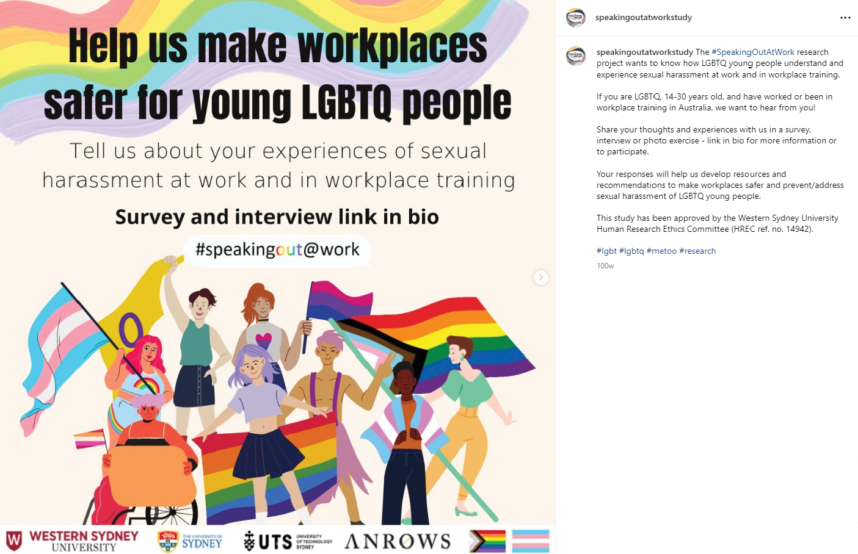
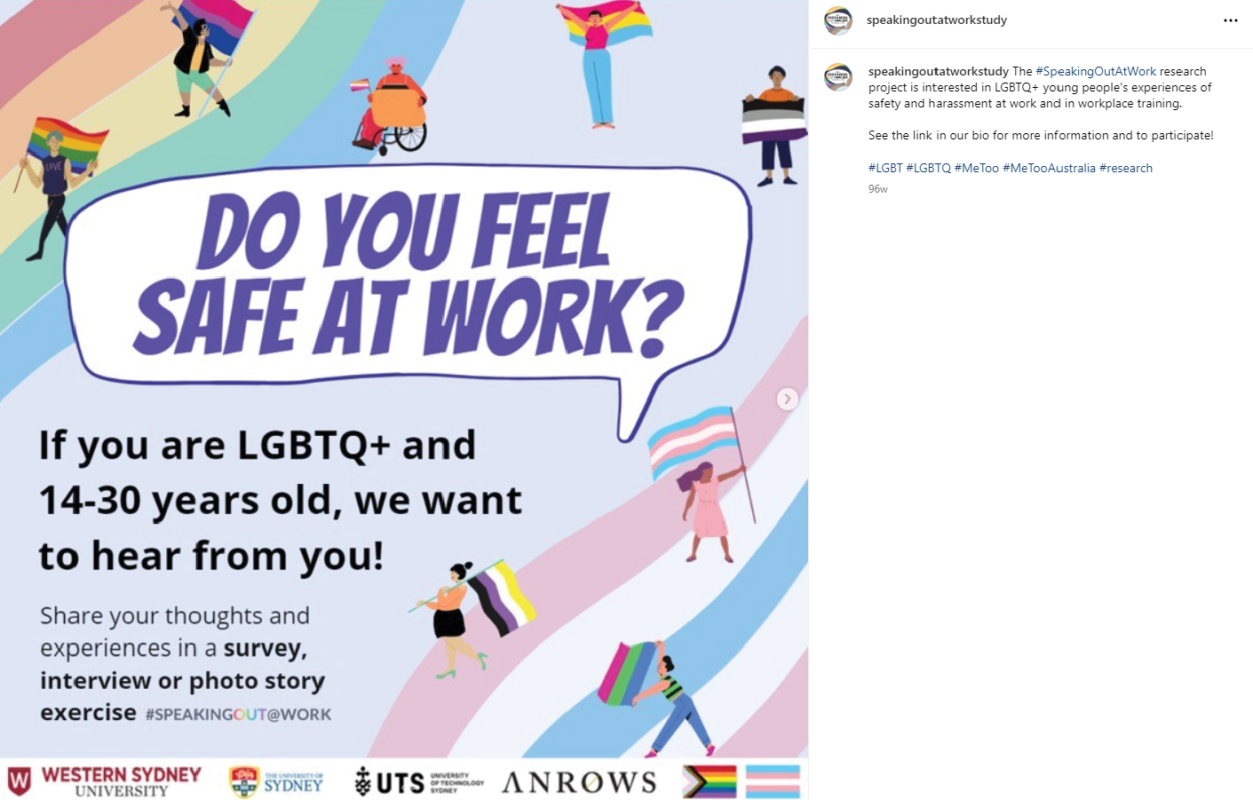
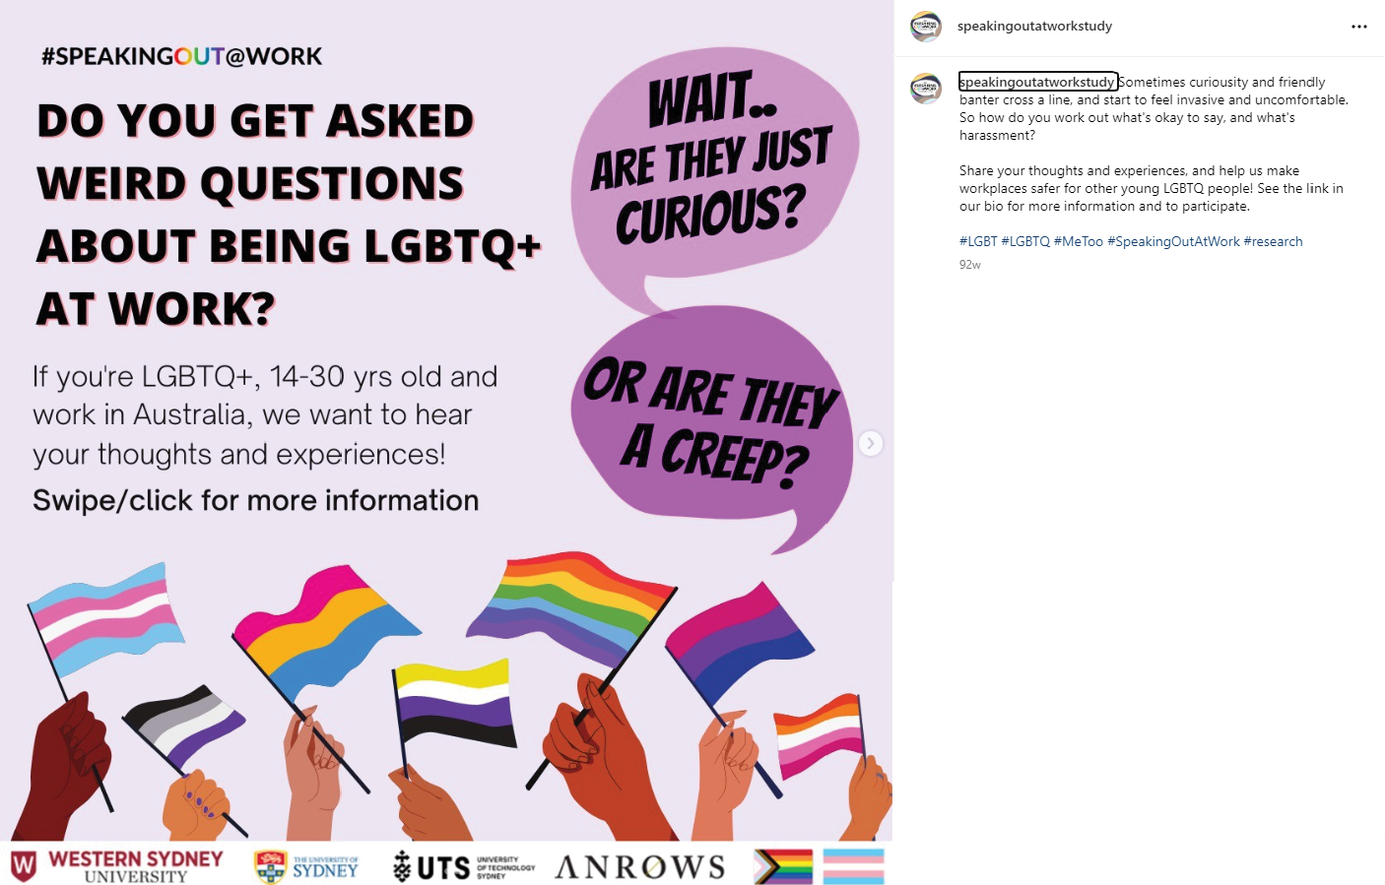

Promotional material provided to community-based LGBTQ, educational and professional organisations for distribution
We are pleased to announce the #SpeakingOut@Work online national survey is now open for responses!
The #speakingout@work study is investigating the sexual harassment of LGBTQ young people (aged 14-30) in the workplace and in workplace training, so we can better understand these experiences. The findings from this survey will inform workplace policy, practice and targeted resources to address and prevent sexual harassment of LGBTQ young people and to make a positive difference to their working and workplace experiences. This is an ANROWS funded research project.
The link to the survey will also provide more information about this research, and how you can also volunteer to be interviewed and /or involved in our photo-story exercise, where you can share your experiences creatively. Please share your experiences by completing this survey: https://surveyswesternsydney.au1.qualtrics.com/jfe/form/SV_9REzGenMlFkWD42
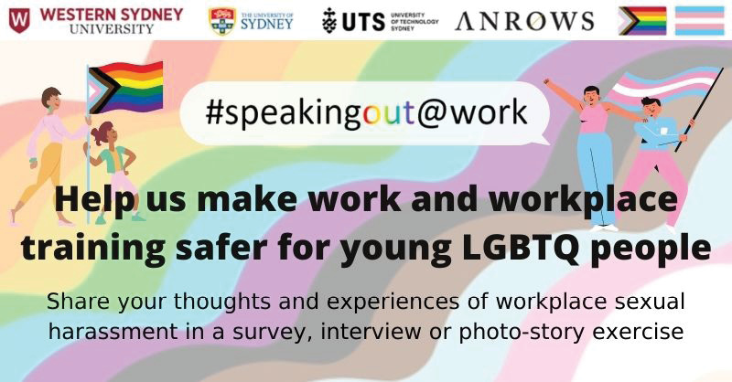

Materials distributed in hard copy at in-person LGBTQ community events
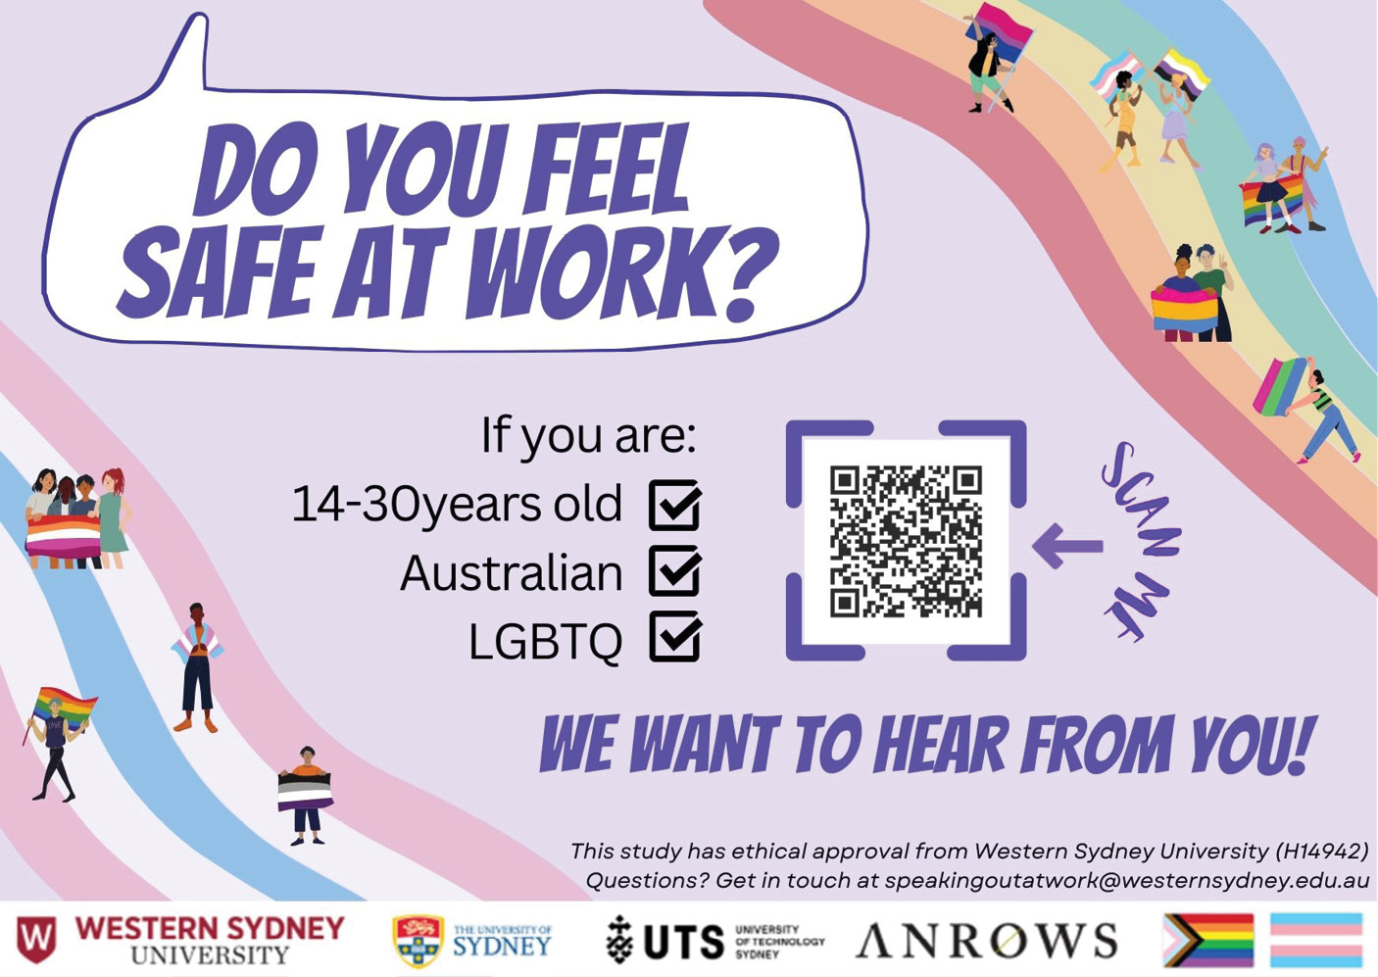
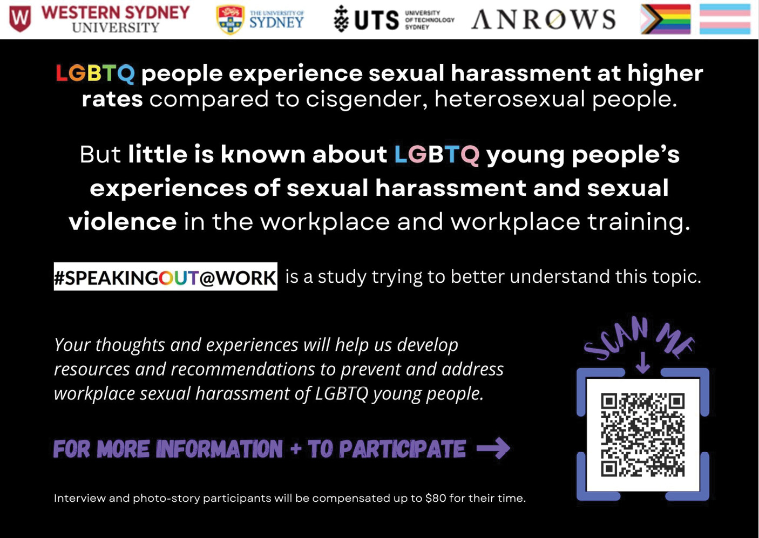

Appendix C:
Project landing page
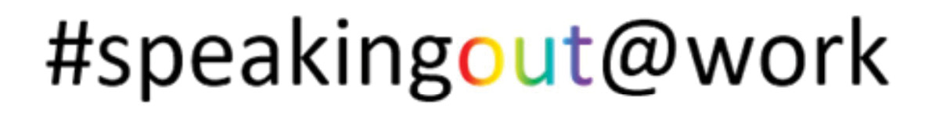

Sexual Harassment of LGBTQ Young People in the Workplace and Workplace Training
This study wants to know about young LGBTQ people’s experiences of sexual harassment in the workplace and in workplace training.

If you are LGBTQ, aged between 14 and 30 years, and have ever worked or been involved in workplace training, we are interested in your experiences.
- “LGBTQ” includes people who are lesbian, gay, bisexual, transgender (binary and non-binary), queer or questioning their sexuality or gender, as well as people who identify with other terms used in our communities.
- “In the workplace” includes working online or offsite, interacting with coworkers outside of work, and while looking for work.
- “In workplace training” includes work experience programs at school, university placements, apprenticeships and internships.
This survey will ask you about your work experience, your understanding of your rights at work, experiences of sexual harassment in the workplace, and your wellbeing. It will take approximately
20-50 minutes to complete.
You also have the option of completing an interview or photo exercise (click for more information [link]) to tell us more about your experiences.
You can find the full participant information sheet here [link].
All information you provide is confidential, and no one outside of the research team will know you have taken part in the study.

More about the project
Who is doing this research? The research is led by Professor Kerry Robinson (Western Sydney University), together with Professor Jane Ussher (WSU), Cristyn Davies (WSU/USYD), Associate Professor Jacqueline Ullman (WSU), Dr Alex Hawkey (WSU), Associate Professor Brahm Marjadi (WSU), Dr Paul Byron (UTS), Dr Kimberley Allison (WSU) and Dr Erika Smith (WSU). Twenty10 and LGBTIQ+ Health Australia are partners on the project. This study is funded by Australia’s National Research Organisation for Women’s Safety (ANROWS) and has been approved by the Western Sydney University Human Research Ethics Committee (HREC 14942).
What will you do with our answers? We will be using the findings of our study to develop resources for employers and LGBTQ young people to make workplaces and workplace training safer. Your information will be used in a way that does not identify you.
Do I have to answer every question? There are a few questions we will prompt you to complete, because there may be follow-up questions depending on how you answer. We have marked those questions with an asterisk*. If you feel uncomfortable answering a question, you can skip it. You can also quit the survey at any time without affecting your relationship with the researchers or organisations involved.
Do I have to complete the survey all at once? No, you can take a break and return to finish the survey later (within one week). However, you need to have cookies enabled in your browser, and you will need to bookmark or save the URL of the page you are on.
Need support? If you feel distressed, you can contact one of the organisations below:
- Lifeline provides phone and online crisis support and suicide prevention services. For help, phone 13 11 14 (every day, 24 hours) or access the web chat at https://www.lifeline.org.au/crisis-chat/ (every day, 7pm-4am AEST)
- QLife provides anonymous and free LGBTQ+ peer support and referral for our communities. For help, phone 1800 184 527 (every day, 24 hours) or access the web chat at http://www.qlife.org.au/ (every day, 3pm-midnight)
- 1800 RESPECT is the National Sexual Assault, Family and Domestic Violence Counselling Line for Australians who have experienced, or at risk of, family/domestic violence or sexual assault. For help, phone 1800 737 732 (every day, 24 hours) or access the web chat at https://chat.1800respect.org.au/#/welcome (every day, 24 hours)
You can find a list of more organisations that can help you here [link]. You may want to keep this open in another tab while you complete the survey.
Complaints or concerns about ethical conduct? Contact the Ethics Committee through Research Engagement, Development and Innovation (REDI) by phoning +612 4736 0229 or emailing
humanethics@westernsydney.edu.au.
Questions about the project? Contact Kimberley (k.allison@westernsydney.edu.au) or Erika (e.smith@westernsydney.edu.au).
I want to complete:
a. The survey AND an interview/or photo story exercise
b. Just the survey
c. Just the interview and/or photo story exercise

Appendix D:
Survey participant information sheet

Sexual Harassment of LGBTQ Young People in the Workplace & Workplace Training

Participant Information Sheet

Project Summary
This research aims to understand the nature of sexual harassment in the workplace and workplace training sites (physical and online spaces) experienced by LGBTQ young people; and investigate
LGBTQ young people’s perceptions and experiences of, and responses to, this harassment, including reporting, and perceived impacts.
If you are a young LGBTQ person between the ages of 14 and 30, with experience working in a workplace and/or in workplace training (e.g. TAFE, University, workplace experience training, or other forms of workplace training conducted by other institutions) you are invited to participate in this study. The research is being conducted by a team led by Western Sydney University (WSU) including Professor Kerry Robinson (WSU), Professor Jane Ussher (WSU), Cristyn Davies (WSU/The University of Sydney), Associate Professor Jacqueline Ullman (WSU), Dr Alex Hawkey (WSU), Associate Professor Brahm Marjadi (WSU) and Dr Paul Byron (University of Technology Sydney).
There are three components to this research: (i) an online survey; (ii) inteviews with young LGBTQ people; and (iii) a photo elicitation project, involving an interview about the photo/image, and with consent, the showing of photos/images in an online exhibition.

How is the study being paid for?
The study is being funded by ANROWS – Australia’s National Research Organisation for Women’s Safety.

What will I be asked to do?
The Online Survey will ask questions about your perceptions and experiences of sexual harassment in the workplace and/or workplace training (e.g. TAFE, University, Colleges, other workplace experience/training sites), bystander experiences of sexual harassment, the impact of this behaviour on your wellbeing, employment or aspirations, responses to and reporting of sexual harassment, awareness and experiences of workplace and workplace training policies and practices, and potential strategies to address sexual harassment in these contexts.

At the end of the survey you will be given the opportunity to also volunteer for two other components of the study:
- An interview that will cover similar areas to those in the survey outlined above but the discussions will be in more depth.
- A photo elicitation project that involves participants taking a photo or producing an image representative of their experiences. Participants will also write a short text to accompany the photos/images. Photos/images, with permission, will be exhibited in an online exhibition, raising awareness of LGBTQ young people’s experiences of sexual harassment in the workplace and /or in workplace training sites. Interviews will also be held with participants to discuss the photos/images and how they are associated with sexual harassment.

How much of my time will I need to give for the survey?
Participation in the survey will take approximately 20-30 minutes.

What benefits will I, and/or the broader community, receive for participating?
This research will provide new evidence about sexual harassment in the workplace and workplace training, including in digital/online spaces, experienced by LGBTQ young people, filling a critical gap in information important for informing policy and practice in these contexts.
We will also develop workplace recommendations and guidelines to address, manage, and prevent sexual harassment of LGBTQ young people; as well as a resources for LGBTQ young people.

Will the study involve any risk or discomfort for me? If so, what can I do?
There is minimal risk associated with involvement in this study, but there may be some discomfort arising for some when answering questions about sexual harassment in the workplace. If you do experience any discomfort during or after taking part in the interview, please consider contacting these organisations for support:
QLife: 1800 184 527, or web chat www.qlife.org.au
Beyond Blue: 1300 224 636, chat online at www.beyondblue.org.au
Lifeline: 13 11 14, or chat online at www.lifeline.org.au

How do you intend to publish or disseminate the results?
It is anticipated that the results of this research project will be published and presented in a variety of forums. A report of the findings will be published by ANROWS and available via the ANROWS website. The results will also be used in professional and academic publications. In any publication and/or presentation, information will be provided in such a way that the confidentiality of participants is assured. Pseudonyms will be used in any publications or presentations (unless specified by individual participants, such as wanting recognition for photos/images).

Will the data and information that I have provided be disposed of?
Only researchers will have access to the raw data provided and the data will not be used in any other projects. Research data is held for a period of five years post publication. At the end of this period, the data is disposed of in an appropriate and secure manner.

Can I withdraw from the study?
Once you have completed the survey you cannot withdraw from the study. You will not be asked for your name, contact details, or other details that would identify you.

What if I require further information?
If you would like any further information about the project you can contact:
Professor Kerry Robinson, School of Social Sciences, Western Sydney University (k.robinson@westernsydney.edu.au)
Dr Kimberley Allison, School of Social Sciences, Western Sydney University (k.allison@westernsydney.edu.au)
Dr Erika Smith, School of Social Sciences, Western Sydney University (e.smith@westernsydney.edu.au)

What if I have a complaint?
This research has been approved by the Western Sydney University Human Ethics Committee (Approval number: H14942).
If you have any complaints or reservations about the ethical conduct of this research, you may contact the Ethics Committee through Research Engagement, Development and Innovation (REDI) on Tel +(02) 4736 0229 or email humanethics@westernsydney.edu.au.
Any issues you raise will be treated in confidence and investigated fully, and you will be informed of the outcome.
If you agree to participate in this study, you will be asked to sign the Participant Consent Form. The information sheet is for you to keep and the consent form is retained by the researcher/s.

What will happen with my information if I agree to it being used in projects other than this one?
Thank you for considering being a participant in a University research project. The researchers are asking that you agree to supply your information (data) for use in this project and to also agree to allow the data to potentially be used in future research projects.
This request is in line with current University and government policy that encourages the re-use of data once it has been collected. Collecting information for research can be an inconvenience or burden for participants and has significant costs associated with it. Sharing your data with other researchers gives potential for others to reflect on the data and its findings, to re-use it with new insight, and increase understanding in this research area.
You have been asked to agree to Extended consent.

Extended consent
When you agree to extended consent it means that you agree that your data, as part of a larger dataset (the information collected for this project) can be re-used in projects that are
- an extension of this project
- closely related to this project
- in the same general area of this research.
The researchers will allow this data to be used by follow up projects to this research by ANROWS or the Western Sydney University researchers.
To enable this re-use, your data will be held at the University in its data repository and managed under a Data Management Plan. The stored data available for re-use will not have information in it that makes you identifiable. The re-use of the data will only be allowed after an ethics committee has agreed that the new use of the data meets the requirements of ethics review.
The researchers want to keep the data in perpetuity for possible re-use. After this time the data will be securely destroyed.
You are welcome to discuss these issues further with the researchers before deciding if you agree. You can also find more information about the re-use of data in research in the National Statement on Ethical Conduct in Human Research – see Sections 2.2.14 - 2.2.18.
https://www.nhmrc.gov.au/about-us/publications/national-statement-ethical-conduct-human-research-2007-updated-2018

Appendix E:
National online survey

Eligibility and Consent
The following questions are to check whether you are eligible to complete this survey.
Are you LGBTQ?
a. Yes
b. No
Are you between 14 and 30 years old?
a. Yes
b. No
Have you ever worked, or been in workplace training, in Australia?
a. Yes
b. No
Have you read the participant information sheet and had the chance to discuss any questions you may have with the researchers?
a. Yes
b. No
Do you consent to participate in this survey?
a. Yes
b. No

Questions about you
Remember that you can provide as much or as little detail as you are comfortable with. You can also skip questions, or quit the survey by closing your browser window at any time. If you feel distressed, you can find a list of organisations that can support you here [link].
1. How old are you (in years)?
DROPDOWN OPTIONS: 14 years – 30 years (listed individually)

2. How do you describe your gender?
a. Man or male
b. Woman or female
c. Non-binary
d. Questioning
e. I use a different term, which I’ve described below
f. Prefer not to answer
If you would like to describe your gender, please do so here:
[FREE RESPONSE]
3. How do you describe your sexual orientation?
a. Straight or heterosexual
b. Gay or lesbian
c. Bisexual
d. Pansexual
e. Queer
f. Questioning
g. Asexual
h. I use a different term, which I’ve described below
i. Don’t know
j. Prefer not to answer
If you would like to describe your sexual orientation, please do so here:
[FREE RESPONSE]

4. What was your sex recorded at birth?
a. Male
b. Female
c. Another term; please specify [FREE RESPONSE]
d. Prefer not to answer
5. What state/territory do you live in?
a. Australian Capital Territory
b. New South Wales
c. Northern Territory
d. Queensland
e. South Australia
f. Tasmania
g. Victoria
h. Western Australia
6. What is your postcode?
[FREE TEXT]
7. Are you of Aboriginal or Torres Strait Islander origin? Please select as many as apply.
a. Yes, Aboriginal
b. Yes, Torres Strait Islander
c. No

8. How would you describe your ethnic/cultural background? Please select as many as apply.
a. Aboriginal
b. African (e.g. Sudanese, Somalian, Zimbabwean background)
c. Anglo-Australian, Caucasian or White (e.g. English, Irish, Scottish background)
d. Asian (e.g. Chinese, Vietnamese, Indian background)
e. European (e.g. Italian, Spanish, Greek background)
f. North African or Middle Eastern (e.g. Egyptian, Lebanese, Syrian background)
g. Pacific Islander (e.g. Fijian, Samoan, Tongan background)
h. South, Central or Latin American (e.g. Brazilian, Mexican, Peruvian background)
i. Torres Strait Islander
j. I use a different term; please specify: [FREE RESPONSE]
If you would like to describe your ethnic/cultural background, please do so here:
[FREE RESPONSE]
9. What language(s) do you speak at home?
a. English only
b. English and another language(s); please specify: [FREE RESPONSE]
c. Other language(s) only; please specify: [FREE RESPONSE]
10. What is your religion?
a. I do not practice any religion
b. Buddhism
c. Christianity
d. Hinduism
e. Islam
f. Judaism
g. A different religion; please specify: [FREE RESPONSE]

If you would like to describe your religion/denomination, please do so here:
[FREE RESPONSE]
11. How would you describe your overall personal financial situation?
a. I live comfortably, and can afford what I want
b. I can afford basic expenses (housing, food, etc.) with a little money left over
c. I can just afford the basic expenses
d. I can’t afford basic expenses
e. Someone else (e.g. family, partner(s)) pays for most of my basic expenses
12. How would you describe your living situation?
a. I own my home
b. I am renting
c. I live with others (e.g. family, partner) but do not pay rent
d. I live in supported (transitional or crisis) housing
e. I am couch surfing or in other short-term/temporary accommodation
f. I am sleeping rough (living on the streets)
g. Something else; please describe: [FREE TEXT]
13. What is the highest level of education you have completed?
a. Primary school (year 6 or less)
b. Some high school (year 7-9)
c. Completed year 10
d. Completed year 12
e. Completed TAFE or a technical qualification
f. Completed undergraduate degree
g. Completed postgraduate degree

14. Do you have any disabilities or conditions which impact your ability to work?
a. Yes
b. No
If you would like to describe your condition(s) and how it affects your ability to work more specifically, please do so here:
[FREE RESPONSE]

Questions about your work
Remember that you can provide as much or as little detail as you are comfortable with. You can also skip questions, or quit the survey by closing your browser window at any time. If you feel distressed, you can find a list of organisations that can support you here [link].
15. How long have you been working (in years)?
DROPDOWN OPTIONS: less than one year, 1-15 years (listed individually), more than 15 years, I have not worked
16. Are you currently working or in workplace training?
(Workplace training includes work experience programs, internships and apprenticeships, orientation and onboarding programs, and other types of skill development, teamwork and safety training for the workplace)
a. Yes, working multiple jobs
b. Yes, working one job
c. Yes, in workplace training; please specify: [FREE TEXT]
d. No
SKIP TO NEXT SECTION if not currently working
17. How would you describe your current employment?
a. Permanent, full-time
b. Permanent, part-time
c. Casual
d. Temporary or fixed-term
e. Freelance or self-employed
f. A different arrangement; please specify: [FREE TEXT]
18. What is your job/occupation?
[FREE TEXT]

Questions about your understanding of sexual harassment in the workplace
Remember that you can provide as much or as little detail as you are comfortable with. You can also skip questions, or quit the survey by closing your browser window at any time. If you feel distressed, you can find a list of organisations that can support you here [link].
19. In your own words, how would you define workplace sexual harassment?
[FREE TEXT]
New survey page
In this study, we define sexual harassment as an unwelcome sexual advance, unwelcome request for sexual favours, or other unwelcome sexual behaviour that you could expect might make someone feel offended, humiliated or intimidated.
“At work” includes working online, at work-related social events, interacting with coworkers outside of work, seeking work and in workplace training.
20. Does this definition (above) match your understanding of sexual harassment in the workplace?
a. Yes
b. No
21. [IF NO] How does this definition differ from what you think sexual harassment is?
[FREE TEXT]
The following list contains behaviours that researchers classify as sexual harassment:
- Unwelcome touching, hugging, cornering or kissing
- Inappropriate staring or leering that made you feel intimidated
- Sexual gestures, indecent exposure or inappropriate display of the body (e.g. “flashing”)
- Sexually suggestive comments or jokes that made you feel offended or uncomfortable
- Sexually explicit pictures, posters or gifts that made you feel offended or uncomfortable
- Repeated or inappropriate invitations to go out on dates
- Intrusive questions about your private life or physical appearance that made you feel offended or uncomfortable
- Inappropriate physical contact
- Being followed, watched or someone loitering nearby
- Requests or pressure for sex or other sexual acts
- Indecent or sexually explicit phone calls or voicemails
- Sexually explicit comments made in emails, text messages or on social media
- Repeated or inappropriate advances in emails, text messages or on social media
- Sharing or threatening to share intimate images or videos of you without your consent
22. Are there any other behaviours not listed above which you think are sexual harassment? We are particularly interested in behaviours that affect LGBTQ people at work.
[FREE TEXT]
23. Do you think workplace sexual harassment is more likely to happen:
a. In person
b. Online or via phone
c. Don’t know
24. Have you completed workplace training about sexual harassment and/or assault?
a. Yes
b. No
c. Don’t remember
25. [IF YES] Did this training identify the specific experiences of LGBTQ people?
a. Yes; please tell us more: [FREE TEXT]
b. No
c. Don’t remember
Is there anything you would like to tell us about this training (e.g. what it involved, what content was covered)?
[FREE TEXT]
New Survey page

26. Some of your rights at work are listed below. Please tell us if you already knew about these rights:
Rights | I knew this | Didn’t know this
a. Everyone has the right to a workplace that is safe - where sexual harassment does not happen. Sexual harassment in the workplace is illegal. | O | O
b. Sexual harassment is considered a workplace hazard (something which can harm people), and your employer is responsible for protecting you from sexual harassment under workplace health and safety laws. | O | O
c. Employers should have plans in place to prevent sexual harassment in the workplace. They should also have plans for how to address sexual harassment if it happens. | O | O
d. Employers can be held liable (legally responsible) for sexual harassment in the workplace if they did not do enough to prevent this from happening. | O | O
27. How much do you agree with the following statements?
Statement | Strongly disagree | Disagree | Neither agree nor disagree | Agree | Strongly agree
a. I know how to formally report or make a complaint about sexual harassment at work | O | O | O | O | O
b. I know where to get support or help if I experience sexual harassment at work | O | O | O | O | O
Is there anything you would like to tell us about your awareness of your rights, reporting pathways and support options?
[FREE TEXT]

27.How much do you agree with the following statements about your abilities?
Statements | Strongly disagree | Disagree | Neither agree nor disagree | Agree | Strongly agree
a. I would be able to identify sexual harassment if it happened at work | O | O | O | O | O
b. I would be able to report sexual harassment if it happened at work | O | O | O | O | O
c. I would be able to get support if I was sexually harassed at work | O | O | O | O | O
d. I would be able to support someone else if they were sexually harassed at work | O | O | O | O | O
Is there anything you would like to tell us about your abilities to identify, report and get support for sexual harassment at work?
[FREE TEXT]

Questions about your experiences of sexual harassment
Remember that you can provide as much or as little detail as you are comfortable with. You can also skip questions, or quit the survey by closing your browser window at any time. If you feel distressed, you can find a list of organisations that can support you here [link].
28. Have you experienced sexual harassment at work or in workplace training, at any time in your life?
a. Yes
b. No

29. Have you ever experienced any of the following behaviours at work or in workplace training in a way that was unwanted or unwelcome?
Behaviours | Experienced
a. Unwelcome touching, hugging, cornering or kissing | O
b. Inappropriate staring or leering that made you feel intimidated | O
c. Inappropriate physical contact | O
d. Actual or attempted rape or sexual assault | O
e. Sexual gestures, indecent exposure or inappropriate display of the body (e.g. flashing, unsolicited nudes) | O
f. Sexually suggestive or explicit comments, jokes or messages that made you feel offended or uncomfortable | O
g. Sexually explicit pictures, memes, posters or gifts that made you feel offended or uncomfortable | O
h. Repeated or inappropriate invitations to go out on dates | O
i. Intrusive questions about your private life or physical appearance that made you feel offended or uncomfortable | O
j. Being followed, watched or someone loitering nearby | O
k. Requests or pressure for sex or other sexual acts | O
l. Sharing or threatening to share intimate images or videos of you without your consent | O
m. Unwelcome questions/comments about your sex life, related to you being LGBTQ+  (e.g. asking about how you have sex or your “role”) | O
n. Unwelcome sexual jokes about your LGBTQ+ identity  (e.g. joking about gay men or bisexual people being promiscuous) | O
o. Unwelcome verbal sexual advances about “correcting” your LGBTQ+ identity  (e.g. suggesting that sex with someone of the opposite sex will make you straight) | O
p. Unwelcome, intrusive questions or comments about your anatomy (body parts), related to your LGBTQ+ identity  (e.g. asking whether you have had gender-affirming surgery) | O

30. Did these behaviours happen:
a. In person only
b. Mostly in person, a little online/via phone
c. About equally in person and online/via phone
d. Mostly online/via phone, a little in person
e. Online/via phone only
Is there anything you would like to tell us about the different types of sexual harassment behaviours you have experienced?
[FREE TEXT]
31. How many times have you experienced sexual harassment at work or in workplace training (including any of the behaviours listed above)?
DROPDOWN OPTIONS: Never, once, twice [ …] ten times, more than ten times.
IF NO EXPERIENCES OF SH AT WORK, skip to next relevant section.
32. [IF SH IS REPORTED] Did you experience these behaviours:
a. In workplace training
b. In the workplace
c. Both
33. Do you think you have ever been sexually harassed at work or in workplace training (including experiencing any of the behaviours listed above):
Reason | Yes | No | Unsure
a. Because of your sexual orientation | O | O | O
b. Because of your gender | O | O | O
c. Because of your age | O | O | O
d. Because of your ethnic/cultural background | O | O | O
e. Because of your religion | O | O | O
f. Because of your illness and/or disability | O | O | O
Please tell us more about your experiences of sexual harassment at work or in workplace training, related to these factors.
[FREE TEXT]

Questions about your most impactful experiences of workplace sexual harassment
Remember that you can provide as much or as little detail as you are comfortable with. You can also skip questions, or quit the survey by closing your browser window at any time. If you feel distressed, you can find a list of organisations that can support you here [link].
Please answer the following questions in relation to the experience of sexual harassment at work or in workplace training that had the biggest effect on you, or that stands out the most in your memory.
These questions will help us understand the types of behaviour LGBTQ young people experience.
34. Please tell us about what happened in this incident.
[FREE TEXT]
35. What about this incident made it have the biggest effect on you?
[FREE TEXT]
36. Was your experience:
a. A one-off/isolated incident
b. Part of a series of incidents
37. Where did this incident occur?
a. At your work station/where you work
b. In a meeting
c. In a social area at your work (e.g. breakroom)
d. At a work social event (e.g. after-work drinks)
e. In a work-provided facility (e.g. bathroom, changeroom)
f. During workplace training
g. While travelling to, from or for work
h. Online (e.g. via email, social media or digital work spaces)
i. A different place; please specify: [FREE TEXT]
38. How many people were involved in harassing you?
[FREE TEXT]

39. What was the gender of the harasser/s?
a. Male only
b. Female only
c. Non-binary only
d. Mixed genders
e. Not sure
40. What was the approximate age of the harasser/s?
Please select as many as apply (if multiple harassers)
a. Under 20 years
b. 20-29 years
c. 30-39 years
d. 40-49 years
e. 50-64 years
f. 65 years or older
g. Don’t know
41. Was the person/people harassing you LGBTQ?
a. Yes
b. No
c. Don’t know
42. Was the person/people harassing you:
Please select as many as apply.
a. The head of your workplace (e.g. the CEO, business owner)
b. Your direct manager or supervisor
c. Another manager, supervisor or more senior coworker
d. A coworker who is at the same level as you
e. A more junior coworker, or someone you manage or supervise
f. Someone you serve (e.g. a client, customer, patient, student)
g. A member of the public
h. Someone else; please specify: [FREE TEXT]
i. Don’t know
Is there anything you would like to tell us about your harasser(s)?
[FREE TEXT]
43. Did anyone else witness this incident?
a. Yes; how many people witnessed the incident? [FREE TEXT]
b. No
c. Don’t know
44. [IF WITNESSES] How did the person/people who saw you being harassed react?
Please select as many as apply.
a. They confronted the harasser about the incident
b. They reported the incident to your workplace or the police
c. They offered you support or reassurance
d. They offered you advice
e. They did not do anything
f. They joined in with the harassment or made it worse
g. They did something else; please specify: [FREE TEXT]
h. Don’t know
Is there anything you would like to tell us about the people who witnessed this incident and their response?
[FREE TEXT]
45. How intimidated did the incident make you feel?
Not at all intimidated | A little intimidated | Moderately intimidated | Very  intimidated | Extremely intimidated
O | O | O | O | O
46. How serious did you think the incident was?
Not at  all serious | A little  serious | Moderately serious | Very  serious | Extremely  serious
O | O | O | O | O
Is there anything you would like to tell us about how intimidating and serious this incident was?
[FREE TEXT]
New survey page
Please answer the following questions in relation to the experience of sexual harassment at work or in workplace training that had the biggest effect on you, or that stands out the most in your memory.
47. How would you describe your employment at the time?
a. Permanent, full-time
b. Permanent, part-time
c. Casual
d. Temporary or fixed-term
e. Freelance or self-employed
f. A different arrangement; please specify: [FREE TEXT]
48. How would you describe the size of your workplace (including people working at other sites)?
a. I worked alone
b. Micro business (1-4 people total)
c. Small business (5-19 people total)
d. Medium business (20-199 people total)
e. Large business (200+ people total)
f. Don’t know
49. What was your job/occupation at the time?
[FREE TEXT]
50. How “out” at work were you to the following groups of people?
Level of “out” | Not at  all out |  |  | Completely  out | N/A
a. Work peers  (i.e. coworkers at the same level) | O | O | O | O | O
b. Work supervisors and managers | O | O | O | O | O
c. Work subordinates  (i.e. more junior coworkers, people you manage or supervise) | O | O | O | O | O
d. People you serve  (e.g. customers, clients, students, patients) | O | O | O | O | O
e. Upper management  (e.g. the CEO or business owner, human resources) | O | O | O | O | O
Is there anything you would like to tell us about how “out” you are at work?
[FREE TEXT]
51. Please rate the following items according to how well they describe the atmosphere for LGBTQ employees in your workplace at the time.
Workplace atmosphere | Doesn’t describe | Describes somewhat or a little | Describes pretty well | Describes extremely well
LGBTQ employees are treated with respect | O | O | O | O
LGBTQ employees feel accepted by coworkers | O | O | O | O
Coworkers make comments that seem to indicate a lack of awareness of LGBTQ issues | O | O | O | O
LGBTQ employees are free to be themselves | O | O | O | O
LGBTQ employees are met with thinly veiled hostility (e.g. scornful looks, icy tone of voice) | O | O | O | O
There is pressure for LGBTQ employees to stay closeted (to conceal their sexual orientation or gender identity/expression) | O | O | O | O
Is there anything you would like to tell us about what it is like for LGBTQ employees in your workplace?
[FREE TEXT]
52. Thinking of your workplace at the time of the most impactful incident of sexual harassment, how often did this type of behaviour happen?
a. It was very rare
b. It was rare
c. It happened sometimes
d. It was common
e. Don’t know
Is there anything you would like to tell us about how common sexual harassment was in your workplace?
[FREE TEXT]

Responses to Sexual Harassment at Work
Remember that you can provide as much or as little detail as you are comfortable with. You can also skip questions, or quit the survey by closing your browser window at any time. If you feel distressed, you can find a list of organisations that can support you here [link].
Please answer the following questions in relation to the experience of sexual harassment at work or in workplace training that had the biggest effect on you, or that stands out the most in your memory.
53. Did you make a formal report or complaint about the incident?
a. Yes, to someone at work; please specify: [FREE TEXT]
b. Yes, to someone else outside of work; please specify: [FREE TEXT]
c. Yes, to the police
d. No [SKIP TO QUESTIONS ABOUT WHY]
54. [IF REPORTED] Did anything happen to you after your report/complaint?
(e.g. someone apologised to you, you were excluded by coworkers)
[FREE TEXT]
55. [IF REPORTED] Did anything happen to your harasser/s after your report/complaint?
(e.g. they were punished, they resigned)
[FREE TEXT]
56. [IF REPORTED] Did anything happen at your workplace after your report/complaint?
(e.g. they introduced training or rules about sexual harassment)
[FREE TEXT]
57. [IF REPORTED] How satisfied were you with the overall process of reporting the incident?
Not at all satisfied | A little satisfied | Moderately satisfied | Very satisfied | Extremely satisfied
O | O | O | O | O
If you would like to say more about the reporting/complaint process, please do so here:
[FREE TEXT]
58. [IF NOT REPORTED] Many people do not report sexual harassment, for a variety of reasons. Why did you decide not to report your experience?
(e.g. I didn’t think it was sexual harassment, I didn’t want to “out” myself as LGBTQ)
[FREE TEXT]
New survey page
59. Did you seek support or advice related to your experience of sexual harassment?
Please select as many as apply.
a. Yes; who/where from?: [FREE TEXT]
b. No
60. [ IF SOUGHT SUPPORT ] How positive or negative was the process of seeking support or advice for your most recent experience of sexual harassment at work?
Very negative | Mostly negative | Mixed (both positive and negative) | Mostly positive | Very positive
O | O | O | O | O
If you would like to say more about the support or advice you received, please do so here:
[FREE TEXT]
61. [ IF DIDN’T SEEK SUPPORT ] People may not seek support for many different reasons, like not knowing where to go or not wanting to out themselves as LGBTQ. Why did you decide not to seek support?
[FREE TEXT]
62. Was your experience of reporting and/or seeking support for your experience of sexual harassment impacted by any of the following:
Attributes | Yes | No
a. Your sexual orientation | O | O
b. Your gender | O | O
c. Your age | O | O
d. Your ethnic/cultural background | O | O
e. Your religion | O | O
f. Your illness, disability or impairment | O | O
Please tell us more about how these factors shaped your experiences of reporting and/or seeking support for sexual harassment.
[FREE TEXT]

Questions about how workplace sexual harassment has affected you
Remember that you can provide as much or as little detail as you are comfortable with. You can also skip questions, or quit the survey by closing your browser window at any time. If you feel distressed, you can find a list of organisations that can support you here [link].
63. Thinking about how your experiences of workplace sexual harassment have impacted you overall, would you say this has negatively affected:
Areas of life | Yes | No
a. Your employment, career or work | O | O
b. Your finances | O | O
c. Your relationships (e.g. with partners, family, friends) | O | O
d. Your self-esteem and confidence | O | O
e. Your health and general wellbeing | O | O
f. Your mental health, or caused you stress | O | O
g. How you feel about being LGBTQ
h. How open you are about being LGBTQ
Please tell us about these impacts.
[FREE TEXT]
Have you experienced any other impacts of your experiences of sexual harassment at work?
[FREE TEXT]
64. The following question asks how you are feeling about your potential future career path. Please rate how much you agree or disagree with this statement:
Question | Completely disagree | Disagree | Neither agree nor disagree | Agree | Completely agree
I have a positive view of my future career | O | O | O | O | O
Has this been affected by your experience(s) of workplace sexual harassment?
[FREE TEXT]
65. The following five questions ask about how you have been feeling in the last four weeks. For each question, please select the option that best describes the amount of time you felt that way.
In the last four weeks, about how often did you feel: | None of the time | A little of the time | Some of the time | Most of the time | All of the time
a. Nervous | O | O | O | O | O
b. Without hope | O | O | O | O | O
c. Restless or jumpy | O | O | O | O | O
d. Like everything was an effort | O | O | O | O | O
e. So sad that nothing could cheer you up | O | O | O | O | O
Has this been affected by your experience(s) of workplace sexual harassment?
[FREE TEXT]

Final questions
Remember that you can provide as much or as little detail as you are comfortable with. You can also skip questions, or quit the survey by closing your browser window at any time. If you feel distressed, you can find a list of organisations that can support you here [link].
66. What do you think workplaces could do to better prevent the sexual harassment of young LGBTQ people?
[FREE TEXT]
67. What do you think workplaces could do to better support young LGBTQ people who are sexually harassed at work?
[FREE TEXT]
68. Is there anything else you would like to share your experience(s) of sexual harassment and sexual assault at work? Please tell us anything you feel comfortable writing about.
[FREE TEXT]
New survey page
We want to talk with young LGBTQ people about their experiences of workplace sexual harassment in more depth.
The interview will take about an hour and can happen in person, by phone or online (e.g. over Zoom), depending your location and preference. We are also running a photo story exercise, which would ask you to provide and talk about photos which capture some aspect of your experience of workplace sexual harassment (optional- click here for more information [link]). You will receive a $40 Prezzee voucher for each interview you complete.
Are you interested in completing an interview or photo story exercise?
Please select all that apply.
a. Yes, an interview
b. Yes, the photo story exercise
c. No
In order for us to contact you, please provide your contact information below.
We will use your survey responses to inform the questions we ask your interview. If you do not want us to link your survey responses and your interview, you can sign up separately using this form [link].
Name: [FREE TEXT]
Email: [FREE TEXT]
Phone number: [FREE TEXT]
Preferred method of contact: [FREE TEXT]
New survey page
Thank you very much for your time and contribution to this study!
Please help us tell others about this study. You can do this by sending them the link to this study, or by sharing the posts from our social media accounts:
Study link: https://surveyswesternsydney.au1.qualtrics.com/jfe/form/SV_9REzGenMlFkWD42
Instagram: @SpeakingOutAtWorkStudy
Need support? If you are feeling distressed or want to talk to talk about your experiences, you can find a list of organisations that can help you here [link].

Appendix F:
List of support services provided to participants seeking support
If you are feeling distressed or other strong emotions while participating in our study and would like to talk to someone, you can get support from one of the organisations below.

General support services
Lifeline
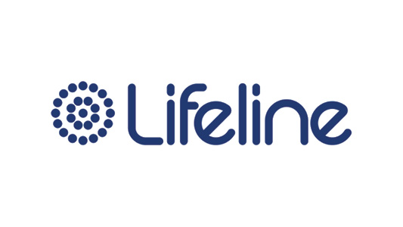
A national charity providing all Australians experiencing a personal crisis with access to 24 hour crisis support and suicide prevention services.
Phone: 13 11 14 (every day, 24hrs)
Web chat: https://www.lifeline.org.au/crisis-chat/
(every day, 7pm – 4am AEST)
Headspace
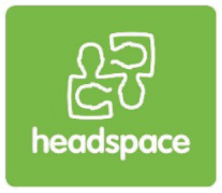
A national service providing mental health support to young people (12-25 years) in person, via phone and online.
Phone: 1800 650 890 (every day, 9am – 1am AEST)
Web chat: https://headspace.org.au/eheadspace/connect-with-a-clinician/

Kids Helpline

A free, confidential online and phone counselling service for young people (5-25 years)
Phone: 1800 55 1800 (every day, 24hrs)
Web chat: https://kidshelpline.com.au/get-help/webchat-counselling (every day, 24hrs)

LGBTQ+ support services
QLife

Anonymous and free LGBTQI+ peer support and referral for people wanting to talk about sexuality, identity, gender, bodies, feelings or relationships.
Phone: 1800 184 527 (every day, 3pm – midnight)
Web chat: http://www.qlife.org.au/ (every day, 3pm – midnight)
Twenty10
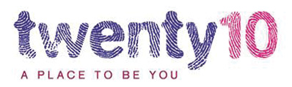
A Sydney-based support service for LGBTQIA+ young people (12-25 years), their families and communities.
Phone: 02 8594 9555 (weekdays, 1pm – 3pm)

Sexual harrassment/assault support services
1800 RESPECT
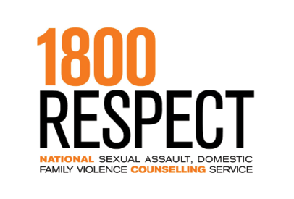
The National Sexual Assault, Family & Domestic Violence Counselling Line for any Australian who has experienced, or is at risk of, family and domestic violence and/or sexual assault.
Phone: 1800 737 732 (every day, 24hrs)
Web chat: https://chat.1800respect.org.au/#/welcome (every day, 24hrs)
Bravehearts
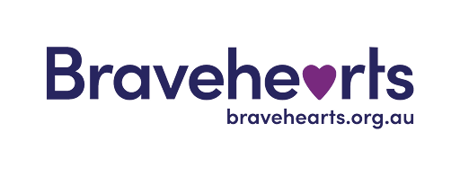
Bravehearts provides support to children and young people who have experienced or are at risk of experiencing child sexual assault and exploitation.
Phone: 1800 272 831 (weekdays, 8.30am – 4.30pm AEST)
State and Territory Support Services
ANROWS maintains a directory of support services for each state and territory. It can be accessed at https://www.anrows.org.au/support-directory/

Work-related support services
Australian Human Rights Commission
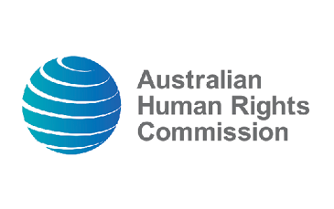
The AHRC accepts complaints about sexual harassment and other forms of discrimination. They typically resolve complaints using conciliation between people involved.
https://www.humanrights.gov.au/
State and Territory WHS Bodies
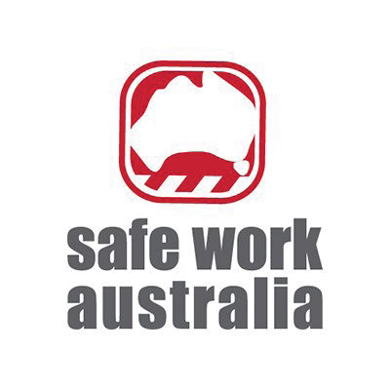
The Workplace Health and Safety (WHS) body for your state/territory can provide advice and assistance about workplace sexual harassment.
Australian Capital Territory: Work Safe ACT
http://www.worksafe.act.gov.au/
New South Wales: SafeWork NSW http://www.safework.nsw.gov.au/
Northern Territory: NT WorkSafe https://worksafe.nt.gov.au/
Queensland: WHS Queensland https://www.worksafe.qld.gov.au/
South Australia: SafeWork SA http://www.safework.sa.gov.au/
Tasmania: WorkSafe Tasmania http://www.worksafe.tas.gov.au/home
Victoria: WorkSafe Victoria http://www.worksafe.vic.gov.au/
Western Australia: WorkSafe WA
http://www.commerce.wa.gov.au/WorkSafe/
State and Territory Anti-Discrimination Bodies
These bodies typically consider, investigate and resolve complaints about discrimination, sexual harassment, and other forms of victimisation.
Australian Capital Territory: ACT Human Rights Commission
http://www.hrc.act.gov.au/
New South Wales: Anti-Discrimination Board of NSW
http://www.antidiscrimination.justice.nsw.gov.au/
Northern Territory: NT Anti-Discrimination Commission
http://www.adc.nt.gov.au/
Queensland: Anti-Discrimination Commission Queensland
http://www.adcq.qld.gov.au/
South Australia: Equal Opportunity Commission SA
http://www.eoc.sa.gov.au/
Tasmania: Office of the Anti-Discrimination Commissioner – Tasmania http://equalopportunity.tas.gov.au/home
Victoria: Victorian Equal Opportunity and Human Rights Commission http://www.humanrightscommission.vic.gov.au/
Western Australia: Equal Opportunity Commission WA
http://www.eoc.wa.gov.au/Index.aspx
Workplace Advice Service
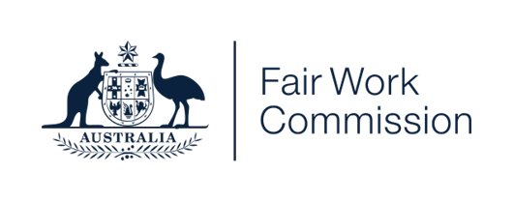
If you do not have a lawyer and are not part of a union, you may be able to get free legal advice about workplace sexual harassment from the Fair Work Commission’s Workplace Advice Service.
https://www.fwc.gov.au/apply-or-lodge/legal-help-and-representation/legal-advice-workplace-advice-service
You can find more information about sexual harassment in the workplace, including how to make a report/complaint, from:
- The Fair Work Ombudsman: https://www.fairwork.gov.au/employment-conditions/bullying-sexual-harassment-and-discrimination-at-work/sexual-harassment-in-the-workplace
- Safe Work Australia: https://www.safeworkaustralia.gov.au/safety-topic/hazards/workplace-sexual-harassment
- The Australian Human Rights Commission: https://humanrights.gov.au/our-work/sex-discrimination/sexual-harassment-information-employees

Appendix G:
Interview and photo story participant demographics and occupations
Pseudonym | Pronouns | Int | Photo | Age | Gender | Sexuality | Disability | Ethnic/ cultural background | Region | Job /industry
Alexander | he/him | Y |  | 26 | Trans man | Bisexual | Y | Anglo | Maj City | Lawyer
Amanda | she/her | Y | Y | 28 | Cis woman | Bisexual | - | Multi (Anglo, Asian) | Maj City | UX designer
Archer | he/they | Y |  | 30 | Agender transmasculine | Bisexual | Y | Anglo | Inn Reg | Retail
Ashley | they/them | Y |  | 27 | Non-binary | Bisexual | Y | Anglo | Maj City | Nurse
Ava | she/her | Y |  | 25 | Trans woman | Lesbian | Y | Anglo | Maj City | Administration
Bailey | they/she | Y |  | 24 | Queer | Queer | Y | Multi (European, South/Central/ Latin American) | Maj City | Academic
Bec | she/her | Y |  | 22 | Cis woman | Bisexual | - | European | Maj City | Administration
Blair | xe/xem | Y |  | 19 | Non-binary | Bisexual | Y | Anglo | Inn Reg | Office worker
Carrie | they/them | Y | Y | 22 | Non-binary AFAB | Queer | Y | Anglo | Maj City | Operations
Charlie | they/he | Y |  | 22 | Non-binary | Queer | Y | Anglo | Maj City | Program facilitator
Christine | she/her | Y |  | 24 | Cis woman | Queer | - | Anglo | Maj City | Teacher
Clara | she/her | Y |  | 25 | Cis woman | Bisexual | Y | Anglo | unknown | Lawyer
Dale | he/they | Y | Y | 16 | Trans man | Pansexual | Y | Multi (Anglo, European, Torres Strait Islander) | Inn Reg | Hospitality
Danielle | they/she | Y |  | 29 | AFAB, questioning non-binary | Gay | Y | Anglo | Maj City | Education
Dylan | they/them | - | Y | 22 | Transmasc non-binary | Pansexual, demisexual | Y | Multi (Anglo, Asian) | Inn Reg | Peer educator (LGBTQ specific role)
Ellen | she/her | Y |  | 25 | Cis woman | Lesbian | Y | Latina | Maj City | Disability employment services (LGBTQ specific role)
Emily | she/her | Y |  | 29 | Cis woman | Bisexual | - | Anglo | unknown | Teacher, hospitality
Evan | they/them | Y |  | 20 | Non-binary | Lesbian | Y | Anglo | Maj City | Logistics
Frankie | she/they | Y |  | 24 | Cis woman | Pansexual | Y | Asian | Maj City | Retail, art model, support worker
Hazel | she/her | Y |  | 24 | Cis woman | Pansexual | Y | Multi (Anglo, European) | Maj City | Hospitality, social work
Jamie | they/them | Y |  | 28 | Non-binary transmasculine | Queer, bisexual | Y | Anglo | Maj City | Counsellor
Johanna | she/her | Y |  | 28 | Cis woman | Bisexual | - | European | Maj City | Tutor
Kendal | they/them | Y |  | 26 | Non-binary | Bisexual | Y | Anglo | Maj City | Administration
Lane | she/ they | Y |  | 26 | Non-binary | Gay | - | Multi (Anglo, Asian) | Maj City | Physiotherapy
Lily | she/ her | Y |  | 27 | Cis woman | Queer | Y | European | Maj City | Community services
Lisa | she/ her | Y |  | 23 | Cis woman | Pansexual | - | Multi (Anglo, European) | Maj City | Marketing
Luca | they/them | Y |  | 23 | Non-binary | Queer | Y | Anglo | Maj City | Education
Lucy | she/ her | Y |  | 25 | Cis woman | Lesbian | Y | Multi (Anglo, European) | Maj City | Teacher
Mei | she/ her | Y |  | 22 | Trans woman | Pansexual | Y | Asian | Maj City | Teacher, hospitality
Mia | she/ her | Y |  | 29 | Cis woman | Gay | Y | Anglo | Maj City | Unemployed (most recently public services)
Nadine | she/ her | Y |  | 26 | Cis woman | Pansexual | - | European | Inn Reg | Administration
Olivia | she/ they | Y |  | 29 | Trans woman | Bisexual | - | Asian | Maj City | Manager, writer
Omar | they/them (any ok) | Y | Y | 20 | Non-binary trans man | Personality- attracted | Y | African | Inn Reg | Hospitality, retail
Page | they/she | Y |  | 24 | Non-binary and female-aligned | Bisexual | Y | Anglo | Maj City | Administration
Ramsey | she/ they | Y |  | 24 | Gender nonconforming | Queer | Y | Anglo | Maj City | Disability advocate
Rory | they/them | Y |  | 21 | Non-binary, presenting masculine | Queer | Y | Anglo | Inn Reg | Hospitality
Ruby | she/ they | Y |  | 27 | Transfem/ trans woman | Gay | Y | Anglo | Maj City | Research
Sadie | she/ her | Y |  | 23 | Cis woman | Lesbian | - | European | Maj City | Finance
Thea | she/ they | Y | Y | 24 | Queer | Lesbian | Y | Anglo | Inn Reg | Retail
Tyler | he/ him | Y |  | 20 | Trans man | Bisexual | Y | Multi (Aboriginal, Anglo) | Maj City | Administration
Zara | she/ her | - | Y | 21 | Cis woman | Bisexual | - | Multi (African, European) | Maj City | Call centre, graphic design
Zoe | she/ her | Y | Y | 25 | Cis woman | Queer | Y | European | Maj City | Research

Appendix H:
Interview schedule

Preamble
Thanks very much for agreeing to do this interview.
Before we start the interview, I have a few things that I’d like to go over with you. This interview is about your thoughts and experiences of sexual harassment in the workplace and workplace training as a young LGBTQ person. Can I just double check what terms you use to describe your gender and sexuality, so I know I’m getting it right?
As part of the interview, I’ll ask you about your understanding of what workplace sexual harassment is, your experiences of sexual harassment in the workplace or workplace training, how you responded to those incidents, and how you think we can better prevent and address the sexual harassment of LGBTQ young people in the workplace and training.
The idea is to hear about what your experiences have been from your own perspective. There are no right or wrong answers to the questions- just whatever has been the case for you.
The interview will take about an hour, maybe less, and as mentioned on the consent form, it will be recorded so we can go over what you said later on.
If you start feeling uncomfortable or upset, you are free to stop this interview at any time. We can also pause, or take a break, and you are free to withdraw from this research study at any time without having to give a reason. You also do not have to answer any questions if you do not wish to.
Everything we talk about today is confidential and all identifying information, such as any names or other identifying information, will be removed from the transcripts. Only the researchers who are part of the project have access to the information you provide.
Do you have any questions before we start?

Interview Questions
Note: Questions to be tailored with respect to survey responses, if available (e.g. following up on experiences or impacts reported in the survey).
General question prompts | Examples of tailored question prompts
Confirm LGBTQ and work status | Just to confirm for the recording – what terms do you use to describe your gender and sexuality? And you’re working in retail?
Tell me about your experience of being a [LGBTQ person] in the workplace and workplace training. | - It sounded like you are pretty out to people at work – can you tell me a bit about how you navigate that coming out in the workplace? What’s the response been like?  - It sounded like sexual harassment was fairly common at your workplace, at least when you were working as a waitress. Can you tell me about that? What was it like to work in a place like that?
What does the phrase workplace sexual harassment mean to you? | - It sounded like you hadn’t had any training about workplace sexual harassment. Is that something you would have wanted? What would you have liked that to cover?  - It sounded like you’d also become something of an advocate, in trying to educate other people around you about workplace sexual harassment. Can you tell me a bit about what that looks like?
Can you tell me about your experiences of sexual harassment in the workplace and in workplace training? | - You mentioned this idea of “blurring of professional and ‘friendliness’” making it hard to work out what was happening at the time. Can you talk to me about that?  - You’ve worked in a couple of different industries – retail as well as education. Have your experiences of workplace sexual harassment differed between those jobs?  - You said on your survey that you thought being a young Asian woman played a large role in why you were harassed. Can you talk to me about that?
Can you talk to me about your decision [not] to report your experience of sexual harassment? | - I’m curious about your expectations of what would happen if you reported sexual harassment at work. You mentioned expecting HR to ignore or write you off as overly sensitive “if [they are] older and of a certain background” - can you tell me a bit about that?  - You mentioned on your survey something about feeling like reporting systems are only set up to support certain types of harassment, and wouldn’t be useful for other experiences. Can you tell me a bit about that?
Can you tell me about the support you received related to your experiences of workplace sexual harassment? | - You mentioned talking to your team leader about one of the series of incidents that happened – how did that go?  - You said in your survey that the insecure and precarious nature of casual academic contracts can make reporting and accessing services difficult. Can you tell me a bit about that?
Can you talk to me about the impact that workplace sexual harassment has had on your life? | - You mentioned that workplace sexual harassment had impacted how out you are and how you feel about being LGBTQ. Can you tell me about that?  - Do you feel safe in the workplace since you were sexually harassed? Has it changed anything about how you behave at work?
As part of this project, we will be developing resources for young LGBTQ people in the workforce, which will help them to understand their rights at work, what sexual harassment is, and what their options are if it happens to them. Do you have recommendations for what we should include?
We will also be developing recommendations for employers who want to know how to make their workplaces safer for young LGBTQ employees, including preventing and responding to sexual harassment.
Is there anything you would want employers to know about how to support young LGBTQ people in the workplace and in workplace training?
Is there anything else that you would like to talk about, or that you think is important for other LGBTQ young people who have experienced sexual harassment in the workplace?

Appendix I:
Photo story instructions
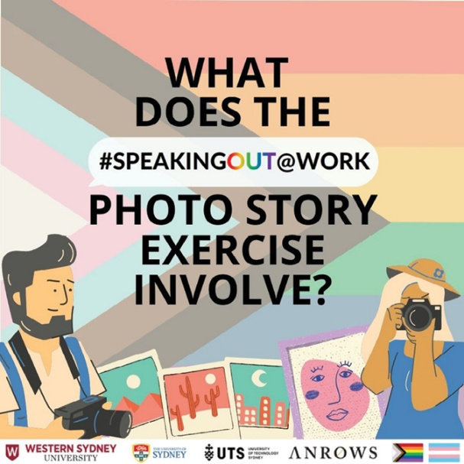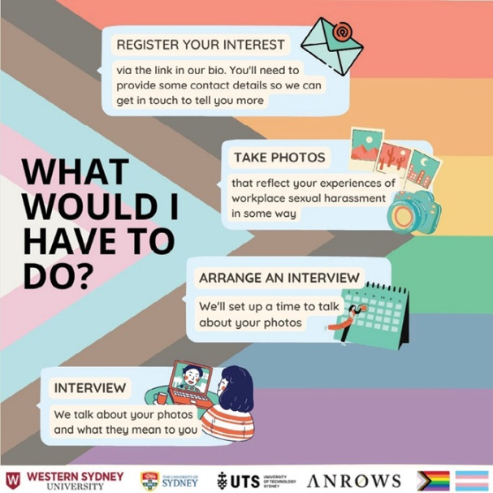

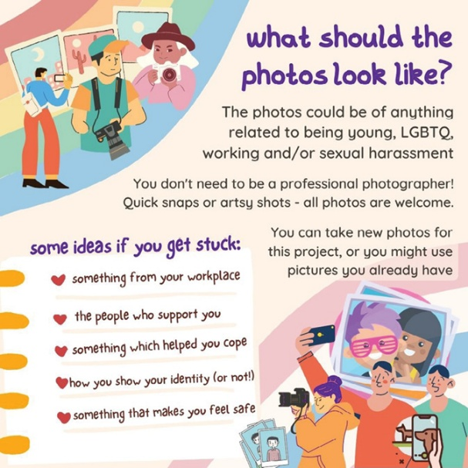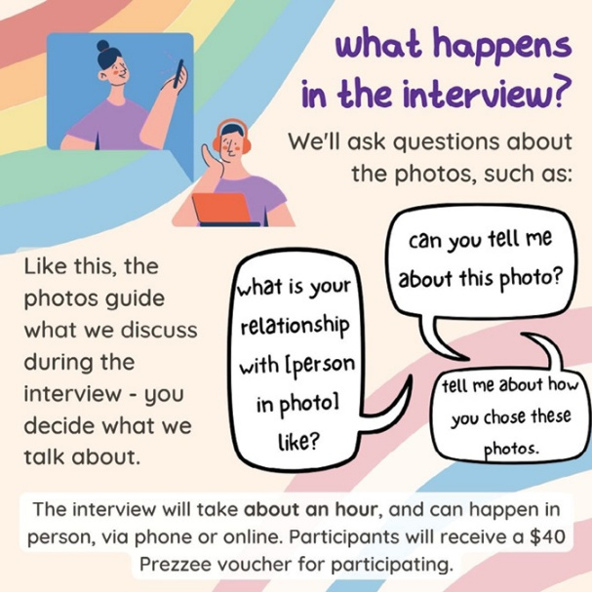

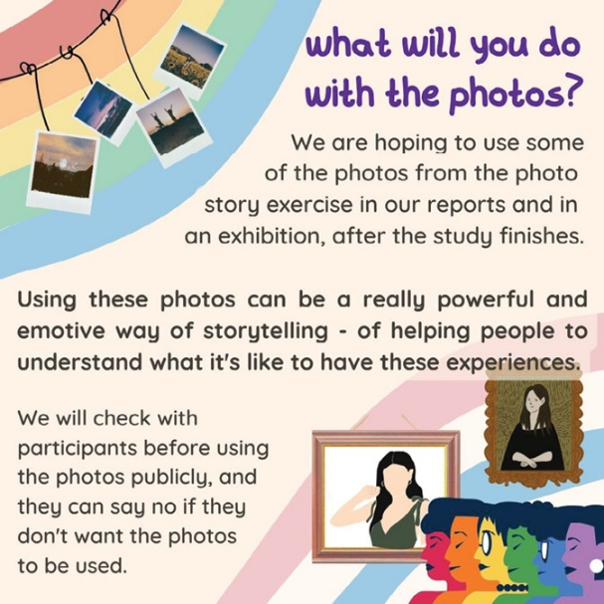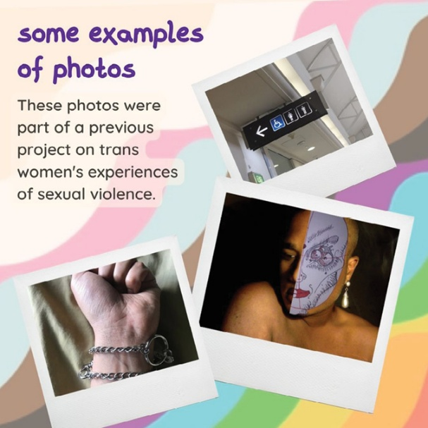

Appendix J:
Photo story interview schedule

Preamble
Thanks very much for sending in your photos for this interview. Just to confirm, we have X photos – [briefly describe photos provided]. Does that sound right to you?
Before we start the interview, I have a few things that I’d like to go over with you. This interview is about your thoughts and experiences of sexual harassment in the workplace and workplace training as a young bisexual non-binary person. During the interview, I will refer to the photographs you have taken, and ask what they mean to you. In this way, the photos serve as points of reflection and recollection about your experiences, in which you can interpret and explain the images as you feel comfortable.
The idea is to hear about what your experiences have been from your own perspective. There are no right or wrong answers to the questions, and you can share as little or as much as you like.
The interview will take about an hour, maybe less, and as mentioned on the Consent Form, it will be recorded so we can go over what you said later on.
If you start feeling uncomfortable or upset at any point, you are free to stop this interview at any time. We can also pause or take a break, and you are free to withdraw from this research study at any time without having to give a reason. You also do not have to answer any questions if you do not wish to.
Everything we talk about today is confidential and all identifying information, such as any names or other identifying information, will be removed from the transcripts. Only the researchers who are part of the project have access to the information you provide.
Do you have any questions before we start?
General question prompts | Examples of tailored question prompts
Confirm LGBTQ and work status | So, can I just confirm for the recording – what terms do you use to describe your gender and sexuality? And you’re currently working in retail, right?
Could you please talk me through these photos and explain what they mean to you? | - This photo made me think about the ways we make our queerness visible through things like our hair and fashion. Has that been a conscious decision for you when it comes to the workplace?  - I know people generally have a lot of photos of their pets. I’m curious about why you chose this one? Do you remember when/where it was taken?  - Can you talk to me about how you made the decision to get this tattoo, and how you decided on the design?  - Can you tell me a bit about why you chose this to represent your experiences of workplace sexual harassment?
Can you talk me through how you decided what photos to take/use for this project? | I’m curious, because these photos are quite focused on times and places where you were harassed – what was it like for you to go back and revisit them?
Is there anything else you want to discuss about your experiences or thoughts about workplace sexual harassment which is not depicted here?

Appendix K:
Coding framework
1. Context
Young LGBTQ+ people’s experiences of workplace safety
2’ code | 3’ code | Description
1.1 Disclosure and concealment of LGBTQ+ identities | - | Discussing decisions around whether, how and to whom to disclose LGBTQ identities; whether to conceal; and impacts
1.2 Workplace culture | 1.2.1 LGBTQ+ related | How participants gauge their safety (as LGBTQ people) at work, e.g. coworker demographics, discussions of LGBTQ issues, visual indicators, nature of industry, experiences of support
1.2 Workplace culture | 1.2.2 Sexual harassment (SH) related | How participants perceive their workplaces’ attitudes towards SH, e.g. organisational tolerance, training/lack of, rules and precautions, portrayal as expected part of job
1.3 Other (non-sexual) harassment and discrimination | 1.3.1 Anti-LGBTQ+ | Homophobia, biphobia, transphobia
1.3 Other (non-sexual) harassment and discrimination | 1.3.2 Sexism, misogyny
1.3 Other (non-sexual) harassment and discrimination | 1.3.3 Ageism
1.4 Other inequalities | 1.4.1 Disability and the workplace | Discussion of how disabilities and other conditions affect work, particularly as they relate to employment precarity (e.g. hard to find job accommodating needs) and vulnerability to WSH (e.g. hard to interpret other people’s intentions)
1.4 Other inequalities | 1.4.2 Other forms of inequality, harassment discrimination, etc. | E.g. racism, classism

2. Training
2’ code | 3’ code | Description
2.1 Sexual harassment (SH) training | 2.1.1 Absence | There is no training
2.1 Sexual harassment (SH) training | 2.1.2 Negative experiences and perceptions | E.g. present but overlooked or dismissed; seen as a tick-a-box exercise that wasn’t taken seriously; cisheteronormative; unmemorable (or can’t remember)
2.1 Sexual harassment (SH) training | 2.1.3 Positive experiences and perceptions | E.g. comprehensive, included explanations of why behaviours were inappropriate
2.1 Sexual harassment (SH) training | 2.1.4 Descriptions | Descriptions of training/what content was covered (no judgement)
2.1 LGBTQ+ inclusion | 2.2.1 Absence
2.1 LGBTQ+ inclusion | 2.2.2 Negative experiences and perceptions
2.1 LGBTQ+ inclusion | 2.2.3 Positive experiences and perceptions
3. Understandings of workplace sexual harassment (WSH)
2’ code | 3’ code | Description
3.1 Definitions  Note: can use crosstabs in NVivo to identify participants who speak about one component but not the other | 3.1.1 Defining workplace component | How is the “workplace” part of WSH conceptualised?
3.1 Definitions  Note: can use crosstabs in NVivo to identify participants who speak about one component but not the other | 3.1.2 Defining sexual harassment (SH) component | What is SH understood to be?  - Traditional perspectives: stereotypes of SH; gender/sexuality ideals: how gender or sexuality expectations correspond to behaviours  - Physical manifestation  - “Inappropriate” as a particular word/concept used as a touchpoint
3.2 Uncertainty  (previously called “lack” of clarity) |  | Grey areas where it is unclear if an incident/ behaviour is SH or not
3.3 Discrepancies |  | Discrepancies between legal/own definitions of WSH; LGBTQ-specific forms of SH felt not covered by initial definitions
3.4 Change in understanding over time  Open to double coding if discussing both in tandem | 3.4.1 How it has changed | Related to age, maturity, experience, changing societal attitudes/understandings, etc.
3.4 Change in understanding over time  Open to double coding if discussing both in tandem | 3.4.2 Where understandings were learned
3.5 Awareness of rights and reporting options | 3.5.1 Lack of awareness | Not sure of rights at work, how to report WSH, etc.
3.5 Awareness of rights and reporting options | 3.5.2 Feeling aware, confident | Inabilities to identify, report, provide support, etc.
4. Experiences
Incidents of WSH
- include any instance of gender- or sexuality-based harassment in order to capture the variation in individual perception of WSH threshold, incl. fetishisation comments re: race/age
2’ code | 3’ code | Description
4.1 Specific incidents  Note: where multiple dynamics are in play, code all present – only where discussion is explicit about how SH was “tailored” for these specific factors (code under 4.2 for general discussions about being seen) | 4.1.1 Targeting sexuality E.g. intrusive questions, comments and jokes about LGBTQ identities, sex lives, bodies, etc.; conversion jokes; sexualisation/fetishisation of LGBTQ people
4.1 Specific incidents  Note: where multiple dynamics are in play, code all present – only where discussion is explicit about how SH was “tailored” for these specific factors (code under 4.2 for general discussions about being seen) | 4.1.2 Targeting trans identities E.g. outing, emphasis on genitalia, unnecessary curiosity, how this changes as per passing or different social placement, misgendering
4.1 Specific incidents  Note: where multiple dynamics are in play, code all present – only where discussion is explicit about how SH was “tailored” for these specific factors (code under 4.2 for general discussions about being seen) | 4.1.3 Targeting women/ femininity
4.1 Specific incidents  Note: where multiple dynamics are in play, code all present – only where discussion is explicit about how SH was “tailored” for these specific factors (code under 4.2 for general discussions about being seen) | 4.1.4 Targeting age
4.1 Specific incidents  Note: where multiple dynamics are in play, code all present – only where discussion is explicit about how SH was “tailored” for these specific factors (code under 4.2 for general discussions about being seen) | 4.1.5 Targeting other factors E.g. race, disability
4.1 Specific incidents  Note: where multiple dynamics are in play, code all present – only where discussion is explicit about how SH was “tailored” for these specific factors (code under 4.2 for general discussions about being seen) | 4.1.6 Non-targeted
4.2 Causes and facilitators of WSH | 4.2.1 Related to workplace | E.g. dynamic (friendliness/closeness) between staff, physical location/proximity, lack of explicit rules/rules not acted upon, nature of work/industry (e.g. pushing boundaries)
4.2 Causes and facilitators of WSH | 4.2.2 Related to victim | E.g. age as vulnerability, open/visible queerness as green light to target, socialised role of worker, assumed easy-going/ receptive
4.2 Causes and facilitators of WSH | 4.2.3 Related to harasser | E.g. harasser’s power and proximity to victims  Queer manifestations – lack or presence of queerness as deniability
4.3 Evaluation/ appraisal of incident | 4.3.1 Individual appraisal | E.g. perceptions of severity, intimidation  Appraisal of events as “inappropriate”
4.3 Evaluation/ appraisal of incident | 4.3.2 Social appraisal | E.g. speaking about it to others to ascertain legitimacy
4.3 Evaluation/ appraisal of incident | 4.3.3 Witnessing
5. Responses to WSH
2’ code | 3’ code | Description
5.1 Reporting | 5.1.1 Positive experiences of reporting
5. Responses to WSH | 5.1.2 Negative experiences of reporting | E.g. dismissing or downplaying incident, not treated confidentially, retaliation
5. Responses to WSH | 5.1.3 Barriers – institutional factors  Barriers/reasons for not reporting/negative expectations – workplace or systemic factors | E.g. fear of retaliation, disrupting coworker dynamics, reputational damage; anticipated criticism, scepticism or blame; difficulty enforcing consequences for customers; unclear procedures; distrust in management; guilt; complicity
5. Responses to WSH | 5.1.4 Barriers – victim-related  Barriers/reasons for not reporting/negative expectations – personal factors | E.g. reporting as undermining personal identity, received differently depending on who the perpetrator is, did not want to be perceived as a “woke lib”, “harassment” from informal disclosures to make a formal complaint
5.2 Support-seeking
5.2 Support-seeking | 5.2.1 Positive experiences of support
5.2 Support-seeking | 5.2.2 Negative experiences of support
5.2 Support-seeking | 5.2.3 Reasons for not seeking support | Note to us for the analysis – check Responses > Other responses > Deliberate inaction code (5.1.4)
5.3 Other responses  (other than reporting or support-seeking) | 5.3.1 Avoidance, defensive behaviour | E.g. avoiding perpetrators or locations of harassment
5.3 Other responses  (other than reporting or support-seeking) | 5.3.2 Compliance, playing along | E.g. answering intrusive questions, going along with offensive jokes
5.3 Other responses  (other than reporting or support-seeking) | 5.3.3 Confrontation
5.3 Other responses  (other than reporting or support-seeking) | 5.3.4 Deliberate inaction | E.g. accepting as expected, trade-off for other benefits of work
5.4 Outcomes of response | 5.4.1 For victim
5.4 Outcomes of response | 5.4.2 For harasser
5.4 Outcomes of response | 5.4.3 For workplace
5.4 Outcomes of response | 5.4.4 Uncertainty
5.4 Outcomes of response | 5.4.5 None
6. Impacts of WSH
2’ code | 3’ code | Description
6.1 Work-related |  | Impacts on work, career, finances, etc.
6.2 Emotional/ mental health–related
6.3 LGBTQ identity–related |  | Impacts on feelings and/or openness about being LGBTQ+, etc.
6.4 Relational
6.5 Other
6.6 None
6.7 Interactions with previous experiences |  | E.g. past abusive relationships, DFV, other sexual harassment/assault
7. Preventing and addressing WSH
2’ code | 3’ code | Description
7.1 Addressing WSH | 7.1.1 Training, education
7.1 Addressing WSH | 7.1.2 Reporting pathways and procedures
7.1 Addressing WSH | 7.1.3 Enforcing consequences
7.1 Addressing WSH | 7.1.4 Other
7.1 Addressing WSH | 7.1.5 Information and support
7.2 LGBTQ workplace safety  Making workplaces safer for LGBTQ people more broadly | 7.2.1 Training, education
7.2 LGBTQ workplace safety  Making workplaces safer for LGBTQ people more broadly | 7.2.2 Specific LGBTQ supports/resources
7.2 LGBTQ workplace safety  Making workplaces safer for LGBTQ people more broadly | 7.2.3 Visible indicators of acceptance
7.2 LGBTQ workplace safety  Making workplaces safer for LGBTQ people more broadly | 7.2.4 Other



Sexual harassment was defined in the survey as “an unwelcome sexual advance, unwelcome request for sexual favours, or other unwelcome sexual behaviour that you could expect might make someone feel offended, humiliated or intimidated. ‘At work’ includes working online, at work-related social events, interacting with co-workers outside of work, seeking work and in workplace training.”
The term “woke” originally described a person who was aware of social inequalities, particularly around racial injustice; it is now primarily used pejoratively to mock those with progressive beliefs (particularly around social justice).
“Masking” is a term describing how neurodivergent people suppress behaviours characteristic of their conditions, instead mirroring the behaviours of neurotypical people who do not have these conditions.
Percentages add up to greater than 100 as more than one perpetrator may have been present.
Dylan provided consent for this identifiable photo to be used in this report.
“Tranny” is an offensive term that is not used by the authors of this report. It is kept as part of the participant’s voice and narrative.
Now known as Anti-Discrimination NSW; website http://www.antidiscrimination.nsw.gov.au/

