
Australian domestic and family violence
death review network data report

Filicides in a domestic and family violence context
2010–2018
First edition | 2024
Holly Blackmore | Freya McLachlan
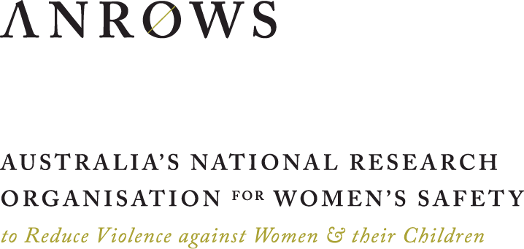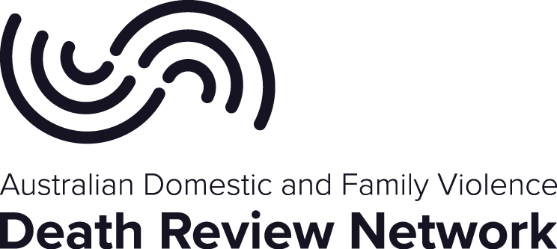
ANROWS acknowledgement
This material was produced with funding from the Australian Government and the Australian state and territory governments. Australia’s National Research Organisation for Women’s Safety (ANROWS) gratefully acknowledges the financial and other support it has received from these governments, without which this work would not have been possible. The findings and views reported in this paper are those of the authors and cannot be attributed to the Australian Government, or any Australian state or territory government.
Acknowledgement of Country
ANROWS acknowledges the Traditional Owners of the land across Australia on which we work and live. We pay our respects to Aboriginal and Torres Strait Islander Elders past and present, and we value Aboriginal and Torres Strait Islander histories, cultures and knowledge. We are committed to standing and working with Aboriginal and Torres Strait Islander peoples, honouring the truths set out in the Warawarni-gu Guma Statement.
Acknowledgement of lived experiences of violence
ANROWS acknowledges the lives and experiences of the women and children affected by domestic, family and sexual violence across Australia. We recognise the individual stories of courage, hope and resilience that form the basis of ANROWS research.
Caution: This report presents research findings on filicide (i.e. the killing of a child by their parent). The report also contains references to the violence that children experienced, to intimate partner violence, and to people, particularly children, who have died, including Aboriginal and/or Torres Strait Islander children. No names or images of deceased people are included in this report.
People may find parts of this content confronting or distressing. Recommended support services include: 1800RESPECT (1800 737 732), Lifeline (13 11 14) and, for Aboriginal and Torres Strait Islander people, 13YARN (13 92 76).
Peer-review process
The quality of ANROWS publications is ensured through a rigorous peer-review process that is consistent with the principles of the Committee on Publication Ethics (COPE) Ethical Guidelines for Peer Review. This report has been assessed by at least two peer reviewers with relevant academic expertise.
 © ANROWS 2024
With the exception of the ANROWS branding, content provided by third parties, and any material protected by a trademark, all material presented in this publication is licensed under a Creative Commons Attribution-NonCommercial 3.0 Australia (CC BY-NC 3.0 AU) licence.
The full licence terms are available at creativecommons.org/licenses/by-nc/3.0/au/legalcode
Published by
Australia’s National Research Organisation for Women’s Safety Limited (ANROWS)
PO Box Q389, Queen Victoria Building, NSW 1230 | www.anrows.org.au
ABN 67 162 349 171
ISBN: 978-1-922645-91-3 (paperback)
ISBN: 978-1-922645-89-0 (PDF)
Please note that there is the potential for minor revisions of this report.
Please check the online version at www.anrows.org.au for any amendment.
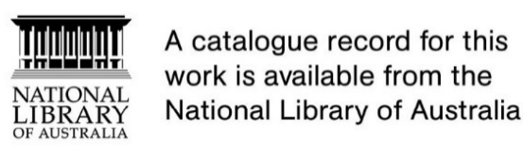
Australian domestic and family violence
death review network data report
Filicides in a domestic and family violence context
2010–2018
First edition | 2024
Prepared by
Dr Holly Blackmore
Dr Freya McLachlan
This report addresses work covered in the ANROWS research project 4AP.9 “Australian Domestic and Family Violence Death Review Network national data update”. Please consult the ANROWS website for more information on this project.
Suggested citation:
Australian Domestic and Family Violence Death Review Network, & Australia’s National Research Organisation for Women’s Safety. (2024). Australian Domestic and Family Violence Death Review Network data report: Filicides in a domestic and family violence context 2010–2018 (1st ed.; Research report, 06/2024). ANROWS.

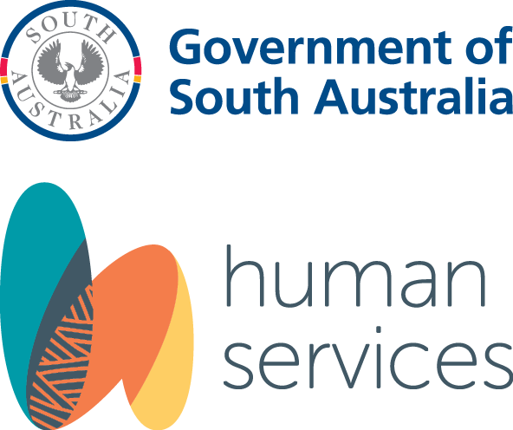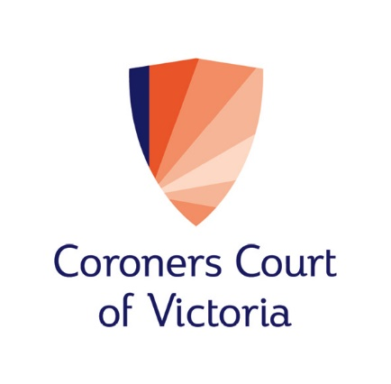

Author acknowledgement
This report is the result of a partnership between Australia’s National Research Organisation for Women’s Safety (ANROWS) and the Australian Domestic and Family Violence Death Review Network (the Network) which is comprised of members from the:
- Victorian Systemic Review of Family Violence Deaths, Coroners Court of Victoria;
- Domestic Violence Death Review Team, NSW Department of Communities and Justice;
- Domestic and Family Violence Death Review Unit, Coroners Court of Queensland;
- South Australian Coroners Court;
- Ombudsman Western Australia;
- Northern Territory Coroner’s Office;
- Magistrates Court of Tasmania (Coronial Division); and
- Australian Capital Territory, Domestic and Family Violence Death Review, Domestic, Family and Sexual Violence Office, Community Services Directorate.
The Network would like to acknowledge Dr Holly Blackmore and Dr Freya McLachlan at ANROWS for their work in writing this report.
The team extend their thanks to Professor Kyllie Cripps for her expert review of the draft data tools for this project and to both Kyllie and Associate Professor Hannah McGlade for their review of an earlier version of this report.
The team also extend their thanks to the stakeholders who shared their insightful reflections on a summary of the findings and whose reflections have been included throughout this report.
The team wish to thank the anonymous peer reviewers and ANROWS colleagues who provided feedback on an earlier version of this report.
Most importantly the team acknowledge all those who have tragically lost their lives to domestic and family violence and extend our sincere condolences to their surviving families and friends.

Contents
Acronyms 3
Definitions and concepts 4
Executive summary 9
Background 10
Aims and method 11
Key findings 11
Implications and future directions 15
Conclusions 17
Introduction 18
Filicide characteristics 21
Filicide in the context of DFV 22
Australia’s cultural and geographic landscape 23
Summary 25
Methods 26
Research design 27
Data sources 28
Ethical considerations 28
Case inclusion criteria 28
Data collection, coding and analysis 29
Stakeholder reflections 31
Findings 32
An overview of filicide in Australia 33
Filicide in a DFV context 34
Case characteristics 34
Victim characteristics 38
Offender characteristics 42
DFV characteristics preceding the filicide 65
SERVICE CONTACT 77
Discussion 85
Data set strengths and limitations 86
Key findings 88
Implications and future directions 95
Conclusion 117
Author contributions 120
References 121
Appendix A 137
Appendix B 142
Appendix C 151

Acronyms
Acronym | Definition
ADFVDRN | Australian Domestic and Family Violence Death Review Network
ANROWS | Australia’s National Research Organisation for Women’s Safety
AOD | Alcohol and other drugs
CARM | Culturally and racially marginalised
DFV | Domestic and family violence
IPH | Intimate partner homicide
IPV | Intimate partner violence
IPVH | Intimate partner violence homicide
NCIS | National Coronial Information System
NGMI | Not guilty by reason of mental illness
NHMP | National Homicide Monitoring Program

Definitions and concepts
Concept | Definition
Assault | The Australian Domestic and Family Violence Death Review Network (the Network) defines assault as an injury from an act of violence where physical force by one or more persons is used with the intent of causing harm, injury or death to another person.
Child protection order | An order made by the Children’s Court, the objective of which is to protect the child/ren involved and may or may not include provisions for their permanent care. The term includes provisional, interim and final orders.  This could include, for example, a permanent care order, family reunification order, temporary custody order, protective supervision order, protection order (special guardianship), or an emergency care and protection order.
Coercive control | A concept that underpins almost all domestic and family violence and manifests as a pattern of behaviours and tactics that can be highly individualised. Coercive control is not associated with a particular type of abuse and can be physical, emotional, cultural, economic, financial and social in nature. Coercive control encompasses the “various means to hurt, humiliate, intimidate, exploit, isolate, and dominate their victims over time”, which includes non-physical and/or physical tactics (Stark, 2007, p. 5; Stark & Hester, 2019).
Domestic and family violence (DFV) | The National Plan to End Violence against Women and Children 2022–2032 (the National Plan) defines domestic violence as:  any behaviour within an intimate relationship (including current or past marriages, domestic partnerships or dates) that causes physical, sexual or psychological harm. This is the most common form of violence against women. Intimate partner violence can also occur outside of a domestic setting, such as in public and between 2 people who do not live together. (Department of Social Services [DSS], 2022, p. 37)  The National Plan further states that family violence refers:  not only to violence between intimate partners but also to violence perpetrated by parents (and guardians) against children, between other family members and in family-like settings. This includes for example elder abuse, violence perpetrated by children or young people against parents, guardians or siblings, and violence perpetrated by other family members such as parents-in-law. Family violence is also the term Aboriginal and Torres Strait Islander peoples prefer because of the ways violence occurs across extended family networks (DSS, 2022, p. 37).  The Network’s definition of DFV (as per the Homicide Consensus Statement in Appendix A) generally aligns with the definition in the National Plan. That is, DFV includes a spectrum of physical and non-physical abuse within an intimate or family relationship. DFV behaviours include physical assault, sexual assault, threats, intimidation, psychological and emotional abuse, social isolation and economic deprivation. Primarily, DFV is predicated upon inequitable relationship dynamics in which one person exerts power and coercive control over another.
Domestic and family violence order (DFV order) | A civil order, the objective of which is to protect victim-survivors – or persons at risk – of DFV from another person with whom they are, or have been, in an intimate or familial relationship. The term includes provisional, interim and final orders.  This is also referred to as an apprehended domestic violence order, a family violence order, family violence intervention order, family violence restraining order, protection order or an intervention order.
Emotional or  psychological violence | The 2023 National Domestic and Family Violence Bench Book states that:  emotional or psychological abuse may include verbal, non-verbal or physical acts by the perpetrator that are intended to exercise dominance, control or coercion over the victim; degrade the victim’s emotional or cognitive abilities or sense of self-worth; or induce feelings of fear and intimidation in the victim (Attorney-General’s Department, 2023, p. 1497).  The Network specifically includes behaviours such as verbally denigrating or belittling the victim-survivor, making threats regarding custody of children as a means to control, and blaming the victim-survivor for all adverse events. Isolating the victim-survivor from family and friends (also known as “social abuse”) is also included under this definition for the purposes of this report.
Family law proceedings | Proceedings commenced in the Federal Circuit and Family Court of Australia (all states except for Western Australia). In Western Australia, this refers to proceedings commenced in the Family Court of Western Australia.
Filicide | The homicide of a child or children under 18 years of age by their parent/s and/or parent equivalent/s. Filicide can also be captured in other terms such as “fatal child abuse” or “non-accidental injury of a child”. In this report, the filicide must have been the result of an intentional act, or failure to act, and the person responsible for the death must have been determined either through a coronial or criminal finding.
Filicide offender | The person whose actions inflicted the injuries to the filicide victim that caused their death/homicide.
Filicide-suicide | A filicide case that involves the suicide of the filicide offender/s.
Filicide victim | The person who died because of the injuries inflicted by the filicide offender/s.
Gender | The term “gender” is used in this report to indicate people’s gender identity notwithstanding their biological sex classification. The National Plan defines gender as:  the economic, social, political, and cultural attributes and opportunities associated with being women and men. The social definitions of what it means to be a woman or a man vary among cultures and change over time. Gender is a sociocultural expression of particular characteristics and roles that are associated with certain groups of people … (DSS, 2022, p. 128)  The term also more comprehensively reflects the gendered nature of DFV related to the socially constructed classifications and characteristics attributed in particular to male and female sex categorisations. This report acknowledges that people’s biological sex may differ from their gender identity.
Homicide | Includes all circumstances in which an individual’s intentional act, or failure to act, resulted in the death of another person, regardless of whether the circumstances were such as to contravene provisions of the criminal law.
Intimate partner violence (IPV) | A pattern of behaviour whereby one person intentionally and systematically uses violence and abuse to gain and maintain power over another person with whom they share, or have previously shared, an intimate relationship (see “Domestic and Family Violence” above).
Intimate partner violence homicide (IPVH) | A homicide that occurs between individuals who are or have been in an intimate relationship following an identifiable history of domestic violence. See also “Homicide” above.
Manner of death | The manner by which a person perpetrates the filicide against another person, or, more broadly, the way in which one person kills another person. Can include methods such as assault with a sharp weapon, assault with a blunt weapon, or homicide by firearm.
Parent | A term that captures the filicide victim’s father, mother, and any other person with parental responsibility for the child on a more than temporary basis (e.g. an adoptive or foster parent, a step-parent, a parent’s partner, or a grandparent who is the child’s primary caregiver). For a child who identifies or is identified as Aboriginal and/or Torres Strait Islander, this also includes a person who is regarded as the child’s parent under Aboriginal tradition or Island custom. The definition does not include persons who are part-time paid caregivers (i.e. persons providing a baby-sitting, nannying or other commercial child-minding service), nor relatives who provide temporary care for the child.
Perpetrator | The National Plan definition refers to: “a person who commits an illegal, criminal or harmful act, including domestic, family or sexual violence” (DSS, 2022, p. 131).
Physical violence | The 2023 National Domestic and Family Violence Bench Book states that:  Actual or threatened physical violence or harm is among the range of behaviours that characterise domestic and family violence … The most common form of physical violence is threats of physical harm, however these are often accompanied by actual physical violence … A perpetrator may intend to intimidate and induce fear in the victim through physical violence or harm yet cause minor or no visible signs of injury on the victim’s body. Victims may be kicked, slapped, bitten, or punched with a fist. They may be pushed, grabbed, or have their arm twisted or hair pulled. They may be hit with an object or have an object thrown at them … (Attorney-General’s Department, 2023, p. 1431)
Primary IPV perpetrator | The person who is the primary (or predominant) perpetrator of IPV. This term is designed to highlight that a person may have been the predominant user of IPV prior to the filicide, and the filicide may have been perpetrated by a person who was typically a perpetrator of IPV.
Primary IPV  victim-survivor | The person who primarily (or predominantly) had IPV used against them (was victimised) during the relationship with a perpetrator, or after that relationship had ended. The term designates a person who predominantly experiences IPV. This term is designed to highlight that a person may be the predominant victim-survivor of IPV prior to the filicide but may ultimately perpetrate filicide. The term “victim-survivor” is used consistently throughout the report for clarity, despite there being several cases where that person may have suicided following the perpetration of the filicide.
Sexual violence | Sexual violence typically refers to unwanted or non-consensual sexual behaviours. The National Plan definition includes:  rape, attempted rape, aggravated sexual assault (assault with a weapon), indecent assault, penetration by objects, forced sexual activity that did not end in penetration and attempts to force a person into sexual activity. Note sexual assault occurs when a person is forced, coerced or tricked into sexual acts against their will or without their consent, including when they have withdrawn their consent. (DSS, 2022, p. 132)  When the victim-survivor is a child, the National Redress Guide defines sexual violence as: “when someone involves a person under the age of 18 in sexual activities that they do not understand, or that are against accepted community standards” and may include “sexual touching of any part of the body, either clothed or unclothed”, “preparing or encouraging a child to engage in sexual activity”, and “sex of any kind with a child” (DSS, 2024).
Victim-survivor | The National Plan defines victim-survivors as:  people who have experienced family and domestic violence or gender-based violence. This term is understood to acknowledge the strength and resilience shown by people who have experienced or are currently living with violence. People who have experienced violence have different preferences about how they would like to be identified and may choose to use “victim” or “survivor” separately, or another term altogether. Some people prefer to use “people who experience, or are at risk of experiencing, violence”. (DSS, 2022, p. 134)
Violence against the child/ren | A range of behaviours including physical, sexual and emotional/psychological forms of violence perpetrated towards a person under the age of 18 years. In this report, it does not include the child hearing, seeing, or otherwise experiencing the effects of IPV. It is recognised that when children are living in homes where IPV is present, this is a form of violence that is also experienced by them. The presence of IPV is captured separately in this research, which can then be combined to demonstrate the total known rates of DFV experienced by the child. This decision meant that any emotional/psychological violence captured in this report involves, for instance, humiliating, verbally abusing, scaring, and/or isolating the child/ren.  The term “experienced” is used over “exposed” or “witnessed” to demonstrate the impact of DFV on the child/ren. When there is DFV present in a child’s home, they cannot be exposed to this violence without being directly affected by it. In using this terminology, there is recognition that children experience DFV as victims in their own right.



Executive summary
This report presents the first national figures for filicides that have occurred in Australia in the context of domestic and family violence (DFV). In this research, DFV context means the filicide was preceded by an identifiable history of violence against the filicide victim/s and/or their siblings that was perpetrated by their parent/s and/or a history of intimate partner violence (IPV) involving their parent/s. The report examines the characteristics of filicide victims and offenders, as well as some of the broader characteristics of filicide. In doing so, this report adds to the national knowledge base of DFV-context filicide and the drivers of DFV. The report is a product of a national filicide project, which has been developed through the collaborative partnership between the Australian Domestic and Family Violence Death Review Network (the Network) and ANROWS.

Background
DFV is characterised by patterns of violence perpetrated within an intimate or family-like relationship (DSS, 2022), including former intimate relationships. DFV can be fatal, with domestic homicides accounting for over a third of all homicides in Australia (Bricknell, 2023) and often occurring following a history of DFV (Australian Domestic and Family Violence Death Review Network [ADFVDRN], 2018). The killing of a child or children by their parents, or filicide, is a relatively rare but alarming occurrence that has a devastating impact on families and a radiating impact on communities. In Australia, filicide comprises the second largest proportion of domestic homicides, after intimate partner homicide (Serpell et al., 2022). Despite the overall rate of domestic homicide trending downwards in Australia, the rate of filicide has remained steady (Brown, Lyneham, et al., 2019). Filicide in Australia requires a national and targeted examination to better understand the characteristics that are associated with filicide, particularly with respect to DFV, and to identify pathways for intervention and prevention.

The Network
The Network was established in 2011 following the implementation of DFV death review mechanisms in several Australian jurisdictions. The Network is a collaboration of all state and territory DFV death review mechanisms. Network members have specialist expertise in DFV deaths, and access to extensive information, such as coronial files, police records, and government and non-government agency records, pertaining to these deaths (ADFVDRN, 2018). The broad objective of these mechanisms is to improve knowledge regarding the frequency and context of DFV deaths and to identify potential areas for improvement in systemic responses to DFV. The mechanisms collect and analyse in-depth data on DFV deaths with a view to identifying patterns and commonalities to guide reform.
In 2018, the Network established a national minimum data set on intimate partner violence homicide (IPVH) and published the inaugural Australian Domestic and Family Violence Death Review Network Data Report in May 2018. This inaugural IPVH Data Report provided an analysis of and findings relating to all intimate partner homicides that occurred in a DFV context (i.e. IPVH) between July 2010 and June 2014 in Australia.

The collaboration between ANROWS and the Network
To produce the second iteration of the IPVH Data Report, the Network collaborated with ANROWS. The second iteration expanded the data to include IPVH cases occurring between 1 July 2010 and 30 June 2018 (see ADFVDRN & ANROWS, 2022). The collaborative partnership between the Network and ANROWS has continued, leading to the development of the current project, which involved developing a national minimum data set on filicides that occurred in the context of DFV and a related report on the national findings.

The national filicide project
The current project seeks to enhance the national understanding of filicide and establish the rate, characteristics and potential intervention points of DFV-context filicide in Australia. The goal of this project aligns with the goals of the Network, the ANROWS Strategic Plan 2022–2027 and the National Plan to End Violence against Women and Children 2022–2032. By identifying those at risk of DFV victimisation and perpetration, this report provides evidence that can inform DFV prevention and intervention strategies and policy.

Aims and method
The primary aim of this project was to create a national minimum data set of filicides that occur in Australia within a DFV context. To do this, the project used a retrospective population-based case series analysis to examine the deaths of children who were killed by their parent/s in Australia between 1 July 2010 and 30 June 2018. This project builds on previous collaborative work undertaken by ANROWS and the Network in updating the Network’s national minimum data set of IPVH, which was developed using a similar methodological framework.
Data collection commenced nationally in September 2022 and concluded in early 2023. Once data was collected from each jurisdiction, it was compiled into a single data set. Data was sourced from each of the state and territory DFV death review mechanisms. The data relates to closed cases of filicide only, as per the case inclusion criteria, and as such excludes any filicide cases with ongoing criminal or coronial proceedings. Once closed, those filicide cases will be reflected in subsequent reporting.
Data for each of the included filicide cases was extracted from any existing jurisdictional data sets, case reviews completed by DFV death review mechanisms, electronic files and/or hard copy files, and then entered into the data set. A focused national minimum data set was created, which included only those filicides that occurred in a DFV context. A range of descriptive statistical analyses were conducted; the results of which are presented in this report.
The project also sought reflections from a range of stakeholders on a summary of the findings to assist with presenting the findings in a sensitive and constructive manner, providing valuable context within which filicides occur, and incorporating other ways of knowing. Perspectives were sought from a senior social worker, a coroner, and child protection practitioners, among others. Once the stakeholder reflections had been gathered, they were reviewed and assigned to relevant findings and implications in the report. Reflections were deidentified and attributed to a stakeholder’s broad role or title (e.g. reflections from a coroner). Throughout the report, reflections are presented in shaded text boxes and are a valuable companion to the findings and implications.

Key findings
Between 1 July 2010 and 30 June 2018, 113 filicides occurred across Australia involving 138 filicide victims and 127 filicide offenders. Three quarters of these cases occurred within a DFV context (76%, n = 86). Across the 86 DFV-context filicide cases, there were 106 filicide victims and 99 filicide offenders. The findings outlined below focus on these 86 cases.

DFV context
A filicide was considered to have occurred in a DFV context where there was an identifiable history of violence prior to the filicide. This history could involve physical, emotional and/or sexual violence perpetrated against the filicide victim/s and/or their sibling/s by their parent/s, as well as any IPV involving their parent/s.
- Of the 86 DFV context filicides, almost 4 in 5 cases involved identifiable violence against the child/ren in the form of physical, emotional and/or sexual violence (78%, i.e. 67 cases).
- Physical violence and emotional violence were the most frequently identified forms of violence, with around 4 in 5 of these cases containing such evidence (84% and 81% of the 67 cases, respectively).
- Evidence of sexual violence was identified in around 1 in 5 of these cases (19% of the 67 cases), although due to the nature of sexual violence it is possible that this form of violence had gone undetected by family, friends and services.
- Prior violence against the child/ren was most often perpetrated by one or, where applicable, both of the filicide offenders (87% of the 67 cases).
- Around 9 in 10 DFV-context filicides demonstrated evidence of a history of IPV prior to the filicide (88% of the 86 cases).
- A gendered nature to the DFV context was observed.
- The majority of DFV-context filicides were perpetrated by male filicide offenders (68%) compared to female filicide offenders (32%).
- Male filicide offenders were more commonly the sole perpetrator of any violence against the filicide victim/s and/or their sibling/s prior to the filicide (73% of the male filicide offenders in cases with prior violence against the child/ren) compared to female filicide offenders (36% of the female filicide offenders in cases with prior violence against the child/ren).
- Almost all filicide offenders who were also identified as a primary IPV perpetrator were male (97% of the 58 primary IPV perpetrators). Whereas nearly all the filicide offenders who were also identified as a primary IPV victim-survivor were female (96% of the 23 primary IPV victim-survivors).
- Parental separation was a characteristic in around a third of cases (31%).

Family dynamics
The nature of filicide, as defined in this project, means that the family dynamic is a key context in which violence is perpetrated.
- Nearly half of the filicide victims were aged under 2 years when they were killed (46%).
- Most filicide offenders were a biological parent (71%).
- In terms of non-biological parents, non-biological fathers comprised 27 per cent of all filicide offenders, while non-biological mothers comprised only 2 per cent.
- Most filicide offenders resided with the filicide victim/s full-time (83%) at the time of the filicide.

Service contact
Service contact was examined in this project to establish a preliminary understanding of the categories of services that filicide victims and/or their families interacted with prior to the filicide, as well as the level and recency of that contact. While capturing the nature and quality of service engagement was outside the scope of this project, it is important to note that service contact existed on a spectrum, from a single interaction through to extensive long-term contact. The preliminary analysis included the following services: health care (general, maternal and mental), police, child protection, education, specialist DFV services, legal services, and alcohol and other drugs (AOD) services. For particular services (i.e. police, courts, tribunals and legal services), the contact needed to relate to DFV rather than another unrelated reason for the contact (e.g. police stopping the filicide offender for a random breath test). Other key points of contact were identified based on demographic and case characteristic data and included workplaces and family court.
- General health services and child protection had high levels of contact with families (71% and 60% of cases, respectively) and both had high recency of contact prior to the filicide (i.e. over half of the cases with prior contact with the service had the last recorded contact less than 3 months prior to the filicide). Whereas police had high levels of contact with families (65%) but low recency (i.e. less than half of the cases with prior contact with the service had the last recorded contact less than 3 months prior to the filicide).
- AOD services, DFV services, and courts and tribunals all had low levels of contact (13%, 19% and 27%, respectively) and low recency.
- Early childhood education and legal practitioners were recorded as having low levels of contact (23% and 20%, respectively) but high recency.
- In terms of other key points of contact, the findings indicated:
- Almost 2 in 5 filicide offenders were employed (37%), meaning workplaces could serve as a key point of contact.
- The rate of cases with family law proceedings, either current or historical (15%), suggests family court could serve as a key point of contact.

Aboriginal and Torres Strait Islander victims and offenders
The findings relating to Aboriginal and/or Torres Strait Islander filicide victims and offenders must be considered with respect to the context within which this violence occurred; that is, as discussed in the “Introduction” section of this report, within the context of colonisation and intergenerational trauma (McGlade, 2012), the ongoing colonial system (Watego et al., 2021), the persistent lack of appropriate services (McGlade, 2012), deficiencies in the practices of identification of Aboriginal and/or Torres Strait Islander peoples (Cripps, 2023), and the limited resourcing of support services and programs (Langton et al., 2020a).
The findings demonstrate a substantial over-representation of Aboriginal and/or Torres Strait Islander children as filicide victims.
- Approximately one quarter of filicide victims were identified as Aboriginal and/or Torres Strait Islander (26%), despite Aboriginal and Torres Strait Islander children comprising around 6 per cent of the Australian child population (Australian Institute of Health and Welfare [AIHW], 2020).
- Around 1 in 5 Aboriginal and/or Torres Strait Islander filicide victims were killed by a non-Indigenous parent.
- While Aboriginal and Torres Strait Islander peoples comprise approximately 4 per cent of the Australian population (Australian Bureau of Statistics [ABS], 2023), they were somewhat over-represented as filicide offenders in this research (16%). This finding of over-representation is consistent with broader trends in the DFV literature (for discussion on this see Cripps, 2008; Nancarrow, 2019; Reeves & Meyer, 2021), although it is noted that the over-representation found in this filicide project is less than that identified in the IPVH Data Report (see ADFVDRN & ANROWS, 2022). Nevertheless, the findings from this study should be considered with respect to the ongoing harm of colonial disposition, structural violence, and lack of culturally appropriate support services (see Atkinson, 1990; McGlade, 2012; Langton et al., 2020a, 2020b, for further discussion on this).
- In considering the gender of Aboriginal and/or Torres Strait Islander filicide offenders, higher rates of Aboriginality were evident among male filicide offenders (19% of male filicide offenders) compared to female filicide offenders (9% of female filicide offenders). This pattern can also be seen in the broader DFV-context filicide findings, which demonstrates a greater number of male filicide offenders compared to female filicide offenders; a finding that also aligns with the IPVH literature (e.g. Cussen & Bryant, 2015) and the previous IPVH Data Report (ADFVDRN & ANROWS, 2022).

Implications and future directions
The findings from this project provide important insights and understandings of DFV-context filicide that can contribute to the development of DFV policy and guide DFV responses and practice. The findings also highlight several emerging areas that warrant further research.

Policy and practice
The following implications for policy and practice should be considered at both a national and state and territory level, with respect to the relevant jurisdictional context.
- Recognising children as victims of DFV in their own right and centring them in responses to DFV is imperative, particularly given the high proportion of children who had experienced DFV prior to the filicide.
- A gendered approach to DFV policy and practice is supported by the findings given the gendered nature of violence evident in the filicide cases. Men were over-represented as filicide offenders and almost all primary IPV perpetrators were male. Services should consider any risk of violence towards women as a risk of violence towards their children.
- Integrated multi-agency efforts to address DFV are important given the extensive nature of DFV, the co-occurrence of other issues such as AOD issues and the varied levels of contact across services.
- Considering service contact in the context of intervention by identifying potential opportunities to intervene in DFV.
- Child protection services are a key point of contact for families, with 60 per cent of cases recording some prior contact. Further consideration of this critical intervention point is warranted, for instance, in relation to responding to DFV and the complex intersecting issues that families can face, as well as having a culturally appropriate response to DFV.
- Police had relatively high levels of prior contact with families; however, this contact was often not recent. It was also not common for DFV to be reported to police nor for reported violence to progress to DFV orders. A more-focused examination of the accessibility of DFV orders, particularly with respect to the inclusion of children on orders, may be warranted.
- DFV services had low rates of contact with families prior to the filicide, despite DFV preceding all filicides examined in this project. Increasing education in communities, schools, healthcare settings and police services, could ensure those experiencing DFV have greater awareness of the relevant services available to them and promote the making of appropriate referrals. Increased funding for DFV services would also allow for greater capacity and facilitate necessary training and greater resources for service providers.
- Healthcare services provide a key opportunity to intervene in DFV, highlighting the importance of sufficient resourcing and training for healthcare practitioners to identify and respond to DFV. Specifically, mental health and maternal health services may represent important sites for DFV intervention and prevention.
- Workplaces were identified as a potential point of contact, despite the relatively low rate of employment among filicide offenders. Intervention could involve increased support for those experiencing DFV, training for workplaces to recognise and respond to DFV, and collaboration with other services.
- The education sector and those who work in schools have unique access to children and can act as points of contact for children experiencing DFV. Training, education and support is necessary for school staff to ensure they have the resources required to appropriately identify and respond to DFV.
- Access to services is crucial for intervening in DFV. The findings invite reflection on potential barriers and complexities in accessing services, such as the location where families reside and the accessibility and appropriateness of services for Aboriginal and Torres Strait Islander peoples.
- Aboriginal and Torres Strait Islander-led services require increased resourcing to further facilitate work with families and communities, respond to DFV perpetration, and support women and children experiencing DFV. While not specifically captured in the data set, it is evident from other research that many Aboriginal and/or Torres Strait Islander peoples use Aboriginal and Torres Strait Islander-led services (see Langton et al., 2020b; McGlade, 2012). Langton and colleagues (2020b) recommend improved monitoring and additional funding for Aboriginal and Torres Strait Islander-led services, while also calling for more services.
- Improved practices in the identification of Aboriginal and Torres Strait Islander peoples within service delivery could improve service responses (e.g. via culturally appropriate service referrals), as well as the accuracy of future research and evaluations.

Directions for future research
Several directions for future research and evaluation are proposed.
- Further DFV death review research that draws upon the breadth and depth of death review data across Australia could continue to build a unique and national understanding of DFV-related deaths. Further research is anticipated in relation to other kinds of deaths (i.e. to supplement existing work on DFV-context filicide and IPVH), potential updates of existing national minimum data sets to maintain the currency of findings, and the limitations identified in this report.
- Aboriginal and Torres Strait Islander-led research is needed in relation to the high rates of Aboriginal and/or Torres Strait Islander children as victims of filicide.
- Further evaluations of responses to men’s violence are vital to assess, monitor and strengthen existing responses, given the gendered nature of DFV in the findings.
- Further in-depth qualitative studies regarding service contact are needed to explore the nature of service engagement with victim-survivors and perpetrators of DFV. Understanding the nature of and rates at which both users of the service and providers maintain contact could help explain why interventions are not always successful in preventing further DFV.
- Comparative research studies of DFV orders are sparse and more research is needed to understand how jurisdictional differences impact the safety of children. Future research should also examine the accessibility and effectiveness of DFV orders across jurisdictions and within culturally and racially marginalised (CARM), rural, and Aboriginal and Torres Strait Islander communities.
- Challenging problematic narratives and stereotypes in filicide, such as those that demonise mothers, is vital if research is to contribute towards improved community understanding of filicide and filicide offenders, and to appropriately respond to risk.
- Surviving siblings are a large but under-researched cohort of victim-survivors, represented by at least 120 siblings in this report and requiring focussed attention in research.

Conclusions
The findings from this national filicide project demonstrate that a majority of filicides in Australia occur following an identifiable history of DFV, meaning there is potential to prevent these deaths through effective prevention, early intervention and responses to DFV. The high rates and gendered nature of IPV that preceded the DFV-context filicides indicate that a risk of violence to women should be seen as a risk to any children, given that almost all primary IPV perpetrators were male and the vast majority of primary IPV victim-survivors were female. Considering the number of filicides that occur in Australia each year, it is important that any research or other examination of filicide captures a lengthy period of time in order to more accurately report on any patterns or trends. The depth and breadth of the death review data examined in this project is an exceptional strength of this research and provides the opportunity to examine the characteristics of each filicide case, including the histories that preceded each filicide with a particular focus on the DFV context. Moreover, by coding and collating this data at a national level, this report provides unique and ground-breaking insights into the characteristics of DFV-context filicide in Australia.

Introduction
Over a third of all homicides in Australia are considered domestic homicides (Bricknell, 2023). Domestic homicides involve the killing of a family member, kin, partner or ex-partner. Specifically, domestic homicides include, for example, intimate partner homicide (IPH), parricide, siblicide, familicide and, the focus of this report, filicide (i.e. the killing of a child by their parent/s). A high proportion of domestic homicides occur in the context of DFV, meaning there was an identifiable history of violence that preceded the homicide (ADFVDRN, 2018). DFV is characterised by patterns of behaviour that include both physical and non-physical forms of abuse.

In Australia, IPH is the most common form of domestic homicide. As such, there has been extensive investigation into these deaths, both state-wide and from a national perspective (see ADFVDRN & ANROWS, 2022; Bugeja et al., 2013; Butler et al., 2017; Cripps, 2023; Cullen et al., 2019; Eriksson et al., 2019; Lloyd, 2014). After IPH, filicide is the second leading type of domestic homicide in Australia (Serpell et al., 2022). Nationally, an average of 20 filicides occur per year (Brown, Lyneham, et al., 2019; Brown et al., 2014). The filicide rate in Australia has remained steady despite the overall rate of domestic homicide trending downwards (Brown, Lyneham, et al., 2019). Research also suggests that filicides are likely to be under-reported and under-recorded, whether through intentional concealment by the filicide offender or the misidentification of the death as accidental by the resulting investigation (Brown, Bricknell, et al., 2019; Dawson, 2015; Porter & Gavin, 2010; Queensland Family and Child Commission, 2022b; Stroud, 2008). Australia has been identified as having relatively high rates of child or infant homicide in comparison to countries such as England, Wales, France and Sweden (Pritchard et al., 2013). The consistent and relatively high prevalence of filicide in Australia highlights the need to better understand the phenomenon of filicide in the Australian context.
The current understanding of filicide in Australia primarily stems from studies or reports focusing on a particular state or territory. This literature (Brown et al., 2014; Domestic Violence Death Review Team, 2022; Queensland Family and Child Commission, 2022b) has made important contributions to understanding the prevalence and characteristics of filicide in states such as Queensland, Victoria and New South Wales. However, because of the relatively low numbers of cases in each state, establishing trend and pattern data for filicide is challenging when focusing on a single state or territory. For example, Queensland reports an average of six filicide cases per year (Domestic and Family Violence Death Review and Advisory Board, 2019), Victoria reports approximately six (Brown et al., 2014), and New South Wales reports approximately five (Domestic Violence Death Review Team, 2022). Further, the reporting of cases for a single state or territory, or even national cases over a relatively short time period, could result in the risk of identification of victims and their families (Saunders et al., 2015; Walford, 2005). Capturing national data over a longer period mitigates these challenges.
There has, however, been very limited research into filicide at a national level and none that has focused on cases in the context of DFV. At the time of writing, only one national study of filicide in Australia had been undertaken. This important study, conducted by Brown, Lyneham and colleagues (2019), reported on filicide in Australia between 2000 and 2012. However, based on the data available to the researchers, the study was not able to determine whether the filicides occurred within a DFV context. In terms of national homicide data sources, currently in Australia there are two primary sources, that is, the National Coronial Information System (NCIS) and the National Homicide Monitoring Program (NHMP). While the NCIS and NHMP provide important prevalence data on homicide deaths, neither supports a deeper analysis of any DFV history preceding domestic homicides, nor the level of detail required to understand the complexity of domestic homicides such as filicide. Another potential source of national homicide data relating to children would be from each of the state and territory-based child death review teams. However, these teams have yet to establish a national data set and the data is not disaggregated by relationship, meaning it would be difficult to isolate filicide specific data in each state and territory.
The Network and ANROWS identified the need to develop a national data set of filicides that occurred within a DFV context. The current project is, therefore, the first to develop and deliver a national dataset and report on DFV-context filicide in Australia and provides much needed insight into the characteristics relating to these deaths. The data set has been developed through the collaboration between the Network and ANROWS, utilising the extensive data made available by the Network. By bringing together valuable jurisdictional death review data, this report provides an in-depth examination and national understanding of the characteristics of filicide and the DFV perpetrated against children and/or between their parents prior to the filicide. It also provides a sense of service visibility through a preliminary examination of service contact with the filicide victims and their families.
This chapter provides an overview of the known characteristics of filicide, based on national and international literature. These characteristics relate to the case, the filicide victims and the offenders. The subsequent sections will then discuss evidence relating to the importance of considering the DFV context in relation to filicide, as well as Australia’s unique context.

Filicide characteristics
Much of the available literature that was reviewed examines filicide more broadly, rather than focusing on filicide that occurs in a DFV context (i.e. following an identifiable history of DFV). Nonetheless, this literature provides an important foundational understanding of filicide. Within the existing literature, a range of characteristics have been examined with respect to filicide. These characteristics, broadly speaking, relate to the case (e.g. the manner of death) or the individuals involved, such as the filicide victim’s age or the offender’s relationship to the victim (e.g. father, mother, stepfather etc). It is important to understand the characteristics of filicide victims and offenders, as well as the contexts in which filicide occurs.

Case characteristics
Australian research indicates that filicide cases mostly involve one victim, although sometimes two or three children are killed within a single incident (Brown, Lyneham, et al., 2019; Brown et al., 2014). The broader filicide literature also cites a range of leading causes of death, including carbon monoxide toxicity (Bourget et al., 2006), asphyxiation or strangling (Dawson, 2015; Myers et al., 2021; Wilczynski, 1995), and variations of “beatings” or “manual assault” (Brown, Lyneham, et al., 2019; Daly & Wilson, 1994; Harris et al., 2007; Wilczynski, 1995).

Victim characteristics
Filicide research typically reports on the age and gender of the victim. In terms of age, filicide victims tend to be young, generally under 10 years of age (Johnson, 2006; Murfree et al., 2022; Queensland Family and Child Commission, 2022a; Wilczynski, 1995), although recent Australian research indicates most victims are under the age of five (Queensland Family and Child Commission, 2022a). Average ages can range, for instance, from a majority of victims being under 1 (Wilczynski, 1995), through to reports of an average age of 7 (Murfree et al., 2022).
The gender of filicide victims is less discussed in the literature; however, most research suggests male children may be slightly more represented as victims compared to female children (Bourget & Gagné, 2006; Brown, Lyneham, et al., 2019; Domestic Violence Death Review Team, 2022). However, results from a Queensland study of fatal child assault and neglect demonstrate that the gender of the victim does not appear to have a large impact on victimisation (Queensland Family and Child Commission, 2022a).

Offender characteristics
Early filicide research attempted to understand filicide by determining the motives of offenders (Resnick, 1969, 1970; Sidebotham, 2013). This “motivational analysis” approach is now recognised by scholars as outdated and one that fails to consider the “constellations of social and psychological stressors and the relationships between them” (Brown et al., 2020, p. 282). This section of the report instead outlines the evidence relating to filicide offender characteristics and then provides a brief discussion comparing male and female filicide offenders.
The literature relating to the typical age of filicide offenders is somewhat more consistent than that focusing on gender and parental role. The average age of filicide offenders is typically between 27 (Flynn et al., 2013) and 36 years (Hatters Friedman et al., 2005), with an Australian study finding an average of 32 years (Brown, Bricknell, et al., 2019). When it comes to gender and parental role, some studies suggest men are more likely to commit filicide (Ontario DVDRC, 2012, in Jaffe et al., 2014; Sachmann & Harris Johnson, 2014), while others specify biological fathers (Queensland Family and Child Commission, 2022b) or stepfathers (Daly & Wilson, 1994). Other scholars contend that mothers are more likely to commit filicide (Wilczynski, 1995). However, this often relates to the perpetration of neonaticide (Liem & Koenraadt, 2008).
Some research has found that people at risk of marginalisation are over-represented as filicide offenders, suggesting these offenders face similar systemic issues as other domestic homicide offenders from these communities, such as discriminatory attitudes and systems and inadequate social support mechanisms (Eriksson et al., 2016; Stroud, 2008; Wilczynski, 1995). More research into the over-representation of Aboriginal and Torres Strait Islander peoples as filicide offenders has been called for by Australian scholars (De Bortoli et al., 2013).
Many scholars cite mental health issues as a characteristic of filicide (Bourget & Gagné, 2002; Brown et al., 2014, 2020; Hatters Friedman et al., 2005; Johnson, 2006; Murfree et al., 2022; Saunders, 2004; Stroud, 2008; Wilczynski, 1995). However, this has been contradicted by other research (e.g. Porter & Gavin, 2010). Furthermore, the role of mental health issues in filicide perpetration can be complicated by the existence of a range of other characteristics, such as DFV and AOD issues (De Bortoli et al., 2013).
Other characteristics that may be associated with filicide include, for instance, separation, AOD issues, unemployment or income instability (Brown & Tyson, 2014; Brown et al., 2014, 2020; Frederick et al., 2022; Hellen et al., 2023; Johnson, 2006; Kirkwood, 2012; Kirkwood & McKenzie, 2013; Murfree et al., 2022; Queensland Family and Child Commission, 2022b; Sidebotham & Retzer, 2018; Stroud, 2008; West et al., 2009; Wilczynski, 1995). Further, Australian studies suggest the largest group of filicides occur during or after separation (Brown & Tyson, 2012; Mouzos & Rushforth, 2003); a finding which points to the parental relationship and the potential significance of DFV in filicide perpetration and aligns with the IPVH Data Report (ADFVDRN & ANROWS, 2022).

Gender differences
Highlighted throughout the literature are differences based on the gender of the filicide offender. Research findings suggest mothers tend to perpetrate filicide at a younger age (Bourget & Gagné, 2002; Milia & Noonan, 2022) compared to fathers (Hatters Friedman et al., 2005; West et al., 2009). Mothers may also be more likely to be experiencing mental health issues (Kirkwood, 2012; Liem & Koenraadt, 2008; Milia & Noonan, 2022; Putkonen et al., 2010) and other external issues such as DFV and IPV, separation, lack of social support and poverty (Kirkwood, 2012; Milia & Noonan, 2022). Research indicates that fathers are more likely to perpetrate filicide in the context of fatal child abuse or maltreatment (Liem & Koenraadt, 2008; Sidebotham & Retzer, 2018), to have previously committed IPV, and to kill their partner at the time of the filicide (Kirkwood, 2012). Research also suggests male filicide offenders are more likely to suicide after the filicide (Myers et al., 2021; Putkonen et al., 2010) and to kill or attempt to kill their partner (Léveillée et al., 2007). Fathers are cited as more likely to be diagnosed with a substance dependence (Putkonen et al., 2010) and have a criminal history or history of violence (Brown, Bricknell, et al., 2019; Brown, Lyneham, et al., 2019; Brown et al., 2020; Murfree et al., 2022; Sidebotham & Retzer, 2018; Wilczynski, 1995), sometimes specifically relating to lethal or non-lethal violence perpetrated against their intimate partner (West et al., 2009).

Filicide in the context of DFV
A substantial proportion of domestic homicides in Australia are characterised by an identifiable history of DFV between the offender and victim prior to the homicide (ADFVDRN & ANROWS, 2022). In DFV-context filicides, the history of DFV could include prior violence perpetrated against the filicide victim/s and/or their sibling/s by their parent/s and/or IPV occurring between their parents. While filicides may occur without any prior DFV, international studies suggest a history of DFV or ongoing violence is linked with the perpetration of filicide (Frederick et al., 2022). Further, Australian data demonstrates a co-occurrence of children experiencing both physical abuse themselves and IPV involving their parents (Easteal & Grey, 2013).
Violence against the child can include physical violence (e.g. kicking, shaking), emotional or psychological violence (e.g. degradation, verbal abuse), and sexual violence (e.g. sexual touching, sex of any kind). In terms of children’s experience of violence, the recent Australian Child Maltreatment Study found over 60 per cent of participants had experienced some form of child maltreatment (Higgins et al., 2023). The effects of this maltreatment can include increased serious health risk behaviours such as cannabis dependence, self-harm and suicide attempts (Lawrence et al., 2023). When compared to the general population, these associated harms were more common throughout the life course of those who had experienced maltreatment than those who had not (Lawrence et al., 2023).
Children do not need to be the primary target of the violence to experience DFV. Experiencing DFV in the home can have serious negative impacts on a child’s development and wellbeing (Edleson et al., 2008). A child’s experience of IPV between their parents can be particularly harmful, both in the short and long term (Edleson et al., 2008; Orr et al., 2022). Short-term impacts include poor mental health, behavioural problems, and physical health issues and somatic symptoms. Some short-term impacts can have longer term effects, such as difficulties in school and cognitive issues (Edleson et al., 2008; Orr et al., 2022). Long-term impacts are harder to measure; however, some research cites that this form of violence can contribute to perpetrating or experiencing DFV in childhood or later in life (Edleson et al., 2008; Harris et al., 2022; Kovacs & Tomison, 2003; although mixed findings have led to some debate, see Richards, 2011).

Antecedents of DFV-context filicide
It has been suggested there are several major situational antecedents for DFV-context filicide, including a history of DFV perpetration and prior contact with agencies (Jaffe et al., 2014). An offender’s history of perpetrating or experiencing DFV has been highlighted by some scholars as a precursor for filicide. This could involve the offender having a traumatic childhood history that includes DFV (Brown et al., 2020; Johnson, 2006; Putkonen et al., 2010; Raymond et al., 2021; Sachmann & Harris Johnson, 2014; Stroud, 2008) or the offender perpetrating IPV or other DFV prior to or at the time of the filicide (Bourget & Gagné, 2002; Brown, Bricknell, et al., 2019; Johnson, 2006; Murfree et al., 2022; Queensland Family and Child Commission, 2022a; Saunders, 2004; Sidebotham & Retzer, 2018; Stroud, 2008; Wilczynski, 1995). Experiencing IPV has been linked to the perpetration of filicide, with Sidebotham and Retzer (2018) suggesting this victimisation can impact a mother’s mental health and may factor into female perpetration of DFV-context filicide.
Another key antecedent of DFV-context filicide, proposed by Jaffe and colleagues (2014), is prior contact with services. When children are the target of lethal violence, contact with services is higher than when a parent is the primary victim (Hamilton et al., 2013). It is noted, however, that the increased contact with services does not necessarily result in increased intervention opportunities (Jaffe et al., 2014).

Australia’s cultural and geographic landscape
While filicide has been defined and discussed in a range of settings in the international literature, it is important to consider Australia’s unique context when examining DFV-context filicide, namely, with respect to Aboriginal and Torres Strait Islander peoples and people who live in rural areas. It is also important to consider the unique barriers to accessing appropriate services that these communities face.

Aboriginal and Torres Strait Islander communities
Aboriginal and Torres Strait Islander communities have faced disproportionate rates of violence from colonisation through to the present day. The colonisation of Australia brought and imposed a set of patriarchal laws and beliefs which in turn threatened the landscape of values that Aboriginal and Torres Strait Islander peoples hold (Atkinson, 1990). This section outlines the historical violence throughout the 18th and 19th centuries, the ongoing impacts resulting in violence, the efforts to address the violence, and the structural violence that Aboriginal and Torres Strait Islander peoples experience.
The historical “frontier violence” that was perpetrated in the 18th and 19th centuries included the massacre and slavery of Aboriginal and Torres Strait Islander peoples, the sexual abuse of women and children, the stolen generations, and the loss of knowledge and culture from elders (Australian Human Rights Commission [AHRC], 2020; McGlade & Tarrant, 2021; Moses, 2012).
The impacts of this colonial imposition on Indigenous ways of living can be seen in the ongoing societal harm that has resulted in disproportionate rates of violence perpetrated by and against Aboriginal and Torres Strait Islander men, women and children (Langton et al., 2020a; Buxton-Namisnyk, 2022). Further, lateral violence, also understood as violence perpetrated within marginalised communities, results from internalised feelings of oppression which are expressed as violence (Cripps & Adams, 2014). However, it should be noted that not all violence experienced by Aboriginal and Torres Strait Islander people is perpetrated by Aboriginal and Torres Strait Islander people (see Atkinson, 1990; Buxton-Namisnyk, 2022; Cripps, 2023).
Efforts to address this level of violence frequently focus on expanding and funding colonial and non-Indigenous solutions, such as increasing policing resources or introducing harsher penalties (for discussion on this, see Buxton-Namisnyk, 2022; McGlade, 2012). It is argued by scholars, however, that these responses fail to adequately challenge the colonial system and do little to reduce violence, such as family violence, in Aboriginal and Torres Strait Islander communities (Atkinson, 1990; Tauri, 2018; Watego et al., 2021). Family violence, including the murder of women and children, is then in some ways attributed to the violence of colonisation and the ongoing lack of appropriate services to support Aboriginal and Torres Strait Islander victims (McGlade, 2012). As most services that are readily accessible are “mainstream”, Aboriginal and Torres Strait Islander people are often left without effective Aboriginal and/or Torres Strait Islander-led formal supports. Mainstream services frequently do not have the training or resourcing to provide support that addresses the unique context of family violence in Aboriginal and Torres Strait Islander communities (Douglas et al., 2020; Langton et al., 2020a).
Violence against Aboriginal and Torres Strait Islander children is part of Australia’s colonial history, and the resulting intergenerational trauma continues to impact Indigenous communities (Atkinson, 1990; McGlade, 2012). Structural violence can further be seen in the under-representation of Aboriginal and Torres Strait Islander people in service data. The parliamentary inquiry into Aboriginal missing and murdered women and children (Senate Legal and Constitutional Affairs References Committee, 2022) has highlighted the impacts of colonisation, as well as how coronial processes can better examine and address violence against Aboriginal and Torres Strait Islander peoples (Cripps, 2023). The coronial data used to identify Aboriginal and Torres Strait Islander victims of homicide is based in the almost always non-Indigenous voice of the coroner (Cripps, 2023). The under-representation in service data results in a partial understanding of the violence experienced by Aboriginal and Torres Strait Islander peoples. Therefore, the service and policy responses to this violence are limited and fail to fully recognise the impact of Australia’s colonial history on Aboriginal and Torres Strait Islander peoples.

Rural communities
Another population that is particular to Australia, and who experience DFV and filicide in a unique context, are those who live in rural areas (Baxter et al., 2011). The context of rurality has been discussed by many scholars in relation to the rate of DFV and the impacts of the vastness of the physical space in rural Australia (Dillon et al., 2015; George & Harris, 2014; Harris, 2016; Hogg & Carrington, 2006). Focusing on violence against children, research suggests that child abuse occurs at a higher rate in geographically and socially isolated areas, particularly when considering some violence is likely undetected (Lonne et al., 1997; Straatman et al., 2020). This is exacerbated by the social construction of rural communities, which often limits help seeking as victim-survivors fear stigma and shame of reporting violence in close-knit communities or small towns (Campo & Tayton, 2015). Beyond the barrier of social isolation, physical access to nearby and appropriate services can be sparse in rural areas, making help seeking more difficult (Harris, 2016). Rural communities should not be seen as a homogenous group, and often service responses do not account for the distinct challenges those in rural areas face (Owen & Carrington, 2015).

Summary
While the extant literature provides some insights into the phenomenon of filicide, much of the research is outdated, based on small sample sizes, or focuses on a discrete population resulting in inconsistent findings from which only limited conclusions can be drawn (Putkonen et al., 2016). This highlights the need for the analysis of larger, national data sets, calls for which have been echoed throughout the literature (Flynn et al., 2013; Kirkwood, 2012; Vincent, 2014). Despite many domestic homicides being characterised by a history of DFV, prior to this national filicide project there was no national level data in Australia that focused on filicide cases in the context of DFV. DFV death review mechanisms have been highlighted by scholars as uniquely positioned to investigate comprehensive data on a national scale while encompassing “individual, community, and societal factors that interact at different levels to influence child health and wellbeing” (Desapriya et al., 2011, in Vincent, 2014). By examining death review data across Australia, this project provides a much-needed national picture of DFV-context filicide cases, victims and offenders. It also seeks to respond to other gaps or less explored areas in the filicide literature, such as the link between violence against women and the risk for violence towards children (Kirkwood, 2012), understanding the filicide offender (Sidebotham, 2013), and the manner of death and frequent methods used by filicide offenders (Porter & Gavin, 2010; Sachmann & Harris Johnson, 2014).

Methods
This chapter outlines the research design, data sources, ethical considerations, case inclusion criteria, data collection and analysis processes, and incorporation of stakeholder reflections.

Research design

Aim and timeframe
The primary aim of this project was to create a national minimum data set of filicides that occur in Australia within a DFV context. To do this, the study used a retrospective population-based case series analysis to examine the deaths of children who were killed by their parents in Australia between 1 July 2010 and 30 June 2018.

Establishment stage
This project builds on previous collaborative work undertaken by ANROWS and the Network in updating the Network’s IPVH national minimum data set, which was developed using a similar methodological framework. The current project commenced with a review of both Australian and international academic and grey literature to examine the current understanding of filicide and inform the creation of the data set. Early stages of the project also involved the ANROWS research team consulting with members of the Network to explore what types of data could be collected. Any relevant variables already being captured by individual jurisdictions were also considered and discussed in a group workshop to determine common variables that could be captured across all jurisdictions. A project working group was established, comprising the ANROWS research team and representatives from several Network member jurisdictions. The working group met regularly throughout the project to discuss preliminary project plans, maintain open and regular communication between ANROWS and the Network, and to discuss and solve any complex data coding issues.
Informed by these initial steps, variables for the data set were established, along with an accompanying data dictionary, which defined each variable and the related response options to increase consistency in the data coding process. Case inclusion criteria were also developed, using the existing criteria for the IPVH data set and further informed by the literature review. The Network’s Homicide Consensus Statement (Appendix A), which defines the inclusion criteria adopted by the Network for DFV homicides, was updated to reflect these newly established case inclusion criteria for DFV-context filicides.

Pilot test and data collection stage
The next stage of the project involved a pilot test of the data set using data from one jurisdiction. This pilot involved a member from the Network and the lead ANROWS researcher for the project individually extracting case data from all available files in that jurisdiction and entering the relevant information into the data set. These two project members then compared their responses to highlight any discrepancies and areas where further clarity was needed in the data dictionary or data variables before coding commenced nationally. Another workshop was then held with members from the Network and the lead ANROWS researcher to finalise the variables, definitions and response options. Data collection commenced nationally in September 2022 and concluded in early 2023. Once data was collected from each jurisdiction, it was compiled into a single data set and descriptive statistical analyses were performed.

Data sources
Data was sourced from each of the DFV death review mechanisms. Specifically, data was collected from the Coroners Courts in New South Wales, Victoria, Queensland, South Australia and the Northern Territory, as well as the National Coronial Information System. Data was also sourced via the Western Australian Ombudsman, the ACT Domestic and Family Violence Death Review, and the Magistrates Court of Tasmania (Coronial Division). The in-depth data available to this project included a range of files and types of information, such as briefs of evidence, police reports, inquest findings, autopsy and toxicology reports, sentencing remarks, case notes from any relevant service providers, health records, witness statements including any statements provided by family members or other people who knew the filicide victims, and any case reviews compiled by the DFV death review mechanisms. The available records in each jurisdiction were reviewed by a Network member/s and/or the ANROWS researchers.

Ethical considerations
Ethics approval was obtained for this project through ANROWS’s internal ethics review process for low and negligible risk projects. Several ethical risks were identified and managed in conducting this research. The first relates to the potential for psychological harm to filicide victims’ families and others, should any sensitive or identifying information be disclosed in an identifiable form or if the traumatic content in the report is read by victims’ families. The second relates to any psychological or social harm to Aboriginal and Torres Strait Islander peoples should high rates of filicide be found involving these communities and these rates not be contextualised and reported in a constructive manner. Finally, the third risk identified was the risk of psychological harm to those working on the project, given the confronting and traumatic nature of the subject matter.
A range of risk mitigation and minimisation strategies were employed to respond to the risks identified above. These strategies included, for example, appropriate data handling procedures, the inclusion of warnings at the start of the report for readers, seeking and acting upon advice from key experts in the field, and the researchers engaging in clinical supervision and regular debriefing.

Case inclusion criteria
Criteria were developed, in accordance with the Network’s Homicide Consensus Statement, to ensure consistent decisions were made regarding which filicide cases would be included or excluded. The Statement was originally developed by the Network in 2014 and was used in their development of the IPVH data set. The Statement was updated to include criteria specific to this national filicide project:
- The death was as a result of a homicide that occurred in Australia between 1 July 2010 and 30 June 2018.
- The homicide victim was killed by their parent/s and/or parent equivalent/s.
- The homicide victim was under 18 years of age at the time of their death.
- The homicide occurred in the context of domestic and family violence.
- The coronial or criminal proceedings relating to the homicide were finalised on or before 31 December 2021.
For the purposes of these criteria, homicide referred to the Network’s definition of homicide, which is broader than the legal definition. The Network defines homicide as including “all circumstances in which an individual’s intentional act, or failure to act, resulted in the death of another person, regardless of whether the circumstances were such as to contravene provisions of the criminal law” (Appendix A). If it was not possible to determine the person or persons responsible for the death, either through a coronial or criminal finding, these cases were excluded from this study.
Parent/s and/or parent equivalent/s could include a filicide victim’s father, mother, and any other person with parental responsibility for the child on a more than temporary basis (e.g. an adoptive or foster parent, a step-parent, a parent’s partner, or a grandparent who is the child’s primary caregiver). For a child who identifies or is identified as Aboriginal and/or Torres Strait Islander, this also includes a person who is regarded as the child’s parent under Aboriginal tradition or Island custom. The definition does not include persons who are part-time paid caregivers (i.e. persons providing a baby-sitting, nannying or other commercial child-minding service), nor relatives providing temporary care.
Criterion four specifies that filicide cases need to have occurred in a DFV context to be included in the data set. In this project, DFV context specifically included any evidence of violence perpetrated towards the filicide victim/s and/or their sibling/s prior to the filicide (i.e. violence against the child/ren), as well as any prior IPV involving the filicide victim/s’ parent/s. Evidence of DFV prior to the filicide included physical and non-physical violence, regardless of whether it was reported to services or non-reported.
Violence against the child/ren needed to have been perpetrated against the filicide victim/s and/or their sibling/s by their parent/s. It included physical, sexual and emotional/psychological forms of violence. For the purposes of this criterion, violence against the child/ren did not include the child hearing, seeing or otherwise experiencing the effects of IPV. While recognising that children do experience any IPV in their home and that this is a form of violence that is also perpetrated towards them, the decision was made to exclude IPV when coding the variables for violence against the child/ren because IPV rates were captured separately and could later be combined to demonstrate the total known rates of DFV that the child/ren experienced. This decision meant that any emotional/psychological violence captured in this study involved, for instance, humiliating, verbally abusing, scaring, and/or isolating the child/ren.
Intimate partner violence, for the purposes of criterion four, was defined as a pattern of behaviour where one person intentionally and systematically used violence and abuse to gain and maintain power over another person with whom they shared or previously shared an intimate relationship. This type of violence also needed to be perpetrated by or against the filicide victim/s’ parent/s.
Filicide cases that met all criteria except for the DFV-context criterion (Criterion 4) were partially entered into the data set, up to the variables that focused on the DFV context and service contact. This approach allowed for the reporting of the broader national filicide rates and characteristics before focusing on those that occurred in a DFV context. There was also a practical benefit from this approach in that the other criteria were often more readily identifiable compared to the DFV-context criterion, which meant that case, victim and offender information could be entered into data set while examining the case in more detail to determine whether there was an identifiable history of DFV.

Data collection, coding and analysis
Data collection involved accessing the administrative data held or accessible by members of the Network. Data for each of the included filicide cases was extracted from any existing jurisdictional datasets, case reviews completed by individual death review mechanisms, electronic files and/or hard copy files, and then entered into the data set using the data dictionary as a guide. Data captured in the national minimum data set was grouped into several categories:
- Case characteristics, including for example, the date/s of incident and death, location of the filicide, manner of death, and the criminal or coronial outcome.
- Victim characteristics, such as age, gender, and Aboriginal and/or Torres Strait Islander status.
- Offender characteristics, which were similar to those captured for filicide victims, with the addition of some specific to the filicide offender, such as whether they were residing with the filicide victim prior to the filicide, employment status, mental health issues, and criminal history.
- Family characteristics, such as whether separation was a characteristic of the case and if there were any current or historical family law proceedings.
- Violence against the child/ren, such as the type of violence perpetrated against the filicide victim/s and/or their sibling/s, and whether the violence had been reported.
- Intimate partner violence, including for example, the identification of the filicide offender as the primary IPV victim-survivor and/or perpetrator, 11 whether the violence had been reported, any IPV convictions recorded against the filicide offender, and any relevant DFV orders.
- Service contact, which related to the most recent contact the family had with certain services prior to the filicide. The family referred to the filicide victim/s, any sibling/s, and their parent/s. The services captured were police, child protection (or child safety), courts and tribunals, legal practitioners, specialist DFV services, general health, maternal health, mental health, AOD services, early childhood education and school, as well as “other services” (to capture any other services present in the data). Instances of services contact could range from a single interaction through to extensive engagement, with only the most recent contact with a service captured in the data set, as a first attempt at understanding service visibility across the filicide cases. Where the family or members of it were moving between jurisdictions, the most recent contact with any services could still be captured; however, there may be less detail or more missing information for those contacts.
Where possible, each case was coded by both a researcher and a member of the Network. This approach was adopted to ensure consistency and had the additional benefit of combining the expertise of members of the Network and ANROWS researchers when coding. Where discrepancies in coding arose, these were discussed and resolved between the coders, and in complex cases, coding questions or issues were discussed by the working group. An ANROWS researcher travelled to each jurisdiction to assist with data extraction and coding.
Following the collection of jurisdictional data, ANROWS researchers compiled the data to create a national minimum data set. All filicide cases, victims and offenders were assigned a unique identifier. These identifiers allowed for filtering during analysis. Data cleaning checks were performed before analysis commenced. Any missing or conflicting information was clarified with the relevant Network member/s. The postcode of each filicide offender’s usual residence was used to identify their remoteness classification, which was added into the data set using the VLOOKUP function in Excel. A focused data set was created, which included only those filicides that occurred in a DFV context. A range of descriptive statistical analyses were conducted, the results of which are presented in the next chapter.
A preliminary analysis of service contact data involved determining levels and recency of contact. In terms of levels of contact, high levels pertained to over half of the DFV-context filicide cases having a record of prior contact with a service, moderate levels equated to between a third and half of the cases indicating prior contact, and low levels involved less than a third of cases containing a record of prior contact with a service. Recency of contact applied only to cases where there was evidence of prior contact with a service. This recency data was divided into two categories, whereby high recency meant more than half of cases (with prior contact with a service) had the last recorded contact within the 3 months prior to the filicide, whereas low recency refers to less than half of those cases.
Despite the many strengths of this project in identifying, capturing and examining extensive national filicide data, there are several important limitations to consider. These include, for example, the under-reporting of Aboriginal and Torres Strait Islander peoples as filicide victims and offenders, the under-reporting of people with a disability, the preliminary nature of the service contact data, and the difficulties in capturing coercive control and the DFV childhood trauma histories of filicide offenders. All limitations are discussed in the “Data Set Strengths and Limitations” section of the report.

Stakeholder reflections
Following data analysis, the expertise of various stakeholders was sought to reflect on and provide contextual insights into the findings. Stakeholder reflections on the findings were incorporated in this report to assist with presenting the findings in a sensitive and constructive manner, particularly given the highly traumatic nature of the subject matter; to support a de-colonised approach to the research; and to challenge the positivist research approach by incorporating other ways of knowing (see, for example, Heckenberg, 2018).
A list of potential stakeholders was compiled starting with contacts known to ANROWS and the Network, with potential stakeholders identified by their expertise in particular areas relating to filicide, child abuse, child protection and other areas relevant to the project. The two primary inclusion criteria for stakeholders were that they had relevant expertise and were over 18 years of age. The researchers also prioritised, where possible, stakeholders who identified as Aboriginal and/or Torres Strait Islander and getting representation across all jurisdictions of Australia. The list was categorised based on the stakeholders’ role type (e.g. DFV workers, coroners), with one stakeholder from each category approached initially to see if they were willing and available to be involved. If a stakeholder was unavailable, an alternative was approached, based on the list or recommendations offered by the unavailable stakeholder.
The research team developed a “principles of engagement” document to circulate to stakeholders, which detailed the conditions of their engagement. Stakeholders were given the option to provide their reflections in writing or verbally via a meeting with the researchers that was audio recorded. Stakeholders who provided their reflections verbally were also offered the opportunity to review a copy of the transcript. Each stakeholder was given a short summary of the findings and asked to consider:
- Which findings are you going to provide reflections on?
- What reflections do you have on these findings?
- What could be some of the reasons for the findings?
- Having seen these findings, what changes would you like to see (policy, practice, research etc.)?
Once the stakeholder reflections had been gathered, they were reviewed by the researchers and assigned to relevant findings or implications in the report. Reflections were deidentified and attributed to each stakeholder’s broad role or title (e.g. reflections from a coroner). Throughout the report, reflections are presented in shaded text boxes to ensure they are not construed as data, rather they are a companion to the findings.
In total, nine stakeholders provided reflections on the findings, some of whom collaborated with colleagues in providing their reflections. Representation of stakeholders across all states and territories was almost achieved, with these stakeholders working across six of the eight jurisdictions in Australia. Reflections were sought from a range of stakeholders, including a Senior Social Worker, a CEO of an Aboriginal Legal Service, a DFV Worker, a Coroner, Senior Child Protection Practitioners, a Specialist DFV Police Officer, and Members of the Federal Circuit and Family Court of Australia (FCFCOA) Family Violence Committee.

Findings
The findings from this national filicide project have been structured in the following manner. The first section presents an overview of all filicides in Australia that occurred between 1 July 2010 and 30 June 2018. The second and more substantial section presents a range of findings relating to the filicides that occurred within a DFV context, meaning there was an identifiable history of violence that preceded the filicide. As this is a data report, the findings from the project are emphasised and, where relevant, comparable findings from other studies have also been included. Each characteristic examined throughout the findings is done so not to suggest it has a causative effect on filicide, but rather to provide a national picture of the case, victim and offender characteristics of DFV-context filicide in Australia. When taken together, these characteristics should be considered in examining, responding to and preventing DFV-context filicide.

An overview of filicide in Australia
Between 1 July 2010 and 30 June 2018, 113 filicide cases occurred across Australia. Across the 113 filicide cases, there was a total of 138 filicide victims and 127 filicide offenders, meaning that some cases involved more than one filicide victim and/or offender. Table 1 presents the frequencies, percentages and rates of filicide victims for each jurisdiction, as well as nationally. In comparing the number of filicide victims for each state and territory with the relative per 100,000 population size (aged 0 to 18 years), it is evident that between 2010 and 2018, the Northern Territory had the highest rate of filicide victims (6.6), followed by the Australian Capital Territory (3.9), despite these territories having what would appear to be small numbers of filicide victims (both 4 respectively). Queensland, South Australia and Tasmania also have relatively high rates of filicide victims compared to the national rate (3.4, 3.1 and 2.6 respectively, compared with 2.4 nationally).
Table 1: Filicide victims in Australia by jurisdiction and nationally, 2010–2018 (n = 138)
Jurisdiction | N of filicide victims | % of total filicide victims a | Rate of filicide victims by 100,000 of the jurisdictional/national population aged 0 to 18 years b
Queensland | 41 | 30 | 3.4
New South Wales | 33 | 24 | 1.8
Victoria | 26 | 19 | 1.8
Western Australia | 15 | 11 | 2.4
South Australia | 12 | 9 | 3.1
Northern Territory | 4 | 3 | 6.6
Australian Capital Territory | 4 | 3 | 3.9
Tasmania | 3 | 2 | 2.6
National (total) | 138 | 100 | 2.4
Notes:
a Refers to the percentage of the number of filicide victims by the national (total) number of victims between 2010 and 2018.
b The rate was calculated using the number of filicide victims per 100,000 of the jurisdictional or national population.
Population estimates are based on the ABS’s Census Community Profiles from 2021 and include ages from 0 to 18 years (ABS, 2022).
In terms of a breakdown by gender, there were relatively similar proportions of female and male filicide victims, 49 and 51 per cent respectively. For filicide offenders, the only genders identified across all cases were men and women, with a higher proportion of men (60%) compared to women (40%). There were no transgender or non-binary parents identified.
Each filicide case was reviewed to determine whether it occurred in a DFV context, meaning that the filicide was preceded by an identifiable history of violence against the filicide victim/s and/or their sibling/s, which was perpetrated by their parent/s, and/or a history of IPV involving their parent/s. Across the 113 cases, just over three quarters (76%; n = 86) were identified as having occurred in a DFV context, aligning with a previous finding of 75.8 per cent from New South Wales (Domestic Violence Death Review Team, 2022). The data presented in the remainder of this report will focus on these 86 filicide cases that occurred in a DFV context.

Filicide in a DFV context
Across the 86 DFV-context filicide cases, there were 106 filicide victims and 99 filicide offenders. The findings are divided into five sections:
- case characteristics
- victim characteristics
- offender characteristics
- DFV characteristics that preceded the filicide, and
- known service contact.

Case characteristics
This section presents a range of characteristics relating to the DFV-context filicide cases including, for example, the location of the filicide, the manner of death, and any pre-planning prior to the filicide.

Location of filicide
The 86 DFV-context filicide cases occurred in a range of locations, with the majority (70%, n = 60) occurring in a shared residence (i.e. a residence lived in by both the filicide victim and filicide offender). A large amount of literature examining filicide has found similarly high rates of filicide occurring in shared residences (Bennett et al., 2006; Brown, Lyneham, et al., 2019; Mouzos & Rushforth, 2003), suggesting that filicide victims face the most danger at home.
The next most common location was public or open places, such as in a public park or in a vehicle on a public road, with around 1 in 10 filicides occurring in this kind of location (13%, n = 11). A smaller proportion of cases occurred in either the filicide victim/s’ residence (9%, n = 8) or the filicide offender/s’ residence (6%, n = 5), meaning that these cases involved filicide victims and offenders who did not live together at the same residence (see Figure 1). Finally, a very small proportion of cases (2%, n = 2) occurred in another location.
Figure 1: Percentage of DFV-context filicide cases by location of incident (n = 86)
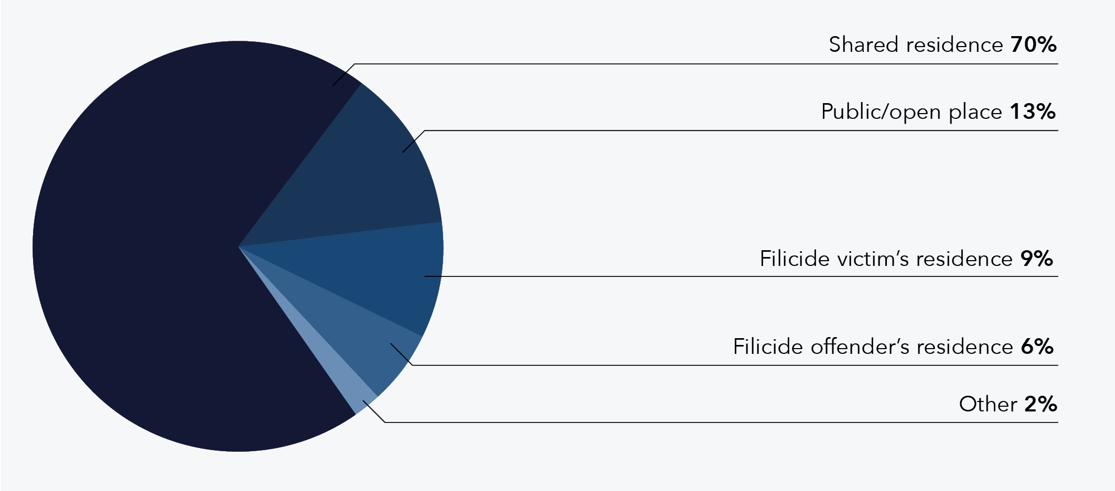
Data table for figure 1:
Location | % of cases
Shared residence | 70
Public/open place | 13
Filicide victim’s residence | 9
Filicide offender’s residence | 6
Other | 2

Manner of death
Findings relating to the manner of death are reported here in relation to the number of filicide cases in order to understand the key types of fatal violence used in DFV-context filicides. For cases with multiple filicide victims, there was almost exclusively one manner of death and, therefore, the one case where the manner of death varied across the filicide victims has been removed when discussing manner of death.
For almost half of the DFV-context filicides, the manner of death was assault with no weapon (47%, n = 40). The incidence of this manner of death likely speaks to the physical vulnerability of the young filicide victims, particularly in relation to the filicide offenders. This finding also aligns with the Australian filicide study by Brown, Lyneham, et al. (2019), which found “beating” was the most common manner of death. International literature lends further support, consistently finding assault without a weapon to be a common manner of death (Daly & Wilson, 1994; Dawson, 2015; Debowska et al., 2015).
The findings show the next most common manner of death was manners categorised as other (13%, n = 11), which includes explosion (intentional) and fall from a height (intentional), among others. This category was shortly followed by assault with a weapon (12%, n = 10; 7% with a sharp weapon and 5% with a blunt weapon). Around 1 in 10 filicides were the result of suffocation or strangulation (9%, n = 8). While strangulation could be considered an assault without a weapon, this manner of death was separated from this category due to the link between strangulation and suffocation with maternal filicides (Bourget & Gagné, 2002), as an indicator for future violence in risk assessment (Glass et al., 2008), and because some suffocation/strangulation cases in this project did involve a weapon of some kind.
The manner of death in the remaining cases included undetermined causes (6%, n = 5), multiple assaultive behaviours (5%, n = 4), drowning (4%, n = 3), shooting (2%, n = 2), fire- or heat-related causes (1%, n = 1), and poisoning or noxious substances (1%, n = 1; see Table 2). The low rate of shooting as a manner of death when compared to other countries, such as the United States and Canada (Dawson, 2015; Hatters Friedman et al., 2005), is reflective of the reduced access to firearms in Australia, particularly following the gun law reforms in 1996 (McPhedran, 2017; Zeoli et al., 2017).
Table 2: DFV-context filicide cases by manner of death (n = 85)
Manner of death | N | %
Assault – no weapon | 40 | 47
Other | 11 | 13
Assault – with a weapon | 10 | 12
Sharp weapon | 6 | 7
Blunt weapon | 4 | 5
Suffocation/strangulation | 8 | 9
Undetermined | 5 | 6
Multiple assaultive behaviours | 4 | 5
Drowning | 3 | 4
Shooting | 2 | 2
Fire/heat-related | 1 | 1
Poisoning/noxious substance | 1 | 1
Total | 85 | 100

Pre-planning
DFV-context filicide cases were examined for any evidence of pre-planning, such as internet searches by the filicide offender/s relating to the manner of death, the offender/s obtaining a particular weapon used in the filicide, and prior threats, messages or notes indicating the filicide offender/s’ intention. In three quarters of cases, no evidence of pre-planning was found (74%, n = 64). That is not to say that no pre-planning occurred, rather that no evidence indicating planning was identified in the case files. It is possible that the filicide offender/s planned a filicide without leaving evidence of such planning.
Of the 26 per cent of cases that did demonstrate evidence of pre-planning (n = 22), this planning usually occurred within 1 week of the filicide (59% of cases with pre-planning, n = 13), with a smaller proportion of cases revealing planning for 1 to 4 weeks (27% of cases with pre-planning, n = 6). The remaining cases included evidence of pre-planning where the duration of planning was unclear (14% of cases with pre-planning, n = 3). Premeditation can often be ignored in the literature and downplayed in coronial inquests (O’Hagan, 2014). Planning behaviour can also go unnoticed and under-recorded when a filicide is investigated (O’Hagan, 2014). Despite this, a quarter of the cases in the national filicide project were found to involve pre-meditation, highlighting the need for threats of harm to be taken seriously and recognised as possible points of intervention.

Familicide
Familicide, or the killing of one or more children and a current or former intimate partner, was perpetrated by filicide offenders in seven cases (i.e. 8% of DFV filicide cases). When considering this number with respect to the national population (ABS, 2022), it is evident that the national rate of DFV-context familicide in Australia between 2010 and 2018 would be approximately 0.34 per million people. In a systematic literature review, Karlsson et al. (2021) noted there are few studies that report on the national incidence of familicide and there is sparse reporting on incidence of DFV-context familicide in Australia. It is difficult to compare this rate to international research findings due to the varying timeframes, population sizes and other methodological differences.

Surviving siblings
In just under two thirds of all DFV-context filicide cases (62%, n = 53) the filicide victim/s in that case was survived by one or more siblings. In total, there were 122 known surviving siblings across the 53 cases where surviving siblings were recorded. It is important to note that this is a conservative estimate of what is likely a much larger group of children who have experienced the trauma of a sibling/s’ homicide, given the data accessed for this project may not specifically mention all surviving siblings. The number of surviving siblings is reported here to highlight the radiating impact of filicide beyond the direct victim/s and to draw attention to the many children who have experienced the loss of a sibling/s at the hands of a parent/s who is then likely to be in custody or have suicided following the filicide.

Multiple filicide victims
In the majority of DFV-context filicide cases, a single filicide victim was killed (84%, n = 72). In the 16 per cent of cases where more than one filicide victim was killed (n = 14), these cases most often involved the killing of two filicide victims (i.e. two siblings; 93% of cases with multiple victims, n = 13). The number of cases with multiple filicide victims is higher than the rates found in jurisdictional studies. For instance, of the DFV-context filicide cases occurring in NSW between 2000 and 2018, less than 10 per cent involved multiple filicide victims (Domestic Violence Death Review Team, 2022). A national study by Brown, Lyneham, et al. (2019) found approximately 16 per cent of cases had at least two filicide victims, which aligns with the current project, though their study included all filicides, rather than focusing on DFV context.

Multiple filicide offenders
Most cases involved one filicide offender (85%, n = 73), with the remaining 15 per cent involving two filicide offenders (n = 13). This finding is similar to Brown, Lyneham and colleagues’ (2019) national findings, where 17 per cent of filicide cases had two offenders, although that study also included non-DFV-context filicides. Although beyond the scope of this report, it is worth noting other studies have indicated that in multiple filicide offender cases, often the female filicide offender is also a primary IPV victim-survivor, and the male filicide offender is a primary IPV perpetrator (Domestic Violence Death Review Team, 2022).

Victim characteristics
This section presents the demographic characteristics of the 106 filicide victims who were killed in a DFV-context filicide. These characteristics include, for example, their gender, age and country of birth.

Gender
Figure 2 illustrates that there was a close to even split of male (55%, n = 58) and female (45%, n = 48) filicide victims. Australian research has consistently found that male and female children are victims of filicide at a similar rate, suggesting that gender does not play a role in filicide victimisation (Brown, Lyneham, et al., 2019; Domestic Violence Death Review Team, 2022; Kirkwood, 2012; Mouzos & Rushforth, 2003).
Figure 2: Percentage of DFV-context filicide victims by gender (n = 106)
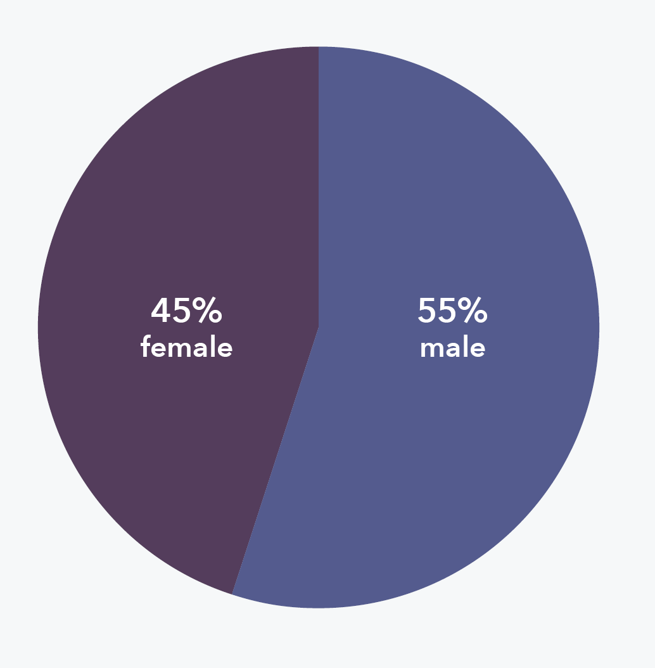
My experience and observations also support the finding that the gender of the filicide victim was not a significant contributing factor. The DFV relationship, mental health, substance misuse and other factors including unemployment, financial issues and other stressors contributed more to the actions of the filicide offender than the gender of the filicide victim.
Reflections from a Specialist DFV Police Officer

Age
Filicide victims were most often aged under 1 year old (27%, n = 29) or between 1 and 2 years of age (19%, n = 20; see Figure 3). For those victims aged under 1 year old, a large portion were killed in the first 2 months of life (41% of victims aged under 1 year, n = 12; see Table 3). The average age for victims in this national project was 4.4 years (Median = 3; SD = 4.14).
The high number of young filicide victims aligns with NSW research finding approximately 20 per cent of victims are aged under 1 year old (Domestic Violence Death Review Team, 2022), as well as national research by Brown, Lyneham and colleagues (2019) that found 31 per cent of all victims (of DFV and non-DFV-context filicide) were less than a year old. This consistent finding also likely reflects the physical vulnerability and parental dependence of infants and young children.
Young children’s dependence on caregivers to meet their needs and keep them safe makes infants and toddlers more vulnerable to abuse and neglect.
Reflections from Senior Child Protection Practitioners

We know that pregnancy and children under one are a risk factor as well, and I think that’s around changing that relationship … the attention’s given to children and so there’s that issue with jealousy.
Reflections from a DFV Worker
Figure 3: Percentage of DFV-context filicide victims by age range (n = 106)
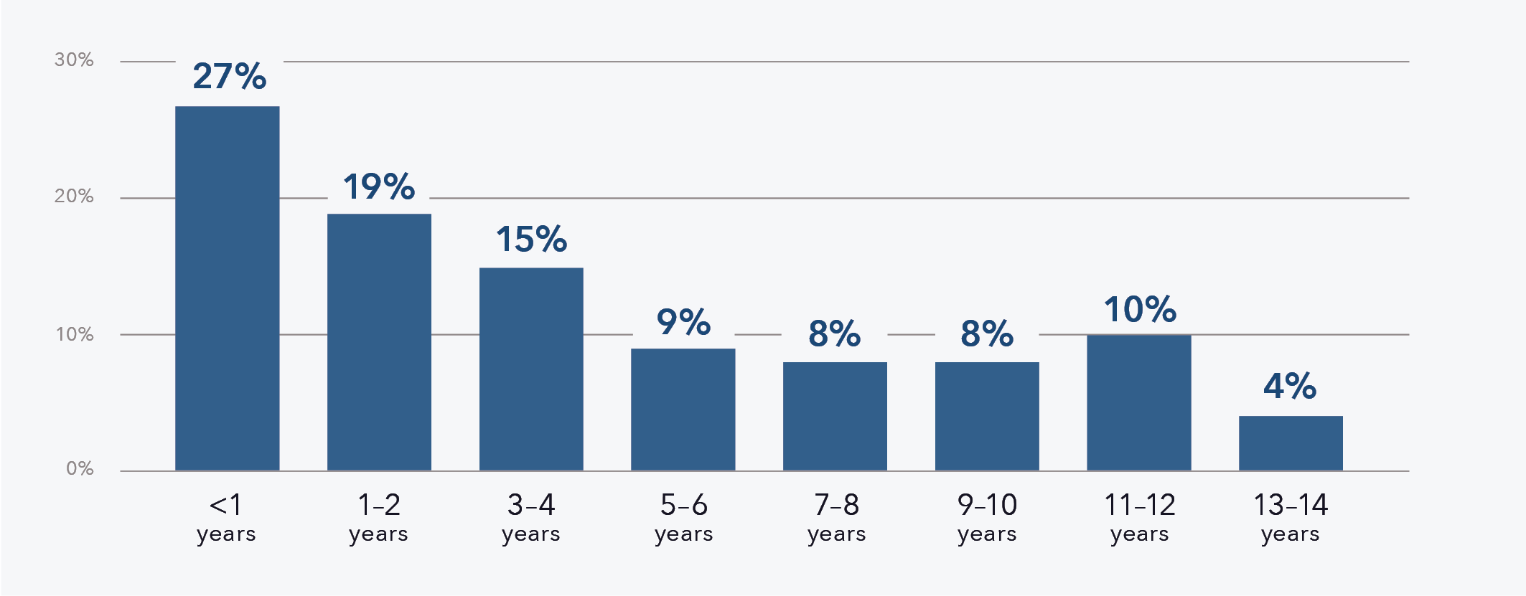
Data table for figure 3:
Age | Percentage of victims (%)
Less than 1 year | 27
1-2 years | 19
3-4 years | 15
5-6 years | 9
7-8 years | 8
9-10 years | 8
11-12 years | 10
13-14 years | 4
Table 3: DFV-context filicide victim ages under 1 year old (n = 29)
Filicide victim age | N | %
0–2 months | 12 | 41
3–5 months | 8 | 28
6–8 months | 3 | 10
9–11 months | 6 | 21
Total | 29 | 100

Country of birth
Nearly all of the 106 filicide victims were born in Australia (93%, n = 99). There were seven filicide victims born outside of Australia, across six different countries.

Aboriginal and/or Torres Strait Islander status
Filicide victims were mostly non-Indigenous Australians (71%, n = 75). Around a quarter of victims (26%, n = 28) were identified as Aboriginal and/or Torres Strait Islander (see Figure 4). However, given that Aboriginal and Torres Strait Islander children make up 5.9 per cent of all children in Australia (AIHW, 2020), Aboriginal and Torres Strait Islander children were vastly over-represented in this national project. It is important to note that 1 in 5 Aboriginal and/or Torres Strait Islander filicide victims were killed by a non-Indigenous parent (21% of Aboriginal and/or Torres Strait Islander filicide victims, n = 6). Additionally, for three victims it could not be determined whether they were Aboriginal and/or Torres Strait Islander due to a lack of information in these cases. Further, it should also be noted that Aboriginal and/or Torres Strait Islander children may not have been indentified as such in the service data.
Figure 4: Percentage of DFV-context filicide victims by Aboriginal and/or Torres Strait Islander status (n = 106)
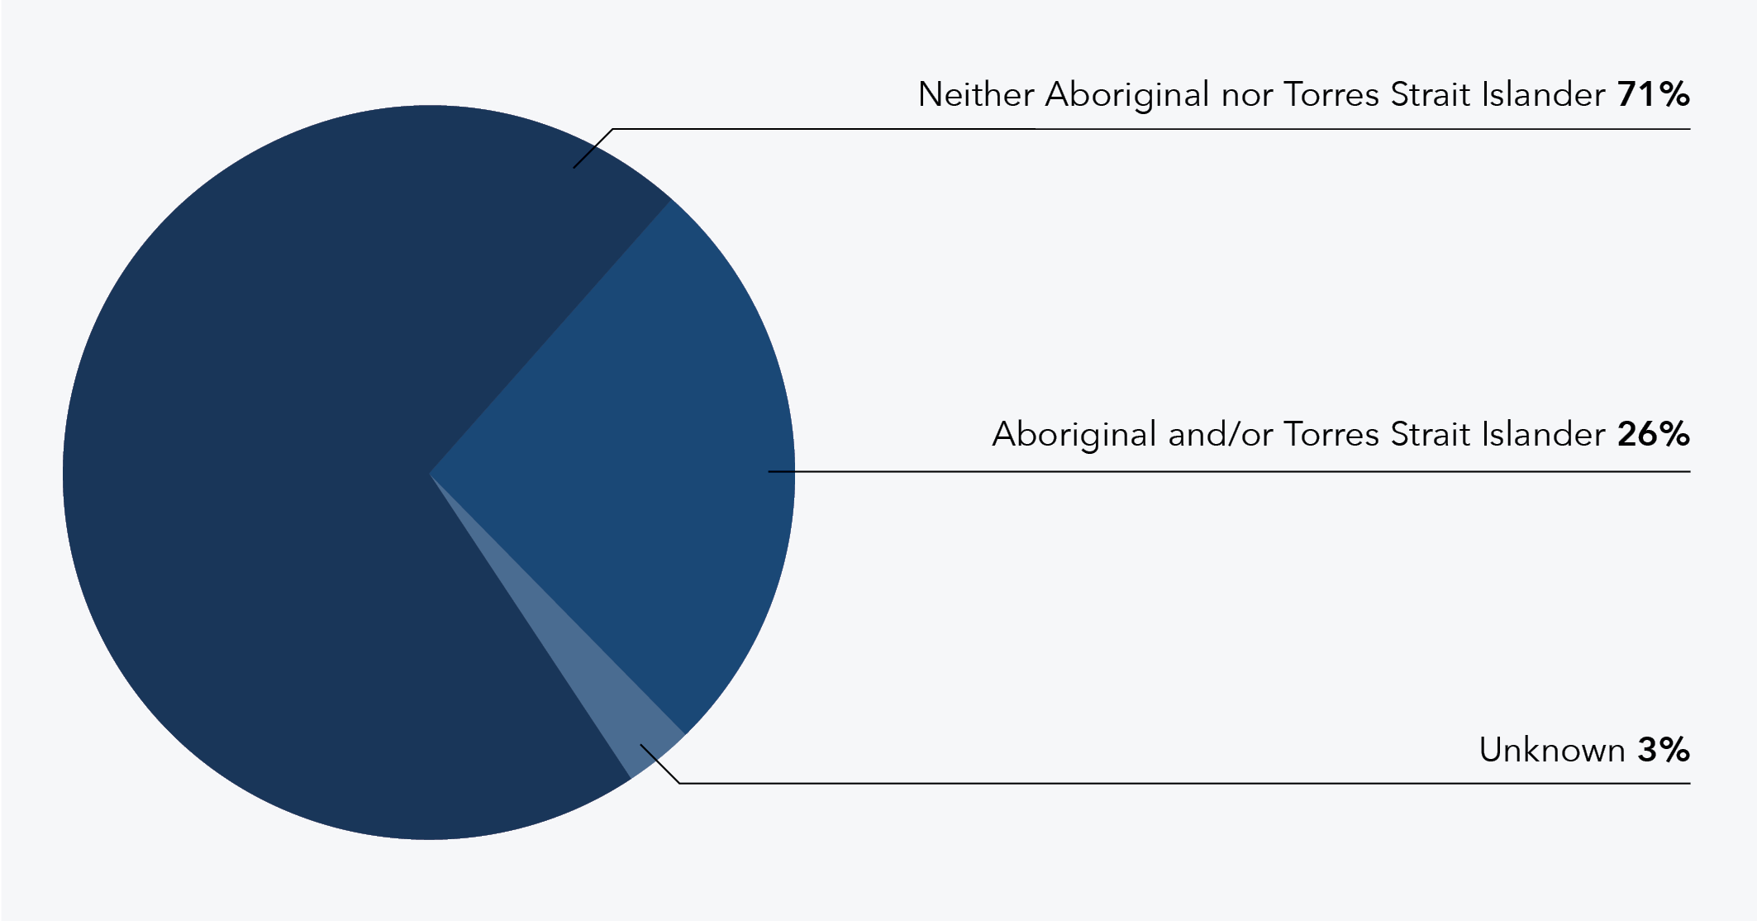
Data table for figure 4:
Status | % of victims
Neither Aboriginal nor Torres Strait Islander | 71
Aboriginal and/or Torres Strait Islander | 26
Unknown | 3

I note with concern the significant over-representation of child victims who identified as Aboriginal and/or Torres Strait Islander, with a far lesser proportion of filicide offenders identifying as Aboriginal and/or Torres Strait Islander.
Reflections from a Coroner

Disability
Less than 1 in 10 filicide victims were recorded as having a disability (6%, n = 6). It should be noted, however, that there are limitations in the identification of disability in service data, which may underestimate the true prevalence. For children, particularly infants, a disability may not yet have been detected or officially recorded, which may have led to an under-representation. The AIHW (2022) estimates that nearly 8 per cent of children between ages 0 and 14 have some level of disability, suggesting that the rates in the national filicide project somewhat align with the general population. However, people with a disability tend to experience higher rates of DFV than the general population (Royal Commission into Violence, Abuse, Neglect and Exploitation of People with Disability, 2020).
There are distinct vulnerabilities relevant for children with disability and their contact with the child protection system. Their risk of abuse and neglect is generally considered higher than for children without disability. However, a child’s impairment alone does not increase their vulnerability. Rather, other features in their environment, relationships, and the attitude and culture of their community more significantly influence their vulnerability.
Reflections from Senior Child Protection Practitioners

Offender characteristics
This section presents the characteristics of the 99 filicide offenders who perpetrated DFV-context filicide. The characteristics include, for example, their age, parental role, employment status, any mental health issues, and criminal history. The findings for each characteristic are presented and generally followed by a disaggregation by the gender of the filicide offenders. This disaggregation was included given the gendered nature of DFV observed in the findings, both in terms of the over-representation of male filicide offenders and the gender differences observed in the IPV results, which are presented later in this report.

Gender
Two thirds (68%, n = 67) of filicide offenders were identified as male and a third (32%, n = 32) were identified as female (see Figure 5). The over-representation of male filicide offenders could be partly due to the focus on DFV context, as in the overall filicide offender sample, female filicide offenders made up 40 per cent (rather than 32%). Most literature supports the finding that without considering the DFV context, males and females perpetrate filicide somewhat evenly (Bourget et al., 2006; Brown, Lyneham, et al., 2019; Kirkwood, 2012), which suggests that the perpetration of DFV-context filicide is gendered. This is also reflected in NSW research that does consider DFV context, with the Domestic Violence Death Review Team (2022) finding 62 per cent of offenders were male, lending further weight to the findings of the national project.
Figure 5: Percentage of DFV-context filicide offenders by gender (n = 99)
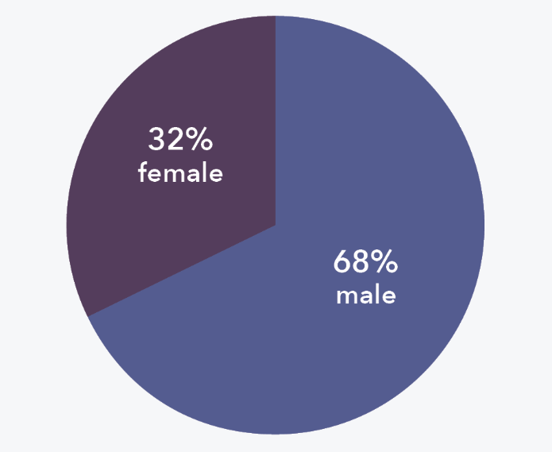

Age
Most filicide offenders were aged between 25 and 29 years (24%, n = 24), followed by those aged 20 to 24 years (20%, n = 20). Figure 6 presents a full breakdown of the percentages of all age groups. The mean age of filicide offenders in this project was 31 years (Median = 30; SD = 9.04).
Figure 6: Percentage of DFV-context filicide offenders by age range (n = 99)
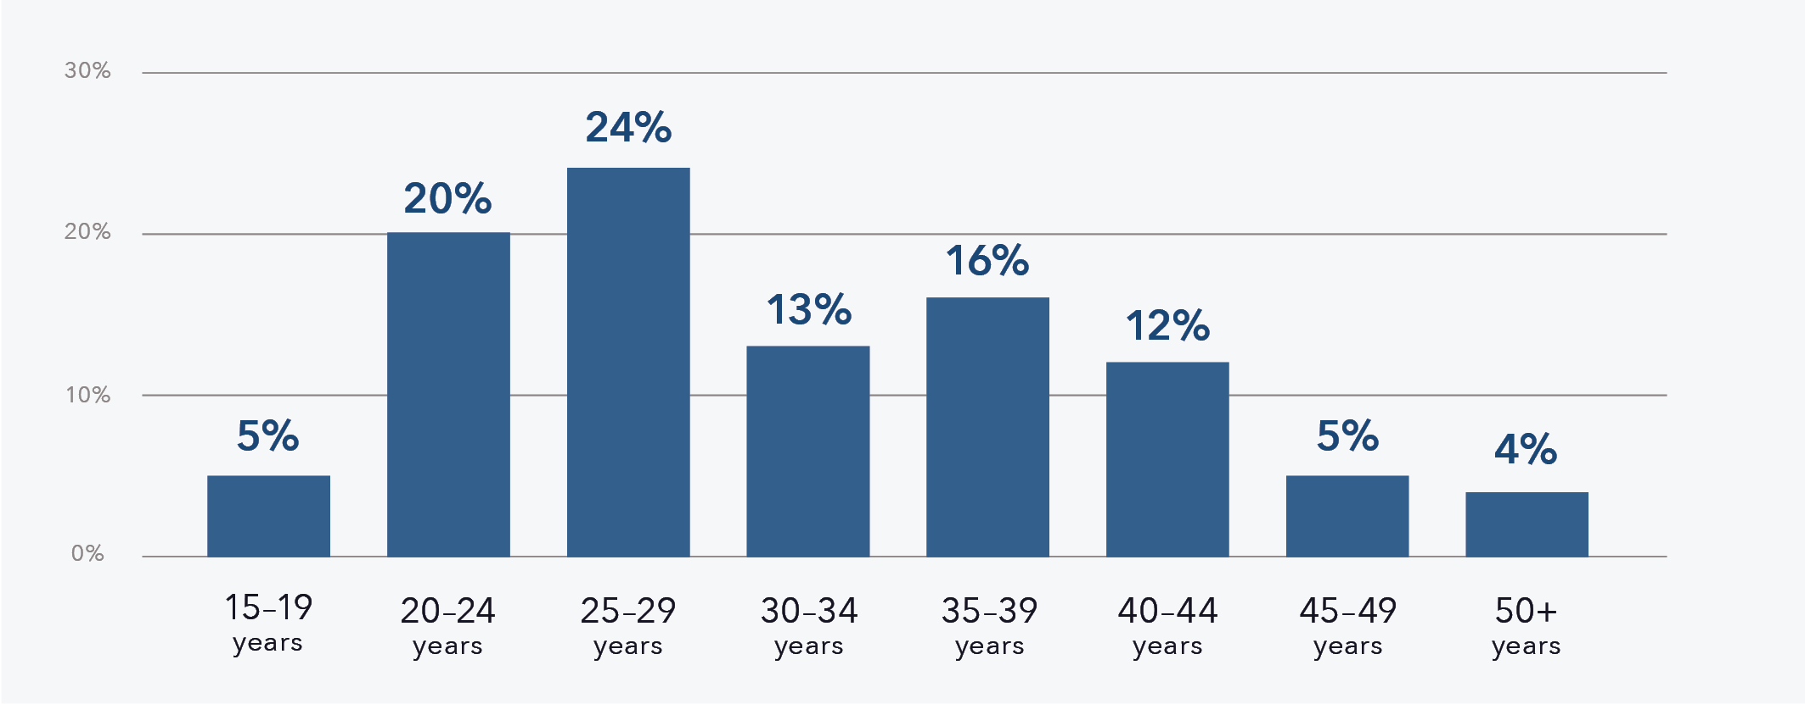
Data table for figure 6:
Age | Percentage of offenders (%)
15-19 years | 5
20-24 years | 20
25-29 years | 24
30-34 years | 13
35-39 years | 16
40-44 years | 12
45-49 years | 5
50 plus years | 4

Investigations I was involved in often involved infants as the filicide victim in the first few months after birth which is acknowledged as a challenging period for parents generally. This is also consistent with the 44 per cent of filicide offenders being aged between 20 and 29 years of age which is a common age range for becoming a parent. While not diminishing responsibility, the challenges and impacts on a person’s conduct … and general coping mechanisms may be intensified if there is existing DFV in the relationship (reported or unreported), mental illness … a history of issues with alcohol and/or drugs and limited supports in place.
Reflections from a Specialist DFV Police Officer

Comparison by filicide offender gender
When comparing male and female filicide offenders, it was evident that both groups were more commonly aged between 25 and 29 years (24%, n = 16 for male filicide offenders and 25%, n = 8 for female filicide offenders; see Figure 7). The ages of male filicide offenders ranged from 15 and 55 years and were 31 years on average. Female filicide offenders were aged between 17 and 49 years and 32 years on average. These findings are similar to general population data that shows the median age for mothers is 31.9 years and 33.7 years for fathers (ABS, 2022). Given the number of filicide victims who were aged below 5 years and the likely age of their parents, the skew towards younger filicide offenders is to be expected.
Figure 7: Percentage of DFV-context filicide offenders by age range and gender (n = 99)
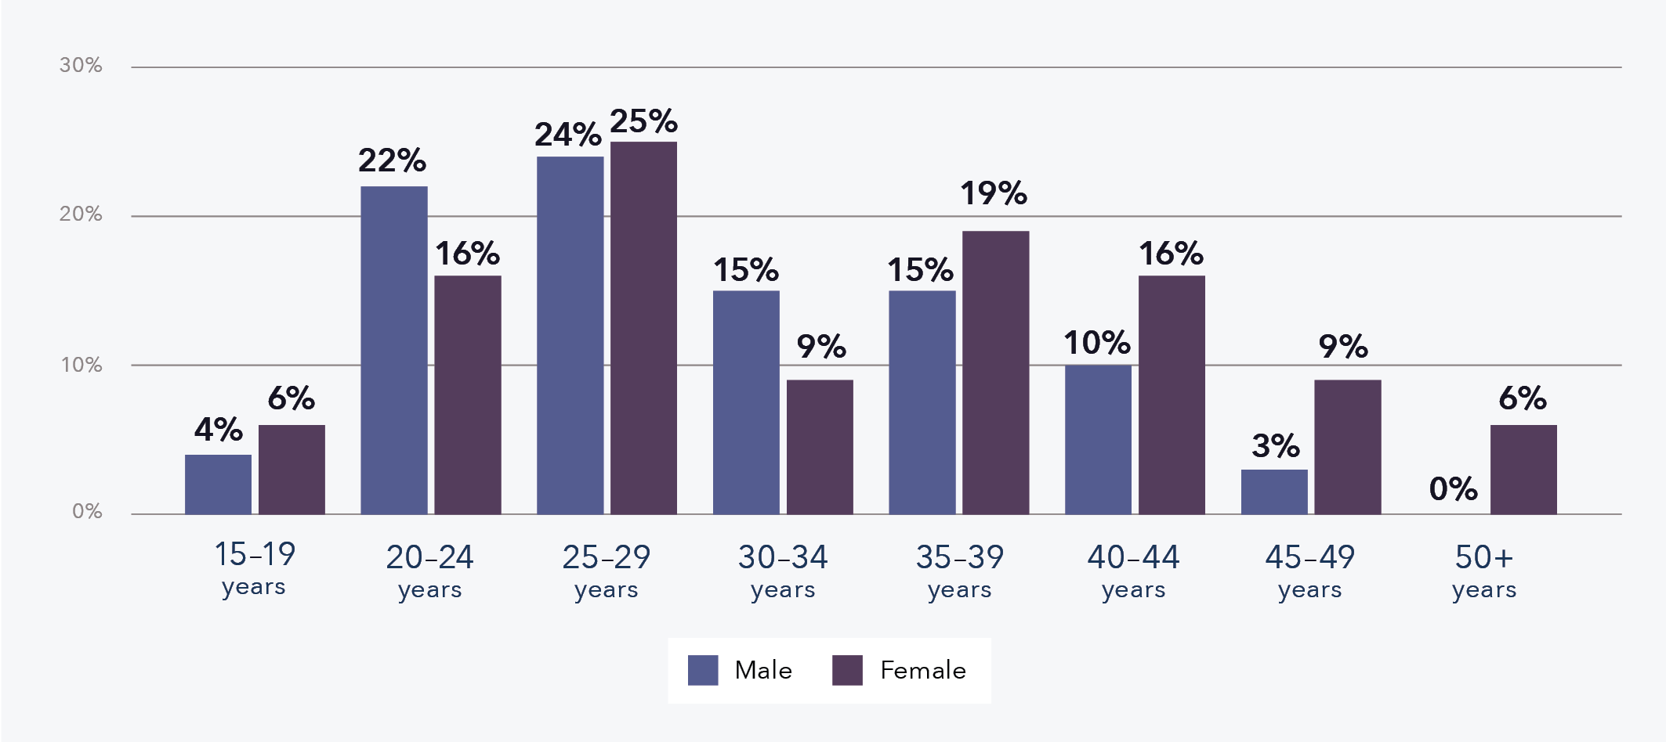
Data table for figure 7:
Age of offenders | % male | % female
15-19 years | 4 | 6
20-24 years | 22 | 16
25-29 years | 24 | 25
30-34 years | 15 | 9
35-39 years | 15 | 19
40-44 years | 10 | 16
45-49 years | 3 | 9
50 plus years | 0 | 6

Parental role
Most filicide offenders were the biological parent of the filicide victim/s (71%, n = 70). Filicide offenders who were recorded as non-biological parents (29%, n = 29) included step-parents, foster parents, kin, and boyfriends/girlfriends of the filicide victim/s’ biological parent. When also considering gender, the largest subset of offenders were biological fathers (40%, n = 40), followed by biological mothers (30%, n = 30), and then non-biological fathers (27%, n = 27), with a very small number of non-biological mothers (2%, n = 2; see Figure 8).
Figure 8: Percentage of DFV-context filicide offenders by parental role (n = 99)
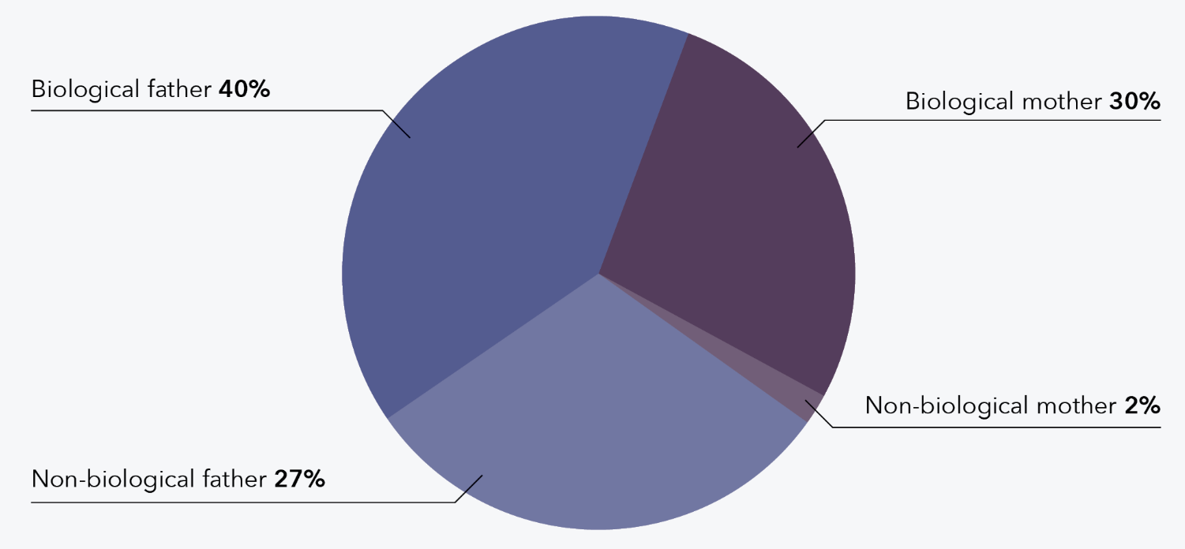
Data table for figure 8:
Parental role | % of offenders
Biological father | 40
Biological mother | 30
Non-biological father | 27
Non-biological mother | 2

Thirteen cases involved two filicide co-offenders (who were both found to be criminally responsible for the filicide). Three cases involved biological parents acting together, nine involved a biological mother and stepfather acting together, and one case involved a biological mother acting together with her boyfriend.
In the context of my work, often the offender will treat children differently, so whether they are their biological child or not, so it could be treating them worse or better, or … “they’re not mine …” which then is a risk factor in itself.
Reflections from a DFV Worker

Country of birth
Almost three quarters of filicide offenders were born in Australia (74%, n = 73). A quarter of the offenders were born outside of Australia (n = 25), in a total of 14 countries. This finding aligns with general population rates from the 2021 Australian Census, whereby 29.1 per cent of the population is born outside of Australia, suggesting that country of birth does not greatly impact the perpetration of DFV-context filicide.

Aboriginal and/or Torres Strait Islander status
Most filicide offenders were neither Aboriginal nor Torres Strait Islander (83%, n = 82; Figure 9). However, given Aboriginal and/or Torres Strait Islander peoples comprise 4 per cent of the population (ABS, 2023), the finding of 16 per cent in this study demonstrates an over-representation. It was not possible to determine the status of one filicide offender due to a lack of information in the case. It is important to note that these figures rely heavily on identification via service data, and it is therefore difficult to report on the Aboriginal and/or Torres Strait Islander status of those filicide offenders who were not recorded as such in the documentation reviewed for this national project.
Figure 9: Percentage of DFV-context filicide offenders by Aboriginal and/or Torres Strait Islander status (n = 99)
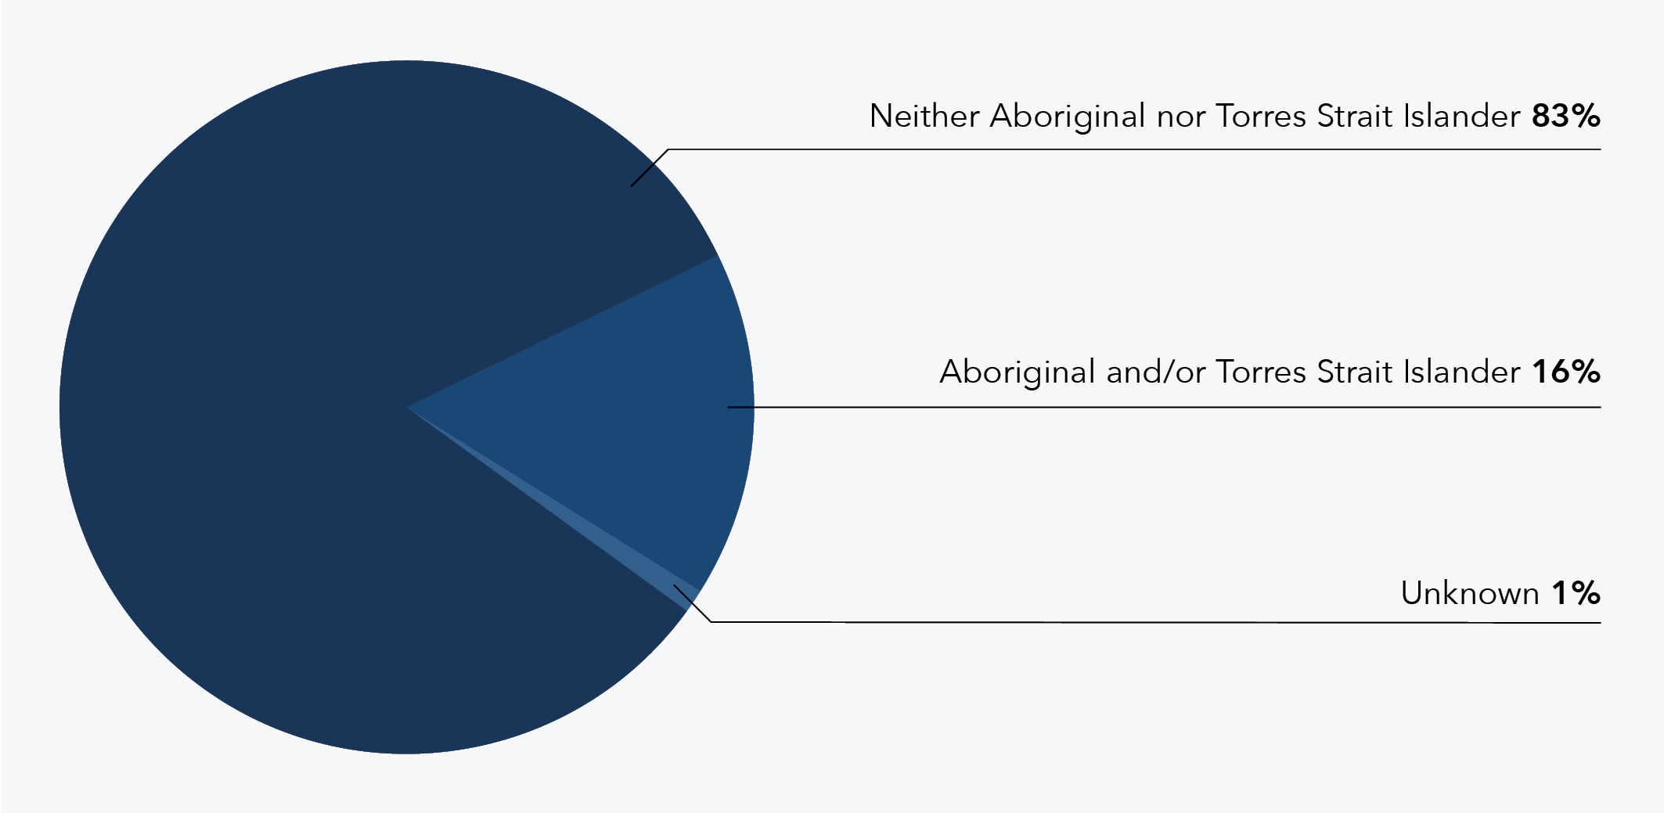
Data table for figure 9:
Status | % of offenders
Neither Aboriginal nor Torres Strait Islander | 83
Aboriginal and/or Torres Strait Islander | 16
Unknown | 1

Comparison by filicide offender gender
When disaggregated by gender, the findings demonstrate higher rates of Aboriginality among male filicide offenders compared to female filicide offenders. Around 1 in 10 female filicide offenders were Aboriginal and/or Torres Strait Islander (9%, n = 3), while almost 1 in 5 male filicide offenders were Aboriginal and/or Torres Strait Islander (19%, n = 13; see Figure 10).
Figure 10: Percentage of DFV-context filicide offenders by Aboriginal and/or Torres Strait Islander status and gender (n = 99)
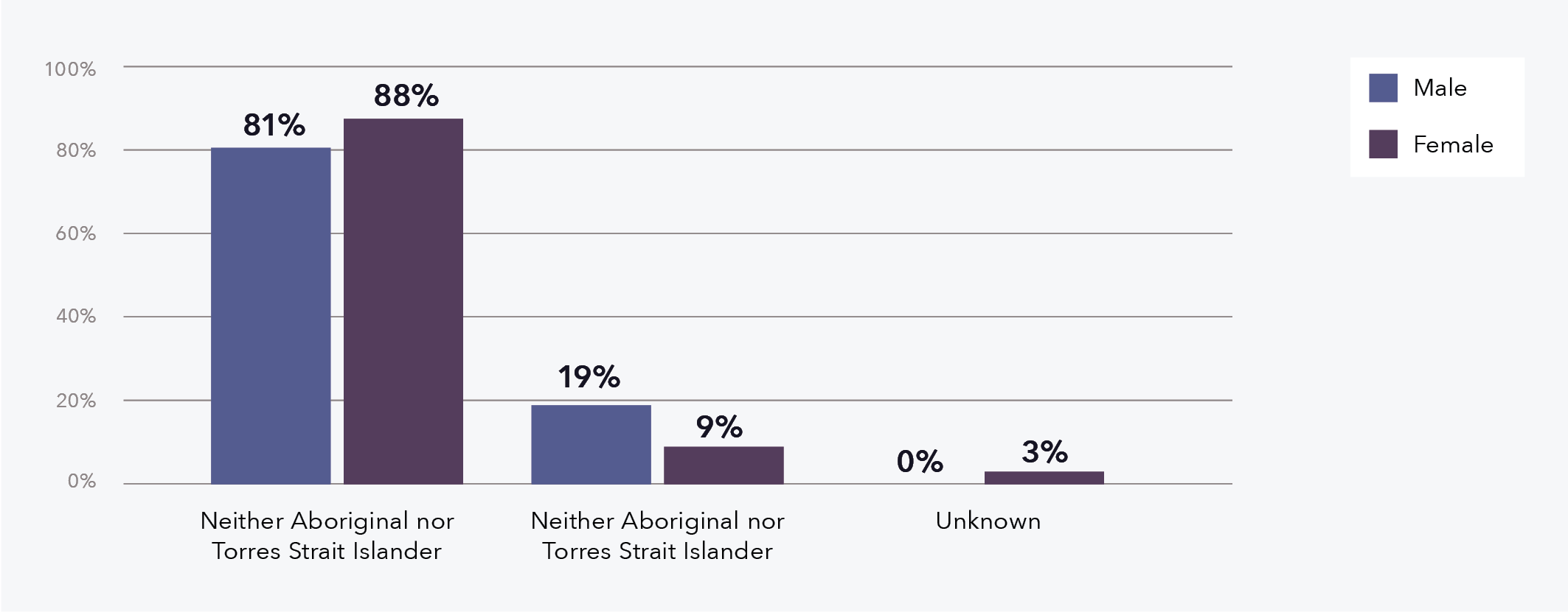
Data table for figure 10:
Statue | % male | % female
Neither Aboriginal nor Torres Strait Islander | 81 | 88
Neither Aboriginal nor Torres Strait Islander | 19 | 9
Unknown | 0 | 3

A lot of the men, primarily Aboriginal men from around where I work. And their reflections in terms of domestic and family violence, they have a lot of pride in their children and a lot of their reflections around wanting to change for the children, not necessarily for the partners.
Reflections from a DFV Worker

Residential location
A large portion of filicide offenders lived in major cities (58%, n = 57), followed by those living in outer regional Australia (18%, n = 18) and inner regional Australia (16%, n = 16), which when taken together means just over a third lived in a regional area (34%, n = 34; see Figure 11). In comparing these findings with the broader Australian population, nearly three quarters of people live in major cities (ABS, 2022), which is a much higher rate than that observed in this project. Just under 20 per cent of the broader population live in inner regional Australia and 8 per cent live in outer regional areas (ABS, 2022), which is less than the rate in this project. This comparison indicates that Australians living in major cities may be under-represented in this filicide project, while regional (particularly outer regional) Australians are potentially over-represented.
Figure 11: Percentage of DFV-context filicide offenders by remoteness classification (n = 99)
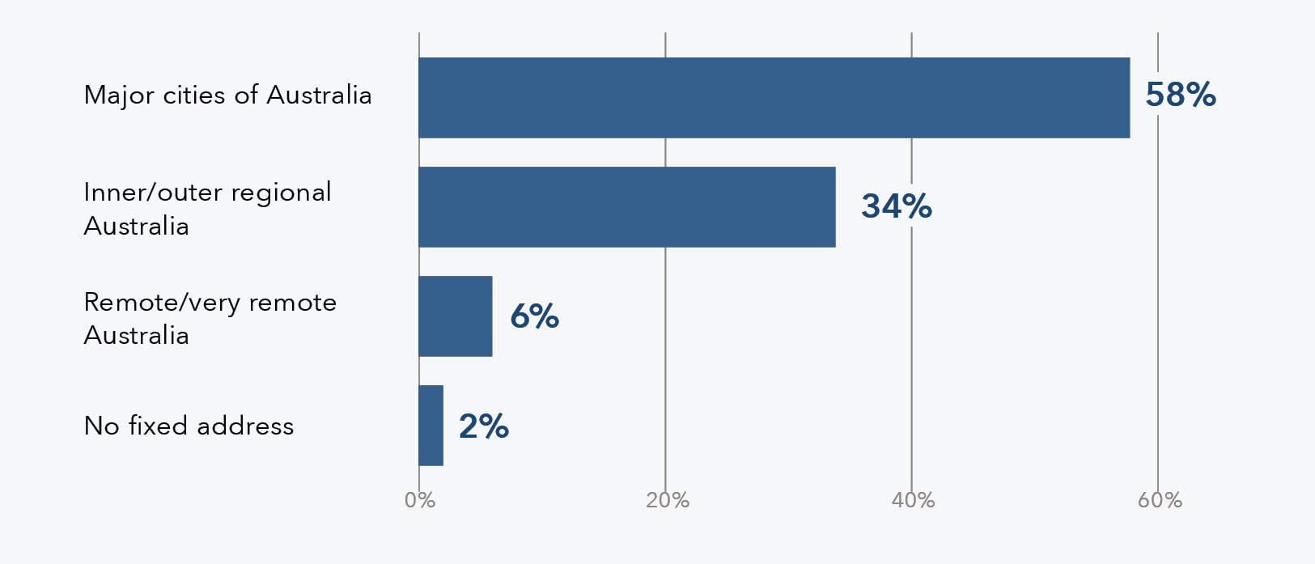
Data table for figure 11:
Remoteness classification | Percentage of offenders (%)
Major cities of Australia | 58
Inner/outer regional Australia | 34
Remote/very remote | 6
No fixed address | 2

Comparison by filicide offender gender
There was little difference between the number of male and female filicide offenders who resided in major cities (55%, n = 37 for male offenders and 63%, n = 20 for female offenders). One gender-based difference that was evident was that only male filicide offenders were found to be residing in remote or very remote areas (6%, n = 4 and 3%, n = 2, respectively); no female filicide offenders resided in these areas (see Figure 12).
Figure 12: Percentage of DFV-context filicide offenders by remoteness classification and gender (n = 99)
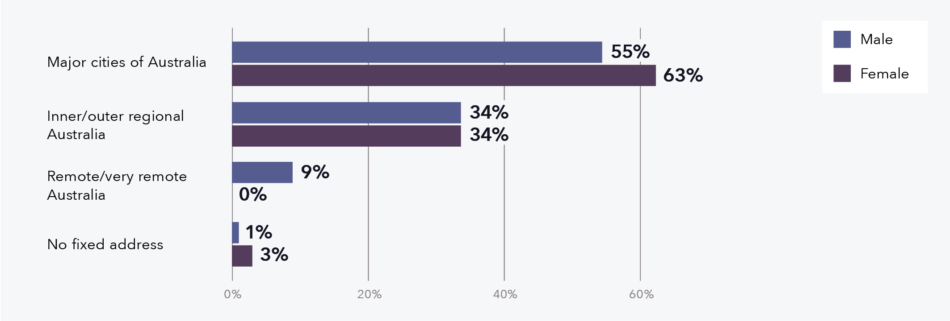
Data table for figure 12:
Remoteness classification | % male | % female
Major cities of Australia | 55 | 63
Inner/outer regional Australia | 34 | 34
Remote/very remote | 9 | 0
No fixed address | 1 | 3

Residing with the victim
Most filicide offenders resided with the filicide victim on a full-time basis at the time of the filicide (83%, n = 82; see Figure 13). When the filicide offender resided with the victim part-time (8%, n = 8), this was often due to a breakdown of the parental relationship resulting in the filicide offender and the other parent living separately.
Figure 13: Percentage of DFV-context filicide offenders by their living arrangements with the victim (n = 99)
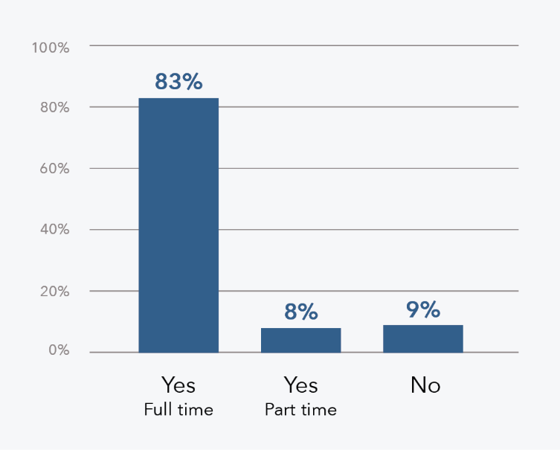
Data table for figure 13:
Living arrangements | % offenders who live with the victim
Yes - full time | 83
Yes – part time | 8
No | 9

Comparison by filicide offender gender
A slightly higher proportion of female filicide offenders lived with the filicide victim full-time (91%, n = 29), when compared with male filicide offenders (79%, n = 53; see Figure 14).
Figure 14: Percentage of DFV-context filicide offenders by their living arrangements with the victim and gender (n = 99)
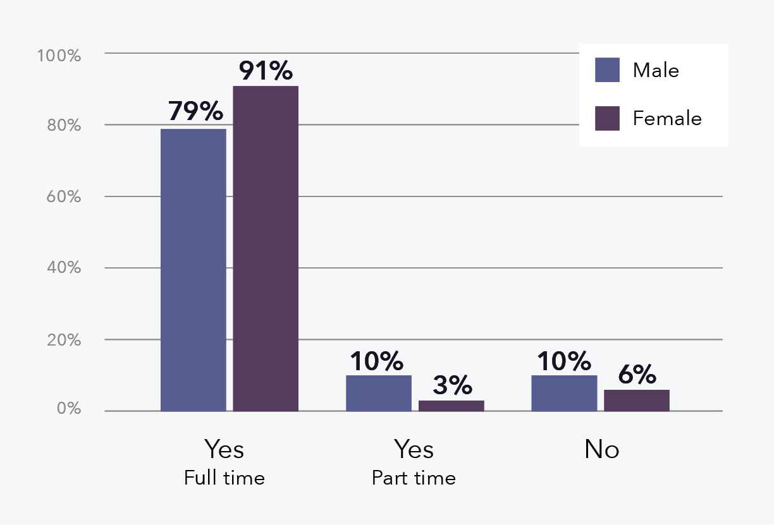

Employment status
Over half of the filicide offenders were not engaged in paid employment (including some who were fulfilling home duties) at the time of the filicide (57%, n = 56; see Figure 17). Over a third (37%, n = 37) of offenders were engaged in paid employment at the time of the filicide, which is much lower than the general population (66.8%; ABS, 2023). The employment status for the remaining filicide offenders was categorised as “Other/Unknown”, which included those who were studying, retired, engaged in a commitment other than paid employment, or where their employment status was unknown. Some research suggests that filicide can occur in the context of external stressors relating to the offender (Brown et al., 2014; Kirkwood, 2012; Stroud, 2008). Unemployment has been identified as a factor in filicide (Hellen et al., 2023; Queensland Family and Child Commission, 2022a; Stroud, 2008; Wilczynski, 1995).
Figure 15: Percentage of DFV-context filicide offenders by employment status (n = 99)
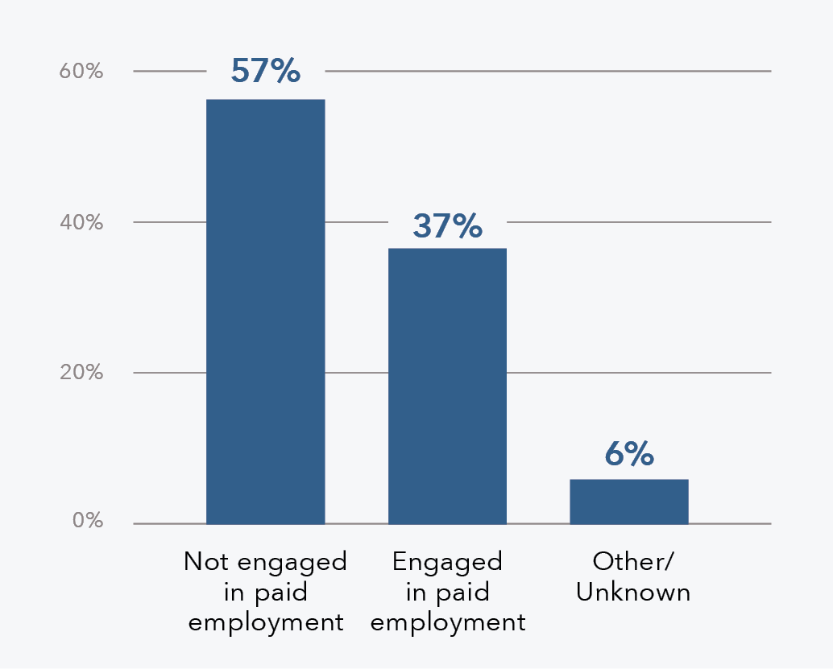
Data table for figure 15:
Employment status | % offenders
Not engaged in paid employment | 57
Engaged in paid employment | 37
Other/unknown | 6

Employment status and that thinking of filicide in general, children cost money. And I guess there’s a huge responsibility on parents to provide for their children. So whether it’s child support … or you know, think of COVID and people laid off, lost income and how that created a lot of stress for parents.
Reflections from a DFV Worker

Comparison by filicide offender gender
Male filicide offenders were more commonly engaged in paid employment (45%, n = 30) than female offenders (22%, n = 7). Conversely, a higher proportion of female filicide offenders were not engaged in paid employment (72%, n = 23), when compared to male filicide offenders (49%, n = 33; see Figure 16). This finding could be partly explained by the project capturing “home duties” under the “not engaged in paid employment” category. These categories were combined as both have similar implications in terms of the potential for prior intervention or support provided via workplaces.
Figure 16: Percentage of DFV-context filicide offenders by employment status and gender (n = 99)
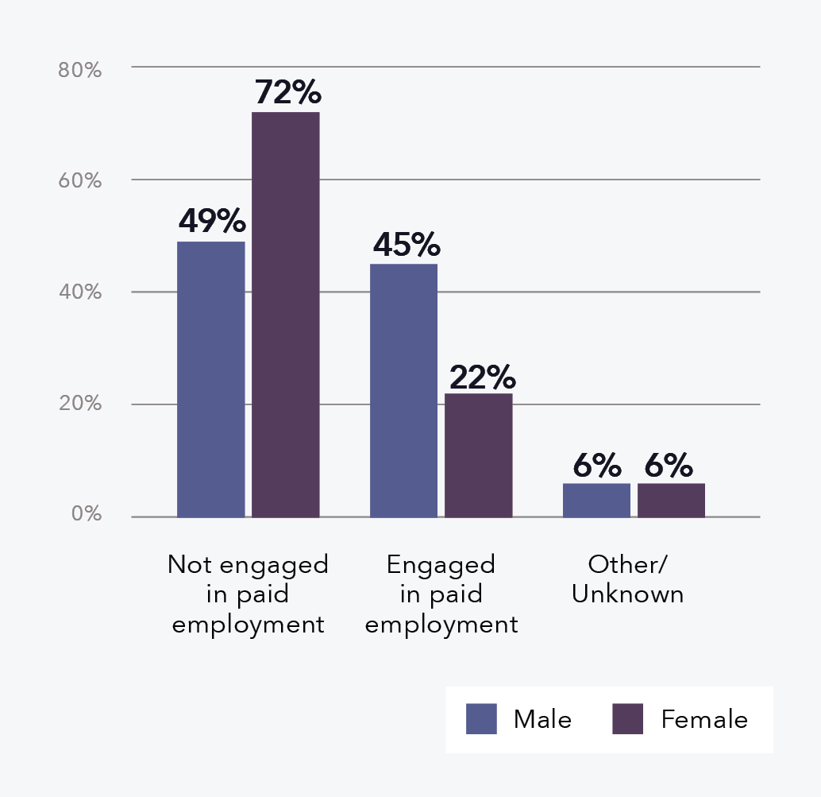
Data table for figure 16:
Employment status | % male | % female
Not engaged in paid employment | 49 | 72
Engaged in paid employment | 45 | 22
Other/unknown | 6 | 6

Filicide offender suicide
Approximately a fifth of the filicide offenders suicided during or after the incident (22%, n = 22). A further three filicide offenders attempted suicide (see Figure 17). Literature suggests that filicide offenders have high rates of suicide when compared to the general population of parents (Bourget & Gagné, 2002). In 2018, the overall rate of suicide in Australia was 1.3 deaths per 10,000 (AIHW, 2023b), whereas the rate within the national filicide project would be 2,222 per 10,000 (based on the 22 out of 99 filicide offenders who suicided).
The findings from the national filicide project are also slightly higher than some other filicide studies, perhaps due to the unique focus on DFV context. For example, an Australian study examining Kirkwood (2012) data from 1997 to 2008 found 17 per cent of filicides were followed by the offender’s suicide (Kirkwood, 2012). Another Australian study found under 20 per cent of filicide offenders suicided (Brown, Lyneham, et al., 2019), and a UK study found 13 per cent of offenders suicided after filicide (Flynn et al., 2013).
In the national filicide project, all filicide offenders who suicided did so within 24 hours of the filicide; often at the time of the incident. Suicides tended to occur in either a public or open place (45% of the 22 filicide-suicides, n = 10) or in a shared residence (41% of the 22 filicide-suicides, n = 9), with the remaining suicides occurring in the filicide offender’s residence (14% of the 22 filicide-suicides, n = 3). All but three filicide offenders suicided in the same location as the filicide, with two of the remaining offenders moving from a shared residence to a public place to die by suicide, and one moving from a shared residence to their own residence to die by suicide.
Figure 17: Percentage of DFV-context filicide offenders by suicide status (n = 99)
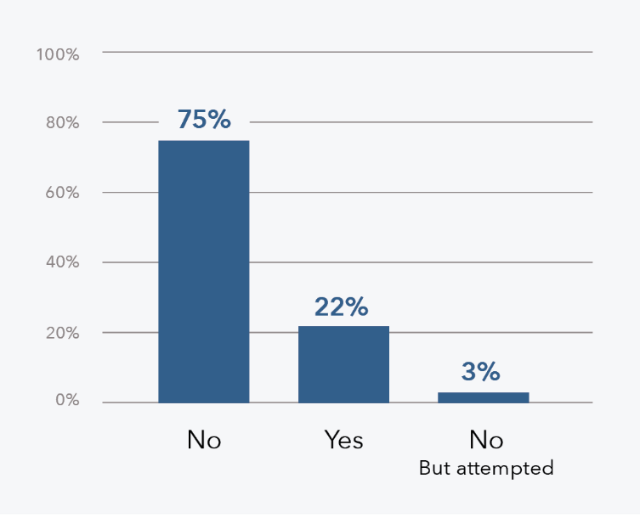
Data table for figure 17:
Suicide status | % of offenders
No | 75
Yes | 22
No - but attempted | 3

Comparison by filicide offender gender
As shown in Figure 18, a higher proportion of female filicide offenders suicided after the filicide (28%, n = 9) compared with male filicide offenders (19%, n = 13).
Figure 18: Percentage of DFV-context filicide offenders by suicide status and gender (n = 99)
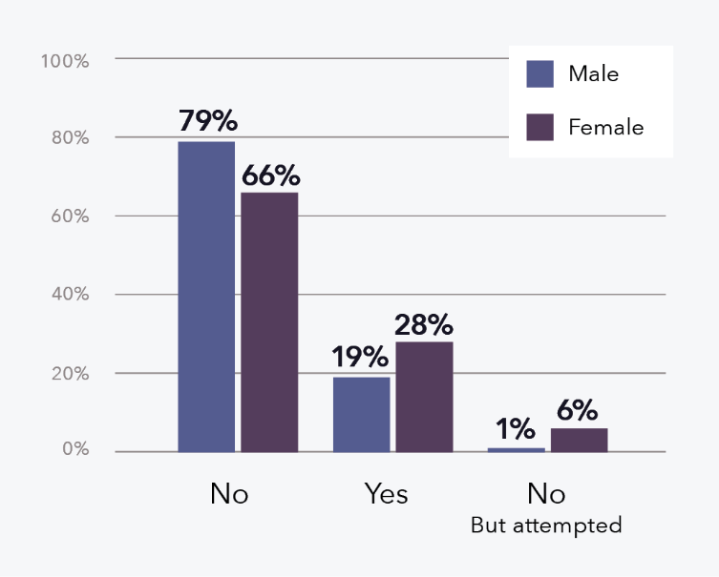
Data table for figure 18:
Suicide status | % male | % female
No | 79 | 66
Yes | 19 | 28
No – but attempted | 1 | 6

Criminal outcome
While existing filicide literature often examines criminal outcomes when comparing male and female offenders (Brown, Lyneham, et al., 2019; Brown et al., 2014), there is little Australian research that examines the criminal outcomes irrespective of gender. Of the 77 filicide offenders in this national project who did not die by suicide, just over half were convicted of manslaughter (52%, n = 40), mostly following a guilty plea (see Table 4). Murder was the next most common conviction (30%, n = 23), with a similar proportion of those who pleaded guilty (n = 12) and those who were found guilty after a trial (n = 11). Seven offenders pleaded guilty to other charges such as child homicide, which is limited to the state of Victoria, and infanticide. Three offenders were found not guilty by reason of mental illness (NGMI). It was not common for filicide offenders to be acquitted or have no charges laid against them (both 3%, n = 2 respectively).

Comparison by filicide offender gender
Despite manslaughter (specifically, manslaughter following a guilty plea) being the most common criminal outcome for both male and female filicide offenders, a higher proportion of female filicide offenders were convicted of manslaughter (65%, n = 15) compared to male filicide offenders (46%, n = 25). Whereas male filicide offenders were more commonly convicted of murder (37%, n = 20) compared to female filicide offenders (13%, n = 3; see Table 5).
My understanding of [filicide] is it’s intentional, but most cases were charged with manslaughter.
Reflections from a DFV Worker
Table 4: DFV-context filicide offenders (who did not suicide) by criminal outcome (n = 77)
Criminal outcome | N | %
Manslaughter | 40 | 52
Guilty plea | 38 | 49
Trial | 2 | 3
Murder | 23 | 30
Guilty plea | 12 | 16
Trial | 11 | 14
Other | 7 | 9
NGMI | 3 | 4
Acquitted | 2 | 3
No billed/charges withdrawn | 2 | 3
Total | 77 | 100

Table 5: DFV-context filicide offenders (who did not suicide) by criminal outcome and gender (n = 77)
Criminal outcome | N male | % male | N female | % female
Manslaughter | 25 | 46 | 15 | 65
Guilty plea | 23 | 43 | 15 | 65
Trial | 2 | 4 | 0 | 0
Murder | 20 | 37 | 3 | 13
Guilty plea | 11 | 20 | 1 | 4
Trial | 9 | 17 | 2 | 9
Other | 5 | 9 | 2 | 9
NGMI | 1 | 2 | 2 | 9
Acquitted | 2 | 4 | 0 | 0
No billed/charges withdrawn | 1 | 2 | 1 | 4
Total | 54 | 100 | 23 | 100

Mental health issues
A little over half of the filicide offenders were noted to be experiencing mental health issues at the time of the filicide (56%, n = 55), which is a higher rate than that observed in the general population (AIHW, 2019). Of these offenders, 73 per cent (n = 40) were experiencing either depression or depression combined with other mental health issues.
Most filicide offenders who were noted to be experiencing mental health issues had received a formal diagnosis from a qualified health professional (56% of filicide offenders with mental health issues, n = 31). See Table 6 for a breakdown of filicide offender mental health issues by type and diagnosis. Of the filicide offenders who were experiencing undiagnosed mental health issues (44% of filicide offenders with mental health issues, n = 24), most often they showed signs of depression (54% of those who were undiagnosed, n = 13) or other mental health issues (33% of those who were undiagnosed, n = 8). It should be noted that when an offender was recorded as not experiencing mental health issues, this meant there was no available evidence to suggest otherwise.
Table 6: DFV-context filicide offenders by mental health issue type and diagnosis (n = 99)
Mental health issues | N | %
No | 44 | 44
Yes | 55 | 56
Depression | 19 | 19
Diagnosed | 6 | 6
Undiagnosed | 13 | 13
Depression and other mental health issue/s | 21 | 21
Diagnosed | 18 | 18
Undiagnosed | 3 | 3
Other mental health issue/s | 15 | 15
Diagnosed | 7 | 7
Undiagnosed | 8 | 8
Total | 99 | 100
The rates of mental health issues in this national project are somewhat higher than that found in other studies. For instance, in a study from England and Wales, Flynn et al. (2013) found 40 per cent of offenders had a history of mental health issues and in an Australian filicide study, Brown, Lyneham and colleagues (2019) found 32 per cent of filicide offenders had mental health issues. However, both studies focused only on diagnosed mental health issues, which is more comparable with the number of offenders in the national filicide project with a formal diagnosis (31%, n = 31). A strength of this national filicide project, therefore, lies in the ability to consider the impact of mental health, even when no formal diagnosis existed, by examining the breadth of data available to the DFV death review mechanisms.

Comparison by filicide offender gender
At the time of the filicide, female filicide offenders were experiencing mental health issues at a far higher rate (72%, n = 23) than male filicide offenders (48%, n = 32), as shown in Figure 19.
Figure 19: Percentage of DFV-context filicide offenders by mental health issue status and gender (n = 99)
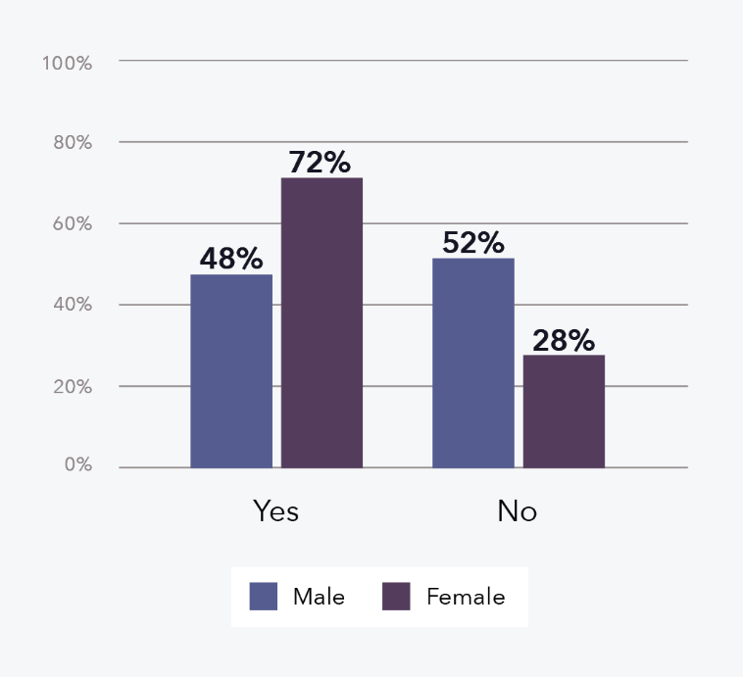
Data table for figure 19:
Gender and mental health issue status | % of offenders
Male - yes | 48
Male -no | 52
Female - yes | 72
Female - no | 28

Disability
Around 1 in 10 filicide offenders had a recorded disability at the time of the filicide (9%, n = 9), which is lower than the rates of disability in the general population (Australian Census 2018). Given the very small numbers of filicide offenders with a disability that could be identified in this national project, this variable has not been disaggregated by gender.
When examining the type of mental health issues male and female filicide offenders were experiencing, it is evident that female offenders experienced depression combined with other mental health issues at a higher rate (48% of the 23 female offenders, n = 11) than male filicide offenders (31% of the 32 male offenders, n = 10). It is important to also consider that experiencing DFV, sexual violence and IPV have been associated with long term negative mental health outcomes, particularly for women (Ayre et al., 2016). This is reflected in the rate of mental health issues for women (see Figure 19) and, as presented later in the report, in the over-representation of female filicide offenders as primary IPV victim-survivors (see Figure 34).
This might again point to the need for greater assessment in the antenatal and postnatal stage in relation to postnatal depression and/or postnatal anxiety.
Reflections from a Senior Social Worker

Alcohol and other drug issues
More filicide offenders were identified as having AOD issues (55%, n = 54) than those who were not (45%, n = 45; see Table 7), with the most common form of AOD issues involving illicit and/or prescription drugs (52% of those with AOD issues, n = 28), followed by issues with both alcohol and other drugs (37% of those with AOD issues, n = 20). Lower rates were observed for issues with alcohol alone (11% of those with AOD issues, n = 6).
Overall, this means 26 per cent of filicide offenders had issues with alcohol and 48 per cent had issues with illicit and/or prescription drugs. Findings from national and international filicide studies suggest rates of offenders with AOD issues can vary between 3 and 30 per cent (Brown, Bricknell, et al., 2019; Brown, Lyneham, et al., 2019; Dixon et al., 2014; Hatters Friedman et al., 2005; Kauppi et al., 2010).
Table 7: DFV-context filicide offenders by AOD issues (n = 99)
Filicide offender AOD issues | N | %
No | 45 | 45
Yes | 54 | 55
Illicit and/or prescription drugs | 28 | 28
Alcohol | 6 | 6
Alcohol and other drugs a | 20 | 20
Total | 99 | 100
Note: a “Other drugs” refers to illicit and/or prescription drugs.
Problematic parental substance use can often exacerbate existing mental health issues and place children at risk. However, for children who have also experienced child abuse or neglect, and who may have complex needs arising from this, problematic parental substance use may increase their vulnerability and place them at higher risk. Substance use can affect a parent’s ability to recognise and meet a child’s needs, supervise them, and provide safety.
Reflections from Senior Child Protection Practitioners

Comparison by filicide offender gender
It was more common for male filicide offenders to have AOD issues (61%, n = 41) compared with female filicide offenders (41%, n = 13; see Figure 20).
Figure 20: Percentage of DFV-context filicide offenders by AOD issues and gender (n = 99)
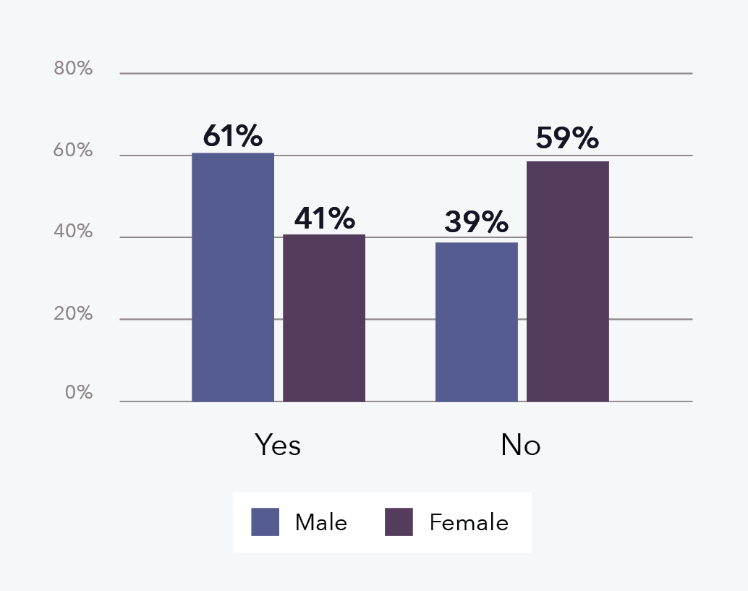
Data table for figure 20:
AOD issue status by gender | % of offenders
Male – yes | 61
Male – no | 39
Female – yes | 41
Female – no | 59

In terms of the type of AOD issues, a higher proportion of female filicide offenders had issues involving illicit and/or prescription drugs (69% of 13 female offenders, n = 9) compared to male filicide offenders (46% of 41 male offenders, n = 19). Male filicide offenders more commonly had both alcohol and other drug issues (41% of 41 male offenders, n = 17) compared to female filicide offenders (23% of 13 female offenders, n = 3).

Experience of DFV in childhood
Just under half of the filicide offenders had a known history of experiencing DFV in their childhood (44%, n = 44; see Figure 21). This appears to be lower than that observed in the general population. For example, in a survey of 8,500 Australian’s over 16 years of age, the Australian Childhood Maltreatment Study found that overall 62.2 per cent experienced at least one form of maltreatment in their childhood, such as physical abuse, “exposure to DFV”, emotional abuse, and/or sexual abuse (Higgins et al., 2023; Mathews et al., 2023).
Figure 21: Percentage of DFV-context filicide offenders by childhood DFV experience (n = 99)
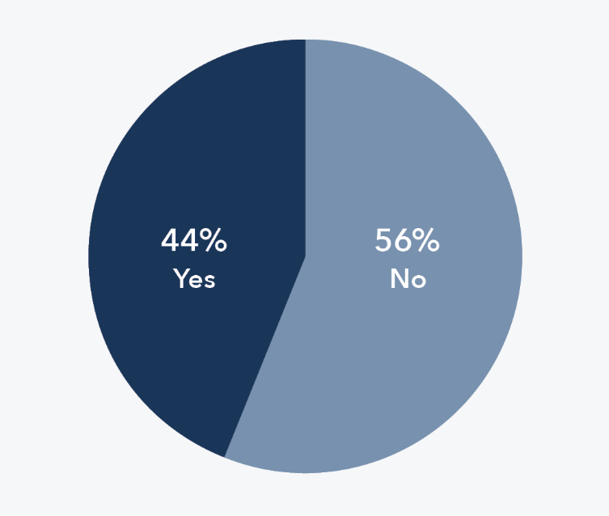
Significant proportion of perpetrators having been victims of DFV themselves, which this intergeneration[al] pattern [is] something that is very prevalent in the child protection system.
Reflections from a Senior Social Worker

Comparison by filicide offender gender
The findings from the national filicide project indicate that a higher proportion of female filicide offenders had a known history of experiencing DFV in their childhood (59%, n = 19) compared to male filicide offenders (37%, n = 25; see Figure 22).
Figure 22: Percentage of DFV-context filicide offenders by childhood DFV experience and gender (n = 99)
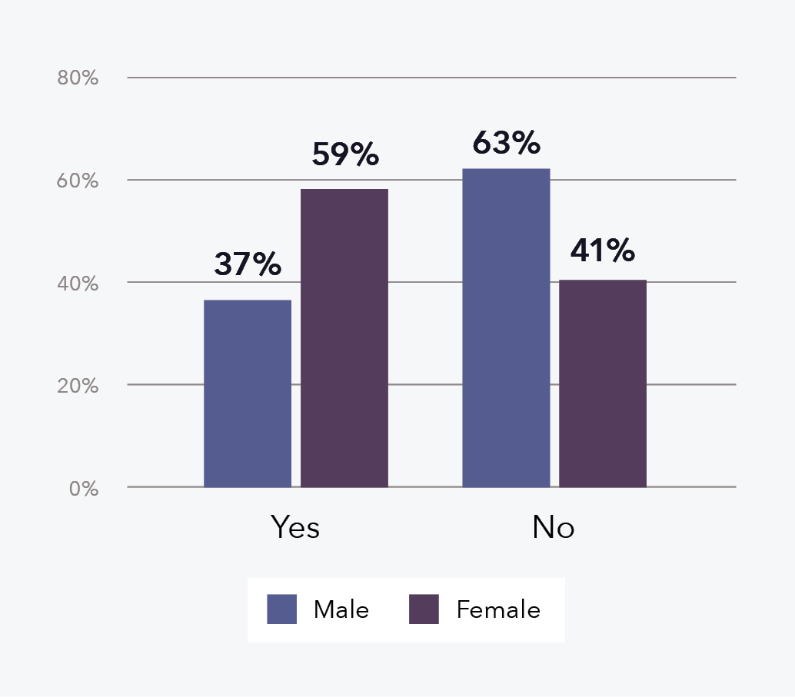
Data table for figure 22:
Childhood DFV experience by gender | % of offenders
Male – yes | 37
Male – no | 63
Female – yes | 59
Female – no | 41

People respond to trauma and violence against them in different ways and it is the role of child protection practitioners to understand how a person’s trauma and resistance shapes who they are and how they interact with others, and then how to connect children and adults to services that can help them heal from trauma.
Reflections from Senior Child Protection Practitioners

Criminal history
Over half of the filicide offenders had a known criminal history (56%, n = 55), which often involved both violent and non-violent offending (see Table 8). Criminal history included any convictions for IPV offences, though just 15 per cent of filicide offenders had such a conviction (n = 15). Overall, the findings show 38 per cent of filicide offenders had a violent criminal history (or 69% of those with a criminal history, n = 38), which could comprise either a violent-only history or a violent and non-violent history. Literature suggests that an offender’s criminal history is related to the perpetration of IPH (Bridger et al., 2017; Fridel & Zimmerman, 2019), and the findings from the national filicide project support other research that has found a connection to filicide (Brown et al., 2019a, 2019b; Hatters Friedman et al., 2005; Flynn et al., 2013).
Table 8: DFV-context filicide offenders by criminal history (n = 99)
Filicide offender criminal history | N | %
No | 44 | 44
Yes | 55 | 56
Both violent and non-violent | 30 | 30
Non-violent offences | 17 | 17
Violent offences | 8 | 8
Total | 99 | 100

Comparison by filicide offender gender
Male filicide offenders more commonly had a criminal history (61%, n = 41), when compared with female filicide offenders (44%, n = 14; see Figure 23).
Figure 23: Percentage of DFV-context filicide offenders by criminal history and gender (n = 99)
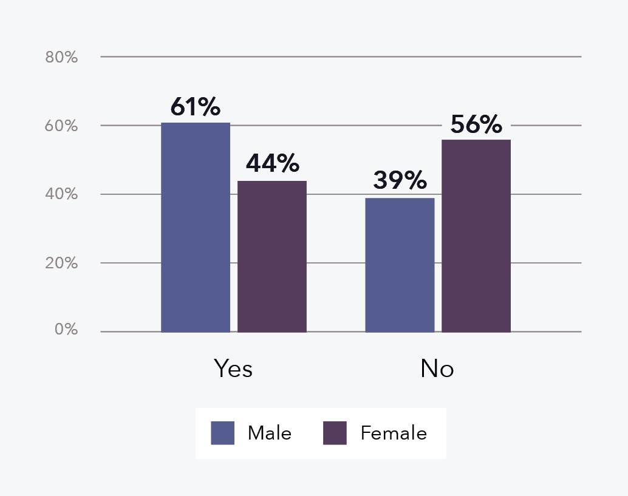
Data table for figure 23:
Criminal history by gender | % of offenders
Male – yes | 61
Male – no | 39
Female – yes | 44
Female – no | 56

Of those with a criminal history, a higher proportion of the male filicide offenders had a violent criminal history compared with the female filicide offenders. Specifically, a violent criminal history was evident for 80 per cent of the 41 male filicide offenders with a criminal history (15% violent-only history and 66% violent and non-violent history), compared to 36 per cent of the 14 female filicide offenders (14% violent-only history and 21% violent and non-violent history).

DFV characteristics preceding the filicide
The DFV death review mechanisms can access and review a wide range of data relating to filicide cases, victims and offenders. This data provides a unique opportunity to examine the identifiable history of DFV that preceded the filicide. The following section presents findings for several violence characteristics of the DFV-context filicides, including the nature of violence perpetrated against the filicide victim/s and/or their sibling/s, any IPV involving their parent/s, any current or historical DFV orders, actual or intended separation of the filicide victim/s’ parent/s, and any family law proceedings. Where relevant, some findings have also been disaggregated by the gender of the filicide offender.

Violence against the child/ren
The findings in this section are primarily presented based on the number of filicide cases, rather than the number of filicide victims, to avoid duplicating reports of violence considering violence was captured in relation to the filicide victim/s and/or their sibling/s (where a sibling may or not may not have also been a filicide victim in cases with multiple victims). In the project, both reported and unreported violence were considered as part of the history of violence against the victim/s and/or their sibling/s. In coding that violence, “Yes” indicates there was evidence of violence in the case files and “No” indicates there was no evidence or known history of that violence (and accordingly the DFV context related to a history of IPV involving the parent/s). Of the 86 DFV-context filicides, a prior history of violence against the filicide victim/s and/or their sibling/s was evident in 78 per cent of cases (n = 67; see Figure 24).
In a study of 49 Australian filicides, Watson (2022) found 63 per cent of victims did not experience any prior abuse, which is almost the reverse of the finding from the national filicide project. The wealth of information available in death review data and the DFV lens used in the national project means that some DFV (physical and non-physical violence) that would otherwise go undetected could be identified in this project. Differing rates could also relate to variances in data sources and definitions that change the scope of how DFV is captured in research (see Brown et al., 2014).
Figure 24: Percentage of DFV-context filicide cases with a history of violence against the child/ren (n = 86)
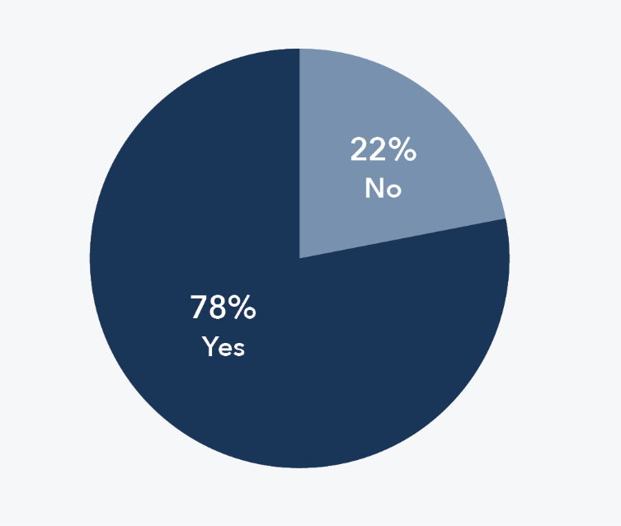

Type of violence
Of the 67 cases with prior violence against the child/ren, in the vast majority of these cases there was evidence of physical violence (84%, n = 56) or emotional violence (81%, n = 54; see Figure 25 and Figure 26). Evidence of sexual violence was rarer, with 19 per cent of the 67 cases identifying the filicide victim/s and/or their sibling/s had experienced sexual violence (n = 13; see Figure 27). These results do not include sexual violence perpetrated by those outside the family or by an unknown offender. It should also be noted that it is particularly difficult to identify when a child may have experienced sexual violence and that sexual abuse, especially child sexual abuse, is severely under-reported (Mathews et al., 2017).
Figure 25: Percentage of DFV-context filicide cases with a history of violence against the child/ren involving physical violence (n = 67) a
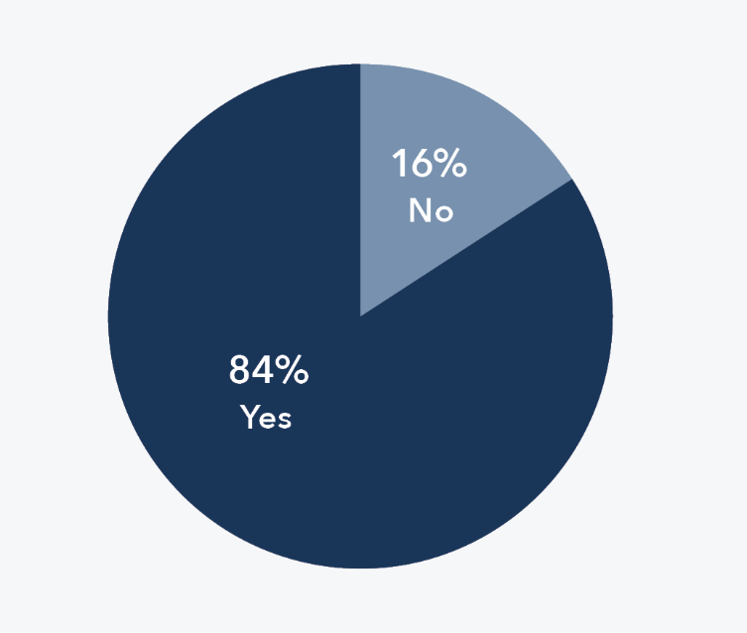
Note: a Filicide victim/s (n = 31); both filicide victim/s and sibling/s (n = 19); sibling/s of the filicide victim/s (n = 6). “No” indicates no evidence or known history of this form of violence.
Figure 26: Percentage of DFV-context filicide cases with a history of violence against the child/ren involving emotional violence (n = 67) a
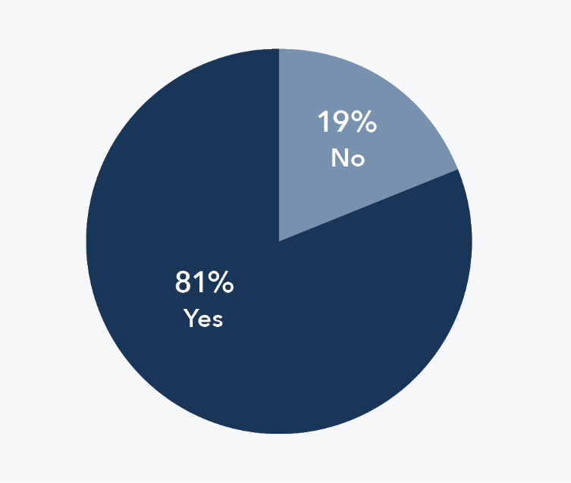
Note: a Filicide victim/s (n = 23); both filicide victim/s and sibling/s (n = 27); sibling/s of the filicide victim/s (n = 5). “No” indicates no evidence or known history of this form of violence.
Figure 27: Percentage of DFV-context filicide cases with a history of violence against the child/ren involving sexual violence (n = 67) a
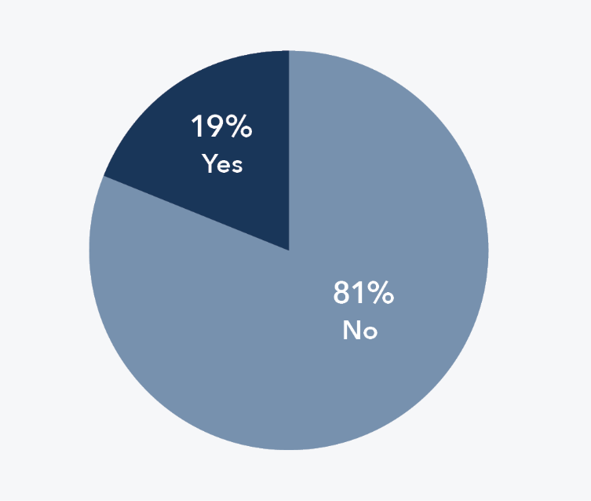
Note: a Filicide victim/s (n = 7); both filicide victim/s and sibling/s (n = 1); sibling/s of the filicide victim/s (n = 5). “No” indicates no evidence or known history of this form of violence.

Timing and reporting of violence
When there was evidence of prior violence against the filicide victim/s and/or their sibling/s, it was most common for that violence to have been last perpetrated less than 3 months prior to the filicide (72% of cases with violence against the child/ren, n = 48; see Figure 28).
Figure 28: Percentage of DFV-context filicide cases with a history of violence against the child/ren by the timing of violence last perpetrated (n = 67)
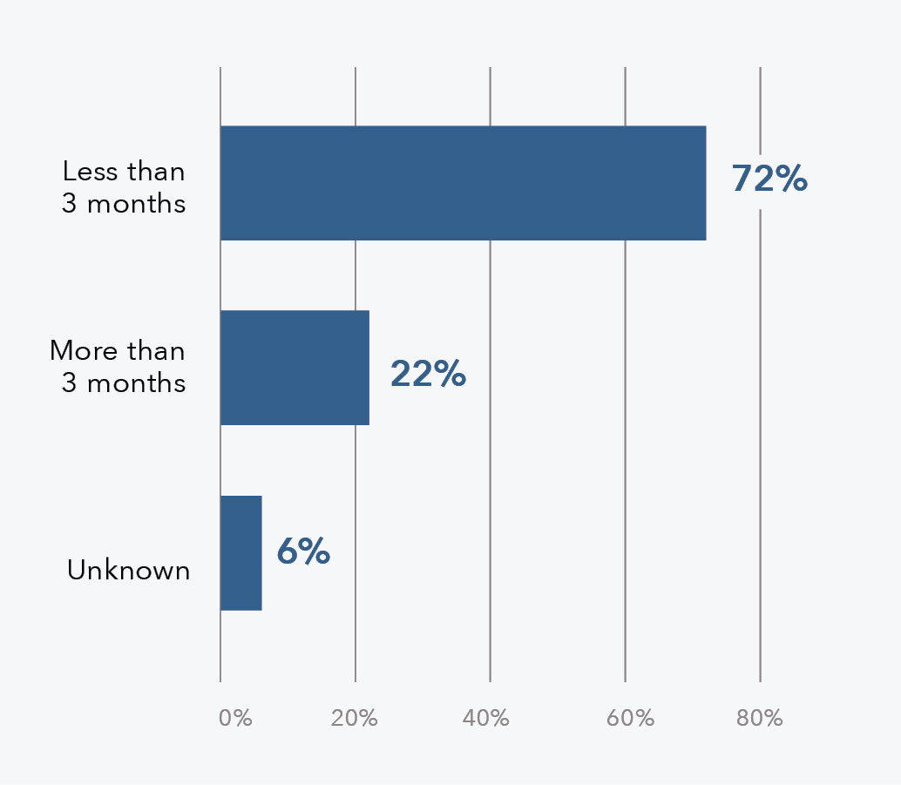
Data table for figure 28:
Violence last perpetrated | % of cases
Less than 3 months | 72
More than 3 months | 22
Unknown | 6

Violence against the filicide victim/s and/or their sibling/s was known to have been reported in over half of cases with that violence (55% of the 67 cases, n = 37). The violence was more often reported to child protection (51% of the 67 cases, n = 34), compared to police (33% of the 67 cases, n = 22; see Figure 29), and was usually reported more than 3 months prior to the filicide (57% of the 37 cases where the violence was reported, n = 21).
Figure 29: Percentage of DFV-context filicide cases with a history of violence against the child/ren by the reporting of that violence (n = 67)
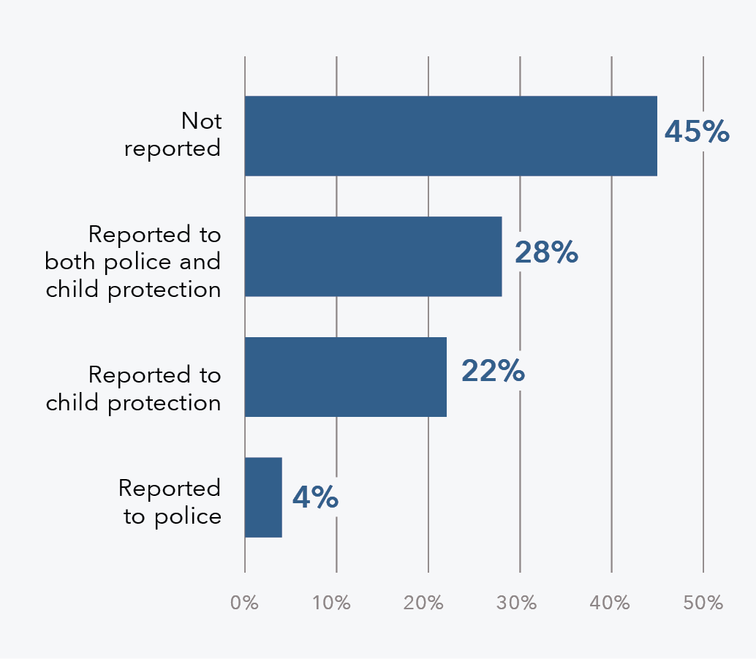
Data table for figure 29:
Status | % of cases
Not reported | 45
Reported to both police and child protection | 28
Reported to child protection | 22
Reported to police | 4

The violence is … really under-reported, masked or just not reported … to me, that kind of highlighted a bit of a trend, I think or a change in a space, but also recognition that domestic and family violence does happen. It does not discriminate.
Reflections from a DFV Worker

Perpetrator of violence
When there was a history of violence against the filicide victim/s and/or their sibling/s, most often the violence was perpetrated by one or, where applicable, both of the filicide offenders (87% of 67 cases). Specifically, in 64 per cent of cases with a history of this violence, the filicide offender was the only known perpetrator of violence (n = 43), in a further 7 per cent of cases one of the two co-offenders perpetrated the violence (n = 5), in 6 per cent of cases both of the co-offenders perpetrated the violence (n = 4), and in a further 9 per cent of cases both the filicide offender and another parent perpetrated violence (n = 6). See Figure 30 for a full breakdown of the adults within the family known to have perpetrated violence against the filicide victim/s and/or their sibling/s. In two cases it was unclear which parent/s and/or parent equivalent/s had perpetrated violence and therefore these cases were categorised as “Unknown”.
Figure 30: Percentage of DFV-context filicide cases with a history of violence against the child/ren by the perpetrator/s of that violence (n = 67)
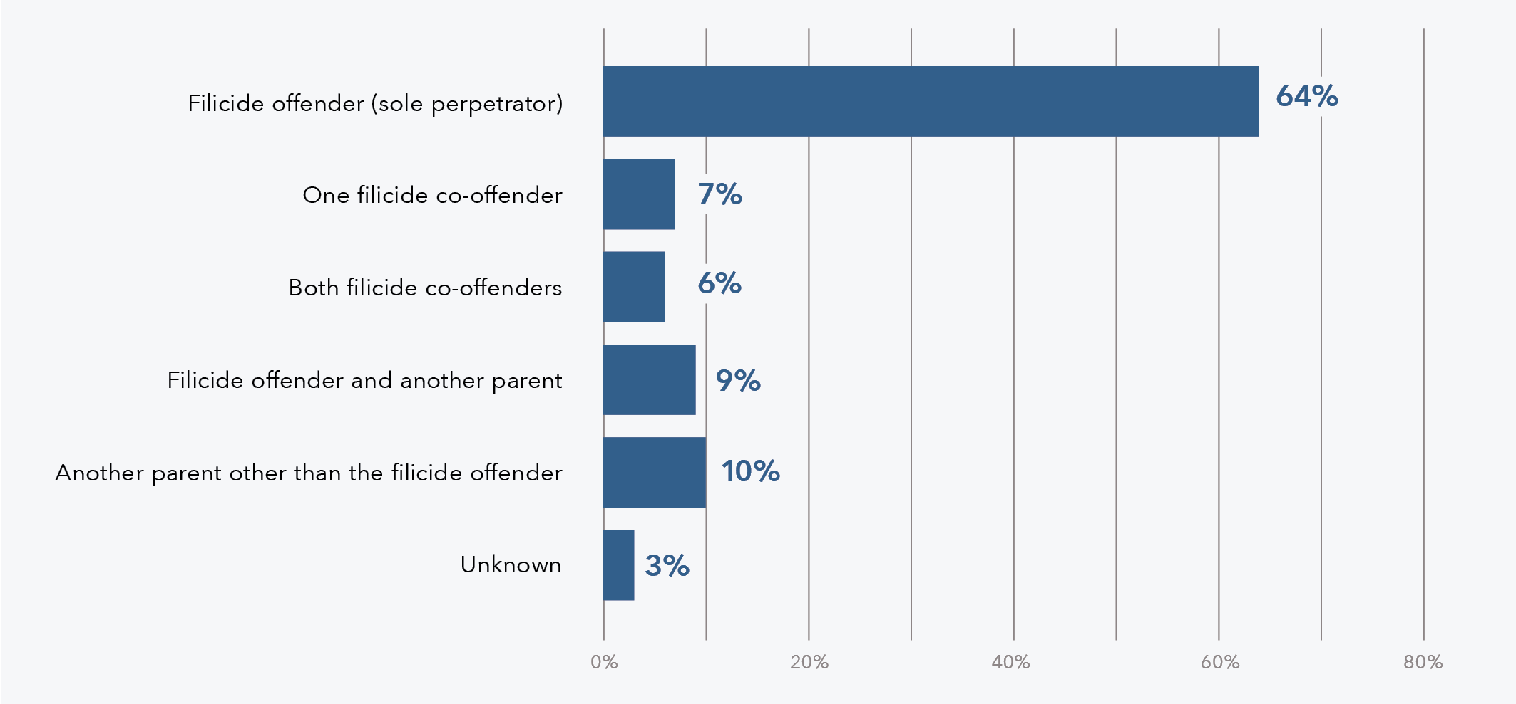
Data table for figure 30:
History of violence | % of cases
Filicide offender (sole perpetrator) | 64
One filicide co-offender | 7
Both filicide co-offenders | 6
Filicide offender and another parent | 9
Another parent other than the filicide offender | 10
Unknown | 3

Comparison by filicide offender gender
When there was a history of violence against the filicide victim/s and/or their sibling/s, this involved 80 filicide offenders in total. Male filicide offenders were far more commonly the sole perpetrator of that violence (73% of these male filicide offenders, n = 40) when compared to female filicide offenders (36% of these female filicide offenders, n = 9; see Figure 31). As shown in Figure 31, female filicide offenders were more commonly captured under the “one filicide co-offender” category, which signifies there was no identifiable history of her having perpetrated violence against the filicide victim/s and/or their sibling/s, rather the male co-offender was identified as having previously perpetrated violence.
Figure 31: Percentage of DFV-context filicide offenders with a history of violence against the child/ren by the gender of the perpetrator/s of that violence (n = 80)
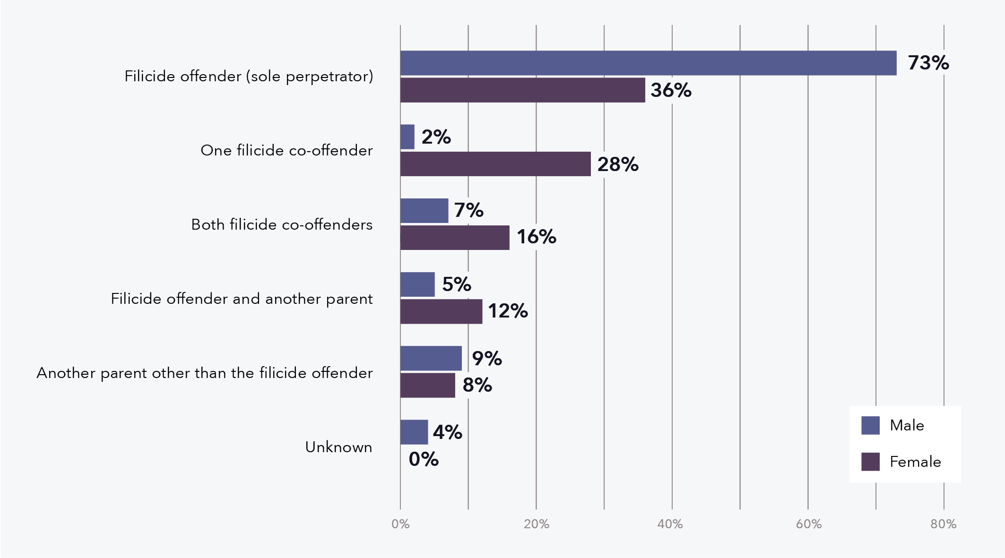
Data table for figure 31:
History of violence | % male | % female
Filicide offender (sole perpetrator) | 73 | 36
One filicide co-offender | 2 | 28
Both filicide co-offenders | 7 | 16
Filicide offender and another parent | 5 | 12
Another parent other than the filicide offender | 9 | 8
Unknown | 4 | 0

Convictions of offences against the filicide victim/s and/or their sibling/s
No filicide offenders had prior convictions for offences against the filicide victim/s and/or their sibling/s. This was despite there being evidence of prior violence against them in 78 per cent of DFV-context filicides, with the violence having been reported prior to the filicide in just over half of these cases. This finding highlights issues around the lack of visibility for these children in terms of the high incidence of unreported violence, as well as the challenges in meeting the threshold for a criminal conviction even when the violence is reported.

Intimate partner violence
IPV was perpetrated or experienced by a filicide offender in 88 per cent of filicide cases (n = 76). The findings in the remainder of this section are presented by the number of filicide offenders rather than cases, which allows for an examination of IPV perpetration and victimisation in cases with multiple filicide offenders, as well as with respect to the gender of the filicide offender. Across all 99 filicide offenders of DFV-context filicides, approximately 3 in 5 were a primary IPV perpetrator (59%, n = 58), and almost a quarter were a primary IPV victim-survivor (23%, n = 23, see Figure 32). Around 1 in 10 filicide offenders were recorded as neither the primary IPV victim-survivor nor perpetrator (11%, n = 11), meaning no evidence of IPV was found (and accordingly the DFV context related to the history of violence against the filicide victim/s and/or their sibling/s). For seven filicide offenders a history of IPV was evident but there was not enough nuance in the available data to determine who was the primary perpetrator and who was the primary victim-survivor of that IPV.
Figure 32: Percentage of DFV-context filicide offenders by perpetration or experience of IPV (n = 99)
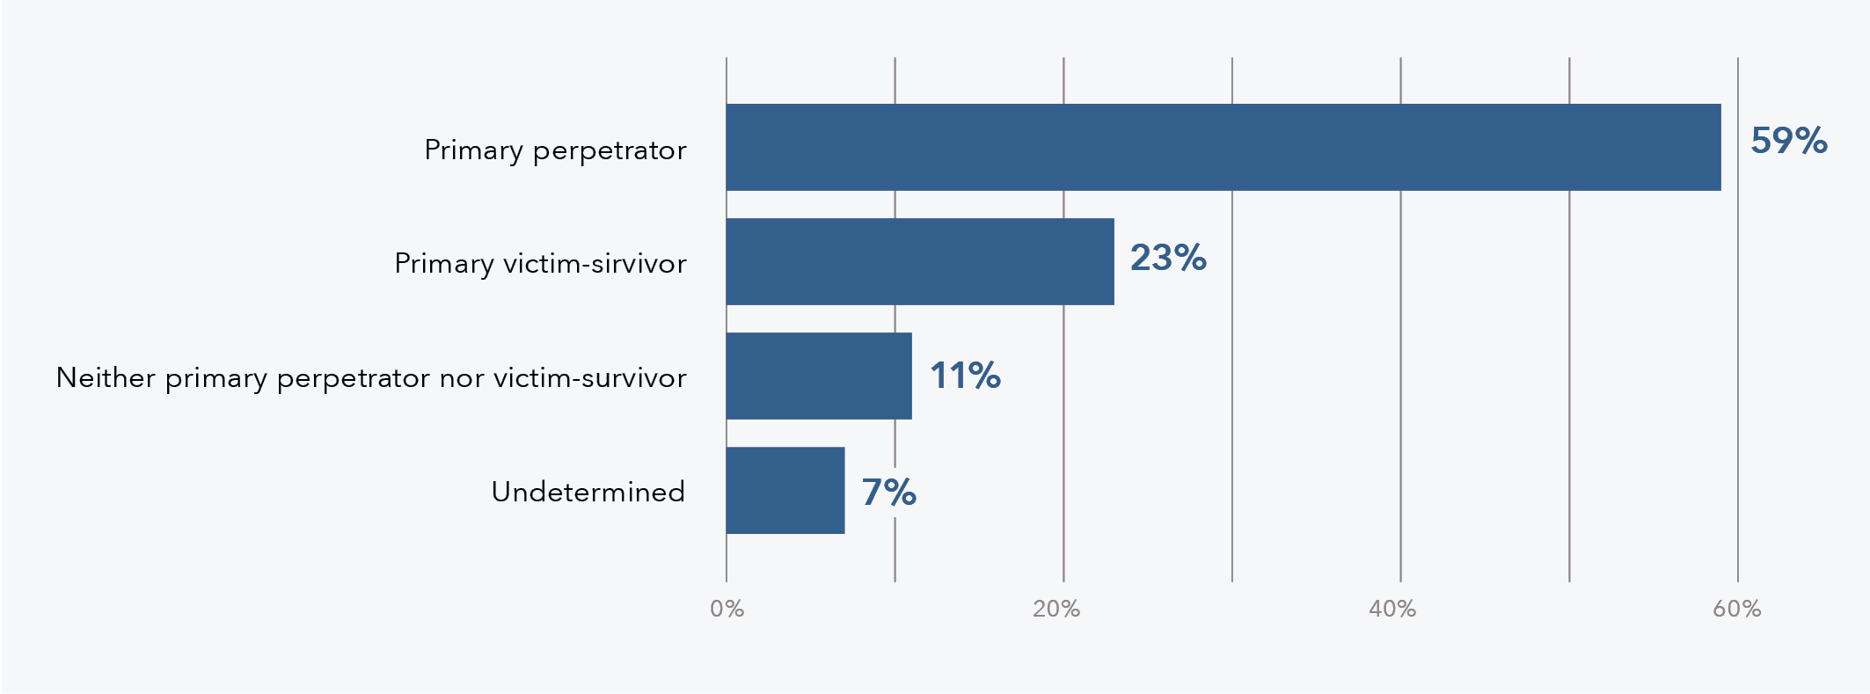
Data table for figure 32:
Perpetration or experience | % of offenders
Primary perpetrator | 59
Primary victim-survivor | 23
Neither primary perpetrator nor victim-survivor | 11
Undetermined | 7

Comparison by filicide offender gender
The findings regarding the primary IPV perpetrator and primary IPV victim-survivor are gendered, with 97 per cent of primary IPV perpetrators being male (n = 56) and 96 per cent of primary IPV victim-survivors being female (n = 22; see Figure 33 and Figure 34). The broader literature suggests that the perpetration or experience of IPV is linked with filicide perpetration. For instance, Eriksson et al. (2016) found in their comparative study of filicide and other homicide offenders that fathers who perpetrated filicide had more commonly perpetrated IPV compared to offenders who had perpetrated other forms of homicide. Further, Brown et al. (2014) in their study of Victorian filicides reported 87 per cent of stepfathers who killed their children had been violent towards an intimate partner. In terms of a filicide offender’s experience of IPV, the NSW Domestic Violence Death Review Team (2022) reported that 94 per cent of female filicide offenders were identified as a primary victim-survivor of IPV, either in a current or former relationship. No male filicide offenders were identified as a primary victim-survivor of IPV (Domestic Violence Death Review Team, 2022).
Figure 33: Percentage of DFV-context filicide offenders who were the primary IPV perpetrator by gender (n = 58)
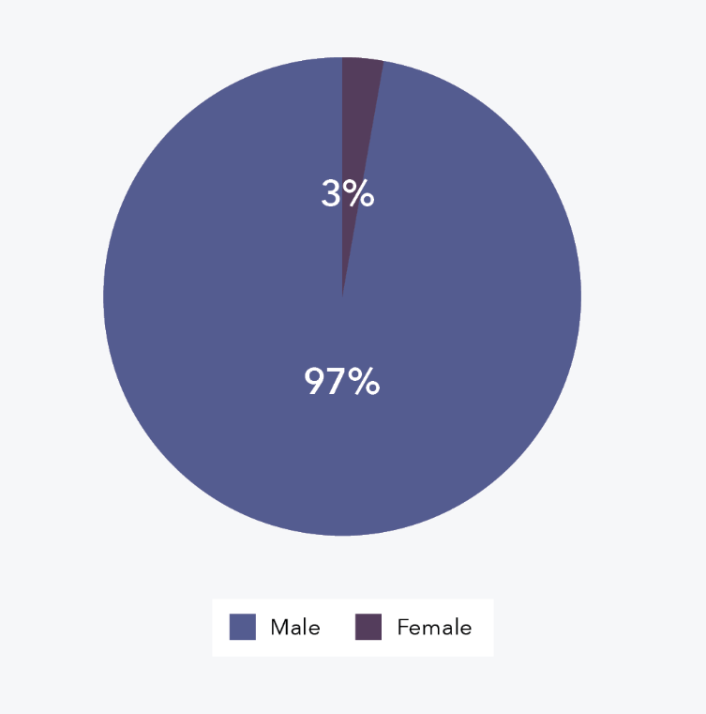
Figure 34: Percentage of DFV-context filicide offenders who were the primary IPV victim-survivor by gender (n = 23)
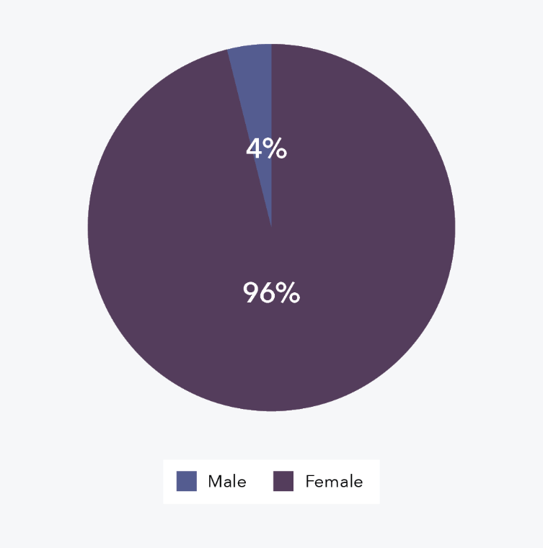
There were 88 filicide offenders recorded as having experienced or perpetrated IPV prior to the filicide and for just under half the IPV had been reported to police (48%, n = 42). There are many barriers to reporting IPV, including a victim-survivor’s fear of their partner, systemic and structural barriers for Aboriginal and/or Torres Strait Islander people, issues with access to police, and the understanding and identification of violence by the victim-survivor or witnesses (Ghafournia & Easteal, 2018; Langton et al., 2020b; Meyer & Stambe, 2020).

Convictions of offences against an intimate partner
As stated in the earlier section on filicide offender criminal history, 15 per cent of all DFV-context filicide offenders had been convicted of any IPV offences prior to the filicide (n = 15).

DFV orders
A DFV order refers to a civil order, the objective of which is to protect victim-survivors or persons at risk of DFV from a person with whom they are, or have been, in an intimate or familial relationship (see “Definitions and Concepts” section for further detail). This section presents findings regarding any historical and/or current DFV orders involving the filicide offender and therefore the findings are presented with respect to the number of filicide offenders (n = 99), rather than number of cases.

DFV orders involving the filicide victim
A very small proportion of filicide offenders had ever been named as a defendant in a final DFV order (or orders) involving the filicide victim/s (8%, n = 8). An even smaller proportion were currently named in a DFV order involving the filicide victim/s at the time of the filicide (3%, n = 3). These findings align with the literature, with research suggesting that while DFV orders have the potential to have a positive impact on a child’s safety, they can often be rejected or delayed in favour of a child maintaining contact with both parents (Jeffries et al., 2015; McKenzie & Woodlock, 2012).
It is really unlikely that children will be named on [DFV orders]. For various reasons … sometimes police will respond and police can enact [DFV orders]. But unless it’s significant and very clear that the children are there, they will not put them on the order. And I think for some of the women that we work with, they are reluctant to put children on [DFV orders] because they still want their partner to have contact with the children. So there’s still that kind of valuing the relationship.
Reflections from a DFV Worker

DFV orders involving a current and/or former partner
Around a quarter of filicide offenders had ever been named as a defendant in a final DFV order (or orders) involving a current and/or former partner (23%, n = 23). At the time of the filicide, almost 1 in 10 filicide offenders were currently named in a DFV order involving a current and/or former partner (7%, n = 7).

Person in need of protection
A small portion of filicide offenders had ever been named as the person in need of protection in a final DFV order (12%, n = 12). At the time of the filicide, very few filicide offenders were currently named as the person in need of protection in a DFV order (4%, n = 4).

Breaches of orders
Fourteen filicide offenders were known to have been convicted of breaching a DFV order (which could have related to either an intimate partner or the filicide victim/s and/or their sibling/s) at some point before the filicide. Additional filicide offenders may have previously breached a DFV order and not been convicted of such an offence.

Child protection orders
A child protection order is an order made by the Children’s Court, the objective of which is to protect the child/ren involved, and it may include provisions for their permanent care (see “Definitions and Concepts” section for further detail). Evidence of current or historical child protection orders was captured for each case and could involve the filicide victim/s and/or their sibling/s; therefore, the findings are presented with respect to the number of filicide cases. The findings demonstrate that filicide victim/s and/or their sibling/s had been subject to a child protection order in 14 per cent of cases (n = 12; see Figure 35), either at the time of the filicide or historically. There were even numbers of current orders and historical orders (both n = 6 respectively). These child protection orders could involve, for instance, the removal and/or supervision of the child/ren.
Figure 35: Percentage of DFV-context filicide cases with a current or historical child protection order (n = 86)
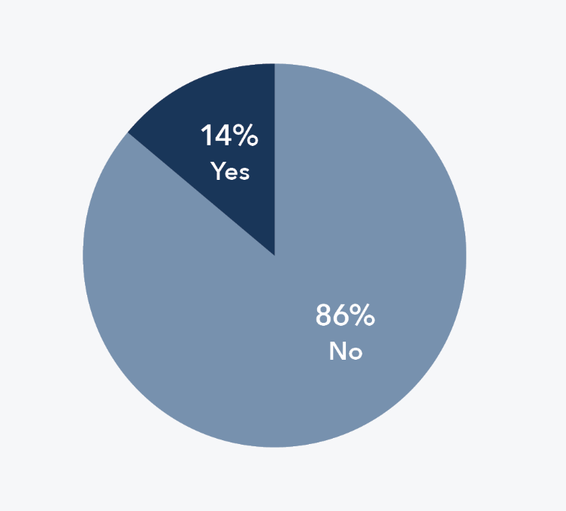

Separation as a characteristic of filicide
Figure 36 shows that separation was a characteristic in almost a third of DFV-context filicide cases (31%, n = 27). Where separation was a characteristic of the filicide, this could involve actual or intended separation. In cases where it was a characteristic, separation more commonly occurred within the 3 months prior to the filicide (63% of cases with separation as a characteristic, n = 17) as opposed to more historical separations (n = 10).
Figure 36: Percentage of DFV-context filicide cases where separation was a characteristic (n = 86) a
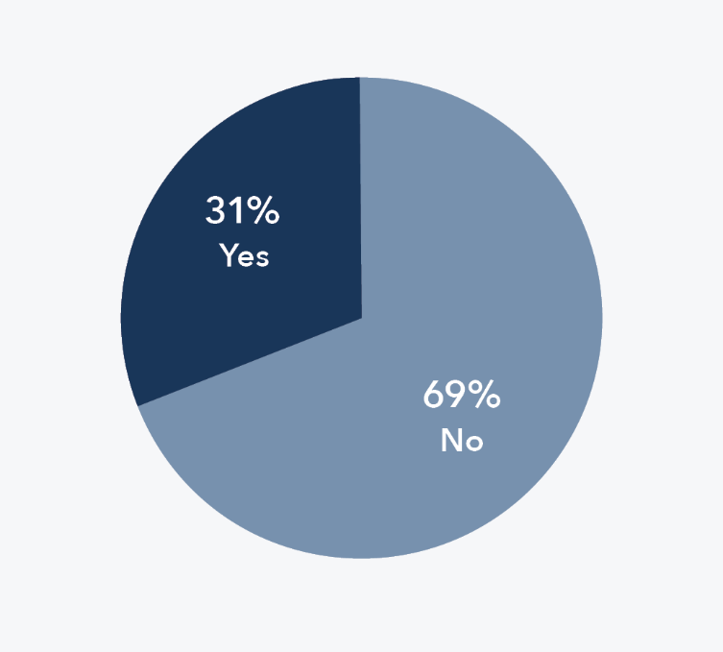
Note: a “No” indicates no evidence of separation being a characteristic in a case.
Many studies have examined the link between separation and divorce on filicide, with findings suggesting that the context of separation may have an impact on filicide perpetration (Brown et al., 2014; Kirkwood, 2012; Kirkwood & McKenzie, 2013; O’Hagan, 2014). Brown et al. (2014) examined filicide cases in Victoria and found over half had a history of parental separation or divorce. Unlike Brown et al. (2014), however, this national filicide project focused on separation as a characteristic of the filicide, rather than separation more broadly, meaning that the separation appeared to be a contributing factor to the filicide. For the 69 per cent of cases in this project that did not have separation as a characteristic, these cases may have had evidence of prior separation relating to the parent/s; however, the separation was not considered to be a key factor in the filicide. There is little research that examines separation as a characteristic of the filicide, meaning that it is difficult to compare the current findings to wider research.

Family law proceedings
Most DFV-context filicide cases did not have any recorded family law proceedings (85%, n = 73; see Figure 37). In the 13 filicide cases with recorded proceedings, around half had current proceedings (n = 7), a few had both current and historical proceedings (n = 3), a couple involved historical proceedings (n = 2), and in one case it was unknown when the proceedings occurred.
Figure 37: Percentage of DFV-context filicide cases with recorded family law proceedings (n = 86)
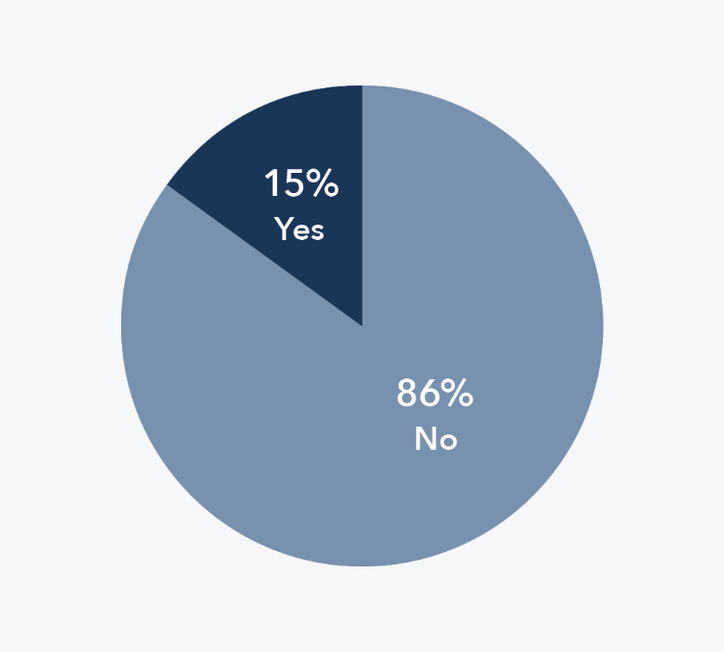
There is sparse research examining the link between family court proceedings and filicide. Johnson (2006) found in a study of familicide in Western Australia that familicide was more closely related to separation than custody or access disputes, which appears to align with the rates of separation and family law proceedings demonstrated by this national filicide project. In the IPVH data report (ADFVDRN & ANROWS, 2022), family law proceedings were even more rare, with less than 4 per cent of cases having recorded family law proceedings. This may be due to a lower rate of child involvement in these cases, although the rate in both filicide and IPVH projects suggests disputes relating to separation are potentially more commonly settled outside of court.
The vast majority of offenders resided with the victim (82%). This is consistent with the … number of cases where there were family law proceedings.
Reflections from Members of the FCFCOA Family Violence Committee

SERVICE CONTACT
The national filicide project examined each DFV-context filicide case for evidence of any prior interactions the family had with services, which served as a first instance of mapping service contact to provide a sense of service visibility. Some research indicates that the number of services and rate of contact is generally higher where DFV involves children compared to DFV that does not involve children (Jaffe et al., 2014), suggesting that there could be greater potential for intervention and prevention prior to filicides that occur in a DFV context.
For the purposes of this project, “service contact” has been conceptualised as referring only to the most recent contact with each type of service, prior to the filicide occurring. Therefore, while service contact could have occurred in these cases for months or years prior to the filicide, the following findings present the last known contact with a range of services. The timing of the most recent contact with each service was captured as occurring either less than 3 months, 3 to 6 months, or more than 6 months prior to the filicide. For this study, contact needed to involve either the filicide victim/s, their sibling/s, and/or their parent/s, which would include the filicide offender/s. It was evident across the DFV-context filicides that the last known contact with each service could exist on a spectrum, from an initial or single interaction with a service through to the most recent occurrence in an extensive long-term contact history.
The type of service interactions that were captured in this project varied depending on the service. For particular services (i.e. police, courts and tribunals, and legal services), the contact needed to relate to DFV rather than another unrelated reason for the contact (e.g. police stopping the filicide offender for a random breath test). Interactions with child protection were included provided the contact concerned the filicide victim/s and/or their sibling/s (i.e. not any historical contact the filicide offender/s may have had with the service as a child themselves). When looking at services such as health care and education, contact with these services was considered at a broader level where it did not have to specifically relate to DFV in order to identify other potential points of intervention.

Police
Around two thirds (65%, n = 56) of DFV-context filicide cases involved prior contact with police, see Table 9. In the cases where police contact was evident, it most commonly last occurred more than 6 months prior to the filicide (48% of cases with prior police contact, n = 27). While this rate of police contact relates to DFV matters, it may not have involved the reporting of any violence against the filicide victim/s and/or their sibling/s (e.g. the contact could have been in relation to IPV) and is therefore different from the rate of reporting of violence perpetrated towards the victim/s and/or their sibling/s presented earlier in this report.

Table 9: Contact with police by DFV-context filicide case (n = 86)
Contact with police | N | %
No | 30 | 35
Yes – how long before the filicide | 56 | 65
Less than 3 months | 15 | 17
3 to 6 months | 13 | 15
More than 6 months | 27 | 31
Unknown | 1 | 1
Total | 86 | 100

The death of the child was sometimes the catalyst for disclosures from the non-offending parent, family members, friends or associates about DFV or other concerning behaviour that had occurred prior to the death of the child.
Reflections from a Specialist DFV Police Officer

Child protection services
In DFV-context filicide cases, 60 per cent involved prior contact with child protection services (n = 52; see Table 10). Of those cases that had reported contact, the last contact most often occurred less than 3 months before the filicide (56% of cases with prior child protection contact).
Table 10: Contact with child protection by DFV-context filicide case (n = 86)
Contact with child protection | N | %
No | 34 | 40
Yes – how long before the filicide | 52 | 60
Less than 3 months | 29 | 34
3 to 6 months | 7 | 8
More than 6 months | 16 | 19
Total | 86 | 100

It is disturbing to read that [many] filicide cases involved recent contact with child protection services. This might suggest that screening did not adequately identify the seriousness or the currency of the risk. Of course, it could also reflect the chronic under resourcing of child protection services. Improved information sharing between different agencies with information about the family (including the FCFCOA) could help here.
Reflections from Members of the FCFCOA Family Violence Committee

I note with concern that in 78 per cent of cases there was a history of violence against victims or their siblings (usually by the filicide offender and within 3 months of the fatal incident); however, only [60%] of cases had any Child Protection involvement. The vulnerability of children in these families is striking.
Reflections from a Coroner

That was worrying for me, you know the drop off [in contact] and I mean – we do see this, that this is often when deaths occur, when there’s no engagement, and it’s almost like- just recently reflecting on … a man who uses violence, not even filicide, but in an intimate partner relationship. And he’s changed his behaviour ’cause he knows he’s being monitored.
Reflections from a DFV Worker

Courts, tribunals and legal services
Contact with courts and tribunal services prior to the filicide was recorded in just over a quarter of cases (27%, (n = 23; see Table 11). When there was previous contact recorded, the last contact most commonly occurred more than 6 months prior to the filicide (57% of cases with courts and tribunal services contact, (n = 13). Contact with legal practitioners occurred in 1 in 5 cases (20%, (n = 17), as shown in Table 12. Of those cases that did have recorded contact, 59 per cent involved prior contact within 3 months of the filicide (n = 10).
Table 11: Contact with courts and tribunals by DFV-context filicide case (n = 86)
Contact with courts and tribunals | N | %
No | 63 | 73
Yes – how long before the filicide | 23 | 27
Less than 3 months | 7 | 8
3 to 6 months | 2 | 2
More than 6 months | 13 | 15
Unknown | 1 | 1
Total | 86 | 100
Table 12: Contact with legal practitioners by DFV-context filicide case (n = 86)
Contact with legal practitioners | N | %
No | 69 | 80
Yes – how long before the filicide | 17 | 20
Less than 3 months | 10 | 12
3 to 6 months | 2 | 2
More than 6 months | 4 | 5
Unknown | 1 | 1
Total | 86 | 100

Specialist DFV services
Around 1 in 5 (19%, n = 16) cases of DFV-context filicide had recorded contact with specialist DFV services (see Table 13). When there was evidence of prior contact, there were similar numbers of cases with contact within 3 months of the filicide (n = 6) and those with last contact more than 6 months prior (n = 6).
Table 13: Contact with DFV services by DFV-context filicide case (n = 86)
Contact with DFV services | N | %
No | 70 | 81
Yes – how long before the filicide | 16 | 19
Less than 3 months | 6 | 7
3 to 6 months | 3 | 3
More than 6 months | 6 | 7
Unknown | 1 | 1
Total | 86 | 100

Health care

General health services
The majority (71%, n = 61) of DFV-context filicides had prior contact with general health services and almost three quarters of those cases had the last recorded contact within the 3 months before the filicide (74% of cases with general health service contact, n = 45; see Table 14). This figure is in keeping with national population rates, which show nearly three quarters of the Australian population is seen by general practitioners and primary care physicians each year (Kuruppu et al., 2022).
Table 14: Contact with general health services by DFV-context filicide case (n = 86)
Contact with general health services | N | %
No | 25 | 29
Yes – how long before the filicide | 61 | 71
Less than 3 months | 45 | 52
3 to 6 months | 3 | 3
More than 6 months | 12 | 14
Unknown | 1 | 1
Total | 86 | 100

Maternal health services
In almost half of the DFV-context filicide cases (44%, n = 38) there was prior recorded contact with maternal health services, as shown in Table 15. This included services such as antenatal clinics or home visits from a child nurse. It was relatively common for the last contact to have occurred less than 3 months prior to the filicide (58% of cases with maternal health services contact, n = 22). It should be noted that, similar to other healthcare services, there may be more DFV-context filicide cases with prior contact however this contact may not have been recorded in the available service data.
Table 15: Contact with maternal health services by DFV-context filicide case (n = 86)
Contact with maternal health services | N | %
No | 48 | 56
Yes – how long before the filicide | 38 | 44
Less than 3 months | 22 | 26
3 to 6 months | 4 | 5
More than 6 months | 11 | 13
Unknown | 1 | 1
Total | 86 | 100

Mental health services
In nearly half (49%, n = 42; see Table 16) of the DFV-context filicide cases there was prior recorded contact with mental health services. In cases that did have recorded contact, the last contact most commonly occurred less than 3 months before the filicide (38%, n = 16), shortly followed by more than 6 months beforehand (36%, n = 15). There is an abundance of literature concerning mental health as a contributing factor to filicide perpetration (De Bortoli et al., 2013; Flynn et al., 2013; Raymond et al., 2021); however, most studies do not consider the context of DFV. In this national filicide project, just over half of filicide offenders had a recorded mental health issue. Given the mental health service contact captured here could relate to the filicide victim/s, their sibling/s, and/or their parent/s, which includes the filicide offender/s, the results suggest that not all filicide offenders with mental health issues had prior recorded contact with a mental health service.
Table 16: Contact with mental health services by DFV-context filicide case (n = 86)
Contact with mental health services | N | %
No | 44 | 51
Yes – how long before the filicide | 42 | 49
Less than 3 months | 16 | 19
3 to 6 months | 7 | 8
More than 6 months | 15 | 17
Unknown | 4 | 5
Total | 86 | 100

AOD services
There were very few (13%, n = 11) cases of DFV-context filicide where prior contact with alcohol and other drug services was evident (see Table 17), despite 55 per cent of filicide offenders being identified as having AOD issues. Of the cases that did involve prior contact with AOD services, 45 per cent had the last contact less than 3 months prior to the filicide (n = 5).
Table 17: Contact with AOD services by DFV-context filicide case (n = 86)
Contact with AOD services | N | %
No | 75 | 87
Yes – how long before the filicide | 11 | 13
Less than 3 months | 5 | 6
3 to 6 months | 2 | 2
More than 6 months | 4 | 5
Total | 86 | 100

Education
Education-related service contact included both early childhood education services and school. It should be noted that when contact with an education service was recorded, it did not necessarily mean the service was aware of any DFV, just that the service has had contact and therefore was identified as a point of contact. Further, it is possible that some filicide cases categorised as not having had prior contact with an education service may have involved such contact and this have not been recorded in the available service data.

Early childhood education
In two thirds of the DFV-context filicide cases (66%, n = 57) there was no evidence of prior contact with early childhood education services, despite there being children in the family of the relevant age (see Table 18). When looking at only the cases with children who were of early childhood age, 26 per cent (n = 20) had recorded prior interactions with early childhood services, with the last recorded contact usually occurring less than 3 months before the filicide (65% of cases with early childhood education contact, n = 13).
Table 18: Contact with early childhood education services by DFV-context filicide case (n = 86)
Contact with early childhood education services | N | %
No children early childhood education aged | 9 | 10
No | 57 | 66
Yes – how long before the filicide | 20 | 23
Less than 3 months | 13 | 15
3 to 6 months | 1 | 1
More than 6 months | 5 | 6
Unknown | 1 | 1
Total | 86 | 100

School
In 1 in 5 of the DFV-context filicide cases (20%, n = 17) there was no evidence of prior contact with school, despite there being children in the family of the relevant age (see Table 19). In cases where there was a child in the family of school age, 69 per cent of those cases included evidence of prior contact with school (n = 37). The last contact for most cases with recorded school contact occurred within the 3 months prior to the filicide (86% of cases with school contact, n = 32).

Table 19: Contact with school by DFV-context filicide case (n = 86)
Contact with school | N | %
No children school aged | 32 | 37
No | 17 | 20
Yes – how long before the filicide | 37 | 43
Less than 3 months | 32 | 37
3 to 6 months | 1 | 1
More than 6 months | 4 | 5
Total | 86 | 100

Other services
In some cases (44%, n = 38), families also had prior contact with other services outside of the categories reported above. These services related to family and parenting support, housing and homelessness, immigration and government, religious groups, and speciality health services.

Discussion
This section of the report begins with a description of the strengths and limitations of the data set, followed by a discussion of the key findings from the project, and concludes with a range of implications for policy, practice and research.

Data set strengths and limitations

Death review data
A key strength of this project is the depth and diversity of information available to the Network, which was used to create the national minimum data set of DFV-context filicides. Network members have access to a wide variety of primary source material, often not publicly available, including coronial files, police briefs of evidence, sentencing remarks, and service contact data. In addition, the expertise of the Network members has informed data coding, with members having in-depth case knowledge and a thorough understanding of DFV context. Moreover, the collation and presentation of jurisdictional death review data at a national level provides a unique opportunity to examine and understand the intersection of DFV and filicide in Australia at a depth and breadth never before achieved.

Identifying filicides
The inclusion criteria used to determine which filicide cases would be included in the overall data set had five provisions, as described in the “Methods” chapter. The first criterion required that the death was the result of a homicide, which was defined by the Network’s scope of homicide that includes any “circumstances in which an individual’s intentional act, or failure to act, resulted in the death of another person”. Therefore, when a manner of death could not be directly linked to an intentional act of harm, or failure to act, the case was excluded. Hence, filicides that do not have a clear manner of death have potentially been excluded from the data set. The second criterion stated that the victim was killed by their parent/s, which required a filicide offender to have first been identified and found responsible, either by a coronial or criminal finding. This resulted in some child deaths being excluded, in cases where it could not be determined who was responsible for the death. According to the last inclusion criterion, cases needed to be closed and finalised prior to 31 December 2021. This meant that any filicide cases with ongoing investigations and proceedings or active appeals were excluded from the project. While these criteria may have led to an undercount of the true extent of filicide in Australia between 1 July 2010 and 30 June 2018, having parameters was necessary for consistency across the jurisdictions and for the overall design of the project. The criteria were developed based on the available data, the project definition of filicide, and a review of the filicide literature, as well as the case inclusion criteria from the previous project on IPVH.

Source data about Aboriginal and Torres Strait Islander peoples
A limitation of this project is the complexity in determining when filicides involved Aboriginal and Torres Strait Islander peoples. The project examined service data such as health records, police reports, child protection records, and other material from government and non-government providers to identify Aboriginal and Torres Strait Islander peoples. The accuracy of these data sources can be inconsistent as it relies on services accurately capturing a filicide victim or offender’s identity. Issues with recording can include a service or practitioner not seeking information about a client’s identity. Data accuracy may also be impacted by any self-reported data, both in terms of someone falsely identifying as Aboriginal and/or Torres Strait Islander or by Aboriginal and Torres Strait Islander peoples choosing not to self-identify. Conversely, Aboriginal and Torres Strait Islander people may be over-surveilled by services such as police and child protection and therefore more likely to be included in the service data. These issues all contribute to the complexity of accurately capturing Aboriginal and/or Torres Strait Islander peoples as filicide victims or offenders.

Source data about people with disability
This project identified individuals with disability using the same service data. It is possible that the rates found in this project are an undercount, given that some service providers do not capture disability and when they do, the definition of disability can vary between jurisdictions and services. The gaps and inconsistencies in administrative data relating to disability create a potential limitation for the project.

Capturing culturally and racially marginalised communities
This project did not capture whether filicide victims or offenders were CARM, limiting the opportunity to highlight the unique systemic and structural barriers that CARM people experience. Service data may not contain relevant information as some service providers may not record CARM status, or if they do, the backgrounds of non-offending parents, partners and siblings may not be captured, which results in further missing information. It is likely that this project did include at least some CARM children, as they have been estimated to comprise between 11 and 44 per cent of the Australian child population (Abdul Rahim et al., 2020). However, there is little Australian research that explores filicide in CARM populations, though some research does address violence against CARM children and the appropriate responses for these communities (Abdul Rahim et al., 2023; Kaur, 2012). Existing studies highlight the challenges that cultural differences bring to locating and receiving culturally appropriate support, a lack of early intervention and prevention strategies for CARM families, and a lack of data that captures the rate at which CARM children are experiencing violence (Kaur, 2012). Barriers for CARM people in accessing services can arise if services are not positioned to provide culturally appropriate support. Cultural and religious abuse can be misunderstood or disregarded by service providers who do not have relevant cultural knowledge. Police and emergency responders may not provide interpreters for CARM people experiencing or reporting DFV due to a lack of resources and/or training. Finally, CARM victim-survivors of violence may be isolated from the community due to language and cultural barriers, being separated from their family, or from cultural abuse.

Source data about gender
The data set is based on information that was captured or provided by service providers, which could also include anecdotal evidence given by family members or friends of the filicide victim or offender. It is possible that the gender of the filicide victims and offenders were at times misrepresented in this data.

Source data about surviving children
As described in the findings, the number of surviving siblings reported is likely an undercount of the actual number of children who experienced the loss of their sibling/s. This is identified as a limitation of the data sources used in this project, as those files do not always record surviving siblings, particularly when they are step siblings or did not live with the filicide victim/s. However, the information that has been captured contributes towards a broader understanding of the impact of filicide.

Service contact data
A key strength of this project, and what sets the findings apart from other filicide research, is the breadth of data that was available. DFV death review mechanisms have access to and examine data that is not readily available to other research, particularly in relation to each filicide victim and offender’s relevant service contact histories. This project involved an initial mapping exercise to establish the known types and timings of the most recent service contacts that families had prior to the filicide. While this is one of the many benefits of the project, it should also be noted that this type of data was not always consistently available, with some cases having more detail than others. Additionally, the research design of using a national minimum data set did not allow for the capturing of in-depth, contextual, or qualitative service contact information. It was also not possible to capture entire service contact histories, with the project instead focusing on the last known contact with service providers as a starting point for future work.

Capturing coercive control
Evidence of coercive and controlling behaviours was considered in determining the presence of IPV involving the filicide victim/s’ parent/s. However, there are challenges in detecting coercive control, which could lead to a potential undercount of relevant cases. Coercive control can involve individualised and subtle tactics that are specific to the victim-survivor and can appear benign to a third party, meaning that it is often difficult to detect by service providers or data coders without consulting with the victim-survivor.

Capturing filicide offender DFV trauma history
The project examined whether filicide offenders had a known history of experiencing DFV in their childhood using available information in the death review data. Given DFV is under-reported, the findings likely represent an underestimate as the data will have not captured all instances of DFV. The focus of the case files available to this project is generally on the violence that led to the death of the filicide victim/s, although where known, each filicide offender’s historical experience of DFV may have been captured as a part of their history. DFV death review mechanisms can vary in terms of their access to historical information, meaning the recording of this data can be inconsistent across jurisdictions. These factors point to a limitation in the coding of this variable. The count of filicide offenders who have experienced DFV in childhood should therefore be considered conservative.

Using postcodes to determine remoteness
To determine each filicide offender’s remoteness classification, the postcode of their residence was used. This is a standard approach that aligns with the Australian Bureau of Statistics’s (ABS) approach to determining if a postcode is within a major city, an inner or outer regional area, or in a remote or very remote area. The ABS also considers proximity to relevant services to determine remoteness. While the project used this method to code remoteness, the approach was limited by several factors. Firstly, some filicide offenders were experiencing housing instability and were recorded as residing at a temporary address, such as the residence of a family member or friend. This resulted in some classifications not being based on a more permanent residence. Secondly, while postcode classification is commonly used, it does not account for the variance within postcodes. The area that is captured by a postcode can differ in accessibility to services, meaning that the experiences of remoteness may vary within the same postcode. Finally, when a filicide offender was experiencing homelessness, “9999” was entered in place of the filicide offender’s postcode to signify no place of residence. This complicated the process of determining remoteness, as these offenders had to be coded as having no fixed address and therefore did not fit within the remoteness classification.

Key findings
Several key findings from this national filicide project are highlighted below. These findings relate to the DFV context and gendered nature of the violence, the family dynamics, service contact, and Aboriginal and Torres Strait Islander peoples as filicide victims and offenders. While these themes do not provide an exhaustive list of the findings, they do highlight some of the key considerations for DFV-context filicide in Australia. Implications and future directions for policy, practice and research, arising from the findings, are discussed in the subsequent section.

DFV context
When a filicide occurred in a DFV context it meant there was an identifiable history of violence prior to the filicide. This history could involve violence against the filicide victim/s and/or their sibling/s that was perpetrated by their parent/s, as well as IPV involving their parent/s. Of the 113 filicide cases examined in this project, just over three quarters were identified as having occurred in a DFV context (76%). Examining DFV-context filicides creates the opportunity to better understand the potential for intervention and prevention through the effective identification of and response to DFV.
Focusing on the 86 filicides that occurred in a DFV context, there was a total of 106 filicide victims across these cases who therefore experienced some form of DFV prior to their death. Notwithstanding that this project had access to a breadth of information for each filicide case (including in relation to anecdotal and unreported DFV), it is acknowledged that these figures may underestimate the true prevalence of DFV-context filicide in Australia.

Violence against the child/ren and intimate partner
Of the 86 DFV-context filicides cases, almost 8 in 10 involved an identifiable history of violence against the child/ren in the form of physical, emotional and/or sexual violence (78%). In some of these cases there was also evidence of IPV in the home. For the remaining 2 in 10 DFV-context filicides there was an identifiable history of IPV with no other kind of identifiable DFV experienced by the filicide victim/s and/or their sibling/s (22%). Taken together this means that almost 9 in 10 DFV-context filicides demonstrated evidence of a history of IPV prior to the filicide (88%). The high prevalence of IPV preceding the filicide is an important consideration in terms of risk to children and suggests that episodes of IPV should also be considered with respect to the risk to any children of the partners or ex-partners involved.

Violence against the child/ren
In examining the 8 in 10 cases with identifiable histories of violence against the child/ren (n = 67), physical violence and emotional violence were the most frequently identified forms of violence, with over three quarters of these cases demonstrating these kinds of violence (84% and 81% of the 67 cases, respectively). Evidence of sexual violence was identified in 19 per cent of cases involving violence against the child/ren; however, as noted earlier, it is still possible that this form of violence went undetected by family, friends and services, and these figures may not accurately reflect the true prevalence of sexual violence.
A further key finding was that in a majority of cases with identifiable histories of violence towards the child/ren, the filicide offender/s was the one responsible for that violence. Specifically, the filicide offender/s was the person who perpetrated violence against the child/ren in 87 per cent of the 67 cases with this kind of violence.

Violence against a current or former intimate partner
There was a total of 99 filicide offenders across the DFV-context filicide cases, 88 of whom were identified as having perpetrated or experienced IPV prior to the filicide. Approximately 6 in 10 filicide offenders were a primary IPV perpetrator (59%) and around a quarter were a primary IPV victim-survivor (23%). For another seven filicide offenders there was an identifiable history of IPV; however, based on the available evidence, it was not possible to determine who was the primary IPV victim-survivor and who was the primary IPV perpetrator.

Gendered nature of DFV-context filicide
Approximately two thirds of DFV-context filicides were perpetrated by male filicide offenders (68%) and one third by female offenders (32%). The over-representation of male offenders could be partly due to the focus on DFV context. When compared to the complete filicide data set (i.e. cases both with and without DFV context), male offenders, while still comprising the majority, were a smaller majority at 60 per cent compared to 68 per cent in DFV-context cases. Gender differences were also observed in terms of who perpetrated prior violence against the child/ren. Male filicide offenders were more commonly the sole perpetrator of the violence (73% of the male filicide offenders in cases with prior violence against the child/ren) compared to female offenders (36% of the female filicide offenders in cases with prior violence against the child/ren).
The gendered nature of violence was also evident in the perpetration and experience of IPV prior to the filicide. Almost all filicide offenders who were identified as a primary IPV perpetrator were male (97% of the 58 primary IPV perpetrators). Conversely, most of the filicide offenders who were identified as a primary IPV victim-survivor were female (96% of the 23 primary IPV victim-survivors).

Separation in DFV-context filicides
Separation, as a discrete characteristic of filicide, was evident in almost a third of cases (31%). Research has shown that in the context of DFV, separation can pose an increased risk of violence for partners on average up to 2 years after the separation (Kirkwood & McKenzie, 2013). The findings from this study suggest this period could similarly represent a time of increased risk of harm for children.

Summary
The findings demonstrate that most cases of filicide occurred within a DFV context, meaning that there was an identifiable history of violence prior to the filicide, either towards the child/ren and/or involving their parent/s. The rate of violence within the DFV-context filicide cases highlights the prevalence of violence experienced by children, either as direct victims or as victims in their own right when IPV was present in the home. The findings highlighted a gendered nature to the DFV, with men most often being the filicide offenders and perpetrators of the DFV prior to the filicide. The presence of separation as a characteristic of DFV-context filicide further demonstrates that the context of filicide is vital in understanding the dangers parents may face at the time of the filicide and how that danger may also be experienced by the children.

Family dynamics
The nature of filicide means the family dynamic is a key context in which DFV is perpetrated. It is often expected that children should be safest within their homes; however, the findings from this national project align with wider literature that suggests the greatest danger to children often comes from trusted adults and those with the most access to the children (Groves, 2001; Mathews et al., 2023; Oliver et al., 2006). DFV-context filicide offenders were primarily the biological parent/s of the filicide victim/s (71%), with the largest group of filicide offenders being biological fathers (40%). Non-biological fathers accounted for 27 per cent of filicide offenders compared to non-biological mothers who comprised the smallest number of filicide offenders (2%).

Rate of younger victims
Many victims of DFV-context filicide were young and therefore particularly vulnerable to DFV. Nearly half (46%) of the filicide victims were aged under 2 years when they were killed. Infants and young toddlers are not able to defend themselves nor readily able to seek help without the aid of a parent or guardian.
The ages of these kids, they’ve got no voice. So who is going to be that voice? Yeah, just terribly sad.
Reflections from a CEO of an Aboriginal Legal Service
Pregnancy and the presence of children are both key risk factors for IPV (Brownridge et al., 2011). Some literature suggests that the introduction of a new child to a relationship can escalate IPV as family dynamics change (e.g. Bancroft et al., 2012) and perpetrators can seek to extend their sphere of control by directing violence towards the child/ren.

Violence inside the home
The findings highlight that filicide victims are most at risk of lethal violence in their own homes where there is a lack of visibility by support and intervention networks. The findings also demonstrate that most filicide offenders (83%) resided with the filicide victims full-time, which suggests that access to children is a key factor in these cases.

Summary
It is a commonly held expectation that children should be safest when in the care of family within the family home. However, the findings from this project demonstrate that the home is where children are most vulnerable to DFV and filicide. Biological parents, mostly fathers, made up the majority of DFV-context filicide offenders and most often the filicide offender/s resided with the victim/s on a full-time basis. Nearly half of the filicide victims were under two and experiencing DFV without the ability to seek help.

Service contact
Service contact was examined to establish a preliminary understanding of the types of services that filicide victims and/or their families interacted with prior to the filicide, as well as the recency of the last known contact with each service that was recorded in the available data. As noted earlier, service contact existed on a spectrum from a single interaction through to extensive engagement. Services that were recorded as having contact with filicide victims and/or their families prior to the filicide included police, child protection, courts and tribunals, legal practitioners, specialist DFV services, a range of healthcare services (e.g. maternal health, mental health) and education. Any services outside of these categories were noted for future research purposes and included parenting support groups, housing and homelessness services, immigration, religious groups, and speciality health services.
It should be noted that some service engagement may not have been captured by the service if, for instance, a family tried to access the service but were turned away due to service resourcing or capacity limits, or the family not meeting certain criteria to be eligible for the service.

Preliminary findings of level and recency of service contact
The preliminary service contact findings indicate varying levels of contact across the services captured in this national project. Relatively high levels of contact (i.e. where over half of the DFV-context filicide cases contained a record of prior contact) were observed for general health services (71%), police (65%) and child protection services (60%). Moderate levels of contact (i.e. where between a third and a half of the DFV-context filicide cases indicated prior contact) were observed for mental health services (49%), maternal health services (44%) and school (43%). Relatively low levels of contact (i.e. where less than a third of the DFV-context filicide cases contained a record of prior contact) were observed for AOD services (13%), specialist DFV services (19%), legal practitioners (20%), early childhood education (23%), and courts and tribunals (27%). Given service contact was captured to provide a preliminary indication of service visibility, the level of contact for both school and early childhood education was considered here across all DFV-context filicides, rather than only those cases with school and early childhood education aged children.
The initial findings also indicated the recency of any recorded service contact and differentiated between services that had high or low levels of proximal contact. Proximal contact refers to any recorded service contact within the 3 months prior to the filicide and relates only to those cases where prior contact with a service was evident. High levels of proximal contact were seen in relation to school (86%), general health services (74%), early childhood education (65%), legal practitioners (59%), maternal health services (58%) and child protection (56%). Whereas, low levels of proximal contact were observed for police (27%), courts and tribunals (30%), mental health services (38%), specialist DFV services (38%) and AOD services (45%).
Figure 38 combines both the preliminary findings relating to the level and recency of contact to indicate those services recorded as having a high level of contact and a high recency of that contact etc. For example, both general health services and child protection were recorded as having high levels of contact and high recency of that contact, whereas police were recorded as having high levels of contact but low recency. When interpreting these findings, there are several important considerations, including the preliminary nature of this service contact data, which is anticipated to lead to future focused research. Other factors that may impact the indicative findings include, for instance, the likelihood of services forming part of a filicide investigation, brief of evidence, or coronial inquest; the availability and accessibility of services to families (including any barriers to service contact or continued engagement); the mandatory or essential nature of particular services; the expected variations in the regularity of contact with any given service; the protective nature of services; and the likelihood of services being involved with families during a crisis point. For example, the relatively low service contact observed for AOD services could relate to a range of factors such as the parents’ fear of losing custody of their children should they access that kind of service (Hameed, 2019; Taylor et al., 2017), a lack of accessible AOD services for those with AOD issues, DFV perpetrators, or family members impacted by a perpetrator’s substance abuse (Taylor et al., 2017), or AOD service contact not forming part of any criminal or coronial investigation and hence not being present in the data.
Figure 38: Preliminary indications of recorded service contact by level and recency
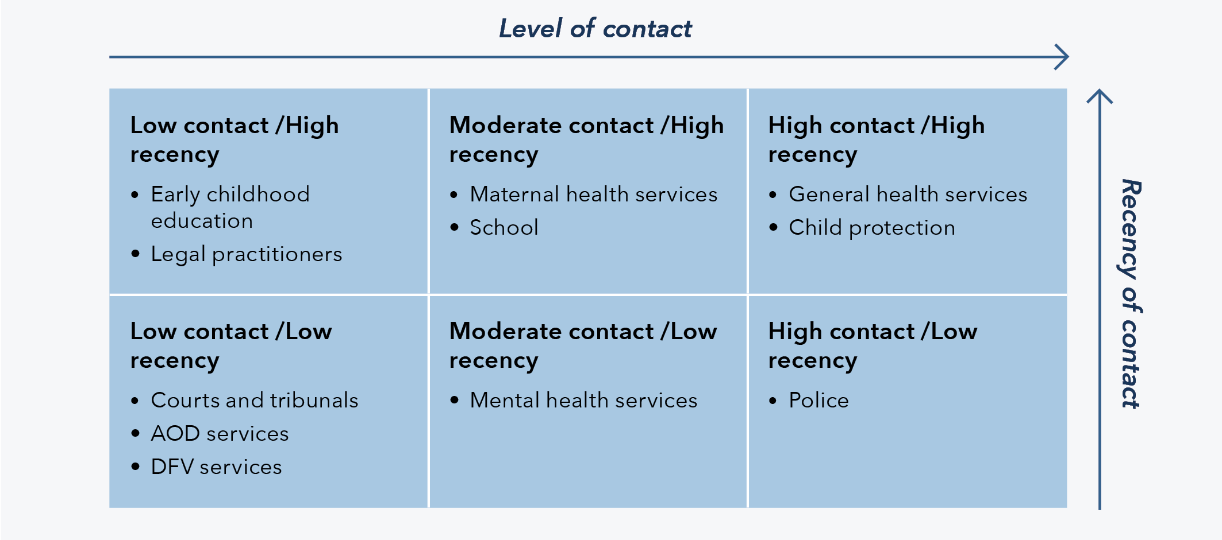
These findings provide a preliminary indication of when and to what extent families were last recorded as having had contact with a range of services prior to the filicide. The reasons behind the varying levels and recency of contact could relate to a range of negative or positive factors. For instance, low contact could be an indication of the complexities in accessing services and that intervention pathways may not be primed to provide appropriate support for parents or children in relation to their experiences of DFV. Alternatively, low levels of contact may suggest that these services are working to keep children safe and are therefore not represented in the DFV-context filicide cases. Further research, examining the nature and quality of service engagement, is needed to examine these issues and may provide further insight into where and how services may be more effectively positioned to respond to DFV.

Other key points of contact
Based on the findings, a number of other key points of contact were identified, including workplaces and family court. Although these points of contact may not have been evident in a high proportion of cases, they are discussed to highlight additional opportunities for services to engage and respond to perpetrators, victim-survivors and families experiencing DFV.

Workplaces
Almost 2 in 5 offenders were engaged in paid employment at the time of the filicide (37%). Research has found that workplaces and employers can be a key point of intervention for those experiencing or perpetrating DFV (Navarro et al., 2014; Weatherall et al., 2021). The findings also showed that filicide offenders engaged in paid employment were more commonly male and those not engaged in paid employment were more commonly female, meaning that female filicide offenders may have less access to any support and interventions that come with paid employment. Some filicide offenders not engaged in paid employment may have been seeking employment through recruiters or known to government services such as Centrelink to receive financial support, and further research may reveal this as a further key point of contact.

Family court
While just 15 per cent of DFV-context filicide cases had known family law proceedings, family court could still serve as a key intervention point for families who come into contact with court services. At the time of writing this report there are multiple changes ongoing to strengthen responses to DFV within the family law system. Reforms include the introduction of the Lighthouse framework, management of high-risk cases (the Evatt List), and increased information sharing between the courts and police and child welfare agencies (Federal Circuit and Family Court of Australia, n.d.). The introduction of Court Child Experts has also provided another pathway of intervention within the courts, with registered social workers or psychologists able to assess risk in families and provide additional support to children and families who are vulnerable (Federal Circuit and Family Court of Australia, n.d.).

Summary
By examining both the level and recency of prior service contact, these preliminary findings invite reflection on the potential for these sites to position themselves in the DFV response space and suggest that both the timing and level of contact could have implications for the efficacy of services in responding to DFV. Other key points of engagement outside of traditional service contacts could be alternate pathways for families experiencing DFV to receive support and referrals to other services.

Aboriginal and Torres Strait Islander victims and offenders
The findings demonstrate an over-representation of Aboriginal and/or Torres Strait Islander children as filicide victims. Approximately one quarter of filicide victims were identified as Aboriginal and/or Torres Strait Islander (26%), despite Aboriginal and Torres Strait Islander children comprising around 6 per cent of the population of Australian children (AIHW, 2020). It is important to recognise, however, that DFV was never part of Aboriginal or Torres Strait Islander culture and practice (Cripps & Adams, 2014), and these findings must be interpreted in the context of the ongoing impact of colonisation and the impact of intergenerational trauma (McGlade, 2012). It is also important to note that, based on the available data, this study found 1 in 5 Aboriginal and/or Torres Strait Islander filicide victims were killed by a non-Indigenous parent.
To a lesser extent, Aboriginal and/or Torres Strait Islander peoples were over-represented as filicide offenders. Of the 99 filicide offenders, 16 per cent were identified as Aboriginal and/or Torres Strait Islander. However, Aboriginal and/or Torres Strait Islander peoples comprise approximately 4 per cent of the Australian population (ABS, 2023). This over-representation is consistent with broader trends in the DFV literature (for discussion on this, see Cripps, 2008; Nancarrow, 2019; Reeves & Meyer, 2021), although it is noted that the over-representation for offenders identified in this project is less than that found in the IPVH Data Report (see ADFVDRN & ANROWS, 2022).
With regard to the gender of Aboriginal and/or Torres Strait Islander filicide offenders, it is evident that there were higher rates of Aboriginality among male offenders (19% of male filicide offenders) compared to female offenders (9% of female filicide offenders). This gendered pattern was also seen in the broader DFV-context filicide findings, which highlighted a greater number of male filicide offenders compared to female filicide offenders; a finding that is also consistent with the IPVH literature (e.g. Cussen & Bryant, 2015) and the previous IPVH Data Report (ADFVDRN & ANROWS, 2022).
As reflected in the findings, most female filicide offenders were also the primary IPV victim-survivor, supporting the framework of IPV being a form of social entrapment for women, limiting their space for action (Douglas et al., 2020). Structural inequalities further impact how Aboriginal and Torres Strait Islander victim-survivors of IPV respond to violence, adding to feelings of entrapment and the inability to escape or protect their children from the primary perpetrator of violence (Douglas et al., 2020). The DFV context is therefore crucial in understanding the representation of female filicide offenders, both Aboriginal and Torres Strait Islander and non-Indigenous.
The high rates of DFV victimisation and perpetration align with the rates of Aboriginal and Torres Strait Islander women who experience DFV outside of the context of filicide (Cripps, 2023; Watego et al., 2021). Because of the over-representation of Aboriginal and Torres Strait Islander filicide victims and offenders, DFV responses should be designed in a culturally safe way, led by Aboriginal and Torres Strait Islander experts. The findings from this project should also be considered with respect to the context within which this violence occurred; that is, as discussed in the introduction, within the context of colonisation and intergenerational trauma (McGlade, 2012), the ongoing colonial system (Watego et al., 2021), lateral violence (Cripps & Adams, 2014), the persistent lack of appropriate services (McGlade, 2012), and the limited resourcing of support services and programs (Langton et al., 2020a).
The understanding of culture and children and families … I guess the understanding of particularly my experiences as an Aboriginal person, that you don’t own your children … They belong to the country, to the community, to the family … Just unpacking some of the findings around that kind of power and control.
Reflections from a DFV Worker

Summary
The over-representation of Aboriginal and/or Torres Strait Islander filicide victims and offenders within the findings is vital to discuss, both with respect to the impact DFV has on Aboriginal and Torres Strait Islander children and adults, as well as the barriers and context that may contribute to the over-representation. Aboriginal and/or Torres Strait Islander filicide victims accounted for a quarter of all DFV-context filicide victims and were not always killed by an Aboriginal and/or Torres Strait Islander filicide offender. The findings highlight the ongoing violence Aboriginal and Torres Strait Islander peoples face in a colonial context. The limited space for action that Aboriginal and Torres Strait Islander victim-survivors of DFV have is key in understanding Aboriginal and/or Torres Strait Islander filicide offenders, particularly for women experiencing IPV.

Implications and future directions
This report presents a national picture of DFV-context filicide in Australia, providing important insights and understandings to inform the development of DFV policy and guide DFV response practice. While Australia’s federalist structure means that the response to DFV is primarily grounded in state and territory-based systems and services (Bugeja et al., 2013; Butler et al., 2017), the findings from this project invite reflection across a range of themes and issues relevant to DFV intervention, prevention and response efforts at both a national and jurisdictional level. The findings also highlight several emerging issues that warrant further research.
The findings provided offer opportunities for further research and practice enhancements, in particular around risk factors and how these might be used by professionals most likely to support families at risk.
Reflections from a Coroner

Policy and practice
Over the past decade, a range of national policy frameworks and initiatives have been implemented to address violence against children in Australia. Safe and Supported: The National Framework for Protecting Australia’s Children 2021–2031 (DSS, 2021) was recently developed by the federal, state and territory government bodies with the aim of reducing the rate of child abuse and neglect and its intergenerational impacts. The framework sets out four focus areas of action, namely: developing a national approach to early intervention and targeted support for children and families experiencing vulnerability or disadvantage; addressing the over-representation of Aboriginal and Torres Strait Islander children in child protection systems; improving information sharing; and strengthening the child and family sector and workforce capability. Safe and Supported builds on work progressed under the National Framework for Protecting Australia’s Children 2009–2020, which laid the foundation for a national collaborative approach to child protection and introduced initiatives such as the National Standards for Out-of-Home Care (Council of Australian Governments, 2009; Department of Families & National Framework Implementation Working Group, 2011). The National Office for Child Safety (n.d.) was established in 2018, responding to findings of the Royal Commission into Institutional Responses to Child Sexual Abuse and leading the development and implementation of key initiatives from other government projects aimed at strengthening child safety. Current policy frameworks such as Safe and Supported seek to address violence against children in the key communities mentioned earlier and build on previous inquiries into child safety in Australia (DSS, 2021).
The findings and reflections from this national project will provide an important contribution to work being progressed under these national initiatives. Similarly, learnings from this project can inform and guide DFV intervention and prevention efforts at a state and territory level and should be considered with respect to the relevant jurisdictional context. Further, any policy and practice responses should consider key communities within the Australian population (such as, Aboriginal and Torres Strait Islander peoples and people who live rurally) who can have unique experiences of DFV and experience particular barriers in accessing appropriate support.

Recognising children as victims of DFV in their own right
The findings from this national project indicate that approximately three quarters of all filicides in Australia between 2010 and 2018 occurred in a context of DFV. The high proportion of children who had experienced DFV prior to their death highlights the need for children to be centred in responses to violence and emphasises the importance of recognising children as victims in their own right.
Several jurisdictions in Australia have prioritised the inclusion of children as victims in their own right through research agendas and royal commissions (NSW Department of Communities and Justice, 2022; Royal Commission into Institutional Responses to Child Sexual Abuse, 2017; State Government of Victoria, 2022). At a national level this is reflected in reports from the National Children’s Commissioner and in the recently released Australian National Research Agenda 2023–2028 (Lloyd et al., 2023). The Children’s Rights Report 2019 notes that a key issue in responses to family violence is the tendency for children to be supported in the “context of the needs of the parent escaping family and domestic violence, rather than in response to their own specific therapeutic needs” (National Children’s Commissioner, 2019, p. 114).
Overwhelmingly, what I note is the continued risk and lack of visibility of young children to the service system, particularly given their vulnerability and inability to self-advocate. This indicates the importance of key services across Australia towards recognising children and young people as victims of [DFV] in their own right.
Reflections from a Coroner

DFV context and the gendered nature of violence
The findings clearly demonstrate the gendered nature of filicide when it is examined through a DFV lens. The majority of filicide offenders were men and most of those men had a history of perpetrating DFV (either violence against the child/ren and/or IPV). A smaller proportion of filicide offenders were women and most of those women had a history of experiencing IPV. These findings align with what is already known about DFV perpetration, namely that it is most often perpetrated by men. Broadly speaking, this has been met by emerging practices that focus on violence against women, generally IPV. Increased public scrutiny has resulted in national responses to violence through the creation of taskforces and the National Plan. It is clear from the findings that policies and practices should also consider a gendered approach when responding to violence against children. Policy and practice aimed at responding to men’s perpetration of IPV should also recognise their role as parents.
Fathers being overlooked in risk assessments, case planning and monitoring has been an ongoing issue in child protection practice and can significantly affect the safety and wellbeing of children. We continue to reinforce the importance of including fathers in our work … inviting men to take responsibility for their behaviour and their child’s safety and wellbeing. [Name of government organisation] aims to provide regular practice development opportunities in working with men who use violence.
Reflections from Senior Child Protection Practitioners
Further, based on the finding that almost all primary IPV perpetrators were male and primary IPV victim-survivors were female, services should more carefully consider any risk of violence towards women as a risk of violence towards their children. This is somewhat reflected in risk assessment frameworks and legislation regarding violence against children; however, this is lacking in practice and there is more work to be done when it comes to children being seen as victims in their own right (Fogden et al., 2023).
It is really interesting to see that correlation between … the female being the [IPV] victim, but also if she ends up being the [filicide offender]. What that looks like and the history of her, the violence that’s been against her … You just get a sense of that sort of, that overwhelming … depression and the trauma and all those things.
Reflections from a CEO of an Aboriginal Legal Service

The finding that male offenders were more likely to perpetrate filicide in a [DFV] context makes sense. When considering cases of filicide reviewed by [name of government organisation] in recent years, where the perpetrator was the mother, the deaths did not appear to occur in the context of [DFV]. In these cases, the mother’s mental health and experience of childhood trauma were often key factors.
Reflections from Senior Child Protection Practitioners

In 80 per cent of filicide cases occurring in the context of [DFV], the filicide offender had a recorded history of violence against the victim or their siblings. This is a very significant statistic and, in our view, one worth highlighting as, while there is a growing awareness of lethality factors in the context of [IPV], there is much less understanding of the significant contributors to filicide.
Reflections from Members of the FCFCOA Family Violence Committee

Integrated multi-agency efforts to address DFV
The findings from this project demonstrate that families and children had contact with a range of services and highlights the need for further research to examine the nature and quality of those engagements. This preliminary work does, however, invite reflection on the importance of collaboration between and integration of services when responding to DFV. While around two thirds of filicide cases had some level of recorded contact with general health services (71%), police (65%) or child protection (60%), the findings highlight low levels of recorded prior contact with key services such as DFV and AOD, despite the DFV context in the cases and the evidence indicating over half of filicide offenders had an AOD issue (55%). These results, when taken together, highlight the importance of adopting an integrated, holistic and multi-agency approach when responding to families experiencing the complex co-occurrence of DFV alongside, for example, AOD and mental health issues.
In my practice I often find that services operate in silos, not sharing information and communicating in a collaborative manner. Multidisciplinary teams and collaboration between departments and services is important regarding successful intervention and to ensure a holistic risk assessment occurs. I know there has been discussion in relation to social workers going out with [police] officers … and I feel that this is important to ensure a child focused lens in the context of a DFV incident … Also, given that of the school aged victims that over two thirds were engaged with school supports, this suggests the value of having social workers and mental health workers in schools. Again, this reinforces the need for a multidisciplinary approach to keeping children safe.
Reflections from a Senior Social Worker
Research points to the success of integrated multi-agency approaches to violence (Herbert & Bromfield, 2019; Humphreys & Healey, 2017; Humphreys et al., 2018; Tsantefski et al., 2021), particularly when government agencies such as child protection and police work collaboratively with specialist services such as DFV, mental health and AOD services. Research also suggests that multi-agency approaches should incorporate the voices of victim-survivors in responding to DFV (Lamb et al., 2020).
Many jurisdictions have established policies and processes to support a multi-agency collaborative approach to responding to DFV. For example, the establishment of High Risk Teams (HRTs) has been a key component of the integrated service response approach developed in Queensland. HRTs bring together a range of key government and non-government stakeholders who work collaboratively to “provide integrated, holistic, culturally appropriate safety responses for victims and their children who are at high risk of serious harm or lethality” (Department of Justice and Attorney-General, 2023). There are currently nine HRTs operating across Queensland with rollout to a number of additional sites anticipated over the next few years. An initial evaluation of the HRTs identified a number of benefits, strengths and indicators of progress with the response model, including enhanced information sharing between agencies, quicker and more targeted service responses for victim-survivors and perpetrators, and the strengthening of relationships between government and non-government service providers (Department of Child Safety, 2019).
It is critical that any current (and future) multi-agency approaches are monitored and evaluated to ensure positive outcomes are identified and shared, while strategies to overcome challenges or limitations are developed to strengthen the response (Herbert et al., 2020).
You can have a government response, but yeah, we know that if we don’t work together better as a community, have a community and a government response that works together, it sort of really doesn’t work because … I feel like sometimes government just works in their silos still … And so there’s a bit more of a coordinated approach with, “We’ll opt out on this because it’s an Aboriginal family that’s got a history with [name of government organisation] and the family don’t feel comfortable. So we’ll opt out, but we’ll connect them to you” … but what does that look like? How do we work together? … I know some they do … but … it just seems like it’s handed over and then it becomes someone else’s responsibility, and then the family don’t conform or don’t reach out and get that support, it just falls by the wayside. And who’s left, it’s the child. It’s unsupported by all these adults that are around supposedly making decisions for them, supposedly being there to do the best for them … But in the end, who, how does that work? Who’s checking in with who, who’s seeing what’s happening? So more of a coordinated approach around how that works and what that looks like.
Reflections from a Senior Social Worker
The move towards more coordinated, collaborative and cross-agency approaches represents a positive shift in the response to DFV. The findings from this project highlight, however, the need to better understand the barriers to service engagement that families face, including the availability of services (and, in particular, the availability of culturally appropriate services for Aboriginal and Torres Strait Islander peoples) and the criteria required for people to be accepted by a service. Other considerations to improve family engagement and service experience may include having assessments of therapeutic readiness, ensuring services are culturally safe and engaging peer workers.

Considering service contact in the context of intervention
The following section examines the findings in relation to service contact prior to the filicide and frames this contact in terms of potential points of intervention to the DFV that was evident across the cases. While the preliminary nature of the service contact mapping undertaken for this project is acknowledged, the findings nevertheless invite reflection on best practice DFV responses, issues that can obstruct pathways to safety for victim-survivors of DFV, and the extent to which non-frontline services are positioned to respond to DFV.
I have worked with a number DFV victims, and I feel that the options for safety are few and often involve significant risk … Victims need to have more support and more options, as in my experience victims usually are required to leave the home with the children, with limited support to do this, there after residing in motels or other temporary accommodation that is not conducive to positive wellbeing.
Reflections from a Senior Social Worker

We’ve got all these other little things that are deadly about teaching kids certain things. But how do you build your resilience to handle a kid that is screaming and crying … What do those coping mechanisms look like …? Because I think parenting programs are one thing. It teaches us all that glossy stuff. But who teaches you how to take a couple of minutes and have that time out … Real practical skills, like programs that are developed for families and fathers, not just mums, it’s fathers. How do we develop things that are actually culturally appropriate … and maybe that’s what a body of work needs to be from government is actually investing in a program like that.
Reflections from a CEO of an Aboriginal Legal Service

Child protection
The findings from this project revealed that in 60 per cent of cases there was contact with child protection services at some point prior to the filicide. Again, while this project has not examined the nature or quality of this engagement, given the central role child protection plays in keeping children safe, further consideration of this critical intervention point is warranted.
Child protection work is an extremely complex and challenging area of practice, and these challenges are compounded by the increasing number of families and children that receive child protection interventions each year. In 2021–22, approximately 178,000 children in Australia came into contact with the child protection system with about 45,500 children being identified as being, or at risk of being, maltreated (AIHW, 2023a). Significant and persistent challenges are evident across child protection systems in Australia including “insufficient capacity to meet the quantity and complexity of cases in statutory child protection and out-of-home care (OOHC), failure to improve outcomes for children in OOHC, and the over-representation of Aboriginal and Torres Strait Islander children in statutory child protection and OOHC” (Wise, 2017, p. 1).
I know one of the cases that we looked at … [the service providers] kept going to the house and knocking on the door and they knew someone was home because they could see the curtain move, but they didn’t do anything. They didn’t take the next step … didn’t check on the child. The child wasn’t going to school – no one had seen it, and it just sort of fell, fell off the face of the Earth … We don’t want like, a really … full on police response every time … but I do think that when there’s a concern around safety of a child, that there needs to be better responses around … what those visits look like …
Reflections from a CEO of an Aboriginal Legal Service

The fact that contact with this system occurred within 3 months prior to the filicide suggests a possible deficit in the assessment skills of the workers involved in this system, as well as the impossible demands on the workers to attempt to support as many families as possible. Linked with the concerns regarding the quality of the risk assessments … is also the quality of the education they have been provided and the supervision afforded them by their seniors. My own experience [working] in the [name of state/territory] child protection system was that there is a significant lack of supervision provided to front end workers, resulting in poor assessment and high worker burn out, and thus a shortage of workers … One of the primary issues is the lack of resources, which sees the child protection system responding only to those cases deemed “urgent” and all others being closed, with attempts made to secure non-statutory services to support the family. However, the lack of capacity in non-statutory services to engage with families then exacerbates this issue. Yet it must be noted, that due to limited capacity in the child protection system, the cases deemed “non-urgent” still present with high and significant risk factors for the child(ren) in the home and as well as this, cases are often closed prematurely due to capacity.
Reflections from a Senior Social Worker

Over the past decade in Australia, the child protection system has been the subject of increasing scrutiny and numerous inquiries, reviews and Royal Commissions have been implemented to redress these challenges. This has seen substantial and ongoing reform across child protection systems and an increasing focus on integrated service delivery. New system architecture is being introduced in several Australian states and territories to build a more robust and coordinated response system and provide more holistic support for vulnerable children and families.
The initial service contact mapping undertaken for this project points to the importance of these reforms. For example, the findings demonstrate the complex intersection of DFV and parental AOD and mental health issues. This highlights the need for child protection practitioners to be appropriately trained and supported to work with families holistically and develop intervention strategies that respond to these complex intersecting issues while maintaining focus on the safety and wellbeing of the child.
One existing model that centres the child in responses to violence is the Safe & Together Model, which focuses on keeping the child and the non-offending parent together to prioritise safety and stability for the child (Safe & Together Institute, 2022). The “Safe & Together Addressing ComplexitY for Children (STACY for Children)” project assessed the implementation of the Safe & Together Model (Safe & Together Institute, 2022) with children and families living with DFV, AOD and/or mental health issues in the home (Humphreys et al., 2020). The researchers found that when child protection practitioners had training in the Safe & Together Model, children were more often central in the assessment of the impact of DFV and in their responses (Humphreys et al., 2020). This focus on children in responding to violence and other issues in the family unit led to some moderate increases in reporting of DFV, suggesting that centralising children in practitioners’ responses to DFV could result in detecting risk of harm earlier and in turn reducing the risk of filicide.
Notwithstanding the significant and ongoing reforms implemented over the past decade, Aboriginal and Torres Strait Islander children continue to be over-represented in the child protection and out-of-home care services. The causes of this over-representation are complicated and “connected to past policies and the legacy of colonisation” (Australian Institute of Family Studies [AIFS], 2020, p. 1). These reasons include assimilation policies, forced child removals, poverty and intergenerational trauma, as well as a “lack of understanding of the cultural differences in child-rearing practices and family structure” (AIFS, 2020, p. 1).
While a detailed exploration of this complex issue is beyond the scope of this report, it is important to note that child protection responses can be experienced as oppressive by Aboriginal and Torres Strait Islander families and re-traumatising for those who need support and safety (Morgan et al., 2023). Child protection operates within a colonial context that can further reinforce still recent historical traumas, such as the removal of Aboriginal and Torres Strait Islander children in acts of structural violence. As such, many Aboriginal and Torres Strait Islander families may perceive any intervention from child protection to be oppositional and that intervention may be at odds with culturally appropriate responses to violence.
Some recent policy developments have begun to address this, such as the Aboriginal Family-Led Decision Making (AFLDM) model, which places Aboriginal and Torres Strait Islander families as active participants in how their children will be protected. AFLDM empowers Aboriginal and Torres Strait Islander families to actively work with practitioners to guide what kind and level of support is needed to provide the best outcomes for their children and bolster their safety and wellbeing. Multiple jurisdictions have implemented this process, centring Aboriginal cultural values and knowledge in responding to potential harm to Aboriginal and Torres Strait Islander children (McGlade, 2019). However, considering the findings of this national project and the research of others, the safety of Aboriginal and Torres Strait Islander children and maintaining their connections with their families must remain a national priority (see Chamberlain et al., 2022; McGlade, 2019; Morgan et al., 2022; Morgan et al., 2023).
When children enter care, restoration is the primary goal to achieve permanency and belonging for children whenever it is safe to do so. The risks around restoration sit heavily with practitioners. Restoration planning requires transparent conversations and critical evaluation of our own practice, our biases, the suitability and success of service support, and the progress of families. Restoration is a current priority for [name of organisation] with the development and implementation of a range of resources to support practitioners in their decision making and work with families to return children safely home.
Reflections from Senior Child Protection Practitioners

Police
The findings highlight that police were the second most common service to have prior contact with filicide victims and their families, with around two thirds of cases having recorded contact. It is noted, however, that this contact did not usually occur in the period proximal to the filicide.
Notwithstanding the relatively high rates of police contact, most violence was not reported to police prior to the filicide. The findings indicated that violence was reported to police in one third of the cases involving a history of violence against the child/ren, and in less than half of the cases involving a history of IPV. There are a range of complex reasons why victim-survivors do not report their experiences of violence to police, including fear of the perpetrator, shame or embarrassment, fear that they will not be believed, and the belief that DFV is a private matter. Barriers to reporting to police can also arise from previous negative experiences with or perceptions of the police. This is most acutely experienced by Aboriginal and Torres Strait Islander peoples who experience a deep and ongoing mistrust of police as a result of a long history of “often violent and racist policing” since colonisation (Yoorrook Justice Commission, 2023).
The findings from this project demonstrate that it was not common for police-reported violence to progress to DFV orders. Very few filicide offenders had a current or historical DFV order that listed the filicide victim, and a small portion were named as the defendant in a current or historical DFV order involving their current and/or former partner. While it is not clear from this preliminary analysis of police contact the reasons as to why the police-reported violence did not progress to DFV orders, a more-focused examination of the accessibility of orders, in particular the inclusion (or exclusion) of children on DFV orders, may be warranted.
Work across the [DFV] sector continues to reinforce the need for children to be included as persons in need of protection on [DFV orders] – not just the adult (usually the child’s mother). Including children on [DFV orders] is a concrete way of raising children’s profile when assessing danger.
Reflections from Senior Child Protection Practitioners

The findings reinforce the importance of identifying if there are children in the relationship … identifying risk factors and offering referrals for appropriate targeted support services to address specific needs. Failing to do so may result in less-than-optimal responses and missed opportunities … One of the missed opportunities may be not requesting born and unborn children are named as a protected person on [DFV] order applications and failing to clearly articulate the rationale and grounds in support of the application for the magistrate to consider.
Reflections from a Specialist DFV Police Officer
Any examination of DFV orders should also consider the many challenges associated with the application and enforcement of orders, specifically in relation to the inclusion of children. The Family Court process has been flagged as a significant barrier to applications for DFV orders (Fitzgerald & Douglas, 2020; Meyer, 2011), particularly due to the disconnect between the state and federal court systems (Stambe & Meyer, 2023). For instance, parenting orders may stipulate that children protected under a DFV order must also have contact with the DFV perpetrator, effectively breaching the DFV order (Kaspiew et al., 2022). Other research has cited the complexities of co-parenting and parenting orders as a barrier to enforcing DFV orders (Dowling et al., 2018), while other studies query the efficacy of DFV orders in protecting both the child and the parent from the DFV perpetrator (Meyer, 2011). Further, parents of children who are, or are at risk of, experiencing violence may be apprehensive to apply for a DFV order, fearing this may lead to their child/ren being removed from them altogether.
Cripps (2023), in her research on Indigenous IPH, also challenges the efficacy of DFV orders for Aboriginal and Torres Strait Islander victim-survivors, with conditions from DFV orders placing restrictions on access to housing, finances or child custody. Cripps (2023) noted that a perpetrator’s ability to access such necessities, as well as their contribution to child caring responsibilities, may prevent a victim-survivor from reporting breaches of DFV orders. These challenges demonstrate the need for better processes for the application and enforcement of orders, as well as more consistent legislation across Australia that works to protect the child when they are at risk of violence.

DFV services
While a prior history of DFV was a characteristic of the filicide cases examined in this project, contact with DFV services was extremely low. While this finding may indicate the effectiveness of DFV services, the low contact levels invite reflection on the accessibility of such services. Promoting awareness of DFV services across the broader community, as well as for police, schools and healthcare providers, may ensure those experiencing DFV have knowledge of the supports available and could encourage service providers to make appropriate referrals. Emerging research suggests that education campaigns highlighting DFV services must coincide with increased funding to account for an increase in levels of contact from victim-survivors and perpetrators (Clarke et al., 2023). This increased funding is not only recommended to allow for greater capacity, but also to facilitate necessary training and greater resources for service providers. Other research suggests that some DFV service providers feel ill equipped to respond to more complex forms of DFV without further education and training, which is often costly and requires practitioners to reduce their workload to undertake (Douglas & Fell, 2020; Humphreys & Healey, 2017). Alongside increased resourcing, DFV services could be strengthened by continued monitoring of program delivery and the evaluation of outcomes to inform future responses to DFV.
I was curious to know about the engagement with the [DFV] specialist service ’cause my experience … that’s when they’re at that pointy end. It’s almost when they’re at that imminent risk, and it’s often their first time they’ve contacted the service. But then they disclose years of abuse.
Reflections from a DFV Worker

Reviewing our risk assessments … nationally … like, I know different states have different assessments, which is understandable, but having some sort of uniform … Include some of this data … around risk to children. And maybe what are some of the indicators that were picked up in this data, in the context of when [DFV] was evident … That’s probably some change I’d like to see.
Reflections from a DFV Worker

Healthcare services
Of the services captured in the national project, filicide victims and their families were most commonly in contact with general health services (71% of cases). Healthcare services have increasingly been recognised as critical sites for identifying and responding to DFV. Healthcare settings can provide victim-survivors with a safe environment to speak out about their experiences of violence and receive support, and research shows that healthcare providers are the professionals that victim-survivors most trust with their disclosures of abuse (Spangaro, 2017).
In Australia there are several educational resources to assist general practitioners in responding to DFV, including the 5th edition of Abuse and Violence: Working with our Patients in General Practice (the White Book) by the Royal Australian College of General Practitioners (RACGP; 2022) and the GP Toolkit prepared by Women’s Legal Services NSW (Women’s Legal Service NSW, 2019). These resources provide information regarding safety assessment and planning, as well as making referrals to other government and non-government agencies (RACGP, 2022).
Notwithstanding the high level of trust in healthcare providers described above, barriers persist in reporting and responding to DFV in these settings. Research has found that women experiencing IPV are often reluctant to disclose violence, due to fear of retaliation from their partner or discomfort in discussing DFV with a practitioner (Hegarty et al., 2012). Further, general practitioners often see high volumes of patients daily and may not have the time needed to identify and/or adequately respond to indications or reports of DFV during an appointment. Additionally, in a study of Australian general practitioners and nurses, Kuruppu and colleagues (2022) found most practitioners felt they would “open a hornet’s nest” in reporting child abuse to services such as child protection (p. 8). These barriers suggest general practitioners and other healthcare providers require better training, education and support to appropriately identify and/or respond to a patient’s experience of DFV, which would involve going beyond risk assessment and actively intervening through referrals and collaborative responses to the violence (Renzetti et al., 2017). Furthermore, the monitoring of practices, such as those recommended in the White Book, would ensure practitioners are equipped and resourced to provide intervention pathways that are appropriate for the context.
There has been a bit of a push and acknowledgement to fund primary healthcare services to provide [DFV] services … We know that people who need health care, like it’s almost an essential service and … that makes sense to provide [DFV] services to health care … Primary healthcare, they serve a purpose. As do specialist [DFV] services … I can see the way it would work is like a partnership. Where perhaps you’ve got someone who works for a special service, who is situated or working with … because sometimes the primary healthcare providers are not the ones to provide the specialist service … My experience working in both services and obviously this is my reflection and my experience … I don’t feel like I was equipped to provide a well enough [DFV] specialist response in a primary healthcare service as I am for [DFV] service because we’ve got crisis accommodation, we’ve got skills, we’ve got training, we’ve got resources.
Reflections from a DFV Worker

The Coroners Court of [name of state/territory] continue to see cases of [DFV] where general health practitioners are one of few services that families have contact with in the lead up to a fatal incident.
Reflections from a Coroner

Health services are [a] really good option. I think a lot of the [Aboriginal medical services] … they show little infomercials … in their waiting rooms, like having strategies there … demonstrating those kind of things in those quiet spaces where people are just sitting and listening and learning, now make the most of those opportunities for people to learn around how to cope or even what services to talk to, even if it’s … 13YARN.
Reflections from a CEO of an Aboriginal Legal Service

Mental health
A little over half of the filicide offenders were experiencing mental health issues at the time of the filicide, most commonly depression or depression together with another mental health issue. The findings also demonstrate that filicide offenders had more often than not received a diagnosis for their mental health issue/s. While it is critical that this finding not be conflated with any causal link between mental health issues and the perpetration of violence, it does highlight mental health services as a key potential intervention point for DFV.
The relatively low rate of contact with mental health services suggests the need for services like police, child protection and DFV services to be better supported to make referrals to mental health services. Other avenues for mental health intervention could include less formal responses, such as workplaces, which have been shown to act as successful intervention points by way of referrals for those experiencing mental health issues (MacGregor et al., 2016; Navarro et al., 2014). Existing practices in Australia, such as the National Mental Health Workforce Strategy 2022–2032 (the Strategy), are working to better support mental health practitioners to respond to people experiencing mental health issues. The Strategy provides a framework for professionals that supports a skilled and integrated approach to mental health responses (Department of Health and Aged Care, 2023). The Strategy also highlights principles of practice, including responses that are trauma informed, integrated and culturally informed (Department of Health and Aged Care, 2023). The evaluation of the strategy in its delivery and longer-term outcomes will be key in assessing its effectiveness in empowering practitioners in responding to DFV.
An important consideration for policy and practice responses to mental health issues is the gendered nature of mental health. Similar to general population rates (see, for example, AIHW, 2019), female filicide offenders in this national filicide project were identified as experiencing mental health issues at a much higher rate than male filicide offenders. Other research has indicated that women may be more represented as having experienced or being diagnosed with a mental health issue because they are more likely to report psychological distress compared to men (Afifi, 2007; Doherty & Kartalova-O’Doherty, 2010). Considering this gendered difference, responses to mental health issues should factor in male resistance to help seeking and the potential impact of masculinities on the recognition and diagnosis of mental health issues affecting men (Vogel & Heath, 2016; Yousaf et al., 2015).
I believe the findings warrant stricter monitoring of DFV perpetrators and requirements regarding therapeutic intervention (perhaps enacted through policy and legislation). The argument for therapeutic intervention is, I believe, also supported by the number of offenders with mental health issues, drug and alcohol issues and repeated criminal offending. My experience has been that such requirements are usually only enforced to any significant degree if the [offender] has been incarcerated.
Reflections from a Senior Social Worker

Effective assessment of a parent’s mental health requires practitioners to balance gaining insight into a parent’s own experience … with speaking with other services that are working with parents such as doctors, psychologists and psychiatrists to understand how parental mental health issues are being clinically managed. Inter-agency collaboration with mental health services needs to focus on how a parent’s mental health impacts on their ability to meet the needs of their own children.
Reflections from Senior Child Protection Practitioners

The finding that more than half the offenders had a mental illness at the time suggest deficits in the mental health system. Again, I think further research and investigation into this system would be beneficial.
Reflections from a CEO of an Aboriginal Legal Service

Maternal health
Contact with maternal health services was low across all DFV-context filicides despite the high proportion of filicide victims being very young. This finding suggests that parents, including non-biological parents, may be missing out on support and education that could otherwise provide the tools and resources to help manage the stressors of family life. Maternal health services provide vital support to young families or parents, and as practitioners have close contact with the child, they are positioned to detect signs of violence and abuse. It is noted, however, that some families may have a lack of trust in mainstream health services (e.g. Aboriginal and Torres Strait Islander peoples), it may be difficult to access the service (e.g. for families living rurally or experiencing financial difficulties), or if a family member is experiencing DFV they may be coerced into isolating from services.
The findings in this project point to the vulnerability of young children, with nearly half of all filicide victims being aged under 2 years. While not a finding unique to this report, it indicates that parents of young children, who may also be young or inexperienced in childcare themselves, need enhanced support and education, particularly when DFV is occurring within the family. Research suggests new mothers will particularly benefit from effective antenatal education, highlighting the need for these types of programs to be consistently evaluated and held to a high standard (Downer et al., 2020; Svensson et al., 2008). Downer and colleagues (2020) suggest the Competency Standards for Childbirth and Early Parenting Educators should be updated to enable this evaluation. Hegarty et al. (2020) proposed the REAL (Relate, Engage, Act, Learn) model in identifying and responding to DFV in antenatal care, which involves the practitioner and the broader health system working with the needs of the woman, including any cultural needs. Aboriginal and Torres Strait Islander mothers may have access to specific antenatal and postnatal programs, however they are not available in all cities or jurisdictions (Hegarty et al., 2020). When Aboriginal and Torres Strait Islander mothers need to access mainstream services, responses may not be culturally appropriate, with services often working with a westernised model of what traditional and successful mothering looks like (Chamberlain et al., 2019). This can lead mainstream antenatal education programs to do more harm and, therefore, culturally safe and appropriate programs that are regularly monitored and evaluated must be made more available to Aboriginal and Torres Strait Islander mothers.
Support in the first 1000 days. The statistics regarding the age of the children when they were killed reinforces the vulnerability of these early years. Whilst I know that there are services designed to support this period, with funding having gone towards the value of early intervention, this statistic arguably indicates the need for greater assessment regarding risk during the antenatal and postnatal periods. This might be able to be generated in health … for example. In support of this, greater education needs to be provided to those working with women and families during this period, such as midwives and hospital social workers, for example, regarding identifying risk factors.
Reflections from a Senior Social Worker

Workplaces
Almost 2 in 5 DFV-context filicide offenders were engaged in paid employment at the time of the filicide, which suggests workplaces could be a potential intervention point. Some evidence suggests workplaces can play a key role in providing support and interventions for both victim-survivors and perpetrators of DFV (MacGregor et al., 2016). Employers are uniquely placed to detect DFV, with research indicating both supervisors and fellow colleagues are often aware of employees experiencing or perpetrating DFV (MacGregor et al., 2016; McFerran, 2011; Schmidt & Barnett, 2012).
The Australian Fair Work Commission’s Family and Domestic Violence Leave Review commissioned a report to assess the accessibility of DFV interventions in the workplace. The report found that DFV victimisation had a negative impact on work attendance and performance and that current legislation does not appropriately support those who are experiencing DFV (Fitz-Gibbon et al., 2021). Fitz-Gibbon and colleagues (2021) suggested that supporting DFV victim-survivors should be considered when developing workplace policies and practices and recommended a minimum 14 days paid DFV leave as a standard of all workplaces.
Because of the potential visibility of DFV in workplaces, associated policy and practice should respond to employees who are identified as or report being a DFV victim-survivor or perpetrator. Interventions in the workplace should aim to be collaborative with other services and employers should be able to suggest referrals to other relevant services. DVConnect provides training for workplaces in recognising and responding to DFV (DVConnect, n.d.), and it is suggested that programs such as these should continue to be funded and expanded to strengthen intervention pathways in workplaces. Furthermore, the outcomes of training programs such as these should be evaluated in both the short and long term, to ensure the content and delivery of such programs continue to be effective at providing resources for responding to DFV.

Education sector
Over two thirds of cases with school aged children had recorded contact with school prior to the filicide. Just over one quarter of cases with children younger than school age had contact with early childhood education services. Although contact with early childhood education services was relatively low compared with school contact, education services more broadly can serve as an important pathway for interventions and responses to DFV.
School staff interact with children outside of their family unit and, therefore, potentially outside of the influence of a parent who could be perpetrating DFV (Dudley et al., 2022). Teachers and other staff are positioned to observe children, as well as other family members, over months or years and may notice physical and/or emotional changes that could be indicative of DFV (Walsh et al., 2008). Staff at schools and other education facilities are among the highest sources of child protection notifications (AIHW, 2020), which likely reflects mandatory reporting policies that, while varying across jurisdictions, apply Australia-wide (AIFS, 2023).
Policy and practice should reflect the important role school staff play in intervening with respect to any identified DFV involving school children. While mandatory reporting legislation is in place nationally, some research suggests school staff can be reluctant to make reports (Falkiner et al., 2017). This reluctance has been found to be due, in part, to uncertainty in identifying signs of violence or neglect, as well as a limited understanding of how to respond when violence is suspected (Falkiner et al., 2017). This reinforces the need for further training, education and support for school staff, ensuring they have the resources to appropriately identify and respond to DFV.
So that seems like [the rate of recent school contact is] really high and … if you got kids at school … you’re seeing kids more frequently most of the time and that’s probably their safe place. And how are those kind of services or those providers not being more attuned to what’s going on with kids … I think sometimes that they’re quick to react to some Aboriginal kids like with rashes and things like that and say the parents neglect or whatever, and it may just be, it’s a skin condition or something like that … I just wonder sometimes do we err on the side of caution with Aboriginal kids and do that, but do we do that with all kids? Have we got the same standards across the board?
Reflections from a CEO of an Aboriginal Legal Service

[DFV] is a reason children don’t go to school. I have worked in a similar case where and I guess in the work that I do, the victim-survivors will withhold children from school, if they know that, that’s where an offender can gain access to them. So it can be a measure to keep your children safe.
Reflections from a DFV Worker

Accessibility of services
The preliminary analysis of service contact, together with other findings in this report, raise important considerations regarding the possible barriers in accessing services. The accessibility of DFV, mental health and AOD services are outlined, followed by the unique barriers relating to people living rurally and Aboriginal and/or Torres Strait Islander communities. While these communities are highlighted here, it is acknowledged that other populations outside the scope of this project, such as CARM communities and people with disabilities, can also experience unique and structural barriers in accessing support.

DFV, mental health and AOD
The findings suggest only some families have recorded contact with key services such as mental health (49%), DFV (19%) and AOD (13%), prior to the filicide. There could be a range of reasons for this. Firstly, given the filicides occurred within a DFV context it is possible that those experiencing DFV were unable to access services due to fear of retaliatory violence from the DFV perpetrator. The primary perpetrator of violence may have used tactics of coercive control to limit the movements of their family members, such as monitoring them physically and through technology, threatening violence, or isolating them from their support networks. In this way, the higher rates of contact with services that are more likely to be mandatory, such as police, health care and child protection, are also explained because contact with these services may have been unavoidable to some extent.
Secondly, in accessing services specifically targeted to DFV, mental health issues or AOD issues, family members must actively seek out practitioners, which may create another barrier. Further, by accessing DFV services, a person is self-identifying to practitioners that their child/ren may be at risk of or experiencing DFV. This could add to the barrier of proactively accessing these services, as parents may fear losing their child. Aboriginal and Torres Strait Islander families are likely to experience this fear to a greater extent, given the often-adversarial role that colonial-led services play in removing Aboriginal and Torres Strait Islander children, historically and currently.
The low rates of contact with these services may also be due to a project limitation. As the national project relies on administrative data, service contact information is dependent on the existence of and access to any such records. Furthermore, given the purpose of and procedures within coronial and criminal proceedings, it is possible that other service contact existed but was not identified during or did not form part of the investigation. Therefore, the findings relating to service contact in this study are potentially an undercount.
Whether victims or offenders don’t know about the services, we still get that feedback that people don’t know about the services. Conflicts is one of our reasons why people don’t engage with our service … Because of the complexity of the environment that we work with, we might work with a woman … Her sister-in-law might also be [experiencing DFV], but she won’t want to access our service because she knows that the sister-in-law is accessing. So it’s not a safe place for her … Bad experiences is a really big one. We have some women that … if they have one bad experience with the service, they won’t go back … Stigma. Feeling judged.
Reflections from a DFV Worker

Location and rurality
The findings demonstrate high rates of DFV-context filicide offenders living in regional or remote locations (40%), noting that only 28 per cent of the general population in Australia lives in rural areas (ABS, 2022). Research suggests living in rural spaces heightens the risk for more frequent and more severe DFV (George & Harris, 2014; McLachlan, 2024; Strand & Storey, 2019). Rural spaces create geographical isolation, with residences often separated through large plots of land, and the communities themselves being isolated from other towns or cities by long distances. The physical isolation of rurality can in turn lead to social isolation, with victim-survivors of DFV feeling cut off from social networks and support systems. Often police and emergency services will be limited and may service multiple towns that are separated by hundreds of kilometres. Living in regional or remote communities can also create unique barriers to accessing services. There are also fewer services, if any, such as DFV, mental health and other speciality services in rural areas, meaning that families experiencing DFV may have to join a waitlist or travel to another area to access support.
Many practices for responding to violence against children assume that victim-survivors of DFV will be visible to community networks and services (e.g. police, general health services and schools) and rely on policies of mandatory reporting. In rural areas, social networks are formed distinct from major cities, and the culture of rural communities creates a unique context in which many residents of a community will know each other. This close-knit social structure makes discreet contact with service providers difficult. Similarly, school employees and health practitioners who may detect possible violence towards a child may not feel comfortable in reporting this violence without the anonymity that a major city provides. Accordingly, the development of policy needs to take into account these unique issues and barriers to ensure victim-survivors living in rural areas have access to appropriate supports and services. Practices should consider the social and physical isolation that can reinforce violence in rural areas, as well as increase the accessibility of emergency services and discreet services that could offer additional support and resources to families experiencing DFV.
Incentives (including financial, housing, reduced tenure) may need to be considered to encourage specialist practitioners to take up employment in locations outside major cities where access to face-to-face support services may be limited. Current waiting lists for support services and behaviour change programs may also impact the opportunity to reduce harm via timely intervention.
Reflections from a Specialist DFV Police Officer

Aboriginal and Torres Strait Islander communities
Aboriginal and Torres Strait Islander families may be hesitant in accessing services due to the lack of training for services to respond to DFV in a culturally safe way. Aboriginal and Torres Strait Islander-led services are better placed to provide support to families; however, these services are often under resourced. The intergenerational trauma and ongoing structural violence that sits behind DFV within Aboriginal and Torres Strait Islander communities can create a distrust of non-Indigenous services. Research suggests Aboriginal and Torres Strait Islander peoples experience prejudiced and inferior treatment in mainstream healthcare services and experience less positive health outcomes than non-Indigenous patients (Nolan-Isles et al., 2021). This deficiency in treatment is further compounded by the fear that Aboriginal and Torres Strait Islander parents will have their children removed (Ware, 2013). Calls for services to work together with Aboriginal and Torres Strait Islander communities suggest a collaborative approach can address the deficient response from services, particularly from the criminal justice system (Langton et al., 2020b).
I think that there just needs to be some kind of service system that responds to Aboriginal kids. We know we’ve got AbSec and they do certain things, and we know we’ve got SNAICC and they do certain things, but something that’s more tailored to provide really intensive support for Aboriginal families. But it also can be that that support, you know whether or not it’s tailored to be looking at potential victims or early intervention, prevention, but also looking at how they can respond to families better so that there is somewhere to go because as we know, if you’re struggling, you’re not going to go to a government agency because the kids are going to be removed rather than try to give you the programs.
Reflections from a CEO of an Aboriginal Legal Service

I do think we need more Aboriginal organisations … and there may be Aboriginal people that don’t want to work with a particular Aboriginal organisation, ’cause of, you know, community politics or whatever it may be. But it’s around having those, those options … But it’s one of the things that we always find too … that sometimes for our clients, they say [to them], “go and do this parenting program or go and do this.” They’re always full. There’s just not enough of them … The programs … they’re not where some people are, the starting points need to be different for different communities.
Reflections from a CEO of an Aboriginal Legal Service

Aboriginal and Torres Strait Islander-led services
The findings from this project demonstrate an over-representation of Aboriginal and/or Torres Strait Islander filicide victims (26% compared to 6% in general child population) and offenders (16% compared to 4% in general adult population). This finding highlights the importance of culturally informed responses from services to ensure that Aboriginal and Torres Strait Islander peoples who experience and/or perpetrate DFV can access services that will do no further harm. Key researchers have recommended that an Aboriginal and Torres Strait Islander presence in services is critical in providing culturally safe and appropriate responses (Langton et al., 2020b).
Research suggests Aboriginal and/or Torres Strait Islander women are unlikely to disclose experiences of violence, with estimates up to 90 per cent non-disclosure rates (DSS, 2016; Willis, 2011). The lack of engagement with services and under-reporting is linked to the historical and current colonial imposition and structural violence that exists in mainstream services (McGlade, 2012). Additionally, the forced removal of children (both historically and through services such as child protection) creates a barrier for Aboriginal and/or Torres Strait Islander mothers who may not feel safe or confident in accessing mainstream services (Morgan et al., 2022). However, service providers have also noted that because of the often-close networks in Aboriginal and Torres Strait Islander communities, DFV victim-survivors or perpetrators may access mainstream services to avoid conflicts of interest or being recognised by other community members (Langton et al., 2020a).
This indicates the need for more Aboriginal and/or Torres Strait Islander-led services that have greater funding and resources to provide culturally appropriate responses (Carlson et al., 2021; Healing Foundation et al., 2017), while providing greater options that do not place the client at further risk of danger or breaches of privacy. Aboriginal and Torres Strait Islander-led monitoring and evaluation of these services could further strengthen responses and lead to building an Aboriginal and Torres Strait Islander-led evidence base for successful interventions and responses to DFV.
At the time of writing, some practices have been implemented to address this need. Intervention and prevention responses for violence against children include the Aboriginal Family-Led Decision Making model, which gives Aboriginal and Torres Strait Islander families the opportunity to have some influence in how services respond to identified risk to their children (McGlade, 2019). Speciality courts such as the Koori Court in Victoria, Circle Sentencing in New South Wales, and the Murri Court in Queensland have been introduced and are in part informed or led by Aboriginal and/or Torres Strait Islander Elders and Respected Persons. These legal responses, however, have been flagged as inadequate when responding to certain offences, including child sexual abuse (McGlade, 2012). While these practices continue to emerge and expand in various jurisdictions, it is vital that further development in this space is sufficiently resourced and led by Aboriginal and Torres Strait Islander experts and communities.
I just think that there needs to be more information around it, more recruitment, more support given to people working in that space because the other thing for us as Aboriginal people is our job doesn’t finish nine to five. So if you become a counsellor and you’re doing it 9:00 to 5:00 or whatever, you’re doing it – if it’s a 24 hour hotline, you know people are going to walk up to you anywhere and start having that conversation, debriefing and what that support looks like. And that investment in that, that whole rounded support for the workers as well. And the vicarious trauma that they carry as well working with clients … And that’s usually coupled with the fact that you got a couple of family members that are actually having situations or things that you’ve got to work with as well.
Reflections from a CEO of an Aboriginal Legal Service

We know a lot of Aboriginal women don’t like counselling, don’t like to talk about what’s going on for them – we’re seeing a bit of a shift … But I think it’s also because of the push from victim services to get women having counsellors and to get counselling reports around their trauma, their victimisation and things like that … A lot of Aboriginal people are going into counselling and actually understanding how that Western sort of format works for us. That’s why I think it’s really important that we have those Aboriginal counsellors because it becomes a bit of a yarning circle … Rather than the White clinical sort of way of doing stuff and not making sense to a lot of people and just the language itself. So just those kind of things around – if we’re having support, what that looks like and what that looks like in investment into the Aboriginal workforce as well. What’s development and having more skill, more capable people working in those areas … And that’s why I think we find a lot of Aboriginal and CALD, I think just keep going with what they’re doing because they just really don’t feel like they’ve got that real safety net out there for them.
Reflections from a CEO of an Aboriginal Legal Service

Improved practices in the identification of Aboriginal and Torres Strait Islander peoples
As described in the “Data Set Strengths and Limitations” section of this report, the identification of filicide victims and offenders as Aboriginal and/or Torres Strait Islander can be complex and at times difficult to accurately capture based on available data. Inconsistencies or missing information in service data relating to Aboriginality have impacts not only for research but, and most importantly, for Aboriginal and Torres Strait Islander children who may then not receive the appropriate support or service response. It is critical for any Aboriginal and/or Torres Strait Islander children who encounter child protection to be identified as such, as soon as possible, so that their rights are respected and their “specific needs” are met (SNAICC, 2018, p. 7). Without this early identification, these children may be “deprived of culturally safe support, case planning and placements” (SNAICC, 2018, p. 7). Issues relating to the identification of Aboriginal and Torres Strait Islander children in the child protection and out-of-home care systems have been highlighted in other work, such as in a review of the rates of Aboriginal children and young people in out-of-home care in New South Wales (see Family is Culture, 2019). The review detailed concerning findings, such as delays in identification and a lack of comprehensive capturing of Aboriginality (Family is Culture, 2019).
While this section has focused on children, given the nature of this report, the need for accurate recording of Aboriginality also applies to adults and could affect their opportunity to access appropriate supports and services. Similarly, there are impacts for the accuracy of research on rates of victimisation etc. For data quality to improve, this will require relevant “education and awareness being provided to professionals”, with training “ensuring that Aboriginality is accurately recorded” (Cripps, 2008, p. 33).

Directions for future research
This report provides a national understanding of DFV-context filicide in Australia, from which there are emerging areas that warrant further research. The following section discusses research implications relating to DFV death review data, Aboriginal and Torres Strait Islander-led research, evaluations of responses to men’s violence, service contact, DFV orders, challenging stereotypes, and surviving siblings.
The findings indicate the prevalence of [DFV] and that this poses a threat not only to the safety of women, but also children. I believe that significant research needs to go into the significantly high rates of DFV as I believe this to be a major social issue. Almost every child protection case I have encountered has indicated DFV, whether proved or suspected, current or in a previous relationship.
Reflections from a Senior Social Worker

Given the finding indicating a low rate of involvement with a specialist [DFV] service, I note with interest the rate of filicide offenders who are also the primary victim of [IPV] … This may be an area for further research and better understanding of prevention opportunities informed by [the] experience[s] of filicide offenders (where suicide did not follow the filicide) and barriers to support.
Reflections from a Coroner

Further developing the evidence base through DFV death review data
This report presents findings on DFV-context filicides across every state and territory in Australia, adding to the broader national evidence base on DFV-related homicides (see ADFVDRN & ANROWS, 2022). The project involved the creation of a national minimum data set utilising the unique and detailed information held by the Network. An equivalent data set was previously established by the Network in relation to IPVH (Australian Domestic and Family Violence Death Review Network, 2018) and then more recently updated by the Network and ANROWS to examine IPVH cases occurring during the same date range as the current project (see ADFVDRN & ANROWS, 2022). Future collaborative work between ANROWS and the Network will explore the potential to further develop this research by examining other kinds of deaths that occur in a DFV context. It is anticipated that future research will examine DFV-context homicides in adult non-intimate partner family/kin relationships and suicides that occur in a DFV context. It is also anticipated that future collaborative work will investigate ways of updating existing data sets and publicly sharing the associated findings to maintain the currency of the national evidence base on IPVH and DFV-context filicide. Future research would also benefit from attempting to address the limitations outlined in the “Data Set Strengths and Limitations” section. This would include, for instance, progressing the initial mapping of service contact to capture more in-depth, qualitative information about the nature and quality of service engagement. Additionally, due to some variations in the availability of information and data capturing processes across the various DFV death review mechanisms, further work could, where appropriate, attempt to bring all mechanisms into alignment, which could require more resourcing for individual review mechanisms.
The further development of death review work must centre Aboriginal and Torres Strait Islander expertise and explore opportunities to better reflect community perspectives and needs. In this work, structural responses to the over-representation of Aboriginal and Torres Strait Islander children in the findings should include strategies such as investigating Indigenous data sovereignty and ways in which Aboriginal and Torres Strait Islander peoples can participate in both death review processes and the ANROWS team.

Aboriginal and Torres Strait Islander-led research
The over-representation of Aboriginal and/or Torres Strait Islander children as victims of DFV-context filicides highlights the need for further research to better understand and respond to DFV experienced in Aboriginal and Torres Strait Islander communities. It is critical, however, that this research is designed and led by Aboriginal and/or Torres Strait Islander peoples. While vital research in the family violence space has been conducted by Aboriginal and/or Torres Strait Islander experts (see the work of Cripps, 2008, 2014, 2023; Gray, 2021; Langton et al., 2020b; McGlade, 2010, 2012, 2019, for example), more is needed to examine what is working to address DFV, the potential to amplify and further support these existing strategies, and more effectively identify where more work is needed.
The phrase “nothing about us, without us”, as used by Aboriginal and/or Torres Strait Islander scholars such as Shay (2017) and Heckenberg (2018), calls for research that concerns Aboriginal and/or Torres Strait Islander people to involve them throughout the research process, from project design and data collection to implementing policy and practice outcomes. The protection of Aboriginal and/or Torres Strait Islander knowledge has been highlighted by researchers as a key reason for Aboriginal and/or Torres Strait Islander-led research (Janke & Sentina, 2017; Shay, 2017). Emerging conversations around the protection of knowledge centre on the Aboriginal and Torres Strait Islander ownership of knowledge, particularly when maintaining oral histories (Heckenberg, 2018). In research design, oral histories should be considered robust and mainstream research should allow for Indigenous ways of knowing, without co-opting or commodifying these practices (Heckenberg, 2018). The perspective of Aboriginal and Torres Strait Islander peoples in research is invaluable for communicating the needs and outcomes of Aboriginal and Torres Strait Islander participants and communities.
As noted above, these perspectives should also be reflected in the research undertaken by death review mechanisms.

Evaluations of responses to men’s violence
As the findings in the report have highlighted, the majority of the DFV that preceded the filicides was perpetrated by men. Further research into and evaluations of programs that respond to men who use violence is, therefore, vital. When responding to male perpetrators of DFV, men’s behaviour change programs are often the most common and well-resourced intervention (Humphreys & Campo, 2017). Research to date has suggested that men’s behaviour change programs can be limited in their “one-size-fits-all approach” (Hine et al., 2022, p. 712) and, therefore, future research should examine not only how to strengthen existing men’s behaviour change programs but also look beyond them to other emerging interventions. This work should be informed by evaluations of men’s behaviour change programs, which point to the need for an integrated approach to addressing men’s violence with broader system responses from justice, health and social services complementing interventions through such programs (Day et al., 2019). Similarly, evaluations have identified that programs geared towards achieving holistic goals that extend beyond stopping men’s violence (such as financial stability, addressing mental health and AOD issues, and parenting education) could potentially improve the effectiveness of such programs; however, further research is needed to explore the effectiveness of this approach (Day et al., 2019). Research has also identified that further evaluation of programs that focus on outcomes for the victim-survivor, as well as the perpetrator, are needed (O’Connor et al., 2021). Further research has also been called for in incorporating the child’s voice in programs that specifically engage fathers, to better understand outcomes for children (Hine et al., 2022).
I acknowledge stopping DFV is a complex and challenging issue which cannot be addressed without significant ongoing investment, education and support from all levels of government and the community … Formal evaluations regarding the success of [state-based DFV initiatives] may provide an evidence base for further rollout and investment in similar programs across … other states and territories.
Reflections from a Specialist DFV Police Officer

Qualitative examinations of service contact
The national project findings highlight the need for more in-depth, qualitative examinations of service contact in relation to DFV-context filicide. Longitudinal evaluations could be employed to assess outcomes of service engagement with police, health services and specialised services. Narrative and documentary analysis could be utilised to explore trajectories of service engagement. Understanding the nature of and rates at which both users of the service and providers maintain contact with each other could help explain why service interventions are not always successful in preventing further violence or deaths. Qualitative interviewing of those in communities who experience additional barriers in accessing support, such as Aboriginal and Torres Strait Islander peoples and those living in rural areas, is also needed to better understand the unique contexts that prevent these communities from receiving appropriate support. Exploring why some services are more utilised than others would also be vital for improving service delivery and strengthening responses by practitioners. While some such research exists (see, for example, Hegarty et al., 2022), more is needed. Furthermore, research utilising and being informed by Indigenous methodologies, either through Aboriginal and Torres Strait Islander-led research or in partnering with Aboriginal and Torres Strait Islander researchers is key in understanding best practice by service providers. Finally, this project captured available data regarding service contact as a form of formal support or engagement. Further research could build upon this by investigating informal support networks such as family and friends.

DFV orders
In Australia, DFV order legislation varies between jurisdictions, meaning that the application process and type of protection offered differs depending on where a person lives. This variation makes it difficult to measure the effectiveness of DFV orders at a national level, but this type of review is necessary to inform policy on best practice to use throughout Australia. Comparative research studies of DFV orders are sparse and more research is needed to understand how jurisdictional differences impact the safety of children. Future research should examine the accessibility and effectiveness of orders across jurisdictions. Research should also investigate communities or cohorts more likely to apply for and be protected by DFV orders, including the rate of enforcement of orders by police for populations such as Aboriginal and Torres Strait Islander peoples (see Cripps, 2023). Additionally, due to Australia’s unique geographical landscape and the large number of filicides that occurred in rural spaces, further research could unpack how DFV orders are impacted when offending occurs in more physically and socially isolated areas.

Challenging stereotypes
Much of the extant literature examines filicide offending through the lens of parental role or motivations (see Resnick, 1969), which can feed into unhelpful or harmful stereotypes. A strength of this national project is that while gender comparisons are provided, the focus was on the DFV context and the filicide offender’s history of violence victimisation or perpetration that preceded the filicide. Previous research has suggested that females more commonly perpetrate filicide; however, these studies almost never account for the context of violence prior to the filicide (Kauppi et al., 2010; Liem & Koenraadt, 2008). Narratives that suggest female filicide offenders perpetrate due to mental health issues or that male filicide offenders mostly perpetrate in an “altruistic” manner (see Barone et al., 2014; De Bortoli et al., 2013; Jaffe et al., 2014; Johnson, 2005) have been challenged by this research, which sees the largest difference between male and female filicide offenders in the perpetration of IPV, with male filicide offenders primarily perpetrating IPV and female filicide offenders primarily experiencing IPV prior to the filicide. Future research should build on this emerging narrative and continue to subvert the harmful or unhelpful narratives surrounding filicide offenders.
Another persistent and harmful narrative that was not substantiated by this national project is that Aboriginal mothers are less capable or more irresponsible than non-Indigenous mothers (for discussion on this see Parkes & Zufferey, 2019; Snyder et al., 2023). Further research that critiques and controverts these stereotypes are vital in addressing community understanding of filicide and filicide offenders, successfully responding to risk and appropriately supporting both children and parents.

Surviving siblings
The findings from this national project identified that the majority of filicide victims were survived by at least one sibling (62% of DFV-context filicides), with at least 120 siblings identified across the cases. There has, however, been limited research focused on this discrete cohort of victim-survivors. The loss and trauma experienced by these siblings inevitably has an impact on their emotional and physical wellbeing (Katz, 2013; Pastrana et al., 2022). Surviving siblings are also likely to have experienced DFV prior to the filicide, which is widely acknowledged to be associated with negative outcomes (Osofsky, 1999; Salter et al., 2020; Strathearn et al., 2020). Surviving siblings need ongoing, coordinated, trauma-informed, culturally and age-appropriate support, however there is little research exploring the extent to which this need is being met. A unique population, surviving siblings are likely to have also lost the presence of at least one, if not both, of their parents through the parent/s’ incarceration or suicide following the filicide, or in the case of familicide, through the homicide of a parent, which could then leave the sibling/s without any parental guardians. This far-reaching and isolating impact of filicide should be examined in focused future research.
The death of a child is a time of significant grief and loss for a family, and if a child has died due to abuse or neglect, there may be risk to other children in the home. A sibling safety response is challenging and requires practitioners to play dual roles. Balancing the need to assess the safety and risk for remaining siblings while supporting the family can often feel incompatible.
Reflections from Senior Child Protection Practitioners

Conclusion

The national filicide project involved the development of a national minimum data set and the capturing of a wide range of information on filicides that occurred in a DFV context in Australia between 1 July 2010 and 30 June 2018. The research used a retrospective population-based case series analysis and examined the extensive primary source data and case summaries available to and developed by the state and territory DFV death review mechanisms. The depth and breadth of this information is a unique strength of the project and allowed for a thorough examination of the characteristics of each filicide case, including the histories of DFV that preceded each filicide. Given the number of filicides that occur in Australia each year, it was important for the research to examine filicide cases occurring over a relatively lengthy time period in order to more accurately identify any patterns or trends. Coding and collating this data at a national scale provides a unique opportunity to understand the characteristics of DFV-context filicide across Australia.
The project complements and builds upon prior collaborative research undertaken by the Network and ANROWS regarding IPVH in Australia, which used a similar methodological framework and spans the same date range of cases (ADFVDRN & ANROWS, 2022). In doing so, both the existing IPVH national data set and the newly created DFV-context filicide data set, contribute towards a national understanding of domestic homicides in Australia that occur following a history of DFV.
This project also incorporated other ways of knowing in an attempt to support a de-colonised approach to the research and to present the findings in a sensitive and constructive manner, particularly given the traumatic nature of the content. Other world views were sought from a range of stakeholders and then included throughout this report. Each stakeholder’s reflections on the findings provides valuable context to the characteristics of the filicide cases, victims, offenders, DFV context and service contact.
The findings demonstrate that most filicides occurred following an identifiable history of DFV, with around three quarters of the 113 filicide cases having occurred in a DFV context (76%). This is an important finding given the opportunity for intervention and prevention in these cases through the identification and response to DFV. Within these 86 DFV-context filicides, there were 106 filicide victims who therefore had experienced some form of DFV prior to their death. The filicide offender characteristics for these DFV-context filicides indicate that around two thirds of filicide offenders were male (68%) and a third were female (32%).
An examination of the 86 DFV-context filicides demonstrated that around 8 in 10 cases showed evidence of prior violence against the child/ren (78%) and some of these cases also showed evidence of prior IPV involving their parent/s. The remaining 2 in 10 DFV-context filicides included evidence of IPV and no evidence of other kinds of violence experienced by the filicide victim/s and/or their sibling/s (22%).
The high rate of IPV that preceded the filicides (88%) suggests that episodes of IPV should also be considered with respect to the risk of harm to any children. Around 3 in 5 filicide offenders were a primary IPV perpetrator (59%) and approximately one quarter were a primary IPV victim-survivor (23%). The findings clearly demonstrated the highly gendered nature of the perpetration and experience of IPV that preceded the filicide, with almost all primary IPV perpetrators being male (97% of the 58 primary IPV perpetrators) and almost all primary IPV victim-survivors being female (96% of the 23 primary IPV victim-survivors). Appropriate and accessible support for women and children is vital to preventing DFV-context filicide, along with appropriate interventions that respond to men’s violence.
Almost half of the filicide victims were aged under 2 years (46%), highlighting that young children are particularly vulnerable to physical violence. Young children are reliant on their parents and caregivers to have their needs met, including their safety needs.
The findings indicated that filicide victims face the most lethal violence in their home and from a parent with whom they live, with around 4 in 5 filicide offenders residing with the filicide victim/s on a full-time basis prior to the filicide. This finding has implications in terms of DFV intervention and prevention due to the level of visibility of both the child and DFV in the home.
Preliminary service contact mapping established that most families had been in contact with at least one service prior to the filicide. Initial analysis of level and recency of contact suggests general health services and child protection had the highest rate (71% and 60%, respectively) and recency of contact (within 3 months prior to the filicide; 74% and 56%, respectively). Courts and tribunals, DFV services, and AOD services were among the lowest in terms of rate (27%, 19% and 13%, respectively) and recency (30%, 38% and 45%, respectively). The report included a discussion of a range of potential barriers and complexities relating to service accessibility, which include, but are not limited to, rurality, DFV victimisation, and the appropriateness of services for Aboriginal and Torres Strait Islander peoples.
The findings demonstrated a considerable over-representation of Aboriginal and/or Torres Strait Islander children as filicide victims, with around one quarter of filicide victims identified as Aboriginal and/or Torres Strait Islander (26%) compared with 6 per cent of all children in Australia (AIHW, 2020). The findings also showed that 1 in 5 Aboriginal and/or Torres Strait Islander filicide victims were killed by a non-Indigenous parent. Aboriginal and/or Torres Strait Islander peoples were over-represented as filicide offenders, however to a lesser extent (16% compared to 4% of the general population). As noted earlier in the report, it is vital that these rates of victimisation and perpetration are responded to in a culturally safe way that is led by Aboriginal and Torres Strait Islander expertise. It is also important that these findings are considered with respect to the historical and ongoing impacts of colonisation and intergenerational trauma (McGlade, 2012), the colonial system (Watego et al., 2021), a lack of appropriate services (McGlade, 2012), and the limited resourcing for support services and programs (Langton et al., 2020a).
A range of implications for policy, practice and further research have been proposed based on the findings from this ground-breaking national filicide project. These suggestions for future directions should be considered with respect to the individual contexts, structures and systems in each jurisdiction in order to respond to the DFV that children experience and, in an attempt, to prevent future filicides.


Author contributions
ANROWS Research Manager (Death Review), Dr Holly Blackmore, oversaw the ethics approval process, facilitated working group meetings, developed the data dictionary and data set framework in partnership with the Network, coded data together with members of the Network, contributed to data analysis, led the identification and gathering of stakeholder reflections, and contributed to writing the report and addressing peer-review feedback.
ANROWS Research Officer (Death Review), Dr Freya McLachlan, supported the facilitation of working group meetings, assisted with the coding of data, contributed to data analysis, assisted with identifying and gathering stakeholder reflections, and contributed to writing the report and addressing peer-review feedback.

References
Abdul Rahim, R., Pilkington, R., D’Onise, K., & Lynch, J. (2020). Capturing cultural and linguistic diversity in child health research in Australia. medRxiv. https://doi.org/10.1101/2020.10.25.20219329
Abdul Rahim, R., Pilkington, R., Procter, A. M., Montgomerie, A., Mittinty, M. N., D’Onise, K., & Lynch, J. (2023). Child protection contact among children of culturally and linguistically diverse backgrounds: A South Australian linked data study. Journal of Paediatrics and Child Health, 59(4), 644–652. https://doi.org/10.1111/jpc.16364
Afifi, M. (2007). Gender differences in mental health. Singapore Medical Journal, 48(5), 385–391. https://pubmed.ncbi.nlm.nih.gov/17453094/
Atkinson, J. (1990). Violence in Aboriginal Australia: Colonisation and gender. Aboriginal and Islander Health Worker Journal, 14(2), 5–21. https://search.informit.org/doi/10.3316/INFORMIT.291270013921347
Attorney-General’s Department. (2023). National Domestic and Family Violence Bench Book. Australian Government. https://dfvbenchbook.aija.org.au/dvbb/docs/NDFVBB-June-2023.pdf
Australian Bureau of Statistics. (2022). Australia, 2021 Census Community Profiles. ABS. https://www.abs.gov.au/census/find-census-data/community-profiles/2021/AUS
Australian Bureau of Statistics. (2023). Births, Australia. ABS. https://www.abs.gov.au/statistics/people/population/births-australia/latest-release
Australian Domestic and Family Violence Death Review Network. (2018). Australian Domestic and Family Violence Death Review Network data report 2018. Domestic Violence Death Review Team. https://coroners.nsw.gov.au/documents/reports/ADFVDRN_Data_Report_2018%20(2).pdf
Australian Domestic and Family Violence Death Review Network, & Australia’s National Research Organisation for Women’s Safety. (2022). Australian Domestic and Family Violence Death Review Network data report: Intimate partner violence homicides 2010–2018 (2nd ed.; Research report, 03/2022). ANROWS. https://www.anrows.org.au/publication/australian-domestic-and-family-violence-death-review-network-data-report-intimate-partner-violence-homicides-2010-2018/
Australian Human Rights Commission. (2020). Wiyi Yani U Thangani (Women’s Voices): Securing our rights, securing our future report. AHRC. https://humanrights.gov.au/our-work/aboriginal-and-torres-strait-islander-social-justice/publications/wiyi-yani-u-thangani
Australian Institute of Family Studies. (2020). Child protection and Aboriginal and Torres Strait Islander children (CFCA Resource sheet, January 2020). AIFS. https://aifs.gov.au/resources/policy-and-practice-papers/child-protection-and-aboriginal-and-torres-strait-islander
Australian Institute of Family Studies. (2023). Mandatory reporting of child abuse and neglect. AIFS. Retrieved April 9, 2024, from https://aifs.gov.au/resources/resource-sheets/mandatory-reporting-child-abuse-and-neglect
Australian Institute of Health and Welfare. (2019). Family, domestic and sexual violence in Australia: Continuing the national story 2019. AIHW. https://doi.org/10.25816/5ebcc837fa7ea
Australian Institute of Health and Welfare. (2020). Australia’s children. AIHW. https://doi.org/10.25816/5ebca4d0fa7dd
Australian Institute of Health and Welfare. (2022). People with disability in Australia 2022. AIHW. https://www.aihw.gov.au/getmedia/3bf8f692-dbe7-4c98-94e0-03c6ada72749/aihw-dis-72-people-with-disability-in-australia-2022.pdf?v=20230605172353&inline=true
Australian Institute of Health and Welfare. (2023a). Child protection. AIHW. Retrieved April 9, 2024, from https://www.aihw.gov.au/reports/child-protection/child-protection-system-in-australia
Australian Institute of Health and Welfare. (2023b). Suicide & self-harm monitoring: Deaths by suicide over time. AIHW. Retrieved May 1, 2024, from https://www.aihw.gov.au/suicide-self-harm-monitoring/data/deaths-by-suicide-in-australia/suicide-deaths-over-time
Ayre, J., Lum On, M., Webster, K., Gourley, M., & Moon, L. (2016). Examination of the burden of disease of intimate partner violence against women in 2011: Final report (ANROWS Horizons, 06/2016). ANROWS. https://www.anrows.org.au/publication/examination-of-the-burden-of-disease-of-intimate-partner-violence-against-women-in-2011-final-report/
Bancroft, L., Silverman, J. G., & Ritchie, D. (2012). The batterer as parent: Addressing the impact of domestic violence on family dynamics (2nd ed.). Sage. https://doi.org/10.4135/9781452240480
Barone, L., Bramante, A., Lionetti, F., & Pastore, M. (2014). Mothers who murdered their child: An attachment-based study on filicide. Child Abuse & Neglect, 38(9), 1468–1477. https://doi.org/10.1016/j.chiabu.2014.04.014
Baxter, J., Gray, M., & Hayes, A. (2011). Families in regional, rural and remote Australia [Fact sheet]. Australian Institute of Family Studies. https://aifs.gov.au/research/research-reports/families-regional-rural-and-remote-australia
Bennett, M. D., Hall, J., Frazier, L., Patel, N., Barker, L., & Shaw, K. (2006). Homicide of children aged 0–4 years, 2003–04: Results from the National Violent Death Reporting System. Injury Prevention, 12(suppl 2), ii39–ii43. https://doi.org/10.1136/ip.2006.012658
Bourget, D., & Gagné, P. (2002). Maternal filicide in Québec. The Journal of the American Academy of Psychiatry and the Law, 30(3), 345–351. https://jaapl.org/content/30/3/345.long
Bourget, D., Grace, J., & Whitehurst, L. (2006). A review of maternal and paternal filicide. The Journal of the American Academy of Psychiatry and the Law, 35(1), 74–82. https://jaapl.org/content/35/1/74.long
Bricknell, S. (2023). Homicide in Australia 2020–21 (Statistical report no. 42). Australian Institute of Criminology. https://doi.org/10.52922/sr78979
Bridger, E., Strang, H., Parkinson, J., & Sherman, L. W. (2017). Intimate partner homicide in England and Wales 2011–2013: Pathways to prediction from multi-agency domestic homicide reviews. Cambridge Journal of Evidence-Based Policing, 1(2), 93–104. https://doi.org/10.1007/s41887-017-0013-z
Brown, T., Bricknell, S., Bryant, W., Lyneham, S., Tyson, D., & Fernandez Arias, P. (2019). Filicide offenders. Trends & Issues in Crime and Criminal Justice, 568. https://doi.org/10.52922/ti09685
Brown, T., Lyneham, S., Bryant, W., Bricknell, S., Tomison, A., Tyson, D., & Fernandez Arias, P. (2019). Filicide in Australia, 2000–2012: A national study. Australian Institute of Criminology. https://www.aic.gov.au/crg/reports/crg-5214-15
Brown, T., & Tyson, D. (2012). An abominable crime: Filicide in the context of parental separation and divorce. Children Australia, 37(4), 151–160. https://doi.org/10.1017/cha.2012.36
Brown, T., & Tyson, D. (2014). Filicide: Recasting research and intervention. Child Abuse Review, 23(2), 75–78. https://doi.org/10.1002/car.2328
Brown, T., Tyson, D., & Fernandez Arias, P. (2014). Filicide and parental separation and divorce. Child Abuse Review, 23(2), 79–88. https://doi.org/10.1002/car.2327
Brown, T., Tyson, D., & Fernandez Arias, P. (2020). Filicide: The Australian story. Children Australia, 45(4), 279–284. https://doi.org/10.1017/cha.2020.47
Brownridge, D. A., Taillieu, T. L., Tyler, K. A., Tiwari, A., Ko Ling, C., & Santos, S. C. (2011). Pregnancy and intimate partner violence: Risk factors, severity, and health effects. Violence Against Women, 17(7), 858–881. https://doi.org/10.1177/1077801211412547
Bugeja, L., Butler, A., Buxton, E., Ehrat, H., Hayes, M., McIntyre, S.-J., & Walsh, C. (2013). The implementation of domestic violence death reviews in Australia. Homicide Studies, 17(4), 353–374. https://doi.org/10.1177/1088767913494787
Butler, A., Buxton-Namisnyk, E., Beattie, S., Bugeja, L., Ehrat, H., Henderson, E., & Lamb, A. (2017). Australia. In M. Dawson (Ed.), Domestic homicides and death reviews: An international perspective (pp. 125–158). Palgrave Macmillan. https://doi.org/10.1057/978-1-137-56276-0_5
Buxton-Namisnyk, E. (2022). Domestic violence policing of First Nations women in Australia: “Settler” frameworks, consequential harms and the promise of meaningful self-determination. The British Journal of Criminology, 62(6), 1323–1340. https://doi.org/10.1093/bjc/azab103
Campo, M., & Tayton, S. (2015). Domestic and family violence in regional, rural and remote communities An overview of key issues. Australian Institute of Family Studies. https://aifs.gov.au/resources/policy-and-practice-papers/domestic-and-family-violence-regional-rural-and-remote
Carlson, B., Day, M., & Farrelly, T. (2021). What works? Exploring the literature on Aboriginal and Torres Strait Islander healing programs that respond to family violence (Research report, 01/2021). ANROWS. https://www.anrows.org.au/publication/what-works-exploring-the-literature-on-aboriginal-and-torres-strait-islander-healing-programs-that-respond-to-family-violence/
Chamberlain, C., Gee, G., Brown, S. J., Atkinson, J., Herrman, H., Gartland, D., Glover, K., Clark, Y., Campbell, S., Mensah, F. K., Atkinson, C., Brennan, S. E., McLachlan, H., Hirvonen, T., Dyall, D., Ralph, N., Hokke, S., & Nicholson, J. (2019). Healing the past by nurturing the future – co-designing perinatal strategies for Aboriginal and Torres Strait Islander parents experiencing complex trauma: Framework and protocol for a community-based participatory action research study. BMJ Open, 9(6). https://doi.org/10.1136/bmjopen-2018-028397
Chamberlain, C., Gray, P., Bennet, D., Elliott, A., Jackomos, M., Krakouer, J., Marriott, R., O’Dea, B., Andrews, J., Andrews, S., Atkinson, C., Atkinson, J., Bhathal, A., Bundle, G., Davies, S., Herrman, H., Hunter, S.-A., Jones-Terare, G., Leane, C., . . . Langton, M. (2022). Supporting Aboriginal and Torres Strait Islander Families to Stay Together from the Start (SAFeST Start): Urgent call to action to address crisis in infant removals. Australian Journal of Social Issues, 57(2), 252–273. https://doi.org/10.1002/ajs4.200
Clarke, J., Morley, C., Warren, S., Carrington, K., Vitis, L., Ryan, V., & Ball, M. (2023). Resilience and resistance in the community sector: Organisational challenges and responses by the Australian DFV sector in the time of COVID-19 pandemic. The British Journal of Social Work, 53(1), 349–367. https://doi.org/10.1093/bjsw/bcac128
Council of Australian Governments. (2009). Protecting children is everyone’s business: National Framework for Protecting Australia’s Children 2009–2020. Commonwealth of Australia. https://www.dss.gov.au/our-responsibilities/families-and-children/publications-articles/protecting-children-is-everyones-business
Crimes Act 1958 (Vic) s 5A.
Cripps, K. (2008). Indigenous family violence: A statistical challenge. Injury, 39(suppl 5), S25–S35. https://doi.org/10.1016/S0020-1383(08)70026-3
Cripps, K. (2014). Who’s failing who?: New failure to protect laws in Victoria and the impact on Indigenous mothers and their children. Indigenous Law Bulletin, 8(13), 15–18. https://search.informit.org/doi/epdf/10.3316/agispt.20151051
Cripps, K. (2023). Indigenous women and intimate partner homicide in Australia: Confronting the impunity of policing failures. Current Issues in Criminal Justice, 35(3), 293–311. https://doi.org/10.1080/10345329.2023.2205625
Cripps, K., & Adams, M. (2014). Family violence: Pathways forward. In P. Dudgeon, H. Milroy, & R. Walker (Eds.), Working together: Aboriginal and Torres Strait Islander mental health and wellbeing principles and practice (2nd ed., pp. 399–416). Commonwealth of Australia, https://www.telethonkids.org.au/globalassets/media/documents/aboriginal-health/working-together-second-edition/wt-part-5-chapt-23-final.pdf
Cullen, P., Vaughan, G., Li, Z., Price, J., Yu, D., & Sullivan, E. (2019). Counting dead women in Australia: An in-depth case review of femicide. Journal of Family Violence, 34(1), 1–8. https://doi.org/10.1007/s10896-018-9963-6
Cussen, T., & Bryant, W. (2015). Indigenous and non-Indigenous homicide in Australia (Research in practice no. 37). Australian Institute of Criminology. https://www.aic.gov.au/publications/rip/rip37
Daly, M., & Wilson, M. I. (1994). Some differential attributes of lethal assaults on small children by stepfathers versus genetic fathers. Ethology and Sociobiology, 15(4), 207–217. https://doi.org/10.1016/0162-3095(94)90014-0
Dawson, M. (2015). Canadian trends in filicide by gender of the accused, 1961–2011. Child Abuse & Neglect, 47, 162–174. https://doi.org/10.1016/j.chiabu.2015.07.010
Day, A., Vlais, R., Chung, D., & Green, D. J. (2019). Evaluation readiness, program quality and outcomes in men’s behaviour change programs (Research report, 01/2019). ANROWS. https://www.anrows.org.au/publication/evaluation-readiness-program-quality-and-outcomes-in-mens-behaviour-change-programs/
De Bortoli, L., Coles, J., & Dolan, M. (2013). Maternal infanticide in Australia: Mental disturbance during the postpartum period. Psychiatry, Psychology, and Law, 20(2), 301–311. https://doi.org/10.1080/13218719.2012.719103
Debowska, A., Boduszek, D., & Dhingra, K. (2015). Victim, perpetrator, and offense characteristics in filicide and filicide–suicide. Aggression and Violent Behavior, 21, 113–124. https://doi.org/10.1016/j.avb.2015.01.011
Department of Child Safety, Youth and Women. (2019). Evaluation of the integrated service response and high risk teams trial (2019): Summary of key findings. Queensland Government. https://www.publications.qld.gov.au/dataset/domestic-and-family-violence-prevention/resource/130048dc-fb31-49eb-8fec-5083246d9e39
Department of Families, Housing, Community Services and Indigenous Affairs, & National Framework Implementation Working Group. (2011). An outline of national standards for out-of-home care. Commonwealth of Australia. https://www.dss.gov.au/our-responsibilities/families-and-children/publications-articles/an-outline-of-national-standards-for-out-of-home-care-2011
Department of Health and Aged Care. (2023). National Mental Health Workforce Strategy 2022–2032. Commonwealth of Australia. https://www.health.gov.au/resources/collections/national-mental-health-workforce-strategy-2022-2032
Department of Justice and Attorney-General. (2023). High Risk Teams. The State of Queensland. Retrieved April 9, 2024, from https://www.justice.qld.gov.au/about-us/services/women-violence-prevention/violence-prevention/service-providers/integrated-service-responses/high-risk-teams
Department of Social Services. (2016). Third Action Plan 2016–2019 of the National Plan to Reduce Violence against Women and their Children 2010–2022. Commonwealth of Australia. https://plan4womenssafety.dss.gov.au/the-national-plan/third-action-plan/
Department of Social Services. (2021). Safe and supported: The National Framework for Protecting Australia’s Children 2021–2031. Commonwealth of Australia. https://www.dss.gov.au/the-national-framework-for-protecting-australias-children-2021-2031
Department of Social Services. (2022). National Plan to End Violence against Women and Children 2022–2032. Commonwealth of Australia. https://www.dss.gov.au/the-national-plan-to-end-violence-against-women-and-children/the-national-plan-to-end-violence-against-women-and-children-2022-2032
Department of Social Services. (2024). National Redress Guide: 1.1.S.30 Sexual abuse. Australian Government. Retrieved April 7, 2024, from https://guides.dss.gov.au/national-redress-guide/1/1/s/30
Dillon, G., Hussain, R., & Loxton, D. (2015). Intimate partner violence in the young cohort of the Australian longitudinal study on women’s health: Urban/rural comparison and demographic associations. Advances in Mental Health, 13(1), 18–29. https://doi.org/10.1080/18374905.2015.1039752
Diversity Council Australia. (2023). A note on language: Culturally and racially marginalised women at work. DCA. Retrieved April 7, 2024, from https://www.dca.org.au/a-note-on-language-culturally-and-racially-marginalised-women-at-work
Dixon, S., Krienert, J. L., & Walsh, J. (2014). Filicide: A gendered profile of offender, victim, and event characteristics in a national sample of reported incidents, 1995–2009. Journal of Crime & Justice, 37(3), 339–355. https://doi.org/10.1080/0735648X.2013.803440
Doherty, D. T., & Kartalova-O’Doherty, Y. (2010). Gender and self-reported mental health problems: Predictors of help seeking from a general practitioner. British Journal of Health Psychology, 15(1), 213–228. https://doi.org/10.1348/135910709X457423
Domestic and Family Violence Death Review and Advisory Board. (2019). Domestic and Family Violence Death Review and Advisory Board: 2018–19 Annual Report. Domestic and Family Violence Death Review and Advisory Board. https://www.courts.qld.gov.au/__data/assets/pdf_file/0006/630159/domestic-and-family-violence-death-review-and-advisory-board-annual-report-2018-19.pdf
Domestic Violence Death Review Team. (2022). NSW Domestic Violence Death Review Team report 2019–2021. Domestic Violence Death Review Team. https://www.parliament.nsw.gov.au/la/papers/Pages/tabled-paper-details.aspx?pk=83862
Douglas, H., & Fell, E. (2020). Malicious reports of child maltreatment as coercive control: Mothers and domestic and family violence. Journal of Family Violence, 35(8), 827–837. https://doi.org/10.1007/s10896-019-00128-1
Douglas, H., McGlade, H., Tarrant, S., & Tolmie, J. (2020). Facts seen and unseen: Improving justice responses by using a social entrapment lens for cases involving abused women (as offenders or victims). Current Issues in Criminal Justice, 32(4), 488–506. https://doi.org/10.1080/10345329.2020.1829779
Dowling, C., Morgan, A., Hulme, S., Manning, M., & Wong, G. (2018). Protection orders for domestic violence: A systematic review. Trends & Issues in Crime and Criminal Justice, 551. https://doi.org/10.52922/ti116237
Downer, T., Young, J., & McMurray, A. (2020). Are we still woman-centred? Changing ideologies, a history of antenatal education in Australia. Collegian, 27(6), 634–641. https://doi.org/10.1016/j.colegn.2020.08.008
Dudley, M. J., Nickerson, A. B., Kim, S., & Livingston, J. A. (2022). School-based child abuse prevention: The role of school climate in intervention outcomes for teachers. Psychology in the Schools, 59(6), 1158–1174. https://doi.org/10.1002/pits.22674
DVConnect. (n.d.). Workplace training. Retrieved March 15, 2024, from https://www.dvconnect.org/about-us/workplace-training/
Easteal, P. L., & Grey, D. (2013). Risk of harm to children from exposure to family violence: Looking at how it is understood and considered by the judiciary. Australian Journal of Family Law, 27(1), 59–77. https://ssrn.com/abstract=2295353
Edleson, J. L., Shin, N., & Johnson Armendariz, K. K. (2008). Measuring children’s exposure to domestic violence: The development and testing of the Child Exposure to Domestic Violence (CEDV) Scale. Children and Youth Services Review, 30(5), 502–521. https://doi.org/10.1016/j.childyouth.2007.11.006
Eriksson, L., Mazerolle, P., Wortley, R., & Johnson, H. (2016). Maternal and paternal filicide: Case studies from the Australian Homicide Project. Child Abuse Review, 25(1), 17–30. https://doi.org/10.1002/car.2358
Eriksson, L., Mazerolle, P., Wortley, R., Johnson, H., & McPhedran, S. (2019). The offending histories of homicide offenders: Are men who kill intimate partners distinct from men who kill other men? Psychology of Violence, 9(4), 471–480. https://doi.org/10.1037/vio0000214
Falkiner, M., Thomson, D., Guadagno, B., & Day, A. (2017). Heads you win, tails I lose: The dilemma mandatory reporting poses for teachers. Australian Journal of Teacher Education, 42(9). https://doi.org/10.14221/ajte.2017v42n9.6
Family is Culture. (2019). Family is Culture: Independent review of Aboriginal children and young people in OOHC. Family is Culture. https://dcj.nsw.gov.au/children-and-families/family-is-culture.html
Family Law Act 1975 (Cth).
Federal Circuit and Family Court of Australia. (n.d.). Lighthouse for practitioners. Federal Circuit and Family Court of Australia. Retrieved March 15, 2024, from https://www.fcfcoa.gov.au/fl/fv/lighthouse/practitioners
Fitz-Gibbon, K., Pfitzner, N., McNicol, E., & Rupanagudi, H. (2021). Safe, thriving and secure: Family violence leave and workplace supports in Australia. Monash University. https://doi.org/10.26180/17131691.v1
Fitzgerald, R., & Douglas, H. (2020). The whole story: The dilemma of the domestic violence protection order narrative. The British Journal of Criminology, 60(1), 180–197. https://doi.org/10.1093/bjc/azz043
Flynn, S. M., Shaw, J. J., & Abel, K. M. (2013). Filicide: Mental illness in those who kill their children. PloS ONE, 8(4), Article e58981. https://doi.org/10.1371/journal.pone.0058981
Fogden, L., Humphreys, C., & Tsantefski, M. (2023). Children in the midst of family violence. In S. Heward-Belle & M. Tsantefski (Eds.), Working with families experiencing vulnerability: A partnership approach (pp. 153–171). Cambridge University Press. https://doi.org/10.1017/9781009218344.011
Frederick, J., Devaney, J., & Alisic, E. (2022). Adverse childhood experiences and potential pathways to filicide perpetration: A systematic search and review. Child Abuse Review, 31(3), Article e2743. https://doi.org/10.1002/car.2743
Fridel, E. E., & Zimmerman, G. M. (2019). Putting homicide followed by suicide in context: Do macro-environmental characteristics impact the odds of committing suicide after homicide? Criminology, 57(1), 34–73. https://doi.org/10.1111/1745-9125.12195
George, A., & Harris, B. (2014). Landscapes of violence: Women surviving family violence in regional and rural Victoria. Deakin University. https://eprints.qut.edu.au/104420/
Ghafournia, N., & Easteal, P. (2018). Are immigrant women visible in Australian domestic violence reports that potentially influence policy? Laws, 7(4), Article 32. https://doi.org/10.3390/laws7040032
Glass, N., Laughon, K., Campbell, J., Block, C. R., Hanson, G., Sharps, P. W., & Taliaferro, E. (2008). Non-fatal strangulation is an important risk factor for homicide of women. The Journal of Emergency Medicine, 35(3), 329–335. https://doi.org/10.1016/j.jemermed.2007.02.065
Gray, P. (2021). First Nations reimagining of child welfare key to addressing ongoing disparities. Australian Bar Review, 50(3), 466–475. http://hdl.handle.net/10453/161881
Groves, B. M. (2001). When home isn't safe: Children and domestic violence. Smith College Studies in Social Work, 71(2), 183–207. https://doi.org/10.1080/00377310109517623
Hameed, M. A. (2019). The tripartite tragedy: Alcohol and other drugs, intimate partner violence and child abuse. Children Australia, 44(1), 32–41. https://doi.org/10.1017/cha.2018.52
Hamilton, L. H. A., Jaffe, P. G., & Campbell, M. (2013). Assessing children’s risk for homicide in the context of domestic violence. Journal of Family Violence, 28(2), 179–189. https://doi.org/10.1007/s10896-012-9473-x
Harris, B. (2016). Violent landscapes: A spatial study of family violence. In A. Harkness, B. Harris & D. Baker (Eds.), Locating crime in context and place: Perspectives on regional, rural and remote Australia (pp. 70–84). Federation Press.
Harris, D. A., Ogilvie, J., Thomsen, L., Barton, J., Rynne, J., & O’Leary, P. (2022). Exploring the onset, duration, and temporal ordering of adverse childhood experiences in young people adjudicated for sexual offences: A longitudinal qualitative study (Research report, 07/2022). ANROWS. https://www.anrows.org.au/publication/exploring-the-onset-duration-and-temporal-ordering-of-adverse-childhood-experiences-in-young-people-adjudicated-for-sexual-offences-a-longitudinal-qualitative-study/
Harris, G. T., Hilton, N. Z., Rice, M. E., & Eke, A. W. (2007). Children killed by genetic parents versus stepparents. Evolution and Human Behavior, 28(2), 85–95. https://doi.org/10.1016/j.evolhumbehav.2006.08.001
Hatters Friedman, S., Hrouda, D. R., Holden, C. E., Noffsinger, S. G., & Resnick, P. J. (2005). Filicide-suicide: Common factors in parents who kill their children and themselves. Journal of the American Academy of Psychiatry and the Law, 33(4), 496–504. https://jaapl.org/content/33/4/496.long
Healing Foundation, Adams, M., Bani, G., Blagg, H., Bullman, J., Higgins, D., Hodges, B., Hovane, V., Martin-Pederson, M., Porter, A., Sarra, G., Thorpe, A., & Wenitong, M. (2017). Towards an Aboriginal and Torres Strait Islander violence prevention framework for men and boys. The Healing Foundation & White Ribbon Australia. https://cdn.healingfoundation.org.au/app/uploads/2017/11/18122323/HF_Violence_Prevention_Framework_Report_Oct2017_V9_WEB.pdf
Heckenberg, S. (2018). Nothing about us without us: Protecting Indigenous knowledges through oral histories and culturally safe research practices [Doctoral dissertation, Swinburne University of Technology]. Swinburne Research Bank. https://researchbank.swinburne.edu.au/items/1ffb3004-a81b-4605-8452-d95c563a6d46/1/
Hegarty, K., MacKenzie, M., McLindon, E., Addison, M., Valpied, J., Hameed, M., Kyei-Onanjiri, M., Baloch, S., Diemer, K., & Tarzia, L. (2022). “I just felt like I was running around in a circle”: Listening to the voices of victims and perpetrators to transform responses to intimate partner violence (Research report, 22/2022). ANROWS. https://www.anrows.org.au/publication/i-just-felt-like-i-was-running-around-in-a-circle-listening-to-the-voices-of-victims-and-perpetrators-to-transform-responses-to-intimate-partner-violence/
Hegarty, K., Spangaro, J., Koziol-McLain, J., Walsh, J., Lee, A., Kyei-Onanjiri, M., Matthews, R., Valpied, J., Chapman, J., Hooker, L., McLindon, E., Novy, K., & Spurway, K. (2020). Sustainability of identification and response to domestic violence in antenatal care (The SUSTAIN study) (Research report, 06/2020). ANROWS. https://www.anrows.org.au/publication/sustainability-of-identification-and-response-to-domestic-violence-in-antenatal-care/
Hegarty, K. L., O’Doherty, L., Astbury, J., & Gunn, J. (2012). Identifying intimate partner violence when screening for health and lifestyle issues among women attending general practice. Australian Journal of Primary Health, 18(4), 327–331. https://search.informit.org/doi/epdf/10.3316/informit.906111001054357
Hellen, F., Verhülsdonk, S., Janssen, B., Ritz-Timme, S., & Hartung, B. (2023). Filicides – a case series analysis. Australian Journal of Forensic Sciences, 55(2), 143–155. https://doi.org/10.1080/00450618.2021.1921271
Herbert, J., Ghan, N., Salveron, M., & Walsh, W. (2020). Possible factors supporting cross-agency collaboration in child abuse cases: A scoping review. Journal of Child Sexual Abuse, 30(2), 167–191. https://doi.org/10.1080/10538712.2020.1856994
Herbert, J. L., & Bromfield, L. (2019). Better together? A review of evidence for multi-disciplinary teams responding to physical and sexual child abuse. Trauma, Violence, & Abuse, 20(2), 214–228. https://doi.org/10.1177/1524838017697268
Higgins, D. J., Mathews, B., Pacella, R., Scott, J. G., Finkelhor, D., Meinck, F., Erskine, H. E., Thomas, H. J., Lawrence, D. M., Haslam, D. M., Malacova, E., & Dunne, M. P. (2023). The prevalence and nature of multi-type child maltreatment in Australia. The Medical Journal of Australia, 218(S6), S19–S25. https://doi.org/10.5694/mja2.51868
Hine, L., Meyer, S., McDermott, L., & Eggins, E. (2022). Intervention programme for fathers who use domestic and family violence: Results from an evaluation of Caring Dads. Child & Family Social Work, 27(4), 711–724. https://doi.org/10.1111/cfs.12919
Hogg, R., & Carrington, K. (2006). Policing the rural crisis. Federation Press.
Humphreys, C., & Campo, M. (2017). Fathers who use violence: Options for safe practice where there is ongoing contact with children (CFCA paper no. 43). Australian Institute of Family Studies. https://aifs.gov.au/resources/policy-and-practice-papers/fathers-who-use-violence
Humphreys, C., & Healey, L. (2017). PAThways and Research Into Collaborative Inter-Agency practice: Collaborative work across the child protection and specialist domestic and family violence interface: Final report (ANROWS Horizons, 03/2017). ANROWS. https://www.anrows.org.au/publication/pathways-and-research-into-collaborative-inter-agency-practice-collaborative-work-across-the-child-protection-and-specialist-domestic-and-family-violence-interface-the-patricia-project-final-report/
Humphreys, C., Healey, L., Kirkwood, D., & Nicholson, D. (2018). Children living with domestic violence: A differential response through multi-agency collaboration. Australian Social Work, 71(2), 162–174. https://doi.org/10.1080/0312407X.2017.1415366
Humphreys, C., Kertesz, M., Parolini, A., Isobe, J., Heward-Belle, S., Tsantefski, M., O’Leary, P., Tan, W. W., Jeffreys, C., Bornemisza, A., Young, A., Fogden, L., & Healey, L. (2020). Safe & Together Addressing ComplexitY for Children (STACY for Children) (Research report, 22/2020). ANROWS. https://www.anrows.org.au/publication/safe-together-addressing-complexity-for-children-stacy-for-children/
Jaffe, P. G., Campbell, M., Olszowy, L., & Hamilton, L. H. A. (2014). Paternal filicide in the context of domestic violence: Challenges in risk assessment and risk management for community and justice professionals. Child Abuse Review, 23(2), 142–153.
Janke, T., & Sentina, M. (2017). Indigenous knowledge: Issues for protection and management. Terri Janke and Company. https://www.terrijanke.com.au/indigenous-knowledge
Jeffries, S., Field, R., & Bond, C. E. W. (2015). Protecting Australia’s children: A cross-jurisdictional review of domestic violence protection order legislation. Psychiatry, Psychology, and Law, 22(6), 800–813. https://doi.org/10.1080/13218719.2015.1015204
Johnson, C. H. (2005). Come with daddy: Child murder-suicide after family breakdown. University of Western Australia Press.
Johnson, C. H. (2006). Familicide and family law: A study of filicide-suicide following separation. Family Court Review, 44(3), 448–463. https://doi.org/10.1111/j.1744-1617.2006.00099.x
Karlsson, L. C., Antfolk, J., Putkonen, H., Amon, S., da Silva Guerreiro, J., de Vogel, V., Flynn, S., & Weizmann-Henelius, G. (2021). Familicide: A systematic literature review. Trauma, Violence, & Abuse, 22(1), 83–98. https://doi.org/10.1177/1524838018821955
Kaspiew, R., Carson, R., Rhoades, H., Qu, L., De Maio, J., Horsfall, B., & Stevens, E. (2022). Compliance with and enforcement of family law parenting orders: Views of professionals and judicial officers (Research report, 01/2022). ANROWS. https://www.anrows.org.au/publication/compliance-with-and-enforcement-of-family-law-parenting-orders-views-of-professionals-and-judicial-officers/
Katz, C. (2013). The narratives of abused children who have survived attempted filicide. Child Abuse & Neglect, 37(10), 762–770. https://doi.org/10.1016/j.chiabu.2013.04.015
Kauppi, A., Kumpulainen, K., Karkola, K., Vanamo, T., & Merikanto, J. (2010). Maternal and paternal filicides: A retrospective review of filicides in Finland. The Journal of the American Academy of Psychiatry and the Law, 38(2), 229–238. https://jaapl.org/content/38/2/229
Kaur, J. (2012). Cultural diversity and child protection: A review of the Australian research on the needs of culturally and linguistically diverse (CALD) and refugee children and families. JK Diversity Consultants. https://www.unisa.edu.au/contentassets/463f611a5f8645c09e089cd8cb43c7e0/cultural_diversity_child_protection_kaur2012_a4.pdf
Kirkwood, D. (2012). “Just say goodbye”: Parents who kill their children in the context of separation (DVRCV Discussion paper no. 8). Domestic Violence Resource Centre Victoria. https://safeandequal.org.au/resources/just-say-goodbye/
Kirkwood, D., & McKenzie, M. (2013). Filicide in the context of parental separation. Australian Journal of Family Law, 27(1), 78–94.
Kovacs, K., & Tomison, A. M. (2003). An analysis of current Australian program initiatives for children exposed to domestic violence. Australian Journal of Social Issues, 38(4), 513–540. https://doi.org/10.1002/j.1839-4655.2003.tb01158.x
Kuruppu, J., Humphreys, C., McKibbin, G., & Hegarty, K. (2022). Tensions in the therapeutic relationship: Emotional labour in the response to child abuse and neglect in primary healthcare. BMC Primary Care, 23, Article 48. https://doi.org/10.1186/s12875-022-01661-7
Lamb, K., Hegarty, K., Amanda, Cina, Fiona, and the University of Melbourne WEAVERs lived experience group, & Parker, R. (2020). The Family Violence Experts by Experience Framework: Research report and framework 2020. University of Melbourne & Domestic Violence Victoria. https://safeandequal.org.au/working-in-family-violence/service-responses/experts-by-experience-framework/
Langton, M., Smith, K., Eastman, T., O’Neill, L., Cheesman, E., & Rose, M. (2020a). Family violence policies, legislation and services: Improving access and suitability for Aboriginal and Torres Strait Islander men (Research report, 26/2020). ANROWS. https://www.anrows.org.au/publication/family-violence-policies-legislation-and-services-improving-access-and-suitability-for-aboriginal-and-torres-strait-islander-men/
Langton, M., Smith, K., Eastman, T., O’Neill, L., Cheesman, E., & Rose, M. (2020b). Improving family violence legal and support services for Aboriginal and Torres Strait Islander women (Research report, 25/2020). ANROWS. https://www.anrows.org.au/publication/improving-family-violence-legal-and-support-services-for-aboriginal-and-torres-strait-islander-women/
Lattanzi, G. M., Provini, L., Williams, R., Aceti, F., & Giaccchetti, N. (2020). Personality structure and attachment models of women who kill their children. A systematic review on maternal filicide. Child Abuse & Neglect, 106, Article 104532. https://doi.org/10.1016/j.chiabu.2020.104532
Lawrence, D. M., Hunt, A., Mathews, B., Haslam, D. M., Malacova, E., Dunne, M. P., Erskine, H. E., Higgins, D. J., Finkelhor, D., Pacella, R., Meinck, F., Thomas, H. J., & Scott, J. G. (2023). The association between child maltreatment and health risk behaviours and conditions throughout life in the Australian Child Maltreatment Study. The Medical Journal of Australia, 218(S6), S34–S39. https://doi.org/10.5694/mja2.51877
Léveillée, S., Marleau, J. D., & Dubé, M. (2007). Filicide: A comparison by sex and presence or absence of self-destructive behavior. Journal of Family Violence, 22(5), 287–295. https://doi.org/10.1007/s10896-007-9081-3
Liem, M., & Koenraadt, F. (2008). Filicide: A comparative study of maternal versus paternal child homicide. Criminal Behaviour and Mental Health, 18(3), 166–176. https://doi.org/10.1002/cbm.695
Lloyd, J. (2014). Violent and tragic events: The nature of domestic violence-related homicide cases in Central Australia. Australian Aboriginal Studies, 2014(1). https://link.gale.com/apps/doc/A376682807/AONE?u=qut&sid=bookmark-AONE&xid=3e594f5a
Lloyd, J., Dembele, L., Dawes, C., Jane, S., & Macmillan, L. (2023). The Australian National Research Agenda to End Violence against Women and Children (ANRA) 2023–2028. ANROWS. https://www.anrows.org.au/publication/australian-national-research-agenda-to-end-violence-against-women-and-children/
Lonne, B., Theunissen, C., & Clapton, S. (1997). Child abuse in rural Australia: Explanations and implications. Rural Society, 7(1), 3–13. https://doi.org/10.5172/rsj.7.1.3
MacGregor, J. C. D., Wathen, C. N., & MacQuarrie, B. J. (2016). Domestic violence in the Canadian workplace: Are coworkers aware? Safety and Health at Work, 7(3), 244–250. https://doi.org/10.1016/j.shaw.2016.01.003
Mathews, B., Bromfield, L., Walsh, K., Cheng, Q., & Norman, R. E. (2017). Reports of child sexual abuse of boys and girls: Longitudinal trends over a 20-year period in Victoria, Australia. Child Abuse & Neglect, 66, 9–22. https://doi.org/10.1016/j.chiabu.2017.01.025
Mathews, B., Pacella, R., Scott, J. G., Finkelhor, D., Meinck, F., Higgins, D. J., Erskine, H. E., Thomas, H. J., Lawrence, D. M., Haslam, D. M., Malacova, E., & Dunne, M. P. (2023). The prevalence of child maltreatment in Australia: Findings from a national survey. The Medical Journal of Australia, 218(S6), S13–S18. https://doi.org/10.5694/mja2.51873
McFerran, L. (2011). Safe at home, safe at work? National Domestic Violence and the Workplace Survey 2011. Australian Domestic and Family Violence Clearinghouse & Gendered Violence Research Network. https://www.arts.unsw.edu.au/sites/default/files/documents/National_Domestic_Violence_and_the_Workplace_Survey_2011_Full_Report.pdf
McGlade, H. (2010). New solutions to enduring problems: The task of restoring justice to victims and communities. Indigenous Law Bulletin, 7(16), 8–11. https://www.austlii.edu.au/cgi-bin/viewdoc/au/journals/ILB/2010/2.html
McGlade, H. (2012). Our greatest challenge: Aboriginal children and human rights (1st ed.). Australian Institute of Aboriginal and Torres Strait Islander Studies. https://aiatsis.gov.au/publication/35247
McGlade, H. (2019). My journey into “Child Protection” and Aboriginal family led decision making. Australian Feminist Law Journal, 45(2), 333–349. https://doi.org/10.1080/13200968.2019.1816650
McGlade, H., & Tarrant, S. (2021). “Say her name”: Naming Aboriginal women in the justice system. In S. Perera & J. Pugliese (Eds.), Mapping deathscapes: Digital geographies of racial and border violence (1st ed., pp. 106–126). Routledge. https://doi.org/10.4324/9781003200611
McKenzie, M., & Woodlock, D. (2012). Recognising the risks: How the legal system can prevent filicide. DVRCV Quarterly, 2, 9–11. https://search.informit.org/doi/abs/10.3316/informit.977698876628361
McLachlan, F. (2024). The rurality of intimate partner femicide: Examining risk factors in Queensland. Violence Against Women, 30(6–7), 1683–1707. https://doi.org/10.1177/10778012231158105
McPhedran, S. (2017). An evaluation of the impacts of changing firearms legislation on Australian female firearm homicide victimization rates. Violence Against Women, 24(7), 798–815. https://doi.org/10.1177/1077801217724450
Meyer, S. (2011). “Acting in the children’s best interest?”: Examining victims’ responses to intimate partner violence. Journal of Child and Family Studies, 20(4), 436–443. https://doi.org/10.1007/s10826-010-9410-7
Meyer, S., & Stambe, R.-M. (2020). Mothering in the context of violence: Indigenous and non-Indigenous mothers’ experiences in regional settings in Australia. Journal of Interpersonal Violence, 37(9–10), NP7958–NP7983. https://doi.org/10.1177/0886260520975818
Milia, G., & Noonan, M. (2022). Experiences and perspectives of women who have committed neonaticide, infanticide and filicide: A systematic review and qualitative evidence synthesis. Journal of Psychiatric and Mental Health Nursing, 29(6), 813–828. https://doi.org/10.1111/jpm.12828
Morgan, G., Butler, C., French, R., Creamer, T., Hillan, L., Ruggiero, E., Parsons, J., Prior, G., Idagi, L., Bruce, R., Gray, T., Jia, T., Hostalek, M., Gibson, J., Mitchell, B., Lea, T., Clancy, K., Barber, U., Higgins, D., . . . Trew, S. (2022). New Ways for Our Families: Designing an Aboriginal and Torres Strait Islander cultural practice framework and system responses to address the impacts of domestic and family violence on children and young people (Research report, 06/2022). ANROWS. https://www.anrows.org.au/publication/new-ways-for-our-families-designing-an-aboriginal-and-torres-strait-islander-cultural-practice-framework-and-system-responses-to-address-the-impacts-of-dfv-on-children-and-yo/
Morgan, G., Butler, C., French, R., Creamer, T., Hillan, L., Ruggiero, E., Parsons, J., Prior, G., Idagi, L., Bruce, R., Twist, A., Gray, T., Hostalek, M., Gibson, J., Mitchell, B., Lea, T., Miller, C., Lemson, F., Bogdanek, S., . . . Cahill, A. (2023). You can’t pour from an empty cup: Strengthening our service and systems responses for Aboriginal and Torres Strait Islander children and young people who experience domestic and family violence (Research report, 01/2023). ANROWS. https://www.anrows.org.au/publication/you-cant-pour-from-an-empty-cup-strengthening-our-service-and-systems-responses-for-aboriginal-and-torres-strait-islander-children-and-young-people-who-experience-domestic-and-family-violenc/
Moses, A. D. (Ed.). (2012). Genocide and settler society: Frontier violence and stolen Indigenous children in Australian history (1st ed., Vol. 6). Berghahn Books. https://doi.org/10.1515/9781782381693
Mousaferiadis, P. (2020, February 17). Beyond CALD (Part 1): Why “culturally and linguistically diverse” has had its day. Diversity Atlas, Cultural Infusion. https://diversityatlas.io/beyond-cald-part-1-why-its-had-its-day/
Mouzos, J., & Rushforth, C. (2003). Family homicide in Australia. Trends & Issues in Crime and Criminal Justice, 255. https://www.aic.gov.au/publications/tandi/tandi255
Murfree, L., DeMaria, A. L., & Schwab-Reese, L. M. (2022). Factors contributing to filicide-suicide: Differences between male and female perpetrators. Child Abuse & Neglect, 129, Article 105637. https://doi.org/10.1016/j.chiabu.2022.105637
Myers, W. C., Lee, E., Montplaisir, R., Lazarou, E., Safarik, M., Chan, H. C., & Beauregard, E. (2021). Revenge filicide: An international perspective through 62 cases. Behavioral Sciences & the Law, 39(2), 205–215. https://doi.org/10.1002/bsl.2505
Nancarrow, H. (2019). Explanations of Indigenous violence and recidivism. In H. Nancarrow (Ed.), Unintended consequences of domestic violence law: Gendered aspirations and racialised realities (pp. 139–155). Palgrave Macmillan. https://doi.org/10.1007/978-3-030-27500-6_5
National Children’s Commissioner. (2019). Children’s Rights Report 2019: In their own right: Children’s rights in Australia. Australian Human Rights Commission. https://humanrights.gov.au/our-work/childrens-rights/publications/childrens-rights-report-2019
National Office for Child Safety. (n.d.). One talk at a time. Australian Government. Retrieved March 14, 2024, from https://www.childsafety.gov.au/
Navarro, J. N., Jasinski, J. L., & Wick, C. (2014). Working for change: Empowering employees and employers to “recognize, respond, and refer” for intimate partner abuse. Journal of Workplace Behavioral Health, 29(3), 224–239. https://doi.org/10.1080/15555240.2014.933704
Nolan-Isles, D., Macniven, R., Hunter, K., Gwynn, J., Lincoln, M., Moir, R., Dimitropoulos, Y., Taylor, D., Agius, T., Finlayson, H., Martin, R., Ward, K., Tobin, S., & Gwynne, K. (2021). Enablers and barriers to accessing healthcare services for Aboriginal people in New South Wales, Australia. International Journal of Environmental Research and Public Health, 18(6), Article 3014. https://doi.org/10.3390/ijerph18063014
NSW Department of Communities and Justice. (2022). NSW Domestic and Family Violence Plan: 2022–2027. The State of NSW. https://dcj.nsw.gov.au/documents/service-providers/domestic-and-family-violence-services/NSW-Domestic-and-Family-Violence-Plan-2022-2027.pdf
O’Connor, A., Morris, H., Panayiotidis, A., Cooke, V., & Skouteris, H. (2021). Rapid review of men’s behavior change programs. Trauma, Violence, & Abuse, 22(5), 1068–1085. https://doi.org/10.1177/1524838020906527
O’Hagan, K. (2014). Filicide-suicide: The killing of children in the context of separation, divorce and custody disputes. Palgrave Macmillan.
Oliver, W. J., Kuhns, L. R., & Pomeranz, E. S. (2006). Family structure and child abuse. Clinical Pediatrics, 45(2), 111–118. https://doi.org/10.1177/000992280604500201
Orr, C., Sims, S., Fisher, C., O’Donnell, M., Preen, D., Glauert, R., Milroy, H., & Garwood, S. (2022). Investigating the mental health of children exposed to domestic and family violence through the use of linked police and health records (Research report, 10/2022). ANROWS. https://www.anrows.org.au/publication/investigating-the-mental-health-of-children-exposed-to-domestic-and-family-violence-through-the-use-of-linked-police-data-and-health-records/
Osofsky, J. D. (1999). The impact of violence on children. The Future of Children, 9(3), 33–49. https://doi.org/10.2307/1602780
Owen, S., & Carrington, K. (2015). Domestic violence (DV) service provision and the architecture of rural life: An Australian case study. Journal of Rural Studies, 39, 229–238. https://doi.org/10.1016/j.jrurstud.2014.11.004
Parkes, A., & Zufferey, C. (2019). Aboriginal mothering in the Australian context. In C. Zufferey & F. Buchanan (Eds.), Intersections of mothering: Feminist accounts (pp. 104–116). Routledge. https://doi.org/10.4324/9780429430411-8
Pastrana, F. A., Moreland, A. D., Milman, E. J., Williams, J. L., delMas, S., & Rheingold, A. A. (2022). Interventions for child and adolescent survivors of intrafamilial homicide: A review of the literature. Death Studies, 46(5), 1206–1218. https://doi.org/10.1080/07481187.2020.1805819
Porter, T., & Gavin, H. (2010). Infanticide and neonaticide: A review of 40 years of research literature on incidence and causes. Trauma, Violence, & Abuse, 11(3), 99–112. https://doi.org/10.1177/1524838010371950
Pritchard, C., Davey, J., & Williams, R. (2013). Who kills children? Re-examining the evidence. The British Journal of Social Work, 43(7), 1403–1438. https://doi.org/10.1093/bjsw/bcs051
Putkonen, H., Amon, S., Eronen, M., Klier, C. M., Almiron, M. P., Cederwall, J. Y., & Weizmann-Henelius, G. (2010). Child murder and gender differences: A nationwide register-based study of filicide offenders in two European countries. The Journal of Forensic Psychiatry & Psychology, 21(5), 637–648. https://doi.org/10.1080/14789941003721050
Putkonen, H., Amon, S., Weizmann-Henelius, G., Pankakoski, M., Eronen, M., Almiron, M. P., & Klier, C. M. (2016). Classifying filicide. International Journal of Forensic Mental Health, 15(2), 198–210. https://doi.org/10.1080/14999013.2016.1152616
Queensland Family and Child Commission. (2022a). Final report: A study of indicators of Red Flags for fatal child assault and neglect in Queensland. The State of Queensland. https://www.qfcc.qld.gov.au/sites/default/files/2022-06/Final%20report%20-%20A%20study%20of%20indicators%20of%20Red%20Flags%20for%20fatal%20child%20assault%20and%20neglect%20in%20-%20May%202022.pdf
Queensland Family and Child Commission. (2022b). Taking lives: A Queensland study on parents who kill their children. The State of Queensland. https://www.qfcc.qld.gov.au/sites/default/files/2022-06/QFCC%20Taking%20lives%20-%20A%20Queensland%20study%20on%20parents%20who%20kill%20their%20children%20-%20May%202022.pdf
Raymond, S., Ducasse, M. V., Azoulay, M., & Gasman, I. (2021). Maternal filicide and mental illness: A descriptive study of 17 women hospitalized in a French secure unit over a 24-year period. Journal of Forensic Sciences, 66(5), 1818–1828. https://doi.org/10.1111/1556-4029.14780
Reeves, E., & Meyer, S. (2021). Marginalized women, domestic and family violence reforms and their unintended consequences. Criminology and Criminal Justice. https://doi.org/10.1093/acrefore/9780190264079.013.666
Renzetti, C. M., Follingstad, D. R., & Coker, A. L. (Eds.). (2017). Preventing intimate partner violence: Interdisciplinary perspectives (1st ed.). Bristol University Press. https://doi.org/10.2307/j.ctt1t89gf6
Resnick, P. J. (1969). Child murder by parents: A psychiatric review of filicide. The American Journal of Psychiatry, 126(3), 325–334. https://doi.org/10.1176/ajp.126.3.325
Resnick, P. J. (1970). Murder of the newborn: A psychiatric review of neonaticide. The American Journal of Psychiatry, 126(10), 1414–1420. https://doi.org/10.1176/ajp.126.10.1414
Richards, K. (2011). Children’s exposure to domestic violence in Australia. Trends & Issues in Crime and Criminal Justice, 419. https://doi.org/10.52922/ti269351
Royal Australian College of General Practitioners. (2022). Abuse and violence – working with our patients in general practice (White Book 5th ed.). RACGP. https://www.racgp.org.au/clinical-resources/clinical-guidelines/key-racgp-guidelines/view-all-racgp-guidelines/abuse-and-violence/about-this-guideline
Royal Commission into Institutional Responses to Child Sexual Abuse. (2017). Final report: Preface and executive summary. Commonwealth of Australia. https://www.childabuseroyalcommission.gov.au/preface-and-executive-summary
Royal Commission into Violence, Abuse, Neglect and Exploitation of People with Disability. (2020). Interim report. Commonwealth of Australia. https://disability.royalcommission.gov.au/publications/interim-report
Sachmann, M., & Harris Johnson, C. M. (2014). The relevance of long-term antecedents in assessing the risk of familicide-suicide following separation. Child Abuse Review, 23(2), 130–141. https://doi.org/10.1002/car.2317
Safe & Together Institute. (2022). Model overview. Safe & Together Institute. Retrieved March 14, 2024, from https://safeandtogetherinstitute.com/the-sti-model/model-overview/
Salter, M., Conroy, E., Dragiewicz, M., Burke, J., Ussher, J., Middleton, W., Vilenica, S., Martin Monzon, B., & Noack-Lundberg, K. (2020). “A deep wound under my heart”: Constructions of complex trauma and implications for women’s wellbeing and safety from violence (Research report, 12/2020). ANROWS. https://www.anrows.org.au/publication/a-deep-wound-under-my-heart-constructions-of-complex-trauma-and-implications-for-womens-wellbeing-and-safety-from-violence/
Saunders, B., Kitzinger, J., & Kitzinger, C. (2015). Anonymising interview data: Challenges and compromise in practice. Qualitative Research, 15(5), 616–632. https://doi.org/10.1177/1468794114550439
Saunders, H. (2004). Twenty-nine child homicides: Lessons still to be learnt on domestic violence and child protection. Women’s Aid Federation of England. https://familieslink.co.uk/download/jan07/twenty_nine_child_homicides.pdf
Schmidt, M. C., & Barnett, A. (2012). Effects of domestic violence on the workplace: A Vermont survey of male offenders enrolled in batterer intervention programs. University of Vermont & Spectrum Youth & Family Services. https://www.uvm.edu/sites/default/files/media/VTDV_WorkplaceStudy2012.pdf
Senate Legal and Constitutional Affairs References Committee. (2022). Missing and murdered First Nations women and children. Parliament of Australia. https://www.aph.gov.au/Parliamentary_Business/Committees/Senate/Legal_and_Constitutional_Affairs/Missingmurderedwomen/Report
Serpell, B., Sullivan, T., & Doherty, L. (2022). Homicide in Australia 2019–20 (Statistical report no. 39). Australian Institute of Criminology. https://doi.org/10.52922/sr78511
Shay, M. (2017). “Nothing about us without us” – collaborative Aboriginal research methodologies: Some ideas from practice [Seminar presentation]. “Stirring Minds” Series, Melbourne, Vic, Australia. https://espace.library.uq.edu.au/view/UQ:6c1526d
Sidebotham, P. (2013). Rethinking filicide. Child Abuse Review, 22(5), 305–310. https://doi.org/10.1002/car.2303
Sidebotham, P., & Retzer, A. (2018). Maternal filicide in a cohort of English Serious Case Reviews. Archives of Women’s Mental Health, 22(1), 139–149. https://doi.org/10.1007/s00737-018-0820-7
SNAICC. (2018). The Aboriginal and Torres Strait Islander Child Placement Principle: A guide to support implementation. SNAICC. https://www.snaicc.org.au/wp-content/uploads/2019/06/928_SNAICC-ATSICPP-resource-June2019.pdf
Snyder, G., Ribeiro Santiago, P. H., Sawyer, A., & Jamieson, L. (2023). A longitudinal mediation analysis of the effect of Aboriginal Australian mothers’ experience of perceived racism on children’s social and emotional well-being. Australian Psychologist, 58(5), 357–372. https://doi.org/10.1080/00050067.2023.2198077
Spangaro, J. (2017). What is the role of health systems in responding to domestic violence? An evidence review. Australian Health Review, 41(6), 639–645. https://doi.org/10.1071/AH16155
Stambe, R.-M., & Meyer, S. (2023). Police and duty lawyer perceptions of domestic violence protection order proceedings involving parents: Towards greater system accountability and family-centred decision-making. Journal of Family Violence, 38(7), 1405–1417. https://doi.org/10.1007/s10896-022-00449-8
Stark, E. (2007). Coercive control: How men entrap women in personal life. Oxford University Press.
Stark, E., & Hester, M. (2019). Coercive control: Update and review. Violence Against Women, 25(1), 81–104. https://doi.org/10.1177/1077801218816191
State Government of Victoria. (2022). Victorian Family Violence Research Agenda 2021–2024. State Government of Victoria. Retrieved March 14, 2024, from https://www.vic.gov.au/victorian-family-violence-research-agenda-2021-2024
Straatman, A.-L., Doherty, D., & Banman, V. (2020). Domestic homicides in rural communities: Challenges in accessing resources. In P. Jaffe, K. Scott, & A.-L. Straatman (Eds.), Preventing domestic homicides (pp. 39–61). Elsevier. https://doi.org/10.1016/B978-0-12-819463-8.00003-4
Strand, S. J. M., & Storey, J. E. (2019). Intimate partner violence in urban, rural, and remote areas: An investigation of offense severity and risk factors. Violence Against Women, 25(2), 188–207. https://doi.org/10.1177/1077801218766611
Strathearn, L., Giannotti, M., Mills, R., Kisely, S., Najman, J., & Abajobir, A. (2020). Long-term cognitive, psychological, and health outcomes associated with child abuse and neglect. Pediatrics, 146(4), Article e20200438. https://doi.org/10.1542/peds.2020-0438
Stroud, J. (2008). A psychosocial analysis of child homicide. Critical Social Policy, 28(4), 482–505. https://doi.org/10.1177/0261018308095281
Svensson, J., Barclay, L., & Cooke, M. (2008). Effective antenatal education: Strategies recommended by expectant and new parents. The Journal of Perinatal Education, 17(4), 33–42. https://doi.org/10.1624/105812408X364152
Tauri, J. M. (2018). Research ethics, informed consent and the disempowerment of First Nation peoples. Research Ethics, 14(3), 1–14. https://ro.uow.edu.au/sspapers/4085/
Taylor, M. F., Marquis, R., Coall, D., & Wilkinson, C. (2017). Substance misuse–related parental child maltreatment: Intergenerational implications for grandparents, parents, and grandchildren relationships. Journal of Drug Issues, 47(2), 241–260. https://doi.org/10.1177/0022042616683670
Tsantefski, M., Young, A., Wilde, T., & O’Leary, P. (2021). High-risk cases at the intersection of domestic/family violence and child protection: Learning from practice. Journal of Family Violence, 36(8), 941–952. https://doi.org/10.1007/s10896-021-00255-8
Vincent, S. (2014). Child death review processes: A six-country comparison. Child Abuse Review, 23(2), 116–129. https://doi.org/10.1002/car.2276
Vogel, D. L., & Heath, P. J. (2016). Men, masculinities, and help-seeking patterns. In Y. J. Wong & S. R. Wester (Eds.), APA handbook of men and masculinities (pp. 685–707). American Psychological Association. https://doi.org/10.1037/14594-031
Walford, G. (2005). Research ethical guidelines and anonymity. International Journal of Research & Method in Education, 28(1), 83–93. https://doi.org/10.1080/01406720500036786
Walsh, K., Bridgstock, R., Farrell, A., Rassafiani, M., & Schweitzer, R. (2008). Case, teacher and school characteristics influencing teachers’ detection and reporting of child physical abuse and neglect: Results from an Australian survey. Child Abuse & Neglect, 32(10), 983–993. https://doi.org/10.1016/j.chiabu.2008.03.002
Ware, V. A. (2013). Mentoring programs for Indigenous youth at risk (Cat. no. IHW 102). Australian Institute of Health and Welfare & Australian Institute of Family Studies. https://www.aihw.gov.au/reports/indigenous-australians/mentoring-programs-for-indigenous-youth-at-risk/summary
Watego, C., Macoun, A., Singh, D., & Strakosch, E. (2021, May 25). Carceral feminism and coercive control: When Indigenous women aren’t seen as ideal victims, witnesses or women. The Conversation. https://theconversation.com/carceral-feminism-and-coercive-control-when-indigenous-women-arent-seen-as-ideal-victims-witnesses-or-women-161091
Watson, A. (2022). Filicide and child abuse: An Australian study [Master’s dissertation, Queensland University of Technology]. https://eprints.qut.edu.au/236034/
Weatherall, R., Gavin, M., & Thorburn, N. (2021). Safeguarding women at work? Lessons from Aotearoa New Zealand on effectively implementing domestic violence policies. Journal of Industrial Relations, 63(4), 568–590. https://doi.org/10.1177/0022185621996766
West, S. G., Hatters Friedman, S., & Resnick, P. J. (2009). Fathers who kill their children: An analysis of the literature. Journal of Forensic Sciences, 54(2), 463–468. https://doi.org/10.1111/j.1556-4029.2008.00964.x
Wilczynski, A. (1995). Risk factors for parental child homicide results of an English study. Current Issues in Criminal Justice, 7(2), 193–222. https://doi.org/10.1080/10345329.1995.12036696
Willis, M. (2011). Non-disclosure of violence in Australian Indigenous communities. Trends & Issues in Crime and Criminal Justice, 405. https://doi.org/10.52922/ti276840
Wise, S. (2017). Developments to strengthen systems for child protection across Australia (CFCA paper no. 44). Australian Institute of Family Studies. https://aifs.gov.au/resources/policy-and-practice-papers/developments-strengthen-systems-child-protection-across
Women’s Legal Service NSW. (2019). When she talks to you about the violence: A toolkit for GPs in NSW. Women’s Legal Service NSW. https://www.wlsnsw.org.au/newly-updated-gp-toolkit/
Yoorrook Justice Commission. (2023). Yoorrook for justice: Report into Victoria’s child protection and criminal justice systems. Yoorook Justice Commission. https://yoorrookforjustice.org.au/
Yousaf, O., Popat, A., & Hunter, M. S. (2015). An investigation of masculinity attitudes, gender, and attitudes toward psychological help-seeking. Psychology of Men & Masculinity, 16(2), 234–237. https://doi.org/10.1037/a0036241
Zeoli, A. M., Malinski, R., & Brenner, H. (2017). The intersection of firearms and intimate partner homicide in 15 nations. Trauma, Violence, & Abuse, 21(1), 45–56. https://doi.org/10.1177/1524838017738725

Appendix A
Australian Domestic and Family Violence Death Review Network: Domestic and Family Violence Homicide Consensus Statement


Background and purpose
Following the implementation of domestic and family violence death review mechanisms in several Australian jurisdictions, the Australian Domestic and Family Violence Death Review Network (the Network) was established in March 2011. The Network comprises representatives from the:
- Domestic Violence Death Review Team, NSW Department of Communities and Justice;
- Domestic and Family Violence Death Review Unit, Coroners Court of Queensland;
- South Australian Coroner’s Court;
- Victorian Systemic Review of Family Violence Deaths, Coroners Court of Victoria;
- Ombudsman Western Australia;
- Northern Territory Coroner’s Office;
- Australian Capital Territory, Domestic and Family Violence Death Review, Domestic, Family and Sexual Violence Office, Community Services Directorate; and
- Tasmanian Magistrates Court (Coronial Division).
The overarching goals of the Network are to, at a national level:
- improve knowledge regarding the frequency, nature and determinants of domestic and family violence deaths
- identify practice and system changes that may improve outcomes for people affected by domestic and family violence and reduce these types of deaths
- identify, collect, analyse and report data on domestic and family violence-related deaths
- analyse and compare domestic and family violence death review findings and recommendations.
These goals align with the National Plan to Reduce Violence Against Women and their Children 2010–2022.

Definitions
This Consensus Statement defines the inclusion criteria adopted by the Network for domestic and family violence homicide. While there is no universally agreed definition of the behaviours that comprise domestic and family violence, in Australia it includes a spectrum of physical and non-physical abuse within an intimate or family relationship. Domestic and family violence behaviours include physical assault, sexual assault, threats, intimidation, psychological and emotional abuse, social isolation, and economic deprivation. Primarily, domestic and family violence is predicated upon inequitable relationship dynamics in which one person exerts power and coercive control over another. This accords with the definition of family violence contained in the Family Law Act 1975 (Cth), which is adopted by the Network.
The definition of homicide adopted by the Network is broader than the legal definition of the term. “Homicide”, as used by the Network, includes all circumstances in which an individual’s intentional act, or failure to act, resulted in the death of another person, regardless of whether the circumstances were such as to contravene provisions of the criminal law.

Surveillance
The World Health Organization defines surveillance as “systematic ongoing collection, collation and analysis of data and the timely dissemination of information to those who need to know so that action can be taken”.
Surveillance processes produce data that describe the frequency and nature of mortality and morbidity at the population level. This serves as a first step to the identification of risk factors to target preventive intervention. The Network applies these principles to ensure a consistent and standardised approach to data collection and analysis. To identify the target population and opportunities for intervention, surveillance of domestic and family violence homicide is conducted both retrospectively and prospectively.

Categorisation
Identification and classification of domestic and family violence deaths is complex and needs to be conducted cautiously. The key considerations in this area are:
- the case type
- the role of human purpose in the event resulting in a death (intent)
- the relationship between the parties (i.e. the deceased–offender relationship)
- the domestic and family violence context (i.e. whether or not the homicide occurred in a context of domestic and family violence).

Consideration 1: Case type
Determination of case type (i.e., external cause, natural cause, unknown cause) is the first consideration for classification. An external cause death is any death caused, directly or indirectly, by an offender through the application of assaultive force or by criminal negligence. In cases where the cause of death is unknown, the death is monitored until further information is available.
Case Type | Definition | Inclusion
External cause | Any death resulting directly or indirectly from environmental events or circumstances that cause injury, poisoning and/or other adverse effect | Yes
Unexplained cause | Deaths for which it is unable to be determined whether it was an external or natural cause | No
Natural cause | Any death due to underlying natural causes. Includes chronic illness due to long-term alcohol abuse/smoking | No

Consideration 2: Intent
The second consideration is to establish the role of human purpose in the event resulting in the external cause of death. In accordance with the WHO International Classification of Disease (ICD-10), the intent is coded according to the following categories.
Intent | Definition | Inclusion
Assault* | Injury from an act of violence where physical force by one or more persons is used with the intent of causing harm, injury, or death to another person; or an intentional poisoning by another person. This category includes intended and unintended victims of violent acts (e.g. innocent bystanders) | Yes
Complications of medical or surgical care | Death which occurred due to medical misadventure, accidents or reactions in the administration of medical or surgical care drugs or medication | No
Intentional self-harm | Injury or poisoning resulting from a deliberate violent act inflicted on oneself with the intent to take one’s own life or with the intent to harm oneself | No
Legal intervention/ operations of war | Death which occurred due to injuries that were inflicted by police or other law-enforcing agents (including military on duty), in the course of arresting or attempting to arrest lawbreakers, suppressing disturbances, maintaining order or other legal action | Yes  (only where DFV context present)
Still enquiring | Death under investigation whereby the intent or case type is not immediately clear based on the level of information available | No
Undetermined intent | Events where available information is insufficient to enable a person to make a distinction between unintentional, intentional self-harm and assault | No
Unintentional | Injury or poisoning that is not inflicted by deliberate means (that is, not on purpose). This category includes those injuries and poisonings described as unintended or “accidental”, regardless of whether the injury was inflicted by oneself or by another person | No
Unlikely to be known | Upon case completion, the coroner was unable to determine whether the death was due to natural or external causes, therefore unable to make a determination on intent | No
* Mortality classification systems refer to “homicide” as “assault”.

Consideration 3: Relationship
The third consideration for classification is whether a domestic or familial relationship existed between the deceased and the offender. The Network recognises the various state and federal legislative instruments that define and address deceased–offender relationship. In particular, it is acknowledged that the member jurisdictions operate within the following legislative frameworks:
- Coroners Act 2009 (NSW)
- Domestic and Family Violence Protection Act 2012 (Qld)
- Intervention Orders (Prevention of Abuse) Act 2009 (SA)
- Family Violence Protection Act 2008 (Vic)
- Restraining Orders Act 1997 (WA) and Parliamentary Commissioner Act 1971 (WA)
- Domestic and Family Violence Act 2007 (NT)
- Domestic Violence Agencies Act 1986 (ACT)
Each review team recognises current or former intimate partners (heterosexual and homosexual), family members (adults and children) and kin as relevant relationships. To standardise the inclusion and categorisation of relationship type, the following definitions are adopted by the Network.
Relationship Type | Definition | Inclusion
Intimate** | Individuals who are or have been in an intimate relationship (sexual or non-sexual) | Yes
Relative*** | Individuals, including children, related by blood, a domestic partnership or adoption | Yes
Aboriginal and/or Torres Strait Islander kinship relationships | A person who under Aboriginal and/or Torres Strait Islander culture is considered the person’s kin | Yes
No relationship | There is no intimate or familial relationship between the individuals | Yes  (only where DFV context present)
Unknown | Relationship is unknown | No
** This includes current and former intimate relationships irrespective of the gender of the individuals.
*** This includes formal and informal family-like relationships, and explicitly includes extended family-like relationships that are recognised within that individual’s cultural group.

Consideration 4: Domestic and family violence context
Having determined that a homicide has occurred and that a domestic relationship exists between the deceased and offender, the final consideration for classification is whether the homicide occurred in a domestic or family violence context. Deaths that fulfil these criteria are defined as domestic and family violence homicides and are subject to review by each jurisdiction.
Each jurisdiction can also review deaths where no direct domestic relationship exists between the deceased and offender but the death nonetheless occurs in a context of domestic and family violence. For example, this might include a bystander who is killed intervening in a domestic dispute or a new partner killed by their current partner’s former abusive spouse.
Similarly, the Network recognises that the existence of an intimate or familial relationship between a deceased and offender does not, in itself, constitute a domestic and family violence homicide. In these deaths, other situational factors determine the fatal incident, such as the offender experiencing an acute mental health episode. These deaths do not feature many of the characteristics known to define domestic and family violence, such as controlling, threatening or coercive behaviour; having previously caused the other person to feel fear; or evidence of past physical, sexual or other abuse.

Case inclusion criteria for the National Minimum Data Set on intimate partner homicides
Additional inclusion criteria were agreed upon for the development of the second edition of the Australian Domestic and Family Violence Death Review Network Data Report, published in 2022. This report focuses on intimate partner homicides, which narrows the “relationship type” inclusion criteria set out previously in the third consideration for classification. This report includes cases where:
- the death was as a result of a homicide that occurred in Australia between 1 July 2010 and 30 June 2018
- the homicide victim and homicide offender were either in a current or former intimate partner relationship
- there was an identifiable history of violence between the homicide victim and homicide offender
- the coronial or criminal proceedings in that homicide were complete on or before 31 December 2020.

Case inclusion criteria for the National Minimum Data Set on DFV context filicide
Additional inclusion criteria were agreed upon for the development of the national minimum dataset on DFV context filicide and the accompanying report. This dataset and report focus on filicides, which narrows the “relationship type” inclusion criteria set out in the third consideration for classification. This dataset and report include cases where:
- the death was as a result of a homicide that occurred in Australia between 1 July 2010 and 30 June 2018
- the homicide victim was killed by their parent(s) and/or parent equivalent(s)
- the homicide victim was under 18 years of age at the time of their death
- the homicide occurred in the context of domestic and family violence
- the coronial or criminal proceedings relating to the homicide were finalised on or before 31 December 2021.
Last updated August 2023

Appendix B
Australian Domestic and Family Violence Death Review Network: Terms of Reference


Background and position summary
Domestic and family violence has a devastating impact on individuals and communities. It is a complex phenomenon and includes child abuse, violence between siblings, violence by adolescents against parents, elder abuse, carer abuse, violence between same-sex partners, and violence perpetrated by women against their male intimate partners. However, in the overwhelming majority of cases, domestic and family violence is perpetrated by males against their female intimate partner.
Domestic and family violence can also be fatal. A significant proportion of all homicide victims are killed by a person with whom they share or have shared a domestic relationship, i.e. a current or former intimate partner or family member. Women are significantly overrepresented in this category of homicide.
Domestic and family violence deaths rarely occur without warning. In many fatal cases, there have been repeated incidents of abuse prior to the homicide, as well as identifiable indicators of risk. There have typically also been many opportunities for individuals or agencies to intervene before the death. When viewed as the escalation of a predictable pattern of behaviour, domestic and family violence deaths can be seen as largely preventable.

Domestic and Family Violence Death Review context

Background to establishment
For well over a decade, domestic and family violence death review processes have been operational in a number of international jurisdictions, most notably in the United States where domestic violence fatality review teams were first established in the early 1990s. Since that time, domestic and family violence death reviews have also been established in Canada, the United Kingdom and New Zealand.
The broad objective of these reviews is to identify potential areas for improvement in systemic responses to domestic and family violence. Domestic and family violence death reviews operate with a view to identifying patterns and commonalities between deaths for the purposes of reform. Such processes are effective in identifying and addressing weaknesses in service delivery and systems related to domestic and family violence.
In the mid-2000s, there was a call for the establishment of domestic and family violence death review processes in Australia. Over the past 12 years, Victoria, Queensland, New South Wales, South Australia, Western Australia and the Northern Territory have each implemented a domestic and family violence death review function with dedicated resources. In 2015 a pilot death review process was commenced in the Australian Capital Territory and it is currently in the process of establishing a permanent death review process.

The national policy context
The establishment of the Network aligns with Strategy 5.2 of the national policy agenda as detailed in the National Plan to Reduce Violence against Women and their Children 2010–2022. This mandates states and territories to work together to:
Strengthen leadership across justice systems.
Action 2: Drive continuous improvement through sharing outcomes of reviews into deaths and homicides related to domestic violence.
Immediate national initiatives: Monitor domestic violence-related homicide issues to inform ongoing policy development, including the Australian Institute of Criminology’s National Homicide Monitoring Program to research domestic violence-related homicides, risk factors and interventions.

Australian Domestic and Family Violence Death Review mechanisms

Victoria
The Victorian Systemic Review of Family Violence Deaths (VSRFVD) was established in 2009.
Positioned within the Coroners Court of Victoria and operating under the provisions of the Coroners Act 2008 (Vic), the VSRFVD assists with open coronial investigations of family violence-related deaths involving children and adults.
The VSRFVD has five main aims, which are to:
- examine deaths suspected to have resulted from family violence
- identify risk and contributory factors associated with deaths resulting from family violence
- identify trends and patterns in deaths resulting from family violence
- identify trends and patterns in responses to family violence
- provide coroners with information obtained through the exercise of the above functions.
The VSRFVD’s definitions of “family violence” and a “family member” are aligned with the Family Violence Protection Act 2008 (Vic) and the Victorian Indigenous Family Violence Taskforce Report (2003).

New South Wales
The Domestic Violence Death Review Team (DVDRT) was established in 2010 under the Coroners Act 2009 (NSW) to review deaths occurring in the context of domestic violence in New South Wales. Adopting both qualitative and quantitative review processes, the DVDRT aims to develop intervention and prevention strategies so as to reduce the likelihood of future deaths and to improve the response to domestic violence more generally.
Convened by the NSW State Coroner, the DVDRT is a multiagency committee constituted by representatives from key government stakeholders, including law enforcement, justice, health and social services, as well as four representatives from non-government agencies. The DVDRT is staffed by a secretariat constituting a manager and a research analyst.
The core legislative functions of the DVDRT are to:
- review and analyse individual closed cases of domestic violence deaths (as defined in the Coroners Act 2009)
- establish and maintain a database so as to identify patterns and trends relating to such deaths
- develop recommendations and undertake research that aims to prevent or reduce the likelihood of such deaths.
The DVDRT reports biennially to the NSW Parliament, setting out findings from the case and data analyses and the recommendations which are derived from these analyses.
The DVDRT secretariat also works with coroners on open cases of domestic violence-related deaths.

Queensland
The Domestic and Family Violence Death Review Unit (DFVDRU) was established in the Coroners Court of Queensland in January 2011 and provides assistance to coroners investigating domestic and family violence-related deaths under the Coroners Act 2003 (Qld). In 2014 the scope of the DFVDRU was expanded to include the deaths of children who were known to the child protection system.
The DFVDRU undertakes research in relation to domestic and family violence, which can be used to contextualise and inform coronial findings and recommendations. The DFVDRU assists coroners to formulate preventative recommendations for those investigations that proceed to inquest. The DFVDRU also maintains a dataset of domestic and family violence-related homicides and suicides.
The DFVDRU’s definitions align with the Domestic and Family Violence Protection Act 2012 (Qld). The DFVDRU is also responsible for the provision of administrative, secretariat and research support to the independent, multidisciplinary Domestic and Family Violence Death Review and Advisory Board, which was established in 2016 to enhance the systemic review of these types of deaths. Under the Coroners Act 2003 the Board is empowered to make recommendations and must submit an annual report to the Attorney-General on the performance of its functions.

South Australia
In response to election commitments made by the South Australian Government, the Office for Women and the South Australian Coroner’s Court have undertaken a partnership to research and investigate domestic violence-related deaths. The position of Senior Research Officer (Domestic Violence) was established in January 2011 as an initiative of the South Australian “A Right to Safety” (ARTS) reform agenda.
This position works collaboratively with the ARTS reporting and advisory structure and reports on outcomes to the Chief Executive Group (chaired by the Minister for the Status of Women) that oversees ARTS outcomes.
The position is based within the South Australian Coroner’s Office and works as part of the coronial investigation team to:
- identify deaths with a domestic violence context in order to assist in the investigation of the adequacy of system responses and/or interagency approaches which may prevent deaths occurring within that context
- review files, provide interim reports and have specific input into coronial inquests which relate to domestic violence
- develop data collection systems in order to inform coronial processes and identify demographic or service trends, gaps or improvements more broadly
- conduct specific retrospective research projects relevant to building a domestic violence death review evidence base.
The legislative basis for this position sits within the Coroners Act 2003 (SA). The definition of “domestic violence context” is aligned with the Intervention Orders (Prevention of Abuse) Act 2009 (SA).

Western Australia
On 1 July 2012, the Ombudsman commenced a new role to review family and domestic violence fatalities. For the purposes of this jurisdiction, a family or domestic relationship has the same meaning as given to it under s 4 of the Restraining Orders Act 1997 (WA).
The Ombudsman has a number of functions in relation to the review of family and domestic violence fatalities:
- reviewing the circumstances in which and why family and domestic violence deaths occur
- identifying patterns and trends that arise from reviews of family and domestic violence deaths
- making recommendations to public authorities about ways to prevent or reduce family and domestic violence deaths.
The Ombudsman reports comprehensively on family and domestic fatalities.

Northern Territory
The position of Research Officer (Family Violence) commenced in 2016 and is based within the Northern Territory Coroner’s Office.
The position operates under the provisions of the Coroners Act 1993 (NT) to assist open coronial investigations of domestic and family violence-related deaths by examining the context in which the death occurred and the adequacy of system responses to domestic and family violence to inform coronial findings and recommendations.
The position also maintains an evidence base so as to identify patterns and trends from reviews of family and domestic violence deaths. Currently that dataset is limited to intimate partner domestic violence-related deaths, but it is intended that the data collection will also extend to include other familial relationships where the death has been identified as domestic and family violence-related.

Common elements of review teams
The following are common elements across all existing Australian domestic and family violence death review mechanisms:
- Each is underpinned by the view that domestic and family violence-related deaths are largely preventable.
- Each operates in accordance with state-based legislation and state-determined governance structure.
- Each state clearly defines relationships and behaviours that amount to domestic and family violence.
- Each adopts review criteria which facilitate the review of homicides, homicide/suicides and suicides where such deaths have occurred in a context of domestic and family violence.
- Each reviews individual deaths with a domestic violence context as well as identifying data trends and patterns across multiple deaths.

ADFVDR Network overview
Following the implementation of domestic and family violence death review mechanisms in several Australian jurisdictions in recent years, the Australian Domestic and Family Violence Death Review Network (the Network) was established in March 2011. The Network comprises permanent representatives from each of the established Australian death review teams, namely the:
- Victorian Systemic Review of Family Violence Deaths (Vic)
- Domestic Violence Death Review Team (NSW)
- Domestic and Family Violence Death Review Unit (Qld)
- Domestic Violence Unit (SA)
- Reviews Team (WA)
- Family Violence Death Review Unit (NT).
The Network recognises that Tasmania and the Australian Capital Territory are exploring the implementation of a death review mechanism within their respective jurisdiction, and as such have not consolidated a final model of operating.
Representatives of these jurisdictions are also considered standing members of the Network where such a trial is being undertaken.

Special observer membership of the ADFVDRN
Special observers are invited to participate in discussions and Network processes but do not have decision-making authority. The addition of special observers recognises that domestic and family violence death review processes are established and operational outside of Australia and can contribute to the knowledge and development of the work undertaken by the Network.

Purpose
The overarching goals of the Network are to:
- improve knowledge regarding the frequency, nature and determinants of domestic and family violence deaths
- identify practice and system changes that may improve outcomes for people affected by domestic and family violence and reduce these types of deaths
- identify, collect, analyse and report data on domestic and family violence-related deaths
- analyse and compare domestic and family violence-related deaths
- analyse and compare domestic and family violence death review findings and recommendations.

Scope
The scope of the activities of the Network includes:
- using the learning and outcomes of state-based review processes to benefit the work of other Network members. This shall include comparing and reporting on findings across jurisdictions
- defining minimum case inclusion criteria and developing standardised minimum data sets across each jurisdiction to contribute to the development of minimum standard national data in relation to domestic and family violence-related deaths
- sharing information and evidence relating to the identification of domestic and family violence risk indicators and/or case characteristics.
Some key areas of consideration may include:
- identifying common risk indicators, case characteristics and/or system failures in the lead-up to a death
- the development of policies and recommendations to state and federal governments.

Governance

Membership
- Membership consists of persons or agreed representatives from each state-based domestic and family violence death review.
- Membership is closed and new membership and special observer requests will be determined by standing members of the Network, based on the compatibility of the function or unit with the purpose of the Network.
- Membership decisions will be formally documented and relayed to the requesting person or authority in writing by the Chairperson.
- Network meetings are restricted to Network members, officially recognised special observers and, by agreement, invited guests.
- The Network can, by agreement, request advice, support and/or consult with outside agencies or individuals as required.

Confidentiality provisions
- Maintaining confidentiality is critical to the functioning of the Network. Due to the sensitive nature of the information discussed, information discussed in the Network is confidential and non-disclosure requirements apply.
- Where the state-based death review is involved in reviewing open coronial matters there will be specific legislative confidentiality provisions required of each participant. It is the responsibility of individual members to be aware of and adhere to their particular legislative requirements regarding confidentiality.

Decision-making
- Each member state is responsible for making decisions in line with their employment and legislative responsibilities. This includes seeking appropriate permission, advice and authority to advance information or participate in decision-making where necessary.
- The Network operates within a consensus decision-making framework, which recognises the autonomy, and differing operating models, of each jurisdiction.
- As an underlying principle, this model will focus on identifying, and as much as practicable, addressing any individual member’s concerns to achieve the agreement of all jurisdictions.
- Where full agreement cannot be achieved on a particular course of action by the Network, but majority consensus has been reached, then this will be documented, but will not restrict the Network from undertaking a particular course of action.
- The Chairperson will document all decisions and actions arising from each Network meeting.

Meeting frequency
- Meetings will be held, either by teleconference or face-to-face, at least four times per year. Meetings may occur more frequently as determined by the needs of the Network.

Roles and responsibilities

Members
- All members are responsible for seeking relevant permissions, advice or authority before participating in decision-making and agree to adhere to the statutory or legislative requirements of their role.
- All members agree to contribute and cooperate in good faith and declare any conflict of interest or other disclaimers at the first possible opportunity or realisation of that conflict.
- All members may submit agenda items and papers for consideration by the Network and should endeavour to do so in a timely fashion for inclusion in the meeting agenda.
- Each member is responsible for keeping their own records of discussion from meetings.

Chairperson
The position of Chairperson will rotate between members on an annual basis. Appointment of the Chairperson will be by agreement of the Network members at the end of each calendar year and should not be undertaken in consecutive years by any representative from the same state.
The roles and responsibilities of the Chairperson include:
- preparing and disseminating the meeting agenda and relevant documents in a timely manner
- ensuring the Network operates in a manner consistent and in alignment with the terms of reference
- moderating decision-making processes
- minuting all decisions and actions arising from each meeting and distribution of these minutes to members as soon as practicable after the conclusion of each meeting
- maintaining a history of all documents produced as part of the Network and transferring that catalogue of information to the next nominated Chairperson
- with prior agreement by the Network, distributing information about the Network, making comment on Network matters (as appropriate), responding to enquiries and correspondence, requests for membership or meeting attendance and other such matters.

Partner project with Australia’s National Research Organisation for Women’s Safety (ANROWS)
ANROWS is an independent, not-for-profit organisation established by the Commonwealth and all state and territory governments of Australia as an initiative under Australia’s National Plan to Reduce Violence against Women and their Children 2010–2022 (the National Plan). ANROWS was formally constituted in February 2013. It was established to build the evidence base through a program of nationally relevant research, and to facilitate the take-up of evidence in policy and practice to support effective implementation of the National Plan. ANROWS is based in New South Wales.
In 2020, ANROWS and the Network established a memorandum of understanding, valid for two years, to facilitate collaboration between the parties to produce the deliverables for the Australian Domestic and Family Violence Death Review National Data Update project (the project’).
ANROWS has been commissioned by the Department of Social Services (DSS) to establish a dedicated program of research to support the Fourth Action Plan of the National Plan to Reduce Violence against Women and their Children 2010–2022. The project will be funded under this arrangement.
The project will include three deliverables:
- Produce the next iteration of the Australian Domestic and Family Violence Death Review Network Data Report, to include IPH data 1 July 2010 to 30 June 2018.
- Analyse data held by the Network to identify risk factors present in IPHs in Australia.
- Develop a national minimum data set for filicide.
The MoU will be monitored by a Network Project Steering Committee (the Steering Committee), which includes representatives from the Network and ANROWS and meets monthly to monitor the currency of the MOU and the effectiveness of collaborations, and to seek to resolve any issues of concern to either of the parties.
The Network member states and territories will retain data ownership as outlined by the Network data sharing protocols. All collated, de-identified data will remain the intellectual property of the Network member states and territories.
Last updated July 2021

Appendix C
Australian Domestic and Family Violence Death Review Network: Data Sharing Protocols

Purpose
The purpose of this document is to establish governance arrangements to allow for the sharing of data across jurisdictions to support the establishment of a National Minimum Dataset on domestic and family violence deaths.
It briefly discusses the policy landscape and national impetus for the development of a dataset, recognises the different governance processes within each jurisdiction that allow this data to be shared, and establishes specifications for which all jurisdictions that participate within this process agree to adhere to, for the purposes of appropriate data collection, storage and dissemination.

Background
For well over a decade, domestic and family violence death review processes have been operational in a number of international jurisdictions, most notably in the United States, where domestic violence fatality review teams were first established in the early 1990s.
Since that time, domestic and family violence death reviews have also been established in Canada, the United Kingdom, Australia and New Zealand, as well as in other jurisdictions. The broad objective of these reviews is to identify potential areas for improvement in systemic responses to domestic and family violence. Domestic and family violence death reviews operate with a view to identifying patterns and commonalities between deaths for the purposes of reform. Such processes are effective in identifying weaknesses in service delivery and systems, and opportunities to improve responses to domestic and family violence across the service system.
In the mid-2000s, after a long period of sector advocacy, there was a call for the establishment of domestic and family violence death review processes in Australia. Within the past decade, Victoria, Queensland, New South Wales, South Australia, Western Australia and the Northern Territory have each implemented a domestic and family violence death review function with dedicated, permanent resources.
The Australian Capital Territory is in the process of establishing a death review mechanism. There is currently no death review process in Tasmania, however, the Chief Coroner has granted the Network access to relevant case files on NCIS for the purpose of progressing the Network’s work.
Following the implementation of domestic and family violence death review mechanisms in several Australian jurisdictions, the Australian Domestic and Family Violence Death Review Network (the Network) was established in March 2011. The establishment of the Network aligned with Strategy 5.2 of the national policy agenda as detailed in the National Plan to Reduce Violence against Women and their Children 2010–2022 (the National Plan).
As detailed in Action 19 of the Second Action Plan one of the overarching goals of the Network is to identify, collect, analyse and report data on domestic and family violence-related deaths, and share information, for the purposes of improving knowledge regarding these types of deaths.
To achieve this work, the Network has taken a number of steps to be able to comprehensively report these data at a national level.
This has included the establishment of a nationally consistent definition of a “domestic and family violence homicide”, through the Homicide Consensus Statement which defines the inclusion criteria adopted by all members of the Network for implementation within their respective jurisdictional review mechanisms.
The Consensus Statement sets out the processes for identifying and classifying domestic and family violence homicides, taking into consideration the case type, the intent, the relationship between the deceased and the offender, and the domestic and family violence context of the death.
Further, building upon this standardised definition, the Network has also established data collection protocols to develop a staged, standardised, national dataset for domestic violence homicides, with the intent to ultimately extend data collection to include homicides within a family relationship, “bystander” homicides, and suicides that have been identified as domestic and family violence related.
To accommodate jurisdictional differences and mandates that govern the way in which the death review processes are conducted, this preliminary data collection covers all closed intimate partner domestic violence context homicides from 2008 onwards to allow for consistency in reporting across jurisdictions.
This dataset identifies specific data variables for collation which include homicide details; demographic details, and other characteristics for the deceased and offender; case characteristics; histories of violence; and relationship characteristics between the deceased and the offender.

Jurisdictional governance
With the majority of domestic and family violence death review mechanisms in Australia embedded within coronial jurisdictions, this paper recognises the legislative landscape which governs the management of data and information in relation to these types of deaths in each state or territory.
Each jurisdiction currently has processes in place to allow for the collection of data and information in relation to domestic and family violence deaths, which includes strict provisions as to when, how and why this information may be shared.

Queensland
In Queensland, data and information pertaining to domestic and family violence deaths is generated through a two-tiered review process, either through supporting coroners in their investigation of a relevant reportable death (Tier 1) or through the Domestic and Family Violence Death Review and Advisory Board, who are responsible for the systemic review of these types of deaths (Tier 2).
Under the Coroners Act 2003 (Qld) the State Coroner is responsible for approving the release of any data or information held in relation to the coronial jurisdiction. The Act specifies when and how this information may be shared, and what the State Coroner needs to consider when making a determination to release data or information.
Applicable provisions also allow for the State Coroner to specify how long a person may have access to coronial information and also provides for the State Coroner to withdraw their approval.
The Act further specifies that access to investigation documents must be de-identified except if the State Coroner is satisfied that the opportunity for increased knowledge that may result from the research outweighs the need to protect the privacy of any living or dead person.
While this Act mainly pertains to investigation documents generated through a coronial investigation, the principles outlined within the Act are extended to apply to data and information generated through the death review process as part of the coronial investigation.
Data in relation to these types of deaths are stored within a secure server, with access restricted to staff at the Coroners Court who are bound by relevant confidentiality requirements to ensure the safe storage of this type of information.

New South Wales
In New South Wales, data and information pertaining to domestic violence deaths is collected by the Domestic Violence Death Review Team (DVDRT) secretariat and housed in a purpose-built secure database. The DVDRT is convened by the NSW State Coroner.
The DVDRT was established with the insertion of Chapter 9A of the Coroners Act 2009 (NSW) and information sharing is governed by a number of sections within this Chapter. Under s 101F(4),
the Convenor may enter into an agreement or other arrangement for the exchange of information between the Team and a person or body having functions in another state or territory that are substantially similar to the functions of the Team, being information relevant to the exercise of the functions of the Team or that person or body.
Information sharing is also anticipated under s 101M of the Act, which provides exceptions to the strict confidentiality provisions governing the DVDRT’s operation and allows the Convenor to share data and information pursuant to an agreement or arrangement made under the Chapter.

South Australia
In South Australia, data and information relating to domestic and family violence deaths is gathered through the coronial investigation of a relevant reportable death. The Senior Research Officer (Domestic Violence) supports the Coroner to investigate deaths and produces detailed reports and analysis on all homicide deaths with a domestic violence context.
As well as informing the active coronial investigation, specific data and information, relating to South Australian homicides and suicides, is collected in the Coronial Domestic Violence Information System (CDVIS). The CDVIS is a purpose-built secure database used to house data and produce reports relating to the prevalence and context of homicides in South Australia. This data is reported in the State Coroner’s Annual Report.
The Coroners Act 2003 (SA), under s 38, provides discretion for the State Coroner, for the purposes of research, education, public policy development or for any other sociological purpose, to permit a person or body access and use of information derived from records of the Coroner’s Court. Furthermore, the provision of this information may be subject to such conditions as the State Coroner thinks fit.

Victoria
In Victoria, data and information pertaining to family violence deaths is collected by the Coroners Court of Victoria.
The Coroners Court of Victoria maintains a secure purpose-built Surveillance Database of all reviewable and reportable deaths in Victoria. The Victorian Coroners Court’s Victorian Homicide Register was established to draw from this database as the basis for the identification and collection of data which is utilised by the Victorian Systemic Review of Family Violence Deaths (VSRFVD).
Section 115(2) of the Coroners Act 2008 (Vic) provides that a Coroner may release a document to:
- an interested party if the Coroner is satisfied that the party has a sufficient interest in the document
- a statutory body if the Coroner is satisfied that the release of the document is required to allow the statutory body to exercise a statutory function
- a police officer for law enforcement purposes
- a person who is conducting research if the Coroner is satisfied that the research has been approved by an appropriate human research ethics committee
- any person if the Coroner is satisfied that the release is in the public interest
- a person specified in the rules as being a person to whom documents may be released.
The Coroners Act 2008 (Vic) also provides that a Coroner may impose conditions on the release of any document. Penalties apply if a person to whom a document has been released fails to comply with any condition placed on that release.

Western Australia
The Ombudsman commenced an important role to review all family and domestic violence fatalities on 1 July 2012. In doing so, the Ombudsman has all the powers provided for in the Parliamentary Commissioner Act 1971 (WA) (the Act) and all of the powers of a standing Royal Commission. In addition to information relating to the Ombudsman’s role to review family and domestic violence fatalities, significant information, data, collation and analysis regarding family and domestic violence arising from reviews undertaken is reported annually to Parliament.
The Ombudsman also undertakes major investigations of his own motion in relation to family and domestic violence fatalities. The first major own motion investigation, Investigation into issues associated with violence restraining orders and their relationship with family and domestic violence fatalities, was tabled in Parliament in November 2015. The report of the investigation contains extensive reporting and analysis of data and information regarding family and domestic violence fatalities in Western Australia and 54 recommendations to prevent or reduce family and domestic violence fatalities.
The Ombudsman also undertakes reporting of the steps taken to give effect to the recommendations arising from major own motion investigations. A report on giving effect to the recommendations arising from the Investigation into issues associated with violence restraining orders and their relationship with family and domestic violence fatalities was tabled in Parliament in November 2016.
Furthermore, subject to the relevant provisions of s 23(1b) of the Act, the Ombudsman may disclose information, or make a statement, to any person or to the public or a section of the public if, in his opinion, it is in the interests of any department or authority to which the Act applies or of any person, or is otherwise in the public interest.

Northern Territory
In the Northern Territory, data and information relating to domestic and family violence deaths is gathered through the coronial investigation of a relevant reportable death.
As well as informing the active coronial investigation, specific data and information relating to domestic and family violence related homicides is collected in the Northern Territory coronial database which has restricted access.
There is no express provision in the Coroners Act 1993 (NT) that provides for the release or sharing of any data or information held in relation to coronial investigations.
However, in line with the overarching goal of the Network to collect, analyse and report on domestic and family violence related deaths at a national level, the Northern Territory agrees to provide such data required for the purposes of achieving its goal including for the development of the national minimum dataset.
All Northern Territory data is de-identified to ensure the protection of the privacy of individuals involved in coronial investigations.

Partnership project with ANROWS
In 2020, ANROWS and the Network established a memorandum of understanding, valid for two years, to facilitate collaboration between the parties to produce the deliverables for the Australian Domestic and Family Violence Death Review National Data Update project (the project).
The project will include three deliverables:
1. Produce the next iteration of the Australian Domestic and Family Violence Death Review Network Data Report, to include IPH data 1 July 2010 to 30 June 2018.
2. Analyse data held by the Network to identify risk factors present in IPHs in Australia.
3. Develop a national minimum data set for filicide.
The MoU sets out the data sharing protocols between the Network and ANROWS. In particular, it states that the parties may exchange confidential information relevant to projects and activity under the MoU.
Each party undertakes to treat as confidential all confidential information obtained from the other party and undertakes not to divulge any confidential information to any person without first obtaining the consent of the other party in writing.
Each party will take such reasonable steps to provide for the safe custody of any and all confidential information in its possession and to prevent unauthorised access thereto or use thereof.
At any time upon the written request of a party, the other party must return any documents which embody confidential information and must not keep any copies in any form.

Issues
Systemic monitoring and surveillance of relevant reportable death categories are a core component of any death review mechanism.
While they are a necessary first step in identifying cases that may benefit from a more detailed review, they also assist in developing an understanding of the prevalence and incidence of these types of deaths within any locality or jurisdiction. They may further assist in the identification of risk indicators or cohorts who may be at increased risk of harm, which enables a more targeted approach to prevention activities.
Despite the prevalence of deaths that occur in the context of domestic and family violence, there has not, until recently, been a mechanism for the systematic review of these deaths across all Australian jurisdictions.
Limitations with current processes for the collection of homicide data have been identified in a range of national reports. For example, the Australian Institute of Criminology has recently highlighted that qualitative incident-specific analysis is required to understand the nuances of precipitating events, personal characteristics of offenders and victims, and motives of perpetrators pertaining to domestic and family violence homicides.
This is not achievable through existing national data collection mechanisms.
The Australian Human Rights Commission has further identified that there is a lack of reliable reporting, in line with consistent definitions of domestic and family violence homicides. In particular, it was noted that the National Homicide Monitoring Program (NHMP) does not report on the context of domestic violence limiting the ability of this function to report on the nuances of this type of death.
Likewise, the National Coronial Investigation System (NCIS) does not reliably report on the context of how a person has died, focusing on the medical cause of death. As a data storage system for coronial information, the NCIS is not a system that is designed to support more nuanced analysis of these types of deaths.
While combining data generated through the death review process is not research in and of itself, there are key learnings that can be adopted from established research guidelines which can inform the consideration of how to administratively manage and share such information, including from the Australian Code for the Responsible Conduct of Research (the Code).
The Code promotes integrity in research, and describes the principles and practices for encouraging the responsible conduct of research for administrators, institutions and researchers. Applicable to this initiative they highlight areas for consideration by institutions for the management of data, and the publication and dissemination of research findings that have been used to inform the development of these protocols for the sharing of data across jurisdictions.
Notably, upon review of these guidelines, the legislative basis within which all of our respective death review mechanisms operate, and the existing jurisdictional mechanisms for the storage and retention of data and information generated through the review process, already supersede processes that are put in place to guide the conduct of responsible research.
In this regard, it is acknowledged at the outset that all members are required to comply with any governing legislation, policies and procedures applicable to their jurisdiction for the appropriate collation, storage and dissemination of data generated through their respective death review processes.
While individual processes may vary across jurisdictions, these protocols aim to instead establish a national standard for the storage, ownership and dissemination for data to be shared across jurisdictions for the sole purpose of the development of a national database on domestic and family violence-related deaths, with the ultimate aim of preventing future deaths.

Shared specifications
All data and information provided to inform the development of a national picture of domestic homicides is strictly confidential and will be treated as such, until such point as all members have formally agreed to its release.
While jurisdictions are empowered under their own legislative framework to manage their data as they consider it appropriate to do so, the following points apply to the custodianship and management of data provided by other jurisdictions to inform this initiative.

Data storage
Each member must take all necessary steps to ensure that data provided by any other member for the purposes of informing a national picture of domestic and family violence homicides is secure at all times.
This must include, but not be limited to, storage on a secure server with access restricted to members hosting the data storage.
As a general principle, where such data is transmitted electronically, this should only be communicated by means of a formal government department, agency or authority email, or encrypted data storage device and password protected. The password should be communicated and stored separately to this communication.
Data will be provided in a de-identified format only. This includes the removal of the following: name of offender, name of deceased, address of death, 46 and identifying details pertaining to the specific circumstances of the death.

Data ownership
Data is provided by members for the purposes of improving knowledge regarding the frequency, nature and determinants of these types of deaths, and as such data cannot be used for any other purpose without the express permission of each contributing member.
Members retain all intellectual property rights and permissions to data that they have provided, including the right to withdraw their consent for this data and information to be stored or accessed by other members.
Should they make a determination to do so, member jurisdictions must advise the Network in writing that they withdraw their consent for this data and information to be accessed. In this event, every other jurisdiction must, as soon as practicable, take all steps necessary to permanently delete or destroy any information or data held by them that had been provided by the requesting jurisdiction. They must then confirm to the requesting jurisdiction that this has been completed in writing.
The exception to this specification are documents that are within the public domain, and that the requesting jurisdiction has previously provided consent to release publicly.
Ownership of the contributed data remains the property of the individual contributing member. As such each member must be consulted with, and agree to, the use of their data for inclusion in any project, document or report, or through presentation in any forum.
In the event that a member makes a determination that their data and information should not be included within any report or activity undertaken by the member, then this should not restrict other members from participating within this activity or report. It is preferable to note within any documentation produced by the members, that the report does not reflect the full membership of the Network.

Data dissemination
Members are expressly prohibited from referencing, or releasing, any data or information provided by another member without their express written consent.
Members commit to taking all reasonable steps to ensure that any data or findings are accurate and properly reported. Should members become aware of misleading or inaccurate statements about the data they have contributed they must take action to correct this as soon as practicable, including to notify the Network chair as soon as possible.

Review
This document will be reviewed annually to ensure it accords with the Network’s priorities, and can be reviewed at any time as requested by a participating jurisdiction.
Last updated July 2021

This accords with the definition of family violence contained in the Family Law Act 1975 (Cth), which is adopted by the Network.
There are challenges in examining filicide, with definitions varying widely across Australia and internationally. The definition of filicide used in this report is included in the “Definitions and Concepts” section.
The Network operate with an established Terms of Reference (Appendix B), which sets out the national policy context, their purpose and governance arrangements.
A broad definition of “parent” was used (see “Definitions and Concepts”).
For information regarding how level and recency of service contact were defined, see the “Data Collection, Coding and Analysis” section.
The term CARM has been used in this report as an alternative to CALD (Diversity Council Australia [DCA], 2023). Emerging research suggests that those who identify outside of white Australian identities prefer the term CARM over CALD (DCA, 2023), as the term CALD can be problematic in labelling minorities as a monolith under an exclusionary label (Mousaferiadis, 2020).
Resnick’s (1969) model of motives proposes five explanations for filicide. However, these motives have since been criticised by scholars and practitioners alike for failing to recognise the complex and indeterminate factors that contribute to perpetration (Brown et al., 2020; Mouzos & Rushforth, 2003). The difficulties in applying subjective and retrospective motivations onto an offender result in speculative research that may not provide accurate or consistent information (Johnson, 2006; Porter & Gavin, 2010). Therefore, the national filicide project does not attempt to capture motives.
Neonaticide is defined in this report as the killing of a child within the first 24 hours of their life (see Lattanzi et al., 2020; Milia & Noonan, 2022; Resnick, 1970).
The Network have established data sharing protocols that facilitate the sharing of data across jurisdictions for the purposes of establishing national minimum data sets (see Appendix C).
Finalised meant that all relevant proceedings had closed and there were no current or active appeals. Therefore, in each jurisdiction there are likely additional filicide cases where there is ongoing investigation or prosecution. These cases will be captured in subsequent reporting.
In very rare instances, it was difficult to determine whether the filicide offender was the primary IPV victim-survivor or perpetrator. In these cases, both options were selected to signify the existence of IPV and the difficulty in determining who was the primary perpetrator or victim-survivor.
In one case it could not be determined which parent perpetrated the filicide. Hence, this case was removed from the calculation of gender for filicide offenders, meaning the percentages reflect a total of 126 filicide offenders. This case is excluded from the remainder of the report as it did not occur within a DFV context.
Undetermined causes” means the coronial investigation, including the forensic pathologist’s examination and/or autopsy, was unable to clarify the medical cause of death or manner in which the filicide victim/s died.
Multiple assaultive behaviours” refers to instances where more than one assaultive behaviour was used.
Referring to people aged 15 years and over.
For the purposes of this research, surviving siblings did include half or step-siblings of the filicide victim/s.
Other genders were considered when examining the cases; however, only male and female filicide victims were identified. Due to the young age of most victims, it is noted that some may not have been able to self-identify as transgender or non-binary and as such are not appropriately identified in the project.
Disability information was captured to highlight potential areas for service intervention.
Other genders were considered when examining the cases; however, only males and females were identified.
When boyfriends or girlfriends were included in the project, they were determined to be fulfilling a parental type of role for the filicide victim/s.
For one offender it was not possible to determine their country of birth. The specific countries of birth other than Australia have not been included to avoid contributing to harmful stigmatisation of those nationalities.
Another filicide offender was inconsistently identified as Aboriginal and/or Torres Strait Islander in the case files both by services and in documentation completed and statements made by the offender. This offender was included as Aboriginal and/or Torres Strait Islander for the purposes of highlighting the structural and systemic barriers faced by Aboriginal and Torres Strait Islander peoples.
The classifications listed in Figure 11 may not always reflect an offender’s permanent residence as in some cases the offender was staying with a friend or family member or in another kind of temporary residence.
Child homicide is defined by the Victorian Crimes Act 1958 (Vic) s 5A as the killing of “a child who is under the age of 6 years in circumstances that constitute manslaughter”. The legal definition of infanticide somewhat differs between the three states that currently have provisions for infanticide: Victoria, Tasmania and New South Wales. For this project, instances of infanticide were defined by the state legislation in which the infanticide occurred. Generally, a sentence of infanticide requires the victim to be a child under 2 years (Victoria) or 12 months (New South Wales and Tasmania) of age, the offender to be the mother of the child, and the offender to be experiencing mental health issues related to the birth of the child.
When a mental health issue was undiagnosed, it was attributed to anecdotal reports or statements from family members or other parties known to the filicide offender.
For most filicide offenders with an illicit and/or prescription drug issue this related to illicit drugs (96%).
Percentages in brackets do not add to the combined violent criminal history percentage due to rounding.
Percentages in brackets do not add to the combined violent criminal history percentage due to rounding.
For the remaining 22 per cent of cases (n = 19), the DFV context related to IPV involving the filicide victim/s’ parent/s.
When considering a child’s experience of IPV in the home as a form of emotional violence, then all (100%) DFV-context filicide victims experienced emotional violence. For the purposes of this report, emotional violence specifically directed towards the child/ren has been reported here to distinguish between the two forms of violence. It is also acknowledged that the experience of physical violence would likely also result in emotional harm. Emotional violence was captured as a distinct form of violence (see “Definitions and Concepts”).
Cases with actual separation included evidence of leaving the relationship, such as one person moving out of the previously shared home or the couple declaring they have ended their relationship. Evidence of intended separation included indications of leaving or planning to leave the relationship, such as one person in the relationship telling their friend/family that they are thinking of ending the relationship. Separation did not have to be recent to be considered a characteristic of the filicide if, for example, the couple had separated some time ago, but the filicide offender was still attempting to maintain control or seek custody of the child/ren.
Family members of the filicide victim included any sibling/s and the parent/s.
These issues with service engagement have most recently and significantly been discussed in the Inquiry into Missing and Murdered First Nations Women and Children. Please see, Senate Legal and Constitutional Affairs References Committee. (2022). Missing and murdered First Nations women and children. Parliament of Australia. https://www.aph.gov.au/Parliamentary_Business/Committees/Senate/Legal_and_Constitutional_Affairs/Missingmurderedwomen/Report, where potential points of intervention have been missed due to services turning women away prior to their subsequent murder
High recency or high levels of proximal contact means that of the cases with prior contact with a particular service over half had the last recorded contact within the 3 months prior to the filicide, while low levels refer to less than half of those cases.
Popularised by the disability rights movement, the phrase has been adopted by many marginalised communities and activist groups to advocate for research, policy and practice to be designed by and for those who are part of those groups.
Adopting the definition in J.M. Last (Ed.). (2001). A Dictionary of Epidemiology (4th ed.). Oxford University Press.
Parent(s) and/or parent equivalent(s)’ includes the filicide victim(s)’s father, mother, and any other person with parental responsibility for the child on a more than temporary basis (e.g., an adoptive or foster parent, a stepparent, a parent’s partner, or a grandparent who is the child’s primary caregiver). For a child who identifies or is identified as Aboriginal and/or Torres Strait Islander, this also includes a person who is regarded as the child’s parent under Aboriginal tradition or Island custom. The definition does not include persons who are part-time paid caregivers (i.e., persons providing a baby-sitting, nannying or other commercial child minding service), nor relatives who provide temporary care for the child.
In the context of domestic and family violence’ includes both reported and unreported instances of domestic and family violence (physical and non-physical) that occurred any time before the filicide; specifically, it includes: (a) violence against the child that was perpetrated against the filicide victim(s) and/or their sibling(s), by their parent(s) and/or parent equivalent(s); and/or (b) intimate partner violence that was perpetrated by or against the filicide victim’s parent(s) and/or parent equivalent(s).
There have been several developments since this Terms of Reference was last updated, including the establishment of a review mechanism in the Australian Capital Territory.
Cussen, T., & W. Bryant, W. (2015). Domestic/family homicide in Australia. Australian Institute of Criminology.
Australian Human Rights Commission. (2017). A National System for Domestic and Family Violence Death Review. AHRC.

