ANROWS logo

Summary of findings: A social network analysis and implementation study of an intervention designed to advance social and emotional learning and respectful relationships in secondary schools

INSIGHTS

ISSUE 04 | NOVEMBER 2023

ANROWS acknowledgement

This material was produced with funding from the Australian Government and the Australian state and territory governments. Australia’s National Research Organisation for Women’s Safety (ANROWS) gratefully acknowledges the financial and other support it has received from these governments, without which this work would not have been possible. The findings and views reported in this paper are those of the authors and cannot be attributed to the Australian Government, or any Australian state or territory government.

This study would not have been possible without the support and efforts of teachers, leaders and students in the participating schools.

Acknowledgement of Country

ANROWS acknowledges the Traditional Owners of the land across Australia on which we work and live. We pay our respects to Aboriginal and Torres Strait Islander Elders past and present. We value Aboriginal and Torres Strait Islander histories, cultures, and knowledge. We are committed to standing and working with Aboriginal and Torres Strait Islander peoples, honouring the truths set out in the Warawarni-gu Guma Statement.

© ANROWS 2023

With the exception of the ANROWS branding, content provided by third parties, and any material protected by a trademark, all material presented in this publication is licensed under a Creative Commons Attribution-NonCommercial 3.0 Australia (CC BY-NC 3.0 AU) licence.

The full licence terms are available at [creativecommons.org/licenses/by-nc/3.0/au/legalcode](https://creativecommons.org/licenses/by-nc/3.0/au/legalcode)

Published by

Australia’s National Research Organisation for Women’s Safety Limited (ANROWS)

PO Box Q389, Queen Victoria Building, NSW 1230 | [www.anrows.org.au](http://www.anrows.org.au) | Phone +61 2 8374 4000

ABN 67 162 349 171

Please note that there is the potential for minor revisions of this report.  
Please check the online version at [www.anrows.org.au](https://www.anrows.org.au/) for any amendment.

Suggested citation:

Cahill, H., Lusher, D., Farrelly, A., Calleja, N., Wang, P., & Hassani, A. (2023). Summary of findings: A social network analysis and implementation study of an intervention designed to advance social and emotional learning and respectful relationships in secondary schools (ANROWS Insights, 04/2023). ANROWS.

Summary of findings: A social network analysis and implementation study of an intervention designed to advance social and emotional learning and respectful relationships in secondary schools

Emeritus Professor Helen Cahill

Chief Investigator  
University of Melbourne

Dr Dean Lusher

Co-Chief Investigator  
SNA Toolbox

Anne Farrelly

Research Fellow  
University of Melbourne

Natalie Calleja

Research Fellow  
University of Melbourne

Dr Peng Wang

Co-Chief Investigator  
SNA Toolbox

Dr Ali Hassani

Research Fellow  
SNA Toolbox

Why include schools in wider efforts to prevent gender-based violence?

Gender-based violence remains a significant issue within society. In the Australian context, one in four (23%) women and one in fourteen (7.3%) men have experienced violence by an intimate partner since the age of 15 (Australian Bureau of Statistics [ABS], 2023). Although Australian community attitudes in relation to gender-based violence have shown a slight improvement since 2009, many Australians (41% of respondents) continue to believe domestic violence is equally committed by men and women, rather than recognising that it is overwhelmingly perpetrated by men against women (Coumarelos et al., 2023). This incongruence between the prevalence data and community awareness points to a need for further education about the relationship between gender inequality and gender-based violence. Prevention education is central to this effort.

Education settings can play a key role in the prevention of gender-based violence as they can be universally accessed, are pivotal in the social, emotional and cognitive development of children and young people, and are connected to broader communities. Recognising the potential contribution that schools can make, this research project examined the delivery of the Resilience, Rights and Respectful Relationships program to Year 7 and Year 9 students in six Victorian secondary schools. This education intervention is a research-informed comprehensive social and emotional learning and respectful relationships program, published by the Victorian Department of Education and Training (DET) and authored by academics from the University of Melbourne. The learning objectives within the program are consistent with the guidance provided in the Victorian and Australian Curriculum.

Aims and research questions

The mixed methods study aimed to investigate the impact of the Resilience, Rights and Respectful Relationships program on the social wellbeing of Year 7 and Year 9 students. To undertake this investigation, the project was guided by three overarching questions:

* How does the Resilience, Rights and Respectful Relationships program impact student social wellbeing, resilience, gender equality attitudes, school connectedness and use of positive-coping strategies?
* How does participation in the program influence student relationships?
* What factors enable and/or inhibit the capacity of schools to implement the program with fidelity?[[1]](file:///S:\IAG\6224%20-%20ANROWS%20-%20Document%20accessibility%20services\2_Working%20Files\Snapshot_Cahill_27\SL_test\Snapshot_Cahill_27-SL.html#footnote-001)

Overview of the Resilience, Rights and Respectful Relationships program

Across 2022, Year 7 and Year 9 students received a modified version of the Levels 7 to 8 and 9 to 10 Resilience, Rights and Respectful Relationships (RRRR) program provided for schools by the Victorian Department of Education.[[2]](file:///S:\IAG\6224%20-%20ANROWS%20-%20Document%20accessibility%20services\2_Working%20Files\Snapshot_Cahill_27\SL_test\Snapshot_Cahill_27-SL.html#footnote-000) This program integrates an approach to development of social and emotional learning and respectful relationships education, including a focus on the prevention of gender-based violence (GBV). The program takes an inclusive approach, recognising that GBV can be perpetrated both within genders and between genders, that women, girls, and LGBTQ people and intersex people are disproportionately victimised, and that men and boys are more commonly the perpetrators.

Using research-informed collaborative learning activities, the intervention used for the research trial addressed seven key topics, each of which include three to five lessons. Topics 1 to 5 support the development of social and relational skills through lessons on emotional literacy, personal strengths, positive coping and stress management, problem solving, and help seeking. Topics 6 and 7 address gender and identity and positive gender relations, focusing on gender norms, respectful relationships, consent education and the prevention of gender-based violence. To support teachers to deliver the program, some of the Year 7 and Year 9 teachers and implementation leaders from each school were provided with a two-day training workshop that introduced the evidence base informing the program rationale and methods and provided opportunity to sample the collaborative activities and discuss implications for teacher practice. The training was provided online due to restrictions on in-person gatherings associated with the pandemic.

Methodology

The study used a mixed methods approach to collecting data across six secondary schools. Two of the schools were in regional locations and four were in metropolitan Melbourne. Four schools were in the State sector and two in the Catholic education system. One metropolitan Catholic school was a boys’ school. The schools represented a mix of demographics.

Surveys were used to collect baseline data from 725 students (n=289 girls, n=398 boys, n=38 gender diverse young people). Both baseline and endpoint surveys were completed by 395 students (n=169 girls, n=205 boys, n=21 gender diverse young people). Survey measures included questions to investigate resilience, attitudes towards gender equality, prevalence of bullying and peer-perpetrated sexual harassment, and student social relationships with their peers in their class (social networks). The endpoint survey included evaluative questions in which students rated the extent to which they found different Resilience, Rights and RespectfulRelationships program components to be useful.

The study also used Social Network Analysis (SNA) to visually map the social relationships between students. SNA presents students as dots in a graph and places lines between students who are connected. The four different types of connections explored in this research were friendship, disrespect, students they said they could work with on group tasks, and students they wanted to spend more time with. The arrows point from the student making the nomination to the student they select within their class for each of the above four categories. The network map presented in Figure 1 is provided as an example. It reveals the separation into groups by gender showing that boys are friends with boys, and girls are friends with girls.

**Figure 1:** Year 7 student nominations of other students in their class that they consider a close friend

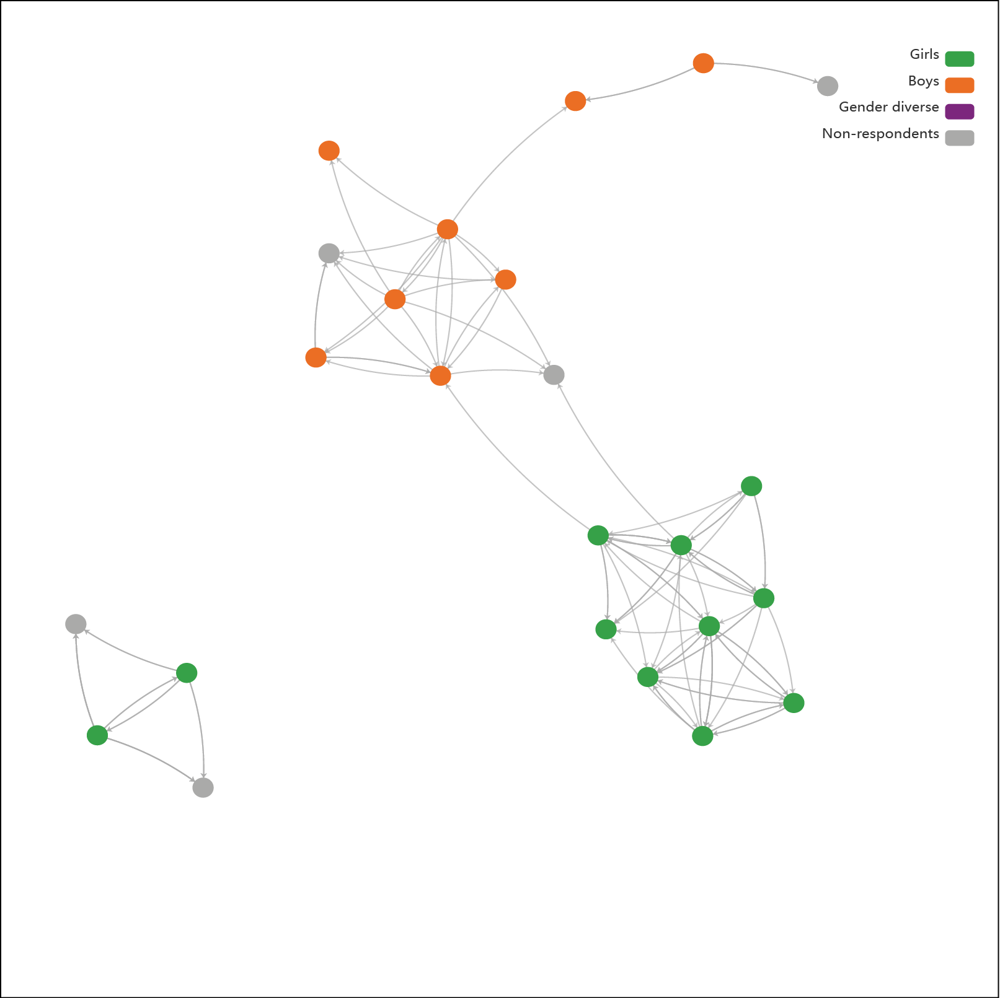

In addition to the network maps, statistical network modelling analysis of the student survey individual-level data (e.g. attitudes, attributes), in conjunction with the social network data, was also conducted to give broader statistical insights to the data.

Focus groups were conducted at endpoint with 61 students from four schools (20 girls, 39 boys and 2 gender diverse young people). Respondents included 29 students from Year 7 and 32 students from Year 9. Students shared their experiences of the Resilience, Rights and Respectful Relationships program and shared observations about the extent to which the program influenced attitudes and behaviour within their class.

Interviews were conducted at endpoint with 19 members of staff (5 Year 7 teachers, 4 Year 9 teachers, 5 implementation leads, 5 principal class). Semi-structured questions were used to elicit information on the delivery of the program, perceptions of impact on students’ attitudes and behaviours, and reflections on those things that supported and/or hindered implementation.

Findings

Taken together, the student surveys, teacher interviews and student focus groups shed new light on the nexus between student resilience and attitudes towards violence and gender equality. The data also provides insight into student experiences of the Resilience, Rights and Respectful Relationships program and the contribution it makes to student’s social capacity and respectful regard for others.

Students found the program useful

The endpoint survey showed that regardless of whether they were in low- or high-fidelity classes the vast majority of students found the program useful. Girls and gender diverse young people were more likely to rate the program as useful than boys. For example, 85.6% of girls, 82.6% of gender diverse students and 76.9% of boys rated learning about gender and equality as “useful”, “very useful” or “extremely useful”, and a slightly higher proportion of each gender endorsed learning about the effects of gender-based violence as “useful” (girls 85.1%, gender diverse 91.3%, boys 78.3%).

Students participating in the focus groups found the social and emotional learning and respectful relationships tasks meaningful and relevant and rated highly the focus on consent education. They valued the relationship-centric focus and the opportunity to develop their capacity for positive relationships with peers via engagement with the learning tasks.

Because the program talked about how people feel and how they don’t show it and stuff, so that sort of made you feel like, “Oh, you need to make sure your friends are okay. Oh, you need to make sure people are okay even if they don’t seem upset.” (School 2, Year 7 student)

I’d probably say the most important thing was consent just because when we went over it, went over a bunch of things like what’s acceptable, what is and what isn’t consent, and knowing those kind of things, is good just to teach to a broader part of the school. So having the whole of Year 9 learn that was probably the most important thing. (School 2, Year 9 student)

Teachers valued the content and methodological guidance provided in the resources

Teachers appreciated the guidance provided by the detailed lesson plans, supported by clear learning intentions, relevant data, information and scenarios, teacher coaching points, and a summary of the guiding evidence base. The guidance helped to build confidence and reduce individual research and preparation time.

From day one it was engaging, just because of the teaching methods … and you could see the staff enthusiasm doing it, and that always translates well when kids get to do it as well. … Yeah, I think just the teaching style and the pedagogy within it, I think helps kids to just be more comfortable. (School 5, Year 7 male teacher)

**Table 1:** Proportion of students rating program components as useful, very useful or extremely useful

Proportion of students rating program components as useful, very useful or extremely useful

| Gender | How to understand & communicate about feelings and needs | How to have good friendships | How to avoid joining in bullying | Gender and equality | Effects of gender-based violence |
| --- | --- | --- | --- | --- | --- |
| Girls | 74.2% | 76.3% | 78.9% | 85.6% | 85.1% |
| Boys | 73.9% | 78.0% | 72.5% | 76.9% | 78.3% |
| Gender diverse | 69.4% | 69.6% | 82.6% | 82.6% | 91.3% |

The program led to reductions in bullying

We found reductions in both bullying and sexual bullying when comparing baseline and endpoint student responses, with a decrease in students who said they sexually bullied other students (baseline = 8.7%, endpoint = 5.9%), and those who said they bullied others from baseline (11.8%) to endpoint (10.3%). In the context of a series of questions about calling people mean names, hitting others, saying mean things about others on social media, and leaving others out in a mean way, our questions about sexualised forms of bullying included, “How many times in the last week did you call other people gay?” and “How many times in the last week did you make sexual comments about someone else?” We found that students who bully other students are also more likely to sexually bully other students. However, those who bully other students were also more likely to themselves be bullied by other students. This adds strength to the notion that violence begets violence, and further contributes to its normalisation and, potentially, to its escalation, and echoes findings in other studies which have found that those who bully others are also more likely to engage in homophobic name-calling and sexual harassment, with boys more likely to take part in these behaviours than girls (Espelage et al., 2018).

Improvements in social capability and respectful regard were stronger for students in high-fidelity classes

Students in high-fidelity classes (in relation to provision of the collaborative learning activities) demonstrated significant increases in both self-reported social capability and self-reported respectful regard at endpoint. Those in low-fidelity classes did not show this improvement (see Figures 3 and 4). This finding indicates the importance of teacher fidelity in relation to method as well as to coverage of content. It is consistent with wider research which demonstrates the importance of critical thinking and collaborative-learning activities within sexuality, gender and consent education (Burton et al., 2023; Herbert & Lohrmann, 2011; Sell et al., 2023).

Most classes were not provided with a high-fidelity version of the program as the majority of the teachers did not make regular use of the collaborative-learning activities which were central to the instructional design. These teachers favoured more teacher-centric approaches such as whole class discussions and individual written work rather than also deploying small group problem-solving activities and peer-to-peer dialogue and role-play activities.

The class, it really depends on how the teacher puts it out and the atmosphere they set up. (School 2, Year 9 student)

**Figure 2:** Students self-reported bullying and sexual bullying other students at baseline and endpoint

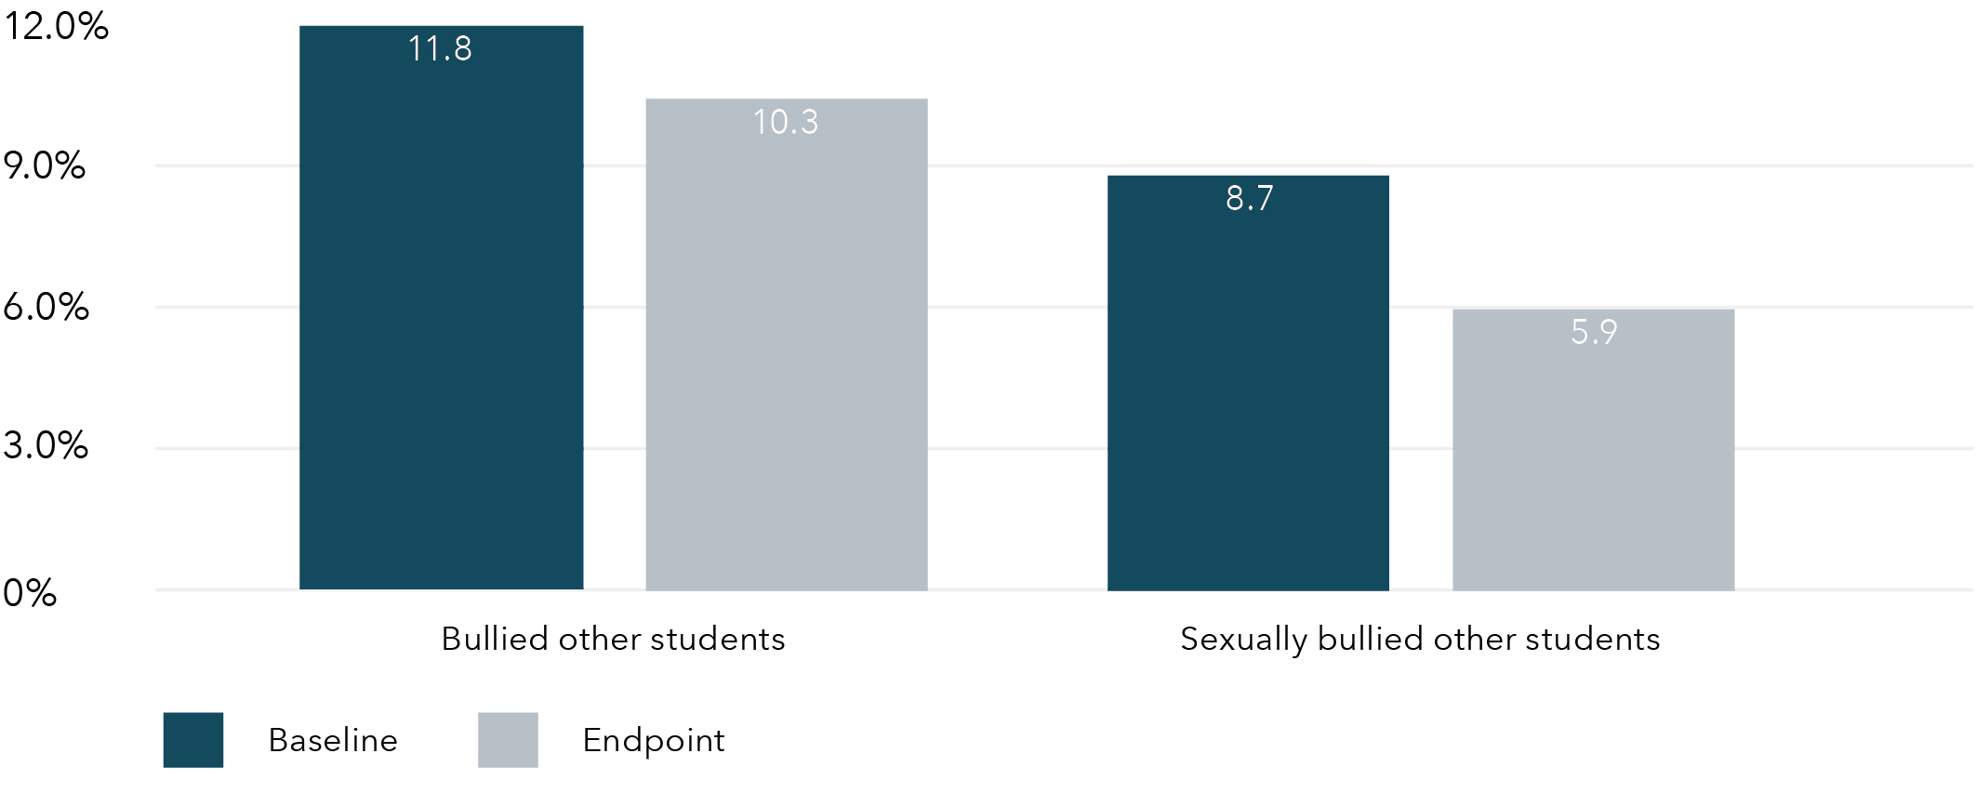

|  | Bullied other students | Sexually bullied other students |
| --- | --- | --- |
| Baseline | 11.8% | 8.7% |
| Endpoint | 10.3% | 5.9% |

**Figure 3:** Respectful regard scores at baseline and endpoint by status of working in small groups (no, yes)

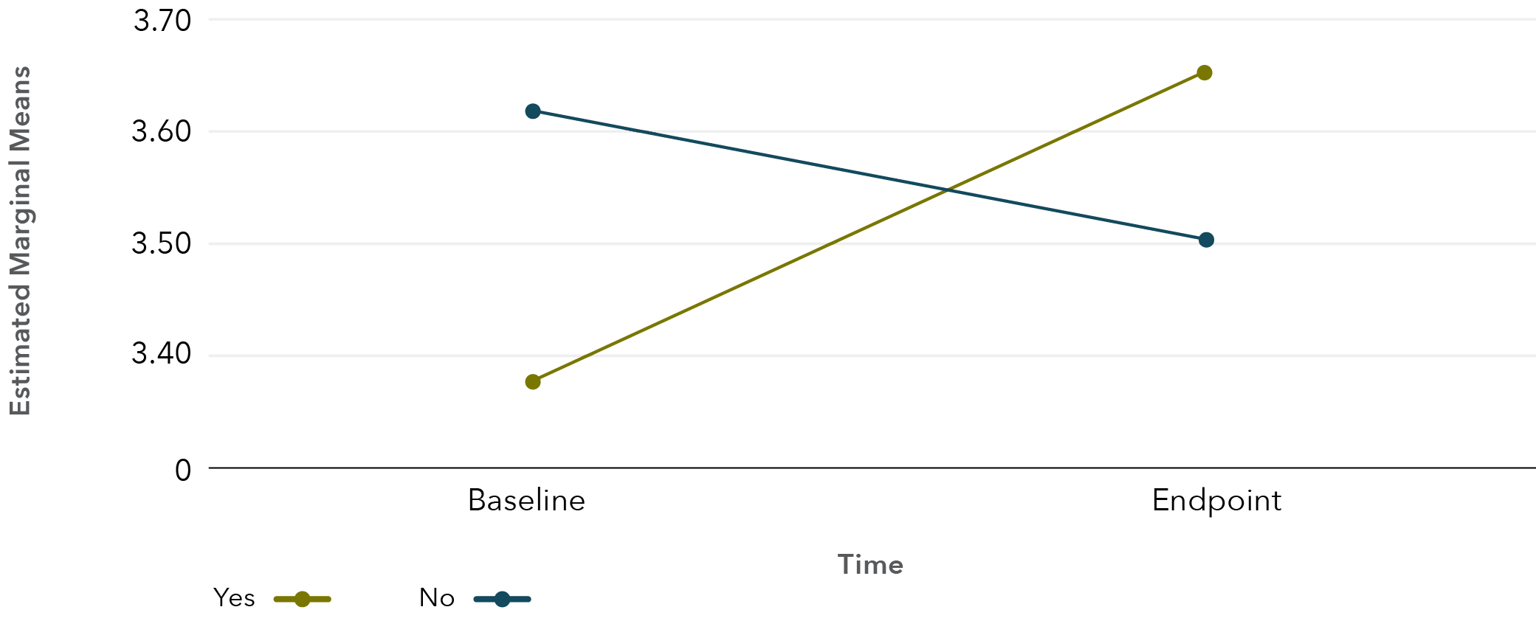

**Figure 4:** Social Capability scores at baseline and endpoint by status of working in small groups (no, yes)

Personally, I felt very comfortable, as if I could say whatever I wanted … Our teacher made everyone feel that way, so that was really good. (School 3, Year 9 boy)

Gender segregation is the norm in student friendships

The social network analysis revealed that student school life was marked by pronounced gender divides, with students rarely becoming close friends, or preferring to work, with those of a different gender. See Figure 4, which demonstrates close friendship relations within a Year 7 class (School 2), and Figure 5, which demonstrates close friendship relations within a Year 9 class at the same school.

The focus group data revealed that there could be social penalties for those who crossed these divides, particularly in the form of sexualised teasing of girls. This is relevant as wider research shows that those with friends who are mainly boys and men are less likely to hold pro-social attitudes regarding gender equality and rejection of violence (Politoff et al., 2019), and these negative attitudes, in turn, operate as drivers of gender-based violence.

Say I’m walking with a boy, everyone’s like, straight away, “Oh, you’re dating. 100 per cent. You’re dating. There’s no doubt about it.” And I’ll be like, “No, we’re just friends.” And they’ll be like, “Oh sure, they all say that.” There’s so much judgment around what gender you hang out with. (School 2, Year 7 girl)

Students group with those who hold similar attitudes

Our social network analysis also showed that those students who hold pro-gender equality attitudes are more likely to be socially connected to like-minded others, either as close friends or as people they say they can work with on group tasks, or in the aspirational sense of wanting to spend more time with that person. In parallel, students who sexually bully other students are close friends with, and prefer to work with or become friends with, others who also sexually bully people. This highlights the importance of social connections and draws attention to the presence of micro-peer cultures operating within class groups. This is of importance, as while peers with positive attitudes can reinforce or support each other, those with negative attitudes may also encourage and socially reward negative behaviour, potentially leading to the escalation and normalisation that appears to be happening for some boys as they move into the middle years of secondary school.

I think maybe putting genders, mixing up genders (in the group tasks) would be helpful. Get everybody’s opinion. (School 2, Year 9 student)

Those who excuse violence are also more likely to hold gender unequal attitudes

At baseline we found that attitudes relating to violence are strongly linked to attitudes relating to gender equality for boys, girls and gender diverse young people, such that those who excuse violence are also less likely to hold gender equal attitudes. Boys held significantly higher pro-violence attitudes and lower gender equality attitudes than girls and gender diverse young people (with the latter two not differing). However, students in focus groups noted experiences of denial.

When it comes to … gender-based violence and stuff, where a majority of it does happen to women … some [students] kind of got defensive about it, and it was a slight disagreement about it … some of the boys at the back of the class … I think it’s… defending. You feel like they’re saying that you [a girl/woman] would do that [too]. (School 4, Year 7 girl)

**Figure 5:** Close friendship relations among a Year 7 class (School 2)

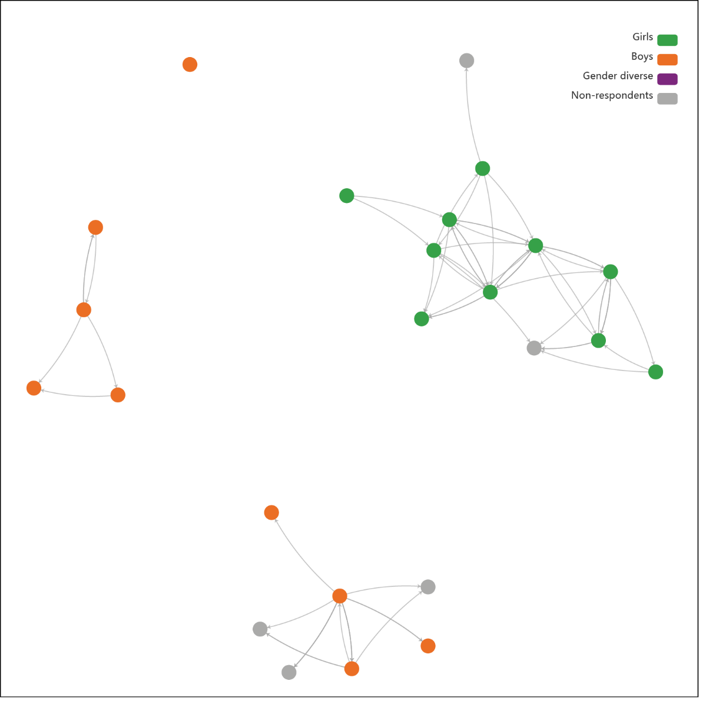

Boys are less likely than girls and gender diverse students to say they would intervene in response to peer-perpetrated sexual harassment.

Our baseline data showed that within both year levels, boys were less likely than girls and gender diverse young people to say they would intervene if a boy in their class told a sexual joke about a girl. Year 9 boys (12.8%) were less likely to say they would intervene than Year 7 boys (20.2%). Around a quarter of boys (Year 7, 23.9% and Year 9, 24%) said they would like to do or say something but wouldn’t know what to do. Girls were much more likely to say they would intervene than boys, with over a third saying they would do so (Year 7 girls, 38.2% and Year 9 girls, 33.3%). Responses from gender diverse young people were similar to those of girls (Year 7, 30.8% and Year 9, 33.3%).

Students reported that concerns about peer reprisal could operate as a barrier to help seeking from teachers in response to reporting instances of harassment.

**Figure 6:** Close friendship relations among a Year 9 class (School 2)

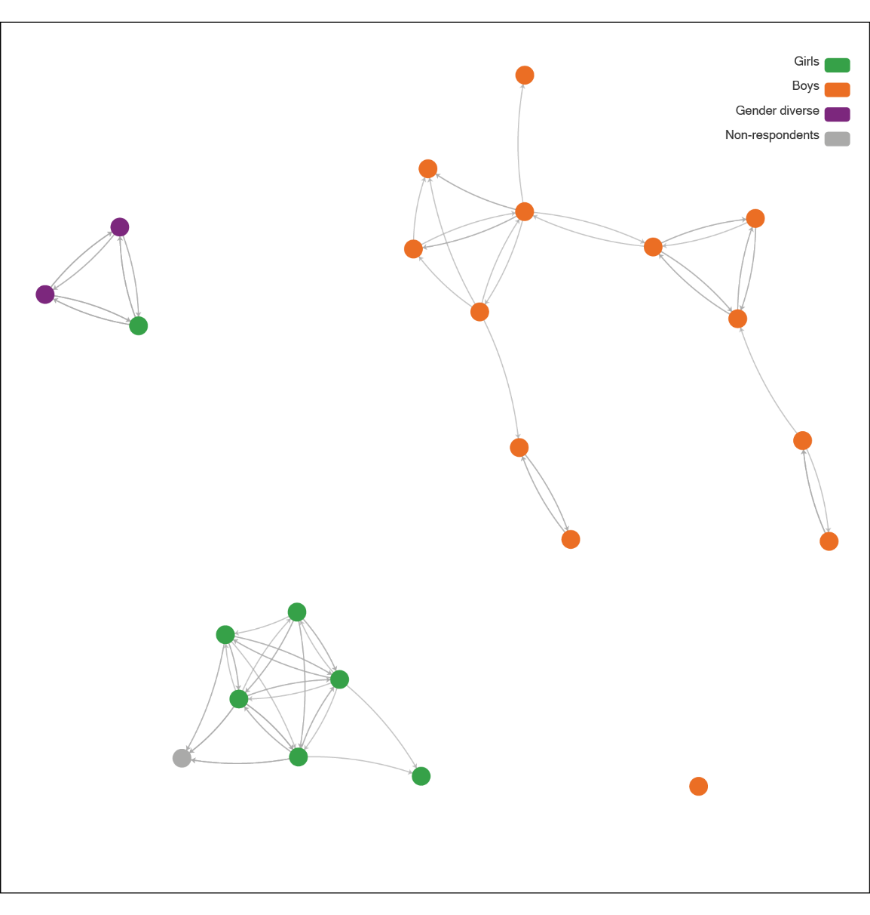

Year 9 boys were less likely to express positive intentions to intervene than were Year 7 boys

Our baseline data also showed that pro-gender equality attitudes were lower and endorsement of violence was higher among Year 9 boys than Year 7 boys. This trend was also apparent for boys in relation to whether a boy telling sexual jokes about girls in their class would bother them. While at start point just over a fifth of Year 7 boys (20.9%) said this behaviour wouldn’t bother them, nearly a third of Year 9 boys (28.8%) said this behaviour would not bother them. This trend towards more negative attitudes was not seen for girls and gender diverse students.

These findings suggest that the minority of boys who hold both pro-violence attitudes and low endorsement of gender equality may become more dominant as they enter the middle years of secondary school. Potentially due to their greater propensity to engage in bullying as well as sexual bullying, the pro-equality boys may feel constrained by the possibility of negative repercussions if they speak up against such attitudes. This was borne out in the focus group data with students noting that backlash or discriminatory treatment could be enacted by some boys, particularly outside of class. Investigators bringing a gender lens to bullying research have also found it to be a strongly gendered practice among adolescents (Espelage et al., 2018; Carrera-Fernández et al., 2018). Bullying can function as a mechanism through which

boys assert hegemonic masculinities via overt and subtle forms of gender policing, including punishing those boys who are deemed to be insufficiently masculine, as well as engaging in sexual harassment of girls as a way to establish dominance or status in the eyes of other boys (Carrera-Fernández et al., 2018). Longitudinal studies have found that those who bully others are also more likely to engage in homophobic name-calling and sexual harassment, and that those who engaged in these behaviours in early adolescence were more likely to engage in sexual harassment in their high school years (Espelage et al., 2018).

If they’re in your year level and you tell someone about it, they’re most likely going to get mad at you and get a lot worse with it. So that’s why people don’t really talk about it. (School 1, Year 7 student)

Some teachers noted some positive changes across the year, such that boys started to challenge peers who expressed misogynistic, homophobic or transphobic views, and this in turn caused a shift in those who expressed these negative views.

Some of the boys started to actually challenge their peers directly, instead of me having to do the challenging. And then all of a sudden more of them got on board, and then there was this turning point where … Those voices suddenly got very quiet and actually started to shift their own narrative. (School 3, Year 9 female teacher)

New insights into gender and resilience

On the overall measure of resilience, boys were more resilient than girls and both groups were significantly more resilient than gender diverse young people. This reflects the broader mental health data in Australia which shows that girls and gender diverse young people are more likely to experience mental health distress than boys (Leung et al., 2022). Using our resilience measure, we found that boys showed higher levels of confidence than did girls and gender diverse young people; however, we found confidence to be a positive predictor for pro-violence attitudes. In this respect, low confidence (not high confidence) was associated with higher gender equity attitudes.

In this association between high confidence and pro-violence attitudes, we found that resilience measures were not well suited to identifying social attitudes pertaining to violence and gender equity, potentially because they have traditionally favoured an individualised, rather than a social, understanding of wellbeing. In contrast to confidence being a poor indicator of respect, we found high social capability and strong respectful regard to be associated with rejection of use of violence and support for gender equality. For boys, social capability and respectful regard linked not only to positive gender equality attitudes, but also with violence dis-endorsing attitudes and intentions to speak up against sexual harassment. This may indicate that boys can benefit from respectful relationships programs which incorporate a focus on emotional awareness, relationship skills and empathy, as well as a focus on gender equality and prevention of gender-based violence.

We did not find a relationship between high levels of confidence and social capability despite this being presumed in the resilience measure we used (Gartland et al., 2011). However, there was a strong relationship between social capability and respectful regard. This suggests building students’ self-confidence is not necessarily going to make them better citizens in terms of the acceptability of violence and gender equality attitudes. Efforts to build active, engaged citizens may be more effective by addressing the interconnections between respectful regard and social capability within gender transformative approaches to respectful relationships education. This points in turn to the importance of providing integrated rather than siloed approaches to social and emotional learning and respectful relationships education.

**Figure 7:** Proportion of students from each cohort who would intervene if a boy in their class told a sexual joke about a girl

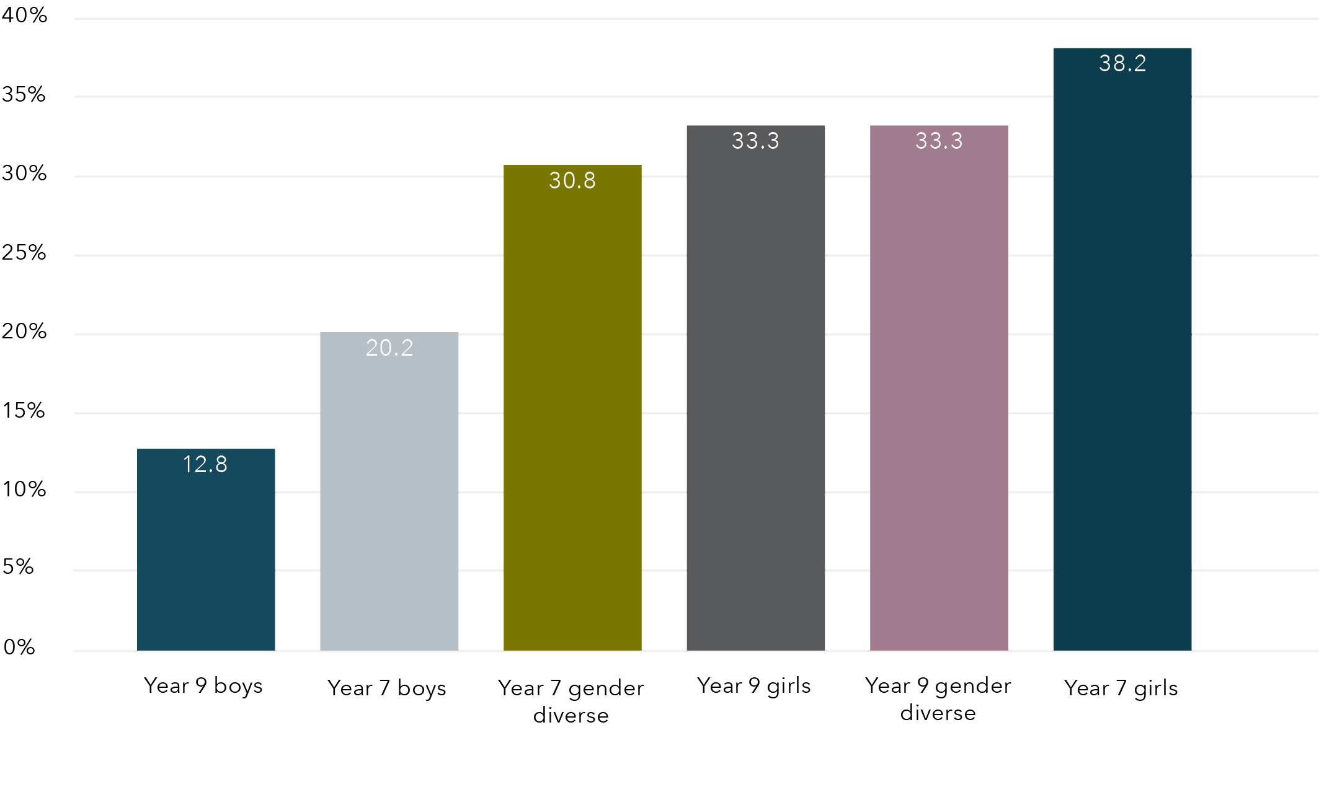

|  | Proportion (%) |
| --- | --- |
| Year 9 boys | 12.8 |
| Year 7 boys | 20.2 |
| Year 7 gender diverse | 30.8 |
| Year 9 girls | 33.3 |
| Year 9 gender diverse | 33.3 |
| Year 7 girls | 38.2 |

**Figure 8:** “If a boy in your class told a sexual joke about a girl in your class, how would you respond?": Boys’ responses

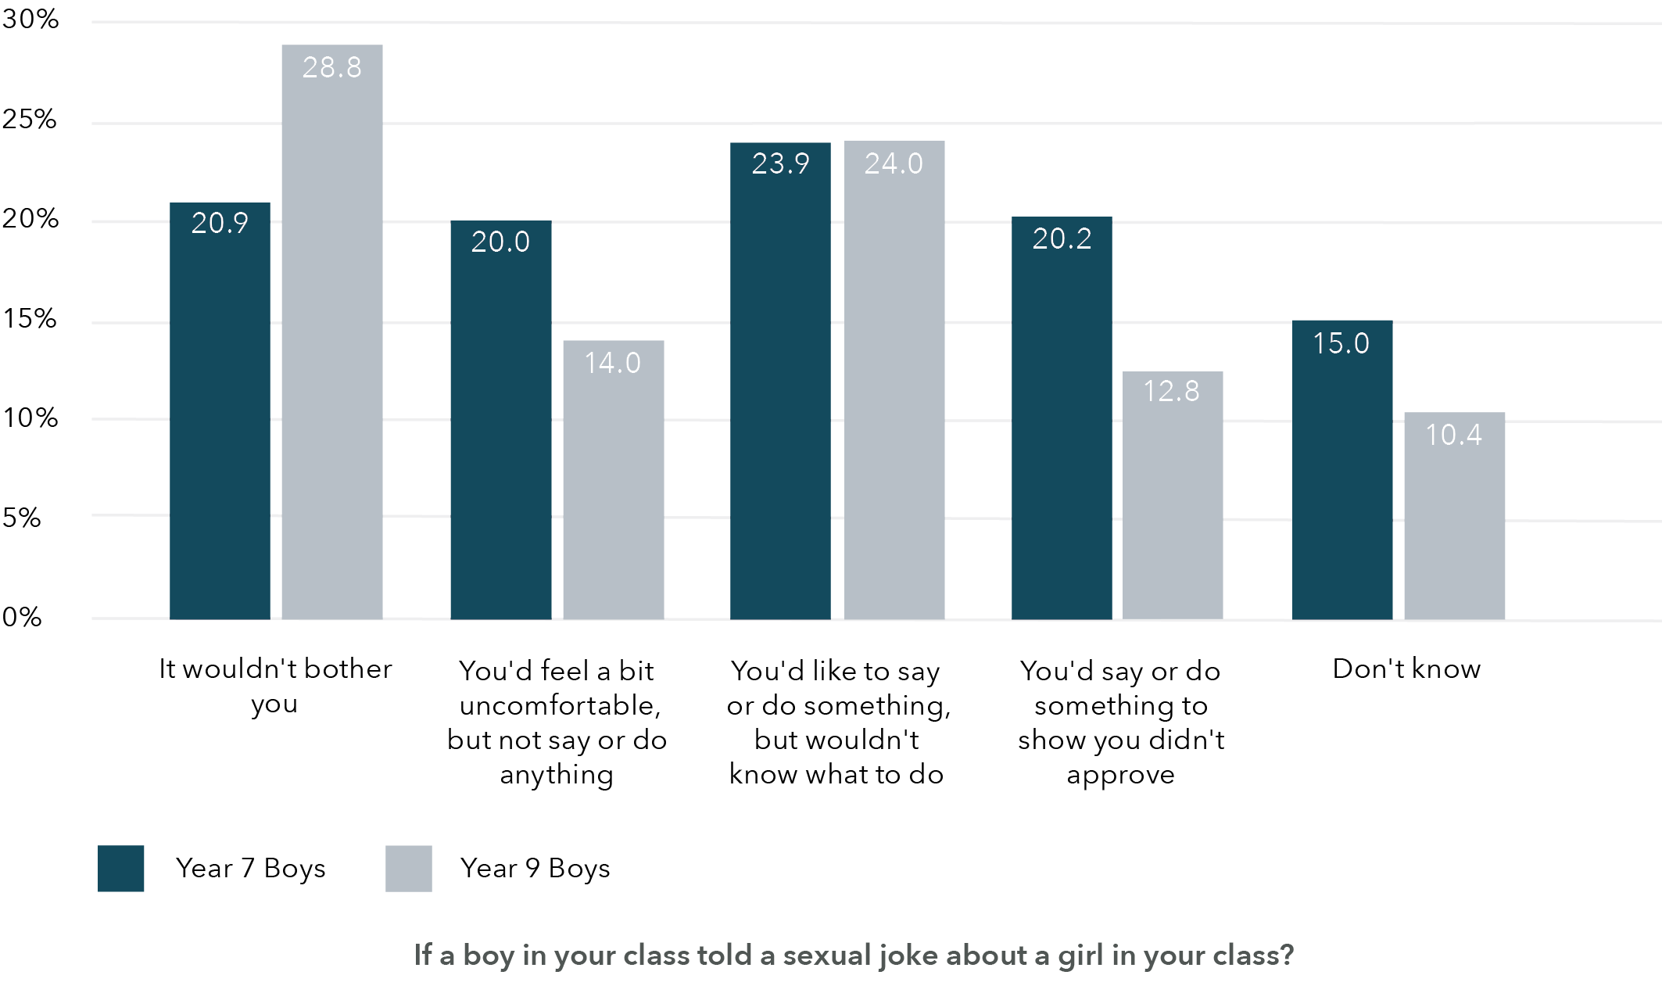

| If a boy in your class told a sexual joke about a girl in your class? | Year 7 Boys | Year 9 Boys |
| --- | --- | --- |
| It wouldn’t bother you | 20.9% | 28.8% |
| You’d feel a bit uncomfortable, but not say or do anything | 20.0% | 14.0% |
| You’d like to say or do something, but wouldn’t know what to do | 23.9% | 24.0% |
| You’d say or do something to show you didn’t approve | 20.2% | 12.8% |
| Don’t know | 15.0% | 10.4% |

And this year we’ve learned … we’ve kind of discovered that it’s fine to be friends with anyone you want to be friends with. And no gender can change that and stuff like that. (School 2, Year 7 student)

School factors affecting implementation

Interviews conducted with implementing teachers and leaders revealed a number of societal, system, school and individual barriers and enablers that affected fidelity and quality of implementation.

At a societal level, the implementation enablers included awareness of heightened rates of student mental and social health distress following the pandemic, while barriers included backlash and resistance expressed by those community members opposed to respectful relationships education.

Post the lockdowns … it was a perfect time to really put a focus on those interpersonal skills and self-management, social awareness skills. (School 2, male implementation lead)

Out of all of the years … I think this year’s been one of the most challenging. … students that have been even more defiant or entrenched in the ways that they want to do things … Yeah, it’s been really challenging and I think for staff as well, they’re very tired. (School 1, male principal class)

At the education system level, implementation enablers included supportive policies, provision of guiding teaching resources in the form of the Resilience, Rights and Respectful Relationships program, and barriers included curriculum crowding and impact on teacher workloads.

I thought the resources were brilliant … The information in the teacher manual, again with the evidence-based information that you could present to the students so they could find relevance in why we are doing this … I really liked a lot of the activities and how it met curriculum and how it was presented and used. Recent statistics and data especially. (School 1, Year 9 male teacher)

At the school level, implementation enablers included alignment with the school mission and vision, support from school leaders to allocate a program home for the intervention, and access to professional learning. School-level barriers included disruptions to teacher continuity due to staffing shortages post-pandemic and lack of adequate time to deliver the program.

I think we’re doing it because it means something, and it’s embedded in what we do in our value system … So our priorities are around making sure that our whole school community embraces the values that we’ve put into our pledge and that we’re able to explicitly teach students about social and emotional learning, how important that is, and what that looks like as well. (School 2, female principal class)

At the individual teacher level, implementation enablers included positive relationships with students, professional confidence and capacity to address the sensitive issues and facilitate the collaborative learning activities, and access to the guiding resources and associated professional learning.

A lot of the topics and things you discuss, you need that close bond with the students and the trust. (School 5, Year 7 male teacher)

Barriers included concerns about teaching sensitive content, managing student behaviour, lack of access to training, and for some teachers there was a conflict between their personal ideology or beliefs and the program objectives.

I felt anxious talking about … consent and things like that because I was worried about making people feel upset or triggering things that I didn’t know were going on. And once or twice there were some students who were challenging some things I guess. And it was a kind of tricky conversation to have. (School 5, Year 9 female teacher)

Implications for policy and practice

Informed by findings from this research, key principles of relevance to policy and practice have been identified across each level of the social-ecological model, with implications for approaches at society, system, school and teacher levels:

* Society-level implications:
* Maintain a whole-of-society approach to prevention of gender-based violence.
* Promote community awareness of the positive contributions made through school-based social and emotional learning and respectful relationships education.
* Implications for education systems:
* Provide teachers with research-informed resources and evidence-based professional learning designed to advance teacher capacity to facilitate both content and method of the program.
* Address curriculum crowding to ensure secondary schools can viably provide comprehensive approaches to social and emotional learning and respectful relationships education.
* Ensure schools are adequately staffed and resourced such that teachers have sufficient time for professional learning, planning, program delivery and provision of wellbeing support for students.
* Provide communication tools to help parents/carers to understand the objectives, content and methods used in integrated approaches to social and emotional learning and respectful relationships education.
* Equip school leaders and teachers with strategies to help them deal with backlash and resistance.
* Embed social and emotional learning and respectful relationships education in the curriculum.
* School-level implications:
* Provide professional learning for all school staff around gender equality and violence prevention in order to ensure the culture of the school is respectful, equal and inclusive.
* Enact the proactive policies, practices and codes of conduct designed to ensure that all teachers play an active role in ensuring the school is a safe, supportive and inclusive environment.
* Provide release time for teachers to attend professional learning and to adequately prepare to deliver the program effectively and as intended.
* Provide additional in-school professional learning and support for teachers delivering the program.
* Provide a comprehensive social and emotional learning and respectful relationships program designed to advance the knowledge, skills and attitudes that inform positive relationships.
* Include students in needs analysis, program evaluation and broader school improvement efforts.
* Include the community in the whole-school approach to gender equality, respect and violence prevention.
* Implications for teachers:
* Establish positive relationships with students.
* Foster a respectful class climate and help students to mix across friendship and gender divides.
* Provide the collaborative learning activities as a key mode through which to foster engagement, critical thinking, social capabilities and student voice.
* Understand that some students experience negative peer pressures, and it may take significant program exposure and time before they feel safe to openly challenge discriminatory attitudes or behaviour on the part of peers.

Conclusion

This study provides insights into ways in which the Resilience, Rights and Respectful Relationships program contributed to the social health of Year 7 and Year 9 students. It provides a snapshot of how attitudes towards use of violence and gender equality intersect and influence student wellbeing, relationships and behaviour in markedly gendered ways. It demonstrates that students value integrated approaches to social wellbeing, respectful relationships and consent education. It finds that a comprehensive program can advance student social capabilities and lead to reductions in sexualised forms of bullying. The study draws attention to the importance of providing teachers with training, strong guiding resources, leadership support, and an adequate home in the timetable for robust provision.

[It is important to have] a really clear sense from senior leadership that this is important, this is a priority of the school, and this is a whole-school approach, and that time is sacred. … It isn’t just Friday Period 2. This is something we live and we breathe, and this is about how we approach our relationships. (School 3, female Implementation lead)

References

Australian Bureau of Statistics. (2023). Personal Safety, Australia 2021–22. ABS. <https://www.abs.gov.au/statistics/people/crime-and-justice/personal-safety-australia/2021-22#key-findings-violence-prevalence-and-changes-over-time>

Burton, O., Rawstorne, P., Watchirs-Smith, L., Nathan, S., & Carter, A. (2023). Teaching sexual consent to young people in education settings: A narrative systematic review. Sex Education, 23(1), 18–34. <https://doi.org/10.1080/14681811.2021.2018676>

Carrera-Fernández, M. V., Lameiras-Fernández, M., & Rodríguez-Castro, Y. (2018). Performing intelligible genders through violence: Bullying as gender practice and heteronormative control. Gender and Education, 30(3), 341–359. <https://doi.org/10.1080/09540253.2016.1203884>

Coumarelos, C., Weeks, N., Bernstein, S., Roberts, N., Honey, N., Minter, K., & Carlisle, E. (2023). Attitudes matter: The 2021 National Community Attitudes towards Violence against Women Survey (NCAS), Findings for Australia (Research report, 02/2023). ANROWS. <https://www.anrows.org.au/publication/attitudes-matter-the-2021-national-community-attitudes-towards-violence-against-women-survey-ncas-findings-for-australia/>

Espelage, D. L., Basile, K. C., Leemis, R. W., Hipp, T. N., & Davis, J. P. (2018). Longitudinal examination of the bullying-sexual violence pathway across early to late adolescence: Implicating homophobic name-calling. Journal of Youth and Adolescence, 47(9), 1880–1893. <https://doi.org/10.1007/s10964-018-0827-4>

Gartland, D., Bond, L., Olsson, C. A., Buzwell, S., & Sawyer, S. M. (2011). Development of a multi-dimensional measure of resilience in adolescents: The Adolescent Resilience Questionnaire. BMC Medical Research Methodology, 11(1), 134. <https://doi.org/10.1186/1471-2288-11-134>

Herbert, P. C., & Lohrmann, D. K. (2011). It’s all in the delivery! An analysis of instructional strategies from effective health education curricula. Journal of School Health, 81(5), 258–264. <https://doi.org/10.1111/j.1746-1561.2011.00586.x>

Leung, S., Brennan, N., Freeburn, T., Waugh, W., & Christie, R. (2022). Youth Survey Report 2022. Mission Australia.

Politoff, V., Crabbe, M., Honey, N., Mannix, S., Mickle, J., Morgan, J., Parkes, A., Powell, A., Stubbs, J., Ward, A., & Webster, K. (2019). Young Australians’ attitudes to violence against women and gender equality: Findings from the 2017 National Community Attitudes towards Violence against Women Survey (NCAS) (ANROWS Insights, 01/2019). ANROWS. <https://www.anrows.org.au/publication/young-australians-attitudes-to-violence-against-women-and-gender-equality-findings-from-the-2017-national-community-attitudes-towards-violence-against-women-survey-ncas/>

Sell, K., Oliver, K., & Meiksin, R. (2023). Comprehensive sex education addressing gender and power: A systematic review to investigate implementation and mechanisms of impact. Sexuality Research and Social Policy, 20, 58–74. <https://doi.org/10.1007/s13178-021-00674-8>

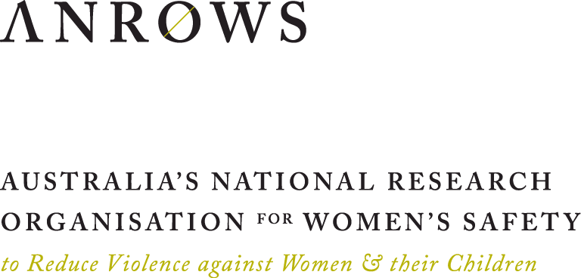

1. Fidelity is a term used to describe the degree to which an education intervention is delivered in a manner that is consistent with its design in relation to both content and method of delivery. Key metrics for fidelity of implementation were whether students were consistently provided with the collaborative learning activities, including working in small groups and engaging in role plays.
2. The RRRR program is published open access on the Victorian Department of Education website. For the purposes of the study, the program was reduced from eight to seven topics with the topics Positive Coping and Stress Management being combined. New lessons on gender policing were added to Topic 7 and additional lessons on affirmative consent were added to Topic 8. In total, Year 7 students received 19 lessons and Year 10 students received 20 lessons. The lessons were delivered across two or three school terms, in either Health or pastoral care classes.