

A social network analysis and implementation study of an intervention designed to advance social and emotional learning and respectful relationships in secondary schools
Helen Cahil | Dean Lusher | Anne Farrelly | Natalie Calleja | Peng Wang | Ali Hassani
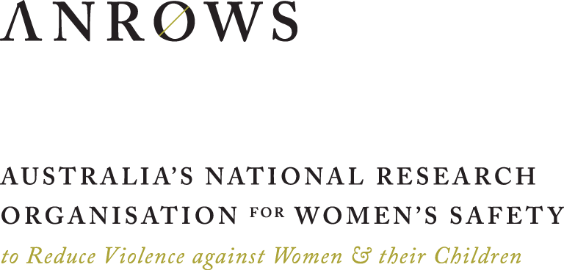
Research Report
Issue 07 | November 2023

ANROWS acknowledgement
This material was produced with funding from the Australian Government Department of Social Services. Australia’s National Research Organisation for Women’s Safety (ANROWS) gratefully acknowledges the financial and other support it has received from the Government, without which this work would not have been possible. The findings and views reported in this paper are those of the authors and cannot be attributed to the Australian Government Department of Social Services.
Acknowledgement of Country
ANROWS acknowledges the Traditional Owners of the land across Australia on which we live and work. We pay our respects to Aboriginal and Torres Strait Islander Elders past and present. We value Aboriginal and Torres Strait Islander histories, cultures and knowledge. We are committed to standing and working with First Nations peoples, honouring the truths set out in the Warawarni-gu Guma Statement.
Peer review process
The quality of ANROWS publications is ensured through a rigorous peer review process that is consistent with the principles of the Committee on Publication Ethics (COPE) Ethical Guidelines for Peer Review. This report has been assessed by at least two peer reviewers with relevant academic expertise.
© ANROWS 2023

With the exception of the ANROWS branding, content provided by third parties, and any material protected by a trademark, all material presented in this publication is licensed under a Creative Commons Attribution-NonCommercial 3.0 Australia (CC BY-NC 3.0 AU) licence.
The full licence terms are available at creativecommons.org/licenses/by-nc/3.0/au/legalcode
Published by
Australia’s National Research Organisation for Women’s Safety Limited (ANROWS)
PO Box Q389, Queen Victoria Building, NSW 1230 | www.anrows.org.au | Phone +61 2 8374 4000
ABN 67 162 349 171
ISBN: 978-1-922645-78-4 (paperback)
ISBN: 978-1-922645-79-1 (PDF)
Please note that there is the potential for minor revisions of this report.
Please check the online version at www.anrows.org.au for any amendment.
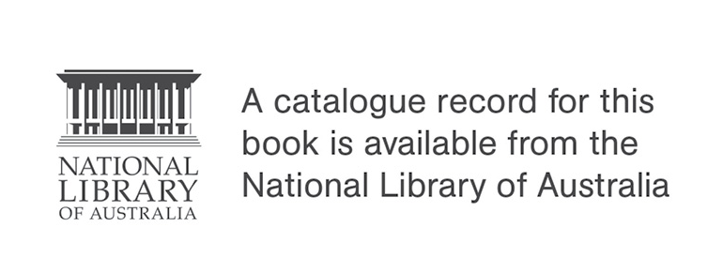

A social network analysis and implementation study of an intervention designed to advance social and emotional learning and respectful relationships in secondary schools
Emeritus Professor Helen Cahill
Chief Investigator, University of Melbourne
Dr Dean Lusher
Co-Chief Investigator, SNA Toolboxª
ANNE FARRELLY
Research Fellow, University of Melbourne
NATALIE CALLEJA
Research Fellow, University of Melbourne
DR PENG WANG
Co-Chief Investigator, SNA Toolbox
Dr ALI HASSANI
Research Fellow, SNA Toolbox
This report addresses work covered in the ANROWS research project “A social network analysis and implementation study of an intervention designed to advance social and emotional learning and respectful relationships in secondary schools”. Please consult the ANROWS website for more information on this project.
ANROWS research contributes to the six National Outcomes of the National Plan to Reduce Violence against Women and their Children 2010–2022. This research addresses National Outcome 2 – Relationships are respectful.
Suggested citation:
Cahill, H., Lusher, D., Farrelly, A., Calleja, N., Wang, P., & Hassani, A. (2023). A social network analysis and implementation study of an intervention designed to advance social and emotional learning and respectful relationships in secondary schools (Research report, 07/2023). ANROWS.

ªSNA Toolbox Pty Ltd is a Swinburne University of Technology start-up company that utilises Social Network Analysis (SNA) to better understanding student social connections and improve student learning, wellbeing and culture (https://www.snatoolbox.com/)

University of Melbourne
University of Melbourne, Graduate School of Education,
100 Leicester Street,
Parkville, Victoria, Australia 3010
SNA Toolbox Pty Ltd
c/o Swinburne University of Technology, 1 John Street,
Hawthorn, Victoria, Australia 3122
Author acknowledgement
The authors would like to thank the principals, teachers and students who participated in this study.
Acknowledgement of lived experiences of violence
ANROWS acknowledges the lives and experiences of the women and children affected by domestic, family and sexual violence who are represented in this report. We recognise the individual stories of courage, hope and resilience that form the basis of ANROWS research.
Caution: Some people may find parts of this content confronting or distressing. Recommended support services include 1800 RESPECT — 1800 737 732 and Lifeline — 13 11 14.

Contents
Contents 5
Acronyms and abbreviations 7
Definitions 8
Executive summary 9
Background 9
Aims and research questions 9
Methodology 10
Findings 11
Conclusion 15
Part A: Introduction 16
Background 16
Literature review 18
Part B: Methodology 26
Introduction 26
Research aims and questions 26
The Resilience, Rights and Respectful Relationships intervention 26
Recruitment 28
Data collection 31
Quantitative data collection 31
Quantitative analysis 44
Qualitative data collection 48
Qualitative analysis 49
Ethics 49
Summary 51
Part C: Key findings – quantitative 52
Introduction 52
Teacher results 52
Student results 52
Summary of student survey results 53
Demographics 57
Social connections 59
Resilience 69
Violence 83
Gender equality 104
Loneliness 108
Classroom climate 110
Evaluation of program 115
Summary 125
Part D: Key findings – qualitative 128
Insights into student experiences of the RRRR program 128
Teacher views about the contribution of the RRRR program 135
Using a social ecology framework to map implementation barriers and enablers 141
Discussion of findings from the qualitative data 151
Part E: Summary and implications 154
Key findings 154
Implications 157
Strengths and limitations 161
Conclusion 162
References 163
Author contributions 174
Appendix A: Year 7 Resilience, Rights and Respectful Relationships activities list 175
Appendix B: Year 9 Resilience, Rights and Respectful Relationships activities list 177
Appendix C: Student survey co-education schools 179
Appendix D: Student survey boys’ schools 211
Appendix E: Student focus group questions 241
Appendix F: Teacher interview questions 242
Appendix G: Leader interview questions 245

Acronyms and abbreviations
Acronym | Meaning
ALAAM | Autologistic Actor Attribute Model
ANOVA | Analysis of Variance
CSE | Comprehensive sexuality education
DET | Department of Education and Training (Victoria)
GBV | Gender-based violence
LOTE | Language Other Than English
MACS | Melbourne Archdiocese Catholic Schools
PCA | Principal Component Analysis
RRRR program | Resilience, Rights and Respectful Relationships program
SEL | Social and emotional learning
SNA | Social Network Analysis

Definitions
Phrase | Meaning
Collaborative learning | refers to those instructional methods which provide opportunity for students to work in pairs or groups. They provide opportunity for shared endeavour and student to student dialogue.
Gender-based violence | is a term used to describe any form of violence that is driven by gender norms or expectations and is perpetrated against a person because of their sex or gender.
Gender diverse | in this study refers to all those participants who chose not to define their gender within the binary categories of male or female.
Implementation fidelity | is a term used to describe the degree to which an education intervention is delivered in a manner that is consistent with that intended by those who designed it.
Resilience | is the capacity to cope with change, challenge and adversity in positive ways.
Respectful relationships education | is a term used to describe education programs which explicitly address prevention of gender-based violence by developing students’ skills, attitudes and understanding of gender inequality and what constitutes respectful, equal and non-violent relationships.
Social and emotional learning (SEL) | is the term used to describe education programs which explicitly teach social or relationship skills, including emotional awareness, cooperation, problem solving, positive coping, help seeking, peer support and social inclusion.
Sexual bullying | in the context of this study is used to refer to reported behaviours such as making sexual comments about others, calling others gay in a derogatory way and making sexual jokes about others.
Social-ecological frameworks | address the complex ways in which culture, policies, institutions, individual and interpersonal factors interact to influence wellbeing.
Whole-school approach | is a term used to describe the ways in which schools make a concerted effort to use their policies, programs, practices and partnerships to address a particular issue.

Executive summary

Background
Gender-based violence (GBV) remains a significant issue within society. In the Australian context, one in four (23%) women compared to one in fourteen (7.3%) men have experienced violence by an intimate partner since the age of 15. Additionally, one in five women (22%) and one in sixteen men (6.1%) have experienced sexual violence (Australian Bureau of Statistics [ABS], 2023). Between 2018 and 2019, the majority (97%) of sexual assault offenders recorded by police were male, with males aged 15 to 19 having the highest sexual assault offender rates of any age group (Australian Institute of Health and Welfare [AIHW], 2020).
Although Australian community attitudes in relation to gender-based violence have shown slight improvement since 2009, the ANROWS 2021 National Community Attitudes towards Violence against Women Survey (NCAS) highlights that many Australians (41% of respondents) continue to believe domestic violence is equally committed by men and women, not recognising that it is overwhelmingly perpetrated by men against women (Coumarelos et al., 2023). Incongruence between the prevalence data and community presumptions and attitudes points to a need for further development of community understandings about the intrinsic relationship between gender and domestic and sexual forms of violence. Education is central to this work.
Education settings play a key role in the prevention of GBV, since they can be universally accessed, are pivotal in the social, emotional and cognitive development of children and young people and are connected to broader communities. Recognising the imperative of the provision of GBV prevention within school settings to effect change, this research project examined the delivery of the Resilience, Rights and Respectful Relationships (RRRR) program to Year 7 and Year 9 students in six Victorian secondary schools. This education program is a research-informed comprehensive social and emotional learning (SEL) and respectful relationships program, published by the Victorian Department of Education and Training (DET) and authored by academics from the University of Melbourne. The learning objectives within the program are consistent with the guidance provided in the Victorian and Australian curriculum (see Appendices A and B for an overview of the program topics).

COVID-19 pandemic
The COVID-19 pandemic was a significant factor in the study context. Schools were severely affected with Victorian students and teachers shifting to virtual learning for almost 2 years (2020 to 2021) as schools closed as part of the Victorian Government’s public health response. Restrictions were placed on research by education departments to allow schools to focus on supporting their communities. After 2 years’ delay, the project commenced in 2022. However, the ongoing impacts of the pandemic, including the physical and mental health impacts on members of the school community, staff shortages and the continuing need for schools to enforce the COVID-19 health restrictions, affected the research design and capacity of staff and students to participate in data collection.

Aims and research questions
The mixed methods study aimed to investigate the impact of the RRRR program on the social health of Year 7 and Year 9 students. To undertake this investigation, the project was guided by three overarching questions:
- How does the RRRR program impact student social wellbeing, resilience, gender-equality attitudes, school connectedness and use of positive coping strategies?
- How does participation in the program influence student relationships with peers and teachers?
- What factors enable and/or inhibit the capacity of schools to implement the program with fidelity?

Overview of the Resilience, Rights and Respectful Relationships program
Over 2022, Year 7 and Year 9 students received a modified version of the Levels 7 to 8 and 9 to 10 resources from the DET RRRR education program. This program integrates an approach to the development of SEL and respectful relationships education including a focus on the prevention of GBV. Using research-informed collaborative learning activities, the intervention used for the research trial addressed seven key topics, each of which included three to five lessons. Topics 1 to 5 support the development of social and relational skills through lessons on emotional literacy, personal strengths, positive coping and stress management, problem solving and help seeking. Topics 6 and 7 address gender and identity and positive gender relations focusing on respectful relationships, consent education and the prevention of GBV (see Appendices A and B for a full list of program activities). To support teachers to deliver the program, a cohort of Year 7 and Year 9 teachers and implementation leaders were provided with a two-day training workshop that introduced the evidence base informing the program rationale and methods and provided opportunity to sample the collaborative activities and discuss implications for teacher practice. The training was provided online due to restrictions on in-person gatherings associated with the pandemic.

Methodology
The study used a mixed methods approach collecting data across six secondary schools. Two of the schools were in regional locations while four were in metropolitan Melbourne. Four schools were in the State sector and two in the Catholic education system. One metropolitan school was a boys’ school. The schools represented a mix of demographics.
Surveys were used to collect baseline data from 725 students (n=289 girls, n=398 boys, n=38 gender diverse young people). Both baseline and endpoint surveys were completed by 395 students (n=169 girls, n=205 boys, n=21 gender diverse young people). Survey measures included questions to investigate resilience, gender attitudes and student social relationships within their classroom group (social networks) and prevalence of bullying and peer-perpetrated sexual harassment. The endpoint survey included evaluative questions in which students rated the extent to which they found different program components to be useful.
Focus groups were conducted at endpoint with 61 students from four schools (20 girls, 39 boys, and 2 gender diverse young people). Respondents included 29 students from Year 7 and 32 students from Year 9. Students shared their experiences of the RRRR program and observations about the extent to which the program influenced attitudes and behaviour within their class.
Interviews were conducted at endpoint with 19 members of staff (5 Year 7 teachers, 4 Year 9 teachers, 5 implementation leads, 5 principal class). Semi-structured questions were used to elicit information on the delivery of the program, perceptions of impact on students’ attitudes and behaviours and reflections on those things that supported and/or hindered implementation.

Findings
Taken together, the student surveys, teacher interviews and student focus groups shed new light on the nexus between student resilience and attitudes towards violence and gender equality. The data also provides insight into student experience of the RRRR program and its contribution to the students’ social capacity and respectful regard for others.

Students found the program useful
The vast majority of students found the program useful regardless of whether they were in low or high-fidelity classes, with girls and gender diverse young people more likely to rate the program as useful than boys. For example, 85.6 per cent of girls, 82.6 per cent of gender diverse students and 76.9 per cent of boys rated learning about gender and equality as useful, very useful or extremely useful, and a slightly higher proportion of each gender endorsed as useful learning about the effects of GBV (girls 85.1%, gender diverse students 91.3%, boys 78.3%). Students participating in the focus groups found the SEL and respectful relationships tasks meaningful and relevant and rated highly the focus on consent education. They valued the relationship-centric focus and the opportunity to develop their capacity for positive relationships with peers via engagement with the learning tasks.

The program led to reductions in bullying
We found reductions in bullying and sexual bullying when comparing baseline and endpoint student responses, with a decrease in students who said they sexually bullied other students (baseline = 8.7%, endpoint = 5.9%), and a slight decrease in students who said they bullied others (from baseline 11.8% to endpoint 10.3%). In the context of a series of questions about calling people mean names, hitting others, saying mean things about others on social media and leaving others out in a mean way, our questions about sexualised forms of bullying included, “How many times in the last week did you call other people gay” and “How many times in the last week did you make sexual comments about someone else”. We found that students who bully other students are also more likely to sexually bully other students. However, those who bully other students were also more likely to themselves be bullied by other students. This indicates the notion that violence begets violence and further contributes to its normalisation and, potentially, to its escalation.

Results were stronger for students in high-fidelity classes
Most classes were not provided with a high-fidelity version of the program in relation to use of the collaborative learning activities which were central to the instructional design. The majority of teachers favoured more teacher-centric approaches such as whole class discussions and individual written work rather than also deploying small group problem-solving activities and peer-to-peer dialogue and role-play activities. Students who experienced the program as high fidelity scored significantly higher in their rating on the usefulness of lessons on gender and equality and lessons on GBV. Those in high-fidelity classes also had a significant increase in both self-reported social capability and self-reported respectful regard after participating in the program, whereas for those students in low-fidelity classes the self-reported levels of emotional insight remained the same.

Gender segregation is the norm in student friendships
We found through the social network analysis that student school life was marked by pronounced gender divides with students rarely becoming close friends or preferring to work with those of a different gender. Indeed, the focus group data revealed that there could be social penalties for those who crossed these divides, particularly in the form of sexualised teasing of girls. This is relevant as wider research shows that those with friends who are mainly boys and men are less likely to hold pro-social attitudes regarding gender equality and rejection of violence (Politoff et al., 2019).

Students group with those who hold similar attitudes
Our social network analysis showed that those students who hold pro-gender equality attitudes are more likely to be socially connected to like-minded others, either as close friends, or as people they say they can work with on group tasks or in the aspirational sense of wanting to spend more time with that person. In parallel, students who sexually bully other students are close friends with and prefer to work with or become friends with others who also sexually bully people. This highlights the importance of social connections and draws attention to the presence of micro-peer cultures operating within class groups. This is of importance, as while peers with positive attitudes can reinforce or support each other, those with negative attitudes may also encourage and socially reward the negative behaviour of their like peers, potentially leading to the escalation and normalisation that appears to be happening for some boys as they move into the middle years of secondary school.

Those who excuse violence are also less likely to hold gender equal attitudes
At baseline, we found that attitudes relating to violence are strongly linked to attitudes relating to gender equality for boys, girls and gender diverse young people, such that those who excuse violence are also less likely to hold gender equality attitudes. Boys held significantly higher pro-violence attitudes and lower gender equality attitudes than did girls and gender diverse young people (with the latter two not differing).

Boys are less likely than girls and gender diverse students to say they would intervene
Our baseline data showed that within both year levels, boys were less likely than girls and gender diverse young people to say they would intervene if a boy in their class told a sexual joke about a girl. Year 9 boys (12.8%) were less likely to say they would intervene than Year 7 boys (20.2%). Around a quarter of boys (Year 7, 23.9%, Year 9, 24%) said they would like to do or say something but wouldn’t know what to do. Girls were much more likely to say they would intervene than boys, with over a third saying they would do so (Year 7 girls, 38.2% and Year 9 girls, 33.3%). Responses from gender diverse young people were similar to those of girls (Year 7, 30.8% and Year 9, 33.3%).

Year 9 boys were less likely to express positive attitudes than Year 7 boys
Our baseline data showed that pro-gender equality attitudes were lower, and endorsement of violence was higher, among Year 9 boys than Year 7 boys. This trend was also apparent for boys in relation to whether a boy telling sexual jokes about girls in their class would bother them. While just over a fifth of Year 7 boys (20.9%) said this behaviour wouldn’t bother them, nearly a third of Year 9 boys (28.8%) said this behaviour would not bother them. This trend towards more negative attitudes was not seen for girls and gender diverse students.
That these differences are so marked for gender and age suggests that the minority of boys who hold both pro-violence attitudes and low endorsement of gender equality may become more dominant as they enter the middle years of secondary school, and that, due to their greater propensity to engage in bullying as well as sexual bullying, pro-equality boys feel constrained by the possibility of negative repercussions from these boys. This was borne out in the focus group data with students noting that backlash or discriminatory treatment could be enacted by some boys, particularly outside of class, when teacher supervision was not in place. This further reinforces the importance of continuing to provide SEL and respectful relationships education as students move through secondary school.

New insights into gender and resilience
Using our resilience measure, we found that boys showed higher levels of confidence than did girls and gender diverse young people; however, we found confidence to be a positive predictor for pro-violence attitudes. In this resilience measure, low confidence (not high confidence) was associated with higher gender equality attitudes. On an overall measure of resilience, we found that boys were more resilient than girls and that boys and girls are both significantly more resilient than gender diverse young people. This reflects the broader mental health data in Australia which shows that girls and gender diverse young people are more likely to experience mental health distress than boys (Leung et al., 2022).
In this association between high confidence and pro-violence attitudes, we found that resilience measures were not well suited to identifying social attitudes pertaining to violence and gender equality, potentially because they favoured an individualised, rather than a social understanding of wellbeing. In contrast to confidence being a poor indicator of respect, we found high social capability and strong respectful regard to be associated with rejection of use of violence and support for gender equality. For boys, social capability and respectful regard linked not only to positive gender equality attitudes, but also with violence dis-endorsing attitudes and intentions to speak up against sexual harassment. This may indicate that boys can benefit from respectful relationships programs which incorporate a focus on emotional awareness, relationship skills and empathy.
Despite cultural presumptions that self-confidence may enable social capability, and constructs may be used to investigate self-confidence within resilience measures (Gartland et al., 2011), we did not find a relationship between confidence and social capability. However, there was a strong relationship between social capability and respectful regard. This suggests that building students’ self-confidence is not necessarily going to make them better citizens in terms of the acceptability of violence and gender equality attitudes. Such efforts to build active, engaged citizens may more effectively address the interconnections between respectful regard and social capability within respectful relationships education. This points in turn to the importance of providing integrated rather than siloed approaches to SEL and respectful relationships education.

Use of a social-ecological model to map factors affecting implementation
Social-ecological frameworks are used in public health to account for and address the ways in which health equity outcomes are influenced by culture, policies and institutions, as well as by individual and interpersonal factors. Interviews conducted with implementing teachers and leaders revealed a number of factors that enabled fidelity and quality of implementation, as well as a number of barriers that impeded provision.

Factors affecting implementation
Interviews conducted with implementing teachers and leaders revealed a number of societal, system, school and individual barriers and enablers that affected fidelity and quality of implementation.
- At a societal level, the implementation enablers included awareness of heightened rates of student mental and social health distress following the pandemic, while barriers included backlash and resistance expressed by those community members opposed to respectful relationships education.
- At the education system level, implementation enablers included supportive policies, provision of guiding teaching resources in the form of the RRRR program. Education system barriers included curriculum crowding and impact on teacher workloads.
- At the school level, implementation enablers included alignment with the school mission and vision, support from school leaders to allocate a program home for intervention and access to professional learning. School-level barriers included disruptions to teacher continuity due to staffing shortages post-pandemic and lack of adequate time to deliver the program.
- At the individual teacher level, implementation enablers included positive relationships with students, professional confidence and capacity to address the sensitive issues and facilitate collaborative learning activities and access to the guiding resources and associated professional learning. Barriers included concerns about teaching sensitive content, managing student behaviour and lack of access to training. For some teachers there was a conflict between their personal ideology or beliefs and the program objectives.

Implications for policy and practice
The learnings from this research have a number of implications for policy and practice responses at society, system, school and teacher levels:
- Society-level implications. There is a need to:
  - maintain a whole-of-society approach for the prevention of GBV
  - promote community awareness of the positive contributions made through school-based SEL and respectful relationships education.
- Implications for education systems. There is a need to:
  - provide teachers with research-informed resources and professional learning designed to advance teacher capacity to facilitate both content and method of the program
  - address curriculum crowding to ensure secondary schools can viably provide comprehensive approaches to SEL and respectful relationships education
  - ensure schools are adequately staffed and resourced such that teachers have sufficient time for professional learning, planning, program delivery and provision of wellbeing support for students
  - provide communication tools to help parents/carers to understand the objectives, content and methods used within integrated approaches to SEL and respectful relationships education
  - equip school leaders and teachers with strategies to help them deal with backlash and resistance
  - embed SEL and respectful relationships education in the curriculum.
- School-level implications. There is a need to:
  - provide professional learning for all school staff around gender equality and violence prevention in order to ensure the culture of the school is respectful, equal and inclusive
  - enact the proactive policies, practices and codes of conduct designed to ensure that all teachers play an active role in ensuring the school is a safe, supportive and inclusive environment
  - provide release time for teachers to attend professional learning and to adequately prepare to deliver the program effectively and as intended
  - provide additional in-school professional learning and support for teachers delivering the program
  - provide a comprehensive social and emotional learning and respectful relationships program designed to advance the knowledge, skills and attitudes that inform positive relationships
  - include students in needs analysis, program evaluation and broader school improvement efforts
  - include the community in the whole-school approach to gender equality, respect and violence prevention.
- Implications for teachers. There is a need to:
  - establish positive relationships with students
  - foster a respectful class climate and help students to mix across friendship and gender divides
  - provide the collaborative learning activities as a key mode through which to foster engagement, critical thinking, social capabilities and student voice
  - understand that some students experience negative peer pressures, and it may take significant program exposure and time before they feel safe to openly challenge discriminatory attitudes or behaviour.

Implications for use in other jurisdictions
Given that the trial was conducted with a small number of Victorian schools, there is not sufficient evidence to determine if the RRRR program is suitable for use in other jurisdictions. However, the use of a research-informed approach to program design, the high level of student satisfaction with the program, the resultant reductions in bullying and sexual bullying, the increases in social capability and respectful regard in the high-fidelity classes and associated findings from earlier research (Cahill et al., 2014; Cahill, Dadvand, Shlezinger, Farrelly et al., 2020; Cahill et al., 2023) investing implementation factors indicate that this may be a program of interest to others.

Conclusion
This study provides insights into the ways in which the RRRR program contributed to the social health of Year 7 and Year 9 students. It provides a snapshot of how attitudes towards the use of violence and gender equality intersect and influence student wellbeing, relationships and behaviour in markedly gendered ways. It demonstrates that students value integrated approaches to social wellbeing, respectful relationships and consent education and that a comprehensive program can advance their social capabilities and lead to reductions in sexualised forms of bullying. The study draws attention to the importance of providing teachers with training, strong guiding resources and an adequate home in the timetable for robust provision.

Part A:
Introduction
The report contains five parts.
- Part A provides an overview of the context in which the study was conducted including a survey of literature.
- Part B sets out the study aims and research questions; program intervention; Resilience, Rights and Respectful Relationships (RRRR); and describes the quantitative and qualitative methods used to collect and analyse data.
- Part C presents the findings from the analysis of the student surveys.
- Part D presents analysis of data from student focus groups and interviews with teachers, implementation leaders and principals.
- Part E integrates the qualitative and quantitative analysis discussing key findings, concluding with a discussion of the implications for policy, practice and future research.

Background
The prevalence of gender-based violence (GBV) has been recognised globally and nationally. The World Health Organization (WHO) estimates that globally approximately one in three (30%) women have been subjected to either physical and/or sexual intimate partner violence or non-partner sexual violence during their lifetime (2021). In the Australian context, one in four (23%) women compared to one in fourteen (7.3%) men have experienced violence by an intimate partner since the age of 15 (ABS, 2023). Despite the patterns shown in the prevalence data, the most recent ANROWS 2021 National Community Attitudes towards Violence against Women Survey (NCAS) finds that although community attitudes have shown slight improvement since 2009, many Australians (41% of respondents) continue to believe domestic violence is equally committed by men and women, not recognising that it is overwhelmingly perpetrated by men against women (Coumarelos et al., 2023). This incongruence between the prevalence data and community awareness points to the role that education can play in raising awareness and addressing the relationship that exists between gender norms and perpetration of violence.

Why a focus on education addressing the prevention of gender-based violence?
A succession of deaths of women and children due to family violence prompted the Victorian Government, in 2014, to establish the Royal Commission into Family Violence. Aimed at better understanding the phenomenon and investigating ways to prevent and respond to family violence incidents, the Commission handed down 227 recommendations (State of Victoria, 2016). In its recommendations, the Commission underscored the vital role education plays in establishing attitudes of respect and equality. Recommendation 189, relating to the prevention of family violence, specifically mandated the implementation of respectful relationships education to be delivered in schools via a whole-school approach. In so recommending, the Commission recognised the transformational possibilities of education to shape children’s and young people’s attitudes and behaviours and have long-term impact on reducing the prevalence of violence in society. The recommendation was informed by an undercurrent of feedback received during Victoria-wide consultations which unanimously signalled the important role education plays in teaching children and young people about respectful relationships. As a result, respectful relationships education was embedded in the Victorian curriculum from Foundation to Year 12.
In 2017, shortly after the handing down of the Royal Commission’s final report and the mandating of respectful relationships education, the global #MeToo movement emerged. The movement further highlighted the endemic social problem of violence and sexual violence against women most often perpetrated by men. The #MeToo movement called for attention to be paid to the prevalence of GBV and for the socio-cultural origins of such violence to be recognised and addressed. In the Australian context, public attention has since been drawn to the experiences of sexual violence survivors, some of whom have become figures of public representation of the #MeToo movement nationally. During this time, the national domestic family and sexual violence counselling service (1800RESPECT, n.d.) experienced unprecedented levels of contact. Attributed to the #MeToo movement, the service recorded a 133 per cent increase in contact in the first quarter of 2018 as compared with the first quarter of 2014.
The emerging global attention turned toward recognising the prevalence of GBV in society increased the public discourse on sexual violence. This further shifted it from a topic surrounded by silence to one positioned as a public issue which should be addressed through policy and strategic action. Part of this public conversation focused on consent, leading to the amendment of consent laws across the world. Amendments reflected an affirmative model shifting the legal responsibility to actively seeking consent rather than sole reliance on the provision of consent. Widespread calls for sexuality education curriculum reform were also heard, including those from young people. Australian student Chanel Contos’s creation in 2021 of the Teach us Consent petition lobbied for comprehensive consent and sexuality education in education settings. The petition received more than 45,000 signatures and almost 7,000 testimonies (Teach us Consent, 2021) adding impetus to calls for reform. This social movement contributed to the mandating of consent education nationally from 2023.

Backlash and resistance in the community
In response to the global and national efforts to address gender equalities and GBV against women, girls, and LGBTQ people and intersex people, there has been an intensification of backlash and resistance. Gender equalities work is often followed by forms of resistance on the part of those who feel threatened by change or who are ideologically opposed to it (Flood et al., 2021). Education programs that aim to teach children and young people about gender equality and inclusion are not exempt from this resistance and can become a target of those who seek to preclude such education. Earlier research investigating factors affecting implementation of the RRRR program found that teaching sensitive topics in the presence of backlash and resistance from those who campaign against such efforts involves efforts of emotional, pedagogical and political labour for schools and teachers as they seek to advance social justice (Cahill & Dadvand, 2021).

Impact of the COVID-19 pandemic on schools
A further significant factor in the study context was the onset, in late 2019, of the COVID-19 pandemic, a global health crisis creating long-term impacts that continue to play out. While the outbreak of COVID-19 caused public health devastation, it also led to an increase in the prevalence of GBV globally, which has become known as the “shadow pandemic” (UN Women, 2022). The pandemic also drastically affected the day-to-day operations of schools across 2020 to 2022. In the context of Victoria, strict lockdown measures that were put in place from 2020 to 2021 resulted in the closure of schools and the beginning of virtual learning, changing the way children and young people engaged with education. Across these 2 years, schools episodically re-opened for modified face-to-face teaching and learning. In these short-lived periods, schools were tasked with enforcing stringent health requirements for all members of their communities. Schools also became a site for the materialisation of public disagreement and backlash about Government responses to the COVID-19 pandemic.
In late 2022, Victorian lockdown measures ceased as a result of rigorous COVID-19 vaccination requirements and schools returned to face-to-face operations. While this brought some relief to students, school staff and society, schools faced continuing challenges due to the increased social and mental health problems affecting students, families and staff.
The COVID-19 pandemic led to an escalation in the levels of mental health distress. Although the prevalence of mental health conditions had been broadly unchanged in many countries for decades, in March 2020 the prevalence of anxiety and depression increased. In Australia, as in countries including Canada, France, the United Kingdom and the United States, the prevalence of depression in early 2020 was double or more than double that observed in previous years (Organisation for Economic Cooperation and Development [OECD], 2021). Rates of mental health distress are particularly high among Australia’s young people. In 2020 to 2021, almost half (46.6%) of females and one third of males (31.2%) had experienced an anxiety disorder in the previous 12 months (ABS, 2022). A 2022 survey of Australian 15- to 19-year-olds showed that 65.9 per cent of gender diverse young people, close to half of females (45.8%) and just over a fifth of males (21.5%) were very or extremely concerned about their mental health (Leung et al., 2022). Such rates can significantly impact young people’s capacity to engage in school.
Escalated mental health distress rates were seen among staff as well as students. An annual survey of Australian school leaders (principals and deputy principals) shows that their rates of mental health distress were also high and increasing. Close to half of the survey respondents (47.8%) triggered a “red flag” email in 2022 (indicating they were at risk of serious mental health issues) compared to the 29.1 per cent recorded in 2021, marking an increase of 18.7 per cent. Along with the sheer quantity of work, the mental health issues of students and staff were among the top five concerns identified by school leaders. Nearly half reported they were dealing with threats of violence (48.8%) and gossip and slander (49.7%), and 44 per cent had experienced physical violence from either students or their parents, indicating the serious challenges impacting on schools and communities (See et al., 2023).
The preliminary Australian Teacher Workforce Data (ATWD) released in March 2023 indicated teachers were also impacted (Australian Institute for Teaching and Leadership (AITSL), 2023). The ATWD findings indicated that more teachers than ever before intend to leave the profession prior to retirement (35%) compared to those who plan to remain in the profession until their retirement (31%). Teachers reported “workload and coping”, “recognition and reward” and “classroom factors” to be the top three reasons why they would leave the profession. The Black Dog Institute reported on data from a survey of more than 4,000 teachers across the nation finding nearly half (46.8%) of the teachers surveyed are contemplating leaving the teaching profession within the next 12 months (2023). This research project was conducted in Victorian schools in 2022, a time during which schools were called on to respond to the effects of the COVID-19 pandemic and the public debate about the prevalence of GBV.

Literature review
It is well recognised that within wider public health responses schools can play a key role in the prevention of GBV. Our Watch’s evidence-based shared framework, Change the Story, identifies education as a sector that can help to change those societal expectations and behaviours that produce gender inequality and GBV (2021). This is because education settings can be universally accessed, play a pivotal role in the social, emotional and cognitive development of children and young people and are connected to broader communities. The National Plan to End Violence against Women and Children 2022–2032 also identifies the importance of prevention as part of a whole-of-society approach and notes the contribution that schools can make in this area (Department of Social Services, 2022).
A range of research investigating wellbeing education is available to inform school-based efforts. This includes research conducted into the ways in which gender inequality and rigid gender norms function as drivers of GBV. It also includes findings derived from research investigating SEL, comprehensive sexuality education, bullying prevention, student voice, and whole-school approaches to advancing wellbeing and participation. This body of research sheds light on effective instructional approaches and on implementation barriers and enablers. This review of literature discusses key insights from these fields and notes how findings can be used to inform provision of research-informed approaches to respectful relationships education.

Why address gender norms within respectful relationships education?
It is important to include a focus on gender norms within school-based violence prevention programs because gender inequality, patriarchal social structures and violence-endorsing attitudes operate as drivers of GBV. In the Australian context it has been found that young people do not necessarily recognise the gendered nature of domestic and family violence, or that perpetration is most commonly by men, and many hold victim-blaming attitudes (Loney-Howes et al., 2023). Additionally, young people tend to excuse certain forms of gendered inequality, discrimination and violence encountered in school settings (Cerdán-Torregrosa et al., 2023) attributing such instances to being part of “normal” school experiences rather than seeing them as instances of gender injustice (Carrera-Fernández et al., 2018; Ringrose & Renold, 2013). An Australian study showed that for young people aged 16 to 24, the strongest predictors of attitudes supportive of violence against women were holding attitudes that endorse gender inequality, having a low level of understanding of violence against women, holding prejudicial attitudes towards others on the basis of their disability, ethnicity, Aboriginality or sexual orientation and generally endorsing violence as a practice (Politoff et al., 2019).
International studies have also demonstrated this association between rigid gender roles and perpetration of violence against women, girls, and LGBTQ people and intersex people. A study investigating the cultural roots of violence against women in 12 European countries found that violence against women was more common in societies where there are rigid gender roles and where constructs of masculinity favour notions of dominance and the importance of protecting male honour. Those societies with a strongly patriarchal culture and in which moral views were harnessed to legitimise violence as a way to contain or punish those who challenged prescribed gender roles were more likely to perpetuate both institutional and interpersonal forms of discrimination and violence against women (Lomazzi, 2023). Similarly, a study of intimate violence perpetration in six countries in the Asia-Pacific region found that gender inequality, exposure to abuse in childhood and enactment of harmful forms of masculinity were factors most consistently associated with perpetration of intimate partner violence (Fulu et al., 2013)
In response, researchers working in the allied areas of prevention of racism (Zembylas, 2015) and prevention of GBV (Crooks et al., 2019; Levy et al., 2019) have argued the importance of education approaches which assist students to critically engage with the ways in which historical and cultural forms of discrimination and oppression continue to affect lives in the present day. In education settings, critical approaches of this nature are termed “gender transformative” approaches.
Gender transformative approaches to education aim to assist people to recognise the ways in which gender norms can influence attitudes, behaviour and access to opportunities. Education programs that focus on detecting and challenging limiting and harmful gender norms and expectations can help to reveal how these norms affect gender relations and how they can become drivers of GBV (Carrera-Fernández et al., 2018; Flood et al., 2022; Our Watch, 2021; Vanner, 2022). Critical engagement with the socio-cultural forces affecting relationships has been recognised as crucial to sexual consent education (Burton et al., 2023) and pornography education (Goldstein, 2020). Along with critical thinking and awareness-raising, effective approaches aim to foster the development of positive social norms (Pulerwitz et al., 2019) while also advancing a sense of shared compassion and collective response-ability for social justice (Zembylas, 2019).

Why include a focus on consent education?
A focus on prevention of intimate partner violence is directly relevant to young people as many of them are already engaging in relationships, and gender norms influence attitudes towards consent (Setty, 2021). Australian studies have found that around a third of young people aged 14 to 18 years who had been in a relationship had experienced some form of intimate partner abuse (Daff et al., 2021), and over half of girls and nearly a quarter of boys report sending a sext because they had been coerced into doing so by their dating partner (Reed et al., 2020). Teaching young people about affirmative consent is thus an important strategy within approaches to the prevention of sexual violence (Donat & White, 2000). It can help prepare young people to engage in ethical and respectful sexual relationships (Whittington & Thomson, 2018).

Social and emotional learning
Social and emotional learning (SEL) programs address key skills needed in everyday life, such as self-regulation, cooperation, problem solving, coping, peer support and help seeking (Greenberg, 2023). A robust body of research has demonstrated that when implemented with fidelity, evidence-based SEL programs have many benefits, including:
- improved mental wellbeing and reductions in anxiety and depression (Wang et al., 2016)
- improved social behaviour and reductions in bullying and harassment (Ttofi & Farrington, 2011)
- improved academic attainment (Durlak, 2016)
- reduced rates of bullying against vulnerable and marginalised students, including students with diverse abilities, LGBTQ students and intersex students, and students from ethnic and migrant backgrounds (Espelage et al., 2014; Espelage, Rose et al., 2015; Rose et al., 2015)
- improved recovery post-exposure to emergency and trauma (Cahill, Dadvand, Shlezinger, Romei et al., 2020).
These positive outcomes have shown lasting positive effects. A meta-analysis study of 82 research trials found long-term positive post-intervention effects at follow ups between 1 to 3 years (Taylor et al., 2017). Positive effects were found in the areas of self-regulation, problem solving and relationship skills as well as in reduced violence perpetration and mental health problems. Comprehensive SEL programs have also demonstrated the potential to reduce GBV. An American study conducted with sixth and seventh grade students showed that those in intervention schools were 56 per cent less likely to self-report being victimised via homophobic name calling and 39 per cent less likely to report perpetrating sexual violence than were students in control schools (Espelage, Low, et al., 2015). SEL education, with its focus on the capacity to relate in positive and respectful ways with others, is therefore integral to GBV programs.

Anti-bullying education
Bullying prevention education has had a much longer history than respectful relationships education. While it has tended to lack a gender lens, it nonetheless sheds light on the importance of empowering “bystanders” or witnesses to intervene in response to peer-perpetrated violence (Polanin et al., 2012). Research into effective approaches also found that it is important to attune to the ways in which bullying tends to become more sexualised in nature as students move into secondary school, manifesting in forms of sexual and gender-based harassment and homophobic harassment (Espelage et al., 2013). Key insights offered from this research highlight that “just say no” approaches to bullying prevention tend to oversimplify the ways in which social norms and peer hierarchies play out in adolescent relationships and that more nuanced interventions are needed which focus on challenging the internalised nature of negative social and peer norms and furthering the skills for respectful relationships (De La Rue et al., 2017). More recently, investigators bringing a gender lens to bullying research have also found it to be a strongly gendered practice among adolescents (Espelage et al., 2018; Carrera-Fernández et al., 2018). Bullying can function as a mechanism through which boys assert hegemonic masculinities via overt and subtle forms of gender policing, including punishing those boys who are deemed to be insufficiently masculine, as well as engaging in sexual harassment of girls as a way to establish dominance or status in the eyes of other boys (Carrera-Fernández et al., 2018). Longitudinal studies have found that those who bully others are also more likely to engage in homophobic name-calling and sexual harassment, and that those who engage in these behaviours in early adolescence are more likely to engage in sexual harassment in their high school years (Espelage et al., 2018).
A systematic review and meta-analysis examining studies on addressing teen dating violence prevention found that, while intervention programs did increase students’ ability to recognise violent behaviour in intimate relationships and reduced violence-endorsing attitudes, the interventions did not reliably lead to reductions in perpetration of teen dating violence (De La Rue et al., 2017). The meta-analysis underscored that while shifts in knowledge and attitudes are essential, interventions must also invest in skill building to empower young people to translate positive attitudes into behaviour within dating relationships. Using the illustrative example of Foshee and Langwick’s 2021 Safe Dates program, the study identified the importance of combining a focus on shifting attitudes associated with gender norms with development and rehearsal of conflict management skills. The importance of an applied approach of this nature has also been affirmed by other empirical research including gender equality work with boys and men in Australia (Stewart et al., 2022).
Gender transformative approaches to violence prevention aim to foster gender equality (Keddie, 2022) and teach the skills as well as attitudes for respectful relationships (Gupta, 2000; Pérez-Martínez et al., 2023). The RRRR program addresses the socio-cultural influences related to gender norms and provides a comprehensive focus on developing relationship skills. This approach has been central to Australian school program interventions designed to build respectful peer relationships (Cahill, 2022; Cahill & Dadvand, 2021; Cahill & Dadvand, 2022; Cahill et al., 2019; Keddie & Ollis, 2019; Ollis, 2017).

Sexuality education
Research examining the effectiveness of comprehensive sexuality education (CSE) programs also provides key insights which can be harnessed in respectful relationships education. The systematic review by Sell et al. (2023) examined how school-based CSE programs that address gender and power impact behavioural and health outcomes for young people. Their review included programs focused on GBV prevention. This review identified three key strategies through which to positively influence adolescents’ sexual and reproductive health outcomes. They included empowerment, relevance to student experiences and transformation of gender norms. These mechanisms were found to be aided by strategies which fostered positive student-facilitator relationships, student participation and open dialogue about the intersections between gender and power. Multiple sessions were found to be a key feature, being of greater value than one-off presentations (Stewart et al., 2022); a finding echoed by other research highlighting that the consistency and duration of sessions influences the degree to which participants can engage with the messaging of intervention programs (Jewkes et al., 2015).
Sell et al. (2023) also found that the gender transformative potential of programs is contingent on the skills and values of the implementing educators and the quality of their relationships with students. Similarly, a study investigating sexual abuse prevention education found effective prevention programs require a focus on teacher-to-student communication where the teacher offers a “safe” space in which they are emotionally available (Efrati & Gewirtz-Meydan, 2023). These findings are consistent with other research which identifies the importance of developing teachers’ skills and confidence in order to achieve robust implementation (Almanssori, 2022; Cahill & Dadvand, 2022).

Advancing positive masculinities
Pivotal to a gender transformative approach is engaging men and boys in the critique of gender norms and the ways in which they can influence violence-endorsing attitudes (Flood, 2019). Traditional gender norms can lead to men and boys believing it is more socially acceptable for them to express anger and rage than to show emotional vulnerability, and this can lead to justification of acts of violence. Masculinity research identifies the importance of a focus on positive masculinities and a critique of violence-endorsing attitudes (Flood, 2019).
Such work has the potential to evoke discomfort, hostility and resistance as students are called upon to examine the negative impacts of masculinities and the realities of discrimination and disadvantage (Keddie, 2022). Some boys and men can become defensive during discussions about prevention of GBV, particularly if they experience it as an attack on men in general and, by attribution, presume that they are being individually accused. In response, there can be an urge to defend one’s membership group, to challenge the veracity of the data, to disbelieve the scale or impact of the problem, or to attribute blame to the victims themselves (Ortiz & Smith, 2022). Educators may seek to bypass such feelings of discomfort in order not to alienate boys (Keddie, 2022). However, bypassing or diluting the work undermines the possibility of creating a “pedagogy of shared responsibility”. This requires collective efforts to recognise and address patterns of privilege and discrimination and to build the capacity for shared response-ability (Zembylas, 2019, p. 415).

Gender-inclusive approaches
People of diverse gender and/or sexuality also experience disempowerment due to the gendered nature of institutional and interpersonal forms of marginalisation and discrimination and are disproportionately affected by violence. For example, 54 per cent of 13- to 18-year-old Australian students report witnessing verbal harassment of gender- and sexuality-diverse students at school (Ullman, 2021).
Although young people indicate an increasing awareness of the importance of safeguarding the rights of those who belong to gender and sexual minorities, they may find that gender norms and peer attitudes work to constrain their friendship choices and that practices of discrimination play out to create forms of exclusion via friendship divides (Bragg et al., 2018).
In response, an inclusive or “gender-complex” approach is used to offer recognition, normalisation and respect for all students including those who are gender diverse and, hence, do not define themselves as fitting within the binary of male/female. Within education programs addressing prevention of GBV use of a “gender-complex” approach includes a focus on challenging forms of erasure, oppression and disadvantage which arise from the binary nature of gender norms, as well as those generated as a result of dominant understandings of masculinity and femininity (Rands, 2009).

Effective instructional approaches: A focus on collaborative learning
Effective approaches to wellbeing education are strongly reliant on the use of collaborative learning activities which provide opportunity for critical thinking, applied learning and peer exchange (Herbert & Lohrmann, 2011). The learning activities are thus dialogic rather than didactic in design and students are given opportunity to work with each other in small group tasks, role-play and problem-solving activities. Collaborative learning activities can be used to structure the kinds of critical dialogue necessary to consider the influence of harmful or limiting gender norms and the consequential power dynamics that reinforce GBV (Vanner, 2022). Collaborative learning has also been found in wider education research to produce improved social wellbeing, engagement and learning attainment (Kyndt et al., 2013; Tolmie et al., 2010).

Incorporating student voice
Key insights into what is needed and what works become available when children and young people are consulted in research into relationships and sexuality education. However, their voices remain underrepresented. This lack of engagement with the recipients of the program positions children and young people as passive consumers and adults as those with expertise to impart (Setty, 2021). An emerging body of empirical research has, however, shown where young people are positioned as partners in learning or in research, they can make significant contributions to programs addressing rights-based sexuality education and policy development (Berglas et al., 2014; Cahill et al., 2019; Makleff et al., 2020; Villardón-Gallego et al., 2023; Williams & Neville, 2017). For example, students in a Canadian study examining the provision of a GBV prevention program emphasised the centrality of strong relationships between students and those delivering such programs (Vanner & Almanssori, 2021). A systematic review of 69 programs also showed the importance of peer-to-peer engagement (Stewart et al., 2021). It found that attitudes were positively influenced by those interventions that used collaborative learning to orchestrate peer-to-peer dialogue, positioned peers as contributors, developed skills for peer relationships, invited positive peer role-modelling and used student voice to inform the design and content of the program. Despite these findings, the use of collaborative learning is not the norm in many classrooms (Cahill et al., 2014).

Use of social-ecological frameworks
Ecological models are used to recognise the ways in which structural and social factors create and perpetuate health inequities such as vulnerability to discrimination and GBV. Moving beyond historical approaches which have chiefly focused at individual and interpersonal levels, public health approaches now advocate use of social-ecological frameworks to address the complex ways in which culture, policies, institutions, individual and interpersonal factors all interact to influence wellbeing. Using these frameworks, it becomes important to find ways to address and measure social and institutional wellbeing, as well as individual wellbeing (Golden & Wendel, 2020). Additionally, due to the complexity of measuring influences at cultural and institutional levels, it is important to combine use of qualitative measures alongside more conventional quantitative measures when seeking to understand the drivers of health inequities and the impact of interventions designed to address these problems (Golden & Wendel, 2020).
The shift from an individual-level approach calls for systems-level thinking rather than a traditional linear model of understanding cause and effect. This is because each of the levels of the ecology work in dynamic interaction with each other and barriers and enablers for positive change might operate simultaneously within different levels of the ecology (Wold & Mittelmark, 2018). In the context of respectful relationships education, this might include the tensions between advocacy and backlash and the tensions between negative and positive forms of gender modelling experienced online, at school, in the media and in the family.

Whole-school approaches
In school-based health promotion, mental health and inclusion initiatives informed by ecological models include the Health Promoting Schools movement, which identifies the importance of addressing school policies, practices and partnerships with communities and agencies, as well as on providing robust wellbeing education via classroom-based curricula (Wold & Mittelmark, 2018). This is sometimes termed a whole-school approach and is typically framed as best practice when addressing positive student behaviour (Sugai & Horner, 2006), mental health promotion (Weare & Nind, 2011; Wyn et al., 2000), bullying prevention (Pearce et al., 2011; Swearer & Doll, 2001; Ttofi & Farrington, 2011), resilience (Lee & Stewart, 2013) and respectful relationships (Keddie & Ollis, 2019; Keddie & Ollis, 2021). However, education researchers have found that simply addressing change at whole-school level through non-prescriptive or unstructured modes leads to a diluted or unsustainable effect. Thus, there is a role within a whole of organisation approach for structured interventions delivered as part of the curriculum, which is embedded in the timetable (Wold & Mittelmark, 2018).
While most of the evidence base around use of SEL and respectful relationships education comes from studies of classroom education programs, a qualitative review of SEL studies found that use of classroom-focused programs together with cross-curricular integration, a focus on classroom and school climate and active engagement of parents and the local community led to stronger outcomes (Cefai et al., 2018).
Efforts at a whole-of-school level have also been found to be important when addressing respectful relationships education. Inclusive and supportive teacher–student relationships play a pivotal role in shaping the school climate for gender diverse students (Ullman, 2017). Clear messaging which promotes gender equality and identifies the unacceptability of harassment and perpetration of GBV has been found to reduce rates of sexual harassment in school (Rinehart & Espelage, 2016). Further, if students consider adults in their school to be supportive, they are more likely to have positive help-seeking attitudes in response to bullying and violence (Eliot et al., 2010) and are more likely to report homophobic harassment of peers to their teachers (Molina et al., 2022).

Factors affecting implementation fidelity
A key challenge in high-quality implementation presents in relation to development of teacher capacity. Provision of evidence-informed programs is not enough to produce positive results. They must also be provided in a manner consistent with their design, in particular via the use of collaborative learning and applied skills-based learning activities within a positive class climate (Durlak et al., 2011; Herbert & Lohrmann, 2011).
Broader implementation research in the field of wellbeing education shows that it is important for teachers to be provided with professional learning which models the use of program methods and assists them to understand the rationale underpinning the learning design (Cahill et al., 2014; Dusenbury et al., 2003). The research trials demonstrating positive outcomes from wellbeing interventions have typically provided teachers with research-informed lesson plans. Provision of this form of detailed guidance has led to better outcomes than in those trials where teachers were only provided with a curriculum framework (Coelho & Sousa, 2017). This is because detailed lesson plans provide teachers with a level of support and modelling, particularly when approaching the venture for the first time.
Implementation studies show that breakdown in fidelity of delivery of wellbeing education programs typically occurs in relation to omitting the collaborative learning activities with teachers tending to omit or substantially modify the dialogic critical-thinking activities, which help students to engage with the ways in which social norms influence behaviour, and the skills-based activities, which provide opportunity for students to rehearse ways to translate this learning into action (Cahill et al., 2014; Dusenbury et al., 2003; Stead et al., 2007). Weaker results are also shown when schools do not find ways to accompany teaching interventions with consistent school-wide approaches to promoting a positive social ecology (Castro-Olivo et al., 2013).
Earlier implementation research investigating use of the RRRR program in the Australian setting showed that teachers faced a number of challenges to implementation, including a combination of forms of emotional, political and pedagogical labour (Cahill & Dadvand, 2021). Emotional labour was associated with teaching troubling material and concerns that it may trigger upset for those students and staff who have been victimised by forms of GBV or family violence. Political labour was identified as associated with experiences in the classroom of resistance, most often by boys, and backlash from parents, carers or community members who were opposed to use of gender-inclusive approaches or approaches that challenge traditional patriarchal notions. Pedagogical labour was associated with facilitating the collaborative learning activities, with some teachers citing lack of confidence in managing dialogue that might emerge or with managing student behaviour.
On the other hand, the research also identified the kinds of structures that supported effective implementation (Dadvand & Cahill, 2021). These “structures for care” included strong leadership support from the school principal, the opportunity to engage in specialised professional learning and the collegial support and guidance that was created via participation in ongoing professional learning communities within the school itself. At a system level, teachers also validated the importance of proactive policy on the part of their education system and the provision of research-informed teacher resources used to guide their approach.
Taken together, this body of research demonstrates that effective respectful relationships and social wellbeing education requires attention to teacher development, provision of research-informed teaching resources, adequate time for program provision and school-wide investment in creating a positive and inclusive social ecology. Effective violence prevention programs include critical engagement with harmful or limiting gender norms and investment in the social and emotional capabilities that young people need to translate positive attitudes into respectful relationships.

Part B:
Methodology

Introduction
This section provides an overview of the aims of the study, the research questions and the educational intervention. It details the recruitment process and the mixed methodology used including surveys, interviews and focus groups and the analysis process. Finally, the ethical considerations in relation to the study are discussed.

Research aims and questions
This collaborative study between the University of Melbourne and SNA Toolbox sought to gain insight into the impact of an integrated SEL and respectful relationships education program on the social health of Year 7 and Year 9 students. Further, it aimed to identify the extent and nature of the education programming needed to advance students’ gender-related attitudes, resilience, peer relationships, student-to-teacher relationships and coping strategies.
To gain these understandings, the study asked the following questions:
- How does the Resilience Rights and Respectful Relationships program impact student social wellbeing, resilience, gender-equality attitudes, school connectedness and use of positive coping strategies?
- How does participation in the program influence student relationships with peers and teachers?
- What factors enable and/or inhibit the capacity of schools to implement the program with fidelity?
A program intervention method was the basis of the investigation. The program and the training provided to teachers to support delivery of the program is described below.

The Resilience, Rights and Respectful Relationships intervention

Resilience, Rights and Respectful Relationships (RRRR) education program
This study used a modified version of Levels 7 to 8 and 9 to 10 from the RRRR education program, taught across the 2022 school year. The RRRR program was developed in response to a commission by the DET and is published open access on their website (FUSE), making it accessible to schools. Developed by Emeritus Professor Helen Cahill and colleagues at the Youth Research Collective in the Melbourne University Graduate School of Education, the program for primary and secondary school students supports the development of social and emotional skills and respectful relationships including a focus on consent and the prevention of GBV. It takes an inclusive approach, recognising that GBV can be perpetrated both within gender and between genders, that women, girls, and LGBTQ people and intersex people are disproportionately victimised and that men and boys are more commonly the perpetrators. It provides students with prevalence data, as well as scenarios to help them to recognise these patterns and to critique the social, cultural and media influences that lead to these patterns. Research-informed collaborative learning activities focus on empathetic engagement, critical thinking, problem solving, peer support, help seeking, respectful conduct within peer and intimate relationships, and affirmative consent. The learning activities are informed by research into SEL and respectful relationships education. Teachers are provided with a summary of the guiding evidence base, detailed lesson plans and coaching points to guide effective practice. The learning objectives within the program are consistent with the guidance provided in the Victorian and Australian curriculum, enabling schools to advance their curriculum responsibilities.
The six research schools were provided with a modified version of the RRRR program for their Year 7 and Year 9 classes, providing 19 lessons for Year 7 and 20 lessons for Year 9 (assuming lessons of 40 to 50 minutes to be delivered across the 2022 school year). The original RRRR program consists of eight thematically arranged topic areas. For the purposes of the study, the program was reduced from eight to seven topics with Topic 3: Positive Coping and Topic 5: Stress Management being combined. Topics 1 to 5 support the development of social and relational skills through lessons on emotional literacy, personal strengths, positive coping and stress management, problem solving and help seeking. Topics 6 and 7, addressing gender and identity and positive gender relations, focus on gender norms, gender equality, respectful relationships, prevention of GBV and help seeking. In order to better respond to young people’s call for more sustained consent education additional lessons were added at both levels. These additional lessons were used to: a) place more emphasis on affirmative consent and skills and strategies through which to conduct consent conversations; b) provide additional focus on forms of gender-based harassment conducted via digital media; and c) discuss research which identifies the harmful influences that GBV demonstrated in pornography can have on people’s attitudes, expectations and behaviours within intimate relationships.
The program addresses each of these topic areas using age-appropriate activities. For example, in Topic 6, students are guided to reflect on the ways in which particular gender norms can lead to limiting or harmful outcomes and to consider a human-rights focus in working for gender inclusion and equality. In Topic 7, students engage with information about consent and the law and address age-appropriate scenarios describing instances of GBV and develop possible responses to such violence in the form of peer support, peer referral and help-seeking actions (see Appendix A and Appendix B for a list of all topics and learning activities taught at each level). Collaborative learning activities are used throughout the program in the form of small group tasks exploring scenarios and role plays designed to facilitate skill development. These activities provide the opportunity for students to engage in dialogue with their peers and work with a range of different classmates.
Teachers were provided with a teacher manual containing an overview of the evidence base informing the rationale and approach used along with learning objectives, coaching points and detailed lesson plans. Delivery was also supported by the provision of a student workbook developed specifically for the research trial. It contained information, scenarios and data. The workbook was provided to each student to minimise preparation work for the teacher and to assist students to keep a record of their learning.
Timing of the intervention varied across settings due to the challenges encountered in recruiting schools to the study and the structure of the school’s timetabling of wellbeing education. Five of the six schools commenced the study during Term 1, 2022, and the sixth school provided the program in Semester 2 (Terms 3 and 4), 2022. Staff delivering the intervention were supported through training provided by the research team.

The Resilience, Rights and Respect Relationships (RRRR) program training support
Schools were funded to employ relief teachers to enable up to eight teachers delivering the RRRR program in each of the schools to attend a two-day online training workshop. Schools could opt to enrol additional staff. The training was delivered online from November 2021 to May 2022 due to the constraints of the pandemic. In some instances, the format was modified (half days and after-school sessions and some face-to-face) to accommodate the varying needs of schools. Mirroring the learning design of the RRRR program, the two-day professional learning workshop created opportunities for teachers to engage with the Year 7 and Year 9 content and sample the collaborative learning activities to discuss anticipated facilitation challenges and engage in critical reflection. Over this period, 83 teacher and wellbeing leaders were trained. A breakdown of training numbers by school is shown in Table 1.
While 83 teachers were trained, in each school this constituted a minority of those delivering the program. Teachers who had attended the training provided some in-school professional learning support for colleagues who did not attend the training. However, there were high levels of staff turnover during the 2022 school year resulting in new teachers and casual relief teachers, who were not able to access training, stepping in to deliver the program at various times over the intervention period.
Table 1: Training participants
School | Number of staff attending training
School 1 | 18
School 2 | 15
School 3 | 10
School 4 | 8
School 5 | 23
School 6 | 9
Total | 83

Recruitment
Recruitment commenced in 2019 and efforts were made to secure permission to research in South Australia, Queensland, New South Wales and Victoria. Permission to recruit schools was declined by the education systems in South Australia and Queensland. The DET in Victoria granted permission to proceed to recruitment in February 2021 despite the moratorium on research in schools that was established in response to the pandemic. This approval was followed by permission from the Melbourne Archdiocese Catholic Schools (MACS). New South Wales initially granted permission to research; however, notification was received in August 2021 that all research in New South Wales schools was suspended due to the pandemic excepting research commissioned by their department, and an exemption was not granted for this study. Given this reduction in permission to conduct research, recruitment was focused on Victoria.
Purposeful sampling was the basis of the recruitment plan to achieve broad insights into program implementation across a range of settings (Patton, 2002). The aim was to recruit schools from diverse socio-economic, cultural and locational contexts. During the period of September to October 2021 and December 2021 seven schools in Victoria consented to participate in the study. The participant schools included two Catholic schools and five from the State sector. Of these, four were metropolitan and three were regional schools. At the end of April 2022, one of the State regional schools withdrew from the study citing challenges due to the impact of the pandemic which had made participation untenable. The six schools remaining in the study included two Catholic schools and four State schools as per Table 2. The six participant schools represented a mix of demographics as per Table 3.
Table 2: Participating schools
School pseudonym | School details
School 1 | Catholic regional co-education school
School 2 | State metropolitan co-education school in the north-east
School 3 | Catholic metropolitan boys’ school
School 4 | State regional co-education school in south-east Victoria
School 5 | State metropolitan co-education school in the west
School 6 | State metropolitan co-education school in the north
Table 3: School demographics
Demographic measure | Schools’ demographic details
Index of Community Socio-Educational Advantage (ICSEA) range | - Six schools: 994 to 1108 ICSEA score
Student enrolment | - Five schools: 1236 to 1532 students  - One school: approximately 400 students
Aboriginal and Torres Strait Islander students | - Three schools: 1% of students  - One school: 4% of students  - Two schools: 0% of students
Language Other Than English (LOTE) students | - Three schools: 29% to 39% of students  - Two schools: 2% to 7% of students  - One school: 0% of students
Following the school-level consent to participate, the process of student and staff recruitment commenced. This coincided with the beginning of Term 4, 2021, and the staged transition of students back to face-to-face learning after almost 2 years of remote schooling in Victoria. Given the challenges schools were experiencing, recruitment efforts had to be extended across Term 1, 2022. Year 7, Year 9 and Year 11 students were invited to participate. Of the three year levels, recruitment of Year 11 students was most challenging.
Participation of staff and students was entirely voluntary, with students who consented also required to have informed consent from parents or guardians after having been provided with a Plain Language Statement summarising the nature of the research and the level of commitment required.
Two schools experienced some challenges with parent/guardian consent. The consent process led to a small number of parents/guardians not only refusing to allow their children to participate in the study, but also removing their children from all lessons involving the RRRR program. This took place despite the fact that the RRRR program had been taught for a number of years in the school (this will be discussed further in Part D).
Schools found it challenging to engage and follow up with students and parents/guardians during the consent process and only a small proportion of students returned a response. A total of 1,295 consented to participate in the study. Of these, 200 were from Year 11. They were drawn from three schools; however, one of these schools had only six consenting Year 11 students.
Of the 1,095 consenting Year 7 (n=635) and Year 9 (n=460) students, 725 completed the baseline survey and 512 competed the endpoint survey. A greater percentage of boys (58%) participated in the study as compared to girls (37.3%). This imbalance is attributable to the high number of participants drawn from the boys’ school. Full demographic details of the Year 7 and Year 9 participation are contained in Table 4.
Table 4: Student survey participants
Characteristic | Count
Students | 725 baseline  512 endpoint  395 baseline and endpoint
Gender (baseline and/or endpoint) | 314 girls (37.3%)  488 boys (58.0%)  40 gender diverse (4.8%)
School type | 177 boys’ school (21.0%)  665 co-education school (79.0%)
Year level | 487 Year 7 (57.8%)  355 Year 9 (42.2%
Age | 13.06 years (average)  (Range: 10–20 years)
Language Other Than English | 120 Language Other Than English (14.3%)  722 English only speaking (85.7%)
Aboriginal and/or Torres Strait Islander | 18 Aboriginal and/or Torres Strait Islander (2.1%)  824 non-Aboriginal and/or Torres Strait Islander (97.9%)
Impairment that impacts on your lifeª | 55 yes (6.5%)  787 no (93.5%)
Note: ª The data for this characteristic was collected as a response to the question, “Do you have any long-term difficulty hearing, seeing, communicating, walking, climbing stairs, bending, learning or doing any similar activities?” and, thus, did not include mental health issues.

Data collection
The identification of the impact of social and emotional and respectful relationships education programs is vital in ensuring efficacy and to justify the allocation of resources in furthering such programs (Askell-Williams et al., 2013; Kern et al., 2021). To examine efficacy, this study used the mixed methods approach detailed below:
- Student surveys. Survey data was collected from Year 7, Year 9 and Year 11 at time points over 2022. In three of the six schools, students completed the survey at two timepoints: baseline and endpoint. Two schools only completed the baseline and endpoint surveys due to teaching the program across a shorter period, rather than the whole school year, while the final school completed the baseline survey and then opted out of the endpoint survey due to low participation rates and ongoing challenges with administering the survey while struggling with staffing changes (see Appendix C for co-education schools and Appendix D for boys’ school).
- Educator surveys. Two types of survey data were collected from school staff. Baseline and endpoint surveys were open to all participating teachers. Those teachers delivering the program were also invited to complete a monthly monitoring survey recording those lessons they had taught, any modifications and/or omissions and the reasons for these.
- Student focus groups. Student focus groups were conducted in Term 4 with Year 7 and Year 9 students in four of the six schools. Most, although not all, classes had completed the program. The remaining two schools encountered challenges in securing return of focus group consent forms despite student willingness to participate (see Appendix E).
- Teacher and leader interviews. Teacher and leader interviews were conducted in five of the six schools. The remaining school encountered challenges in securing teachers to participate in interviews (see Appendix F for teacher questions and Appendix G for leader questions).

Quantitative data collection

Survey instrument design

Student surveys
This project followed a pre- and post-intervention design, collecting network and attitudinal data in a survey before and after the RRRR program was implemented in schools in Years 7 and 9.
The student survey collected demographic information and asked questions about wellbeing, gender attitudes and student social relationships within their classroom group (social networks). Evaluative questions on the RRRR program were added to the endpoint survey to gauge Year 7 and Year 9 students’ views of the RRRR program including fidelity of implementation in relation to provision of the collaborative learning tasks in which they were provided the opportunity to work in small groups.
The unit of analysis was the student, with the broader unit of analysis being the class. For this reason, class social network nominations were only permitted within the class. That is, students only told us about their social relations with other students in their class.
Teachers and school leaders were invited to participate in an exit survey after receiving training for the RRRR program. Further, teachers, like the students, were invited to complete a baseline and endpoint survey. Finally, teachers and school leaders were invited to provide data about the fidelity of implementation of the RRRR program that they taught for a particular class.

Survey data collection
Baseline survey data was collected between March and June of 2022, with endpoint data collected between September and November 2022.
Social network research focuses on a social context and all of the social interactions within it. As respondents need to nominate peers that they have relationships with, network data cannot be anonymous to the research team. It is a precondition of social network data that we know the other people in the network that respondents choose as their friends (Kadushin et al., 2005). As an example, we need to know that it is Mary that chooses John as a friend (i.e. the arrow points from Mary to John – thus Mary is selecting John as a friend), otherwise we cannot add a connection from Mary to John in our network. Of course, we need this information about everyone’s selections to build a network “map”. Technically speaking, we need this information from all dyads (i.e. possible pairs of people within the network) in order to construct the network of student social relations. To enable social network data collection work, we need a roster of first names only of students collated by class for each school. If two or more students have the same first name, we then add a number (e.g. Steve1, Steve2, and the teacher can identify for the students which Steve is which by writing such information on the board when students are filling out their surveys).
Importantly, in social network research, it is recognised that every person has their own perception of their connections to others. In the example of Mary and John, Mary has selected John as a friend (i.e. the arrow points from Mary to John). However, John has not selected Mary as a friend (i.e. there is no arrow pointing from John to Mary). This perception of the relationship is separate and independent of how the other person may view such a relationship, with the perception belonging to the person who specifies what connections they perceive to be real. If we were to require that the person being nominated approves, as some people argue, then psychiatrists could not ask a patient about their relationship with their mother without first getting their patient’s mother’s approval (see Robins, 2015, pp. 152–155).
Importantly, disparities in relationship status – A says B is a friend, but B does not say A is a friend – are extremely informative because they uncover power dynamics between A and B. In such situations, B is in a position of power because A feels dependent upon them, but B is not dependent on A. By putting all of these perceptions together we get an overall view of how people are connected. In this study, data were collected on four network questions within homeroom classes.
SNA Toolbox generated login names and passwords for each student which they provided to the implementation leads in schools as a PDF. Class teachers distributed these logins to each individual participating student in class at the time when the students were doing their survey in class. In this way, SNA Toolbox had identifiable information to create the networks, but the data provided was limited to first names only, so limited student data was handled for the research.

Survey questions and variables

Teacher training exit, baseline and endpoint survey questions
A decision was made to not analyse the teacher and leader quantitative data due to the paucity of survey responses. Seventy-six teachers consented to participate in the study. Due to the additional burdens affecting teacher workload and wellbeing following the impacts of the pandemic during 2022, only 14 of the 76 teachers who consented to participate in the study completed the baseline and endpoint survey, and only 19 completed the monthly program implementation monitoring survey. Further details of survey design and planned methods for analysis of teacher and leader data are, therefore, not presented.
However, we will say that the training exit, teacher baseline and end point surveys included measures used previously in surveys in Australian and international settings with educators. The research team drew on and adapted questions from the Determining Implementation Drivers in Resilience Education survey (Australia; Cahill, Dadvand, Shlezinger, Farrelly et al., 2020) and the Connect with Respect (2016) survey, a survey used across the Asia/Pacific and Southern and Eastern Africa.

Student baseline and endpoint survey questions
The student baseline and endpoint surveys contain a number of important variables for our analysis. We detail them here.

Resilience
The resilience measure we used in this research was a modified version of Gartland et al.’s (2011) Adolescent Resilience Questionnaire (ARQ).
First, the original ARQ is an 88-item scale covering twelve subdomains or subscales. This was too long for the purposes of this research, so we created a shortened form of the ARQ using only nine of the twelve subscales and also having a maximum of four items per subscale instead of eight. Items selected were based upon researcher decisions about understandability by students and overlap with key concepts of the RRRR program.
The next step involved a Principal Component Analysis (PCA) on the 36 items from Gartland et al.’s (2011) ARQ. We used the 725 Year 7 and Year 9 student baseline dataset. Additionally, we did have some data collected on 98 Year 11 students (31 girls, 65 boys, and 2 gender diverse). For the PCA, we included these students so that we had extra data points, but primarily because it provides representation of the older years in secondary school. This makes the results we present here more applicable across the breadth of secondary school, not just the younger and middle years. The results of the PCA are presented in Table 5.
Table 5: Principal Component Analysis, Varimax rotation results of factors
Rotated Component Matrixª
Factor | Component 1 | Component 2 | Component 3 | Component 4 | Component 5 | Component 6 | Component 7 | Component 8
REV – I can’t stop worrying about my problems (ARQ) | .801
REV – I tend to think the worst is going to happen (ARQ) | .773
REV – When things go wrong, I tend to give myself a hard time (ARQ) | .746
REV – My feelings are out of my control (ARQ) | .734
REV – I feel left out of things (ARQ) | .650
REV – I have trouble explaining how I am feeling (ARQ) | .598 |  |  |  |  |  | .436
REV – I find it hard to make important decisions (ARQ) | .579
REV – I wish I had more friends I felt close to (ARQ) | .568 | .452
REV – I am easily frustrated with people (ARQ) | .554
REV – I find it hard to express myself to others (ARQ) | .517 |  |  |  |  |  | .458
I have friends who make me laugh (ARQ) |  | .798
I am happy with my friendship group (ARQ) |  | .761
When I am down, I have friends that help cheer me up (ARQ) |  | .743
I have a friend I can trust with my private thoughts and feelings (ARQ) |  | .651
I enjoy being around people my age (ARQ) |  | .595
My teachers provide me with extra help if I need it (ARQ) |  |  | .822
My teachers are caring and supportive of me (ARQ) |  |  | .796
My teachers notice when I am doing a good job and let me know (ARQ) |  |  | .768
There is an adult at school who I could talk to if I had a personal problem (ARQ) |  |  | .629
I feel confident that I can handle whatever comes my way (ARQ) |  |  |  | .735
I feel hopeful about my life (ARQ) |  |  |  | .682
I feel good about myself (ARQ) | .406 |  |  | .673
I am a person who can go with the flow (ARQ) |  |  |  | .619
I look for what I can learn out of bad things that happen (ARQ) |  |  |  | .488 | .434
I think about other people’s feelings before I say things (ARQ) |  |  |  |  | .787
I am patient with people who can’t do things as well as I can (ARQ) |  |  |  |  | .710
I think things through carefully before making decisions (ARQ) |  |  |  |  | .602
Other people’s feelings are easy for me to understand (ARQ) |  |  |  |  | .597 |  |  | .422
I enjoy being at school (ARQ) |  |  |  |  |  | .752
REV - I hate going to school (ARQ) |  |  |  |  |  | .638
I try hard in school (ARQ) |  |  |  |  |  | .623
I participate in class (ARQ) |  |  |  |  |  | .580
I can share my personal thoughts with others (ARQ) |  |  |  |  |  |  | .653
If I have a problem, I know there is someone I can talk to (ARQ) |  |  |  |  |  |  | .498
If I can’t handle something, I find help (ARQ) |  |  |  |  |  |  | .440
Making new friends is easy (ARQ) |  |  |  |  |  |  |  | .496
Notes: Extraction method: Principal Component Analysis.
Rotation method: Varimax with Kaiser Normalization.
ª Rotation converged in 11 iterations.

What we found from Table 5 was that the PCA factors for the ARQ items aligned with Gartland et al.’s (2011) subscales in many cases. The first four items of Factor 1 aligned with negative cognition, though items from other scales also load on this. We note that all of the items that load on this factor were reversed scored questions as well. In addition, Factor 2 aligned with peer connectedness, Factor 3 with supportive school environment, Factor 4 with individual confidence, Factor 6 with school connectedness and there was nothing of significance in alignment with Factor 8.
However, Factors 5 and 7 showed some differences for the PCA. The RRRR program is explicitly focused around the issues of these subscales – which Gartland et al. (2011) have named Emotional Insight and Empathy/Tolerance. The PCA results suggested new combinations of these items, as well as with one item from the Social Skills subscale. In conjunction with the theoretical underpinnings of the RRRR program, these PCA results encouraged the creation of two new subscales – called Social Capability and Respectful Regard – dropping Gartland et al.’s (2011) subscales of Emotional Insight and Empathy/Tolerance. The alignment of old and new items can be found in Table 6.
Table 6: Creation of new subscales Social Capability and Respectful Regard
Question | ARQ subscale | New subscale
I look for what I can learn out of bad things that happen | Emotional Insight | NA
I think things through carefully before making decisions | Emotional Insight | Respectful Regard
If I have a problem, I know there is someone I can talk to | Emotional Insight | Social Capability
If I can’t handle something, I find help | Emotional Insight | Social Capability
I am patient with people who can’t do things as well as I can | Empathy / Tolerance | Respectful Regard
I am easily frustrated with people (R) | Empathy / Tolerance | NA
I think about other people’s feelings before I say things | Empathy / Tolerance | Respectful Regard
Other people’s feelings are easy for me to understand | Empathy / Tolerance | Respectful Regard
I can share my personal thoughts with others (ARQ) | Social Skills | Social Capability
Mean scores for nine subscales (including two newly created, replacing two dropped subscales) were created using the average of the four items (in some cases only three items) due to Cronbach Reliability scores showing the scale was better with an item deleted. Cronbach R for the subscales was as follows in Table 7.
Table 7: Australian Resilience Questionnaire (ARQ)
Scale | Original Cronbach Alpha (α) | Possible improvement if item deleted | Final Cronbach Alpha (α)
Individual – Confidence | .833 | .842  if item 4 deleted | .842
Individual - Social Skills | .670 | .731  if item 6 deleted | .731
Individual – Social Capability (new) | .693 |  | .693
Individual – Respectful Regard (new) | .729 |  | .729
Individual – Negative Cognition | .875 |  | .875
Peers – Connectedness | .796 |  | .796
Peers – Availability | .702 | .726  if item 27 deleted | .726
School – Connectedness | .730 |  | .730
School – Supportive Environment | .821 | .854  if item 36 deleted | .854
We note that we did not use all of the subscales in this analysis, with some seeming less important than others. Nonetheless, when we created an overall resilience measure that is reported in this research, we used all 36 items.
We removed an item dragging subscales down in reliability and came up with scales on the righthand column, which means that every subscale except one scored > .70 in terms of Cronbach Alpha (α) reliability scores (Social Capability scored .693). The items removed were ARQ items 4, 6, 14, 27 and 36 so that all subscale reliabilities were > .70. These Cronbach scores were all greater than Gartland et al.’s (2011) for the subscales except for Peer Connectedness (.73 for this study, .81 for Gartland et al.).

Violence
A measure of pro-violence attitudes was constructed from previous research work on the RRRR program (Cahill, Dadvand, Shlezinger, Farrelly et al., 2020) and the Connect with Respect project (Cahill et al., 2016, Cahill et al., 2023). We asked two questions on this:
- If a person hits you, you should hit them back?
- If people threaten my family/friends, they deserve to get hurt?
A reliability analysis showed the Cronbach R could be increased to .857 with the deletion of the third item about children. As such, we created a mean score based on responses to the first two questions which we call violence (variable name = RRRR CWR Violence).

Domestic violence
A measure of domestic violence was the mean score from the following three items, taken from the National Community Attitudes towards Violence against Women Survey (Coumarelos et al., 2023):
- Domestic violence can be excused if, afterwards, the violent person is really sorry for what they have done.
- Domestic violence can be OK if it just results from people getting so angry that they lose control for a while.
- Domestic violence can be excused if the offender is heavily affected by alcohol.

Gender equality
A measure of gender equality was constructed from a combination of items from the National Community Attitudes towards Violence against Women Survey Undermine Leadership subscale (items G4 and G5; Coumarelos et al., 2023) and from the World Values Survey (Inglehart et al., 2022). The three items are:
- On the whole, men make better political leaders than women (item G4, NCAS 2021).
- In the workplace, men generally make more capable bosses than women (item G5, NCAS 2021).
- When jobs are scarce men should have more right to a job than women (World Values Survey).
Scale reliability from SPSS for the three items is .923.

Social networks
The social network questions asked in this research were as follows:
- In your class, who do you consider a close friend?
- In your class, who can you work with on group tasks?
- In your class, which students are disrespectful towards you?
- In your class, who would you like to spend more time with?
Social network questions do not usually follow standard wording like many of the scales used to measure psychological predispositions or various attitudes. However, friendship is a common type of relationship that appears substantially in social network research (e.g. Krackhardt, 1992). In terms of “In your class, who can you work with on group tasks?,” this question was created for this project with a view to understanding what the student saw as permissible or desirable ties in terms of working with others. The question asking about disrespect is also relatively underutilised and was included here given the focus of the research on respectful relationships. Respect is likely to be picked up in friendship choices and also in asking who students would like to spend more time with. This latter question gets at aspirations of the student and reflects those people they see value in. Friendship, to work with and spend more time with are all positive relationships. The disrespect relation is the opposite, reflecting what we might call a negative tie. Importantly, negative relations are not just where there is a lack of positive ties, so it is very important to collect information on these negative ties because they are very insightful about relationships that cause people angst, trouble and distress (Labianca & Brass, 2006).

Year level
This reflects the year level the student was in, coded as either 7 (= Year 7) or 9 (= Year 9). The school provided this data for the research team.

Gender
Responses were coded in relation to the question, “What is your gender?” (0 = girls, 1 = boys, 2 = gender diverse). In the Autologistic Actor Attribute Models (ALAAMs), we included a binary variable for boys (=1, 0 otherwise) and for girls (=1, 0 otherwise), with gender diverse being the default category in the model.

Age
Age was measured in years and rounded off to the nearest whole number (e.g. Q: How old are you? A: 13).

Language Other Than English (LOTE)
In response to the question, “Other than English, which languages do you speak at home?” we created a variable called LOTE. Where students selected “Only English” they were coded as 0, and where students selected “Other (please describe)” they were coded as having LOTE (=1).

Aboriginal and/or Torres Strait Islander
In response to the question, “Are you of Aboriginal and/or Torres Strait Islander origin?”, students who responded “yes” were coded as 1 (or 0 otherwise).
This Aboriginal and/or Torres Strait Islander variable does not appear in many of our analyses as the small numbers often made model convergence unstable.

Impairment impact
Participants were asked the question, “Do you have any long-term difficulty hearing, seeing, communicating, walking, climbing stairs, bending, learning or doing any similar activities?” If they answered “yes”, they were also asked, “Does this condition/Do these conditions reduce the amount or kind of activity you can do in your daily life?” If the student answered “yes”, then impairment impact =1 (0 otherwise).

Bully you
A variable concerning whether other students bully the participants was based upon students answering more than 0 to any of the following questions:
- “How many times did other students do this to you during the last week of school term time?”
  - called you mean names?
  - hit you?
  - left you out in a mean way?
  - said means things about you on social media or online?
We note that these bullying questions ask about students from any grade in the school not only those students in their class. We created a binary variable such that 0 = 0, and anything >0 was coded as 1 (= you are bullied). The variable name was “bully you”.

Sexually bully you
A variable concerning whether other students sexually bully the participants was based upon students answering more than 0 to any of the following questions:
- “How many times did other students do this to you during the last week of school term time?”
  - made sexual comments about you?
  - called you gay?
We created a binary variable such that 0 = 0, and anything >0 was coded as 1 (= you are sexually bullied). The variable name was “sexually bully you”.

You bully others
A variable concerned with whether the participants bully other students was based upon students answering more than 0 to any of the following questions:
- “Thinking about the last week at school, how many times did the following happen?”
  - You called other people mean names?
  - You hit other people?
  - You left other people out in a mean way?
  - You said means things about them on social media or online?
We created a binary variable such that 0 = 0, and anything >0 was coded as 1 (= you bullied others). The variable name was “you bully”.

You sexually bully others
The variable “you sexually bully others” was based upon students answering more than 0 to any of the following questions:
- “Thinking about the last week at school, how many times did the following happen?’”
  - You called other people gay?
  - You made sexual comments about someone else?
We created a binary variable such that 0 = 0, and anything >0 was coded as 1 (= you sexually bullied others). The variable name was “you bully sexually”.

Lonely
Loneliness was determined by responses to the following question:
- “During the past week, how often did you feel lonely?”
The range of response options was on a 5-point scale:
- Never
- Rarely
- Sometimes
- Most of the time
- Always

Sexual harassment
Students were asked the following question:
- “If a boy in your class told a sexual joke about a girl in your class? Do you think …”
The range of response options was on a 5-point scale:
- It wouldn’t bother you.
- You’d feel a bit uncomfortable, but not say or do anything.
- You’d like to say or do something but wouldn’t know what to do.
- You’d say or do something to show you didn’t approve.
- Don’t know.
Students who indicated (4) that they would say or do something to show they didn’t approve were coded as 1 (and otherwise = 0).

Classroom climate
A measure of classroom climate came from the OECD’s (2018) PISA scale about climate, which includes the following five questions:
- Students don’t listen to what the teacher says.
- There is noise and disorder.
- The teacher has to wait a long time for students to quiet down.
- Students cannot work well.
- Students don’t start working for a long time after the lesson begins.

Responses ranged from:
- 4|Every lesson
- 3|Most lessons
- 2|Some lessons
- 1|Never or hardly ever
An average score across these 5 items was created, with higher scores indicating a more disrupted classroom experience for the student (variable name = “PISA Classroom”).

Quantitative analysis

Social Network Analysis (SNA)
Social Network Analysis (SNA) is a theoretical and methodological framework that focuses on the relations between social entities, their patterns and implications (Wasserman & Faust, 1994). It is a relational perspective where the interdependencies of social connection are not removed from the analysis, as happens with standard statistical approaches. Rather, SNA explicitly embraces these interdependencies mapping them out as a network of social connection.

Network visualisation
Social network visualisation takes social relationships and maps them out as a network, where the dots are actors in a network (in this case, students in a class) and the lines between them are social connections (e.g. friendship, disrespect, work within class groups, spend more time with). Arrows point from the sender (nominator) of the tie in relation to a particular question (e.g. “In this class, who are your close friends?”) to the receiver (nominated person) of the tie (i.e. the person who is chosen as a friend). By putting this information together for all students in a class, we can present this in network form as in Figure 1.
Figure 1: Visualisation of friendship relations in class as a network
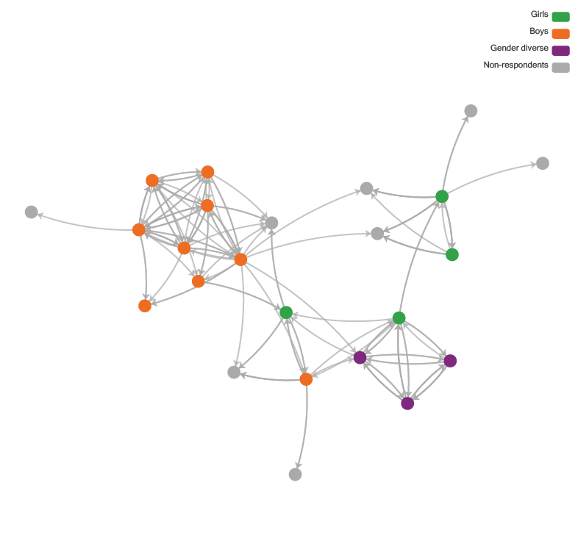

Statistical models for social networks: ALAAM
An Autologistic Actor Attribute Model (ALAAM; Daraganova & Robins, 2013; Robins et al., 2001) is a statistical model based on the widely used exponential random graph model (ERGM) for social networks (Frank & Strauss, 1986; Lusher et al., 2013). An ERGM can be used to model social networks, predicting the presence of a tie between two actors based on other ties (structural properties of the network) and attributes of the actors (nodes) themselves. By contrast, an ALAAM can be used to predict an attribute of an actor based on the actor’s ties to other nodes in the network, as well as attributes of the actor and its network partners. In this way, it is similar to logistic regression, but unlike logistic regression or similar statistical techniques it specifically does not assume independence of the predicted attributes across actors — an actor’s outcome attribute may depend also on those of its neighbours in the network. Hence, an ALAAM may be used as a model of social influence examining how some attribute of an actor in a network is affected by his or her position in the network and the attributes of other actors in the network.
We use ALAAMs for social network data to model a number of binary outcomes, namely resilience, pro-violence attitudes and gender equality attitudes. ALAAMs are a type of social influence model for predicting node-level outcomes. Similar to logistic regression, ALAAMs can model binary outcome variables (e.g. high resilience) from other node-level attributes, such as gender and education level. The key differences between ALAAMs and logistic regressions are that instead of treating an individual’s outcome as independent observations, ALAAMs consider these observations to be conditionally dependent. That is, people’s confidence in the group, or the lack thereof, may be dependent on their networked partners’ confidence in the group, or the lack thereof, as well as other attributes of their networked partners.
ALAAMs were first described in Robins et al. (2001) modelling the probability of attribute Y (a vector of binary attributes) given the network X (a matrix of 0–1 tie variables). The model can be expressed in the form (Daraganova & Robins, 2013) below. Let X denote the network variable which is a collection of network tie variables X={X_{ij}}, where X_{ij}=1 if there is a tie between node i and j, let Y={Y_{i}} denote the vector of outcome variables for nodes (i)s in the network, let Y^{c} denote other nodal attributes. Using lower case letters for instances of the network or attribute variables, ALAAMs can be expressed as:
Pr(Y = y|X = x, Y^{c} = y^{c}) = 1/κ exp ∑_{Q}θ_{Q}z_{Q}(Y,X,Y^{c})
where, z_{Q} are statistics counting the number of graph configurations of type Q. zQ (Y,X,Yc) has a typical form of z_{Q}(Y,X,Y^{c} ) = ∑_{Y}∏_{{Y,X,Y}^{c}_{}∈Q}^{YXYc} where all variables {Y,X,Y^{c}} within each configuration Q are conditionally dependent, conditional on a set of pre-specified outcomes (Daraganova, 2008; Koskinen & Daraganova, 2022).
The ALAAM predicts the outcome variable Y, taking into account network dependencies in a principled manner which is not possible with standard logistic regression. Assumptions about which attributes Y are independent, and therefore which configurations are allowed in the model, determine the class of the model. In the simplest case, in which any two attribute variables Yi and Yj are assumed to be independent, the only possible configuration is a single node. Then there are no network effects and the model reverts to standard logistic regression (Daraganova & Robins, 2013, p. 105).
The simplest network dependence assumption is that an attribute variable Yi is conditionally dependent on network tie Xjk if and only if {i}∩{k, j} is not empty; that is, if and only if the actor i is one end of the tie Xjk. Hence, the configurations allowed in this class of model include stars (Daraganova & Robins, 2013, p. 107) as well as the contagion effect; that is, the propensity of two nodes with a tie between them to both have the attribute Y.
Table 8 also lists the label of the effects, graph configurations and the possible interpretation when parameter estimates are positive (negative parameter means the opposite).
Table 8: List of ALAAM effects
Effects | Configurations | Interpretations (when positive)
Density |  | Baseline propensity to have outcomeª
Sender |  | Being more active in the network promotes outcome
Receiver |  | Being more popular in the network promotes outcome
Contagion |  | Contagion between networked partners
Nodal attributes |  | Having covariate attribute promotes outcome
Notes: ALAAM configurations and possible interpretations whenparameter estimates are positive. "1" indicates a node
with an outcome variable (Yi = 1) for node i. A grey node indicates a node with other nodal attributes (Y^{c}) as covariates.
Arrows of ties indicate directions. For non-directed networks, arrows are omitted, the "Sender" and "Receiver" effects are
replaced by the network "Activity" effect interpreted similarly to the "Sender" effect.
a The “Density” parameter is more like an intercept in linear regression and is not interpreted.
ALAAM is a social influence type model so the language used (e.g. “contagion”) reflects this approach. However, with cross-sectional data we are unable to discern if there is social influence (i.e. social contagion) or whether it is social selection (e.g. selecting people who are similar to me as friends).

Linear regression versus ALAAM
We include both linear regression models and ALAAMs because they both offer us value in different ways. Linear regression gives us the ability to look at predictors of attitudes and behaviours by gender, but not the impact of social relationships. ALAAMs, however, do give us the ability to look at the impact of social relationships. However, we cannot look at one gender at a time (like we do with linear regression) because this would remove all of the cross-gender relationships, which are so important, from our analysis. So, both are valuable, but in different ways.
Notably, for the linear regression models by gender, we do not include other resilience measures as predictors. We do so for two reasons. First, we do not want to overload our models with parameters, especially given the small numbers of gender diverse respondents (n=38). Second, these measures by gender regression models allow us to see what other non-resilience factors are related to this particular aspect of resilience. This approach contrasts with the ALAAMs where we have ample data points (n=725) as all genders are together and where we can include other resilience factors as predictors. We note that it is not possible to run ALAAM statistical network models separately by gender, as we did for the linear regression models, as this would remove social ties between genders which would impact on modelling results. Gender is included in the model as an attribute for boys and one for girls, with gender diverse young people being the default category. So, our analysis approaches are different, both by design and by model data structure limitations, to give us differing insights into the same issues.

Qualitative data collection
Qualitative data collection allows researchers to access participants’ nuanced experiences and their views, feelings and emotions on the topics being examined. Within the study, staff interviews and student focus groups were used to elicit participant perceptions of the program, views of those things that acted as drivers and barriers, and impacts of the program on attitudes, behaviours and relationships. Each of the methodologies will be described in detail below.

Students
Focus groups are designed to foster a supportive peer environment which enables participants to share their experiences and to engage in critical thinking and constructive dialogue (Adler et al., 2019). Qualitative research methods are particularly useful when seeking young people’s perspectives on the ways in which gender norms affect their lives and relationships and the extent to which they find their education programs make a positive contribution. Additionally, methods that seek student contributions within program evaluations provide opportunities for program designers, educators, and policymakers to access feedback from those for whom the programs are designed.
Focus groups were conducted with Year 7 and Year 9 students in four schools, with a total of 61 students aged 12 to 15 years. Of these students, 20 identified as girls, 39 identified as boys and two as gender diverse. An overview of the focus group participants is provided in Table 9.
Table 9: Focus group participation
Year level | Girls | Boys | Gender diverse | Language Other Than English
Year 7 | 13 | 15 | 1 | 5
Year 9 | 7 | 24 | 1 | 5
Students were asked about their experiences and responses to the program and were also asked to reflect on the school climate and how the program may have impacted attitudes and behaviour within their setting (see Appendix E for the student focus group questions).
The focus groups took place, in most cases, after program delivery was completed, which coincided with the end of the school year. There were a small number of students in some schools who were in classes that were still working through the final topics. Students were given the opportunity to scan their workbooks to remind them about the topics completed over the course of the year. Focus groups ran for between 30 and 55 minutes. All focus groups were audio-recorded and professionally transcribed. Transcriptions were quality checked against the recording by members of the research team in preparation for analysis.

Educators
Qualitative data collection from educators was by way of individual interviews. Semi-structured questions were used to elicit information on the delivery of the program, perceptions of impact of students’ attitudes and behaviours, and reflections on those things that supported and/or hindered implementation (see Appendix F for teacher interview questions and Appendix G for leader interview questions). Interviews ranged in duration from 20 to 55 minutes. Interviews were audio-recorded and professionally transcribed. The details of interview participants are provided in Table 10.
Table 10: Teacher interview participation
Interviewees | School 1 | School 2 | School 3 | School 4 | School 5 | School 6
Year 7 teacher | 2 | 1 | 1 | 0 | 1 | 0
Year 9 teacher | 1 | 1 | 1 | 0 | 1 | 0
Implementation lead | 0 | 1 | 2 | 1 | 1 | 0
Principal class | 1 | 1 | 1 | 1 | 1 | 0

Qualitative analysis

Student focus group and teacher interview analysis
Focus group and teacher interview data was analysed through the constant-comparative method of analysis using an iterative approach to determine thematic similarities and differences in responses. These became the basis for grouping the data into tentative categories and subcategories which were then dissected or combined to create generative themes that captured the patterns and relationships observed during analysis. Using these themes, the data was re-analysed by using Microsoft Word software to code the data to consider the emergent themes in relation to the research questions. Six themes that emerged through the analysis were:
- context of delivery in challenging times
- dealing with backlash and resistance
- staff capability, expertise and confidence
- student experience and contribution of the RRRR program when implemented with high fidelity
- teacher comfort, confidence and capacity as factors affecting fidelity of implementation
- structural factors affecting implementation.

Ethics

Ethical approval
This research project received ethics approval from University of Melbourne, Human Research Ethics Committee of The University of Melbourne (HREC: 20157547). Permission to conduct research in schools was granted by the Victorian Department of Education and Training (2020_004343) and the Melbourne Archdiocese Catholic Schools (1047_NAF). All research staff had Working with Children Checks (WWCC).

Language in report
Language used in this report was subject to ethical considerations. This research project explored the impacts of gender within a GBV prevention education program in schools. This prompted us, as researchers, to consider gender within the context of language to ensure that its use within this project reflected gendered rather than biological language. The student survey tool included a demographic question about gender identification. Gendered terms are used in this report to refer to the subgroups in the gender demographic sample. These terms are distinct from those terms available as response options to the gender demographic survey question. Table 11 details these distinctions and includes an explanation of the subgroups in the gender demographic sample:
Table 11: Gender demographic sample terms
Survey tool subgroup term | Report subgroup term | Subgroup explanation
Female | Girl | The term “girl” is used in this report for the subgroup of survey respondents who selected “female” as the response to the gender demographic question.
Male | Boy | The term “boy” is used in this report for the subgroup of survey respondents who selected “male” as the response to the gender demographic question.
Other or non-binary gender | Gender diverse | The term “gender diverse” is used is this report for the subgroup of survey respondents who selected “other or non-binary gender” as the response to the gender demographic question.

Participant safety
Engaging with topics related to gender and GBV can be sensitive. It is, therefore, important to create a sense of safety for participants. To mitigate risk of harm a range of protocols were established. Participants were advised on the focuses of the intervention program, surveys, interviews and focus group discussions including possible risk of emotional distress allowing for informed consent. Student and staff surveys included guides to help seeking advising of the importance of seeking support in the event of experiencing distress and contact details of organisations such as Kids Helpline and 1800RESPECT. School staff administering the student survey were provided with a Guide to Student Participation that contained a script to read to students prior to conducting each of the three surveys. This script reinforced that participation was voluntary, that questions could be skipped, that opting out of the survey was acceptable and drew attention to the help-seeking information in the event of experiencing any distress. Schools were advised to inform their wellbeing staff about the study and data collection schedule to create awareness in the event of students requiring support. To address any concerning levels of violence reported by students, data from the student surveys was analysed within two weeks by the SNA researchers enabling prompt detection of any issues. Participants were advised in the Plain Language Statement that if evidence of concerning levels of violence was detected, the chief investigator would contact the principal of the school to provide them with an overview of the pattern observed and to alert them to the need for school-based vigilance and protective responses. No such levels were found in the data returns.

Participant privacy
The confidentiality of participants’ personal information was protected through a secure data management process. Pseudonyms were assigned to each of the schools. To protect the identity of students, only first names and class names were used in the student social network survey questions. Student names were only accessible to the social network researchers for the purposes of constructing the survey and conducting analysis. Names of class peers chosen by participating students from the dropdown list automatically converted to a unique identifier number following input by the student making the selection. Students in the focus groups were not asked to supply their name on the demographic information sheet and were assured their contributions would be reported via their school’s pseudonym, their year level and the word “student”. Accordingly, direct quotes in this report use the school pseudonym, data source and participant status (e.g. School 1, Student Focus Group, Year 7). While student gender information was provided by participants on the information sheet, attribution of gender to direct quotes in the report was only possible for the boys’ school as all focus group participants in this setting checked male on their demographic information sheet. Attributing gender to participants from all other schools based on name and/or voice from the recordings and transcripts had the potential to misgender and was therefore omitted from these students’ direct quotes.

Summary
A mixed methodology was used to examine the impact of the RRRR program on the social health of Year 7 and Year 9 students and to identify the extent and nature of the education programming needed to advance students’ gender-related attitudes, resilience, peer relationships, student to teacher relationships and coping strategies. Data was collected through surveys, teacher and leader interviews and student focus groups. Participants were recruited from six Victorian State and Catholic secondary schools. Survey data was statistically analysed as described above and interview and focus group data were analysed to identify themes in relation to addressing the research question.

Part C:
Key findings – quantitative

Introduction
This part provides an overview of participants and an analysis of the student survey data. Social connections (i.e. networks) between students within their classes is analysed using Social Network Analysis (SNA). To examine the social and emotional health of the student participants, resilience is analysed using a range of measures including individual confidence, respectful regard, social capability and negative cognition. Additionally, we also examine violence-endorsing attitudes, gender equality attitudes, loneliness, student perceptions of classroom climate and student intentions to act (i.e. “speak out”) in the face of hearing or witnessing sexual harassment. Finally, students’ evaluation of the RRRR program is analysed to understand students’ perceptions of the value of this education program.

Teacher results
The teacher survey data was significantly limited in both quality and quantity. For the teacher training exit surveys, 36 responses were received across the six schools. For the program implementation monitoring surveys, responses were received from 46 staff members; however, there were only 19 complete surveys from the six schools. For the baseline teacher surveys, we received 37 responses across six schools and for the endpoint surveys, we received 19 partial responses (and only 14 fully completed responses) from teachers across five schools. The set of baseline and endpoint surveys from the same teachers included only 14 complete responses and 18 partial responses across five schools.
These numbers were substantially less than the ~100 teacher responses hoped for. Given the limited number of data points for teachers, we do not analyse this teacher baseline and endpoint or the teacher implementation monitoring survey data in any detail here. For greater insight into teacher experiences, we direct the reader to the qualitative results of teacher interviews.

Student results
The student survey data were analysed and the results are presented here under eight key headings:
- Demographics
- Social connections
- Individual resilience versus social resilience
- Violence: Disrespect comes from pro-violence people
- Gender equality predictors
- Loneliness
- Classroom climate
- Program evaluation

Summary of student survey results
The following represent a summary of the key findings from the quantitative survey approach. These findings are also included in each of the relevant sections.

Resilience
On the overall resilience measure, boys are more resilient than girls, and both groups are significantly more resilient than gender diverse young people. For some aspects of resilience (i.e. subscales or subcomponents), boys score significantly higher than girls, including on confidence, dealing with negative cognitions, and peer availability.
Respectful regard for boys is linked to positive gender equality attitudes and speaking up against sexual harassment. Social capability for boys is also associated with speaking up against sexual harassment and with violence dis-endorsing attitudes. However, while individual confidence is also associated with speaking up against sexual harassment, it is unrelated to gender equality and violence attitudes. Overall, analyses for confidence that include all genders show that confidence is negatively related to supporting gender equality. This suggests that respectful regard and social capability, as resilience measures, are much more impactful and pertinent when addressing violence reduction and gender equality than individual confidence, though confidence has a role for boys in bystander intervention.
Individual confidence may be an aspect of resilience that may help the individual but not those around them. That is, what is good for an individual may not be good for everyone else around them. In contrast, we can think of respectful regard and social capability as social resilience measures, ones which are geared to understanding the perspectives of others (respectful regard), as well as being able to appropriately socially engage with others (social capability). Thus, respectful regard and social capability are important relational measures of resilience. Confidence can certainly be a positive thing, but we suggest it must be in conjunction with respectful regard and social capability. Despite that individual confidence has been seen as a marker of resilience, it may not be a marker of respectful relationships and it is possible that individual confidence could overlap as a measure which also picks up what might be called a sense of entitlement. Currently, our data suggest that a link between respectful regard and gender equality attitudes is present for boys, but not for girls. The same is true for social capability. This may indicate that boys are in greater need of the contributions of the program addressing emotional awareness and empathy, as well as from a focus on gender equality and prevention of gender-based violence.
There appears to be no relationship between social capability and confidence, but there is between social capability and respectful regard. As will be noted in the section on violence later in this part, confidence is highly related to violence, negatively related to social capability and unrelated to respectful regard. Further, low confidence attitudes are predictors of pro-gender equality attitudes. This again suggests a singular focus on building individual student confidence and how it is not necessarily going to make them better student citizens in terms of violence and gender equality. Building individual student confidence, coupled with the predominant resilience tools, respectful regard and social capability, would better facilitate building gender equality attitudes and behaviours.
Boys and girls who are not bullied by other students, and gender diverse young people who are not sexually bullied by other students, can better deal with negative cognitions. In addition, dealing better with negative cognitions is related to calmer classrooms for both boys and girls.
For gender diverse young people, not being sexually bullied by other students predicts both higher social capability and is additionally a predictor of a higher ability to deal with negative cognitions. Bullying prevention may reduce vulnerability to negative cognitions, and for gender diverse young people is likely to impact on other resilience factors including confidence and respectful regard.
In summary, the findings from the resilience data suggests that girls, boys and gender diverse young people have different resilience profiles. Gender should certainly be taken into account; however, it should also be noted that there is considerable variability within genders and that students should not be stereotyped based solely on gender.

Violence
Baseline data shows that boys hold significantly higher pro-violence attitudes and pro-domestic violence attitudes than girls. Pro-violence attitudes are linked to lower gender equality attitudes, which is in line with theoretical perspectives and empirical evidence on these issues (Hill et al., 2020).
In analyses of the genders grouped, individual confidence is a positive predictor for pro-violence attitudes, whereas social capability is a negative predictor for pro-violence attitudes. As previously noted, to have high individual confidence without social capability and respectful regard may not be conducive to respectful conduct within relationships.
Pro-violence attitudes positively relate to peer connectedness but negatively to school connectedness.
Students who bully other students are also more likely to sexually bully others. Those who bully other students are also more likely to be bullied by other students themselves. This indicates the entwining of violence and gendered violence, as well as the notion that violence begets violence.
Students who bully others are more likely to be selected by other students as being directly disrespectful to them.
Students who bully others are more likely to choose, as close friends, other students who also bully others. Additionally, students who bully others are significantly more likely to want to work with, and also spend more time with, other students who also bully others. This pattern also holds for those who sexually bully others, as they are close friends with other students who also sexually bully others. Further, such students also report they could work with these similar-acting students on group tasks and want to spend more time with them. This suggests some students may be socially connected in ways that position them to mutually reinforce various bullying and sexualised bullying behaviours through their positive social connections with peers who hold the same beliefs and enact the same behaviours. Interventions could consider changing opportunities for social interaction (e.g. mixing students across friendship and gender divides when working on collaborative tasks and ensuring that students hear from a diverse range of voices within class discussions).
Support for domestic violence is strongly associated with low gender equality attitudes. Similar to sexually bullying and social ties, there is a social element at play such that students who endorse domestic violence views are more likely to nominate someone else who endorses domestic violence as someone they want to spend more time with.

Gender
Baseline data showed that gender equality attitudes are lower, on average, for boys than either girls or gender diverse young people (with the latter two genders not differing).
For boys, positive gender equality attitudes are associated with low violence-endorsing and low domestic violence-endorsing attitudes, as well as with preparedness to speak up against sexual harassment. Girls who hold positive gender equality attitudes also demonstrate this profile; however, girls’ positive gender equality attitudes show an additional associated factor of being unlikely to bully others. Anti-violence attitudes also relate to pro-gender equality attitudes for gender diverse young people. Overall, attitudes about use of violence are strongly linked to attitudes towards gender equality.
For all genders, students who hold pro-gender equality attitudes are more likely to be socially connected to like-minded others, either as friends or as people they say they can work with on group tasks, or in an aspirational sense of wanting to spend more time with that person. This result is a counterpoint to the students who bully and/or sexually bully others and are friends with similar acting others. This highlights the absolute importance and intersection of social connections and attitudes that students hold.
Pro-gender equality attitudes reduce with age, with Year 9 students more likely to hold negative gender equality attitudes as compared to Year 7 students.
Low individual confidence, not high individual confidence, is associated with higher gender equality attitudes. As previously noted, individual confidence may be an indicator of a sense of entitlement and reinforce power relations.

Loneliness
Gender differences exist for loneliness. Gender diverse young people are lonelier than girls and girls are lonelier than boys, which is in line with research (see Leung et al., 2022).
Boys and girls who have a physical impairment that impacts on their daily lives are more likely to feel lonely.
Students who are lonely do not seem to be less connected than other students in terms of the social networks measured, but they do say they do not feel connected to their peers. This suggests that lonely students may not be connected in meaningful ways to other students.
In terms of resilience factors, lonely students are high in social capability, but are likely to be low in confidence, struggle with negative cognitions, and feel disconnected from their peers. Being high in social capability may not necessarily mean that someone is experiencing close or satisfying relationships.

Disruptive classrooms
Gender diverse young people deem the classroom climate to be significantly more disrupted than girls and boys, though girls and boys do not differ in their perceptions of the classroom environment.
Popular students are less likely to see the classroom climate as disrupted. Potentially this may be because it is interaction between socially connected popular students which is the cause of some of the class disruption. If so, this could mean that those doing the disruption are less likely to perceive it to be a problem, while others find it upsetting. Overall, the data suggests that social relations are important in how students view their classroom climate.
Gender profiles for boys, girls and gender diverse young people who report the classroom as a disrupted environment suggest very different reasons or outcomes.
Overall, students who report the classroom as disrupted are older, report being lonely and being challenged by negative cognitions.

Program implementation
A key metric for fidelity of implementation is whether students consistently worked in small groups or not. In terms of fidelity of implementation of the RRRR program, within endpoint surveys, we found only 26 students (or 6.6%) reported working in small groups all of the time, with 369 (93.4%) not doing so. This would suggest that the fidelity of implementation of the RRRR program across the schools was not high in relation to use of the collaborative learning methods. Instead, whole class discussions, rather than role plays or working in small groups, was the most common way in which the RRRR program was delivered.
Students who experienced the program as high fidelity scored significantly higher in their rating on the usefulness of lessons on gender and equality and GBV and showed a significant increase in both self-reported social capability and self-reported respectful regard at endpoint, whereas the reported emotional insight of students who did not report working in small groups all of the time remained the same. This is supporting evidence that when the RRRR program is implemented with high fidelity there are stronger outcomes, including an increase in social capability and respectful regard for students.
Nonetheless, the vast majority of students said they gained from participating in the RRRR program, with girls and gender diverse young people making stronger endorsements than boys. It is notable that gender diverse young people scored almost twice as high as girls and boys in terms of reporting that lessons about gender and equality were “extremely useful”.
When asked about whether the RRRR program should be provided for Year 7 and Year 9 next year, there were marked differences in students’ responses between different schools, with students from some schools less enthusiastic to continue with the RRRR program. Many of the students were unsure. This may reflect levels of fidelity of delivery.
Comparing baseline and endpoint student responses, we observe a reduction in the number of students who said they sexually bullied other students (baseline = 8.7%, endpoint = 5.9%), and for non-sexual bullying we see a decrease from baseline (11.8%) to endpoint (10.3%). This points to a positive impact of the RRRR program.

Social connections
Through our social network analysis, we found that students’ school life was marked by pronounced gender divides, with students rarely befriending or working with others of a different gender. The inclusion of student social relationships (as social networks) provides a valuable insight into the structure of social connections between students by showing the intersection between social connections and attitudes that students hold. Social relationships are mechanisms that may influence both attitudes and behaviour, in either positive or negative ways. Therefore, we should not look only to solutions that position students as isolated individuals operating as independent agents, but also as young people connected in dynamic ways within a social ecology.
In this report, we see evidence that students seek to socially connect with those who hold similar attitudes and/or behave similarly – whether this be bullying others, holding beliefs that support domestic violence or holding anti-violence or pro-gender equality attitudes. Given that we also note the gender divides in student friendship groupings, this can mean that a number of different micro-cultures might exist within one class, offering different forms of peer influence.

Demographics
The overall numbers of student participants by school in baseline and/or endpoint surveys are presented in Table 12.
Table 12: Year level by school of survey participants (baseline and endpoint)
Count | School 1 | School 2 | School 3 | School 4 | School 5 | School 6 | Total
Year 7 | 63 | 110 | 17 | NA | 32 | 14 | 236
Year 9 | 57 | 62 | 31 | NA | 9 | 0 | 159
Total | 120 | 172 | 48 | NA | 41 | 14 | 395
Table 13 and Table 14 show the participating number of students per school for baseline and endpoint surveys, respectively. The greatest numbers of student participants were for the baseline (Time 1) survey between March and June for the schools – prior to the commencement of the RRRR program intervention.
Table 13: Year level by school of survey participants (baseline only)
Count | School 1 | School 2 | School 3 | School 4 | School 5 | School 6 | Total
Year 7 | 125 | 121 | 59 | 21 | 62 | 25 | 413
Year 9 | 129 | 80 | 52 | 11 | 26 | 0 | 312
Total | 254 | 201 | 111 | 32 | 88 | 39 | 725
Table 14: Year level by school of survey participants (endpoint only)
Count | 1 | 2 | 3 | 4 | 5 | 6 | Total
Year 7 | 75 | 116 | 52 | NA | 39 | 28 | 310
Year 9 | 65 | 64 | 62 | NA | 11 | 0 | 202
Total | 140 | 180 | 114 | NA | 50 | 28 | 512
For the endpoint survey data (see Table 14), it was agreed that one of the schools would modify their participation in the research due to low response rates to the baseline survey and the school reporting ongoing survey administration challenges. This school remained in the study and participated in the qualitative data collection phase.
Table 15, Table 16 and Table 17 present the gender breakdown by school for baseline and endpoint, baseline only and endpoint only, respectively.
Table 15: Year level by gender of survey participants (baseline and endpoint)
Count | Girls | Boys | Gender diverse | Total
Year 7 | 106 | 120 | 10 | 236
Year 9 | 63 | 85 | 11 | 159
Total | 169 | 205 | 21 | 395
Table 16: Year level by gender of survey participants (baseline only)
Count | Girls | Boys | Gender diverse | Total
Year 7 | 178 | 222 | 13 | 413
Year 9 | 111 | 176 | 25 | 312
Total | 289 | 398 | 38 | 725
Table 17: Year level by gender of survey participants (endpoint only)
Count | Girls | Boys | Gender diverse | Total
Year 7 | 127 | 171 | 12 | 310
Year 9 | 67 | 124 | 11 | 202
Total | 194 | 295 | 23 | 512
Broader student characteristics are presented in Table 18. (This table matches the previously presented Table 4 but is represented here for ease of reference.)

Table 18: Participating student characteristics (baseline and/or endpoint, total)
Characteristic | Count
Students | 725 baseline  512 endpoint  395 baseline and endpoint
Gender | 314 girls (37.3%)  488 boys (58.0%)  40 gender diverse (4.8%)
School type | 177 boys’ school (21.0%)  665 co-education school (79.0%)
Year level | 487 Year 7 (57.8%)  355 Year 9 (42.2%)
Age | 13.06 years (average)  (Range: 10–20 years)
Language Other Than English | 120 LOTE (14.3%)  722 English only speaking (85.7%)
Aboriginal and/or Torres Strait Islander | 18 Aboriginal and/or Torres Strait Islander (2.1%)  824 non-Aboriginal and/or Torres Strait Islander (97.9%)
Impairment that impacts on your lifeª | 55 yes (6.5%)  787 no (93.5%)
Note: ª As noted, responses are to the question, “Do you have any long-term difficulty hearing, seeing, communicating, walking, climbing stairs, bending, learning or doing any similar activities?” and, thus, do not include mental health issues.
Many of the findings in this report focus on this baseline data due to high participation rates and thus good coverage across six schools. The baseline data provides for a broad analysis of attitudes and experiences as students commenced the program.
Overall, given increased attrition rates for students participating in surveys, and sporadic and low fidelity of implementation of the RRRR program, it was decided to focus on the baseline data as the largest dataset and present results based on this data. We note that the social network models presented in this report utilise baseline data only (n=725). However, we also present data comparing baseline and endpoint on 395 students who participated in the surveys at both timepoints, as we have some key analyses that look at baseline and endpoint survey responses from these students.

Social connections
A key component of the quantitative component of this research was a focus on social connections among students, and the use of Social Network Analysis (SNA) to do so. More detail about SNA can be found in the methodology section (see Part B).
As a reminder, we have four questions we asked students about their social relations:
- In your class, who do you consider a close friend?
- In your class, who can you work with on group tasks?
- In your class, which students are disrespectful towards you?
- In your class, who would you like to spend more time with?
Below we present some visualisations of these social connections of students. Importantly, students were only able to nominate other students within their own classroom in terms of responding to the four questions above due to the research design. This was because the RRRR program was implemented on a per class basis and so it was hoped to be able to match classroom social dynamics and overall class levels with the implementation of the program. Unfortunately, only a small number of teachers/school leaders who implemented and taught the RRRR program completed the endpoint survey (14 only), and so this opportunity to connect teacher-rated program implementation with student views of the program was not possible systematically based on the data collected.
We begin with a selection of network visualisations (i.e. maps) of student relations from classrooms before presenting some overall school-level network maps.

Classroom social relations (networks)
Figure 2 (panels A to D) shows four different examples of friendship relations among class members and the notably different social dynamics from one class to the next. Each dot represents a student, and the arrow points toward the selected student – in Figure 2, towards students who are selected as close friends.
Figure 2 (panel A) shows both separate clusters of students in the class, as well as a separation by gender. Compare this to Figure 2 (panel B) which shows one large friendship group that has multiple cross-gender connections and highly connected gender diverse young people. In such a class, there may be more receptivity to increasing intergender relations. This contrasts with Figure 2 (panel C) where there is complete separation by gender (assuming the non-participants are the same gender as the rest of the group they are connected to). Finally, Figure 2 (panel D) shows a paucity of close friendship relations within the class, with many students having no-one they call a close friend within their class. These illustrative examples highlight how different, even within the same school, one class can be to another. While there may be some similarities, every class will be unique in the structure of its social relations.
Figure 2: Friendship in four classrooms
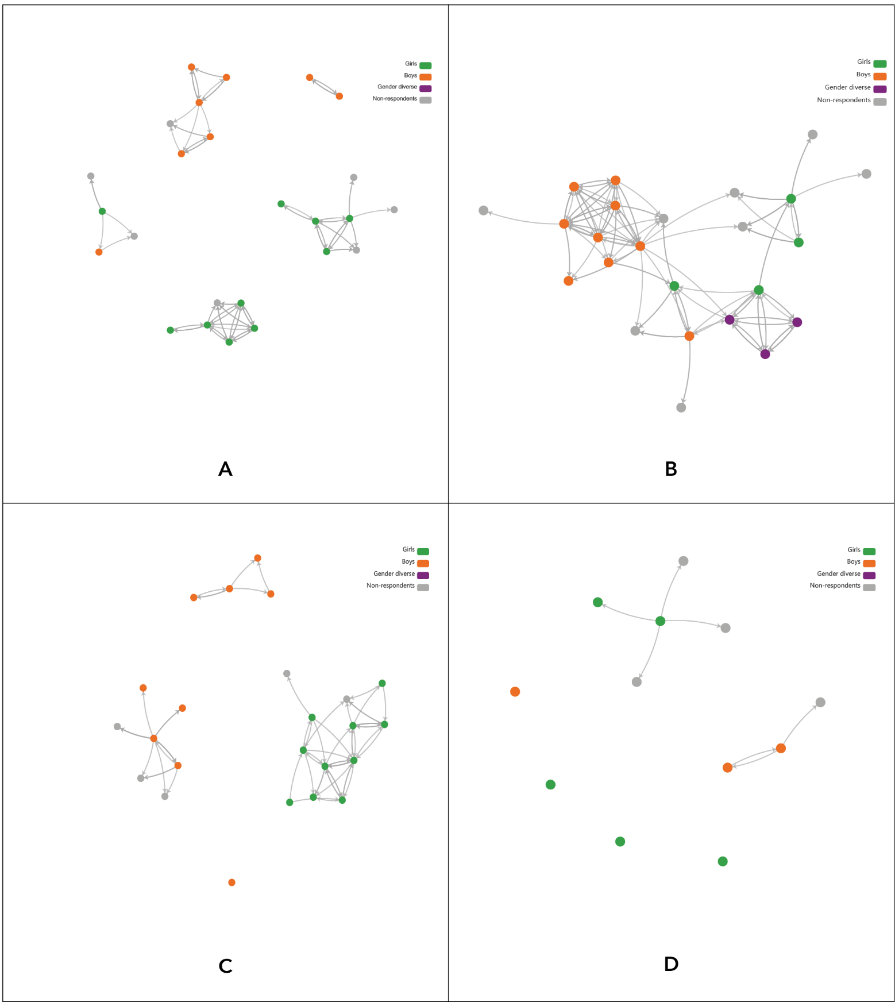
In Figure 3, we examine six classrooms for their disrespect relations. Figure 3 shows a range of ways that disrespect relations can manifest themselves within a classroom. Figure 3 (panel A) shows a girl who selects multiple others as being disrespectful to her (all the arrows are pointing out from her towards others).
At the top of Figure 3 (panel B) we see a star-like configuration of disrespect relations, but this time there is one student who is highly selected by many others (many arrows pointing toward one student). So here is a case where a number of students view one particular student as disrespectful.
Figure 3 (panel C) is somewhat of a combination of A and B in that we see some students who nominate many others as disrespectful, and we also see some students who are nominated by many others as disrespectful. Further, there is within-gender and cross-gender disrespect here.
Figure 3 (panel D) shows quite low levels of disrespect, and for the classroom in Figure 3 (panel E) it is entirely absent. We should note that this was the only class in the whole study for which there was not one disrespect relation present.
Finally, Figure 3 (panel F) offers a complete contrast, where every student is involved in some way in terms of disrespect. Here we can see one gender diverse young person indicating one other student is disrespectful towards them, another gender diverse young person indicating that multiple students are disrespectful towards them, and a third gender diverse young person who both disrespects and is disrespected by others. There are other cross-gender disrespect relations going from boys to girls and from girls to boys. Additionally, we see that some of these disrespect relations are mutual (the arrow goes in both directions), indicating that both students see the other as being disrespectful. No such mutual disrespect ties were present in the other disrespect networks. Mutual disrespect ties may represent more entrenched animosity.
What Figure 3 demonstrates is that implementing the RRRR program will be easier in some classrooms (Figure 3 [panel E]) than in others (Figure 3 [panel F]). Further, different approaches may be required depending on the social dynamics of the class. Having social network data such as this could be exceptionally helpful as an evidence base for teachers to help them better understand and, in many cases, confirm their understanding of student social relations in the class. Armed with this evidence base, teachers could more readily understand where gaps exist between groups and how to organise mixed group activities.
Figure 3: Disrespect in six classrooms
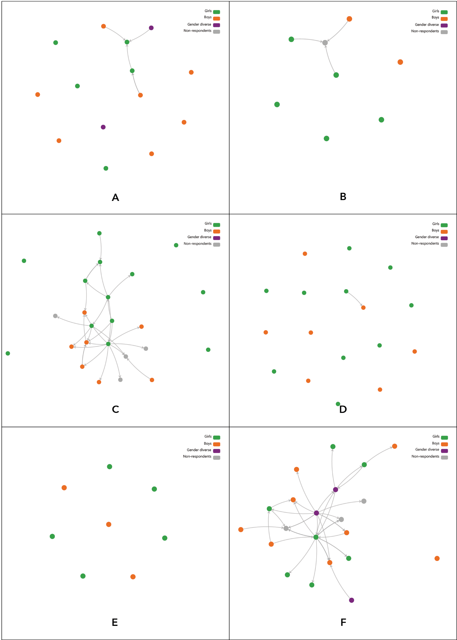

Whole school
We now present some visualisations for one whole school to demonstrate the greater variety of social structures that exist in schools.
In Figure 4, we present the close friendship relations of one school. Each dot represents a student, and the arrowed lines represent the nomination of another student as a close friend, with the arrow pointing towards the student nominated. What is visible are small clusters of students. For the bigger clusters (e.g. circled in red) this would represent a whole classroom, such as those presented in the previous section in Figure 3. Some of the smaller clusters (e.g. circled in light blue) would represent smaller subgroups of friends from a class.
Some students nominate others as close friends, but are not nominated in return – that is, there is an arrow only going in one direction, not in both directions as per a mutually agreed friendship. In some cases, this may be because of an asymmetry in the perception of the relationship where one student views there to be a close friendship and the other does not. Such asymmetries can represent power differences where one student may feel the need to impress the other student to agree to be their friend. Such asymmetries may also represent differences in how students define “close friend”. In other cases, though, we know that not all students from each class participated in the research, and so there may be the absence of a tie in the network visualisation because the student that was nominated did not participate and therefore could not nominate the other student in return.
Along these lines, we do see a number of students with no close friendship nominations – they appear isolated. Indeed, some students surely will be isolated in terms of friendship, and not have anyone within their class that they consider a close friend. However, from other research we know this is not all that common (see Lusher, 2011) and it is more likely that students may have close friends in other classes, or may have friends, but do not consider them to be “close” friends. However, as noted above we have focused here only on social relations within classes, and as such we do not capture these cross-classroom connections. However, including these non-participants within the network maps is useful because we can identify if students have nominated others as close friends. If we only included students who participated, we would miss this valuable information. Future research would do well to account for these cross-classroom connections, particularly for secondary school students. Additionally, stronger recruitment of participants within classes would show a more complete picture of in-class relationships.
Perhaps the most significant insight is gender separation in the networks. Girls (green nodes) and boys (orange nodes) appear quite separate and disconnected from each another despite being connected within genders. Further, where there are connections across the gendered divide, it is usually one or two students who are acting as brokers across genders. This data, drawn to the attention of teachers, might serve to prompt teacher awareness of these patterns of segregation by gender, and alert them to the importance of providing opportunities for students to mix with others in the class using collaborative pedagogies.
Gender diverse young people (purple nodes) are distributed in different ways across the friendship network, with no clear patterns. One is isolated, one serves as a broker between friendship groups, some are connected to girls, to boys, or both, and when there are multiple gender diverse young people within a class they are often connected. Variability is also a feature for the connections of girls and boys. It should be noted that the cluster with the most gender diverse young people are from the school that had the highest number of participants identifying as gender diverse.
Figure 4: Network visualisation of friendship network for a school (Years 7 and 9)
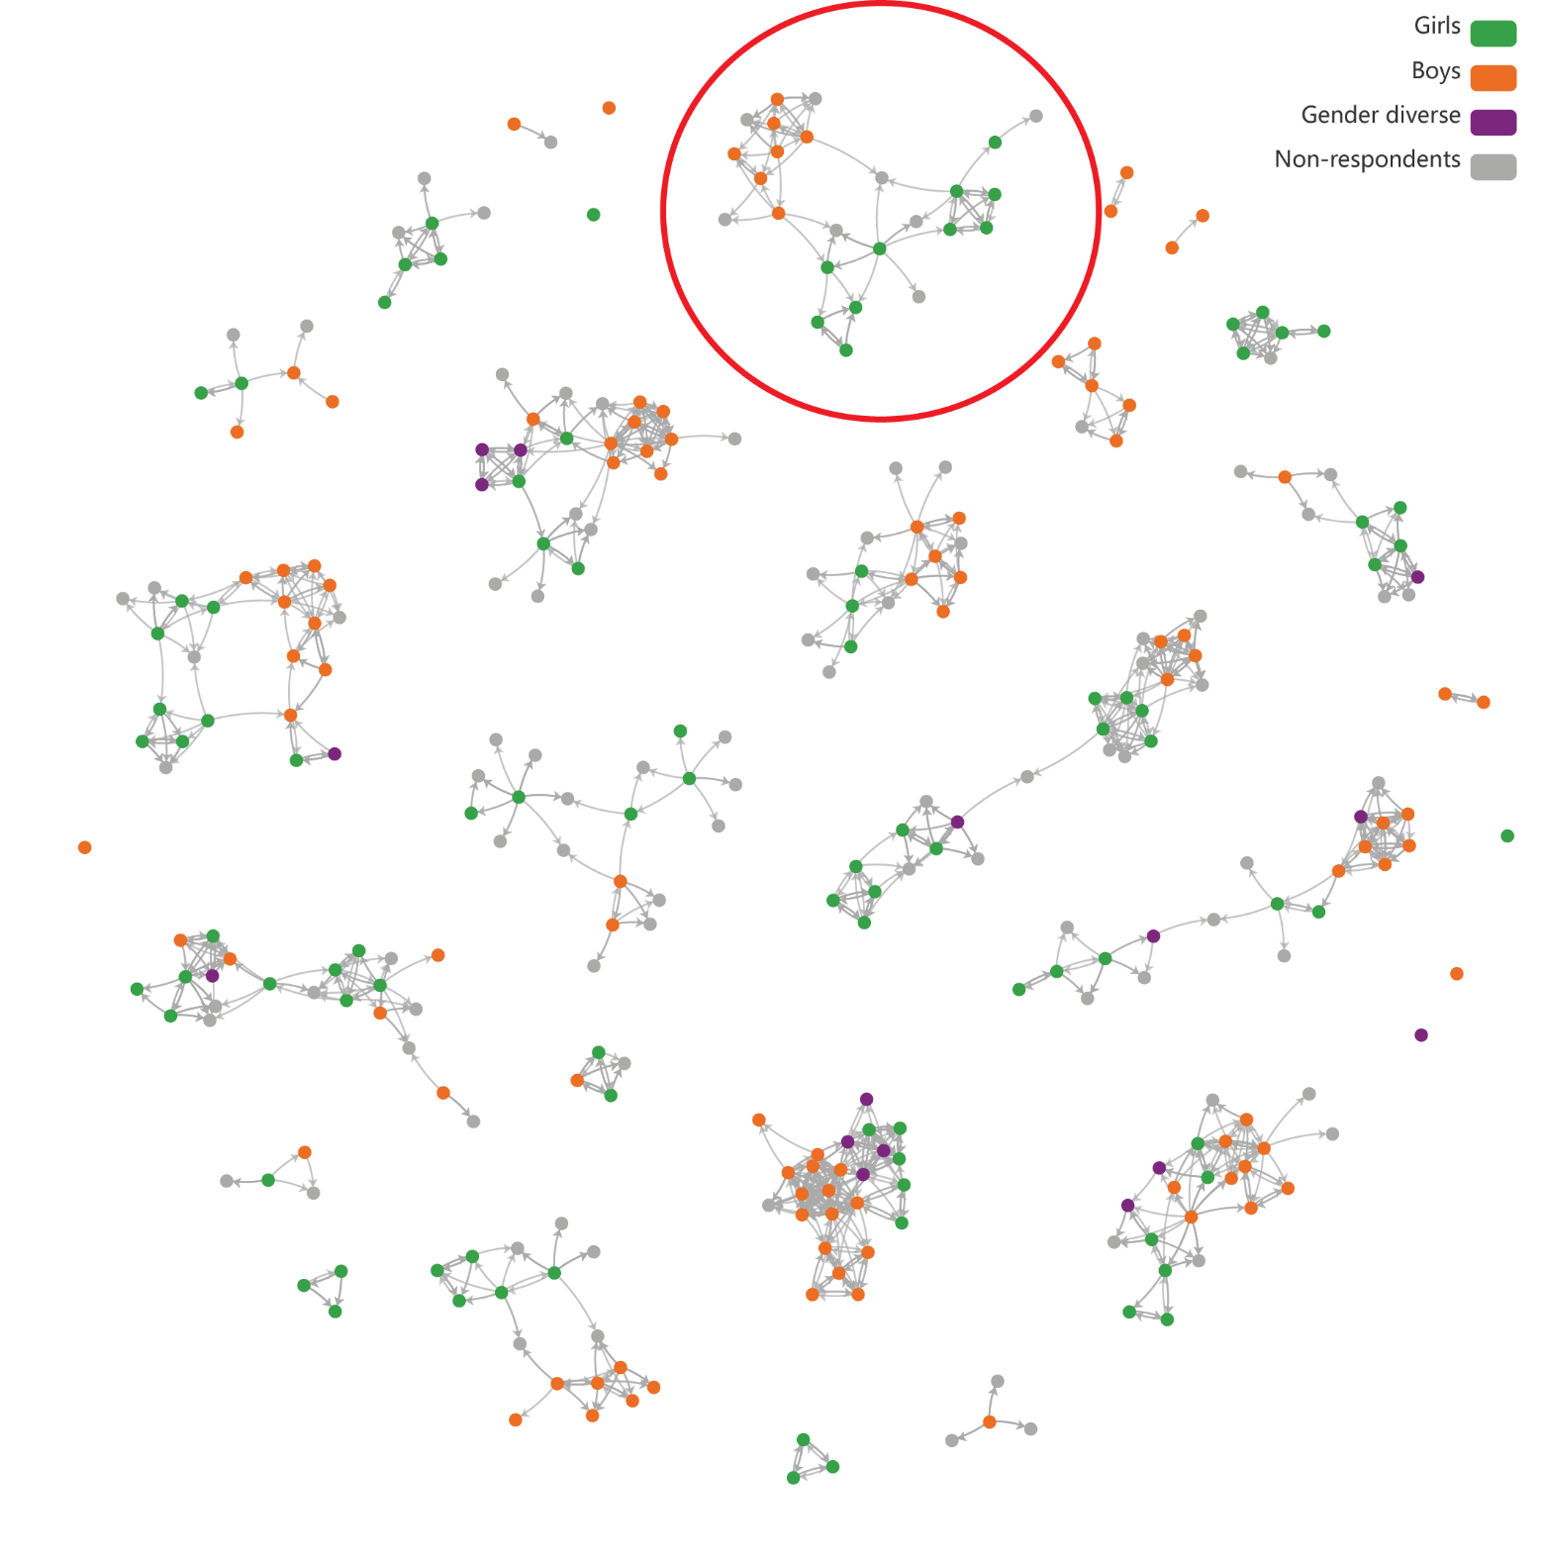
When we examine the network for “In your class, who can you work with on group tasks?” it appears that gender segregation is even more pronounced. There are strong clusters of green and of orange nodes, often with no connection to one another or with one to two nodes acting as brokers across genders. Gender diverse young people are connected in many ways but are certainly connected to one another. There are only a small number of isolated students. This suggests that students see their social interactions and student learning opportunities through a gendered lens that is quite firmly, for most students, within genders. This, in turn, may be an indicator that teachers rarely provide opportunities for students to work on collaborative tasks in mixed gender groupings.
Figure 5: Network visualisation of “Who can you work with on group tasks?” for a school (Years 7 and 9)
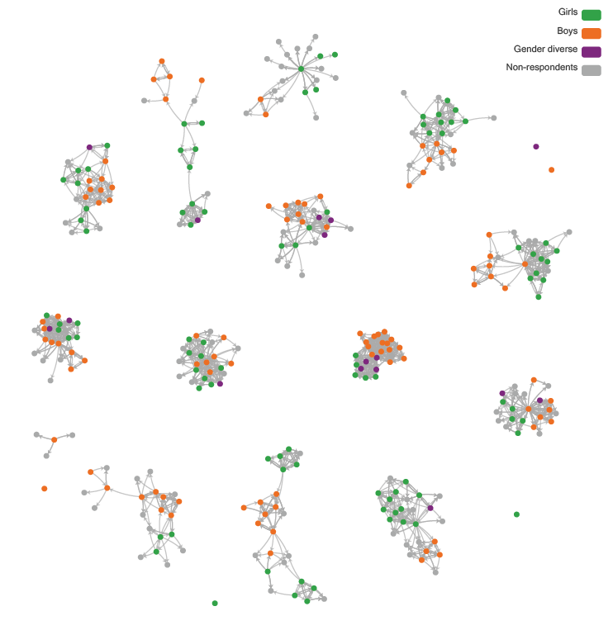
A network visualisation of disrespectful relations is presented in Figure 6 and shows a number of interesting things. First, there are fewer social ties pointing to others as disrespectful, which is highly positive. While close friendship relations are favourable, fewer disrespectful relations is optimal. As you can see, there are many isolated nodes compared to the friendship network and this is a positive for this type of relationship which we would define as a negative relationship (unlike the positive relationship of friendship). Of course, it may be that we are not picking up some disrespectful relations because not all students participated, and there may be some cross-classroom nominations which we have not permitted in the data collection method. Second, there is more cross-gender connection here than in the friendship network visualisation, indicating that some students feel disrespected by those outside their gender membership group. There remains considerable nomination of students as disrespectful within genders, but there does appear to be more interconnectivity or experiences of cross-gender disrespect here. In addition, gender diverse young people appear to be nominating other students as disrespectful (arrows going out) but do not seem to be nominated as disrespectful as often (arrows coming in).
Figure 6: Network visualisation of “Which students are disrespectful towards you?” for a school (Years 7 and 9)
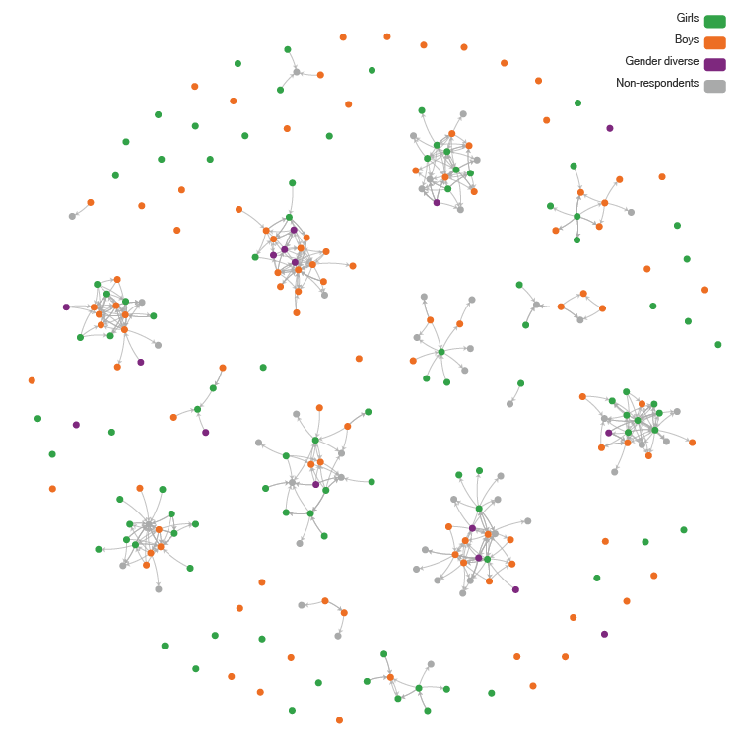
The final network visualisation, Figure 7, shows who students would like to spend more time with. Here we see some instances where there appears to be more cross-gender relations, though in the rest of the graph there remains quite an amount of clustering within genders, and where there is cross-connection it is often by one to two individuals. Interestingly, gender diverse young people sit in a mediating position between boys and girls. This suggests that some students would appreciate opportunities to build stronger relationships with those of other genders.
Figure 7: Network visualisation of “Who would you like to spend more time with?” for a school (Years 7 and 9)
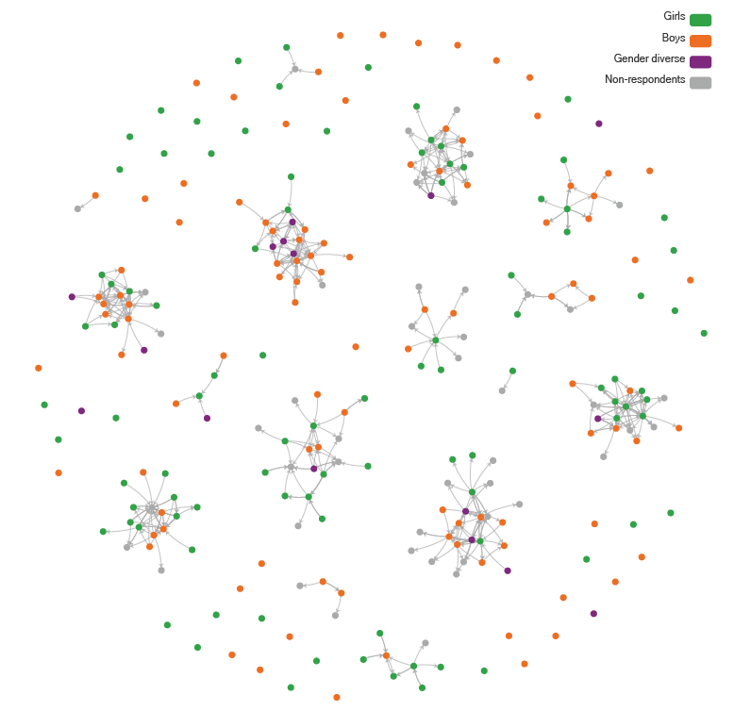

Insights on social connections
These illustrative network images from one school give us a sense of the social network data we have on student social connections. They illustrate visually and clearly the level and structure of connectivity among students and provide insights into the social system of schools. There is, of course, variability from one school and class to the next, but, overall, there is strong similarity across the participating schools in terms of gender relations.
While the network visualisations are certainly helpful, we now focus on the results of the statistical models for social networks because these provide statistically backed insights about patterns of the survey data. As a reminder, details explaining these network statistical models are in the methodology section (see Part B).

Resilience
Resilience is a key concern regarding the healthy development of school students. Resilience research has evolved from a tradition of longitudinal studies which track children’s capacity to deal with adversity or the ways in which they made positive adaptations to change and challenges (Gartland et al., 2019). This research has identified that risk and protective factors for resilience include those at individual, family, school and community levels (Beyers et al., 2004; Masten & Obradović, 2006; Mmari & Blum, 2009; Resnick et al., 1997). To measure resilience, we used a subsection of the Adolescent Resilience Questionnaire (ARQ) developed by Gartland et al. (2011) for use in the Australian context. The subsection we used was the component designed to identify individual factors associated with resilience. The questions that constitute the scale items and the construction of subscales can be found in the methodology section (see Part B). We utilised items from Gartland et al.’s (2011) Emotional Insight and Empathy/Tolerance subscale to create our own new Social Capability subscale. Further, we utilised items from Emotional Insight and Social Skills to create a new Respectful Regard subscale. These decisions, detailed in the methods and discussed later in this section, were based upon the notion that Gartland et al.’s (2011) Emotional Insight and Empathy/Tolerance subscale is, in our view, more relevant to emotional insight, empathy, respect and inclusion of the diversity and needs of others. This is the focus throughout the RRRR program as an underpinning orientation in relation to peer support, respect and positive relationships. The program focuses specifically on considering how others might feel not only in Topic 1: Emotional Literacy of the program, but also across all topics. Further, a Principal Component Analysis (PCA) of the baseline data showed statistical support for the new grouping of these items for these concepts.
Importantly, other Gartland et al. (2011) subscales within the items relating to individual influences on resilience remain as designed, though we did use a reduced number of questions and removed any items that improved the scales’ reliability.
In Table 19, in the lefthand side column, we present subscale names of the ARQ, and in the righthand side column, we show the post-hoc statistically significant differences in mean scores from an ANOVA examining each subscale by gender.
From Table 19 we see for the ARQ Resilience measure – overall score and subscale scores – that all factors showed significant effects for gender, apart from respectful regard. As such, boys scored significantly higher on many aspects of resilience than girls. Boys and girls showed significantly higher scores than gender diverse young people on almost all resilience measures. However, all genders are equal in terms of respectful regard.
The differences in gender profiles for the overall scale and the subscale results suggested it is worth examining some of these subscales in more detail, as well as the overall ARQ scores of students. Those which we found most theoretically applicable to the current research were individual confidence, emotional insight and negative cognition. Peer connectedness and school connectedness were also concepts of interest that we consider in our analyses.

Table 19: Gender differences for resilience subscales for baseline survey data
ARQ Resilience subscale | Difference
ARQ Overall Resilience | Boys = Girls > Gender diverse
INDIVIDUAL – Confidence | Boys > Girls > Gender diverse
INDIVIDUAL – Social Capabilityª | Boys = Girls > Gender diverse
INDIVIDUAL – Respectful Regard^{b} | Boys = Girls = Gender diverse
INDIVIDUAL – Dealing with Negative Cognition | Boys > Girls > Gender diverse
INDIVIDUAL - Social Skills | Boys > Girls = Gender diverse
PEERS – Connectedness | Boys = Girls > Gender diverse
PEERS – Availability | Boys > Girls > Gender diverse
School – Connectedness | Boys = Girls > Gender diverse
School – Supportive Environment | Boys > Gender diverse^{c}
Notes:
ª Social Capability is a new subscale utilising items from the Emotional Insight and Empathy/Tolerance subscales from Gartland et al. (2011). See methods section for details.
^{b} Respectful Regard is a new subscale utilising items from the Emotional Insight and Social Skills subscales from Gartland et al. (2011). See methods section for details.
^{c} For School – Supportive Environment the girls were not significantly different from the boys and girls were also not significantly different from gender diverse young people, even though boys were significantly different from gender diverse young people. As such, girls “sat” in between boys and gender diverse young people, and were not significantly different from either.

Linear regression versus Autologistic Actor Attribute Models (ALAAMs)
We include both linear regression models and ALAAMs because they both offer good value in different ways. Linear regression gives us the ability to look at predictors of attitudes and behaviours by gender, but not the impact of social relationships. ALAAMs, however, do give us the ability to look at the impact of social relationships, but we cannot look at one gender at a time (like we do with linear regression) because this would remove all of the cross-gender relationships integral to our analysis. So, both are valuable, but in different ways.
Notably, for the linear regression models by gender we do not include other resilience subscales as predictors (though we do include them in the ALAAMs). We do so for two reasons. First, we do not want to overload our models with parameters, especially given the small numbers of gender diverse young people (n=38). Second, these regression models by gender allow us to see what other non-resilience factors are related to this particular aspect (i.e. Resilience subscale, such as Individual Confidence) of resilience. This approach contrasts with the ALAAMs where we have ample data points (n=725) as all genders are together, and where we can include other resilience factors as predictors. We note that it is not possible to run ALAAM statistical network models separately by gender as we did for the linear regression models, as this would remove social ties between genders which would impact on modelling results. Gender is included in the model as an attribute for boys and one for girls, with gender diverse young people being the default category. So, our analysis approaches are different, both by design and by model data structure limitations, to give us differing insights into the same issues.

Individual confidence: Boys, girls and gender diverse young people
We begin with an examination of individual confidence for boys, girls and gender diverse young people separately using linear regression models predicting the resilience measure of Individual Confidence, run separately for boys and girls. This was for baseline survey data, n=725 (girls = 289, boys = 398 and gender diverse young people = 38) using linear regression models for each gender.
An average of the following three items was calculated for each student’s responses (ranging from 1 = never to 5 = all of the time) to create their measure of individual confidence.
I feel hopeful about my life.
I feel confident that I can handle whatever comes my way.
I feel good about myself.

ANOVA
In terms of individual confidence, we note that there is a significant difference for gender (F(2,722) = 31.889, p < .001) with post-hoc tests revealing that boys are significantly more confident than girls who are, in turn, significantly more confident than gender diverse young people.

Linear regression
For boys (n=398), variables that significantly predict individual confidence are the following. Loneliness negatively predicts individual confidence (standardised β = -.313, t = -8.319, p < .001) such that if you are not lonely you are more likely to have individual confidence. Further, boys indicating that they would speak up against sexual harassment positively predicts individual confidence (standardised β = .148, t = 3.372, p < .001). Finally, if the student identified as having an impairment that impacts on their daily activity and life, this is a significant and negative predictor of individual confidence (standardised β =-.160, t = -3.580, p < .001).
For girls (n=289), as for boys, loneliness negatively predicts individual confidence (standardised β = -.388, t = -6.924, p < .001), such that if you are not lonely you are more likely to have individual confidence. However, different to boys, for girls we see that pro-violence attitudes negatively predicted individual confidence (standardised β = -.151, t = -2.781, p = .006). Importantly, being bullied by other students was a significant and negative predictor of confidence for girls (standardised β = -.139, t = -2.242, p = .026).
For gender diverse young people (n=38), we do not have as many data points as for girls and boys but nonetheless present what we have. The factors associated with individual confidence were not feeling lonely (standardised β = -.385, t = -2.476, p = .020).

Statistical network models
As noted in the methodology section (see Part B), we use Autologistic Actor Attribute Models (ALAAMs) to predict individual confidence as they can account for individual-level factors as well as network data together in the same model. As a short reminder, ALAAMs are akin to standard logistic regression except that they include effects for the dependencies of social ties. One limitation of ALAAMs is the requirement for the dependent variable to be a binary outcome. As such, we create a binary variable for individual confidence by which any student scoring above the 75th percentile for the continuous measure of individual confidence is scored as confident (=1, 0 otherwise). Thus, the model is predicting the top 25 per cent of confident students. In Table 20, we analyse all students together (boys, girls and gender diverse young people), and this time also include their social connections, in this case, their close friendship relations as a network as well as their other individual level attributes, and use these factors to predict individual confidence.
Box 1
When the probability (P>|z|) is less than .05 then the parameter is statistically significant, and it appears in bold.
In summary, the network effects are the parameters Density, Sender, Receiver, and Contagion. Density is not interpreted in these results. Sender reflects the tendency of students who more often nominate their peers and its impact on having an outcome variable (e.g. high confidence). Receiver indicates the tendency of students who are more often nominated by their peers and its impact on having an outcome variable. Finally, Contagion shows when network partners (e.g. the sender and the receiver of a friendship tie) both have an outcome variable.

From Table 20 we see that there is no impact of friendship relations on individual confidence due to the non-significant parameter estimates for sender, receiver and contagion. This lack of social network effects on individual confidence is also found in the three other models in which we include disrespect, work with, and spend more time with networks. Overall, individual confidence does not appear to be related to student social relations.
However, significant individual-level factors associated with individual confidence abound. Students who are more likely to be confident are from non-LOTE backgrounds (-0.7877, SE 0.364, p = .031), are those who do not feel lonely (-0.4544, SE 0.130, p < .001), those high in the ability to deal with negative cognitions (0.6097, SE 0.121, p < .001), those who feel connected to their peers (0.3819, SE 0.171, p = .026), those who feel connected to their school (0.6103, SE 0.189, p = .001), those who hold low gender equality attitudes (-0.3367, SE 0.117, p = .004), and finally those in more disrupted classes (0.3946, SE 0.164, p = .016). Taken together, these results show that low gender equality attitudes are associated with individual confidence, and that more disruptive classrooms are associated with higher individual confidence. As boys were more likely than girls in the same class to find their classroom to be lower in disruption, this could just be an effect of gender. However, an ANOVA looking at classroom climate scores and gender demonstrates that, overall, there was no significant difference between boys, girls and gender diverse young people in terms of perceptions of classroom climate.

Table 20: Predicting individual confidence x close friendship network and other individual attributes
Pseudolikelihood estimation results
Logit regression results
Dep. Variable: y
Model: Logit
Method: MLE
Date: Fri, 12 May 2023
Time: 17:59:31
Converged: True
Covariance type: nonrobust
No. observations: 725
Df residuals: 701
Df model: 23
Pseudo R-squ.: 0.2423
Log-Likelihood: -315.20
LL-Null: -415.99
LLR p-value: 1.725e-30
Attribute | coef | std err | z | P>|z| | [0.025 | 0.975]
Density | -8.1666 | 1.921 | -4.252 | 0.000 | -11.931 | -4.402
Sender | 0.1209 | 0.083 | 1.453 | 0.146 | -0.042 | 0.284
Receiver | 0.0665 | 0.100 | 0.664 | 0.507 | -0.130 | 0.263
Contagion | -0.1354 | 0.104 | -1.298 | 0.194 | -0.340 | 0.069
Male | 0.4080 | 0.513 | 0.795 | 0.427 | -0.598 | 1.414
Female | 0.6126 | 0.525 | 1.166 | 0.244 | -0.417 | 1.642
LOTE | -0.7877 | 0.364 | -2.161 | 0.031 | -1.502 | -0.073
Impairment_Impact | 0.5702 | 0.411 | 1.388 | 0.165 | -0.235 | 1.376
sexual_harrasment_  do_something | 0.0179 | 0.244 | 0.074 | 0.941 | -0.460 | 0.496
Bully_you | 0.1096 | 0.245 | 0.448 | 0.654 | -0.370 | 0.589
Sexual_Bully_you | 0.2047 | 0.258 | 0.793 | 0.428 | -0.301 | 0.710
You_bully | 0.0567 | 0.314 | 0.180 | 0.857 | -0.559 | 0.672
You_bully_sexual | 0.1620 | 0.364 | 0.446 | 0.656 | -0.551 | 0.875
Age | -0.0501 | 0.097 | -0.518 | 0.604 | -0.240 | 0.140
Lonely | -0.4544 | 0.130 | -3.508 | 0.000 | -0.708 | -0.201
ARQ_Social_Capability | 0.0638 | 0.186 | 0.343 | 0.731 | -0.300 | 0.428
ARQ_Respectful_Regard | 0.5749 | 0.160 | 3.605 | 0.000 | 0.262 | 0.888
ARQ_Individ_Negative_  Cognition4 | 0.6097 | 0.121 | 5.050 | 0.000 | 0.373 | 0.846
ARQ_Peer_Connectedness4 | 0.3819 | 0.171 | 2.233 | 0.026 | 0.047 | 0.717
ARQ_School_Connectedness4 | 0.6103 | 0.189 | 3.234 | 0.001 | 0.240 | 0.980
RRRR_CWR_Violence | 0.1248 | 0.091 | 1.368 | 0.171 | -0.054 | 0.304
NCAS_Domestic_Violence | -0.0126 | 0.126. | -0.100 | 0.920 | -0.259 | 0.234
Gender_Equity_OVERALL_av3 | -0.3367 | 0.117 | -2.875 | 0.004 | -0.566 | -0.107
PISA_Classroom | -0.3946 | 0.164 | 2.407 | 0.016 | 0.073 | 0.716
Notes:
To read Table 20, we have the effect name listed in the left-hand column:
coef is the model parameter estimate for that effect
std err is the standard error for the parameter estimate
z is the parameter estimate divided by the standard error
P>|z| gives the probability of the parameter estimate
[0.025 is the lower end of the confidence interval
0.975 is the higher end of the confidence interval]

Respectful regard
Our next resilience measure for investigation is respectful regard, for which we ran three separate models – one for boys, one for girls and one for gender diverse young people – to predict their ability for respectful regard using linear regression.

To create a measure of respectful regard, an average of the following items was calculated for each student’s responses (ranging from 1 = never to 5 = all of the time):
I think about other people’s feelings before I say things.
I am patient with people who can’t do things as well as I can.
I think things through carefully before making decisions.
Other people’s feelings are easy for me to understand.
Reliability of these four items is high (Cronbach α = .748). As noted in the methodology section, this respectful regard variable does not follow Gartland et al.’s (2011) ARQ subscales, as the items come from different ARQ subscales.

ANOVA
For respectful regard there is no significant effect for gender, meaning that boys, girls and gender diverse young people do not differ in their self-reported respectful regard.

Linear regression
For boys (n=398), predictors of respectful regard are as follows: speaking up against sexual harassment (standardised β = .098, t = 1.999, p = .046) and pro-gender equality attitudes (standardised β = .198, t = 3.455, p < .001).
For girls (n=289), respectful regard is associated with not being sexually bullied (standardised β = -.167 t = -2.704, p = .007), a calm classroom climate (standardised β = -.147, t = -2.704, p < .007) and low pro-violence attitudes (standardised β = -.376, t = -6.714, p < .001).
For gender diverse young people (n=38), there are no significant predictors of respectful regard.

Statistical network models
We predict respectful regard using network social relations and individual-level variables for all students together (girls, boys and gender diverse young people), with the results presented in Table 21. There are no significant network effects for this friendship network. Additionally, there are no network effects for disrespect relations, work with on group tasks relations, or on spend more time with relations.
The individual-level attributes that were associated with high respectful regard were four other resilience factors: higher individual confidence (0.8522, SE 0.188, p < .001), higher social capability (0.9837, SE 0.191, p < .001), higher ability to deal with negative cognitions (0.2701, SE 0.127, p = .034) and higher peer connectedness (0.9316, SE 0.174, p < .001). Given the relatedness of these resilience concepts, this is not surprising. Additionally, students who make many close friendship nominations are unlikely to be high in respectful regard (-0.2032, SE 0.089, p = .022), which may indicate students high in respectful regard are more discerning in their choices of close friends. We see no effects for gender from these models.
The same pattern of significant individual-level effects qualitatively holds for the other models that each examined the disrespect, work with, and spend more time with networks. That is, while the values of precise statistical values of parameters differ slightly from model to model as we include a different network, individual-level effects that were significant in one model were also significant in another model. However, for the effects of the network itself, unlike the friendship network, there were no network effects in these latter three models.
Table 21: Predicting respectful regard x friendship network and other individual attributes
Pseudolikelihood estimation results
Logit regression results
Dep. Variable: y
Model: Logit
Method: MLE
Date: Fri, 12 May 2023
Time: 17:59:31
Converged: True
Covariance type: nonrobust
No. observations: 725
Df residuals: 701
Df model: 23
Pseudo R-squ.: 0.2948
Log-Likelihood: -310.81
LL-Null: -440.74
LLR p-value: 5.333e-42

Attributes | coef | std err | z | P> |z| | [0.025 | 0.975]
Density | -13.1536 | 2.145 | -6.132 | 0.000 | -17.358 | -8.949
Sender | -0.2032 | 0.089 | -2.293 | 0.022 | -0.377 | -0.029
Receiver | 0.0084 | 0.093 | 0.091 | 0.928 | -0.173 | 0.190
Contagion | 0.0852 | 0.102 | 0.832 | 0.406 | -0.116 | 0.286
Male | -0.0846 | 0.512 | -0.165 | 0.869 | -1.089 | 0.919
Female | 0.0045 | 0.526 | 0.009 | 0.993 | -1.026 | 1.035
LOTE | 0.3292 | 0.331 | 0.995 | 0.320 | -0.319 | 0.978
Impairment_Impact | -0.5386 | 0.452 | -1.192 | 0.233 | -1.424 | 0.347
sexual_harrasment_do_something | -0.1686 | 0.253 | -0.667 | 0.505 | -0.664 | 0.327
Bully_you | 0.1199 | 0.241 | 0.497 | 0.620 | -0.353 | 0.593
Sexual_Bully_you | 0.1399 | 0.260 | 0.539 | 0.590 | -0.369 | 0.649
You_bully | 0.0343 | 0.324 | 0.106 | 0.916 | -0.600 | 0.669
You_bully_sexual | 0.0074 | 0.379 | 0.019 | 0.985 | -0.736 | 0.751
Age | -0.0405 | 0.099 | -0.410 | 0.682 | -0.234 | 0.153
Lonely | -0.1224 | 0.127 | -0.962 | 0.336 | -0.372 | 0.127
ARQ_Individ_Confidence3 | -0.8522 | 0.188 | 4.534 | 0.000 | 0.484 | 1.221
ARQ_Social_Capability | 0.9837 | 0.191 | 5.163 | 0.000 | 0.610 | 1.357
ARQ_Individ_Negative_Cognition4 | 0.2701 | 0.127 | 2.122 | 0.034 | 0.021 | 0.520
ARQ_Peer_Connectedness4 | 0.9316 | 0.174 | 5.366 | 0.000 | 0.591 | 1.272
ARQ_School_Connectedness4 | 0.2938 | 0.185 | 1.587 | 0.113 | -0.069 | 0.657
RRRR_CWR_Violence | -0.0650 | 0.092 | -0.710 | 0.477 | -0.244 | 0.114
NCAS_Domestic_Violence | 0.0997 | 0.132 | 0.756 | 0.449 | -0.159 | 0.358
Gender_Equity_OVERALL_av3 | 0.1114 | 0.125 | 0.893 | 0.372 | -0.133 | 0.356
PISA_Classroom | -0.0149 | 0.167 | -0.089 | 0.929 | -0.342 | 0.313

Social capability
The measure of social capability was the average (mean score) of the following items, calculated for each student’s responses (ranging from 1 = never to 5 = all of the time):
I can share my personal thoughts with others.
If I have a problem, I know there is someone I can talk to.
If I can’t handle something, I find help.
We note that these items come from Gartland et al.’s (2011) Adolescent Resilience Questionnaire (ARQ). However, the first item comes from the Social Skills subscale, and the latter two items come from the Emotional Insight subscale. Our own Principal Component Analysis (PCA) of the ARQ shows that these three items form a single factor. The reliability of these three items is high (Cronbach α = .722). Given the intersection of items from Gartland et al.’s (2011) Social Skills and Respectful Regard subscales, we have created a new name to capture this dimension of resilience and called it Social Capability.

ANOVA
An ANOVA examining social capability by gender shows a significant effect of gender (F(2,722) = 10.460, p <.001), with post-hoc tests demonstrating that boys and girls do not differ in social capability, but both are significantly greater in self-reported social capability than gender diverse young people.

Linear regression
Our next resilience measure is social capability, for which we ran three separate models – one for boys, one for girls and one for gender diverse young people – to predict their ability for social capability using linear regression.
For boys (n=398), significant predictors of social capability are: not feeling lonely (standardised β = -.153, t = -2.301, p = .022), speaking up against sexual harassment (standardised β = .230, t = 3.606, p < .001), not having an impairment that affects their daily life (standardised β = -.196, t = -3.302, p = .003) and low pro-violence attitudes (standardised β = -.216, t = -3.213, p = .002).
For girls (n=289), significant predictors of social capability are not feeling lonely (standardised β = -.302, t = -5.089. p < .001) and low pro-violence attitudes (standardised β = -.171, t = -2.694, p = .003).
For gender diverse young people (n=38), social capability is associated with not having an impairment that impacts on their daily life (standardised β = -.554, t = -3.593, p = .001) and not being sexually bullied (standardised β = 0.546, t = -3.425, p = .002).

Statistical network models
Table 22 shows the results for predicting social capability using the friendship network and other individual-level attributes. We see social capability is predicted by respectful regard (0.3824, SE 0.136, p = .005), peer connectedness (0.4917, SE 0.143, p = .001), school connectedness (0.5090, SE 0.154, p = .001) and low pro-violence attitudes (-0.2213, SE 0.078, p = .004). There are no network effects for friendship and no gender effects.
The network models for disrespect, work with, and spend more time all showed no significant network-specific effects. However, these models showed the same pattern of individual-level predictor results as for the friendship network in terms of social capability.
Table 22: Predicting social capability x close friendship network and other individual attributes
Pseudolikelihood estimation results
Logit regression results
Dep. Variable: y
Model: Logit
Method: MLE
Date: Fri, 12 May 2023
Time: 17:59:31
Converged: True
Covariance type: nonrobus
No. observations: 725
Df residuals: 701
Df model: 23
Pseudo R-squ.: 0.1367
Log-Likelihood: -406.95
LL-Null: -471.38
LLR p-value: 1.034e-16
Attributes | coef | std err | z | P> |z| | [0.025 | 0.975]
Density | -6.7153 | 1.705 | -3.939 | 0.000 | -10.056 | -3.374
Sender | 0.0774 | 0.076 | 1.018 | 0.309 | -0.072 | 0.226
Receiver | -0.1340 | 0.086 | -1.566 | 0.117 | -0.302 | 0.034
Contagion | -0.0185 | 0.086 | -0.214 | 0.830 | -0.187 | 0.150
Male | 0.3489 | 0.441 | 0.791 | 0.429 | -0.516 | 1.213
Female | 0.1918 | 0.451 | 0.425 | 0.671 | -0.693 | 1.076
LOTE | 0.0476 | 0.295 | 0.162 | 0.872 | -0.530 | 0.625
Impairment_Impact | -0.1947 | 0.390 | -0.500 | 0.617 | -0.958 | 0.569
sexual_harrasment_do_something | -0.0373 | 0.212 | -0.176 | 0.860 | -0.452 | 0.378
Bully_you | 0.1514 | 0.204 | -0.741 | 0.458 | -0.552 | 0.249
Sexual_Bully_you | 0.2302 | 0.219 | 1.053 | 0.293 | -0.198 | 0.659
You_bully | 0.4338 | 0.278 | 1.560 | 0.119 | -0.111 | 0.979
You_bully_sexual | -0.3764 | 0.330 | -1.142 | 0.254 | -1.023 | 0.270
Age | -0.0005 | 0.084 | -0.006 | 0.995 | -0.166 | 0.165
Lonely | 0.1489 | 0.105 | 1.416 | 0.157 | -0.057 | 0.355
ARQ_Individ_Confidence3 | 0.1862 | 0.152 | 1.225 | 0.220 | -0.112 | 0.484
ARQ_Respectful_Regard | 0.3824 | 0.136 | 2.821 | 0.005 | 0.117 | 0.648
ARQ_Individ_Negative_Cognition4 | -0.1242 | 0.108 | -1.146 | 0.252 | -0.337 | 0.088
ARQ_Peer_Connectedness4 | 0.4917 | 0.143 | 3.435 | 0.001 | 0.211 | 0.772
ARQ_School_Connectedness4 | 0.5090 | 0.154 | 3.296 | 0.001 | 0.206 | 0.812
RRRR_CWR_Violence | -0.2213 | 0.078 | -2.850 | 0.004 | -0.374 | -0.069
NCAS_Domestic_Violence | 0.0953 | 0.113 | 0.847 | 0.397 | -0.125 | 0.316
Gender_Equity_OVERALL_av3 | 0.1384 | 0.105 | 1.321 | 0.187 | -0.067 | 0.344
PISA_Classroom | -0.0023 | 0.138 | -0.017 | 0.987 | -0.274 | 0.269

Negative cognition
To create a measure of dealing with negative cognition, an average of the following items was calculated for each student’s responses (ranging from 1 = never to 5 = all of the time):
When things go wrong, I tend to give myself a hard time.
I can’t stop worrying about my problems.
I tend to think the worst is going to happen.
My feelings are out of my control.

All items were reverse scored so that higher scores indicate a student’s ability to deal well with negative cognitions.

ANOVA
In terms of dealing with negative cognitions, we see a significant effect of gender (F(2,722) = 38.567, p < .001), and post-hoc tests show that boys score significantly higher than girls, who in turn score significantly higher than gender diverse young people.

Linear regression
Next, linear regression models were run to predict negative cognitions.
For boys (n=398), in terms of being resilient and dealing with negative cognitions, the significant associations were being in a calm classroom (standardised β = -.164, t = -3.582, p < .001), not feeling lonely (standardised β = -.367, t = -7.735, p < .001) and speaking up against sexual harassment (standardised β = .128, t = 2.850, p = .005). This could be because boys anticipate less peer support if they do speak up and so need be able to deal with doubting thoughts.
For girls, predictors of being able to deal with negative cognitions are as follows. Notably, girls who are bullied by other students are more likely to say they have trouble dealing with negative cognitions (standardised β = -.210, t = -3.675, p < .001). Having a calm classroom predicts dealing with negative cognitions (standardised β = -.177, t = -3.333, p < .001) as does not feeling lonely (standardised β = -.310, t = -5.609, p < .001).
For gender diverse young people (n=38), not being sexually bullied predicts the ability to deal with negative cognitions (standardised β = -.538, t = -3.118, p = .005). This factor comes up consistently for gender diverse young people in terms of resilience measures, and is the only factor associated with dealing with negative cognitions.

Statistical network models
Predictors of negative cognition using the friendship network and a range of individual-level variables is presented in Table 23.
From Table 23 we see a negative contagion effect, which suggests that students who deal well with negative cognitions are unlikely to be connected as close friends (-0.2196, SE 0.111, p = .048). Additionally, students who deal well with negative cognitions are unlikely to feel lonely (-0.7807, SE 0.132, p < .001), more likely to be confident (1.0777, SE 0.187, p < .001), be low in social capability (-0.7933, 0.189, p < .001), high in school connectedness (0.5144, SE 0.188, p = .006) and perceive a calm classroom environment (-0.5512, SE 0.173 p = .001). There were no effects of gender.
Additionally, there were no network effects for any of the other three network models (disrespect, work with, spend more time with) and the same overall pattern of significant effects was present in these models too.
Table 23: Predicting dealing with negative cognitions x close friendship network and other individual attributes
Pseudolikelihood estimation results
Logit regression results
Dep. Variable: y
Model: Logit
Method: MLE
Date: Fri, 12 May 2023
Time: 17:59:31
Converged: True
Covariance type: nonrobust
No. observations: 725
Df residuals: 701
Df model: 23
Pseudo R-squ.: 0.2808
Log-Likelihood: -309.86
LL-Null: -403.83
LLR p-value: 1.970e-38
Attributes | coef | std err | z | P> |z| | [0.025 | 0.975]
Density | -2.8753 | 1.921 | -1.497 | 0.134 | -6.640 | 0.889
Sender | 0.0658 | 0.084 | 0.782 | 0.434 | -0.099 | 0.231
Receiver | 0.1703 | 0.106 | 1.603 | 0.109 | -0.038 | 0.378
Contagion | -0.2196 | 0.111 | -1.979 | 0.048 | -0.437 | -0.002
Male | 0.1507 | 0.514 | 0.293 | 0.769 | -0.857 | 1.158
Female | 0.4676 | 0.525 | 0.890 | 0.374 | -0.562 | 1.498
LOTE | -0.3017 | 0.360 | -0.838 | 0.402 | -1.007 | 0.404
Impairment_Impact | -0.4604 | 0.437 | -1.053 | 0.292 | -1.317 | 0.396
sexual_harrasment_do_something | -0.4524 | 0.249 | -1.816 | 0.069 | -0.941 | 0.036
Bully_you | 0.4020 | 0.245 | 1.642 | 0.101 | -0.078 | 0.882
Sexual_Bully_you | -0.3204 | 0.264 | -1.215 | 0.224 | -0.837 | 0.196
You_bully | 0.1586 | 0.314 | 0.505 | 0.614 | -0.458 | 0.775
You_bully_sexual | 0.1431 | 0.369 | 0.388 | 0.698 | -0.580 | 0.866
Age | 0.0514 | 0.096 | 0.537 | 0.591 | -0.136 | 0.239
Lonely | -0.7807 | 0.132 | -5.897 | 0.000 | -1.040 | -0.521
ARQ_Individ_Confidence3 | 1.0777 | 0.187 | 5.759 | 0.000 | 0.711 | 1.444
ARQ_Social_Capability | -0.7933 | 0.189 | -4.197 | 0.000 | -1.164 | -0.423
ARQ_Respectful_Regard | 0.2096 | 0.164 | 1.278 | 0.201 | -0.112 | 0.531
ARQ_Peer_Connectedness4 | 0.1602 | 0.165 | 0.973 | 0.331 | -0.163 | 0.483
ARQ_School_Connectedness4 | 0.5144 | 0.188 | 2.731 | 0.006 | 0.145 | 0.884
RRRR_CWR_Violence | -0.0915 | 0.092 | -0.992 | 0.321 | -0.272 | 0.089
NCAS_Domestic_Violence | -0.1786 | 0.133 | -1.346 | 0.178 | -0.439 | 0.081
Gender_Equity_OVERALL_av3 | -0.1218 | 0.118 | -1.035 | 0.301 | -0.352 | 0.109
PISA_Classroom | -0.5512 | 0.173 | -3.185 | 0.001 | -0.890 | -0.212

Violence
In this section, we examine violence attitudes, looking at predictors of pro-violence attitudes, pro-domestic violence attitudes, as well as what predicts bullying and sexually bullying others.
To create a measure of pro-violence, an average of the following two items was calculated for each student’s responses (ranging from 1 = strongly disagree to 5 = strongly agree):
If a person hits you, you should hit them back.
If people threaten my family/friends they deserve to get hurt.
Before we examine the results of the statistical social network models (ALAAMs), we present some standard ANOVA comparisons by gender of various measures of violence.

Pro-violence attitudes

ANOVA: Gender and violence
An Analysis of Variance (ANOVA) of pro-violence attitudes by gender for the baseline data (n=725) shows a significant difference by gender (F(2,722) = 14.737, p < .001). Post-hoc analysis reveals that boys score significantly higher than girls on pro-violence, but that boys and gender diverse young people are not significantly different. Further, girls and gender diverse young people do not differ in their endorsement of violence.
For boys (n=398), pro-violence attitudes are significantly associated with anti-gender equality attitudes (standardised β = -.258, t = -4.796, p < .001).
For girls (n=289), as for boys, pro-violence attitudes are significantly associated with anti-gender equality attitudes (standardised β = -.155, t = -2.487, p = .013).
For gender diverse young people (n=38), there are no significant predictors of pro-violence attitudes.

Statistical network models predicting violence
We use Autologistic Actor Attribute Models (ALAAMs) to predict pro-violence attitudes. Using the baseline survey data, our models utilise responses from 725 students for which we have complete data. Due to the need for a binary variable predictor outcome (a current limitation of the ALAAM analytic framework), we utilise the 75th percentile as a cut-off mark, where those who score above this 75th percentile are deemed to endorse violence (=1, 0 otherwise). This ALAAM analysis utilises the baseline data of six schools and includes them all in the same analysis. Table 24 presents predictors of pro-violence attitudes using the friendship network and other individual-level variables.
Firstly, from Table 24, friendship relations between students are unrelated to pro-violence attitudes. From our models, neither sender, receiver nor contagion effects are significant. Additionally, we do not present models including the disrespect, work with, or spend more time with, as none of these relationships are significantly associated with pro-violence attitudes. Further, the same individual-level factors appear consistently as in Table 24.
However, there are a range of individual-level factors that predict pro-violence attitudes from Table 24, which are having higher individual confidence (0.3978, SE 0.143, p = .004), lower social capability (-0.3968, SE 0.149, p = .008), higher peer connectedness (0.5010, SE 0.139, p < .001), lower school connectedness (-0.7443, SE 0.155, p < .001) and lower gender equality attitudes (-0.3695, SE 0.099, p < .001). We note that there are no effects for gender in this model. That is, even though our ANOVA showed differences by gender, we are not picking that up here in these models. We do include effects for boys and for girls, with the default category being gender diverse in these models. It is possible that gender may be interacting with the resilience measures in ways that we have not modelled here. However, we do know that boys score significantly higher on individual confidence and significantly lower on gender equality, so there is some gendered nature to these findings in that sense.

Table 24: Predicting pro-violence attitudes x close friendship network and other individual attributes
Pseudolikelihood estimation results
Logit regression results
Dep. variable: y
Model: Logit
Method: MLE
Date: Fri, 12 May 2023
Time: 17:59:31
Converged: True
Covariance type: nonrobust
No. observations: 725
Df residuals: 701
Df model: 23
Pseudo R-squ.: 0.1193
Log-Likelihood: -392.61
LL-Null: -445.80
LLR p-value: 1.091e-12
Attributes | coef | std err | z | P> |z| | [0.025 | 0.975]
Density | 0.2061 | 1.620 | 0.127 | 0.899 | -2.968 | 3.381
Sender | 0.0365 | 0.076 | 0.477 | 0.633 | -0.113 | 0.186
Receiver | -0.1544 | 0.089 | -1.728 | 0.084 | -0.330 | 0.021
Contagion | 0.0291 | 0.099 | 0.295 | 0.768 | -0.164 | 0.222
Male | -0.0891 | 0.423 | -0.211 | 0.833 | -0.918 | 0.740
Female | -0.3549 | 0.433 | -0.820 | 0.412 | -1.203 | 0.494
LOTE | 0.0436 | 0.306 | 0.143 | 0.887 | -0.556 | 0.643
Impairment_Impact | -0.1182 | 0.386 | -0.306 | 0.760 | -0.875 | 0.639
sexual_harrasment_do_something | 0.2833 | 0.212 | 1.338 | 0.181 | -0.132 | 0.698
Bully_you | -0.1727 | 0.208 | -0.830 | 0.406 | -0.580 | 0.235
Sexual_Bully_you | -0.0276 | 0.225 | -0.123 | 0.902 | -0.469 | 0.414
You_bully | 0.2712 | 0.283 | 0.958 | 0.338 | -0.284 | 0.826
You_bully_sexual | -0.0602 | 0.334 | -0.180 | 0.857 | -0.716 | 0.595
Age | 0.1285 | 0.083 | 1.539 | 0.124 | -0.035 | 0.292
Lonely | 0.0713 | 0.106 | 0.675 | 0.500 | -0.136 | 0.278
ARQ_Individ_Confidence3 | 0.4618 | 0.145 | 3.188 | 0.001 | 0.178 | 0.746
ARQ_Social_Capability | -0.3968 | 0.149 | -2.656 | 0.008 | -0.690 | -0.104
ARQ_Respectful_Regard | -0.2045 | 0.135 | -1.510 | 0.131 | -0.470 | 0.061
ARQ_Individ_Negative_Cognition4 | -0.1103 | 0.111 | -0.997 | 0.319 | -0.327 | 0.106
ARQ_Peer_Connectedness4 | 0.5010 | 0.139 | 3.592 | 0.000 | 0.228 | 0.774
ARQ_School_Connectedness4 | -0.7443 | 0.155 | -4.797 | 0.000 | -1.048 | -0.440
NCAS_Domestic_Violence | -0.0532 | 0.111 | -0.479 | 0.632 | -0.271 | 0.165
Gender_Equity_OVERALL_av3 | -0.3695 | 0.098 | -3.781 | 0.000 | -0.561 | -0.178
PISA_Classroom | 0.1516 | 0.138 | 1.100 | 0.271 | -0.119 | 0.422

Domestic violence
To create a measure of domestic violence, an average of the following three items was calculated for each student’s responses (ranging from 1 = strongly disagree to 5 = strongly agree):
Domestic violence can be excused if, afterwards, the violent person is really sorry for what they have done.
Domestic violence can be OK if it just results from people getting so angry that they lose control for a while.
Domestic violence can be excused if the offender is heavily affected by alcohol.
These items are from the 2017 National Community Attitudes towards Violence against Women Survey (Webster et al., 2018).

ANOVA: Gender and domestic violence
An ANOVA comparing domestic violence attitudes shows a significant effect for gender (F(2,722) = 18.641, p <.001). Post-hoc analysis indicates that boys score significantly higher (i.e. are more endorsing of domestic violence) than girls and also gender diverse young people. However, there is no difference between girls and gender diverse young people in terms of domestic violence attitudes.

Linear regression
For boys (n=398), domestic violence attitudes are significantly associated with anti-gender equality attitudes (standardised β = -.374, t = -7.487, p < .001) and with having an impairment that impacts on your daily life (standardised β = .126, t = 2.668, p = .008).
For girls (n=289), domestic violence attitudes are significantly associated with anti-gender equality attitudes (standardised β = -.248, t = -4.074, p < .001).
For gender diverse young people (n=38), domestic violence attitudes are significantly associated with anti-gender equality attitudes (standardised β = -.746, t = -6.295, p < .001).

Statistical network models: Domestic violence
We ran ALAAMs to predict domestic violence-endorsing attitudes using the baseline survey data, the results of which are presented in Table 25. There were no effects of friendship relations, disrespect relations, or work with relations – but we do see an effect for the spend more time with network, presented in Table 25.
Students who endorse domestic violence are more likely to nominate someone else who endorses domestic violence as someone they want to spend more time with (0.3613, SE 0.154, p = .019). With cross-sectional data, it is unclear if this is a social influence or a social selection effect, but it is clear that domestic violence-supporting attitudes, at least in part, must be known by the students and impact on who they want to socialise with more. This grouping together with like-minded others is likely to work in a way to support one another’s beliefs and make individual change more difficult.
Additional significant individual-level predictors of domestic violence from Table 25 include being younger (-0.3244, SE 0.092, p < .001) and scoring low on gender equality attitudes (-0.8107, SE 0.102, p < .001). Again, we do not see an effect for gender, and in particular for boys, in these models. However, what we do see is the strong connection of low gender equality attitudes and pro-domestic violence attitudes.

Table 25: Predicting domestic violence attitudes x spend more time with network and other individual attributes
Pseudolikelihood estimation results
Logit regression results
Dep. variable: y
Model: Logit
Method: MLE
Date: Fri, 12 May 2023
Time: 18:01:32
Converged: True
Covariance type: nonrobust
No. observations: 725
Df residuals: 701
Df model: 23
Pseudo R-squ.: 0.1527
Log-Likelihood: -348.88
LL-Null: -411.76
LLR p-value: 3.776e-16
Attributes | coef | std err | z | P> |z| | [0.025 | 0.975]
Density | 6.8948 | 1.743 | 3.955 | 0.000 | 3.478 | 10.312
Sender | -0.0865 | 0.090 | -0.965 | 0.335 | -0.262 | 0.089
Receiver | -0.1964 | 0.109 | -1.795 | 0.073 | -0.411 | 0.018
Contagion | 0.3613 | 0.154 | 2.349 | 0.019 | 0.060 | 0.633
Male | 0.4186 | 0.495 | 0.846 | 0.397 | -0.551 | 1.388
Female | 0.7300 | 0.502 | 1.454 | 0.146 | -0.254 | 1.714
LOTE | 0.4195 | 0.318 | 1.321 | 0.186 | -0.203 | 1.042
Impairment_Impact | -0.0913 | 0.429 | -0.213 | 0.831 | -0.932 | 0.749
sexual_harrasment_do_something | 0.1197 | 0.230 | 0.520 | 0.603 | -0.331 | 0.571
Bully_you | -0.1938 | 0.227 | -0.853 | 0.394 | -0.639 | 0.252
Sexual_Bully_you | -0.1462 | 0.248 | -0.590 | 0.555 | -0.632 | 0.340
You_bully | 0.5275 | 0.300 | 1.758 | 0.079 | -0.061 | 1.116
You_bully_sexual | 0.2861 | 0.353 | 0.810 | 0.418 | -0.406 | 0.978
Age | -0.3244 | 0.092 | -3.526 | 0.000 | -0.505 | -0.144
Lonely | -0.1508 | 0.116 | -1.304 | 0.192 | -0.377 | 0.076
ARQ_Individ_Confidence3 | 0.0633 | 0.155 | 0.410 | 0.682 | -0.240 | 0.366
ARQ_Social_Capability | -0.1165 | 0.165 | -0.706 | 0.480 | -0.440 | 0.207
ARQ_Respectful_Regard | 0.1484 | 0.146 | 1.019 | 0.308 | -0.137 | 0.434
ARQ_Individ_Negative_Cognition4 | -0.1928 | 0.118 | -1.634 | 0.102 | -0.424 | 0.038
ARQ_Peer_Connectedness4 | -0.0172 | 0.147 | -0.117 | 0.907 | -0.306 | 0.271
ARQ_School_Connectedness4 | -0.0916 | 0.169 | -0.541 | 0.588 | -0.423 | 0.240
RRRR_CWR_Violence | -0.0375 | 0.087 | -0.432 | 0.666 | -0.207 | 0.133
Gender_Equity_OVERALL_av3 | -0.8107 | 0.102 | -7.912 | 0.000 | -1.012 | -0.610
PISA_Classroom | 0.0454 | 0.155 | 0.294 | 0.769 | -0.257 | 0.348

Bullying other students
To create a measure of bullying other students, any student who noted that they did one or more of these actions was considered to bully others (=1, 0 otherwise):
- You called other people mean names.
- You hit other people.
- You left other people out in a mean way.
- You said means things about them on social media or online.
However, bullying others does not include sexual bullying (which is measured by the questions, “You called other people gay?” and “You made sexual comments about someone else?”). Sexual bullying is analysed in the next section.

Crosstabs: Gender and bullying others
A crosstabs analysis comparing whether students bully others or not by gender shows a non-significant Pearson’s chi-squared effect (χ2 = 2.398, p = .302). This suggests that there are no significant differences between boys, girls and gender diverse young people in terms of non-sexualised bullying of others.

Binary logistic regression
For boys (n=398), bullying other students is significantly associated with sexually bullying others (β = 2.678, SE = .438, p < .001) and with being bullied by others (β = 2.377, SE .674, p = .008).
For girls (n=289), bullying other students is significantly associated with sexually bullying others (β = 2.209, SE = .639, p < .001), with being bullied by others (β = 2.446, SE = .818, p = .003) and with being sexually bullied by others (β = 1.172, SE .486, p = .016).
For gender diverse young people (n=38), there are no significant predictors of bullying others.

Statistical network models: Bullying others
We ran ALAAMs using the baseline survey data to predict whether a student self-identifies as bullying others. We present four models because we see effects for friendship relations, disrespectful relations, work with relations and spend more time with relations, indicating that people who bully others may be more socially prominent and cognisant of others around them that others are also bulliers.
First, from Table 26, there is a significant and negative sender effect (-0.3327, SE 0.126, p = .017), which indicates that students who bully others are unlikely to nominate many others as close friends. In addition, we see a contagion effect for bullying others, which indicates that students who bully others are significantly more likely to have close friends that also bully others (0.5840, SE 0.185, p = .002). Combined, this suggests that students who bully others do not nominate many others as close friends, but those they do nominate are also people who bully. As our data collected on bullying others did not identify who the victim was, we cannot tell from this data if these people who bully work together to bully specific others. But this effect from Table 15 suggests at the very least that students who bully others are friends and, thus, potentially provide endorsement or even encouragement to these other students that they like enough to call them a close friend. This suggests a subculture of bullying may be present wherein those people who bully also endorse others who engage in bullying.
From Table 26, additional significant individual-level predictors of bullying others include indicating that other students bully you (2.2684, SE 0.452, p < .001), other students sexually bully you (0.8154, SE 0.315, p = .010), and also that the student sexually bullies others (2.5864, SE 0.335, p < .001). These are all independent effects so there is no suggestion that they occur for all students. However, together these results suggest that if a student bullies others, then the student is also likely to sexually bully others. Further, students who bully others are also more likely to be bullied themselves. This indicates the entwining of violence and gendered violence, as well as the notion that violence begets violence.

Table 26: Predicting bullying others x close friendship network and other individual attributes
Pseudolikelihood estimation results
Logit regression results
Dep. Variable: y
Model: Logit
Method: MLE
Date: Fri, 12 May 2023
Time: 17:59:30
Converged: True
Covariance type: nonrobust
No. observations: 725
Df residuals: 701
Df model: 23
Pseudo R-squ. : 0.3696
Log-Likelihood: -195.63
LL-Null: -310.34
LLR p-value: 5.966e-36
Attributes | coef | std err | z | P> |z| | [0.025 | 0.975]
Density | -5.6004 | 2.400 | -2.333 | 0.020 | -10.304 | -0.896
Sender | -0.3327 | 0.126 | -2.640 | 0.008 | -0.580 | -0.086
Receiver | -0.0463 | 0.121 | -0.384 | 0.701 | -0.282 | 0.190
Contagion | 0.5850 | 0.185 | 3.155 | 0.002 | 0.222 | 0.948
Male | -0.0364 | 0.553 | -0.066 | 0.948 | -1.121 | 1.048
Female | 0.0316 | 0.567 | 0.056 | 0.955 | -1.079 | 1.142
LOTE | -0.1721 | 0.417 | -0.413 | 0.679 | -0.988 | 0.644
Impairment_Impact | 0.6405 | 0.441 | 1.454 | 0.146 | -0.223 | 1.504
sexual_harrasment_do_something | -0.1184 | 0.321 | -0.368 | 0.713 | -0.748 | 0.512
Bully_you | 2.2684 | 0.452 | 5.024 | 0.000 | 1.383 | 3.153
Sexual_Bully_you | 0.8154 | 0.315 | 2.588 | 0.010 | 0.198 | 1.433
You_bully_sexual | 2.5864 | 0.335 | 7.716 | 0.000 | 1.929 | 3.243
Age | 0.1762 | 0.111 | 1.585 | 0.113 | -0.042 | 0.394
Lonely | -0.0576 | 0.162 | -0.355 | 0.723 | -0.375 | 0.260
ARQ_Individ_Confidence3 | -0.2898 | 0.220 | -1.320 | 0.187 | -0.720 | 0.141
ARQ_Social_Capability | -0.1930 | 0.241 | -0.802 | 0.423 | -0.655 | 0.279
ARQ_Respectful_Regard | -0.0726 | 0.217 | -0.335 | 0.737 | -0.497 | 0.352
ARQ_Individ_Negative_Cognition4 | 0.1495 | 0.160 | 0.932 | 0.352 | -0.165 | 0.464
ARQ_Peer_Connectedness4 | 0.1692 | 0.219 | 0.773 | 0.439 | -0.260 | 0.598
ARQ_School_Connectedness4 | 0.2718 | 0.232 | 1.171 | 0.242 | -0.183 | 0.727
RRRR_CWR_Violence | -0.1612 | 0.117 | -1.375 | 0.169 | -0.391 | 0.069
NCAS_Domestic_Violence | -0.0352 | 0.162 | -0.218 | 0.828 | -0.352 | 0.282
Gender_Equity_OVERALL_av3 | 0.1144 | 0.159 | 0.720 | 0.471 | -0.197 | 0.426
PISA_Classroom | -0.3995 | 0.206 | -1.936 | 0.053 | -0.804 | 0.005
Table 27 shows predictors of bullying others and the disrespect network. The same individual-level effects (others bully you, others sexually bully others, you sexually bully others) from the previous ALAAM which included friendship also appear in these results.
What is notable from Table 27 is that there is a positive and significant receiver effect, indicating that students who bully others are more likely to be selected by other students as disrespectful (0.4470, SE 0.174, p = 0.010). This is not a surprising effect, but it is an important one and should be unpacked. First, as bullying is the sharp end of the more general concept of disrespect, it is likely that the victims of these people who bully others may be nominating them as disrespectful. In addition, it is also likely that students who bully others are more likely to be disrespectful in general to others. As a reminder, the specific question was “In your class, which students are disrespectful towards you?” and so this is not picking up bystander effect, but direct and personal disrespect.
Our analyses also looked at the work with and spend more time with network models, neither of which we present as a table here but which we shall discuss. For both models we find similar findings to the friendship network model, such that there is a significant and positive contagion effect (0.5214, SE 0.164, p = .007), indicating that students who bully others are significantly more likely to want to work with other students who also bully others. In addition to this, we see the significant and negative sender effect (-0.2970, SE 0.109, p = .007), which means that students who choose lots of others to work with are unlikely to be people who bully others. Taken together, it suggests that students who bully do not want to work with other students much, unless that student also bullies others.
For the spend more time with network, we see a significant and positive contagion effect for bullying others (0.7724, SE 0.254, p = .002), indicating that students who bully others are significantly more likely to want to spend more time with other students who also bully others. There is also a significant and negative sender effect (-0.3185, SE 0.140, p = .023), which again says that students who choose lots of others to work with are unlikely to be bulliers. What these effects suggest together is that students who bully others do not want to spend time with many other students generally, but when they do choose to, it is with other students who also bully others.
Table 27: Predicting bullying others x disrespect network and other individual attributes
Pseudolikelihood estimation results
Logit regression results
Dep. Variable: y
Model: Logit
Method: MLE
Date: Thu, 11 May 2023
Time: 16:13:20
Converged: True
Covariance type: nonrobust
No. observations: 725
Df residuals: 701
Df model: 23
Pseudo R-squ.: 0.3580
Log-Likelihood: -199.24
LL-Null: -310.34
LLR p-value: 1.578e-34

Attributes | coef | std err | z | P> |z| | [0.025 | 0.975]
Density | -7.1037 | 2.378 | -2.988 | 0.003 | -11.764 | -2.444
Sender | 0.1109 | 0.195 | 0.569 | 0.569 | -0.271 | 0.493
Receiver | 0.4470 | 0.174 | 2.568 | 0.010 | 0.106 | 0.788
Contagion | -0.2973 | 0.284 | -1.046 | 0.296 | -0.854 | 0.260
Male | -0.1216 | 0.567 | -0.215 | 0.830 | -1.232 | 0.989
Female | -0.0220 | 0.568 | -0.039 | 0.969 | -1.136 | 1.092
LOTE | -0.2997 | 0.408 | -0.734 | 0.463 | -1.100 | 0.500
Impairment_Impact | 0.4720 | 0.443 | 1.066 | 0.286 | -0.396 | 1.340
sexual_harrasment_do_something | -0.1392 | 0.316 | -0.441 | 0.659 | -0.759 | 0.480
Bully_you | 2.2042 | 0.452 | 4.878 | 0.000 | 1.319 | 3.090
Sexual_Bully_you | 0.8605 | 0.314 | 2.743 | 0.006 | 0.246 | 1.476
You_bully_sexual | 2.5539 | 0.328 | 7.783 | 0.000 | 1.911 | 3.197
Age | 0.1954 | 0.110 | 1.769 | 0.077 | -0.021 | 0.412
Lonely | 0.0103 | 0.161 | 0.064 | 0.949 | -0.306 | 0.326
ARQ_Individ_Confidence3 | -0.2453 | 0.217 | -1.129 | 0.259 | -0.671 | 0.181
ARQ_Social_Capability | -0.1781 | 0.236 | -0.754 | 0.451 | -0.641 | 0.285
ARQ_Respectful_Regard | -0.0565 | 0.209 | -0.271 | 0.787 | -0.466 | 0.353
ARQ_Individ_Negative_Cognition4 | 0.1401 | 0.159 | 0.883 | 0.377 | -0.171 | 0.451
ARQ_Peer_Connectedness4 | 0.2413 | 0.214 | 1.127 | 0.260 | -0.178 | 0.661
ARQ_School_Connectedness4 | 0.1874 | 0.229 | 0.818 | 0.413 | -0.262 | 0.636
RRRR_CWR_Violence | -0.1222 | 0.116 | -1.057 | 0.291 | -0.349 | 0.104
NCAS_Domestic_Violence | 0.0624 | 0.158 | 0.395 | 0.693 | -0.247 | 0.372
Gender_Equity_OVERALL_av3 | 0.1594 | 0.157 | 1.015 | 0.310 | -0.149 | 0.467
PISA_Classroom | -0.3274 | 0.197 | -1.660 | 0.097 | -0.714 | 0.059

Sexually bullying other students
We created a measure of sexually bullying other students, which was deemed present if a student answered in the affirmative to either of these questions:
You called other people gay.
You made sexual comments about someone else.

Crosstabs: Gender and sexually bullying others
A crosstabs analysis comparing whether students sexually bully others or not by gender shows a significant Pearson’s chi-squared effect (χ2 = 13.092, p = .001). The adjusted residual scores on Table 28 indicate that girls are over-represented in the not bullying group and under-represented in the group who say they sexually bully others. In contrast, gender diverse young people are under-represented in the not bullying group and over-represented in the group who say they sexually bully others.
Table 28: Chi-squared results for “sexually bully others” by gender
Girls
 | No. | You sexually bully others | Total
Count | 267 | 22 | 289
% of total | 36.8% | 3.0% | 39.9%
Adjusted residual | 2.6 | -2.6

Boys
 | No. | You sexually bully others | Total
Count | 348 | 50 | 398
% of total | 48.0% | 6.9% | 54.9%
Adjusted residual | -1.2 | 1.2

Gender diverse
 | No. | You sexually bully others | Total
Count | 28 | 10 | 38
% of total | 3.9% | 1.4% | 5.2%
Adjusted residual | -3.0 | 3.0

Total
 | No. | You sexually bully others | Total
Count | 643 | 82 | 725
% of total | 88.7% | 11.3% | 100.00%

Binary logistic regression
For boys (n=398), sexually bullying other students is significantly associated with bullying others (β = 2.726, SE = .452, p < .001) and with being sexually bullied by other students (β = 2.691, SE .691, p = .008).
For girls (n=289), sexually bullying other students is significantly associated with bullying others (β = 2.292, SE = .691, p < .001) and a more disrupted classroom environment (β = .880, SE = .405, p = .030).
For gender diverse young people (n=38), there are no significant predictors of sexually bullying others.

Statistical network models: Sexually bullying others
We ran ALAAMs to predict sexually bullying others. Table 29 indicates there is a significant and positive social contagion effect for sexually bullying others (0.5495, SE 0.217, p = .011). This suggests affirmation of students who sexually bully others by other like-minded, similar acting students and, thus, more of a support subculture for this behaviour.
Additionally, individual-level factors that are significant that are associated with sexually bullying others are: bullying others (2.5377, SE 0.336, p < .001), being sexually bullied by other students yourself (2.0717, SE 0.436, p < .001) and not speaking up against sexual harassment (0.9842, SE 0.416, p = .018).
In terms of sexually bullying others and disrespect, there were no network effects for disrespect. However, while not presented in a table here, for the work with network (“In your class, who can you work with on group tasks?”), there is a significant and positive contagion effect (0.6124, SE 0.195, p = .002), which again shows that students who sexually bully others are more likely to be connected to others who sexually bully others they work with on group tasks.
In addition, while the specific result is not presented here in a table, there is also a social contagion effect (0.8900, SE 0.343, p = .009) for sexually bullying others when we examine the spend more time with network (“In your class, who would you like to spend more time with?”). Again, this finding highlights clearly that social relations are important mechanisms which may encourage certain sorts of behaviours, and that we should not just look to solutions that treat students as isolated individuals but as people connected in a social system.

Table 29: Predicting sexually bullying others x close friendship network and other individual attributes
Pseudolikelihood estimation results
Logit regression results
Dep. variable: y
Model: Logit
Method: MLE
Date: Thu, 11 May 2023
Time: 16:12:33
Converged: True
Covariance type: nonrobust
No. observations: 725
Df residuals: 701
Df model: 23
Pseudo R-squ.: 0.3791
Log-Likelihood: -158.88
LL-Null: -255.89
LLR p-value: 5.054e-29
Attributes | coef | std err | z | P> |z| | [0.025 | 0.975]
Density | -2.7264 | 2.815 | -0.968 | 0.333 | -8.244 | 2.792
Sender | -0.2238 | 0.141 | -1.591 | 0.112 | -0.500 | 0.052
Receiver | -0.0449 | 0.142 | -0.317 | 0.751 | -0.323 | 0.233
Contagion | 0.5495 | 0.217 | 2.530 | 0.011 | 0.124 | 0.975
Male | -0.8148 | 0.535 | -1.523 | 0.128 | -1.863 | 0.234
Female | -0.9851 | 0.572 | -1.722 | 0.085 | -2.107 | 0.136
LOTE | -0.2411 | 0.477 | -0.506 | 0.613 | -1.176 | 0.693
Impairment_Impact | -0.5523 | 0.537 | -1.028 | 0.304 | -1.606 | 0.501
sexual_harrasment_do_something | -0.9842 | 0.416 | -2.368 | 0.018 | -1.799 | -0.169
Bully_you | -0.1069 | 0.434 | -0.246 | 0.805 | -0.957 | 0.744
Sexual_Bully_you | 2.0717 | 0.436 | 4.754 | 0.000 | 1.218 | 2.926
You_bully | 2.5377 | 0.336 | 7.564 | 0.000 | 1.880 | 3.195
Age | 0.0170 | 0.132 | 0.129 | 0.898 | -0.242 | 0.276
Lonely | -0.0923 | 0.201 | -0.459 | 0.646 | -0.487 | 0.302
ARQ_Individ_Confidence3 | 0.4429 | 0.256 | 1.729 | 0.084 | -0.059 | 0.945
ARQ_Social_Capability | -0.0071 | 0.275 | -0.026 | 0.980 | -0.546 | 0.532
ARQ_Respectful_Regard | 0.1616 | 0.243 | 0.665 | 0.506 | -0.314 | 0.638
ARQ_Individ_Negative_Cognition4 | -0.1968 | 0.195 | -1.008 | 0.313 | -0.580 | 0.186
ARQ_Peer_Connectedness4 | -0.4494 | 0.250 | -1.799 | 0.072 | -0.939 | 0.040
ARQ_School_Connectedness4 | -0.0207 | 0.252 | -0.082 | 0.935 | -0.515 | 0.473
RRRR_CWR_Violence | -0.0160 | 0.132 | -0.121 | 0.904 | -0.275 | 0.243
NCAS_Domestic_Violence | 0.0712 | 0.180 | 0.395 | 0.693 | -0.282 | 0.425
Gender_Equity_OVERALL_av3 | 0.0173 | 0.178 | 0.097 | 0.923 | -0.332 | 0.367
PISA_Classroom | -0.0445 | 0.222 | -0.200 | 0.841 | -0.480 | 0.391

Speaking up against sexual harassment
To examine to what degree students feel comfortable speaking up about sexual harassment, we present a number of figures which present, by gender and by year level, students’ responses to the following question:
“If a boy in your class told a sexual joke about a girl in your class, how would you respond?”
We see here that girls and gender diverse young people are more likely to speak out against sexual harassment than boys. Also notable is that pro-social intentions diminish for boys as they age. Year 9 boys (10.8%) were less likely to say they would intervene than Year 7 boys (19.4%). Girls were much more likely to say they would intervene than boys with over a third saying they would do so (Year 7 girls, 38.2% and Year 9 girls, 33.3%). Responses from gender diverse young people were similar to those of girls (Year 7 gender diverse, 30.8% and Year 9 gender diverse, 32.0%). Overall, around a quarter of boys (Year 7 boys, 24.3%, Year 9 boys, 21.6%) said they would like to do or say something but wouldn’t know what to do. Concerningly, close to a third of Year 9 boys (29.0%) and about a fifth of Year 7 boys (19.8%) said this behaviour wouldn’t bother them. That these differences are so marked for gender and age suggests that young people may find it increasingly difficult to speak up about negative peer behaviour as they enter the middle years of secondary school, and that, overall, boys may either be far less motivated to intervene against their peers, or more constrained by the possibility of negative repercussions from those boys who display these behaviours. This further reinforces the importance of considering the social nature of wellbeing and the importance of continuing to provide SEL and respectful relationships education as students move through secondary school.
Figure 8: Year 7 girls’ responses to speaking out against sexual harassment
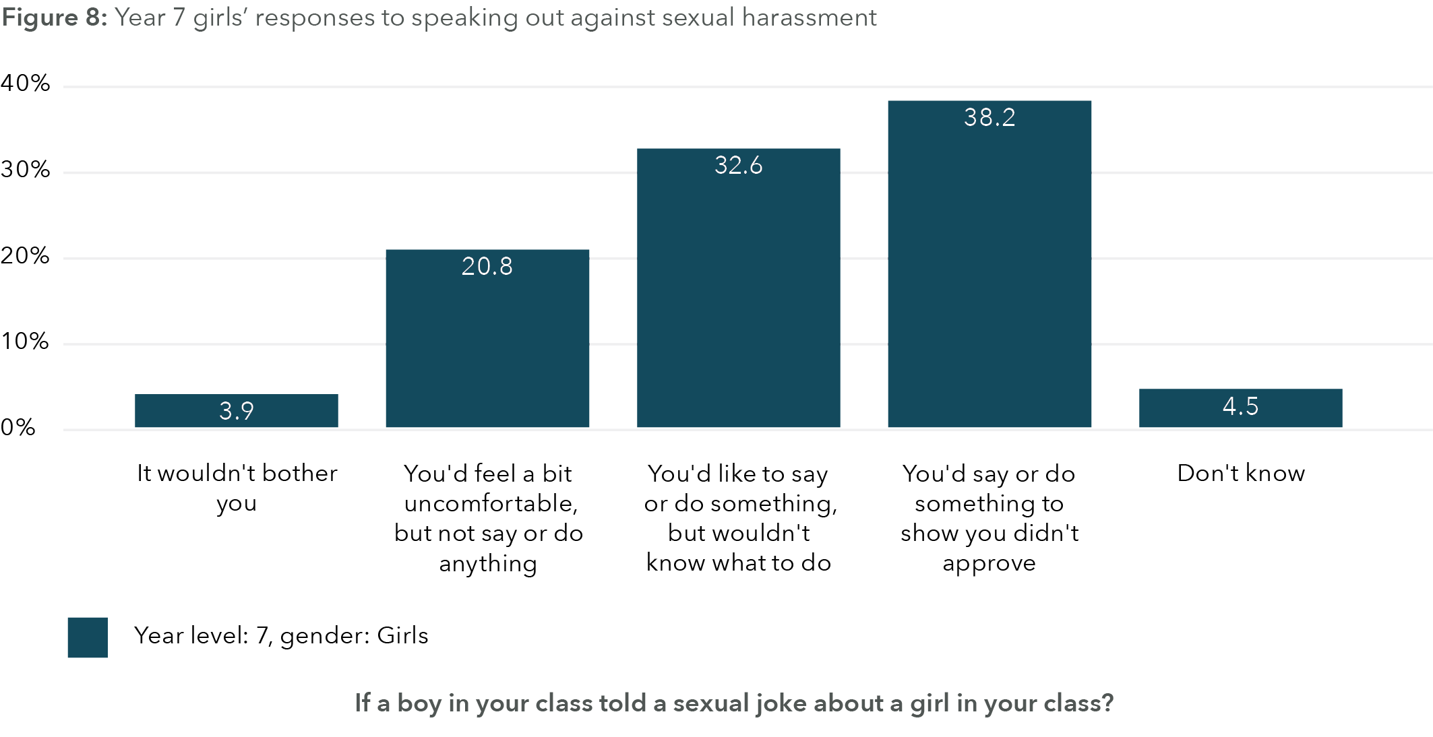
Data table for figure 8
Response | Percentage
It wouldn't bother you | 39%
You'd feel a bit uncomfortable, but not say or do anything | 20.8%
You'd like to say or do something, but wouldn't know what to do | 32.6%
You'd say or do something to show you didn't approve | 38.2%
Don't know | 4.5%

Figure 9: Year 7 boys’ responses to speaking out against sexual harassment
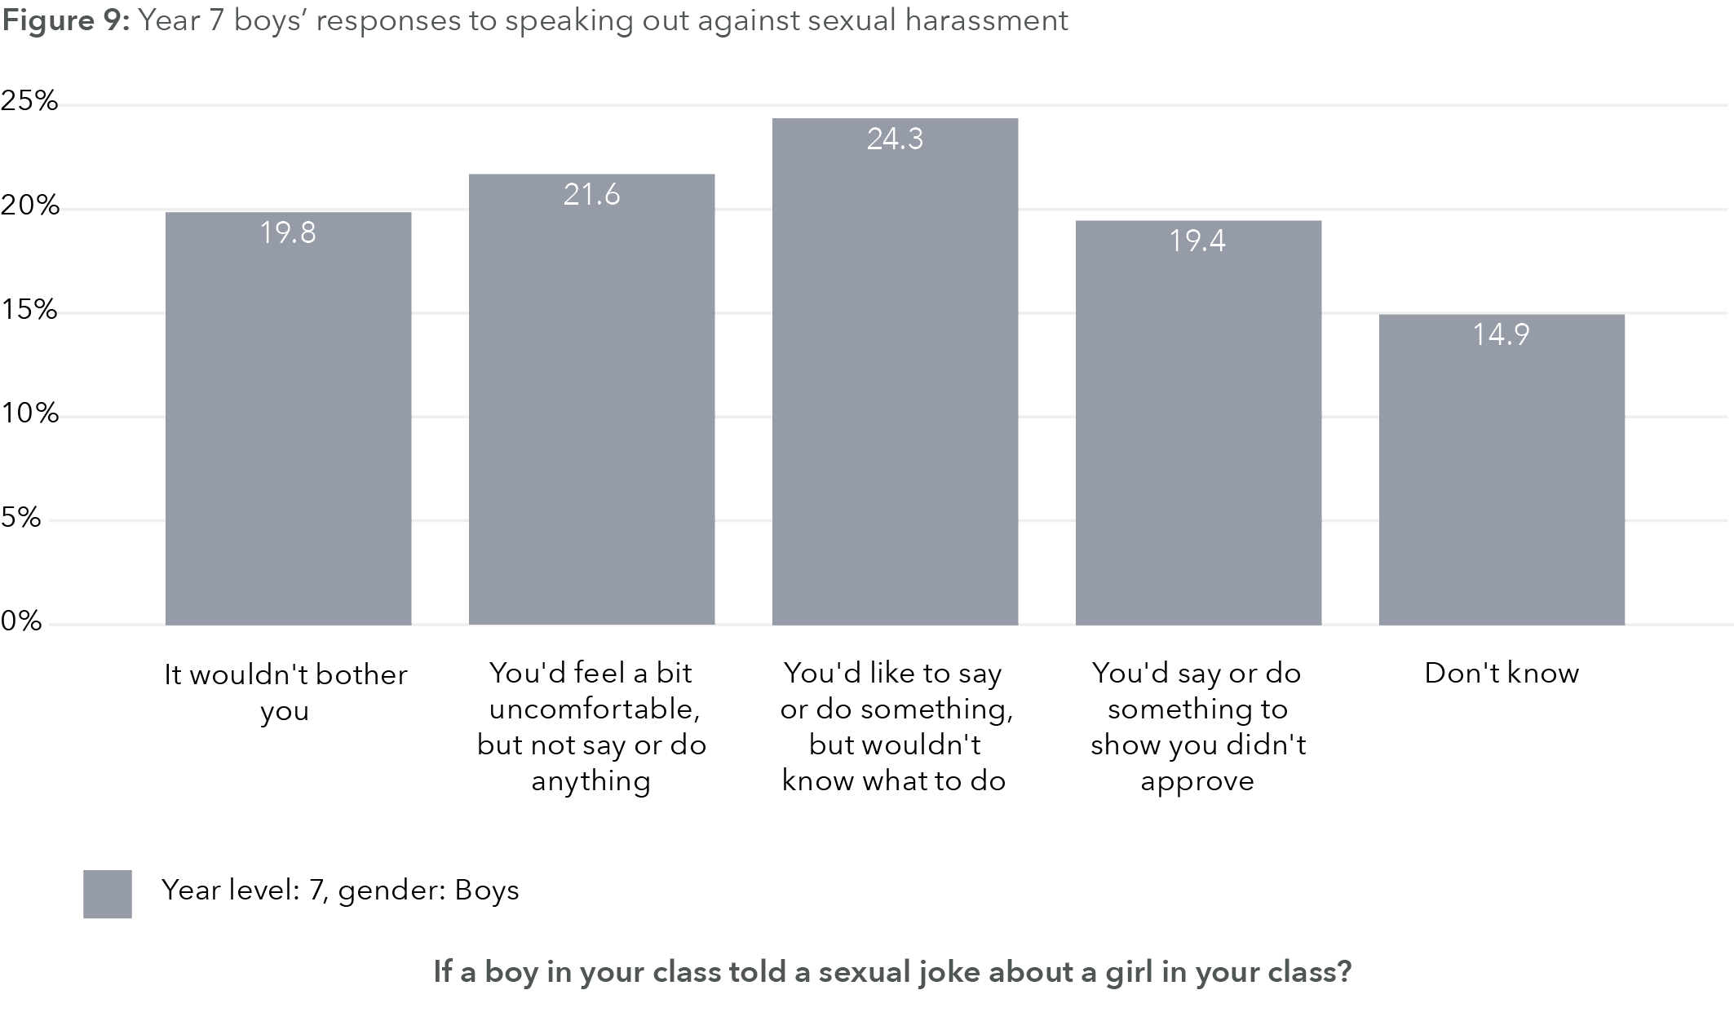
Data table for figure 9
Response | Percentage
It wouldn't bother you | 19.8%
You'd feel a bit uncomfortable, but not say or do anything | 21.6%
You'd like to say or do something, but wouldn't know what to do | 24.3%
You'd say or do something to show you didn't approve | 19.4%
Don't know | 14..9%

Figure 10: Year 7 gender diverse young people’s responses to speaking out against sexual harassment
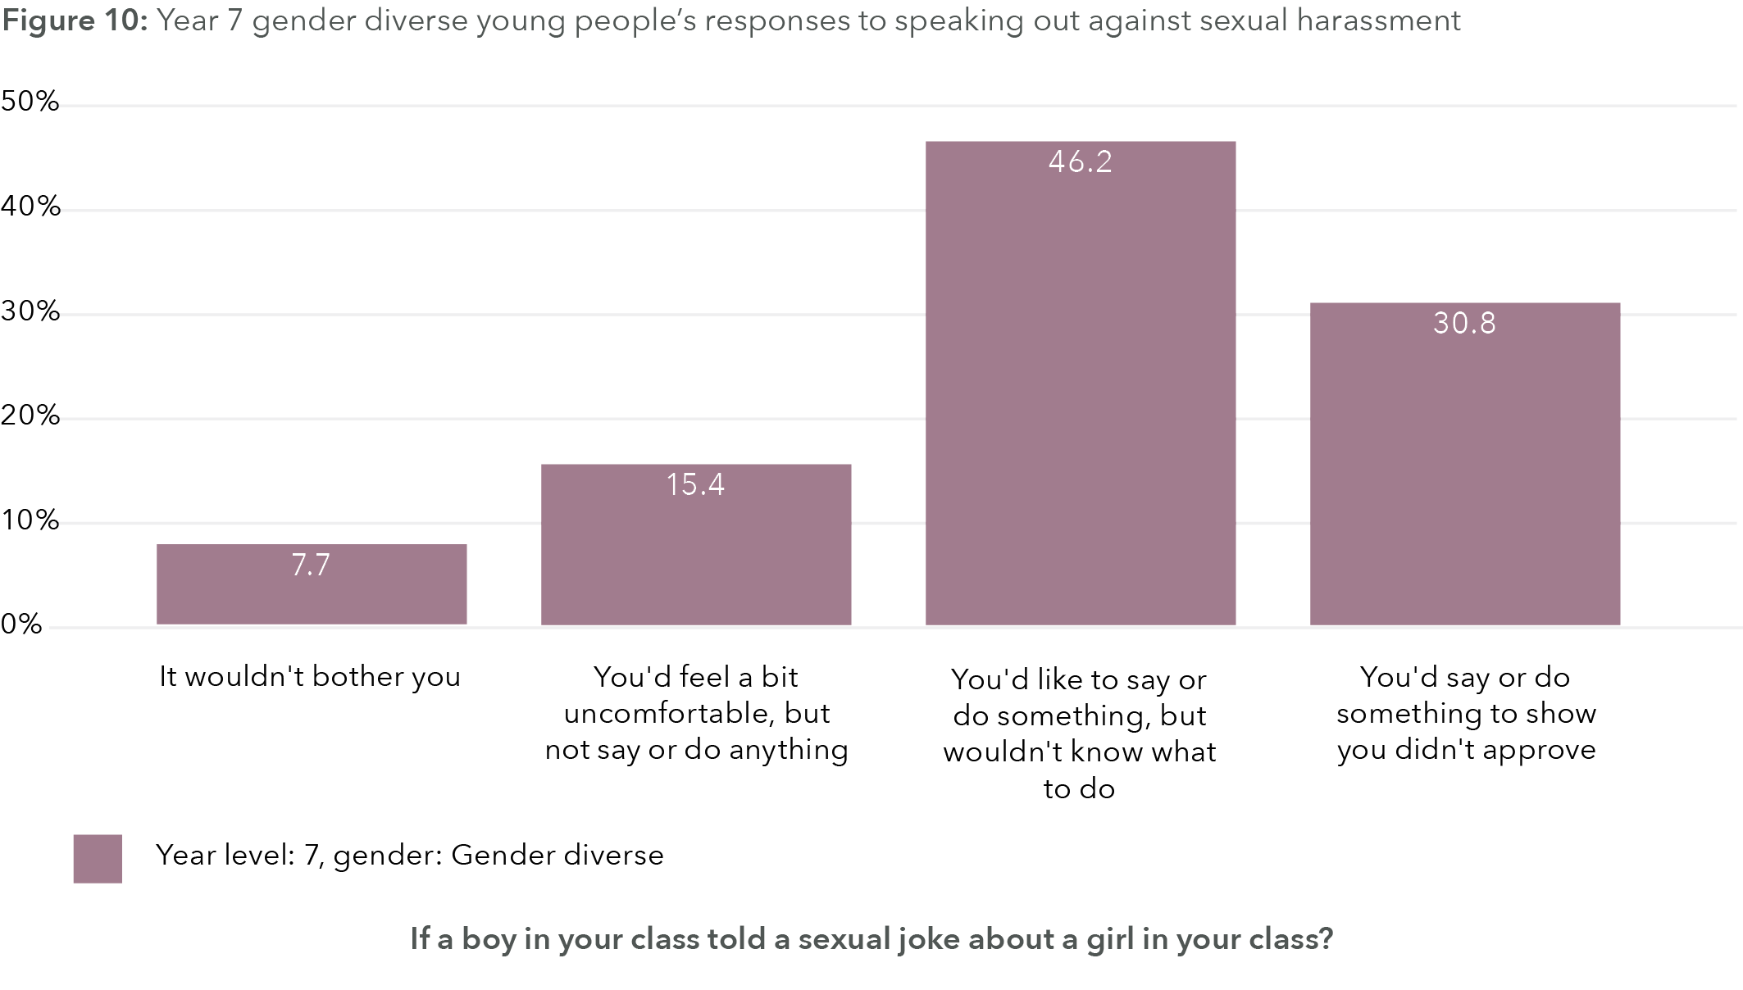
Data table for figure 10:
Response | Percentage
It wouldn't bother you | 7.7%
You'd feel a bit uncomfortable, but not say or do anything | 15.4%
You'd like to say or do something, but wouldn't know what to do | 46.2%
You'd say or do something to show you didn't approve | 30.8%

Figure 11: Year 9 girls’ responses to speaking out against sexual harassment
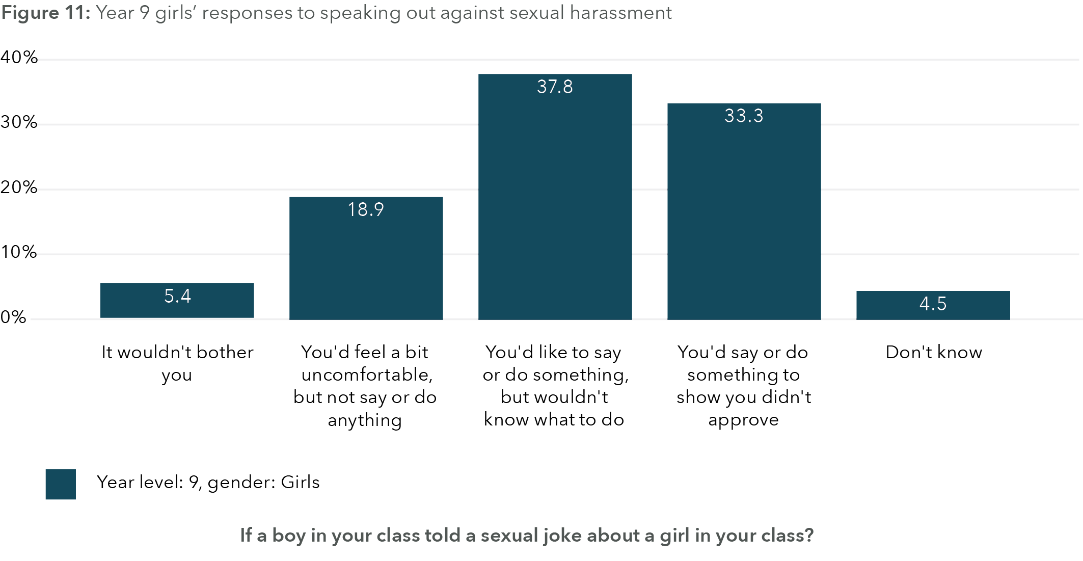
Data table for figure 11
Response | Percentage
It wouldn't bother you | 5.4%
You'd feel a bit uncomfortable, but not say or do anything | 18.9%
You'd like to say or do something, but wouldn't know what to do | 37.8%
You'd say or do something to show you didn't approve | 33.3%
Don't know | 4.5%

Figure 12: Year 9 boys’ responses to speaking out against sexual harassment
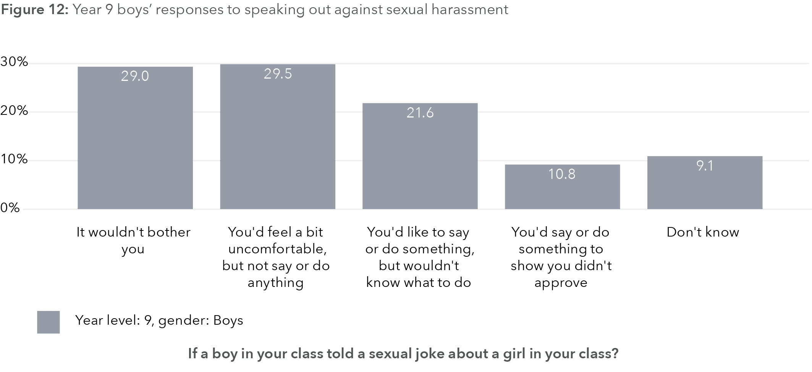
Data table for figure 12:
Response | Percentage
It wouldn't bother you | 29.0%
You'd feel a bit uncomfortable, but not say or do anything | 29.5%
You'd like to say or do something, but wouldn't know what to do | 21.6%
You'd say or do something to show you didn't approve | 10.8%
Don't know | 9.1%

Figure 13: Year 9 gender diverse young people’s responses to speaking out against sexual harassment
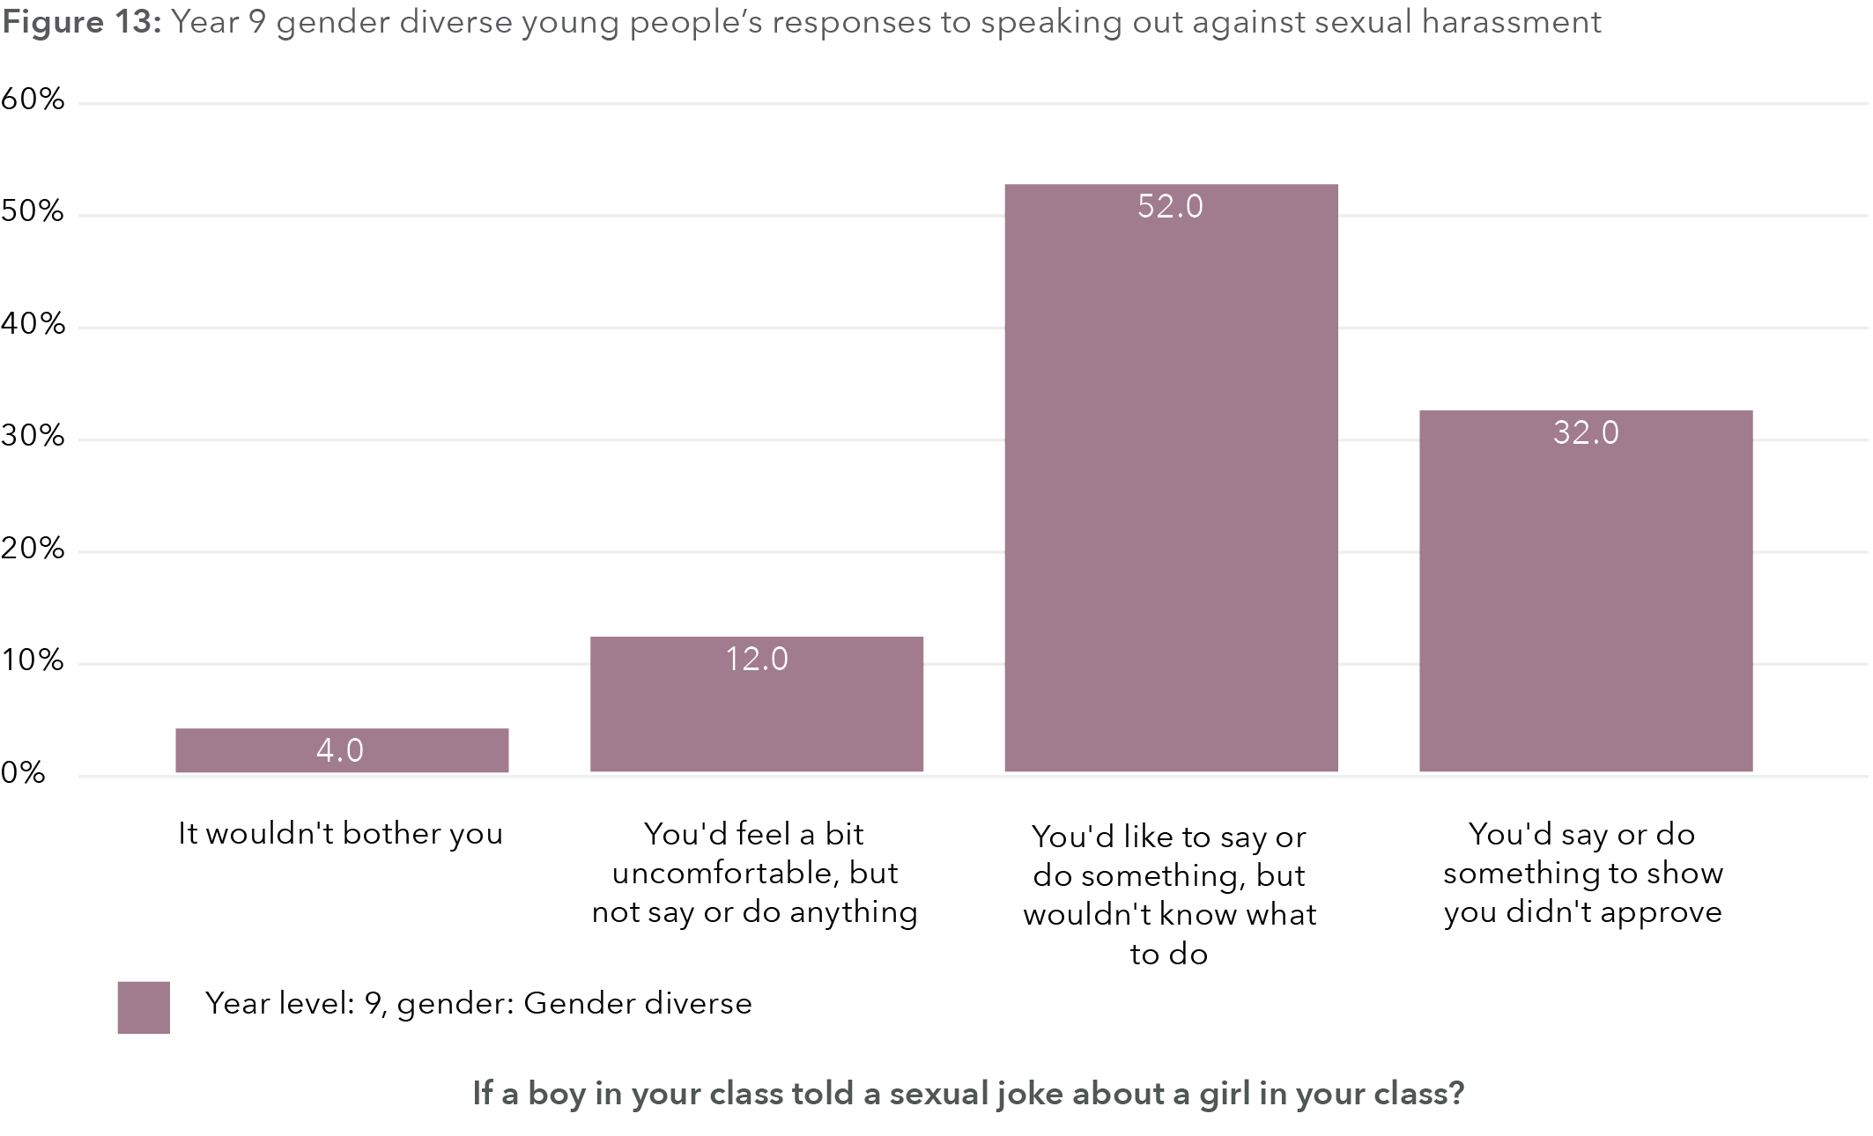
Data table for figure 13:
Response | Percentage
It wouldn't bother you | 4.0%
You'd feel a bit uncomfortable, but not say or do anything | 12.0%
You'd like to say or do something, but wouldn't know what to do | 52.0%
You'd say or do something to show you didn't approve | 32.0%

Gender equality
To create a measure of gender equality, an average of the following three items was calculated for each student’s responses (ranging from 1 = never to 5 = all of the time):
In the workplace, men generally make more capable bosses than women.
On the whole, men make better political leaders than women.
When jobs are scarce, men should have more right to a job than women.
Responses to all three items were reverse scored so that higher scores indicate greater gender equality attitudes.

ANOVA: Gender equality by gender
An Analysis of Variance (ANOVA) of gender equality attitudes from the baseline survey (n=725) shows a significant effect for gender (F(2,722) = 54.378, p < .001). In addition, post-hoc tests reveal that difference lies with boys such that they score significantly lower on gender equality endorsement than girls but also than gender diverse young people. However, girls and gender diverse young people do not differ in their gender equality attitudes.

Linear regression
For boys (n=398), gender equality attitudes are significantly and positively associated with speaking out against sexual harassment (standardised β = .106, t = 2.398, p = .017). Further for boys, gender equality is associated with low violence-endorsing attitudes (standardised β = -.338, t = -7.487, p < .001) and low support for domestic violence (standardised β = -.218, t = -4.796, p < .001).
For girls (n=289), predictors of gender equality include speaking out against sexual harassment (standardised β = .114, t = 2.091, p = .037), not bullying other students (standardised β = .128, t = 2.055, p = .041), low violence attitudes (standardised β = -.141, t = -2.487, p = .013) and low domestic violence attitudes (standardised β = -.227, t = -4.074, p < .001).
For gender diverse young people (n=38), gender equality attitudes are predicted by low violence attitudes (standardised β = -.797, t = -6.295, p < .001).

Statistical network models (ALAAM): Predicting gender equality attitudes
Once again, we use statistical network models to predict individual-level attributes of interest and, in this case, the prediction of gender equality attitudes. The ALAAM results predicting gender equality (+75th percentile = 1, 0 otherwise) demonstrated can be found in Table 27. This includes all students who provided complete data for the baseline survey in Years 7 and 9, and includes girls, boys and gender diverse young people (n=725). As a reminder, model estimate coefficients are not standardised, and so we cannot make insights on the strength of the effect, only on whether it is significant or not.
From Table 30 we see that students who hold gender equality endorsing attitudes are more likely to be friends with other students who hold gender equality endorsing attitudes (0.2916, SE = 0.079, p < .001). As this is cross-sectional data, we are unable to unpack the causal nature of whether this is a social influence effect (i.e. my friendship with you makes me become more like you in terms of attitudes) or a social selection effect (i.e. I choose to become friends with you because we both hold similar beliefs) or some combination of influence and selection. In any case, this significant network effect for friendship does provide evidence that students structure their social ties in terms of similarity in gender equality attitudes, and that gender equality attitudes are an important and valued attribute among students.
From the individual-level factors from the model in Table 30 that are seen to predict higher gender equality attitudes, the most surprising and striking is that being a boy positively predicts pro-gender equality attitudes (0.8616, SE 0.432, p = .046). While counter intuitive, it needs to be considered in the context of all of the other variables, some of which are strongly associated with girls (e.g. lower confidence, lower pro-violence attitudes, lower support for domestic violence). It is possible that once these key factors are taken into account, there is still a number of boys scoring highly on pro-gender equality. In terms of the other effects, we see that being younger (-0.2681, SE 0.087, p = .002), lower confidence (-0.3390, SE 0.150, p = .024), low endorsement of violence attitudes (-0.3041, SE 0.079, p < .001) and low endorsement of domestic violence (-1.0263, SE 0.124, p < .001) contributes to pro-gender equality attitudes. The data from Table 30 also suggests that there may be significant variability in boys’ gender equality attitudes and aligns with the linear regression model for boys that indicates speaking up against sexual harassment as well as low violence and domestic violence attitudes are present for boys who endorse gender equality.
The same individual-level attributes that are significant in Table 28 are also significant in the other models as well for the different networks. Both the work with network and the spend more time with network models also show a contagion effect for gender equality attitudes, highlighting that pro-gender equality students are more likely to want to work with and spend more time with others of similar pro-gender attitudes.
Table 30:Upd Predicting positive gender equality attitudes x close friendship network and other individual attributes
Pseudolikelihood estimation results
Logit regression results
Dep. Variable: y
Model: Logit
Method: MLE
Date: Thu, 11 May 2023
Time: 16:12:34
Converged: True
Covariance type: nonrobust
No. observations: 725
Df residuals: 701
Df model: 23
Pseudo R-squ.: 0.2118
Log-Likelihood: -396.08
LL-Null: -502.53
LLR p-value: 1.058e-32

Attributes | coef | std err | z | P> |z| | [0.025 | 0.975]
Density | 4.2438 | 1.598 | 2.656 | 0.008 | 1.113 | 7.375
Sender | -0.0783 | 0.083 | -0.942 | 0.346 | -0.241 | 0.085
Receiver | -0.1535 | 0.091 | -1.695 | 0.090 | -0.331 | 0.024
Contagion | 0.2916 | 0.079 | 3.696 | 0.000 | 0.137 | 0.446
Male | 0.8616 | 0.432 | 1.996 | 0.046 | 0.015 | 1.708
Female | 0.4432 | 0.441 | 1.005 | 0.315 | -0.421 | 1.308
LOTE | -0.4423 | 0.312 | -1.420 | 0.156 | -1.053 | 0.168
Impairment_Impact | 0.1939 | 0.384 | 0.505 | 0.614 | -0.559 | 0.947
sexual_harrasment_do_something | 0.1820 | 0.214 | 0.850 | 0.395 | -0.238 | 0.602
Bully_you | 0.1823 | 0.207 | 0.883 | 0.377 | -0.223 | 0.587
Sexual_Bully_you | -0.0764 | 0.225 | -0.340 | 0.734 | -0.517 | 0.364
You_bully | -0.1000 | 0.290 | -0.345 | 0.730 | -0.668 | 0.468
You_bully_sexual | 0.1689 | 0.335 | 0.504 | 0.614 | -0.488 | 0.826
Age | -0.2681 | 0.087 | -3.098 | 0.002 | -0.438 | -0.098
Lonely | 0.0070 | 0.108 | 0.065 | 0.948 | -0.204 | 0.218
ARQ_Individ_Confidence3 | -0.3390 | 0.150 | -2.254 | 0.024 | 0.634 | -0.044
ARQ_Social_Capability | 0.1774 | 0.155 | 1.147 | 0.251 | -0.126 | 0.480
ARQ_Respectful_Regard | 0.2279 | 0.140 | 1.633 | 0.102 | -0.046 | 0.501
ARQ_Individ_Negative_Cognition4 | -0.1174 | 0.114 | -1.034 | 0.301 | -0.340 | 0.105
ARQ_Peer_Connectedness4 | 0.0166 | 0.137 | 0.121 | 0.904 | -0.253 | 0.286
ARQ_School_Connectedness4 | 0.1932 | 0.157 | 1.235 | 0.217 | -0.114 | 0.500
RRRR_CWR_Violence | -0.3041 | 0.079 | -3.827 | 0.000 | -0.460 | -0.148
NCAS_Domestic_Violence | -1.0263 | 0.124 | -8.262 | 0.000 | -1.270 | -0.783
PISA_Classroom | 0.1891 | 0.138 | 1.370 | 0.171 | -0.081 | 0.460

Loneliness
Loneliness was measured by the question:
“During the past week, how often did you feel lonely?”
This question was rated from 1 = Never, 2 = Rarely, 3 = Sometimes, 4 = Most of the time, 5 = All of the time, with higher scores indicating that a student feels increased loneliness, and this is a proxy measure for student wellbeing.
As we need to have a binary outcome for the ALAAM, students who scored above the 75th percentile were deemed to be lonely (=1, 0 otherwise). Before the ALAAMs, however, we look at gender differences and gender predictors of loneliness.

ANOVA
Loneliness is significantly different by gender (F(2,722) = 38.592, p < .001) with post-hoc tests revealing that gender diverse young people are significantly lonelier than girls, who, in turn, are significantly lonelier than boys. This aligns with the same patterns presented by the 2022 Mission Australia survey (Leung et al., 2022).

Linear regression
For boys (n=398), predictors of loneliness include being in a disrupted classroom (standardised β = .172, t = 3.572, p < .001) and having an impairment that impacts on their daily life (standardised β = .170, t = 3.535, p < .001).
For girls (n=289), predictors of loneliness include being bullied by other students (standardised β = .309, t = 4.872, p < .001) and having an impairment that impacts on their daily life (standardised β = .135, t = 2.437, p = .015).
For gender diverse young people (n=38), there are no significant predictors of loneliness.
Table 31 presents the individual-level and friendship network predictors of loneliness. Of note, there are no significant network effects predicting loneliness, but they are extremely close. There is an almost significant and negative sender effect for friendship in predicting loneliness (p = .050), which, if significant, would mean students who are more likely to nominate others as close friends are less lonely, so there is some indication that social connection is important to loneliness, as we would expect. However, there is an almost significant contagion effect for loneliness (p = .054), which suggests that lonely students are close friends with other lonely students. In terms of the other networks, there are no network effects for disrespect, work with on group tasks, or spend more time with, in terms of effects on loneliness.
However, the individual level effects predicting loneliness are low individual confidence (-0.7884, SE 0.153, p < .001), high social capability (0.3353, SE 0.166, p = .043), low ability to deal with negative cognitions (-0.7701, SE 0.117, p < .001) and low perceived peer connectedness (-.4228, SE 0.144, p = .003). This last effect around perceived peer connectedness does suggest the importance of social connection.
The almost significant network effects, and the presence of this perceived lack of peer connection, might suggest that loneliness is not feeling you are connected, or not connected in meaningful ways, rather than not actually being connected. That is, loneliness is more about the perception of depth of relationships rather than the actual absence of such relations.
Table 31: Predicting loneliness x close friendship network and other individual attributes
Pseudolikelihood estimation results
Logit regression results
Dep. Variable: y
Model: Logit
Method: MLE
Date: Fri, 12 May 2023
Time: 17:59:31
Converged: True
Covariance type: nonrobust
No. observations: 725
Df residuals: 701
Df model: 23
Pseudo R-squ.: 0.2517
Log-Likelihood: -360.07
LL-Null: -481.20
LLR p-value: 1.706e-38
Attributes | coef | std err | z | P> |z| | [0.025 | 0.975]
Density | 6.3400 | 1.720 | 3.686 | 0.000 | 2.969 | 9.711
Sender | -0.1750 | 0.089 | -1.962 | 0.050 | -0.350 | -0.000
Receiver | -0.0126 | 0.088 | -0.142 | 0.887 | -0.186 | 0.161
Contagion | 0.1872 | 0.097 | 1.927 | 0.054 | -0.003 | 0.378
Male | 0.2924 | 0.474 | 0.617 | 0.537 | -0.637 | 1.222
Female | 0.0362 | 0.484 | 0.075 | 0.940 | -0.912 | 0.985
LOTE | -0.2624 | 0.326 | -0.806 | 0.420 | -0.900 | 0.376
Impairment_Impact | -0.1819 | 0.414 | -0.439 | 0.661 | -0.994 | 0.630
sexual_harrasment_do_something | -0.3856 | 0.229 | -1.686 | 0.092 | -0.834 | 0.063
Bully_you | 0.0349 | 0.218 | 0.160 | 0.873 | -0.392 | 0.462
Sexual_Bully_you | 0.1533 | 0.235 | 0.651 | 0.515 | -0.308 | 0.615
You_bully | -0.2887 | 0.311 | -0.930 | 0.353 | -0.897 | 0.320
You_bully_sexual | 0.1182 | 0.352 | 0.336 | 0.737 | -0.571 | 0.807
Age | -0.0831 | 0.089 | -0.939 | 0.348 | -0.257 | 0.090
ARQ_Individ_Confidence3 | -0.7884 | 0.153 | -5.154 | 0.000 | -1.088 | -0.489
ARQ_Social_Capability | 0.3353 | 0.166 | 2.021 | 0.043 | 0.010 | 0.661
ARQ_Respectful_Regard | -0.0826 | 0.144 | -0.573 | 0.567 | -0.365 | 0.200
ARQ_Individ_Negative_Cognition4 | -0.7701 | 0.117 | -6.582 | 0.000 | -0.999 | -0.541
ARQ_Peer_Connectedness4 | -0.4228 | 0.144 | -2.931 | 0.003 | -0.705 | -1.140
ARQ_School_Connectedness4 | -0.0651 | 0.164 | -0.396 | 0.692 | -0.387 | 0.257
RRRR_CWR_Violence | 0.0640 | 0.085 | 0.756 | 0.450 | -0.102 | 0.230
NCAS_Domestic_Violence | -0.1638 | 0.122 | -1.344 | 0.179 | -0.403 | 0.075
Gender_Equity_OVERALL_av3 | 0.0694 | 0.110 | 0.632 | 0.527 | -0.146 | 0.284
PISA_Classroom | 0.0244 | 0.146 | 0.167 | 0.867 | -0.261 | 0.310

Classroom climate
To create a measure of classroom climate, an average of the following five items was calculated for each student’s responses (ranging from 1 = never or hardly ever to 4 = every lesson):
Students don’t listen to what the teacher says.
There is noise and disorder.
The teacher has to wait a long time for students to quiet down.
Students cannot work well.
Students don’t start working for a long time after the lesson begins.
Higher scores on classroom climate indicate a more disruptive classroom experience for the student.

ANOVA: Classroom climate
An Analysis of Variance (ANOVA) was conducted on classroom climate assessments by students for our baseline survey data (n=823), and we found a significant effect for gender (F(2,722) = 5.639, p = .004). Post-hoc tests reveal gender diverse young people say that the classroom is significantly more disruptive than either boys or girls. However, there is no significant difference between classroom climate scores for boys and girls.

Linear regression
For boys (n=398), a disruptive classroom environment is associated with feeling lonely (standardised β = .186, t = 3.572, p < .001).
For girls (n=289), a disruptive classroom environment is associated with being sexually bullied by other students (standardised β = .250, t = 3.748, p < .001).
For gender diverse young people (n=38), a disruptive classroom environment is associated with having an impairment that impacts on their daily life (standardised β = .403, t = 2.332, p = .027).

Statistical network models (ALAAM): Classroom climate
We examine classroom climate and search for variables that are associated with student perceived disruptive experiences in class. We use the 75th percentile of student self-rated disruptive classroom climate scores (1 = disrupted, 0 otherwise) which is derived from PISA (OECD, 2018).
Table 32 presents the ALAAM results for predicting disruptive classroom ratings including individual-level variables and the student friendship network. First, there is a significant and negative receiver effect for perceiving the classroom to be disruptive (-0.2588, SE 0.091, p = .004), meaning that students who are more likely to be nominated as close friends are very unlikely to say that the classroom is disruptive. This suggests that popular choices of students as friends are people who do not see the classroom they are in as disruptive.
In addition, and to be interpreted in conjunction with the previous receiver effect, there is a contagion effect for friendship for perceiving the classroom to be disruptive (0.4882, SE 0.089, p < .001). This means that students who think the classroom is disruptive are more likely to be close friends with other students who think the classroom is disruptive. This latter effect suggests shared perceptions about classroom climate may be mediated by friendship relations between students. Together, these two significant effects suggest different processes, one in which popular friends see less classroom climate issues, and another where pairs of friends perceive the classroom climate to be disruptive. In addition, given the gendered nature of many social interactions (as seen in the network visualisations earlier in the report), there may indeed be a gendered aspect to this as well.
In addition, there are some individual-level attributes that are important predictors of perceived classroom climate. First, students who perceive the classroom as disrupted are older (0.2111, SE 0.083, p = .011), are lonely (0.2433, SE 0.104, p = .019) and are unable to deal with negative cognitions (-0.3977, SE 0.109, p < .001). While there is no specific gender effect here, as both girls and gender diverse young people have higher rates of loneliness and negative cognitions, there is also a possible gender aspect here.
The model predicting disruptive classroom which includes the disrespect network showed no significant network effects and the same pattern of individual-level variable impacts is seen.
Table 32: Predicting disruptive classroom x close friendship network and other individual attributes
Pseudolikelihood estimation results
Logit regression results
Dep. variable: y
Model: Logit
Method: MLE
Date: Fri, 12 May 2023
Time: 17:59:32
Converged: True
Covariance type: nonrobust
No. observations: 725
Df residuals: 701
Df model: 23
Pseudo R-squ.: 0.1293
Log-Likelihood: -394.37
LL-Null: -452.96
LLR p-value: 1.335e-14
Attributes | coef | std err | z | P> |z| | [0.025 | 0.975]
Density | -2.8719 | 1.627 | -1.765 | 0.078 | -6.061 | 0.317
Sender | -0.0767 | 0.079 | -0.969 | 0.333 | -0.232 | 0.079
Receiver | -0.2588 | 0.091 | -2.851 | 0.004 | -0.437 | -0.081
Contagion | 0.4882 | 0.089 | 5.514 | 0.000 | -0.315 | 0.662
Male | -0.3561 | 0.425 | -0.839 | 0.402 | -1.188 | 0.476
Female | -0.2024 | 0.433 | -0.468 | 0.640 | -1.050 | 0.646
LOTE | 0.3427 | 0.294 | 1.167 | 0.243 | -0.233 | 0.918
Impairment_Impact | 0.4320 | 0.372 | 1.162 | 0.245 | -0.297 | 1.161
sexual_harrasment_do_something | -0.0868 | 0.214 | -0.406 | 0.685 | -0.506 | 0.333
Bully_you | 0.0234 | 0.206 | 0.114 | 0.909 | -0.380 | 0.426
Sexual_Bully_you | 0.1445 | 0.221 | 0.654 | 0.513 | -0.288 | 0.578
You_bully | -0.2589 | 0.294 | -0.879 | 0.379 | -0.836 | 0.318
You_bully_sexual | -0.5430 | 0.348 | -1.560 | 0.119 | -1.225 | 0.139
Age | 0.2111 | 0.083 | 2.548 | 0.011 | 0.049 | 0.373
Lonely | 0.2433 | 0.104 | 2.343 | 0.019 | 0.040 | 0.447
ARQ_Individ_Confidence3 | 0.1092 | 0.143 | 0.763 | 0.445 | -0.171 | 0.390
ARQ_Social_Capability | -0.2001 | 0.148 | -1.352 | 0.176 | -0.490 | 0.090
ARQ_Respectful_Regard | 0.0511 | 0.135 | 0.378 | 0.706 | -0.214 | 0.317
ARQ_Individ_Negative_Cognition4 | -0.3977 | 0.109 | -3.646 | 0.000 | -0.611 | -0.184
ARQ_Peer_Connectedness4 | -0.1642 | 0.135 | -1.213 | 0.225 | -0.429 | 0.101
ARQ_School_Connectedness4 | -0.0668 | 0.150 | -0.445 | 0.656 | -0.361 | 0.227
RRRR_CWR_Violence | 0.1338 | 0.081 | 1.662 | 0.097 | -0.024 | 0.292
NCAS_Domestic_Violence | 0.1283 | 0.112 | 1.143 | 0.253 | -0.092 | 0.348
Gender_Equity_OVERALL_av3 | 0.1481 | 0.102 | 1.451 | 0.147 | -0.052 | 0.348
In the final model on negative cognition in Table 33 using the work with network, we see that students wish to work with other students who also think the classroom is disrupted (0.4094, SE 0.078, p < .001). Like in the other model results, this suggests that how the classroom is managed makes a difference to whom students wish to invest their time and socialise with. As such, the classroom climate is important to students. The pattern for the individual-level effects remains as for the other networks.
Table 33: Predicting disruptive classroom x work with network and other individual attributes
Pseudolikelihood estimation results
Logit regression results
Dep. variable: y
Model: Logit
Method: MLE
Date: Fri, 12 May 2023
Time: 18:00:55
Converged: True
Covariance type: nonrobust
No. observations: 725
Df residuals: 701
Df model: 23
Pseudo R-squ.: 0.1239
Log-Likelihood: -396.85
LL-Null: -452.96
LLR p-value: 1.022e-13
Attributes | coef | std err | z | P> |z| | [0.025 | 0.975]
Density | -3.2657 | 1.639 | -1.992 | 0.046 | -6.479 | -0.053
Sender | -0.1089 | 0.058 | -1.876 | 0.061 | -0.223 | 0.005
Receiver | -0.0745 | 0.067 | -1.118 | 0.263 | -0.205 | 0.056
Contagion | 0.4094 | 0.078 | 5.249 | 0.000 | 0.257 | 0.562
Male | -0.2989 | 0.423 | -0.706 | 0.480 | -1.128 | 0.531
Female | -0.0951 | 0.431 | -0.221 | 0.825 | -0.940 | 0.750
LOTE | 0.3031 | 0.296 | 1.025 | 0.306 | -0.277 | 0.883
Impairment_Impact | 0.4659 | 0.370 | 1.259 | 0.208 | -0.259 | 1.191
sexual_harrasment_do_something | -0.1424 | 0.213 | -0.669 | 0.503 | -0.559 | 0.275
Bully_you | 0.0217 | 0.206 | 0.106 | 0.916 | -0.381 | 0.425
Sexual_Bully_you | 0.1591 | 0.219 | 0.725 | 0.468 | -0.271 | 0.589
You_bully | -0.2704 | 0.293 | -0.922 | 0.356 | -0.845 | 0.304
You_bully_sexual | -0.5318 | 0.348 | -1.530 | 0.126 | -1.213 | 0.150
Age | 0.2225 | 0.084 | 2.662 | 0.008 | -0.059 | 0.386
Lonely | 0.2583 | 0.104 | 2.491 | 0.013 | 0.055 | 0.462
ARQ_Individ_Confidence3 | 0.0956 | 0.142 | 0.675 | 0.500 | -0.182 | 0.373
ARQ_Social_Capability | -0.1854 | 0.147 | -1.258 | 0.209 | -0.474 | 0.104
ARQ_Respectful_Regard | 0.0258 | 0.135 | 0.191 | 0.848 | -0.239 | 0.290
ARQ_Individ_Negative_Cognition4 | -0.3637 | 0.108 | -3.360 | 0.001 | -0.576 | -0.152
ARQ_Peer_Connectedness4 | -0.1624 | 0.134 | -1.210 | 0.226 | -0.425 | 0.101
ARQ_School_Connectedness4 | -0.0868 | 0.150 | -0.579 | 0.562 | -0.381 | 0.207
RRRR_CWR_Violence | 0.1474 | 0.080 | 1.837 | 0.066 | -0.010 | 0.305
NCAS_Domestic_Violence | 0.1313 | 0.112 | 1.171 | 0.241 | -0.088 | 0.351
Gender_Equity_OVERALL_av3 | 0.1443 | 0.102 | 1.409 | 0.159 | -0.056 | 0.345

Evaluation of program
Endpoint student evaluations of the program were obtained for 512 students. Table 34 shows student responses to questions about how useful they found various aspects of the program. They used a 5-point scale for usefulness. Table 34 shows the percentage who selected the responses “useful”, “very useful” or “extremely useful”. The vast majority of students positively endorsed the usefulness of the program, despite that most of them were in low-fidelity classes in relation to use of the collaborative learning activities, with stronger responses from girls and gender diverse young people than from boys.
Table 34: Proportion of students rating program components as useful, very useful or extremely useful
Gender | How to understand & communicate about feelings and needs | How to have good friendships | How to avoid joining in bullying | Gender and equality | Effects of gender-based violence
Girls | 74.2% | 76.3% | 78.9% | 85.6% | 85.1%
Boys | 73.9% | 78.0% | 72.5% | 76.9% | 78.3%
Gender diverse | 69.4% | 69.6% | 82.6% | 82.6% | 91.3%
Figure 14 demonstrates that when asked about how useful the lessons were on effects of GBV, “useful” was the predominant response, followed by “very useful” and “extremely useful”. This highlights that a significant number of students are taking value from such lessons in the RRRR program. Additionally, we see gender diverse young people responding at double the rate of boys and girls (at about 35%) for saying that such lessons on effects of GBV were “extremely useful”.
Figure 14: Student responses to the question that it was useful to do lessons about the effects of GBV
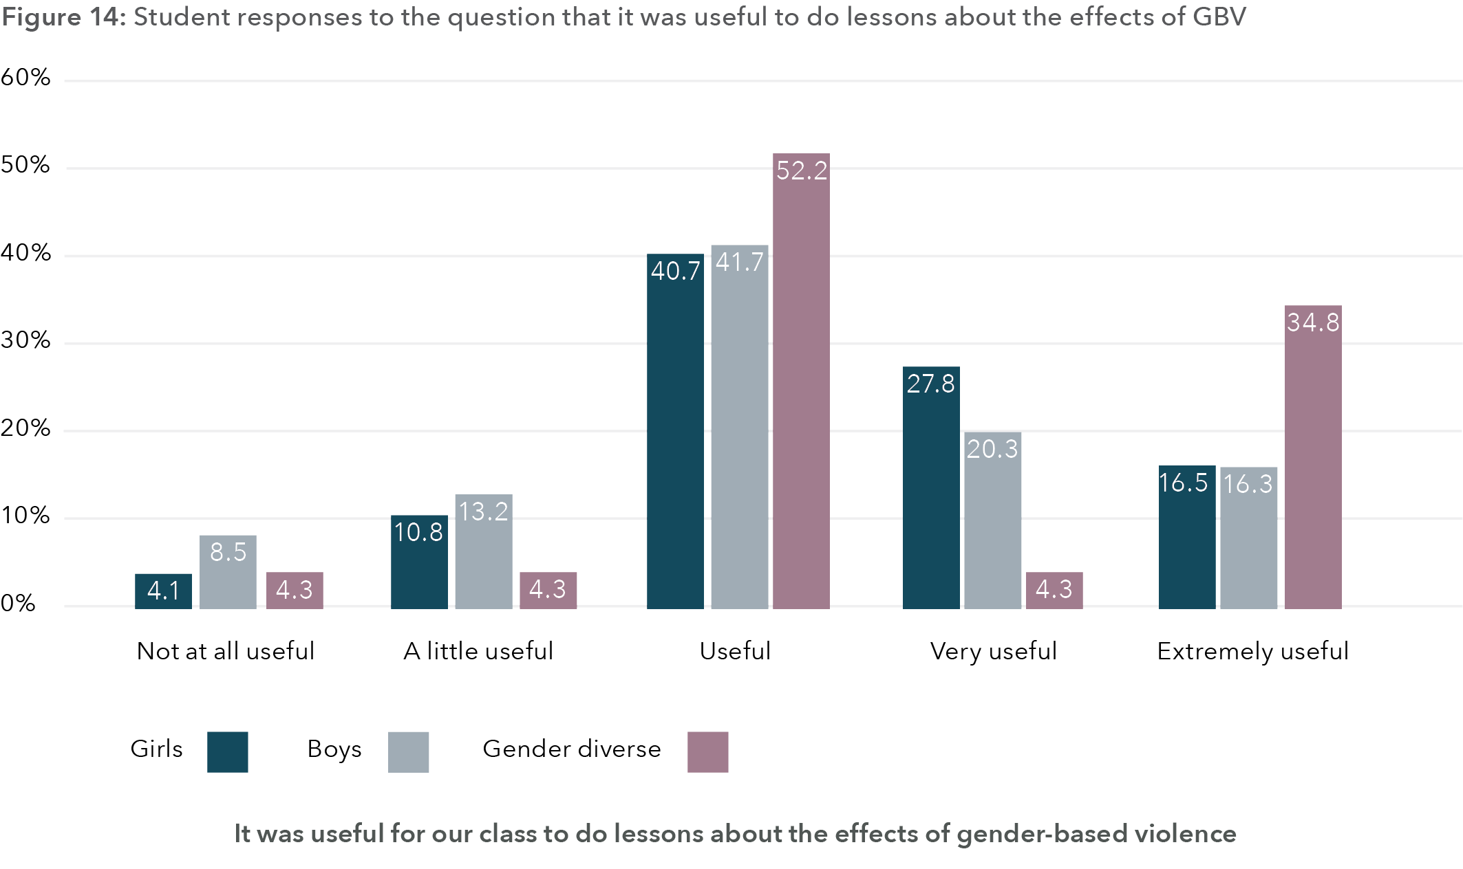
Data table for figure 14:
Response | Girls | Boys | Gender diverse
Not at all useful | 4.1% | 8.5% | 4.3%
A little useful | 10.8% | 13.2% | 4.3%
Useful | 40.7% | 41.7% | 52.2%
Very useful | 27.8% | 20.3% | 4.3%
Extremely useful | 16.5% | 16.3% | 34.8

In response to how useful it was to do lessons about gender and equality, again, the vast majority said the lessons were “useful”, followed by “very useful” and “extremely useful”. Gender diverse young people scored almost twice as high as girls and boys in terms of saying that lessons about gender and equality were “extremely useful”.
Figure 15: Student responses to the question that it was useful to do lessons about gender and equality
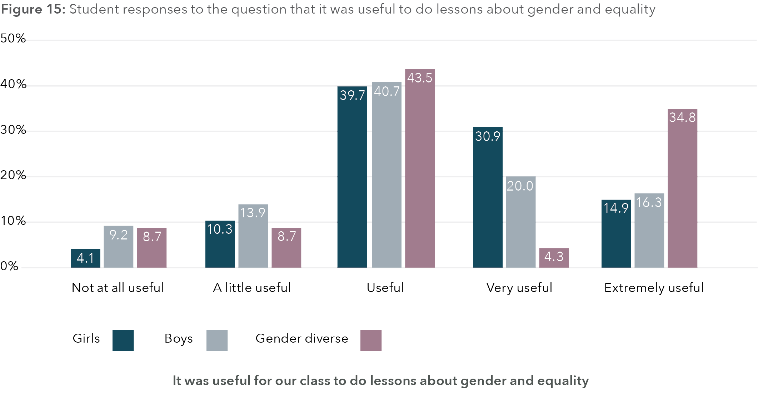
Data table for figure 15:
Response | Girls | Boys | Gender diverse
Not at all useful | 4.1% | 9.2% | 8.7%
A little useful | 10.3% | 13.9% | 8.7%
Useful | 39.7% | 40.7% | 43.5%
Very useful | 30.9% | 20.0% | 4.3%
Extremely useful | 14.9% | 16.3% | 34.8%

Students were also asked if they recommended having more lessons next year on how to have good relationships with others. The most prevalent response for girls and boys was “unsure”, followed by “yes” and then “no”. However, the majority of gender diverse young people responded “yes”, indicating that they received the program well and many would like to see it continue.
Figure 16: Student responses to the question of doing more lessons next year about how to have good relationships with others
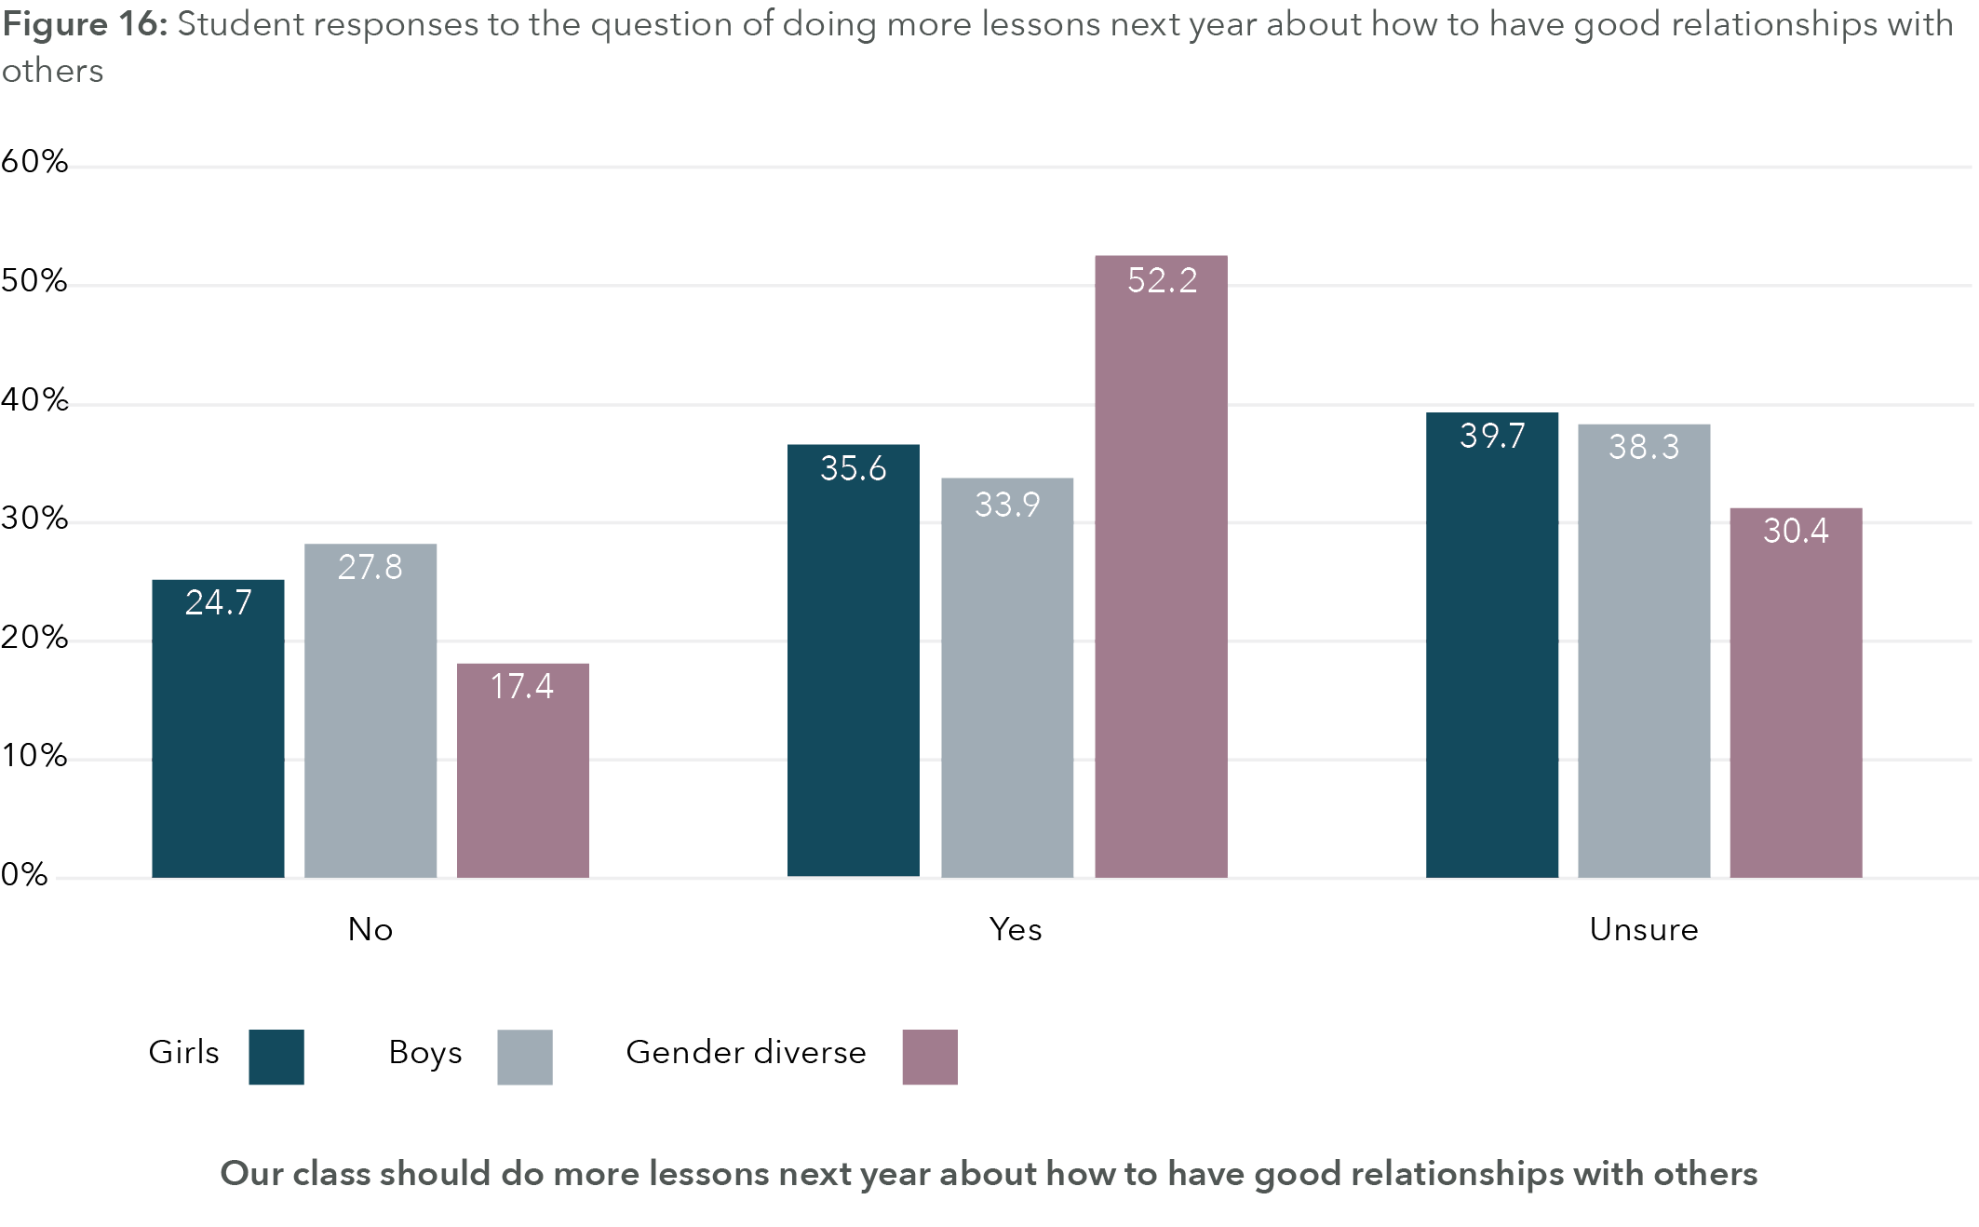
Data table for figure 16:
Response | Girls | Boys | Gender diverse
No | 24.7% | 27.8% | 17.4%
Yes | 35.6% | 33.9% | 52.2%
Unsure | 39.7% | 38.3% | 30.4%

Additionally, as noted in Figure 17, there were marked differences for schools, with students from some schools less enthusiastic to continue such education.

Figure 17: Responses by school to the question of doing more lessons next year about how to have good relationships with others
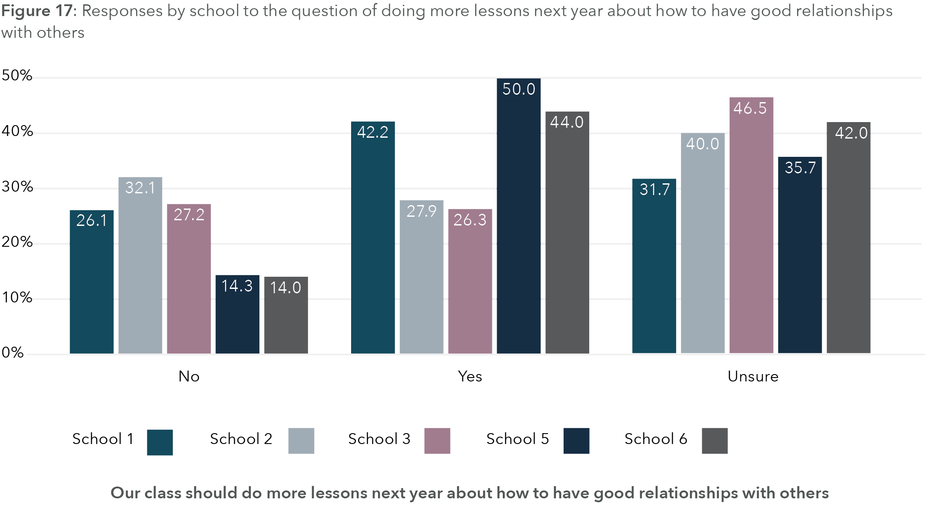
Data table for figure 17:
Response | Girls | Boys | Gender diverse
No | 24.7% | 27.8% | 17.4%
Yes | 35.6% | 33.9% | 52.2%
Unsure | 39.7% | 38.3% | 30.4%

In terms of implementation, a key measure of fidelity of implementation for the RRRR program is working in small groups as the collaborative learning activities require time for students to engage with the tasks directly with peers (either in small groups or pairs). For high fidelity of implementation, this would be experienced every lesson, and moderate fidelity would be most lessons. From Figure 18 we can see that students responded in greatest numbers for “most lessons” with very few indicating they worked in small groups “every lesson”.
Figure 18: Student responses to the question of how often they got to work in small groups
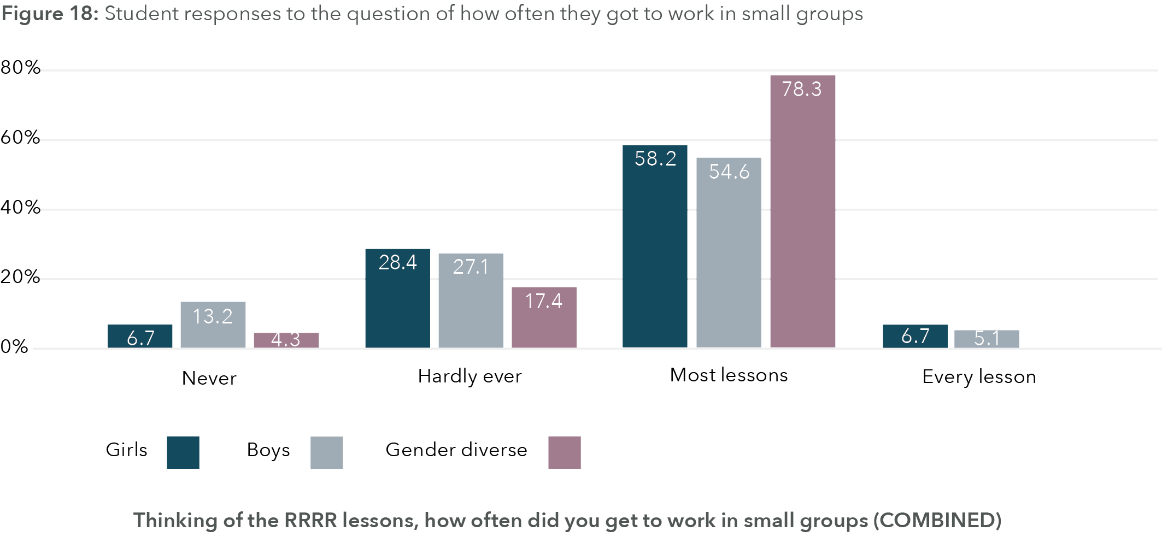
Data table for figure 18:
Response | Girls | Boys | Gender diverse
Never | 6.7% | 13.2% | 4.3%
Hardly ever | 28.4% | 27.1% | 17.4%
Most lessons | 58.2% | 54.6% | 78.3%
Every lesson | 6.7% | 5.1% | 0%
Another key measure of fidelity of implementation is doing role plays. Role plays were only designed into a minority of lessons, though more frequently in the topics addressing problem solving, help seeking, and positive gender relations. From Figure 19 we can see that “hardly ever” was the predominant response, with “never” and “most lessons” then sharing similar levels of response. It is clear that very few students indicated that role plays were done every lesson.
Figure 19: Student responses to the question of how often they got to do role play
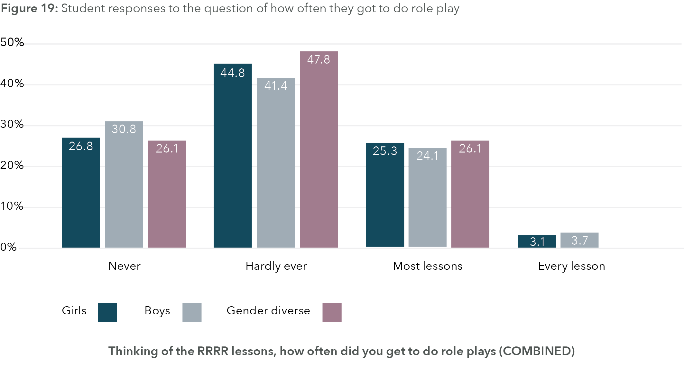
Data table for figure 19:
Response | Girls | Boys | Gender diverse
Never | 26.8% | 30.8% | 26.1%
Hardly ever | 44.8% | 41.4% | 47.8%
Most lessons | 25.3% | 24.1% | 26.1%
Every lesson | 3.1% | 3.7% | 0%
When we look at Figure 20, responses to whether students were able to have whole class discussion show that “most lessons” is the most popular response, followed by “every lesson”. This indicates that whole class discussions, rather than role plays or working in small groups, was the most common way to deliver the RRRR program.
Figure 20: Student responses to the question of how often they got to have whole class discussions
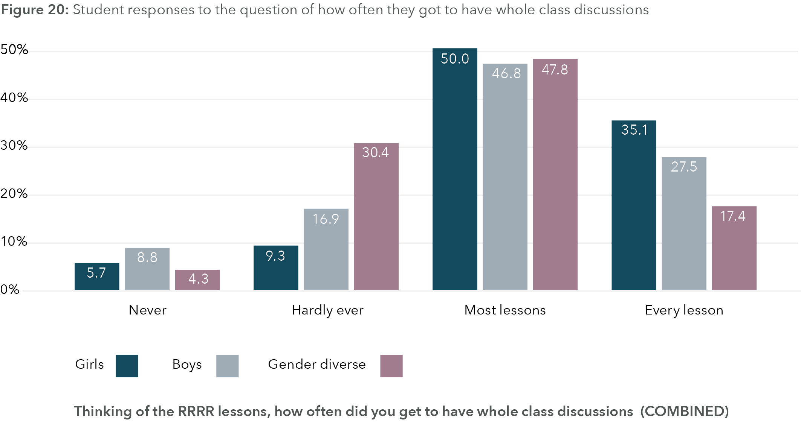
Data table for figure 20:
Response | Girls | Boys | Gender diverse
Never | 5.7% | 8.8% | 4.3%
Hardly ever | 9.3% | 16.9% | 30.4%
Most lessons | 50.0% | 46.8% | 47.8%
Every lesson | 35.1% | 27.5% | 17.4%

Fidelity of implementation
As noted, a key metric for fidelity of implementation is whether students consistently worked in small groups or not. Looking at responses for those students who completed both the baseline and endpoint surveys (n=395), we found only 26 students (or 6.6%) claimed they had the opportunity to work in small task groups in all lessons, with 369 (93.4%) not doing so. This would suggest that the fidelity of implementation of the RRRR program in relation to provision of the collaborative learning activities was not high across the schools.
Notably, a t-test comparing high fidelity (i.e. worked in small groups all of the time) with low fidelity (i.e. those who did not) shows significant effects for how useful the students rated doing RRRR lessons on gender and equality (t = 2.228, df = 510, p = .013, one-sided) and on the effects of GBV (t = 2.523, df = 510, p = .006, one-sided), with high-fidelity implementation being significantly higher.
We compared these two student groups on their baseline and endpoint scores on a range of key measures and found the following.
For individual confidence, a measure of resilience, we found that students who said they worked in small groups were more confident overall than those who did not work in small groups all of the time (F(1,393) = 5.449, p = .020). There was no interaction effect over time, meaning that individual confidence neither went up or down for either group.
For respectful regard, another measure of resilience, we found a significant interaction effect for time by work in small groups (F(1,393) = 7.546, p = .006), such that for the students who worked in small groups all of the time there is a significant increase in self-reported respectful regard, whereas the other group slightly decreased overall. This change per group can be seen in Figure 21. This is supporting evidence that when the RRRR program is implemented with high fidelity that there is an increase in respectful regard for students.
Figure 21: Respectful regard scores at baseline and endpoint by status of working in small groups (no, yes)
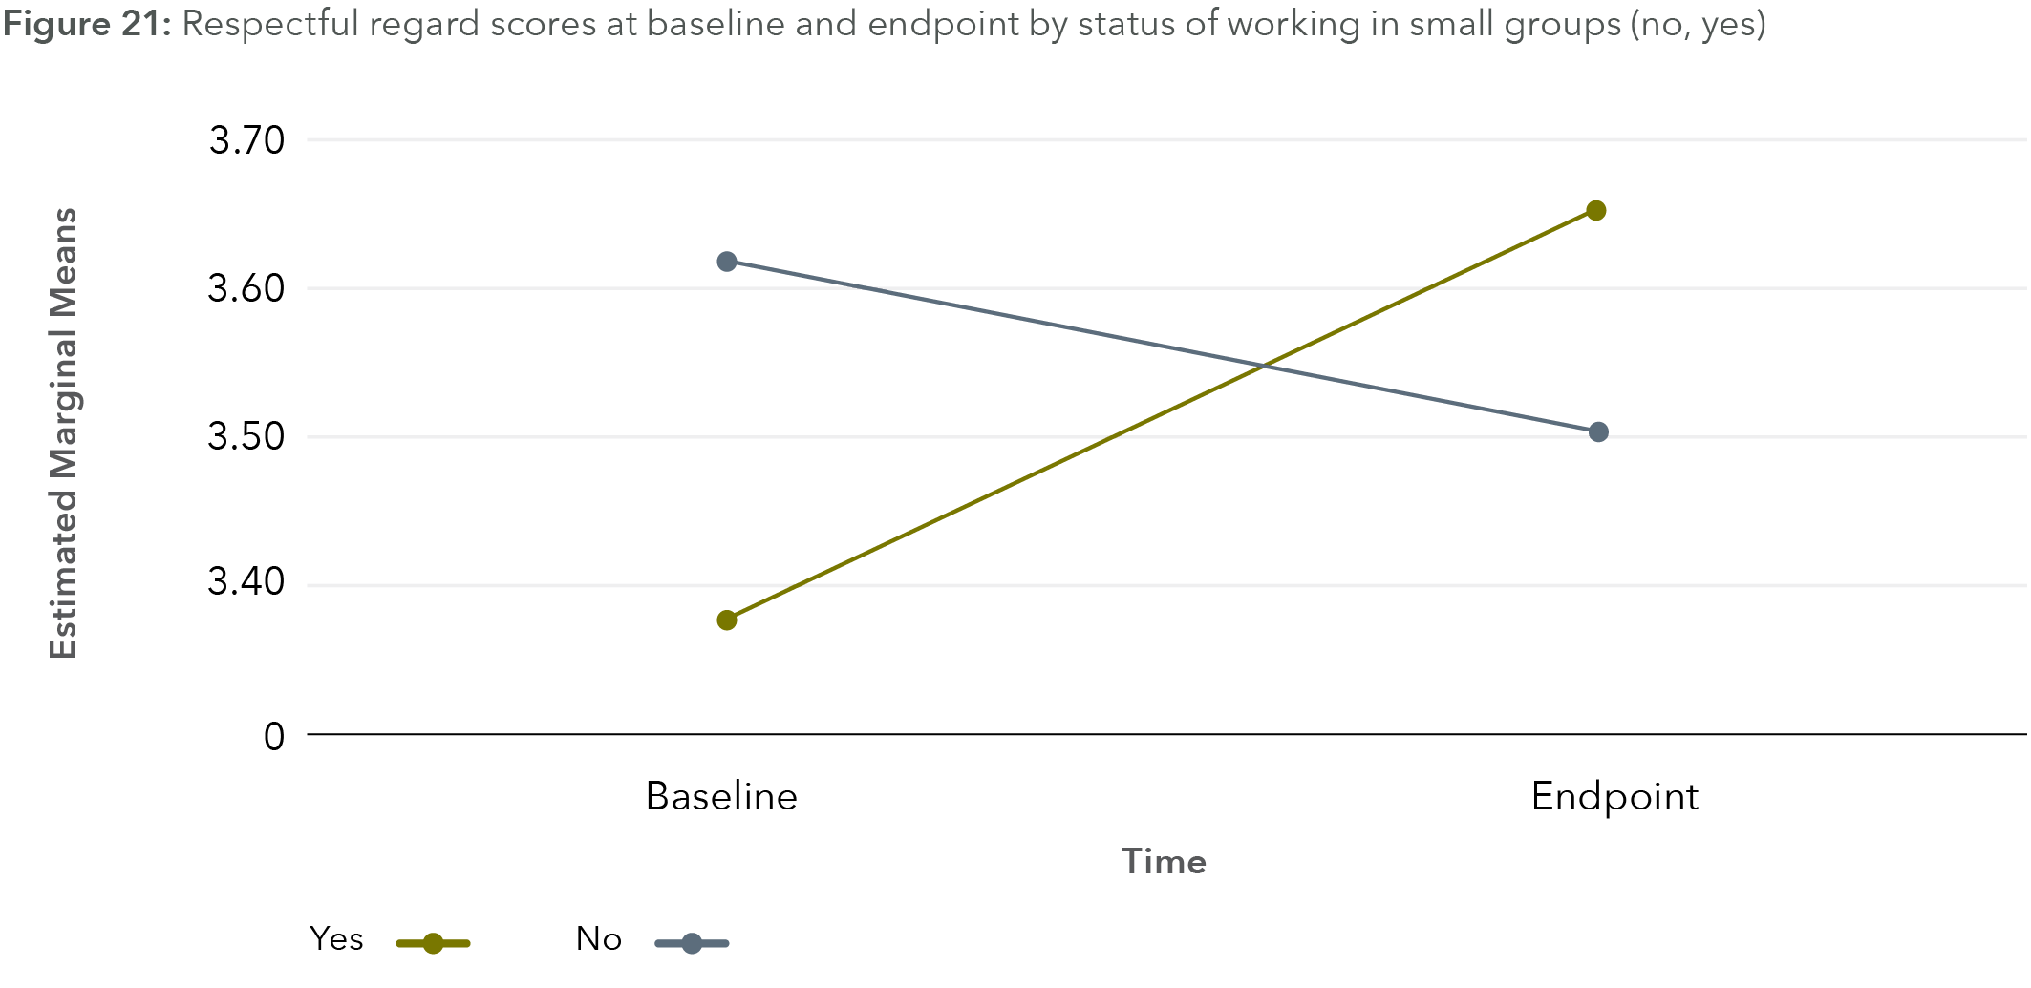
In terms of social capability, we found a significant interaction effect for time by work in small groups (F(1,393) = 5.061, p = .025), such that for the students who worked in small groups all of the time there is a significant increase in self-reported social capability that is not present for those students who did not work in small groups all the time (see Figure 22). This is supporting evidence for the value of the RRRR program when fidelity is high.
Figure 22: Social capability scores at baseline and endpoint by status of working in small groups (no, yes)
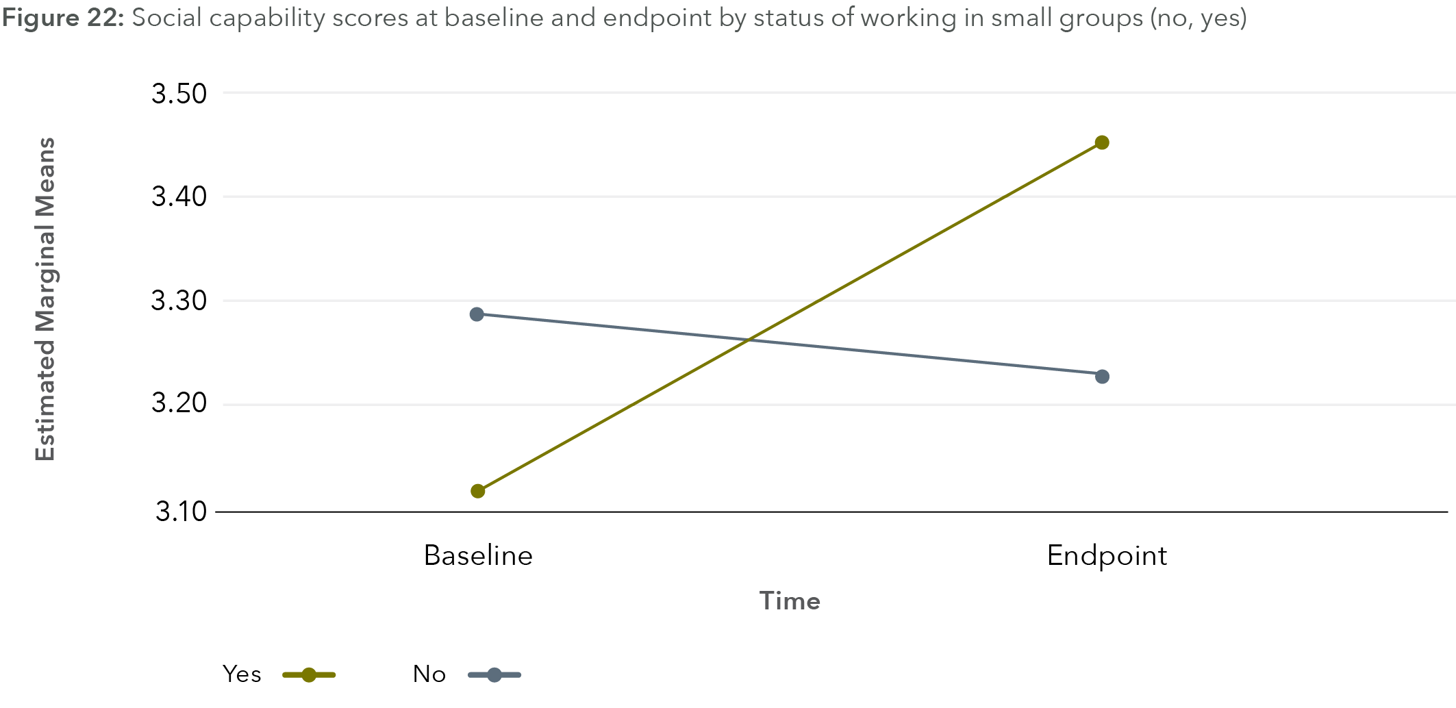
Another resilience measure, dealing with negative cognitions, demonstrated no significant differences or interaction effects across time as a result of fidelity of implementation (i.e. always working in small groups, or not). That is, fidelity of implementation did not matter here. However, gender was the only significant effect (F(2,392) = 25.511, p < .001) with post-hoc tests showing us that boys scored significantly higher than girls and gender diverse young people, and girls scored significantly higher than gender diverse young people, in terms of dealing with negative cognitions.

Reductions in bullying and sexual bully following program implementation
When comparing the 395 students who participated at baseline and endpoint (see Figure 23), we see a reduction in the number of students who said they sexually bullied other students (baseline = 8.7%, endpoint = 5.9%) and for those who said they bullied others (baseline = 11.8%, endpoint = 10.3%). These are small changes but do point to a positive impact of the RRRR program in relation to violence reduction. Further, as longitudinal research has found that those who engaged in bullying behaviours and homophobic name-calling in early adolescence are more likely to engage in sexual harassment in their high school years, it is important to encompass prevention of all forms of interpersonal violence (Espelage et al., 2018).

Figure 23: Reductions in bullying and sexually bullying (baseline to endpoint) for Years 7 and 9
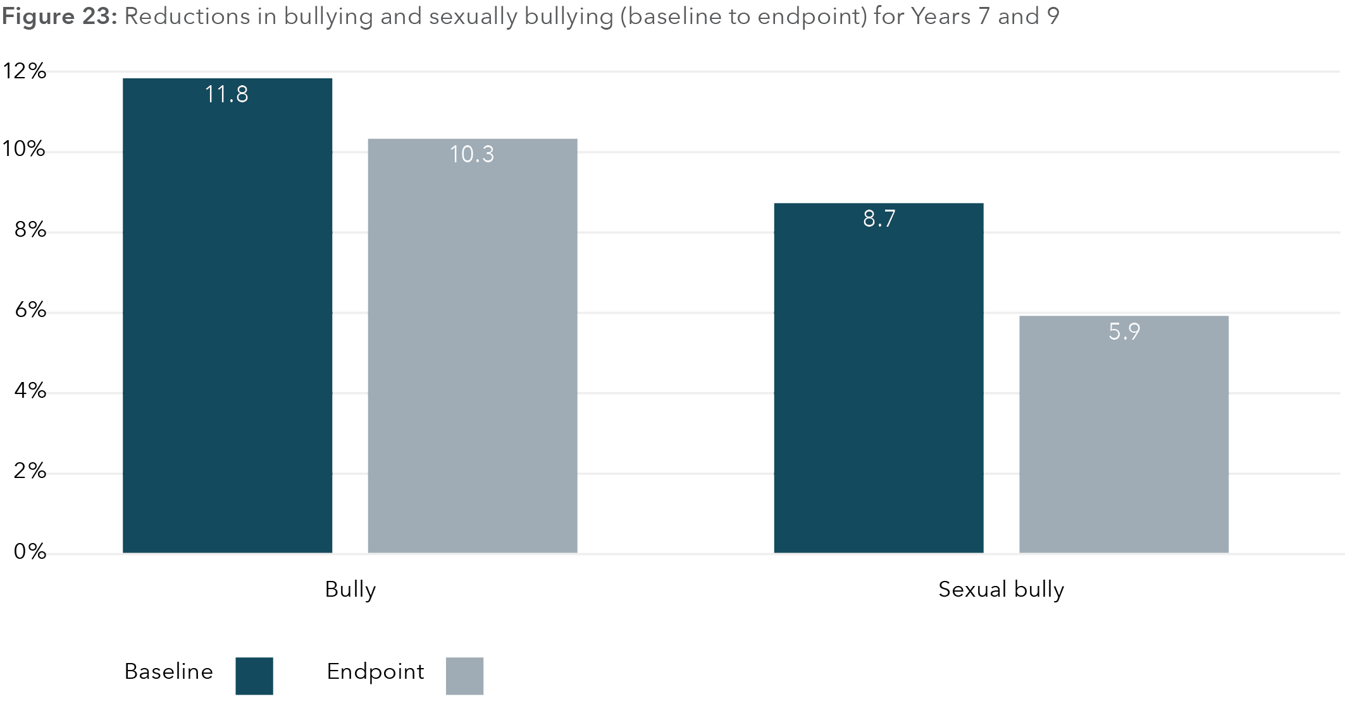
Data table for figure 23:
Bullying or sexual bullying | Baseline | Endpoint
Bully | 11.8% | 10.3%
Sexual bully | 8.7% | 5.9%

Summary
We found that school life was marked by pronounced gender divides, with students rarely befriending or working with others of a different gender. The inclusion of student social relationships (as social networks) provides a valuable insight into the structure of social connections between students by showing the intersection between social connections and attitudes that students hold.
Through the social network analysis, we see evidence that students seek to socially connect with those who hold similar attitudes and/or behave similarly – whether this be bullying others, holding beliefs that support domestic violence or holding anti-violence or pro-gender equality attitudes. Given that we also note the gender divides in student friendship groupings, this can mean that a number of different micro-cultures might exist within one class, offering different forms of peer influence.
At baseline, we found that gender equality attitudes are lower, on average, for boys than either girls or gender diverse young people (with the latter two genders not differing). For boys, positive gender equality attitudes are associated with low violence-endorsing and low domestic violence-endorsing attitudes, as well as with preparedness to speak up against sexual harassment. Girls who hold positive gender equality attitudes also demonstrate this profile; however, girls’ positive gender equality attitudes show an additional associated factor of being unlikely to bully others. Anti-violence attitudes also relate to pro-gender equality attitudes for gender diverse young people. Overall, attitudes about use of violence are strongly linked to attitudes towards gender equality.
Boys’ pro-gender equality attitudes reduce with age, with Year 9 boys more likely to hold negative gender equality attitudes as compared to Year 7 boys. Low individual confidence, not high individual confidence, is associated with higher gender equality attitudes.
Through investigating resilience factors at baseline, we found that girls, boys and gender diverse young people have different resilience profiles. Boys are significantly more resilient than girls who are, in turn, significantly more resilient than gender diverse young people.
For boys, resilience factors relating to respectful regard are linked to positive gender equality attitudes and speaking up against sexual harassment, and those relating to social capability are also associated with speaking up against sexual harassment and with violence dis-endorsing attitudes. However, while individual confidence for boys is also associated with speaking up against sexual harassment, it is unrelated to gender equality and violence attitudes. Overall, analyses for confidence across the genders show that resilience factors pertaining to confidence are negatively related to supporting gender equality. In contrast, low confidence attitudes are predictors of pro-gender equality attitudes. Boys also hold significantly higher pro-violence attitudes and pro-domestic violence attitudes than girls, and pro-violence attitudes are linked to lower gender equality attitudes.
Despite that individual confidence has been seen as a marker of resilience, it may not be a marker of respectful relationships. There appears to be no relationship between social capability and confidence, but there is between social capability and respectful regard, and social capability is a negative predictor for pro-violence attitudes.
Through our investigation at baseline, we found that students who bully other students are also more likely to sexually bully others and are also more likely to be bullied by other students themselves. Students who bully and/or sexually bully others are more likely to choose close friends, want to work with and spend more time with students who also bully others. This suggests that some students may be socially connected in ways that position them to mutually reinforce various bullying and sexualised bullying behaviours through their positive social connections with peers who hold the same beliefs and enact the same behaviours. For all genders, the reverse is also true, with students who hold pro-gender equality attitudes more likely to be socially connected to like-minded others, either as friends or as people they say they can work with on group tasks, or in an aspirational sense of wanting to spend more time with that person. This highlights the intersection between social networks and attitudes that students hold.
Intentions to act in a pro-social way in response to instances of sexual harassment also vary considerably by gender and age. Baseline data showed that within both year levels, boys were far less likely than girls and gender diverse young people to say they would intervene if a boy in their class told a sexual joke about a girl and Year 9 boys were less likely to say they would intervene than Year 7 boys. Responses from girls and gender diverse young people were similar. Concerningly, close to a third of Year 9 boys and over a fifth of Year 7 boys said this behaviour wouldn’t bother them. That these differences are so marked for gender and age suggests that boys may find it increasingly difficult to speak up about negative peer behaviour of other boys as they enter the middle years of secondary school. This further reinforces the importance of considering the social nature of wellbeing, the importance of continuing to provide SEL and respectful relationships education as students move through secondary school.
In terms of fidelity of implementation of the RRRR program in relation to provision of the collaborative learning activities, within endpoint surveys, we found that most students reported teacher use of whole class discussions, rather than small group activities or role plays. Students who experienced the program as high fidelity scored significantly higher in their rating on the usefulness of lessons on gender and equality and GBV and showed a significant increase in both self-reported social capability and self-reported respectful regard at endpoint, whereas the reported emotional insight of students who did not report working in small groups all of the time remained the same. This is supporting evidence that when the RRRR program is implemented with high fidelity there are stronger outcomes.
Nonetheless, despite varied levels of fidelity, the vast majority of students said they gained from participating in the RRRR program, with girls and gender diverse young people making stronger endorsements of the usefulness of the program than boys.
Comparing baseline and endpoint student responses, we found reductions in bullying and sexual bullying when comparing Year 7 and Year 9 baseline and endpoint student responses, with a decrease in students who said they sexually bullied other students (baseline = 8.7%, endpoint = 5.9%), along with a slight decrease in bullying from baseline (11.8%) to endpoint (10.3%). This points to a positive impact of the RRRR program.

Part D:
Key findings – qualitative
This part provides an integrated discussion of the data drawn from the student focus groups, teacher interviews and implementation leader and principal interviews. The first of four sections details student accounts of the contribution of the program. The second presents teacher observations of the contribution of the program. The third section uses a social ecology framework to map the implementation enablers and barriers, and the fourth section provides a discussion of key insights from the data.

Insights into student experiences of the RRRR program
In the focus groups students were asked to describe the peer culture that they experienced in their class and in the broader school environment and whether they saw need for a program addressing respectful relationships. Their accounts revealed that while there were many positive relationships between peers, there were also students who rejected the notion that men and boys were more commonly the perpetrators of violence, who engaged in sexualised, homophobic and transphobic forms of harassment, along with other forms of discrimination against people who are held to be “different” or from a marginalised group.

Indicated need for the program: Student experience of peer cultures of support and resistance
Generally, students reported that most students were in support of acknowledging the problem of violence against women:
I thought people were pretty understanding about that stuff and really took it into consideration that it does happen and really be aware of it and help other people if they’re going through something like that. (School 2, Year 9 student)
However, students in each of the schools also noted that a minority of peers showed resistance or expressed negative views about gender equality or gender inclusion. One common form of resistance presented as a denial on the part of some boys that violence against women and girls is chiefly perpetrated by men and boys was:
When it comes to … gender-based violence and stuff, where a majority of it does happen to women … some of the people [students] kind of got defensive about it, and it was a slight disagreement about it … some of the boys at the back of the class … I think it’s … defending. You feel like they’re saying that you [a girl/woman] would do that [too]. (School 4, Year 7 student)
Students also reported that resistance could be expressed via disrespectful comments, disruptive behaviours or refusal to take the topic seriously:
Yeah, I feel like most of them, just … acting like silly and stuff like that, and they didn’t really care to be honest … they wouldn’t be focusing on the work, they weren’t interested, and they would just be laughing. … They just looked like they weren’t paying attention. Obviously not all of them but some. (School 1, Year 7 student)
Outside the classroom, backlash could be expressed in a more florid way. For example, one Year 9 student observed how distressing they found it when some boys actively parodied the focus on gender stereotypes and sexual assault:
I just go outside and there’s like, I'm not trying to be really stereotypical, but it’s usually boys who do it, and they’d be like, “Oh my god, you’re touching me, that’s assault, that’s rape!” And then they really joke around those sensitive topics and it’s like a stab in the heart ... (School 2, Year 9 student)

Student experiences of peer policing of gender segregation
Students reported that sexualised forms of harassment commonly occurred if people crossed the gender divides that marked their friendship groups:
I’m friends with girls, boys. I’m friends with anyone. If they’re nice, that’s all I need. But say I’m walking with a boy, everyone’s like, straight away, “Oh, you’re dating. 100 per cent. You’re dating. There’s no doubt about it.” And I’ll be like, “No, we’re just friends.” And they’ll be like, “Oh sure, they all say that”. There’s so much judgment around what gender you hang out with. It feels very hard to associate with different genders when people see you doing that … (School 2, Year 7 student)
Crossing the gender divide could bring more negative reputational repercussions for girls than for boys:
There’s definitely a lot more judgment on the girls when it comes to being friends with a boy … If a girl were to be friends with a boy, they would get, definitely comments about, “Oh, you like them. You must only hang around boys because you want to date them, or you like them. So, you only hang out with those kind of people.” And then I’m guessing. This is not me knowing for sure, but I’m guessing when it comes to the boys, it’s kind of a different reaction where it’s like, “Oh, you must like her. Good on you. I mean, go for it.” There’s definitely a different side, different perspectives … (School 2, Year 7 student)
Another student described ways in which derogatory slang terms like “pick-me girl” were used to criticise girls for the friendships they shared with boys, attributing the reasoning girls pursued such friendships was to seek sexual interest from boys:
I feel like in most situations … If it’s a bunch of boys and one girl, the girl would be definitely judged that she would be a pick-me girl or something like that. But she wants to just hang out with boys. (School 2, Year 7 student)

Intersection of gender-based harassment with other forms of discriminatory treatment
More broadly, students reported that other forms of discriminatory treatment occurred in the school with negative comments made about those who were perceived to be different:
Well, I feel like it’s really bad when someone’s different because everyone teases them for it and doesn’t really ever forget about it, [it] just keeps going the whole year or because of something they can’t really control. And I’ve seen that a lot … A lot of the time online, but in the yard, they’ll like maybe call out their name randomly, mock them and make sarcastic comments … It’s mostly about, sometimes about their appearance, but a lot of the time how they act mostly. (School 1, Year 7 student)
Harassment of this nature was typically perpetrated around markers of difference such as race, sexuality and gender identity. For example, many students reported that homophobic and transphobic attitudes existed among some peers:
One of my friends in another class she divides her class into, when she explains it to me, the homophobic and transphobic girls and boys, and then her friends, it’s kind of that bad. (School 2, Year 9 student)
Another student noted the important role that learning plays in shifting disrespectful behaviour towards LGBTQ and intersex groups:
In my personal experience, there are still people in the school and outside the school that say things on the street, or they say things even if they don’t mean it to be harmful, sometimes they purposely mean it to be harmful and they purposely say these harmful things knowing how disrespectful and how hurtful it can be. But there’s also just the ignorance as well and not being taught properly about the LGBTQIA+ community. (School 2, Year 9 student)
One Year 7 student described witnessing students overtly targeting those of diverse gender during breaks:
In the line in the canteen, if I’m in there and I see someone with the opposite gender, I don’t say anything about it, but people on the opposite line, they’re always looking at them and giving them looks and talking about them. And they’d know because they’re so loud … and they’re shaming their name and everything. (School 1, Year 7 student)
Another student at the same school pointed out that classmates were reluctant to report this kind of harassment because they feared negative repercussions from their peers:
But if they’re in your year level and you tell someone about it, they’re most likely going to get mad at you and get a lot worse with it. So that’s why people don’t really talk about it. (School 1, Year 7 student)
These accounts describe the ways in which gender divides work to perpetuate certain stereotypes. They also highlight the ways in which gendered forms of discrimination and harassment can play out and the barriers to reporting which may lead to teachers being relatively unaware of the scale and impact of the problem. This data is consistent with other research which shows that young people holding gender inequality attitudes are also more likely to hold discriminatory attitudes relating to ethnicities and that young men are more likely to hold negative views than young women (Politoff et al., 2019). It highlights the need for prevention education and proactive whole-school approaches to ensuring that all students feel safe, respected and included at school.

Student experience of the content and methods within the RRRR program
The focus groups provided opportunity to ask students about their experience of the RRRR program. Students were given time to refer to their workbooks to help them remember different elements of the program, as for some, the intervention had been taught across around two-thirds of their school year. While the survey data shows that most students found the program useful, the focus group data sheds light on what it was they found useful both in relation to content and method of delivery. Students valued the dialogic exchange about relevant situations and the applied focus on tools and skills that helped them to:
- understand themselves and others
- communicate and problem solve
- provide peer support

- think about how they might challenge gender stereotypes and associated forms of peer pressure
- discuss how to have consent conversations and respect the rights of others, including within intimate relationships.
Students valued the program focus on emotional awareness (a key focus of Topic 1: Emotional Literacy) which focused on understanding self, communicating about emotions, empathising with the experiences of others and the focus on strategies for peer support, peer referral and help seeking (a key focus within Topic 5: Help Seeking):
Because the program talked about how people feel and how they don’t show it and stuff, so that sort of made you feel like, “Oh, you need to make sure your friends are okay. Oh, you need to make sure people are okay even if they don’t seem upset.” The program made you want to feel like you needed to help people, because you didn’t know what they were feeling. (School 2, Year 7 student)
This focus on supportive relationships aligned well with the students’ deeper regard for friends and their desire to be able to provide effective forms of peer support:
Because sometimes in life, people are going to be upset and you want to be there for them. You don’t know what to do. So, this program helped us to learn what to do in certain scenarios. (School 2, Year 7 student)
Along with the focus on how to express empathetic regard for others, students also found the program helped them to develop self-awareness and self-regulation skills:
Oh, I like the emotion bit as well. But not just towards other people. Towards yourself and how to deal with your emotions. (School 1, Year 7 student)
A Year 9 student from the boys’ Catholic metropolitan school spoke to the importance of understanding emotions and the ways in which masculinity norms could constrain expression of emotional vulnerability such as when help seeking:
I think that the help seeking, it made it sound easier in the book than it is in real life. In real life it’s very hard to be a male and ask for help, because there’s a lot of stereotypes behind being tough and not asking for help. (School 3, Year 9 boy)
Students appreciated the focus in Topic 2: Personal Strengths, where there was a focus on development of strategies that could be used in response to negative forms of peer pressure:
The Personal Strength topic, it’s going to help me in life because I’m someone who’s peer pressured a lot. So, just going through this topic, it helps me stand up for myself and not let people tell me what to do. (School 3, Year 7 boy)
Another Year 7 student from the same school highlighted the benefits of learning about ways to deal with overly negative or anxious forms of self-talk (a key focus in Topic 3: Positive Coping):
I just want to comment on self-talk. I feel like you’d use that in most everyday lives because, you have that voice in your head that you use to talk to yourself about something that you want to do, something that you think you can do. So, if you do something and then you don’t feel like you’ve done the best, you might put yourself down for that, for what you’ve done and you might feel like, “Oh, I could have done way better than that. I could have done something way better.” But I think, the self-talk in your head could help you really feel better to yourself and make yourself feel like you’re better than what your voice says that you’re not. (School 3, Year 7 boy)
One student noted how the RRRR program contributed to their critical thinking about gender stereotypes (a key focus of Topic 6: Gender and Identity). It strengthened their rights-oriented attitudes and commitment to treat others as equals:
(We saw that) it doesn’t even matter what gender you are, it’s, you need to treat everyone equally. (School 2, Year 9 student)
This critical engagement also assisted them to rethink some of the social norms which led to friendships based on gender, and they became more confident about crossing the gender divide that marked school-based friendships:
And this year we’ve learned … we’ve kind of discovered that it’s fine to be friends with anyone you want to be friends with. And no gender can change that and stuff like that. (School 2, Year 7 student)
Students considered that learning about respecting boundaries in relationships was an important aspect of addressing consent in the program (a key focus within Topic 7: Positive Gender Relations). A Year 9 student shared that it was not only useful to learn about boundaries and consent, but also to focus on what to do in relationships to ensure the other person is respected:
It was very useful. I think a lot of students learned a lot about what to do and what not to do, and how to confront the situations for rape … It’s just having a girlfriend and respecting her boundaries and that kind of thing. Don’t try to push past them, just respect them. Even if you don’t like that, you’ve just got to respect it. (School 3, Year 9 boy)
Students identified that consent conversations are integral to establishing safe and respectful relationships:
Well, your relationship … the thing of consent is that at that time, that is still one of the most important things of that relationship. That you’re not pushing boundaries, that you’re not going too far, that people feel comfortable being there and that they don’t feel forced to be involved in that. (School 4, Year 9 student)
It was common for students to note that all students should be provided with consent education. As one Year 9 student noted:
I’d probably say the most important thing was consent just because when we went over it went over a bunch of things like what’s acceptable, what is and what isn’t consent, and knowing those kind of things, is good just to teach to a broader part of the school. So having the whole of Year 9 learn that was probably the most important thing. (School 2, Year 9 student)

Student experiences of fidelity of delivery
Students were asked whether they were provided with opportunities to do small group tasks within which they engaged with scenarios and problem-solving discussion and whether their class participated in role-play activities. Students were readily able to remember whether they had done so or not and in each focus groups there were some students whose teachers had regularly employed these methods and some whose teachers rarely or never used them.
The students whose teachers provided the RRRR program with strong fidelity were particularly enthusiastic about its contribution. As one student noted, some students would not get to talk about these issues at home, due to the sensitivity of the topics, and thus it was particularly important that schools provide this opportunity:
I think it’s pretty good that we get the opportunity to learn about this … I think it should [continue to be taught] because there are some things covered in the program that we probably wouldn’t have learned otherwise. Because things like drug education, sex education, usually they’re considered kind of taboo. So, we don’t really have the conversation with our parents sometimes. So, it’s good that we’re learning this stuff. (School 2, Year 7 student)
Year 9 students from School 2 were clear that their participation was best fostered by teachers who were open to student views and who used the collaborative pedagogies to support positive and meaningful dialogue between peers.
The class, it really depends on how the teacher puts it out and the atmosphere they set up. (School 2, Year 9 student)
Another Year 9 student from School 2 found that the teacher had helped establish a culture of respect and that this enabled deep discussion and engagement with the material:
I thought people were respected, they were listening, and … there was always something to say that was meaningful or it had purpose. (School 2, Year 9 student)
In similar fashion, a Year 9 student from School 3 attributed the engagement of their peers to the teacher’s willingness to be open, non-judgemental and focused on the importance of learning:
There was definitely not a time where anyone felt uncomfortable, or anyone felt scared to ask anything. Our teacher will always say, “There’s no right or wrong answer, we’re just here to learn.” Personally, I felt very comfortable, as if I could say whatever I wanted, add it to the topic. Our teacher made everyone feel that way, so that was really good. (School 3, Year 9 boy)
Those students who had been in classes in which the teacher used the collaborative learning reported they found it useful to engage with peers and the content via small group tasks, and to have the opportunity to watch or participate in role plays as they helped to make things real. A Year 7 student from School 3 reported that his teacher made strong use of the collaborative learning activities:
Pretty much every time we did it we were in small groups and I think, maybe once or twice, he’d [the teacher] tell us to act out the situation ... He’d give each of the groups one of the situations and then after that we’d have to talk about it and then maybe even act it out. … I think it was useful because it got everyone involved and active … if it’s acted out, they could be more interested in it and seeing the actual things that are happening inside the acting. (School 3, Year 7 boy)
Other students in Year 7 focus groups noted that the scenarios helped them to focus and engage in an applied way with challenges that were relevant to their lives:
Yeah, I did find the scenarios about consent really helpful because it shows examples of when you need to use consent and when you need to understand when to stop doing something that you’re doing to someone else. (School 3, Year 7 boy)
I like how near the end [of the program] … we were allowed to make our own scenarios and use ways that we learned to cope with the situations. We would be able to implement those in our scenarios. And I really like that feeling of being able to apply what we’ve learned already in our own things. (School 2, Year 7 student)
Some students from this School 2 focus group got to mix with diverse others in their class. They reported that this mixing helped them to expand their friendships groups and to also increase understanding of the values and beliefs of classmates:
So he would set us up with a group … [and] say, two boys and two girls. The girls wouldn’t be friends so they wouldn’t just go off in their own little group, and the boys wouldn’t go off in their little group. They would actually have to all be together and all chat together, which was good. And because everyone in the whole class had to hang out with different genders in class doing the work, then no one would be judged because everyone would (be doing) the same. (School 2, Year 7 student)
These responses are consistent with research that finds higher levels of student engagement and retention of knowledge when their GBV prevention education employs collaborative and participatory modes of learning which engage with relevant material (Vanner & Almanssori, 2021). Those students whose teachers had not used the collaborative learning tasks were clear that this was not the optimal approach to promote student engagement and skill building:
My class don’t pay attention much to these lessons because of the teaching style of our teacher. He just talks and sometimes we do class discussions but it’s not too interactive. So, I think our class gets bored. (School 2, Year 9 student)
Most of the time we … sat there writing and listening, that’s not fun, that’s not what I would describe as fun. Getting out and doing something around it … (would be) more practical. (School 4, Year 9 student)
Basically, the teacher would just talk for an hour and then we just write in our books for an hour. (School 4, Year 9 student)
A lot of it was in a booklet that we had to fill in, in our own time … So, our teacher... It’d be, “Just make sure this is done by the end of the lesson.” (School 1, Year 9 student)
Some students reported that their teacher skipped or gave only a minimal focus to the content of certain topics, such as addressing gender norms:
We didn’t really [learn about gender norms]. It was like the teachers just like, “… I’ve done some gender norms, I’m sure we did.” Majority of the class didn’t do it. We did like two and the teacher was like “Anyway, move on, moving on.” (School 4, Year 7 student)
Students also noted that it was important that the teacher was confident and capable of facilitating open discussion on sensitive topics:
If it’s going to be awkward if he’s [the teacher] just kind of, I don’t know, not really teaching it the right way, then obviously kids won’t want to really learn and they’re just going to be really closed up about it, and not really know what to say. Because it is a really sensitive topic. (School 2, Year 9 student)
Students suggested that if a teacher was confident about managing student behaviour and trusted their students, then they would be more likely to run activities like role play:
I think the role plays we did had trust from a teacher because I think that a lot of inappropriate and immature jokes can be made in this kind of topic, especially the role play. But I think that the teacher trusted, personally, our class enough to do something with that and really get to the point, and not be immature, and do it maturely. (School 3, Year 9 boy)
When asked about what they believed to be the most useful instructional approaches, students across all focus groups unanimously endorsed the use of collaborative pedagogies as the optimal mechanisms for supporting their engagement with the program content.
I feel like it could have had more group activities to do with things. (School 4, Year 7 student)
I mean it was mainly just on paper, if you would set a role play or something about something, that’d be a bit more fun. (School 4, Year 7 student)
Those who had not been provided with the opportunity to work in mixed gender groups suggested that doing this would assist peers to get to know each other better, help shift misconceptions and support them in broadening their social circles:
I want it to be mixed so … [you] could get to know everyone in the class, get to know everyone’s opinions and experiences and that way we can learn together. (School 2, Year 9 student)
I think maybe putting genders, mixing up genders would be helpful. Get everybody’s opinion. Especially if it’s people you don’t talk to, you don’t know them, you don’t know, you just have this idea of who they are and they could be the best person, but you don’t like them because they’ve said one thing in class, and you hated what they said. And I think to help with that, mixing it up a bit more would be better because … I feel like you make friends in primary school and then you bring those school friends with you to high school and then that’s who you’re with until something happens or whatever. So, I think teachers need to definitely mix it up. (School 2, Year 9 student)
As noted in these responses, when teachers used more didactic approaches rather than the collaborative learning models provided in the lesson plans their students missed opportunities to constructively engage with peers through dialogue and critical reflection. They also did not get the opportunity to extend the social skills that would be activated within such tasks. This in turn led to reduced opportunities to get to know each other or to bridge friendship or gender divides. In this, students in high-fidelity classrooms were offered a very different learning experience from those in low-fidelity classrooms.

Teacher views about the contribution of the RRRR program
The following section draws on the teacher interviews. It sheds light on their experiences of providing the program and their observations about student responses. There are some limitations in this data, as the teachers who participated in the interviews were not a representative sample of those who taught the program. They were chiefly those who had been able to attend the training provided by the research team, played an active role in assisting with school uptake and had implemented the program with high fidelity. Those teachers who the students described as providing a more didactic or teacher-centred approach were not represented in this data set.
In reporting on their own classroom experience, the teachers who did participate in the interview process found that:
- The RRRR program provided strong guidance and modelling to support their practice.
- The learning activities supported critical reflection on gender norms, gender discrimination, gender-based violence and positive approaches to consent conversations.

- Students became more willing to challenge disrespectful views expressed by peers.
- Engagement with the program lead to improved relationships between students and between the teacher and the class.

Teacher responses to the content and methods of the RRRR program
Teachers positively appraised the guidance and learning activities provided in the RRRR program. One Year 9 teacher noted that as they entered the training, the program initially seemed quite challenging, but the training built their sense of confidence:
… by the end of it I was incredibly positive about [it]. I think it was tough at the beginning. (School 3, Year 9 female teacher)
This teacher reported that they went on to implement the program with high fidelity and reported positive engagement on the part of their Year 9 students in the boys’ Catholic metropolitan school:
We used most of them [the learning activities]. They loved the role play actually. I have to say that’s something I think I should do more of in my own teaching. They actually really got into that, and I think that they liked those kind of kinaesthetic type activities. We did a lot of group discussion in small groups in pairs, and then bringing back to the whole room. ... also, towards the end they quite liked almost co-leading the session. So, they took their own turns to come up to the board and scribe the notes and they’d lead the discussion with their peers. So, I tried to use some of that as they got more confident with the way we were operating. And that’s nice. It’s nice to just become the facilitator and let them almost lead their peers through a discussion. (School 3, Year 9 female teacher)
The teachers who delivered the program with high fidelity felt supported by the guidance and learning activities within the RRRR resource. They viewed the intervention to be of high quality and appreciated that it was mapped to the Victorian Curriculum:
I thought the resources were brilliant ... The information in the teacher manual, again with the evidence-based information that you could present to the students so they could find relevance in why we are doing this … I really liked a lot of the activities, and how it met curriculum, and how it was presented and used. Recent statistics and data especially. (School 1, Year 9 male teacher)
Teachers appreciated the program guidance about ways to use a strengths-based approach to enhancing mental health and developing relationship skills:
Some of the earlier lessons, the character strengths, managing emotions, I think that’s a really positive way of talking about mental health really … I actually think that’s a really positive way of raising awareness of mental health. I think young people nowadays, they know what anxiety, depression, and all those things are. So, what they need is skills to manage their day to day lives … (School 2, male implementation lead)
These teachers also found that the program elicited strong student engagement and that the class discussions and the interactions helped them to get to know their students better and to build stronger relationships with their students:
When you’re having those discussions, often you do build relationships with students, you get to understand them a little bit more, and they get to understand you a little bit more. (School 2, male implementation lead)
Teachers noted that evidence of positive response from their students in turn sustained their own commitment to continue to provide the program with high fidelity:
I always thought from day one it was engaging, just because of the teaching methods … and you could see the staff enthusiasm doing it, and that always translates well when kids get to do it as well. … Yeah, I think just the teaching style and the pedagogy within it, I think helps kids to just be more comfortable. (School 5, Year 7 male teacher)
Another Year 9 teacher also found it encouraging that their class responded positively to the collaborative learning activities:
They liked having the case studies [scenarios]. … They really enjoyed having prompts, topics, the games, something for them to work in groups, but also something to, I guess, start the conversation as well … so we did a lot of group work sharing, lots of stuff on the board. They loved the group work in terms of small groups, larger groups, then sharing to the class as their probably more enthusiastic part of it … (School 2, Year 9 female teacher)
The scenarios provided a focus through which to consider different situations and engage in critical reflection, discussion and formulating potential actions for use in response to challenging situations. A Year 9 teacher observed that the scenarios helped the students to talk freely about issues without being called upon to share their personal experiences. She noted that even talking about personal emotions could be challenging within an all-boys’ school and there was a need for protective distancing:
I think in an all-boys environment it is quite hard for them to talk about their emotions. I don’t think there’s a whole lot of that that goes on in the yard … a lot of the time the scenario work was a lot easier for them because they’re very happy to talk about hypothetical people. I think some of those earlier things (involve) a bit more talking about yourself and that’s actually quite hard for a lot of our boys, I think. (School 3, Year 9 female teacher)
Teacher coaching points within the program encourage teachers to mix students across friendship and gender divides with the notion that this can help students to get to know others better, develop their social capabilities and transcend any gender divides that may exist in the class. A leader observed that something as simple as use of mixed gender groups helped to disrupt gendered stereotypes and associated friendship divides:
Just not knowing someone feeds into stereotypes. So teenagers just have a perception of that person over there in that group, doesn’t matter what gender they are really, and they’ll just box them into a stereotype. And unless they actually sit down and have a conversation with them, they don’t get a chance to do that. (School 2, male implementation lead)
However, other teachers opted not to mix students but just to allow them to select their own groups because they anticipated that this would be more comfortable for students:
I was having them just work with groups that they were comfortable with because with the conversations that they were having, I thought it’s probably best for them to be talking with people that they feel comfortable having conversations with. (School 2, Year 7 female teacher)
Teachers were asked how their classes responded to the topics within the program that had a particular focus on gender norms and on prevention of GBV. They found that conversations about gender norms increased awareness and understanding of the ways in which these norms and associated social pressures can lead to limiting or harmful outcomes. Even at Year 9 they found that unpacking gendered stereotypes was new work for many of their students:
When you talked about, what does being a girl or a female look like, sound like, what compliments do you get as a female versus what do you get compliments as a male [for] … they [the students] were like: “I’ve never thought of that before. Girls get commented on their appearance. Boys get commented on their ability to do things.” So it’s quite interesting some of the conversations. And many of them were very insightful saying: “We’ve never actually thought of that before.” (School 2, Year 9 female teacher)
A Year 7 Health/PE teacher noted that becoming more literate about gender diversity could also play a role in building an inclusive culture. She spoke with enthusiasm of the moment in which she saw students adopting the use of inclusive and respectful language and applying their understandings of gender diversity:
I noticed such a difference once, [I taught] the difference between something like sex and gender, going forward, their terminology when we’re talking about puberty was, “so that’s like how we have the biological, but then someone can identify differently.” … And that was really exciting. So even just small comments like that, I think that was lovely for them to really grasp the idea of different genders. I think they really understood that well. (School 1, Year 7 female teacher)

Teacher accounts of the importance of the relational environment
Confirming an existing body of research, school leaders and teachers emphasised the importance of strong student and teacher relationships in facilitating effective program implementation (Cahill, Dadvand, Shlezinger, Farrelly et al., 2020; Vanner & Almanssori, 2021):
I think another key factor to the successful implementation of this program is having a relationship with the students. And so having that sort of established relationship. (School 3, male implementation lead)
As a principal observed, positive teacher–student rapport enabled teachers to lead students into deeper discussion and meaningful exchange:
And you can tell that when you walk into the classroom straight away, that they’ve got that relationship with the students, where they know that they can get to the core of some of the issues. (School 1, male principal class)
Indeed, having an established positive relationship was noted as a factor that enabled credibility of the teacher to lead this form of learning:
I think you have to have the relationship to start with, otherwise they’re just not going to necessarily take everything on board as a genuine learning activity. (School 2, Year 9 female teacher)
A sense of trust and social safety was seen as particularly important when addressing the more sensitive topics within the program, such as those addressing help seeking, gender identity and prevention of GBV:
A lot of the topics and things you discuss, you need that close bond with the students and the trust. (School 5, Year 7 male teacher)
Positive teacher–student relationships were also important when teachers were called on to respond to student resistance. One teacher pointed to the importance of preserving relationships with students, while also closing down negative forms of address and seeking ways to follow up after problematic incidents:
Well it can be really tricky. You want to try and keep those students on side in lots of ways … closing it down firstly, and then taking them aside. (School 2, male implementation lead)
Other teachers noted that it was important to respond during the class discussion, rather than deflect challenging questions from students who appeared to be resistant, as respectful engagement on their part as a teacher strengthened their relationship with these students:
I did find with the few students, especially with the, I’ll say tougher topics to talk about, a student here or there would ask a question about it. And when we kind of discussed it, I did feel our relationship kind of strengthened because we kind of went through I guess that awkward conversation, but they appreciated that I took the time out to have that conversation. (School 1, Year 9 male teacher)
These findings are consistent with wider research which shows students involved in programs addressing GBV find strong teacher–student and student–student relationships to play a major role in fostering their engagement and learning (Vanner & Almanssori, 2021).

Achieving change in negative attitudes takes time
The discussions generated by the activities surfaced a range of attitudes about gender equality. Some teachers found it quite confronting, as they had not realised that some of their students held negative views about gender equality. Despite this discomfort, a Year 7 teacher in the boys’ school saw the value of surfacing these views, contending:
I do think it’s necessary [the discussion of the RRRR topics]. It’s a clear guideline and it helps us as teachers understand the students’ values. Some shocking values, but it’s a good way to understand them, so that we know what we should work on and what we should provide at school. (School 3, Year 7 female teacher)
She observed that a sustained period of engagement with the program was needed before shifts in behaviour became apparent among those boys who held negative views and/or who participated in discriminatory talk or treatment of others.
They understand the gender and identity, the gender relations, the violence, the stereotypes for both genders and the inequality ... They know that many of them know that. But there are still some students who … don’t really implement that in their real life. In their real life their action doesn’t really match what they say in the class. (School 3, Year 7 female teacher)
However, this teacher did report seeing favourable signs of improvement in relation to boys becoming more prepared to call out or report this behaviour:
I see the influence of it, because I think their attitudes and their definitions of snitching has changed somehow … Now if any students calls another student like, “You snitch”, or something, the other students will stand up and say, “This is not snitching, it’s just reminding you to do the right thing.” So, I do think that for some students, they changed their definition of the behaviour and they understand what to do, what not to do. And when somebody’s doing the wrong thing, they do think it’s part of their responsibility to stop that. (School 3, Year 7 female teacher)
Similarly, a Year 9 teacher in the boys’ school noted that there were some students with very fixed ideas about gender equality. However, she did observe that over time some students opened up to alternative ways of thinking and others felt more comfortable to challenge negative attitudes:
I think a lot of their attitudes were quite cemented at the start. That was, for them, it was proving a barrier and then as we went through, they realised that actually maybe, they’d done some deeper thinking and maybe some of their attitudes were shifting and they were starting to get a little bit safer with challenging each other. I think that’s something that we [didn’t] have maybe much of a culture of that at the start, that was hard for them. (School 3, Year 9 female teacher)
However, this teacher also noted that it took a long immersion in the program before these students began to openly challenge gender inequality views expressed by their peers:
I’d say it only started happening in Terms 3, 4, but they actually started to feel like: “I’m going to call that out” … And no one was doing it in a particularly disrespectful way. … I think they started to be more comfortable with challenging each other’s attitudes and it became apparent to me, which was quite … encouraging that the prevailing attitude was very positive in terms of moving forward. But there were a few in there that were very oppositional, and it was about how the collective can work together to try and help slowly, slowly shift that. (School 3, Year 9 female teacher)
Similarly, a Year 9 teacher from a co-educational school noted the persistent nature of the negative peer pressure that meant that those boys who did not approve of certain abusive behaviours felt unable to challenge their peers:
Some of them really struggled with that because … “Oh, my mates will just have a go at me.” … But that’s probably what the peer side of things is like, probably needs a lot more attention on how they can let their peers know that what they’re saying is not okay, shutting it down quickly or in a way that they’re comfortable with, so they don’t feel as though they’re going to get the backlash. (School 2, Year 9 female teacher)
This teacher also noticed that it took time for signs of improvement to emerge on the part of those who held resistant attitudes:
As we progressed through the year, curiosity came out a lot more and a lot of questions about how you would do X, Y, Z. And I think particularly, maybe not the questions, but the engagement from some students who may belong to groups that perhaps may not be inclusive at all times, I would certainly say that they didn’t switch off … maybe not quite at the point where they’re putting up their hands and asking, but just tuning in and listening. I could probably notice a group of young Year 9s perhaps who might have just dismissed a lot of things, just tuning in … I did have a good role model in my class who is a very, I would say, sporty male who did ask lots of questions, did engage and put his hand up, would always answer things … I think he made it okay for everyone else to engage as well. (School 2, Year 9 female teacher)
A slow process of change became evident within the peer culture of this Year 9 class. Those who were resistant began to “tune in” and pro-social peers began to speak up rather than feel silenced in the face of possible backlash.
Gender scholars have identified that men and boys play a significant role in influencing other boys and men within violence prevention efforts (Flood, 2019). These examples illustrate that positive change in peer cultures can take time. In each of these classes, teachers noted that concern about repercussion from dominant peers who espoused negative views worked to constrain those who did not share these views from speaking up, despite that they might be in the majority. Over time, however, teachers observed shifts in this power balance, such that it became more legitimate for students to speak up when others made sexist, homophobic or transphobic comments. This data collected from students and implementing teachers shows that when implemented well, the program is beneficial to the students. Four key factors contributed to the quality of the teaching and learning experience:
- Teacher capacity. Teacher confidence, capacity and comfort in relation to both program content and instructional method affected student engagement and student access to all elements of the program.
- Use of collaborative learning activities. These activities helped students to engage with the material and provided opportunity for students to mix and work with each other. They assisted students to critically engage with the material in relevant and applied ways. In learning with and from each other, the students were better able to develop respectful relationships across the existing gender divides, advance positive social norms and become more confident to challenge negative peer behaviours.
- Providing an integrated approach to SEL and respectful relationships education. Students valued the focus on SEL as well as the focus on gender norms, gender equality, consent education and prevention of GBV.
- The quality of the relational environment. Positive teacher–student relationships affected student engagement, as did the quality of peer relationships and associated standards of behaviour. Negative community attitudes about gender equality and gender inclusion affected levels of social safety within the social ecology of the school and teachers needed to be able to deal with expressions of backlash or resistance in the classroom as part of advancing the learning objectives.

Using a social ecology framework to map implementation barriers and enablers
As discussed in the literature review, social ecology frameworks are widely advocated within public health approaches to addressing complex wellbeing and social justice challenges (Golden & Wendel, 2020). A social ecology framework identifies that a complex array of nested societal, institutional, community and individual factors operate as forces of influence. Barriers and enablers not only intersect at each level of the ecology, but also interact in dynamic ways across all levels of the ecology. Additionally, enablers are not always the inverse of barriers, but can consist of a different assemblage of forces.
The data we collected from teachers not only provides insights into their experiences of providing the intervention and their observations of student responses, it also sheds light on the intersecting societal, system, school and individual barriers and enablers that affected implementation. Taken together with the teacher accounts, the interviews with principals and implementation leaders provide an overarching account of the factors affecting the school-level response to providing the intervention. The following section uses a social ecology framework to map the complexity of intersecting barriers and enablers revealed within this data.
In the following, the subsection titled “Community attitudes as societal factors affecting implementation” discusses the societal-level enablers and barriers. The section titled “Education system enablers and barriers” discusses the accounts given of the function of their education system in enabling or constraining implementation. The section titled “School-level implementation enablers and barriers” discusses the factors at school level, and the section titled “Teacher-level implementation enablers and barriers” discusses the teacher-level professional, personal and relational factors at play.

Community attitudes as societal factors affecting implementation
Interviews with teachers, implementation leaders and principals revealed that enabling societal attitudes included awareness of the heightened rates of student mental and social health distress post-pandemic, along with wider societal acknowledgement problems pertaining to gender inequality, sexual violence, family violence, consent, and inclusion of LGBTQ students and intersex students. The community attitudes which the schools experienced as barriers constraining implementation included parent and community backlash and resistance to respectful relationships education, expressed as misogyny, homophobia and transphobia.

Awareness of heightened rates of student mental and social distress post-pandemic
The heightened levels of social and psychological distress post-pandemic caused challenges for schools; however, broader societal awareness of these challenges also legitimised and propelled school commitment to engage with the program and thus operated as an implementation driver.
School leaders noted that along with increased rates of antisocial behaviour with the return to face-to-face schooling, students displayed greatly increased rates of anxiety and other forms of mental health distress. Indeed, all of the principals observed that they had never before witnessed such a widespread impact of external events on student wellbeing as that which they experienced across 2022:
[The impact of the pandemic is] huge, huge, huge. I’ve been in this profession all my working life. I’ve never seen wellbeing, what’s happening to the extent that it’s happening now … self-harm, psychological difficulties, they’ve all been big indicators. (School 5, female principal class)
With the return to face-to-face schooling in 2022 (the year of the intervention), educators found they were dealing with an increased presentation of challenging behaviour and negative social interactions between students:
Out of all of the years … I think this year’s been one of the most challenging. We’ve seen quite a number of erratic behaviours from students … or just students that have been even more defiant or entrenched in the ways that they want to do things … Yeah, it’s been really challenging and, I think, for staff as well, they’re very tired. (School 1, male principal class)
The school leaders readily recognised that the RRRR intervention focus on SEL via teaching awareness of emotions, communication skills, coping strategies, help seeking and problem solving was particularly pertinent at this time:
Post the lockdowns … it was a perfect time to really put a focus on those interpersonal skills and self-management, social awareness skills. (School 2, male implementation lead)
In this regard, their perceptions of need were consistent with research which identifies that GBV and mental health problems increase post-emergency and that social and emotional learning programs can make a key contribution to recovery (Powell & Bui, 2016; Slone et al., 2013).

Dealing with backlash and resistance
The data collected from principals and implementation leaders revealed that they shared common experiences of backlash and resistance from parents opposed to respectful relationships education. This backlash was expressed as misogyny, homophobia, transphobia or a questioning of the school’s right to provide respectful relationships education.
Leaders in each of the schools reported having to deal with complaints expressed by a small group of parents/carers who were strongly opposed to respectful relationships education. Some school leaders noted that negative discourse about respectful relationships education in the media perpetuated harmful myths about the content and objectives of the program and this in turn fuelled resistance:
The media has actually given RR a fair beating in terms of the focus on domestic violence in its initial rollout … “Their masculinity’s going to be taken away!” … That was really annoying, because we knew, and we always took it from a perspective of respect, and just having empathy … So we had parents in our community ring up to say, “My child will not be involved in anything that has to do with RR.” And through [the school addressing] diversity and encouraging discussions about that community, all those communities, changing your pronouns, having gender neutral toilets, all of those sorts of things, brought out the worst in people. (School 2, female principal class)
In the regional State school, a small number of families insisted on withdrawing their Year 9 students from the RRRR lessons due to their suspicion about inclusive approaches to respectful relationships education:
Their [parents] big question was “schools don’t have classes for straight people so why would they have classes to teach about gays?” (School 4, female implementation lead)
Leaders in other schools also noted similar experiences with a minority of their parent/carer community raising concerns about the school’s efforts to include diverse genders and sexualities. Leaders in the Catholic schools commented on the importance of being mindful of community attitudes when teaching the final topics of the program addressing gender identity and GBV. One leader described the effort the school made to create an inclusive school community while remaining mindful of how the approach to inclusion was described by the school:
Our philosophy or micro-philosophy in particular is that we need to be having these conversations with students and we need to be careful with how we phrase the language, but I’d like to think that students can be themselves and can feel connected to our school and we walk with students and families as best we can to support them in that process. (School 1, male principal class)
All school leaders described having met with concerned parents/carers in an attempt to correct misconceptions and explain how the program was aligned with the values and philosophies of the school. Research recommends this approach of schools attending to community concern when implementing programs such as sexuality education to allow opportunities for parent/carers to be aware of program rationale and content (Robinson et al., 2017). However, these conversations did not necessarily change parent views.
Despite backlash and resistance from some parents and students, leaders reported that most teachers, students, parents/carers in their school communities were supportive of the RRRR program’s values and aims. Some schools did report a sense of progression in community attitudes over time, despite initial resistance. For example, the co-education State metropolitan school that had implemented respectful relationships education for several years and initially encountered community resistance reflected on this shift:
But I think now we’re at the other end where it’s bringing out the best in the community, and the support for that is really strong. (School 2, male principal class)
This observation is a good fit with research which identifies that the media tends to present the views of a vocal minority who are opposed to gender-inclusive approaches (Ferfolja & Ullman, 2017), and this can lead to the impression that backlash is more widespread than it is. Additionally, Australian research investigating parent understandings of inclusive approaches to education concerning gender and sexuality diversity found that more than 80 per cent of a nationally representative sample of parents supported the inclusion of education on these issues (Ullman et al., 2022).

Student exposure to negative gender influencers on social media
While leaders reported that negative community attitudes presented as complaints from some parents, teachers reported that some boys were espousing misogynistic and discriminatory views in response to influencers they followed on social media:
I think that the number of students who come in with already really set negative attitudes about [the] Respectful Relationships program, they’re really stubborn and they’re really stuck and … really getting the misinformation from social media … There’s very few of them, but the ones that are [they are] very negative and very destructive. (School 2, male implementation lead)
A Year 9 teacher in School 2 found that those boys who followed influencer Andrew Tate felt entitled to express discriminatory gender attitudes including making sexist comments about the role of women and girls, as well as using homophobic and transphobic forms of address. Hearing students in the class talking about Andrew Tate prompted this teacher to devote a class to critically examining ways to respond to this form of messaging:
So, I know when kids were talking about Andrew Tate … [I considered] “Why is he saying these things? Why are people listening?” So that took over a whole lesson … [I asked] “How do you deal with what you’ve seen? What does it mean? What does it look like?” What are these different voices in their world saying to them [students], and how do we get them to be a little bit more analytical in, I guess, assessing the source. (School 2, Year 9 female teacher)
A Year 9 teacher in the boys’ school also noted that she found it confronting to discover that some students held these misogynistic views and that it was challenging to know how to respond in an educative way:
When we talked about gender and gender identity, positive gender relations, I was actually kind of surprised that some students gave me very valuable opinions, where at the same time some students give me opinions that I absolutely cannot tolerate … And it makes me reflect on my own practices. How would I, as a teacher, change that situation? How would I convey this information and make them realise what they should do and what’s the right thing. I’ve been still thinking about that. Today, I still don’t really have a solid answer as to … this is exactly what I should do. (School 3, Year 7 female teacher)
A Year 9 teacher in this school observed that in a boys’ school, this manifestation of student resistance to notions of gender equality was more challenging for female teachers, particularly in relation to managing expression of such views within class discussion:
There was this point probably around the middle of the program where some very gendered attitudes were coming out from some of the boys, which was not helped by the fact that I’m female at the front of the room. And that created all sorts of challenging dynamics, particularly when we got into gender stereotyping, gender policing and that sort of thing. So, there were times when I had to really think carefully about how I am going to keep going with this without being confrontational, because I’ve just been triggered by what they’ve just said. But I can’t respond in that way because that’s not helpful for them right now. But how do I also help them understand that what they’re saying maybe is not helpful either. So that was tricky … (School 3, Year 9 female teacher)
I think unfortunately that the prevalent view of the community is probably not particularly accepting, and there are certainly homophobic comments made. That probably results in bullying in some cases that we have to intervene in. And I think that attitude is one which I don’t know that we’ve made a whole lot of headway in shifting yet. (School 3, Year 9 female teacher)
Teachers reported that for some of their colleagues, these forms of negative social address resulted in some teachers avoiding use of class discussions or group work or modifying the program either by omitting some content or by replacing the collaborative learning activities with more individualised or teacher-centric work tasks.

Education system enablers and barriers
Interviews with teachers and leaders identified two key enablers operative at the level of the education system. They included the supportive policies held by their education system and associated provision by the education system of guiding teaching resources in the form of the RRRR program. Two key system-level barriers were cited in discussions of curriculum crowding and the associated challenges of fitting sufficient time for wellbeing education into the school program and the workload and time pressures affecting teacher capacity to implement innovations.

Policy and curriculum support
Teachers and leaders noted the importance of the proactive respectful relationships policies provided by the DET and MACS. Within the policy set were those which clearly outlined the rights of the LGBTQ students and intersex students and the right of all staff and students to be included and free from harassment. The DET policy also mandated teaching of respectful relationships to all students for half an hour per week (this mandate did not specify use of any particular teaching resources such as the RRRR program). These policies not only set direction for action but were also experienced as a protective factor that schools could lean on when encountering resistance from their school community. In these instances, schools could describe the DET initiative and invite parents to visit the system website to view the policy and, in the case of DET, the supporting resources.
As noted by one principal, the direction set in the curriculum provided a rationale for the school to use when responding to parents’ concerns about respectful relationships education:
I actually leaned on the curriculum and leaned on the Department and the work it’s done in terms of on its website and so forth. [I said to a parent] “You’re welcome to go and have a look.” And she was sort of taken back by that … [I responded,] “Yes, they [the Department] do know because they encourage us to, and this is why they’ve given us license to deliver the curriculum, and this is why we’ve made it a priority in our school.” (School 5, male principal class)

Respectful Relationships education is included within the Victorian Curriculum
The intervention is closely aligned with the aims of the Personal and Social Capability strand within the Victorian Curriculum and those pertaining to the Health and Physical Education learning area. The Victorian Personal and Social Capability curriculum aims to develop knowledge, understandings and skills to enable students to:
- recognise, understand and evaluate the expression of emotions
- demonstrate an awareness of their personal qualities and the factors that contribute to resilience
- develop empathy for and understanding of others and recognise the importance of supporting diversity for a cohesive community
- understand how relationships are developed and use interpersonal skills to establish and maintain respectful relationships
- work effectively in teams and develop strategies to manage challenging situations constructively.
The Victorian Health and Physical Education curriculum includes 12 focus areas, two of which can be advanced via provision of the RRRR program:
- Mental health and wellbeing addresses how mental health and wellbeing can be enhanced and strengthened at an individual and community level. The curriculum supports students to develop knowledge, understanding and skills to manage their own mental health and wellbeing and to support that of others.
- Relationships and sexuality addresses physical, social and emotional changes that occur over time and the significant role relationships and sexuality play in these changes. The curriculum supports students to develop knowledge, understanding and skills to support them to establish and manage respectful relationships. It also supports them to develop positive practices in relation to their reproductive and sexual health and the development of their identities. In doing so, students will gain an understanding of the factors that influence gender and sexual identities.

Crowded curriculum and lack of time to prepare
The crowded curriculum presented a structural challenge for schools. In order to provide sufficient time for this program, schools had to “make time” by removing something or by co-opting time previously used for other subjects or learning areas. Some schools used the Health and Physical Education subject home as a way to provide the intervention; however, as they found it challenging to fit such a comprehensive program into the available timetable, they typically had to arrange for some sections of the program to be provided in another subject. Other schools had already established a designated wellbeing or home group time slot and used this time as a means through which to provide the program. This came with associated challenges including low frequency of scheduling within a given week, delivery by a large team of staff drawn from a number of different learning areas and frequent disruption given that this time was also often used for other school events such as assemblies or student briefings. In all cases, it was a struggle to find a sufficient program home within which to house a comprehensive program.
There were further challenges associated with setting up a shared scope and sequence and preparing all allocated staff to provide the program. Those middle level leaders or subject coordinators tasked with assisting their colleagues to implement the program had only a small amount of time for preparation and administration of this task. This ranged from Health and Physical Education leaders receiving only a couple of lessons to design how best to embed the RRRR program into the existing curriculum and to communicate this plan with colleagues, to middle level leaders who were tasked with including this work within their assigned weekly time of around 50 minutes for leadership duties.
In each of the schools there was very little time that could be used for in-school professional learning or collegial support through which to enable those who had not attended the dedicated training to progress with program provision. Typically, meeting structures in the school were already limited and allocated for other school responsibilities. Despite their best efforts, available meeting times was not typically sufficient to allow for troubleshooting or more responsive forms of professional dialogue, particularly when teaching into the more sensitive areas of the program such as the sections on help seeking, gender and identity and positive gender relations. The presumption that a cascade approach would work and that those who did have access to the dedicated training would be able to support knowledge transfer to their colleagues via internal professional learning was very challenging to manage in practice. This was particularly so in those schools where the program was being taught into a homeroom structure by staff from different disciplinary areas across the school. In these instances, it was even more challenging to find opportunities for teachers to come together for sustained internal professional development and reflect on how the implementation of the program was going:
I think because all the staff that teach this are all in different areas, sometimes it’s really hard to come together and discuss how it’s going. So, in my office, there’s no one else that’s teaching this, so sometimes it’s a bit difficult to engage. (School 1, Year 7 female teacher)
The increased rate of presentations of student distress following the impact of the pandemic was also noted as a system-level implementation barrier. It called for considerable response on the part of staff, meaning that time and energies were stretched. This made it hard to find the time for prevention work, due to being stretched in relation to carrying out secondary forms of wellbeing support:
So, the suicide attempts, the self-harm … that takes up support structures that have to be put in place … It takes our mental health practitioners out of being able to do health promotion and into crisis management. (School 2, female principal class)
These challenges relating to lack of teacher time for planning and professional development as well as for response to student wellbeing needs reflect the ways in which schools are funded and staffed at a system level and the consequent reality that innovations must typically be subsumed into existing work allocations.

School-level implementation enablers and barriers
At the school level the implementation enablers included alignment with the school mission and vision, leadership support for an assigned program home and access to dedicated professional learning. Implementation barriers included disruptions to teacher continuity and lack of adequate time to provide the program in full.

Alignment with school mission and values
A key driver of program uptake was the recognised consistency between the program objectives and the values and policy upheld by schools. The intervention was seen as a means through which to advance broader school efforts to support student wellbeing and inclusion:
I think we’re doing it because it means something, and it’s embedded in what we do in our value system … So our priorities are around making sure that our whole school community embraces the values that we’ve put into our pledge and that we’re able to explicitly teach students about social and emotional learning, how important that is, and what that looks like as well. (School 2, female principal class)

Leadership support for a sufficient program home in the timetable
Implementing teachers found that visible and consistent support from the senior leadership team played an important role in convincing colleagues of the importance of providing dedicated teaching time of a similar status to that provided in other disciplinary areas:
[It is important to have] a really clear sense from senior leadership that this is important, this is a priority of the school, and this is a whole-school approach, and that time is sacred. … It isn’t just Friday Period 2. This is something we live and we breathe, and this is about how we approach our relationships. (School 3, male implementation lead)

Access to training
Those teachers that had the opportunity to participate in the training provided by the research team noted that this also made a positive contribution to their capability and confidence. One teacher noted that following the training there was a change in staff discourse and relationships within the Health and Physical Education staff group responsible for teaching the program:
You’ve got the typical PE [Physical Education] teacher personalities all together and it can get really inappropriate at times … [But] some of the staff members’ understanding of this content improved, and I think the dynamics and the levels of respect that are being shown in the office have changed, which is good … (School 2, Year 9 female teacher)
Within the boys’ school a member of the principal class noted that staff were now using the language for respectful relationships within their broader wellbeing and behaviour management interactions with students:
I noticed some of the language we use about respectful relationships, it’s used by homeroom teachers, and it’s used by YLLs [year level leaders] when they unpack incidents and things that boys are going through … they’re unpacking it, and it kind of holistically takes place without us kind of forcing it … So yeah, I definitely think it’s subtle, but if you look for it, you notice it everywhere. (School 3, male principal class)

Teacher continuity
Implementation barriers at the school level included disruptions to teacher continuity as staff availability was impacted by higher levels of sickness post- the pandemic. This along with teacher shortages, high rates of staff turnover and high use of casual relief teachers to cover staff absences created a challenging context within which to provide the program. This impacted consistency of program delivery. The high reliance on replacement teachers to cover staff absences meant that it was difficult, in some classes, to find enough time to provide the program in full. Some of the content of the program was also not seen as appropriate for delivery by a relief teacher and this further hindered implementation:
It’s really important to have those trusting, positive relationships with your students. If you’re chopping and changing the teacher [it] makes it difficult to deliver that curriculum [respectful relationships education]. And so those (staffing) challenges which have not just been for us [but] across the system, do interfere with implementation. (School 5, female principal class)
In addition, the staffing shortages led overall to many teachers being required to teach out of their subject areas, with consequent increased workload in relation to their broader teaching portfolio as well as in relation to the innovations presented via the RRRR program.

Teacher-level implementation enablers and barriers
As is evident in the section reporting on educator experiences of teaching the RRRR program there were a number of enablers that assisted people to provide with fidelity. Among these were positive relationships with students, evidence that the program was contributing to growth in student social capability and respectful regard, access to the training, the guidance provided in the RRRR teacher manuals and a commitment to addressing the sensitive issues relating to help seeking, mental health, gender identity, and prevention of sexual violence. A number of challenges or barriers to implementation were also evident in their accounts. They included lack of access to training, anxiety about teaching sensitive or contested content, lack of confidence to manage student behaviour while also facilitating the collaborative learning activities and, in a small number of cases, a conflict between personal ideology or beliefs and the program objectives. As these barriers and enablers operate in a close nexus, they are discussed in an integrated way below and refer back to the data already presented in the earlier section on teacher experiences.

Teacher confidence and capacity to deliver sensitive content
Teachers and leaders noted that there was a range of capability, expertise and comfort evident among those teachers providing the program and that this affected fidelity of implementation. While some teachers were able to lead the work with confidence and to assist other colleagues to move forward, others charged with providing the program were not comfortable to lead some of the more sensitive content around gender diversity and prevention of GBV. Others did not opt to set up small group tasks or facilitate role plays. Both students and staff noted that this compromised program fidelity for many classes. A number of teachers named anxiety about the sensitive or contested material as a key factor inhibiting teacher readiness to provide the topics addressing help seeking, gender and identity and GBV. In part this anxiety emanated from a range of concerns including the possibility of causing distress for those students who have experienced abuse and the possibility that negative responses from some students might cause distress to others in the class:
I found that it was one of the harder topics to teach, on the help-seeking stuff … because you just don’t know what you’re going to get … what kids are going to say. (School 5, Year 7 male teacher)
I felt anxious talking about … consent and things like that because I was worried about making people feel upset, or triggering things that I didn’t know was going on. And once or twice there were some students who were challenging some things, I guess. And it was a kind of tricky conversation to have. (School 5, Year 9 female teacher)
There was also a concern on the part of some teachers that conversations about GBV could trigger distress or discomfort for themselves and for colleagues as well as for some students:
Sometimes it is a little bit triggering for the teachers, I think … I have had a difficult time once or twice talking about stuff … (School 5, Year 9 female teacher)
Other teachers noted they were worried about inadvertently causing offence as a result of not being adequately knowledgeable about the appropriate terminology to use for gender diversity and that, as a result of this being new knowledge for them, they might get it wrong and inadvertently cause offence:
Fear probably of offending someone, getting it wrong … It’s probably that I worry I don’t have the right language and I don’t have enough knowledge to be able to be a proper advocate, I guess. (School 4, female implementation lead)
These accounts illustrate that access to guiding resources, though noted to be extremely valuable by the teachers, was not in itself sufficient to allay teacher anxiety. Teachers also noted that they appreciated the guidance given in the training, along with support from colleagues within the school. Further, as many were teaching some elements of this material for the first time, it may be that their confidence would increase with experience.

Challenges in managing student behaviour
A concern about disrespectful conduct on the part of some students was also named as an implementation barrier by a leader who observed that teachers would likely find it harder to initiate conversations within a class where some students exhibited a lack of respect for peers and for the teacher themselves:
But there’s probably half that don’t feel comfortable doing that because they don’t know where the conversations will end up. So the confidence in the staff if anything goes wrong is, I think, what is one of the hesitations. (School 3, female implementation lead)
Teachers were concerned that some students might engage in victim-blaming during analysis of scenarios addressing consent and that this would cause distress:
I suppose maybe the lack of respect that they’ve had shown to them by the students … then [they] are apprehensive about then approaching and opening this can of worms of talking about sexual harassment or other things like that. (School 3, female implementation lead)
Wider research in the Australian context shows that victim-blaming is likely to be relatively common given that one in four Australians aged 16 to 24 believe that a lot of the time women who say they are raped led the man on and then had regrets, with this view more prevalent among young men (32%) than young women (18%) (Politoff et al., 2019). Other studies have also found that there can be gender differences in understandings of consent when responding to scenarios, with young men less likely than young women to accurately identify when rape has occurred (Beres, 2014; Coy et al., 2016). Additionally, studies have shown that sexual assault is less likely to be identified in those scenarios which describe the event as occurring in the context of ongoing romantic and/or sexual relationships or when young women are seen to have initially invited the sexual encounter (Coy et al., 2016; Politoff et al., 2019).
In the classroom context in which teachers are not confident that they can ensure a safe and supportive environment for all, or in which they believe that some students may make hurtful comments, there is a close nexus between the imperative to maintain control over class conversations, either through use of a teacher-centric whole-of-class discussion or through avoidance of discussion and allocation of written responses. There are thus many intersections between positive teacher and positive peer relationships, productive use of positive behaviour management strategies and choices about which instructional methods to use. Unfortunately, in some classes in which there are students who most need to develop greater respectful regard for others, the teachers of those classes may not feel it is viable or safe to use the very instructional methods most likely to produce this growth in positive attitudes on the part of those students.

Conflict between personal ideology/beliefs and the program objectives
School leaders reported that there were a few members of staff who chose not to implement parts of the program either because they did not share a commitment to the objectives or because they were ideologically opposed to inclusion of those of diverse genders and sexualities within a focus on the prevention of GBV. As one principal noted, lack of professional experience and confidence can be addressed through various forms of professional learning and collegial support, but these strategies are reliant on teachers’ underpinning belief that they share a responsibility for advancing gender equality and inclusion, or at least an endorsement of these goals. If they are apathetic or do not see their role as an opportunity to advance social justice, that presents a different problem:
We try to prepare them as well as we would like them to be prepared … But that doesn’t mean that they feel prepared, because it’s about how confident they feel too, and how passionate they are about whatever it is that they’re delivering … I’d love to say that everyone is right onto human rights and equality and inclusion … but … we get that range. (School 5, female principal class)
This principal described the disparity in levels of teacher engagement as a challenge associated with school-wide deployment of staff into homeroom programs and the associated necessity of deploying teachers to the task who may prefer not to be allocated this duty. They noted that while many teachers are capable and passionate, there are some who are less able to teach a program of this nature with high fidelity:
When you’re implementing something with any group of people, you get the people that will jump in and go, “This is really great!” You get the superstars that deliver with fidelity, and then you get the little lagging group. And that is always a challenge in terms of do they give it the quality that it deserves so that the students can get the best out of it? (School 5, female principal class)
This principal also noted that one or two teachers chose not to teach the program and to instead provide their own content. This then presented a challenge for school leadership to address, as they worked to understand why this choice was made and institute strategies to develop the capacity of these teachers:
One or two teachers actually made a decision … just to do their own thing, because they didn’t place that value that we were hoping they would place on it. And that required work from us as leaders to work with them as to why that’s not happening. Because that’s the expectation we set. (School 5, female principal class)
In one of the Catholic schools there were some teachers who did not wish to teach the material about gender inclusion due to conflict with their religious beliefs around diversity of gender and sexualities. In this instance the matter was discussed with implementation leaders, and they stepped in to assist by either providing certain lessons or team teaching that person’s class during the lessons that the teacher did wish to lead:
I ran through the lesson just to explain it all. And then I went to support. But a lot of it [the lessons] I took, because it was religious beliefs that the person had. So they were really conflicted actually teaching [this] … it was hard because it was that barrier, and that barrier wasn’t changing. (School 3, female implementation lead)
As none of those teachers who were ideologically opposed to teaching this material participated in the interviews, no data is available to shed light upon how their standpoint might have affected program delivery more broadly.

Discussion of findings from the qualitative data
Both teachers and students noted that there was a need for the program, given the ways in which forms or gender-based harassment and inequality play out within communities and within the school itself. Students pointed to ways in which peer harassment and forms of hate speech can reduce student confidence to express their views. They noted that concerns about negative repercussions can make it hard for students to feel comfortable to report or intervene. The teacher interviews also revealed that behaviour of this nature can diminish teacher confidence about whether or how to teach such material, given the possibility that negative talk from peers might cause offence or distress. This is consistent with other research which finds that teachers can feel anxious about using dialogic methods when addressing forms of troubling knowledge with their students (Cahill & Dadvand, 2021; Zembylas, 2015).
In this study teachers expressed concerns that discussion on certain topics might evoke distress on the part of those who have been victimised and that misogynistic, homophobic, transphobic or victim-blaming comments from some students may cause hurt. Teachers also expressed a degree of uncertainty about how to manage “challenging comments” or forms of resistance in the classroom, with some expressing a degree of shock at the views espoused by some students. Leaders also noted that concerns about behaviour management led to teacher avoidance of some material or methods, thus leaving some students without full access to the prevention education program. This trend towards avoidance is of concern, as research investigating the use of hate speech within schools finds that young people with friends who use hate speech are more likely to adopt this practice themselves and that it is when hate speech is challenged by peers and/or teachers that it is more likely to diminish (Wachs et al., 2022). Further, hate speech is less likely to occur and peers are more likely to be challenged via forms of counter speech in those classrooms where there is a positive classroom climate, where students have empathy for those who are victimised and a sense of self-efficacy with regard to how to intervene to challenge this form of address (Wachs et al., 2023). This research lends strength to the argument that comprehensive approaches to promotion of respectful relationships should include a focus on SEL. It further highlights that teachers can benefit from training which helps them to develop strategies for managing respectful dialogue about troubling or contested issues in a manner that helps participants move towards a sense of collective response-ability and compassionate regard (Cahill & Dadvand, 2021).
As has been found in other research (Vanner & Almanssori, 2021), the students were well able to appraise different elements of the program and describe the different ways in which they put the learning to use in their own development and relationships. They were also able to make insightful comments about the relative effectiveness of the instructional approaches used by their teachers and to describe the teaching methods they found most conducive to their engagement, most notably, collaborative learning strategies.
The focus group discussions revealed students found the program engaging, relevant and useful, particularly when led by teachers who were able to maintain a positive relationship and effectively facilitate dialogic exchange between peers within the collaborative learning activities. However, only some students reported that their teachers made consistent use of the collaborative learning activities. Others reported that their teachers more commonly conducted whole class discussions combined with individual written tasks. Role play was not used at all in some classes despite being a feature of the learning design in those lessons addressing consent conversations, help seeking and peer referral. However, students who did get to use this method found it useful and engaging and recommended its further use. Other studies have found that Health teachers rarely or never using role play due to lack of knowledge about how to facilitate this instructional technique (Cahill et al., 2014). This is a concern because just as in our study, other research investigating wellbeing education programs shows that results are compromised as a result of the breakdown in method of delivery (Dusenbury et al., 2003; Herbert & Lohrmann, 2011).
High implementing teachers found that the program made a positive contribution to student relationships and dynamics within the classroom and to their capacity to enact respect for others. They saw evidence over time that those students who expressed discriminatory views had begun to shift their mode of address and engage more thoughtfully with the material. They also saw evidence that more students became capable of counter-speech or were more willing and able to challenge discriminatory talk on the part of their peers.
The teacher and leader interviews also shed light on the factors affecting implementation. Use of the social ecology framework to map the complexity of these intersecting factors shed light on the nexus between societal barriers and enablers and factors at the level of education systems as well as those factors operative at the level of the school and the individual teacher. Use of this framework makes an important contribution by highlighting those factors which it is in the power of schools to change and those where they can benefit from wider government, community or institutional responses. This approach to mapping ecological implementation factors can help to interrupt the tendency towards a school-blaming logic whereby schools and teachers are charged with sole responsibility for rectifying social problems, while also being under-resourced to do so (Mayher & Rossi, 2011).
Societal barriers and drivers permeate all levels of the ecology. They included denial of the prevalence, patterns and drivers of the problem of GBV and of the contribution that rights-informed education responses can make. However, societal-level enablers included the increasing awareness of high levels of social and psychological distress affecting young people. We found that a complex array of implementation factors play out within the institutional level of the education system, including constraints arising from curriculum crowding and adequate resourcing of schools to carry out their broader wellbeing and care commitments and responsibilities. However, strong enablers at the system level included proactive policies for wellbeing, inclusion and the right for all those in schools to be free from harassment and violence. Support was also experienced in the form of the RRRR teaching resources provided to guide teachers in their provision of SEL and respectful relationships education.
At school levels, implementation challenges included lack of access to professional learning, constraints on teacher time for planning and innovation and the struggle to ensure sufficient time could be found in the school timetable to provide the program. Enablers included strong leadership support and the synchrony between the overarching vision and mission of the school and the program objectives and methods. At teacher level, barriers included the challenge of addressing sensitive content and management of classroom dialogue via the use of collaborative learning strategies. Enablers included collegial support, the guiding resources, and evidence that the program was making a contribution to the students.
These findings about the key barriers and enablers are consistent with earlier research investigating the implementation of the RRRR program in 40 Victorian schools (Cahill et al., 2019). This research revealed that many teachers found themselves doing new work which pushed them out of their comfort zone and called on them to engage in forms of emotional, pedagogical and political labour which were not part of their usual teaching experience (Cahill & Dadvand, 2021). The emotional labour arose due to their apprehensions about causing distress on the part of those who had experienced sexual violence or family abuse. The political labour was required due to the fear of backlash or aggressive response on the part of those students, parents or staff who were ideologically opposed to gender equality or inclusion of those of diverse genders or sexualities. Teachers experienced an intersection form of pedagogical labour as many were not confident about leading dialogic or collaborative learning methods and were uncertain about their capacity to ensure that all students would behave in respectful ways towards their peers during small group tasks. However, a number of school-level “structures for care” enabled schools to move forward with robust implementation (Dadvand & Cahill, 2021). These enabling features included support from leadership, proactive policies, in-school professional learning and collegial support, access to training and the guiding resources and an established program home within the timetable. These conditions, along with increased confidence that came from teaching the lessons or from observing colleagues teaching the program, enabled schools to improve implementation efforts over time (Dadvand & Cahill, 2021).

Part E:
Summary and implications

Key findings
This section provides an integrated summary of the key findings from the quantitative and qualitative research. It concludes with implications for policy, practice and further research, along with a discussion of limitations.

The program produced positive outcomes
In comparing baseline and endpoint student responses we found reductions in bullying and sexual bullying. We also found that those students in high-fidelity classes showed improvements in social capability and respectful regard.

Students found the program useful
The survey data shows that the vast majority of students found the program useful, regardless of whether they were in low or high-fidelity classes in relation to provision of the collaborative learning tasks. Girls and gender diverse young people were more likely to rate the program as useful than were boys. All genders rated very highly the program components addressing gender and equality and effects of gender-based violence.
The focus group consultations showed the students found the SEL and respectful relationships tasks meaningful and relevant. They valued the relationship-centric focus and the opportunity to develop their capacity for positive relationships with peers via engagement with the learning tasks. They also valued the opportunity to critically engage with consideration of ways in which gender stereotypes can lead to harmful or limiting outcomes, along with the program focus on consent education. They strongly preferred the use of collaborative learning methods and recommended them as the best way to engage students and help them to develop the skills and attitudes that are important for respectful relationships. Students were well able to appraise the quality and impact of the instructional and relational approaches of their teachers, including use or non-use of collaborative learning activities and were able to effectively report on the complexities of their social environments.

Results were stronger for students in high-fidelity classes
Most classes were not provided with a high-fidelity version of the program in relation to provision of the collaborative learning tasks, with teacher-centric approaches such as whole class discussion favoured over the small group activities which were central to the learning design. Students who experienced the program as high fidelity scored significantly higher in their rating on the usefulness of lessons on gender and equality and lessons on GBV. Those in high-fidelity classes also had a significant increase in both social capability and respectful regard after participating in the RRRR program, whereas the other students’ emotional insight remained the same. This demonstrates that where the program was implemented with high fidelity in relation to the instructional methods that there was a measurable increase in social capability and respectful regard. This increase was not attained when the program was taught with low fidelity due to omission of the collaborative learning activities.

Student friendships are largely segregated by gender
The social network analysis and the student focus groups revealed that student school life was marked by pronounced gender divides, with students rarely befriending or working with others of a different gender. Indeed, there could be social penalties for those who crossed these divides, particularly in the form of sexualised harassment of girls. Students in focus groups noted the ways peers tended to sexualise cross-gender friendships and that they were rarely provided with opportunities to work in mixed gender groups in RRRR classes despite this assisting them to connect better across friendship and gender divides. This is of concern as research shows that those with friends who are mostly boys are less likely to hold pro-social attitudes regarding gender equality and rejection of violence (Politoff et al., 2019).

Boys held significantly higher pro-violence attitudes and lower gender equality attitudes than girls and gender diverse young people
We found that those who excuse violence are also less likely to hold gender equality attitudes. Boys held significantly higher pro-violence attitudes and lower gender equality attitudes than did girls and gender diverse young people (with the latter two not differing). Additionally, at baseline, the pro-gender equality attitudes were lower among Year 9 boys than Year 7 boys suggesting the possible escalating influence of negative aspects of masculine peer culture or wider exposure over time to social discourses which normalise such attitudes for boys.
We found that students who bully are also more likely to use sexual forms of bullying demonstrating the nexus between sexual violence and other forms of relational violence. Our social network analysis showed that those students who sexually bully others choose as friends those who also do so. In parallel, students who hold pro-gender equality attitudes are more likely to befriend like-minded others. Those who bully were also found to be more likely to be bullied by others. This indicates that violence begets violence and further contributes to its normalisation and potentially to its escalation within peer groups. Within such peer groups both gender inequality and violence-endorsing attitudes may be validated as part of high status or dominant masculinities. This suggests that efforts addressing prevention of GBV should also encompass a focus on the ways in which bullying of boys by other boys is also a gendered form of violence, in that it functions as a mode through which to establish social hierarchies and promote or reward negative expressions of masculinity.

Boys are less willing to intervene
The survey data showed that boys were less likely than girls or gender diverse students to say they would intervene or would see it as a problem if other boys made sexual jokes about girls in their class. This disparity increased for boys at Year 9 who were even less likely to intervene or see this form of harassment as a problem. This indicates that negative peer pressure around respect and gender equality may heighten as boys age into middle adolescence and work to normalise behaviours that would have been rejected in earlier years. This challenges the notion that boys will simply “grow out” of bullying and posits the possibility that a dominant minority of those boys who hold negative views may use negative peer tactics such as bullying to gain increasing influence over other boys as they move into the middle years of high school. This trend is borne out in other research which shows that bullying becomes more sexualised as students move from primary to secondary school, and that homophobia, bullying and endorsement of sexual harassment can become a mode through which boys endorse negative expressions of masculinity on the part of their peers (Espelage et al., 2018).
Our research found that those who bully other students are more likely to be selected by other students as being directly disrespectful to them, indicating the importance of adding disrespect items to traditional measures designed to capture bullying. Disrespect can constitute subtle messaging about gender hierarchies and indeed about social hierarchies within gender groups.

New insights into gender and resilience
We found that the resilience measures we used were not well attuned to capturing healthy social attitudes in relation to attitudes relating to gender equality or to the use of violence. The resilience measure revealed that boys showed higher levels of confidence than did girls and gender diverse young people. However, we found that high individual confidence was also a positive predictor for pro-violence attitudes. Low individual confidence was associated with higher gender equality attitudes. Potentially the high confidence scores may have been capturing an individualised rather than a social understanding of wellbeing or a sense of entitlement related to dominance within power relations. Given this finding, it may be important to challenge the notion that self-esteem on its own is a protective factor against negative social behaviour as self-esteem without regard for rights of others and without capacity for empathetic engagement may lead to people feeling entitled to use violence or to hold gender inequality attitudes. This suggests the need for further gender-informed research in relation to the construction of resilience measures.
We found high social capability to be a negative predictor for pro-violence attitudes, such that those with high social capability were also likely to reject the use of violence and to favour gender equality. For boys, strong respectful regard was linked not only to positive gender equality attitudes, but also with violence dis-endorsing attitudes and intentions to speak up against sexual harassment. The same was true for social capability. This suggests that gender transformative education approaches should focus on developing social capabilities, emotional awareness and empathy. There is likely merit therefore in combining SEL programs with programs addressing respectful relationships as was done in the case of the RRRR program.
Despite presumptions that confidence may drive social capability, we did not find a relationship between confidence and social capability, but rather a strong relationship between social capability and respectful regard. This suggests building students’ self-confidence is not necessarily going to make them better citizens in terms of the acceptability of violence and gender equality attitudes. Efforts to build respectful, proactive and caring citizens may be more effective if they strengthen interconnections between respectful regard and social capability and advance the skills needed to enact positive attitudes. This points to the importance of providing collaborative learning activities as a means through which to develop social skills and as a means through which to scaffold student interactions with the full diversity of their peers.
We found that bullying has negative effects on aspects of resilience, as those who are neither bullied nor sexually bullied were found to deal better with negative cognitions or negative self-talk. This was particularly true for gender diverse young people, as not being sexually bullied by other students was associated with both higher social capability and higher ability to deal with negative cognitions, indicating a nexus between respect, peer inclusion and vulnerability to negative cognitions.

The quality of the relational environment impacts implementation
Teachers’ confidence and capability in delivering the program impacted the fidelity and success of the implementation. Those teachers who felt well-prepared had strong relationships with their students, held a level of comfort in teaching the topics and experienced collegial support reported a greater likelihood of delivering the program with higher fidelity. Teachers and students noted the importance of positive teacher and peer relationships in establishing the type of relational environment conducive to participation in this program. Learning activities provided in the program were integral to developing and supporting these relationships. Student focus group data confirmed this finding with students noting higher levels of engagement where this relational environment was established.
Conversely many other teachers in the study were reported to have found it challenging to address the more sensitive issues pertaining to mental health, gender diversity and GBV. These teacher responses demonstrate that in order to provide a program of this nature they require access to training and support.

Societal, system, school and teacher factors affect implementation
A number of structural factors affected implementation including access to training, in-school support and sufficient time to prepare and provide the program in full. Teachers pointed to the problem of curriculum crowding and found that a lack of instructional time was a key barrier to providing a comprehensive program. Additionally, the disciplinary structure of secondary schools works as a barrier to provision of comprehensive wellbeing education as it is commonly timetabled so that each class has multiple teachers and subjects are based around the key disciplines defined in the curriculum. While many of the learning objectives of the RRRR program are consistent with those of the Health and Physical Education curriculum area and the Personal and Social Capabilities, many secondary schools only provide the Health subject in a small window each week and sometimes only on a half-yearly basis. Responsibility for advancing the Personal and Social Capabilities is distributed in a generic way as the shared responsibility of all teachers.
The RRRR program provides a resource to assist teachers to provide SEL and respectful relationships education for students in Years 11 and 12. However, as most schools did not already have timetabled subjects taken by all students at this level, an intervention at senior levels was not included in the trial. Students are rarely provided with wellbeing education in their final 2 years of secondary school. This is because their courses are centred around selected subjects in preparation for final years’ assessments. This is concerning because as students age into the senior years of secondary school they are more likely to establish intimate relationships and enter a time of life during which a greater proportion of their peers experience study stress and mental health problems.

Implications
Taken together with the wider body of research available to inform school-based efforts to provide SEL and respectful relationships education, the learnings from this research have a number of implications for policy and practice responses at society, system, school and teacher levels.

Implications for policy and practice at a society level
At a societal level there is a need to:
- Maintain a whole-of-society approach to prevention of gender-based violence. Given that community attitudes play out within schools and that misinformation together with discriminatory attitudes can foster backlash and resistance on the part of parents and students, it is important to advance community awareness of the drivers of GBV. In order to dispel misinformation about respectful relationships education, it is important to educate and engage the wider community (DSS, 2022). It is also important to educate parents as to the positive contributions that can be made through school-based SEL and respectful relationships education (Our Watch, 2021).

Implications for policy and practice on the part of education systems
At an education system level there is a need to:
- Set a clear policy agenda. Establish policy direction around gender equality and inclusion of students of diverse genders and sexualities and ensure that the school is a safe, supportive and inclusive environment for all (Ullman, 2021).
- Provide teachers with research-informed instructional tools which integrate SEL and respectful relationships education. Include a focus on how the evidence base informs the rationale for the approach and guidance about why and how to use the collaborative learning and critical-thinking activities which are central to the effectiveness of SEL and gender transformative education programs. Provision of this form of detailed guidance has led to better outcomes than in those trials where teachers were only provided with a curriculum framework (Coelho & Sousa, 2017).
- Invest in teacher development. Provide evidence-based professional learning which equips teachers to facilitate lessons addressing sensitive content (Almanssori, 2022; Cahill & Dadvand, 2022) and enables them to make effective use of the collaborative learning strategies which are associated with more positive outcomes (Stewart et al., 2021).
- Ensure that schools are adequately staffed and resourced. Review the ways in which schools are staffed such that time for teacher learning, planning, program provision and wellbeing support for students can be encompassed within viable teacher workloads. Teacher burnout is closely associated with overload and high levels of emotional labour (McCormick & Barnett, 2011).
- Provide communication tools for parents and carers. Provide schools with communication tools to help parents and carers to understand the objectives, content and methods used within integrated approaches to SEL and respectful relationships education (Keddie & Ollis, 2021).
- Support school leaders to deal with resistance and backlash. Gender-focused community groups are increasingly using more aggressive modes of protest, either in person or online, and schools are often used as the site for protest. Australian principals are increasingly subjected to violence (See et al., 2023). It is important therefore to equip school leadership with strategies and support to deal with aggressive forms of community backlash and resistance.
- Address curriculum crowding. Address the problem of the crowded curriculum and signal the responsibility of all schools to provide SEL and respectful relationships education (Our Watch, 2021).
- Provide age and stage appropriate respectful relationships education for all students. There is a heightened need for prevention education as students move into secondary school, as bullying and harassment tends to become more sexualised (De La Rue et al., 2017), young people become exposed to sexual violence within their own intimate relationships (Daff et al., 2021) and rates of mental health distress increase (Leung et al., 2022).

Implications for policy and practice at school
It is important to develop and support teacher capability to:
- Activate a whole-of-school approach. Provide professional learning for all school staff. Raise awareness about how all staff can play a role in advancing gender equality and violence prevention. Ensure that all staff are able to support the proactive policies, practices and codes of conduct designed to ensure that the school is a safe, supportive and inclusive environment. Include the community in the whole-school approach to gender equality, respect and violence prevention (Our Watch, 2021).
- Maintain positive relationships with students. Students are better able to engage when they feel respected by their teachers. Research shows that positive teacher–student relationships are associated with better engagement and higher levels of help seeking from a teacher following the sexualised harassment of a peer (Molina et al., 2022; Ullman, 2021).
- Foster a respectful class climate. Research shows that students are better able to engage with sensitive topics related to gender, sexuality and power relations when working within a safe social space (Sell et al., 2023).
- Use collaborative learning activities to promote critical reflection and social capabilities. Provide the collaborative learning activities as a key mode through which to foster engagement, critical thinking, social capabilities and student voice. Dialogue promotes engagement, agency and social connectedness. Research demonstrates that omission of collaborative learning weakens program outcomes (Herbert & Lohrmann, 2011).
- Provide opportunities for students to mix and work across friendship and gender divides. This study demonstrates that student friendships are largely segregated by gender. However, research shows that those who have mainly male friends are less likely to hold gender equal attitudes (Politoff et al., 2019). A systematic review of 69 program interventions designed to shift negative gender attitudes and behaviour shows the importance of peer-to-peer engagement (Stewart et al., 2021). Students in this study found that working in mixed gender groups helped to promote more respectful relationships within the class.
- Address use of derogatory behaviour. Make it clear that any use of derogatory language or discriminatory behaviour is not tolerated in the school. Clear messaging which promotes gender equality and identifies the unacceptability of harassment and perpetration of GBV has been found to reduce rates of sexual harassment in school (Rinehart & Espelage, 2016).
- Understand that empowering students to challenge negative peer behaviour may take time. This study demonstrated that, in some classes, students experience negative peer pressure, and it may take significant program exposure and time to better understand the rights of all to be free from harassment (Carrera-Fernández et al., 2018). It will also take time to advance more positive social norms which assist students to feel safe enough to openly challenge or report peers who harass others.

Implications relating to viability of the intervention for use in other settings
Given that the trial was conducted with only a small number of Victorian schools, questions may arise as to whether the intervention is suitable for use in other jurisdictions in Australia or beyond. There is not sufficient evidence from this trial to determine that with certainty. However, the following pointers may be useful for those considering this option:
- Student views. This study sought student views as to the relevance and utility of the learning activities. That the majority found the RRRR program to be useful is one indication that it might also be valued by students in other jurisdictions. Similar findings emerged from research conducted with students in Scotland who identified that the most useful aspects of their respectful relationships program were the dialogic learning activities and the focus on skills for positive relationships (Williams & Neville, 2017). They also favoured the use of contextually relevant scenarios which addressed the more minor or routinely experienced forms of gender-based harassment. In similar fashion, data collected from over 9,000 students from three African countries who participated in the Connect with Respect program addressing prevention of GBV (Cahill et al., 2021) found that 84 per cent of the students believed the program contributed to their relationship skills (Cahill et al., 2023). These students found the most useful program components to be learning about gender equality and human rights, learning how to get help for those affected by violence, understanding and communicating about their emotions, strategies to avoid joining in with bullying and harassment and understanding the effects of gender-based violence. (The lead author of this program is also the lead author of the RRRR intervention. It contains similar learning activities, albeit with scenarios attuned to different cultural, legal and policy contexts.)
- Measurable outcomes. That the program led to reductions in bullying and sexual bullying is also a positive indicator that it could contribute in other settings. That the students in high-fidelity classrooms demonstrated gains in social capability and respectful regard is also an indicator that the program outcomes align with the objectives. Other studies have found that SEL programs can work in similar ways when used in different countries. A meta-analysis study of 82 research trials conducted across diverse geographic contexts (44 conducted within and 38 outside of the United States) found long-term positive effects at follow ups between 1 to 3 years post-intervention. This meta-analysis also found consistent positive effects for those from diverse racial and socio-economic backgrounds within particular national contexts (Taylor et al., 2017). Nonetheless, programs work best when they are responsive to the context within which they are to be implemented (Wigelsworth et al., 2016). Interventions are, therefore, more likely to be culturally and contextually relevant if a participatory, bottom-up approach is used to consult with school staff, students and parents during the program development phase (Weare & Nind, 2011) and if those developing or refining a program are informed by this form of needs analysis, as well as the available research.
- Research informed. The theory of change and instructional design of the learning activities is informed by research into effective approaches to SEL and to prevention of GBV. The program provides a summary of the evidence base that informs the approach within the lesson plans. This can be of use to those considering the relevance of the research and merits of the approach in their own context.
- Informed by earlier research investigating implementation factors and student outcomes. The modified version of the program used for the research was informed by the earlier research funded by an ARC Linkage Projects grant supporting research in 40 Victorian schools. (Publications from this research include the following: Cahill, 2022; Cahill & Dadvand, 2020; Cahill & Dadvand, 2021; Cahill et al., 2019; Kern et al., 2021; Midford et al., 2017; Molina et al., 2022; Molina et al., 2023.)

Implications for further research and theory development
There are a number of implications for further research that arise from this study, including:
- use of Social Network Analysis methods to investigate the changing social ecology of classes provided with high-fidelity facilitation of integrated approaches to social and emotional learning and respectful relationships education
- longitudinal research following the influence of integrated approaches to SEL and respectful relationships education
- longitudinal research investigating changes in teacher confidence and capability post-training, and across a number of years of program provision
- longitudinal case studies which chart factors affecting sustainability of program delivery in schools.
The findings from this study also make a number of contributions to theory-informing design and facilitation of social wellbeing education and to broader efforts to ensure that all schools activate a gender lens in their wider efforts to ensure that schools are inclusive, respectful and safe for all members of the community. These contributions point to the importance of:
- re-working individualised resilience measures to better reflect the social nature of wellbeing and encompass attention to the skills and attitudes for respectful relationships
- activating a gender transformative lens within wellbeing education programs to ensure that students engage with the ways in which gender norms can influence a wide array of health behaviours
- ensuring a focus on emotional insight and social capabilities within education for positive masculinities
- critically engaging with the ways in which non-formalised modes of gender segregation in schools constrain the development of inclusive and respectful cross-gender friendships
- seeking student involvement in needs analysis, program evaluation and broader school improvement efforts
- addressing the importance of teacher development within school-wide involvement in promotion of respectful relationships and prevention of all forms of gender-based inequality, discrimination and violence
- addressing teacher confidence and capability in the facilitation of collaborative learning activities
- re-thinking the ways schools are funded, structured and resourced given they are increasingly used as a key setting through which to advance wellbeing and social justice outcomes.

Strengths and limitations
Some substantial limitations regarding data collection affected this research. There were challenges in recruiting a high proportion of students to participate in the baseline and endpoint intervention surveys. The very small number of teacher responses to implementation surveys also meant it was not possible to gain finer insight into the ways in which they modified the program and their reasons for doing so. Additionally, the fact that some classes had not completed the last two topic areas of the program at the time of “post-” data collection (these last two topics addressed gender and identity, and positive gender relationships) also meant we were without a full picture of what the full program might have contributed to their learning.
Some of the strengths include the use of a mixed methods approach and the inclusion of Social Network Analysis within the quantitative methods deployed. This method made it possible to garner greater insight into the social ecology of the class and the ways in which attitudes and behaviours inform peer relationships. Social Network Analysis identifies the social dependencies between students, or the ways in which peer influence may operate. It gives us a relational perspective on students, their attitudes and behaviours and their social connections. A social network approach, therefore, differs from standard quantitative assessments that statistically analyse student data as independent observations of individuals.
Another strength lay in the access to a robust amount of qualitative data collected from implementing teachers, school leaders and students receiving the program, including that students were drawn from a range of different classes, such that some had high implementing teachers and others did not. However, there were also limitations with the teacher interview data as respondents were not a representative sample of teachers providing the program, but rather were teachers who had participated in the training provided by the research team and took a more prominent role in implementation efforts. We were thus unable to directly access the views of teachers who provided the program with low fidelity.

Conclusion
There were a number of structural conditions and contextual factors that constrained implementation of the RRRR program. These included the wellbeing, behaviour and workload pressures affecting students and school staff following the COVID-19 pandemic and the return to face-to-face schooling in 2022, the presence of negative community attitudes around using an inclusive approach to respectful relationships education, and lack of consistent levels of staff confidence and expertise in relation to the program content and methods.
Despite the contextual and structural barriers which impacted school provision, schools reported a number of drivers that assisted them to move forward. These structural supports included the presence of proactive policy, leadership support, in-school champions, access to staff professional learning and collegial support, and access to high-quality guidance from the intervention resources that worked to support implementation. School efforts to make time for this program were also sustained through recognition of the need for wellbeing education and the positive student responses where the program was implemented with high fidelity.
Teachers noted growth in student and staff capabilities in response to the program and observed that teaching it led to improved teacher–student relationships. The student experience data showed that young people found the program engaging, relevant and helpful. The survey data showed that those receiving the intervention delivered with high fidelity in relation to use of the collaborative learning strategies demonstrated improvements in social capabilities and respectful regard for others. From the accounts given, it is evident that achieving a consistent level of fidelity in program delivery would likely take additional years of effort and would be reliant on continued resourcing, commitment and support.
As implementation rigour and quality has an impact on program effectiveness (Reyes et al., 2012), it is critical that education systems attend to what is needed to enable schools to provide high-quality SEL and respectful relationships education. Significant investment is needed in teacher capability and curriculum time to provide such education. Without an adequate curriculum home, the program will likely be truncated both in content coverage and in relation to use of effective instructional methodologies.
This has implications for policy and practice, most particularly in relation to investing in teacher development and in ensuring an adequate program home in the curriculum and timetabling so that all students can benefit from provision of education programs designed to improve SEL and respectful relationships.

References
1800RESPECT. (n.d.). #metoo movement leads to a sharp rise in number of Australians contacting 1800RESPECT for sexual assault and domestic violence support and counselling [Media release]. https://www.1800respect.org.au/news-and-media/press-release-archive/metoo-movement-1800respect
Adler, K., Salanterä, S., & Zumstein-Shaha, M. (2019). Focus group interviews in child, youth, and parent research: An integrative literature review. International Journal of Qualitative Methods, 18, 1–15. https://doi.org/10.1177/1609406919887274
Almanssori, S. (2022). Sexual violence prevention is missing in teacher education: Perspectives of teacher candidates on prevention education. Sex Education, 1–15. https://doi.org/10.1080/14681811.2022.2108391
Askell-Williams, H., Dix, K. L., Lawson, M. J., & Slee, P. T. (2013). Quality of implementation of a school mental health initiative and changes over time in students’ social and emotional competencies. School Effectiveness and School Improvement, 24(3), 357–381. https://doi.org/10.1080/09243453.2012.692697
Australian Bureau of Statistics. (2022). National Study of Mental Health and Wellbeing 2020–21. ABS. https://www.abs.gov.au/statistics/health/mental-health/national-study-mental-health-and-wellbeing/latest-release
Australian Bureau of Statistics. (2023). Personal Safety, Australia 2021–22. ABS. https://www.abs.gov.au/statistics/people/crime-and-justice/personal-safety-australia/2021-22#key-findings-violence-prevalence-and-changes-over-time
Australian Institute of Health and Welfare. (2020). Sexual assault in Australia. AIHW. https://www.aihw.gov.au/reports/domestic-violence/sexual-assault-in-australia/contents/summary
Australian Institute for Teaching and Leadership. (2023). Australian Teacher Workforce Data. AITSL. https://www.aitsl.edu.au/docs/default-source/atwd-js/march29-2023/atwd-key-metrics-dashboard---march-2023.pdf?sfvrsn=ebd1b03c_2
Beres, M. A. (2014). Rethinking the concept of consent for anti-sexual violence activism and education. Feminism & Psychology, 24(3), 373–389. https://doi.org/10.1177/0959353514539652
Berglas, N. F., Constantine, N. A., & Ozer, E. J. (2014). A rights-based approach to sexuality education: Conceptualization, clarification and challenges. Perspectives on Sexual and Reproductive Health, 46(2), 63–72. https://doi.org/10.1363/46e1114
Beyers, J. M., Toumbourou, J. W., Catalano, R. F., Arthur, M. W., & Hawkins, J. D. (2004). A cross-national comparison of risk and protective factors for adolescent substance use: The United States and Australia. Journal of Adolescent Health, 35(1), 3–16. https://doi.org/10.1016/j.jadohealth.2003.08.015
Black Dog Institute. (2023). Teacher mental health and burnout could halve workforce, new data by Black Dog Institute [Media release]. https://www.blackdoginstitute.org.au/wp-content/uploads/2023/02/230223_Black-Dog-Institute_Teacher-survey-data.pdf
Bragg, S., Renold, E., Ringrose, J., & Jackson, C. (2018). “More than boy, girl, male, female”: Exploring young people’s views on gender diversity within and beyond school contexts. Sex Education, 18(4), 420–434. https://doi.org/10.1080/14681811.2018.1439373
Burton, O., Rawstorne, P., Watchirs-Smith, L., Nathan, S., & Carter, A. (2023). Teaching sexual consent to young people in education settings: A narrative systematic review. Sex Education, 23(1), 18–34. https://doi.org/10.1080/14681811.2021.2018676
Cahill, H. (2022). Using metaphors to cross the divide between feminist theory and pedagogical design. Gender and Education, 34(1), 49–63. https://doi.org/10.1080/09540253.2020.1723496
Cahill, H., Beadle, S., Davis, M., & Farrelly, A. (2016). Connect with Respect: Preventing gender-based violence in schools; classroom programme for students in early secondary school (ages 11–14). UNESCO. https://unesdoc.unesco.org/ark:/48223/pf0000243252
Cahill, H., Beadle, S., Davis, M., Farrelly, A., & Romei, K. (2021 ). Connect with Respect: Preventing gender-based violence in schools; classroom programme for learners in upper primary and early secondary school (ages 12–15); teacher guide & classroom activities. UNESCO. https://unesdoc.unesco.org/ark:/48223/pf0000380633
Cahill, H., Coffey, J., Lester, L., Midford, R., Ramsden, R., & Venning, L. (2014). Influences on teachers’ use of participatory learning strategies in health education classes. Health Education Journal, 73(6), 702–713. https://doi.org/10.1177/0017896913513892
Cahill, H., & Dadvand, B. (2020). Social and emotional learning and resilience education. In R. Midford, G. Nutton, B. Hyndman, & S. Silbur (Eds.), Health and education interdependence: Thriving from birth to adulthood (pp. 205–223). Springer.
Cahill, H., & Dadvand, B. (2021). Triadic labour in teaching for the prevention of gender-based violence. Gender Education, 33(2), 252–266. https://doi.org/10.1080/09540253.2020.1722070
Cahill, H., & Dadvand, B. (2022). Transformative methods in teacher education about gender-based violence. Pedagogy, Culture & Society, 30(3), 311–327. https://doi.org/10.1080/14681366.2021.1977978
Cahill, H., Dadvand, B., Shlezinger, K., Farrelly, A., & Romei, K. (2020). Determining implementation drivers in resilience education: Secondary schools data snapshot. The University of Melbourne. https://education.unimelb.edu.au/__data/assets/pdf_file/0005/3488162/RFQ04010-MGSE-YRC_SecondaryInfographicReport_Final.pdf
Cahill, H., Dadvand, B., Shlezinger, K., Romei, K., & Farrelly, A. (2020). Strategies for supporting student and teacher wellbeing post-emergency. RicercAzione, 12(1), 23–38. https://doi.org/10.32076/RA12108
Cahill, H., Dadvand, B., Suryani, A., & Farrelly, A. (2023). A student-centric evaluation of a program addressing prevention of gender-based violence in three African countries. International Journal of Environmental Research and Public Health, 20(15), 6498. http://dx.doi.org/10.3390/ijerph20156498

Cahill, H., Kern, M. L., Dadvand, B., Cruickshank, E. W., Midford, R., Smith, C., Farrelly, A., & Oades, L. (2019). An integrative approach to evaluating the implementation of social and emotional learning and gender-based violence prevention education. The International Journal of Emotional Education, 11(1), 135–152.
Carrera-Fernández, M. V., Lameiras-Fernández, M., & Rodríguez-Castro, Y. (2018). Performing intelligible genders through violence: Bullying as gender practice and heteronormative control. Gender and Education, 30(3), 341–359. https://doi.org/10.1080/09540253.2016.1203884
Castro-Olivo, S. M., Tran, O. K., Begum, G. F., Arellano, E. M., Garcia, N. M., & Tung, C. Y. (2013). A comprehensive model for promoting resiliency and preventing violence in schools. Contemporary School Psychology, 17, 23–34. https://doi.org/10.1007/BF03340986
Cefai, C., Bartolo P. A., Cavioni. V., & Downes, P. (2018). Strengthening Social and Emotional Education as a core curricular area across the EU. A review of the international evidence, NESET II report. Publications Office of the European Union. https://doi.org/10.2766/664439
Cerdán-Torregrosa, A., Nardini, K., & Vives-Cases, C. (2023). “I reject it, but that’s what normally happens”: Grey zones of gender-based violence and gender roles in young people. Journal of Interpersonal Violence, 38(11–12), 7656–7677. https://doi.org/10.1177/08862605221147070
Coelho, V. A., & Sousa, V. (2017). Comparing two low middle school social and emotional learning program formats: A multilevel effectiveness study. Journal of Youth and Adolescence, 46, 656–667. https://doi.org/10.1007/s10964-016-0472-8
Coumarelos, C., Weeks, N., Bernstein, S., Roberts, N., Honey, N., Minter, K., & Carlisle, E. (2023). Attitudes matter: The 2021 National Community Attitudes towards Violence against Women Survey (NCAS), Findings for Australia (Research report, 02/2023). ANROWS. https://www.anrows.org.au/publication/attitudes-matter-the-2021-national-community-attitudes-towards-violence-against-women-survey-ncas-findings-for-australia/
Coy, M., Kelly, L., Vera-Gray, F., Garner, M., & Kanyeredzi, A. (2016). From “no means no” to “an enthusiastic yes”: Changing the discourse on sexual consent through sex and relationships education. In V. Sundaram & H. Sauntson (Eds.), Global perspectives and key debates in sex and relationships education: Addressing issues of gender, sexuality, plurality and power (pp. 84–99). Palgrave Pivot. https://doi.org/10.1057/9781137500229_6
Crooks, C. V., Jaffe, P., Dunlop, C., Kerry, A., & Exner-Cortens, D. (2019). Preventing gender-based violence among adolescents and young adults: Lessons from 25 years of program development and evaluation. Violence Against Women, 25(1), 29–55. https://doi.org/10.1177/1077801218815778
Dadvand, B., & Cahill, H. (2021). Structures for care and silenced topics: Accomplishing gender-based violence prevention education in a primary school. Pedagogy, Culture and Society, 29(2), 299–313. https://doi.org/10.1080/14681366.2020.1732449
Daff, E. S., McEwan, T. E., & Luebbers, S. (2021). Australian adolescents’ experiences of aggression and abuse by intimate partners. Journal of Interpersonal Violence, 36(9–10), NP5586–NP5609. https://doi.org/10.1177/0886260518801936
Daraganova, G. (2008). Statistical models for social networks and network mediated social inﬂuence processes [Doctoral dissertation, The University of Melbourne].
Daraganova, G., & Robins, G. (2013). Autologistic Actor Attribute Models. In D. Lusher, J. Koskinen, & G. Robins (Eds.), Exponential random graph models for social networks: Theory, methods, and applications (pp. 102–114). Cambridge University Press. https://doi.org/10.1017/CBO9780511894701.011
De La Rue, L., Polanin, J. R., Espelage, D. L., & Pigott, T. D. (2017). A meta-analysis of school-based interventions aimed to prevent or reduce violence in teen dating relationships. Review of Educational Research, 87(1), 7–34. https://doi.org/10.3102/0034654316632061
Department of Social Services. (2022). National Plan to End Violence against Women and Children 2022–2032: Ending gender-based violence in one generation. Commonwealth of Australia. https://www.dss.gov.au/the-national-plan-to-end-violence-against-women-and-children/the-national-plan-to-end-violence-against-women-and-children-2022-2032
Donat, P., & White, J. (2000). Re-examining the issue of nonconsent in acquaintance rape. In C. B. Travis & J. W. White (Eds.), Sexuality, society, and feminism (psychology of women) (pp. 355–376). American Psychological Association.
Durlak, J. A. (2016). Programme implementation in social and emotional learning: Basic issues and research findings. Cambridge Journal of Education, 46(3), 333–345. https://doi.org/10.1080/0305764X.2016.1142504
Durlak, J. A., Weissberg, R. P., Dymnicki, A. B., Taylor, R. D., & Schellinger, K. B. (2011). The impact of enhancing students’ social and emotional learning: A meta-analysis of school-based universal interventions. Child Development, 82(1), 405–432. https://doi.org/10.1111/j.1467-8624.2010.01564.x
Dusenbury, L., Brannigan, R., Falco, M., & Hansen, W. B. (2003). A review of research on fidelity of implementation: Implications for drug abuse prevention in school settings. Health Education Research, 18(2), 237–256. https://doi.org/10.1093/her/18.2.237
Efrati, Y., & Gewirtz-Meydan, A. (2023). Just talk to them! The importance of teacher-pupil communication about child sexual abuse and harassment as a preventive measure: Data from an Israeli sample of pupils and their homeroom teachers. Sexuality Research and Social Policy, 20, 273–286. https://doi.org/10.1007/s13178-022-00778-9
Eliot, M., Cornell, D., Gregory, A., & Fan, X. (2010). Supportive school climate and student willingness to seek help for bullying and threats of violence. Journal of School Psychology, 48(6), 533–553. https://doi.org/10.1016/j.jsp.2010.07.001
Espelage, D. L., Basile, K. C., Leemis, R. W., Hipp, T. N., & Davis, J. P. (2018). Longitudinal examination of the bullying-sexual violence pathway across early to late adolescence: Implicating homophobic name-calling. Journal of Youth and Adolescence, 47, 1880–1893. https://doi.org/10.1007/s10964-018-0827-4
Espelage, D. L., Low, S., Polanin, J. R., & Brown, E. C. (2013). The impact of a middle school program to reduce aggression, victimization, and sexual violence. Journal of Adolescent Health, 53(2), 180–186. https://doi.org/10.1016/j.jadohealth.2013.02.021
Espelage, D. L., Low, S., Van Ryzin, M., & Polanin, J. R. (2015). Clinical trial of second step middle school program: Impact on bullying, cyberbullying, homophobic teasing and sexual harassment perpetration. School Psychology Review, 44(4), 464–479. https://doi.org/10.17105/spr-15-0052.1
Espelage, D. L., Polanin, J. R., & Low, S. K. (2014). Teacher and staff perceptions of school environment as predictors of student aggression, victimization, and willingness to intervene in bullying situations. School Psychology Quarterly, 29(3), 287–305. https://doi.org/10.1037/spq0000072
Espelage, D. L., Rose, C. A., & Polanin, J. R. (2015). Social-emotional learning program to reduce bullying, fighting, and victimization among middle school students with disabilities. Remedial and Special Education, 36(5), 299–311. https://doi.org/10.1177/0741932514564564
Ferfolja, T., & Ullman, J. (2017). Gender and sexuality in education and health: Voices advocating for equity and social justice. Sex Education, 17(3), 235–241. https://doi.org/10.1080/14681811.2017.1306379
Flood, M. (2019). Why engage men and boys in prevention? In Engaging men and boys in violence prevention (pp. 87–112). Palgrave Macmillan.
Flood, M., Brown, C., Dembele, L., & Mills, K. (2022). Who uses domestic, family, and sexual violence, how, and why? The state of knowledge report on violence perpetration. Queensland University of Technology. https://southsafe.org.au/wp-content/uploads/2023/02/Who-uses-domestic-family-and-sexual-violence-how-and-why-The-State-of-Knowledge-Report-on-Violence-Perpetration-2023.pdf
Flood, M., Dragiewicz, M., & Pease, B. (2021). Resistance and backlash to gender equality. Australian Journal of Social Issues, 56(3), 393–408. https://doi.org/10.1002/ajs4.137
Foshee, V., & Langwick, S. (2021). Safe Dates: A teen relationship abuse prevention curriculum. Hazelden. https://www.hazelden.org/store/item/545255?Safe-Dates-Third-Edition
Frank, O., & Strauss, D. (1986). Markov graphs. Journal of the American Statistical Association, 81(395), 832–842. https://doi.org/10.2307/2289017
Fulu, E., Warner, X., Miedema, S., Jewkes, R., Roselli, T., & Lang, J. (2013). Why do some men use violence against women and how can we prevent it?: Quantitative findings from the United Nations multi-country study on men and violence in Asia and the Pacific: Summary report. UNDP, UNFPA, UN Women and UNV. https://www.partners4prevention.org/sites/default/files/resources/p4p-report.pdf
Gartland, D., Bond, L., Olsson, C. A., Buzwell, S., & Sawyer, S. M. (2011). Development of a multi-dimensional measure of resilience in adolescents: The Adolescent Resilience Questionnaire. BMC Medical Research Methodology, 11(1), 134. https://doi.org/10.1186/1471-2288-11-134
Gartland, D., Riggs, E., Muyeen, S., Giallo, R., Afifi, T. O., MacMillan, H., Herman, H., Bulford, E., & Brown, S. J. (2019). What factors are associated with resilient outcomes in children exposed to social adversity? A systematic review. BMJ Open, 9(4), e024870. https://dx.doi.org/10.1136/bmjopen-2018-024870
Golden, T. L., & Wendel, M. L. (2020). Public health’s next step in advancing equity: Re-evaluating epistemological assumptions to move social determinants from theory to practice. Frontiers in Public Health, 8, 131. https://doi.org/10.3389/fpubh.2020.00131
Goldstein, A. (2020). Beyond porn literacy: Drawing on young people’s pornography narratives to expand sex education pedagogies. Sex Education, 20(1), 59–74. https://doi.org/10.1080/14681811.2019.1621826
Greenberg, M. T. (2023). Evidence for Social and Emotional Learning in schools. Learning Policy Institute. https://doi.org/10.54300/928.269
Gupta, G. R. (2000). Gender, sexuality, and HIV/AIDS: The what, the why, and the how. Canadian HIV/AIDS Policy & Law Review, 5(4), 86–93.
Herbert, P. C., & Lohrmann, D. K. (2011). It’s all in the delivery! An analysis of instructional strategies from effective health education curricula. Journal of School Health, 81(5), 258–264. https://doi.org/10.1111/j.1746-1561.2011.00586.x
Hill, A. L., Miller, E., Switzer, G. E., Yu, L., Heilman, B., Levtov, R. G., Vlahovicova, K., Espelage, D. L., Barker, G., & Coulter, R. W. S. (2020). Harmful masculinities among younger men in three countries: Psychometric study of the Man Box Scale. Preventive Medicine, 139, Article 106185. https://doi.org/10.1016/j.ypmed.2020.106185
Inglehart, R., Haerpfer, C., Moreno, A., Welzel, C., Kizilova, K., Diez-Medrano, J., Lagos, M., Norris, P., Ponarin, E., & Puranen B. (Eds.). (2022). World Values Survey: All Rounds – Country-Pooled Datafile (Version 3.0) [Data set]. JD Systems Institute & WVSA Secretariat. https://doi.org/10.14281/18241.17
Jewkes, R., Flood, M., & Lang, J. (2015). From work with men and boys to changes of social norms and reduction of inequities in gender relations: A conceptual shift in prevention of violence against women and girls. The Lancet, 385(9977), 1580–1589. https://doi.org/10.1016/S0140-6736(14)61683-4
Kadushin, C., Lindholm, M., Ryan, D., Brodsky, A., & Saxe, L. (2005). Why it is so difficult to form effective community coalitions. City & Community, 4(3), 255–275. https://doi.org/10.1111/j.1540-6040.2005.00116.x
Keddie, A. (2022). Engaging boys in gender transformative pedagogy: Navigating discomfort, vulnerability and empathy. Pedagogy, Culture & Society, 30(3), 401–414. https://doi.org/10.1080/14681366.2021.1977980
Keddie, A., & Ollis, D. (2019). Teaching for gender justice: Free to be me? The Australian Educational Researcher, 46, 533–547. https://doi.org/10.1007/s13384-019-00301-x
Keddie, A., & Ollis, D. (2021). Context matters: The take up of Respectful Relationships Education in two primary schools. The Australian Educational Researcher, 48, 211–225. https://doi.org/10.1007/s13384-020-00398-5
Kern, M. L., Cahill, H., Morrish, L., Farrelly, A., Shlezinger, K., & Jach, H. (2021). The responsibility of knowledge: Identifying and reporting students with evidence of psychological distress in large-scale school-based studies. Research Ethics, 17(2), 193–216. https://doi.org/10.1177/1747016120952511
Koskinen, J., & Daraganova, G. (2022). Bayesian analysis of social influence. Journal of the Royal Statistical Society Series A: Statistics in Society, 185(4), 1855–1881. https://doi.org/10.1111/rssa.12844
Krackhardt, D. (1992). A caveat on the use of the quadratic assignment procedure. Journal of Quantitative Anthropology, 3, 279–296.
Kyndt, E., Raes, E., Lismont, B., Timmers, F., Cascallar, E., & Dochy, F. (2013). A meta-analysis of the effects of face-to-face cooperative learning. Do recent studies falsify or verify earlier findings? Educational Research Review, 10, 133–149. https://doi.org/10.1016/j.edurev.2013.02.002
Labianca, G., & Brass, D. J. (2006). Exploring the social ledger: Negative relationships and negative asymmetry in social networks in organizations. Academy of Management Review, 31(3), 596–614. https://doi.org/10.5465/amr.2006.21318920
Lee, P. C., & Stewart, D. E. (2013). Does a Socio-Ecological School Model promote resilience in primary schools? Journal of School Health, 83(11), 795–804. https://doi.org/10.1111/josh.12096
Leung, S., Brennan, N., Freeburn, T., Waugh, W., & Christie, R. (2022). Youth Survey Report 2022. Mission Australia.
Levy, J. K., Darmstadt, G. L., Ashby, C., Quandt, M., Halsey, E., Nagar, A., & Greene, M. E. (2019). Characteristics of successful programmes targeting gender inequality and restrictive gender norms for the health and wellbeing of children, adolescents, and young adults: A systematic review. The Lancet Global Health, 8(2), e225–e236. https://doi.org/10.1016/S2214-109X(19)30495-4
Lomazzi, V. (2023). The cultural roots of violence against women: Individual and institutional gender norms in 12 countries. Journal of Social Sciences, 12(3), 117. https://doi.org/10.3390/socsci12030117
Loney-Howes, R., MacPhail, C., Hanley, N., & Fabrianesi, B. (2023). Youth attitudes to domestic and family violence: A scoping review of young people’s attitudes and perceptions in Australia. Trauma, Violence, & Abuse, 24(2), 702–718. https://doi.org/10.1177/15248380211036054
Lusher, D. (2011). Masculinity, educational achievement and social status: A social network analysis. Gender and Education, 23(6), 655–675. https://doi.org/10.1080/09540253.2010.527825
Lusher, D., Koskinen, J., & Robins, G. (Eds.). (2013). Exponential random graph models for social networks: Theory, methods, and applications. Cambridge University Press. https://doi.org/10.1017/CBO9780511894701
Makleff, S., Garduño, J., Zavala, R. I., Barindelli, F., Valades, J., Billowitz, M., Márquez, V. I. S., & Marston, C. (2020). Preventing intimate partner violence among young people – a qualitative study examining the role of comprehensive sexuality education. Sexuality Research and Social Policy, 17, 314–325. https://doi.org/10.1007/s13178-019-00389-x
Masten, A. S., & Obradović, J. (2006). Competence and resilience in development. Annals of the New York Academy of Sciences, 1094(1), 13–27. https://doi.org/10.1196/annals.1376.003
Mayher, J., & Rossi, R. (2011). NO R-E-S-P-E-C-T: Blaming teachers and teacher educators for the “crises” in American schools. English in Australia, 46(2), 21–26.
McCormick, J., & Barnett, K. (2011). Teachers’ attributions for stress and their relationships with burnout. The International Journal of Educational Management, 25(3), 278–293. https://doi.org/10.1108/09513541111120114
Midford, R., Cahill, H., Geng, G., Leckning, B., Robinson, G., & Te Ava, A. (2017). Social and emotional education with Australian Year 7 and 8 middle school students: A pilot study. Health Education Journal, 76(3), 362–372. https://doi.org/10.1177/0017896916678024
Mmari, K., & Blum, R. W. (2009). Risk and protective factors that affect adolescent reproductive health in developing countries: A structured literature review. Global Public Health, 4(4), 350–366. https://doi.org/10.1080/17441690701664418
Molina, A., Cahill, H., & Dadvand, B. (2022). The role of gender, setting and experience in teacher beliefs and intentions in social and emotional learning and respectful relationships education. The Australian Educational Researcher, 49(1), 63–79. https://doi.org/10.1007/s13384-020-00420-w
Molina, A., Shlezinger, K., & Cahill, H. (2023). Asking for a friend: Seeking teacher help for the homophobic harassment of a peer. The Australian Educational Researcher, 50, 481–501. https://doi.org/10.1007/s13384-021-00492-2
Ollis, D. (2017). The power of feminist pedagogy in Australia: Vagina shorts and the primary prevention of violence against women. Gender and Education, 29(4), 461–475. https://doi.org/10.1080/09540253.2017.1321737
Organisation for Economic Cooperation and Development. (2018). PISA for Development Assessment and Analytical Framework: Reading, Mathematics and Science. OECD. https://doi.org/10.1787/9789264305274-en
Organisation for Economic Cooperation and Development. (2021). OECD policy responses to Coronavirus (COVID-19): Tackling the mental health impact of the COVID-19 crisis: An integrated, whole-of-society response. OECD. https://www.oecd.org/coronavirus/policy-responses/tackling-the-mental-health-impact-of-the-covid-19-crisis-an-integrated-whole-of-society-response-0ccafa0b/
Ortiz, R. R., & Smith, A. M. (2022). A social identity threat perspective on why partisans may engage in greater victim blaming and sexual assault myth acceptance in the #MeToo era. Violence Against Women, 28(5), 1302–1325. https://doi.org/10.1177/10778012211014554
Our Watch. (2021). Change the story: A shared framework for the primary prevention of violence against women in Australia. Our Watch. https://media-cdn.ourwatch.org.au/wp-content/uploads/sites/2/2021/11/18101814/Change-the-story-Our-Watch-AA.pdf
Patton, M. Q. (2002). Two decades of developments in qualitative inquiry: A personal, experiential perspective. Qualitative Social Work, 1(3), 261–283. https://doi.org/10.1177/1473325002001003636
Pearce, N., Cross, D., Monks, H., Waters, S., & Falconer, S. (2011). Current evidence of best practice in whole-school bullying intervention and its potential to inform cyberbullying interventions. Journal of Psychologists and Counsellors in Schools, 21(1), 1–21. https://doi.org/10.1375/ajgc.21.1.1
Pérez-Martínez, V., Marcos-Marcos, J., Cerdán-Torregrosa, A., Briones-Vozmediano, E., Sanz-Barbero, B., Davó-Blanes, M., Daoud, N., Edwards, C., Salazar, M., La Parra-Casado, D., & Vives-Cases, C. (2023). Positive masculinities and gender-based violence educational interventions among young people: A systematic review. Trauma, Violence, & Abuse, 24(2), 468–486. https://doi.org/10.1177/15248380211030242
Polanin, J. R., Espelage, D. L., & Pigott, T. D. (2012). A meta-analysis of school-based bullying prevention programs’ effects on bystander intervention behavior. School Psychology Review, 41(1), 47–65. https://doi.org/10.1080/02796015.2012.12087375
Politoff, V., Crabbe, M., Honey, N., Mannix, S., Mickle, J., Morgan, J., Parkes, A., Powell, A., Stubbs, J., Ward, A., & Webster, K. (2019). Young Australians’ attitudes to violence against women and gender equality: Findings from the 2017 National Community Attitudes towards Violence against Women Survey (NCAS) (ANROWS Insights, 01/2019). ANROWS. https://www.anrows.org.au/wp-content/uploads/2019/12/2017NCAS-Youth-SubReport.pdf
Powell, T. M., & Bui, T. (2016). Supporting social and emotional skills after a disaster: Findings from a mixed methods study. School Mental Health, 8(1), 106–119. https://doi.org/10.1007/s12310-016-9180-5
Pulerwitz, J., Blum, R., Cislaghi, B., Costenbader, E., Harper, C., Heise, L., Kohili, A., & Lundgren, R. (2019). Proposing a conceptual framework to address social norms that influence adolescent sexual and reproductive health. Journal of Adolescent Health, 64(4), S7–S9. https://doi.org/10.1016/j.jadohealth.2019.01.014
Rands, K. E. (2009). Considering transgender people in education: A gender-complex approach. Journal of Teacher Education, 60(4), 419–431. https://doi.org/doi:10.1177/0022487109341475
Reed, L. A., Boyer, M. P., Meskunas, H., Tolman, R. M., & Ward, L. M. (2020). How do adolescents experience sexting in dating relationships? Motivations to sext and responses to sexting requests from dating partners. Children and Youth Services Review, 109, 104696. https://doi.org/10.1016/j.childyouth.2019.104696
Resnick, M. D., Bearman, P. S., Blum, R. W., Bauman, K. E., Harris, K. M., Jones, J., Tabor, J., Beuhring, T., Sieving, R. E. Shew, M., Ireland, M., Bearinger, L. H., & Udry, R. (1997). Protecting adolescents from harm: Findings from the National Longitudinal Study on Adolescent Health. JAMA, 278(10), 823–832. https://doi.org/10.1001/jama.1997.03550100049038
Reyes, M. R., Brackett, M. A., Rivers, S. E., Elbertson, N. A., & Salovey, P. (2012). The interaction effects of program training, dosage, and implementation quality on targeted student outcomes for the RULER approach to social and emotional learning. School Psychology Review, 41(1), 82–99. https://doi.org/10.1080/02796015.2012.12087377
Rinehart, S. J., & Espelage, D. L. (2016). A multilevel analysis of school climate, homophobic name-calling, and sexual harassment victimization/perpetration among middle school youth. Psychology of Violence, 6(2), 213–222. https://doi.org/10.1037/a0039095
Ringrose, J., & Renold, E. (2013). Normative cruelties and gender deviants: The performative effects of bully discourses for girls and boys in school. British Educational Research Journal, 36(4), 573–596. https://doi.org/10.1080/01411920903018117
Robins, G. (2015). Doing social network research: Network-based research design for social scientists. Sage.
Robins, G., Pattison, P., & Elliott, P. (2001). Network models for social influence processes. Psychometrika, 66, 161–189. https://doi.org/10.1007/BF02294834
Robinson, K. H., Smith, E., & Davies, C. (2017). Responsibilities, tensions and ways forward: Parents’ perspectives on children’s sexuality education. Sex Education, 17(3), 333–347. https://doi.org/10.1080/14681811.2017.1301904
Rose, C. A., Espelage, D. L., Monda-Amaya, L. E., Shogren, K. A., & Aragon, S. R. (2015). Bullying and middle school students with and without specific learning disabilities: An examination of social-ecological predictors. Journal of Learning Disabilities, 48(3), 239–254. https://doi.org/10.1177/0022219413496279
See, S. M., Kidson, P., Dicke, T., & Marsh, H. (2023). The Australian Principal Occupational Health, Safety and Wellbeing Survey: 2022 data. Australian Catholic University. https://www.healthandwellbeing.org/reports/AU/2022_ACU_Principals_HWB_Final_Report.pdf
Sell, K., Oliver, K., & Meiksin, R. (2023). Comprehensive sex education addressing gender and power: A systematic review to investigate implementation and mechanisms of impact. Sexuality Research and Social Policy, 20, 58–74. https://doi.org/10.1007/s13178-021-00674-8
Setty, E. (2021). Sex and consent in contemporary youth sexual culture: The “ideals” and the “realities”. Sex Education, 21(3), 331–346. https://doi.org/10.1080/14681811.2020.1802242
Slone, M., Shoshani, A., & Lobel, T. (2013). Helping youth immediately following war exposure: A randomized controlled trial of a school-based intervention program. The Journal of Primary Prevention, 34, 293–307. https://doi.org/10.1007/s10935-013-0314-3
State of Victoria. (2016). Royal Commission into family violence: Summary and recommendations, Parl Paper no. 132 (2014–2016). Victorian Government. http://www.rcfv.com.au/Report-Recommendations
Stead, M., Stradling, R., MacNeil, M., MacKintosh, A. M., & Minty, S. (2007). Implementation evaluation of the Blueprint multi‐component drug prevention programme: Fidelity of school component delivery. Drug and Alcohol Review, 26(6), 653–664. https://doi.org/10.1080/09595230701613809
Stewart, R., Roberts, S., Wright, B., & Smith, L. (2022). “Men actually need to practice the conversation”: Collective learnings from Australian programs seeking to challenge outdated masculine stereotypes and norms. The Journal of Men’s Studies, 31(1), 44–68. https://doi.org/10.1177/10608265221088937
Stewart, R., Wright, B., Smith, L., Roberts, S., & Russell, N. (2021). Gendered stereotypes and norms: A systematic review of interventions designed to shift attitudes and behaviour. Heliyon, 7(4), e06660. https://doi.org/10.1016/j.heliyon.2021.e06660
Sugai, G., & Horner, R. R. (2006). A promising approach for expanding and sustaining school-wide positive behavior support. School Psychology Review, 35(2), 245–259. https://doi.org/10.1080/02796015.2006.12087989
Swearer, S. M., & Doll, B. (2001). Bullying in schools: An ecological framework. Journal of Emotional Abuse, 2(2–3), 7–23. https://doi.org/10.1300/J135v02n02_02
Taylor, R. D., Oberle, E., Durlak, J. A., & Weissberg, R. P. (2017). Promoting positive youth development through school-based social and emotional learning interventions: A meta-analysis of follow-up effects. Child Development, 88(4), 1156–1171. https://doi.org/10.1111/cdev.12864
Teach us Consent. (2021). Teach us Consent. https://www.teachusconsent.com/
Tolmie, A. K., Topping, K. J., Christie, D., Donaldson, C., Howe, C., Jessiman, E., Livingston, K., & Thurston, A. (2010). Social effects of collaborative learning in primary schools. Learning and Instruction, 20(3), 177–191. https://doi.org/10.1016/j.learninstruc.2009.01.005
Ttofi, M. M., & Farrington, D. P. (2011). Effectiveness of school-based programs to reduce bullying: A systematic and meta-analytic review. Journal of Experimental Criminology, 7, 27–56. https://doi.org/10.1007/s11292-010-9109-1
Ullman, J. (2017). Teacher positivity towards gender diversity: Exploring relationships and school outcomes for transgender and gender diverse students. Sex Education, 17(3), 276–289. https://doi.org/10.1080/14681811.2016.1273104
Ullman, J. (2021). Free2Be ... Yet?: The second national study of Australian high school students who identify as gender and sexuality diverse. Western Sydney University. https://doi.org/10.26183/3pxm-2t07
Ullman, J., Ferfolja, T., & Hobby, L. (2022). Parents’ perspectives on the inclusion of gender and sexuality diversity in K–12 schooling: Results from an Australian national study. Sex Education, 22(4), 424–446. https://doi.org/10.1080/14681811.2021.1949975
UN Women. (2022). The Shadow Pandemic: Violence against women during COVID-19. UN Women. https://www.unwomen.org/en/news/in-focus/in-focus-gender-equality-in-covid-19-response/violence-against-women-during-covid-19
Vanner, C. (2022). Education about gender-based violence: Opportunities and obstacles in the Ontario secondary school curriculum. Gender and Education, 34(2), 134–150. https://doi.org/10.1080/09540253.2021.1884193
Vanner, C., & Almanssori, S. (2021). “The whole truth”: Student perspectives on how Canadian teachers should teach about gender-based violence. Pedagogy, Culture & Society, 1–20. https://doi.org/10.1080/14681366.2021.2007987
Villardón-Gallego, L., García-Cid, A., Estévez, A., & García-Carrión, R. (2023). Early educational interventions to prevent gender-based violence: A systematic review. Healthcare, 11(1), 142. https://doi.org/10.3390/healthcare11010142
Wachs, S., Castellanos, M., Wettstein, A., Bilz, L., & Gámez-Guadix, M. (2023). Associations between classroom climate, empathy, self-efficacy, and countering hate speech among adolescents: A multilevel mediation analysis. Journal of Interpersonal Violence, 38(5–6), 5067–5091. https://doi.org/10.1177/08862605221120905
Wachs, S., Gámez-Guadix, M., & Wright, M. F. (2022). Online hate speech victimization and depressive symptoms among adolescents: The protective role of resilience. Cyberpsychology, Behavior, and Social Networking, 25(7), 416–423. https://doi.org/10.1089/cyber.2022.0009
Wang, H., Chu, J., Loyalka, P., Xin, T., Shi, Y., Qu, Q., & Yang, C. (2016). Can social-emotional learning reduce school dropout in developing countries? Journal of Policy Analysis and Management, 35(4), 818–847. https://doi.org/10.1002/pam.21915
Wasserman, S., & Faust, K. (1994). Social network analysis: Methods and applications. Cambridge University Press. https://doi.org/10.1017/CBO9780511815478
Weare, K., & Nind, M. (2011). Mental health promotion and problem prevention in schools: What does the evidence say? Health Promotion International, 26(suppl_1), i29–i69. https://doi.org/doi:10.1093/heapro/dar075
Webster, K., Diemer, K., Honey, N., Mannix, S., Mickle, J., Morgan, J., Parkes, A., Politoff, V., Powell, A., Stubbs, J., & Ward, A. (2018). Australians’ attitudes to violence against women and gender equality: Findings from the 2017 National Community Attitudes towards Violence against Women Survey (NCAS) (Research report, 03/2018). ANROWS. https://ncas.anrows.org.au/wp-content/uploads/2018/11/NCAS-report-2018.pdf
Whittington, E., & Thomson, R. (2018). Educating for consent: Beyond the binary. Peter Lang.
Wigelsworth, M., Lendrum, A., Oldfield, J., Scott, A., ten Bokkel, I., Tate, K., & Emery, C. (2016). The impact of trial stage, developer involvement and international transferability on universal social and emotional learning programme outcomes: A meta-analysis. Cambridge Journal of Education, 46(3), 347–376. https://doi.org/10.1080/0305764X.2016.1195791
Williams, D. J., & Neville, F. G. (2017). Qualitative evaluation of the mentors in violence prevention pilot in Scottish high schools. Psychology of Violence, 7(2), 213–223. https://doi.org/10.1037/vio0000046
Wold, B., & Mittelmark, M. B. (2018). Health-promotion research over three decades: The social-ecological model and challenges in implementation of interventions. Scandinavian Journal of Public Health, 46(20_suppl), 20–26. https://doi.org/10.1177/1403494817743893
World Health Organization. (2021). Violence against women prevalence estimates, 2018: Global, regional and national prevalence estimates for intimate partner violence against women and global and regional prevalence estimates for non-partner sexual violence against women. WHO. https://www.who.int/publications/i/item/9789240022256
Wyn, J., Cahill, H., Holdsworth, R., Rowling, L., & Carson, S. (2000). MindMatters, a whole-school approach promoting mental health and wellbeing. Australian & New Zealand Journal of Psychiatry, 34(4), 594–601. https://doi.org/10.1080/j.1440-1614.2000.00748.x
Zembylas, M. (2015). “Pedagogy of discomfort” and its ethical implications: The tensions of ethical violence in social justice education. Ethics and Education, 10(2), 163–174. https://doi.org/10.1080/17449642.2015.1039274
Zembylas, M. (2019). Encouraging shared responsibility without invoking collective guilt: Exploring pedagogical responses to portrayals of suffering and injustice in the classroom. Pedagogy, Culture and Society, 27(3), 403–417. https://doi.org/10.1080/14681366.2018.1502206

Author contributions
Helen Cahill, Dean Lusher, Anne Farrelly, Natalie Calleja and Peng Wang prepared this report. Helen Cahill and Dean Lusher conceived the research methodology. The interviews, focus groups and qualitative analyses were conducted jointly by Helen Cahill, Anne Farrelly and Natalie Calleja. Dean Lusher, Peng Wang and Ali Hassani were responsible for the network survey data collection and conducted the quantitative network analyses and standard statistical analyses. Helen Cahill assisted with survey design and interpretation of quantitative analyses.

Appendix A:
Year 7 Resilience, Rights and Respectful Relationships activities list
Topics and activities
Optional introductory activities
Activity 1: Getting to know you games
Activity 2: Making the class rules

Topic 1: Emotional Literacy
Activity 1: Emotions vocabulary
Activity 2: Hidden emotions
Optional Game: The Mirror Game l

Topic 2: Personal Strengths
Activity 1: Qualities that I admire
chool Activity 2: Using strengths
Optional homework: Finding your top five strengths
Optional game: A Relay Game

Topic 3: Positive Coping and Stress Management
Activity 1: Sources of stress and strategies for coping
Activity 2: What is self-talk?
Activity 3: Building skills in positive self-talk
Optional activity: Relaxation exercises

Topic 4: Problem Solving
Activity 1: Tree change!
Activity 2: Introducing assertiveness
Optional game: Who’s Leading the Motion?

Topic 5: Help Seeking
Activity 1: Help seeking: What could you do?
Activity 2: Help seeking: What could you say?
Optional Game: Airport and Controller

Topic 6: Gender and Identity
Activity 1: Tracking gender: Investigating gender norms
Activity 2: Negative health impacts of gender norms
Activity 3: Positive and negative uses of power and privilege
Optional Game: Robot and Controller

Topic 7: Positive Gender Relations
Activity 1: What is interpersonal gender-based violence?
Activity 2: Positive acts of peer support
Activity 3: Critical thinking about gender-based violence in relation to sexting and online sexual imagery
Activity 4: Safety and help seeking in situations involving gender-based violence
Optional game: Linked Together

Appendix B:
Year 9 Resilience, Rights and Respectful Relationships activities list
Topics and Activities
Optional introductory activities
Activity 1: Getting to know you
Activity 2: Making the class rules
Optional game: The Three Things I Know About You

Topic 1: Emotional Literacy
Activity 1: Understanding complex emotions
Activity 2: Empathy matters
Optional game: Slow Motion or relaxation exercise

Topic 2: Personal Strengths
Activity 1: Valuing character strengths
Optional game: Relaxation exercise

Topic 3: Stress Management and Positive Coping
Activity 1: Understanding stress
Activity 2: Managing negative self-talk
Optional game: Relaxation exercises

Topic 4: Problem Solving
Activity 1: Using a pathways model for problem solving
Activity 2: Making an assertive ‘I’ statement
Optional game: The hot potato game

Topic 5: Help Seeking
Activity 1: Active listening for peer support
Activity 2: How to ask for help
Optional game: Back-to-Back

Topic 6: Gender and Identity
Activity 1: Gender policing and gender stress
Activity 2: Dealing with gender policing
Activity 3: Gender, safety and wellbeing
Activity 4: Consent is more than asking: a focus on power relations
Optional game: Who is leading?

Topic 7: Positive Gender Relations
Activity 1: Gender-based violence and the law
Activity 2: Consent and the law
Activity 3: Peer support and peer referral in response to gender-based violence
Activity 4: Conducting help-seeking conversations
Activity 5: Race for respect
Optional game: Traffic Lights

Appendix C:
Student survey co-education schools
Thanks for participating in this survey. Please answer the questions on this page, and click the ‘Next’ button to proceed to the next questions.
- What is your gender?*
- Female
- Male
- Other or non-binary gender
- How old are you?*
- Other than English, which languages do you speak at home?
- Only English
- Other (describe)
- Are you of Aboriginal and/or Torres Strait Islander origin?*
- No
- Yes
- Unsure
- Do you have any long-term difficulty hearing, seeing, communicating, walking, climbing stairs, bending, learning or doing any similar activities?*
Response
- Yes, always
- Yes, often
- Yes, sometimes
- Yes, rarely
- No, never

- Does this condition/Do these conditions reduce the amount or kind of activity you can do in your daily life?
- No
- Yes
- During the past week, how often did you feel lonely?*
- Never
- Rarely
- Sometimes
- Most of the time
- Always
- “I worry a lot about how my body looks”: This is...
- Not at all like me
- A little like me
- Somewhat like me
- A lot like me
- Totally like me
- When I have a problem, I do these things to help me cope...
(Tick all of the boxes that are true for you)
- Tell someone
- Talk it over
- Exercise or sport
- Listen to music
- Read
- Watch TV
- Have a fight
- Cry

- Play games
- Work out a plan
- Ask for help
- How likely are you to seek help from a teacher if a friend was affected by. ..*
 | Not at all | A little | Fairly likely | Very Likely
Mental health distress | □ | □ | □ | □
Family violence | □ | □ | □ | □
Sexual harassment | □ | □ | □ | □
Bullying | □ | □ | □ | □
Money problems at home | □ | □ | □ | □
Missing lots of work due to illness | □ | □ | □ | □
- How likely are you to seek help from a teacher if you were affected by...*
 | Not at all | A little | Fairly likely | Very Likely
Mental health distress | □ | □ | □ | □
Family violence | □ | □ | □ | □
Sexual harassment | □ | □ | □ | □
Bullying | □ | □ | □ | □
Money problems at home | □ | □ | □ | □
Missing lots of work due to illness | □ | □ | □ | □

- If I had a serious problem AT SCHOOL, I would seek help from... (tick all that are true for you)
- A teacher
- A school counsellor
- My friends
- My parents or carer
- A doctor
- The internet
- No one
- Someone else
- Statements
I feel hopeful about my life
- Never
- Not often
- Sometimes
- Most of the time
- All of the time
I feel confident that I can handle whatever comes my way
- Never
- Not often
- Sometimes
- Most of the time
- All of the time
I feel good about myself
- Never
- Not often
- Sometimes
- Most of the time
- All of the time
I am a person who can go with the flow
- Never
- Not often
- Sometimes
- Most of the time
- All of the time
Great work, keep it up!
- Statements
I find it hard to express myself to others
- Never
- Not often
- Sometimes
- Most of the time
- All of the time
I can share my personal thoughts with others
- Never
- Not often
- Sometimes
- Most of the time
- All of the time
I find it hard to make important decisions
- Never
- Not often
- Sometimes
- Most of the time
- All of the time
I have trouble explaining how I am feeling
- Never
- Not often
- Sometimes
- Most of the time
- All of the time
- Statements
I look for what I can learn out of bad things that happen
- Never
- Not often
- Sometimes
- Most of the time
- All of the time
I think things through carefully before making decisions
- Never
- Not often
- Sometimes
- Most of the time
- All of the time

If I have a problem, I know there is someone I can talk to
- Never
- Not often
- Sometimes
- Most of the time
- All of the time
If I can’t handle something I find help
- Never
- Not often
- Sometimes
- Most of the time
- All of the time
Well done – great work!
Keep going
There are some more questions below
- Statements
I am patient with people who can’t do things as well as I can
- Never
- Not often
- Sometimes
- Most of the time
- All of the time
I am easily frustrated with people
- Never
- Not often
- Sometimes
- Most of the time
- All of the time
I think about other people’s feelings before I say things
- Never
- Not often
- Sometimes
- Most of the time
- All of the time
Other people’s feelings are easy for me to understand
- Never
- Not often
- Sometimes
- Most of the time
- All of the time
- Statements
When things go wrong, I tend to give myself a hard time
- Never
- Not often
- Sometimes
- Most of the time
- All of the time

I can’t stop worrying about my problems
- Never
- Not often
- Sometimes
- Most of the time
- All of the time
I tend to think the worst is going to happen
- Never
- Not often
- Sometimes
- Most of the time
- All of the time
My feelings are out of my control
- Never
- Not often
- Sometimes
- Most of the time
- All of the time
You are doing really well
- Statements
When I am down I have friends that help cheer me up
- Never
- Not often
- Sometimes
- Most of the time
- All of the time
I have a friend I can trust with my private thoughts and feelings
- Never
- Not often
- Sometimes
- Most of the time
- All of the time
I have friends who make me laugh
- Never
- Not often
- Sometimes
- Most of the time
- All of the time
I enjoy being around people my age
- Never
- Not often
- Sometimes
- Most of the time
- All of the time
- Statements
I feel left out of things
- Never
- Not often
- Sometimes
- Most of the time
- All of the time

I wish I had more friends I felt close to
- Never
- Not often
- Sometimes
- Most of the time
- All of the time
Making new friends is easy
- Never
- Not often
- Sometimes
- Most of the time
- All of the time
I am happy with my friendship group
- Never
- Not often
- Sometimes
- Most of the time
- All of the time
Yep, there’s a couple more questions below
- Statements
I hate going to school
- Never
- Not often
- Sometimes
- Most of the time
- All of the time
I try hard in school
- Never
- Not often
- Sometimes
- Most of the time
- All of the time
I enjoy being at school
- Never
- Not often
- Sometimes
- Most of the time
- All of the time
I participate in class
- Never
- Not often
- Sometimes
- Most of the time
- All of the time
- Statements*
My teachers are caring and supportive of me
- Never
- Not often
- Sometimes
- Most of the time
- All of the time

My teachers provide me with extra help if I need it
- Never
- Not often
- Sometimes
- Most of the time
- All of the time
My teachers notice when I am doing a good job and let me know
- Never
- Not often
- Sometimes
- Most of the time
- All of the time
There is an adult at school who I could talk to if I had a personal problem
- Never
- Not often
- Sometimes
- Most of the time
- All of the time
Well done - you are getting there!
Now for a few questions about other students in your class.
Social relationships in class
In this section we would like to ask you about your social connections to other students in your class.
*Please select those students from your class that are relevant for each question listed.*
Note that you can choose as many or as few students as you like for each question.
It is OK for you NOT to select anyone for a question.
For these questions, start typing the name of the student from your class, or you can click the button on the right that has a list of all students and select from there.
Please go to the next page.
Friends
In your class, who do you consider a close friend?
You can choose as many or as few students as you like. You can also leave the question blank if there is no-one that you want to select.
Spend more time with
In your class, who would you like to spend MORE time with?
You can choose as many or as few students as you like. You can also leave the question blank if there is no-one that you want to select.
Disrespect
In your class, which students are disrespectful towards you?
You can choose as many or as few students as you like. You can also leave the question blank if there is no-one that you want to select.
Work with
In your class, which students are disrespectful towards you?
You can choose as many or as few students as you like. You can also leave the question blank if there is no-one that you want to select.
Well done you!
Now we’d like to ask you some questions about your school
Please click on ‘next’ to continue
These questions are about other people at your school
- People who are different are treated with respect at my school
- Strongly disagree
- Disagree
- Neither agree nor disagree
- Agree
- Strongly agree

- How often do these things happen in your classroom?
 | Every lesson | Most lessons | Some lessons | Never or hardly ever
Students don’t listen to what the teacher says | □ | □ | □ | □
There is noise and disorder | □ | □ | □ | □
The teacher has to wait a long time for students to quiet down | □ | □ | □ | □
Students cannot work well | □ | □ | □ | □
Students don’t start working for a long time after the lesson begins | □ | □ | □ | □
- How many times did other students do this to you during the last week of school term time?*
 | Never | Once | A few Times | Many times
Called you mean names? | □ | □ | □ | □
Hit you? | □ | □ | □ | □
Left you out in a mean way? | □ | □ | □ | □
Said mean things about you on social media or online? | □ | □ | □ | □
Made sexual comments about you? | □ | □ | □ | □
Called you gay | □ | □ | □ | □

- Thinking about the last week at school, how many times did the following happen?*
You called other people mean names?
- 0 times
- 1 time
- 2 times

- 3 times
- 4 times
- 5 or more times
You hit other people?
- 0 times
- 1 time
- 2 times
- 3 times
- 4 times
- 5 or more times
You left other people out in a mean way?
- 0 times
- 1 time
- 2 times
- 3 times
- 4 times
- 5 or more times
You said mean things about them on social media or online?
- 0 times
- 1 time
- 2 times
- 3 times
- 4 times
- 5 or more times

You called other people gay?
- 0 times
- 1 time
- 2 times
- 3 times
- 4 times
- 5 or more times
You made sexual comments about someone else?
- 0 times
- 1 time
- 2 times
- 3 times
- 4 times
5 or more times
- Thinking about the last week at school how many times...*
Did you hear BOYS calling OTHER BOYS gay or saying they are like a girl?
- 0 times
- 1 time
- 2 times
- 3 times
- 4 times
- 5 or more times
Did you hear GIRLS calling OTHER BOYS gay or saying they are like a girl?
- 0 times
- 1 time
- 2 times
- 3 times
- 4 times
- 5 or more times
Did you hear BOYS making sexual comments TO GIRLS?
- 0 times
- 1 time
- 2 times
- 3 times
- 4 times
- 5 or more times
Did you hear GIRLS making sexual comments TO BOYS?
- 0 times
- 1 time
- 2 times
- 3 times
- 4 times
- 5 or more times
Your views?
- What is your view on the following statements?*
In the workplace, men generally make more capable bosses than women
- Strongly disagree
- Somewhat disagree
- Neither agree nor disagree
- Somewhat agree
- Strongly agree

On the whole, men make better political leaders than women
- Strongly disagree
- Somewhat disagree
- Neither agree nor disagree
- Somewhat agree
- Strongly agree
When jobs are scarce men should have more right to a job than women
- Strongly disagree
- Somewhat disagree
- Neither agree nor disagree
- Somewhat agree
- Strongly agree
In a dating relationship, the boy and girl should have about equal power
- Strongly disagree
- Somewhat disagree
- Neither agree nor disagree
- Somewhat agree
- Strongly agree
Swearing is worse for a girl than for a boy
- Strongly disagree
- Somewhat disagree
- Neither agree nor disagree
- Somewhat agree
- Strongly agree

It is all right for a girl to ask a boy out on a date
- Strongly disagree
- Somewhat disagree
- Neither agree nor disagree
- Somewhat agree
- Strongly agree
It is more important for boys than girls to do well in school
- Strongly disagree
- Somewhat disagree
- Neither agree nor disagree
- Somewhat agree
- Strongly agree
If both husband and wife have jobs, the husband should do a share of the housework such as washing dishes and doing the laundry
- Strongly disagree
- Somewhat disagree
- Neither agree nor disagree
- Somewhat agree
- Strongly agree
And a few more questions about your views...
- What is your view on the following statements?*
Girls should have the same freedom as boys
- Strongly disagree
- Somewhat disagree
- Neither agree nor disagree
- Somewhat agree
- Strongly agree
Girls and boys should be treated equally at school
- Strongly disagree
- Somewhat disagree
- Neither agree nor disagree
- Somewhat agree
- Strongly agree
Boys and girls should be able to play the same sports and games if they want to
- Strongly disagree
- Somewhat disagree
- Neither agree nor disagree
- Somewhat agree
- Strongly agree
Boys and girls should do equal share of chores at home
- Strongly disagree
- Somewhat disagree
- Neither agree nor disagree
- Somewhat agree
- Strongly agree
Boys and girls should be able to wear the same kinds of clothes if they want to
- Strongly disagree
- Somewhat disagree
- Neither agree nor disagree
- Somewhat agree
- Strongly agree

If a person hits you, you should hit them back
- Strongly disagree
- Somewhat disagree
- Neither agree nor disagree
- Somewhat agree
- Strongly agree
If people threaten my family/friends they deserve to get hurt
- Strongly disagree
- Somewhat disagree
- Neither agree nor disagree
- Somewhat agree
- Strongly agree
It is okay to hit children if they have done something wrong
- Strongly disagree
- Somewhat disagree
- Neither agree nor disagree
- Somewhat agree
- Strongly agree
Your views?
- What is your view on the following statements?*
Domestic violence can be excused if, afterwards, the violent person is really sorry for what they have done
- Strongly disagree
- Somewhat disagree
- Neither agree nor disagree
- Somewhat agree
- Strongly agree
Domestic violence can be OK if it just results from people getting so angry that they lose control for a while
- Strongly disagree
- Somewhat disagree
- Neither agree nor disagree
- Somewhat agree
- Strongly agree
Domestic violence can be excused if the offender is heavily affected by alcohol
- Strongly disagree
- Somewhat disagree
- Neither agree nor disagree
- Somewhat agree
- Strongly agree
- Do you think that it is mainly men, mainly women or both men and women that COMMIT ACTS of domestic violence?*
- Mainly men
- Both - but men more often
- Both - equally
- Both - but women more often
- Mainly women
- Do you think that men or women would be more likely to suffer PHYSICAL HARM as a result of domestic violence?*
- Men
- (Equal)
- Women

- Statement*
 | A lot of the time | Some of the time | Rarely | Not at all
Does pressure to be tough lead to men being violent in the home? | □ | □ | □ | □
Is the way violence is shown in the media (like movies, TV, social media, video games, newspapers and magazines) a factor in domestic violence? | □ | □ | □ | □
- Do you agree that violence against women is a problem in our community?*
- Strongly disagree
- Disagree
- Neither agree nor disagree
- Somewhat agree
- Strongly agree
If a boy...
- If a boy in your class told a sexual joke about a girl? Do you think...*
- It wouldn’t bother you
- You’d feel a bit uncomfortable, but not say or do anything
- You’d like to say or do something, but wouldn’t know what to do
- You’d say or do something to show you didn’t approve
- Don’t know
- Suppose you did say or do something to show disapproval, do you think you would have the support of…*
- All or most of your classmates
- Some of your classmates
- Few, if any of your classmates

- Suppose you did say or do something to show disapproval, do you think you would have the support of a teacher?*
- Yes
- No
If a girl...
- If a girl told a sexual joke about a boy in your class? Do you think...*
- It wouldn’t bother you
- You’d feel a bit uncomfortable, but not say or do anything
- You’d like to say or do something, but wouldn’t know what to do
- You’d say or do something to show you didn’t approve
- Don’t know
- Suppose you did say or do something to show disapproval, do you think you would have the support of...*
- All or most of your classmates
- Some of your classmates
- Few, if any of your classmates
- Suppose you did say or do something to show disapproval, do you think you would have the support of a teacher?*
- Yes
- No
- If you noticed a boy in your class was insulting or verbally abusing a girl he was in a relationship with? Do you think...*
- It wouldn’t bother you
- You’d feel a bit uncomfortable, but not say or do anything
- You’d like to say or do something, but wouldn’t know what to do
- You’d say or do something to show you didn’t approve
- Don’t know
- Suppose you did say or do something to show disapproval, do you think you would have the support of…*
- All or most of your classmates
- Some of your classmates
- Few, if any of your classmates
- Suppose you did say or do something to show disapproval, do you think you would have the support of a teacher?*
- Yes
- No
- If you noticed a girl was insulting or verbally abusing a boy she was in a relationship with? Do you think...*
- It wouldn’t bother you
- You’d feel a bit uncomfortable, but not say or do anything
- You’d like to say or do something, but wouldn’t know what to do
- You’d say or do something to show you didn’t approve
- Don’t know
- Suppose you did say or do something to show disapproval, do you think you would have the support of...*
- All or most of your classmates
- Some of your classmates
- Few, if any of your classmates
- Suppose you did say or do something to show disapproval, do you think you would have the support of a teacher?*
- Yes
- No

Other People
- Statement*
In most cases, I like people from my culture more than I like people from different
- Strongly disagree
- Somewhat disagree
- Neither agree nor disagree
- Somewhat agree
- Strongly agree
In general, I prefer doing things with people from my own culture more than with people from different cultures
- Strongly disagree
- Somewhat disagree
- Neither agree nor disagree
- Somewhat agree
- Strongly agree
- Is your personal attitude positive, negative or neutral towards...*
Women who are sexually attracted to women
- Very negative
- Somewhat negative
- Neutral
- Somewhat positive
- Very positive
People with mental disabilities
- Very negative
- Somewhat negative
- Neutral

- Somewhat positive
- Very positive
People with physical disabilities
- Very negative
- Somewhat negative
- Neutral
- Somewhat positive
- Very positive
Men who are sexually attracted to men
- Very negative
- Somewhat negative
- Neutral
- Somewhat positive
- Very positive
People from a different cultural, ethnic or religious background
- Very negative
- Somewhat negative
- Neutral
- Somewhat positive
- Very positive

This page only appears on the Endpoint survey for students
- Thinking of the RRRR lessons, did you do lessons about...*
 | Yes | No | Unsure
How to cope and manage stress? | □ | □ | □
How to communicate your feelings to others | □ | □ | □
How to seek help or support a friend if they are affected by gender-based violence | □ | □ | □
- Thinking of the RRRR lessons, how often did you get to...*
 | Never | Hardly ever | Most lessons | Every lesson
Work in small groups | □ | □ | □ | □
Work in pairs | □ | □ | □ | □
Mix with different class members | □ | □ | □ | □
Work in mixed groups of both boys and girls | □ | □ | □ | □
Do role plays | □ | □ | □ | □
Play games | □ | □ | □ | □
Have whole class discussions | □ | □ | □ | □
Use your RRRR student workbook | □ | □ | □ | □
- It was useful for our class to do lessons about...*
How to understand and communicate about feelings and needs
- Not at all useful
- A little useful
- Useful
- Very useful
- Extremly useful
How to have good friendships
- Not at all useful
- A little useful
- Useful
- Very useful
- Extremly useful
Gender and equality
- Not at all useful
- A little useful
- Useful
- Very useful
- Extremly useful
The effects of gender-based violence
- Not at all useful
- A little useful
- Useful
- Very useful
- Extremly useful
How to avoid joining in with bullying
- Not at all useful
- A little useful
- Useful
- Very useful
- Extremly useful

- Doing the RRRR lessons improved my relationships with...*
Girls in the class
- Not at all
- A little
- Somewhat
- Mostly
- Always
Boys in the class
- Not at all
- A little
- Somewhat
- Mostly
- Always
The teacher of this subject
- Not at all
- A little
- Somewhat
- Mostly
- Always
- Statement*
Doing the RRRR lessons improved the way boys and girls in our class mix and get along
- Not at all
- A little
- Somewhat
- Mostly
- Always

- Our class should do more lessons next year about how to have good relationships with others*
- Yes
- No
- Unsure

Appendix D:
Student survey boys’ schools
Thanks for participating in this survey. Please answer the questions on this page, and click the ‘Next’ button to proceed to the next questions.
- What is your gender?
- Female
- Male
- Other or non-binary gender
- How old are you?*
- Other than English, which languages do you speak at home?
- Only English
- Other (describe)
- Are you of Aboriginal and/or Torres Strait Islander origin?*
- No
- Yes
- Unsure
- Do you have any long-term difficulty hearing, seeing, communicating, walking, climbing stairs, bending, learning or doing any similar activities?*
Response
- Yes, always
- Yes, often
- Yes, sometimes
- Yes, rarely
- No, never

- Does this condition/Do these conditions reduce the amount or kind of activity you can do in your daily life?
- No
- Yes
- During the past week, how often did you feel lonely?*
- Never
- Rarely
- Sometimes
- Most of the time
- Always
- “I worry a lot about how my body looks”: This is...
- Not at all like me
- A little like me
- Somewhat like me
- A lot like me
- Totally like me
- When I have a problem, I do these things to help me cope...
(Tick all of the boxes that are true for you)
- Tell someone
- Talk it over
- Exercise or sport
- Listen to music
- Read
- Watch TV
- Have a fight
- Cry

- Play games
- Work out a plan
- Ask for help
- How likely are you to seek help from a teacher if a friend was affected by. ..*
 | Not at all | A little | Fairly likely | Very Likely
Mental health distress | □ | □ | □ | □
Family violence | □ | □ | □ | □
Sexual harassment | □ | □ | □ | □
Bullying | □ | □ | □ | □
Money problems at home | □ | □ | □ | □
Missing lots of work due to illness | □ | □ | □ | □
- How likely are you to seek help from a teacher if you were affected by...*
 | Not at all | A little | Fairly likely | Very Likely
Mental health distress | □ | □ | □ | □
Family violence | □ | □ | □ | □
Sexual harassment | □ | □ | □ | □
Bullying | □ | □ | □ | □
Money problems at home | □ | □ | □ | □
Missing lots of work due to illness | □ | □ | □ | □
- If I had a serious problem AT SCHOOL, I would seek help from... (tick all that are true for you)
- A teacher
- A school counsellor
- My friends
- My parents or carer
- A doctor
- The internet
- No one
- Someone else
- Statements
I feel hopeful about my life
- Never
- Not often
- Sometimes
- Most of the time
- All of the time
I feel confident that I can handle whatever comes my way
- Never
- Not often
- Sometimes
- Most of the time
- All of the time
I feel good about myself
- Never
- Not often
- Sometimes
- Most of the time
- All of the time

I am a person who can go with the flow
- Never
- Not often
- Sometimes
- Most of the time
- All of the time
Great work, keep it up!
- Statements
I find it hard to express myself to others
- Never
- Not often
- Sometimes
- Most of the time
- All of the time
I can share my personal thoughts with others
- Never
- Not often
- Sometimes
- Most of the time
- All of the time
I find it hard to make important decisions
- Never
- Not often
- Sometimes
- Most of the time
- All of the time

I have trouble explaining how I am feeling
- Never
- Not often
- Sometimes
- Most of the time
- All of the time
- Statements
I look for what I can learn out of bad things that happen
- Never
- Not often
- Sometimes
- Most of the time
- All of the time
I think things through carefully before making decisions
- Never
- Not often
- Sometimes
- Most of the time
- All of the time
If I have a problem, I know there is someone I can talk too
- Never
- Not often
- Sometimes
- Most of the time
- All of the time

If I can’t handle something I find help
- Never
- Not often
- Sometimes
- Most of the time
- All of the time
Well done – great work!
Keep going
There are some more questions below
- Statements
I am patient with people who can’t do things as well as I can
- Never
- Not often
- Sometimes
- Most of the time
- All of the time
I am easily frustrated with people
- Never
- Not often
- Sometimes
- Most of the time
- All of the time

I think about other people’s feelings before I say things
- Never
- Not often
- Sometimes
- Most of the time
- All of the time
Other people’s feelings are easy for me to understand
- Never
- Not often
- Sometimes
- Most of the time
- All of the time
- Statements
When things go wrong, I tend to give myself a hard time
- Never
- Not often
- Sometimes
- Most of the time
- All of the time
I can’t stop worrying about my problems
- Never
- Not often
- Sometimes
- Most of the time
- All of the time

I tend to think the worst is going to happen
- Never
- Not often
- Sometimes
- Most of the time
- All of the time
My feelings are out of my control
- Never
- Not often
- Sometimes
- Most of the time
- All of the time
You are doing really well
- Statements
When I am down I have friends that help cheer me up
- Never
- Not often
- Sometimes
- Most of the time
- All of the time
I have a friend I can trust with my private thoughts and feelings
- Never
- Not often
- Sometimes
- Most of the time
- All of the time

I have friends who make me laugh
- Never
- Not often
- Sometimes
- Most of the time
- All of the time
I enjoy being around people my age
- Never
- Not often
- Sometimes
- Most of the time
- All of the time
- Statements
I feel left out of things
- Never
- Not often
- Sometimes
- Most of the time
- All of the time
I wish I had more friends I felt close to
- Never
- Not often
- Sometimes
- Most of the time
- All of the time

Making new friends is easy
- Never
- Not often
- Sometimes
- Most of the time
- All of the time
I am happy with my friendship group
- Never
- Not often
- Sometimes
- Most of the time
- All of the time
Yep, there’s a couple more questions below
- Statements
I hate going to school
- Never
- Not often
- Sometimes
- Most of the time
- All of the time
I try hard in school
- Never
- Not often
- Sometimes
- Most of the time
- All of the time

I enjoy being at school
- Never
- Not often
- Sometimes
- Most of the time
- All of the time
I participate in class
- Never
- Not often
- Sometimes
- Most of the time
- All of the time
- Statements*
My teachers are caring and supportive of me
- Never
- Not often
- Sometimes
- Most of the time
- All of the time
My teachers provide me with extra help if I need it
- Never
- Not often
- Sometimes
- Most of the time
- All of the time

My teachers notice when I am doing a good job and let me know
- Never
- Not often
- Sometimes
- Most of the time
- All of the time
There is an adult at school who I could talk to if I had a personal problem
- Never
- Not often
- Sometimes
- Most of the time
- All of the time
Well done - you are getting there!
Now for a few questions about other students in your class.
Social relationships in class
In this section we would like to ask you about your social connections to other students in your class.
*Please select those students from your class that are relevant for each question listed.*
Note that you can choose as many or as few students as you like for each question.
It is OK for you NOT to select anyone for a question.
For these questions, start typing the name of the student from your class, or you can click the button on the right that has a list of all students and select from there.
Please go to the next page.
Friends
In your class, who do you consider a close friend?
You can choose as many or as few students as you like. You can also leave the question blank if there is no-one that you want to select.

Spend more time with
In your class, who would you like to spend MORE time with?
You can choose as many or as few students as you like. You can also leave the question blank if there is no-one that you want to select.
Disrespect
In your class, which students are disrespectful towards you?
You can choose as many or as few students as you like. You can also leave the question blank if there is no-one that you want to select.
Work with
In your class, which students are disrespectful towards you?
You can choose as many or as few students as you like. You can also leave the question blank if there is no-one that you want to select.
Well done you!
Now we’d like to ask you some questions about your school
Please click on ‘next’ to continue
These questions are about other people at your school
- People who are different are treated with respect at my school
- Strongly disagree
- Disagree
- Neither agree nor disagree
- Agree
- Strongly agree
- How often do these things happen in your classroom?
 | Every lesson | Most lessons | Some lessons | Never or hardly ever
Students don’t listen to what the teacher says | □ | □ | □ | □
There is noise and disorder | □ | □ | □ | □
The teacher has to wait a long time for students to quiet down | □ | □ | □ | □
Students cannot work well | □ | □ | □ | □
Students don’t start working for a long time after the lesson begins | □ | □ | □ | □
- How many times did other students do this to you during the last week of school term time?*
 | Never | Once | A few Times | Many times
Called you mean names? | □ | □ | □ | □
Hit you? | □ | □ | □ | □
Left you out in a mean way? | □ | □ | □ | □
Said mean things about you on social media or online? | □ | □ | □ | □
Made sexual comments about you? | □ | □ | □ | □
Called you gay | □ | □ | □ | □

- Thinking about the last week at school, how many times did the following happen?*
You called other people mean names?
- 0 times
- 1 time
- 2 times
- 3 times
- 4 times
- 5 or more times

You hit other people?
- 0 times
- 1 time
- 2 times
- 3 times
- 4 times
- 5 or more times
You left other people out in a mean way?
- 0 times
- 1 time
- 2 times
- 3 times
- 4 times
- 5 or more times
You said mean things about them on social media or online?
- 0 times
- 1 time
- 2 times
- 3 times
- 4 times
- 5 or more times
You called other people gay?
- 0 times
- 1 time
- 2 times
- 3 times
- 4 times
- 5 or more times
You made sexual comments about someone else?
- 0 times
- 1 time
- 2 times
- 3 times
- 4 times
- 5 or more times
- Thinking about the last week at school how many times...*
Did you hear BOYS calling OTHER BOYS gay or saying they are like a girl?
- 0 times
- 1 time
- 2 times
- 3 times
- 4 times
- 5 or more times
Did you hear BOYS making sexual comments ABOUT GIRLS?
- 0 times
- 1 time
- 2 times
- 3 times
- 4 times
- 5 or more times
Your views?

- What is your view on the following statements?*
In the workplace, men generally make more capable bosses than women
- Strongly disagree
- Somewhat disagree
- Neither agree nor disagree
- Somewhat agree
- Strongly agree
On the whole, men make better political leaders than women
- Strongly disagree
- Somewhat disagree
- Neither agree nor disagree
- Somewhat agree
- Strongly agree
When jobs are scarce men should have more right to a job than women
- Strongly disagree
- Somewhat disagree
- Neither agree nor disagree
- Somewhat agree
- Strongly agree
In a dating relationship, the boy and girl should have about equal power
- Strongly disagree
- Somewhat disagree
- Neither agree nor disagree
- Somewhat agree
- Strongly agree

Swearing is worse for a girl than for a boy
- Strongly disagree
- Somewhat disagree
- Neither agree nor disagree
- Somewhat agree
- Strongly agree
It is all right for a girl to ask a boy out on a date
- Strongly disagree
- Somewhat disagree
- Neither agree nor disagree
- Somewhat agree
- Strongly agree
It is more important for boys than girls to do well in school
- Strongly disagree
- Somewhat disagree
- Neither agree nor disagree
- Somewhat agree
- Strongly agree
If both husband and wife have jobs, the husband should do a share of the house-work such as washing dishes and doing the laundry
- Strongly disagree
- Somewhat disagree
- Neither agree nor disagree
- Somewhat agree
- Strongly agree
And a few more questions about your views...

- What is your view on the following statements?*
Girls should have the same freedom as boys
- Strongly disagree
- Somewhat disagree
- Neither agree nor disagree
- Somewhat agree
- Strongly agree
Girls and boys should be treated equally at school
- Strongly disagree
- Somewhat disagree
- Neither agree nor disagree
- Somewhat agree
- Strongly agree
Boys and girls should be able to play the same sports and games if they want to
- Strongly disagree
- Somewhat disagree
- Neither agree nor disagree
- Somewhat agree
- Strongly agree
Boys and girls should do equal share of chores at home
- Strongly disagree
- Somewhat disagree
- Neither agree nor disagree
- Somewhat agree
- Strongly agree

Boys and girls should be able to wear the same kinds of clothes if they want to
- Strongly disagree
- Somewhat disagree
- Neither agree nor disagree
- Somewhat agree
- Strongly agree
If a person hits you, you should hit them back
- Strongly disagree
- Somewhat disagree
- Neither agree nor disagree
- Somewhat agree
- Strongly agree
If people threaten my family/friends they deserve to get hurt
- Strongly disagree
- Somewhat disagree
- Neither agree nor disagree
- Somewhat agree
- Strongly agree
It is okay to hit children if they have done something wrong
- Strongly disagree
- Somewhat disagree
- Neither agree nor disagree
- Somewhat agree
- Strongly agree
Your views?

- What is your view on the following statements?*
Domestic violence can be excused if, afterwards, the violent person is really sorry for what they have done
- Strongly disagree
- Somewhat disagree
- Neither agree nor disagree
- Somewhat agree
- Strongly agree
Domestic violence can be OK if it just results from people getting so angry that they lose control for a while
- Strongly disagree
- Somewhat disagree
- Neither agree nor disagree
- Somewhat agree
- Strongly agree
Domestic violence can be excused if the offender is heavily affected by alcohol
- Strongly disagree
- Somewhat disagree
- Neither agree nor disagree
- Somewhat agree
- Strongly agree
- Do you think that it is mainly men, mainly women or both men and women that COMMIT ACTS of domestic violence?*
- Mainly men
- Both - but men more often
- Both - equally
- Both - but women more often
- Mainly women
- Do you think that men or women would be more likely to suffer PHYSICAL HARM as a result of domestic violence?*
- Men
- (Equal)
- Women
- Statement*
 | A lot of the time | Some of the time | Rarely | Not at all
Does pressure to be tough lead to men being violent in the home? | □ | □ | □ | □
Is the way violence is shown in the media (like movies, TV, social media, video games, newspapers and magazines) a factor in domestic violence? | □ | □ | □ | □
- Do you agree that violence against women is a problem in our community?*
- Strongly disagree
- Disagree
- Neither agree nor disagree
- Agree
- Strongly agree
If a boy...
- If a boy in your class told a sexual joke about a girl? Do you think...*
- It wouldn’t bother you
- You’d feel a bit uncomfortable, but not say or do anything
- You’d like to say or do something, but wouldn’t know what to do
- You’d say or do something to show you didn’t approve
- Don’t know

- Suppose you did say or do something to show disapproval, do you think you would have the support of…*
- All or most of your classmates
- Some of your classmates
- Few, if any of your classmates
- Suppose you did say or do something to show disapproval, do you think you would have the support of a teacher
- Yes
- No
If a girl...
- If a girl told a sexual joke about a boy in your class? Do you think...*
- It wouldn’t bother you
- You’d feel a bit uncomfortable, but not say or do anything
- You’d like to say or do something, but wouldn’t know what to do
- You’d say or do something to show you didn’t approve
- Don’t know
- Suppose you did say or do something to show disapproval, do you think you would have the support of...*
- All or most of your classmates
- Some of your classmates
- Few, if any of your classmates
- Suppose you did say or do something to show disapproval, do you think you would have the support of a teacher?*
- Yes
- No

- If you noticed a boy in your class was insulting or verbally abusing a girl he was in a relationship with? Do you think...*
- It wouldn’t bother you
- You’d feel a bit uncomfortable, but not say or do anything
- You’d like to say or do something, but wouldn’t know what to do
- You’d say or do something to show you didn’t approve
- Don’t know
- Suppose you did say or do something to show disapproval, do you think you would have the support of…*
- All or most of your classmates
- Some of your classmates
- Few, if any of your classmates
- Suppose you did say or do something to show disapproval, do you think you would have the support of a teacher?*
- Yes
- No
- If you noticed a girl was insulting or verbally abusing a boy in your class she was in a relationship with? Do you think... *
- It wouldn’t bother you
- You’d feel a bit uncomfortable, but not say or do anything
- You’d like to say or do something, but wouldn’t know what to do
- You’d say or do something to show you didn’t approve
- Don’t know
- Suppose you did say or do something to show disapproval, do you think you would have the support of...*
- All or most of your classmates
- Some of your classmates
- Few, if any of your classmates
- Suppose you did say or do something to show disapproval, do you think you would have the support of a teacher?*
- Yes
- No
Other People
- Statement*
In most cases, I like people from my culture more than I like people from different cultures
- Strongly disagree
- Somewhat disagree
- Neither agree nor disagree
- Somewhat agree
- Strongly agree
In general, I prefer doing things with people from my own culture more than with people from different cultures
- Strongly disagree
- Somewhat disagree
- Neither agree nor disagree
- Somewhat agree
Strongly agree
- Is your personal attitude positive, negative or neutral towards...*
Women who are sexually attracted to women
- Very negative
- Somewhat negative
- Neutral
- Somewhat positive
- Very positive

People with mental disabilities
- Very negative
- Somewhat negative
- Neutral
- Somewhat positive
- Very positive
People with physical disabilities
- Very negative
- Somewhat negative
- Neutral
- Somewhat positive
- Very positive
Men who are sexually attracted to men
- Very negative
- Somewhat negative
- Neutral
- Somewhat positive
- Very positive
People from a different cultural, ethnic or religious background
- Very negative
- Somewhat negative
- Neutral
- Somewhat positive
- Very positive

This page only appears on the Endpoint survey for students
- Thinking of the RRRR lessons, did you do lessons about...*
 | Yes | No | Unsure
How to cope and manage stress? | □ | □ | □
How to communicate your feelings to others? | □ | □ | □
How to seek help or support a friend if they are affected by gender-based violence | □ | □ | □
- Thinking of the RRRR lessons, how often did you get to...*
 | Never | Hardly ever | Most lessons | Every lesson
Work in small groups | □ | □ | □ | □
Work in pairs | □ | □ | □ | □
Mix with different class members | □ | □ | □ | □
Do role plays | □ | □ | □ | □
Play games | □ | □ | □ | □
Have whole class discussions | □ | □ | □ | □
Use your RRRR student workbook | □ | □ | □ | □
- It was useful for our class to do lessons about...*
How to understand and communicate about feelings and needs
- Not at all useful
- A little useful
- Useful
- Very useful
- Extremly useful
How to have good friendships
- Not at all useful
- A little useful
- Useful
- Very useful
- Extremly useful
Gender and equality
- Not at all useful
- A little useful
- Useful
- Very useful
- Extremly useful
The effects of gender-based violence
- Not at all useful
- A little useful
- Useful
- Very useful
- Extremly useful
How to avoid joining in with bullying
- Not at all useful
- A little useful
- Useful
- Very useful
- Extremly useful

- Doing the RRRR lessons improved my relationships with...*
Boys in the class
- Not at all
- A little
- Somewhat
- Mostly
- Always
The teacher of this subject
- Not at all
- A little
- Somewhat
- Mostly
- Always
- Statement*
Doing the RRRR lessons improved the way boys and girls in our class mix and get along
- Not at all
- A little
- Somewhat
- Mostly
- Always
- Our class should do more lessons next year about how to have good relationships with others*
- Yes
- No
- Unsure

Appendix E:
Student focus group questions
Resilience, Rights and Respectful Relationships education:
- What topics and activities have you done in in your Resilience, Rights and Respectful Relationships lessons (use the name of the local program here)?
- In what ways did you work with other students in those lessons (probe for: pairs, small groups, and role plays. Did you mix with others)?
- Which parts of the program did you find most valuable and why?
- How did people in your class respond to learning about Gender and Identity and the prevention of gender-based violence?
- Are there things you think could be added to this program to help students learn how to have good relationships with each other and to manage their challenges?
Peer Relationships:
How has the RRRR program influenced the relationships between students in your class (between boys, between girls, between boys and girls)?
- How has the RRRR program impacted on the way students who are (or who are thought to be) gay, lesbian, bi or transgender are treated at this school?
- How has the RRRR program affected the way students from different religious and ethnic groups are treated at this school?
- How has the RRRR program affected the way students with disabilities are treated at this school?
Teacher–Student Relationships:
How has the RRRR program (or the local program name) affected your ability to seek help for yourself or for other students from your teachers or friends about:
- Problems with being bullied or excluded?
- Problems with gender-based violence?
- Problems with feeling anxious or depressed?
- Family problems?
Finishing the Focus Group
- What advice would you give your school about whether they should provide the Resilience, Rights and Respectful Relationships education for Year 7/Year 9 students next year?
- What advice would you give your school about whether they should provide a version of the Resilience, Rights and Respectful Relationships education for students in other year levels?

Appendix F:
Teacher interview questions
Background Questions
- Please tell me your name.
- Please describe your role in the school. E.g. What subject/s do you teach? Your leadership roles?
- In which Year 7/Year 9 class/es did you teach the Resilience, Rights and Respectful Relationships (RRRR) lessons?
- Did you teach this/these Year 7/Year 9 classes for other subjects? (Which subjects?)
- How much of the program did you provide? E.g. Which Topics did you cover? In full? In part?
Interview Questions by Themes
Professional learning and training
- Did you attend the RRRR training provided by the University of Melbourne? If so, how useful was it?
- Did you participate in school-based peer-led professional learning around providing the Resilience Rights and Respectful Relationships program? If so, how useful was it?
- What improvements would you suggest for training?
Teacher response to the Program
- How did you find the experience of teaching the Resilience Rights and Respectful Relationships (RRRR) program?
- To what extent was the RRRR program different from or similar to other programs you have previously provided in this school?
- Were there any aspects of the program that you found more challenging?
- If you made modifications or left out sections, what factors led to you doing this?
- Would you do anything differently next time you teach the program?
- To what extent, and in what ways did you use elements of the program in other aspects of your teaching (e.g. concepts, language, collaborative methods)?
Perceptions about Program Impact on Students
- How did your students respond to the Resilience Rights and Respectful Relationships program
Gender and violence attitudes
- Cross-gender relations between students? Between staff?
- Within-gender relations between students?
- Teacher–student relationships?
- Awareness of the importance of gender equality among students? Staff?
- Attitudes to the use of violence?
Inclusion and respect
- The ways in which a student who is, or might be thought to be, lesbian, gay, bisexual, transgender or intersex might be treated in this school? By students? By staff?
- The ways in which students from diverse ethnic, cultural or religious backgrounds might be treated in this school? By students? By staff?
- The ways in which students with disabilities might be treated in the school?
Help seeking
- The ways in which people affected by family violence might be supported in this school?
- The ways in which people affected by mental health problems might be supported in this school?
- Students’ help-seeking behaviours?
- Staff help-seeking behaviours?
School facilitation and implementation drivers
1. Home
To what extent did the school timetable and curriculum provide an appropriate home for delivery of the Resilience Rights and Respectful Relationships program?
2. Time
How much time did it take to plan and prepare for teaching the Resilience Rights and Respectful Relationships materials?
3. Resources
What role did having the hard copies of the Teacher Manual and Student Workbook facilitate the teaching and learning of RRRR?
4. Collaboration
To what extent did you do any collaborative planning for RRRR with colleagues? a. To what extent did you experience or provide peer support or team teaching in the provision of the Resilience Rights and Respectful Relationships program?
5. Leadership
To what extent did you find that the Principal and/or the school leadership team and/or focal point was active in supporting the program?

6. Community, public, and media influence
What role has the following played in your approach to teaching the Resilience Rights and Respectful Relationships program:
  - Media (TV, the press or social media) debates about topics such as gender diversity, gender identity, family violence, gender-based violence, and consent?
  - Impacts of the pandemic, mental health, and disasters?
7. Access to data
Did you have access to data on your cohort or your class from the study?
  - If yes:
    - How useful was it to receive the wellbeing and social network data about your students?
    - To what extent did this data motivate you to provide social and emotional learning and respectful relationships education?
    - What recommendations do you have about providing this kind of data to teachers?
    - To what extent has teaching this program or exposure to this data influenced your wider teaching practice?
Final comments or suggestions for future use
- Would you recommend your school provides the program for Year 7 and/or Year 9 again next year?
- Would you recommend your school extends use of the program to other year levels?
- What advice would you give your own school about providing the Resilience Rights and Respectful Relationships program in future?

Appendix G:
Leader interview questions
School facilitation
- What subject home was used for delivery of the Resilience Rights and Respectful Relationships program?
- How long were the sessions?
- How often did they occur (weekly, fortnightly, more often)
- Did you need to adjust the school timetable or curriculum to make this possible? If so, what changes did you make?
School-based leadership
- What organisation or management structure did you use to lead the whole of school response to Respectful Relationships and provision of the Resilience Rights and Respectful Relationships program (who was involved, how often and in what ways? E.g. use of staff meetings, team meetings, internal professional learning)?
- How much time was the project focal point or leader given to lead the school implementation efforts?
- To what extent was provision of the program held to be a high priority among those in the principal class?
School and staff characteristics/readiness
- To what extent was provision of the Resilience Rights and Respectful Relationships program for Year 7 and Year 9 seen to fit with the school’s vision and priorities?
- How equipped did you feel your teachers were to provide this program (for example in relation to their understanding of the rationale and approach, the teaching methods, and their perceptions about the importance of teaching about social and emotional learning, gender and the prevention of gender-based violence)?
Perception of data impact and outcomes
- What responses did you have to the wellbeing and social network data provided about the impacts of the RRRR program?
- What recommendations do you have about providing this kind of data to schools and to teachers?
- To what extent has exposure to this data influenced your approach to the promotion of student wellbeing and positive gender relationships?
Perceptions about Program Impact on Students
- How did you find the staff responded to the program?
- How did students in your school respond to the Resilience Rights and Respectful Relationships program?
Prompts: In what ways, if any, do you think the provision of the Resilience Rights and Respectful Relationships pro[gram has influenced:
- Cross-gender relations between students? Between staff?
- Within gender relations between students?
- Teacher–student relationships?
- Awareness of the importance of gender equality among students? Staff?
- Attitudes to the use of violence?
- The ways in which a student who is, or might be thought to be, lesbian, gay, bisexual, transgender or intersex would be treated in this school? By students? By staff?
- The ways in which students from diverse ethnic, cultural or religious backgrounds might be treated in this school? By students? By staff?
- The ways in which students with disabilities might be treated in the school? By students? By staff?
- The ways in which people affected by family violence might be supported in this school?
- The ways in which people affected by mental health problems might be supported in this school?
- Students’ help-seeking behaviours?
- Staff help-seeking behaviours?
Professional learning and training
How effective was the professional learning provided:
- The external, face-to-face professional learning?
- Remote professional learning or support?
- In-school professional learning or support?
System support
- To what extent is the Department of Education priority on provision of respectful relationships education influential in encouraging your school’s uptake and provision of this program?
Students/Parent/community needs and expectations
- To what extent did teachers or parents express concerns about elements of the Resilience Rights and Respectful Relationships program among parents and/or the community (for example around topics 7 and 8 which deal with Gender and Identity and prevention of Gender-based violence)?
- What role has media (TV, the press or social media) debates about topics such as gender diversity, family violence, gender-based violence, mental health, and impacts of emergencies/pandemic have played in your interest in providing the RRRR program in your school?

Program compatibility and prior school provision of wellbeing education
- What sorts of school-wide activity did your school already have in place in the areas of positive behaviour management, prevention of bullying and gender-based harassment, social and mental health promotion, the provision of classroom teaching programs for resilience, mental health or gender equality?
- To what extent was the Resilience Rights and Respectful Relationships program different from or similar to other programs your school has previously provided?
- To what extent do you find the Resilience Rights and Respectful Relationships program to be compatible with the school’s current teaching and learning provision? How have you integrated RRRR with the other programs you mentioned?
Final comments or suggestions
- What advice would you give your own school about providing Resilience, Rights and Respectful Relationships education in the future?
- Do you think the school should continue to use the program for Year 7 and Year 9 students in future?
- Do you think the school should provide the versions of the program devised for other year levels?



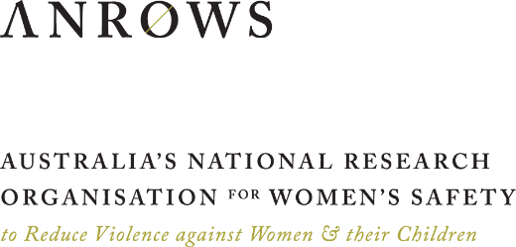

Some teachers or school leaders taught the RRRR program to multiple classes, but we requested that they only report to the research team on one specific class, and we documented this.
We thank Dr Alex Stivala for help with presenting this explanation of ALAAM.
This PCA is detailed in the methods.
As noted in the methods, the reliability of the scale was improved by deleting one of the items, so we have three and not four items in this subscale.
We note that our Principal Component Analysis (PCA) placed these four items with a number of other items in the ARQ scale, including items from social skills and peer connectedness. We note that the highest loading items of the PCA factor are from the ARQ Negative Cognition subscale. While there could be some more robust statistical insights from using a greater number of items, we stayed with the Gartland et al. (2011) ARQ Negative Cognition subscale out of a desire to keep the subscale measure to four items that could be used in future as a more parsimonious survey subscale for use with students.
Andrew Tate is a Tik Tok influencer who espouses extreme misogynistic views in the guise of promoting success through toxic masculinities, power and supremacy.

