
Migrant and refugee women in Australia:
A study of sexual harassment in the workplace
Marie Segrave
Rebecca Wickes
Chloe Keel
Shih Joo (Siru) Tan
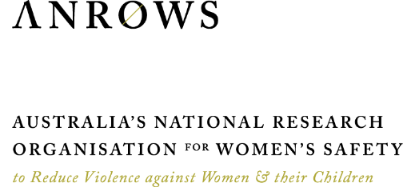 | Research report  Issue 6 | August 2023
ANROWS acknowledgement
This material was produced with funding from the Australian Government Department of Social Services. Australia’s National Research Organisation for Women’s Safety (ANROWS) gratefully acknowledges the financial and other support it has received from the government, without which this work would not have been possible. The findings and views reported in this paper are those of the authors and cannot be attributed to the Australian Government Department of Social Services.
Acknowledgement of Country
Monash University, Harmony Alliance: Migrant and Refugee Women for Change, Griffith University and ANROWS acknowledge the Traditional Owners of the land across Australia on which we live and work. We pay our respects to Aboriginal and Torres Strait Islander Elders past and present. We value Aboriginal and Torres Strait Islander histories, cultures and knowledge. We are committed to standing and working with First Nations Peoples, honouring the truths set out in the Warawarni-gu Guma Statement.
Peer-review process
The quality of ANROWS publications is ensured through a rigorous peer-review process that is consistent with the principles of the Committee on Publication Ethics (COPE) Ethical Guidelines for Peer Review. This report has been assessed by at least two peer reviewers with relevant academic expertise.
© ANROWS 2023

With the exception of the ANROWS branding, content provided by third parties, and any material protected by a trademark, all material presented in this publication is licensed under a Creative Commons Attribution-NonCommercial 3.0 Australia (CC BY-NC 3.0 AU) licence.
The full licence terms are available at creativecommons.org/licenses/by-nc/3.0/au/legalcode
Published by
Australia’s National Research Organisation for Women’s Safety Limited (ANROWS)
PO Box Q389, Queen Victoria Building, NSW 1230 | www.anrows.org.au
ABN 67 162 349 171
ISBN: 978-1-922645-74-6 (paperback)
ISBN: 978-1-922645-75-3 (PDF)
Please note that there is the potential for minor revisions of this report.
Please check the online version at www.anrows.org.au for any amendment.
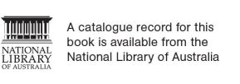

Migrant and refugee women in Australia:
A study of sexual harassment in the workplace
Professor Marie Segrave
Monash University
Professor Rebecca Wickes
Griffith University
Dr Chloe Keel
Postdoctoral Research Fellow, Monash University
Dr Shih Joo (Siru) Tan
Postdoctoral Research Fellow, Monash University
This report addresses work covered in the ANROWS research project SH.22.04 "Migrant and refugee women’s attitudes, experiences and responses to sexual harassment in the workplace". Please consult the ANROWS website for more information on this project.
Suggested citation:
Segrave, M., Wickes, R., Keel, C., & Tan, S. J. (2023). Migrant and refugee women in Australia: A study of sexual harassment in the workplace (Research report, 06/2023). ANROWS.

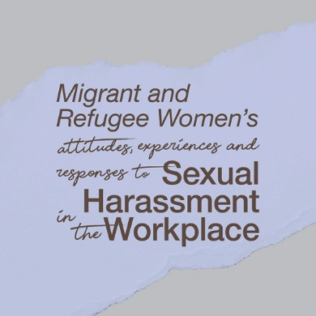 |   Monash University  20 Chancellors Walk,  Clayton VIC 3800 |   Griffith University  Mt Gravatt Campus  Brisbane 4122 QLD


Harmony Alliance
46 Jardine Street,
Kingston ACT 2604
Author acknowledgement
The research team extends our deep appreciation to the participants in this study for taking the time to share their experiences and views.
We are grateful to the members of the advisory group from AMES Australia, JobWatch, Settlement Services International, MindTribes, United Workers Union and the Department of Social Services. We also thank the participants in the National Roundtable from the Department of the Prime Minister and Cabinet, Workplace Safety Australia, Council of Small Business Organisations Australia, Diversity Council Australia, Women’s Legal Services South Australia, Working Women’s Centre, Women’s Health Tasmania, Philippines Australia Solidarity Association, Ethnic Communities’ Council of NSW, Office of Industrial Relations QLD, Family Safety Victoria, WorkSafe Victoria, Department of Mines, Industry Regulation and Safety, She’s A Crowd, NT Working Women’s Centre, Shakti Australia and Migrant Justice.
Acknowledgement of lived experiences of violence
Monash University, Harmony Alliance: Migrant and Refugee Women for Change, Griffith University and ANROWS acknowledge the lives and experiences of the women affected by sexual violence who are represented in this report. We recognise the individual stories of courage, hope and resilience that form the basis of ANROWS research.
Caution: Some people may find parts of this content confronting or distressing. Recommended support services include 1800RESPECT (1800 737 732), Lifeline (13 11 14) and, for Aboriginal and Torres Strait Islander people, 13YARN (13 92 76).
Terminology
This report focuses on migrant and refugee women. Throughout the report we refer to “women in this study”, “respondents” and “migrant and refugee women in this study” interchangeably.

Contents
Acronyms 3
Executive summary 8
Key findings 8
Conclusion 10
Introduction 11
Aims of the research and focus of this report 12
Background 13
Sexual harassment in the workplace and migrant and refugee women: What do we know? 13
Next steps: Building an evidence base on migrant and refugee women and sexual harassment
at work in Australia 14
Method 15
Expert engagement in research design 15
The survey design: The role of the technical report 16
Data presentation 19
Respondent demographics 22
Comparing the sample to ABS recent migrant data 22
Country of birth 23
Age 23
Education 23
Employment 24
Familial status 24
Overall findings 25
Types of sexual harassment in the workplace 25
Frequency of sexual harassment experiences 25
Views on workplace sexual harassment: Identifying sexual harassment & assessing its
importance as a workplace problem 26
Who are the harassers in the workplace 29
Who experiences sexual harassment in the workplace 31
Responding to incidents of workplace sexual harassment 31
Motivation: Respondent perceptions of what drives sexual harassment in the workplace 32
Types of harassment: Incident-based description 33
Trans men and non-binary respondents 77
Limitations of this research 79
Discussion and conclusion 80
References 81
Appendix 84

Acronyms
Acronym | Definition
ABS | Australian Bureau of Statistics
AHRC | Australian Human Rights Commission
ANROWS | Australia’s National Research Organisation for Women’s Safety
CoRMS | Characteristics of Recent Migrants Survey
DSS | Department of Social Services
FLEX | Focus on Labour Exploitation
ILO | International Labour Organization

Key findings

Migrant and refugee women in Australia:
A study of sexual harassment in the workplace

Sexual harassment experiences
46% of respondents experienced at least one form of sexual harassment in the workplace in the last 5 years
The most frequent experiences included:
- Indecent phone calls/messages of a sexual nature
- Sexually suggestive comments or jokes
- Intrusive questions about private life or physical appearance
- Staring or leering that was intimidating
Men were most frequently the harassers in the workplace. Harassment was most often perpetrated by men:
- In senior positions in the workplace
- Who were clients or customers
It is worth noting that for 9 of the 15 reported behaviours, women were more likely to be in temporary and/or casual roles than permanent roles when they experienced workplace sexual harassment.

Why?
Participants believed the harassment was most often motivated because of their:
- Gender and/or sex
- Race and/or religion
This finding illuminates the importance of addressing and understanding gendered inequity and sexual harassment as deeply connected to discrimination based on race and religion.

Responses to incidents of workplace sexual harassment

37% told no one
The major reasons for not reporting/disclosing sexual harassment were:
- Feeling responsible
- Feeling uncertain about what to do
- Feeling concerned about impact on their employment
In a third of the incidents of workplace-based sexual harassment, women had been threatened or warned not to report.

88% of those who told someone only sought informal support and shared the experience with a friend/family/colleague
Few women reported their experiences formally.
For women who did formally report their experiences of sexual harassment, approximately half of the sample formally reported the incident to someone in their workplace.
In this sample very few women reported to an authority outside of the workplace (15%).

Implications for policy and practice
- Capturing detailed accounts of sexual harassment at work for specific nation-wide populations matters – The Australian Human Rights Commission’s (AHRC) fifth national survey, Time for Respect (2022)¹ did not ask about other factors such as cultural diversity, visa status or religion, for example, limiting the possibility of drawing a deep understanding of migrant and refugee women's experience in Australia.
- Examining the intersections of gendered forms of violence with other forms of discrimination is critical – By asking migrant and refugee women in-depth questions about their experiences, these findings illuminate the intersection of gender and racial discrimination. Understanding this intersection is critical for informing the design, implementation and monitoring of workplace sexual harassment initiatives.
- Diversity of data collection matters – Refugee and migrant women in more precarious forms of employment with temporary visas are under represented in this sample. Phase 2 of the study is designed to reach women to address this under-representation. This reaffirms the importance of investment in large-scale nationally representative samples to build a picture of specificity of experience of key populations in the Australian community.
“These findings point to the importance of developing a comprehensive picture of the different ways in which workplace-based sexual harassment manifests, as well as diversification of strategies to address it.”
Segrave et al., 2023

701 migrant and refugee women were surveyed

About the survey

Demographic picture
701 self-identified migrant and refugee women were surveyed from August to September 2022. The survey was available in six languages – Arabic, English, Farsi, Swahili, Chinese (Simplified) and Dari. 11 per cent of respondents completed the survey in a language other than English.
The respondents:
- 63% were Australian citizens, 19% were permanent residents, and 18% were temporary residents
- 88% were born outside of Australia, primarily from countries in Asia
- ages ranged between 18 and 70 years of age. The mean was 40 years of age
- were highly educated. 74% of respondents had bachelor degrees or higher
- 55% worked full time, 24% worked part time, 11% were casual workers, and 10% were not in the labour force at the time they completed the survey
- the majority were in professional employment (48%), followed by technicians and trade workers (15%), and clerical and administrative workers (11%).

Dynamics surveyed
Every respondent who indicated they had experienced a form of sexual harassment in the last 5 years in Australia was then asked if this harassment occurred in the workplace. They were then asked about:
- the forms of sexual harassment experienced in the workplace
- who the perpetrators were, including their position in the workplace in relation to the respondent
- perceived motivations for the sexual harassment
- responses to incidents of workplace sexual harassment, including reporting and perceptions and feelings about their experiences.

Endnotes:
Data collected by the AHRC 2022 survey relied only on the single variable of language spoken at home as a marker of cultural and linguistic diversity and on English as the sole language for the telephone and online survey instrument: https://humanrights.gov.au/time-for-respect-2022

Source:
Segrave, M., Wickes, R., Keel, C., & Tan, S. J. (2023). Migrant and refugee women in Australia: A study of sexual harassment in the workplace (Research report, 06/2023). ANROWS.

Suggested citation:
Australia’s National Research Organisation for Women’s Safety. (2023). Migrant and refugee women in Australia: A study of sexual harassment in the workplace [Fact sheet]. ANROWS.

Executive summary
The “Migrant and refugee women’s attitudes, experiences and responses to sexual harassment in the workplace” study aims to build a detailed national picture of the experiences of a diverse group of migrant and refugee women to inform more targeted engagement with women and workplaces regarding unacceptable workplace behaviour. This is the first national study of migrant and refugee women’s experiences, understandings and responses to workplace sexual harassment of its type. This study comprises of two phases. The first is a national survey, and the second is a national qualitative project talking to migrant and refugee women and stakeholders across Australia. This report presents the findings from the first phase of this project. They come from a non-probability sample, and thus the findings are not generalisable to all migrant and refugee women. The findings, however, offer insights into the attitudes, experiences and responses of just over 700 migrant and refugee women from across Australia, all of which will be explored in more detail in the next phase of this research and in the final report to be released in 2024.
The “Migrant and refugee women’s attitudes, experiences and responses to sexual harassment in the workplace” study sits within the priorities of Australia’s National Research Agenda to Reduce Violence against Women and their Children (ANRA) 2020–2022, delivered via Australia’s National Research Organisation for Women’s Safety (ANROWS) 2021-2024 Sexual Harassment Research Program. This research was developed to support and enhance the Australian Government’s A Roadmap for Respect: Preventing and Addressing Sexual Harassment in Australian Workplaces (Attorney-General’s Department, 2021) which states that a whole-of-society response is necessary for preventing and responding to workplace sexual harassment. A commitment highlighted in A Roadmap for Respect is ensuring that the experiences of culturally and linguistically diverse migrant and refugee women are adequately captured and accounted for. This research aligns with national commitments to reporting on and responding to sexual harassment in the workplace (Australian Human Rights Commission [AHRC], 2022). It also fills a recognised gap by addressing the specificity of migrant and refugee women’s experiences which are not adequately captured in national data. Focusing on the findings from the first phase of the “Migrant and refugee women’s attitudes, experiences and responses to sexual harassment in the workplace” study, this research is also aligned with the National Plan to End Violence against Women and Children 2022–2032 (the National Plan). The National Plan recognises sexual harassment as being “part of the continuum of sexual violence and abuse … predominantly experienced by women, girls and LGBTIQA+ people” and is committed to addressing the range of settings where sexual harassment takes place, including workplaces (Commonwealth of Australia, 2022, p. 51).
In consultation with an advisory committee and industry stakeholders, the research team developed a survey instrument that sought to measure migrant and refugee women’s experiences of sexual harassment in the workplace, alongside their attitudes, understanding and responses to these types of workplace behaviour. This survey was conducted online using the Qualtrics survey platform from August to September 2022 and was available in six languages – Arabic, English, Farsi, Swahili, Chinese (Simplified) and Dari. This report details the findings from 701 migrant and refugee women and provides a summarised account of the nine gender diverse respondents who participated in this study.

Key findings
The findings from this study are best understood as interim. The second phase of this research will offer a more comprehensive account of migrant and refugee women’s experiences, understandings and responses to sexual harassment. Nonetheless, there are important findings from the survey to highlight:

Experiences of sexual harassment
- 68 per cent of migrant and refugee women in this study had experienced at least one form of sexual harassment in the last 5 years in Australia.
- 46 per cent of migrant and refugee women in this study had experienced at least one form of sexual harassment in the workplace in the last 5 years in Australia.
- For 9 of the 15 reported behaviours, women were more likely to be in temporary and/or casual roles than permanent roles when they experienced workplace sexual harassment.

The most commonly reported forms of sexual harassment in the workplace
- Indecent phone calls/messages of a sexual nature (71%)
- Sexually suggestive comments or jokes (53%)
- Intrusive questions about private life or physical appearance (49%)
- Staring or leering that was intimidating (48%)

Who is doing the harassing in the workplace?
- Men were most frequently the harassers (see Figure 4).
- In most cases, it was either people in senior positions in the workplace (managers) or clients/customers engaging in sexually harassing behaviour (see Table 21 in the Appendix).
- There was often more than one person harassing the respondent in the workplace (see Table 20 in the Appendix).

Identifying motivation
The survey asked respondents to report their perception of the motivation for each form of sexual harassment behaviour they experienced in the workplace. There were seven possible responses and respondents could select multiple answers to this question – race, gender identity, religion, sexual orientation, ability, visa status and other (which had open-text response to provide details). The most common motivation chosen was gender and/or sex and race and/or religion. This finding illuminates the importance of addressing and understanding gendered inequity and sexual harassment as deeply connected to discrimination based on race and religion.
It is important to note here that perceived motivation may not align with the alleged harasser’s version of events (Roulstone et al., 2011). There are very few cases of prejudice motivated harms that are successfully prosecuted in Australia or elsewhere, particularly for incidents that involve sexual assault and/or harassment (Roulstone et al., 2011). This is often a function of the threshold of evidence needed to prove prejudice motivation (Mason et al., 2017; Wickes et al., 2016). Ultimately, whether or not a particular motivation can be proved is immaterial to the significant trauma experienced by people who believe an incident was motivated by prejudice or hate (Benier, 2017). Thus, we argue that victim-survivor perceptions regarding the motivation behind a given incident are of the upmost importance and we privilege them accordingly.

Responses to incidents of workplace sexual harassment
There were 323 women who reported one or more types of workplace sexual harassment. For each of the 15 sexual harassment behaviours, we asked the participant if they shared the experience formally or informally with someone. We then aggregated these data to identify broader reporting patterns. Across the 773 incidents of sexual harassment in the workplace captured in this study, 63 per cent were reported to someone. The breakdown of this reporting is as follows:
- In 88 per cent of the incidents, the respondent spoke to someone informal outside of their workplace.
- In 15 per cent of the incidents, the respondent spoke to a formal authority outside their workplace.
- In 45 per cent of the incidents, the respondents spoke to someone in their workplace (formal or informal).
We also asked women who experienced a behavioural type of sexual harassment but did not report or disclose it why they chose not to do so. We asked two questions, the first was focused on their perceptions of the situation or feelings about the experience.
- Consistently, women listed “felt responsible” as the primary reason for not telling anyone.
- Not being sure what to do and/or employment concerns were the second most frequently identified reasons for not reporting.
We then asked a question that focused on external pressure or advice, asking whether they had experienced threats or warnings not to report.
- In approximately 33 percent of the incidents of workplace-based sexual harassment, women had been threatened or warned not to report.

Conclusion
This research highlights the importance of asking migrant and refugee women about their experiences in detailed ways. The findings reveal patterns of workplace-based sexual harassment, including the commonality of multiple perpetrators as being key to many migrant and refugee women’s experiences. The high rate of clients as perpetrators of workplace-based sexual harassment was also important. When we examined women’s responses to workplace sexual harassment two things were consistent: first, that women reported feeling responsible, were concerned about their employment or did not know what to do or who to go to; second, threats and warnings to not report were commonly experienced. Taken with the finding regarding the role of senior members of staff being responsible often for perpetrating workplace sexual harassment, the rate with which women reported being concerned about their employment raises important issues. Broadly, these findings point to the importance of developing a comprehensive picture of the different ways in which workplace-based sexual harassment manifests, as well as diversification of strategies to address it.
The findings also illuminate the intersection of gender and racial discrimination, specifically that the experience of sexual harassment for migrant and refugee women in this study is often closely connected to racial discrimination. Working towards a more comprehensive understanding of the intersections of discrimination that can underpin sexual harassment is key to informing the design, implementation and monitoring of initiatives that are intended to prevent and respond to workplace sexual harassment.
We note that this research is only a partial account of the workplace sexual harassment experienced by migrant and refugee women. As discussed above, the survey was limited by its reach. Refugee and migrant women in more precarious forms of employment with temporary visas are under-represented in this sample. This reaffirms the importance of investment in large-scale, national survey research to generate a fuller picture of the experiences of migrant and refugee women in the Australian community.

Introduction
Sexual harassment of women in the workplace is recognised as a substantial human rights and public health issue with significant ramifications for workplaces and communities (Willness, Steel & Lee, 2007; Nielsen & Einarsen, 2012; United Nations [UN], 2017; O’Neil et al., 2018; Commonwealth of Australia, 2022; AHRC, 2022). While all people have the right to work free from violence and harassment, sexual harassment against women remains prevalent “in all jobs, occupations and sectors of the economy in all countries across the world” (International Labour Organization [ILO] & United Nations Women, 2019). Internationally, sexual harassment in the workplace is condemned in multiple human rights instruments, including General Recommendation No. 19 (1992) of Article 11 in Convention on the Elimination of All Forms of Discrimination against Women (CEDAW), which refers to gender-specific violence such as sexual harassment in the workplace. The International Labour Organization’s (ILO) Violence and Harassment Convention (No. 190, 2019) emphasises “the right of everyone to a world of work free from violence and harassment, including gender-based violence and harassment”. The UN Sustainable Development Goals (2017) recognises gender-based violence and violence in the workplace as key issues. Specifically, Target 5.2 under Goal 5 speaks of the need to “eliminate all forms of violence against all women and girls in the public and private spheres, including trafficking and sexual and other types of exploitation” (UN, 2017). Target 8.8 under Goal 8 commits to protecting “labour rights and promot[ing] safe and secure working environments for all workers, including migrant workers, in particular women migrants, and those in precarious employment” (UN, 2017).
Within the context of these commitments, the importance of paying close attention to women’s experiences has come to the fore, including those of migrant and refugee women. The need to account for specificities of migrant and refugee women’s experiences is also highlighted in US and Canadian research, which has revealed how insecure immigration status and insecure employment intersect to exacerbate migrant and refugee women’s experiences of workplace sexual harassment (Morales & Saucedo, 2015; Parra, 2015; Villegas, 2019). These empirical studies’ examination of the experiences of migrant women in diverse employment sectors have been critical in bringing to the fore the interlocking facets that uniquely influence how migrant women understand and respond to experiences of workplace sexual harassment (Parra, 2015; Villegas, 2019). More recently, the ILO stated the following in its guide to the definitions, core principles and measures in Convention 190:
The different needs of people with disabilities, individuals belonging to ethnic minorities, and migrant workers, among others, should be taken into account. In this regard, Convention No. 190 requires that tools, guidance, education and training be provided in accessible formats, which is essential for widespread and inclusive awareness raising (Arts 4(2)(g) and 11(b)). Information and training on the hazards and risks of violence and harassment, as well as on associated prevention and protection measures, also need to be in accessible formats (Art. 9(d)). (ILO, 2021, p. 19)
This is indicative of the international commitment to paying specific attention to the safety of migrant and refugee women’s experiences in the workplace.

Aims of the research and focus of this report
This report is focused on the findings from the first phase of a larger research project which aims to build a detailed national picture of the experiences and views of a diverse group of migrant and refugee women in relation to sexual harassment in the workplace. The aim of the first phase of the research was to build a quantitative picture of migrant and refugee women’s experiences and their responses to and attitudes towards sexual harassment. The second phase of the research will allow this data to be explored via qualitative interviews and focus groups to reach those less likely to access the survey. It offers a more detailed and comprehensive understanding of the results from this survey and the issues pertaining to sexual harassment in the workplace from the perspective of migrant and refugee women.
This is a non-probability survey that was not designed to capture prevalence. Instead, this study does the following:
- It allows women to self-identify as migrant and refugee women; that is, we have not limited this study to first-generation migrant women. This was endorsed by our advisory board, who encouraged an expansive and inclusive approach.
- It recognises that a representative sample is a complex task that, while not insurmountable, would require significantly greater financial investment to undertake both the design to capture the sample and the conduct of the research (i.e. an online survey would be insufficient).
- It responds to a need for a quantitative picture of experiences, responses and understanding, enhanced by a comprehensive qualitative stage of research. This influenced the design and budgeting for the project, which is one of five studies funded under the ANROWS 2021–2024 Sexual Harassment Research Program.

Background

Sexual harassment in the workplace and migrant and refugee women: What do we know?
International statistics and prevalence data around migrant women’s experiences of sexual harassment in the workplace vary significantly depending on the measures used. Similar to other victimisation data, “self-reported estimates exceed the official estimates reported to law enforcement” (McLaughlin et al., 2021, p. 37). An international study of people’s experiences of violence and harassment at work conducted by the ILO, Lloyd’s Register Foundation (LRF) and Gallup in 2022 (based on 74,364 interviews with respondents from across 121 countries) found that migrant women in particular were seen to be at risk; they were more likely than migrant men to have experienced violence and harassment, and twice as likely as non-migrant women to report sexual violence and harassment (ILO, Lloyd’s Register Foundation [LRF] & Gallup, 2022, p. 32). A study of migrant workers in the UK similarly found a higher incidence of workplace sexual harassment across various fields; 42 per cent of women and non-binary people in cleaning, 44 per cent in hospitality and 57 per cent in app-based deliveries experienced workplace harassment (Focus on Labour Exploitation [FLEX], 2022). Several international studies exploring industry-specific sexual harassment for migrant women workers focus on the experience of migrant domestic workers and agricultural workers. For example, the International Domestic Workers’ Federation’s Report on IDWF Survey on Gender-based Violence Against Domestic Workers, Asia (2018) found that across 12 Asian countries, the most prevalent types of violence experienced by members included economic, psychological and sexual abuse. Domestic workers in particular were seen to be “dispensable and easily replaceable” by employers (International Domestic Workers’ Federation, 2018, p. 6). Studies in the US focusing on the agricultural sector have repeatedly demonstrated that immigrant and undocumented female workers experience high rates of sexual harassment, which is in part a reflection of the type of work, the workplace setting and their structural circumstances (including their visa status and their reliance on the employer/their employment for survival; see Human Rights Watch, 2012; Waugh, 2010; Kim et al., 2016).
International research across both industry-specific and broader population-focused studies has highlighted that it is both possible and important to capture data regarding structural conditions and the specificity of migrant and refugee experiences – even if the research approach has varied in terms of the scope of the sample and the breadth of the dataset. For example, studies have demonstrated the link between high rates of sexual harassment and low-wage and insecure work (FLEX, 2022), as well as the higher risk of experiencing sexual harassment due to migration and employment status (FLEX, 2022; Ditkowsky, 2019; Department of Social Services [DSS], 2015; AHRC, 2020). Other studies have looked at factors such as language proficiency (Durana et al., 2018), race-based bias and discrimination, and disparate cultural expectations (DSS, 2015).
In Australia, few studies have detailed the experiences of workplace sexual harassment among migrant and refugee women. The Australian Human Rights Commission (AHRC) has led the way in building an evidence base of sexual harassment in the workplace over five survey-based studies, including the most recent 2022 Time for Respect: Fifth National Survey on Sexual Harassment in Australian Workplaces report (2022). Results from both the 2022 and 2018 surveys suggest that people who mainly speak English at home are more likely to have been sexually harassed in their lifetime than those who speak a language other than English. This finding contradicts international research that suggests migrant women are more vulnerable to workplace sexual harassment (see ILO, LRF & Gallup, 2022). However, the AHRC notes that this national dataset is limited in its capture of migrant and refugee worker experiences in two key ways: it relies only on the single variable of language spoken at home as a marker of cultural and linguistic diversity; it also relies on English as the sole language for the telephone and online survey instrument, which excludes women with limited English proficiency from participating (AHRC, 2022, p. 27). Another limitation of the AHRC survey design regarding its capture of migrant and refugee experiences has to do with the way some questions are asked. For example, questions and response options do not tend to capture the structural insecurity of temporary visa holders or the specific ways insecure migration status can be used as leverage to exploit and sexually harass workers (Farbenblum & Berg, 2017; Segrave et al., 2021). The AHRC recognises these limitations and in its most recent report offered this caution:
insecure immigration status and/or insecure work contracts might be a disincentive to participating in surveys related to work, particularly for those who do not speak English, low-socio economic migrants, international students, and humanitarian refugee visa holders. (AHRC, 2022, p. 27)
In their report Respect@Work: National Inquiry into Sexual Harassment in Australian Workplaces, the AHRC noted that “workers who may be more likely to experience sexual harassment in the workplace include workers from culturally and linguistically diverse (CALD) backgrounds” and “migrant workers or workers holding temporary visas” (AHRC, 2020, p. 19). The Inquiry also recognised that workers in non-standard employment arrangements – such as temporary, labour hire, contract, casual or non-ongoing arrangements – could be deterred from reporting abuse for fear of losing work; such sectors are predominantly filled with female, migrant and young workers and contain high levels of sexual harassment (AHRC, 2020, p. 75). Reflecting international findings, the Inquiry found other major contributors to experiences of sexual harassment at work. Among them were the following:
reduced power in the labour market, difficulties in securing alternative employment, social isolation … lack of language skills and financial resources, and power imbalances that arise from their immigration status and visa conditions. (AHRC, 2020, p. 189)
Other national surveys have similarly drawn attention to migrant and refugee women’s experiences of workplace sexual harassment but have been limited in scope. A representative national study of over 2000 Australian working women under 40 found that Asian-born women and CALD women (based on the indicator of “language spoken at home”) were twice as likely to have experienced workplace sexual harassment than white women or women born in Australia (Baird et al., 2018, p. 92). This was quite different to the industry-focused survey of over 4000 Shop, Distributive and Allied Employees’ Association members, which found that members who spoke mainly English at home were more likely to have experienced lifetime sexual harassment (AHRC, 2019). Once again, this industry study was limited in its design and, thus, conclusions on these relationships should be interpreted with caution.

Next steps: Building an evidence base on migrant and refugee women and sexual harassment at work in Australia
The 2020 Migrant and Refugee Women’s Safety Survey (Segrave et al., 2021) highlighted the importance of utilising multiple variables to capture the diversity of migrant and refugee women’s experiences, including detailed information regarding visa status, English-language proficiency and employment details. While other studies have broadened the purview of migrant and refugee women’s experiences at work (e.g. Baird, 2018; Women of Colour Australia & Archer, 2021), they have not included the breadth of factors, such as migration status, that are known to impact women’s experiences of victimisation and responses. This lays the groundwork for responding to the call for data and knowledge on sexual harassment and migrant and refugee women. This is especially critical given that over one million people arrived in Australia between 2017 and 2021; more than half of the population in Australia is now comprised of first- or second-generation migrants (Australian Bureau of Statistics [ABS], 2022).
A significant challenge remains in determining the scope and design of research. Industry-based studies have the advantage of capturing the ways that sexual harassment manifests in the employment setting. They can provide very specific information to the sector and to makers of policy and law about how workplace settings provide and sustain the conditions under which sexual harassment occurs. However, national studies that seek to capture experiences across workplace settings also play an important role: they offer an opportunity to lay a foundation for a more detailed measure of the national picture. Given the limited national data capturing the specificity of migrant and refugee women’s experiences at work, the first phase of this study seeks to begin building that picture via a national survey. The second phase of this work will offer an opportunity to enrich the findings from the survey data and explore the experiences of key groups of migrant and refugee women in Australia, including those in precarious employment and those holding a temporary visa.
The AHRC (2022) approach to measuring sexual harassment at work operationalised both a legal and behavioural understanding of sexual harassment. Nonetheless, the list of behaviours was not grounded in migrant and refugee women’s understanding and definitions. The translation of terminology and concepts pertaining to sexual harassment requires careful attention and nuance (Tarzia et al., 2020). We know this to be true of migrant and refugee women’s experiences of domestic and family violence (Segrave et al., 2021). However, relatively little to date has revealed migrant and refugee women’s workplace experiences of sexual harassment.

Method
This study involves two core components: the national survey, which is the focus of this report, and a qualitative interview and focus-group discussion data phase that will be undertaken in 2023 (see Figure 1). These two phases are iterative: the learnings from the survey (reported here) will guide the focus of the discussions with migrant and refugee women across Australia in the next phase. The focus on whom we seek to include will be designed to extend and deepen the breadth of the survey sample and to create a more comprehensive picture of migrant and refugee women’s experiences, attitudes and responses to sexual harassment in the workplace.

Expert engagement in research design
This research has been designed and undertaken in a partnership between Monash University, Griffith University and Harmony Alliance: Migrant and Refugee Women for Change (Harmony Alliance). Harmony Alliance is one of six national women’s alliances that are funded to promote the views of all Australian women. Harmony Alliance provides a platform to advocate for issues that impact all migrant and refugee women, and their role in the research is critical to delivering impactful work designed by and for migrant and refugee women. In addition to this partnership, the research design involved two ways to consult key stakeholders whose work is also focused broadly on migrant and refugee women’s advancement in Australia. In the first instance, we identified key groups for representation on the project advisory board; the final group included representatives from AMES Australia, JobWatch, Settlement Services International, MindTribes, United Workers Union and the Department of Social Services. Using recommendations from our advisory board and ANROWS, the research team then invited a broad range of experts and stakeholders to participate in a national roundtable intended to share the research design and seek input for the final approach. This broader stakeholder group included participants from the Department of the Prime Minister and Cabinet, Workplace Safety Australia, the Council of Small Business Organisations Australia, Diversity Council Australia, Women’s Legal Services South Australia, Working Women’s Centre, Women’s Health Tasmania, the Philippines Australia Solidarity Association, the Ethnic Communities’ Council of NSW, the Office of Industrial Relations QLD, Family Safety Victoria, WorkSafe Victoria, the Department of Mines, Industry Regulation and Safety, She’s A Crowd, NT Working Women’s Centre, Shakti Australia and Migrant Justice. As outlined in Figure 2 below, both the advisory group and the roundtable were key to the development and implementation of the research and analysis of the findings at key stages of the project.
Figure 1: Overall research design
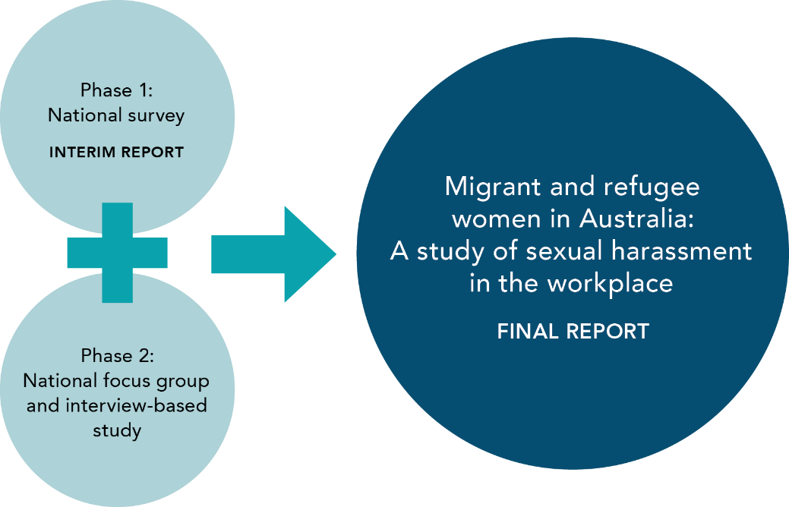

The survey design: The role of the technical report
We detail in the following section the methodological approach for the first phase of the research and provide a broad overview of the survey design and implementation. A full Technical report has been prepared and released alongside this report; it provides detailed information regarding the development of the survey instrument and the analysis, including the full survey instrument and the codebook (please see the technical report, Keel et al., 2023). We strongly recommend reading the technical report alongside this overview of the approach: the decision-making in design and analysis is complex and important, and supporting transparency and accessibility to these processes is key to supporting the broader development of high-quality survey instruments.

Measuring sexual harassment and sexual harassment in the workplace
This survey adopted a behavioural approach to sexual harassment. It draws largely on the AHRC 2018 survey instrument, which detailed 15 behaviours that constitute sexual harassment. These were as follows:
Figure 2: Phase 1: Engagement with stakeholders in design
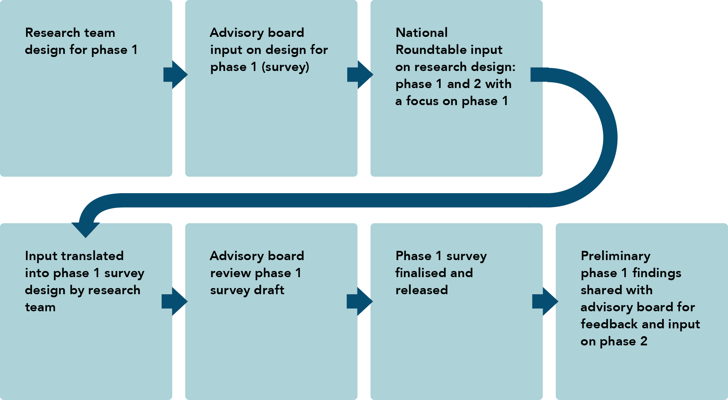
Table 1: List of sexual harassment behaviour types
Icon | Harassment Type
 | 1. Indecent phone calls, including someone leaving a message on a voicemail or an answering machine of a sexual nature in a way that was unwelcome
 | 2. Comments made in emails, SMS messages or on social media of a sexual nature in a way that was unwelcome
 | 3. Repeated or inappropriate advances made in emails, social networking websites or internet chat room in a way that was unwelcome
 | 4. Someone sharing or threatening to share intimate images/film of you without your consent in a way that was unwelcome
 | 5. Any other conduct of a sexual nature that occurred online or via some form of technology in a way that was unwelcome
 | 6. Touching, hugging, cornering or kissing in a way that was unwelcome
 | 7. Staring or leering that made you feel intimidated in a way that was unwelcome
 | 8. Sexual gestures, indecent exposure or inappropriate display of the body in a way that was unwelcome
 | 9. Sexually suggestive comments or jokes that made you feel offended in a way that was unwelcome
 | 10. Repeated or inappropriate invitations to go out on dates in a way that was unwelcome
 | 11. Intrusive questions about your private life or physical appearance that made you feel offended in a way that was unwelcome
 | 12. Inappropriate physical contact in a way that was unwelcome
 | 13. Being followed or watched, or loitering nearby in a way that was unwelcome
 | 14. Requests or pressure for sex or other sexual acts in a way that was unwelcome
 | 15. Actual or attempted rape or sexual assault
For each type of behaviour, we asked whether the respondent had any experience of this behaviour in the last 5 years that was sexual in nature and unwelcome, and we specified our focus on experiences in Australia. Here is an example:
Q. While in Australia and within the last 5 years, have you experienced indecent phone calls, including someone leaving a message on a voicemail or an answering machine of a sexual nature in a way that was unwelcome?
For those who responded “yes”, we asked whether that experience had occurred in the workplace. If so, a full suite of questions followed to understand more about that experience (please see the technical report, Keel et al., 2023), including the perceived motivation for the incident, reporting of the incident and information on the harassers. This allows us to provide a detailed picture of the types of behaviours that are occurring in workplaces across Australia as experienced by migrant and refugee women. We drew on a range of survey instruments to inform the design of the instrument used in this research. This was done to ensure the inclusion of other important questions, ones that sit outside the scope and approach of the AHRC survey. The question around perceived motivation for the sexual harassment at work, for example, allows for a more compelling account of the intersection of gendered and other forms of discrimination and/or structural inequity.

Ethics
This research was undertaken with the approval of the Monash University Human Research Ethics Committee (MUHREC) Project 32812. A key component of undertaking this work involving questions of a sensitive nature was making sure that respondents were supported by the provision of information about support services across Australia. This information was provided at the completion of the survey.

Survey instrument
This study focused on migrant and refugee women’s experiences of workplace sexual harassment. We used survey items from several well-designed studies on these topics. The survey design also engaged stakeholder interaction and consultation (see Figure 2 above) to ensure the instrument would address areas of priority relevant to stakeholders, including migrant and refugee women across Australia. The final iteration of the survey instrument and a more detailed account of its construction can be accessed in the accompanying technical report.

Gender and sexuality
Based on feedback from advisory group members and translators to an early draft of the survey, a decision was made to simplify the language options regarding gender and sexuality data capture. In the opening of the survey, we asked respondents whether their gender was male, female, non-binary/third gender, transgender man, transgender woman or prefer not to say.
Some feedback also recommended the use of detailed sexuality options as best practice, but this was met with concerns regarding the translation of terms. The decision was made to ask whether the respondent identified as LGBTQI+ with a view that the acronym has a meaning that is understood across languages.

Mode of delivery
The survey was delivered online via the Qualtrics platform (under the Monash University licence). The survey was made available in 6 languages: Arabic, English, Farsi, Swahili, Chinese (Simplified) and Dari. The selection of languages drew on insights from the 2020 Migrant and Refugee Women Safety Survey (Segrave et al., 2021). The link to the survey was shared via email to professional networks (including Harmony Alliance members, Monash Gender and Family Violence Prevention Centre’s subscription members, the National Advocacy Group on Women on Temporary Visas Experiencing Violence) and via paid advertising on the social networking sites Twitter, Facebook and LinkedIn. Adverts on all three platforms were translated into the five survey languages. The report was launched on Tuesday 9 August 2022 and closed on Tuesday 20 September 2022.

Language accessibility
We chose the four most selected languages based on the Migrant and Refugee Women in Australia: The Safety and Security Study, with the addition of Dari and Swahili to reflect a small but important group of migrant and refugee women who are less likely to access an English-language survey (see Segrave et al., 2021). 11 per cent of respondents completed the survey in a language other than English. This is in part a reflection of the sample’s high level of English language proficiency. While this proportion is lower than in other recent surveys (Segrave et al., 2021), it does affirm the importance of making the survey available in multiple languages.

Data presentation

Self-report data compared to offence data
This report details respondents’ reported experiences of sexual harassment, and it is important to be clear that they cannot be determined to be criminal offences or a breach of discrimination legislation (this would be decided by a court; see AHRC, 2022, p. 26).
Throughout this report, we use the term “respondent” for those who reported experiencing sexual harassment, and we use the term “harasser” to refer to individuals who are alleged to have sexually harassed our respondents. We do not use the term “offender”, as there is no suggestion that it has been established that either a criminal offence or a breach of discrimination legislation has been determined.

Rounded numbers
We round numbers in this report to the nearest whole number, such that in some cases the percentages may not add up to 100 per cent. We make clear where we are reporting findings on questions that enabled multiple responses where the totals do not add up to 100 per cent.

List of sexual harassment behaviours
For readability, we have simplified the articulation of the behaviours through this report as detailed in Table 2.
Table 2: List of shortened descriptors for sexual harassment types
Icon | Harassment Type | Harassment Type: shortened descriptor
 | 1. Indecent phone calls, including someone leaving a message on a voicemail or an answering machine of a sexual nature in a way that was unwelcome | 1. Indecent phone calls/messages
 | 2. Comments made in emails, SMS messages or on social media of a sexual nature in a way that was unwelcome | 2. Comments made in emails/SMS messages/social media
 | 3. Repeated or inappropriate advances made in emails, social networking websites or internet chat room in a way that was unwelcome | 3. Repeated or inappropriate advances in emails/social networking/online
 | 4. Someone sharing or threatening to share intimate images/film of you without your consent in a way that was unwelcome | 4. Sharing or threatening to share intimate images/film of you
 | 5. Any other conduct of a sexual nature that occurred online or via some form of technology in a way that was unwelcome | 5. Other conduct of a sexual nature that occurred online/via technology
 | 6. Touching, hugging, cornering or kissing in a way that was unwelcome | 6. Touching, hugging, cornering or kissing
 | 7. Staring or leering that made you feel intimidated in a way that was unwelcome | 7. Staring or leering
 | 8. Sexual gestures, indecent exposure or inappropriate display of the body in a way that was unwelcome | 8. Sexual gestures, indecent exposure or inappropriate display of the body
 | 9. Sexually suggestive comments or jokes that made you feel offended in a way that was unwelcome | 9. Sexually suggestive comments/jokes
 | 10. Repeated or inappropriate invitations to go out on dates in a way that was unwelcome | 10. Repeated or inappropriate invitations to go out on dates
 | 11. Intrusive questions about your private life or physical appearance that made you feel offended in a way that was unwelcome | 11. Intrusive questions about your private life/physical appearance
 | 12. Inappropriate physical contact in a way that was unwelcome | 12. Inappropriate physical contact
 | 13. Being followed or watched, or loitering nearby in a way that was unwelcome | 13. Being followed/watched/loitering
 | 14. Requests or pressure for sex or other sexual acts in a way that was unwelcome | 14. Requests or pressure for sex or other sexual acts
 | 15. Actual or attempted rape or sexual assault | 15. Actual or attempted rape or sexual assault

Respondent demographics
At the closing of the survey, there was a total of 1369 respondents who had entered some data. However, there was a significant number of non-responses and non-valid responses (for full details see the technical report, “Distribution of survey: Non-response and missing data”, Keel et al., 2023). Due to these exclusions, we proceeded with a final sample of 710 respondents. Within this final sample there were nine respondents who identified as non-binary or trans men. Given the specificity of their experience of gender identity, we provide a separate analysis of the data arising from this small sample. We are aware that the experiences of gender-diverse people in the context of sexual harassment at work constitute an important area for more focused and detailed analysis; unfortunately, it could not be addressed in this report given the small sample size.
From the sample details provided below, it is clear that this survey represents only a partial account of the workplace harassment experienced by migrant and refugee women. Compared to other nationally available data this survey did not have sufficient capture of refugee and migrant women in more precarious forms of employment with temporary visas. Given this fact, and that this is a non-probability survey, our observations cannot generalise to all migrant and refugee women and are only reflective of the sample we discuss below.
We offer below an overall picture of the demographics of our sample.

Comparing the sample to ABS recent migrant data
In the following section we provide a summary of the female survey respondents (n=701) that comprise our main analytic sample. We utilise the Australian Bureau of Statistics’ (ABS) Characteristics of Recent Migrants Survey (CoRMS; ABS, 2019) – which includes information on people who have arrived in the last 10 years. The CoRMS dataset is a robust administrative dataset that provides insights into the characteristics of people who come to Australia; it is the most reliable administrative dataset for comparison, although that comparison is imperfect. We first compare the demographics of female migrants in our study (n=701) with the female sample of the ABS’s CoRMS data.
Most respondents in our survey were Australian citizens. We had a lower proportion of migrants who were permanent residents without citizenship and temporary residents than the broader Australian migrant population.

Table 3: Sample comparison with the Australian Bureau of Statistics’ (ABS) Characteristics of Recent Migrants Survey
Citizenship Status | % Survey sample | % Characteristics of Recent Migrants Survey (ABS, 2019)
Australian citizen | 63 | 20
Permanent resident without Australian citizenship | 19 | 39
Temporary resident | 18 | 41
This will inform decisions regarding recruitment for the second phase of the broader project and the focus on recruiting women who hold temporary and permanent resident status.

Country of birth
In our sample, 88 per cent of the respondents were born outside of Australia. The top 10 countries of birth captured in the survey were China (9%), India (8%), Iran (4%), Malaysia (4%), the United States (3%), Singapore (3%), Sri Lanka (3%), Afghanistan (3%), Iraq (2%), Colombia (2%), and England (2%).

Age
Of the 701 respondents, only 383 provided information on their age. The mean age of this group was 40 years of age, and the age range was between 18 and 70 years of age. Just over one-third of the respondents were between 25 and 35 years old. The second most common age group was 35 to 44 years old (see Table 4). When compared with the CoRMS data more broadly, the respondents in our sample group were younger than migrant women in Australia.

Education
Based on the responses to the education question (n=383), we had a highly educated sample: almost half had a postgraduate degree (45%; n=177), compared with only 7 per cent in the CoRMS (ABS, 2019). Just under one-third had a bachelor’s degree (29%; n=114), and only 9 per cent (n=35) indicated that they had attained a high school certificate or below, compared to 45 per cent of women in the ABS recent migrant data.

Employment
Based on the responses to employment questions (n=430), 55 per cent of the respondents worked full time (n=236), 24per cent (n=101) worked part time, 11 per cent were casual workers (n=47), and 10 per cent were not in the labour force (n=44) at the time they completed the survey.
We used the Australian and New Zealand Standard Classification of Occupations (ANZSCO) occupation codes to capture the type of work our respondents were engaged in, and then mapped that into the broader level category (Category 1) to give an overall sense of types of employment. The majority of respondents in this sample were in professional employment (48%), followed by technicians and trade works (15%), clerical and administrative workers (11%), and community and personal service workers (8%), with the remaining 18 per cent working as managers, machinery operators and drivers, and labourers or in sales. Due to the approach to capturing occupation codes, and the relatively low sample size, we only report on the type of occupation, not the industry that women in this survey work in.

Familial status
Approximately three-quarters of the respondents were in a relationship (72%; n=288), followed by 19 per cent (n=19) who were single, and 8 per cent (n=33) who were separated, divorced or widowed. The majority of respondents did not have dependent children (58%; n=214). Of those who had children, slightly more had more than one child (22%; n=90) than only one child (18%; n=65).
Table 4: Age distribution of the sample
Age | % Survey sample (n= 383) | % Characteristics of Recent Migrants Survey (ABS, 2019)
24 or less | 7 | 15
25 to 34 | 35 | 18
35 to 44 | 34 | 17
45 to 54 | 17 | 16
55 and up | 8 | 34
Total | ~100 | 100

Overall findings
This report centres on migrant and refugee women’s experiences of sexual harassment in Australia, with a focus on workplace sexual harassment. Overall, over two-thirds (68%) of respondents had experienced sexual harassment in Australia in the last 5 years (see Figure 3).
Every respondent who indicated they had experienced a behavioural type of sexual harassment in the last 5 years in Australia was then asked if this harassment occurred in the workplace.
Of the 478 women who experienced sexual harassment, 323 women (approximately 46% of the total sample and 67% of the women who had experienced sexual harassment) experienced sexual harassment at work. This is slightly higher than the AHRC (2022) finding – that of the 33 per cent of surveyed Australians who reported experiencing sexual harassment in the workplace in the last 5 years, 41 per cent had been women (AHRC, 2022, p. 52).
Of those women who experienced sexual harassment at work, nearly two-thirds (58%) had experienced two or more types of sexual harassment in the workplace, while 42 per cent had experienced one type of harassment in the workplace.

Types of sexual harassment in the workplace
While the number of respondents who experienced each type of sexual harassment overall varied, we present in Figure 3 below the behaviours that women reported as proportionately more likely to be experienced at work.

Frequency of sexual harassment experiences
Respondents who indicated they had experienced a behavioural type of sexual harassment in the workplace in the last 5 years in Australia were then asked how often the type of harassment occurred. What is most clear is that respondents who experienced workplace sexual harassment experienced multiple types of sexual harassment, per Figure 3 below. Women in the survey who had experienced sexual harassment in the workplace rarely experienced only one type of sexual harassment; they more often experienced multiple types of behaviours. Further, women who had experienced workplace sexual harassment more commonly experienced each type of behaviour multiple times, not just once, as is evident in Table 19 in the Appendix.

Views on workplace sexual harassment: Identifying sexual harassment & assessing its importance as a workplace problem
Following the questions regarding experiences of behaviours, we asked all respondents (n=701) whether they considered each of the types of behaviours sexual harassment. We found that the majority of respondents (80–94%) considered the behaviours we listed as sexual harassment. We compared those who had experienced workplace sexual harassment and those who had not and found there was no differences in the groups as to what would be defined as sexual harassment.
We asked women in this study to rank how much of a problem workplace sexual harassment was in Australian workplaces on a scale of 1 (not a problem) to 10 (a serious problem). Overall, the mean response was 8.17, indicating that respondents recognise sexual harassment as a problem in the workplace. We compared the attitudinal responses of women who reported experiencing workplace sexual harassment to those who did not and found a significant difference between the two groups. Women who had experienced sexual harassment in the workplace reported that it was a greater problem in Australian workplaces (mean 9.22) than those who had not (mean 7.11). Overall, there is a clear recognition from this sample that workplace sexual harassment is a problem in Australian workplaces.
Figure 3: Percentage of women who experienced sexual harassment at work by type of behaviour
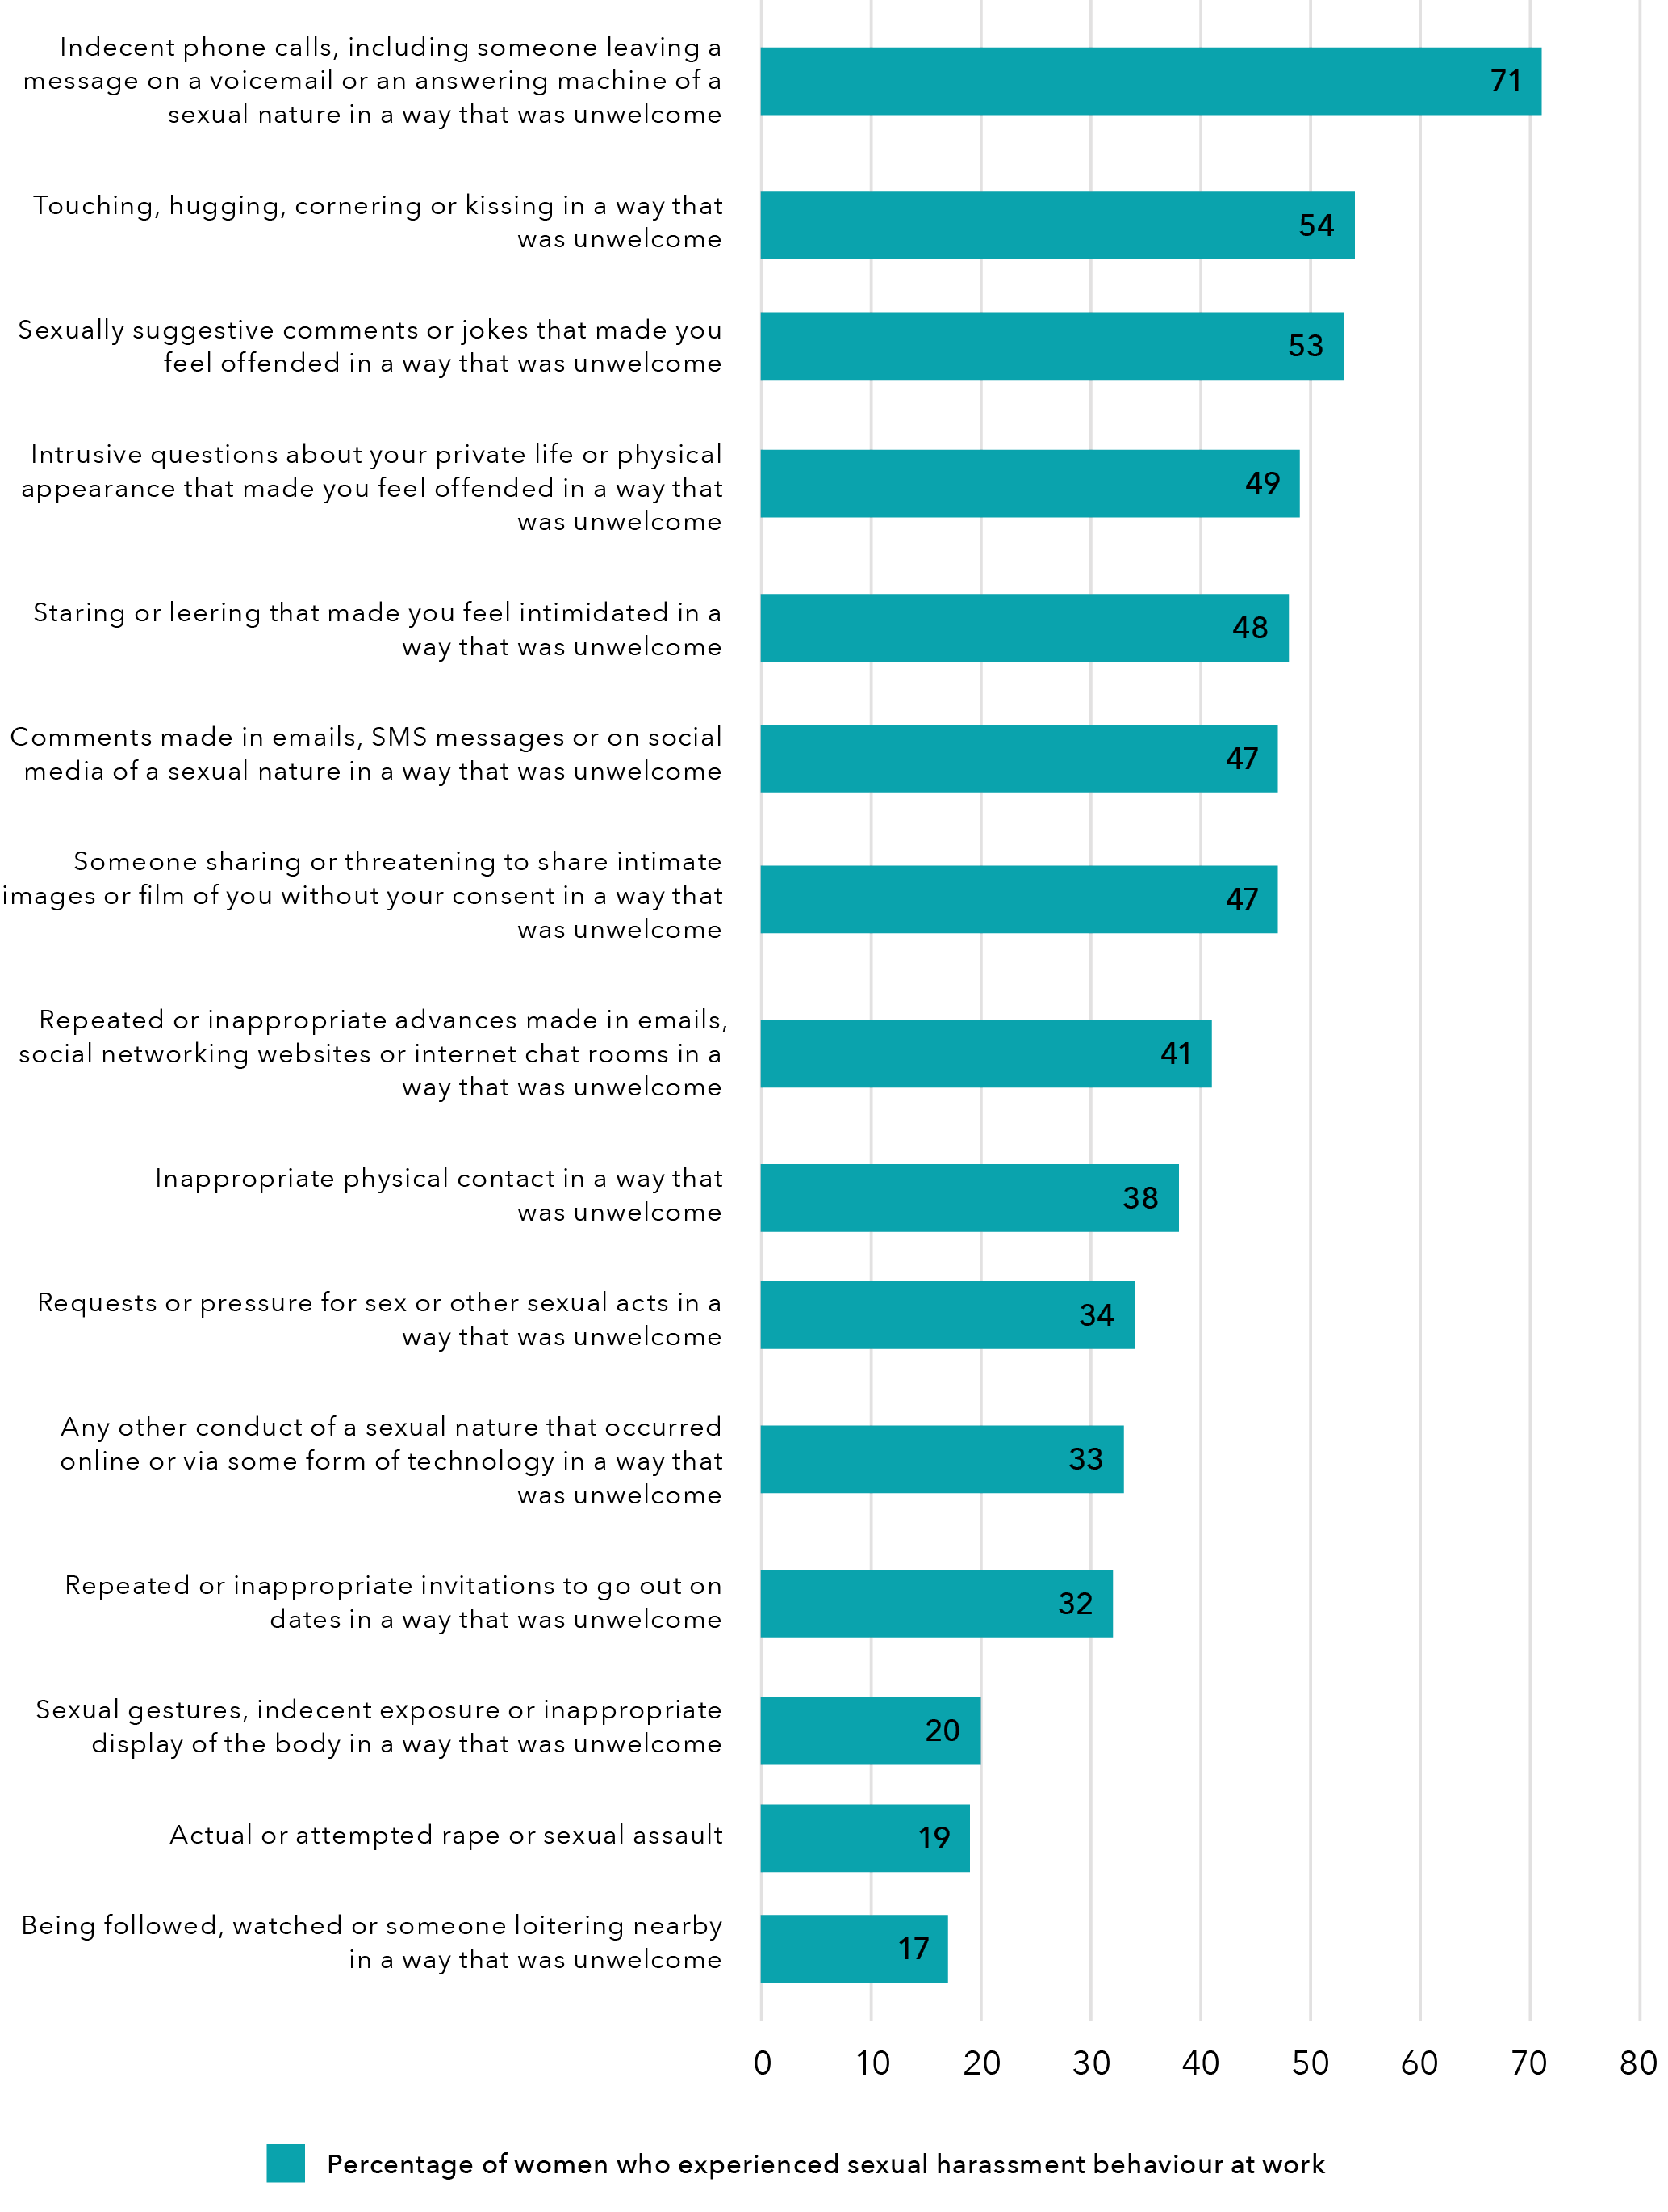
Data table for Figure 3:
Type of behaviour | Percentage of women who experienced sexual harassment at work
Indecent phone calls, including someone leaving a message on a voicemail or an answering machine of a sexual nature in a way that was unwelcome | 71
Touching, hugging, cornering or kissing in a way that was unwelcome | 54
Sexually suggestive comments or jokes that made you feel offended in a way that was unwelcome | 53
Intrusive questions about your private life or physical appearance that made you feel offended in a way that was unwelcome | 49
Staring or leering that made you feel intimidated in a way that was unwelcome | 48
Comments made in emails, SMS messages or on social media of a sexual nature in a way that was unwelcome | 47
Someone sharing or threatening to share intimate images or film of you without your consent in a way that was unwelcome | 47
Repeated or inappropriate advances made in emails, social networking websites or internet chat rooms in a way that was unwelcome | 41
Inappropriate physical contact in a way that was unwelcome | 38
Requests or pressure for sex or other sexual acts in a way that was unwelcome | 34
Any other conduct of a sexual nature that occurred online or via some form of technology in a way that was unwelcome | 33
Repeated or inappropriate invitations to go out on dates in a way that was unwelcome | 32
Sexual gestures, indecent exposure or inappropriate display of the body in a way that was unwelcome | 20
Actual or attempted rape or sexual assault | 19
Being followed, watched or someone loitering nearby in a way that was unwelcome | 17

Who are the harassers in the workplace
We asked participants about the main harasser in relation to each type of experience of sexual harassment; this included questions about their gender and their role in the/in relation to the workplace. We also asked about the number of harassers. These questions allowed some filling in of the picture of who is perpetrating different types of harassment in the workplace. For all experiences of sexual harassment in the workplace, the main harasser was most frequently a man (see Figure 4).

Number of harassers
For each of the 15 types of harassment, respondents who experienced workplace harassment (n=323) were asked how many people were involved in the incident. This was an open-ended question that allowed respondents to manually type in their responses. Due to the nature of how respondents answered this question (some made it clear in their responses that they counted themselves as a person in the incident, e.g. two people were involved – the victim and the harasser), we focus here on the percentage of women who indicated there were more than three people involved in a given incident (see Table 20 in the Appendix).
Figure 4: Percentage of male harassers across sexual harassment behaviours
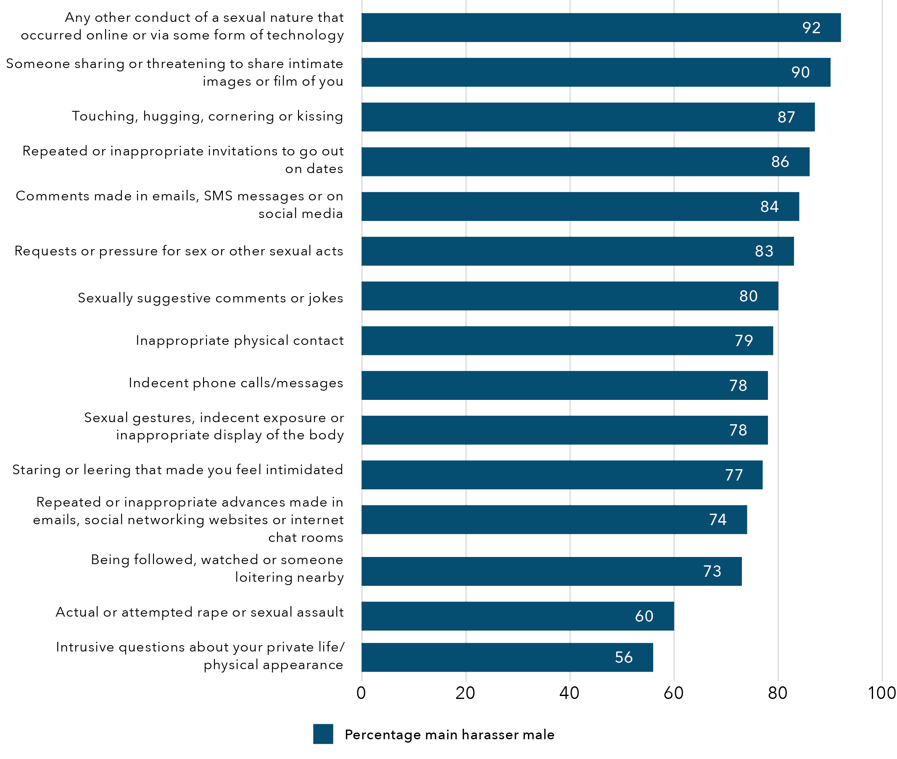
Data table for Figure 4:
Type of behaviour | Percentage of male harassers across sexual harassment behaviours
Any other conduct of a sexual nature that occurred online or via some form of technology | 92
Someone sharing or threatening to share intimate images or film of you | 90
Touching, hugging, cornering or kissing | 87
Repeated or inappropriate invitations to go out on dates | 86
Comments made in emails, SMS messages or on social media | 84
Requests or pressure for sex or other sexual acts | 83
Sexually suggestive comments or jokes | 80
Inappropriate physical contact | 79
Indecent phone calls/messages | 78
Sexual gestures, indecent exposure or inappropriate display of the body | 78
Staring or leering that made you feel intimidated | 77
Repeated or inappropriate advances made in emails, social networking websites or internet chat rooms | 74
Being followed, watched or someone loitering nearby | 73
Actual or attempted rape or sexual assault | 60
Intrusive questions about your private life/physical appearance | 56

Harasser workplace position
For each of the 15 types of harassment, respondents were asked what position the harasser held in the workplace. Respondents could choose from nine possible responses:
- the head of your workplace or organisation – such as the CEO, business owner or similar
- your direct manager or supervisor at work
- another manager or supervisor at work
- a co-worker who was more senior
- a co-worker at the same level as you
- a client or customer
- someone else associated with your workplace
- don’t know
- prefer not to say.
These responses were not mutually exclusive; respondents could select multiple positions for the harasser. The responses were aggregated into four categories to reflect a broader picture of the workplace context and the following structural positions in relation to their power:
- senior staff, which included anyone who was in a senior position (e.g. managers)
- people at the same level as the respondent
- clients or customers of the workplace where the incident occurred
- all others who were not included in these aforementioned categories.
Across all incident types, those in senior positions were reported as engaging in sexually harassing behaviour in the workplace most frequently. This was followed closely by clients (see Table 21 in the Appendix). This offers important insights for strategies to address workplace sexual harassment, given the challenges for workplaces to respond to the actions of clients. It also speaks to the pressures employees may feel around their job security and safety when their complaint impacts or pertains to, for example, an important external funder or client.

Who experiences sexual harassment in the workplace
There are several limitations to this dataset which prevent analysis based on age or other demographic data. However, a central goal of this research is to examine the relationship between those who experienced workplace sexual harassment and their relative position of power when they experienced the incident. For 9 of the 15 reported behaviours, women were more likely to be in temporary and/or casual roles than permanent roles (see Table 22 in the Appendix).

Responding to incidents of workplace sexual harassment
There were 323 women in this study who reported 773 incidents of workplace sexual harassment. In 63 per cent of these incidents, women told someone:
- 88 per cent spoke to someone informal outside their workplace (413 out of 489 reported incidents).
- 15 per cent spoke to a formal authority outside their workplace (71 out of 489 reported incidents).
- 45 per cent spoke to someone in their workplace (formal or informal; 211 out of 489 reported incidents).
We asked women about the reason they did not report, and they could select all that applied (and add additional reasons). Across all types of workplace sexual harassment, the survey data reveal that the main reason for non-reporting was that women felt responsible for the harassing behaviour (see Table 23 in the Appendix).
While the question about the reason for not reporting was focused primarily on women’s views about their situations and options, we asked a follow-up question to see how many women may have received direct threats and/or warnings about the consequences of reporting. This second question about threats or warnings not to report captured the influence of external pressure to not report. Specifically, we asked: “Did you not tell because of threats and/or warnings about the consequences?” Compared to the previous question, this one was explicitly about threats or warnings from somebody else that women should not report. We found that in one-third of the incidents, women had been threatened or warned not to report as is detailed in Table 24 in the Appendix (which provides only the percentage for “yes” for clarity of focus).

Motivation: Respondent perceptions of what drives sexual harassment in the workplace
For each of the 15 types of harassment, respondents were asked about their perception of the motivation for the harassment. Clearly, this is only the view of the victim: we cannot know the motivation of those who enacted these behaviours. However, this information offers an important insight into women’s experiences of sexual harassment in the workplace and their perception of what factors motivated the behaviour. We sought to capture motivations based on appearance (race, religion) or other forms of prejudice (ability, sexual orientation), but also structural inequality (e.g. visa status – we know from previous research that those on temporary visas tend to be at risk of both gender-based violence and labour exploitation; see Segrave et al., 2020; Boucher, 2019). There were seven possible responses and respondents could select multiple answers to this question. These responses were then aggregated into four separate variables:
- Race and/or religion includes:
  - race
  - religion
- Gender and/or sex includes:
  - gender identity
  - sexual orientation
- ability
- visa status
- Other includes all valid other responses which did not relate to race, religion, gender, sex, ability or visa status.
Across each type of behaviour, gender and/or sex and race and/or religion were consistently perceived as the primary motivation for the incident (see Table 25 in the Appendix). These findings provide strong evidence that for this sample, addressing workplace sexual harassment for migrant and refugee women requires addressing gendered inequity alongside discrimination based on race and/or religion.

Types of harassment: Incident-based description
The survey was constructed to enable detailed examination of 15 behaviours that constitute sexual harassment in the workplace and the patterns specific to each type of sexual harassment. This enables a closer examination of the types of workplace sexual harassment that different groups of migrant and refugee women experience. Yet it also offers detailed information about incident types that can be used to translate these findings into specific efforts to address workplace behaviour. Given the limit of a non-representative sample, it is not possible to compare across types of behaviour. Further, data limitations preclude a comparison of experiences across respondents who had experienced more than one type of sexual harassment in the workplace (as noted above, 58 per cent of respondents experienced two or more types of workplace sexual harassment). For this reason, we offer a detailed description of each type of workplace sexual harassment behaviour in terms of who experienced it, how it was experienced, who perpetrated the harassment and the response of women who experienced it in terms of disclosures and informal or formal action. In the summaries below we provide the most common answers, rather than every possible response, to offer a clearer indication of the patterns emerging.
There were a number of questions that allowed multiple responses. These questions included the harasser’s workplace position, who respondents told about the harassment and why respondents did not tell anyone about the harassment. The tables may not always have a total percentage of 100.


1. Indecent phone calls, including someone leaving a message on a voicemail or an answering machine of a sexual nature in a way that was unwelcome
Figure 5: Snapshot: Characteristics of indecent phone calls/messages
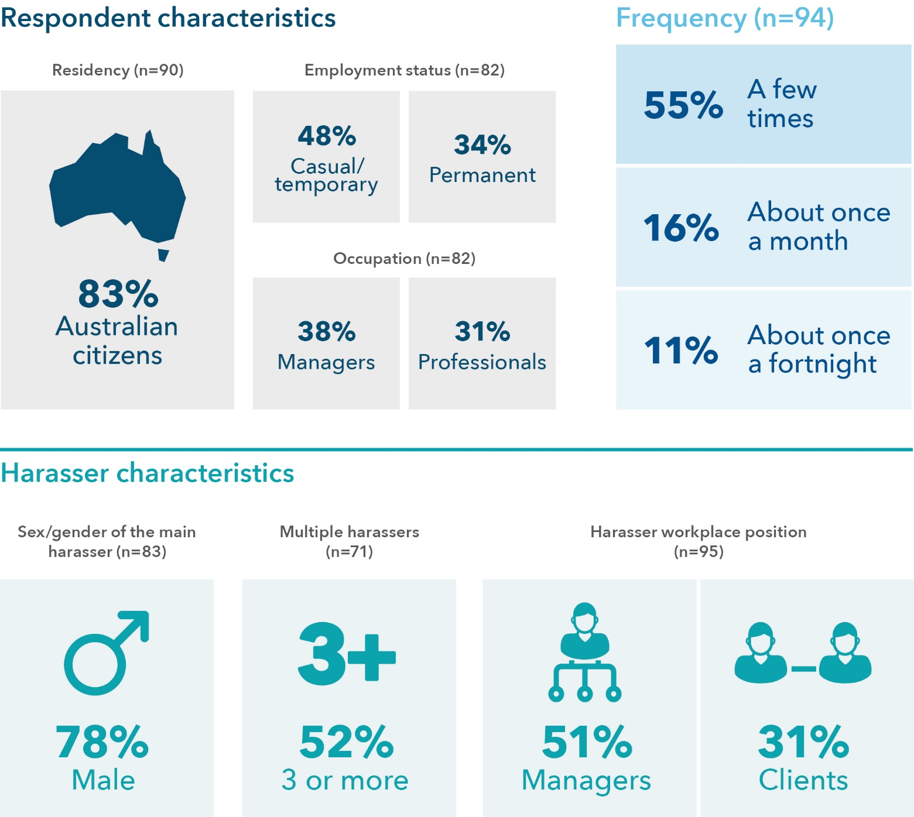

Data tables for Figure 5:
Respondent characteristics | % Survey sample
Australian citizens | 83 (n=90)
Employment status: casual/temporary | 48 (n=82)
Employment status: permanent | 34 (n=82)
Occupation: managers | 38 (n=82)
Occupation: professionals | 31 (n=82)

Frequency | % Survey sample (n=94)
A few times | 55
About once a month | 16
About once a fortnight | 11

Harasser characteristics | % Survey sample
Sex/gender of the main harasser: male | 78 (n=83)
Multiple (3 or more) harassers | 52 (n=71)
Harasser workplace position: managers | 51 (n=95)
Harasser workplace position: clients | 31 (n=95)

Who experienced this
71 per cent of women who reported sexual harassment in the form of indecent phone calls experienced them in the workplace setting. Of this group of women, 83 per cent were Australian citizens, 8 per cent were permanent residents, and 9 per cent were temporary residents. Almost half of those who experienced indecent phone calls in the workplace (48%) were in casual and/or temporary employment at the time (see Figure 5).

Frequency of the experience
Respondents who experienced workplace sexual harassment in the form of indecent phone calls most frequently experienced it more than once in the last 5 years (see Figure 5).

Harassers
Respondents were asked to consider this workplace-related incident or the most serious workplace-related incident (if it had happened more than once in the last 5 years). In 54 per cent of these incidents of sexual harassment in the form of indecent phone calls, the main harasser was a manager, and, in 33 per cent, the main harasser was a client (see Figure 5).

Motivation
Of those women who experienced workplace-related indecent phone calls, 72 per cent of the respondents believed the incident was motivated by gender and/or sexuality, and 62 per cent believed it was motivated by race and/or religion (n=95).

Reporting and sharing of workplace sexual harassment
Just over half of the respondents who experienced indecent phone calls told someone about the behaviour. Approximately 89 per cent told an informal support outside the workplace, 40 per cent told someone in the workplace, and 26 per cent told a formal authority outside the workplace. Of those who told someone, 27 per cent said things improved and remained much better, and 40 per cent said things improved for a short time, while 27 per cent said nothing changed, and 6 per cent reported it resulted in further harm. Among those who did not tell anyone about the behaviour, 77 per cent felt responsible in some way for the incident, and 59 per cent had employment concerns. Approximately 44 per cent (n=39) of respondents who did not tell anyone about the incident said this was because of threats and/or warnings about the consequences (see Table 5).
Table 5: Reporting characteristics associated with workplace-related indecent phone calls
Question | Response
Did you tell? (n=93) | 57% Yes  42% No
Who was told? (n=53) | 40% Workplace  89% Non-workplace informal  26% Non-workplace formal
Improvement after telling (n=48) | 40% Yes, things improved for a short time  27% Yes, things improved and remained much better  6% No, it resulted in further harm or abuse  27% No, nothing changed in their behaviour
If you didn’t tell, why? (n=39) | 59% Employment concerns  13% Visa/immigration concerns  77% Felt responsible  26% Took action/action already underway  38% No support/unsure what to do
Did you not tell because of threats and/or warnings about the consequences (n=36) | 44% Yes  50% No  3% Prefer not to say



2. Comments made in emails, SMS messages or on social media of a sexual nature in a way that was unwelcome
Figure 6: Snapshot: Characteristics of comments made in emails/SMS messages/social media
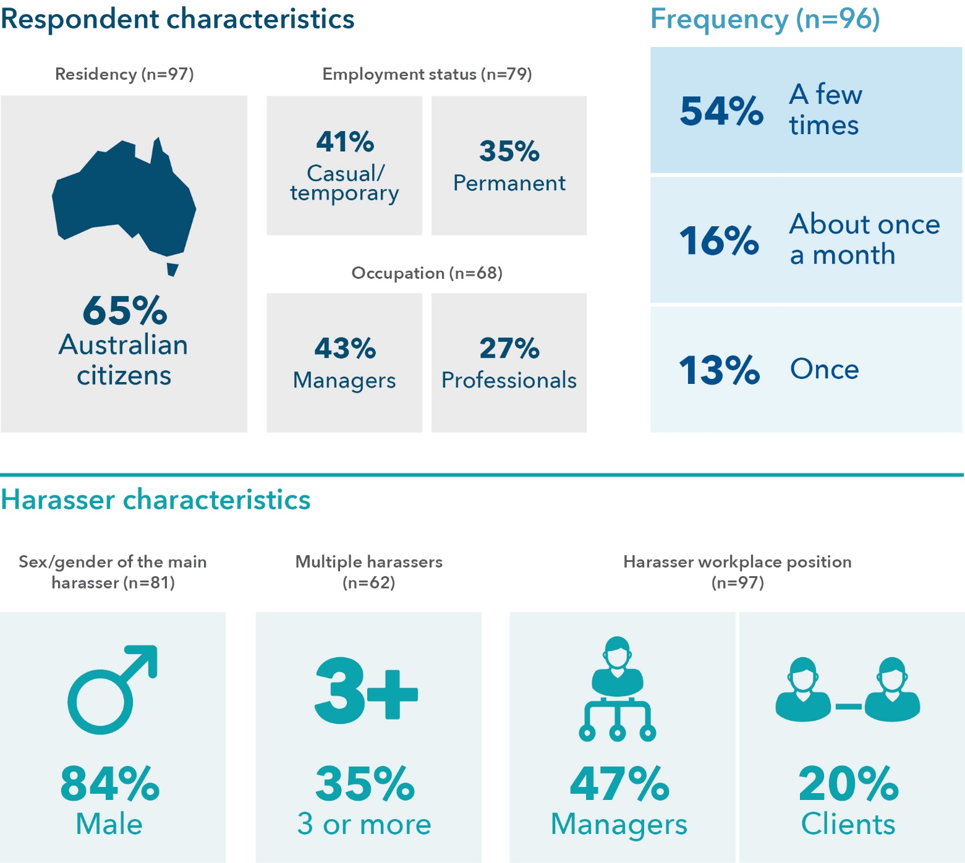

Data tables for Figure 6:
Respondent characteristics | % Survey sample
Australian citizens | 65 (n=97)
Employment status: casual/temporary | 41 (n=79)
Employment status: permanent | 35 (n=79)
Occupation: managers | 43 (n=68)
Occupation: professionals | 27 (n=27)

Frequency | % Survey sample (n=96)
A few times | 54
About once a month | 16
Once | 13

Harasser characteristics | % Survey sample
Sex/gender of the main harasser: male | 84
Multiple (3 or more) harassers | 35
Harasser workplace position: managers | 47
Harasser workplace position: clients | 20

Who experienced this
47 per cent of women who experienced unwelcome comments of a sexual nature made in emails, SMS messages or on social media experienced them in the workplace. Of this group of women, 65 per cent were Australian citizens, 20 per cent were permanent residents, and 15 per cent were temporary residents. Nearly half (41%) were in casual and/or temporary employment when this incident occurred (see Figure 6).

Frequency of the experience
The majority of respondents who experienced unwelcome comments of a sexual nature made in workplace-related emails, SMS messages or on social media experienced it more than once (see Figure 6).

Harassers
Respondents were asked to consider the workplace-related incident or the most serious workplace-related incident (if it had happened more than once in the last 5 years). In 47 per cent of the workplace-related incidents of unwelcome comments of a sexual nature made in emails, SMS messages or on social media, the main harasser was a manager (see Figure 6).

Motivation
Of the 97 women who experienced unwelcome messages at work, 69 per cent believed the incident was motivated by gender and/or sex, and 55 per cent believed it was motivated by race and/or religion.

Reporting and sharing of workplace sexual harassment
More than half of the respondents told someone about their experience of unwelcome messages; 78 per cent told an informal support outside the workplace, 44 per cent told someone in the workplace, and 12 per cent told a formal authority outside the workplace. Of those who told someone, 25 per cent said things improved and remained much better, 25 per cent said things improved for a short time, while 43 per cent said nothing changed, and 8 per cent reported it resulted in further harm. Of those who did not tell anyone about the behaviour, 73 per cent felt responsible in some way for the incident, and 47 per cent had employment concerns. Approximately 40 per cent of respondents who did not tell anyone about the incident said this was because of threats and/or warnings about the consequences (see Table 6).
Table 6: Reporting characteristics associated with receiving unwelcome comments in emails, SMS messages or on social media in the workplace
Question | Response
Did you tell? (n=90) | 66% Yes  33% No
Who was told? (n=59) | 44% Workplace  78% Non-workplace informal  12% Non-workplace formal
Improvement after telling (n=49) | 25% Yes, things improved for a short time  25% Yes, things improved and remained much better  8% No, it resulted in further harm or abuse  43% No, nothing changed in their behaviour
If you didn’t tell, why? (n=30) | 47% Employment concerns  13% Visa/immigration concerns  73% Felt responsible  27% Took action/action already underway  40% No support/unsure what to do
Did you not tell because of threats and/or warnings about the consequences (n=25) | 40% Yes  52% No  8% Prefer not to say



3. Repeated or inappropriate advances made in emails, social networking websites or internet chat rooms in a way that was unwelcome
Figure 7: Snapshot: Characteristics of repeated or inappropriate advances in emails/social networking/online
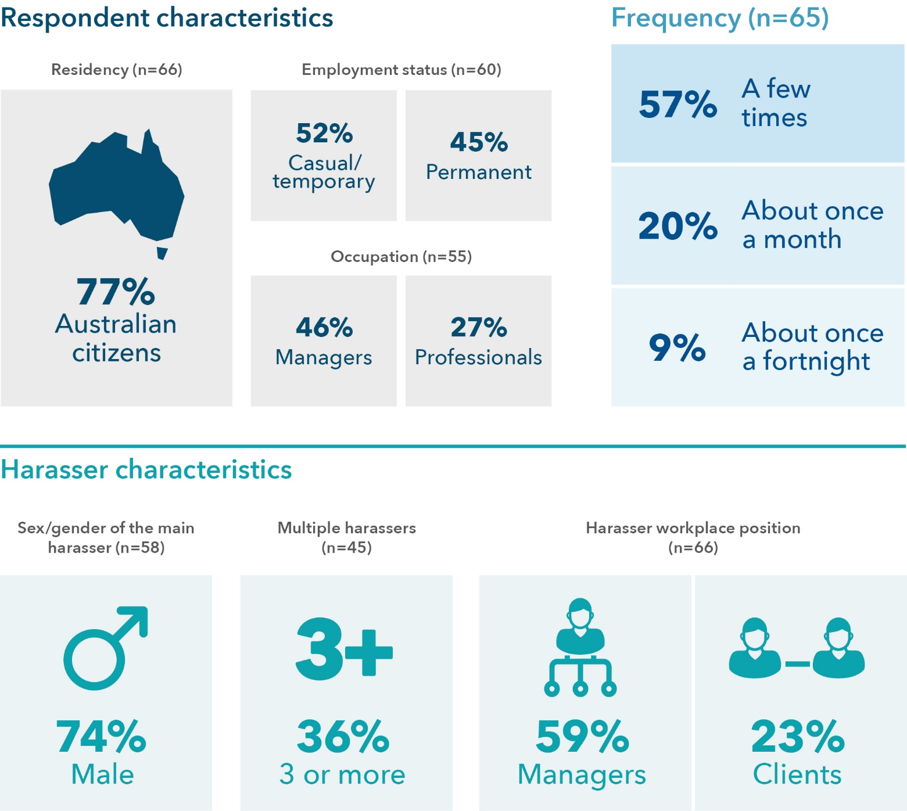

Data tables for Figure 7:
Respondent characteristics | % Survey sample
Australian citizens | 77 (n=66)
Employment status: casual/temporary | 52 (n=60)
Employment status: permanent | 45 (n=60)
Occupation: managers | 46 (n=55)
Occupation: professionals | 27 (n=55)

Frequency | % Survey sample (n=65)
A few times | 57
About once a month | 20
About once a fortnight | 9

Harasser characteristics | % Survey sample
Sex/gender of the main harasser: male | 74 (n=58)
Multiple (3 or more) harassers | 36 (n=45)
Harasser workplace position: managers | 59 (n=66)
Harasser workplace position: clients | 23 (n=66)

Who experienced this
Approximately 41 per cent of women who experienced repeated or inappropriate advances made in emails, social networking websites or internet chat rooms experienced it in the workplace. Of those who had experienced this, 66 per cent were Australian citizens, 12 per cent were permanent residents, and 11 per cent were temporary residents. More than half (52%) were in casual and/or temporary employment when this occurred (see Figure 7).

Frequency of the experience
Respondents who experienced this type of repeated or inappropriate advances in work-related emails, social networking websites or internet chat rooms most frequently experienced it more than once (see Figure 7).

Harassers
Respondents were asked to consider the workplace-related incident or the most serious workplace-related incident (if it had happened more than once in the last 5 years). In 59 per cent of incidents, the main harasser was a manager (see Figure 7).

Motivation
Sixty-six women experienced repeated or inappropriate advances made in work-related emails, social networking websites or internet chat rooms, and of these, 68 per cent believed the incident was motivated by gender and/or sex, and 56 per cent believed it was motivated by race and/or religion.

Reporting and sharing of workplace sexual harassment
More than half of the respondents told someone about these unwelcome workplace advances in emails, social networking websites or internet chat rooms; 93 per cent told an informal support outside the workplace, 38 per cent told someone in the workplace, and 11 per cent told a formal authority outside the workplace. Of those who told someone, 23 per cent said things improved and remained much better, and 28 per cent said things improved for a short time, while 44 per cent said nothing changed, and 5 per cent reported it resulted in further harm. Of those who did not tell anyone about the behaviour, 90 per cent felt responsible in some way for the incident, and 40 per cent had employment concerns. Approximately 50 per cent of respondents who did not tell anyone about the incident said this was because of threats and/or warnings about the consequences (see Table 7).
Table 7: Reporting characteristics associated with receiving repeated advances made via workplace-related technology
Question | Response
Did you tell? (n=65) | 69% Yes  31% No
Who was told? (n=45) | 38% Workplace  93% Non-workplace informal  11% Non-workplace formal
Improvement after telling (n=43) | 28% Yes, things improved for a short time  23% Yes, things improved and remained much better  5% No, it resulted in further harm or abuse  44% No, nothing changed in their behaviour
If you didn’t tell, why? (n=20) | 40% Employment concerns  30% Visa/immigration concerns  90% Felt responsible  25% Took action/action already underway  50% No support/unsure what to do
Did you not tell because of threats and/or warnings about the consequences (n=20) | 50% Yes  45% No  5% Prefer not to say


4. Someone sharing or threatening to share intimate images or film of you without your consent in a way that was unwelcome
Figure 8: Snapshot: Characteristics of sharing or threatening to share intimate images/film of you
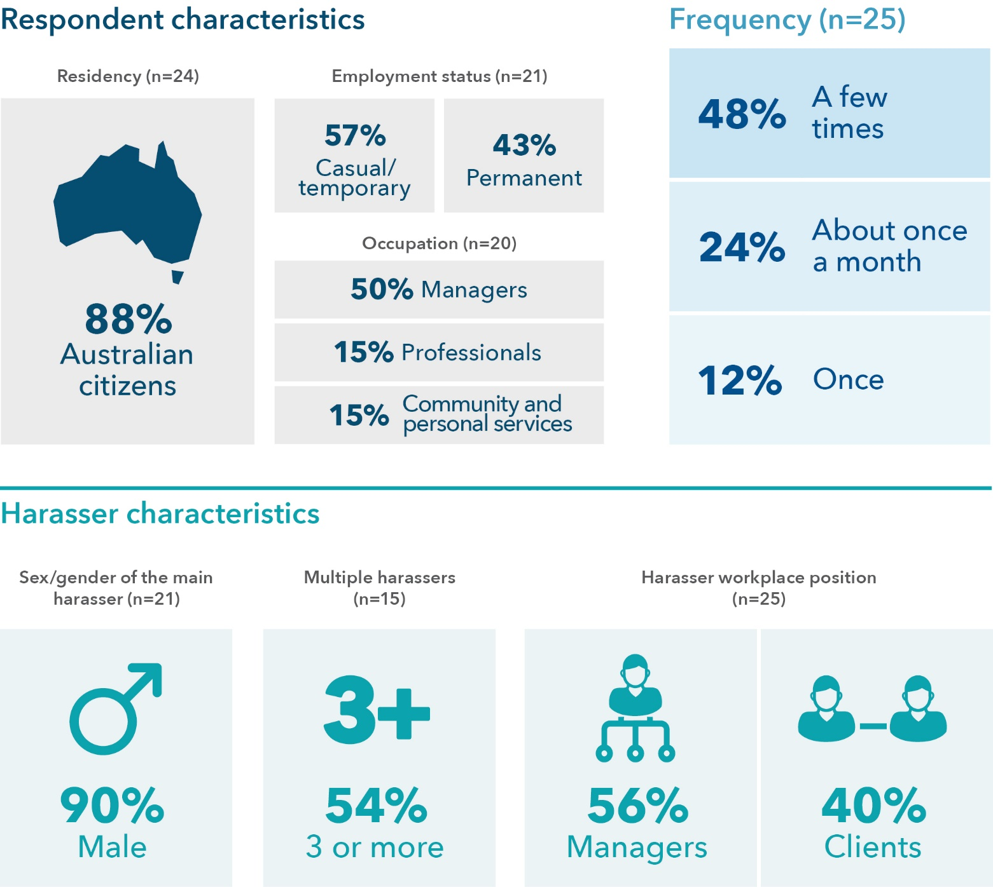

Data tables for Figure 8:
Respondent characteristics | % Survey sample
Australian citizens | 88 (n=24)
Employment status: casual/temporary | 57 (n=21)
Employment status: permanent | 43 (n=21)
Occupation: managers | 50 (n=20)
Occupation: professionals | 15 (n=20)
Community and personal services | 15 (n=20)

Frequency | % Survey sample (n=25)
A few times | 48
About once a month | 24
Once | 12

Harasser characteristics | % Survey sample
Sex/gender of the main harasser: male | 90 (n=21)
Multiple (3 or more) harassers | 54 (n=15)
Harasser workplace position: managers | 56 (n=25)
Harasser workplace position: clients | 40 (n=25)

Who experienced this
41 per cent of women who experienced someone sharing or threatening to share intimate images or film of them without their consent, and in a way that was unwelcome, experienced this in the workplace. Of this group of women, 88 per cent were Australian citizens, and 13 per cent were permanent residents. More than half (57%) were in casual and/or temporary employment when this occurred (see Figure 8).

Frequency of the experience
Women in this study who experienced workplace-related sharing or threats to share intimate images or film without consent most frequently experienced it more than once (see Figure 8).

Harassers
Respondents were asked to consider the workplace-related incident or the most serious workplace-related incident (if it had happened more than once in the last 5 years). In 56 per cent of the incidents, the main harasser was a manager, and, in 40 per cent of the incidents, the main harasser was a client (see Figure 8).

Motivation
Twenty-five women experienced sharing or the threat to share intimate images or film without consent in the workplace; of these, 60 per cent believed the incident was motivated by gender and/or sex, and 56 per cent believed it was motivated by race and/or religion.

Reporting and sharing of workplace sexual harassment
Just over half of the respondents told someone about workplace-related sharing or threats to share intimate images or film without consent; 50 per cent told someone in the workplace, 67 per cent told an informal support outside the workplace, and 17 per cent told a formal authority outside the workplace. Of those who told someone, 22 per cent said things improved and remained much better, and 67 per cent said things improved for a short time, while 11 per cent reported it resulted in further harm. Of those who did not tell anyone about the behaviour, 90 per cent felt responsible in some way for the incident, and 22 per cent had employment concerns. Approximately 78 per cent of respondents who did not tell anyone about the incident said this was because of threats and/or warnings about the consequences (see Table 8).
Table 8: Reporting characteristics associated with someone sharing or threatening to share intimate images in the workplace
Question | Response
Did you tell? (n=21) | 57% Yes  43% No
Who was told? (n=12) | 50% Workplace  67% Non-workplace informal  17% Non-workplace formal
Improvement after telling (n=9) | 67% Yes, things improved for a short time  22% Yes, things improved and remained much better  11% No, it resulted in further harm or abuse
If you didn’t tell, why? (n=9) | 22% Employment concerns  11% Visa/immigration concerns  90% Felt responsible  44% No support/unsure what to do
Did you not tell because of threats and/or warnings  about the consequences (n=9) | 78% Yes  22% No


5. Any other conduct of a sexual nature that occurred online or via some form of technology in a way that was unwelcome
Figure 9: Snapshot: Characteristics of other conduct of a sexual nature that occurred online/via technology
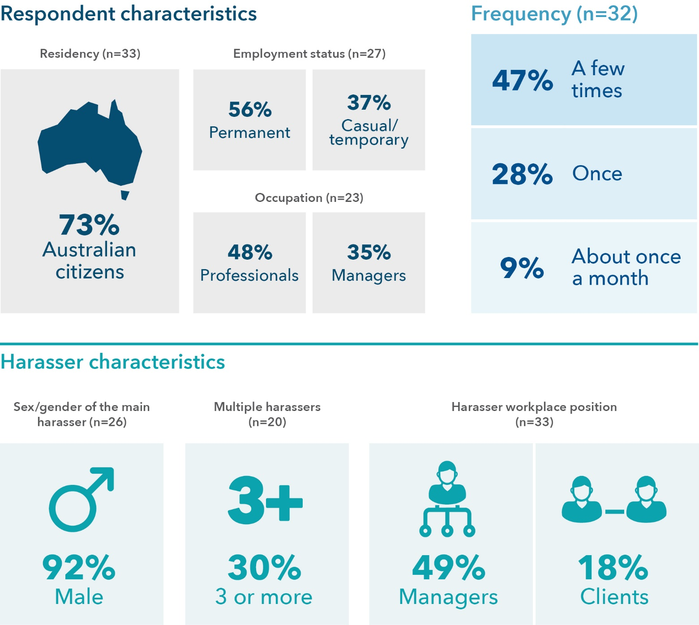

Data tables for Figure 9:
Respondent characteristics | % Survey sample
Australian citizens | 73 (n=33)
Employment status: permanent | 56 (n=27)
Employment status: casual/temporary | 37 (n=27)
Occupation: professionals | 48 (n=23)
Occupation: managers | 35 (n=23)

Frequency | % Survey sample (n=32)
A few times | 47
Once | 28
About once a month | 9

Harasser characteristics | % Survey sample
Sex/gender of the main harasser: male | 92 (n=26)
Multiple (3 or more) harassers | 30 (n=20)
Harasser workplace position: managers | 49 (n=33)
Harasser workplace position: clients | 18 (n=33)

Who experienced this
33 per cent of women who experienced conduct of a sexual nature that occurred online or via some form of technology in a way that was unwelcome experienced this in the workplace. Of this group of women, 73 per cent were Australian citizens, 9 per cent were permanent residents, and 18 per cent were temporary residents. More than half (56%) were in permanent employment when this occurred (see Figure 9).

Frequency of the experience
Women in this study who experienced unwelcome conduct of a sexual nature that occurred online or via some form of workplace technology most frequently experienced it more than once (see Figure 9).

Harassers
Respondents were asked to consider the workplace-related incident or the most serious workplace-related incident (if it had happened more than once in the last 5 years). In 49 per cent of the incidents, the main harasser was a manager, and, in 18 per cent of the incidents, the main harasser was a client (see Figure 9).

Motivation
Thirty-three women experienced unwelcome conduct of a sexual nature occurring online or via some form of technology in the workplace. Of these, 52 per cent of the respondents believed the incident was motivated by race and/or religion, and 45 per cent believed it was motivated by gender and/or sex.

Reporting and sharing of workplace sexual harassment
More than half of the respondents told someone about the unwelcome conduct of a sexual nature that occurred online or via some form of technology in the workplace; of those, 88 per cent told an informal support outside the workplace, 44 per cent told someone in the workplace, and 25 per cent told a formal authority outside the workplace. Of those who told someone, 20 per cent said things improved and remained much better, and 27 per cent said things improved for a short time, while 47 per cent said nothing changed, and 7 per cent reported that it resulted in further harm. Of those who did not tell anyone about the behaviour, 82 per cent felt responsible in some way for the incident, and 46 per cent had employment concerns. Approximately 64 per cent of respondents who did not tell anyone about the incident said this was because of threats and/or warnings about consequences (see Table 9).
Table 9: Reporting characteristics associated with experiencing unwanted conduct of a sexual nature in the workplace via technology
Question | Response
Did you tell? (n=27) | 59% Yes  41% No
Who was told? (n=16) | 44% Workplace  88% Non-workplace informal  25% Non-workplace formal
Improvement after telling (n=15) | 27% Yes, things improved for a short time  20% Yes, things improved and remained much better  7% No, it resulted in further harm or abuse  47% No, nothing changed in their behaviour
If you didn’t tell, why? (n=11) | 46% Employment concerns  82% Felt responsible  9% Took action/action already underway  36% No support/unsure what to do
Did you not tell because of threats and/or warnings about the consequences (n=11) | 64% Yes  36% No



6. Touching, hugging, cornering or kissing in a way that was unwelcome
Figure 10: Snapshot: Characteristics of touching, hugging, cornering or kissing
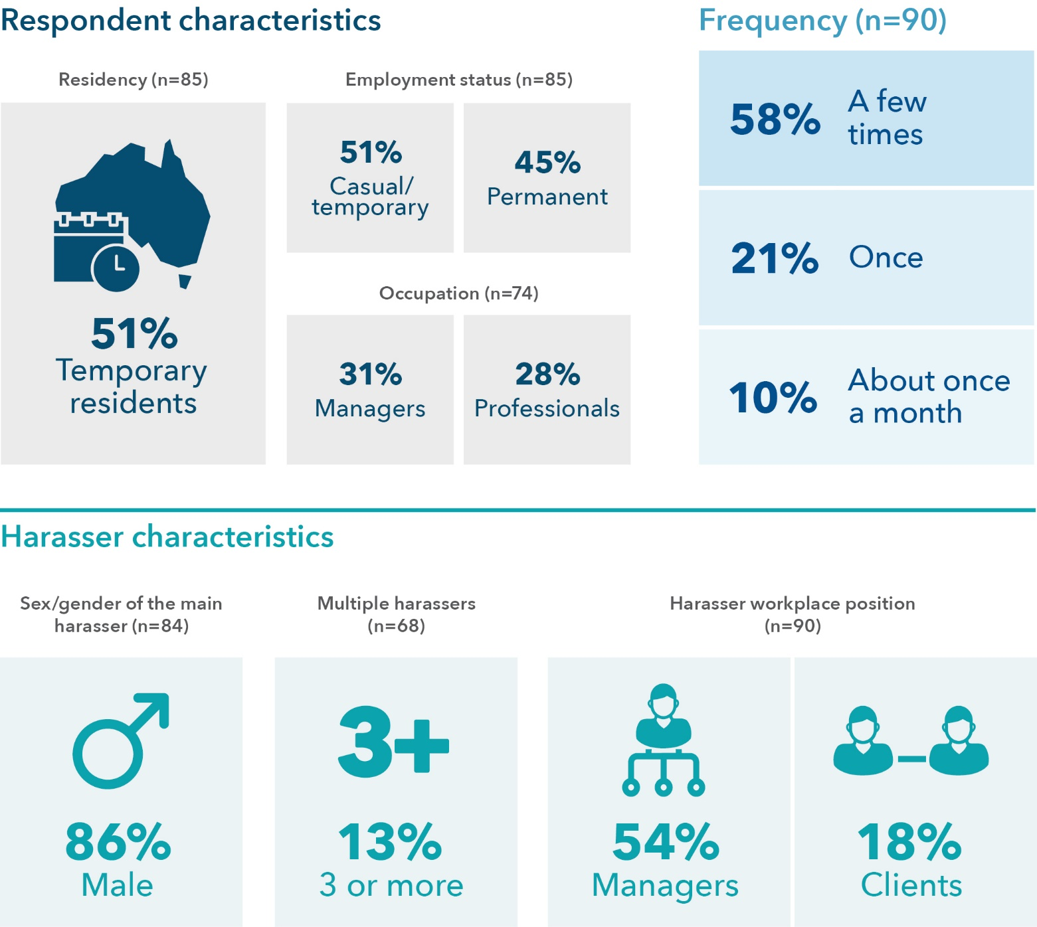

Data tables for Figure 10:
Respondent characteristics | % Survey sample
Temporary residents | 51 (n=85)
Employment status: casual/temporary | 51 (n=85)
Employment status: permanent | 45 (n=85)
Occupation: managers | 31 (n=74)
Occupation: professionals | 28 (n=74)

Frequency | % Survey sample (n=90)
A few times | 58
Once | 21
About once a month | 10

Harasser characteristics | % Survey sample
Sex/gender of the main harasser: male | 86 (n=84)
Multiple (3 or more) harassers | 13 (n=68)
Harasser workplace position: managers | 54 (n=90)
Harasser workplace position: clients | 18 (n=90)

Who experienced this
54 per cent of women who experienced touching, hugging, cornering or kissing in a way that was unwelcome experienced this in the workplace. Of this group of women, 45 per cent were permanent, and 51 per cent were temporary residents. Approximately half (51%) were in casual and/or temporary employment when this occurred (see Figure 10).

Frequency of the experience
Respondents who experienced unwelcome touching, hugging, cornering or kissing in the workplace most frequently experienced it more than once (see Figure 10).

Harassers
Respondents were asked to consider the workplace-related incident or the most serious workplace-related incident (if it had happened more than once in the last 5 years). In 54 per cent of the incidents, the main harasser was a manager (see Figure 10).

Motivation
Ninety women experienced touching, hugging, cornering or kissing in a way that was unwelcome in the workplace. Of these, 64 per cent believed the incident was motivated by gender and/or sex, and 46 per cent believed it was motivated by race and/or religion.

Reporting and sharing of workplace sexual harassment
More than half of the respondents told someone about the unwelcome touching, hugging, cornering or kissing in the workplace; 83 per cent told an informal support outside the workplace, 46 per cent told someone in the workplace, and 11 per cent told a formal authority outside the workplace. Of those who told someone, 22 per cent said things improved and remained much better, and 18 per cent said things improved for a short time, while 47 per cent said nothing changed, and 14 per cent reported it resulted in further harm. Of those who did not tell anyone about the behaviour, 88 per cent felt responsible in some way for the incident, and 22 per cent had employment concerns. Approximately 32 per cent of respondents who did not tell anyone about the incident said this was because of threats and/or warnings about the consequences (see Table 10).
Table 10: Reporting characteristics associated with unwelcome touching, hugging, cornering or kissing in the workplace
Question | Response
Did you tell? (n=89) | 61% Yes  26% No
Who was told? (n=54) | 46% Workplace  83% Non-workplace informal  11% Non-workplace formal
Improvement after telling (n=51) | 18% Yes, things improved for a short time  22% Yes, things improved and remained much better  14% No, it resulted in further harm or abuse  47% No, nothing changed in their behaviour
If you didn’t tell, why? (n=32) | 22% Employment concerns  9% Visa/immigration concerns  88% Felt responsible  22% Took action/action already underway  31% No support/unsure what to do
Did you not tell because of threats and/or warnings about the consequences (n=31) | 32% Yes  68% No



7. Staring or leering that made you feel intimidated in a way that was unwelcome
Figure 11: Snapshot: Characteristics of staring or leering
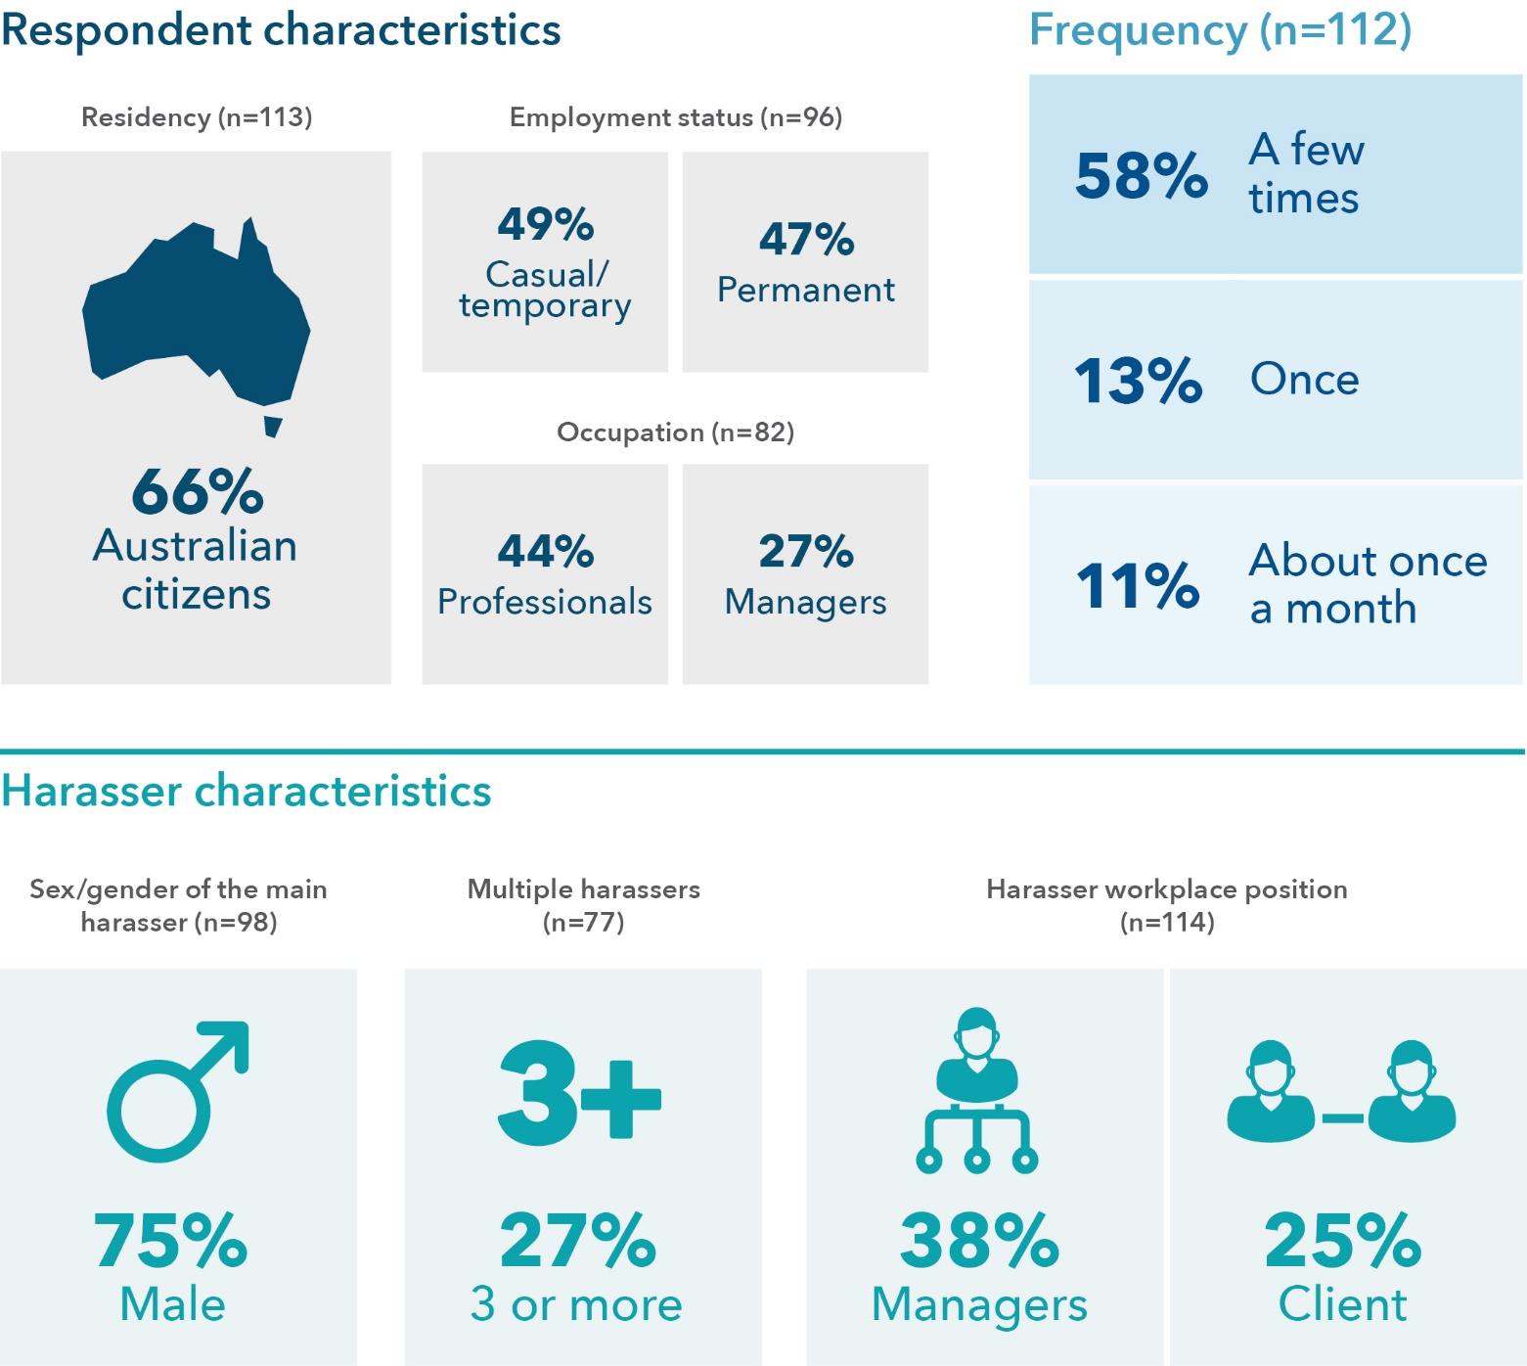

Data tables for Figure 11:
Respondent characteristics | % Survey sample
Australian citizens | 66 (n=113)
Employment status: casual/temporary | 49 (n=96)
Employment status: permanent | 47 (n=96)
Occupation: professionals | 44 (n=82)
Occupation: managers | 27 (n=82)

Frequency | % Survey sample (n=112)
A few times | 58
Once | 13
About once a month | 11

Harasser characteristics | % Survey sample
Sex/gender of the main harasser: male | 75
Multiple (3 or more) harassers | 27
Harasser workplace position: managers | 38
Harasser workplace position: clients | 25

Who experienced this
48 per cent of women in this study who had experienced staring or leering in a way that was intimidating experienced this in the workplace. Of this group of women, 66 per cent were Australian citizens, 15 per cent were permanent residents, and 20 per cent were temporary residents. Almost half (49%) were in casual and/or temporary employment when this occurred (see Figure 11).

Frequency of the experience
Respondents who experienced workplace-related staring or leering in a way that was intimidating most frequently experienced it more than once (see Figure 11).

Harassers
Respondents were asked to consider the workplace-related incident or the most serious workplace-related incident (if it had happened more than once in the last 5 years). In 38 per cent of the incidents, the main harasser was a manager, and, in 25 per cent of the incidents, the main harasser was a client (see Figure 11).

Motivation
Of the 114 women who experienced workplace staring or leering in a way that was intimidating, 57 per cent believed the incident was motivated by gender and/or sex, and 57 per cent believed it was motivated by race and/or religion.

Reporting and sharing of workplace sexual harassment
Just over half of the respondents told someone about the workplace-related staring or leering; 91 per cent told an informal support outside the workplace, 47 per cent told someone in the workplace, and 11 per cent told a formal authority outside the workplace. Of those who told someone, 13 per cent said things improved and remained much better, and 20 per cent said things improved for a short time, while 65 per cent said nothing changed, and 2 per cent reported it resulted in further harm. Of those who did not tell anyone about the behaviour, 82 per cent felt responsible in some way for the incident, and 27 per cent had employment concerns. Approximately 17 per cent of respondents who did not tell anyone about the incident said this was because of threats and/or warnings about the consequences (see Table 11).
Table 11: Reporting characteristics associated with staring or leering in the workplace
Question | Response
Did you tell? (n=103) | 53% Yes  43% No
Who was told? (n=55) | 47% Workplace  91% Non-workplace informal  11% Non-workplace formal
Improvement after telling (n=54) | 20% Yes, things improved for a short time  13% Yes, things improved and remained much better  2% No, it resulted in further harm or abuse  65% No, nothing changed in their behaviour
If you didn’t tell, why? (n=44) | 27% Employment concerns  5% Visa/immigration concerns  82% Felt responsible  25% Took action/action already underway  34% No support/unsure what to do
Did you not tell because of threats and/or warnings about the consequences (n=41) | 17% Yes  83% No



8. Sexual gestures, indecent exposure or inappropriate display of the body in a way that was unwelcome
Figure 12: Snapshot: Characteristics of sexual gestures, indecent exposure or inappropriate display of the body
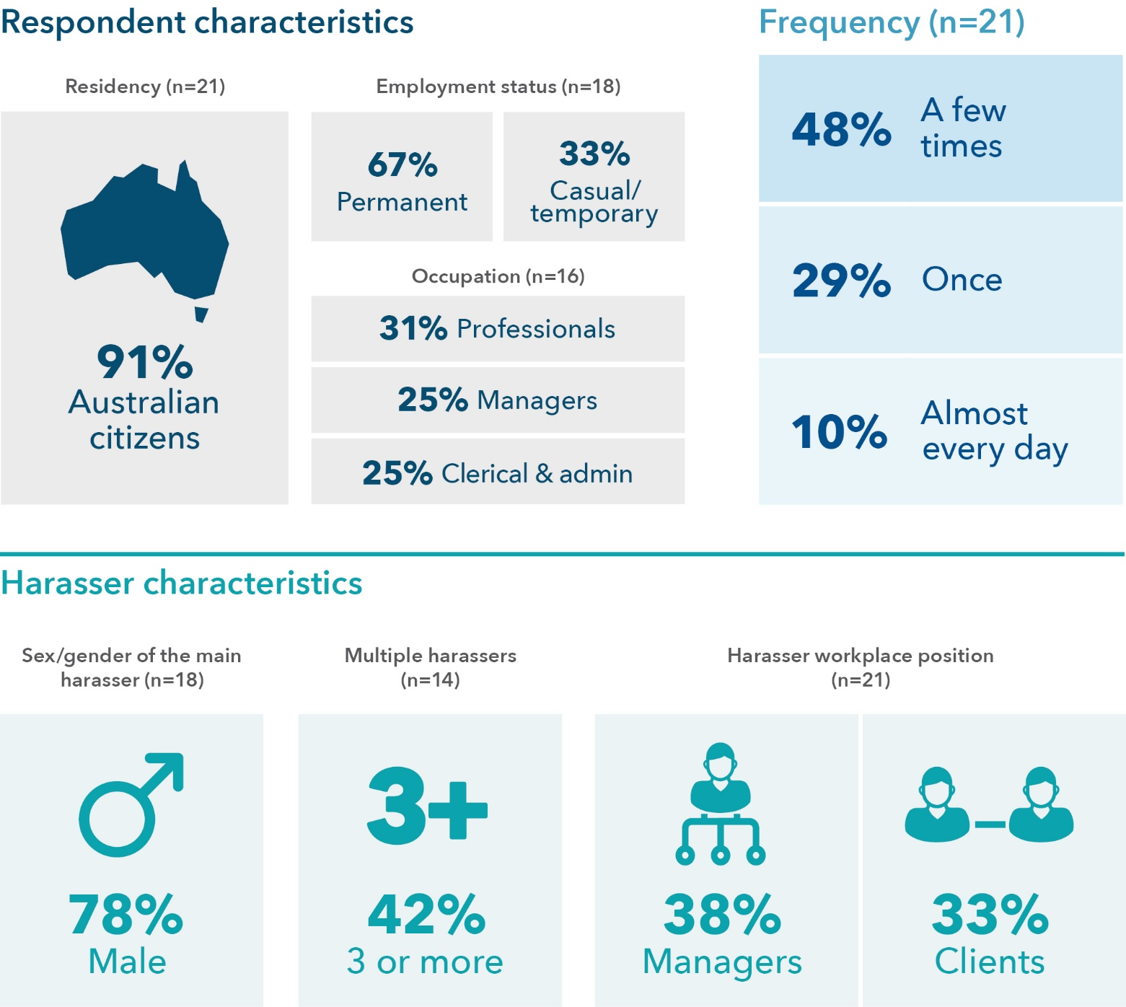

Data tables for Figure 12:
Respondent characteristics | % Survey sample
Australian citizens | 91 (n=21)
Employment status: permanent | 67 (n=18)
Employment status: casual/temporary | 33 (n=18)
Occupation: professionals | 31 (n=16)
Occupation: managers | 25 (n=16)
Occupation: clerical and admin | 25 (n=16)

Frequency | % Survey sample (n=21)
A few times | 48
Once | 29
Almost every day | 10

Harasser characteristics | % Survey sample
Sex/gender of the main harasser: male | 78 (n=18)
Multiple (3 or more) harassers | 42 (n=14)
Harasser workplace position: managers | 38 (n=21)
Harasser workplace position: clients | 33 (n=21)

Who experienced this
20 per cent of women in this study who had experienced sexual gestures/indecent exposure or inappropriate displays of the body experienced this in the workplace. Of this group of women, 91 per cent were Australian citizens, 5 per cent were permanent residents, and 5 per cent were temporary residents. Approximately one-third (33%) were in casual and/or temporary employment when this occurred (see Figure 12).

Frequency of the experience
Respondents who experienced workplace-related sexual gestures/indecent exposure or inappropriate display of the body most frequently experienced it more than once (see Figure 12).

Harassers
Respondents were asked to consider the workplace-related incident or the most serious workplace-related incident (if it had happened more than once in the last 5 years). In 38 per cent of the incidents, the main harasser was a manager, and, in 33 per cent of the incidents, the main harasser was a client. In close to half of the incidents where the number of harassers was reported by the respondent, there were three or more harassers perpetuating this form of workplace sexual harassment (see Figure 12).

Motivation
Twenty-one women experienced sexual gestures, indecent exposure or inappropriate display of the body in the workplace, and of these, 67 per cent of respondents believed the incident was motivated by gender and/or sex, and 57 per cent believed it was motivated by race and/or religion.

Reporting and sharing of workplace sexual harassment
Three-quarters of the respondents told someone about the workplace-related sexual gestures/indecent exposure or inappropriate display of the body; 67 per cent told an informal support outside the workplace, 67 per cent told someone in the workplace, and 20 per cent told a formal authority outside the workplace. Of those who told someone, 29 per cent said things improved and remained much better, and 21 per cent said things improved for a short time, while 50 per cent said nothing changed. Of those who did not tell anyone about the behaviour, all reported feeling responsible in some way for the incident, and 40 per cent had employment concerns. Approximately 40 per cent of respondents who did not tell anyone about the incident said this was because of threats and/or warnings about the consequences (see Table 12).
Table 12: Reporting characteristics associated with experiencing sexual gestures or indecent exposure in the workplace
Question | Response
Did you tell? (n=20) | 75% Yes  25% No
Who was told? (n=15) | 67% Workplace  67% Non-workplace informal  20% Non-workplace formal
Improvement after telling (n=14) | 21% Yes, things improved for a short time  29% Yes, things improved and remained much better  50% No, nothing changed in their behaviour
If you didn’t tell, why? (n=5) | Excluded as n <10
Did you not tell because of threats and/or warnings about the consequences (n=5) | Excluded as n <10



9. Sexually suggestive comments or jokes that made you feel offended in a way that was unwelcome
Figure 13: Snapshot: Characteristics of sexually suggestive comments/jokes
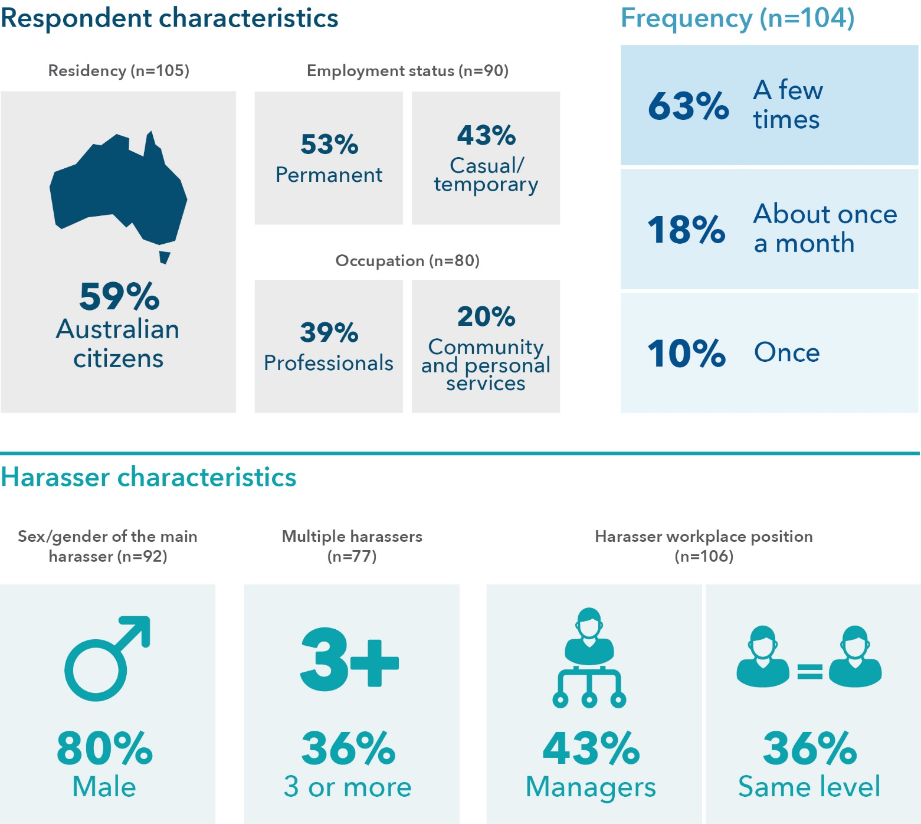

Data table for Figure 13:
Respondent characteristics | % Survey sample
Australian citizens | 59 (n=105)
Employment status: permanent | 53 (n=90)
Employment status: casual/temporary | 43 (n=90)
Occupation: professionals | 39 (n=80)
Occupation: community and personal services | 20 (n=80)

Frequency | % Survey sample (n=104)
A few times | 63
About once a month | 18
Once | 10

Harasser characteristics | % Survey sample
Sex/gender of the main harasser: male | 80 (n=92)
Multiple (3 or more) harassers | 36 (n=77)
Harasser workplace position: managers | 43 (n=106)
Harasser workplace position: same level | 36 (n=106)

Who experienced this
Over half of the women in this study (58%) who had experienced sexually suggestive comments or jokes experienced this in the workplace. Of this group of women, 59 per cent were Australian citizens, 23 per cent were permanent residents, and 18 per cent were temporary residents. Almost half (43%) were in casual and/or temporary employment when this occurred (see Figure 13).

Frequency of the experience
Respondents who experienced workplace-related sexually suggestive comments or jokes most frequently experienced it more than once (see Figure 13).

Harassers
Respondents were asked to consider the workplace-related incident or the most serious workplace-related incident (if it had happened more than once in the last 5 years). In 43 per cent of the incidents, the main harasser was a manager, and, in 36 per cent of the incidents, the main harasser was a colleague at the same level (see Figure 13).

Motivation
Of the 106 women who experienced sexually suggestive comments or jokes in the workplace, 75 per cent believed the incident was motivated by gender and/or sex, and 47 per cent believed it was motivated by race and/or religion.

Reporting and sharing of workplace sexual harassment
Three-quarters of the respondents told someone about the workplace-related sexually suggestive comments or jokes; 78 per cent told an informal support outside the workplace, 47 per cent told someone in the workplace, and 11 per cent told a formal authority outside the workplace. Of those who told someone, 25 per cent said things improved and remained much better, and 19 per cent said things improved for a short time, while 46 per cent said nothing changed, and 10 per cent reported it resulted in further harm. Of those who did not tell anyone about the behaviour, 85 per cent felt responsible in some way for the incident, and 31 per cent had employment concerns. Approximately 21 per cent of respondents who did not tell anyone about the incident said this was because of threats and/or warnings about the consequences (see Table 13).
Table 13: Reporting characteristics associated with experiencing sexually suggestive comments or jokes in the workplace
Question | Response
Did you tell? (n=99) | 73% Yes  26% No
Who was told? (n=72) | 47% Workplace  78% Non-workplace informal  11% Non-workplace formal
Improvement after telling (n=69) | 19% Yes, things improved for a short time  25% Yes, things improved and remained much better  10% No, it resulted in further harm or abuse  46% No, nothing changed in their behaviour
If you didn’t tell, why? (n=26) | 31% Employment concerns  4% Visa/immigration concerns  85% Felt responsible  19% Took action/action already underway  50% No support/unsure what to do
Did you not tell because of threats and/or warnings about the consequences (n=24) | 21% Yes  79% No



10. Repeated or inappropriate invitations to go out on dates in a way that was unwelcome
Figure 14: Snapshot: Characteristics of repeated or inappropriate invitations to go out on dates
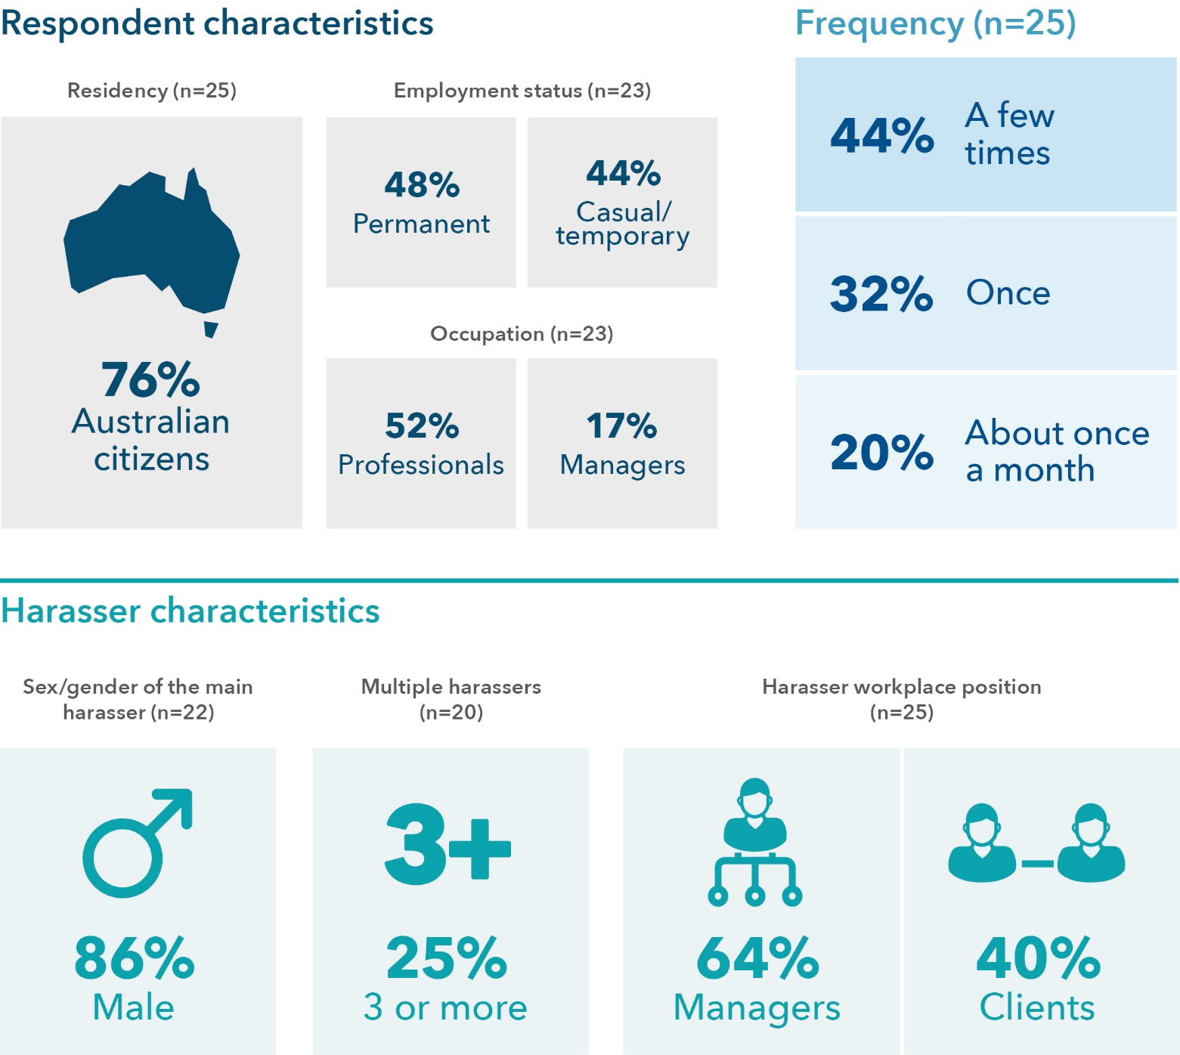

Data tables for Figure 14:
Respondent characteristics | % Survey sample
Australian citizens | 76 (n=25)
Employment status: permanent | 48 (n=23)
Employment status: casual/temporary | 44 (n=23)
Occupation: professionals | 52 (n=23)
Occupation: managers | 17 (n=23)

Frequency | % Survey sample (n=25)
A few times | 44
Once | 32
About once a month | 20

Harasser characteristics | % Survey sample
Sex/gender of the main harasser: male | 86 (n=22)
Multiple (3 or more) harassers | 25 (n=20)
Harasser workplace position: managers | 64 (n=25)
Harasser workplace position: clients | 40 (n=25)

Who experienced this
32 per cent of women in this study who had experienced repeated or inappropriate invitations for dates experienced this in the workplace. Of those women, 76 per cent were Australian citizens, 12 per cent were permanent residents, and 12 per cent were temporary residents. Almost half (44%) were in casual and/or temporary employment when this occurred (see Figure 14).

Frequency of the experience
Respondents who experienced repeated or inappropriate workplace invitations for dates most frequently experienced it more than once (see Figure 14).

Harassers
Respondents were asked to consider the workplace-related incident or the most serious workplace-related incident (if it had happened more than once in the last 5 years). In 64 per cent of the incidents, the main harasser was a manager, and, in 40 per cent of the incidents, the main harasser was a client. In 35 per cent of the incidents, there was more than one main harasser (see Figure 14).

Motivation
Of the 25 women who experienced repeated or inappropriate invitations to go out on dates, 80 per cent believed the incident was motivated by gender and/or sex, and 60 per cent believed it was motivated by race and/or religion.

Reporting and sharing of workplace sexual harassment
More than three-quarters (80%) of the respondents told someone about the repeated or inappropriate invitations to go out on dates; of these, 85 per cent told an informal support outside the workplace, 35 per cent told someone in the workplace, and 20 per cent told a formal authority outside the workplace. Of those who told someone, 50 per cent said things improved and remained much better, and 11 per cent said things improved for a short time, while 39 per cent said nothing changed. Of those who did not tell anyone about the behaviour, 80 per cent felt responsible in some way for the incident, and 60 per cent had employment concerns.
Approximately 40 per cent of respondents who did not tell anyone about the incident said this was because of threats and/or warnings about the consequences (see Table 14).
Table 14: Reporting characteristics associated with experiencing repeated or inappropriate invitations to go out on dates in the workplace
Question | Response
Did you tell? (n=25) | 80% Yes  20% No
Who was told? (n=20) | 35% Workplace  85% Non-workplace informal  20% Non-workplace formal
Improvement after telling (n=18) | 11% Yes, things improved for a short time  50% Yes, things improved and remained much better  39% No, nothing changed in their behaviour
If you didn’t tell, why? (n=5) | Excluded as n <10
Did you not tell because of threats and/or warnings about the consequences (n=5) | Excluded as n <10



11. Intrusive questions about your private life or physical appearance that made you feel offended in a way that was unwelcome
Figure 15: Snapshot: Characteristics of intrusive questions about your private life/physical appearance
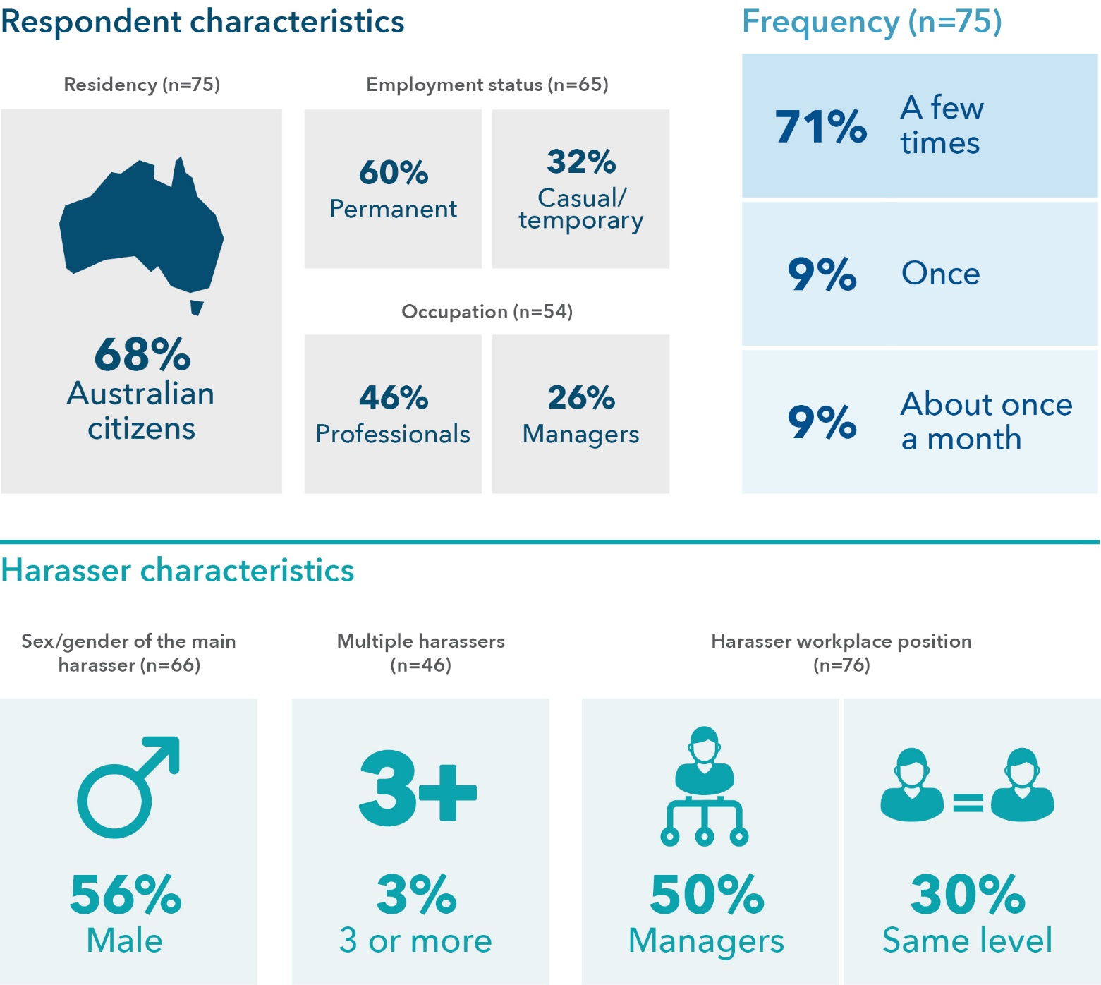

Data tables for Figure 15:
Respondent characteristics | % Survey sample
Australian citizens | 68 (n=75)
Employment status: permanent | 60 (n=65)
Employment status: casual/temporary | 32 (n=65)
Occupation: professionals | 46 (n=54)
Occupation: managers | 26 (n=54)

Frequency | % Survey sample (n=75)
A few times | 71
Once | 9
About once a month | 9

Harasser characteristics | % Survey sample
Sex/gender of the main harasser: male | 56 (n=66)
Multiple (3 or more) harassers | 3 (n=46)
Harasser workplace position: managers | 50 (n=76)
Harasser workplace position: same level | 30 (n=76)

Who experienced this
49 per cent of women in this study who experienced intrusive questions about their private life/physical appearance experienced this in the workplace. Of the women who had experienced such questions at work, 68 per cent were Australian citizens, 16 per cent were permanent residents, and 16 per cent were temporary residents. Approximately one-third (32%) were in casual and/or temporary employment when this occurred (see Figure 15).

Frequency of the experience
Respondents who experienced intrusive questions about their private life/physical appearance in the workplace most frequently experienced it more than once (see Figure 15).

Harassers
Respondents were asked to consider the workplace-related incident or the most serious workplace-related incident (if it had happened more than once in the last 5 years). In 50 per cent of the incidents, the main harasser was a manager, and, in 30 per cent of the incidents, the main harasser was a colleague of the same level (see Figure 15).

Motivation
Seventy-six women experienced intrusive questions about their private life or physical appearance in the workplace; of these, 64 per cent believed the incident was motivated by race and/or religion, and 58 per cent believed it was motivated by gender and/or sex.

Reporting and sharing of workplace sexual harassment
Just over half of the respondents told someone about the repeated intrusive questions about their private life or physical appearance in the workplace; 88 per cent told an informal support outside the workplace, 37 per cent told someone in the workplace, and 12 per cent told a formal authority outside the workplace. Of those who told someone, 21 per cent said things improved and remained much better, and 18 per cent said things improved for a short time, while 56 per cent said nothing changed, and 5 per cent reported that it resulted in further harm. Of those who did not tell anyone about the behaviour, 85 per cent felt responsible in some way for the incident, and 34 per cent had employment concerns. Approximately 25 per cent of respondents who did not tell anyone about the incident said this was because of threats and/or warnings about the consequences (see Table 15).
Table 15: Reporting characteristics associated with experiencing intrusive questions about your private life or physical appearance in the workplace
Question | Response
Did you tell? (n=41) | 59% Yes  37% No
Who was told? (n=41) | 37% Workplace  88% Non-workplace informal  12% Non-workplace formal
Improvement after telling (n=39) | 18% Yes, things improved for a short time  21% Yes, things improved and remained much better  5% No, it resulted in further harm or abuse  56% No, nothing changed in their behaviour
If you didn’t tell, why? (n=26) | 34% Employment concerns  85% Felt responsible  8% Took action/action already underway  31% No support/unsure what to do
Did you not tell because of threats and/or warnings about the consequences (n=24) | 25% Yes  75% No



12. Inappropriate physical contact in a way that was unwelcome
Figure 16: Snapshot: Characteristics of inappropriate physical contact
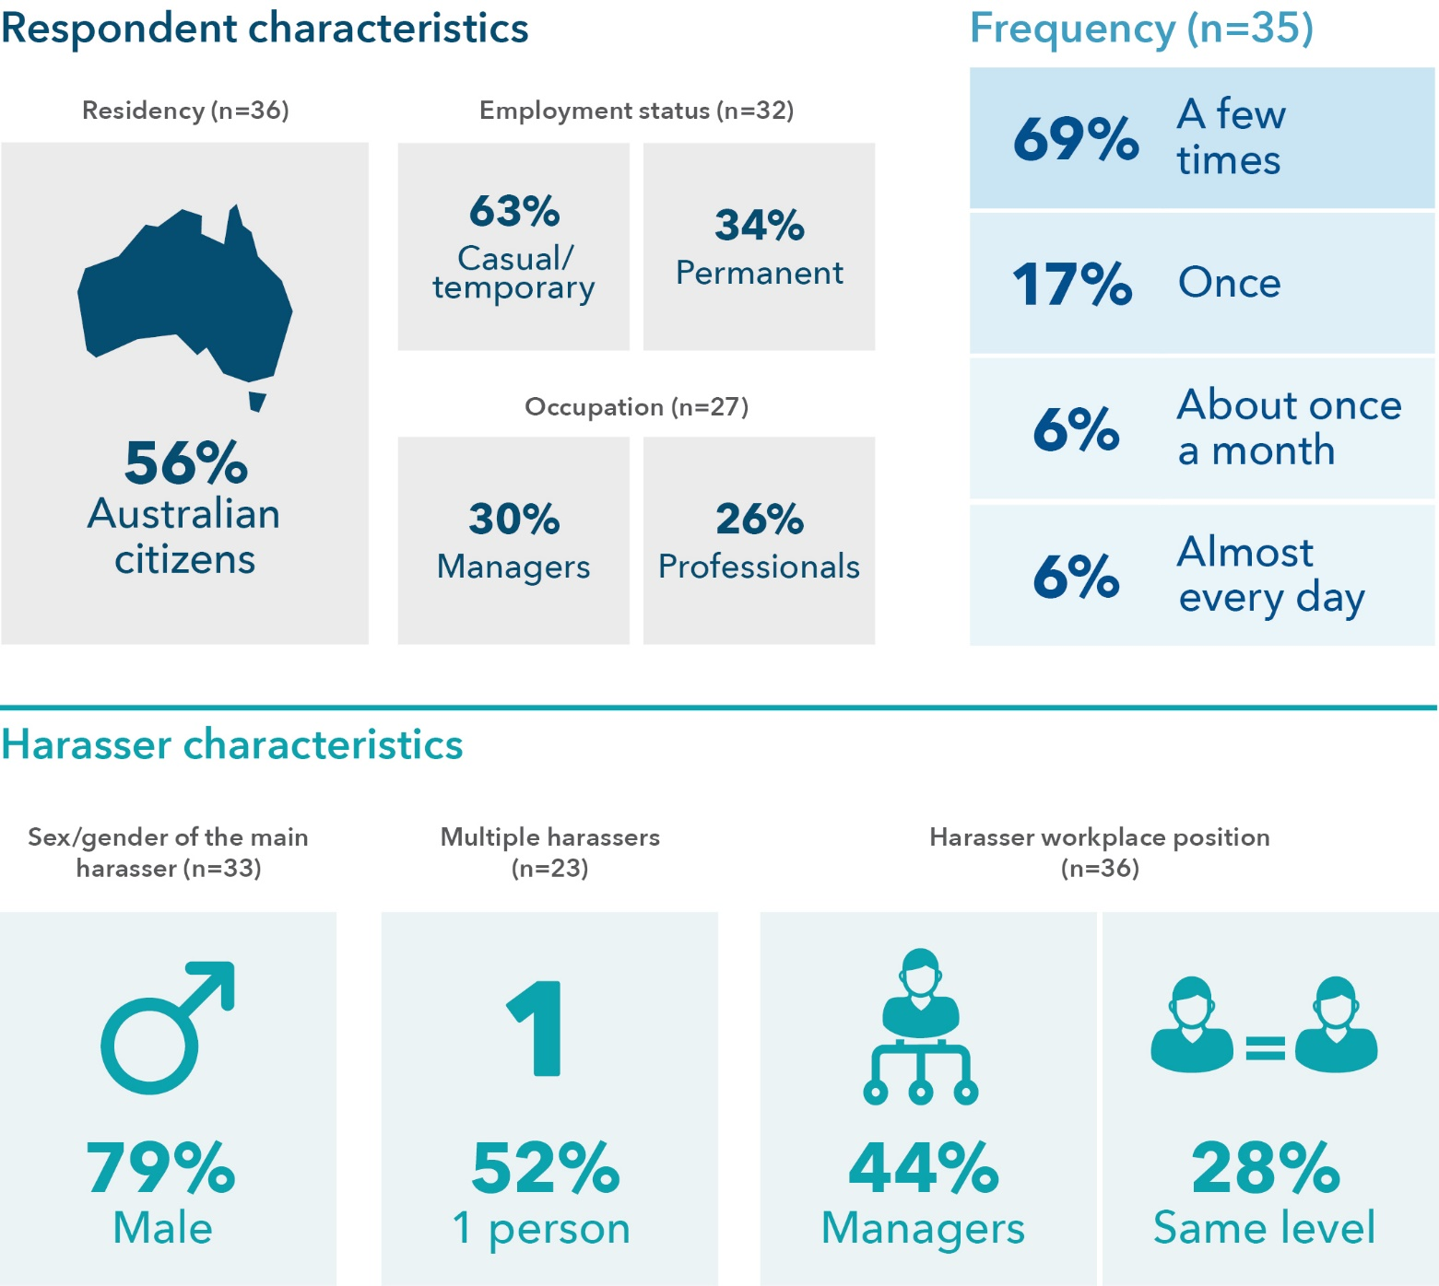

Data tables for Figure 16:
Respondent characteristics | % Survey sample
Australian citizens | 56 (n=36)
Employment status: casual/temporary | 63 (n=32)
Employment status: permanent | 34 (n=32)
Occupation: managers | 30 (n=27)
Occupation: professionals | 26 (n=27)

Frequency | % Survey sample (n=35)
A few times | 69
Once | 17
About once a month | 6
Almost every day | 6

Harasser characteristics | % Survey sample
Sex/gender of the main harasser: male | 79 (n=33)
Multiple (3 or more) harassers | 52 (n=23)
Harasser workplace position: managers | 44 (n=36)
Harasser workplace position: same level | 28 (n=36)

Who experienced this
38 per cent of women in this study who experienced inappropriate physical contact experienced this in the workplace. Of those women, 56 per cent were Australian citizens, 14 per cent were permanent residents, and 31 per cent were temporary residents. Almost two-thirds (63%) were in casual and/or temporary employment when this occurred (see Figure 16).

Frequency of the experience
Respondents who experienced inappropriate physical contact in the workplace most frequently experienced it more than once (see Figure 16).

Harassers
Respondents were asked to consider the workplace-related incident or the most serious workplace-related incident (if it had happened more than once in the last 5 years). In 44 per cent of the incidents, the main harasser was a manager, and, in 28 per cent of the incidents, the main harasser was a colleague at the same level (see Figure 16).

Motivation
Thirty-six women experienced inappropriate physical contact in the workplace; of these, 72 per cent believed the incident was motivated by gender and/or sex, and 36 per cent believed it was motivated by race and/or religion.

Reporting and sharing of workplace sexual harassment
Just over half of the women (58%) who experienced inappropriate physical contact in the workplace told someone about the behaviour; 90 per cent told an informal support outside the workplace, 42 per cent told someone in the workplace, and 16 per cent told a formal authority outside the workplace. Of those who told someone, 61 per cent said nothing changed, while 22 per cent said things improved and remained much better. Of those who did not tell anyone about the behaviour, 77 per cent felt responsible in some way for the incident (see Table 16).
Table 16: Reporting characteristics associated with experiencing inappropriate physical contact in the workplace
Question | Response
Did you tell? (n=33) | 58% Yes  39% No
Who was told? (n=19) | 42% Workplace  90% Non-workplace informal  16% Non-workplace formal
Improvement after telling (n=18) | 11% Yes, things improved for a short time  22% Yes, things improved and remained much better  6% No, it resulted in further harm or abuse  61% No, nothing changed in their behaviour
If you didn’t tell, why? (n=13) | 23% Employment concerns  77% Felt responsible  39% Took action/action already underway  46% No support/unsure what to do
Did you not tell because of threats and/or warnings about the consequences (n=13) | 8% Yes  92% No
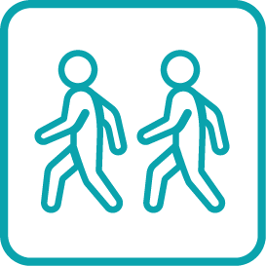

13. Being followed, watched or someone loitering nearby in a way that was unwelcome
Figure 17: Snapshot: Characteristics of being followed/watched/loitering
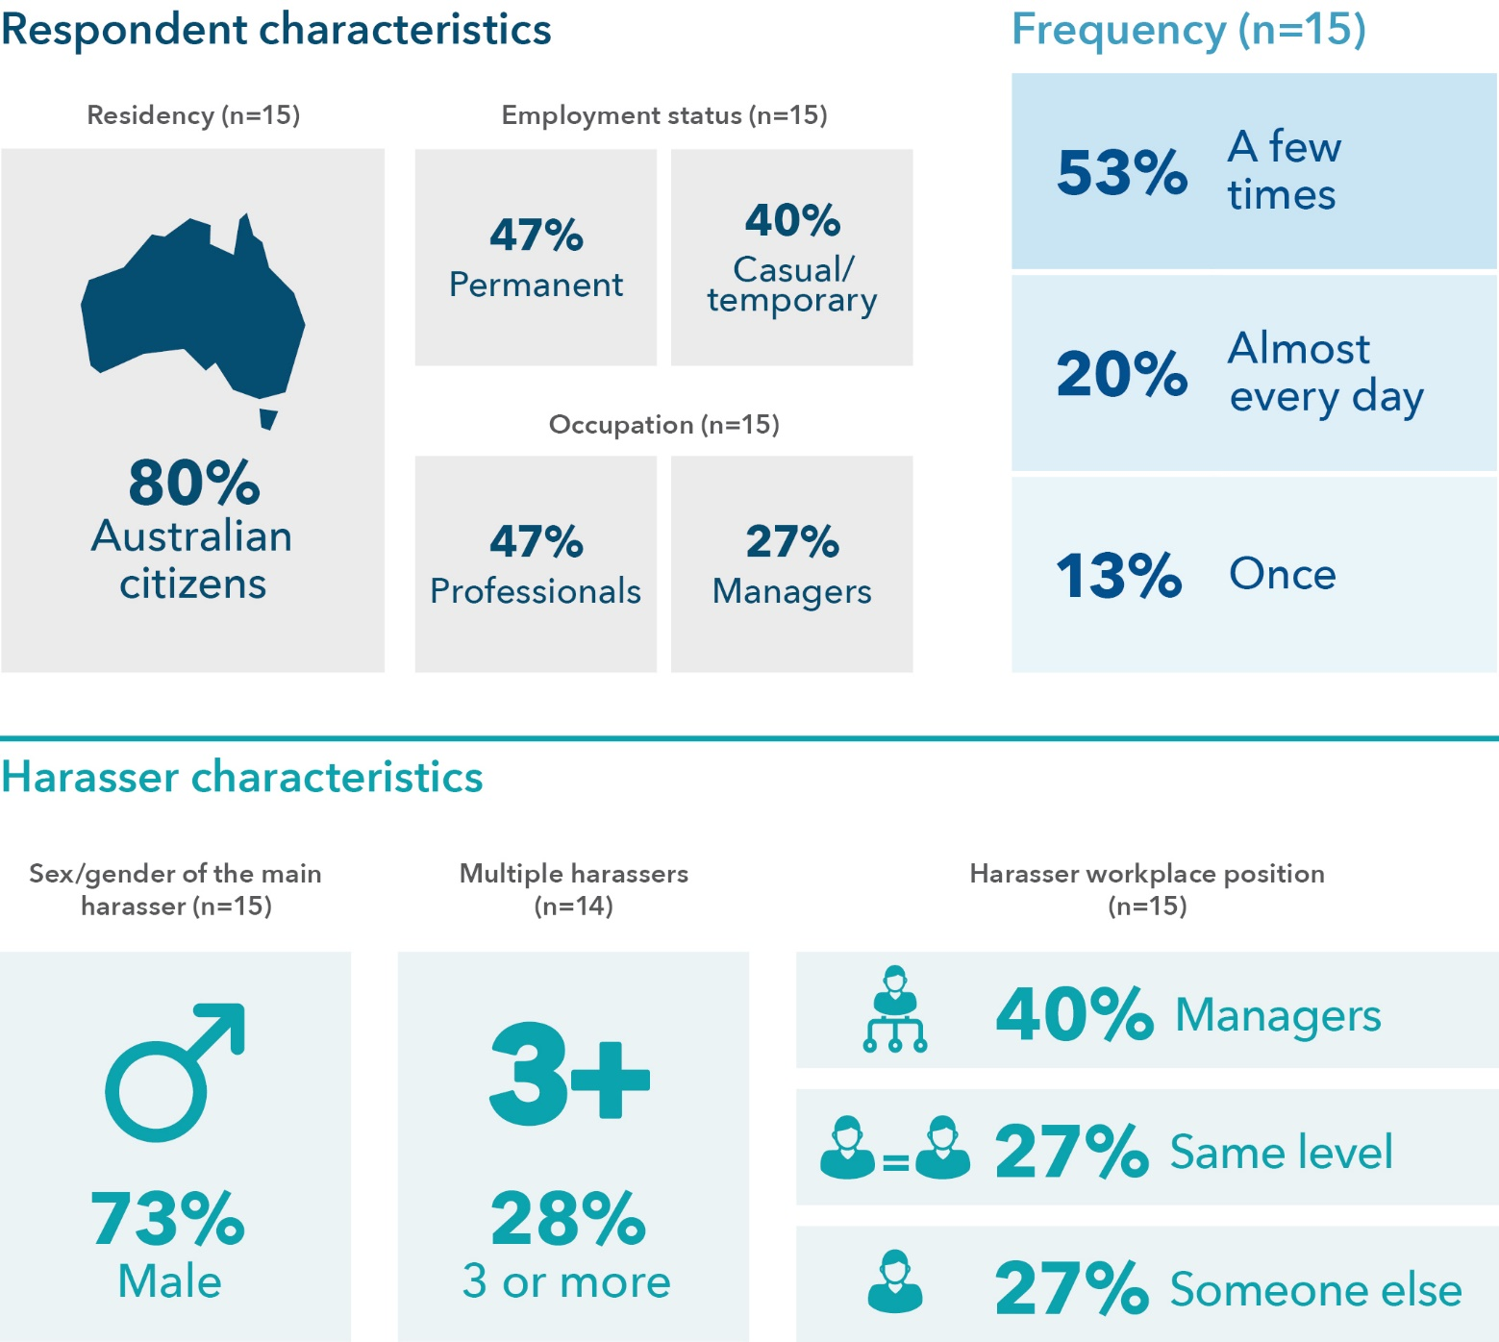

Data tables for Figure 17:
Respondent characteristics | % Survey sample
Australian citizens | 80 (n=15)
Employment status: permanent | 47 (n=15)
Employment status: casual/temporary | 40 (n=15)
Occupation: professionals | 47 (n=15)
Occupation: managers | 27 (n=15)

Frequency | % Survey sample (n=15)
A few times | 53
Almost every day | 20
Once | 13

Harasser characteristics | % Survey sample
Sex/gender of the main harasser: male | 73 (n=15)
Multiple (3 or more) harassers | 28 (n=14)
Harasser workplace position: managers | 40 (n=15)
Harasser workplace position: same level | 27 (n=15)
Harasser workplace position: someone else | 27 (n=15)

Who experienced this
17 per cent of the women in this study who experienced being followed/watched or loitering experienced this in the workplace. Of those women, 80 per cent were Australian citizens, 7 per cent were permanent residents, and 13 per cent were temporary residents. Almost half (47%) were in permanent employment when this occurred (see Figure 17).

Frequency of the experience
Respondents who experienced being followed/watched/loitering in the workplace most frequently experienced it more than once (see Figure 17).

Harassers
Respondents were asked to consider the workplace-related incident or the most serious workplace-related incident (if it had happened more than once in the last 5 years). In 40 per cent of the incidents, the main harasser was a manager, and, in 27 per cent of the incidents, the main harasser was a colleague at the same level (see Figure 17).

Motivation
Fifteen women experienced being followed/watched/loitering in the workplace; of these, 60 per cent believed the incident was motivated by gender and/or sex, and 47 per cent believed it was motivated by race and/or religion.

Reporting and sharing of workplace sexual harassment
The majority of the women (n=15) who experienced being followed/watched/loitering in the workplace told someone (87%). The majority told an informal support outside the workplace (92%); 46 per cent told someone in the workplace. Of those who told someone, 39 per cent said nothing changed, while for the rest of the women who had this experience something changed but not always for the long term (see Table 17).
Table 17: Reporting characteristics associated with being followed or watched in a workplace-related setting
Question | Response
Did you tell? (n=15) | 87% Yes  7% No
Who was told? (n=13) | 46% Workplace  92% Non-workplace informal  8% Non-workplace formal
Improvement after telling (n=13) | 31% Yes, things improved for a short time  31% Yes, things improved and remained much better  39% No, nothing changed in their behaviour
If you didn’t tell, why? (n=1) | Excluded as n <10
Did you not tell because of threats and/or warnings about the consequences (n=1) | Excluded as n <10



14. Requests or pressure for sex or other sexual acts in a way that was unwelcome
Figure 18: Snapshot: Characteristics of requests or pressure for sex or other sexual acts
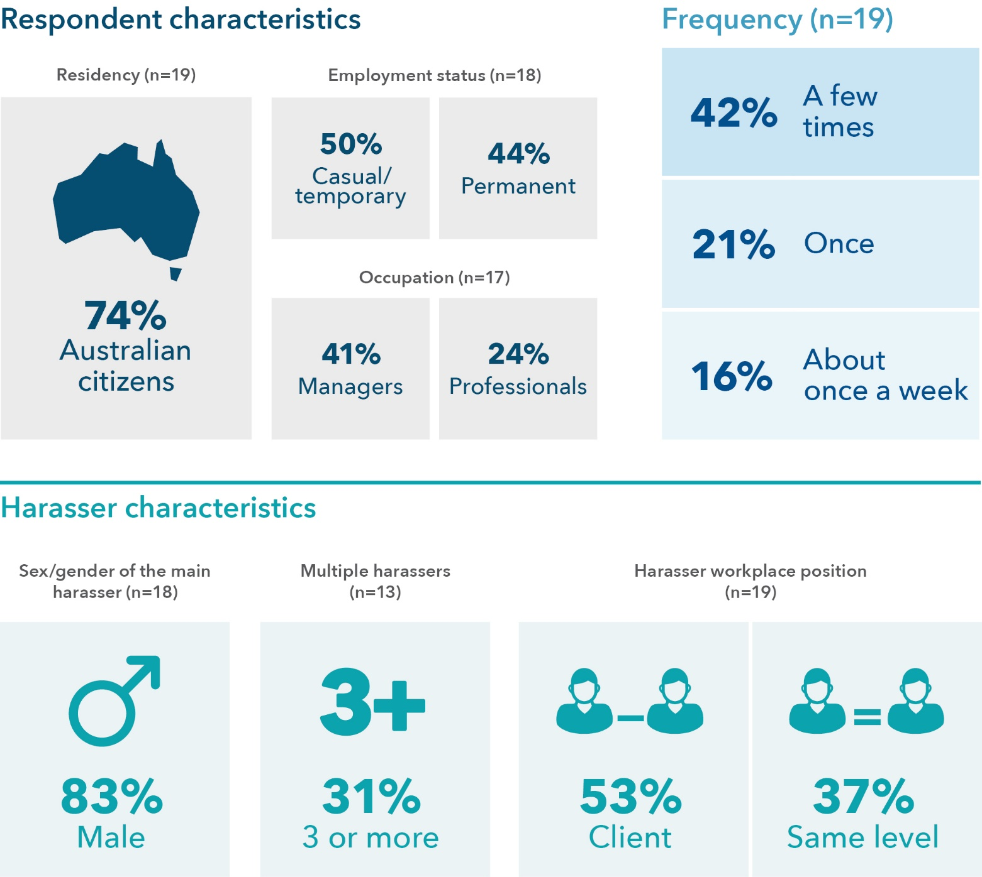

Data tables for Figure 18:
Respondent characteristics | % Survey sample
Australian citizens | 74 (n=19)
Employment status: casual/temporary | 50 (n=18)
Employment status: permanent | 44 (n=18)
Occupation: managers | 41 (n=17)
Occupation: professionals | 24 (n=17)

Frequency | % Survey sample (n=19)
A few times | 42
Once | 21
About once a week | 16

Harasser characteristics | % Survey sample
Sex/gender of the main harasser: male | 83 (n=18)
Multiple (3 or more) harassers | 31 (n=13)
Harasser workplace position: managers | 53 (n=19)
Harasser workplace position: same level | 37 (n=19)

Who experienced this
34 per cent of women in this study who had experienced requests or pressure for sex/other sexual acts experienced this in the workplace. Of those women, 74 per cent were Australian citizens, 11 per cent were permanent residents, and 16 per cent were temporary residents. Almost half (44%) were in casual and/or temporary employment when this occurred (see Figure 18).

Frequency of the experience
Respondents who experienced requests or pressure for sex/other sexual acts in the workplace most frequently experienced it more than once (see Figure 18).

Harassers
Respondents were asked to consider the workplace-related incident or the most serious workplace-related incident (if it had happened more than once in the last 5 years). In 53 per cent of the incidents, the main harasser was a client, and, in 37 per cent of the incidents, the main harasser was a colleague of the same level (see Figure 18).

Motivation
Of the 19 women who experienced requests or pressure for sex, 74 per cent believed the incident was motivated by gender and/or sex, and 42 per cent believed it was motivated by race/religion.

Reporting and sharing of workplace sexual harassment
Over half of the women in this study told someone about the requests or pressure for sex/other sexual acts in the workplace (67%); the majority (83%) told someone informal outside the workplace. Of those who told, most reported that things improved for a short time, while 25 per cent of the women said things did not change (see Table 18).
Table 18: Reporting characteristics associated with experiencing requests or pressure for sex or other sexual acts in a workplace-related setting
Question | Response
Did you tell? (n=18) | 67% Yes  28% No
Who was told? (n=12) | 25% Workplace  83% Non-workplace informal  17% Non-workplace formal
Improvement after telling (n=12) | 58% Yes, things improved for a short time  17% Yes, things improved and remained much better  25% No, nothing changed in their behaviour
If you didn’t tell, why? (n=5) | Excluded as n <10
Did you not tell because of threats and/or warnings about the consequences (n=5) | Excluded as n <10



15. Actual or attempted rape or sexual assault

Who experienced this
There are six women in this study who experienced workplace-related rape or attempted rape or sexual assault. Four of these women were Australian citizens, and two women were temporary residents. Four of these women were in casual and/or temporary employment when this occurred.

Frequency of the experience
Four of the six respondents who experienced this type of behaviour experienced it more than once.

Harassers
Given the small sample, we can only report the following for this incident:
- Harassers were mostly male.
- Clients were the main reported harasser.

Motivation
For women who had experienced workplace-related rape or attempted rape or sexual assault, approximately half identified gender and/or sex and race and/or religion as motivators.

Reporting and sharing of workplace sexual harassment
Only three of the five women who provided information on reporting behaviours indicated they told someone. In all cases, women told someone informally and outside the workplace.

Trans men and non-binary respondents
Thus far, the report has presented women’s responses to the survey. There were nine respondents who did not identify as women: seven identified as non-binary and/or third gender and two identified as trans men. Six of the respondents were Australian citizens, and one was a temporary resident. Citizenship status was not provided by two respondents. Seven respondents were born outside of Australia. Two respondents were born in the United States, one respondent was born in Nepal, one respondent was born in India, one respondent was born in China, one respondent was born in the Philippines and one respondent was born in Northern Ireland.

Experiences of workplace sexual harassment
Six of the nine respondents in this group experienced workplace sexual harassment. Three respondents experienced one type of harassment and three reported two or more types of workplace sexual harassment.
Those who reported workplace sexual harassment experienced the following:
- indecent phone calls/messages
- comments made in emails, SMS messages or on social media
- advances made in emails, social networking websites or internet chat rooms
- other conduct that occurred online or via some form of technology
- touching, hugging, cornering or kissing
- staring or leering
- invitations to go out on dates
- intrusive questions
- inappropriate physical contact
- request or pressure for sex.

Perceived motivation for workplace sexual harassment
Similar to the pattern for female respondents, trans men and non-binary respondents consistently identified race and/or religion and gender and/or sex as motivating those who were harassing respondents.

Action and response to experiences of workplace sexual harassment and outcomes
Given the small sample size, the actions of these respondents and the outcomes of any action taken for these respondents are detailed below:
- One respondent had experienced indecent phone calls, and they believed it was motivated by race, religion or accent; however, they did not tell anyone.
- All three respondents who had received comments in emails, SMS or social media told someone; two of the three said telling someone did not change the behaviour.
- The one respondent who had advances made in emails, social networking websites or internet chat rooms did tell someone about the experience; it resulted in further harm and abuse.
- The respondent who experienced other conduct that occurred online or via some form of technology did not tell anyone.
- Of the two respondents who had been touched, hugged, cornered or kissed, one told someone about the experience, which did not change the behaviour.
- Two respondents had experienced staring or leering. One respondent told someone and one did not, but neither responded to the question about the outcome of telling someone.
- Of the two respondents who had experienced sexually suggestive comments or jokes, one respondent told someone and they indicated things improved for a short time.
- Two respondents had experienced intrusive questions, and one respondent reported they told someone about the experience, which resulted in an improvement in the behaviour for a short time.
- Of the two respondents who experienced inappropriate physical contact, one respondent told someone, which did not change the behaviour.
- One respondent had requests or pressure for sex, which they did report, but it did not change the behaviour.

Limitations of this research
This survey is an important milestone that charts the beginning of a national research focus on migrant and refugee women’s experiences of workplace sexual harassment. Though the survey provides important insights into these experiences, there are limitations to the design and implementation of the survey. First, the online survey was a non-probability sample that cannot be generalised to all migrant women. It provides insights into the experiences that some women have had; a more representative sample could reveal different patterns than what we find here. It is worth noting here that there is no “sampling frame” that would allow us to draw a probability sample of migrant women for a study like this. There are certainly other ways to achieve representativeness; however, these approaches would take considerable time and resources that go beyond those available through these kinds of schemes. Our sample is limited in ways that we expected; it is not unexpected that questions about the workplace are more likely to be answered by women in more secure positions – in relation to employment, financial security and/or their visa status. It was expected that the majority of women would complete the survey in English, but this should not discount the value and importance of offering surveys in multiple languages to offer women a choice of which language they would like to complete the survey in.
It is true that a more significant financial investment would enable a more comprehensive approach both in terms of how the survey is conducted (for example, using a range of different methodological approaches and targeting residential areas with large proportions of women who are likely in the workforce and born overseas). Yet, it is also true that this survey was part of a broader research project: many questions cannot be asked via a survey; the instrument has limitations because we cannot ask limitless questions. The survey, however, provides an important foundation for the targeted interviews and focus groups. The two approaches taken together will provide a fuller picture of migrant and refugee women’s experiences of workplace sexual harassment. The key lessons to learn, we would argue, are that it is important to be ambitious and it is important to build rigour in research design and approaches. Part of this commitment is to be found in the accompanying technical report, which offers the detailed specifics of design, data collection, coding, findings and the full survey instrument. Robust and informed survey design is critical; we hope that this research is the beginning of a program of research committed to carefully interrogating workplace sexual harassment as a problem deeply connected to gender inequity and other critical areas of inequity and discrimination – these include, but are not limited to, racial or religious discrimination and the precariousness of temporary visa status.

Discussion and conclusion
This report captures only the first phase of a larger research project. As such, implications and policy recommendations are not provided at this point. However, there are several implications and areas that will be the focus of the next phase of the research:
- Capturing detailed accounts of sexual harassment at work for specific populations nationally matters. Although this is a non-probability sample, it provides sufficient evidence that workplace sexual harassment is a significant issue for migrant and refugee women. Unlike national probability samples, non-probability samples do not allow for any generalisation beyond the sample. To more comprehensively capture prevalence of workplace sexual harassment would entail significant resources to ensure adequate representation of migrant and refugee women. We have noted that no sampling frame would be complete; however, it is possible to extend the representativeness of the sample through funding of a more comprehensive design and approach, and we believe this is a critical next step.
- Examining the intersections of gendered forms of violence with other forms of discrimination is critical. At least half of the women who reported workplace sexual harassment believed these incidents were motivated by gender and/or sexuality and race and/or religion. This illuminates the importance of prevention and mitigation strategies recognising the ways in which gender intersects with other aspects of inequity. A one-size-fits-all approach to preventing workplace sexual harassment will not be effective for women from migrant and refugee backgrounds.
- Sexual harassment in the workplace is perpetrated by colleagues and, frequently, clients. This brings to the fore the importance of recognising a range of strategies to address and respond to workplace sexual harassment. Different factors can impact how women and workplaces may respond to sexual harassment perpetrated by clients compared to colleagues; the next phase of this research will explore this issue further.
- Paying careful attention to non-reporting. This survey identified that many women who experienced sexual harassment in the workplace reported that feeling responsible for what had happened was a reason for not telling anyone. This raises critical issues around the ongoing narratives around gender-based violence, victimisation and blame. Importantly, we also found that many women reported that they had been threatened or warned not to report. While limited in terms of knowing who was threatening or warning women, this finding does suggest that there are very specific external pressures felt by many women regarding telling anyone or acting on their experiences of sexual harassment in the workplace.
- Diversity of data collection matters. The second phase of this research will be conducted in 2023. The findings from the survey, discussed in this report, will guide the questions we ask of participants to enable us to explore understandings of and responses to workplace sexual harassment. They will also guide the examination of the impact of the intersection of gendered and racialised discrimination that was evident in this report. A central focus of the next stage of the research will be to reach a wider sample beyond the group of women who generously engaged in this survey – particularly women in low-valued and seasonal or temporary labour.
This study has demonstrated the experiences of sexual harassment in the workplace for over 700 migrant and refugee women across Australia. The research highlights the importance of paying careful attention to the experiences of migrant and refugee women to ensure more targeted and relevant policy and workplace strategies are created that can reduce the prevalence of workplace sexual harassment and better protect women at work. As stated previously, broader policy and legal implications arising from this work will be considered in the final report, which will bring together the survey and the national qualitative study. What is clear from this report is that this research is timely and critical to illuminating specificity in the national commitment to understanding, responding to and preventing workplace sexual harassment for migrant and refugee women.

References
Attorney-General’s Department. (2021). A roadmap for respect: Preventing and addressing sexual harassment in Australian workplaces. Australian Government. https://apo.org.au/node/311776
Australian Bureau of Statistics. (2022, June 27). 2021 Census: Nearly half of Australians have a parent born overseas [Media release]. https://www.abs.gov.au/media-centre/media-releases/2021-census-nearly-half-australians-have-parent-born-overseas.
Australian Human Rights Commission. (2018). Everyone’s business: Fourth national survey on sexual harassment in Australian workplaces. AHRC. https://humanrights.gov.au/our-work/sex-discrimination/publications/everyones-business-fourth-national-survey-sexual
Australian Human Rights Commission. (2019). Everyone’s business: Survey on sexual harassment of members of the Shop, Distributive and Allied Employees’ Association. AHRC. https://humanrights.gov.au/everyones-business-sexual-harassment-sda-members
Australian Human Rights Commission. (2020). Respect@Work: National inquiry into sexual harassment in Australian workplaces. AHRC. https://humanrights.gov.au/our-work/sex-discrimination/publications/respectwork-sexual-harassment-national-inquiry-report-2020
Australian Human Rights Commission. (2022). Time for respect: Fifth national survey on sexual harassment in Australian workplaces. AHRC. https://humanrights.gov.au/time-for-respect-2022
Baird, M., Cooper, R., Hill, E., Probyn, E., & Vromen, A. (2018). Women and the future of work: Report 1 of The Australian Women’s Working Futures Project. University of Sydney. https://doi.org/10.25910/5db0ef76585d1
Boucher, A. (2019). Measuring migrant worker rights violations in practice: The example of temporary skilled visas in Australia. Journal of Industrial Relations, 61(2), 277–301. https://doi.org/10.1177/0022185618783001
Committee on the Elimination of Discrimination against Women. (1992). CEDAW General Recommendation No. 19: Violence against women. United Nations Women. https://www.un.org/womenwatch/daw/cedaw/recommendations/recomm.htm
Commonwealth of Australia. (2022). National Plan to End Violence against Women and Children 2022–2032: Ending gender-based violence in one generation. Department of Social Services. https://www.dss.gov.au/sites/default/files/documents/11_2022/national_plan_to_end_violence_against_women_and‌_children_2022-2032.pdf
Department of Social Services. (2015). Hearing her voice: Report from the kitchen table conversations with culturally and linguistically diverse women on violence against women and their children. Commonwealth of Australia. https://plan4womenssafety.dss.gov.au/wp-content/uploads/2015/07/cald_womens_safety_report.pdf
Ditkowsky, M. (2019). #UsToo: The disparate impact of and ineffective response to sexual harassment of low-wage workers. UCLA Journal of Gender and Law, 26(2). https://doi.org/10.5070/l3262045668
Durana, A., Lenhart, A., Miller, R., Schulte, B., & Weingarten, E. (2018). Sexual harassment: A severe and pervasive problem: What drives this unwanted, costly, and damaging behavior across industry sectors by wage and gender. New America. https://d1y8sb8igg2f8e.cloudfront.net/documents/Sexual_Harassment_A_Severe_and_Pervasive_‌Problem_2018-10-10_190248.pdf
Farbenblum, B., & Berg, L. (2017). Migrant workers’ access to remedy for exploitation in Australia: The role of the national Fair Work Ombudsman. Australian Journal of Human Rights, 23(3), 310-331. https://doi.org/10.1080/1323238x.2017.1392478
Focus on Labour Exploitation. (2022). Position paper: Tackling sexual harassment in low-paid and insecure work. FLEX. https://respect.international/tackling-sexual-harassment-in-low-paid-and-insecure-work/?utm_source=rss&utm_medium=rss&utm_campaign=tackling-sexual-harassment-in-low-paid-and-insecure-work
Human Rights Watch. (2012). Cultivating fear: The vulnerability of immigrant farmworkers in the US to sexual violence and sexual harassment. HRW. https://www.hrw.org/report/2012/05/15/cultivating-fear/vulnerability-immigrant-farmworkers-us-sexual-violence-and
International Domestic Workers’ Federation. (2018). Report on IDWF survey on gender-based violence against domestic workers, Asia. IDWF. https://idwfed.org/wp-content/uploads/2022/07/report_on_idwf_survey_on_gender_based_violence_against_domestic_workers_asia_en.pdf
International Labour Organization. (2019). C190 – Violence and Harassment Convention, 2019 (No. 190). ILO. https://www.ilo.org/dyn/normlex/en/f?p=NORMLEXPUB:12100:0::NO::P12100_ILO_CODE:C190
International Labour Organization. (2021). Violence and harassment in the world of work: A guide on Convention No. 190 and Recommendation No. 206. ILO. https://www.ilo.org/global/topics/violence-harassment/resources/WCMS_814507/lang--en/index.htm
International Labour Organization, Lloyd’s Register Foundation, & Gallup. (2022). Experiences of violence and harassment at work: A global first survey. ILO. https://www.ilo.org/global/publications/WCMS_863095/lang--en/index.htm
Keel, C., Wickes, R., Cherkesly, I., Segrave, M., & Tan, S. J. (2023). Technical report for migrant and refugee women in Australia: A study of sexual harassment in the workplace (ANROWS Insights, 03/2023). ANROWS.
Kim, N. J.-E., Vásquez, V. B., Torres, E., Bud Nicola, R. M., & Karr, C. (2016). Breaking the silence: Sexual harassment of Mexican women farmworkers. Journal of Agromedicine, 21(2), 154–162. https://doi.org/10.1080/1059924x.2016.1143903
Mason, G., Maher, J. M., McCulloch, J., Pickering, S., Wickes, R., & McKay, C. (2017). Policing hate crime: Understanding communities and prejudice. Taylor & Francis. https://doi.org/10.4324/9781315696508
McLaughlin, H., Uggen, C., & Blackstone, A. (2017). The economic and career effects of sexual harassment on working women. Gender & Society, 31(3), 333–358. https://doi.org/10.1177/0891243217704631
Morales, M. C., & Saucedo, L. (2015). Disposability and resistance in a male dominated industry: Latina immigrants organizing in residential construction. Human Organization, 74(2), 144–153. https://doi.org/10.17730/0018-7259-74.2.144
Nielsen, M. B., & Einarsen, S. (2012). Prospective relationships between workplace sexual harassment and psychological distress. Occupational Medicine, 62(3), 226–228. https://doi.org/10.1093/occmed/kqs010
O’Neil, A., Sojo, V., Fileborn, B., Scovelle, A., & Milner, A. (2018). The #MeToo movement: An opportunity in public health? The Lancet, 391(10140), 2587–2589. https://doi.org/10.1016/S0140-6736(18)30991-7
Parra, G. (2015). Immigration policy for workplace violence and undocumented women: State-based solutions for Wisconsin. Wisconsin Journal of Law, Gender & Society, 30(1), 99–129. https://uwlaw-omeka.s3.us-east-2.amazonaws.com/original/c1a8d26583040bd88c25b21f738d017d8fd2c416.pdf
Roulstone, A., Thomas, P., & Balderston, S. (2011). Between hate and vulnerability: Unpacking the British criminal justice system’s construction of disablist hate crime. Disability & Society, 26(3), 351–364. https://doi.org/10.1080/09687599.2011.560418
Segrave, M., Wickes, R., & Keel, C. (2021). Migrant and refugee women in Australia: The safety and security study. Monash University. https://doi.org/10.26180/14863872
United Nations. (2017). Global indicator framework for the Sustainable Development Goals and targets of the 2030 Agenda for Sustainable Development. UN. https://unstats.un.org/sdgs/indicators/Global%20Indicator%20Framework%20after%202022%20refinement_Eng.pdf
United Nations Women, & International Labour Organization. (2019). Handbook: Addressing violence and harassment against women in the world of work. UN Women. https://www.unwomen.org/sites/default/files/Headquarters/Attachments/Sections/Library/Publications/2019/Addressing-violence-and-harassment-against-women-in-the-world-of-work-en.pdf
Villegas, P. E. (2019). “I made myself small like a cat and ran away”: Workplace sexual harassment, precarious immigration status and legal violence. Journal of Gender Studies, 28(6), 674-686. https://doi.org/10.1080/09589236.2019.1604326
Waugh, I. M. (2010). Examining the sexual harassment experiences of Mexican immigrant farmworking women. Violence against Women, 16(3), 237–261. https://doi.org/10.1177/1077801209360857
Wickes, R. L., Pickering, S., Mason, G., Maher, J. M., & McCulloch, J. (2016). From hate to prejudice: Does the new terminology of prejudice motivated crime change perceptions and reporting actions? The British Journal of Criminology, 56(2), 239–255. https://doi.org/10.1093/bjc/azv041
Willness, C. R., Steel, P., & Lee, K. (2007). A meta-analysis of the antecedents and consequences of workplace sexual harassment. Personnel Psychology, 60(1), 127–162. https://doi.org/10.1111/j.1744-6570.2007.00067.x
Women of Colour Australia, & Archer, C. (2021). Women of Colour Australia: Workplace survey report 2021. WoCA. https://womenofcolour.org.au/workplace-survey-report-2021/

Appendix
Table 19: Incident type and frequency of experience
Harassment Type | Frequency
1. Indecent phone calls/messages | 8% Once  55% A few times  16% About once a month  11% About once a fortnight  7% About once a week  3% Almost every day
2. Comments made in emails/SMS messages/social media | 13% Once  54% A few times  16% About once a month  6% About once a fortnight  4% About once a week  4% Almost every day
3. Repeated or inappropriate advances in emails/social networking/online | 8% Once  57% A few times  20% About once a month  9% About once a fortnight  3% About once a week  3% Almost every day
4. Sharing or threatening to share intimate images/film of you | 12% Once  48% A few times  24% About once a month  8% About once a fortnight  4% Almost every day
5. Other conduct of a sexual nature that occurred online/via technology | 28% Once  47% A few times  9% About once a month  6% About once a fortnight  6% Almost every day
6. Touching, hugging, cornering or kissing | 21% Once  58% A few times  10% About once a month  3% About once a fortnight  4% About once a week  3 % Almost every day
7. Staring or leering | 13% Once  58% A few times  11% About once a month  6% About once a fortnight  6% About once a week  5% Almost every day
8. Sexual gestures, indecent exposure or inappropriate display of the body | 29% Once  48% A few times  5% About once a month  5% About once a fortnight  5% About once a week  10% Almost every day
9. Sexually suggestive comments/jokes | 10% Once  63% A few times  18% About once a month  3% About once a fortnight  3% About once a week  3% Almost every day
10. Repeated or inappropriate invitations to go out on dates | 32% Once  44% A few times  20% About once a month  4% Almost every day
11. Intrusive questions about your private life/physical appearance | 9% Once  71% A few times  9% About once a month  4% About once a fortnight  4% About once a week  3% Almost every day
12. Inappropriate physical contact | 17% Once  69% A few times  6% About once a month  3% About once a fortnight  6% Almost every day
13. Being followed/watched/loitering | 13% Once  53% A few times  7% About once a month  7% About once a week  20% Almost every day
14. Requests or pressure for sex or other sexual acts | 21% Once  42% A few times  11% About once a month  5% About once a fortnight  16% About once a week  5 % Almost every day
15. Actual or attempted rape or sexual assault | 17 % Once  67% A few times  17% Almost every day

Table 20: Percentage of women indicating three or more harassers by harassment type
Harassment Type | Three or more people
1. Indecent phone calls/messages | 52%
2. Comments made in emails/SMS messages/social media | 35%
3. Repeated or inappropriate advances in emails/social networking/online | 36%
4. Sharing or threatening to share intimate images/film of you | 54%
5. Other conduct of a sexual nature that occurred online/via technology | 30%
6. Touching, hugging, cornering or kissing | 13%
7. Staring or leering | 27%
8. Sexual gestures, indecent exposure or inappropriate display of the body | 42%
9. Sexually suggestive comments/jokes | 36%
10. Repeated or inappropriate invitations to go out on dates | 25%
11. Intrusive questions about your private life/physical appearance | 3%
12. Inappropriate physical contact | 12%
13. Being followed/watched/loitering | 28%
14. Requests or pressure for sex or other sexual acts | 31%
15. Actual or attempted rape or sexual assault | Excluded as n <10

Table 21: Harasser workplace position by harassment type
Harassment Type | Harasser workplace position
1. Indecent phone calls/messages | 54% Managers  33% Client  15% Same level
2. Comments made in emails/SMS messages/social media | 47% Managers  20% Same level  19% Client
3. Repeated or inappropriate advances in emails/social networking/online | 59% Managers  23% Client  15% Same level
4. Sharing or threatening to share intimate images/film of you | 56% Managers  40% Client  20% Same level
5. Other conduct of a sexual nature that occurred online/via technology | 49% Managers  18% Client  9% Same level/  9% Someone else
6. Touching, hugging, cornering or kissing | 54% Managers  18% Client  16% Same level
7. Staring or leering | 38% Managers  25% Client  24% Same level
8. Sexual gestures, indecent exposure or inappropriate display of the body | 38% Managers  33% Client  29% Same level
9. Sexually suggestive comments/jokes | 43% Managers  36% Same level  24% Client
10. Repeated or inappropriate invitations to go out on dates | 64% Managers  40% Client  20% Someone else
11. Intrusive questions about your private life/physical appearance | 50% Managers  30% Same level  21% Someone else
12. Inappropriate physical contact | 44% Managers  28% Same level  22% Client
13. Being followed/watched/loitering | 40% Managers  27% Same level  27% Someone else
14. Requests or pressure for sex or other sexual acts | 53% Client  32% Managers  37% Same level
15. Actual or attempted rape or sexual assault | 67% Client  17% Managers/  17% Same level/  17% Someone else

Table 22: Harassment type and employment status of women
Harassment type | Employment status
1. Indecent phone calls/messages | 48% Casual/temporary  34% Permanent
2. Comments made in emails/SMS messages/social media | 41% Casual/temporary  35% Permanent
3. Repeated or inappropriate advances in emails/social networking/online | 52% Casual/temporary  45% Permanent
4. Sharing or threatening to share intimate images/film of you | 57% Casual/temporary  43% Permanent
5. Other conduct of a sexual nature that occurred online/  via technology | 56% Permanent  37% Casual/temporary
6. Touching, hugging, cornering or kissing | 51% Casual/temporary  45% Permanent
7. Staring or leering | 49% Casual/temporary  47% Permanent
8. Sexual gestures, indecent exposure or inappropriate display of the body | 67% Permanent  33% Casual/temporary
9. Sexually suggestive comments/jokes | 53% Permanent  43% Casual/temporary
10. Repeated or inappropriate invitations to go out on dates | 48% Permanent  44% Casual/temporary
11. Intrusive questions about your private life/physical appearance | 60% Permanent  32% Casual/temporary
12. Inappropriate physical contact | 63% Casual/temporary  34% Permanent
13. Being followed/watched/loitering | 47% Permanent  40% Casual/temporary
14. Requests or pressure for sex or other sexual acts | 50% Casual/temporary  44% Permanent
15. Actual or attempted rape or sexual assault | 80% Casual/temporary

Table 23: Reasons for non-reporting by type
Harassment type | Reason for not reporting (top 3/multi- choice)
1. Indecent phone calls/messages | 77% Felt responsible  59% Employment concerns  38% No support/unsure what to do
2. Comments made in emails/SMS messages/social media | 73% Felt responsible  47% Employment concerns  40% No support/unsure what to do
3. Repeated or inappropriate advances in emails/social networking/online | 90% Felt responsible  50% No support/unsure what to do  40% Employment concerns
4. Sharing or threatening to share intimate images/film of you | 90% Felt responsible  44% No support/unsure what to do  22% Employment concerns
5. Other conduct of a sexual nature that occurred online/via technology | 82% Felt responsible  46% Employment concerns  36% No support/unsure what to do
6. Touching, hugging, cornering or kissing | 88% Felt responsible  22% Employment concerns  31% No support/unsure what to do  22% Took action/action already underway
7. Staring or leering | 82% Felt responsible  34% No support/unsure what to do  27% Employment concerns
8. Sexual gestures, indecent exposure or inappropriate display of the body | 100% Felt responsible  40% Employment concerns  20% Visa/immigration concerns
9. Sexually suggestive comments/jokes | 85% Felt responsible  50% No support/unsure what to do  31% Employment concerns
10. Repeated or inappropriate invitations to go out on dates | 80% Felt responsible  60% Employment concerns  40% No support/unsure what to do
11. Intrusive questions about your private life/physical appearance | 85% Felt responsible  34% Employment concerns  31% No support/unsure what to do
12. Inappropriate physical contact | 77% Felt responsible  46% No support/unsure what to do  39% Took action/action already underway
13. Being followed/watched/loitering | Excluded as n <10
14. Requests or pressure for sex or other sexual acts | 100% Felt responsible  60% Took action/action already underway  60% No support/unsure what to do
15. Actual or attempted rape or sexual assault | Excluded as n <10

Table 24: Experienced external threats and/or warnings to not report
Harassment type | Threats and/or warnings to not report
1. Indecent phone calls/messages | 44% Yes
2. Comments made in emails/SMS messages/social media | 40% Yes
3. Repeated or inappropriate advances in emails/social networking/online | 50% Yes
4. Sharing or threatening to share intimate images/film of you | 78% Yes
5. Other conduct of a sexual nature that occurred online/via technology | 64% Yes
6. Touching, hugging, cornering or kissing | 32% Yes
7. Staring or leering | 17% Yes
8. Sexual gestures, indecent exposure or inappropriate display of the body | Excluded as n <10
9. Sexually suggestive comments/jokes | 21% Yes
10. Repeated or inappropriate invitations to go out on dates | Excluded as n <10
11. Intrusive questions about your private life/physical appearance | 25% Yes
12. Inappropriate physical contact | 8% Yes
13. Being followed/watched/loitering | Excluded as n <10
14. Requests or pressure for sex or other sexual acts | 20% Yes
15. Actual or attempted rape or sexual assault | Excluded as n <10
Table 25: Perceived motivation by harassment type
Harassment Type | Perceived motivation
1. Indecent phone calls/messages | 72% Gender and/or sex  62% Race and/or religion
2. Comments made in emails/SMS messages/social media | 69% Gender and/or sex  55% Race and/or religion
3. Repeated or inappropriate advances in emails/social networking/online | 68% Gender and/or sex  56% Race and/or religion
4. Sharing or threatening to share intimate images/film of you | 60% Gender and/or sex  56% Race and/or religion
5. Other conduct of a sexual nature that occurred online/via technology | 52% Race and/or religion  45% Gender and/or sex
6. Touching, hugging, cornering or kissing | 64% Gender and/or sex  46% Race and/or religion
7. Staring or leering | 57% Gender and/or sex  57% Race and/or religion
8. Sexual gestures, indecent exposure or inappropriate display of the body | 67% Gender and/or sex  52% Race and/or religion
9. Sexually suggestive comments/jokes | 75% Gender and/or sex  47% Race and/or religion
10. Repeated or inappropriate invitations to go out on dates | 80% Gender and/or sex  60% Race and/or religion
11. Intrusive questions about your private life/physical appearance | 64% Race and/or religion  58% Gender and/or sex
12. Inappropriate physical contact | 72% Gender and/or sex  36% Race and/or religion
13. Being followed/watched/loitering | 60% Gender and/or sex  47% Race and/or religion
14. Requests or pressure for sex or other sexual acts | 74% Gender and/or sex  42% Race and/or religion
15. Actual or attempted rape or sexual assault | 50% Gender and/or sex  50% Race and/or religion

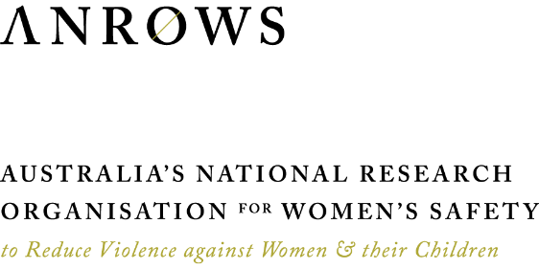

For example, the survey was conducted in English, and it did not ask specific questions regarding visa status.
We detail how we have managed “prefer not to say”/missing data in the technical report and note here that we do not offer any bivariate analysis based on these demographics, given some of the limitations created via missing data (see the technical report, “Distribution of survey: Non-response and missing data”, Keel et al., 2023).
CoRMS broadly includes people who have come to Australia in the last 10 years. The ABS differentiate between “recent migrants” and “temporary residents”. Recent migrants are defined to include those on a permanent visa or those who have become Australian citizens since arrival. Temporary residents are defined to include those on a temporary visa with the intention to stay for 1 year or more on arrival.
We note that the ABS (2019) measures sex as a binary variable (male–female), while our study allowed respondents to identify their gender identity. While the ABS data is an imperfect dataset as it relates to gender identity, it provides a point of comparison of the broader migrant population in Australia and our sample.
For a discussion of the research team’s decision regarding migrant and refugee identification, please see the technical report, “Key design issues: Migrant and refugee identification”.
This data reflects the types of behaviour that were proportionately higher at work than in any setting – that is, the relationship between respondents who reported they had experienced it in any setting compared to the number who had indicated they had experienced it at work. For example, 100 women experienced repeated or inappropriate advances via email at work, which made up only 47% of women who indicated they had experienced this behaviour in the last 5 years. Comparatively, indecent phone calls were experienced by 96 women at work, but this represented 71% of women who had experienced this type of sexual harassment in any setting. This presentation reflects a focus on understanding what is happening in the workplace (see the technical report for full data analysis, Keel et al., 2023).
We aggregated perceptions of identifying workplace sexual harassment into a count. We then ran a t-test to examine if there were differences between those who had experienced and those who had not experienced workplace sexual harassment. We found no differences between these groups.
As is detailed in the technical report, women who indicated they only experienced a type of sexual harassment once were asked about the harasser/s involved. Those who had experienced more than one type of sexual harassment reported on the most serious experience (see the technical report, “Experiences of harassment: Harasser workplace position”, Keel et al., 2023).
While we asked about concerns regarding visas, only a small proportion of our sample held temporary visas. This is a limitation of non-probability sampling. Further research is needed to explore in more detail the reasons for not reporting in different groups of women.
A full description of the survey instrument and operationalisation of concepts can be found in the technical report that accompanies this main report. To summarise here: to capture occupation, 76 potential answers from the minor groups of Australian and New Zealand Standard Classification of Occupations (ANZSCO; ABS, 2022) framework were provided. These were then aggregated to major groups in line with the ABS framework. Managers were defined as “the head of your workplace or organisation – such as the CEO, business owner or similar”, “your direct manager or supervisor at work”, “another manager or supervisor at work”, or “a co-worker who was more senior”. With regards to motivation, a single variable was created for gender and/or sexuality using those who selected “gender identity” or “sexual orientation” as the motivation for the incident, and a single variable was created for race and/or religion using those who selected “race” or “religion” as the motivation for the incident.

