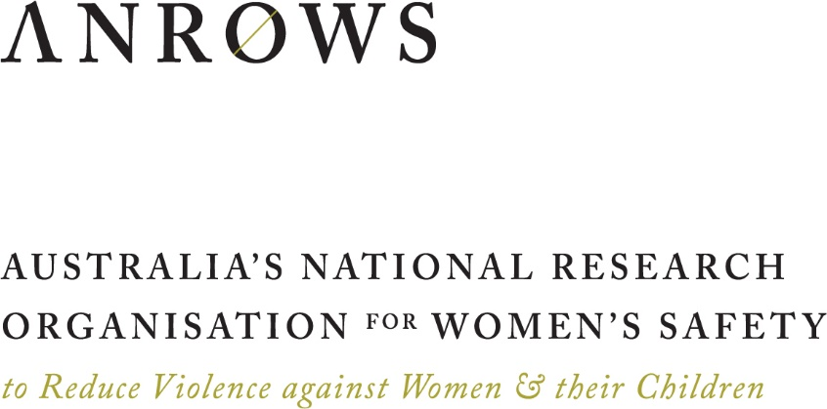

Compass

**Research to policy and practice**

**Issue 04 | June 2016**

Media representations of violence against women   
and their children: *Key findings and future directions*

Prepared by

Dr Georgina Sutherland, Centre for Mental Health,   
Melbourne School of Population and Global Health, University of Melbourne

Mr Angus McCormack, Centre for Mental Health,   
Melbourne School of Population and Global Health, University of Melbourne

Professor Jane Pirkis, Centre for Mental Health,   
Melbourne School of Population and Global Health, University of Melbourne

Dr Cathy Vaughan, Centre for Health Equity,   
Melbourne School of Population and Global Health, University of Melbourne

Dr Michelle Dunne-Breen,   
Faulty of Arts and Design, University of Canberra

Professor Patricia Easteal,   
Faculty of Business, Government and Law, University of Canberra

Dr Kate Holland,   
Faulty of Arts and Design, University of Canberra

********

****University of Melbourne****

University of Melbourne, Parkville VIC 3010

****ANROWS Compass (Research to policy and practice papers) are concise papers that summarise key findings of research on violence against women and their children, including research produced under ANROWS’s research program, and provide advice on the implications for policy and practice.****

****This report addresses work covered in ANROWS research project 2.2 “Media representations of violence against women and their children”. Please consult the ANROWS website for more information on this project. In addition to this paper, an ANROWS Landscapes (State of knowledge papers) and ANROWS Horizons (Research report) is available as part of this project.****

ANROWS acknowledgement

This material was produced with funding from the Australian Government and the Australian state and territory governments. Australia’s National Research Organisation for Women’s Safety (ANROWS) gratefully acknowledges the financial and other support it has received from these governments, without which this work would not have been possible. The findings and views reported in this paper are those of the authors and cannot be attributed to the Australian Government, or any Australian state or territory government.

Acknowledgement of Country

ANROWS acknowledges the traditional owners of the land across Australia on which we work and live. We pay our respects to Aboriginal and Torres Strait Islander elders past, present and future; and we value Aboriginal and Torres Strait Islander history, culture and knowledge.

© ANROWS 2016

Published by

Australia’s National Research Organisation for Women’s Safety Limited (ANROWS)  
PO Box 6322, Alexandria NSW 2015 | [www.anrows.org.au](http://www.anrows.org.au) | Phone +61 2 8374 4000  
ABN 67 162 349 171

**Media representations of violence against women and their children : key findings and future directions / Georgina Sutherland, Angus McCormack, Jane Pirkis, Cathy Vaughan, Michelle Dunne-Breen, Patricia Easteal, Kate Holland.**Sydney : ANROWS, c2016.  
Pages ; 30 cm. (ANROWS Compass, Issue 04/2016)  
I. Violence in mass media. II. Mass media – Influence. III. Victims of crime in mass media. IV. Women in mass media.  
I. Sutherland, Georgina. II. McCormack, Angus. III. Pirkis, Jane. IV. Vaughan, Cathy (Catherine Maree). V. Dunne-Breen, Michelle. VI. Easteal, Patricia. VII. Holland, Kate (Kate E.).

ISSN: 2204-9622 (print) 2204-9630 (online)

Creative Commons Licence

Attribution-Non Commercial



CC BY-NC

This licence lets others distribute, remix and build upon the work, but only if it is for non-commercial purposes and they credit the original creator/s (and any other nominated parties). They do not have to license their Derivative Works on the same terms.

Version 3.0 (CC Australia ported licence): View CC BY-NC Australia Licence Deed | View CC BY-NC 3.0 Australia Legal Code

Version 4.0 (international licence): View CC BY-NC 4.0 Licence Deed | View CC BY-NC 4.0 Legal Code

Design

Erin Snelgrove

## Aim

The current study aimed to establish a baseline picture of the extent and nature of reporting of violence against women by the Australian media to inform future strategies for change. The project involved two key components: one quantitative (content analysis) and one qualitative (critical discourse analysis).

## Method

The project collected media items on violence against women for four months from February to June 2015 in three states of Australia: New South Wales, Queensland and South Australia. These three states were selected on the basis of being geographically and demographically diverse. A media monitoring and retrieval service, Isentia, was used to identify items of relevance from all capital city newspapers in the three states, a selection of suburban newspapers in Queensland and South Australia, a selection of daily and non-daily regional newspapers in New South Wales, news and current affairs programs on all free-to- air and pay-for-view television and radio stations, and from seven online news sites.

## Content analysis

For the quantitative component of the study, a range of identifying and descriptive information about each media item was provided by Isentia and used to characterise the extent of media reporting on violence against women. A stratified random sample of 10 percent of items was selected for in-depth content analysis. Trained coders extracted information about the nature of media reporting on violence against women.

## Critical discourse analysis

For the qualitative component of the study, particular groups of media items (case studies) were selected to explore the discursive practices through which journalists construct news stories. The case studies were selected because they had gained significant attention in the media by way of volume of reporting and represented different forms of violence against women. The approach to analysis was through a critical discourse lens in which detailed linguistic textual analysis was used to examine print and online media items on the three case studies in their social and cultural contexts.

## Findings

The final sample included 4516 items in connection with violence against women, comprising 1870 radio broadcasts (41.4%), 1332 items from online news sites (29.5%), 929 newspaper articles (20.6%) and 385 television broadcasts (8.5%). Taking into account syndication, where the same news item is broadcast or published by different media outlets, these items appeared in, or were broadcast more than 15,000 times during the 4 month data collection period. This volume of reporting suggests media coverage of violence against women has the potential to reach a wide audience. There was considerable month-by-month variation, largely driven by high profile media stories.

The content analyses identified that:

* coverage of violence against women tended to focus on individual incidents without providing information about the social context or the underlying drivers of violence;
* few media items included information for women (or men) on where to seek help;
* physical and sexual violence, particularly fatal events, were reported more frequently than other forms of gender-based violence;
* the use of sensational headlines, graphic language and photographs that minimised or trivialised the issue were a concern, although these were in the minority;
* some media reports on sexual violence referenced the behaviour of women, thereby inferring mutuality in the abuse;
* many media reports provided no information about male perpetrators of crime rendering their presence invisible in most media coverage; and
* media relied primarily on criminal justice professionals as sources of information in news reports on violence against women.

The critical discourse analyses identified that:

* media act in a myriad of ways to perpetuate ambiguity and ambivalence concerning the definition, the dynamics and the harms of family violence and sexual assault;
* story angles, story structures and lexical features, such as how the people were represented and the word choices used to describe them, contributed to discursively minimising the harms of rape and domestic violence; and
* some news stories were presented in a sensationalist manner and others were not; and
* the angles or aspects of the stories pursued in news items pointed to editorial judgements about relevance or perceived news value.

## Strengths and limitations

This study was one of the largest of its kind internationally, as it collected data on media reports on violence against women from a representative sample of media in Australia, including newspapers, radio, television and online. While considerable effort was made to ensure our approach to data collection and analysis was methodologically sound, the following key limitations should be considered:

* the sampling frame was restricted to a selection of states, a selection of newspapers in those states and a small selection of online news sites;
* the content of broadcast news items (radio and television) were available as summaries only restricting the level of detail available;
* the content analysis sample was restricted to a stratified random sample of 10 percent of items;
* the critical discourse analysis was restricted to three case studies; and
* coders may have interpreted and coded certain elements in news items differently, particularly information that may be considered as more subjective. Likewise in the discourse analysis, values, beliefs, attitudes and experiences may have affected analytical choices and interpretations.

Overall, both methodological approaches to the data - content and critical discourse analysis – brought to this project strengths and weaknesses, but together provided a comprehensive picture of the extent and nature of media representations of violence against women in Australia. By using a mixed method approach we have explored various layers, nuances and implied meanings in media reports – processes that are difficult to capture with either method alone.

## Implications and conclusions

This project provided a glimpse into the complexity of reporting practices. Clearly, media in Australia have the potential to more accurately reflect the reality of women’s experiences of violence and our results point to some ways that might be accomplished.

The volume of news items across all forms of media demonstrated that journalists are required to cover the topic. There remain, however, persistent areas of concern; most of these are amenable to change without the need to directly censor or limit the media’s freedom to report on the issue. While some areas of concern are already addressed in a number of local and international media guidelines, their apparent lack of uptake suggests more targeted dissemination strategies may be required to affect change. For example, promoting the inclusion of help seeking information likely requires more than the generic instructions contained in media guidelines typical in this field. Quick reference cards, similar to those produced and disseminated by the Mindframe National Media Initiative (2014), may be useful. This format provides time-poor journalists with short, sharp pieces of information that they can use quickly and easily under deadline pressure.

While this study adds to the growing body of research on how news and information media depict violence against women, gaps in our knowledge remain. Few studies have explored media representations of violence against women in broadcast news – radio or television. The number of news items on violence against women in this format and the method of delivery in short news sound bites suggest this is an important area for future research. Likewise, with people increasingly accessing news online, it is critical that we are aware of how violence against women is being discussed in this space. Consumers not only access news online, but also discuss and share news via social networking sites and journalists are increasingly using this medium to break new stories. For all these reasons, there is an urgent need to better understand online news production, reporting and audience engagement.

The other key gap in the literature is how news stories on violence against women are interpreted by different readers and viewers. For the media to have a transformative effect, careful thought needs to go into what the messages should look like and the forum in which those messages are best presented. To date, there is little evidence on which to base effective messages about violence against women. The key questions being: do certain media messages have positive (e. g. improve knowledge and attitudes) or negative effects (e.g. normalise the issue or trigger feelings of shame)? Are these effects different for men in comparison to women, young versus old? Consistent with anecdotal and emerging empirical research, there is also an urgent need to understand the role that media play in copycat and/ or protective effects in the context of violence against women.

