
Australians’ attitudes to violence
against women and gender equality

Findings from the 2017 National Community Attitudes
towards Violence against Women Survey (NCAS)
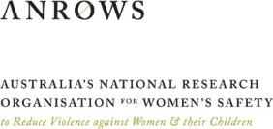
In partnership with:

Suggested citation
Webster, K., Diemer, K., Honey, N., Mannix, S., Mickle, J., Morgan, J., Parkes, A., Politoff, V., Powell, A., Stubbs, J., & Ward, A. (2018). Australians’ attitudes to violence against women and gender equality. Findings from the 2017 National Community Attitudes towards Violence against Women Survey (NCAS) (Research report, 03/2018). Sydney, NSW: ANROWS.
Acknowledgements
This material was produced with funding from the Australian Government. Australia’s National Research Organisation for Women’s Safety (ANROWS) gratefully acknowledges the financial and other support it has received from the Government, without which this work would not have been possible. ANROWS led the project in collaboration with The University of Melbourne (UOM), University of New South Wales (UNSW), the Royal Melbourne Institute of Technology University (RMIT) and the Social Research Centre (SRC) as research partners. ANROWS is indebted to all these research partners as well as to the many research, practice and policy experts from across Australia who contributed to the 2017 survey through the project’s advisory structures. Although too numerous to name here, they are listed in Appendix A.
ANROWS acknowledges the Victorian Health Promotion Foundation (VicHealth) for its consistent support, with John Fulcher and Renee Imbesi making particular contributions. Thanks are extended to Dr Stuart Ross and Dr Walter DeKeseredy for their thoughtful review of this report as part of ANROWS peer review processes, and for their helpful suggestions for strengthening it; to Mark Richardson for his invaluable contribution and unwavering generosity and support; and to Holly Windle for her design expertise.
Acknowledgement of Country
ANROWS acknowledges the traditional owners of the land across Australia on which we work and live. We pay our respects to Aboriginal and Torres Strait Islander elders past, present, and future, and we value Aboriginal and Torres Strait Islander history, culture, and knowledge.
Acknowledgement of lived experiences of violence
It is also important to acknowledge the lives and experiences of the women and children affected by domestic violence and sexual assault.
Caution: Some people may find parts of this content confronting or distressing.
Recommended support services include: 1800 RESPECT – 1800 737 732, Lifeline – 13 11 14
Australians’ attitudes to violence against women and gender equality. Findings from the 2017 National Community Attitudes towards Violence against Women Survey (NCAS) / Kim Webster et al.
Sydney, NSW: ANROWS.
Pages ; 30 cm. (Research report, 03/2018)
I. Women – Violence against – Australia – Public opinion. II. National Community Attitudes Towards Violence Against Women Survey (Australia : 2017). III. Family violence – Australia – Public opinion – Statistics. IV. Gender mainstreaming – Public opinion – Statistics.
I. Webster, Kim. II. Diemer, Kristin. III. Honey, Nikki. IV. Mannix, Samantha. V. Mickle, Justine. VI. Morgan, Jenny. VII. Parkes, Alexandra. VIII. Politoff, Violeta Marticorena. IX. Powell, Anastasia. X. Stubbs, Julie. XI. Ward, Andrew.
ISBN: 978-1-925372-91-5 (print)
978-1-925372-90-8 (online)

Creative Commons Licence
Attribution Non-Commercial
CC BY-NC 4.0 International
https://creativecommons.org/licenses/by-nc/4.0

Please note that there is the potential for minor revisions of this report. Please check the online version at http://ncas.anrows.org.au for any amendment.
The findings and views reported in this paper are those of the authors and cannot be attributed to the Australian Government, or any Australian state or territory government.

Contents
Project implementation group, research team and peer reviewers 2
Abbreviations 3
About this report 4
1 Executive summary 5
2 About the National Community Attitudes Survey towards
Violence against Women Survey 23
3 The need for action to reduce and prevent violence against women 24
4 Why measure knowledge, attitudes and intentions? 31
5 About the 2017 questionnaire 40
6 Conducting the NCAS 49
7 Analysing and reporting the results 51
8 Benchmarking knowledge and understanding of violence against women 56
9 Benchmarking attitudes towards gender equality 84
10 Benchmarking attitudes to violence against women 100
11 Knowledge and attitudes among people and in places 124
12 Knowledge and attitudes in social contexts and occupations 134
13 Factors influencing knowledge and attitudes 146
14 Intended responses to violence against women 162
15 Key findings in Australian states and territories 177
16 Strengths and limitations of the NCAS 185
17 Implications for policy, practice and further research 187
18 References 214
19 Appendix A: NCAS expert and advisory group members 253
20 Appendix B: Glossary and terminology 255
21 Appendix C: Attitudes to general violence and prejudice: frequencies 258

Project implementation group, research team and peer reviewers

Implementation group (including lead researchers)
- Professor Jenny Morgan, Melbourne Law School, The University of Melbourne (co-chair)
- Professor Julie Stubbs, Faculty of Law, UNSW, Sydney (co-chair)
- Dr Kristin Diemer, Senior Research Fellow, Department of Social Work, The University of Melbourne
- Associate Professor Anastasia Powell, Criminology and Justice Studies, RMIT University
- Dr Nikki Honey, Research Director, Social Research Centre
- Ms Kim Webster, Project Manager, Australia's National Research Organisation for Womens Safety and lead author
- Dr Mayet Costello, (then) Director, Research Program, Australia’s National Research Organisation for Women’s Safety
- Dr Heather Nancarrow, CEO, Australia’s National Research Organisation for Women’s Safety
- Ms Loksee Leung, (then) Senior Data & Evaluation Advisor, Our Watch

Researchers and project contributors

Social Research Centre
- Ms Alexandra Parkes, Research Consultant
- Mr Andrew Ward, Principal Statistician

Australia’s National Research Organisation for Women’s Safety
- Ms Violeta Marticorena Politoff, Senior Research Officer
- Ms Samantha Mannix, Research Officer
- Ms Justine Mickle, Project Officer
- Dr Kate O’Halloran, Research Officer
- Ms Nicolette Solomon, Research Officer
- Ms Rosie Yasmin, Research Officer

Peer reviewers
- Dr Stuart Ross, Enterprise Professor, School of Social & Political Sciences, The University of Melbourne
- Dr Walter S. DeKeseredy, Anna Deane Carlson Endowed Chair of Social Sciences, Director of the Research Center on Violence, and Professor of Sociology, Department of Sociology and Anthropology, West Virginia University

Design and graphics
- Chris Scanlan, Visualism, graphic design and layout
- Eleanor Shepherd, ANROWS, art direction and cover design
- Holly Windle, art direction and graphic design

Abbreviations
A glossary of terms used in this report is at Appendix B.
Abbreviation | Definition
ANROWS | Australia’s National Research Organisation for Women’s Safety
ABS | Australian Bureau of Statistics
CASVAWS | Community Attitudes Supportive of Violence Against Women Scale
Change the Story framework | Change the Story: A shared framework for the primary prevention of violence against women and their children in Australia (Our Watch, ANROWS, & VicHealth, 2015)
DCRF | Data Collection and Reporting Framework
DSS | Department of Social Services
GEAS | Gender Equality Attitudes Scale
GVC | General Violence Construct
ITAC | Intention to Act Construct
LGBTI | lesbian/gay/bisexual/transgender/intersex
National Plan | The National Plan to Reduce Violence against Women and their Children 2010-2022
NCAS | National Community Attitudes towards Violence against Women Survey
PAC | Prejudice Attitudes Construct
PSS | Personal Safety Survey
UN | United Nations
UVAWS | Understanding Violence Against Women Scale
VicHealth | The Victorian Health Promotion Foundation
WHO | World Health Organization

About this report
This report documents findings from the National Community Attitudes towards Violence against Women Survey (NCAS) and considers them in the context of other related research. It focuses on results for the community as a whole. It has been written for an audience interested in greater detail about the concepts measured in the survey, survey findings and implications for policy, program development and practice.
It is one of a suite of resources being produced by ANROWS that draws on data from the 2017 NCAS. The suite includes a high level summary of this report, and is available on the ANROWS website
ncas.anrows.org.au.
Separate reports for the samples of Aboriginal people and Torres Strait Islanders, people from non-English speaking backgrounds and young people (aged 16-24 years) will be available on the ANROWS website, along with other relevant resources.
This report also includes, in summary form, the methodologies used for redevelopment of the 2013 questionnaire and the collection and analysis of data. Greater detail on the methods used can be found in National Community Attitudes towards Violence against Women Survey Methodology Report: Survey Redevelopment and Implementation 2017-18 on the ANROWS website.

1 Executive summary
Intimate partner violence, sexual assault, sexual harassment and stalking are prevalent problems with serious consequences for women, their children and wider society.
Many factors contribute to this violence and arise at the individual, relationship, community, organisational and societal levels. There is evidence that violence against women can be prevented before it occurs by addressing the underlying factors that cause the problem. Prevention action complements but is separate from responses after violence has occurred. However, both forms of action are required to reduce the prevalence of violence over time.
Attitudes towards gender inequality and violence are among the many factors that contribute to this violence. Indirectly, they can influence the responses of service providers as well as those of family, friends, neighbours and work colleagues of those affected. Attitudes can also influence perpetrators and women subject to violence. Since attitudes reflect the world around us, measuring these over time is one way of monitoring progress towards addressing the problem.
The NCAS is a periodic telephone survey (mobile and landline) of a representative sample. In 2017, more than 17,500 Australians aged 16 years and over were surveyed about their:
- knowledge of violence against women;
- attitudes towards this violence and gender equality; and
- intentions if they were to witness abuse or disrespect towards women.
It is one of the main mechanisms for measuring progress against the six National Outcomes as outlined in The National Plan to Reduce Violence against Women and their Children 2010-2022 (the National Plan; Council of Australian Governments, 2011). Another is the Personal Safety Survey (PSS), which measures experiences of violence (Australian Bureau of Statistics (ABS), 2017). Previous waves of the NCAS have been conducted in 1995, 2009 and 2013.
This report records findings for the Australian community as a whole. Responses from people born overseas, Aboriginal people and Torres Strait Islanders and young people are included in the total sample. Findings for these groups are not analysed separately here, but in dedicated reports (forthcoming).

The 2017 NCAS
Although as many questions as possible from the 2013 questionnaire have been retained, a substantial redevelopment was undertaken for the 2017 NCAS, with key outcomes being:
- the capacity to measure and understand the ways Australians ‘think’ about violence against women and gender equality, recognising that attitudinal support for these concepts can take many different forms;
- the use of composite measures (made up of groups of questions) to gauge understanding, attitudes and people’s intention to act, as overall concepts;
- new measures used to increase understanding of factors shaping knowledge, attitudes and intention to act, including measures of (a) the gender composition of a person’s social network, (b) prejudice on the basis of disability, sexuality, ethnicity and Aboriginal and Torres Strait Islander status and (c) attitudes towards violence in general; and
- better alignment with the National Plan and Change the Story: A shared framework for the primary prevention of violence against women and their children in Australia (Our Watch, ANROWS, & VicHealth, 2015).

There has been positive change in knowledge and attitudes between 2013 and 2017
Overall, the majority of Australians have a good level of knowledge of violence against women, support gender equality, reject attitudes supportive of violence against women and say they would act, or like to act, when witnessing violence or disrespect towards women. As shown in Table 1-1, there was an improvement between 2013 and 2017 on 27 of the 36 questions asked in both 2013 and 2017. There was improvement on all but two of the eleven questions asked in both the 1995 and 2017 surveys (with a third showing no change).

Table 1-1: Change over time in questions included in one or more survey wave (1995 to 2017)

Knowledge of violence against women (% agree)

Understanding that certain behaviours are a form of domestic violence‡/violence against women
Action | 1995∞ | 2009 | 2013× | 2017
Slaps or pushes to cause harm or fear | 97 | 97 | 97*^{Ω} | 97
Forces the other partner to have sex | 94* | 97 | 96 | 97
Tries to scare/control by threatening to hurt other family members | - | 98 | 97 | 98
Throws or smashes objects to frighten or threaten | 91* | 97 | 96 | 96
Repeatedly criticises to make partner feel bad or useless | 71* | 85* | 85* | 92
Controls social life by preventing partner from seeing family/friends | 74* | 83* | 85* | 91
Controls the other partner by denying them money | 62* | 71* | 70* | 81
Stalking by repeatedly following/watching at home/work | - | 90* | 89* | 92
Harassment by repeated emails, text messages | - | 85* | 85* | 90

Other elements of knowledge of violence against women
Statement | 1995∞ | 2009 | 2013× | 2017
Violence against women is common in our community | - | 74 | 68* | 72
If a woman doesn’t physically resist – even if protesting verbally – then it isn’t really rape | - | - | 10* | 7
Women are more likely to be raped by someone they know than by a stranger | 76* | 70* | 64 | 64
If I needed to get outside advice or support for someone about a domestic violence issue, I would know where to go | - | 62 | 57* | 60
Mainly men or men more often commit acts of domestic violence | 86* | 74* | 71* | 64
Women are more likely to suffer physical harm from domestic violence | - | 89* | 86* | 81
Levels of fear from domestic violence are worse for women | - | 55* | 52 | 49

Attitudes to gender equality (% agree)
Statement | 1995∞ | 2009 | 2013× | 2017
A woman has to have children to be fulfilled | - | 11* | 12* | 8
On the whole, men make better political leaders than women | - | 23* | 27* | 14
Men should take control in relationships and be the head of the household | - | 18 | 19* | 16
Women prefer a man to be in charge of the relationship | - | 27 | 28* | 25
Discrimination against women is no longer a problem in the workplace in Australia | - | 11 | 13* | 10

Attitudes to violence against women (% agree)
Statement | 1995∞ | 2009 | 2013× | 2017
Domestic violence can be excused if it results from people getting so angry that they temporarily lose control | - | 20* | 22* | 12
Domestic violence can be excused if the violent person was themselves abused as a child | - | - | 12* | 8
Domestic violence can be excused if, afterwards, the violent person genuinely regrets what they have done | - | 25* | 21* | 14
Domestic violence is a private matter to be handled in the family | 18* | 14 | 17* | 12
It’s a woman’s duty to stay in a violent relationship in order to keep the family together | - | 8* | 9* | 4
Domestic violence can be excused if the victim is heavily affected by alcohol | - | 9* | 11* | 5
Domestic violence can be excused if the offender is heavily affected by alcohol | - | 8* | 9* | 5
A man is less responsible for rape if he is drunk or affected by drugs at the time | - | 8 | 9 | 8
If a woman is raped while she is drunk or affected by drugs she is at least partly responsible | - | 18* | 19* | 13
In domestic situations where one partner is physically violent towards the other it is entirely reasonable for the violent person to be made to leave the family home | - | 90* | 89 | 87
Women who are sexually harassed should sort it out themselves rather than report it | 20* | 13* | 12* | 7
Women going through custody battles often make up or exaggerate claims of domestic violence in order to improve their case | - | 51* | 53* | 43
A lot of times, women who say they were raped had led the man on and then had regrets | - | - | 38* | 31
Women often say ‘no’ when they mean ‘yes’ | 18* | 14* | 16* | 12
Rape results from men not being able to control their need for sex | - | 35 | 43* | 33
^{Ω} There is a significant difference of less than one percent between 2013 and 2017. This is not apparent in the table as all numbers have been rounded.
‡ The term ‘domestic violence’ is used in the survey questions for reasons described in Box 8-2 of this report.
* Difference between survey year and 2017 is statistically significant, p≤.01.
∞ Bolded numbers represent improvement between 1995 and 2017.
× Bolded numbers represent improvement between 2013 and 2017.
This improvement is also evident when assessing overall change using the composite measures of understanding of violence against women, attitudes to gender equality and attitudes to violence against women. Between 2013 and 2017:
- the average score for Australians on the measure of understanding of violence against women increased from 64 to 70 (ranging from 1 to 100, with 100 indicating the highest level of understanding) (Figure 1-1);
- the score for attitudinal support for gender equality increased from 64 to 66 (again with 100 indicating the highest level of endorsement of gender equality) (Figure 1-2); and
- on the measure of attitudinal support for violence against women, the average score decreased from 36 to 33 (with 1 representing the lowest level of attitudinal support for violence against women) (Figure 1-3).
There was no change on these measures between 2009 and 2013, except for the mean gender equality score which went down fractionally (i.e. by 0.6) between 2009 and 2013 (not apparent in Figure 1-2 owing to rounding).
Figure 1-1: Changes in understanding of violence against women over time, 2009, 2013
and 2017
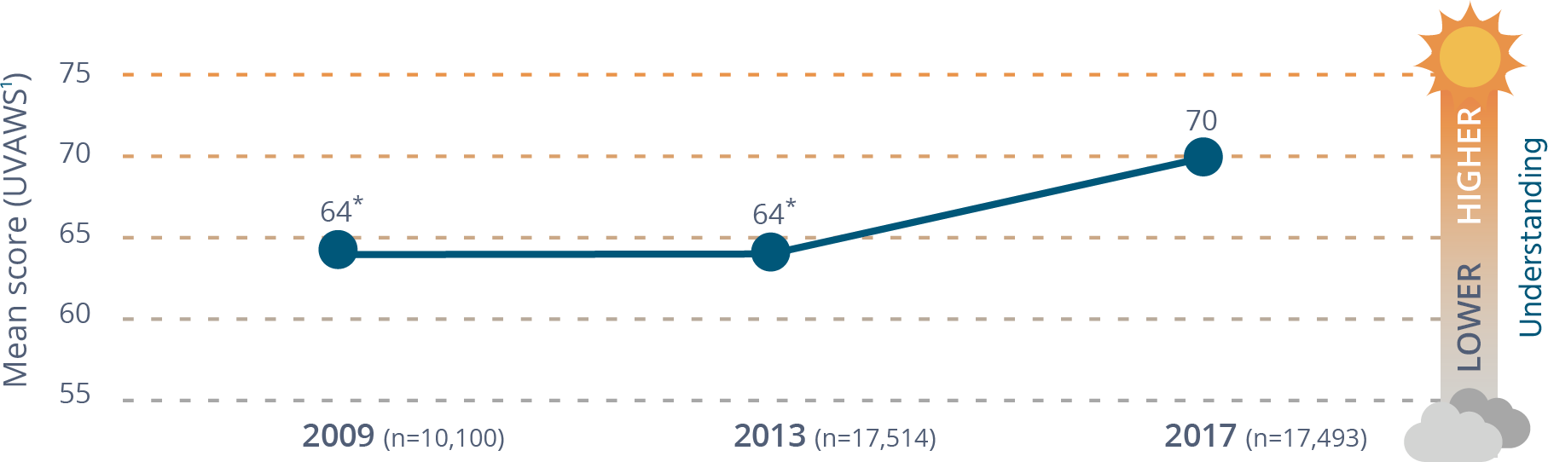

Changes in understanding of violence against women over time, 2009, 2013 and 2017. Mean scores for the UVAWS - a higher score indicates a better understanding of violence
Year | Mean score (UVAWS¹)
2009 (n=10,100) | 64*
2013 (n=17,514) | 64*
2017 (n=17,502) | 70
Figure 1-2: Changes in attitudinal support for gender equality over time, 2009, 2013 and 2017
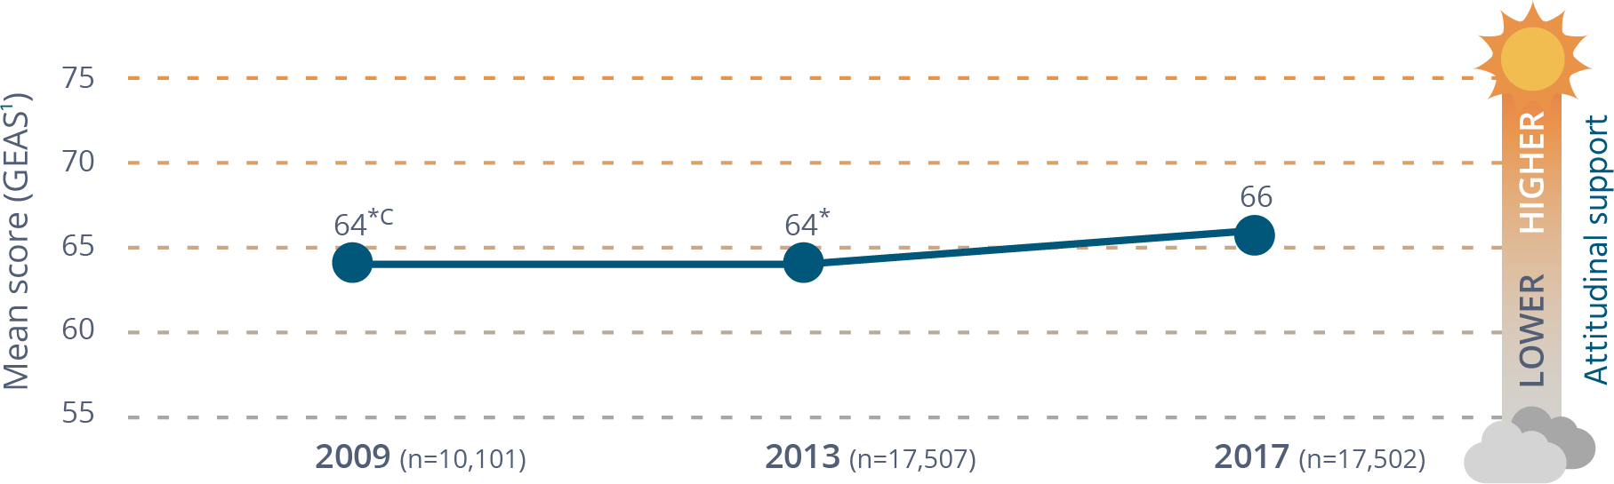
Changes in attitudinal support for gender equality over time, 2009, 2013 and 2017. Mean scores for the GEAS - A higher score indicates greater support for gender equality
Year | Mean score (GEAS¹)
2009 (n=10,101) | 64*^{C}
2013 (n=17,507) | 64*
2017 (n=17,502) | 66
Figure 1-3: Changes in attitudinal support for violence against women over time, 2009, 2013 and 2017
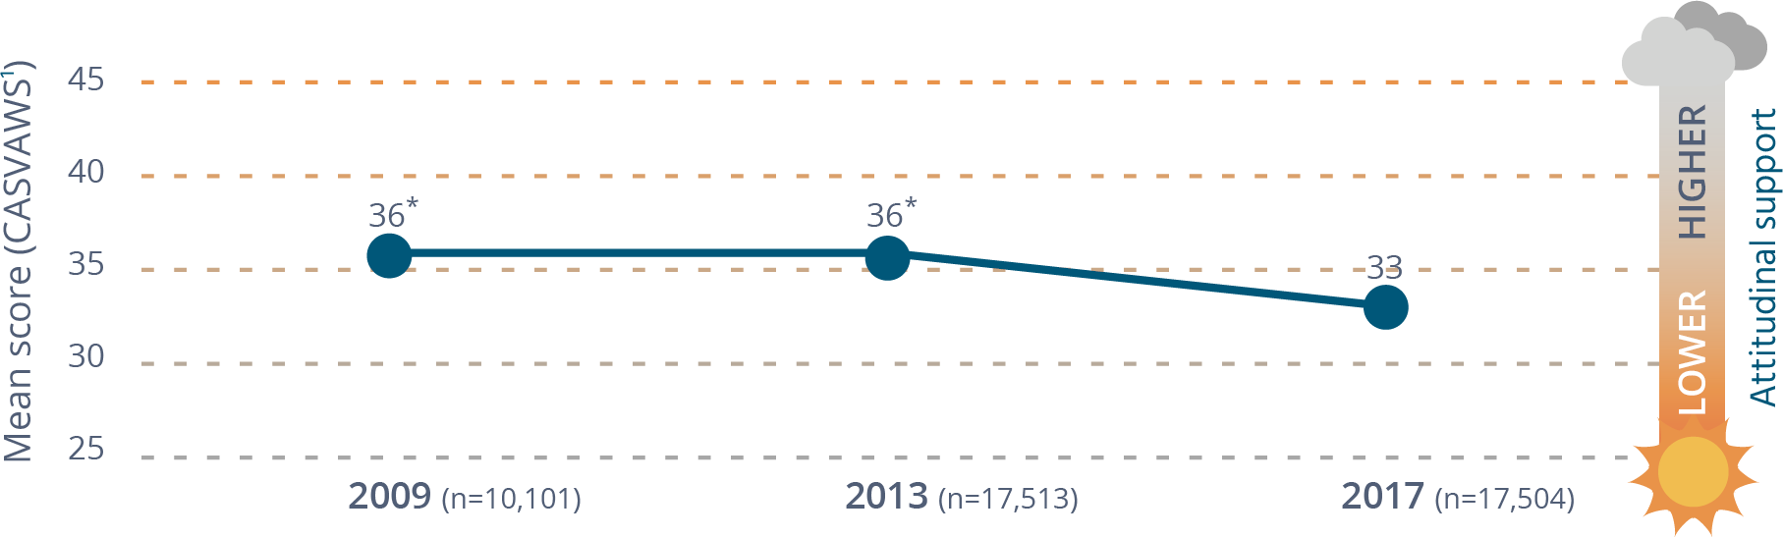
Changes in attitudinal support for violence against women over time, 2009, 2013 and 2017. Mean scores for the CASVAWS - A lower score is better and indicates lower attitudinal support for violence against women
Year | Mean score (CASVAWS¹)
2009 (n=10,101) | 36*
2013 (n=17,507) | 36*
2017 (n=17,502) | 33
* Difference between survey year and 2017 is statistically significant, p≤.01.
¹ Measured using the composite measures described Section 5.2.
^{c} Difference between 2009 and 2013 is statistically significant, p≤.01.
Increasing knowledge and changing attitudes take time, and the current results show that knowledge and attitudes to violence against women and gender equality in Australia are gradually improving. In spite of this progress, areas of concern remain.

Knowledge of violence against women
Consistent with the international definition of violence against women, most Australians understand this violence as constituting a continuum of behaviours. However, they are more likely to recognise obvious physical violence and forced sex than emotional, social and financial forms of abuse and control as forms of violence against women.
A majority of Australians know key facts associated with violence against women. However, the findings for some questions are still concerning:
- One in five (20%) are unaware that violence against women is common.
- One in fourteen (7%) are unaware that a woman’s physical resistance is not required to satisfy a claim of sexual violence.
- One in six (16%) believe that many allegations of sexual assault made by women are false (contrary to research showing that such claims are rare).
- Nearly one in five (19%) are unaware that non-consensual sex in marriage is against the law (12% say they do not think it is illegal, while 7% say they do not know).
- Nearly one in five (18%) disagree that women are more likely to be sexually assaulted by a known man than by a stranger, and a further 16 percent say they do not know whether this is the case. This is contrary to research showing that Australian women are over three times more likely to be sexually assaulted by a man known to them.
- Nearly two in five (38%) do not know where to get outside advice or support about a domestic violence issue.
In each survey since 1995, the majority of Australians have recognised the unequal impact of domestic violence on women as compared with men. However, successive surveys show that this knowledge is declining. This trend continued in 2017 on two of the three measures:
- Consistent with the evidence, a majority (64%) agree that domestic violence is perpetrated mainly by men, or by men more often. However, this is seven percentage points fewer than in 2013 (71%).
- Eighty-one percent agree that the physical harms from domestic violence are greater for women than for men, although this is five percentage points less than in 2013 (86%).
- In 2017, the proportion agreeing that women are more likely than men to experience fear as a result of domestic violence was less than half (49%). However, the difference between this and the proportion agreeing in 2013 (52%) was not statistically significant. There has been a six percentage point decline since 2009, when 55 percent of respondents recognised that levels of fear are worse for women.
Australians’ knowledge that multiple factors contribute to violence against women is strong, although people are more likely to identify individual conditions as important contributing factors to violence against women (e.g. alcohol use) than factors in the wider environment (e.g. media representations of violence).

Attitudes towards gender equality
The NCAS includes questions that measure support for aspects of gender equality understood to be linked to violence against women and align with Change the Story. These are referred to as themes in this report. Analysis confirmed that these aspects are indeed consistent with the way Australians think about gender equality. One exception is that, while Change the Story identifies ‘men’s control of decision-making and limits to women’s independence in public and private life’ as a single gendered driver, the NCAS found that Australians feel differently about equality in public life than in the private domain. A separate composite measure was developed for each of these aspects of gender equality.
Box 1-1: What are attitudes that undermine gender equality?
The five gender equality themes measured in the NCAS
Theme 1: Attitudes promoting rigid gender roles, stereotypes and expressions – reflecting the idea that men and women are naturally suited to ‘do’ different tasks and responsibilities and have naturally distinctive, and often oppositional, personal characteristics.
Theme 2: Attitudes undermining women’s independence and decision-making in public life – agreeing that men make better leaders, decision-makers or are more suited to holding positions of responsibility.
Theme 3: Attitudes undermining women’s independence and decision-making in private life – agreeing that men have greater ‘natural’ authority, decision-making and control in the private realm of intimate relationships and should have the ultimate say over what happens in a relationship or how a family and household are run.
Theme 4: Attitudes condoning male peer relations involving aggression and disrespect towards women – agreeing that it is normal or harmless for men to encourage negative aspects of masculinity among one another (e.g. aggression and not showing one’s feelings) and to talk about women in ways that are sexist and disrespectful (often referred to as ‘locker room talk’).
Theme 5: Attitudes denying gender inequality is a problem – expressing either a denial of gender inequality, sexism, discrimination and/or hostility towards women, and resentment of improvements in women’s rights. These are sometimes referred to as ‘backlash’ attitudes.
To find out which aspects of gender equality are more or less likely to be supported by Australians overall, each respondent was given a score based on their answers to questions in each theme. An average for the Australian population was then calculated. Scores range from 1 to 100, with 1 signifying the lowest level of support for gender equality (a negative result).
Although most Australians support gender equality overall, there is variability between the themes and among individual questions, as illustrated in Figure 1-4, with support for inequality being especially high in the theme of ‘denying gender inequality is a problem’.
Figure 1-4: Community attitudes towards gender equality/inequality, by theme 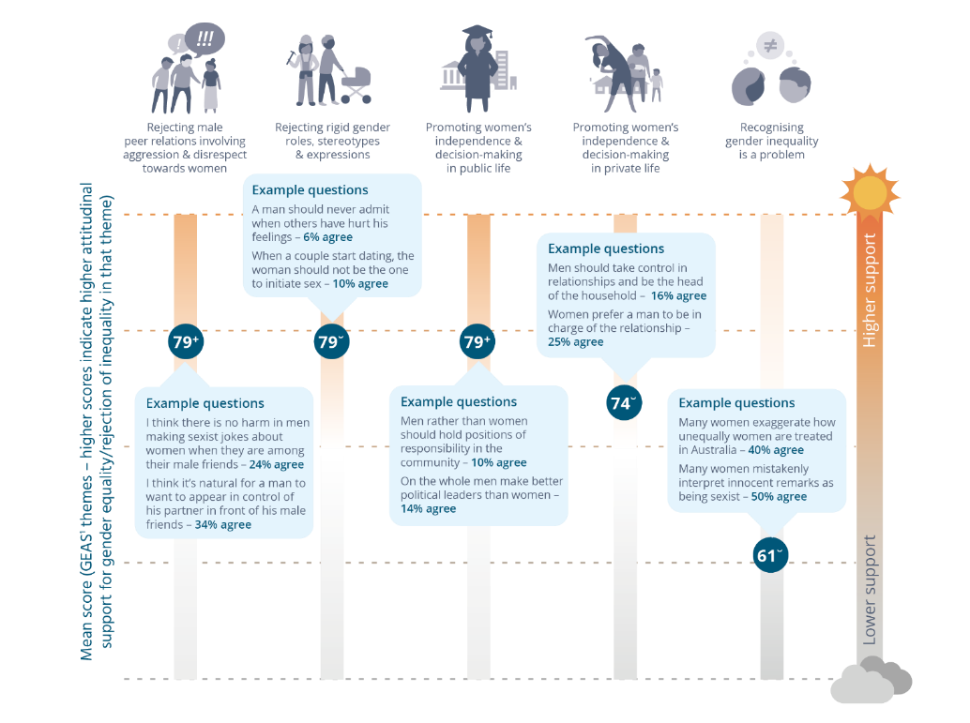
Mean score for the GEAS¹ themes – higher scores indicate higher attitudinal support for gender equality/rejection of inequality in that theme
Theme | Mean score | Example questions
Rejecting male peer relations involving aggression & disrespect towards women | 79⁺ | - I think there is no harm in men making sexist jokes about women when they are among their male friends – 24% agree  - I think it’s natural for a man to want to appear in control of his partner in front of his male friends – 34% agree
Rejecting rigid gender roles, stereotypes & expressions | 79˘ | - A man should never admit when others have hurt his feelings – 6% agree  - When a couple start dating, the woman should not be the one to initiate sex – 10% agree
Promoting women’s independence & decision-making in public life | 79⁺ | - Men rather than women should hold positions of responsibility in the community – 10% agree  - On the whole men make better political leaders than women – 14% agree
Promoting women’s independence & decision-making in private life | 74˘ | - Men should take control in relationships and be the head of the household – 16% agree  - Women prefer a man to be in charge of the relationship – 25% agree
Recognising gender inequality is a problem | 61˘ | - Many women exaggerate how unequally women are treated in Australia – 40% agree  - Many women mistakenly interpret innocent remarks as being sexist – 50% agree
Note: There may be statistically significant differences between values that are less than one percentage point. These are not apparent in this figure due to rounding.
¹ Measured using the composite measure described in Section 5.2.
˘ Difference between this theme and all other themes in this sample is statistically significant, p≤.01.
⁺ Difference between this theme and ‘rejecting rigid gender roles, stereotypes and expressions’, ‘promoting women’s independence and decision-making in private life’ and ‘recognising gender inequality is a problem’ in this sample is statistically significant, p≤.01.
There is greater attitudinal support for gender equality in decision-making in public life compared with decision-making in private life (see Figure 1-4). This difference in levels of support for equality in the public as opposed to private spheres was confirmed by forming and comparing two additional composite measures, one containing all of the gender equality questions concerned with equality in public life and the other containing all of the questions addressing equality in the household and relationships (see Section 9.6).

Community attitudes supportive of violence against women
Attitudinal support for violence against women was measured in four themes. There is overlap between these and the themes used in the 2013 NCAS, selected by synthesising prior studies (i.e. ‘justify, excuse, minimise and trivialise violence against women’ and ‘shifting blame from victim to perpetrator’). Two new themes emerged from the analyses in 2017: ‘mistrusting women’s reports’ and ‘disregarding the need to gain consent’.
To find out which violence-supportive attitudes are more or less likely to be supported by Australians overall, each respondent was given a score based on their answers to questions in each theme. An average for the Australian population was then calculated. Scores range from 1 to 100, with 1 signifying the lowest level of support for violence against women (a positive result).
Similar to their responses about gender inequality, most Australians are inclined to reject attitudes supportive of violence against women, although again there is variation between the themes measured and individual questions, with support for attitudes in the theme of ‘mistrusting women’s reports’ being the highest (Figure 1-5).
Two additional composite measures were made. One included all questions concerned with sexual violence, and the other included questions about intimate partner violence (excluding sexual coercion). No notable overall differences were found in Australians’ attitudes between these two forms of violence (see Section 10.5).
Box 1-2: What are violence-supportive attitudes?
The four violence-supportive attitudes themes measured in the NCAS
Theme 1: Attitudes excusing the perpetrator and holding women responsible – having attitudes that shift responsibility for violence from the perpetrator and/or to the victim by holding them partly responsible for the violence occurring or for not preventing it (e.g. flirting too much with other men). Attitudes excusing men are based on the impression that there are factors leading to some men being unable to control their behaviour.
Theme 2: Attitudes minimising violence against women – by denying its seriousness, downplaying the impact on the victim, or making the violence and its consequences seem less significant or complex than they really are.
Theme 3: Attitudes mistrusting women’s reports of violence – having attitudes that are linked to the idea that women lie about or exaggerate reports of violence in order to ‘get back at’ men or gain tactical advantage in their relationships with men.
Theme 4: Attitudes disregarding the need to gain consent – by denying the requirement for sexual relations to be based on the presence and ongoing negotiation of consent. These attitudes rationalise men’s failure to actively gain consent as a ‘natural’ aspect of masculinity (e.g. that women are passive in sexual matters).
Figure 1-5: Community attitudes towards violence against women, by theme 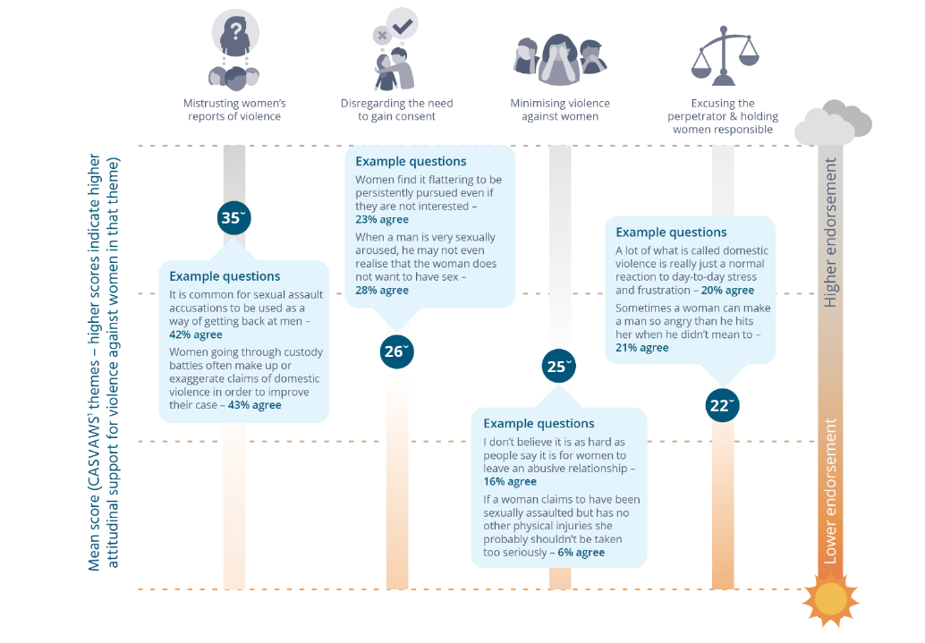
Mean score for the CASVAWS¹ themes – higher scores indicate higher attitudinal support for violence against women in that theme
Theme | Mean score | Example questions
Mistrusting women’s reports of violence | 35˘ | - It is common for sexual assault accusations to be used as a way of getting back at men – 42% agree  - Women going through custody battles often make up or exaggerate claims of domestic violence in order to improve their case – 43% agree
Disregarding the need to gain consent | 26˘ | - Women find it flattering to be persistently pursued even if they are not interested – 23% agree  - When a man is very sexually aroused, he may not even realise that the woman does not want to have sex – 28% agree
Minimising violence against women | 25˘ | - I don’t believe it is as hard as people say it is for women to leave an abusive relationship – 16% agree  - If a woman claims to have been sexually assaulted but has no other physical injuries she probably shouldn’t be taken too seriously – 6% agree
Excusing the perpetrator & holding women responsible | 22˘ | - A lot of what is called domestic violence is really just a normal reaction to day-to-day stress and frustration – 20% agree  - Sometimes a woman can make a man so angry that he hits her when he didn’t mean to – 21% agree
¹ Measured using the composite measure described in Section 5.2.
˘ Difference between this theme and all other themes in this sample is statistically significant, p≤.01.

Factors associated with understanding and attitudes towards violence and gender equality
Relationships between understanding and attitudes and relevant demographic and contextual factors were explored using the composite measures. The differences between people based on demographic and contextual factors were generally not large and varied across the three measures. However, the people who are more likely to have either a low level of understanding, a low level of support for gender equality and/or a high level of attitudinal support for violence against women are:
- those aged 65 years and over;
- men;
- people in highly male dominated occupations or with mainly male friends; and
- people experiencing one or more forms of disadvantage (low education, living in a disadvantaged area, being unemployed).
When the influence of the composite measures is taken onto account, demographic factors have relatively less influence on attitudes towards gender equality and violence against women. The composite measures are much stronger predictors (Table 1-2). In other words, the survey found that the best predictors of a person’s attitude towards violence against women are their level of support for gender equality, their understanding of violence against women, their level of prejudice towards others, and their level of support for violence in general. This was similar to the 2013 NCAS, in which understanding of violence against women and attitudes to gender equality were found to be stronger predictors of attitudes to violence against women than demographic factors.
When the influence of the individual gender equality themes on attitudes towards violence against women is examined, the measures of ‘denying gender inequality is a problem’ and ‘promoting rigid gender roles, stereotypes and expressions’ have the strongest influence on attitudes towards violence against women.

Table 1-2: Top six predictors of measures of understanding of and attitudes towards violence against women and attitudes towards gender equality, 2017
Understanding and attitudes measures¹ | Key predictors
Low level of understanding of violence against women (demographic and contextual factors only) | 1) Gender (male)  2) Age (75 years and over²)  3) English language proficiency (not speaking English well)  4) Gender composition of social network (having mainly male friends)  5) Country of birth (being born in a non-main English speaking country)  6) Level of education (low)
Low level of attitudinal support for gender equality | 1) Endorsing attitudes of prejudice towards people on the basis of other attributes (e.g. disability and sexuality)  2) Endorsing attitudes supportive of violence in general  3) Level of education (low)  4) Occupation of main income earner in household (less skilled)  5) Gender (male)  6) Age (65 years plus)
High level of attitudinal support for violence against women | 1) Support for gender equality (low)  2) Level of understanding of violence against women (low)  3) Endorsing attitudes of prejudice towards people on the basis of other attributes (e.g. disability and sexuality)  4) Endorsing attitudes supportive of violence in general  5) Age (65 years plus)  6) Level of education (low)
¹ Measured using the composite measures described in Section 5.2.
² There was also some variation from the reference category (people aged 55–64 years) among younger cohorts. This is explored in a forthcoming NCAS report.

Intentions to act if witnessing abuse or disrespect towards women
To measure people’s intentions to act in response to abuse or disrespect of women, respondents were asked about two scenarios: a male friend telling a sexist joke and a male friend insulting or verbally abusing his female partner. In both scenarios a majority say they would be bothered by the situation (76% for the sexist joke and 98% for the verbal abuse scenario) and would either take action (45% and 70%) or like to take action (13% and 22%). People were more bothered by and had a stronger intention to act in the verbal abuse scenario than in relation to the sexist joke.
A majority in both scenarios say they would have the support of ‘all or most of their friends’ (55% for the sexist joke and 69% for the verbal abuse scenario), although this proportion is lower than the number of respondents who say they would be bothered in both of these situations (76% for the sexist joke and 98% for the verbal abuse scenario). This suggests that people appear to underestimate the support they are likely to receive from their friends (i.e. more people say they would themselves be bothered than feel they would have the support of most of their friends if they acted to express disapproval).
The top six factors predicting a higher intention to act in response to the scenarios, in order of importance, are attitudes supportive of gender equality, attitudes opposed to violence against women, a person having a good understanding of violence against women, gender (being female), the gender composition of a person’s social network (mixed or female dominated) and education level (high).
Among the gender equality themes, the measure of ‘promoting male peer relations emphasising disrespect of women’ had the strongest influence on the absence of intention to act, and its influence was stronger among men.

The findings: Factors to keep in mind
As is the case with all research the NCAS has both strengths and limitations that need to be taken into account when considering the findings:
- It is not possible to reach everyone contacted by the randomly generated telephone numbers. Approximately half (49%) of those reached agreed to participate. The technical term for this is the 'cooperation rate'. The response rate is a more exacting standard and takes into account all randomly generated numbers that were called and could have resulted in an interview (insert footnote symbol). That is, it includes all numbers that were never answered, not just those where someone answered. the response rate for NCAS was 17 percent. This is comparable, if not better than, other similar surveys across the world. Response rates are challenging to interpret in a rapidly changing telecommunications era where many people screen unknown phone numbers and never answer the calls made. Sample weighting was used to correct the impact of any known imbalances in the sample.
- Well-established statistical modelling was used to investigate some of the more complex questions. As with any statistical modelling, some assumptions were made.
- Responses to surveys on complex social issues can be influenced by language and cultural differences, as well as people answering based on what they believe is socially acceptable rather than their actual opinion (referred to as social desirability bias).
- A relationship between two variables (e.g. attitudes and education) does not necessarily mean that one causes the other.
- The more questions that are used to measure a concept (e.g. understanding of violence against women), the more precise the measure will be. As the questionnaire must not exceed 20 minutes in length, it was not possible to measure all the concepts with the same number of questions. The possibility that differences in precision between measures influenced results cannot be excluded.
The NCAS has a number of features that contribute to its capacity to provide an accurate and reliable measure of community knowledge and attitudes, including that it:
- has a large sample size;
- involves both mobile and landline interviewing. This helps to ensure that people from a range of backgrounds can participate and that the sample is as representative as possible;
- is a periodic survey, enabling changes in knowledge and attitudes to be measured over time; and
- was developed, implemented and analysed using rigorous, well accepted methods and procedures.

Implications for policy & practice
Attitudes are shaped by the world around us, such as through the media we are exposed to, as well as influences in everyday environments such as schools, workplaces and friendship groups. In reflecting this world, they are a good ‘barometer’ of the wider social conditions that contribute to violence against women. The positive change found in people’s knowledge of and attitudes to violence against women and gender equality suggests that Australia is on track to achieving changes in the conditions understood to contribute to violence against women. Continued effort is needed to ensure that these gains are not lost to negative influences in the external environment. Such efforts, involving governments, non-government organisations, communities and the business sector, are currently coordinated under the auspices of the National Plan.
The positive changes in attitudes found in the survey were not matched by a reduction in violence against women between the 2012 and 2016 waves of the PSS. This is not unexpected as it takes time to change complex and entrenched behaviours. Attitudes are only one factor influencing behaviour, and that influence is indirect, so change in both is unlikely to occur at the same time. The complex pathways to behavioural change show the need to monitor change over the long term and using a range of measures, including those that focus on the intermediate conditions necessary to reduce violence. Such measures have been outlined in the National Plan, Counting on Change: A guide to prevention monitoring (Our Watch & ANROWS, 2017) (focusing on indicators relevant to monitoring primary prevention) and the National Data Collection and Reporting Framework (DCRF) (ABS, 2014).*
* Developed for the DSS by the ABS, the DCRF provides the basis for consistent collection of administrative data by organisations in the field of family, domestic and sexual violence. The data items identified in the DCRF are designed to support a stable national framework that is consistent with the reporting needs of organisations, jurisdictions and national programs.
Other possible reasons for a lack of reduction in violence, despite changes in attitudes, include:
- increases in awareness and understanding of violence and reduced community tolerance of it (as shown in this survey) leading to increased disclosure of violence, which subsequently masks any reduction in experience;
- temporary increases in violence as part of a backlash effect to positive changes in conditions for women; and
- a plateau in positive attitudes to gender equality (which in turn influence attitudes to violence against women) in the years prior to the promising 2017 results.
Prevention action to address violence against women is most effective when it involves mutually reinforcing strategies across multiple levels and aims to achieve change in attitudes, behaviours and also systems and structures (Fulu, Kerr-Wilson, Lang, 2013; Fulu, Warner, Kerr-Wilson et al., 2014; Our Watch, ANROWS, & VicHealth, 2015; WHO, 2002, 2010). Action to achieve changes in knowledge and attitudes needs to be integrated into wider strategies at community and organisational levels rather than attempting to change attitudes in isolation.
In prioritising future effort to prevent violence against women, there would be benefits in:
- addressing the gaps in knowledge of violence against women documented earlier – in particular, information about help-seeking, the gendered nature and dynamics of partner violence, and the greater risk of sexual assault by a known person (rather than by a stranger);
- addressing all aspects of gender equality with a focus on challenging rigid gender roles and the idea that gender inequality is no longer a problem. The latter is especially important, as attitudes in this theme are both the strongest predictor of attitudes supportive of violence against women (of the five gender equality themes measured in the NCAS) and the most widely held. Particular emphasis should also be placed on achieving gender equality in private realms such as relationships and households;
- strengthening attitudes that promote a mutually respectful approach to consent in sexual relations, and challenging the idea that it is commonplace for women to use claims of violence to gain tactical advantage;
- addressing barriers to bystander action by informing people that they are likely to be supported by more of their friends than they might think, by strengthening their knowledge, skills and attitudes and by focusing on people who feel uncomfortable and would like to act but say they would not do so; and
- encouraging bystander action by addressing attitudes that ‘condone male peer relations involving aggression and disrespect of women’, as this is the gender equality theme that most strongly predicts people’s intention to act (especially among men).
The significance of attitudes in themes suggestive of ‘backlash’ in the NCAS components of both gender equality and attitudes supportive of violence against women indicate the need to build strategies to address backlash in prevention programs and policy.
The influence of gender equality attitudes on attitudes to violence against women supports the recommendation of expert bodies that a gender transformative approach to preventing violence against women is needed. This approach promotes equal and respectful relationships between men and women as a key to reducing this violence. There are likely to be benefits in integrating means to address other forms of prejudice and discrimination in prevention activity, as well as in challenging the use of violence as a practice. As attitudes are not the only factor influencing violence and are themselves influenced by the external world, a multi-strategy approach is required that also targets change in other conditions known to increase the risk of violence against women.
Attitudes towards gender equality, violence in general and levels of prejudice are stronger predictors of attitudes towards violence against women than demographic factors. This suggests that these attitudes, and the norms, cultures and practices supporting them, should have greater emphasis in prevention than a person’s demographic characteristics. This also suggests a need for prevention strategies that reach the whole population.
However, the finding that education level is a predictor of attitudes to violence against women suggests that increasing access to advanced education is likely to have a positive impact on attitudes towards both gender equality and violence against women. There are also some grounds for targeting prevention action to:
- men and boys;
- men and women in male dominated occupations and social networks;
- older people; and
- people experiencing other forms of disadvantage (in addition to a low level of education).
Violence against women is influenced by many factors, and levels of knowledge and attitudes are not the only criteria on which to base decisions to target action. There are other criteria to consider, such as the prevalence of violence in a particular group, or the presence of other risk factors.
There is a need for further research, in particular qualitative research, to better understand why certain attitudes are held or are changing. Longitudinal designs would help to foster understanding of factors influencing knowledge and attitudes. Many other research questions could be explored using the NCAS data base.
There is also scope to improve the capacity of NCAS to meets its aims. People’s behaviour is strongly influenced by their beliefs about what is expected of them by others. Referred to as social norms, these could be measured in future surveys. Other possibilities include questions to assess:
- the wider community’s attitudes towards violence and gender equality affecting particular groups of women such as young women or Aboriginal and Torres Strait Islander women;
- the influence of other factors on attitudes (e.g. people’s media consumption habits and preferences or measures of social cohesion); and
- attitudes in, and towards violence in, particular organisational contexts such as sporting clubs or schools.
The NCAS findings provide some cause for optimism, although certainly not for complacency. Although knowledge and attitudes are tracking in the direction of positive change, the changes themselves are modest, and some areas investigated in the NCAS raise cause for concern. Further, there are many other factors that influence behaviour. The findings in this report will be useful to guide future action to identify and address gaps, with the aim of building cultures of safety, respect and equality for all Australians.

2 About the National Community Attitudes Survey towards Violence against Women Survey
The National Community Attitudes towards Violence against Women Survey, referred to as the NCAS, is a survey of over 17,500 Australians about their:
- knowledge of violence against women;
- attitudes towards gender equality;
- attitudes towards violence against women; and
- intentions should they witness (or be bystanders to) abuse or disrespect towards women.
The NCAS is funded by the Commonwealth Department of Social Services (DSS) as one of the main mechanisms to monitor progress in achieving the outcomes in The National Plan to Reduce Violence Against Women and their Children 2010-2022 (Council of Australian Governments, 2011). Another key survey is the Personal Safety Survey, led by the ABS (2017). It is used to monitor the prevalence and experience of violence.
The National Plan represents a 12-year strategy bringing together Commonwealth, state and territory actions, as well as work being undertaken by civil society, the business sector and the wider community to achieve a significant and sustained reduction in violence against women (COAG, 2011). The plan has been implemented through successive detailed three-year action plans, the fourth of which is due in 2019.
Consistent with a proposal in the Second Action Plan of the National Plan (Australia, DSS, 2014), a national framework, published as Change the Story: A shared framework for the primary prevention of violence against women and their children in Australia, has been developed to guide the primary prevention of violence against women (Our Watch, ANROWS, & VicHealth, 2015). The 2017 NCAS is aligned with both the National Plan and Change the Story.
The NCAS contributes to the evidence base for prevention of violence against women through the following aims:
- Gauge contemporary attitudes towards violence against women and gender relations and track changes over time in these attitudes in the community, including among Aboriginal people and Torres Strait Islanders, people with disabilities, culturally and linguistically diverse communities, and young people.
- Improve understanding of factors leading to the formation of community attitudes about violence against women and gender relations.
- Provide a foundation for continued monitoring of the National Plan outcomes.
The questionnaire was initially developed on behalf of the Australian Government in 1995 (Office of the Status of Women, 1995), drawing on an earlier 1987 instrument (Public Policy Research Centre, 1988). The NCAS has been repeated every four years since 2009 (VicHealth, 2010 VicHealth, 2014) including this 2017 wave. A further wave (in 2021) is planned under the National Plan.

3 The need for action to reduce and prevent violence against women
Action to address violence against women is important because this problem is prevalent and has serious implications for women, their children and wider society. These implications can be reduced by identifying and responding to violence after it has occurred. However, there is also increasing evidence that violence against women can be prevented before it starts.

Violence against women is prevalent
Violence against women is a prevalent problem across the globe (United Nations (UN) Statistics Division, 2016). Although violence against women takes many forms, among the most common are physical and sexual violence perpetrated by a man, in particular a known man such as an intimate partner, friend or work colleague (UN Statistics Division, 2016). It is estimated that one in three women globally have been subject to intimate partner or sexual violence in their lifetimes (World Health Organization (WHO), 2013a).
In this sense, Australia is no exception. Australia is among world leaders in its efforts to reduce violence against women and to promote gender equality and respect. However, the latest PSS, a household survey of Australians’ experience of violence, shows that among Australian women aged 18 years and over:
- one in three women have experienced physical violence since the age of 15 (ABS, 2017);
- one in six women have experienced physical or sexual violence from a current or former cohabitating partner since the age of 15 (ABS, 2017). This rises to one in four women if violence perpetrated by a boyfriend or date is also included (Cox, 2015);
- one in five women have experienced sexual violence since the age of 15 (ABS, 2017);
- one in six women have experienced stalking since the age of 15 (ABS, 2017); and
- more than half (53%) of women have experienced sexual harassment during their lifetime (ABS, 2017).
Although the workplace has been identified as a setting in which women are vulnerable to sexual harassment (Australian Human Rights Commission (AHRC), 2018a) several recent reports have highlighted the prevalence of harassment of women on the street and in other public places (Johnson & Bennett, 2015; Plan International, 2018), as well as on social media (Henry, Powell, & Flynn, 2017).
Moreover, there has been no overall improvement, between 2012 (when the last PSS was taken) and 2016, in the proportion of women experiencing intimate partner violence in the 12 months prior to the survey. Meanwhile the proportion reporting sexual violence increased slightly from 1.2 percent in 2012 to 1.8 percent in 2016 (ABS, 2017) and the proportion experiencing sexual harassment from 15 percent in 2012 to 17 percent in 2016 (ABS, 2017).
Although occurring across the social spectrum this violence has a greater impact on certain groups of Australian women. There is well documented evidence of a higher prevalence of violence among Australian women with disabilities (ABS, 2017; Krnjacki, Emerson, Llewellyn et al., 2016) and the prevalence of violence is also higher among women aged 18-24 years than among women in older age groups (ABS, 2017). Those found to experience more severe impacts and greater barriers to disclosure and seeking safety from violence include Australian women:
- in some culturally and linguistically diverse communities (Fisher, 2009; Mitra-Kahn, Newbigin, & Hardefeldt, 2016; Poljski & Murdolo, 2011; Rees & Pease, 2007);
- in Aboriginal and Torres Strait Islander communities (Al-Yaman, Van Doeland, & Wallis, 2006; Bryant & Bricknell, 2017; Olsen & Lovett, 2016; Webster, 2016);
- experiencing social marginalisation (Meyer, 2012; Slabbert, 2016); and
- in rural communities (Balogun, Owoaje, & Fawole, 2012; Carrington, 2007; Peek-Asa, Wallis, Harland et al., 2011; Saunders, 2015; Wendt 2016; Wendt, Chung, Elder et al., 2015; Wendt & Zanettino, 2014).
There are no known studies asking Australian men about their use of violence against women. However, studies conducted elsewhere show that when asked if they have engaged in behaviours constituting violence against women, a substantial proportion of men disclose that they have done so.
- In a survey of young people (18-27 years) from ten European countries (Austria, Belgium, Cyprus, Greece, Lithuania, the Netherlands, Poland, Portugal, Slovakia and Spain), between 5.5 and 48.7 percent of young men reported having perpetrated at least one act of sexual aggression. The rates were higher for men than for women in all countries, with the overall rates for women being between 2.6 and 14.8 percent (Krahé, Berger, Vanwesenbeeck et al., 2015).
- In a randomly selected sample of 615 US men, one third said they had done something at work within the past year that would qualify as objectionable behaviour or sexual harassment, such as telling crude jokes or stories or sharing inappropriate videos. Ten percent reported ‘unwanted sexual attention’ including touching, making comments about somebody’s body and asking colleagues on dates after they had said ‘no’. Two percent said that they had engaged in sexual coercion (Patel, Griggs, & Miller, 2017).
- In a US study of college-aged men, nearly one in five self-reported having engaged in behaviours that constitute sexual assault, before commencing their university education (Salazar, Swartout, Swahn et al., 2018).
- In a household survey conducted in South Africa with randomly selected men aged 18-49 years, 26.7 percent disclosed engaging in behaviours that would constitute rape, and 8.8 percent reported engaging in such behaviours along with other male perpetrators (Jewkes, Sikweyiya, Dunkle et al., 2015).
- In a study of dating violence in the US, 28 percent of boys reported at least one form of violence perpetration (sexual, physical or using psychological violence and threats of violence) and this was 45 percent among boys who had ever had sex (Reed, Silverman, Raj et al., 2011).
- Across nine South Pacific countries, between 26 percent and 80 percent of men disclosed perpetrating physical or sexual intimate partner violence (Fulu, Jewkes, Roselli et al., 2013; Jewkes, Fulu, Roselli et al., 2013).

Violence against women has serious impacts
Violence against women has serious consequences, affecting:
- the human rights of women and their children – This is because violence is a human rights violation in itself and because it is a barrier to women and their children realising other rights, including the right to life, to the highest attainable standard of physical and mental health, to decent work, to freedom of expression and to holding opinions without interference, to leisure and play (if a child or young person), to education and to freedom from torture and other cruel, inhuman or degrading treatment or punishment (AHRC, 2018b);
- women’s health and wellbeing – Partner violence and sexual assault are associated with a range of short- and long term physical and mental health consequences (Ayre, Lum On, Webster et al. 2016). At the population level, intimate partner violence alone has been shown to contribute more to disease burden than any other risk factor among women aged 18-44 years (Webster, 2016);
- women’s financial security – Intimate partner violence contributes to poverty and financial insecurity among women, and its attendant stresses and consequences (Braaf & Meyering, 2011);
- homelessness – Domestic and family violence remain one of the key reasons people seek help for homelessness (Australian Institute of Health and Welfare, 2018);
- women’s social, civic and economic participation – Experiencing intimate partner violence has been found to impede women’s progress in employment and their long term career and financial prospects (Adams, Tolman, Bybee et al., 2012; Franzway, Wendt, Moulding et al., 2015; Meyer, 2016; Staggs & Reiger, 2005). Likewise, sexual harassment in the workplace has been linked with lower levels of job satisfaction and confidence (AHRC, 2018a; Birinxhikaj & Guggisberg, 2017; McLaughlin, Uggen, & Blackstone, 2017) and with ability to seek future employment (McLaughlin, Uggen, & Blackstone, 2017). The fear of violence may constrain the freedom of movement of a much larger group of women and hence their ability to participate in economic, social and civic activity;
- achievement of gender equality – For the reasons previously described, violence against women acts as a barrier to achieving gender equality at the population level;
- health and wellbeing of children – Children with mothers who have experienced or are experiencing intimate partner violence may face a range of problems including social and emotional problems (Fusco, 2017; Shin, Rogers, & Law, 2015); depression, anxiety and poor mental wellbeing (Ragavan, Bruce, Lucha et al., 2017); behavioural problems; learning difficulties; low self-esteem, poor school attendance; bullying (as victim and perpetrator); trauma symptoms; and adolescent risk-taking behaviour (e.g. substance abuse) (Campo, 2015; Holt, Buckley, & Whelan, 2008; Kaspiew, Horsfall, & Qu, 2017; McTavish, MacGregor, Wathen et al., 2016; Spinney, 2013);
- transmission of disadvantage across generations – Although not all children exposed to intimate partner violence grow up to be perpetrators or victims of violence themselves, they do have a higher risk of doing so, and this may result in intergenerational cycles of violence (Stith, Rosen, Middleton et al., 2000). Exposure to intimate partner violence increases children’s risk of poverty and homelessness, and this in turn may contribute to intergenerational cycles of disadvantage (Cheng, Johnson, & Goodman, 2016);
- businesses – For example, sexual harassment contributes to increasing staff turnover due to low morale (McLaughlin, Uggen, & Blackstone, 2017; Sojo, Wood, & Genat, 2015); and
- the Australian economy – It is estimated that the total cost of violence against women to the Australian economy in 2015-2016 was $22 billion (KPMG, 2016).
The impacts of violence against women are not confined to those directly subject to it, but rather extend to a much wider group of women. The 2016 PSS showed that feelings of safety among both men and women in Australia have improved between 2012 and 2016. Nevertheless, women were less likely than men to say that they waited for and used public transport alone or took a walk in their local areas after dark. They were also more likely to give feeling unsafe as a reason for not doing so, and those who did wait for public transport or took a local walk after dark were more likely than men who did so to report feeling unsafe (ABS, 2017).
Gender differences in feelings of safety and use of public space are confirmed in other Australian research, which also found that women were more likely than men to engage in a range of other behaviours in order to manage their safety, such as catching a taxi instead of walking, crossing the street to avoid strangers, not exercising alone after dark, watching their drinks when socialising and holding car keys when alone in anticipation of using them in self-defence (Johnson & Bennett, 2015). This constant vigilance involves a practical, cognitive and emotional ‘load’ that in turn impacts on women’s participation in civic, recreation and leisure, economic, creative and social activities, and ultimately the achievement of gender equality (Johnson & Bennett, 2015).

Box 3-1: Why a focus on men’s violence against women?
Violence takes many forms. All types of violence are inexcusable and warrant the attention of the community and governments. The NCAS has a particular focus on men’s violence against women, and on:
- physical and sexual violence in their intimate relationships; and
- sexual violence and harassment.
This is because these are the most common forms of violence affecting women across Australian society (ABS, 2017). Men face a slightly higher risk of being subject to interpersonal violence overall than do women. In 2016, 42 percent of men reported having experienced violence since the age of 15, compared with 37 percent of women (ABS, 2017). Sexual assault and intimate partner violence are also experienced by men (ABS, 2017).
There are distinct gender differences in the patterns of both the perpetration of violence and victimisation (see table below). These differences suggest that there are some unique challenges in ending violence against women. In particular:
- violence against women is often perpetrated by a person with whom women are socially and in many cases emotionally and economically connected to. This adds a particular layer of complexity to this violence (Stark, 2007); and
- the dynamics of men’s violence against women described in the table below have particular consequences for women’s mental health and for the ways in which others respond to violence, as well as for the risks of further victimisation and for preventing violence (Stark, 2007).
There are some common factors that increase the risk of men using violence against women as well as violence against other men (Fleming, Gruskin, Rojo et al., 2015). However, in the case of violence against women, there are also some unique risk factors (WHO, 2002; Our Watch, ANROWS, & VicHealth, 2015). As discussed further below, these are linked to gender differences in roles, relationships and expressions and the manner in which they are supported by societal institutions, practices and norms.
The fact that most forms of interpersonal violence are significantly more likely to be perpetrated by men (ABS, 2017) suggests that efforts to prevent such violence will need to be targeted towards men and boys and engage men as partners in prevention.
Differences between violence against women and against men
Factor | Violence against women | Violence against men
Perpetrator | More likely be a man - 32 percent experienced violence from a male perpetrator compared with 9.2 percent from a female perpetrator. | More likely to be a man - 39 percent experienced violence from a male perpetrator versus 12 percent from a female perpetrator.
Perpetrator | More likely than for men to be a current or previous partner (more than three times more likely than for men), or boyfriend, girlfriend or date (nearly four times more likely than for men). | Three times more likely than women to experience violence by a stranger.

Factor | Violence against women | Violence against men
Place | More likely than men to experience physical assault in their home. | More likely than women to experience violence in a place of entertainment, recreation or other public space.
Sexual violence | Substantially more likely than men to experience sexual violence (18% of women since age 15) and sexual harassment (53% of women). | Substantially less likely than women to experience sexual violence (4.7% since the age of 15) and sexual harassment (25%).
Dynamics and pattern | Violence is more likely to involve abusive and controlling behaviours designed to intimidate, belittle and control the victim (ABS, 2017; Krebs, Breiding, Browne et al., 2011; Mouzos & Makkai, 2004; Stark, 2009 Wangmann, 2011).  A majority of women reporting intimate partner violence experience repeated violence (ABS, 2013 cited in Webster et al., 2015). | Violence more likely than for women to be a single incident of physical violence.
Dynamics and pattern | Women more likely than men to experience stalking (one in six). | Men less likely than women to experience stalking (one in 15 men).
Note: All data from ABS, 2017, unless otherwise indicated.

What about other forms of violence against women?
To the extent possible the NCAS aims to explore the particular ways in which other sources of identity and social position, such as age, sexuality, disability, ethnicity or race, influence knowledge of and attitudes towards intimate partner violence and sexual assault against women.
However, there are many other forms of violence to which specific groups of women are vulnerable, such as human trafficking, female genital mutilation, forced marriage and violence against women in prisons and facilities for women with disabilities (UN, 1993). These forms of violence are serious and require attention. However, since they occur in very specific institutional and community contexts, more targeted approaches to researching cultures of support for them are required than is possible in a large population-based survey.
Intimate partner violence is also a problem within lesbian, gay, bisexual, transgender and/or intersex (LGBTI) relationships (National Coalition of Anti-Violence Programs, 2016; O’Halloran, 2015; Pitts, Smith, Mitchell et al., 2006). There are some commonalities between the drivers of intimate partner violence and violence against people from within LGBTI communities, such as the adherence to gender norms and structures that reinforce inequalities (Our Watch, 2017).
While the NCAS focuses on men’s violence against women specifically (for the reasons already outlined), some of the insights from the survey may also be relevant in responding to these other forms of violence against women. This is because each of these forms of violence shares some risk factors in common with the forms of violence included in the scope of NCAS.

Violence against women and its effects are preventable
There is a continuum of strategies that can be employed to prevent violence against women and its impacts, ranging from stopping violence before it starts to supporting long term recovery (see Figure 3-1).
In the past 60 years, much has been done to improve responses to women and their children affected by violence and to men who use this violence (State of Victoria, 2016). However, despite this, violence against women remains a persistent problem. There has been minimal change in women’s experience of violence since data was first collected in 1996 (see Section 17). Further, as awareness and reporting have increased, response services such as refuges, health and counselling services, the police and the courts are finding it increasingly difficult to cope with demand (State of Victoria 2016). Importantly, intervening after the violence has occurred, although critical, can only limit the health, social and economic consequences of violence against women. To eliminate them, there is a need to prevent new cases of violence against women. This involves complementing response strategies with those designed to prevent violence before it occurs by identifying and addressing its root causes; that is, the broader social conditions understood to increase the risk of this violence occurring. This approach is referred to as primary prevention and is the focus of the national framework for action called Change the Story (Our Watch, ANROWS, & VicHealth, 2015).
Research on social factors contributing to violence against women has been synthesised by a number of expert bodies (European Commission, 2010b; Heise, 2011; Heise & Kotsadam, 2015; Sexual Violence Research Initiative, 2014; UN Women, 2015; VicHealth, 2007, 2011; WHO, 2010) and underpins both the National Plan and the Change the Story framework. These factors are discussed in greater detail in Section 4. Addressing these conditions is especially important for primary prevention. However, as will be shown, they may also contribute to recurring violence and may work against recovery. For this reason they are relevant to consider on all four points on the continuum in Figure 3-1.
A growing body of intervention research and evaluation shows that it is possible to modify these conditions, thereby increasing the prospects of reducing violence against women (Arango, Morton, Gennari et al., 2014; Ellsberg, Arango, Morton et al., 2014; Flood, 2015a; Fulu, Kerr-Wilson, & Lang, 2013; Fulu, Warner, Kerr-Wilson et al., 2014; Heise, 2011; Heise 2012; Lundgren & Amin, 2015; Sexual Violence Research Initiative, 2014). Reflecting this evidence, expert bodies argue the need for a coordinated approach to responding to and preventing violence against women across the continuum illustrated in Figure 3-1. This approach needs to involve multiple strategies implemented with individuals, families and relationships, as well as communities, organisations and society-wide institutions such as the media and the criminal justice system (Garcia-Moreno, Zimmerman, Morris-Gehring et al., 2014; Michau, Horn, Bank et al., 2015; Our Watch, ANROWS, & VicHealth, 2015; VicHealth, 2007, 2011; WHO, 2002).
Figure 3-1: Possibilities for the prevention of violence against women and its impacts: A continuum 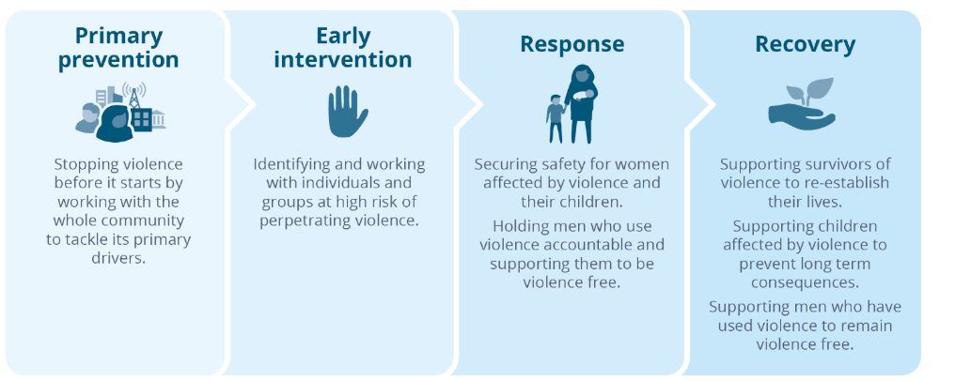
Possibilities for the prevention of violence against women and its impacts: A continuum
Primary prevention
Stopping violence before it starts by working with the whole community to tackle its primary drivers.
Early intervention
Identifying and working with individuals and groups at high risk of perpetrating violence.
Response
Securing safety for women affected by violence and their children.
Holding men who use violence accountable and supporting them to be violence free.
Supporting survivors of violence to re-establish their lives.
Recovery
Supporting children affected by violence to prevent long term consequences.
Supporting men who have used violence to remain violence free.
Such an approach is also reflected in the National Plan in which six key outcomes are identified:
- Communities are safe and free from violence.
- Relationships are respectful.
- Indigenous communities are strengthened.
- Services meet the needs of women and their children experiencing violence.
- Justice responses are effective.
- Perpetrators stop their violence and are held to account.
This approach draws on lessons learned in successfully addressing other serious health issues, such as tobacco use, poor diet and nutrition and motor vehicle related death and injury (VicHealth, 2017a).
As discussed in Section 4, knowledge of violence against women, attitudes towards violence against women and gender equality, and the responses of witnesses to violence and disrespect of women, are relevant along the continuum in Figure 3-1. They are also important for monitoring progress in achieving environments that are safe and respectful for all.

4 Why measure knowledge, attitudes and intentions?
Prior to the 1980s, violence against women was understood to be due mainly to the characteristics of affected individuals (e.g. uncontrollable biological urges, alcohol and drug use and poor anger management), or to dynamics in their relationships (e.g. poor conflict management). Studies do show a link between some of these factors and violence against women (Abramsky, Watts, Garcia-Moreno et al., 2011; Norlander & Eckhardt, 2005). However, the links are not strong enough for these factors to explain this violence on their own (Ali & Naylor, 2013; Hutchinson, Mattick, Braunstein et al., 2014; Norlander & Eckhardt, 2005). That is, while some people affected by violence have these characteristics, many do not. Further, many of these factors affect only a small proportion of the population. These factors are important to understand violence against women, especially when working with individuals in a clinical setting. However, they are not sufficient on their own to explain violence against women as affecting many people across the population.
Accordingly, research in recent decades has sought to complement knowledge about individual and relationship factors that contribute to violence. It has looked towards factors in our broader social environment that may also help to explain the behaviours of individuals. This has involved looking at certain social patterns to see if they are linked with a higher prevalence of violence against women. Among the first researchers to do this was Peggy Reeves Sanday, who compared the characteristics of societies in terms of the rates of sexual violence perpetrated within them (Sanday, 1981). Sanday found that rape was more likely in societies with a higher level of interpersonal violence, male dominance and a high degree of gender separation (Sanday, 1981).
Many other studies conducted since Sanday’s pioneering work have extended this approach to other forms of violence against women and explored the role that other social conditions might play (for reviews see European Commission, 2010b; Hesie, 1998, 2011; VicHealth, 2007; WHO, 2002, 2010). This has led to an increasing consensus that violence against women is best understood as the product of an interplay between the characteristics of individuals and influences in their families; the communities they live in; the organisations they interact with in the course of their education, work and leisure; and broader social influences such as the media, laws, social norms and beliefs (Heise, 1998; Michau, Horn, Bank et al., 2015). This is widely referred to as an ecological approach (Heise, 1998). This approach has led to increasing understanding that, in addition to responding to violence after it has occurred to prevent recurrence and contain its harms, there are also opportunities to prevent this violence before it starts by reforming the social conditions known to increase the likelihood of it occurring.
Gender inequality is understood to create the social conditions that increase the likelihood of violence against women occurring both in the first place, as well as part of a recurring pattern (Heise & Kotsadam, 2015; Our Watch, ANROWS, & VicHealth, 2015; WHO, 2010). This inequality is manifest in many ways. Particular forms of gender inequality implicated in violence against women are identified in the Change the Story framework. Referred to as the ‘gendered drivers’ of violence against women, these are illustrated in Figure 4-1. The ways in which these factors operate to increase the likelihood of violence against women are discussed in greater detail in Section 9. However, gender inequality is not the only social factor implicated in violence against women. In addition, the Change the Story framework identifies five reinforcing factors (Figure 4-1) that interact with gender inequality to increase the frequency and severity of violence against women (Our Watch, ANROWS, & VicHealth, 2015).
Together the gendered drivers and reinforcing factors operate through three social processes: social practices, social norms and social structures (Table 4-1).
Figure 4-1: Gendered drivers and reinforcing factors in violence against women
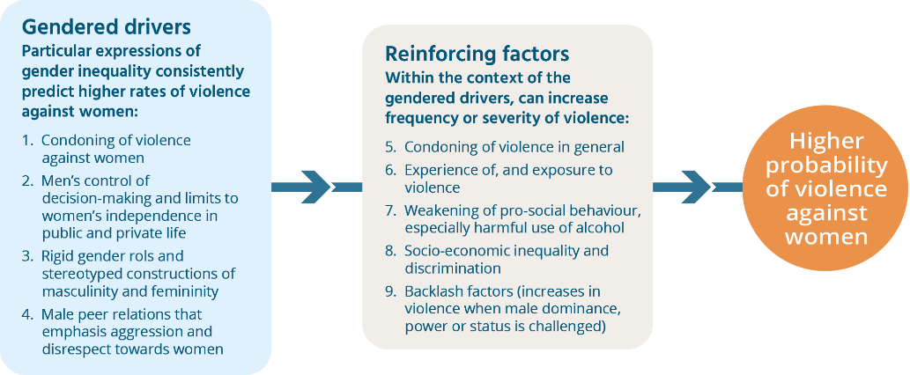
Source: Our Watch, ANROWS, & VicHealth, 2015
Table 4-1: The processes through which gendered drivers and reinforcing factors operate
Process | Description
Social practices | These are individual and collective patterns of behaviour, including everyday interaction, sexual behaviour, child-rearing practices such as the use of physical forms of discipline and gendered divisions of labour and patterns of decision-making in families, in organisations and at the societal level (Webster & Flood, 2015).
Social norms | These are rules of conduct and models of behaviour expected by a society or group. These are influential because the behaviour of individuals is influenced less by their own beliefs than by what they believe is expected of them, or what they believe others would do in similar circumstances (Alexander-Scott, Bell, & Holden, 2016). Norms are transmitted through families, organisational and community cultures and through society-wide institutions such as the media. Social norms can be informal (such as a widely held expectation that childcare will be performed by women) or formal (such as a law stating that physical forms of violence are a crime) (Webster & Flood, 2015; VicHealth, 2014).
Social structures | These operate at the relationship, organisational and institutional levels and are patterned social arrangements in a given context. Like social norms, structures can be formal (such as legislation) or informal (such as the gender hierarchy in a family) (Webster & Flood, 2015). Structures are both influenced by and influence human behaviour (Pease & Flood, 2008).

These three processes are referred to collectively throughout this report as representing ‘cultures of support’ for violence against women. Although addressing these cultures is the key task of primary prevention (see Figure 3-1), cultures of support for violence against women also affect how women themselves respond to their victimisation, how well they recover from the effects of violence, how family, friends and professional service providers respond, as well as whether perpetrators are held to account (Bieneck & Krahé, 2011; DeJong, Burgess-Proctor, & Ellis, 2008; Hans, Hardesty, & Haselschwerdt et al., 2014; Lee, Lee, & Lee, 2012; Meyer, 2012; Saunders, Faller, & Tolman, 2016). This means that they are relevant to consider in actions along the continuum described in Figure 3-1 and in achieving all six outcomes in the National Plan (outlined in Section 3).
This report turns now to examine the role of attitudes towards violence against women, attitudes to gender equality, knowledge of violence against women and bystander responses in cultures of support for violence against women.
Figure 4-2: The role of attitudes supportive of violence against women in the perpetration of, and responses to, violence against women 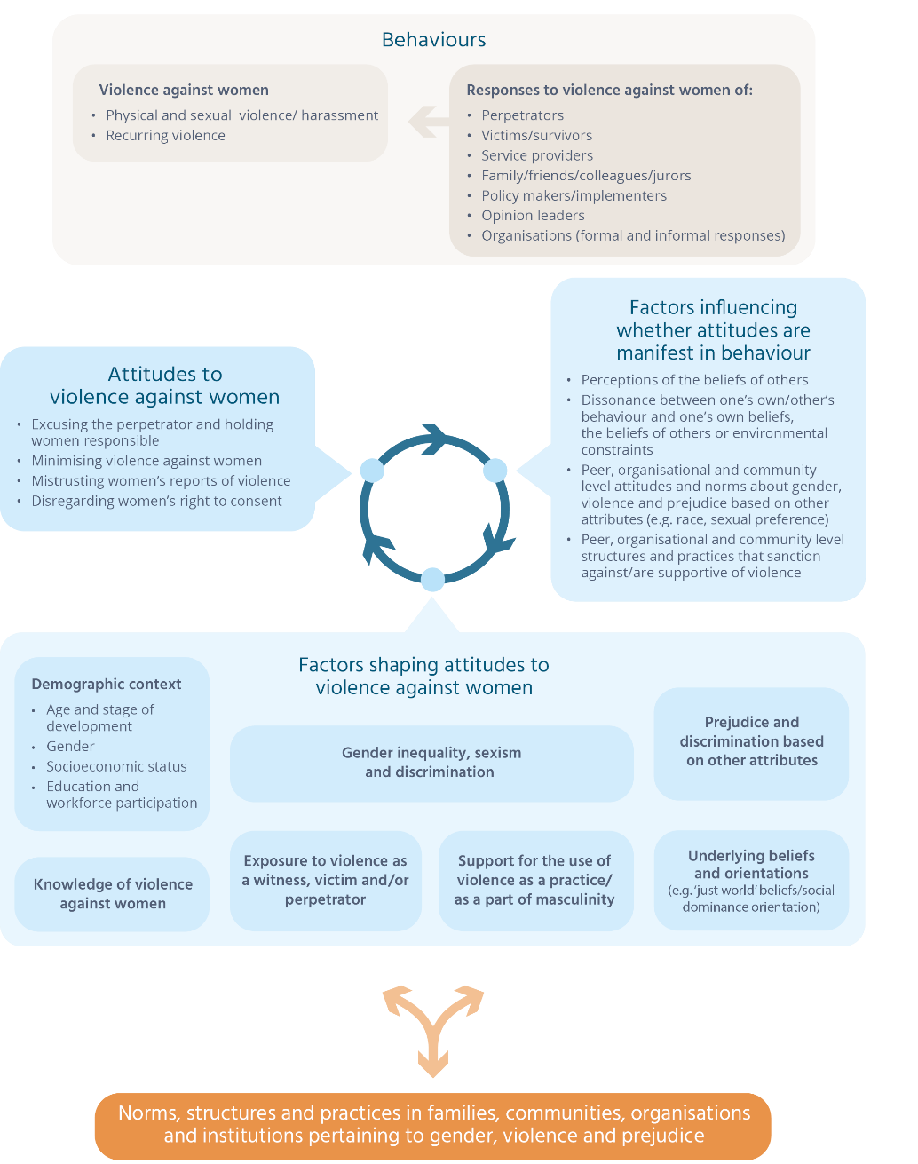
Adapted from Flood & Pease (2009) and VicHealth (2014).

The role of attitudes towards violence against women and gender equality
Attitudes towards violence against women and gender equality play an important role in an overall strategy to reduce violence against women as they are:
- among the factors contributing to this violence; and
- a means of monitoring progress in reducing and preventing violence.

Attitudes, behaviour and actions
A model for understanding the relationship between attitudes and behaviours is outlined in Figure 4-2.
There is a very large body of theory and evidence on the link between attitudes and behaviour, and some disagreement between experts (Howarth, 2006). Studies on attitudes towards a range of phenomena (not just violence against women) show that attitudes play a part in behaviour, but that this role is not always a direct causal one. Some studies show an association between the attitudes people hold and their behaviour. This is the case with violence against women, with some studies showing that perpetrators of violence against women are more likely than others to hold attitudes supportive of this violence or gender inequality (see Section 9 and Section 10). Likewise there are studies showing that violence against women is more common in communities in which violence-supportive attitudes are held (WHO, 2010). This apparent link between attitudes and behaviours was once thought to be because individually held attitudes ‘caused’ people to behave in certain ways (for a brief historical review see Ajzen & Fishbein, 2005). However, more recent studies suggest that people adopt certain attitudes in order to justify or rationalise their own or others’ behaviour, or at least that the relationship is a reciprocal one (see, for example, Rebellon, Mariasse, Van Gundy et al., 2014).
Still other research has shown that the relationship between an individual’s behaviour and their attitudes is relatively weak, and this has led some theorists to reject the notion that attitudes have a key role in influencing complex human behaviours (Chaiklin, 2011). However, other theorists maintain that there is an indirect relationship, exercised through social norms (see Table 4-1) (Ajzen & Fishbein, 2005). In this view, attitudes are understood to be among the factors contributing to social norms, especially if they are held by many people in a particular context, or by individuals who are powerful or influential (Ajzen, 2015; Ajzen & Fishbein, 2005; Berkowitz, 2004; Fishbein & Ajzen, 2010). This approach is based on the understanding that people’s behaviour is not primarily influenced by their own attitudes but rather:
- what they believe other people believe or expect of them in a particular environment (often referred to as informal social sanctions) (Ajzen & Fishbein, 2005). Such expectations may vary from context to context (e.g. they may be different in a person’s sports club than in their workplace); and
- expectations communicated through other formal social controls such as the rules of an organisation or laws and law enforcement, referred to as formal social sanctions (Flood & Pease, 2006).
This understanding suggests that changing attitudes is likely to have some impact on changing behaviour via social norms, but that it is not the only way. Another important way to change behaviour is more directly through strengthening social sanctions against it (e.g. laws, regulations, policies and practices). In this view, attitudinal change is understood to follow behavioural change (Chaiklin, 2011).
As indicated in Figure 4-2, reducing violence against women will involve focusing not only on those who use violence. Attention must also be paid to the cultures within organisational, institutional, community and broader societal environments, behaviours of professionals when responding to those affected by violence, others who witness or become aware of violence, and women who experience violence themselves. Attitudes supportive of violence against women, documented in greater detail in Box 4-1 are relevant across the continuum described earlier (Figure 3-1):
- They may contribute to the development of a culture in a community or organisation in which violence and disrespect towards women and gender inequality are not socially sanctioned against, and may even be encouraged (Flood & Pease, 2006, 2009). This is especially the case if these are held by a large number of people or by individuals with particular influence (Bohner, Siebler, & Schmelcher, 2006; Mackie, Monetti, Denny et al., 2015; Pease & Flood, 2008).
- Negative attitudes can serve as a barrier to women seeking safety from violence (Diemer, Ross, Humphreys et al., 2017; Egan & Wilson, 2012; Giles, Cureen, & Adamson, 2005; Gracia, García, & Lila, 2008; Lea, 2007; Page, 2008; Segrave & Wilson, 2011; Segrave, Wilson, & Fitz-Gibbon, 2016; Weiss, 2009), or to approaching family, friends or professionals for help (Ahrens, 2006).
- People who think others hold negative attitudes towards women and violence are less likely to take helpful action if they witness violence or disrespect, because they are less confident that they will be supported by those around them (Brown & Messman-Moore, 2010; Powell, 2011).
- Men who use violence often call upon violence-supportive attitudes to justify or excuse their behaviour, and this may increase the likelihood of recurrence and decrease their chances of becoming violence free (Bonomi, Gangamma, Locke et al., 2011; Lila, Herrero & García, 2008; Meyer, 2018; Morrison, Hawker, Cluss et al., 2018, Scott & Straus, 2007; Weldon & Gilchrist, 2012).
- Women may adopt attitudes to minimise or excuse their partner’s use of violence if they experience dissonance; that is, an inconsistency between the beliefs they hold and the actions they are in a position to take. In other words, women may be well aware that violence is wrong and harmful, but not take action because the options available to them have other serious consequences for them, their partners or their children (e.g. homelessness, police involvement). If a woman avoids taking action for these reasons, minimising or excusing their partner’s behaviour can reduce the ‘gap’ between this inaction and their belief that their partner’s violence is wrong (Lim, Valdez & Lilly, 2015)
- Negative attitudes of others can inhibit the recovery of women and their children who have survived violence, by undermining their sense of safety or of being respected (Herman, 2015). If expressed, negative attitudes may potentially trigger upset or trauma caused by past experiences of violence (Herman, 2015).
- If negative attitudes are thought to be widely held in a particular context, such as a community or organisation, this may reduce motivation among key decision-makers in those contexts to take action to address violence against women (Stimson, MacKuen, & Erikson, 1995).
‘Condoning violence against women’ is one of the four gendered drivers in the Change the Story framework. This reflects the evidence that some of the impacts previously described are more likely in circumstances in which norms, structures and practices do not clearly condemn, and may even condone or encourage, violence (e.g. where laws and regulations against violence are weak) (European Commission, 2010b; Heise, 2011). The attitudes reflecting these cultures are referred to in this report as ‘attitudes supportive of violence against women’ and are described in greater detail in Box 4-1.
Attitudes to gender equality have been found to be linked to attitudes to violence against women (Pease & Flood, 2008; Suarez & Gadalla, 2010) and to the perpetration of violence against women (Gallagher & Parrott, 2011; Yamawaki, Ostenson, & Brown, 2009). Like gender equality itself, these attitudes form the underlying conditions that in turn can shape cultures supportive of violence against women. Particular aspects of gender equality linked to violence against women have been identified in Change the Story as the remaining gendered drivers. Attitudes reflecting them are described in Box 4-1. The specific ways in which these attitudes are linked to violence against women are discussed in greater detail in Section 9.
The factors influencing attitudes towards violence have been identified in research conducted in prior waves of the NCAS (Flood & Pease 2006; 2009; VicHealth 2014; Webster, Pennay, Bricknall et al., 2014) and are summarised in Figure 4-2. Like violence against women itself, attitudes are shaped by many factors, and these lie in many different environments: in families and relationships, organisations, communities, institutions and wider societal institutions.
It is important to keep in mind that attitudes, and indeed norms, are only one of many factors contributing to violence against women and attitudes are but one factor contributing to social norms. Further attitudes are themselves shaped by the world around us (Pease & Flood, 2009). This means that if we are to achieve sustained change in behaviours, there is a need for change in the structures and practices that shape attitudes and behaviours in the first place. Change in these structures and practices is also needed because they influence whether attitudes are manifest in norms and behaviours. In short, attitudinal change is just one part of a larger strategy to reduce violence against women.

Attitudes as mechanisms to monitor progress
As attitudes are shaped by the world around us they can be a reflection of this world. In this way they can serve as a barometer, telling us whether progress is being made and where we may need to focus future effort.
At the societal level, studies show a relationship between attitudes towards violence and the prevalence of violence against women (European Commission, 2010b; Fulu, Warner, Miedema et al., 2013) as well as other indicators such as laws to sanction against violence against women (UN Women, 2011). Likewise, research comparing attitudes to gender equality at the national level with key indicators of gender equality across 57 countries shows that the two are related; countries with a low level of equality between women and men also tend to have a low level of attitudinal support for gender equality (Brandt, 2011). As there is a link between gender equality and violence against women, measuring attitudes towards gender equality is a key way of monitoring progress in reforming the conditions that increase the risk of violence against women.
Monitoring the achievement of gender equality is of course also important because equal and respectful gender relationships are beneficial for men, women and Australian society as a whole (AHRC, 2010; Organization for Economic Cooperation and Development, 2015; VicHealth, 2017b, 2017c).
Box 4-1: What are attitudes supportive of violence towards women and gender inequality?
Researchers studying the role of attitudes in violence against women have conceptualised them in different ways. In this report, four key themes or dimensions of attitudes supportive of violence against women are distinguished:
- Excuse the perpetrator and hold women responsible by shifting responsibility for violence from the perpetrator and/or to the victim by holding women responsible for the violence occurring, or for not preventing it. Attitudes excusing the perpetrator suggest that there are factors that make some men unable to control their behaviour.
- Minimise violence against women by denying its seriousness, downplaying the impact on the victim, or making the violence and its consequences seem less significant or complex than they really are (e.g. the idea that it’s not hard for women to leave an abusive relationship).
- Mistrust women’s reports of violence – linked to the idea that women lie about or exaggerate reports of violence in order to ‘get back at’ men or gain tactical advantage in their relationships with men (e.g. to improve their prospects in cases involving conflict over care arrangements for children following separation).
- Disregard the need to gain consent by denying the requirement for sexual relations to be based on the presence and ongoing negotiation of consent. These attitudes rationalise men’s failure to actively gain consent as a ‘natural’ aspect of masculinity (e.g. men’s uncontrollable sexual drive), or are based on stereotypes of female sexuality (e.g. that women are passive in sexual matters).
Individuals who hold such attitudes are not necessarily violence prone or would openly condone violence against women. However, as already indicated, when such attitudes are expressed by influential individuals or are held by a substantial number of people they can contribute to a culture in which violence is at best not clearly condemned and at worst condoned or encouraged.
Underpinning these attitudes are attitudes towards gender inequality. Reflecting gendered drivers in the Change the Story framework, five themes are distinguished:
- men’s control of decision-making in public life – attitudes agreeing that men make better leaders, decision-makers or are more suited to holding positions of responsibility;
- men’s control of decision-making in private life – attitudes agreeing that men should have greater authority to make decisions and control in the private realm of intimate relationships, family life and household affairs;
- rigid gender roles, stereotypes and expressions – the idea that men and women are naturally suited to different tasks and responsibilities, and have naturally distinctive – often oppositional – personal characteristics (e.g. ‘women are emotional and are therefore better child carers’, while ‘men are rational and are therefore better politicians’);
- male peer relations that emphasise aggression and disrespect towards women – attitudes accepting aggressive and disrespectful behaviour towards/about women by men in peer group settings as normal, natural or harmless (e.g. ‘locker room talk’); and
- denying gender inequality is a problem – denial that gender inequality, sexism or discrimination against women continue to be problems in society. These attitudes often reflect hostility towards women and resentment of improvements or action for the improvement of women’s rights. This theme responds to the reinforcing factor in the Change the Story framework concerned with a backlash towards gains made by women. It includes attitudes that express either a denial of gender inequality and discrimination against women (often referred to as ‘modern sexism’) and/or that express a hostility towards women (often referred to as ‘hostile sexism’).

Knowledge
Research on attitudes towards a range of social issues shows that knowledge is among the factors influencing attitudes (Ajzen & Fishbein, 2005; Chaiken & Trope, 1999; Fazio, 1990), although the relationship is widely regarded as a modest one (Kollmuss & Agyeman, 2002; Visser, Holbruck, & Krosnick, 2008). Evaluation of efforts to address other social issues suggest that raising knowledge and awareness, while in some cases a necessary condition for behavioural change is generally not sufficient on its own (Fah & Sirsena, 2014; Snyder, Hamilton, Mitchell et al., 2004; Visser, Holbrook, & Krosnick, 2008).
A well-informed community is better able to help prevent violence against women (Carlson & Worden, 2005; McMahon & Baker, 2011; O’Neill & Morgan, 2010), and to respond appropriately when they witness violence and its precursors (Powell, 2012).
The law can play an important role in shaping social norms towards issues such as violence (Bilz & Nadler, 2014). Knowledge of the law is important to enable this to occur (Salazar, Baker, Price et al., 2003).
Women’s knowledge of violence has also been shown to influence their responses. For example, women who have experienced rape and who have an accurate knowledge of the law have been found to be less likely to blame themselves than those whose knowledge of the law is poor (Miller & Summers, 2007).

Monitoring prosocial behaviour
The NCAS also addresses the way people respond when they witness abuse and disrespect towards women. There are risks associated with members of the community intervening when physical violence is occurring. However, interest has been increasing in supporting positive or prosocial behaviour to address early signs of violence or conditions that contribute to violence. This is because:
- what other people believe or are perceived to believe has a strong impact on people’s behaviour (Bohner, Siebler, & Schmelcher, 2006; Brown & Messman-Moore, 2010);
- only a small proportion of women experiencing violence report to the police. Likewise, many of the antecedents to violence (e.g. disrespect of women) occur in everyday contexts beyond the gaze of those responsible for sanctioning against them (e.g. sporting code officials and human resource management personnel in workplaces); and
- many of the antecedents to violence are not themselves against the law, but can be challenged when it is safe to do by active social censure.
Research shows that taking positive action when witnessing abuse and disrespect of women is influenced by a number of factors. These are also explored in the NCAS survey so that barriers to taking action in the Australian community can be identified and addressed.

5 About the 2017 questionnaire
The questionnaire from the 2013 survey was redeveloped for 2017, retaining as many questions as possible. The NCAS Questionnaire Framework is shown in Figure 5-1.
The core of the questionnaire (represented in the centre cells) involves four components made up of questions. These respond to the four concepts introduced in the Section 4. They ask about people’s knowledge of violence against women (25 questions), attitudes towards gender equality (19 questions), attitudes towards violence against women (35 questions and 2 scenarios) and intentions if witnessing abuse or disrespect towards women (2 scenarios).
Each component is further divided into themes. These reflect different aspects of knowledge and different ways attitudinal support for gender equality and violence against women can be expressed. The themes have been described in greater detail earlier in Box 4-1. The themes in the ‘bystander’ component reflect the conditions known to increase the chances that people will take positive action as bystanders to abuse and disrespect.
As well as measuring people’s responses to individual questions, overall concepts are gauged using 15 composite measures (these may also be referred to as scales or constructs). These are made up from selected questions using statistical methods (Rash analysis and factor analysis) to ensure they measure the concept accurately. The strength of a composite measure is that it can measure a complex overall topic or concept (such as support for gender equality) that would be difficult to measure with a single question or even several questions considered separately.
The first component in the NCAS Questionnaire Framework, the knowledge component, has one composite measure that gauges people’s overall understanding that violence against women extends beyond physical violence to also include psychological, social and financial means of control and intimidation. There are composite measures to gauge attitudes towards gender equality and violence against women overall, as well as the themes in each of these components. Drawing on questions from the bystander component, there is a composite measure of people’s overall intention to take positive action if they witness violence or disrespect towards women.
Box 5-1: How are composite measures used in NCAS?
Composite measures compliment the data that comes from people’s responses to individual questions. These are used in the NCAS to:
- measure overall understanding and attitudinal support more validly;
- measure change in overall concepts over time;
- find out how widely particular attitudinal concepts are held, so that greater focus can be placed on more troubling concepts in prevention work;
- explore factors that are related to understanding, attitudes and action. For example, whether a person’s age influences whether they are more likely to endorse gender equality overall; and
- explore relationships between concepts. For example, to find out whether some aspects of attitudinal support for gender equality are more strongly related to attitudinal support for violence against women than others.
Figure 5-1: The NCAS questionnaire framework
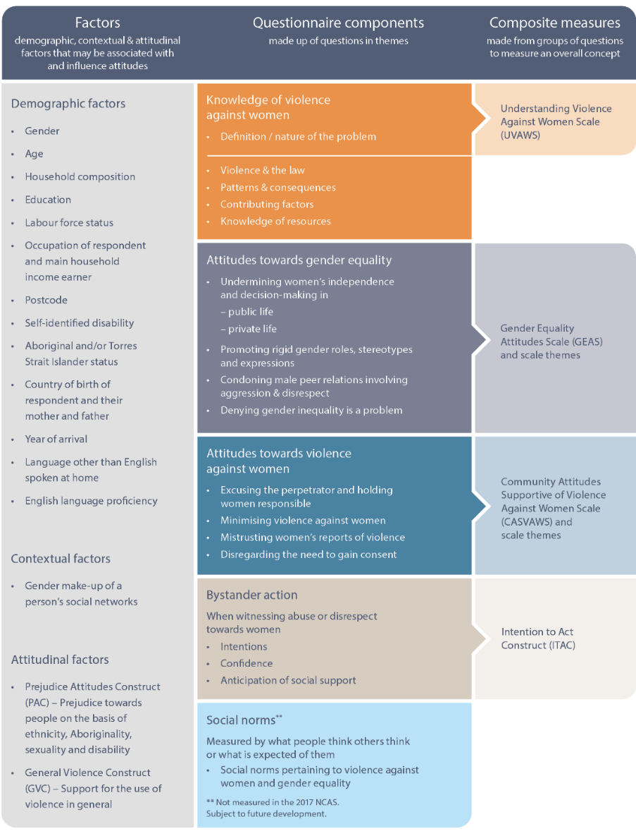
The NCAS questionnaire framework
Factors  demographic, contextual & attitudinal factors that may be associated with and influence attitudes | Questionnaire components  made up of questions in themes | Composite measures  made from groups of questions to measure an overall concept
Demographic factors  - Gender  - Age  - Household composition  - Education  - Labour force status  - Occupation of respondent and main household income earner  - Postcode  - Self-identified disability  - Aboriginal and/or Torres Strait Islander status  - Country of birth of respondent and their mother and father  - Year of arrival  - Language other than English spoken at home  - English language proficiency  Contextual factors  - Gender make-up of a person’s social networks  Attitudinal factors  - Prejudice Attitudes Construct (PAC) – Prejudice towards people on the basis of ethnicity, Aboriginality, sexuality and disability  - General Violence Construct (GVC) – Support for the use of violence in general | Knowledge of violence against women  - Definition / nature of the problem  - Violence & the law  - Patterns & consequences  - Contributing factors  - Knowledge of resources | Understanding Violence Against Women Scale (UVAWS)
 | Attitudes towards gender equality  - Undermining women’s independence and decision-making in  - public life  - private life  - Promoting rigid gender roles, stereotypes and expressions  - Condoning male peer relations involving aggression & disrespect  - Denying gender inequality is a problem | Gender Equality Attitudes Scale (GEAS) and scale themes
 | Attitudes towards violence against women  - Excusing the perpetrator and holding women responsible  - Minimising violence against women  - Mistrusting women’s reports of violence  - Disregarding the need to gain consent | Community Attitudes Supportive of Violence Against Women Scale (CASVAWS) and scale themes
 | Bystander action  When witnessing abuse or disrespect towards women  - Intentions  - Confidence  - Anticipation of social support | Intention to Act Construct (ITAC)
 | Social norms**  Measured by what people think others think or what is expected of them  - Social norms pertaining to violence against women and gender equality  ** Not measured in the 2017 NCAS.  Subject to future development. | -

Figure 5-2: Key steps in questionnaire redevelopment and implementation 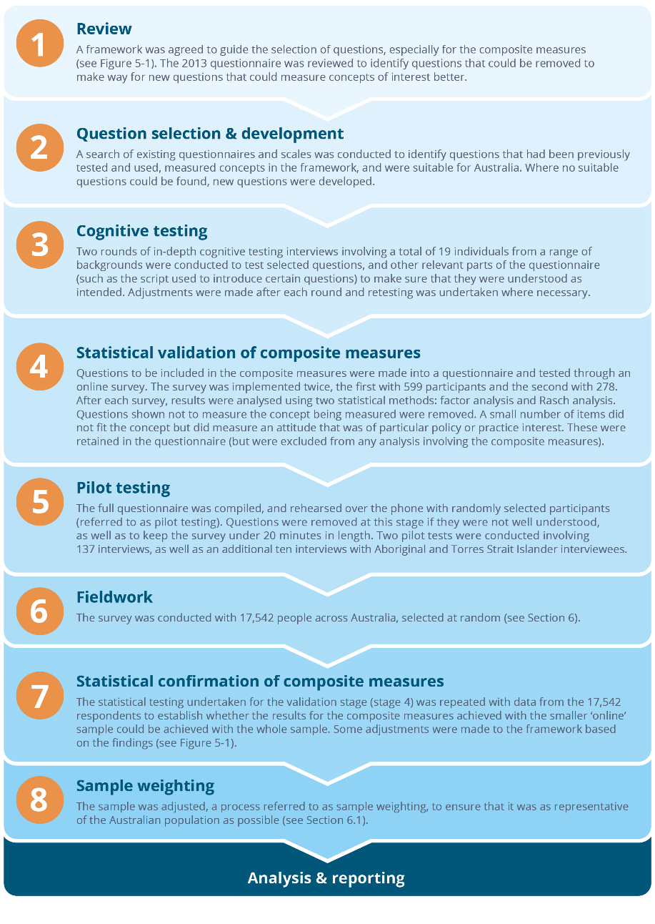

Key steps in questionnaire redevelopment and implementation
- Review
A framework was agreed to guide the selection of questions, especially for the composite measures (see Figure 5-1). The 2013 questionnaire was reviewed to identify questions that could be removed to make way for new questions that could measure concepts of interest better.
- Question selection & development
A search of existing questionnaires and scales was conducted to identify questions that had been previously tested and used, measured concepts in the framework, and were suitable for Australia. Where no suitable questions could be found, new questions were developed.
- Cognitive testing
Two rounds of in-depth cognitive testing interviews involving a total of 19 individuals from a range of backgrounds were conducted to test selected questions, and other relevant parts of the questionnaire (such as the script used to introduce certain questions) to make sure that they were understood as intended. Adjustments were made after each round and retesting was undertaken where necessary.
- Statistical validation of composite measures
Questions to be included in the composite measures were made into a questionnaire and tested through an online survey. The survey was implemented twice, the first with 599 participants and the second with 278. After each survey, results were analysed using two statistical methods: factor analysis and Rasch analysis. Questions shown not to measure the concept being measured were removed. A small number of items did not fit the concept but did measure an attitude that was of particular policy or practice interest. These were retained in the questionnaire (but were excluded from any analysis involving the composite measures).
- Pilot testing
The full questionnaire was compiled, and rehearsed over the phone with randomly selected participants (referred to as pilot testing). Questions were removed at this stage if they were not well understood, as well as to keep the survey under 20 minutes in length. Two pilot tests were conducted involving 137 interviews, as well as an additional ten interviews with Aboriginal and Torres Strait Islander interviewees.
- Fieldwork
The survey was conducted with 17,542 people across Australia, selected at random (see Section 6).
- Statistical confirmation of composite measures
The statistical testing undertaken for the validation stage (stage 4) was repeated with data from the 17,542 respondents to establish whether the results for the composite measures achieved with the smaller ‘online’ sample could be achieved with the whole sample. Some adjustments were made to the framework based on the findings (see Figure 5-1).
- Sample weighting
The sample was adjusted, a process referred to as sample weighting, to ensure that it was as representative of the Australian population as possible (see Section 6.1).
Analysis & reporting

Many factors influence knowledge and attitudes. Increasing understanding of these factors is an aim of the NCAS. The factors included in the 2017 NCAS are shown in the far left cells in the NCAS Questionnaire Framework. Information is collected from survey participants to measure each of these factors and is used in analysis of their responses. This information includes questions about themselves such as their age, occupation, education and whether they have a disability. Three new factors were introduced into the 2017 NCAS, including measures of people’s levels of prejudice on the basis of other attributes (sexual orientation, Aboriginality, ethnicity and disability), their support for violence in general, and the gender composition of their friendship networks.
In Section 5.1 and Section 5.2 more detail is provided on how the questionnaire was redeveloped for the 2017 survey, and how each of the composite measures were formed.

5.1 Questionnaire redevelopment
In prior NCAS waves, minor additions and adjustments were made to the questionnaire to reflect emerging issues and changing theoretical understanding and language. For the 2017 survey, a more substantial redevelopment was undertaken to:
- improve the composite measures of attitudinal support for violence against women and gender equality;
- introduce more contemporary questions that better measure the concepts of interest;
- investigate whether different concepts underlie Australians’ attitudinal support for gender inequality and violence against women and, if so, whether they could be measured;
- introduce new measures to improve understanding of factors influencing attitudes;
- improve questions on people’s intentions should they witness abuse or disrespect towards women; and
- conduct retesting to ensure that the questionnaire as a whole measures knowledge and attitudes as accurately as possible.
The key steps involved in the redevelopment and implementation of the questionnaire are outlined in Figure 5-2. Ethics approval for the redevelopment and implementation was obtained from The University of Melbourne.

5.2 Composite measures used in the 2017 NCAS

Understanding Violence Against Women Scale (UVAWS)
The UVAWS was developed in the 2013 survey from a series of questions in the knowledge component of the questionnaire. The questions are designed to assess the extent to which people understand violence against women as a continuum of behaviours from obvious physical assault and forced sex through to social, emotional, psychological and economic forms of control, abuse and exploitation (VicHealth, 2014; Webster et al., 2014). This set of questions was chosen because this understanding of violence underpins international and Australian government strategies to address violence against women. It is widely regarded as being pivotal to understanding the dynamics and causes of violence. More detail on why this is the case can be found in Section 8.

Gender Equality Attitudes Scale (GEAS) and the Community Attitudes Supportive of Violence Against Women Scale (CASVAWS)
These composite measures were formed for the 2017 questionnaire using a statistical method called Rasch analysis, which is designed for deciding the best group of questions to measure the concept of interest, and then for confirming this is the case (see Figure 5-2).
The GEAS replaces the Gender Equality Scale used in the 2013 questionnaire. It contains 19 questions that were selected to represent attitudes reflecting the gendered drivers of violence against women in the Change the Story framework and the reinforcing factor of ‘backlash’ (see Box 4-1). The CASVAWS measures the overall concept of ‘condoning violence against women’ in the Change the Story framework. It was developed from the 2013 scale measuring this concept (referred to in 2013 reporting as the Violence-Supportive Attitudes Scale). It includes 32 questions across four themes (see Box 4-1).
Tentative themes were developed drawing on the Change the Story framework, and research undertaken in prior waves of the NCAS. A statistical approach called factor analysis was used to see if these themes were the same as those underpinning support for violence against women and gender inequality in the Australian population. Questions in the resulting factors, referred to as themes, were also used as composite measures. Using data from the whole NCAS sample, it was confirmed that Australians think about gender equality in ways that align with Change the Story except that they think differently about equality in public life and equality in private life.
Box 5-2: Why is it helpful to understand how people think about violence and equality, and how do we find out?
Identifying the broad concepts (referred to as ‘themes’ in this report) that underpin Australians’ attitudes to violence against women and gender equality is important as it can make communicating about attitudinal support simpler. This is because the attitudes can be described in general terms, rather than having to describe each question. More importantly the resulting measures provide a valid measure of the overall concept and can be used to identify which themes are more prominent in the community, as well as the relationships between concepts (e.g. particular aspects of gender equality and attitudes towards violence against women). Confirming existing concepts or being aware of new ones in a particular population (in this case, Australia) is also useful as they can be used to make sure that messages and approaches in prevention programming resonate with the ways in which people think.
To identify these concepts, a statistical technique called factor analysis was used. This involves first selecting questions that are understood to measure overall concepts drawn from prior research. These are then tested through the survey to see whether people answer the questions within each theme in a similar way. If they do, it can reasonably be assumed that these are the broad concepts underlying attitudes in the Australian community and that the questions used are measuring the concept. If this is not the case, the results can be examined to see if other patterns are apparent in the data and whether a new concept emerges.
There were also some adjustments to the themes in the CASVAWS. In the 2013 NCAS there were five themes – justify, excuse, minimise, trivialise and victim-blaming (formed on theoretical grounds). These were used as tentative themes. Four themes emerged from the factor analysis using the 2017 NCAS data. The ‘minimise’ theme was confirmed, while the concepts of ‘excusing the perpetrator’ and ‘victim blaming’ emerged as a single factor. There were two new themes reflecting the concepts of ‘mistrusting women’s reports of violence’ and ‘disregarding the need to gain consent in intimate relationships’ (see Box 4-1 and Section 10 for further detail). The NCAS Questionnaire Framework has been adjusted to reflect these findings, and the themes are used throughout this report.

Other composite measures
Three further composite measures appear in the questionnaire. These were developed using many of the processes and statistical techniques just described. To keep the survey to an acceptable length, these contain fewer questions and are therefore less comprehensive and precise. These are referred to as constructs rather than scales.
The first of these is the Intention to Act Construct (ITAC). This is an overall measure of the fourth key concept of interest in the NCAS Questionnaire Framework. It is a measure derived from responses to two scenarios (verbal abuse of a woman by her partner, and hearing a sexist joke about a woman). The measure takes into account the extent to which people would be bothered by the scenarios, whether they would take action, their confidence to act and, if acting, whether they think they would have the support of others.
The other two measures were designed to measure factors identified in the NCAS Questionnaire Framework (see Figure 5-1) as being linked to attitudes towards gender equality and violence against women:
- The General Violence Construct (GVC) – includes six questions gauging respondents’ attitudes to the use of violence as a practice, in particular whether it is serious, or is legitimate in certain circumstances as a form of punishment or retaliation. The questions concern the use of violence between adults, in disciplining children and in the media (see Appendix C).
- The Prejudice Attitudes Construct (PAC) – includes nine questions, measuring attitudes towards ethnic difference, as well as feelings towards Aboriginal people and Torres Strait Islanders, people with mental and physical disabilities and those who are same-sex attracted (see Appendix C).

6 Conducting the NCAS
People aged 16 years and over were randomly selected from across Australia and invited to participate in a 20-minute telephone interview. Forty percent of the interviews were conducted with people contacted on a landline telephone and 60 percent with people contacted on a mobile phone. Including both landline and mobile phone interviews recognises that an increasing number of Australians (around 36%) have a mobile phone only (Australian Communications and Media Authority, 2017). The survey would not be representative if mobile phone interviews were not included. Young people, people from non-English speaking backgrounds and Aboriginal and Torres Strait Islander people are more likely than other Australians to live in houses with mobile phones only.
Key questions were asked of the whole sample. However, to maximise the range of topics explored, others were divided into two sets of questions, and one half of the sample (approximately 8,250 respondents) were asked one set of questions and the other half of the sample were asked the other set of questions. This allows approximately twice the number of questions to be asked (although each question is asked of fewer people). Other groups of questions were divided into four sets, and each were asked of one quarter of the sample (approximately 4,125 respondents). Again, this allows more questions in total to be asked (although again these questions were asked of fewer people). Nevertheless these questions were allocated to participants on a random basis.
Interviewing was available in 12 community languages, using translated versions of the questions and in-house bilingual interviewers, or interpreters.
A sample size of 17,542 was reached. Of the 37,000 people reached, 48 percent completed an interview. A response rate of 17 percent was achieved. Although low in absolute terms, there has been a noted decline in survey response rates globally (Pickett, Cullen, Bushway et al., 2018; Tourangeau, 2017). The rate achieved for NCAS in 2017 is as high as, if not higher than, other similar surveys in countries comparable to Australia (Kohut, Keeter, Doherty, Dimock, & Christian, 2012; Riggle, Rostosky, & Reedy, 2005; Shih & Fan, 2008). The ‘response rate’ takes into account all the numbers contacted regardless of whether or not contact was established.
At least 1,000 interviews were conducted in each state and territory, and a larger number in more populous jurisdictions. The large sample size, together with combining landline and mobile phone interviews, ensured sufficient randomly selected interviews with Aboriginal people and Torres Strait Islanders and with people from non-English speaking backgrounds to allow inferences to be drawn about these populations. Results for these samples are in separate forthcoming reports. Data from respondents in these groups are included in the analysis in this report.
There were not enough telephone interviews with people aged 16-17 years. As this group was of particular interest, a ‘booster’ survey was conducted. Participants in the booster sample answered the same questions as young people interviewed over the telephone, but they completed the survey online. They were approached through families registered with an existing panel established to engage people in research.
Data from this online sample have not been included in the analysis for this report. Rather, these were combined with data from interviews with 16-17 year olds conducted over the telephone, and used to produce a separate report concerned with young people aged 16-24 years (forthcoming). Only data from telephone interviews with people in this age group are included in this report.

6.1 Sample adjustment
It is usual to adjust the data collected by sample surveys to take account of the unequal chances of being selected and the effects of non-coverage and non-response. This is commonly referred to as weighting the data. Part of the weighting process involves aligning the sample to external population benchmarks so that it mirrors the population as a whole as closely as possible. This strengthens the ability to say that the results from the survey have a high likelihood of representing those of the total population.
More detail about the weighting approach can be found in the methodology report on the ANROWS website (ncas.anrows.org.au).

7 Analysing and reporting the results

7.1 Reporting categories and themes
The survey results are reported in the four components in the NCAS Questionnaire Framework (see Figure 5-1):
- knowledge of violence against women;
- attitudes to gender equality;
- attitudes to violence against women; and
- intentions if witnessing abuse or disrespect towards women.
Within each of these categories, questions are reported within themes (also shown in the NCAS Questionnaire Framework in Figure 5-1).

7.2 Composite measures
The UVAWS, GEAS and CASVAWS are used in this report to assess:
- overall change in understanding and attitudes over time;
- relationships between overall topics (e.g. whether attitudes to violence against women are related to attitudes to gender equality); and
- relationships between overall topics measured in the survey and other factors such as age and occupation.
The ITAC is also used in the ways just described, with the exception of assessing change over time (as the questions were asked for the first time in 2017). Top-line findings for the questions in the GVC and PAC are included in Appendix C. The focus of this report is on understanding attitudes to violence against women and gender equality. The GVC and the PAC are used for this purpose in this report (that is, to see if prejudice and attitudes to violence in general are related to attitudes to gender equality and violence against women). However, in contrast to questions on understanding of and attitudes towards violence against women and gender equality, individual questions on these two measures have not been explored in depth in this report.

7.3 Tests of statistical significance and effect
When a sample has been randomly selected, some differences found can be due to chance rather than to an actual difference. To help decide whether a difference is likely to be due to a real difference, rather than random variation, tests of statistical significance were carried out. Unless otherwise indicated, all significance testing is at the 99 percent confidence level (p≤.01).
All results that are referred to in the text are statistically significant. However, not every statistically significant difference is shown. This is because it is possible for a result to be statistically significant without necessarily having any practical importance. For example, a two percentage point difference between men and women on a particular measure may be significantly different but would not generally suggest the need to treat men and women differently.
To avoid reporting differences between groups that are trivial in size, a test referred to as Cohen’s test of effect size was used to discern results that are likely to have a degree of importance. Only results that meet thresholds for statistical significance and effect size are identified in tables or referred to in the text. Exceptions to this are data relating to change over time and data comparing themes within the composite measures. All significant differences were reported for these analyses. Attitudinal change occurs slowly, so even small changes matter.
When comparisons are being made between groups, and the effective base size of the groups is small, we cannot be sure that the difference detected is not due to chance. For this reason, significant differences involving an effective base size less than 30 are not reported. Those with an effective base size between 30 and 100 are identified with a footnote indicating that they should be interpreted with caution.

7.4 Benchmarking
In the benchmarking sections, frequencies are reported for each individual question in the questionnaire. For most questions, participants were given a scale comprising ‘strongly agree’, ‘somewhat agree’, ‘somewhat disagree’ and ‘strongly disagree’. They could also respond by saying that they did not know, or did not wish to give a response. For simplicity, when reporting questions measuring attitudes, the ‘somewhat agree’ and ‘strongly agree’ responses are combined and this is generally the only figure shown in the charts.
The ‘don’t know’ proportion is only routinely reported for questions in the knowledge section. It is reported for attitudes questions in the text if there is a large proportion of such responses in a particular group of questions or if to do so aids understanding.
Frequencies are reported at the total sample level in the charts. Differences between men and women are routinely given in the narrative when they meet the thresholds for significance and effect (discussed in Section 7.3).
Demographic differences other than gender (e.g. on the basis of age, occupation) are reported at the composite level only as this is more valid and straightforward than reporting differences for each question. There are two exceptions to this: findings for individual questions are presented for states and territories and for people with disabilities. This is because few differences were found among these groups at the composite level. However, they are variables in which there is a high level of stakeholder interest.

7.5 Measuring change over time
Change over time is reported for:
- the 36 individual questions that were retained from the 2013 questionnaire and questionnaires from previous NCAS waves; and
- the composite measures of understanding violence against women, attitudes to gender equality and community attitudes supportive of violence against women.
For each of the measures, a score was calculated for each respondent and an average produced for each wave of the survey (2009, 2013 and 2017). The results for each wave were then compared.
The 2013 questions in the UVAWS were retained with only minor changes, making direct comparisons between survey waves possible. In the CASVAWS, as many 2013 questions as possible were retained. However, a balance had to be struck between this and making space in the questionnaire for new topics and strengthening the questions used. The scale to measure attitudinal support for gender equality (the GEAS) was developed anew for the 2017 survey. Sufficient questions were retained from the 2013 Gender Equality Scale to measure change over time at the composite level. To measure change over time for the CASVAWS and GEAS, the measures obtained from the 2017 model were applied to the common questions asked in all three surveys, to determine where respondents in 2009 and 2013 sit within the 2017 model. This allowed change to be calculated at the scale level, even with the revised scales.
The samples of all three surveys were weighted using the same approach. This makes sure that they are as comparable as possible and that any patterns found are not due to changes in the structure of the population between surveys.

7.6 Comparing groups within the population and exploring relationships between concepts
All participants in the survey were given a score on each of the composite measures based on their answers to the questions in the relevant questionnaire component or theme. For the purposes of comparing groups within the population the sample as a whole was divided into four based on their responses to questions in each composite measure. In the CASVAWS, for example, people in the first quarter were labelled as having ‘low endorsement’ of attitudes supportive of violence against women, the middle two quarters were combined and labelled ‘medium endorsement’, and the fourth quarter forms the third category and was labelled ‘high endorsement’.
The resulting thresholds (and their category labels) were then applied to groups of interest within the sample. The percentages in the three categories in a given group (e.g. women) can then be compared with the percentages in these categories in other groups (e.g. men). For example, if 20 percent of men are in the ‘high endorsement’ category for the CASVAWS measure, compared with 10 percent of women in this category, this shows that men are more likely overall to hold attitudes supportive of violence against women than are women. Typically, this approach produces variation between groups in the highest and lowest quartiles, with variation in the second and third quartiles being minimal. Accordingly, for simplicity, only the ‘high’ and ‘low’ categories are reported.
Figure 7-1: Definitions of high/low percentage and mean scores for composite measures 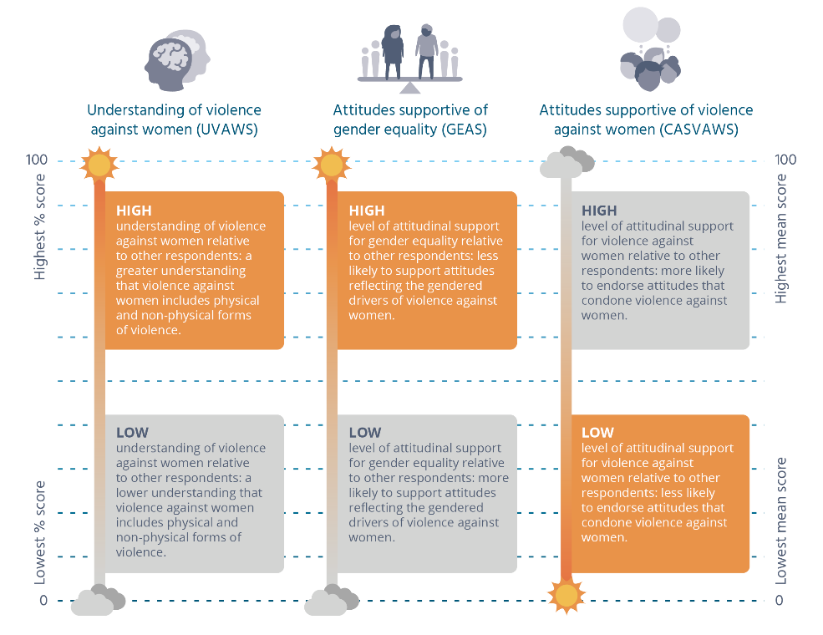
Definitions of high/low percentage and mean scores for composite measures
Composite measure | A high score means | A low score means
Understanding of violence against women (UVAWS) | A high understanding of violence against women relative to other respondents: a greater understanding that violence against women includes physical and non-physical forms of violence. | A low understanding of violence against women relative to other respondents: a lower understanding that violence against women includes physical and non-physical forms of violence.
Attitudes supportive of gender equality (GEAS) | A high level of attitudinal support for gender equality relative to other respondents: less likely to support attitudes reflecting the gendered drivers of violence against women. | A low level of attitudinal support for gender equality relative to other respondents: more likely to support attitudes reflecting the gendered drivers of violence against women.
Attitudes supportive of violence against women (CASVAWS) | A high level of attitudinal support for violence against women relative to other respondents: more likely to endorse attitudes that condone violence against women. | A low level of attitudinal support for violence against women relative to other respondents: less likely to endorse attitudes that condone violence against women.
Although this approach is useful for comparing groups, in the previous example it would be wrong to say that 20 percent of men have a high level of endorsement of attitudes towards violence against women in an absolute sense. This is because the thresholds or ‘cutoff points’ for the categories are assigned by the NCAS research team using statistics (quartiles). Each category is ‘high’ or ‘low’ relative only to the other two categories. This approach is taken because, at present, knowledge about the impact of attitudes at the individual or group level is not well enough developed to enable us to identify a scale score level at which negative consequences are likely (see for example Edwards, Turchik, Dardis et al., 2011). This is in contrast to other health and social problems for which it is possible to identify the point at which something becomes a problem. For example it is widely agreed that if a child has a temperature of between 38ºC and 40ºC, further investigation is warranted. This is based on evidence from many studies and clinical experience showing that this is the temperature range at which adverse health outcomes are more likely.
Figure 7-1 shows the meaning of the scores for each of the three key measures, noting that the meaning of a ‘high’ or ‘low’ score varies between each of the measures. For reasons discussed in Section 4, the objective of preventing violence against women is best served through a high proportion of people having a good understanding of violence against women, a tendency to endorse gender equality and to dis-endorse attitudes supportive of violence against women. This means we are aiming for a larger proportion of people with:
- high UVAWS scores or in the ‘high’ UVAWS category (compared with people with low scores or in the low category);
- high GEAS scores or in the ‘high’ GEAS category (compared with people with low scores or in the low category); and
- low CASVAWS scores or in the ‘low’ CASVAWS category (compared with people with high scores or in the high category).
Multivariate analysis was also used in this report for exploring relationships between factors after the influence of other factors has been taken into account (see Section 13). The raw score for each of the composite measures was used in these analyses. Further detail on the multivariate models can be found in the methodology report on the ANROWS website (ncas.anrows.org.au).

7.7 Gender
Respondents were asked what gender they identified with. Thirty-one people did not identify as male or female and seven people did not respond to the question. There was only sufficient sample size to provide details of males and females. There was insufficient data to compare persons who did not nominate a gender to those identifying as either male or female.
Further detail on how people identifying as ‘other’ or who did not respond to the question were treated in the analysis can be found in the detailed methodology report on the ANROWS website (ncas.anrows.org.au).

7.8 Young people, people from non-English speaking backgrounds and Aboriginal people and Torres Strait Islanders
Samples of young people, people from non-English speaking backgrounds and Aboriginal people and Torres Strait Islanders were formed through the main NCAS sample. These respondents are included in the analysis in this report. Separate analysis is being conducted within each of these samples and will be reported in three dedicated reports (forthcoming). For this reason, analysis within these groups is not addressed in this report.

8 Benchmarking knowledge and understanding of violence against women
Five areas of knowledge are measured in the questionnaire. The first of these is an understanding of what behaviours constitute violence against women. This was measured through ten single questions. Selected questions within this series were also used to form a scale, the UVAWS. In Section 8.1, frequencies and change over time data are reported for each of the individual questions in the scale. Change over time is reported for both the individual questions (in Section 8.1) and the scale (in Section 8.2).
In addition, there are individual questions that measure knowledge pertaining to the law, patterns of violence against women, factors contributing to violence, and knowledge of services providing help regarding domestic violence. These questions are not included in a scale. However, frequencies and change over time (where applicable) are reported for each individual question.

8.1 Community understanding of violence against women
Respondents were presented with a series of descriptions of ten behaviours, on a continuum from physical violence through to social, emotional and financial forms of abuse. They were asked first whether these behaviours were a form of domestic violence or violence against women. If they agreed that these were, they were asked whether this was ‘always’, ‘usually’ or ‘sometimes’. The second part of the question is asked to establish the extent of certainty in people’s thinking about which behaviours constitute violence and which do not; that is, whether or not they think such behaviours are unequivocally domestic violence whenever they occur. These questions are deliberately framed to capture the repeated, controlling or abusive intent of the behaviour.

Although recognising that domestic violence can take many forms, Australians are less likely to be aware of non-physical violence
A substantial majority of the sample (over 80% or more depending on the behaviour) recognised all of the behaviours put to them as a form of domestic violence or violence against women either ‘always’, ‘usually’ or ‘sometimes’ (Figure 8-1). The proportion recognising obvious physical forms of violence ranges from between 96 percent (throwing or smashing objects) to 98 percent (threatening to hurt others). This is slightly higher than the proportion agreeing that non-physical forms are ever violence, which ranges from 81 percent for financial control to 92 percent for stalking and for repeatedly criticising a partner to make them feel bad and useless. In other words, people are a little more likely to recognise physically coercive forms of behaviour as violence than they are to recognise non-physical forms. There are no differences between men and women for the physically coercive behaviours. However, men are less likely than women to recognise most of the non-physical forms as domestic violence or violence against women including repeatedly criticising a partner (89% of men vs 95% of women), controlling a partner’s social life (88% vs 95%), denying a partner money (73% vs 88%) and repeatedly keeping track of a partner using electronic means (77% vs 92%).
Compared with those recognising the behaviours as ‘ever’ (i.e. ‘always’, ‘usually’ or ‘sometimes’) domestic violence or violence against women, the proportion recognising these behaviours as ‘always’ violence is somewhat smaller for each behaviour (Figure 8-2). For the behaviours involving physical forms of violence, this is still a substantial majority, ranging from 76 percent for throwing and smashing objects to 88 percent for threatening to hurt others. However, the proportion recognising social, emotional, financial and electronic means of control as ‘always’ violence is smaller, ranging from only half the sample (in the case of financial control) to 70 percent in the case of controlling the social life of one’s partner.
The patterns of variation between behaviours in the proportion agreeing that a behaviour is ‘ever’ as opposed to ‘always’ violence is similar, although there are some minor exceptions. Again, there are no differences between men and women for the physical behaviours. However, men are less likely than women to identify many of the non-physical behaviours as ‘always’ domestic violence or violence against women, including repeatedly criticising a partner (56% of men vs 68% of women), controlling a partner’s social life (63% vs 78%), denying a partner money (41% vs 59%) and repeatedly keeping track of a partner using electronic means (51% vs 69%).

2013 to 2017 has been a period of increasing awareness of the dynamic of domestic violence
There has been an improvement on all of the measures since they were first asked in either 1995 or 2009 (with the exception of ‘slapping and pushing’, which was already recognised as a form of domestic violence by almost all Australians in 1995) (Figure 8-1). Between 2009 and 2013, there was almost no change in the proportion recognising the behaviours as ‘always’, ‘usually’ or ‘sometimes’ violence. However, between 2013 and 2017, there was improvement on most of the questions about non-physical forms of violence. The most notable of these was for financial control, increasing by 11 percentage points. However, there were also increases in the proportion recognising repeated criticism (seven percentage points) and controlling the social life of a partner (six percentage points).
Figure 8-1: Percentage agreeing~ that certain behaviours are a form of domestic violence/violence against women, 1995, 2009, 2013 and 2017 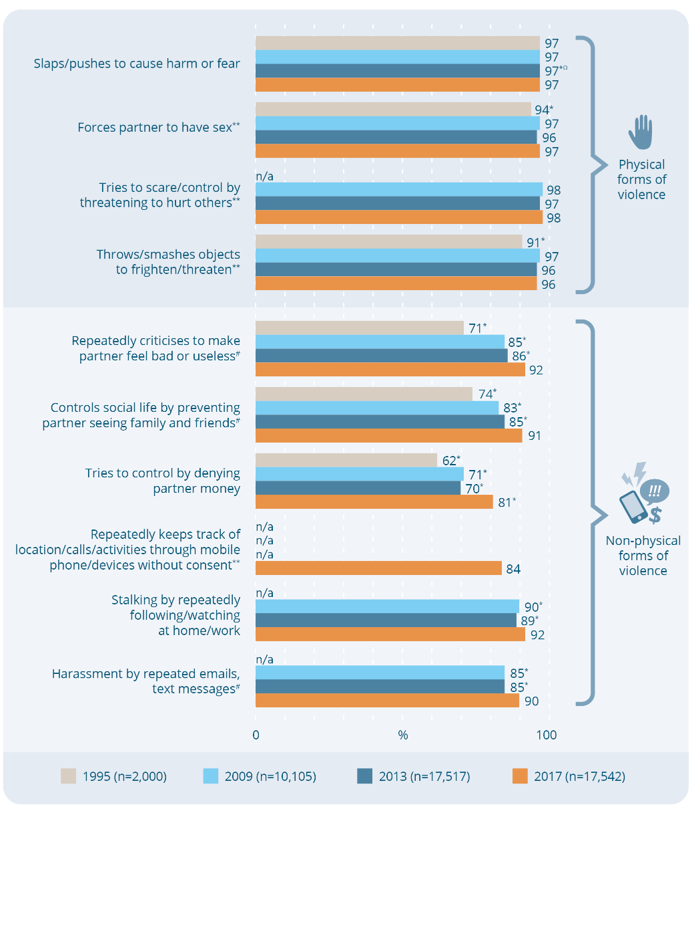
Percentage agreeing~ that certain behaviours are a form of domestic violence/violence against women, 1995, 2009, 2013 and 2017
Physical forms of violence
Action | 1995  (n=2,000) (%) | 2009  (n=10,105) (%) | 2013  (n=17,517) (%) | 2017  (n=17,542) (%)
Slaps/pushes to cause harm or fear | 97 | 97 | 97*^{Ω} | 97
Forces partner to have sex** | 94* | 97 | 96 | 97
Tries to scare/control by threatening to hurt others** | n/a | 98 | 97 | 98
Throws/smashes objects to frighten/threaten** | 91* | 97 | 96 | 96
Non-physical forms of violence
Action | 1995  (n=2,000) (%) | 2009  (n=10,105) (%) | 2013  (n=17,517) (%) | 2017  (n=17,542) (%)
Repeatedly criticises to make partner feel bad or useless# | 71* | 85* | 86* | 92
Controls social life by preventing partner seeing family and friends# | 74* | 83* | 85* | 91
Tries to control by denying partner money | 62* | 71* | 70* | 81*
Repeatedly keeps track of location/calls/activities through mobile phone/devices without consent** | n/a | n/a | n/a | 84
Stalking by repeatedly following/watching at home/work | n/a | 90* | 89* | 92
Harassment by repeated emails, text messages# | n/a | 85* | 85* | 90
Note: Each of the questions in this series was deliberately framed to capture the intent of the behaviour (i.e. to control, intimidate or abuse).
Note: These questions make up the UVAWS.
^{Ω} There is a significant difference of less than one percent between 2013 and 2017. This is not apparent in the figure as all values have been rounded.
* Difference between survey year and 2017 is statistically significant, p≤.01.
# Asked of half the sample in 2017.
** Asked of a quarter of the sample in 2017.
n/a The question was not asked in the survey year.
~ Percent agree combines responses of ‘always’, ‘usually’ and ‘sometimes’.

Figure 8-2: Responses to questions asking if certain behaviours are a form of domestic violence/violence against women, 2017 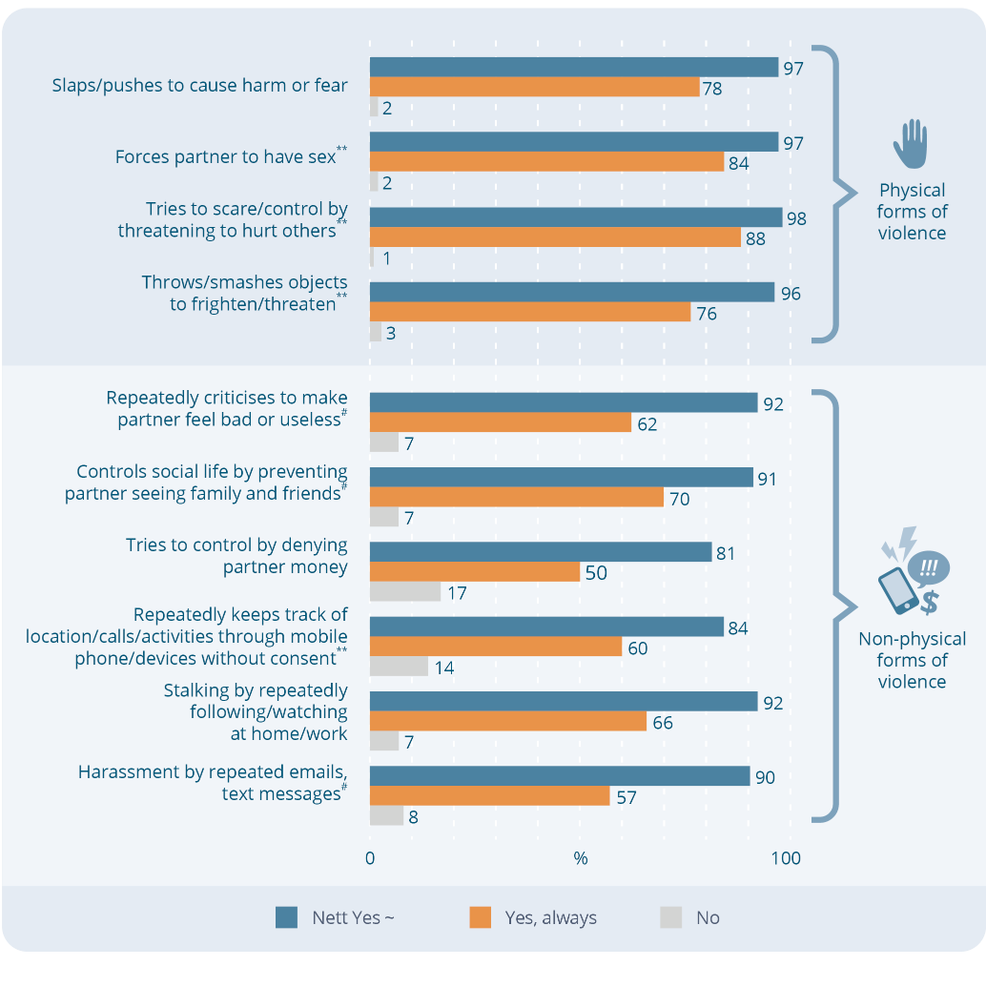
Responses to questions asking if certain behaviours are a form of domestic violence/violence against women, 2017
Physical forms of violence
Action | Nett Yes~ (%) | Yes, always (%) | No (%)
Slaps/pushes to cause harm or fear | 97 | 78 | 2
Forces partner to have sex** | 97 | 84 | 2
Tries to scare/control by threatening to hurt others** | 98 | 88 | 1
Throws/smashes objects to frighten/threaten** | 96 | 76 | 3
Non-physical forms of violence
Action | Nett Yes ~ (%) | Yes, always (%) | No (%)
Repeatedly criticises to make partner feel bad or useless# | 92 | 62 | 7
Controls social life by preventing partner seeing family and friends# | 91 | 62 | 7
Tries to control by denying partner money | 81 | 50 | 17
Repeatedly keeps track of location/calls/activities through mobile phone/devices without consent** | 84 | 60 | 14
Stalking by repeatedly following/watching at home/work | 92 | 66 | 7
Harassment by repeated emails, text messages# | 90 | 57 | 8
Note: Each of the questions in this series was deliberately framed to capture the intent of the behaviour (i.e. to control, intimidate or abuse).
Note: These questions make up the UVAWS.
# Asked of half the sample in 2017.
** Asked of a quarter of the sample in 2017.
~ Percent ‘Nett Yes’ combines responses of ‘always’, ‘usually’ and ‘sometimes’.

Box 8-1: Understanding of what behaviours constitute violence against women
Why does it matter?
The National Plan is underpinned by the definition in the UN Declaration on the Elimination of Violence against Women (UN, 1993). Violence against women is defined as occurring on a continuum from behaviours designed to intimidate and cause psychological harm to women through to those involving forced sex and physical injury. Understanding that violence can extend beyond physical violence is important because of the prevalence of social, psychological and financial forms of abuse. Studies have shown that these forms of violence can be as damaging, if not more damaging, to women’s health than physical violence (Ayre, Lum On, Webster et al., 2016; Lum On, Ayre, Webster et al., 2016).
Controlling behaviours in a relationship can be an early warning sign of behaviours that may progressively become more serious (Centre for Innovative Justice, 2015). They may be more readily apparent to family and friends than physical forms and hence may be a signal that other forms of abuse are occurring. If the community are aware of the meaning of these behaviours they can more readily identify situations in which violence may be occurring and play a constructive role, both among women affected by the behaviours and with men engaged in them. This is suggested by studies showing that people who have a good understanding that violence against women comprises a continuum of behaviours are more likely than those who do not to reject other false beliefs about violence against women (Tam & Tang, 2005).
In intimate partner violence, physical violence is often accompanied by abusive, controlling and intimidating behaviours, or these may occur without physical violence. This helps to explain the serious and long term consequences of this violence (Belknap & Melton, 2005; Caldwell, Swan, & Woodbrown, 2012; Clark & Quadara, 2010; Hamberger & Larsen, 2015; Myhill, 2015; Stark, 2009). This complexity is also among the factors explaining why women may find it hard to take action to seek safety from such relationships (Meyer, 2012). Understanding these complexities can help to ensure that people around women affected by violence offer appropriate support.
Although there is continuing debate among relevant experts (Wangmann, 2011), many believe that the common co-occurrence of physical violence with controlling, intimidating and abusive behaviours provides insight into the motivations of men who use violence against women. This understanding in turn informs work undertaken with men who use violence against women as well as efforts to prevent the problem (Our Watch, ANROWS, & VicHealth, 2015; WHO, 2010). Contemporary approaches to working with men who use violence seek to address the physical violence, alongside the use of tactics of control, intimidation and abuse (Centre for Innovative Justice, 2015; MacKay, Gibson, Lam et al., 2015). Family, friends and others who understand the complex dynamic of violence are more likely to support these approaches when communicating with men who use violence.
Learning to distinguish normal conflict from behaviour that is controlling and abusive is a key component of healthy relationships education, a key strategy to prevent violence against women among young people (Flood, Fergus, & Heenan, 2009; Gleeson, Kearney, Leung et al., 2015; Ollis, 2014). This understanding also increases the likelihood that the key messages in healthy relationships education are reinforced in other environments, such as in a family or school community (Gleeson, Kearney, Leung et al., 2015).
Laws in some states and territories protect women against some non-physical forms of abuse. Understanding that non-physical abuse is a form of violence may make it more likely that affected women are aware that they can access the protection of the law.

8.2 Change in understanding of violence against women over time
The findings for individual questions that have been asked in more than one wave of the survey are reported in Figure 8-1. Figure 8-3 shows the change for the UVAWS as a whole. The highest score is 100 and the lowest is 1. For the UVAWS, the higher the value of the score, the higher a person’s level of understanding that violence against women involves a continuum of abusive, controlling and intimidating behaviours. There has been a statistically significant improvement in the mean score, from 64 in 2009 and 2013 to 70 in 2017.
Understanding of the continuum of violence has improved among both men and women. When comparing the effect size of the change between the 2009 and 2017 waves of the survey, the effect is greater between 2009 and 2017 (0.3184) than between the 2013 and 2017 waves (0.3144), meaning that over a longer period of time there has been greater improvement. This is a positive result for the UVAWS, illustrating what would be expected with change in knowledge. Such change takes time and this report documents a slow but steady overall improvement.
Figure 8-3: Changes in understanding of violence against women over time, 2009, 2013 and 2017 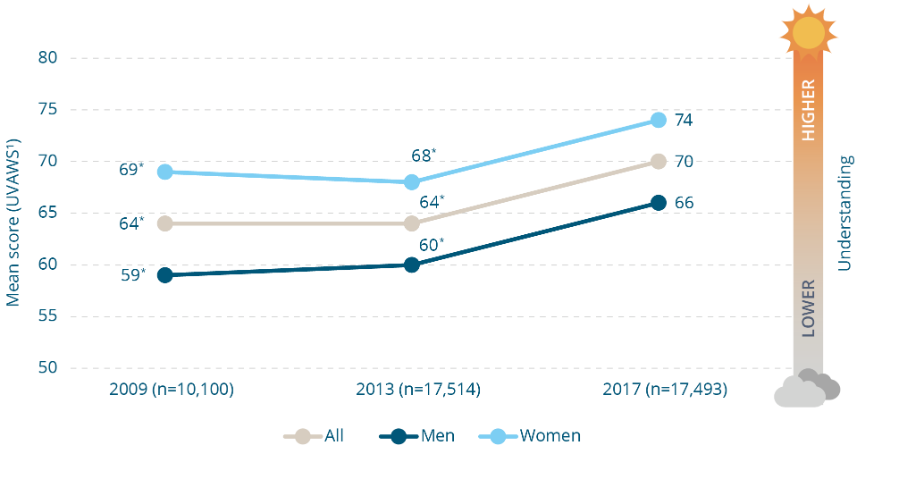
Changes in understanding of violence against women over time, 2009, 2013 and 2017.
Mean scores for the UVAWS - a higher score indicates a better understanding of violence
Group | 2009 (n=10,100) | 2013 (n=17,514) | 2017 (n=17,493)
All | 64* | 64* | 70
Men | 59* | 60* | 66
Women | 69* | 68* | 74
* Difference between survey year and 2017 is statistically significant, p≤.01.
¹ Measured using the composite measure described in Section 5.2.

Box 8-2: Terminology: intimate partner violence, family violence and domestic violence
Methodological note
Several terms related to violence against women are used in this report.
In contemporary research and policy, the term intimate partner violence is generally used to distinguish violence occurring between people in an intimate relationship and the term family violence to encompass intimate partner violence, but also to include violence involving other family members (e.g. violence between siblings). Recognising this, the term ‘intimate partner violence’ is used in this report, except when referring to NCAS questions and findings that use the terminology of domestic violence. Many of the questions in the survey use the term domestic violence, because this is the term used when they were first asked nationally in 1995. The terminology of domestic violence was retained in the questions in which it was used in 2013 to enable the 2017 results to be compared with previous NCAS waves.
The NCAS encompasses four forms of violence: intimate partner violence, sexual assault, sexual harassment and stalking. The term ‘violence against women’ is used when referring to two or more of these forms of violence.
In the cognitive testing conducted for the 2017 questionnaire (see Figure 5-2) people were asked what they understood the term ‘domestic violence’ to encompass. This showed that people generally have a wider range of relationships in mind when they think about ‘domestic violence’ than just relationships between men and women (e.g. violence against elders or against a sibling).
Respondents were advised at key points in the telephone interview that in the survey ‘domestic violence’ included violence in a married or de-facto relationship or amongst couples who are dating. It is not possible to know if people kept this in mind when answering questions using this term, or whether responses to previous surveys may have been different when the term ‘domestic violence’ was not explicitly defined as was the case in 2017.

Box 8-3: Past NCAS finding: perceived seriousness of behaviours
Methodological note
Responses to prior waves of the NCAS show that when people say a behaviour is domestic violence or violence against women, they also think the behaviour is serious. The questions regarding behaviours have been asked since the first survey in 1995. In previous waves of the survey, they included a third part, whereby people were asked if they thought the behaviours were serious. There was a pattern in responses to the first and second parts of the question (asking people if they recognised the behaviours as violence) and the third part (asking them if they regarded it as serious). If a large proportion of people thought a behaviour was domestic violence or violence against women, a similarly large proportion agreed that it was serious, whereas if a smaller proportion regarded it as domestic violence, a similarly smaller proportion regarded that behaviour as serious. This suggests that people have the perceived seriousness of each of the behaviours in mind when they are thinking whether or not they constitute violence against women. Therefore it can reasonably be assumed that when people in the 2017 survey say they thought a behaviour was domestic violence or violence against women, they also thought the behaviour concerned was serious.

8.3 Other measures of knowledge
This sub-section reports on the findings of individual questions measuring knowledge of violence against women. These questions were not included in a scale.

One in ten either agree or do not know whether it can only be rape if a woman physically resists
Only 7 percent agree with the statement ‘if a woman doesn’t physically resist – even if protesting verbally – then it isn’t really rape’. This was three percentage points less than in 2013, when it was 10 percent of the sample. While only 7 percent in 2017 agree, a further 4 percent report that they do not know if it is rape only when physical resistence is involved (Figure 8-4).

One quarter of Australians are not aware that false allegations of sexual assault are rare
Just over one in six people (16%) agree that many allegations of sexual assault made by women are false and a further 9 percent do not know (Figure 8-5). Women are more likely to disagree with this statement than men (77% vs 67%) (data not shown).
The wording of this statement was changed in 2017 to make it clearer. Between 1995 and 2013, the question was worded ‘women rarely make false claims of being raped’. There was no change in responses to this question across these three survey waves (VicHealth, 2014). These results cannot be directly compared with the 2017 question owing to the changed wording between surveys.
Box 8-4: Knowledge of the law pertaining to consent
Why does it matter?
Historically, courts often failed to convict on charges of rape or sexual assault unless women could show that they had actively resisted or assertively communicated their lack of consent. Reform of laws and procedures in recent years has begun to reflect the idea of ‘positive consent’; that is, consent to sexual relations must be freely and voluntarily given. Further, the absence of active non-consent does not necessarily imply consent (Crowe & Sveinsson, 2017; Fileborn, 2011; Larcombe, 2012). These reforms were designed to respond to the complex circumstances in which much sexual violence occurs, as discussed in Box 8-9 and Box 10-7, as well as to reflect a more respectful and negotiated approach to sexual relations (Flynn & Henry, 2012).
Figure 8-4: Responses to ‘if a woman doesn’t physically resist – even if protesting verbally – then it isn’t really rape’, 2013 and 2017 (%) 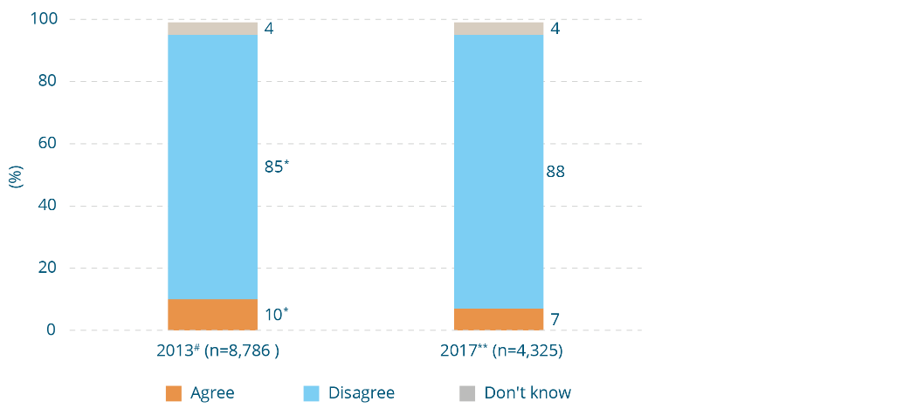
Responses to ‘if a woman doesn’t physically resist – even if protesting verbally – then it isn’t really rape’, 2013 and 2017 (%)
Response | 2013# (n=8,786) (%) | 2017** (n=4,325) (%)
Agree | 10* | 7
Disagree | 85* | 88
Don’t know | 4 | 4
* Difference between survey years and 2017 is statistically significant, p≤.01.
** Asked of a quarter of the sample in 2017.
# Asked of half the sample in 2013.
Figure 8-5: Responses to ‘many allegations of sexual assault made by women are false’, 2017, and ‘women rarely make false claims of being raped’, 2013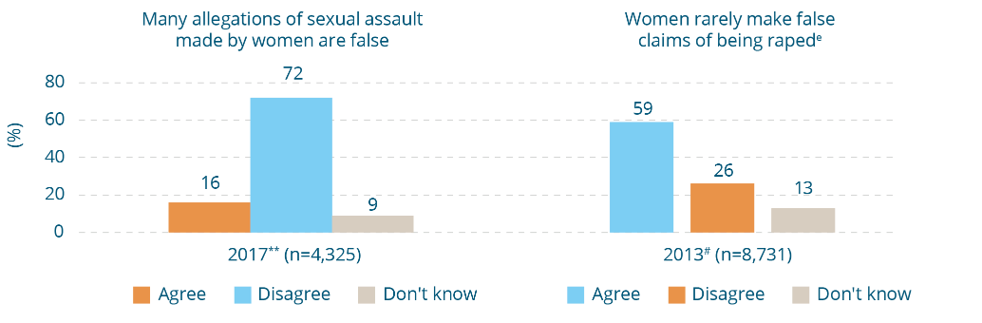

Responses to ‘many allegations of sexual assault made by women are false’, 2017, and ‘women rarely make false claims of being raped’, 2013
Many allegations of sexual assault made by women are false
Response | 2017** (n=4,325) (%)
Agree | 16
Disagree | 72
Don’t know | 9
Women rarely make false claims of being raped ^{e}
Response | 2013# (n=8,731) (%)
Agree | 59
Disagree | 26
Don’t know | 13
** Asked of a quarter of the sample in 2017.
# Asked of half the sample in 2013.
^{e} Reverse scored question.
Box 8-5: Knowledge that false allegations are rare
Why does it matter?
Different rates for false allegations are cited in existing studies and these range from 1.2 percent to 10 percent of all reports to police (Ferguson & Malouff, 2016; Heenan & Murray, 2006; Kelly, 2010; Levitt & The Crown Prosecution Service Equality and Diversity Unit, 2013; Lisak, Gardinier, Nicksa et al., 2010; Lonsway, Cortina, & Magley, 2008; Patton & Snyder-Yuly, 2007; Spohn, White, & Tellis, 2014; Weiser, 2017). This clearly indicates that false allegations are not made ‘often’. The rate of false allegations of sexual assault is as low, if not lower, than for other offences (Kelly, 2010).
It is difficult to determine the actual rate of false allegations of sexual assault and it is probable that the actual rate is at the lower end of the range cited. This is because there is variation in how false allegations are defined (Kelly, 2010). Studies that have audited reports labelled ‘false’ show that this can be for many reasons other than a woman retracting the claim as false or a false allegation being legally substantiated (Kelly, 2010). For example, in a study in the UK it was shown that a large proportion of allegations deemed false were identified as such by the police (Kelly, 2010). However, in these cases the possibility cannot be excluded that this assessment was itself influenced by negative assessments of rape victims and their perceived ‘credibility’ by police (McMillan, 2016; Venema, 2016).
Indeed, the key problem in sexual assault reporting is not with false allegations, but rather that sexual assault is under-reported (Cox, 2015; Daly & Bouhours, 2010; Hohl & Stanko, 2015) particularly when compared with reporting of other offences (Kelly, 2010) and that women are not believed (Avalos, 2017). Moreover, when reported, cases of sexual assault are less likely to be prosecuted or to result in a conviction (Lievore, 2005).
The view that women often make false allegations of sexual assault:
- diverts attention from under-reporting as a key problem in preventing and responding to sexual assault (Belknap, 2010);
- may act as a disincentive to women disclosing and reporting (Hohl & Stanko, 2015; Lisak, Gardinier, Nicksa et al., 2010; Lonsway & Archambault, 2012);
- may negatively influence the responses of police, prosecutors, judicial personnel and juries (Carpenter, 2017; Cook & Messman-Moore, 2018; Dwyer, Easteal, & Hopkins, 2012; Taylor, 2007);
- has been identified as a factor in low rates of reporting, prosecution and conviction (Larcombe, 2011; Lisak, Gardinier, Nicksa et al., 2010; Lonsway & Archambault, 2012);
- may inhibit women’s recovery from the effects of sexual violence (see Section 4); and
- contributes to an environment of impunity, working against the law playing a role in reinforcing social norms against the use of sexual violence. In some cases documented in the literature, a report has been incorrectly treated as false and the perpetrator has subsequently engaged in serial offending (Kelly, 2010).
A further concern is evidence showing that groups of women least likely to be believed are among the most vulnerable to sexual assault, including women with mental health problems and learning difficulties (Kelly, 2010).
The belief that women often make false reports may also lead to women being unfairly prosecuted for false reporting or being accused of vexatious litigation (Levitt & The Crown Prosecution Service Equality and Diversity Unit, 2013). This is more likely to occur in cases involving vulnerable women (including women affected by alcohol) or cases that are more complex and difficult to investigate, involve questions raised about a woman’s ‘reputation’ or her demeanour, or involve a delay in reporting (Avalos, 2017; Jordan, 2004; Weiser, 2017; Weiss, 2010). This may act as a further disincentive to women making reports in these circumstances.

Nearly one in five Australians are not clear that coerced sex in marriage is against the law
In previous NCAS waves, questions have been asked to establish knowledge of the law regarding domestic violence and non-consensual sex in a relationship. The statement ‘domestic violence is a criminal offence’ had been included in the survey since 1995 and was agreed to by a large percentage of the sample (96% in 2013). Given this consistently high level of awareness of this aspect of the law, this was not retained in 2017.
In contrast, a slightly larger proportion of the sample (9% in 2013) were not aware of the law pertaining to rape in the context of a relationship and this was substantially higher in some sub-samples. Cognitive testing of this question as worded in 2013 showed that it was not readily understood by some participants. Accordingly, it was reworded in 2017. The statement was deliberately limited to non-consensual sex in the context of marriage to exclude the possibility that people may have a different understanding of the law pertaining to sexual coercion in marriage as opposed to coercion in other intimate relationships (e.g. dating relationships). The findings for both the 2017 and 2013 questions are presented in Figure 8-6, noting that they cannot be directly compared owing to the changed wording.
Although the majority of Australians (81%) are aware that non-consensual sex in marriage is against the law, more than one in ten (12%) mistakenly believe that it is not against the law and a further 7 percent say that they do not know.
Figure 8-6: Responses to ‘it is a criminal offence for a man to have sex with his wife without her consent’, 2017, and ‘a woman cannot be raped by someone she is in a sexual relationship with’, 2013 (%)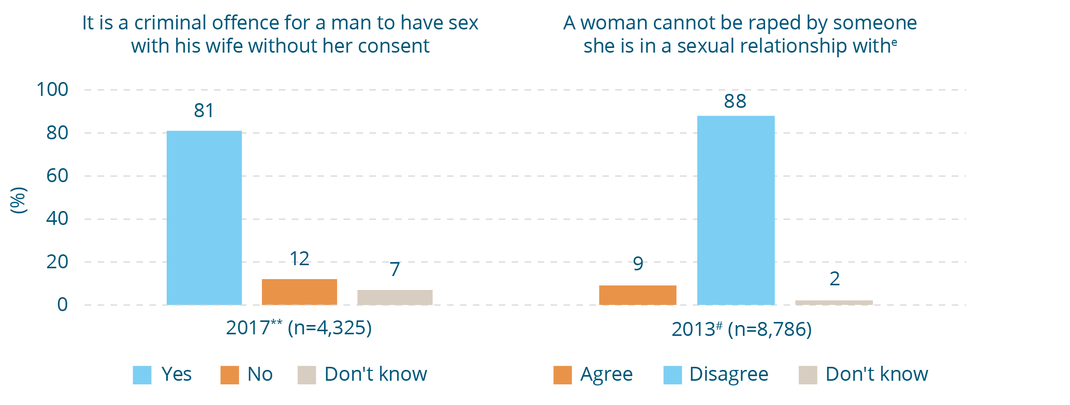
Responses to ‘it is a criminal offence for a man to have sex with his wife without her
consent’, 2017, and ‘a woman cannot be raped by someone she is in a sexual relationship with’, 2013 (%)
It is a criminal offence for a man to have sex with his wife without her consent
Response | 2017** (n=4,325) (%)
Yes | 81
No | 12
Don’t know | 7
A woman cannot be raped by someone she is in a sexual relationship with^{e}
Response | 2013# (n=8,786) (%)
Yes | 9
No | 88
Don’t know | 2
** Asked of a quarter of the sample in 2017.
# Asked of half the sample in 2013.
^{e} Reverse scored question.

Box 8-6: Knowledge of the law pertaining to coerced sex in marriage
Why does it matter?
Whether the law is an effective deterrent in preventing individuals from perpetrating violence against their partners is subject to debate (Buzawa, Buzawa, & Stark, 2012; Manning, 1996). However, the law can play an important symbolic role by strengthening social norms against violence (Salazar, Baker, Price et al., 2003). Social norms can in turn influence whether individuals perpetrate violence and how family, friends and others respond to it (Bohner, Siebler, & Schmelcher, 2006; Gidycz, Orchowski, & Berkowtiz, 2011; Hoxmeier, Flay, & Acock, 2018). Women who are aware that violence is against the law are also less likely to blame themselves (Egan & Wilson, 2012) and this can in turn increase their prospects of recovery.
Historically, many countries around the world have not explicitly criminalised coerced sex in marriage, the notion being that marriage implies consent by a wife to all sexual intercourse with her husband. In Australia, it was assumed that under the common law – judge-made law – there could be no liability for rape in marriage. Starting with South Australia in 1976, legislatures throughout Australia enacted legislation removing this exemption during the 1980s. This was part of a broader trend towards reforming laws pertaining to intimate partner violence and sexual assault. Interestingly, in 2012, the High Court in PGA v R (2012) HCA21; 245 CLR 355 held that if the marital rape exemption was ever part of the common law of Australia, it had ceased to exist long before the formal legislative changes in the 1980s due to changes in the law of marriage and other progressive social changes (Larcombe & Heath, 2012).
Today, 37 countries around the world do not have laws criminalising coerced sex in marriage (UN Women, 2018).

The majority of Australians agree that violence against women is common
Seventy-two percent of Australians (64% of men and 80% of women) agree that violence against women is common, and this is higher than in 2013, when it was 68 percent, although not significantly different than 2009 (74%) when the question was first asked nationally (Figure 8-7). It is important to note that there has been an increase in the proportion disagreeing that violence against women is common (15% in 2009 to 20% in 2017).

Knowledge that sexual assault is more likely to be perpetrated by a known person has declined since 1995
The 2016 PSS shows that women who reported sexual assault were over three times more likely to have been assaulted by a person known to them than by a stranger (ABS, 2017). Consistent with this, nearly two thirds of Australians agree that a ‘woman is more likely to be raped by someone they know than a stranger’ (64%). However, there has been an overall decline in the proportion recognising that women are more likely to be raped by someone they know than a stranger, from 76 percent in 1995 to 70 percent in 2009 and 64 percent in 2013 and 2017 (Figure 8-8).

Box 8-7: Knowledge that violence against women is common
Why does it matter?
Studies show that people who recognise that violence against women is common are more likely to say that they would provide assistance to a woman if they witnessed violence taking place against her (Gracia & Herrero, 2006). Further, decision-makers may be more likely to take action on a problem if they are persuaded that the community perceive it to be common (Burnstein, 2003).
Figure 8-7: Responses to ‘violence against women is common in our community’, 2009, 2013 and 2017 (%)
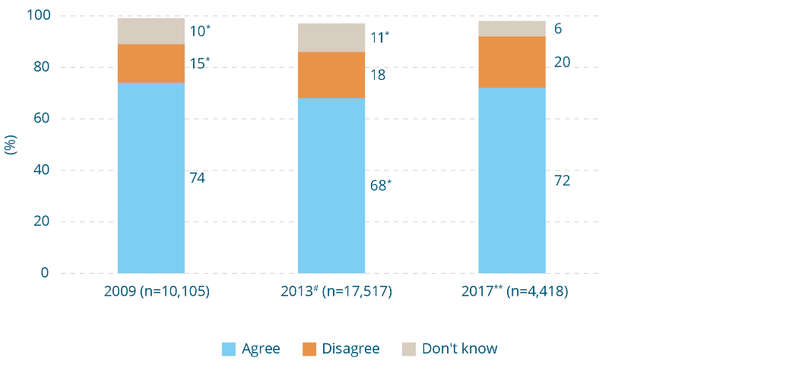
Responses to ‘violence against women is common in our community’, 2009, 2013 and 2017 (%)
Response | 2009 (n=10,105) (%) | 2013# (n=17,517) (%) | 2017** (n=4,418) (%)
Agree | 74 | 68* | 72
Disagree | 15* | 18 | 20
Don’t know | 10* | 11* | 6
Note: This is a reverse scored question.
* Difference between survey years and 2017 is statistically significant, p≤.01.
** Asked of a quarter of the sample in 2017.
# Asked of half the sample in 2013.
Figure 8-8: Responses to ‘women are more likely to be raped by someone they know than by a stranger’, 1995, 2009, 2013 and 2017 (%) 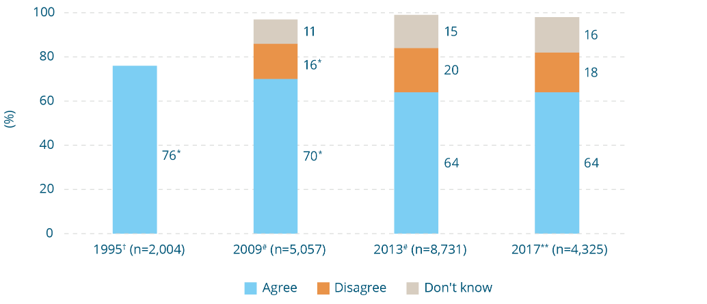
Responses to ‘women are more likely to be raped by someone they know than by a stranger’, 1995, 2009, 2013 and 2017 (%)
Response | 1995† (n=2004) (%) | 2009#  (n=5,057) (%) | 2013#  (n=8,731) (%) | 2017**  (n=4,325) (%)
Agree | 76* | 70* | 64 | 64
Disagree | - | 16* | 20 | 18
Don’t know | - | 11 | 15 | 16
Note: This is a reverse scored question.
* Difference between survey years and 2017 is statistically significant, p≤.01.
** Asked of a quarter of the sample.
# Asked of half the sample.
† Only ‘agree’ data is available for 1995.
Box 8-8: Knowledge of a higher risk of sexual assault by a known person
Why does it matter?
The false belief that women are at higher risk of rape by a stranger:
- leads to exaggerated fears of stranger rape, and potentially to women restricting their movements in order to avoid it (Ryan, 2011);
- may contribute to the neglect of rape by known persons in legal and policy reform; and
- is the foundation of what researchers call the ‘real rape script’.
Compared with other crimes against the person, sexual assaults are less likely to be reported, to be prosecuted and to result in conviction (Larcombe, 2011). Researchers have attributed this, in part, to the ‘real rape script’, a story or cultural script that many people hold about what constitutes a ‘real’, ‘credible’ or ‘genuine’ rape (Estrich, 1986). Studies show that the more the circumstances of a sexual assault depart from the ‘real rape script’, the greater the chances that blame will be transferred from perpetrator to victim. This is evident in the responses of victims who are less likely to report (Egan & Wilson, 2012), those to whom they may turn for assistance (Cohn, Dupuis, & Brown, 2009; Grubb & Harrower, 2008; Harrison, Howerton, Secarea et al., 2008; Krahé, Temkin, & Bieneck, 2007; Krahé, Temkin, Bieneck et al., 2008; Weiss, 2009) and in outcomes in the criminal justice system (Ellison & Munroe, 2009a,b; Larcombe, 2011).
The ‘real rape script’: myth and reality
Factor | Myth: the ‘real rape script’ | Reality
Time and place | In a dark secluded place, outdoors, late at night. | Often a domestic, workplace or social setting (Brecklin & Ullman, 2002; Clark & Quadara, 2010; Untied, Orchowski, & Lazar, 2013).
Victim | Conservatively dressed and of ‘good character’, not affected by alcohol, no history of mental health or cognitive problems. Typically alone at the time of the assault. | In about half of all reported sexual assaults either the victim or perpetrator have been drinking (Abbey, 2011).  A disproportionate number of victims have disabilities that make them particular targets for assault (Heenan & Murray, 2006).
Perpetrator | Unknown to the victim. | Three times more likely to be known to the victim (ABS, 2017) and may be a person with whom the victim has previously had consensual sex or has spent some time with prior to the assault. Often a man who is socially more powerful than the victim (e.g. a workplace superior).
Consent | Physical force is used, involving aggression and weapons. | Submission typically secured through instilling fear and other forms of psychological coercion (Lievore, 2003).  Weapons rarely involved (Lievore, 2003).
Victim response | Physical resistance resulting in visible physical injury. | A diversity of responses, which may include women psychologically dissociating themselves and giving the appearance of becoming ‘frozen’ (Mason & Lodrick, 2013). A large proportion of sexual assaults do not involve physical injury (Lievore, 2003).

There has been a continuing decline in understanding of the gendered patterns of domestic violence
The gendered patterns of intimate partner violence are outlined in Box 8-10. Survey respondents were asked questions to gauge the extent to which they understood these. Consistent with the evidence (shown in Box 8-9), 64 percent of the sample agree that it is mainly men, or men more often, who commit domestic violence (Figure 8-9). Men are more likely than women to agree that men and women are equally likely to perpetrate domestic violence (39% vs 25%). In 2017, again consistent with the evidence, a majority of Australians agree that women are more likely to experience physical harm (81%). However, despite evidence showing that women are more likely to experience fear as a result of intimate partner violence than are men, only 49 percent of the sample believe that the level of fear is higher for women. Only 1 percent believe that fear is worse for men. However, 48 percent believe that the level of fear is equally great for both men and women (data not shown).
There was a statistically significant decline in the proportion of Australians agreeing that violence is perpetrated by men or mainly men between 1995 (86%), 2009 (74%) and 2013 (71%). This trend continued in 2017 (64%) (Figure 8-9).
Between 2009 and 2013, there was a similar trend on the questions on impacts of domestic violence on men and women. The proportion agreeing that women were more likely to experience physical harm, or that fear associated with violence was worse for women, declined between 2009 and 2013 by three percentage points. In 2017, this trend continued for physical harms, with the proportion agreeing that physical harms were greater for women decreasing by five percentage points (from 86% in 2013 to 81% in 2017).
In summary, the results from these questions show that while the majority of Australians understand that men are more likely than women to perpetrate domestic violence and that women are more likely to suffer physical harms, this majority has declined steadily over NCAS waves. In 2017, the proportion recognising gender differences in fear associated with domestic violence was below 50%.
Figure 8-9: Perceptions of the perpetration and impacts of domestic violence, 1995, 2009, 2013 and 2017 (%)
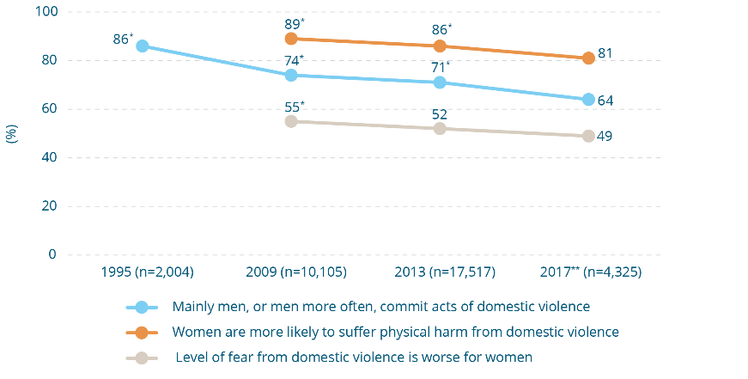
Perceptions of the perpetration and impacts of domestic violence, 1995, 2009, 2013 and 2017 (%)
Statement | 1995  (n=2004) (%) | 2009  (n=10,105) (%) | 2013  (n=17,517) (%) | 2017**  (n=4,325) (%)
Mainly men, or men more often, commit acts of domestic violence | 86* | 74* | 71* | 64
Women are more likely to suffer physical harm from domestic violence | - | 89* | 86* | 81
Level of fear from domestic violence is worse for women | - | 55* | 52 | 49
* Difference between survey year and 2017 is statistically significant, p≤.01.
** Asked of a quarter of the sample in 2017.
Box 8-9: Knowledge of the patterns of partner violence
Why does it matter?
Knowledge of the patterns of intimate partner violence is important because it:
- reflects understanding of the nature, severity and dynamics of violence itself. A person’s responses are likely to be very different if they understand intimate partner violence as mutual behaviour between two equally powerful individuals than if the power of a male aggressor is understood; and
- may guide the level of policy attention and resourcing needed to address intimate partner violence affecting women, relative to that affecting men.
Both men and women can experience violence from their partners and both are capable of perpetrating such violence. However, studies show that men are more likely than women to:
- perpetrate intimate partner violence (ABS, 2017; Cox, 2015);
- use frequent, prolonged and extreme violence (Bagshaw, Chung, Couch et al., 2000; Belknap & Melton, 2005; Holtzworth-Munroe, 2005; Kimmel, 2012);
- sexually assault a female partner (Swan, Gambone, Van Horn et al., 2012); and/or
- subject their partners to controlling and coercive behaviours (Caldwell, Swan, & Woodbrown, 2012; Hamberger & Larsen, 2015).
In contrast, when women do use violence in their intimate relationships, this is more likely to be in self-defence (Cercone, Beach, & Arias, 2005; Dobash, Dobash, Cavanagh et al., 2004; Holtzworth-Munroe, 2005), due to their fear of violence escalating (Larance & Miller, 2016; Mennicke & Kulkarni, 2016), or in response to a loss of control or dignity as a result of ongoing violence or controlling behaviours by their partner (Larance & Miller, 2016; Velonis, 2016).
With regard to the impacts of violence, women have been found to be more likely than men to:
- sustain physical injury, including injuries requiring medical treatment, time away from work and days in bed (Belknap & Melton, 2005; Myhill, 2015);
- be the victims of domestic homicide (Australian Domestic and Family Violence Death Review Network, 2018; Chan & Payne, 2013); and
- report experiencing fear as a result of violence (ABS, 2017; Bagshaw, Chung, Couch et al., 2000; Caldwell, Swan, & Woodbrown, 2012; Headey, Scott, & De Vaus, 1999; National Crime Prevention, 2001).
These reporting patterns are not the result of women being more inclined to report when subject to a similar level of violence (e.g. because women are more fragile). Rather, studies show that women report higher levels of injury and fear because they are subject to more serious and severe forms of violence than men (Hamberger & Larsen, 2015; Romito & Grassi, 2007).

Box 8-10: Why is understanding of patterns of intimate partner violence changing?
The declining understanding of the greater impacts of intimate partner violence on women may be due to:
- the community having a wider definition of violence in mind when responding to this survey question and seeing that both men and women are capable of perpetrating behaviours that do not involve physical force;
- portrayal of intimate partner violence as gender-neutral in the media and some policy and professional discourse (Murray & Powell, 2009; Phillips, 2006; Yates, 2018);
- some media portrayals of partner violence as individualised events, rather than as a wider problem that occurs in a particular social context (as described in Section 4 (Easteal, Holland, & Judd, 2015; Lindsay-Brisbin, DePrince, & Welton-Mitchell, 2014; Morgan & Politoff, 2012). People may form perceptions of this violence that do not take this context into account;
- lack of awareness that such violence is frequent and prolonged, rather than a ‘one-off’ event (Bagshaw, Chung, Couch et al., 2000; Belknap & Melton, 2005; Holtzworth-Munroe, 2005; Kimmel, 2012);
- the influence of campaigns by men’s rights groups to change family law where ‘gender equality’ language (Behre, 2015) is used to claim, contrary to the evidence, that violence is both perpetrated by and affects men and women equally (Flood, 2010; Messner, 2016);
- increasing attention to other forms of violence perpetrated by women and girls (e.g. street violence), which may have spilled over to influence perceptions about the use of violence by women in relationships. Whether there has been an actual increase in violence perpetrated by women and girls remains the subject of debate among experts (Chesney-Lind & Irwin, 2008; Collins, 2014; Luke, 2008);
- increasing recognition of violence occurring in same-sex relationships. While recognition is welcome and long overdue, it may have led to misunderstandings among some people about the gendered patterns of partner violence; and
- a perception that, through feminist gains, gender equality has been achieved or surpassed, such that men and women are indeed equal in their intimate relationships, with a similar propensity for violence and similar capacities to inflict harm upon one another. Indeed it has been argued that in some respects this equality has been at the disadvantage of men and boys (Gill, 2016).
The last explanation given in Box 8-10 is indicated in the NCAS data when the responses to the questions on perpetration of domestic violence and attitudinal support for gender equality, as measured by the GEAS, are compared. Having a high GEAS score (relative to other respondents) does not mean that a person is more likely than those with a low GEAS score to agree that:
- physical harms from domestic violence are more likely to be experienced by women; and
- the level of fear from domestic violence is worse for women.
This is in contrast to all other questions in the survey. For all the other questions, people with a high GEAS score are more likely than those with a low score to give a response that is consistent with the evidence or rejects attitudinal support for violence against women. In other words, it is possible that having strong support for gender equality could lead some people to believe that women and men have greater equality in their intimate relationships than is actually the case.

Australians are more likely to attribute domestic violence to individual characteristics than to broader social factors
In 2013, a question was introduced to explore knowledge of factors involved in violence against women. Respondents were presented with three options (poor anger control, the belief in men needing to be in charge in a relationship, and financial stress) and asked to select what they believed to be the main cause.
This question format was difficult to administer because many people were reluctant to identify only one of the three options. Further, the question format gave only limited information to compare the options. Prior research conducted in the US shows that members of the community are more likely to attribute violence to the characteristics of individuals who use violence (e.g. alcohol abuse), rather than to broader social factors. When they do consider social factors, they are more likely to mention things such as unemployment and social exclusion than inequalities between men and women (e.g. the objectification of women in the media) (O’Neil & Morgan, 2010). That research also shows that, when people are asked in an open-ended way what factors they think contribute to violence against women, very few suggest broader social factors and factors to do with gender relations. However, if these options are put to them in a survey, many people do select them (European Commission, 2010a; Harris-Decima, 2009; O’Neil & Morgan, 2010; Worden & Carlson, 2005). This tendency to attribute human behaviour to individual, as opposed to situational factors is not confined to violence against women, and also applies to other social problems (Stangor, 2011).
Accordingly, people were asked in 2017 about the extent to which they believed various conditions led men to use domestic violence ‘a lot of the time’, ‘some of the time’, ‘rarely’ or ‘not at all’. Six factors were included, three of which concerned the attributes of individuals (‘an alcohol problem’, ‘wanting to control women’ and ‘anxiety or depression’) and three concerning influences beyond the individual (‘pressure from other men to be tough’, ‘lack of employment opportunities in a community’ and ‘the way violence is shown in the media’).
There are limitations to how thoroughly community knowledge of factors contributing to domestic violence can be explored through a small number of survey questions. However, some patterns emerge. A majority of respondents (between 56% and 92%, depending on the option) agree that the factors put to them are implicated ‘a lot of the time’ or ‘some of the time’, suggesting that the community understands that domestic violence is likely to have multiple contributing factors.
However, there are differences in response patterns between the individual-level options and those associated with factors in the wider social environment. Respondents are much more likely to say that the individual level factors (‘an alcohol problem’, ‘wanting to control women’ and ‘having anxiety or depression’) are factors in domestic violence ‘a lot of the time’ than the broader factors and less likely to say that the three social conditions are factors. Conversely, they are less likely to say that the individual conditions were ‘rarely’ or ‘not at all’ factors compared with the factors in the wider social environment.
In comparing the specific responses, the option ‘wanting to control women’ was identified as a factor ‘a lot of the time’ or ‘some of the time’ by the largest proportion of respondents (92%). This option reflects an explanatory approach that privileges the construction of gender roles and relationships as key factors in domestic violence. However, this was not the only option reflecting an emphasis on gendered roles: ‘pressure from other men to be tough’ was another factor put to respondents. Of all the factors, this option had the lowest proportion of responses indicating it was a factor ‘a lot of the time’ or ‘some of the time’ (56%) and the highest proportion of responses indicating that it was a factor ‘rarely’ or ‘not at all’ (39%). There were gender differences for both of these factors: men were less likely than women to say that men ‘wanting to control women’ was a factor ‘a lot of the time’ (44% vs 60%) and were more likely than women to say ‘pressure from other men to be tough’ was ‘not at all’ a factor (16% vs 7%).
Having ‘an alcohol problem’ and ‘anxiety or depression’ were the factors second and third most likely, respectively, to be identified. Of the three social contributors, the option most likely to be identified as implicated in domestic violence ‘a lot of the time’ or ‘some of the time’ was ‘lack of employment opportunities in a community’ (74%). Only 63 percent identified ‘the way violence is shown in the media’ as a factor ‘a lot of the time’ or ‘some of the time’.
Figure 8-10: Knowledge of factors leading to domestic violence** (%), 2017 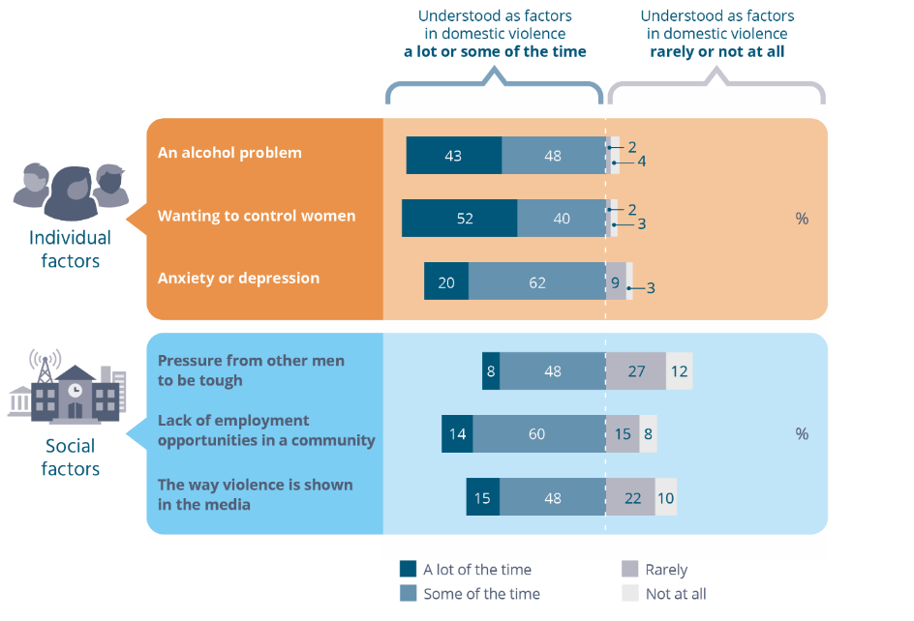
Knowledge of factors leading to domestic violence**.
How often each item is understood as a factor in domestic violence (%), 2017.
Individual factors
Factor | A lot of  the time (%) | Some of  the time (%) | Rarely (%) | Not at all (%)
An alcohol problem | 43 | 48 | 2 | 4
Wanting to control women | 52 | 40 | 2 | 3
Anxiety or depression | 20 | 62 | 9 | 3
Social factors
Factor | A lot of  the time (%) | Some of  the time (%) | Rarely  (%) | Not at all (%)
Pressure from other men to  be tough | 8 | 48 | 27 | 12
Lack of employment opportunities in a community | 14 | 60 | 15 | 8
The way violence is shown in the media | 15 | 48 | 22 | 10
** Asked of a quarter of the sample in 2017.
Box 8-11: Knowledge of factors contributing to violence against women
Why does it matter?
Information about community knowledge of factors contributing to violence against women can help to identify strengths on which to build and gaps in knowledge that need to be addressed. Preventing violence against women will involve collaborating with people in the day-to-day environments in which factors contributing to violence lie. As discussed in Section 4, some of these factors lie with individuals, but many can be found in our workplaces, the settings in which we enjoy recreation and leisure and in the media we consume. Engaging these sectors in prevention will require a wide understanding of the links between what happens in these environments and violence against women.
Implementation of policy approaches ‘on the ground’ is more likely to be successful when the reasons for such approaches are understood. For example, people who see partner violence as mainly a product of depression may find it difficult to understand the current policy environment, which emphasises the importance of holding men accountable for their use of violence (Worden & Carlson, 2005).

Box 8-12: How factors work together to contribute to intimate partner violence
As indicated in Section 4, a range of factors contribute to intimate partner violence. Each of the factors put to respondents makes some contribution. However, studies show that rather than treating each factor in isolation, it is important to look at how they interact with one another.
Although there is debate about whether there are different forms of intimate partner violence (Wangmann, 2011), surveys in which participants have been randomly selected from the general community show that women reporting physical violence from their partners have a high likelihood of also experiencing controlling behaviours, such as their partner preventing them from seeing family and friends, or controlling their movements (Garcia-Moreno, Jansen, Ellsberg et al., 2005; Mouzos & Makkai, 2004). This relationship has been found in studies conducted across many countries (Garcia-Moreno, Jansen, Ellsberg et al., 2005; Day & Bowen, 2015; Hamberger, Larsen, & Lehrner, 2017; Loveland & Raghavan, 2017; Myhill, 2015; Whitaker, 2013). Drawing on this evidence, many experts argue that a desire to control and exert power over women is among the most common motives for intimate partner violence.
Men who have an alcohol problem have been found to be more likely to perpetrate intimate partner violence (Foran & O’Leary, 2008), and alcohol use is linked to the frequency and severity of violence (Bennett & Bland, 2008; Braaf, 2012; Connor, Kypri, Bell et al., 2011; Graham, Bernards, Wilsnack et al., 2011; Stockl, March, Pallitto et al., 2014; Wilson, Graham, & Taft, 2017). Australian population-level research shows that people who drink at risky levels are more likely to both engage in and to experience abuse and/or physical violence when compared with people classified as low risk drinkers (Australian Institute of Health and Welfare, 2017).
However, a study investigating the relationship between alcohol and the perpetration of violence that took into account the findings of many studies found that the association is a modest one (Foran & O’Leary, 2008). Many men who use violence do not have a problem with alcohol, while many men with an alcohol problem do not use violence against their partners (Foran & O’Leary, 2008; Foundation for Alcohol Research and Education (FARE), 2015). Alcohol use is not a factor in approximately 50 percent of cases reported to the police Australia wide (FARE, 2015). Since only a small proportion of intimate partner violence comes to the attention of the police (Cox, 2015), it cannot be assumed that such cases are typical.
It is also important to disentangle the impacts of alcohol per se from other factors influencing both drinking behaviour and behaviour when intoxicated. Experimental studies do show that alcohol increases aggression, but that this is substantially more so for men than for women (Klosterman & Fals-Stewart, 2006; Taft & Toomey, 2005; Wilson, Graham, & Taft, 2017). This suggests that gendered differences in behaviour (which are in themselves shaped by our social environment (Fine, 2010) are also manifest when people are intoxicated. Moreover, there is a cultural expectation that alcohol will change behaviour (Bennett & Bland, 2008) and this may lead men who are predisposed to violence to drink in order to give themselves permission to behave in ways they know are not acceptable (Clark & Quadara, 2010; Graham, Bernards, Wilsnack et al., 2011; Grubb & Turner, 2012). This is further indicated in studies where men are successfully treated for their alcohol problem, but their use of violence persists (Babcock, Green, & Robie, 2004; Leonard, 2005).
The social context in which drinking occurs may also be a factor, with some men drinking in cultures that valorise negative aspects of masculinity and promote disrespect of women (Abbey, 2008; DeKeseredy & Schwartz, 2013; Humphreys, Regan, River et al., 2005; Schwartz & DeKeseredy, 1997). The impact of the context in which people drink is also illustrated at a community level, where it has been shown that an increase in packaged liquor outlets in a community is associated with an increase in intimate partner violence reported to the police (Livingston, 2011), whereas an increase in the number of cafes and small bars dispensing alcohol is not (Cunradi, Mair, Ponicki et al., 2012; Livingston, 2010; McKinney, Caetano, Harris et al., 2009).
A problem with seeing alcohol as a primary cause of intimate partner violence is that it does not explain the large gender differences in perpetration of this violence (Smyth, 2013). For these reasons, many experts agree that, although alcohol use needs to be considered in risk assessment in individual cases, current evidence does not support a direct causal relationship between alcohol and intimate partner violence (Hutchinson, Mattick, Braunstein et al., 2014). Programs working with men who use violence identify the need to reframe alcohol as a trigger for violence rather than an excuse. As shown in this survey (see Figure 10-2), there is minimal support in the Australian community for excusing men who use violence against women because they are affected by alcohol.
Anxiety and depression are prevalent mental health problems affecting 22.3 percent of women and 17.6 percent of men in a 12-month period (ABS, 2007). Men who suffer anxiety or depression have a moderately higher likelihood of perpetrating intimate partner violence than men who do not (Fulu, Jewkes, Roselli et al., 2013; Oram, Trevillion, Khalifeh et al., 2014; Shorey, Febres, Brasfield et al., 2012; Stith, Smith, Penn et al., 2004). However, most men who do experience these problems do not use violence (Fulu, Jewkes, Roselli et al., 2013; Machisa, Christofides, & Jewkes, 2016; Oram, Trevillion, Khalifeh et al., 2014; Shorey, Febres, Brasfield et al., 2012; Stith, Smith, Penn et al., 2004).
Studies that have collected data on men’s mental health, along with their views on gender relationships and their relationship practices, show that such views and practices also influence their use of violence, if not more so (Fulu, Jewkes, Roselli et al., 2013; Machisa & Shamu, 2018; Stith, Smith, Penn et al., 2004). This suggests that men with anxiety or depression who use violence against their partners are more likely to do so if they are already predisposed to supporting gender inequality and disrespect of women. As is the case for alcohol, anxiety and depression are unlikely to be a primary factor in intimate partner violence because they cannot explain gender differences in perpetration. Also, there is evidence that men and women with anxiety and depression show their symptoms differently and that these differences are linked to gender differences in socialisation (Gorman, 2006; Winkler, Pjrek & Kasper, 2006).
Social factors, such as poverty, social isolation and exposure to violence, particularly as a child, increase the risk of developing anxiety and depression as adults for both men and women (WHO, 2014). Preventing these problems is important for health and wellbeing, and is also likely to help prevent violence against women. In a similar way as for an alcohol problem, noting the presence of anxiety and depression is important when assessing the risk of an individual perpetrating violence against their partner. However, it does not excuse the behaviour, and in relation to explaining intimate partner violence needs to be considered in the context of other factors, in particular gender socialisation and gendered relationship practices.
Although there have been some contrary findings, a number of studies show that intimate partner violence is more common in communities with high levels of unemployment (Cunradi, Mair, Ponicki et al, 2002; Sanz-Barbero, Vives-Cases, Otero-García et al., 2015; Vanderende, Yount, Dynes et al., 2012). Different explanations for this link can be found in the literature. One view is that unemployment contributes to social disorganisation in a community (e.g. the loss of services and facilities and the breakdown of trust and connections between people). This is thought to lead to the breakdown of formal and informal normative controls against negative behaviours, including violence against women (Benson, Fox, DeMaris et al., 2003). Another view is that unemployment causes stress in relationships, which in turn leads to violence. However, studies show that this is unlikely to be due to unemployment causing stress per se. Rather, joblessness impacts on men’s ability to fulfil their role as income earners; that is, it places stress on the traditional masculine role. This is shown in a study that found that unemployed men who had strong beliefs about their role as income earners did have an increased risk of perpetrating intimate partner violence, whereas those who did not hold such beliefs did not (Atkinson, Greenstein, & Lang, 2005). A third view is that in conditions in which men lose their economic power as a result of unemployment, violence against women may be used as a means of reasserting that power (Weitzman, 2014; Whaley, Messner, & Veysey, 2013). At the community level, this effect may be particularly likely where there are high rates of male unemployment and job losses in traditionally masculine industries (Weissman, 2007). Again, however, the research suggests that this is influenced by men’s views of gender relations, with a recent study finding that the risk of perpetration among men with lower economic status than their partners was confined to those who lacked trust in women (Zito, 2017).
A relationship has been found between violence against women and male peer relationships that emphasise aggressive masculinities (discussed in greater detail in Section 9.4).
Although there is some debate about whether the portrayal of violence in the media leads to aggression, there is evidence that it does so, including some specific evidence that it may increase the risk of violence in intimate relationships (Coyne, Nelson, Graham-Kevan et al., 2011; Denson & Ruddock, 2015). This is based on the theory that violence is in part a learned behaviour (Orue, Bushman, Calvete et al., 2011). Violence in the media is often portrayed in a highly gendered way. For example, women are disproportionately represented as victims of violence and often in sexualised and passive ways (Dietz, 1998; Dill & Thill, 2007; Miller & Summers, 2007). Thus the portrayal of violence in the media may be especially potent, contributing to learning both about violence itself, as well as negative aspects of gender relations and the role of violence in maintaining them.

Two in five Australians do not know where to find help about domestic violence
Sixty percent of the sample agree that they know where to get outside advice or support from someone about domestic violence (Figure 8-11). This was three percentage points higher than in 2013 (57%). This is one of the very few questions in the NCAS on which were no notable demographic differences.
Figure 8-11: Percentage agreeing ‘if I needed to get outside advice or support for someone about a domestic violence issue, I would know where to go’, 2009, 2013 and 2017
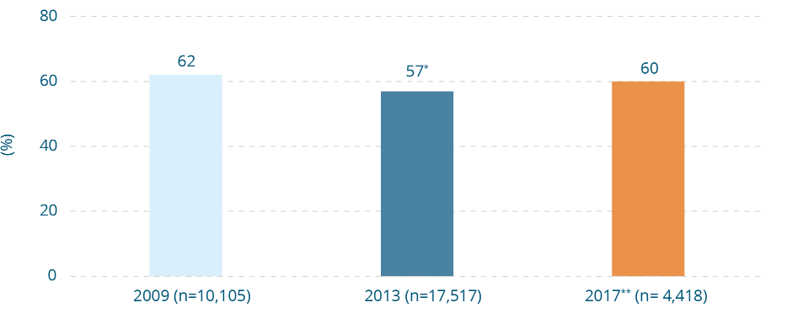
Percentage agreeing ‘if I needed to get outside advice or support for someone about a domestic violence issue, I would know where to go’, 2009, 2013 and 2017
Response | 2009 (n=10,105) (%) | 2013 (n=17,517) (%) | 2017** (n=4,418) (%)
Agree | 62 | 57* | 60

Box 8-13: Knowledge of where to find help about domestic violence
Why does it matter?
- Knowledge of how to help is a factor in whether people who become aware that violence is taking place take action to prevent it or to prevent it escalating (see Powell, 2011 for a review). Services can also provide advice on how to help safely.
- Lack of knowledge of services has been identified as a barrier to women seeking help and a delay to help-seeking (Dunham & Senn, 2000; Francis, Loxton, & James, 2017; Fugate, Landis, Riordan et al., 2005).
- Women experiencing violence may seek informal support from family and friends first (Baholo, Christofides, Wright et al., 2015).
- It is beneficial to take action when early signs of violence and abuse are present (Centre for Innovative Justice, 2015). However, these can be difficult to discern and respond to. Assistance from experts may be particularly useful in these circumstances.

9 Benchmarking attitudes towards gender equality
The 2017 NCAS asked participants to respond to 19 statements that represented different aspects of attitudes towards gender equality in Australia. These statements were developed to better understand Australians’ progress towards the promotion and normalising of gender equality across both public and private life, a key national indicator for monitoring population-level change towards the prevention of violence against women.
The statements that participants were asked to respond to each reflect key attitudinal drivers and reinforcers of violence against women as identified in the Change the Story framework (Our Watch, ANROWS, & VicHealth, 2015). They are reported in the five themes introduced earlier (see Box 4-1).
Decades of international research has demonstrated that attitudes endorsing men’s control, rigid or stereotyped gender roles, as well as disrespect and hostility towards women, are associated with attitudes that condone violence against women (see Section 4). In some studies, an association has been found between such attitudes and the perpetration of sexual and/or intimate partner violence itself (see Section 9.1 to Section 9.5 below).

9.1 Gender equality theme 1: Attitudes promoting rigid gender roles, stereotypes and expressions
Attitudes that support rigid gender roles include agreeing with the idea that men and women are naturally suited to ‘do’ different tasks and responsibilities. For example, endorsement of rigid gender roles might reflect views that women are naturally better parents, while men are naturally better income earners.
Attitudes that support gender stereotypes and expressions include agreement with the idea that men and women have naturally distinctive, and often oppositional, personal characteristics. These might include views that associate women with stereotypically ‘feminine’ traits such as patience, emotional sensitivity, passivity, dependence and moral or sexual purity. Meanwhile men might be associated with stereotypically ‘masculine’ traits such as strength, dominance, assertiveness, rationality and aggression.
International research shows that individuals whose attitudes support traditional gendered roles and stereotypes are more likely to excuse the perpetrators and blame the victims in instances of men’s violence against women (Angelone, Mitchell, & Smith, 2016; Grubb & Turner, 2012; Yamawaki, Ostenson, & Brown, 2009).

Most Australians reject rigid gender roles and expressions
The level of attitudinal support for rigid gender roles, stereotypes and expressions is generally low among Australians (Figure 9-1). For all the statements, 10 percent or less of the sample endorsed them, suggesting very low agreement with rigid gender roles, stereotypes and expressions on issues such as parenting, income earning, and employment in traditionally ‘male’ or ‘female’ jobs. There was a gender difference for only one of the statements, with 86 percent of men disagreeing that ‘a woman has to have children to be fulfilled’, compared with 93 percent of women. The proportion agreeing that ‘a woman has to have children to be fulfilled’ has declined by four percentage points since it was asked in 2013, when 12 percent agreed with it. The highest level of support in this set of questions was for the statement ‘when a couple start dating, the woman should not be the one to initiate sex’, agreed to by one in ten people.
Figure 9-1: Attitudes promoting rigid gender roles, stereotypes and expressions, 2009, 2013 and 2017 (% agree) 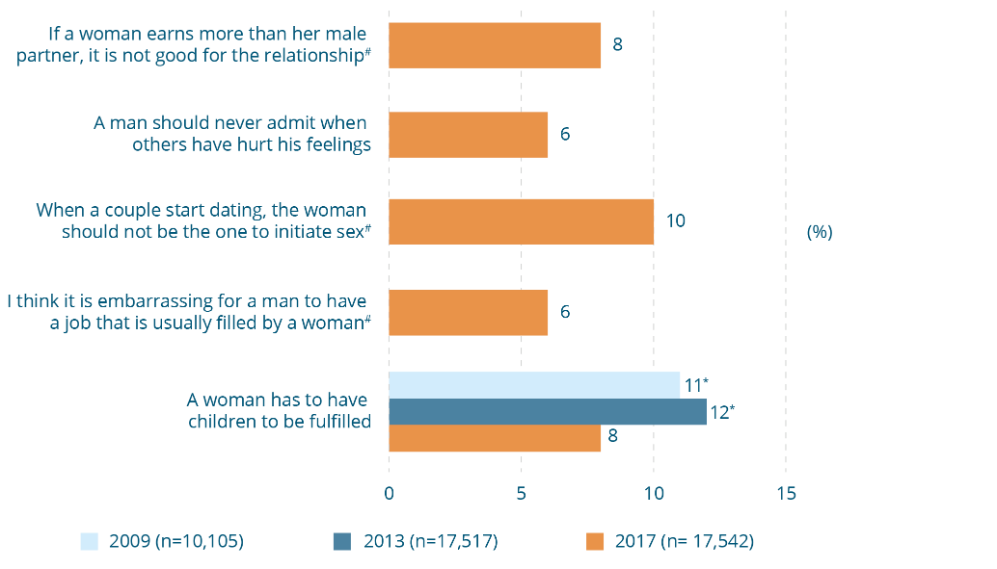
Attitudes promoting rigid gender roles, stereotypes and expressions, 2009, 2013 and 2017
(% agree)
Attitude | 2009  (n=10,105) (%) | 2013  (n=17,517) (%) | 2017  (n=17,542) (%)
If a woman earns more than her male partner, it is not good for the relationship# | - | - | 8
A man should never admit when others have hurt his feelings | - | - | 6
When a couple start dating, the woman should not be the one to initiate sex# | - | - | 10
I think it is embarrassing for a man to have a job that is usually filled by a woman# | - | - | 6
A woman has to have children to be fulfilled | 11* | 12* | 8
* Difference between survey year and 2017 is statistically significant, p≤.01.
# Asked of half the sample.
Box 9-1: Attitudes about gender stereotypes and sex
Why do they matter?
Rigid gender roles and stereotypes affect how individuals think that ‘proper’ or ‘real’ men and women should think, feel and behave. The attitude that ‘the woman should not be the one to initiate sex’ reinforces the idea that men should want and actively pursue sex, while women should not show an active desire for sex. It brings to mind related gender stereotypes where women in particular are judged as ‘sluts’ if they show too much sexual interest. Such attitudes that position heterosexual encounters as adversarial – with men’s and women’s interests in conflict with one another – have been linked to increased risk for men’s sexual violence perpetration (Tharp, DeGue, Valle et al., 2013).
In the negotiation of intimate relationships, such an attitude places unrealistic expectations on men to be always active, assertive and the decision-maker when it comes to sex. Research has shown that this kind of ‘hyper-masculine’ or ‘male conquest’ model of sexual intimacy can put pressure on men to pursue sex as a marker of being a man (DeKeseredy & Schwartz, 2013), and has been linked with sexual aggression towards women (DeKeseredy, Dragiewicz, & Schwartz, 2017; Hust, Rodgers, & Bayly, 2017; Reidy, Smith-Darden, Cortina et al., 2015; Tharp, DeGue, Valle et al., 2013) and gay men (Baugher & Gazmararian, 2015).
When the negotiation of consensual sex starts from an unequal playing field – in which men are seen as the ‘natural’ or more socially acceptable pursuers – it also contributes to intimate encounters in which it is less socially acceptable for women to assert their desires as the basis for sexual decision-making (Powell, 2010). In short, adherence to rigid gender roles and stereotypes in sexual encounters contributes to an eroticisation of inequality that undermines the equal and ethical negotiation of sexual consent (Sanchez, Fetterolf, & Rudman, 2012).
Researchers have found that ‘masculine gender role stress’ is a predictor of men’s increased anger, aggression, and endorsement of violent behaviour (Gallagher & Parrott, 2011). Masculine role stress occurs when men who endorse rigid gender roles feel as though they are not able to meet the benchmark of ‘masculine’ behaviour. The US Centers for Disease Control and Prevention has identified an individual’s endorsement of strict gender roles as a risk factor for intimate partner violence, while ‘hyper-masculinity’ and hostility towards women are risk factors for sexual violence (Tharp, DeGue, Valle et al., 2013).
Hyper-masculine identities may also be associated with violence against women because they may:
- contribute to the valorisation of violence and its use;
- involve characteristics such as callousness and insensitivity, which can serve as precursors to violence (Farr, Brown, & Beckett, 2004; Wardman, 2017);
- contribute to the perception that men are naturally more violent than women and are driven by uncontrollable sexual urges, which may in turn lead to men justifying their behaviour and others excusing it (Hlavka, 2014); and
- collectively contribute to organisational environments in which violence in general and violence against women are normalised (e.g. prisons) (SpearIt, 2011).
Some experts have argued that highly feminised identities may lead to women being sexualised and objectified, which in turn may make them vulnerable to hostility and exploitation (American Psychological Association, 2010; Papadopoulos, 2010). The extent to which women victims of violence conform to idealised notions of femininity has been found to influence whether sympathy is extended to them (Masser, Lee, & McKimmie, 2010; Yamawaki, 2007). Women who transgress idealised notions of femininity, meanwhile, have been found to be particularly vulnerable to violence (Whatley, 2005). Likewise, violence may be used, particularly in intimate relationships, to reinforce role divisions or punish women for breaching expected gender roles (Antai, 2011; Koenig, Stephenson, Ahmed et al., 2006; York, 2011).
Importantly, rigid gender roles and identities set the stage for many of the other aspects of gender inequality linked to violence against women (e.g. by contributing to the concentration of women in jobs with lower pay or to the formation of highly masculinised environments).

9.2 Gender equality theme 2: Attitudes undermining women’s independence and decision-making in public life
Women’s equal participation in institutions of public life – such as government, employment, and within the community – is a recognised international indicator of gender equality. In Australia, women continue to be under-represented in positions of leadership and decision-making in public life (AHRC, 2018b; World Economic Forum, 2017). The lack of representation of women in such public positions, including as CEOs, board members and in parliament, is not simply a reflection of women’s lack of interest or capability in performing such decision-making roles. For example, in employment research many studies have found that interested and capable women are often passed over for leadership positions in preference for male applicants (Johnson, Hekman, & Chan, 2016; Koch, D’Mello, & Sackett, 2015). In effect, decisions about who is the right person for the job can reflect an unconscious bias, or attitude, that men make better leaders, decision-makers or are more suited to holding positions of responsibility.
Reflecting Change the Story, the 2017 NCAS asked participants to respond to six statements that expressed attitudes about men’s and women’s relative suitability for positions of leadership and decision-making in both public and private life. The statistical analysis showed that these questions fall into two separate categories: men’s control in public contexts (Figure 9-2) and men’s control in intimate relationships (Figure 9-3).
Figure 9-2: Attitudes undermining women’s independence and decision-making in public life, 2009, 2013 and 2017 (% agree) 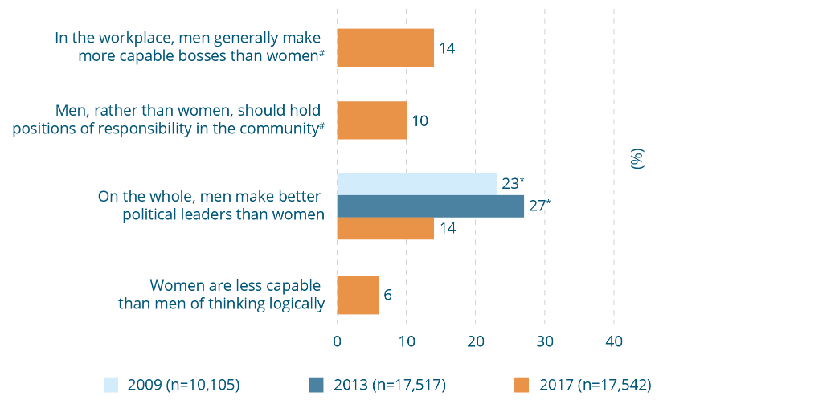

Attitudes undermining women’s independence and decision-making in public life, 2009, 2013 and 2017 (% agree)
Attitude | 2009  (n=10,105) (%) | 2013  (n=17,517) (%) | 2017  (n=17,542) (%)
In the workplace, men generally make more capable bosses than women# | - | - | 14
Men, rather than women, should hold positions of responsibility in the community# | - | - | 10
On the whole, men make better political leaders than women | 23* | 27* | 14
Women are less capable than men of thinking logically | - | - | 6
* Difference between survey year and 2017 is statistically significant, p≤.01.
# Asked of half the sample.

One in six Australians disagree that women are equally capable in politics and the workplace
Endorsement of each of the statements supporting men’s control of decision-making in public life was a little higher than the statements in gender equality theme 1. Nearly one in six Australians (14%) believe that men make better political leaders and more capable bosses, while one in ten (10%) agree that ‘men, rather than women, should hold positions of responsibility in the community’. However, only 6 percent believe that ‘women are less capable than men of thinking logically’.
Men are less likely to disagree with all but one of the statements in Figure 9-2. This statement is ‘men rather than women should hold positions of responsibility in the community’ (84% men disagree compared with 90% of women). However, this difference is not statistically significant. The proportion of Australians supporting the statement ‘men make better political leaders than women’ nearly halved between 2013 and 2017 (from 27% to 14%). Endorsement of this question increased four percentage points between 2009 and 2013 and, although the reasons for this can only be speculated upon, it is of note that the 2013 survey was conducted between January and May 2013 in the context of the controversy surrounding the conclusion of Julia Gillard’s prime ministership (on 26 June 2013) (Trimble, 2016). That said, the 2017 finding is nine percentage points less than the 2009 proportion (23%).
Box 9-2: Attitudes about women as decision makers in public life
Why do they matter?
Attitudes that view men’s authority, capability and leadership in settings such as government, employment and the community as ‘better’ or more ‘natural’ undermine gender equality in public life. Agreeing with such attitudes does not necessarily mean that an individual believes that women are not at all capable of undertaking public positions of decision-making and responsibility. Rather, such attitudes suggest that – given the option between a man and a woman in these roles – a person may think that a man would do a better job.
Such discrimination against women applicants may be largely unconscious, with some studies finding that research participants on mock interview panels who describe themselves as supporting gender equality still often choose male names for their shortlisted applicants, even when the education and experience of male and female applicants have been accounted for (Johnson, Kekman, & Chan, 2016; Koch, D’Mello, & Sackett, 2015).
In addition to creating a barrier to women’s appointment to leadership roles, attitudes that undermine women as leaders may prevent women from actively seeking such roles. For example, in a recent Australian study, women who had been reminded of the sexist commentary about former prime minister Julia Gillard during her term in office reported a reduced interest in taking up leadership roles (Hunt, Gonsalkorale, & Zadro, 2014).
In these ways attitudes endorsing men’s control in public life may have flow-on effects for women’s equal workforce participation and economic independence, as well as reinforcing a cultural expectation that women should defer to men’s leadership on matters of importance.
Supporting women’s equal participation in public life is an important part of preventing violence against women because:
- when there are high rates of women’s participation in formal decision-making and civic action, collectively, women are more likely than men to act in the interests of securing women’s freedom from violence (Grey, 2002; Htun & Weldon, 2012; Jones, 1997; Taylor-Robinson & Heath, 2003); and
- women’s lower status may serve a symbolic function, communicating to individual men and women themselves that they are of lower social value and less worthy of respectful treatment, with the result that violence against them may be more readily accepted and legitimised in the wider community (Gilgun & McLeod, 1999; Hill & Fischer, 2001).

9.3 Gender equality theme 3: Attitudes undermining women’s independence and decision-making in private life
The survey questions in this theme indicate an individual’s endorsement of men’s greater ‘natural’ authority, decision-making and control in the private realm of intimate relationships. They express an agreement with a relationship model and household structure in which men have the ultimate say over what happens in the relationship or how the family is run. Again, this does not suggest that women do not contribute to these tasks – indeed, Australian data indicates that women continue to carry a larger share of day-to-day household and caring responsibilities (Craig, Perales, Vidal et al., 2016; Ting, Perales, & Baxter, 2016) – but that there is an attitude that, in decision-making in private life, women ought to defer to men’s leadership.

Many Australians do not support gender equality in their private lives
In contrast to attitudinal support for promoting women’s independence and decision-making in public life, a larger proportion supported each of the statements concerned with maintaining men’s control over decision-making in private life. One quarter of Australians (25%) agree that ‘women prefer a man to be in charge of the relationship’ and more than one in six (16%) agree that ‘men should take control in relationships and be the head of the household’. Men were also more likely than women to support each of these statements. For example, one in three men (32%) agree that ‘women prefer a man to be in charge of the relationship’ compared with only one in five women (19%). Meanwhile, almost twice as many men (21%, or one in five) agree that ‘men should take control in relationships and be the head of the household’ as compared with one in ten women (12%).
There was a small decline in the proportion supporting both measures between 2013 and 2017. However there is no significant difference between the proportions agreeing between 2009 and 2017.
Figure 9-3: Attitudes undermining women’s independence and decision-making in private life, 2009, 2013 and 2017 (% agree) 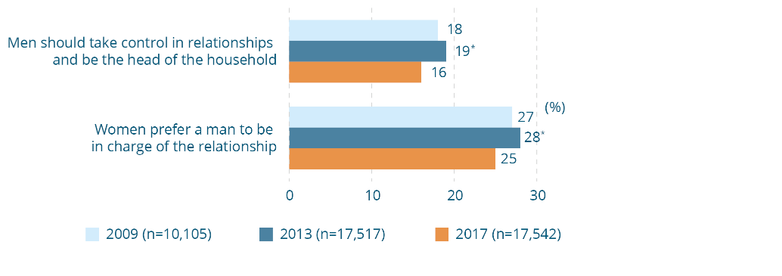
Attitudes undermining women’s independence and decision-making in private life, 2009, 2013 and 2017 (% agree)
Attitude | 2009  (n=10,105) (%) | 2013  (n=17,517) (%) | 2017  (n=17,542) (%)
Men should take control in relationships and be the head of the household | 18 | 19* | 16
Women prefer a man to be in charge of the relationship | 27 | 28* | 25
* Difference between survey year and 2017 is statistically significant, p≤.01.
Box 9-3: Attitudes about decision-making in relationships
Why do they matter?
Men’s control over decision-making in private life can have flow-on effects on women’s independence and ability to participate in other aspects of public life. For example, the ‘man of the house’ having the final say in who works and who stays at home to take a greater share of parenting can impact on a woman’s capacity to participate in the workforce, and therefore to be economically self-sufficient. Women’s economic dependence on men is a continuing barrier to women seeking safety from violence (Meyer, 2012).
In the context of heterosexual intimate relationships, attitudes that normalise male control of decision-making and limit women’s independence may also normalise controlling behaviours such as restricting women’s contact with friends and family, access to finances, and participation in the workforce. Such controlling behaviours are a common feature of intimate intimate partner violence and are themselves often linked to attitudes that assert male dominance in relationships (Day & Bowen, 2015; Hamberger, Larsen, & Lehrner, 2017; Loveland & Raghavan, 2017; Myhill, 2015; Whitaker, 2013).
This is not to suggest that an individual who agrees with these questions will necessarily engage in violent behaviours. However, community support for these attitudes may make it more difficult for individuals to recognise when men’s control over decision-making might constitute abuse. Women experiencing multiple forms of abuse may also find it more difficult to leave a violent relationship.
When gender relations are based on a hierarchical model where men are in charge and women play a subordinate role, violence may be used and accepted as a means of maintaining this hierarchical dynamic, especially when it is under threat, such as when families migrate to a country with more liberal gender norms (True, 2012), or when economic development and change give women a greater role in society (Chon, 2013; Jewkes, 2002; Simister & Mehta, 2010; Xie, Heimer, & Lauritsen, 2012).

9.4 Gender equality theme 4: Attitudes condoning male peer relations involving aggression and disrespect towards women
An established body of research indicates that negative male peer group cultures that reinforce aggressive masculinities, and either tolerate or condone disrespect and hostility towards women, may be associated with both greater attitudinal endorsement of violence against women and in some cases a higher probability of perpetration of violence against women (DeKeseredy, 1990; DeKeseredy & Schwartz, 2013; Dúran, Megías, & Moya, 2016; Flood & Pease, 2009; Schwartz & DeKeseredy, 1997; Seabrook, Ward, & Giaccardi, 2018). Such male peer relations may be measured in two key ways: first, through specific attitudes that normalise male peer group interactions emphasising aggression, sexism, and disrespect towards women; second, through an examination of the gender composition of individuals’ peer networks and whether these impact on other attitudes towards women (see Section 12.1).
The 2017 NCAS included three questions that provide a measure of attitudinal support for male peer relations that tolerate or condone sexism or violence towards women. Agreement with these questions indicates attitudes that normalise ‘locker room talk’, or ‘boys will be boys’ behaviours, which treat women as unequal and/or with disrespect.

Nearly one quarter of Australians see no harm in telling sexist jokes
Almost no Australians (2%) agree that ‘it’s ok for men to joke with their male friends about being violent towards women’ (Figure 9-4). However, nearly one quarter (24%) agree that men making sexist jokes when in the company of their male friends does no harm. An attitude that downplays the harm of sexist jokes is much higher among men (30%) than it is among women (18%). Meanwhile, over one third of Australians (34%, or one in three) agree that ‘it’s natural for a man to want to appear in control of his partner in front of his male friends’. Responses to this question then, are similar to the trend in gender equality themes 1 and 3, whereby Australians tend to hold attitudes least supportive of gender equality in the context of intimate relationships in private life.
Figure 9-4: Attitudes condoning male peer relations involving aggression and disrespect towards women, 2017 (% agree) 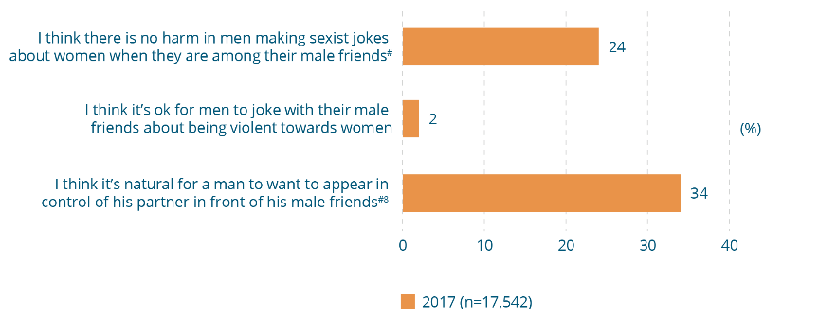
Attitudes condoning male peer relations involving aggression and disrespect towards women, 2017 (% agree)
Attitude | 2017  (n=17,542) (%)
I think there is no harm in men making sexist jokes about women when they are among their male friends# | 24
I think it’s ok for men to joke with their male friends about being violent towards women | 2
I think it’s natural for a man to want to appear in control of his partner in front of his male friends^{#8} | 34
# Asked of half the sample.
⁸ Not in GEAS.
Box 9-4: Attitudes supporting male peer relations that emphasise disrespect of women
Why do they matter?
Positive peer relations are an important source of social support for both men and women and are vital for health and wellbeing (Grief, 2006; Patton, Sawyer, Santelli et al., 2016). However, negative aspects in some male peer cultures may increase the risk of violence against women because:
- men encouraged to privilege their relationships with other men over those with women may result in them more readily excusing their peers’ disrespectful or violent behaviour towards women (European Commission, 2010b; Powell, 2010);
- they may discourage men from taking a stand against the violent and disrespectful behaviour of their peers because they fear rejection (Carlson, 2008);
- in some male peer contexts, men may be encouraged to perpetrate violence against women as part of proving their masculinity (Flood, 2007); and
- they may normalise violence and disrespect towards women (Flood, 2007).

9.5 Gender equality theme 5:
Attitudes denying gender inequality is a problem
Attitudes that deny gender inequality is a problem and/or that express hostility towards women are among the most overt examples of cultural support for gender inequality, and may also be some of the most harmful. These attitudes are widely referred to in international research as examples of ‘modern sexism’ (Swim, Aikin, Hall et al., 1995) and ‘hostile sexism’ (Glick & Fiske, 1997) respectively. The two forms of sexism are closely related, as hostility towards women can include a hostility towards the women’s movement and towards individual women’s attempts to gain equality (such as by naming certain comments or behaviours as ‘sexist’).
Internationally, research has found that individuals who endorse overtly sexist attitudes may be more likely to treat women unfairly in the workplace and other settings in public life (Fraser, Osborne, & Sibley, 2015; Jones, Peddie, Gilrane et al., 2016; Stamarski & Son Hing, 2015). In private life, research has found a strong link between holding attitudes that are hostile towards women and the perpetration of intimate partner and sexual violence (Baugher & Gazmararian, 2015; Loveland & Raghavan, 2017; Zinzow & Thompson, 2015).
These kinds of sexist attitudes are also sometimes understood as ‘backlash’ attitudes. The concept of backlash helps to explain why it is that despite progress towards greater equality for women, community-level endorsement of sexist attitudes might initially increase rather than decrease in response to actual or perceived gains of the women’s movement.
The 2017 NCAS included five questions that measure attitudes expressing either a denial that sexism and gender inequality continue to be problems in Australia, or a more overt hostility towards women.

Attitudes underestimating the extent of gender inequality are endorsed by up to half of Australians
A sizeable proportion of the community do not recognise gender inequality and discrimination as problems within Australian society (Figure 9-5). Two in five (40%) agree that ‘many women exaggerate how unequally women are treated in Australia’ and half (50%) that ‘many women mistakenly interpret innocent remarks or acts as being sexist’. In addition to hostility towards women’s attempts to gain equality, a substantial minority also endorse attitudes that are hostile towards women individually. More than a third (36%) agree that ‘many women fail to fully appreciate all that men do for them’ and one in five (20%) that ‘women often flirt with men just to be hurtful’.
One in ten Australians (10%) agree that ‘discrimination against women is no longer a problem in the workplace in Australia’. This is less than in 2013 (13%), although not statistically significantly different from when it was first asked in 2009 (11%). Men are more likely than women to agree that ‘many women exaggerate how unequally women are treated in Australia’ (45% vs 35% of women).
Box 9-5: What is ‘backlash’ towards gender equality?
Backlash towards gender equality refers to a strong negative reaction to the progress made by the women’s rights movement. In 1991, US journalist Susan Faludi wrote of the backlash against women’s social, economic and political progress that was observable in the US media and public debates at the time. Faludi observed that there are cyclical or recurring patterns in such backlash – returning “every time women begin to make some headway towards equality” (Faludi, 1991, p.46).
Since then, psychological research has set out to measure the extent to which individuals hold attitudes that reflect a backlash towards gender equality (Glick & Fiske, 1996, 1997; Swim, Aiken, Hall et al., 1995; Swim & Cohen, 1997; Tougas, Brown, Beaton et al., 1995). Such backlash can be seen in attitudes that deny that gender inequality remains a problem requiring public action, that endorse sexism, discrimination or are hostile against women, or that express a resentment towards women’s rights (Dragiewicz, 2011; Kimmel, 2017).
The term ‘backlash’ may be used in two other ways in research and programming to prevent violence against women. First, although gender inequality contributes to violence against women, research shows that as gender equality increases there may be an initial increase in violence before it reduces (Whaley, Messner, & Veysey, 2013). Some experts have argued that this is evidence of men seeking to reassert or maintain the existing gender hierarchy, labelling it part of the backlash phenomenon (Dragiwecz, 2011; Gracia & Merlo, 2016; Rudman & Glick, 2001). Second, when policies and strategies are adopted in organisations and communities to reduce inequalities to prevent violence against women, there may be resistance to this (Dragiewicz, 2011; Kimmel, 2017). This may manifest in increases in violence towards individual project participants (e.g. projects with the aim of increasing women’s economic independence have resulted in increasing vulnerability to intimate partner violence) (Hughes, Bolis, Fries et al., 2015). As awareness of this backlash phenomenon has grown, so has understanding of the means to prevent it (VicHealth, 2018).
Figure 9-5: Attitudes denying gender inequality is a problem, 2009, 2013 and 2017 (% agree) 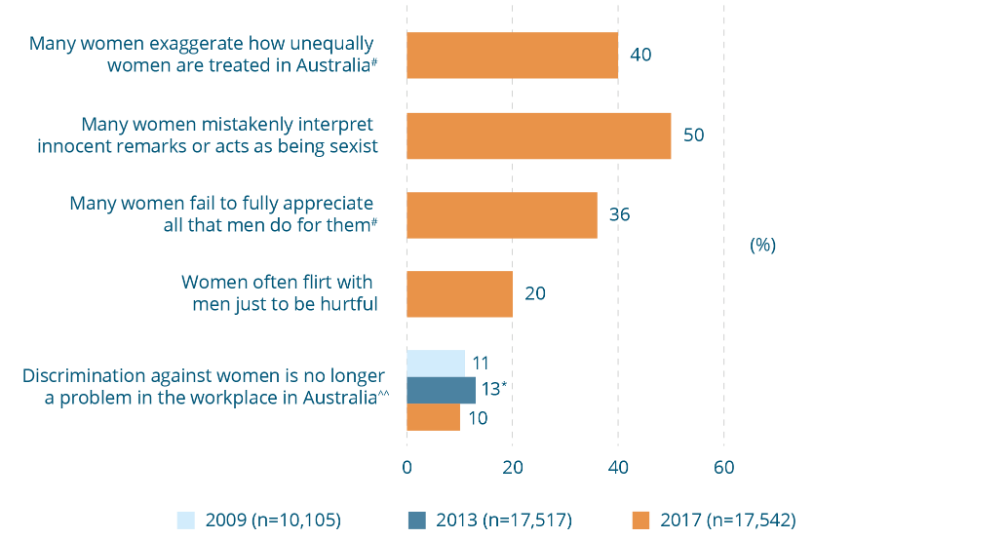
Attitudes denying gender inequality is a problem, 2009, 2013 and 2017 (% agree)
Attitude | 2009  (n=10,105) (%) | 2013  (n=17,517) (%) | 2017  (n=17,542) (%)
Many women exaggerate how unequally women are treated in Australia# | - | - | 40
Many women mistakenly interpret innocent remarks or acts as being sexist | - | - | 50
Many women fail to fully appreciate all that men do for women# | - | - | 36
Women often flirt with men just to be hurtful |  |  | 20
Discrimination against women is no longer a problem in the workplace in Australia^^ | 11 | 13* | 10
* Difference between survey year and 2017 is statistically significant, p≤.01.
# Asked of half the sample.
^^ This question has been reported here for conceptual coherence. In the factor analysis (see Box 5-2) it was correlated with questions in the ‘condoning male peer relations involving aggression and disrespect towards women’ and is included in that theme in any theme level analysis.
Box 9-6: Reporting gender inequality but scoring equality
Methodological note
So far, results in the gender equality component have been reported in terms of the proportion of people who endorse gender inequality. This reflects both the wording of the gendered drivers in the Change the Story framework and the questions used to measure them. However, for the GEAS as a whole and each of the themes, the scoring is based on support for gender equality (see Figure 7-1).
Reflecting this, in the following sections we turn from describing support for gender inequality to support for gender equality, both overall and in each of the themes.

9.6 Are attitudes more likely to be held in some themes than in others?
So far, findings for individual questions have been reported. To find out which aspects of gender equality were more or less likely to be supported in the Australian community overall, findings for these individual questions were grouped into the five themes just described. Each respondent was given a score based on their answers to the questions in each theme, and a mean (or average) for the Australian population was calculated for each of the themes. Scores range from 1 to 100 with 1 signifying the lowest level of support for gender equality based on respondents’ answers and 100 the highest level of support for gender equality. This information can help identify particular aspects of support for gender equality that need to be strengthened in prevention programming because they are more widely held or more strongly associated with attitudes towards violence against women.
Figure 9-6 shows the mean scores for each of the themes. The most striking finding is that Australians are less likely to support attitudes that recognise gender inequality is a problem than any of the other four themes (see Box 4-1). This means that, when considered together, questions in this theme show the lowest average score (61 out of 100), signifying a low level of support for recognising gender inequality is a problem.
There are relatively low levels of support for gender equality in decision-making in private life (with an average score of 74). Support is a little higher for gender equality in decision-making in public life, as well as for rejecting rigid gender roles and expressions and male peer relations that emphasise respect for women (each with an average score of 79).
When men and women are compared, women are significantly more likely to support gender equality in each of the themes (i.e. to have a higher mean score than men). This is particularly pronounced in the theme of ‘promoting women’s independence and decision-making in private life’, for which women have a mean score of 79, compared with only 69 among men.
Figure 9-6: Relative attitudinal support for gender equality, by theme^, 2017 (n=17,401)
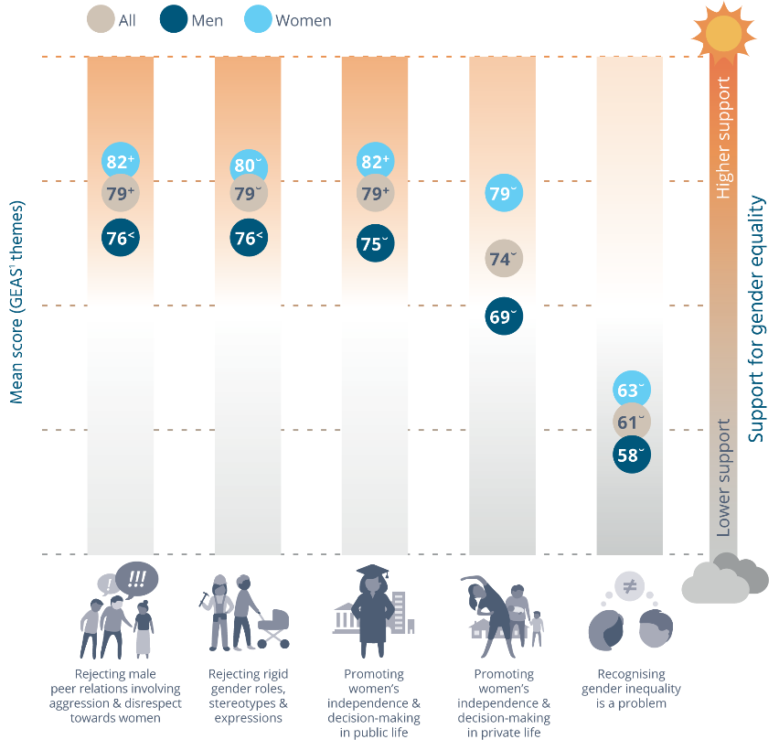
Relative attitudinal support for gender equality, by theme^, 2017 (n=17,401).
Mean scores for the GEAS themes – higher scores indicate higher attitudinal support for gender equality/rejection of inequality in that theme
Theme | All | Men | Women
Rejecting male peer relations involving aggression & disrespect towards women | 79⁺ | 76< | 82⁺
Rejecting rigid gender roles, stereotypes & expressions | 79˘ | 76< | 80˘
Promoting women’s independence & decision-making in public life | 79⁺ | 75˘ | 82⁺
Promoting women’s independence & decision-making in private life | 74˘ | 69˘ | 79˘
Recognising gender inequality is a problem | 61˘ | 58˘ | 63˘
Note: There may be statistically significant differences between values that are less than one percentage point. These are not apparent in the figure due to rounding.
^ All differences between men and women are statistically significant, p≤.01.
¹ Measured using the composite measure described in Section 5.2.
˘ Difference between this theme and all other themes in this sample is statistically significant, p≤.01.
⁺ Difference between this theme and ‘rejecting rigid gender roles, stereotypes and expressions’, ‘promoting women’s independence and decision-making in private life’, and ‘recognising gender inequality is a problem’ in this sample is statistically significant, p≤.01.
< Difference between this theme and ‘promoting women’s independence and decision-making in private life’, ‘promoting women’s independence and decision-making in public life’, and ‘recognising gender inequality is a problem’ in this sample is statistically significant, p≤.01.
Given the higher level of support for equality between men and women in decision-making in public life than in private life, this distinction was further explored by creating two new themes using all the questions in the GEAS (rather than looking only at those concerned with decision-making in public and private life). Questions were sorted into those concerned with public and those concerned with private life.
The average score for ‘gender equality in public life’ is higher (76) than that for ‘gender equality in private life’ (66) (Figure 9-7). This confirms that people have a higher level of attitudinal support for gender equality in public life than they do for equality in their private lives. This is true for both men and women. When men and women are compared, men are less likely to support gender equality in private life. However, there is no statistically significant difference between men’s and women’s support for gender equality in public life.

Figure 9-7: Relative attitudinal support for gender equality in public versus private life^, 2017 (n=17,447)
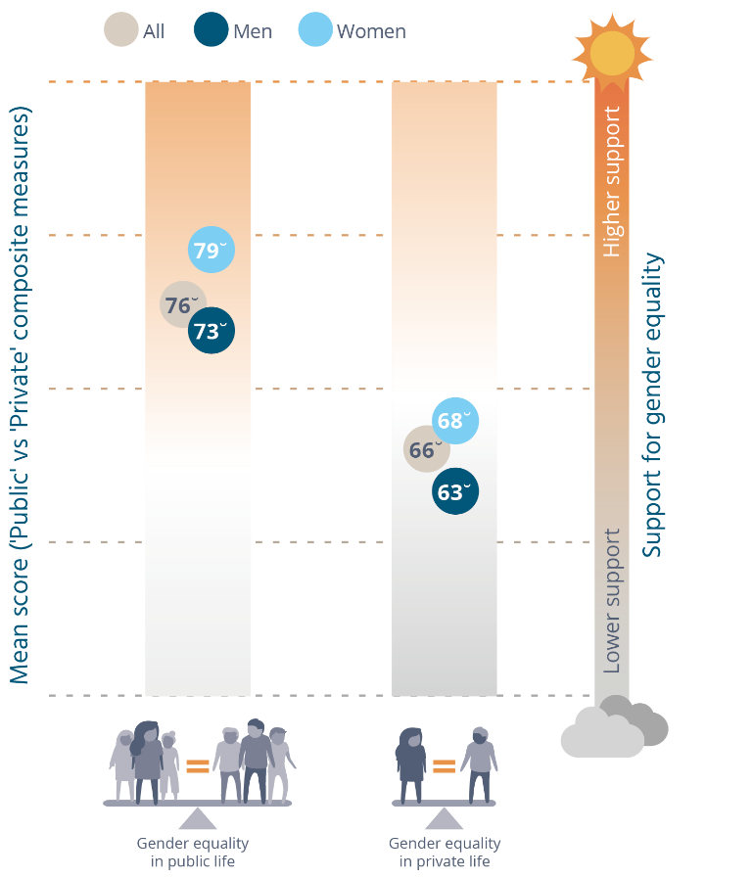
Relative attitudinal support for gender equality in public versus private life^, 2017 (n=17,447), Mean scores for the GEAS sub-themes – higher scores indicate higher attitudinal support for gender equality/rejection of inequality in that theme
Theme | All | Men | Women
Gender equality in public life | 76˘ | 73˘ | 79˘
Gender equality in private life | 66˘ | 63˘ | 68˘
^ Difference between men and women is statistically significant, p≤.01 for gender equality in the private sphere.
˘ Difference between this theme and all other themes in this sample is statistically significant, p≤.01.

9.7 Change in attitudes towards gender equality over time
The findings for individual questions that have been asked in more than one wave of the survey have been reported in Section 9-1 to Section 9-5.
Figure 9-8 shows the change for the GEAS as a whole. A score is calculated for each respondent to the survey with a range between 1 and 100 based on answers to the statements in the scale. As discussed in Section 7.5, a statistical modelling approach was used to take account of the fact that only some of the 2017 questions had been asked in previous surveys. Again, the higher the value of the score, the higher a person’s level of attitudinal support for gender equality. Figure 9-8 shows that there has been a statistically significant improvement in the mean overall score, from 64 in 2009 and 2013, to 66 in 2017. When comparing the effect size of the change between the 2009 and 2017 waves of the NCAS, for the population as a whole, the effect is greater between 2009 and 2017 (0.1717) than between the 2013 and 2017 waves (0.1702), meaning that over a longer period of time there has been greater improvement. This is a positive result for the GEAS, illustrating what would be expected with change in attitudes. Such change takes time and this report documents a slow but steady overall improvement.
There was a fractional decline (0.6) in the gender equality score between 2009 and 2013. This is not apparent in Figure 9-8 owing to rounding. Among women, there was a slightly negative trend between 2009 and 2013.
Figure 9-8: Changes in attitudinal support for gender equality over time, 2009, 2013 and 2017 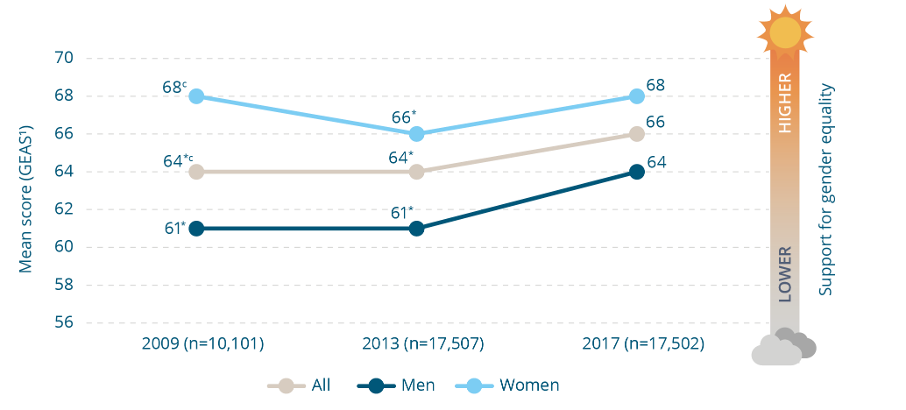
Changes in attitudinal support for gender equality over time, 2009, 2013 and 2017. Mean scores for the GEAS – higher scores indicate higher attitudinal support for gender equality/rejection of inequality in that theme
Group | 2009  (n=10,101) | 2013  (n=17,507) | 2017  (n=17,502)
All | 64*^{c} | 64* | 66
Men | 61* | 61* | 64
Women | 68^{c} | 66* | 68
* Difference between survey year and 2017 is statistically significant, p≤.01.
^{c} Difference between 2009 and 2013 is statistically significant, p≤.01.
¹ Measured using the composite measure described in Section 5.2.

10 Benchmarking attitudes to violence against women
The 2017 NCAS included 35 questions measuring attitudes to violence against women, 32 of which are included in the redeveloped CASVAWS, plus two scenario-style questions (described in Section 10.4). These are reported in the four themes introduced earlier (see Box 4-1).

10.1 Violence against women theme 1: Attitudes excusing the perpetrator and holding women responsible
These attitudes involve shifting responsibility for violence from the perpetrator and/or to the victim by holding the latter partly responsible for the violence occurring (e.g. for flirting too much with other men) or for not preventing it (e.g. by dressing ‘provocatively’). Attitudes excusing men who use violence do not agree that violence is appropriate, but are based on the impression that there are factors leading to some men being unable to control their behaviour (Pepin, 2016; Scott & Lyman, 1968). These factors may include mental illness, alcohol use or love for the victim (Sutherland, McCormack, Pirkis et al., 2015). Excuses indirectly shift responsibility by focusing on the trigger behaviour (e.g. use of alcohol, the woman leaving a relationship). This theme also includes attitudes that provide excuses for action not being taken to stop or prevent violence (e.g. because keeping the family together is more important).

Some excuses for domestic violence are believed to be acceptable
Although not a majority, sizeable proportions of the population in Australia hold attitudes that excuse the perpetrator or hold women responsible for violence. The lowest level of support (other than that for the mitigating role of alcohol, discussed later in this sub-section) was for the statement ‘domestic violence can be excused if the violent person was abused as a child’, supported by only 8 percent of respondents.
Australians are somewhat more likely to excuse violence due to more immediate situational factors, including those associated with gendered dynamics in intimate relationships. One in five people (21%) believe that violence results from a woman making a man ‘so angry that he hits her when he didn’t mean to’; similarly, one in five (20%) believe that ‘a lot of what is called domestic violence is really just a normal reaction to day-to-day stress and frustration’. Men are more likely to agree with this statement than women (25% vs 16%). In addition, nearly one in six Australians (14%) believe that ‘women who flirt all the time are somewhat to blame if their partner gets jealous and hits them’.
In 2017, some excuses are less likely to be accepted compared with previous survey waves. Nearly one in six (14%) respondents agree that ‘domestic violence can be excused if, afterwards, the violent person genuinely regrets what they have done’. The proportion agreeing to this statement has decreased steadily over the three surveys in which it has been asked, being 21 percent in 2013 and 25 percent in 2009. Twelve percent of Australians agree that ‘domestic violence can be excused if it results from people getting so angry they temporarily lose control’; this is also a statistically significant improvement, being ten percentage points less than in 2013 (22%) and eight percentage points less than when the statement was first asked nationally in 2009 (20%). Finally, people are also less inclined to excuse violence if the violent person was abused as a child (8%), down four percentage points from 12 percent in 2013.
Figure 10-1: Attitudes excusing the perpetrator and holding women responsible for domestic violence, 2009, 2013 and 2017 (% agree) 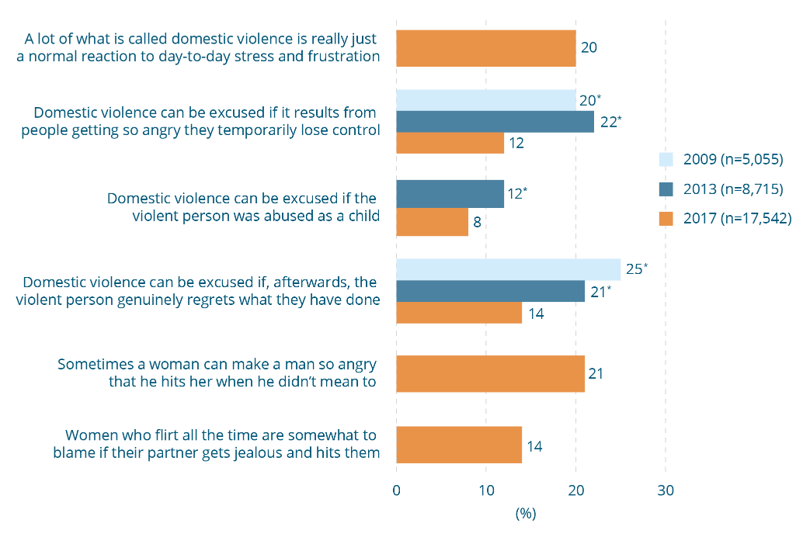
Attitudes excusing the perpetrator and holding women responsible for domestic violence, 2009, 2013 and 2017 (% agree)
Attitude | 2009  (n=5,055) (%) | 2013  (n=8,715) (%) | 2017  (n=17,542) (%)
A lot of what is called domestic violence is really just a normal reaction to day-to-day stress and frustration | - | - | 20
Domestic violence can be excused if it results from people getting so angry they temporarily lose control | 20* | 22* | 12
Domestic violence can be excused if the violent person was abused as a child | - | 12* | 8
Domestic violence can be excused if, afterwards, the violent person genuinely regrets what they have done | 25* | 21* | 14
Sometimes a woman can make a woman so angry that he hits her when he didn’t mean to | - | - | 21
Women who flirt all the time are somewhat to blame if their partner gets jealous and hits them | - | - | 14

Box 10-1: Attitudes excusing violence against women and blaming them
Why do they matter?
Excusing violence in intimate relationships by blaming the victim may lead to violence becoming acceptable in certain circumstances. This is a concern as social disapproval of violence is one of the strongest factors protecting against victimisation (Emery, Jolley, & Wu, 2011; Sampson, 1993; Waltermaurer, 2012. See also Section 4).
Excusing violence may also work against the application of legal sanctions. For example, the excuses of provocation or ‘loss of self-control’ are partial legal defences for murder in many countries and some states of Australia and are frequently used by men to excuse their murder of an intimate partner (Burman, 2014). There is longstanding criticism that this partial defence of provocation has been used to deny some men’s responsibility for violence against women. Recent law reforms across Australia and in other countries have attempted to address these problems in different ways, but debate continues about the place of provocation within the criminal law (Australian Law Reform Commission & NSW Law Reform Commission, 2010; Fitz-Gibbon & Stubbs, 2012).
Dispelling excuses is important to build appropriate accountability mechanisms for men who use violence who may call upon excuses to justify their behaviour, thus increasing the risk that they will continue to perpetrate violence (Morrison, Hawker, Cluss et al., 2018). If held by personnel in response and support services, excuses for violence may work against appropriate assistance for women who are victims (Diemer, Ross, Humphreys et al., 2017; Lea, 2007; Page, 2008; Segrave & Wilson, 2011; Segrave, Wilson, & Fitz-Gibbon, 2016).

A small and declining proportion believe that violence can be excused because alcohol is involved
Only a small proportion of Australians agree that intoxication is an excuse for violence, although people are slightly more likely to see alcohol as a mitigating factor in men’s perpetration of rape (8%) than they are to excuse domestic violence because alcohol is involved (5%) (Figure 10-2).
The proportion of people prepared to excuse domestic violence is the same (5%) whether it is the victim or perpetrator who is intoxicated. However, a larger percentage (13%) attributed some responsibility to women for rape if they were affected by alcohol or drugs at the time. With the exception of this statement, the proportions supporting statements excusing violence owing to intoxication are smaller than is the case for most other statements in the survey. There has been a decline between 2013 and 2017 in the proportions agreeing that domestic violence can be excused if either the victim or perpetrator is affected by alcohol. In 2013, 11 percent agreed that such violence could be excused if the victim is intoxicated (compared with 5% in 2017) while 9 percent in 2013 agreed that violence could be excused if the offender is intoxicated (compared with 5% in 2017). Further, there has been a decline of six percentage points in the proportion of people agreeing that ‘if a woman is raped while she is drunk or affected by drugs she is at least partly responsible’ (19% in 2013 compared with 13% in 2017).
One other question in the questionnaire addresses the role of alcohol. It pertains to victim intoxication and consent to sexual relations (see Section 10.4) and is worded ‘if a woman is drunk and starts to have sex with a man but falls asleep, it is understandable if he continues having sex with her anyway’. While the proportion of Australians supporting the statement (10%) is relatively low compared with most other questions in the questionnaire, it is somewhat higher than the proportion who see alcohol as excusing domestic violence. Agreement with this attitude is inconsistent with laws pertaining to consent. Indeed in some Australian jurisdictions the law specifically identifies severe intoxication as a condition compromising the capacity to give consent (Flynn & Henry, 2012).
Figure 10-2: Attitudes supporting being intoxicated as an excuse for violence, 2009, 2013 and 2017 (% agree) 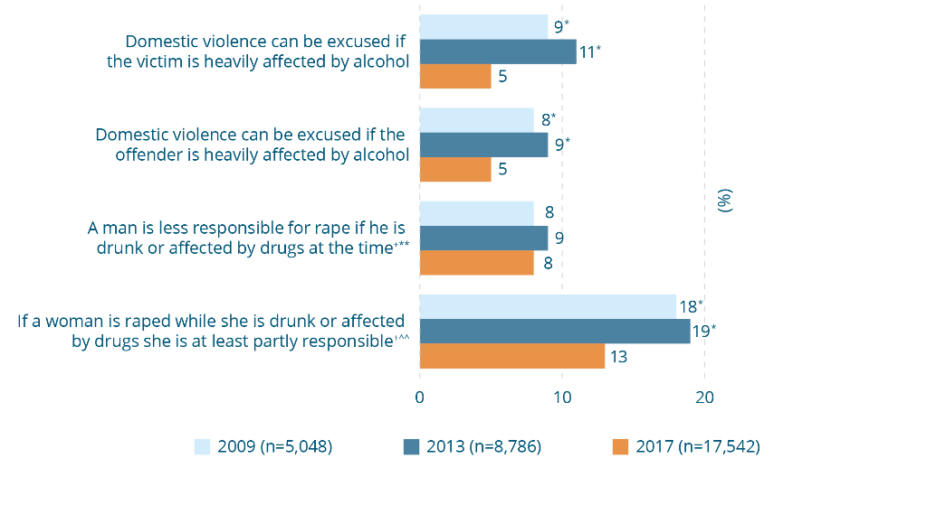

Attitudes supporting being intoxicated as an excuse for violence, 2009, 2013 and 2017
(% agree)
Attitude | 2009  (n=5,048) (%) | 2013  (n=8,786) (%) | 2017  (n=17,542) (%)
Domestic violence can be excused if the victim is heavily affected by alcohol | 9* | 11* | 5
Domestic violence can be excused if the offender is heavily affected by alcohol | 8* | 9* | 5
A man is less responsible for rape if he is drunk or affected by drugs at the time⁺** | 8 | 9 | 8
If a woman is raped while she is drunk or affected by drugs she is at least partly responsible^{+^^} | 18* | 19* | 13
* Difference between survey year and 2017 is statistically significant, p≤.01.
** Asked of a quarter of the sample in 2017.
⁺ Cognitive testing indicated that respondents did not differentiate between drugs or alcohol in response to this question.
^^ This question has been reported here for conceptual coherence. In the factor analysis (see Box 5-2) it was correlated with questions in the ‘minimising violence against women’ theme and is included in that theme in any theme-level analysis.
Box 10-2: Attitudes excusing violence due to alcohol
Why do they matter?
Excusing men for using violence when they are intoxicated works against them accepting accountability for their behaviour. It can also lead to emphasis being placed on addressing their alcohol use at the expense of addressing other factors. The role of men’s use of alcohol in the problem of intimate partner violence was discussed in Box 8-12.
There is indeed evidence that men who misuse alcohol are more likely to perpetrate sexual assault (Abbey, Wegner, Woerner et al., 2014; Wall & Quadara, 2014). In approximately half of all reported and unreported sexual assaults either the victim, perpetrator or both have been using alcohol (Abbey, 2011; Abbey, Zawacki, Buck et al., 2004; Heenan & Murray, 2006). However, the increased risk associated with alcohol is primarily among men who are already predisposed to sexual aggression (Abbey, 2011).
There is also evidence that women who report experiencing intimate partner violence are more likely to report risky levels of drinking (Devries, Child, Bacchus et al., 2014). However, longitudinal studies show that risky levels of drinking increase with exposure to intimate partner violence, suggesting that alcohol misuse may also be a consequence of violence; that is, women may increase their alcohol consumption as a means of managing the impacts of violence in their relationship (Devries, Child, Bacchus et al., 2014).

A small and declining proportion agree that domestic violence is a private, family matter
The overall proportions of people in Australia agreeing that ‘domestic violence is a private matter to be handled in the family’ or that ‘it’s a woman’s duty to stay in a violent relationship in order to keep the family together’ are small, with 12 percent and 4 percent agreeing to these statements respectively in 2017. The proportion agreeing to the first statement, while fluctuating over the four surveys in which it has been asked, declined between 2013 (17%) and 2017 and is less than in 1995 when it was first asked nationally (18%). The proportion agreeing that ‘it’s a woman’s duty to stay in a violent relationship in order to keep the family together’ more than halved between 2013 (9%) and 2017 (4%).

10.2 Violence against women theme 2: Attitudes minimising violence against women
Violence is minimised by attitudes that deny its seriousness, underestimate the impact on the victim or make something seem less important or complex than it really is (e.g. denying the difficulty of leaving an abusive relationship) (Dunham & Senn, 2000; Easteal, Bartels, & Bradford, 2012; Harned, 2005; Henning, Jones, & Holdford, 2005; Lim, Valdez, & Lilly, 2015).
Figure 10-3: Attitudes towards domestic violence, family privacy and unity, 1995, 2009, 2013 and 2017 (% agree) 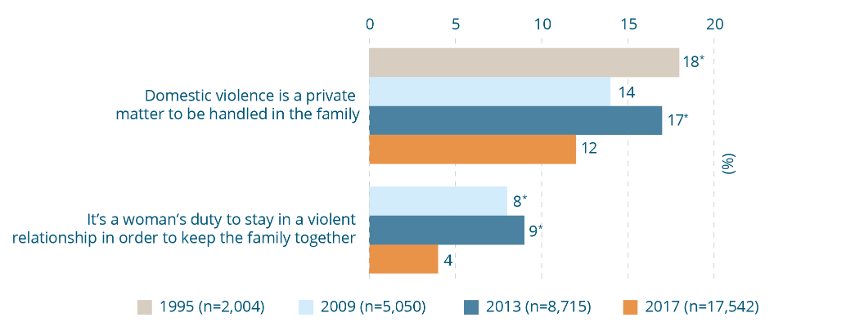
Attitudes towards domestic violence, family privacy and unity, 1995, 2009, 2013 and 2017
(% agree)
Attitude | 1995  (n=2004) (%) | 2009  (n=5,050) (%) | 2013  (n=8,715) (%) | 2017  (n=17,542) (%)
Domestic violence is a private matter to be handled in the family | 18* | 14 | 17* | 12
It’s a woman’s duty to stay in a violent relationship in order to keep the family together | - | 8* | 9* | 4
* Difference between survey year and 2017 is statistically significant, p≤.01.

Most support policies for responding to recurring domestic violence
Australian states and territories have developed policies and practices to enable continuing police intervention in recurring violence, as well as to support women and their children to establish their right to remain in the family home. In most jurisdictions this has involved the introduction of laws to allow the removal of the perpetrator from the home (Breckenridge, Chung, Spinney et al., 2015).
The findings in Figure 10-4 suggest that the majority of Australians support the principles underlying these policies. Most do not hold negative attitudes towards women who remain in or return to relationships in which violence is occurring, do not trivialise the seriousness of the abuse and support the continued involvement of police and counselling and support services in relationships in which there is recurring violence.
As was the case in prior waves of the survey, the majority of people in Australia (87%) agree that ‘in domestic situations where one partner is physically violent towards the other, it is entirely reasonable for the violent person to be made to leave the family home’. Men were less likely to agree with this statement than were women (84% vs 91%). The difference between the sample as a whole in 2013 (89%) and 2017 (87%) was not statistically significant. However, the proportion agreeing to the statement is three percentage points less than when it was first asked in 2009 (90%).
Nevertheless, nearly one in three Australians (32%) agree that women who do not leave a relationship in which violence is occurring hold some responsibility for the abuse continuing and just over one in six (16%) ‘don’t believe it’s as hard as people say it is for women to leave a violent relationship’. Men were more likely to agree with this than women (20% vs 12%). More than one in ten Australians (12%) believe that ‘if a woman keeps on going back to an abusive partner then the violence cannot be very serious’. A similar proportion agree that ‘it’s acceptable for the police to give lower priority to domestic violence cases they have attended many times before’ (12%) and that ‘women who stay in abusive relationships should be entitled to less help from counselling and support services than women who end the relationship’ (11%).
Box 10-4: Laws enabling the removal of a violent person from the family home
Why do they matter?
- Laws play an important symbolic role in setting new social norms – in this case regarding accountability for violent behaviour (Flood & Pease, 2006; Salazar, Swartout, Swahn et al., 2003).
- Laws and procedures facilitating the removal of the violent person from the family home serve a vital practical purpose, reducing the burden of homelessness and disruption on women and children (Murray, 2007).
- Wide community support for the use of the law as a mechanism to respond to and prevent violence is an indicator that the community understands the seriousness of the problem and supports it being one of public policy concern. Such support can also facilitate its implementation (Worden & Carlson, 2005).
Figure 10-4: Attitudes minimising the impacts and consequences of recurring domestic violence, 2009, 2013 and 2017 (% agree) 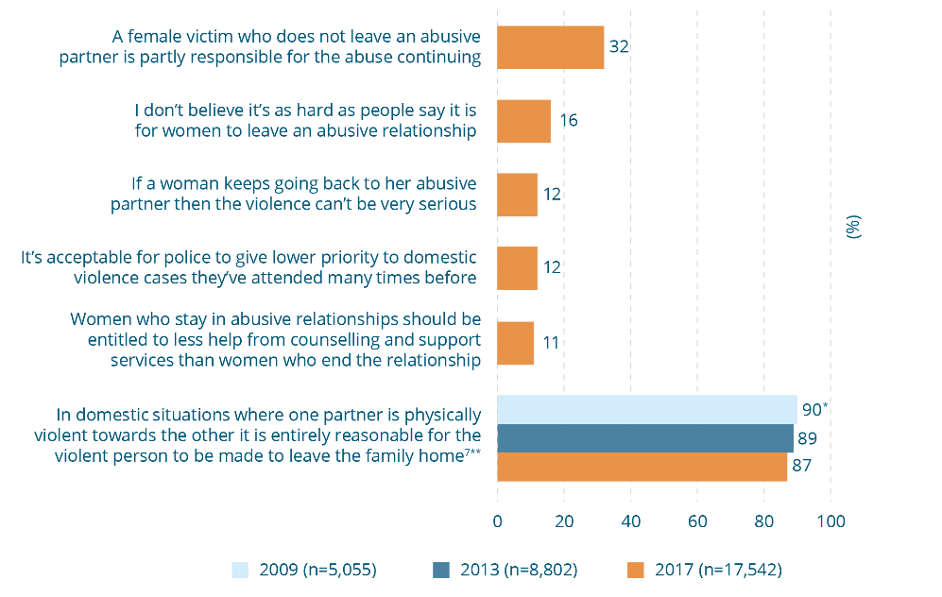
Attitudes minimising the impacts and consequences of recurring domestic violence, 2009, 2013 and 2017 (% agree)
Attitude | 2009  (n=5,055) (%) | 2013  (n=8,802) (%) | 2017  (n=17,542) (%)
A female victim who does not leave an abusive partner is partly responsible for the abuse continuing | - | - | 32
I don’t believe it’s as hard as people say it is for women to leave an abusive relationship | - | - | 16
If a woman keeps going back to her abusive partner then the violence can’t be very serious | - | - | 12
It’s acceptable for police to give lower priority to domestic violence cases they’ve attended many times before | - | - | 12
Women who stay in abusive relationships should be entitled to less help from counselling and support services than women who end the relationship | - | - | 11
In domestic situations where one partner is physically violent towards the other it is entirely reasonable for the violent person to be made to leave the family home^{7**} | 90* | 89 | 87
* Difference between survey year and 2017 is statistically significant, p≤.01.
** Asked of a quarter of the sample in 2017.
⁷ Not in CASVAW scale and reverse scored.
Box 10-5: Attitudes that minimise recurring intimate partner violence
Why do they matter?
Attitudes that minimise violence can divert attention away from holding the perpetrator accountable for their behaviour. Minimisation of the seriousness of the violence by family, friends, neighbours and service providers may silence a woman and/or compromise the support and protection that would otherwise be available to her.
Minimising attitudes may underlie or reinforce responses among women experiencing violence, compounding their situation or working against them securing support from others. Studies show that women may:
- utilise strategies of minimisation, such as omission of information, when disclosing to family, friends and professionals, in an effort to manage the reactions of others (Dunham & Senn, 2000; Francis, Loxton, & James, 2017);
- minimise their situation as a coping mechanism (Francis, Loxton, & James, 2017) or a way of making sense of violence (Easteal, Bartels, & Bradford, 2012; Harned, 2005; Lim, Valdez & Lilly, 2015); and
- internalise minimising attitudes, such that violence becomes normalised (Lim, Valdez & Lilley, 2015; Fakunmoju, Bammeke, Oyekanmi et al., 2016; McCarry & Lombard 2016; Schick, 2014). As a consequence, they may not recognise their situation as violent (Francis, Loxton, & James, 2017; Harned, 2005) or not see help-seeking as warranted (Layman, Gidycz, & Lynn, 1996; Pitts & Schwartz, 1993). This may be compounded by the tendency for perpetrators themselves to minimise the violence they use (Bonomi, Gangamma, Locke et al., 2011). Continued exposure to the minimising attitudes of others can result in a culture of resignation (Thapar-Björkert & Morgan, 2010).

Box 10-6: What are the barriers to women seeking safety from violence?
Many women who live with violence and abuse fear that the violence will increase if they try to leave and therefore may feel trapped. This fear is not baseless, with evidence showing that the risk of violence is greater in the lead-up to separation and afterwards (Brownridge, 2006; Campbell, Webster, Kozol-McLain et al., 2011; Davies, Ford-Gilboe, & Hamilton, 2009) and that this risk may also extend to children (Davies, Ford-Gilboe, & Hamilton, 2009; DeKeseredy, Rogness, & Schwartz, 2004). This includes a higher risk of intimate partner homicide (Domestic Violence Death Review Team, NSW, 2017; Johnson & Hotton, 2003; Mahoney, 1991).
The myth that women can easily leave violent and abusive relationships belies the risks of escalating violence, along with other well documented barriers to women seeking safety, including:
- lack of alternative sources of housing and income (Braaf & Meyering, 2011; Meyer, 2016);
- unhelpful responses from family, friends (Fanslow & Robinson, 2010) and service providers (Dunham & Senn, 2000; Francis, Loxton, & James, 2017);
- a lack of knowledge of support services (Dunham & Senn, 2000; Francis, Loxton, & James, 2017), a dearth of available services (Ragusa, 2017), or problems in accessing services (e.g. as a consequence of language and cultural differences (Bartolomei, Eckert, & Pittaway, 2014; Zannettino, 2012) or disability (McGilloway, Smith, & Galvin, 2018);
- concern for the future safety and wellbeing of children, particularly in rural areas (DeKeseredy, Dragiewicz, & Schwartz, 2017). Family laws privileging shared parenting arrangements after separation may be of particular concern (Meyer, 2012; Murray, 2007);
- a strong commitment to maintaining family unity and community reputation, a particular concern in some collectivist communities or communities that are already stigmatised (Eräranta & Kantola, 2016; McGlade, 2012; Nash, 2005; Yoshioka & Choi, 2005);
- the impacts of the violence itself on their health and wellbeing which may in turn impact on their confidence to establish a new life (Kim & Gray, 2008); and
- the cyclical nature of much intimate partner violence (with episodes of violence and abuse often interspersed with remorse), which may impact upon women’s resolve to seek safety (Baholo, Christofides, Wright et al., 2015; Rhatigan, Street, & Axsom, 2006).
Some women may make a rational decision to remain in a violent relationship, because they have a commitment to the relationship and just want the violence to stop, or they may wish to carefully plan a safe departure. Protection against violence is especially important in these circumstances. Some experts claim that, paradoxically, the increasing emancipation of women has led to less sympathy for those remaining in violent relationships than may have been the case in the past, since it is assumed that women (at least in contemporary western societies) have the resources to protect and care for themselves (Ramsey, 2013).

Few believe that women are lying about sexual violence just because they don’t report straight away
A minority of Australians holds attitudes challenging the credibility of women’s reports, with 9 percent agreeing that ‘women who wait weeks or months to report sexual harassment are probably lying’ and 11 percent agreeing that this is so in the case of claims of sexual assault. Only 6 percent of Australians support the attitude that rape is unlikely to have occurred if there are no obvious signs of physical force.
Figure 10-5: Attitudes minimising sexual violence by claiming that women lie, 2017 (% agree) 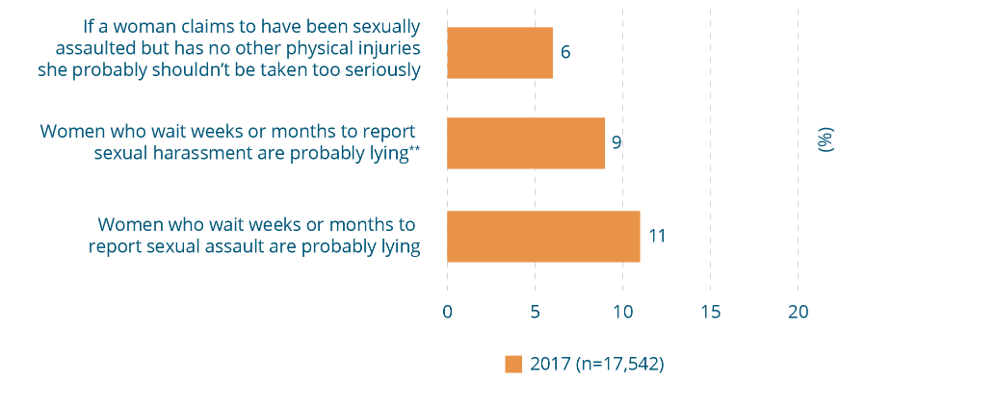

Attitudes minimising sexual violence by claiming that women lie, 2017 (% agree)
Attitude | 2017  (n=17,542)  (%)
If a woman claims to have been sexually assaulted but has no other physical injuries she probably shouldn’t be taken too seriously | 6
Women who wait weeks or months to report sexual harassment are probably lying** | 9
Women who wait weeks or months to report sexual assault are probably lying | 11
** Asked of a quarter of the sample in 2017.
Box 10-7: Attitudes that women lie about sexual violence
Why do they matter?
Most sexual assault, rape and sexual harassment is perpetrated by a man known to the woman (see Box 8-8), and this makes it less likely that the victim will be believed when she alleges that she did not consent (Cook & Messman-Moore, 2018). Rather, the perpetrator may be viewed as having misunderstood or misread her ‘signals’ and therefore his behaviour is seen as more tolerable than if he had behaved similarly in an encounter with a stranger (Ben-David & Schneider, 2005; Simonson & Subich, 1999). In many circumstances the perpetrator may hold a position of status in a particular context, and/or hold social or structural power over the woman. This may compound her fear that she won’t be believed, as well as her concern that she may suffer social rejection and other consequences if she does report the offence (Crebbin, Campbell, Hillis et al., 2015; McLaughlin, Uggen, & Blackstone, 2017).
A culture of blaming women for ‘being raped’, disbelieving some women’s experiences and minimising others may also lead victims to minimise their own experience, questioning the seriousness of what happened to them, and denying they have been sexually assaulted. This may in turn lead some women to delay reporting. Research into how women label unwanted sexual experiences with dating partners indicates they pass through a process before defining an experience as sexual abuse or assault. In this process, women report having to work through issues of consent, whether they could be said to have ‘caused’ the abuse and whether indeed the incident was serious enough to constitute assault or abuse (Harned, 2005; Jeffrey & Barata, 2016).
Other implications of the belief that women make false allegations are discussed in Box 10-9.

One in five disagree that financial abuse is serious
Economic partner abuse is prevalent (Macdonald, 2012; Postmus, McMahon, Warrener et al., 2011) and contributes to significantly high rates of poverty and unemployment among women who have experienced partner abuse (Kutin, Russell & Reid, 2017; Postmus, McMahon, Warrener et al., 2011). Financial dependence is among the barriers to women seeking safety from a violent relationship (Meyer, 2012).
In the 2009 and 2013 surveys, people were presented with the series of behaviours (introduced earlier in Figure 8-1 and Figure 8-2) and asked if they believed these are serious. Most people (87% or more in the case of each behaviour in 2013) agree that they are indeed serious (VicHealth, 2014). An exception was the statement that ‘trying to control one’s partner by denying them money’ is serious. Only 74 percent of the sample agreed with this in 2013 (VicHealth, 2014, p.44). Although the other questions in the series were removed to make way for new questions, a question on the perceived seriousness of financial control was retained in the 2017 questionnaire, so that community attitudes towards this could be monitored.
As can be seen in Figure 10-6, 81 percent believe that that financial control is serious. While this is a larger percentage than in 2013, the wording of this question differed from that of the question on financial control in the 2009 and 2013 surveys, so the results cannot be directly compared. While the majority in 2017 agree with the statement, nearly one in six people (16%) do not believe that financial control is serious.

Few think that women should have to deal with violence on their own
The proportion of Australians believing that ‘women who are sexually harassed should sort it out themselves rather than report it’ is only 7 percent in 2017 and has declined steadily since 1995 when 20 percent agreed with it. Likewise, only a minority of Australians (13%) agree that reporting intimate partner violence is shameful for the family.
Figure 10-6: Attitudes minimising violence against women by making it a problem for women to bear, 1995, 2009, 2013 and 2017 (% agree) 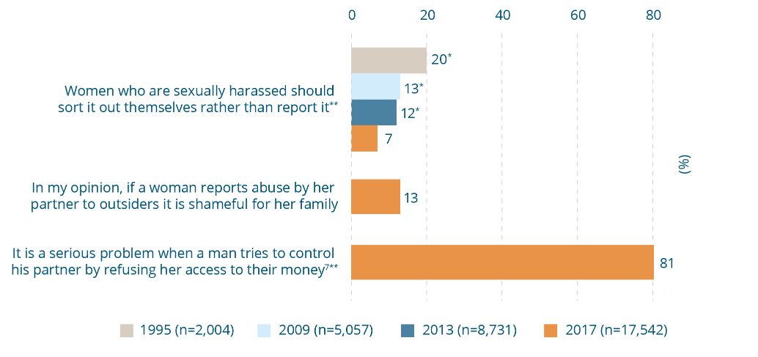

Attitudes minimising violence against women by making it a problem for women to bear, 1995, 2009, 2013 and 2017 (% agree)
Attitude | 1995  (n=2,004)  (%) | 2009  (n=5,057)  (%) | 2013  (n=8,731)  (%) | 2017  (n=17,542)  (%)
Women who are sexually harassed should sort it out themselves rather than report it** | 20* | 13* | 12* | 7
In my opinion, if a woman reports abuse by her partner to outsiders it is shameful for her family | - | - | - | 13
It is a serious problem when a man tries to control his partner by refusing her access to their money^{7**} | - | - | - | 81
* Difference between survey year and 2017 is statistically significant, p≤.01.
** Asked of a quarter of the sample in 2017.
⁷ Not in CASVAW scale and reverse scored.
Box 10-8: Attitudes that women should deal with violence on their own
Why do they matter?
The need to protect the reputation of the family may magnify shame when disclosing and reporting violence and seeking help (Owen & Carrington, 2015; Prentice, Blair, & O’Mullan, 2017; Spangaro, Koziol-McLain, Zwi et al., 2016). For some women the reputation of the family in the community may be valued more than the protection of the individual, and shame may be magnified (Femi-Ajao, Kendal, & Lovell, 2018; Yoshioka & Choi, 2005). Fear of bringing shame on the family can lead women and their support network to tolerate violence in order to ‘protect the family name’, or avoid further stigmatising a community (Nash, 2005; McGlade, 2012).
Whereas violence against women was once seen as a private problem and women were required to deal with it themselves (Schneider, 1991), advocacy undertaken by the women’s movement, together with legal, policy and program reform, have shifted the dialogue and understanding away from the private and into the public domain. This has intensified in recent years with social media campaigns such as #metoo and the ShittyMediaMenList, coupled with stronger media reporting of cases involving entrenched serial perpetration of abuse and harassment (Corcione, 2018). Constructive and responsible public dialogue can serve to validate victims and hold perpetrators to account (Corcione, 2018), while helping to strengthen social norms (Fileborn & Loney-Howes, 2017).

10.3 Violence against women theme 3: Attitudes mistrusting women’s reports of violence
The attitudes in this theme are linked to the idea that women lie about or exaggerate reports of violence in order to ‘get back at’ men or gain tactical advantage in their relationships with men (e.g. to improve their prospects in cases involving conflict over care arrangements for children following separation).
The attitudes in this theme overlap with those introduced in the minimising theme described earlier (concerned with delayed reporting) in that they both concern the proposition that women make false allegations of violence. Both themes reflect negative stereotypes of women as liars, lacking in credibility (Edwards, Turchik, Dardis et al., 2011). However, the fact that these statements fell into separate themes in the analysis of the data suggests that they are distinct from one another; that is, the statements in the minimising theme, consistent with other statements in that theme, are likely to reflect a lack of appreciation (i.e. a minimising) of the barriers to reporting by respondents. In contrast, the statements in the theme of ‘mistrusting women’s reports’ are distinguished by the idea that women lie or exaggerate for the purposes of gaining tactical advantage. The fact that these statements fall out statistically into a distinct theme is an important finding, for reasons discussed in Box 5-2.

Attitudes that women use reports of violence for tactical reasons are widely held, but may be improving
There was a substantially higher level of support among Australians for questions in this theme than for the first two themes reported (Figure 10-7). More than two in five Australians (43%) agree that women make up or exaggerate violence in order to secure tactical advantage in disputes involving where children will live after separation or divorce, with men more likely to agree than women (49% vs 37%). More than two in five (42%) agree that ‘it is common for sexual assault accusations to be used as a way of getting back at men’. Nearly one third (31%) agree that ‘a lot of times women who say they were raped had led the man on and then had regrets’, with men less likely to disagree than women (50% vs 61%). One in five (23%) agree that ‘many women tend to exaggerate the problem of male violence’, with men being more likely to agree with this statement than women (28% vs 18%).
Two of the questions were asked in prior waves of the survey. There has been a decline in support for both statements. The proportion of people who agree that women lie or exaggerate about domestic violence in the context of family law proceedings has declined ten percentage points since 2013, when 53 percent agreed, and eight percentage points since 2009, when 51 percent agreed. The proportion agreeing that ‘a lot of times women who say they were raped had led the man on and then had regrets’ declined seven percentage points between 2013 (38%) and 2017 (31%).
Also of note in this theme is the large proportion of people who gave a ‘don’t know’ response to each of the questions. The proportion of people who gave this response to questions in other parts of the questionnaire is usually between 1 and 3 percent (with most being 1%) (data not shown). However, the ‘don’t know’ ranged from 8 to 16 percent of the sample in the theme of ‘mistrusting women’s claims’ (data not shown). This may be because respondents did not feel they had sufficient experience of the circumstances in the questions to give a response, which is a possibility given that these questions involve issues of contestation between men and women as to the ‘facts’ of a situation. However, other research shows that respondents to surveys may also be more inclined to choose ‘don’t know’ when given the option in a Likert scale, to avoid giving a response they know to be socially undesirable (Beatty, Hermann, Puskar et al., 1998; Krosnick, 2018).
Figure 10-7: Attitudes mistrusting women’s reports of violence, 2009, 2013 and 2017 (% agree) 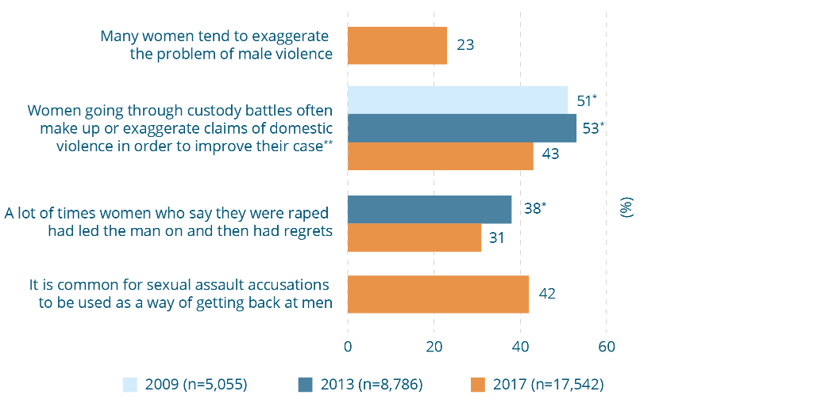
Attitudes mistrusting women’s reports of violence, 2009, 2013 and 2017 (% agree)
Attitude | 2009  (n=5,055)  (%) | 2013  (n=8,786)  (%) | 2017  (n=17,542)  (%)
Many women tend to exaggerate the problem of male violence | - | - | 23
Women going through custody battles often make up or exaggerate claims of domestic violence in order to improve their case** | 51* | 53* | 43
A lot of times women who say they were raped had led the man on and then had regrets | - | 38* | 31
It is common for sexual assault accusations to be used as a way of getting back at men | - | - | 42
* Difference between survey year and 2017 is statistically significant, p≤.01.
** Asked of a quarter of the sample in 2017.

Box 10-9: Attitudes that women report violence for tactical reasons
Why do they matter?
Although attitudes in this theme reflect the view of women as untrustworthy and lacking in credibility, they have an additional element: they reflect the idea that gender relations are inherently contested and hostile; that is, that women are ‘out to get’ men. In this sense these are similar to some of the questions in the gender equality theme ‘denying gender inequality is a problem’, which in turn have been associated with a ‘backlash’ towards women’s advancement.
This backlash to women’s advancement has been particularly strong in two related areas. The first is family law, and the second concerns policies, laws and programs that have been introduced in recent decades to respond to and prevent violence against women (Dragiewicz, 2011; Flood, 2010; Girard, 2009; Schmitz & Kazyak, 2016). If these ideas become prominent in the community and among key decision-makers, there is a risk they may compromise political will to support policies and programs to address the problem or result in social policy responses that fail to deal appropriately with it (Flood, 2010; Girard, 2009).
The consequences of the belief that women lie about sexual violence have been discussed earlier (see Box 8-5). Similar implications are associated with the view that women lie about intimate partner violence. This is especially the case in family law disputes because, as indicated in Box 10-6, women and their children face an elevated risk of severe and lethal violence following separation. There is evidence that a perception by women that this belief is held by others influences disclosure, with many who experience intimate partner violence making a deliberate decision not to disclose this in the course of family law disputes. This is because women believe that doing so will prejudice their prospects of achieving an appropriate care arrangement for their children (Laing, 2010, 2016; Saunders & Oglesby, 2016). For example, in a recent Australian study 38 percent of parents who had experienced domestic violence and/or held safety concerns for their children did not disclose this to family law professionals during family court negotiations (Kaspiew, Carson, Dunstan et al., 2015). These fears are not ill-founded, with a study of family law practitioners finding that they believed that false allegations of intimate partner violence were made in 30–80 percent of cases (Haselschwerdt, Hardesty, & Hans, 2011). Also of note is that the very notion of intimate partner violence conferring a tactical advantage to women is not well founded. Even where intimate partner violence has been established legally, there is a tendency for courts to prioritise children maintaining contact with their fathers (Hans, Hardesty, Haselschwerdt et al., 2014; Kaspiew, Carson, Dunstan et al., 2015; Macdonald, 2016; Maloney, Smyth, Weston, et al., 2007).
Although there are no known studies that have sought to investigate the extent to which allegations of intimate partner violence in the course of family law proceedings are ultimately found to be false, studies on false allegations of child abuse in this context suggest that they are rare (Hans, Hardesty, Haselschwerdt et al., 2014). A Canadian study found that such allegations were more likely to be made by the non-custodial parent (primarily men), who were responsible for 43 percent of false reports, or by relatives, neighbours or acquaintances (responsible for 19%). Custodial parents (primarily women) were responsible for 14 percent and children only 2 percent (Trocme & Bala, 2005). A particular concern is evidence that some men make counter-allegations of domestic violence in family law proceedings as a form of ongoing abuse and control (Hans, Hardesty, Haselschwerdt et al., 2014).

10.4 Violence against women theme 4: Disregarding the need to gain consent
Attitudes in this theme typically reflect stereotyped beliefs about the roles that men and women play in sexual relationships (e.g. that women are passive and subservient to men) (Bay-Cheng & Elisio-Arras, 2008; Fantasia, 2011; Hust, Marett, Lei et al., 2015; Hust, Rodgers, & Bayly, 2017; Ward, 2003; Warren, Swan, & Allen, 2015). Such attitudes deny the requirement for sexual relations to be based on the presence and ongoing negotiation of consent. They rationalise men’s failure to actively gain consent as a ‘natural’ aspect of masculinity (e.g. men’s uncontrollable sexual drive), or are based on stereotypes of female sexuality (e.g. assuming that a woman who has been sexually assertive consents to all sexual activity).
Questions with a theme of sexual consent group together in the statistical analysis, distinguishing this as a second new theme underpinning violence-supportive attitudes in the Australian population. The emergence of this theme is particularly noteworthy given the extensive debate in recent years in the wider community and in the legal sector about the capacity to give consent and about acceptable forms of consent (Rubenfeld, 2013), and victim testimony and belief (Dwyer, Easteal, & Hopkins, 2012; Flynn & Henry, 2012; Fraser, 2015; Levanon, 2012). This debate has also been concerned with the blurred boundaries between a woman expressing sexual agency, and the degree to which this can be construed as implied consent (Alcoff, 2009; Fraser, 2015; Hust, Rodgers, & Bayly, 2017). The issues blurring the consent boundaries are similar to those linked to disbelief of women’s reports of violence (e.g. alcohol and drug use, and delayed reporting) (Dwyer, Easteal, & Hopkins, 2012).
Many of the beliefs that have historically underpinned attitudes towards sexual relations also play out in newer forms of sexual offence, such as the non-consensual distribution of images online (Barkacs & Barkacs, 2010; Draper, 2012; Karaian, 2012, 2014; Krieger, 2017; Salter, Crofts, & Lee, 2013).

Many reject key elements of a mutually negotiated approach to consent
There is a relatively high level of support for attitudes that attribute responsibility to women for men’s sexual aggression based on gendered assumptions about relationships. More than one in five (23%) support the statement that ‘women find it flattering to be persistently pursued, even if they are not interested’, while over one in ten (12%) agree that ‘women often say ‘no’ when they mean ‘yes’’. The proportion agreeing to this statement has decreased gradually since it was first asked nationally in 1995, when 18 percent agreed with it.
Likewise, sizeable proportions of Australians believe that women exercising sexual agency is implicated in men’s sexual aggression. Nearly one in three (30%) agree that ‘if a woman sends a nude image to her partner, then she is partly responsible if he shares it without her permission’, and one in five (21%) support the statement ‘since some women are so sexual in public, it’s not surprising that some men think they can touch women without permission’.
One in ten (10%) agree that ‘if a woman is drunk and starts having sex with a man, but then falls asleep, it is understandable if he continues having sex with her anyway’. This latter statement, however, attracted a lower level of endorsement than other statements in this theme, and is consistent with the generally low level of endorsement of attitudes supportive of violence related to the involvement of alcohol (see discussion in Section 10.1).

Male sexual drive is believed to be a factor in rape
Many Australians hold attitudes suggesting that sexual aggression can be attributed in part to men’s ‘sexual drive’. Over one in four (28%) agree that ‘when a man is very sexually aroused, he may not even realise that the woman doesn’t want to have sex’ and a third (33%) that ‘rape results from men not being able to control their need for sex’. The statement ‘rape results from men not being able to control their need for sex’ was first asked nationally in 2009. Although the minor difference between 2017 and 2009 (35%) is not statistically significant, the proportion in 2017 is ten percentage points less than it was in 2013 (43%).
Figure 10-8: Attitudes disregarding the need to gain consent, 1995, 2009, 2013 and 2017 (% agree) 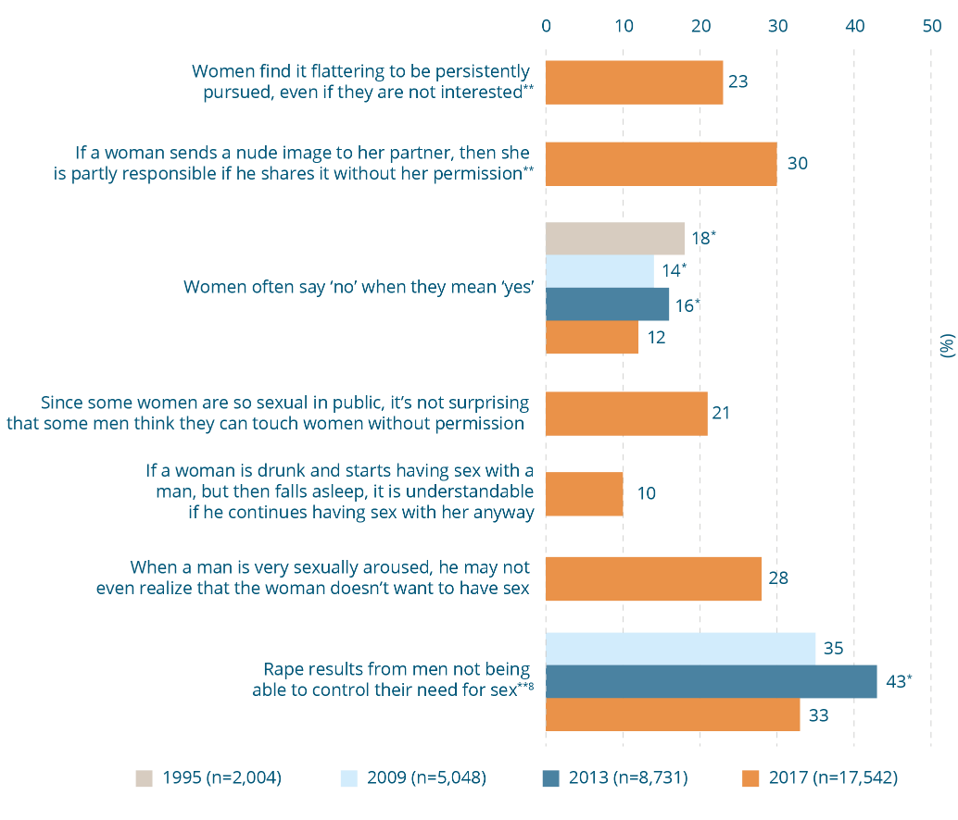

Attitudes disregarding the need to gain consent, 1995, 2009, 2013 and 2017 (% agree)
Attitude | 1995  (n=2004)  (%) | 2009  (n=5,048)  (%) | 2013  (n=8,731)  (%) | 2017  (n=17,542)  (%)
Women find it flattering to be persistently pursued, even if they are not interested** | - | - | - | 23
If a woman sends a nude image to her partner, then she is partly responsible if he shares it without her permission** | - | - | - | 30
Women often say ‘no’ when they mean ‘yes’ | 18* | 14* | 16* | 12
Since some women are so sexual in public, it’s not surprising that some men think they can touch women without permission | - | - | - | 21
If a woman is drunk and starts having sex with a man, but then falls asleep, it is understandable if he continues having sex with her anyway | - | - | - | 10
When a man is very sexually aroused, he may not even realize that the woman doesn’t want to have sex | - | - | - | 28
Rape results from men not being able to control their need for sex**⁸ | - | 35 | 43* | 33
* Difference between survey year and 2017 is statistically significant, p≤.01.
** Asked of a quarter of the sample in 2017.
⁸ Not in CASVAW scale.

Australians are more likely to justify non-consensual sex if the woman initiates intimacy
In the 2017 NCAS, two scenarios were introduced to investigate whether or not Australians would justify certain behaviour in the context of negotiating sex in different circumstances (Figure 10-9). Specifically the scenarios were used to investigate two concepts: first, whether Australians were more likely to justify sexual coercion in the context of a marital relationship, as opposed to between acquaintances; second, whether Australians were more likely to justify coercion in a circumstance where a woman had initiated intimacy (e.g. by kissing a man) as opposed to when she did not. The married and non-married variations were included to establish the extent to which the community supports the belief that women forgo their sexual autonomy after marriage (as was once understood to be the case at law, as discussed in Box 8-6). The variations with and without the woman kissing the man were included to explore community perceptions of the consequences for consent of women exercising sexual agency, and when assertive consent is required.
The scenarios were adapted from a paper-based Scottish study (Reid, McConville, Wild et al., 2015) into a form suitable to be administered over the phone. Australians responded similarly to both scenarios. Overall there was little support for a man to insist on or force sex on a woman, and this was regardless of whether the couple have just met (3%) or they are married (4%). However, approximately one in seven Australians believe a man would be justified to force sex if the woman first initiated intimacy (she brought him into the bedroom and started kissing him) but then changed her mind and pushed him away. There was slightly greater support for justification if the couple was married (15%) than if the couple had just met (13%).
Figure 10-9: Impact of situational factors on attitudes towards consent⁸ (% agree), 2017 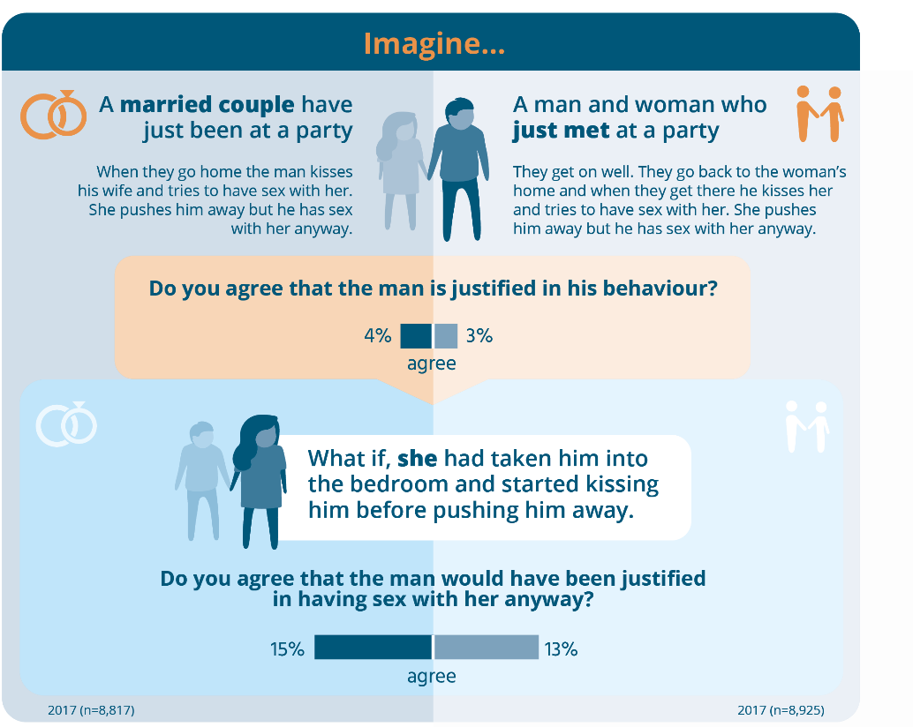
Impact of situational factors on attitudes towards consent⁸ (% agree), 2017
Scenario 1
A married couple have just been at a party
When they go home the man kisses his wife and tries to have sex with her. She pushes him away but he has sex with her anyway.
Question | Agreed (%)
Do you agree that the man is justified in his behaviour? | 4
What if she had taken him into the bedroom and started kissing him before pushing him away?  Do you agree that the man would have been justified in having sex with her anyway? | 15
Scenario 2
A man and woman who just met at a party
They get on well. They go back to the woman’s home and when they get there he kisses her and tries to have sex with her. She pushes him away but he has sex with her anyway.
Question | Agreed (%)
Do you agree that the man is justified in his behaviour? | 3
What if she had taken him into the bedroom and started kissing him before pushing him away?  Do you agree that the man would have been justified in having sex with her anyway? | 13
⁸ Not in the CASVAW scale.
Box 10-10: Attitudes justifying non-consensual sex
Why do they matter?
Non-consensual sex can range from rape to coerced sex to non-consensual acts within an initially consenting sexual encounter. Attitudes that deny the importance of consent undermine the complexity in discerning the fine line between consensual sex and coercion (Muehlenhard, Humphreys, Jozkowski et al., 2016; Warren, Swan, & Allen, 2015).
Ensuring ongoing positive consent is important as people have the right to change their minds or are in situations where they are no longer comfortable. Consent is often negotiated in a context where there are gendered power dynamics, expectations and stereotypes around male aggression and female submission (Hust, Rodgers, & Bayly, 2017).
It has been argued that the legal treatment of consent in rape and sexual harassment claims shows the damaging effects of this process as women are forced to prove an absence of consent while men assume consent is given (Fraser, 2015). This is especially the case with non-verbal non-consent.

10.5 Are attitudes in some themes more likely than others?
In the previous sub-sections, the proportion of Australians supporting individual statements in the questionnaire has been explored. These were grouped in the themes that emerged from the factor analysis (see Box 5-2).
Here, each of the themes is compared overall to see which types of attitudes are more or less strongly held in the community. This is done by calculating a score for each respondent in the survey depending on their answers in each of the groups of questions already introduced. An average or mean score is then calculated for each theme, with the range being between 1 and 100. For themes in the CASVAWS, the smaller the value of the score, the lower a person’s level of attitudinal support for violence against women.
This information is useful, because it can help identify which particular dimensions of attitudinal support for violence against women need to be given emphasis in prevention in order to reduce support for this violence.
Figure 10-10 shows that the mean score for the sample is the lowest (22) for the ‘excusing the perpetrator and holding women responsible’ theme (indicating that attitudes excusing violence are the least likely to be supported). The highest mean score is for the theme of ‘mistrusting women’s reports of violence’ (35).
When men and women are compared, women are significantly less likely to hold attitudes supporting violence against women in each of the themes (i.e. to have a lower mean score than men). The difference between men and women in the theme ‘disregarding the need to gain consent’ is small relative to the other themes.
Figure 10-10: Relative attitudinal support for violence against women, by theme^, 2017 (n=17,111) 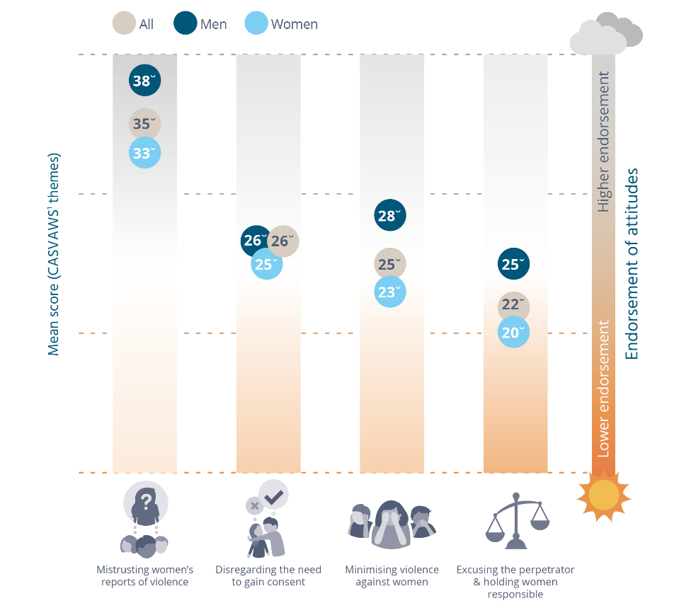
Relative attitudinal support for violence against women, by theme^, 2017 (n=17,111).
Mean scores for the CASVAWS themes - A lower score is better and indicates lower attitudinal support for violence against women
CASVAWS theme | All | Men | Women
Mistrusting women’s reports of violence | 35˘ | 38˘ | 33˘
Disregarding the need to gain consent | 26˘ | 26˘ | 25˘
Minimising violence against women | 25˘ | 28˘ | 23˘
Excusing the perpetrator & holding women responsible | 22˘ | 25˘ | 20˘
^ All differences between men and women are statistically significant, p≤.01.
¹ Measured using the composite measure described in Section 5.2.
˘ Difference between this theme and all other themes in this sample is statistically significant, p≤.01.

Are Australians more likely to hold attitudes supportive of sexual violence or intimate partner violence?
Two sub-scales were constructed using questions from the CASVAWS. The first included statements concerned with intimate partner violence (excluding sexual coercion) and the second included statements concerned with sexual assault. As before, an average or mean score was calculated for each sub-scale. Again, the smaller the value of the score, the lower the level of attitudinal support for violence against women.
Table 10-1 shows that there are no notable differences in the scores for the two sub-scales in the whole sample and among men. However, women had a slightly higher mean score for attitudes supportive of sexual violence than for intimate partner violence.
Table 10-1: Relative attitudinal support for sexual versus domestic violence, 2017^ (mean scores)
Topic | Label | Total sample  (mean score) | Men  (mean score) | Women  (mean score)
Violence – sexual assault (n=17,534) | A | 30^{B} | 31 | 29^{B}
Violence – domestic violence (n=17,542) | B | 29 | 31 | 26
Note: Where indicated, differences between A/B are statistically significant, p≤.01.
^ All differences between men and women are statistically significant, p≤.01.

10.6 Change in attitudes towards violence against women over time
The findings for individual questions that have been asked in more than one wave of the survey have been reported above. Figure 10-11 shows the change for the CASVAWS as a whole. A score is calculated for each respondent to the survey based on their answers to the statements in the scale. As discussed in Section 7.5, a statistical modelling approach was used to take account of the fact that the 2017 questionnaire has fewer historical questions. As for the themes reported in 10.5, the smaller the value of the score, the lower a person’s level of attitudinal support for violence against women. A mean or average score is calculated for each survey year. There has been a small improvement in the mean score, from 36 in 2009 and 2013, to 33 in 2017 (Figure 10-11). When comparing the effect size of the change between the 2009 and 2013 waves of the survey the effect is greater between 2009 and 2017 (0.3119) than between the 2013 and 2017 waves (0.3029) – meaning over a longer period of time there has been a greater improvement. This is a positive result for CASVAWS, illustrating what would be expected with attitude change. Changes in attitudes take time and this report documents a slow but steady overall improvement.
Figure 10-11: Changes in attitudinal support for violence against women over time, 2009, 2013 and 2017 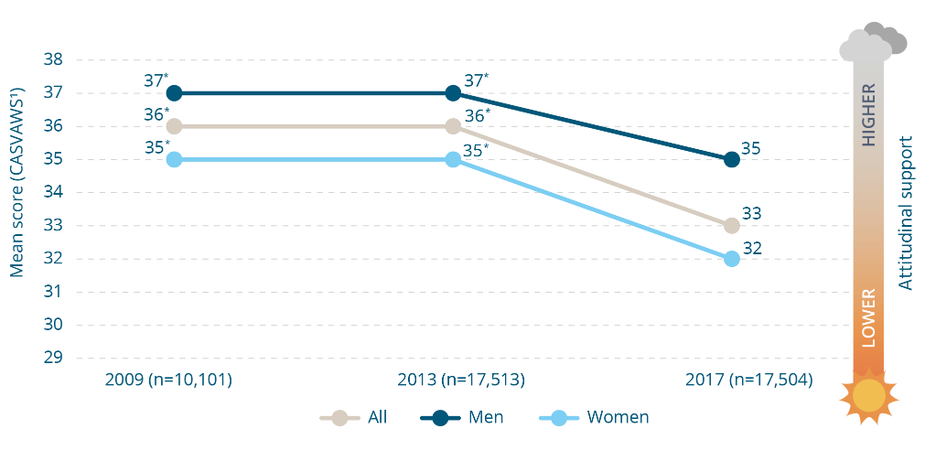
Changes in attitudinal support for violence against women over time, 2009, 2013 and 2017. Mean scores for the CASVAWS - A lower score is better and indicates lower attitudinal support for violence against women
Group | 2009 (n=10,101) | 2013 (n=17,513) | 2017 (n=17,504)
All | 36* | 36* | 33
Men | 37* | 37* | 35
Women | 35* | 35* | 32
¹ Measured using the composite measure described in Section 5.2.
* Difference between survey year and 2017 is statistically significant, p≤.01.

11 Knowledge and attitudes among people and in places
In Sections 8, 9 and 10, knowledge and attitudes in the community as a whole were explored. Here, they are examined among particular groups in the population, as well as in different types of areas. This is done by comparing the proportion of people in the high and low endorsement categories for the UVAWS, GEAS and CASVAWS. A guide to interpreting these categories can be found in Figure 7-1. Findings for each of the themes within the GEAS and CASVAWS are also explored. The data were analysed by scales and their sub-themes as this is more valid than evaluating responses to single questions.
This information can help to target efforts to prevent violence against women, focusing on where they are most needed. Overall differences between groups in the population are small, and there are no differences between some of the groups and places considered.

Women have better understanding and attitudes than men
Prior research shows that men have poorer knowledge about violence against women, are less likely to support gender equality and are more likely to hold attitudes supportive of violence against women (Davis & Greenstein, 2009; Flood & Pease, 2009). This may be due to the different social experiences to which men and women are exposed, or because some men believe it is in their interests to hold certain attitudes (Bolzendahl & Myers, 2004; Hockett, Smith, Klausing et al., 2016).
This is also shown in the 2017 NCAS data. When compared with men, women are more likely to be classified as having a:
- higher level of understanding of violence against women;
- higher level of attitudinal support for gender equality; and
- lower level of endorsement of attitudes supportive of violence against women.
This was also the case for each of the themes within the measures of gender equality and attitudes supportive of violence against women, except the CASVAWS theme of ‘disregarding the need to gain consent’ (data not shown), on which there are no differences between men and women.

Table 11-1: Understanding and attitudinal support for gender equality and violence against women, by gender, 2017
Gender^ | Unweighted base  n | Label | High understanding of violence against women  (UVAWS¹)  % | Low understanding of violence against women (UVAWS¹)  % | High attitudinal support for gender equality (GEAS¹)  % | Low attitudinal support for gender equality (GEAS¹)  % | Low attitudinal support for violence against women (CASVAWS¹)  % | High attitudinal support for violence against women (CASVAWS¹)  %
Total | 17,531 |  | 33 | 26 | 25 | 25 | 26 | 25
Men | 8,218 | A | 27 | 33^{B} | 17 | 33^{B} | 19 | 29
Women | 9,275 | B | 39^{A} | 19 | 32^{A} | 18 | 32^{A} | 21
Note: Percentages do not equal 100% as for simplicity only the ‘high’ and ‘low’ categories have been presented for each measure.
Note: Where indicated, differences between categories indicated by letters A and B are statistically significant, p≤.01 and reach the 0.2 Cohen’s threshold.
¹ Measured using the composite measures described in Section 5.2.
^ The difference between the sum of men and women and the total is accounted for by people who did not identify a gender or who did not respond to the question on gender.

Overall, older people have less positive attitudes towards gender equality and violence against women than other age groups
Other studies show that people in older cohorts are less likely to hold attitudes supportive of gender equality and more likely to hold attitudes supportive of violence against women. Two possible explanations are proposed in the literature:
- developmental factors associated with being older; and
- a cohort effect.
In the literature pertaining to ageing, experts taking a developmental approach propose that attitudes change as we age due to changes in cognitive functioning (Stewart, von Hippell & Radvansky, 2009; von Hippell, 2007). It is argued that these changes result in people being less likely to pick up on external social censure of certain views and/or being less likely to self-censor expression of them (Stewart et al., 2009; von Hippell, 2007). Those taking the cohort approach propose that attitudes are influenced primarily by the social conditions to which people are exposed, particularly in their formative years. In this explanation it is argued that the attitudes of people who are currently over the age of 65 years reflect social conditions present at the time they were children and young adults (van Egmond, Baxter, Buchler et al., 2010). This was a time when gender roles and relationships were more rigidly defined. It preceded widespread recognition of violence against women as a prevalent problem and the social and legal reforms introduced to respond to it (Dragiewitz, 2009).

Variation among older cohorts is also shown in the 2017 NCAS data:
- Poor understanding of violence against women is most likely to be found among those 75 years and over and those aged 25-34 years.
- Positive attitudes towards gender equality are less likely among people 65 years and over, and more likely among those aged 25-64 years.
- Endorsement of attitudes supportive of violence against women is more likely among people 65 years and over than people aged 25-64 years.
In contrast to people in the CASVAWS as a whole, people aged 25-34 years were more likely than those aged 45-54 years to endorse attitudes in the CASVAWS theme of minimising violence against women.
Further analysis was undertaken to investigate whether the change over time found for the community as a whole was also found for older respondents. This indicated that the patterns of change for this cohort mirrored those of the sample as a whole for all three measures (data not shown). In other words, there was improvement in all three measures among this cohort and this was proportionately similar to the improvement for each of the measures in the sample as a whole. This provides support for the attitudes of older people being subject to social influences (and hence changeable).

Poorer understanding and negative attitudes are more likely to be found among those experiencing social and economic disadvantage
Different approaches to measuring socio-economic status and disadvantage are used in existing studies. However, some of these do show some variation in attitudes by various measures of socio-economic status. Specifically, people experiencing various forms of disadvantage are more likely to hold attitudes supportive of violence against women (Gracia & Lila, 2015; Suarez & Gadalla, 2010). People with lower levels of education and participation in the labour force are less likely to support gender equality (Bolzendahl & Myers, 2004; Davis & Greenstein, 2009). There are three measures of socio-economic status in the NCAS questionnaire: the degree of advantage or disadvantage in the geographical area in which a respondent lives, their level of education and their employment status.
There are three reasons for hypothesising that people living in areas affected by social and economic disadvantage are less likely to support gender equality and/or are more likely to hold attitudes supportive of violence against women. First, these areas are more likely to be affected by other forms of violence. There is a relationship between witnessing other interpersonal violence and attitudes towards violence against women (Raiford, Seth, Braxton, & DiClemente, 2013).
Second, some research suggests that such communities are more likely to be affected by social disorganisation (Raghavan, Mennerich, Sexton et al., 2006); that is, the breakdown of social cohesion and trust in a community. This in turn is thought to work against the application of informal sanctions (people expressing their disapproval for certain behaviours, which may be measurable via their attitudes). It is argued that social disorganisation is particularly likely to occur when there is reduced investment in systems responsible for maintaining formal sanctions against violence, such as the police and judiciary (Sampson & Groves, 1989; Sampson & Wilson, 1995).
Figure 11-1: Understanding and attitudinal support for gender equality and violence against women, by age group, 2017 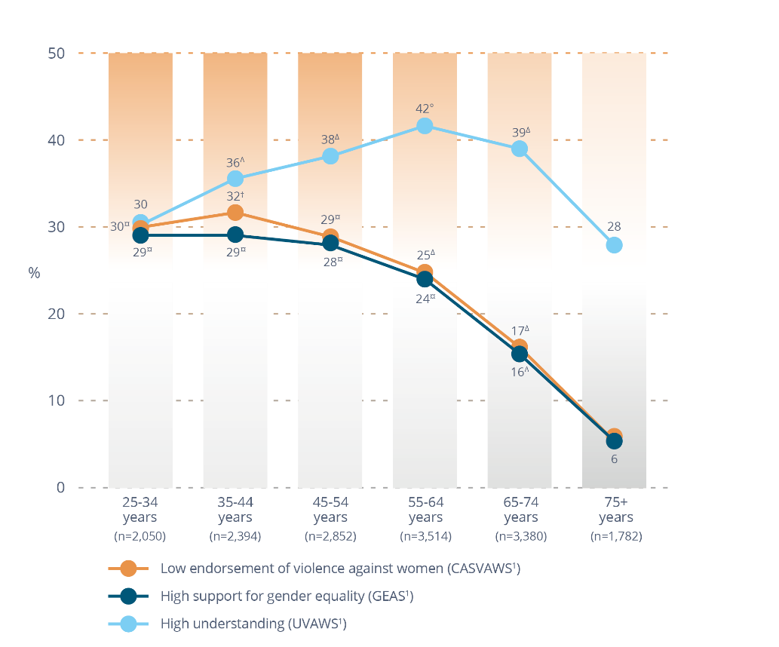
Understanding and attitudinal support for gender equality and violence against women, by age group, 2017
Age group | Low endorsement for  violence against women (CASVAWS¹) (%) | High support for  gender equality (GEAS¹) (%) | High understanding (UVAWS¹) (%)
25-34 years (n=2,050) | 30¤ | 29¤ | 30
35-44 years (n=2,394) | 32† | 29¤ | 36∆
45-54 years (n=2,852) | 29¤ | 28¤ | 38∆
55-64 years (n=3,514) | 25∆ | 24¤ | 42°
65-74 years (n=3,380) | 17∆ | 16∆ | 39∆
75+ years (n=1,782) | 6 | 6 | 28
¹ Measured using the composite measures described in Section 5.2.
° Differences between this age group and those aged 25-34 years, and ≥75 years are statistically significant, p≤.01 and reach the 0.2 Cohen’s threshold.
† Differences between this age group and those aged 55-64, 65-74 and ≥75 years are statistically significant, p≤.01 and reach the 0.2 Cohen’s threshold
¤ Differences between this age group and those aged 65-74 and ≥75 years are statistically significant, p≤.01 and reach the 0.2 Cohen’s threshold.
∆ Differences between this age group and those aged ≥75 years are statistically significant, p≤.01 and reach the 0.2 Cohen’s threshold.
Third, such areas are likely to be made up of groups more likely to hold negative attitudes towards gender equality and violence against women. Among these are the two other indicators of disadvantage included in the NCAS: education and employment status.
A person’s level of education is sometimes used as an indicator of socio-economic status. However, there is also evidence that education, in particular tertiary education, has a liberalising impact on people’s attitudes (Bolzendahl & Myers, 2004; Davis & Greenstein, 2009; Stack, Cao, & Adamzyck, 2007). In other words, the influence of limited education on attitudes may not be economic deprivation per se, but limited exposure to the liberalising influences of further education.
Four main reasons are proposed in the literature for a relationship between attitudes and employment status. First, some experts argue violence against women may occur as a reaction to stress in relationships (Smith & Weatherburn, 2013; Weatherburn, 2011). Because unemployment is a source of stress (e.g. financial difficulties and homelessness), people affected by it may be more likely to also be affected by violence and hence inclined to adopt negative attitudes as a means of rationalising negative behaviour (either in which they are themselves engaged or that is occurring within their relationships).
Second, reflecting on evidence that men who are unemployed are more likely than those who are not to perpetrate intimate partner violence, some experts have argued that this is a result not of stress per se, but rather that joblessness engenders masculine role stress (i.e. a perceived inability to meet the expectations of the male role) (Weitzman, 2014; Whaley, Messner, & Veysey, 2013). This is demonstrated by evidence showing that the increased risk of intimate partner violence occurs mainly among those men who place a high value on their role as income earners (Atkinson, Greenstein, & Lang, 2005). Again, men in this position may be more inclined to adopt negative attitudes towards violence against women as a means of excusing their behaviour. Masculine role stress may be a particular issue in recent times as economic and industry restructuring has had differential impacts for men and women; specifically, there has been a dramatic decline in jobs in industries in which men traditionally dominated, and growth in those in which women have traditionally dominated (Dworkin, Colvin, Hatcher et al., 2012; Weissman, 2007).
Third, people who are unemployed may have less exposure to the diverse social influences that would otherwise be available to them via the workplace, and this may act as a form of social censure against negative attitudes.
Fourth, unemployment has a profoundly negative impact on individual wellbeing (Kim & von dem Knesebeck, 2015; Milner, Page, & LaMontagne, 2014), and hence may increase the likelihood of women internalising negative attitudes about themselves.
The 2017 NCAS data show that those more likely to have a poorer understanding of violence against women are people with secondary education or less compared with those with post-school qualifications. Those who are unemployed compared with those who are employed are less likely to have positive attitudes towards gender equality and are more likely to endorse attitudes supportive of violence against women. The exceptions are the GEAS themes of attitudes towards ‘male peer relations involving aggression and disrespect towards women’ and ‘women’s independence and decision-making in private life’, and the CASVAWS theme of ‘disregarding the need to gain consent’. In these themes there were no differences between people based on their employment status.

Table 11-2: Understanding and attitudinal support for gender equality and violence against women, by measures of employment, socio-economic status and education, 2017

Employment status
Employment status | Unweighted base  n | Label | High understanding of violence against women  (UVAWS¹)  % | Low understanding of violence against women (UVAWS¹)  % | High attitudinal support for gender equality (GEAS¹)  % | Low attitudinal support for gender equality (GEAS¹)  % | Low attitudinal support for violence against women (CASVAWS¹)  % | High attitudinal support for violence against women (CASVAWS¹)  %
Employed | 9,213 | A | 34 | 25 | 28 | 21 | 30 | 19
Unemployed | 501 | B | 32 | 32 | 20 | 33^{A} | 23 | 32^{A}

Socio-economic status (quintiles)
Low: most advantaged
High: most advantaged
Socio-economic status (quintile) | Unweighted base  n | Label | High understanding of violence against women  (UVAWS¹)  % | Low understanding of violence against women (UVAWS¹)  % | High attitudinal support for gender equality (GEAS¹)  % | Low attitudinal support for gender equality (GEAS¹)  % | Low attitudinal support for violence against women (CASVAWS¹)  % | High attitudinal support for violence against women (CASVAWS¹)  %
1 – low | 2,450 | C | 35 | 26 | 19 | 32^{FG} | 21 | 34^{EFG}
2 | 2,664 | D | 34 | 26 | 22 | 28^{G} | 24 | 28^{F}
3 | 3,454 | E | 34 | 26 | 23 | 25 | 25 | 23
4 | 3,528 | F | 33 | 25 | 26^{D} | 23 | 27 | 22
5 – high | 5,264 | G | 31 | 27 | 29^{CE} | 21 | 29^{D} | 21

Highest education
Highest  education | Unweighted base n | Label | High understanding of violence against women  (UVAWS¹)  % | Low understanding of violence against women (UVAWS¹)  % | High attitudinal support for gender equality (GEAS¹)  % | Low attitudinal support for gender equality (GEAS¹)  % | Low attitudinal support for violence against women (CASVAWS¹)  % | High attitudinal support for violence against women (CASVAWS¹)  %
University or higher | 7,168 | H | 33 | 25 | 37^{IJ} | 18 | 35^{J} | 20
Trade/  certificate/ diploma | 4,403 | I | 36^{J} | 24 | 24 | 23 | 26 | 20
Secondary or below | 5,844 | J | 31 | 28^{I} | 19 | 31^{H} | 31 | 31^{HI}
Note: Percentages do not equal 100% as for simplicity only the ‘high’ and ‘low’ categories have been presented for each measure.
Note: Where indicated, differences between categories indicated by letters A through J are statistically significant, p≤.01 and reach the 0.2 Cohen’s threshold.
¹ Measured using the composite measure described in Section 5.2.
People less likely to have positive attitudes towards gender equality and more likely to endorse attitudes supportive of violence against women are those who:
- live in the most disadvantaged areas compared with people in the most advantaged areas; and
- have secondary education or less compared with people with university or higher education.

There are some differences between areas based on their remoteness
In the Section 3, it was proposed that women in rural and regional areas may experience more severe and prolonged violence than women in other areas. It has been hypothesised in the literature that people in rural and remote communities are more likely to hold negative attitudes towards violence against women and gender equality (Carrington & Scott, 2008; Edwards, 2015). A number of reasons for this have been suggested, including:
- lower levels of participation in tertiary education in these areas (Carrington & Scott, 2008);
- that men in these communities may have been particularly affected by economic restructuring and hence may be more likely to support ‘backlash’ attitudes (Carrington, McIntosh, Hogg et al., 2013; Kimmel, 2017);
- a greater conservatism in rural communities (Pease, 2010);
- unique aspects of rural masculinity that uphold and prioritise notions of ‘mateship’ (Carrington, Hogg & McIntosh, 2011; DeKeseredy & Schwartz, 2009; Wendt, 2009) and wherein toughness and self-reliance are particularly emphasised (Carrington, McIntosh, Hogg et al., 2013; Wendt, 2009); and
- a greater inclination to excuse and minimise men’s violence, to avoid disrupting rural social networks, with rural communities tending to have more dense and interdependent networks (George & Harris, 2014; Owen & Carrington, 2015).
In the 2017 NCAS, data were analysed by two measures. Cities were compared with the rest of the state and areas were compared on the basis of their remoteness. The remoteness area measure includes five classifications: cities, inner regional areas, outer regional areas, remote areas and very remote areas.
There are no differences between cities and the rest of the state on the composite measures. On the remoteness areas measure, there is a difference in the gender equality measure: people in outer regional areas are more likely to have low support for gender equality than those in inner regional areas (30% vs 24%). There are also some differences in the gender equality themes. Specifically, and consistent with the proposition in the literature:
- those in inner regional areas are more likely to have high support for gender equality in the theme of ‘women’s independence and decision-making in private life’ than those in outer regional and remote areas (37% vs 35% vs 24% respectively); and
- those in major cities and inner regional areas are more likely to have high support for gender equality in ‘women’s independence and decision-making in public life’ (30% and 28%) than those in remote and very remote areas (18% and 10%).
However, those in outer regional areas are more likely to be in the high support category in the theme of ‘denying gender inequality is a problem’ (signifying that they are more likely to have positive attitudes towards gender inequality in this theme) than those in major cities (35% vs 25%).
Although there was no variation in the CASVAWS overall, consistent with the proposition in the literature:
- those in major cities are more likely to have a low endorsement of attitudes in the theme of ‘mistrusting women’s claims’ than those in remote areas (26% vs 16%); and
- those in very remote areas are more likely to have a high endorsement of attitudes that minimise violence against women than those in inner regional areas (38% vs 21%).
However, people in major cities are less likely to have a low endorsement of attitudes in the theme of ‘mistrusting women’s claims’ than those in outer regional areas (26% vs 35%).

There are few differences between people with disabilities and those without
Although there is very little prior research on knowledge and attitudes towards violence against women and gender equality among people with disabilities, drawing on other research it may be hypothesised that this group may be more likely to have lower levels of knowledge and less sympathetic attitudes for a number of reasons:
- People with disabilities have greater exposure to violence in their communities, workplaces, families and institutional environments (Dillon, 2010; Khalifeh, Howard, Osborn et al., 2013).
- People with disabilities tend to be infantilised or perceived as asexual. This may result in human relations matters being neglected in formal education as well as in informal discourse with people with disabilities (Frawley & Bigby, 2014; Healy, 2013).
- Men with disabilities may be particularly vulnerable to masculine role stress (Shuttleworth, Wedgewood, & Wilson, 2012).
- Owing to prejudice and discrimination against people with disabilities, women with disabilities may be particularly vulnerable to internalising negative attitudes about themselves (Campbell, 2008).
- People with disabilities are more likely to share many of the other conditions found in this survey to be associated with negative attitudes (e.g. unemployment).
It has been argued that older people with disabilities may be particularly subject to some of these influences, because they are a cohort more likely to have been in institutional care (with deinstitutionalisation of disability care commencing in the 1980s). Studies show that violence and discrimination were commonplace in many institutional environments, and this may increase the risk of people with disabilities internalising negative attitudes about themselves (Dillon, 2010; Sobsey, 1994).
In the 2017 NCAS, questions were analysed separately for people with disabilities under the age of 65 years and those 65 years and over. This is because disability becomes more common with age. As attitudes are also different among older people (see Figure 11-1), analysing in two separate groups allows the impact of age to be accounted for (i.e. because it excludes the possibility that differences are due to age rather than disability).
The only difference between people with disabilities and those without disabilities on the composite measures is in the theme of ‘denying gender inequality is a problem’: those with a disability under the age of 65 years are more likely to deny that gender inequality is a problem (i.e. have a low support for gender equality in this theme) (32% of those with a disability were in the low support category compared with 20% of those without).
In this report, results for groups within the population are generally given at the composite level only, as these provide the most valid measure. Given limited difference at this level among people with disabilities, results for individual questions for this group are also given here. In the knowledge component of the survey those with a disability aged under 65 years are less likely than those without a disability in the same age group to agree that wanting to control women is a factor in domestic violence some of the time (32% vs 42%). They are more likely to agree that:
- ‘many allegations of sexual assault made by women are false’ (21% vs 13%);
- ‘violence against women is common’ (82% vs 70%);
- having an alcohol problem is a factor in domestic violence a lot of the time (49% vs 39%).
In responding to questions in the knowledge component of the survey, people with a disability aged 65 years and over are less likely than those without a disability in the same age group to agree that:
- throwing or smashing objects to frighten or threaten a partner is always a form of domestic violence (59% vs 70%); and
- women are more likely to suffer physical harm from domestic violence (84% vs 91%).
They are more likely to agree that:
- both men and women equally commit acts of domestic violence (32% vs 20%);
- wanting to control women is rarely a factor in domestic violence (7% vs 2%); and
- men are more likely to suffer physical harm from domestic violence (3% vs 0%).
In responding to questions on their attitudes towards gender equality, people with a disability aged under 65 years are more likely than those without a disability in the same age group to agree that:
- ‘women fail to fully appreciate all that men do for them’ (42% vs 30%); and
- ‘women often flirt with men just to be hurtful’ (26% vs 15%).
People with a disability aged 65 years and over are more likely than those without a disability in the same age group to agree that ‘women often flirt with men just to be hurtful’ (41% vs 31%).
In responding to questions in the attitudes to violence against women component of the survey, those with a disability aged 65 years and over were less likely than those without a disability in the same age group to disagree that ‘a man is less responsible for rape if he is drunk or affected by drugs at the time’ (76% vs 85%), and more likely to agree that:
- ‘women who wait weeks or months to report sexual harassment are probably lying’ (32% vs 15%);
- ‘women going through custody battles often make up or exaggerate claims of domestic violence in order to improve their case’ (59% vs 46%).

12 Knowledge and attitudes in social contexts and occupations
In Section 11, the relationships between knowledge, attitudes and prosocial behaviour and a range of individual, socio-economic and place-based measures were explored. A large body of literature shows that attitudes can also vary and be influenced by particular organisational contexts, such as schools (De La Rue, Polanin, Espelage et al., 2017; Gleeson, Kearney, Leung et al., 2015), sport and recreation settings (Dyson & Flood, 2008; Liston, Mortimer, Hamilton et al., 2017), workplaces (Holmes & Flood, 2015; Powell, Sandy, & Findling, 2015; Saunders, 2015) and peer groups (DeKeseredy, Hall-Sanchez, & Nolan, 2017; Durán, Megias, & Moya, 2018; Jacques-Tiura, Abbey, Wegner et al., 2015; Kaczkowski, Brennan, & Swartout, 2017; Thompson, Swartout, & Koss, 2013).
It is a challenge to explore these contexts in a large population survey, given the limitations on survey time and the diversity in organisational attachments across the population (e.g. not everyone goes to school or participates in a team sport). In 2017, two approaches have been taken to strengthen the potential to understand knowledge and attitudes in two key contexts: peer groups and occupations.

12.1 Peer contexts
For almost 30 years, researchers have been examining the role that male peer groups play in either facilitating or challenging men’s sexist abuse of women. In a foundational article in 1990, sociologist Walter DeKeseredy proposed that male peer support refers to “the attachments to male peers and the resources that these men provide which encourage and legitimate woman abuse” (p.130). In short, DeKeseredy’s and related research has shown that within some male dominated environments, as well as specifically male peer groups whose attitudes and practices show tolerance or support for violence or sexist abuse towards women, there is a higher likelihood of individual men engaging in violence against women (DeKeseredy, Hall-Sanchez & Nolan, 2017; Durán, Megías, & Moya, 2018; Jacques-Tiura, Abbey, Wegner et al., 2015; Schwartz & DeKeseredy, 2000; Thompson, Swartout, & Koss, 2013).
Importantly, the opposite is also true: men who participate in a greater range of different peer and other social networks are less likely to hold attitudes supportive of violence and hostility towards women, and are less likely to perpetrate violence against women (Kaczkowski, Brennan, & Swartout, 2017). Research has also shown that whether men intend to take positive action in response to witnessing violence, harassment or disrespect is influenced more so by whether they believe they would have the support of their peers for intervening than by their own individual attitudes about sexual violence (Bohner, Siebler, & Schmelcher, 2006; Brown & Messman-Moore, 2010; Durán Megías, & Moya, 2018; Thompson, Swartout, & Koss, 2013).
Respondents were asked whether their social networks were made up mainly of men, mainly of women or equally of men and women. As was the case in Section 12, responses were analysed for each of the three main measures (UVAWS, GEAS and CASVAWS), as well as for themes in the GEAS and CASVAWS. A guide to interpreting these categories can be found in Figure 7-1. In Section 14, the influence of the gender composition of a person’s social network on their intention to take action as bystanders to violence against women and its precursors is examined.

Men in male dominated social networks are less supportive of some aspects of gender equality, compared with men in female dominated social networks
In four of the five GEAS themes and in the GEAS overall there are no differences between men with male dominated, gender equal or female dominated social networks in understanding of, or attitudes towards, violence against women (Table 12-1).

Table 12-1: Understanding and attitudinal support for gender equality and violence against women, by gender composition of social network, 2017

Base: men
Gender composition of social network | Unweighted base  n | Label | High understanding of violence against women  (UVAWS¹)  % | Low understanding of violence against women (UVAWS¹)  % | High attitudinal support for gender equality (GEAS¹)  % | Low attitudinal support for gender equality (GEAS¹)  % | Low attitudinal support for violence against women (CASVAWS¹)  % | High attitudinal support for violence against women (CASVAWS¹)  %
Mainly or totally women – men | 442 | A | 29 | 32 | 19 | 32DE | 18 | 27^{D}
Equal men and women – men | 6,090 | B | 28 | 31 | 18 | 31DE | 20 | 29^{DF}
Mainly or totally men – men | 1,620 | C | 21 | 40 | 14 | 36^{DEF} | 17 | 28^{DF}

Base: women
Gender composition of social network | Unweighted base  n | Label | High understanding of violence against women  (UVAWS¹)  % | Low understanding of violence against women (UVAWS¹)  % | High attitudinal support for gender equality (GEAS¹)  % | Low attitudinal support for gender equality (GEAS¹)  % | Low attitudinal support for violence against women (CASVAWS¹)  % | High attitudinal support for violence against women (CASVAWS¹)  %
Mainly or totally women – women | 3,332 | D | 40^{ABCF} | 18 | 36^{ABCF} | 16 | 36^{ABCF} | 17
Equal men and women – women | 5,644 | E | 40 ^{ABCF} | 18 | 30^{ABC} | 19 | 30^{ABC} | 23
Mainly or totally men – women | 236 | F | 24 | 31DE | 24^{C} | 23 | 22 | 18
Note: Percentages do not equal 100% as for simplicity only the ‘high’ and ‘low’ categories have been presented for each measure.
Note: Where indicated, differences between categories indicated by letters A through F are statistically significant, p≤.01, and reach the 0.2 Cohen’s threshold.
¹ Measured using the composite measure described in Section 5.2.
However, consistent with the hypothesis in the literature, men in male dominated social networks are more likely to have a low level of support for gender equality in the male peer relations theme (43%) than men in female dominated social networks (33%) (data not shown). As shown in Section 14, they are less likely to take prosocial action as bystanders. As discussed these are measures men might be particularly expected to vary on, based on the proposition in the literature that the influence of male peer groups is driven in part by what men believe other men think and expect of them. In contrast, and again consistent with the literature already introduced, men with female dominated social networks are more likely than those with mainly male friends to reject attitudes supporting male peer relations that emphasise disrespect of women (20% vs 12%), and to have a high level of support for gender equality in private life (28% vs 19%) (data not shown).

Women in male dominated social networks have poorer understanding and less positive attitudes than other women
In contrast to men, there is variation between women by type of social network in measures of understanding (UVAWS), attitudes to gender equality (GEAS) and attitudes to violence against women (CASVAWS). Specifically, women in female dominated and gender equal networks are more likely to be classified as having a high level of understanding of violence against women than women in male dominated networks (40% vs 24%). Women in female dominated networks are more likely to be classified as holding a high level of support for gender equality (36% vs 24%) and a low level of attitudinal support for violence against women (36% vs 22%) than those in male dominated networks.
The difference in attitudes towards violence against women is largely accounted for by differences in the theme of ‘mistrusting women’s reports’, where women in male dominated networks are less likely to be in the low endorsement category (19%) than women in gender equal (29%) and female dominated networks (36%). There are no differences by network type for women in the other three CASVAWS themes (data not shown).
Among the GEAS themes there are no differences between people in different types of social networks on the themes of ‘rigid gender roles’ and ‘men’s control in public life’. Variations in the other themes are consistent with that already described for the GEAS as a whole.

Women generally have better understanding and more positive attitudes than men, but this is not the case for women in male dominated social networks
Comparing men and women on the basis of the composition of their social networks, findings vary across the measures. However, with some exceptions, women with gender equal or female dominated networks have relatively higher understanding of violence against women and support for gender equality and a lower level of attitudinal support for violence against women than men, regardless of the make-up of men’s social networks.
In contrast, women in male dominated social networks tend to vary in this way only from men in male dominated social networks (again with some exceptions).
In summary, the findings on the gender composition of a person’s social network suggest that:
- men and women in female dominated networks are more likely to have a good understanding of violence against women and positive attitudes towards gender equality and violence against women compared with men and women in male dominated social networks; and
- good understanding and positive attitudes are less likely in male dominated social networks compared with female dominated and gender equal social networks. This pattern is apparent across a wider range of measures for women than it is for men.

12.2 Occupations
Occupational and workplace context has an important role to play in responding to women’s experiences of violence. As discussed in Section 3, experiencing intimate partner violence can impact upon women’s ability to obtain and maintain stable employment (Franzway, Wendt, Moulding et al., 2015), and the ways in which an organisation responds to gendered violence and/or harassment has been shown to impact upon staff outcomes (AHRC, 2018a; McLaughlin, Uggen, & Blackstone, 2017; Sojo, Wood, & Genat, 2015). For example, workplaces can adopt strategies to help staff recognise and respond to intimate partner and family violence (Navarro, Jasinski, & Wick, 2014), or introduce family violence policies and leave entitlements (Baird, McFerran, & Wright, 2014; Breckenridge, Cale, Hameed et al., 2015), and formal policies and procedures surrounding sexual harassment (AHRC, 2018a).
Industries and workplaces have been consistently identified as key sites for prevention work (Chung, Zufferey, & Powell, 2012; Holmes & Flood, 2015; Our Watch, ANROWS, & VicHealth, 2015; Powell, Sandy, & Findling, 2015), and gender equality in the workplace can help to prevent violence against women (Powell, Sandy, & Findling, 2015). Industries and individual workplaces can raise awareness of violence, model gender equitable relationships and implement policies to address inequitable numbers of women on staff and in leadership positions, and promote gender equitable pay and availability of flexible working arrangements (Powell, Sandy, & Findling, 2015). Such interventions may decrease women’s experience of sexual harassment, as research has shown that women in male dominated industries are more likely to report experiencing sexual harassment (de Haas & Timmerman, 2010; Dresden, Dresden, Ridge et al., 2017; Saunders, 2015).
Research conducted by de Haas and Timmerman (2010) found that, in male dominated industries, women were at an increased risk of sexual harassment if the workplace culture rewarded masculine norms, such as tolerance of sexist jokes and the belittling of women and traditionally ‘feminine’ behaviours. Further, workplace cultures have been shown to play a role in shaping staff attitudes, and whole-of-organisation policies and education programs have been identified as a tool to promote attitudinal and cultural change (Flood, 2015b).
Table 12-2 shows understanding and attitudes by occupations organised into eight broad groups with similar levels of skill and specialisation (ABS, 2013). Patterns are variable among occupations across the three measures of UVAWS, GEAS and CASVAWS. However, three key patterns emerge. First, people in labouring, machinery operating and driving and/or technical and trade occupations tend to be more likely than other occupations to be classified as having a low understanding of violence against women and/or to hold negative attitudes towards violence against women and gender equality than people in other occupations. For example:
- labourers and technical and trades workers are less likely to have a higher understanding of violence against women (28%) than community and personal services workers (39%) and clerical and administrative workers (40%);
- people in technical and trades, machinery operating and driving and labouring occupations are less likely to have a low endorsement of attitudes supportive of violence against women than people in all the other occupational groups; and
- managers (29%), professionals (39%), community services workers (32%) and clerical and administrative workers (31%) are more likely to be in the high gender equality support category than people in machinery operator and driving (11%), technical and trades (18%), and labouring occupations (14%).
Second, people in professional occupations tend to be more likely than those in most other occupations to have a high level of support for gender equality and/or a low level of support for violence against women.

Table 12-2: Understanding and attitudinal support for gender equality and violence against women, by occupation, 2017

Base: Employed respondents
Occupation (and gender composition) ^{β} | Unweighted base  n | Label | High understanding of violence against women  (UVAWS¹)  % | Low understanding of violence against women (UVAWS¹)  % | High attitudinal support for gender equality (GEAS¹)  % | Low attitudinal support for gender equality (GEAS¹)  % | Low attitudinal support for violence against women (CASVAWS¹)  % | High attitudinal support for violence against women (CASVAWS¹)  %
Manager (male dominated, 63% men) | 1,499 | A | 35 | 26E | 29^{CGH} | 18 | 32^{CGH} | 14
Professional (mixed gender, 55% women) | 3,114 | B | 35^{H} | 23 | 39^{CEFGH} | 14 | 38^{CGHI} | 13
Technicians and trade (highly male dominated, 84% men) | 1,120 | C | 28 | 31DE | 18 | 29^{ABDEF} | 21 | 24^{ABDE}
Community and personal service (female dominated, 70% women) | 957 | D | 39^{CH} | 20 | 32^{CFGH} | 17 | 34^{CGH} | 15
Clerical and administrative (highly female dominated, 76% women) | 1,034 | E | 40^{CH} | 16 | 31^{CGH} | 14 | 36^{CGH} | 12
Sales worker (female dominated, 61% women) | 437 | F | 32 | 26E | 23^{GH} | 18 | 29^{CGH} | 19E
Machinery operator and driver (highly male dominated, 90% men) | 347 | G | 31 | 31DE | 11 | 36^{ABDEF} | 14 | 33^{ABDEF}
Labourer (male dominated, 65% men) | 508 | H | 28 | 33^{BDE} | 14 | 39^{ABCDEFI} | 14 | 35^{ABCDEF}
Note: Percentages do not equal 100% as for simplicity only the ‘high’ and ‘low’ categories have been presented for each measure.
Note: Where indicated, differences between categories indicated by letters A through I are statistically significant, p≤.01, and reach the 0.2 Cohen’s threshold.
¹ Measured using the composite measure described in Section 5.2.
^{β} Source: ABS (2016a).
Third, clerical and administrative workers and community and personal services workers tend to have a higher level of understanding and support for gender equality and/or a lower level of support for violence against women than people in sales occupations. For example:
- People in sales occupations are more likely than those in clerical and administrative positions to have lower understanding (26% vs 16%).
- Community and personal services workers are more likely to have a high level of support for gender equality (32%) than sales workers (23%).
- People in sales occupations are more likely than those in clerical positions to have a high endorsement of attitudes supportive of violence against women (19% vs 12%).
There are three possible explanations for these patterns. First, they may reflect the socio-economic patterns found in Section 11 and Section 12; that is, most of the groups with poorer knowledge, less support for gender equality and a higher level of attitudinal support for violence against women are also in lower skilled occupations, and people in them may have lower levels of education. The sales occupational grouping is also likely to have a disproportionate number of young people. As shown in the 2013 NCAS (VicHealth, 2014), young people may be more likely to hold attitudes supportive of violence and gender inequality than people aged 25-64 years. The 2017 NCAS results for young people are in a forthcoming report.
However, this does not explain the pattern that relatively unskilled, female dominated occupations (e.g. sales, clerical and administrative workers) have relatively better attitudes than labourers, machinery operators and drivers, and technical and trades workers.
A second possibility is that people in certain occupations have a greater level of exposure to violence against women and its consequences as well as to education and advocacy activity to address the problem. This may account in part for the relatively high level of knowledge and positive attitudes among professionals and community services workers.
A third possible explanation is similar to that proposed for peer networks: that knowledge is poorer and attitudes less sympathetic in male dominated environments. The only clear gender pattern in the data is for labourers and machinery operators and drivers (Table 12-2).
Prior research shows that cultures within industries and workplaces may be influenced by three interrelated factors: their composition (i.e. the characteristics of the people in the occupations), the cultures of particular occupations or organisations (e.g. whether particular attributes that may be a risk for violence are valued in or integral to a particular job), and structural factors (e.g. whether an occupation has a gender hierarchy or whether power, status and resources tend to be equally shared between men and women) (Huppatz & Goodwin, 2013).
To more fully understand the relationship between the gender composition of occupations and attitudes towards violence against women and gender equality, data would be needed on all of these aspects (i.e. demographic composition of occupations as well as about theoretically relevant structural and cultural factors).
The NCAS does not ask respondents about the structure and culture of their workplaces or occupation. However, it is possible to explore the influence of gender composition using NCAS data. To do this, each respondent was classified, again on the basis of skill and specialisation, but at a more detailed level. ABS data on the gender composition for each of the occupation groups were used to classify the occupations according to gender composition. Each respondent was then categorised according to the gender composition of their occupational group.

Table 12-3: Levels of understanding and attitudinal support for gender equality and violence against women, by gender composition of occupation, 2017

Base: men
Gender composition of occupation | Unweighted base  n | Label | High understanding of violence against women  (UVAWS¹)  % | Low understanding of violence against women (UVAWS¹)  % | High attitudinal support for gender equality (GEAS¹)  % | Low attitudinal support for gender equality (GEAS¹)  % | Low attitudinal support for violence against women (CASVAWS¹)  % | High attitudinal support for violence against women (CASVAWS¹)  %
Highly male dominated (75-100% male) | 2,045 | A | 27 | 33 | 16 | 33^{BCDE} | 19 | 25
Male dominated (60-74% male) | 535 | B | 34 | 32 | 20 | 23 | 28^{A} | 19
Mixed (50-59% male/female) | 891 | C | 27 | 32 | 26^{A} | 22 | 26 | 19
Female dominated (60-74% female) | 399 | D | 25 | 30 | 25^{A} | 22 | 28^{A} | 19
Highly female dominated (75-100% female) | 247 | E | 29 | 29 | 26^{A} | 21 | 31^{A} | 21

Base: women
Gender composition of occupation | Unweighted base  n | Label | High understanding of violence against women  (UVAWS¹)  % | Low understanding of violence against women (UVAWS¹)  % | High attitudinal support for gender equality (GEAS¹)  % | Low attitudinal support for gender equality (GEAS¹)  % | Low attitudinal support for violence against women (CASVAWS¹)  % | High attitudinal support for violence against women (CASVAWS¹)  %
Highly male dominated (75 -100% male) | 268 | F | 40 | 23^{J} | 32 | 12 | 28 | 18^{HI}
Male dominated (60-74% male) | 249 | G | 40 | 14 | 42 | 11 | 45^{F} | 11
Mixed (50-59% male/female) | 894 | H | 39 | 18 | 39 | 10 | 39^{F} | 10
Female dominated (60-74% female) | 788 | I | 42 | 15 | 39 | 10 | 44^{F} | 10
Highly female dominated (75-100% female) | 1,512 | J | 47 | 14 | 39 | 11 | 41^{F} | 13
Note: Gender dominance categorisation based on classifications used by the Workplace Gender Equality Agency (2016).
Note: Percentages do not equal 100% as for simplicity only the ‘high’ and ‘low’ categories have been presented for each measure.
Note: Where indicated, differences between categories indicated by letters A through J are statistically significant, p≤.01, and reach the 0.2 Cohen’s threshold.
¹ Measured using the composite measure described in Section 5.2.

Low understanding, low support for gender equality and high endorsement of attitudes supportive of violence against women are more likely in male dominated occupations
There was no variation among men in different occupational groupings in their understanding of violence against women. However, men in highly male dominated occupations are:
- less likely to be classified as having a low level of endorsement of attitudes supportive of violence against women than men in most other groupings; and
- more likely to be classified as having a low level of support for gender equality.
The reverse is true for men in mixed gender (26%), female dominated (25%) and highly female dominated (26%) occupations, who are more likely to have a high level of support for gender equality than those in highly male dominated occupations (16%).
The main pattern of variation for women was between women in highly male dominated occupations and others. This group are:
- more likely than women in highly female dominated occupations to have a low level of understanding (23% vs 14%); and
- substantially less likely than all other women to have a low level of endorsement of violence against women and more likely than women in mixed and female dominated occupations to have a high endorsement of attitudes supporting violence against women.
However, there are no differences between women in different occupational groupings in their level of support for gender equality.
In summary, the findings on the gender composition of a person’s occupation suggest that both men and women in male dominated occupations are more likely to hold attitudinal support for violence against women. Men in these occupations are less likely to support gender equality, while women are more likely to have a low level of understanding of violence against women.
It is useful to disentangle the extent to which these findings are due to people being part of a male dominated occupation, as opposed to people in male dominated occupations having other characteristics that may explain these patterns (e.g. having lower education or living in a disadvantaged area). To do this, a statistical technique called multiple linear regression analysis was used which gauges the contribution made by a variable after the contribution of other variables measured in a study have been taken into account. It is discussed in greater detail in Section 13.
Multivariate models were developed for the CASVAWS and GEAS measures with the gender composition of occupation as an input, along with other relevant factors including gender, education, age and area disadvantage, and the gender composition of a person’s social network. The 2013 NCAS data show that people from non-English speaking backgrounds and those with poor proficiency in English tend to have a relatively low level of support for gender equality and to hold attitudes supportive of violence against women compared with the Australian born and those whose proficiency in English is good. Since these groups may also be found in unskilled male dominated occupations, these variables were also included. As shown in Figure 12-1 and Figure 12-2 although there are other more influential factors, the gender composition of a person’s occupation makes a notable independent contribution to variance in both attitudes to gender equality (11%, the fourth strongest in the model) and violence against women (13%, the third strongest in the model). Interestingly, the gender composition of a person’s occupation contributes more to variance in attitudes to both gender equality and violence against women than the gender composition of their social network. There are some differences between the male and female models (data not shown), but the overall patterns are similar.
Figure 12-1: Influence of gender composition of occupation in predicting attitudinal support for gender equality¹, 2017 (n=17,502) 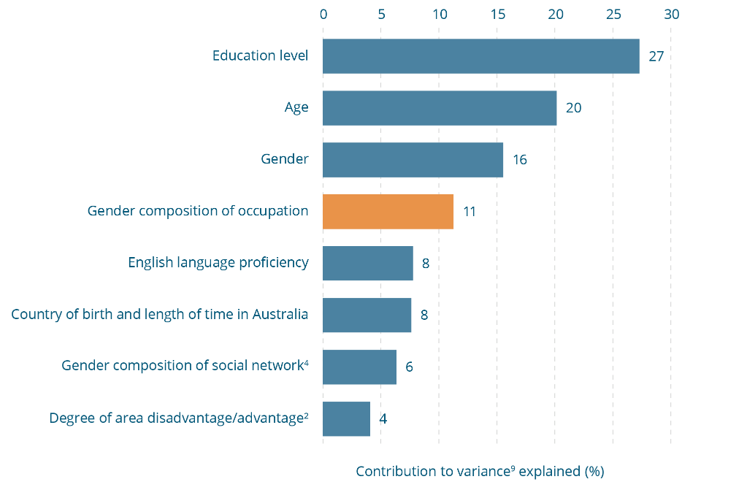
Influence of gender composition of occupation in predicting attitudinal support for gender equality¹, 2017 (n=17,502)
Predictor | Contribution to variance⁹ explained (%)
Education level | 27
Age | 20
Gender | 16
Gender composition of occupation | 11
English language proficiency | 8
Country of birth and length of time in Australia | 8
Gender composition of social network⁴ | 6
Degree of area disadvantage/advantage² | 4
Note: Percentages may not equal 100% due to rounding.
¹ Measured using the composite measure described in Section 5.2.
² Measured with an ABS product which categorises postcode areas based on their distance from facilities and services.
⁴ Measured based on whether the respondent’s social network is made up of mainly men, mainly women or a mixture of both.
⁹ Percentage of variance explained by model is 19%.
Figure 12-2: Influence of gender composition of occupation in predicting attitudinal support for violence against women¹, 2017 (n=17,504) 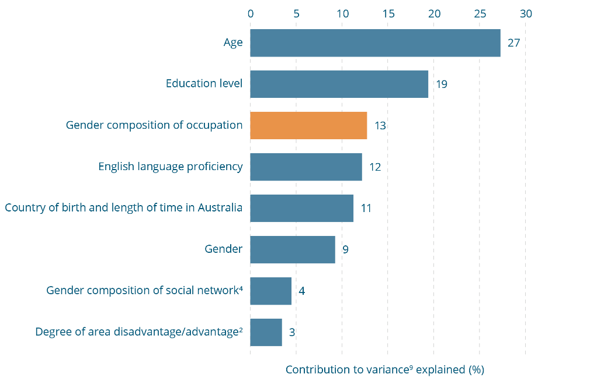
Influence of gender composition of occupation in predicting attitudinal support for violence against women¹, 2017 (n=17,504)
Predictor | Contribution to variance⁹ explained (%)
Age | 27
Education level | 19
Gender composition of occupation | 13
English language proficiency | 12
Country of birth and length of time in Australia | 11
Gender | 9
Gender composition of social network⁴ | 4
Degree of area disadvantage/advantage² | 3
Note: Percentages may not equal 100% due to rounding.
¹ Measured using the composite measure described in Section 5.2.
² Measured with an ABS product which categorises postcode areas based on their distance from facilities and services.
⁴ Measured based on whether the respondent’s social network is made up of mainly men, mainly women or a mixture of both.
⁹ Percentage of variance explained by model is 19%.

13 Factors influencing knowledge and attitudes
The data presented in Section 11 and Section 12 show patterns of association between attitudes and both demographic factors (e.g. age and gender) and disadvantaged areas and, to a lesser extent, remote areas, as well as in different organisational contexts. Although the differences are generally small, men as compared with women were identified as having poorer knowledge, a lower level of support for gender equality and a higher level of support for violence against women using the composite measures.
Although not necessarily uniform across all the composite measures, a similar pattern was also found for people:
- in the two oldest age cohorts (65-74 and 75 years and over) as compared with people of other ages;
- with low education, who are unemployed or live in a disadvantaged area;
- in particular occupations, especially labourers, machinery operators and drivers, sales and technical and trades occupations;
- working in male dominated occupations;
- with male dominated social networks, compared with gender equal and female dominated networks; and
- in outer regional and remote areas compared with inner regional areas and cities.
Other demographic factors were explored (e.g. disability). Few associations were found between them and the composite measures.
Understanding associations is important to show levels of knowledge and attitudes among different groups of people and between places. This is useful for directing messages and programs to improve knowledge and attitudes. However, this form of analysis has limited value in understanding influences on attitudes because it does not take into account how other variables might affect results. For example, people who are professionals might be less likely to endorse attitudes supportive of violence against women because of the influence of their higher level of education, rather than because they work in a profession.
The other drawback is that this type of analysis cannot show how strongly a factor (e.g. age) is associated with or predicts a concept of interest (e.g. gender equality attitudes) relative to other factors (e.g. education level and gender). This information can help to work out which factors to prioritise in prevention programming.
To establish with greater certainty whether particular variables influence attitudes would require a longitudinal study, which follows the same people over time to assess whether attitudes change as other conditions change (e.g. as people grow older or become more educated). In contrast, the NCAS asks people about the attitudes they hold at a point in time – it is a cross-sectional study. A correlation between two variables in a cross-sectional study does not necessarily show a cause-and-effect relationship – the relationship may be due to another factor, either one measured in the questionnaire or something else.
As discussed earlier in Section 12, multiple linear regression analysis (a form of multivariate analysis) is a statistical technique that can be used to gauge the contribution made by a variable after the contributions of other variables measured in the study have been taken into account. Although it still does not allow definitive conclusions to be drawn about the influence of particular variables, it does increase the ability to isolate the variables that are more likely than others measured in the study to be influential. This information can help to identify particular conditions that may shape attitudes, and these can be the focus of change effort. For example, if a person’s education level is found to make a contribution to variance, after accounting for relevant variables such as occupation or income, it could reasonably be assumed that increasing access to education will lead to a liberalising of attitudes towards gender equality and a reduction in support for violence against women. This analysis can also indicate how strongly a factor may predict a person holding negative attitudes or having low levels of knowledge relative to other factors being measured.
In the 2013 NCAS, the multivariate analysis showed that demographic variables, such as age and gender, explained a relatively small proportion of variance in attitudes towards violence against women. The two constructs, the 2013 Gender Equality Scale and the UVAWS, contributed more than the demographic variables. However, a substantial proportion of all variance remained unexplained by the demographic and other factors included in the 2013 questionnaire. This tells us that other factors are likely to be involved in influencing and predicting poor knowledge and attitudes to gender equality and violence against women. Accordingly in the review of the 2013 survey (see Section 5.1) it was agreed that other theoretically relevant variables should be added to the questionnaire to help strengthen understanding of these factors. These were identified by the research team in consultation with key stakeholders drawing on the model to understand the role of attitudes supportive of violence against women presented in Figure 4-2 and include measures of:
- the gender composition of a person’s social network. (The reasons for including this are discussed in Section 12);
- attitudinal support for prejudice on the basis of ethnicity, Aboriginality, sexual preference and disability; and
- attitudinal support for violence in general.
In addition, the gender equality measure was redeveloped for the 2017 survey so that it measured more of the aspects of gender equality understood to be associated with attitudes towards violence against women in the literature (Section 4).
Knowing about the relationships between these concepts and attitudes towards violence against women and gender equality in the Australian population is important for the following reasons:
- If they are related, it is possible that another factor underlying all four concepts (support for violence against women, gender inequality, prejudice and violence in general) needs to be identified and addressed in prevention programming and policy.
- Understanding the relative importance of each of the factors can help to work out which of them needs to be prioritised in prevention programming to strengthen cultures of support for gender equality and counter cultures supportive of violence against women.
- Attitudes are a reflection of broader structures, norms and practices. Understanding the relationships between attitudes towards different phenomena can contribute to knowledge about the extent to which the problems themselves are interrelated and why.
- Understanding which groups in the population are likely to hold negative attitudes in one or more of the four concepts measured can be used in targeting prevention programming, and tailoring it to particular groups.
- If certain attitudes are known to co-exist, either within populations or across the population, they can be addressed jointly in prevention programming.
As shown in the NCAS Questionnaire Framework (see Figure 5-1), a large number of theoretically relevant demographic variables are included in the survey. In 2017, all these variables were used as inputs in the multivariate models presented throughout the report, unless otherwise stated. To simplify the models a two-step procedure was used. The first step involved identifying and excluding from the model any variables that made a trivial contribution after controlling for the influence of other variables. This explains why the number of variables shown in each model is different.
As is the case with all other analysis in this report, the multivariate analysis included the entire sample, although excluding the booster sample of 16-17 year olds. Results pertaining to young people, people who identify as Aboriginal or Torres Strait Islander and people from non-main English speaking countries are reported and discussed in forthcoming reports.

Why include a measure of support for other forms of prejudice in the NCAS?
Attitudes that show a lack of support for gender equality and support for violence against women may be more than just sexism or hostility towards women. Rather, such attitudes can reflect a broader set of views and values about diversity and difference in the community. International research has shown that individuals who endorse sexism are more likely to have other prejudices, such as racism, heterosexism, ableism and classism (Fiske, 2012; Whitehead & Stokoe, 2015).
People can experience prejudice on a range of attributes, such as because they have a disability or are part of a minority ethnic group. These negative attitudes on the basis of other attributes (e.g. disability) may combine with sexism and attitudes supportive of violence against women to contribute to:
- the development of structural and cultural barriers to seeking help if women experience violence (Cripps & Adams, 2014; Healey, 2013);
- a greater likelihood of attitudes supportive of violence against women being held against them. This is shown in a US study comparing participants’ responses with scenarios involving two victims in the same circumstances with the only difference being the race of the victim. Participants were more likely to attribute culpability to the victim in the scenario involving an African American woman victim than when the victim was of an Anglo American background (Esqueda & Harrison, 2005); and
- women experiencing the combined impacts of attitudes supportive of violence against women as well as sexism and discrimination on the basis of other attributes. Violent and abusive ‘trolling’ of outspoken Aboriginal women is an example of this (Carey, 2018; Rushton, 2018).
Negative attitudes, particularly on the basis of ethnicity, race and disability, may contribute to the marginalisation of men in particular groups, and this in turn may be linked to them being more likely to hold attitudes supportive of violence against women as a means of reasserting power (Day, Jones, Nakata et al., 2012).
Such prejudices have been found to influence the way in which members themselves respond to their own victimisation. This may occur in two ways.
First, women exposed to multiple forms of discrimination (e.g. on the grounds of race, disability or gender) may be especially vulnerable to internalising negative attitudes about themselves (Lipsky, 1987; Pyke, 2010). This suggests that addressing the impacts of different forms of prejudice is important in working with affected communities.
Second, women’s awareness of the discrimination to which they and the men in their community are subject may serve as further barriers to seeking help (Cox, Young, & Bairnsfather-Scott, 2014; Crenshaw, 1991; Nash, 2005). For example, research shows that Aboriginal and Torres Strait Islander women’s fear that men will be treated unfairly in the criminal justice system may serve as a barrier to reporting (Cripps & Adams, 2014; Nixon & Cripps, 2014). This is not an ill-founded fear, evidenced most notably in the disproportionately higher rates of incarceration of Aboriginal and Torres Strait Islander men (ABS, 2016c).
Further research is required to understand these relationships. A possibility proposed in the literature is that different forms of prejudice (including prejudice against women) and attitudes towards violence against women are underpinned by the same deeper philosophical orientations. Two such orientations have been explored in prior research as potentially underpinning multiple forms of prejudice and discrimination. These are a desire to preserve traditional values and maintain collective security and cohesion (sometimes referred to in the academic literature as ‘right wing authoritarianism’ (Sibley, Overall, & Duckitt, 2007) or a desire to subjugate groups that are perceived as weak or inferior (referred to in the literature as ‘social dominance orientation’ (Sibley, Overall, & Duckitt, 2007). Research shows that these orientations are linked to different forms of prejudice (Golec de Zavala, Guerra & Simão, 2017; Poteat & Spanierman, 2012), attitudes towards gender equality (Fraser, Osborne & Sibley, 2015) and, in the case of right wing authoritarianism, attitudes supportive of violence against women (Manoussaki & Veitch, 2015).
Some theorists suggest that violence and cultures supportive of violence are used to reinforce not only gender hierarchies, but also hierarchies based on race, disability, sexuality, class and ethnicity (Fahlberg & Pepper, 2016).

Why include a measure of support for the use of violence as a practice in the NCAS?
A relationship has been found regarding attitudes endorsing violence generally, whereby those who support dominance and aggression as ways of resolving conflict are more likely to hold attitudes supportive of violence against women (Diaz-Aguado & Martinez, 2015; Herrero, Torres, Rodriguez et al., 2017). Further, men who use violence in other contexts may be more likely to use violence against women (Fulu, Jewkes, Roselli et al., 2013; Jewkes, Fulu, Roselli et al., 2013), and cultures of support for violence against women are more likely to occur in contexts in which violence in general occurs or is valorised (e.g. some university fraternities and male sport clubs) (DeKeseredy, 1990; Durán, Megías, & Moya, 2016; Flood & Pease, 2009; Schwartz & DeKeseredy, 1997; Seabrook, Ward, & Giaccardi, 2018).
There are three different views on this relationship in the literature. The first view is that attitudes towards violence against women are a sub-set of broader cultural support for violence as a practice (Anderson & Anderson, 1997; Anderson, Benjamin, Wood et al., 2006; Ferreira, Lopes, Aparicio et al., 2014; Malamuth, 1998; Velicer, Huckel, & Hansen, 1989). These cultures are thought to lead to the normalisation of the use of violence and desensitisation to it. As a result, individuals are understood to become more inclined to use violence, as opposed to other means of resolving problems or achieving goals. This is thought to particularly occur when social norms against violence break down, such as in impoverished neighbourhoods (Sampson & Groves, 1989; Sampson & Wilson, 1995) or following a natural disaster (Bolin, Jackson, & Crist, 1998; Dasgupta, Sriner, & Partha, 2010; Enarson & Meyreles, 2004). Some researchers argue that for this reason such cultures are more likely to affect people experiencing social disadvantage (Markowitz, 2001, 2003). They also point to the greater exposure that people in these circumstances may have to factors that might trigger violence (e.g. overcrowding and economic stress) (Markowitz, 2003).
A second explanation draws on evidence that almost all forms of violence are more likely to be perpetrated by men than by women. In this explanation it is suggested that contemporary forms of masculinity (and the norms, cultures and practices supporting them) are among the root causes of violence perpetration by men and underlie both violence against women and other forms of violence against men (e.g. community violence and violence in sport) (Fleming, Gruskin, Rojo et al., 2015).
A third view is that violence against women reflects and reinforces inequalities in relationships between men and women and needs to be understood as a distinct form of violence. In this view, violence against women is understood to vary from violence perpetrated by men against other men – it has different motivations and is more likely to be repeated, to involve more than just physical violence, to occur in the context of an existing relationship and in a place familiar to the victim, such as her family home or workplace (Dragiewicz, 2009; Houry, Rhodes, Kemball et al., 2008). People adopting this view maintain that violence against women and other forms of violence are separate and have some different causes.

13.1 Predictors of understanding of violence against women
The UVAWS, measuring one aspect of knowledge of violence against women, was used to explore factors associated with knowledge (Section 5.2). Only demographic and contextual variables were included in this model.

Gender and age are the strongest predictors of understanding of violence against women
The multivariate model for understanding shows that the inputs in the model explain 9 percent of overall variance. After controlling for other factors, gender and age are the strongest predictors of understanding of violence against women. Gender contributes more than a third of the explained variance (37%), while age contributes almost a fifth (18%) (Figure 13-1). Other factors include proficiency in English, the gender composition of a person’s social network and country of birth. Level of education contributes less than 4 percent and area advantage/disadvantage less than 1 percent.
Figure 13-1: Influence of factors in predicting understanding of violence against women¹, 2017 (n=17,531)
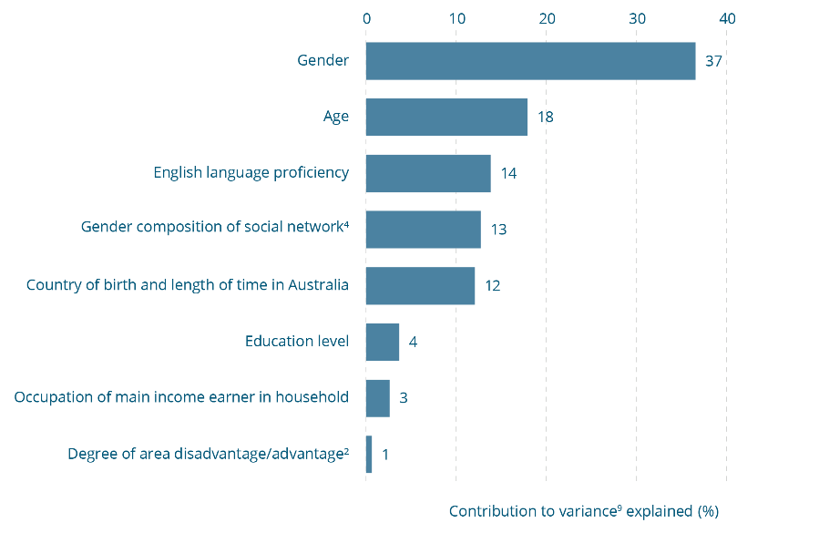

Influence of factors in predicting understanding of violence against women¹, 2017 (n=17,531)
Predictor | Contribution to variance⁹ explained (%)
Gender | 37
Age | 18
English language proficiency | 14
Gender composition of social network⁴ | 13
Country of birth and length of time in Australia | 12
Education level | 4
Occupation of main income earner in household | 3
Degree of area disadvantage/advantage² | 1
Note: Percentages may not equal 100% due to rounding.
¹ Measured using the composite measure described in Section 5.2.
² Measured with an ABS product which categorises postcode areas based on their distance from facilities and services.
⁴ Measured based on whether the respondent’s social network is made up of mainly men, mainly women or a mixture of both.
⁹ Percentage of variance explained by model is 9%.

13.2 Factors predicting attitudes towards gender equality
The measures of prejudice and attitudinal support for violence in general were examined firstly at the bivariate level and subsequently included in the multivariate model. As was the case in Section 11 and Section 12, the bivariate analysis involved comparing people in the ‘high’ and ‘low’ support categories for each of the relevant concepts. A guide to interpreting these categories for the UVAW, GEAS and CASVAW can be found in Figure 7-1. A low support for prejudice, (as measured by the PAC) means a tendency to dis-endorse attitudes of prejudice (relative to other respondents). A low level of support for violence in general (as measured by the GVC) signifies a tendency to dis-endorse attitudes supporting the use of violence as a practice (relative to other respondents). The multivariate model also included the demographic factors introduced in the NCAS Questionnaire Framework in Section 5.

People rejecting prejudice and the use of violence in general are more likely to have positive attitudes towards gender equality
Figure 13-2 and Figure 13-3 confirm that the findings of prior research are also the case in the Australian community: people with lower levels of prejudice and endorsement of attitudes supporting violence in general relative to other respondents are more likely to have high endorsement of attitudes supportive of gender equality. For example, of those with low support for violence in general, 42 percent are classified as having a high level of support for gender equality compared with only 13 percent in the low support category (Figure 13-2). Similarly, those with lower levels of prejudice are more likely to have a high level of support for gender equality (46%) than a low level (8%) (Figure 13-3). The reverse is also true: when, relative to other respondents, people have higher levels of prejudice and support for violence in general, they are less likely to hold attitudes that are supportive of gender equality.
Figure 13-2: Relationship between attitudinal support for gender equality and violence in general, 2017
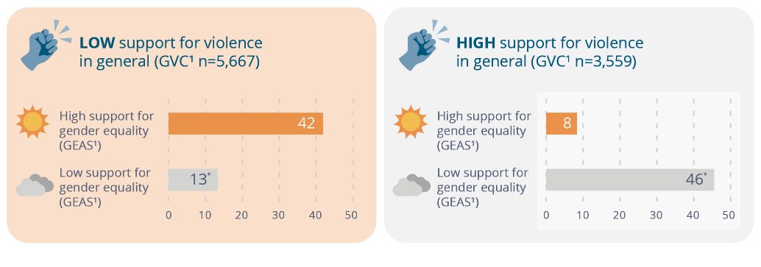
Relationship between attitudinal support for gender equality and violence in general, 2017
Support for violence in general | High support for gender equality (GEAS¹) | Low support for gender equality (GEAS¹)
Low support for violence in general  (GVC¹ n=5,667) | 42 | 13*
High support for violence in general  (GVC¹ n=3,559) | 8 | 46*
* Differences between high and low support for gender equality are statistically significant, p≤.01, and reach the 0.2 Cohen’s threshold.
¹ Measured using the composite measure described in Section 5.2.

Figure 13-3: Relationship between attitudinal support for gender equality and prejudice, 2017
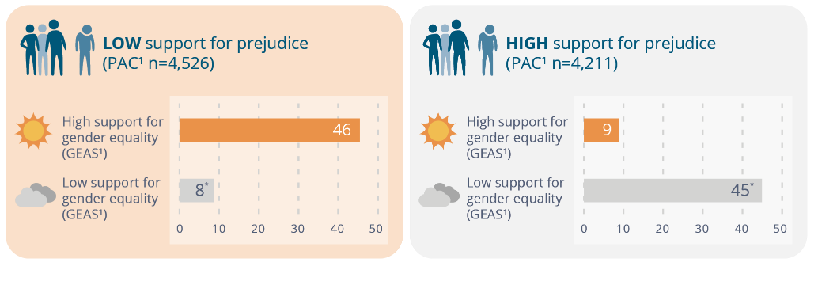
Relationship between attitudinal support for gender equality and prejudice, 2017
Support for prejudice | High support for gender equality (GEAS¹) | Low support for gender equality (GEAS¹)
Low support for prejudice  (PAC¹ n=4,526) | 46 | 8*
High support for prejudice  (PAC ¹ n=4,211) | 9 | 45*
* Differences between high and low support for gender equality are statistically significant, p≤.01, and reach the 0.2 Cohen’s threshold.
¹ Measured using the composite measure described in Section 5.2.

Figure 13-4: Influence of factors in predicting attitudes to gender equality¹, 2017 (n=17,540)
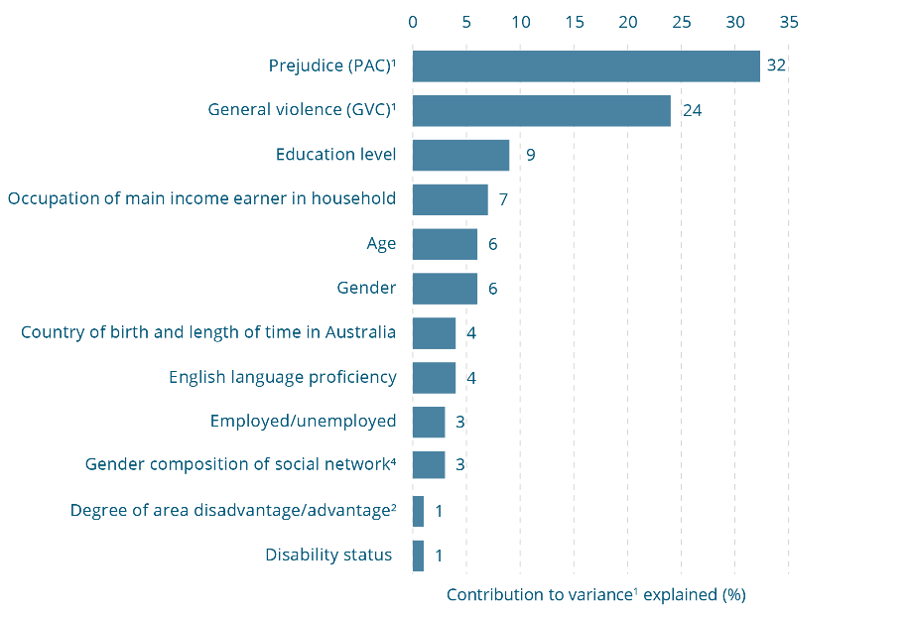
Influence of factors in predicting attitudes to gender equality¹, 2017 (n=17,540)
Predictor | Contribution to variance¹ explained (%)
Prejudice (PAC)¹ | 32
General violence (GVC)¹ | 24
Education level | 9
Occupation of main income earner in household | 7
Age | 6
Gender | 6
Country of birth and length of time in Australia | 4
English language proficiency | 4
Employed/unemployed | 3
Gender composition of social network⁴ | 3
Degree of area disadvantage/advantage² | 1
Disability status | 1
Note: Percentages may not equal 100% due to rounding.
¹ Measured using the composite measure described in Section 5.2.
² Measured with an ABS product which categorises postcode areas based on their distance from facilities and services.
⁴ Measured based on whether the respondent’s social network is made up of mainly men, mainly women or a mixture of both.
⁹ Percentage of variance explained by model is 35%.

Prejudice and attitudinal support for violence in general are the strongest predictors of attitudes to gender equality
The multivariate model for gender equality shows that the inputs in the model explain 35 percent of overall variance. The strongest predictor of attitudes towards gender equality was attitudes supporting other forms of prejudice (PAC) (Figure 13-4). These attitudes explain the largest portion (32%) of individuals’ differences in their support for gender equality. This was followed by attitudes endorsing violence generally, at 24 percent. Meanwhile, demographic factors are much less helpful in explaining and understanding the extent to which a person supports gender equality. Of demographic factors, level of education, the occupation of the main income earner in the household, age and gender were the most important, explaining 9, 7, 6 and 6 percent of the variance respectively.

13.3 Predictors of community attitudes supportive of violence against women

People with poor understanding of violence against women, low attitudinal support for gender equality and high support for prejudice and violence in general are more likely to endorse attitudes supportive of violence against women
Figure 13-5 to Figure 13-8 show that the associations found in other studies between attitudes supportive of violence against women, understanding of violence and attitudes towards gender equality, prejudice and violence in general are also apparent in the Australian community. Specifically, people with greater understanding of violence against women, higher support for gender equality, lower endorsement of general violence and lower levels of prejudice relative to other respondents are consistently more likely to have a low level of endorsement of attitudes supportive of violence against women. For example, those with a relatively high level of understanding of violence against women are much less likely to be in the high endorsement category for attitudes supportive of violence against women (11% vs 42%) (Figure 13-5). Likewise, those with relatively high support for gender equality are overwhelmingly less likely to have a high level of endorsement of attitudes supportive of violence against women (2%) (Figure 13-6) and are more likely to have a low level of endorsement of such attitudes (66%) (Figure 13-6). Again, the reverse is also true: when people have a lower level of understanding of violence against women, higher levels of prejudice and support for general violence, and lower levels of support for gender equality relative to other respondents, they are more likely to hold attitudes that are supportive of violence against women (Figure 13-5 to Figure 13-8).

Figure 13-5: Relationship between attitudinal support for and understanding of violence against women, 2017
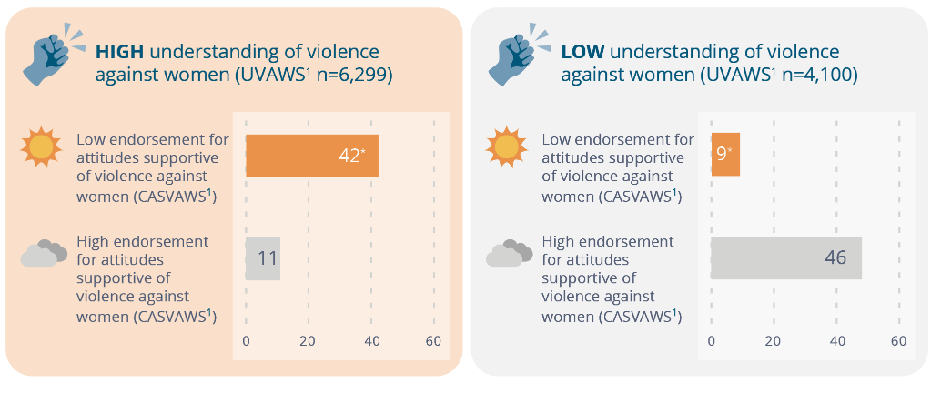
Relationship between attitudinal support for and understanding of violence against women, 2017
Understanding of violence against women | Low endorsement for attitudes supportive of violence against women (CASVAWS¹) | High endorsement for attitudes supportive of violence against women (CASVAWS¹)
High understanding of violence against women (UVAWS¹ n=6,299) | 42* | 11
Low understanding of violence against women (UVAWS¹ n=4,100) | 9* | 46
* Differences between high and low endorsement of violence against women are statistically significant, p≤.01, and reach the 0.2 Cohen’s threshold.
¹ Measured using the composite measure described in Section 5.2.
Figure 13-6: Relationship between attitudinal support for violence against women and support for gender equality, 2017
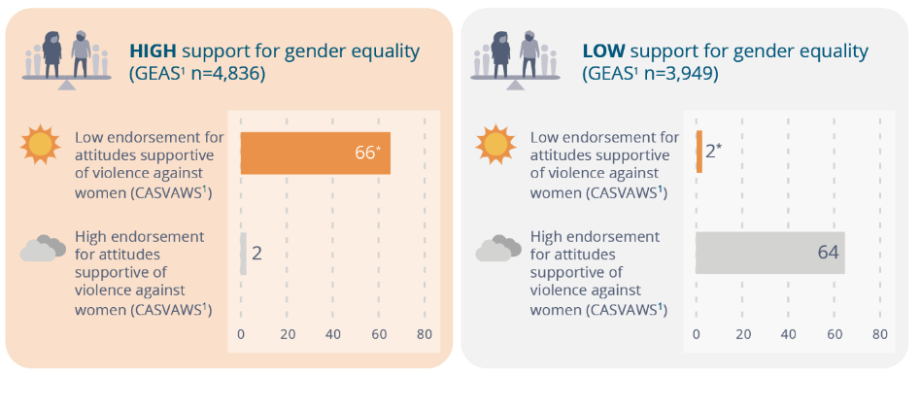
Relationship between attitudinal support for violence against women and support for gender equality, 2017
Support for gender equality | Low endorsement for attitudes supportive of violence against women (CASVAWS¹) | High endorsement for attitudes supportive of violence against women (CASVAWS¹)
High support for gender equality (GEAS¹ n=4,836) | 66* | 2
Low support for gender equality (GEAS¹ n=3,949) | 2* | 64
* Differences between high and low endorsement of violence against women are statistically significant, p≤.01, and reach the 0.2 Cohen’s threshold.
¹ Measured using the composite measure described in Section 5.2.
Figure 13-7: Relationship between attitudinal support for violence against women and support for violence in general, 2017
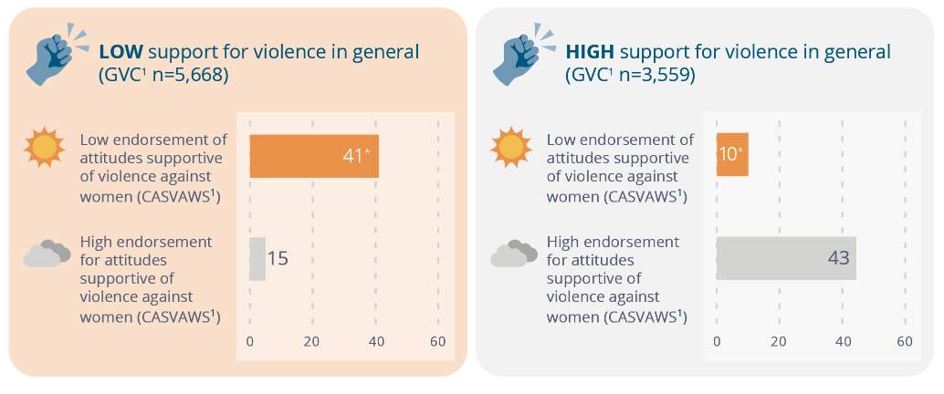
Relationship between attitudinal support for violence against women and support for violence in general, 2017
Support for violence in general | Low endorsement for attitudes supportive of violence against women (CASVAWS¹) | High endorsement for attitudes supportive of violence against women (CASVAWS¹)
Low support for violence in general (GVC¹ n=5,668) | 41* | 15
High support for violence in general (GVC ¹ n=3,559) | 10* | 43
* Differences between high and low endorsement of violence against women are statistically significant, p≤.01, and reach the 0.2 Cohen’s threshold.
¹ Measured using the composite measure described in Section 5.2.
Figure 13-8: Relationship between attitudinal support for violence against women and prejudice, 2017 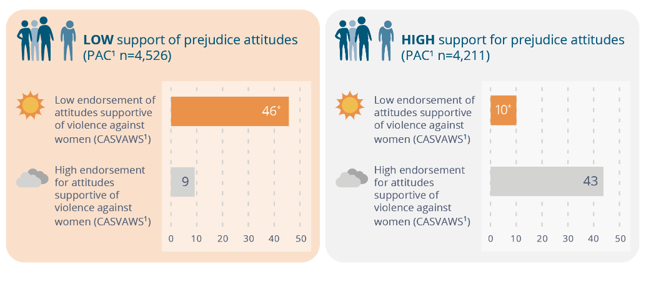
Relationship between attitudinal support for violence against women and prejudice, 2017
Support for prejudice attitudes | Low endorsement for attitudes supportive of violence against women (CASVAWS¹) | High endorsement for attitudes supportive of violence against women (CASVAWS¹)
Low support for prejudice attitudes (PAC¹ n=4,526) | 46* | 9
High support for prejudice attitudes (PAC ¹ n=4,211) | 10* | 43
* Differences between high and low endorsement of violence against women are statistically significant, p≤.01, and reach the 0.2 Cohen’s threshold.
¹ Measured using the composite measure described in Section 5.2.

Attitudes to gender equality and prejudice, and understanding of violence against women, are the strongest predictors of attitudes towards violence against women
The multivariate model for attitudes to violence against women (Figure 13-9) shows that the inputs in the model explain 54 percent of overall variance. The strongest predictor of attitudes to violence against women is the overall GEAS score, which contributes more than half of the variance (54%). Understanding of violence against women (UVAWS) and attitudes to prejudice (PAC) contribute 10 and 9 percent respectively, while a person’s level of support for violence in general (GVC) contributes 8 percent. These composite measures have stronger associations than any of the demographic factors included in the survey (see Figure 5-1) or the gender composition of a person’s social network, which together contribute only 19 percent to variance. Of these, age makes the largest contribution (4%), with education level, the occupation of the main income earner in the household and English language proficiency contributing 3 percent respectively.
Figure 13-9: Influence of factors in predicting attitudes towards violence against women¹, 2017 (n=17,541) 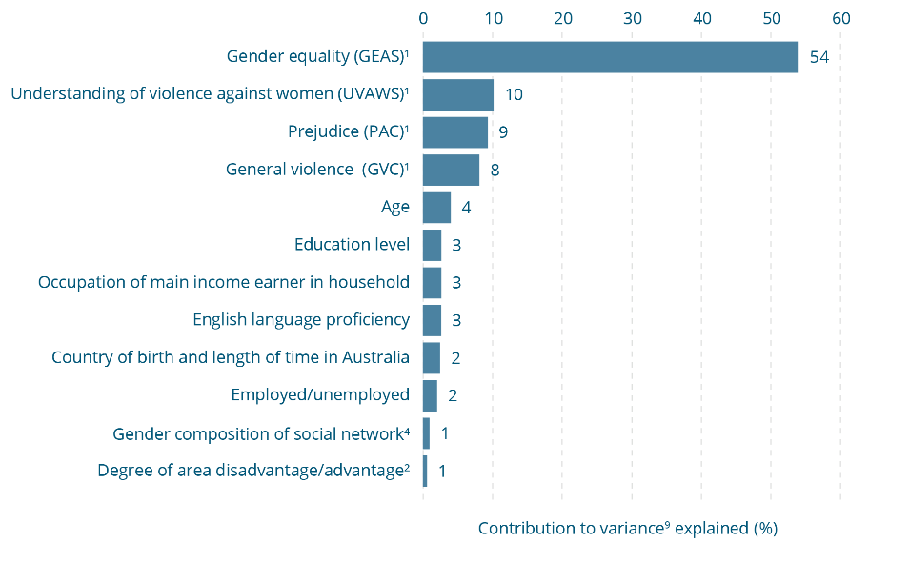
Influence of factors in predicting attitudes towards violence against women¹, 2017 (n=17,541)
Predictor | Contribution to variance⁹ explained (%)
Gender equality (GEAS)¹ | 54
Understanding of violence against women (UVAWS)¹ | 10
Prejudice (PAC)¹ | 9
General violence (GVC)¹ | 8
Age | 4
Education level | 3
Occupation of main income earner in household | 3
English language proficiency | 3
Country of birth and length of time in Australia | 2
Employed/unemployed | 2
Gender composition of social network⁴ | 1
Degree of area disadvantage/advantage² | 1
Note: Percentages may not equal 100% due to rounding.
¹ Measured using the composite measure described in Section 5.2.
² Measured with an ABS product which categorises postcode areas based on their distance from facilities and services.
⁴ Measured based on whether the respondent’s social network is made up of mainly men, mainly women or a mixture of both.
⁹ Percentage of variance explained by model is 54%.

Of the five gender equality themes, attitudes that deny gender inequality is a problem and support rigid gender roles are the strongest predictors of attitudes to violence against women
In Section 9 the extent to which attitudes in each of the GEAS themes are held in the community was explored (see Figure 9-6). A second important question for planning and tailoring prevention is how strongly each of these concepts is associated with attitudes supportive of violence against women. To investigate this, a multivariate model was designed containing each of the GEAS themes.
Figure 13-10 shows that the inputs in the model explain 47 percent of overall variance. Attitudes in all five of the GEAS themes make a substantial contribution to explained variance. However, attitudes ‘denying gender inequality is a problem’ and those supporting ‘rigid gender roles’ make the largest contribution (40% and 21% respectively), suggesting that they are the most strongly associated with attitudes towards violence against women.
Figure 13-10: Influence of gender equality themes¹ in predicting attitudes to violence against women, 2017 (n=17,541) 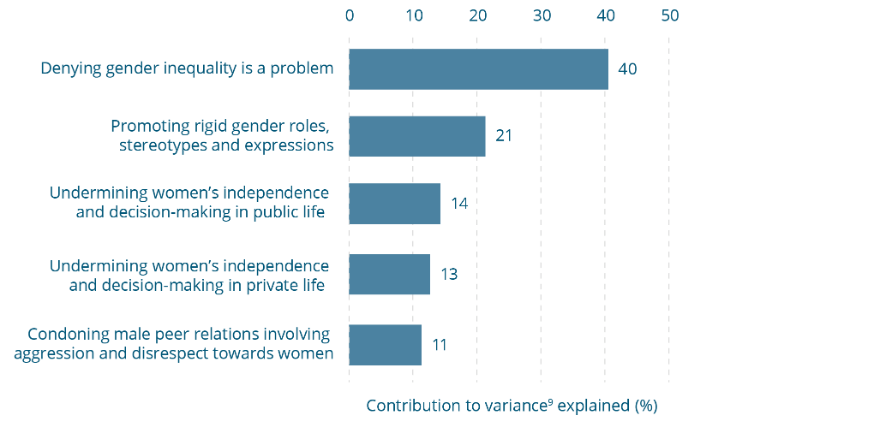

Influence of gender equality themes¹ in predicting attitudes to violence against women, 2017 (n=17,541)
Predictor | Contribution to variance⁹ explained (%)
Denying gender inequality is a problem | 40
Promoting rigid gender roles, stereotypes and expressions | 21
Undermining women’s independence and decision-making in public life | 14
Undermining women’s independence and decision-making in private life | 13
Condoning male peer relations involving aggression and disrespect towards women | 11
Note: Percentages may not equal 100% due to rounding.
¹ Measured using the composite measure described in Section 5.2.
⁹ Percentage of variance explained by model is 47%.

14 Intended responses to violence against women
In this context, a bystander is somebody who observes, or becomes aware of, a potentially harmful event in which they are not directly involved but have the opportunity to assist or intervene. In responding to violence against women, bystanders might observe an act of physical assault, verbal abuse, emotional abuse, stalking and/or harassment, and in doing so have an opportunity to say or do something to intervene. While a person might have an opportunity to take action by supporting a victim or confronting a perpetrator who discloses violence or abuse, much violence against women occurs behind closed doors where there is little likelihood that a bystander will be present and able to intervene. Further, intervening when violence is occurring may be risky for all involved.
However, many Australians do have the opportunity to contribute to preventing violence against women by being active prosocial bystanders. Such bystander action can include challenging sexism, discrimination, disrespect and violence-supportive attitudes when they observe them, whether that is in their workplace, in community settings or among their family and friends. Challenging the norms, structures and practices that underlie violence against women might include ‘calling out’ and naming problematic behaviours, expressing discomfort or disapproval and/or ‘calling in’ a person to raise their awareness and change a problematic attitude or behaviour.
Several decades of psychological research have established five key steps in an individual’s decision-making that can help identify when people might choose to take action (prosocial bystanders) and when they might choose to do nothing in the face of violence, abuse or harassment by another (passive bystanders). The following five steps are adapted from a model first proposed by psychologists Darley and Latane (1968):
Step 1: Noticing the situation – Individuals have knowledge about what behaviours constitute violence against women, sexism and/or discrimination.
Step 2: Interpreting the situation as requiring intervention – Individuals believe the problems of violence against women, sexism and/or discrimination are serious.
Step 3: Assuming responsibility – Individuals do not see violence against women, sexism and/or discrimination as ‘private matters’ that are ‘none of their business’, but rather feel uncomfortable when witnessing these issues and feel that they ought to act.
Step 4: Deciding how to help – Individuals know what they would say and/or do when witnessing a situation.
Step 5: Confidence in capacity to help – Individuals feel certain that their actions would have a positive outcome, and that they would have the support of their peers in taking action.
In prior waves of the NCAS, people have been asked about their intentions to take action if they witnessed an incident of intimate partner violence. A very large percentage (92% or more) indicated that they would intervene, and this was the case in all the scenarios that were put to respondents. Regardless of whether the woman was a known person or a stranger, and in scenarios with and without children present, a majority of Australians have said that they would intervene in some way (VicHealth, 2014). Yet the questions provided very little additional information on the barriers and facilitators to prosocial bystander behaviour. Also, because they were focused on physical violence after it had occurred, they were of limited use in understanding the potential role of bystanders in preventing violence against women from occurring, or potentially intervening earlier in a cycle of abuse.
Accordingly, in the 2017 NCAS these questions were removed and new questions were introduced to focus on factors that may underpin violence or lead to more serious violence. The questions were reworded, drawing on the framework previously outlined, to provide information that would be helpful in understanding some of the barriers and facilitators to engaging the wider community as prosocial bystanders in the prevention of violence against women.
There are many different examples of sexist, discriminatory and/or abusive behaviours towards women that might provide opportunities for bystanders to witness and intervene. In the 2017 NCAS two scenarios were included that might commonly be observed in social and/or family settings, and as such represented situations that many Australians might observe as bystanders at some time in their lives. One scenario involved a male friend verbally insulting or verbally abusing a woman that he was in a relationship with, and the other a male friend telling a sexist joke about women. Respondents were asked what they would do in response to the behaviour (Figure 14-1), and whether if they said or did something to express their disapproval they would have the support of their friends. The scenarios deliberately did not involve physical violence for the reasons previously introduced.

Verbal abuse scenario
Overall, almost all Australians agree that if they saw a man insulting or verbally abusing a woman with whom he was in a relationship they would feel bothered by it (98%), and most also agree they would either act or want to act (92%). A large proportion of these (70%) say that they would actually take some form of action, and a further 22 percent say that they’d like to act, but wouldn’t know how or what they could do.
Despite almost universal agreement that they want to act as bystanders, only 69 percent of Australians think they would have the support of all or most of their friends if they did so. The survey shows that while the overwhelming majority of Australians would want to say or do something to stop the verbal abuse, they are not entirely confident that they would have the backing of those around them. As already discussed, other research suggests that this may be among the reasons they may not take action.

Sexist joke scenario
The survey results are less positive for intervening in response to a sexist joke than for observing the verbal abuse of a woman by a male friend. Although the majority of Australians (76%) state that they would feel bothered by the situation, one in five (20%) Australians say that they would not be bothered if a male friend told a sexist joke about women.
Compared with the verbal abuse scenario, a smaller proportion of the sample agree that they would either act or like to act, if they heard a male friend tell a sexist joke (58% compared with 92% in the verbal abuse scenario).
Of those who say they would be bothered by the sexist joke scenario, 45 percent say they would take action. Thirteen percent state that they would like to act, but would not know how, while 18 percent state that they would not act despite feeling uncomfortable.
Just over half of the sample (55%) agree that, if they did say or do something to express disapproval, they would have the support of all or most of their friends. However, 29 percent report they would have the support of only some of their friends, while 11 percent say that they would be supported by few, if any, friends. Overall, fewer Australians say that they would have the support of all or most of their friends for intervening if a male friend told a sexist joke than if they intervened when a male friend was verbally abusing a woman (55% feel supported to intervene in a sexist joke, compared with 69% in a verbal abuse scenario).
Figure 14-1: Respondents’ reactions to sexist joke and verbal abuse scenarios, 2017** 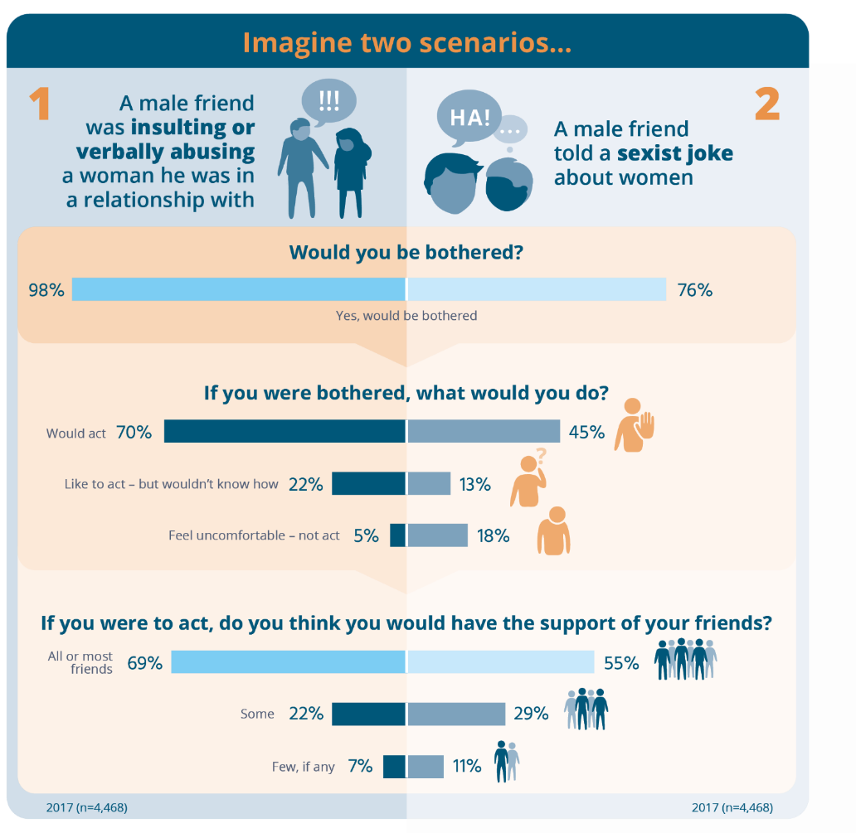
Respondents’ reactions to sexist joke and verbal abuse scenarios, 2017**
Scenario 1
A male friend was insulting or verbally abusing a woman he was in a relationship with
Would you be bothered?
Response | Agreed (%)
Yes, would be bothered | 98

If you were bothered, what would you do?
Response | Agreed (%)
Would act | 70
Like to act – but wouldn’t know how | 22
Feel uncomfortable – not act | 5
If you were to act, do you think you would have the support of your friends?
Response | Agreed (%)
All or most friends | 69
Some | 22
Few, if any | 7
Scenario 2
A male friend told a sexist joke about women
Would you be bothered?
Response | Agreed (%)
Yes, would be bothered | 76
If you were bothered, what would you do?
Response | Agreed (%)
Would act | 45
Like to act – but wouldn’t know how | 13
Feel uncomfortable – not act | 18
If you were to act, do you think you would have the support of your friends?
Response | Agreed (%)
All or most friends | 55
Some | 29
Few, if any | 11
Note: Percentages may not equal 100% due to rounding.
Note: Differences between the two scenarios are all statistically significant, p≤.01.
** Asked of a quarter of the sample in 2017.
Interestingly, more Australians (22%) say that they’d like to act but wouldn’t know how in response to the verbal abuse scenario than in the sexist joke scenario (13%).
When taken together, responses to these two scenarios tell us something about Australians’ likelihood to intervene in different aspects of violence on the one hand and sexism on the other. In general, individuals are more likely to assume responsibility for taking action (step 3 of Darley and Latane’s steps of bystander action) in the verbal abuse rather than the sexist joke scenario. Yet, at the same time, individuals are more likely to know what they would do (step 4) in the sexist joke scenario as compared with a verbal abuse scenario. In both scenarios, survey responses suggest that Australians underestimate how many of their friends would be likely to support them taking action as bystanders. This is shown by the gap between the proportion of people who themselves say they would feel uncomfortable compared with the proportion who believe they would have the support of their friends.
These findings suggest that more needs to be done to inform the community of helpful and safe actions they could take as bystanders if they observe or become aware of violence against women. They also suggest that Australians might not understand the seriousness of everyday sexism as a harmful behaviour that is worthy of intervention as bystanders. Finally, the findings suggest that we could all be more confident about intervening in either of these scenarios – knowing that we would likely have the support of more of our friends than we think.
Box 14-1: Responding to sexist jokes
Why does it matter?
Humour has long been identified by psychologists as reflecting an individuals’ deeper attitudes and values – as well as communicating shared social norms in a society, community or peer group – particularly those of a negative or prejudicial nature (Allport, 1954). Individuals who engage in sexist joke telling, as well as those who find sexist jokes humorous, rate much higher in endorsement of hostile sexism – or unequal and aggressive attitudes towards women – compared with those who do not (Greenwood & Isbell, 2002).
But the problem goes much deeper than sexist jokes simply being a form of banter or communication among individuals who hold sexist attitudes. So what is harmful about a sexist joke and thus why should it be challenged?
- It could be sexual harassment – In the workplace, sexually suggestive jokes and comments can constitute a form of unlawful sexual harassment (AHRC, 2018a). In a 2018 survey, the AHRC found the most common types of workplace sexual harassment reported by participants were sexually suggestive comments or offensive jokes (19%), followed by intrusive questions (14%) and inappropriate staring or leering (11%). A majority of sexual harassers were reported as males (79%), with 93 percent of women saying that their harasser was a man (AHRC, 2018a).
- It affects women’s lives – Many studies have examined women’s reactions when they are exposed to sexist jokes and commentary. A recent review of the international research found that, in workplace settings, less intense harmful experiences – such as sexism and gender harassment – nevertheless had similar negative impacts on women’s wellbeing as physical forms of harm such as sexual coercion (Sojo, Wood, & Genat, 2015). Research has also found that sexist joke tellers are less likely to be confronted by their colleagues or peers than those who make a sexist comment outright – even though the impacts of sexist jokes and commentary on receivers may be similarly harmful. This suggests that jokes can be a particularly insidious form of sexism (Mallett, Ford, & Woodzicka, 2016).
- It contributes to male peer support for inequality and abuse – Evidence suggests that men’s participation in sexist jokes and commentary forms a type of in-group bonding and reinforces stereotypical or ‘traditional’ masculine identities. In an Australian study, psychologist Christopher Hunt and colleagues (2014) found that men were more likely to engage in sexist joke telling when they had received encouragement from a male peer, scored higher on measures of traditional masculinity and/or been told that they rated lower than average on a masculinity measure. Other studies have similarly found that male peer support for sexism, harassment and/or violence against women contributes to individual men’s endorsement of sexist and violence-supportive attitudes, and may be linked to increased likelihood of engaging in perpetration behaviours (Dúran, Megías, & Moya, 2016; DeKeseredy, 1990; DeKeseredy & Schwartz, 2013; Seabrook, Ward, & Giaccardi, 2018; Thomae & Pina, 2015).

Intention to act among people and places
There are a number of demographic differences in responses to the verbal abuse scenario questions:
- Those aged 75 years and over are more likely (than other age groups) to feel uncomfortable but not act, and to want to act but not know how. This age group is also less likely to act and to support action, and less likely to have the support of all or most of their friends if they took action in the verbal abuse scenario.
- Those in remote areas (compared with other areas) are more likely to feel uncomfortable and not act in the verbal abuse scenario.
- Employed respondents are more likely (than those in other employment categories) to say they would act and would support action, and more likely to say that they would have the support of all or most of their friends if they took action.
- Machinery operators and drivers are more likely (than those in other occupational categories) to report that few if any of their friends would support them if they took action in the verbal abuse scenario.
- Labourers are more likely to feel uncomfortable but not act in the verbal abuse scenario.
- Those in the most disadvantaged area category are more likely (than those in other area categories) to say that they would have the support of few, if any, of their friends if they took action in the verbal abuse scenario.
- People with a disability aged 65 years and over are more likely than those without a disability in the same age group to say they would have the support of some of their friends if they spoke out against verbal abuse.
There were no significant differences between men and women in the questions asked about the verbal abuse scenario. In contrast, in the sexist joke scenario the largest differences were by gender, with women (85%) much more likely than men (65%) to say that they would be bothered and less likely to say they wouldn’t be bothered (13% of women compared to 29% of men) in response to a male friend telling a sexist joke. Women are also more likely to support action in response to this scenario (71% of women compared to 45% of men) or to say that they would indeed act (56% compared to 33% of men). Finally, women are more likely than men to say that all or most of their friends would support action (62% of women compared to 48% of men), while men are more likely than women to report that few if any friends would support them if they took action (7% of women compared to 15% of men) (data not shown).

For the sexist joke scenario questions, there are other demographic differences:
- Those aged 75 years and over are less likely (than other age groups) to say they wouldn’t be bothered by the sexist joke scenario.
- Those with a university degree or higher are less likely (than other education categories) to say they wouldn’t be bothered by the sexist joke scenario.
- Machinery operators and drivers, and those working as technicians and tradespeople, are less likely (than those in other employment categories) to say they would feel bothered by the sexist joke scenario, less likely to act and less likely to support action.
- Those with a disability and aged 65 years and over (compared with those without a disability in the same age group) are less likely to say they would have the support of all or most of their friends if taking action in the sexist joke scenario. They are more likely to say they would have the support of some of their friends.
In order to more easily compare the different characteristics of those individuals who are highly likely to act, or have a low intention to act across either scenario, an Intention to Act Construct (ITAC) was formed (Section 5.2). On the overall construct, there are no differences in intention to act by remoteness of the area, or the socio-economic status indicators of employment status, education level or area disadvantage.
The most striking finding using this measure is the combination of gender (Table 14-1) with the gender composition of an individual’s social network (Table 14-2) and the gender composition of their occupation (Table 14-3). The findings clearly demonstrate that men, and people with a peer network that comprises mainly or totally other men, are the least likely to take prosocial action as bystanders. Men with male dominated peer networks are more likely to be classified as having a low intention to act (44%) than men in female dominated or mixed gender peer groups (22% and 32% respectively), whereas men in female dominated and mixed gender peer groups are more likely than men in male dominated peer groups to be in the high intention to act category (Table 14-2). Compared with women in gender mixed social networks, women in male dominated social networks are also more likely to be classified as having a low intention to act.
There is a similar pattern for occupations, with people in highly male dominated occupations having a lower intention to act than other categories of occupations (Table 14-3). However, there are no differences among men or among women based on the gender composition of their occupation (although this may be because of the small numbers in each of the categories) (data not shown).
People in trade, technical, machinery operating and driving occupations have a lower intention to act than most other occupational groupings (Table 14-4).

Table 14-1: Intention to act, by gender, 2017
Gender^ | Unweighted base  n | Label | High intention to act construct (ITAC¹)  % | Low intention to act construct (ITAC¹)  %
Total | 4,410 | - | 23 | 27
Men | 2,070 | A | 18 | 35^{B}
Women | 2,327 | B | 27^{A} | 19
Note: Percentages do not equal 100% as for simplicity only the ‘high’ and ‘low’ categories have been presented for each measure.
Note: Where indicated, differences between categories indicated by letters A through B are statistically significant, p≤.01, and reach the 0.2 Cohen’s threshold.
¹ Measured using the composite measure described in Section 5.2.
^ The difference between the sum of men and women and the total is accounted for by people who did not identify a gender or who did not respond to the question on gender.
Table 14-2: Intention to act, by gender composition of social network, 2017
Base: men
Gender composition of social network | Unweighted base  n | Label | High intention to act construct (ITAC¹)  % | Low intention to act construct (ITAC¹)  %
Mainly or totally women | 120 | A | 23^{C≠} | 22≠
Equal men and women | 1,510 | B | 21^{C} | 32DE
Mainly or totally men | 429 | C | 9 | 44^{ABDE}
Base: women
Gender composition of social network | Unweighted base  n | Label | High intention to act construct (ITAC¹)  % | Low intention to act construct (ITAC¹)  %
Mainly or totally women | 881 | D | 24^{C} | 20
Equal men and women | 1,379 | E | 30^{C} | 18
Mainly or totally men | 56 | F | 23≠ | 36^{E≠}
Note: Percentages do not equal 100% as for simplicity only the ‘high’ and ‘low’ categories have been presented for each measure.
Note: Where indicated, differences between categories indicated by letters A through F are statistically significant, p≤.01, and reach the 0.2 Cohen’s threshold.
¹ Measured using the composite measure described in Section 5.2.
≠ Significant differences to be treated with caution due to low base size (n≥100).

Table 14-3: Intention to act, by gender composition of occupation, 2017
Base: Combined male and female
Gender composition of occupation | Unweighted base  n | Label | High intention to act construct (ITAC¹)  % | Low intention to act construct (ITAC¹)  %
Highly male dominated (75-100% male) | 571 | A | 16 | 36^{BCDE}
Male dominated (60-74% male) | 189 | B | 24 | 22
Mixed (50-59% male/female) | 476 | C | 28^{A} | 23
Female dominated (60-74% female) | 307 | D | 26^{A} | 20
Highly female dominated (75-100% female) | 410 | E | 32^{A} | 20
Note: Percentages do not equal 100% as for simplicity only the ‘high’ and ‘low’ categories have been presented for each measure.
Note: Where indicated, differences between categories indicated by letters A through E are statistically significant, p≤.01, and reach the 0.2 Cohen’s threshold.
Note: Gender dominance categorisation based on classification used by the Workplace Gender Equality Agency (2016).
¹ Measured using the composite measure described in Section 5.2.
Table 14-4: Levels of intention to act, by occupation, 2017
Occupation (and gender composition)^{β} | Unweighted base  n | Label | High intention to act construct (ITAC¹)  % | Low intention to act construct (ITAC¹)  %
Manager (male dominated, 63% men) | 366 | A | 30^{CG} | 20
Professional (mixed gender, 55% women) | 788 | B | 26^{C} | 25
Technicians and trade (highly male dominated, 84% men) | 275 | C | 16 | 36^{ABDE}
Community and personal service (female dominated, 70% women) | 232 | D | 30^{CG} | 22
Clerical and administrative (highly female dominated, 76% women) | 259 | E | 29^{C} | 21
Sales worker (female dominated, 61% women) | 109 | F | 21≠ | 25≠
Machinery operator and driver (highly male dominated, 90% men) | 98 | G | 14≠ | 41^{ABDE≠}
Labourer (male dominated, 65% men) | 139 | H | 19 | 27
Note: Percentages do not equal 100% as for simplicity only the ‘high’ and ‘low’ categories have been presented for each measure.
Note: Where indicated, differences between categories indicated by letters A through H are statistically significant, p≤.01, and reach the 0.2 Cohen’s threshold.
^{β} Source: ABS (2016a).
¹ Measured using the composite measure described in Section 5.2.
≠ Significant differences to be treated with caution due to low base size (n≤100).

Knowledge and attitudes influencing intention to act
Decades of psychological research suggest that, in taking action as a bystander, individuals are influenced by the extent to which they feel responsible for taking action (step 3 of Darley and Latane’s model earlier in this section), know what to do (step 4), and feel confident in taking action including having the support of their peers (step 5). The findings just reported suggest a majority of Australians would feel uncomfortable in the scenarios provided, would want to take action or say that they would indeed take action, and many feel that they would have the support of all or most of their friends if they did so. The findings reported so far also suggest that being male, in particular having male dominated social networks, substantially reduces the likelihood that an individual will take action as a bystander and intervene in verbal abuse or sexism towards a woman.

People with high understanding of and high support for gender equality and low endorsement of attitudes supportive of violence against women are more likely to act
What about steps 1 and 2 in the influences on bystander action? Previous research suggests that in order to take action as a bystander, individuals also have to first notice the situation, which suggests that they understand something about the nature of violence and sexism against women (Darley & Latane, 1968). Individuals also have to believe that the behaviour requires intervention, which suggests that they hold attitudes that view violence and sexism as serious problems. We might expect then that Australians who have high scores in their understanding of violence against women, those who have low scores in community attitudes supportive of violence against women and those who have high scores in endorsement of gender equality have a greater likelihood to act as bystanders.
Figure 14-1 and Figure 14-2 show that this is the case. The more a person understands violence against women the greater their intention to intervene as a prosocial bystander in response to violence or sexism against women (Figure 14-2). Similarly, those individuals whose attitudes show high support for gender equality are among those who also show the highest intention to intervene as bystanders in violence or sexism against women (Figure 14-3). In contrast, individuals with a high endorsement of attitudes supportive of violence against women (as measured by the CASVAWS composite measure) are less likely to intervene as bystanders (Figure 14-4).
Figure 14-2: Relationship between understanding violence against women and intention to act, 2017 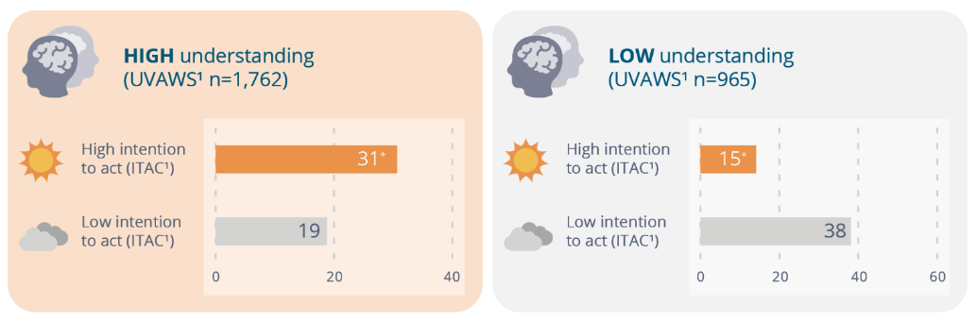
Relationship between understanding violence against women and intention to act, 2017
Understanding of violence  against women | High intention to act (ITAC¹) | Low intention to act (ITAC¹)
High understanding of violence against women (UVAWS¹ n=1,762) | 31* | 19
Low understanding of violence against women (UVAWS¹ n=965) | 15* | 38
* Differences between high and low intention to act are all statistically significant, p≤.01, and reach the 0.2 Cohen’s threshold.
¹ Measured using the composite measure described in Section 5.2.
Figure 14-3: Relationship between support for gender equality and intention to act, 2017 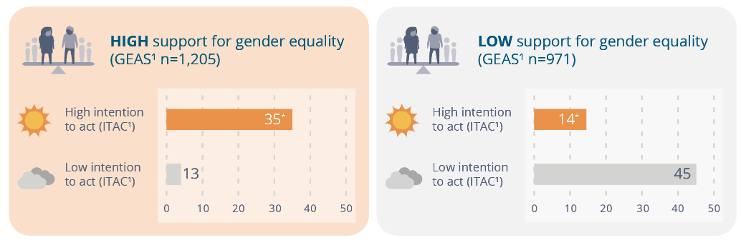
Relationship between support for gender equality and intention to act, 2017
Support for gender equality | High intention to act (ITAC¹) | Low intention to act (ITAC¹)
High support for gender equality (GEAS¹ n=1,205) | 35* | 13
Low support for gender equality (GEAS¹ n=971) | 14* | 45
* Differences between high and low intention to act are all statistically significant, p≤.01, and reach the 0.2 Cohen’s threshold.
¹ Measured using the composite measure described in Section 5.2.
Figure 14-4: Relationship between endorsement of attitudes that support violence against women and intention to act, 2017 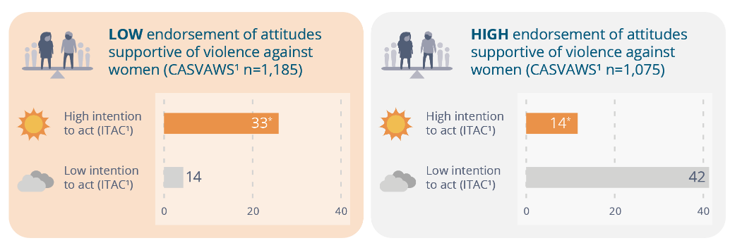

Relationship between endorsement of attitudes that support violence against women and intention to act, 2017
Endorsement of attitudes supportive of violence against women | High intention to act (ITAC¹) | Low intention to act (ITAC¹)
Low endorsement of attitudes supportive of violence against women (CASVAWS¹ n=1,185) | 33* | 14
High endorsement of attitudes supportive of violence against women (CASVAWS¹ n=1,075) | 14* | 42
* Differences between high and low intention to act are all statistically significant, p≤.01, and reach the 0.2 Cohen’s threshold.
¹ Measured using the composite measure described in Section 5.2.

Factors influencing bystander action
The data presented in Figures 4-2 to 4-4 tells us whether certain factors are related to intention to act and the direction of that relationship (e.g. whether having attitudes supportive of violence against women makes someone more or less likely to take prosocial action). It is also useful to know the extent of the influence of each factor, especially when compared with the other factors. To investigate this, multilinear regression analyses (see Section 12) were conducted using the overall intention to act measure, with UVAWS, CASVAWS, GEAS, the gender composition of one’s social network, and the demographic factors in the NCAS Questionnaire Framework (see Figure 5-1) all entered as potential explanatory variables.
The multivariate model for intention to act (Figure 14-5) explains 14% of the overall variance. The analyses show that, of each of the variables, a person’s attitude towards gender equality is the strongest predictor of their intention to act as a bystander to violence or sexism against women (accounting for 34% of variance). This was followed by attitudes supporting violence against women (explaining 24% of variance in intention to act), and understanding of violence against women (explaining 18% of variance). Gender and social network composition contributed 10 percent and 9 percent respectively, while education contributed only 5 percent (Figure 14-5).
In Section 12.1 it was proposed, drawing on prior research, that men in male dominated peer networks may be more likely to hold attitudes supportive of violence against women and less likely to support attitudes supportive of gender equality. It is hypothesised in the literature that it is “the attachments to male peers and the resources that these men provide which encourage and legitimate woman abuse” (DeKeseredy, 1990, p.130). As previously indicated, the hypothesis that male dominated peer networks may encourage and legitimate woman abuse is borne out in intention to act, with men in male dominated peer networks having a lower intention to act. In Section 12.1, it was shown that this is also apparent in the NCAS data in the fourth GEAS theme. Men in male dominated social networks were more likely than men in female dominated networks to have a low level of support for gender equality in the ‘male peer relations involving aggression and disrespect towards women’, theme (although not any other measures).
To investigate the extent of the influence of particular themes within the GEAS a multivariate model was developed containing each of the GEAS themes. Given the theory in the literature that male peer relations (see Section 12.1), and the cultures supporting them, impact particularly upon men, separate models were developed for men, women and the sample as whole.
This multivariate model, illustrated in Figure 14-6, explains 14% of the overall variance (for the whole sample). The model shows the extent to which each of the GEAS themes predicts people’s intention to act (e.g. the extent to which a person’s level of support for rigid gender roles influences their intentions to act). The theme of ‘condoning male peer relations involving aggression and disrespect towards women’ is the strongest predictor in the sample as a whole as well as for men and women. However, it contributed significantly more to variance in intentions to act among men than among women.
This means that, although attitudes towards gender equality overall predict people’s intention to act, holding attitudes promoting male peer relations emphasising disrespect of women is a particularly strong predictor, and this is especially the case among men.
Figure 14-5: Influence of factors in predicting people’s intention to act¹, 2017 (n=4,410) 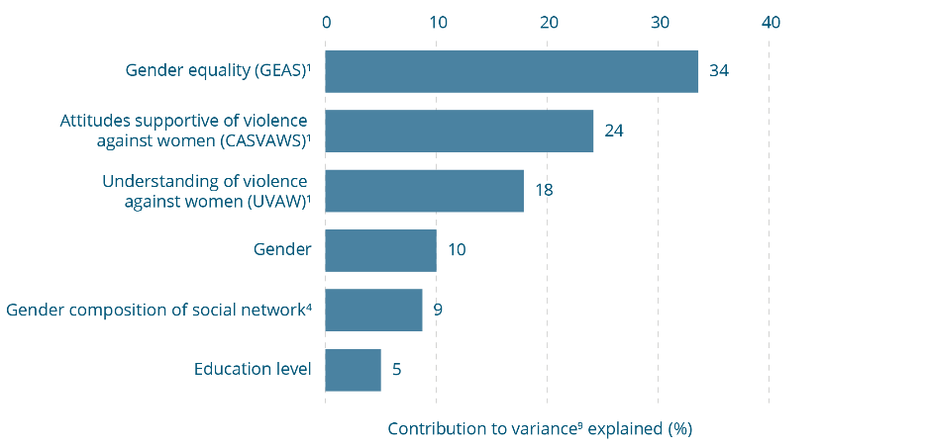
Influence of factors in predicting people’s intention to act¹, 2017 (n=4,410)
Predictor | Contribution to variance⁹ explained (%)
Gender equality (GEAS)¹ | 34
Attitudes supportive of violence against women (CASVAWS)¹ | 24
Understanding of violence against women (UVAW)¹ | 18
Gender | 10
Gender composition of social network⁴ | 9
Education level | 5
Note: Percentage does not equal 100% due to rounding.
¹ Measured using the composite measure described in Section 5.2.
⁴ Measured based on whether the respondent’s social network is made up of mainly men, mainly women or a mixture of both.
⁹ Percentage of variance explained by model is 14%.
Figure 14-6: Influence of gender equality themes in predicting people’s intention to act¹, 2017 (n=4,410)\
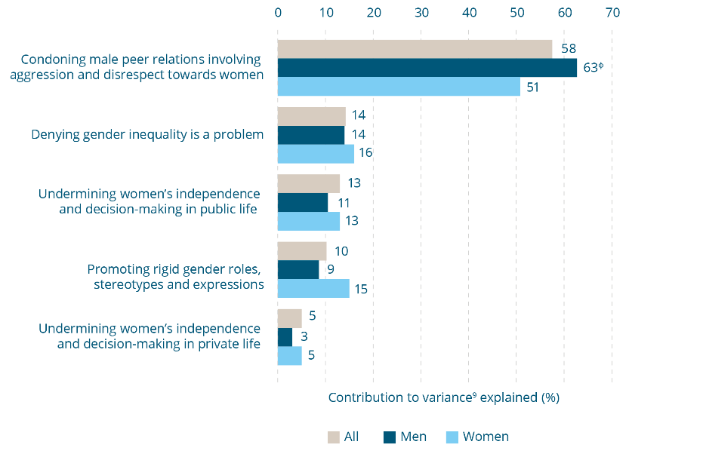
Influence of gender equality themes in predicting people’s intention to act¹, 2017 (n=4,410). Contribution to variance explained for each theme (%)
Theme | All (%) | Men (%) | Women (%)
Condoning male peer relations involving aggression and disrespect towards women | 58 | 63 ^{ф} | 51
Denying gender inequality is a problem | 14 | 14 | 16
Undermining women’s independence and decision-making in public life | 13 | 11 | 13
Promoting rigid gender roles, stereotypes and expressions | 10 | 9 | 15
Undermining women’s independence and decision-making in private life | 5 | 3 | 5
¹ Measured using the composite measure described in Section 5.2.
^{ф} Difference between men and women is statistically significant, p≤.01.
⁹ Percentage of variance explained by the overall model for the total sample is 14%. The percentage of variance explained by model for men is 16%. The percentage of variance explained by model for women is 10%.

15 Key findings in Australian states and territories
In this section, key findings for Australian states and territories are reported, including for:
- individual questions – This is done by comparing the percentage agreeing to each question (or selecting a particular response option given to respondents as relevant) for each state and territory against the rest of Australia;
- the four composite measures – These are the UVAWS (measuring understanding of violence against women), GEAS (measuring support for gender equality), CASVAWS (measuring attitudes towards violence against women) and the ITAC (measuring intention to act in response to witnessing abuse or disrespect of women). Within the GEAS and the CASVAWS, results were analysed for each of the themes (see Section 5.2 for a description of measures and their themes). Analysis involved comparing the percentage in the ‘high’ and ‘low’ categories for each measure, as explained in Section 7.6; and
- change over time for the UVAWS, GEAS and CASVAWS measures – As before (see Section 7.5), change over time was assessed by comparing the average score for each measure in the jurisdiction concerned. The score range is between 1 and 100. For the UVAWS and the GEAS, the higher the score the higher the level of understanding of violence against women and support for gender equality respectively. For the CASVAWS, a smaller score signifies a lower level of attitudinal support for violence against women.
Results for each jurisdiction were compared with those for the rest of Australia (i.e. respondents in all other jurisdictions). For many of the questions and measures there are no differences between jurisdictions and the rest of Australia that are both statistically significant and meaningful in size (see Section 7.3 for an explanation of the approach to identifying significant and meaningful differences). Results for individual questions and the composite measures are only reported for a jurisdiction when they are significantly and meaningfully different from the rest of Australia.

Australian Capital Territory (ACT)
Individual questions – People in the ACT are more likely than people in the rest of Australia to identify ‘pressure from other men to be tough’ as a factor in domestic violence ‘a lot of the time’ (20% vs 8% in the rest of Australia) (a question from the knowledge component of the questionnaire) and are less likely to agree that ‘women find it flattering to be persistently pursued even if they are not interested’ (10% vs 24%) or that ‘women going through custody battles often make up or exaggerate claims of domestic violence in order to improve their case’ (28% vs 43%) (both questions about attitudes towards violence against women).
Composite measures – There are no differences on any of the three measures or themes between people in the ACT and the rest of Australia.
Change over time – There has been a statistically significant improvement on all three measures between 2013 and 2017 in the ACT (Figure 15-1).
Figure 15-1: Changes in composite measures, Australian Capital Territory, 2009, 2013 and 2017 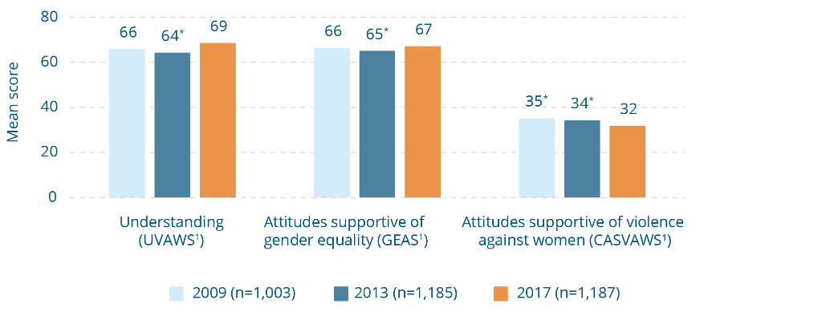
Changes in mean score for composite measures, Australian Capital Territory, 2009, 2013 and 2017.
Composite measure | 2009  (n=1,003) | 2013  (n=1,185) | 2017  (n=1,187)
Understanding (UVAWS¹) | 66 | 64* | 69
Attitudes supportive of gender equality (GEAS¹) | 66 | 65* | 67
Attitudes supportive of violence against women (CASVAWS¹) | 35* | 34* | 32
* Difference between survey year and 2017 is statistically significant, p≥.01.
¹ Measured using the composite measure described in Section 5.2.

New South Wales (NSW)
There are no differences between people in NSW and people in the rest of Australia on any individual questions or the four composite measures. There has been improvement in all three measures among people in NSW between 2013 and 2017 (Figure 15-2).
Figure 15-2: Changes in composite measures, New South Wales, 2009, 2013 and 2017 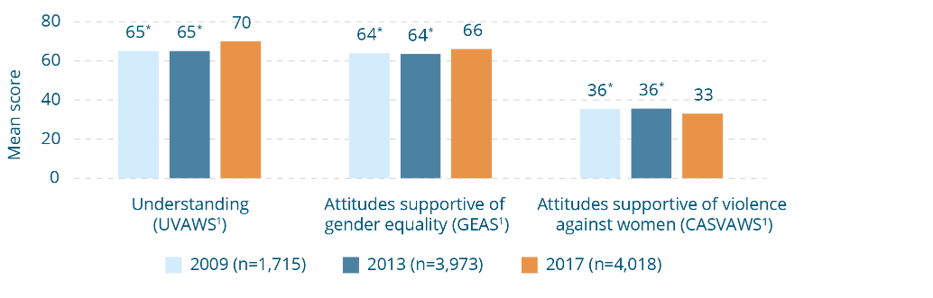
Changes in mean score for composite measures, New South Wales, 2009, 2013 and 2017.
Composite measure | 2009  (n=1,715) | 2013  (n=3,973) | 2017  (n=4,018)
Understanding (UVAWS¹) | 65* | 65* | 70
Attitudes supportive of gender equality (GEAS¹) | 64* | 64* | 66
Attitudes supportive of violence against women (CASVAWS¹) | 36* | 36* | 33
* Difference between survey year and 2017 is statistically significant, p≤.01.
¹ Measured using the composite measure described in Section 5.2.

Northern Territory (NT)
Individual questions – In responding to questions in the knowledge component of the questionnaire, people in the NT are more likely to identify ‘having an alcohol problem’ (62% vs 42% among people in the rest of Australia) and ‘pressure from other men to be tough’ (22% vs 8%) as factors in domestic violence ‘a lot of the time’, and more likely to say that ‘the way violence is shown in the media’ is ‘rarely’ a factor (40% vs 21%). In responding to questions concerned with attitudes towards violence against women, they are less likely to disagree that domestic violence can be excused if afterwards the violent person genuinely regrets what they have done (75% vs 84%).
They are less likely to agree that ‘it is a serious problem when a man tries to control his partner by refusing her access to their money’ (58% vs 81%). They are more likely to agree that:
- ‘women who flirt all the time are somewhat to blame if their partner gets jealous and hits them’ (23% vs 14%);
- ‘domestic violence can be excused’ if either the victim (13% vs 5%) or offender (11% vs 5%) is ‘heavily affected by alcohol’;
- ‘women who wait weeks or months to report’ sexual assault (22% vs 11%) and sexual harassment (26% vs 9%) ‘are probably lying’;
- ‘since some women are so sexual in public it’s not surprising that some men think they can touch women without permission’ (30% vs 21%); and
- ‘when a man is very sexually aroused, he may not even realise that the woman does not want to have sex’ (41% vs 28%).
In the gender equality component of the questionnaire respondents in the Northern Territory are more likely than those in the rest of Australia to agree that ‘men rather than women should hold positions of responsibility in the community’ (21% vs 9% in the rest of Australia).
Composite measures – There is only one difference between the NT and the rest of Australia. The NT had a higher likelihood to have a high endorsement of the ‘disregard for the need to gain consent’ theme (35% vs 24%) in the CASVAWS.
Change over time – There has been no statistically significant change in the UVAWS, GEAS or CASVAWS measures in the NT since 2009 or 2013 (Figure 15-3).
The differences for the NT are unlikely to be explained by the larger proportion of people of Aboriginal or Torres Strait Islander background in the NT sample. While the number (61 people of a total of 1000) is too small to analyse, results for this group of respondents nationally have been recorded in a separate report (forthcoming). They show that there are few differences between this group and non-Indigenous Australians.
Figure 15-3: Changes in composite measures, Northern Territory, 2009, 2013 and 2017 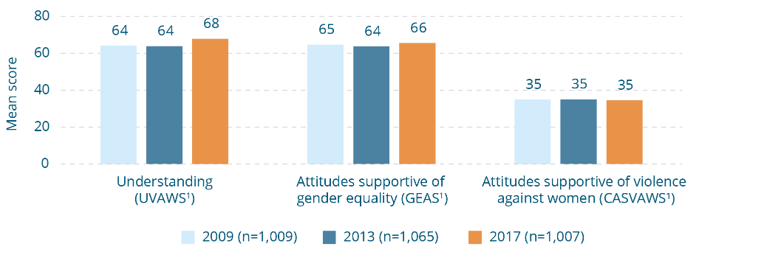
Changes in mean scores for composite measures, Northern Territory, 2009, 2013 and 2017
Composite measure | 2009  (n=1,009) | 2013  (n=1,065) | 2017  (n=1,007)
Understanding (UVAWS¹) | 64 | 64 | 68
Attitudes supportive of gender equality (GEAS¹) | 65 | 64 | 66
Attitudes supportive of violence against women (CASVAWS¹) | 35 | 35 | 35
¹ Measured using the composite measure described in Section 5.2.

Queensland
There are no differences between people in Queensland and people in the rest of Australia on any of the individual questions or the composite measures. There was an improvement on all three measures among people in Queensland (Figure 15-4).
Figure 15-4: Changes in composite measures, Queensland, 2009, 2013 and 2017 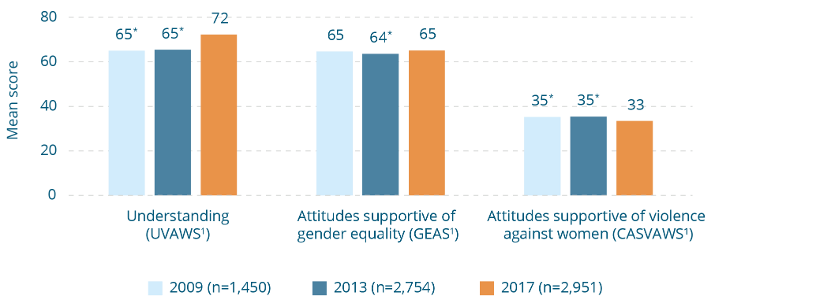
Changes in mean scores for composite measures, Queensland, 2009, 2013 and 2017
Composite measure | 2009  (n=1,450) | 2013  (n=2,754) | 2017  (n=2,951)
Understanding (UVAWS¹) | 65* | 65* | 72
Attitudes supportive of gender equality (GEAS¹) | 65 | 64* | 65
Attitudes supportive of violence against women (CASVAWS¹) | 35* | 35* | 33
* Difference between survey year and 2017 is statistically significant, p≤.01.
¹ Measured using the composite measure described in Section 5.2.

South Australia (SA)
Individual questions – People in South Australia are more likely to feel uncomfortable but not act in response to ‘a male friend insulting or verbally abusing a woman he is in a relationship with’ (12% vs 5% in the rest of Australia), and are less likely to support taking action in this circumstance (86% vs 93%).
Composite measures – There are no differences on any of the four measures or themes between people in South Australia and the rest of Australia.
Change over time – There has been an improvement among people in South Australia on all three measures between 2013 and 2017 (Figure 15-5).
Figure 15-5: Changes in composite measures, South Australia, 2009, 2013 and 2017 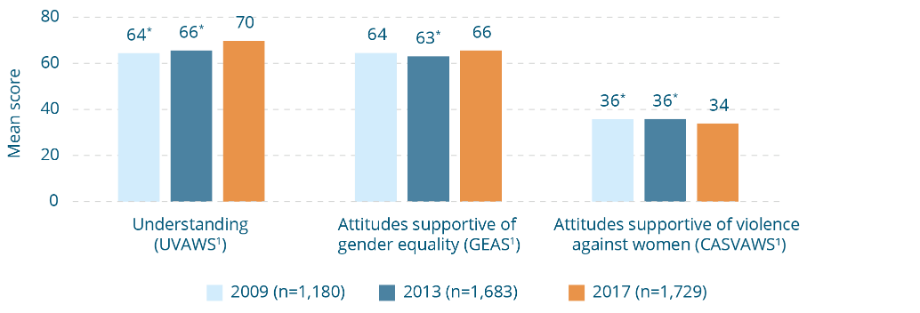
Changes in mean scores for composite measures, South Australia, 2009, 2013 and 2017
Composite measure | 2009  (n=1,180) | 2013  (n=1,683) | 2017  (n=1,729)
Understanding (UVAWS¹) | 64* | 66* | 70
Attitudes supportive of gender equality (GEAS¹) | 64 | 63* | 66
Attitudes supportive of violence against women (CASVAWS¹) | 36* | 36* | 34
* Difference between survey year and 2017 is statistically significant, p≤.01.
¹ Measured using the composite measure described in Section 5.2.

Tasmania
Individual questions – In responding to questions in the component of the questionnaire concerned with attitudes towards violence against women, people in Tasmania are:
- less likely to agree that ‘it is a serious problem when a man tries to control his partner by refusing her access to their money’ (69% vs 81% in the rest of Australia); and
- less likely to disagree that ‘if a woman is drunk and starts having sex with a man, but then falls asleep, it is understandable if he continues having sex with her anyway’ (74% vs 82%).
Composite measures – There are no differences on any of the four measures or themes between people in Tasmania and the rest of Australia.
Change over time – Among people in Tasmania there has been an improvement in the measure of attitudes towards violence against women (CASVAWS), from an average score of 36 in 2013 to 33 in 2017. The average score on the measure of understanding of violence against women (UVAWS) was three points higher in 2017 than in 2009. There was no significant change between 2013 and 2017. There has been no significant change in attitudes towards gender equality (measured by the GEAS) since 2009 among people in Tasmania (Figure 15-6).
Figure 15-6: Changes in composite measures, Tasmania, 2009, 2013 and 2017 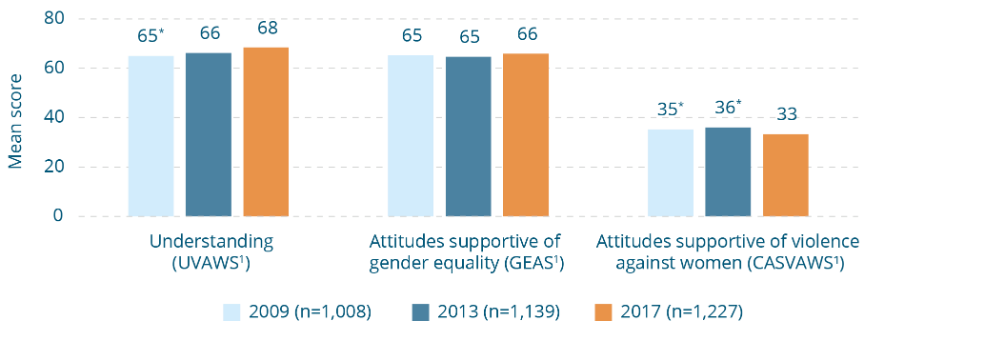
Changes in mean scores for composite measures, Tasmania, 2009, 2013 and 2017
Composite measure | 2009  (n=1,008) | 2013  (n=1,139) | 2017  (n=1,227)
Understanding (UVAWS¹) | 65* | 66 | 68
Attitudes supportive of gender equality (GEAS¹) | 65 | 65 | 66
Attitudes supportive of violence against women (CASVAWS¹) | 35* | 36* | 33
* Difference between survey year and 2017 is statistically significant, p≤.01.
¹ Measured using the composite measure described in Section 5.2.

Victoria
There is no difference between people in Victoria and the rest of Australia on any of the individual questions or the composite measures. There has been a significant improvement on all three measures among people in Victoria between 2013 and 2017 (Figure 15-7).
Figure 15-7: Changes in composite measures, Victoria, 2009, 2013 and 2017 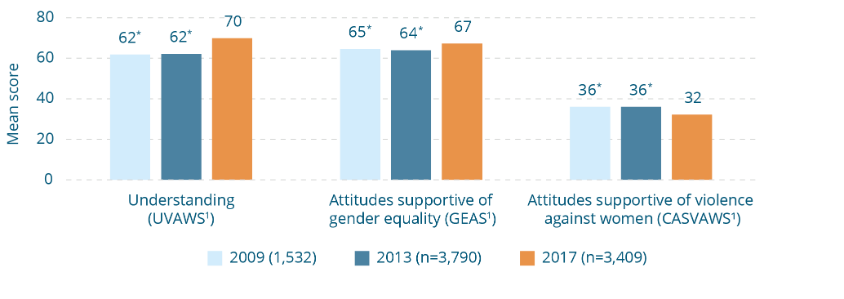

Changes in mean scores for composite measures, Victoria, 2009, 2013 and 2017
Composite measure | 2009  (n=1,532) | 2013  (n=3,790) | 2017  (n=3,409)
Understanding (UVAWS¹) | 62* | 62* | 70
Attitudes supportive of gender equality (GEAS¹) | 65* | 64* | 67
Attitudes supportive of violence against women (CASVAWS¹) | 36* | 36* | 32
* Difference between survey year and 2017 is statistically significant, p≤.01.
¹ Measured using the composite measure described in Section 5.2.

Western Australia (WA)
There is no difference between people in Western Australia and the rest of Australia on any of the individual questions or the composite measures. There has been an improvement among people in Western Australia on all three measures between 2013 and 2017 (Figure 15-8).
Figure 15-8: Changes in composite measures, Western Australia, 2009, 2013 and 2017 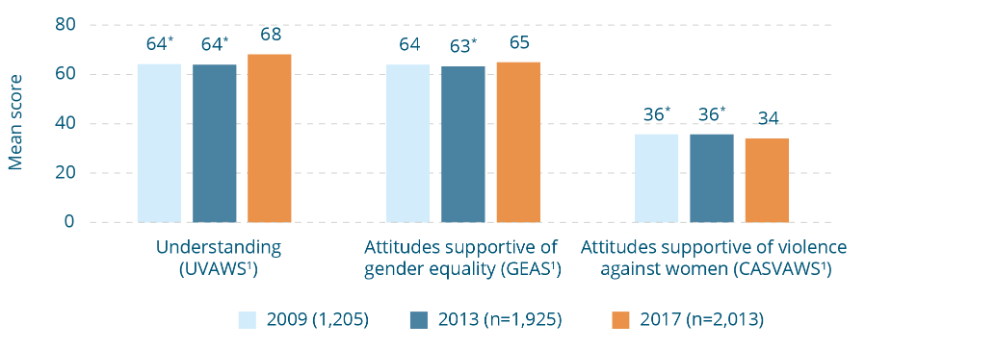
Changes in composite measures, Western Australia, 2009, 2013 and 2017
Composite measure | 2009  (n=1,205) | 2013  (n=1,925) | 2017  (n=2,013)
Understanding (UVAWS¹) | 64* | 64* | 68
Attitudes supportive of gender equality (GEAS¹) | 64 | 63* | 65
Attitudes supportive of violence against women (CASVAWS¹) | 36* | 36* | 34
* Difference between survey year and 2017 is statistically significant, p≤.01.
¹ Measured using the composite measure described in Section 5.2.

16 Strengths and limitations of the NCAS
The NCAS has a number of strengths. However, as is the case with all research, several factors need to be considered in interpreting the results.

Strengths
- The NCAS is a multi-wave survey enabling assessment over time.
- It has a large sample size, enabling rich analysis, involving representative samples among small groups within the population, including Aboriginal and Torres Strait Islander people.
- The sampling frame used is probability based, minimising coverage error and allowing inferences about the population to be made with confidence. Further, the sampling frame can be replicated for monitoring change over time.
- Although the response rate was low in absolute terms, it was as high if not higher than for comparable surveys (Kohut, Keeter, Doherty et al., 2012; Riggle, Rotosky & Reedy, 2005; Shih & Fan, 2008)
- Best practice approaches were used to maximise the possibilities of all groups in the population having an equal chance of being selected to participate in the survey (e.g. an extensive callback regime and interviewing in languages other than English).
- A split sampling approach (see Section 6) enabled inclusion of more questions and investigation of a larger number of relationships between variables.
- A 60/40 mobile phone and landline sample was used, responding to the increasing number of mobile only households in Australia.
- Questions were selected using a framework grounded in existing theory and evidence and that is compatible with contemporary Australian frameworks and policies to guide prevention of violence against women.
- The composite measures enable whole concepts to be measured more accurately and with greater validity than just using single questions.
- Rigorous statistical methodologies were used to form the GEAS and CASVAWS composite measures. Because these both contain measurable sub-themes, it was possible to investigate the different attitudinal concepts that make up attitudinal support for gender equality and violence against women.
- The questions are drawn from existing measures, meaning that they are mainly ‘tried and tested’. However, it is widely recognised that many existing studies are now very dated, which impacts on the precision of the questions included in them.

Factors to consider in interpreting the results
- The split sampling approach resulted in small numbers for some questions, especially among sub-populations.
- As in any telephone survey it is difficult to measure attitudes accurately because people may hold subtle negative attitudes that are notoriously difficult to measure. Social desirability bias is also probable. This involves people giving answers they think are socially acceptable rather than what they actually believe. It is highly likely that this has resulted in the findings under-representing the extent of negative attitudes.
- Some groups may have been under-represented in the survey. Where this is known, sample weighting is used to correct it.
- The more questions used to measure a concept (e.g. understanding of violence against women) the more precise it will be. As the questionnaire must not exceed 20 minutes in length, it was not possible to measure all of the concepts with the same number of questions. The possibility that differences in precision between measures influenced results cannot be excluded.
- Due to split sampling, all the composite measures contained some questions that were asked of only a portion (half or a quarter) of the sample. This means that scores for those composite measures are based on the number of questions asked of each respondent, rather than the number of questions within each measure. For example, each respondent answered 15 of the 19 GEAS questions. Therefore, each respondent’s GEAS score is calculated using 15 questions, but the measure is based on 19 questions, as different sample members answered different questions to provide data across all 19 questions.
- The relationships found in multivariate analysis may be in either direction, run both ways, or be due to a common third factor not measured in the survey. Longitudinal research is required to better understand factors linked to attitudes and knowledge.
- The possibility that differences between the main sample and particular groups, such as Aboriginal people and Torres Strait Islanders and people born in non-main English speaking countries are, in part, due to cultural and language differences and differences in life experience, rather than actual differences in attitudes, cannot be excluded. This is discussed further in the two sub-population reports (forthcoming).

17 Implications for policy, practice and further research
In this section, findings presented in this report are discussed in the context of other research, and implications for policy, practice and further research are identified.

17.1 Implications for overall policy and action by communities, the non-government sector and businesses
Violence against women is a serious problem, affecting many Australian women and their children, as well as organisations, communities and Australian society as a whole. There is increasing agreement in both the Australian and international communities that addressing this violence requires a concerted, coordinated and sustained effort involving many different strategies not only with affected individuals, but in communities, organisations and wider societal institutions (Michau, Horn, Bank et al., 2015). Such an approach needs to involve strategies along a continuum from preventing violence before it occurs (primary prevention) and early intervention, through to responding to those affected by violence and supporting their long term recovery. The need for this approach is recognised in the Council of Australian Governments’ (COAG) National Plan.
To support the achievement of the National Plan goals, COAG established ANROWS to build the evidence base and support the take-up of evidence in policy and practice, nationally. Subsequently, Our Watch was established to drive change in the social norms, structures, attitudes and practices that underpin and support violence against women and their children. Together, Our Watch, ANROWS and VicHealth produced a National Framework (Change the Story), providing a shared approach to the primary prevention of violence against women (Our Watch, ANROWS, & VicHealth, 2015). Australia is the first country in the world to have adopted this comprehensive approach to planning and implementation of a coordinated strategy.
In the years since the release of the National Plan, there has been substantial growth in initiatives to address violence against women in Australia, supported by both government and non-government organisations, women’s groups and the community and business sectors. More recently, this has included a focus on prevention – that is, stopping violence before it starts – through whole-of-community action (VicHealth, 2015). These efforts build on the foundation laid in the pioneering work of women’s and other civil society groups across the world, which was initiated in the 1960s and has continued to the present day.
The issue of violence against women has also attracted unprecedented attention in the media and popular culture, both in Australia and internationally. Particularly notable was the media response to allegations of serial sexual offending made against then film producer Harvey Weinstein in 2017. These spurred a global campaign which adopted the hashtag #metoo, a phrase coined in 2006 by civil rights advocate Tarana Bourke, encouraging women to expose the prevalence of the problem of sexual assault by sharing their stories. Intimate partner violence has also had a strong media profile, including extensive coverage of the murder of Luke Batty by his father, and the appointment of Luke’s mother, Rosie Batty, as Australian of the Year in 2015. It is also evident in the regular reporting of women killed by family members in both mainstream and social media (supported by advocacy group Destroy the Joint’s Counting Dead Women campaign). Violence against and disrespect of women have been the focus of a number of documentaries and fictionalised stories, such as journalist Sarah Ferguson’s family violence report Hitting Home (ABC Television 2015), The Handmaid’s Tale (SBS Television 2017, featuring a dystopian future involving the extreme subjugation of women), Big Little Lies (HBO 2017, depicting the cyclical and controlling nature of intimate partner violence) and 13 Reasons Why (Netflix 2017, exploring how rape culture is perpetuated).
The context just described is important to note because it may both signal and contribute to change. However, as will be discussed further in this sub-section, it may also influence the way people respond to surveys, and so needs to be taken into account when considering the findings.
As shown in Section 4, attitudes are not fixed, but rather change in response to changes in wider society. Attitudes have many influences. The NCAS measures change in attitudes, but does not tell us why attitudes have changed. While this makes it difficult to attribute change to any particular factor, initiative or group of initiatives, the evidence from the 2017 NCAS suggests that collectively the efforts previously described may be gaining traction within the Australian community. Between 2009 and 2013, there was no positive change in the three key indicators in the NCAS (understanding and attitudes towards violence against women, and attitudes towards gender equality). Indeed, there was a slight decline in support for gender equality in that period. However, between 2013 and 2017, there has been improvement in all three measures. The average score on the understanding of violence of against women measure has increased from 64 to 70 (with 1 being the lowest understanding and 100 being the highest) and on the gender equality measure from 64 to 66 (with 100 indicating the highest possible level of support). Meanwhile the average score indicating attitudinal support for violence against women has declined from 36 to 33 (with 1 indicating the lowest level of attitudinal support for violence against women and 100 indicating the highest level). Further, although there are some exceptions (which will be discussed further) for many questions a majority of Australians gave answers indicating an accurate knowledge of violence against women and a rejection of attitudinal support for violence against women and gender inequality.
These findings provide some cause for optimism, although certainly not for complacency. Although they are tracking in the direction of positive change towards a community that recognises and rejects violence against women, and supports gender equality, the changes themselves are modest. Further, despite the positive findings at an overall level, responses to some individual questions suggest that there remain areas of concern. These are discussed further in Section 17.2. There are four further reasons to resist complacency:
- Changes in attitudes have yet to show as changes in behaviour. It takes time, sustained effort and a range of actions for changes in attitudes to translate into changes in behaviour.
- Attitudes are one of many factors influencing behaviour.
- Attitudinal change is not necessarily a linear process.
- Apparently low levels of support for gender inequality and violence against women may nevertheless be a problem.

Changes in attitudes take time to translate into changes in behaviour
The relationship between attitudes towards violence against women and the prevalence of violence is not straightforward: myriad factors influence violence (not just, or even primarily, attitudes). For this reason a direct relationship between changes in attitudes towards violence against women and changes in prevalence would not necessarily be expected. Further, it is important (as will be discussed further) to measure progress using a range of indicators, not just reduction in violence. Nevertheless, as shown in Box 17-1 there has been minimal change in the prevalence of violence against women since 2005. The positive change in attitudes found in the NCAS has yet to translate into changes in behaviour.
The apparent lack of reduction in violence may be in part an artefact of increases in disclosure of violence, which may have masked any decrease in actual experience. Increased preparedness to disclose may be due to:
- increased awareness of violence against women in the community, including among women (as shown in the NCAS);
- better understanding of behaviours constituting violence against women (also shown in the NCAS); and
- women perceiving reductions in violence-supportive attitudes in the community (especially reductions in victim-blaming and minimising attitudes, and those concerned with maintaining the privacy of the family).
Lacking such knowledge, holding the attitudes just described, or perceiving that they are held by others, have been identified as barriers to disclosure (see Section 8 and Section 10).
However, there are reasons to suggest that the lag between attitudes and behavioural change is real. As shown in Section 4, attitudes influence behaviours indirectly, primarily through social norms. Collectively held attitudes are among the factors contributing to formal and informal social norms, and these in turn influence behaviour. The indirect nature of their influence means that it may take some time for changes in attitudes to be reflected in reductions in violent behaviour or improved responses to violence against women. The fact that attitudes are changing is promising, but suggests the need to maintain the momentum of effort so that such changes are ultimately manifest in formal and informal social norms, and in turn in behaviour.
A further consideration is the fact that reducing violence against women involves more than changing the behaviour of men who use violence. It also involves reducing violence indirectly by supporting change in attitudes, knowledge, behaviours and social norms among service providers, bystanders to violence and disrespect, and key decision-makers and opinion influencers, as well as creating the conditions in which women who are subject to violence have a wider range of options. Such changes may similarly take time to result in reduction in violence itself.
Another potential reason for changes in behaviour lagging behind changes in attitudes towards violence against women is the possible plateauing of gender equality attitudes in the years prior to the 2016 PSS. As has been shown in this report, attitudes to gender equality underpin attitudes to violence against women. Research involving immigrants to high income countries further shows that changes in attitudes to violence against women are linked to changes in attitudes to gender equality. The attitudes of immigrants to violence against women become more positive with increasing years of settlement in a new country, but this change is mediated by increasing attitudinal support for gender equality (Bhanot & Senn, 2007).
The evidence just introduced suggests that the prospects of reducing violence against women are best served by strengthening equality and respect between men and women. Section 4 showed that attitudes towards gender equality mirror actual levels of this inequality at the population level (Brandt, 2011). However, while attitudes to gender equality appeared to improve markedly in Western countries, including Australia, between the 1960s and the 1980s, change levelled somewhat in the 1990s, possibly even stalling (Cotter, Hermsen, & Vanneman, 2011; van Egmond, Baxter, Buchler et al., 2010). Recent research conducted in the US and Europe suggests that a nuanced picture emerges when attitudes towards different dimensions of gender equality are explored. Attitudes towards gender equality in the public sphere show a continuous liberalising trend, whereas attitudes towards gender equality in private life have either plateaued or rebounded (Donnelly, Twenge, Clark et al., 2016; Pepin & Cotter, 2018). Some caution is warranted in applying international research to the Australian context (Perales, Philipp, & Baxter, 2017). However, it is possible that this pattern may also be the case in Australia. Indeed, the findings of this report show attitudes supporting gender inequality in the private sphere to be more widely held than those towards gender inequality in public life (see Figure 9-7).
Although the gender equality measure has been in only two waves of the NCAS, the lack of positive change between 2009 and 2013 provides some support for the hypothesis that attitudes towards gender equality have plateaued. Monitoring the prevalence of violence against women commenced only in 1996, so there is no baseline predating the changes in gender equality commencing in the 1970s. Therefore, it is not possible to examine the extent to which the large changes in gender equality attitudes in Australia between the 1960s and the 1980s were accompanied by reductions in violence against women. However, it is possible that the reduction in violence between the 1996 Women's Safety Survey and the 2005 wave of the PSS reflected improvements in gender equality in the preceding decades and that the lack of change in women’s experience of violence shown in successive PSS waves (see Box 17-1) reflects the stalling of change in gender equality attitudes documented in the NCAS and other studies. In this regard, the improvement in the NCAS gender equality measure in 2017 is particularly encouraging, suggesting the potential for further improvement in both gender equality and, consequently, future reduction in violence against women. This improvement is likely to be dependent upon continued efforts to address gender equality.
Experience in addressing other complex social issues suggests that changing behaviours takes time and requires long term and sustained effort. Examples include the marked reductions in tobacco use (MacKay, Bettcher, Minhas et al., 2012) and motor vehicle accident morbidity and mortality secured in many high-income countries, including Australia, in the past 60 years (WHO, 2013b; World Bank, 2009). This is particularly the case for primary prevention of violence against women because primary prevention interventions seek to change conditions somewhat ‘upstream’ of the behaviour of violence itself. It may take some years before these changes are apparent in reductions in violence. Because both attitudes and behaviour are influenced by wider social conditions (see Section 4), once change is achieved it should be sustained by firmly embedding it in families, organisations, communities and wider institutions.

Attitudes are one of many factors influencing behaviour
A range of factors other than attitudes influence behaviour (see Section 4), and change in these may have yet to occur or to take effect. Although recent decades have seen many positive changes in responses to violence and social conditions for women, there have also been potentially countervailing influences such as increased exposure of young people to, and greater violence in, pornography (Davis, Carrotte, Hellard et al., 2018; DeKeseredy & Corsianos, 2015; Flood, 2009; Lim, Agius, Carrotte et al., 2017), access to violence-supportive content and online communities via social media (Ging, 2017; Gotell & Dutton, 2016; Marwick & Caplan, 2018; Vickery & Everbach, 2018) as well as continued under-representation and disrespect of women in Australian parliaments (Collier & Raney, 2018; McCann & Wilson, 2014). There have also been substantial economic and social changes that have particularly impacted upon employment among men, potentially increasing the risk of violence against women (Weissman, 2007).
It is for this reason that a comprehensive approach to prevention – rather than one focusing primarily on attitudes – is more likely to lead to sustained changes at the organisational and community levels (Our Watch, ANROWS, & VicHealth, 2015; Fulu, Kerr-Wilson & Lang, 2013; Fulu, Warner, Kerr-Wilson, 2014; Salter, 2016; WHO, 2010).

Attitudinal and behavioural change are not necessarily linear processes
A third reason for the need to avoid complacency, despite the positive changes in the 2017 NCAS, is evidence from other similarly complex social issues suggesting that attitudinal and behavioural change are not necessarily linear processes. Rather, negative influences in the external environment can undermine gains achieved. This is apparent in studies showing marked increases in negative sentiment towards people of the Islamic faith in western societies, coinciding with negative public discourse in the wake of the 9/11 World Trade Center attacks and the 7/7 London bombings (Disha, Cavendish, & King, 2011; Hanes & Machin, 2014). Research has also shown an increase in hate crimes directed towards people of Asian and Arabic appearance following such events, suggesting that intense media coverage and framing of events may impact on discriminatory attitudes (Hanes & Machin, 2014).
Findings of successive NCAS waves suggest that understanding and attitudes towards violence against women and gender equality are similarly sensitive to external influences. Although many individual NCAS questions have an improving trend over survey waves, some others have fluctuated and a small number show a worsening trend, for example questions about understanding gendered patterns of violence. These may be due to a range of changes and trends in the wider environment (see Box 8-10).
It is important to note that the time between the 2013 and 2017 surveys was one of unprecedented civic advocacy, media coverage and associated public discourse on violence against women (see earlier in this section). Such activity is a vital part of an overall strategy to achieve change in cultures supportive of violence against women. However, there is the risk that advances gained through such discourse alone may be lost after attention wanes, or if activity is not supported and reinforced by other changes (e.g. changes in laws or their implementation or policies and practices to address violence against women in organisations).
This sensitivity of attitudes to the ebbs and flows of contemporary public and media discourse is suggested in the increase (from 23 percent to 27 percent) in people agreeing that ‘men make better political leaders than women’ between the 2009 and 2013 NCAS waves. This was a period involving intense public discussion about the then Prime Minister Julia Gillard’s leadership, one often characterised by gendered hostility and disrespect (Trimble, 2016). In the 2017 NCAS, the proportion of Australians supporting this sentiment fell below its 2009 level, to 14 percent.
The risk of positive changes in attitudes and behaviours being undermined is particularly acute given evidence of the ‘backlash’ response (see Box 9-5). This may be apparent in the form of negative media and public discourse and may also manifest in temporary increases in violence itself, as structural and cultural conditions associated with gender equality and violence against women improve, before beginning to decline (Gracia & Merlo, 2016; Rudman & Glick, 2001; Whaley, Messner, & Veysey, 2013). While this report did not explore changes over time in the individual themes in the CASVAWS and GEAS, the risk of a backlash effect occurring in Australia is suggested by the fact that attitudes in the themes of ‘mistrusting women’s reports’ (in the CASVAWS) and ‘denying gender inequality is a problem’ (in the GEAS) are the most widely held. Both contain questions reflecting the overall concept of backlash.
It is possible that the lack of reduction in violence despite positive changes in attitudes is at least partially attributable to violence being perpetrated as part of a backlash to positive changes in cultures supportive of violence against women. While not a reason to desist from efforts to strengthen gender equality and reduce violence against women, the risk of backlash suggests that it will be especially important to maintain and extend efforts to prevent violence against women as well as to ensure that strategies are in place at the national, organisational and individual project level to mitigate the risk.

Apparently low levels of support for violence against women and gender inequality may still be a problem
A final reason to avoid complacency on the basis of the 2017 NCAS results is that the level at which the prevalence of negative attitudes towards gender equality or attitudes supportive of violence against women becomes a problem, in terms of influence on social norms and ultimately behaviour, is unknown (Edwards, Turchik, Dardis et al., 2011). It may be at the levels found in the 2017 NCAS, or it may be higher or lower. Even when only a minority hold negative attitudes, they may have a substantial impact if a person or people with power and influence hold them. This phenomenon has been a feature in recent high profile cases of sexual assault and harassment, whereby many bystanders to violence remained silent because they feared being ostracised in a culture in which disrespect and mistreatment of women was normalised by people with power and influence (O’Hehir, 2017). Also, it is not known how different attitudes interact with one another – whether negative social norms form only when many people hold the same or similar negative attitude (e.g. that women lie about sexual assault), or whether different forms of attitudinal support (e.g. the range of attitudes described in this report) have a cumulative effect on social norms and behaviour (Edwards, Turchik, Dardis et al., 2011).
It is probable that the results underestimate the prevalence of negative attitudes. This is because such attitudes are likely to be implicitly held, at a deeper and sometimes unconscious level. This means that these attitudes can be hard to ‘reach’ through survey questions (McMahon & Farmer, 2011). Further, when people respond to surveys on sensitive or political issues, they may give answers that they believe are socially acceptable or that they think the interviewer wants to hear, rather than the attitude that they actually hold (Krumpal, 2013; McMahon & Farmer, 2011). Steps were taken in the NCAS to minimise these problems and measure attitudes as accurately as possible. However, these problems affect most surveys on sensitive issues, not just NCAS, and they are difficult to eliminate altogether.
In short, although the proportion of NCAS respondents indicating some support of violence against women or gender inequality is small, this does not necessarily mean that there is not a problem.

The need for ongoing and coordinated action
Gender inequality and violence against women, and the cultures supporting them, are deeply entrenched and require sustained effort over time to achieve change. Long term action in other health and social change areas has demonstrated that even deeply entrenched behaviours and attitudes can shift over time and that change at the population level can be achieved. For example, in tobacco control and motor vehicle safety success has been due to several factors including:
- a long term commitment;
- a sound infrastructure to support prevention (e.g. via coordination, workforce and resource development);
- implementation across sectors, recognising that problems have many contributing factors, and that these lie in a range of environments;
- coordinated, well planned action, recognising the need to ensure that the approach across sectors and ecological levels is consistent;
- multiple strategies including policy development, legislative and regulatory reform, communications and social marketing, organisational and community development, advocacy and programs with individuals and groups to support behavioural change. These strategies aim to change attitudes and norms, but also seek reinforcing change in structures and practices;
- reinforcing approaches across levels of the social ecology (i.e. interventions with individuals and families, as well as with communities, organisations and society-wide institutions);
- monitoring to ensure that behavioural change, as well as the intermediate outcomes required to secure it, are being achieved; and
- a research and evaluation capacity to build evidence of ‘what works’ and prioritise strategies that optimise impact (VicHealth, 2017a).
Box 17-1: Have there been changes in the prevalence of violence against women over time?
The earliest signs of a positive impact on the prevalence of violence would be evident in a reduction in violence in the previous 12 months. This is because these data are sensitive to recent and current reform. In contrast, the data on experience of violence since age 15 also include violence occurring long before social and legal reforms were implemented.
There was a decline in the proportion of women experiencing violence in the preceding 12 months as recorded between the 1996 Women’s Safety Survey and the 2005 PSS (ABS, 2006). This figure includes both physical and sexual violence, and violence by any perpetrator. A decline between 1996 and 2005 was also found when women’s experience of partner violence (i.e. violence perpetrated by a current or former cohabitating partner) was examined (ABS, 2006).
Since 2005 there has been a reduction in both men and women experiencing physical violence in the last 12 months (that is physical violence by any perpetrator) (ABS, 2016). However, when different types of violence experienced by women in the 12 months prior to the survey are examined:
- the proportion of women who have experienced partner violence has remained unchanged since 2005 (ABS, 2017);
- the proportion of women experiencing sexual violence remained steady between 2005 and 2016, and increased from 1.2% of women in 2012 to 1.8% in 2016 (ABS, 2017); and
- the proportion of women experiencing sexual harassment increased from 15% in 2012 to 17% in 2016 (ABS, 2017).
Drawing on experience in addressing these other health and social issues, expert bodies propose that a similar approach is both warranted and necessary to reduce violence against women and their children (Heise, 1998; Michau, Horn, Bank et al., 2015). Although high quality evaluations are scarce, a growing body of research and evaluation in the prevention of violence against women confirms the experience of the other public health programs already discussed. It highlights that reduction in violence and changes in the cultures supporting it are most effectively achieved through a comprehensive approach, involving multiple strategies at different levels, rather than isolated initiatives such as stand-alone campaigns or programs focusing on single factors (Arango et al, 2014; Fulu, Kerr-Wilson & Lang. 2013, Fulu, Warner, Kerr-Wilson et al., 2014; Our Watch, ANROWS, & VicHealth, 2015; WHO, 2010).
While such an approach involves an investment of effort and resources, economic analyses of comprehensive programs to address other health issues have demonstrated their overall cost effectiveness (Hurley & Matthews, 2008). This is also likely to be the case if such an approach is successfully applied to reducing violence against women, with a recent study indicating that evidence-based prevention strategies could save $37.8 billion to $74.7 billion over a lifetime (PwC, Our Watch & VicHealth, 2015).

The need for ongoing monitoring that includes but is not limited to monitoring attitudes
A feature of successful programs to address other serious health issues has been careful monitoring of progress. Such monitoring is especially important for complex social issues such as violence against women, in which the ultimate goal of changing behaviour (in this case the perpetration of violence against women) requires change in the ‘upstream’ social conditions understood to underlie violence. This makes it important to monitor changes in these conditions (using intermediate indicators), as well as in violence against women itself. Reduction in violence will also be supported through changes in the behaviours of a range of actors (e.g. service providers, bystanders), not just the behaviours of men who perpetrate violence. This means that the behaviours of these other actors and the conditions that facilitate positive change in them also need to be considered in evaluating whether progress is being made. Such an approach to monitoring has been developed by Our Watch and its partners in Counting on Change: A Guide to Prevention Monitoring (Our Watch & ANROWS, 2017), and by the ABS on behalf of DSS in the DCRF (ABS, 2014) (which also focuses on monitoring responses to violence after it has occurred).
Community attitudes are an indicator of progress, and hence monitoring them is an important part of an overall monitoring regime. However, they are not the only indicator.

Implications for overall policy and actions – summary of implications
- The modest improvement in knowledge of violence against women, gender equality and attitudes towards violence against women are cause to be optimistic about the potential to change cultures supportive of violence against women and inequality and suggests that Australia is on track to achieving safer and more respectful environments for all.
- A planned, sustained and coordinated approach to prevention involving multiple strategies implemented across levels and relevant sectors of society is indicated in the evidence and advocated by expert bodies.
- The findings, considered in the context previously outlined, confirm the value of nationally led, strategic and sustained effort, and the importance of continuing to monitor change.
- There is a need to develop strategies to address the risk of ‘backlash’ to improvements in women’s safety and gender equality.

17.2 Particular gaps and issues to address in prevention actions

Priorities in knowledge of violence against women
Knowledge of violence against women is among the factors influencing attitudes (Ajzen & Fishbein, 2005; Chaiken & Trope, 1999; Fazio, 1990) and is an important resource for both affected individuals and those around them to identify and respond constructively to the problem (Carlson & Worden, 2005; Powell, 2011). Knowledge of the law is particularly important to encouraging individuals to report violence when it occurs and can play a role in shaping positive social norms that take violence seriously (Salazar, Baker, Price et al., 2003).
Findings from previous waves of the NCAS show that Australians overall have a high level of knowledge about violence against women, including that it is common and that there are laws against it. However, these surveys also indicate that there are key gaps in understanding of the complex dynamics of both intimate partner violence and sexual assault.
There are signs that this knowledge gap is narrowing: a larger proportion of Australians in the 2017 NCAS recognise that domestic violence involves behaviours such as verbal abuse, as well as social and financial means of control, than was the case in 2013. Further, when presented with six possible factors contributing to domestic violence, Australians are most likely to identify the factor shown in research to be among the most commonly linked with intimate partner violence: ‘men wanting to control women’.
Contrasting with these findings are those relating to understanding of the gendered patterns of intimate partner violence. Since 1995 there has been a decline in the proportion of Australians agreeing that domestic violence is perpetrated mainly by men, and that female victims are more likely than male victims to suffer physical harm and fear from domestic violence. This is contrary to the research findings discussed (see Box 8-9).
This trend continued in 2017, and indeed sharpened on two of the three measures. The reasons for this trend require further investigation. It suggests a declining appreciation of the power dynamics involved in intimate partner violence and of women’s particular vulnerability in violent relationships. Paradoxically, this change may be in part a consequence of increasing acceptance of gender equality (see Box 8-11), which may serve to mask continuing inequalities between men and women, especially in the private sphere of intimate relationships. This may in turn lead to a belief that gender equality has been achieved, or spur a ‘backlash’ against advancing equality. While not reasons to desist from efforts to achieve gender equality, these factors should be taken into account in developing policies, programs and strategies to combat violence against women and to promote gender equality.
Governments, non-government agencies and advocacy groups have done much work in recent years to raise awareness of the complex circumstances in which much sexual assault takes place. Such efforts have sought to improve rates of reporting, prosecution and conviction, as well as to promote cultures that encourage a mutually respectful and consensual approach to sexual relations (Larcombe, 2011). As in previous surveys, the 2017 NCAS findings suggest a need for continuing work in the area of community understandings of sexual assault. Contrary to the evidence, more than a third of Australians do not understand that sexual assault is more likely to be perpetrated by a known person, one in ten do not understand that physical resistance is not required to satisfy a claim of sexual assault and one in four disagree that false allegations of sexual assault are rare. Addressing these false beliefs has been identified in the literature as key to preventing and improving responses to sexual assault (Edwards, Turchik, Dardis et al., 2011).
The findings of the 2017 NCAS suggest that the Australian community has a strong appreciation that multiple factors contribute to intimate partner violence. However, there would be benefits in continuing to strengthen community understanding that reducing violence will involve not only responding to affected individuals, but also addressing cultures, practices and structures in day-to-day environments known to increase the likelihood of violence against women.
The proportion of Australians saying they would know where to seek help in relation to a domestic violence matter (60%) is three percentage points higher than in the 2013 NCAS, and not statistically significantly different to what it was in 2009 (62%). While a small improvement, this finding suggests the need to continue to promote knowledge of services and resources, and also to build the capacity and reach of services across states and territories.

Addressing gaps in knowledge of violence against women – summary of implications
There is a need to continue to raise awareness and knowledge of key aspects of violence against women including:
- the dynamics of intimate partner violence, in particular that this violence may extend beyond physical forms and coerced sex and is often motivated by a desire to control and belittle women;
- that Australian law is based on a model privileging a mutually respectful approach to negotiating sexual relationships;
- the circumstances in which most sexual assault occurs;
- that addressing violence against women will involve attention to the social conditions that make it more common, not just responding to individual victims and perpetrators; and
- places where help and support can be obtained to deal with violence against women.

Priorities in strengthening attitudes to gender equality
The Australian Government has a policy commitment to achieving gender equality, and doing so is important for many reasons, including that such equality is associated with the wellbeing of women, men and their families, and improved productivity, creativity, economic development, as well as the protection and promotion of human rights (VicHealth, 2017b, 2017c). As shown in Section 4, the level of attitudinal sexism at the national level has been found to be predictive of the level of gender inequality in a country (Brandt, 2011). This means that monitoring community attitudes is one important way of monitoring progress in achieving gender equality at the national level.
Promoting gender equality is also pivotal to reducing violence against women, because gender inequality and attitudes supporting gender inequality provide the social conditions in which violence against women is more likely to occur (WHO, 2010). This is a position supported by key expert bodies (Michau, Horn, Bank et al., 2015; UN Women, 2015; WHO, 2010) and that underpins both the National Plan and the Change the Story framework. Monitoring attitudes towards gender equality is therefore important to monitor progress in reducing violence against women.
Although Australia compares favourably with many other countries, much progress is still to be made before gender equality is achieved. Australia was recently ranked 35th at a global index that compares countries on key gender equality indicators. According to data from the 2017 Global Gender Gap Report, Australian women continue to experience inequality relative to men in important areas such as economic participation, as well as political representation (World Economic Forum, 2017). Australia’s highest previous ranking was 15th in 2006, suggesting that sustained progress towards gender equality requires targeted and persistent action.
Overall the 2017 NCAS findings show that the majority of Australians reject negative attitudes towards gender equality. However, there is wide variation in findings between the 19 statements put to survey participants, and a sizeable minority hold negative attitudes. For example, 50 percent of respondents agree with the statement ‘many women mistakenly interpret innocent remarks as being sexist’ and 40 percent agree that ‘many women exaggerate how unequally women are treated in Australia’. Further, for the reasons already discussed, it is probable that the NCAS findings overestimate the level of support for gender equality in the Australian community.
Gender inequality takes many forms, and those particularly associated with violence against women have been identified in prior research and are summarised in the Change the Story framework as including the following themes (referred to as ‘drivers’ in the framework), being attitudes that:
- promote rigid gender roles, stereotypes and expressions;
- undermine women’s independence and decision-making in public life;
- undermine women’s independence and decision-making in private life;
- condone male peer relations involving aggression and disrespect towards women; and
- deny gender inequality is a problem.
A key strength of the 2017 questionnaire is that a new 19 question composite measure to gauge attitudes towards gender equality was developed, and from this separate measures were developed to gauge the level of attitudinal support for each of the themes. The analysis confirmed the concepts in the Change the Story framework, with the exception that it was found that Australians think differently about gender equality in private life than they do about gender equality in public life.
The analysis showed only modest differences between the five themes (with the exception of denying gender inequality; see subsequent discussion), suggesting that it is relevant to address all of the concepts in programming and practice to prevent violence against women. Other research suggests that each of the themes is interconnected (e.g. rigid gender roles ‘set the scene’ for other aspects of gender inequality such as sex segregation in employment, in turn a factor contributing to the gender pay gap, and to a greater likelihood of women’s economic dependence) (Webster & Flood, 2015).
Nevertheless, the lowest levels of support for gender equality are in the themes of ‘denying gender inequality is a problem’ and ‘undermining women’s independence and decision-making in private life’. Further analysis using all the questions measuring attitudes towards gender equality in the private realm (not just those related to decision-making) confirmed Australians’ greater resistance to equality in their household and intimate relations than in public contexts (e.g. work and education). This distinction between gender inequality in public as opposed to private life is also suggested in the statistical testing undertaken to form the measures (see Section 5.2 and Section 9.2). The analysis suggested that the Australian public tends to see gender equality in public life and gender equality in private life as two separate concepts.
The weaker support for gender equality in private life (i.e. in households and relationships) suggests the importance of giving greater emphasis to this as opposed to gender equality in the public sphere in policy, programming and practice to prevent and reduce violence against women. While many policy levers are available to governments to address gender inequality in public life (e.g. legislating or regulating paid parental leave or equal opportunity provisions in workplaces), addressing gender equality in private life can be more challenging. However, there are promising approaches. Examples include The Line, a social marketing initiative for young people aged 12-20 to help them develop healthy, respectful relationships and reject violence (Our Watch, 2018); Respectful Relationships programs, delivered in schools and early childhood settings to promote and model respect and positive attitudes and behaviours (Department of Education and Training Victoria, 2018); and Baby Makes 3, a program designed to support new parents to negotiate their gendered roles and identities in their transition to new parenthood (Keleher & Hutcheson, 2016).
Although attitudes in the male peer relations theme are less strongly held than some of the other themes in the community as a whole, these attitudes do appear to play a role in male dominated social and occupational environments (as will be discussed further). It is also worthwhile noting that, of all the themes in the GEAS, there were fewer questions capturing different aspects of male peer relations emphasising aggression and disrespect towards women. A particular gap was questions measuring the concept of aggression as a part of masculinity. This may be an area for future scale development and qualitative research.

Strengthening attitudes to gender equality – summary of implications
- While Australians are generally supportive of gender equality, there is room for improvement.
- Continued monitoring of attitudes towards gender equality is an important means of monitoring progress in achieving the nationally agreed commitment to achieving gender equality itself.
- Gender inequality is linked to violence against women and attitudes towards violence against women.
- Attitudinal support for gender equality takes many forms. The NCAS confirms that the way Australians think about gender equality aligns with the key themes identified in the Change the Story framework, with the exception that they think differently about (and are less supportive of) gender equality in families, households and intimate relationships than they are of gender equality in public life (e.g. work and politics).
- If the objective is reducing violence against women, there is a need for a greater focus in prevention programming on achieving gender equality in the private sphere.
- Of the five forms most commonly linked with violence against women in the literature, the most strongly held in the Australian community are attitudes ‘denying gender inequality is a problem’ and ‘undermining women’s independence in decision making in private life’. Although it is important to address all five themes in prevention programming, there would be benefits in giving greater emphasis to these two themes.
- There would be benefits in strengthening the measure of ‘condoning male peer relations involving aggression and disrespect towards women’ to include measures of support for aggression as part of masculinity in the next NCAS.

Priorities in reducing attitudes supportive of violence against women
Overall, the majority of Australians do not endorse attitudes that excuse the perpetrator and/or hold women responsible, minimise violence, mistrust women’s reports or disregard the need to gain consent. However, for many questions, the minority endorsing violence-supportive attitudes is sizeable. For example, 43 percent agree to the statement ‘women going through custody battles often make up or exaggerate claims of domestic violence in order to improve their case’, and 42 percent agree ‘it is common for sexual assault accusations to be used as a way of getting back at men’. As discussed earlier, surveys are likely to underestimate the true prevalence of violence-supportive attitudes, and the possibility that attitudes may be harmful, even if held by a small proportion of the population, cannot be ruled out.
Interestingly, attitudes excusing violence because either the victim or perpetrator is affected by alcohol are supported by only a small proportion of Australians and for most relevant questions this declined between 2013 and 2017.
Research shows that one of the most powerful influences on behaviour is what people think others think or would do in a particular situation (Alexander-Scott, Bell, & Holden, 2016; DeKeseredy & Schwartz, 2013; Fabiano et al., 2003; Pease & Flood, 2008). Survey findings can be used in interventions to reduce violence against women, such as social marketing campaigns or professional and community education. The research evidence on the power of social norms suggests the need for caution in using the less favourable NCAS findings in this way as there may be a risk of inadvertently presenting the attitudes concerned as normative, thereby potentially compounding cultural support for violence against women (Paluck, Ball, Poynton et al., 2010).
An example of this is the large proportion of people in this survey agreeing that violence against women is common. There is a risk in using this finding in prevention programs that some people will think that since many people think violence is common that such violence is the ‘norm’. This may in turn influence how they respond if they become aware that someone they know is affected by violence. On the other hand, a small number of questions in NCAS could be used to motivate people towards positive action on the basis of believing they will have the support of their peers. For example, only 4 percent of Australians agree that it is ‘it’s a woman’s duty to stay in a violent relationship in order to keep the family together’, a finding which could convey to women seeking to leave a violent relationships that they in fact may find a high level of support in the community.
In previous waves of the NCAS, questions were reported according to five themes drawn from prior research (justifying, excusing, minimising and trivialising violence, and shifting blame from perpetrator to victim). In reporting previous surveys, frequency data was used to give a broad impression of the types of attitudes most likely to be supported in the community. The strength of the 2017 reporting is that the themes have been formed using the same statistical methodology already described for the gender equality measure above (factor analysis).
In the case of the measure of attitudes towards violence against women, this analysis showed that there was a need to adjust the framework used in 2013. Findings indicate that attitudinal support for violence against women in the Australian community is underpinned by four concepts or themes, including a tendency to:
- excuse the perpetrator and hold women responsible for the violence or for preventing it;
- minimise violence against women;
- mistrust women’s reports of violence; and
- disregard the need to gain consent in intimate relationships.
There is some overlap between the new framework and the framework used in previous waves of the NCAS in that the ‘minimise’ theme was confirmed, while the 2013 themes of ‘excuse’ and ‘victim blaming’ emerged as a single theme. However, the latter two themes are new. The first new theme, ‘mistrusting women’s reports’, shares many of the features of the ‘denying gender inequality is a problem’ theme in the gender equality component (see above). It reflects the notion that women use allegations of violence to gain tactical advantage in their relationships with men. Many experts see such attitudes as part of a ‘backlash’ or hostility towards advances in gender equality (Schmitz & Kazyak, 2016). Such a backlash has been particularly manifest in reforms pertaining to violence against women (e.g. in the area of family law and social and legal responses to intimate partner violence) (Dragiewicz, 2011; Flood, 2010; Girard, 2009; Schmitz & Kazyak 2016). The emergence of a group of questions reflecting this theme in survey questions concerning violence against women suggests that this is a distinct concept underlying attitudinal support for violence against women. Again, while not suggesting the need to retreat from achieving safety for women, it does indicate that cultures supporting backlash warrant specific attention in prevention practice, programming and policy. The second of the new themes, ‘disregarding the need to gain consent’, may reflect emerging recognition of issues associated with consent in the wake of increasing public discourse on this issue (discussed above)
As was the case for the gender equality themes, analysis was undertaken to see which of the themes measuring attitudinal support for violence against women were most likely to be supported in the community. Although this showed that all the themes are relevant, attitudes more likely to be held were in the two new themes of ‘mistrusting women’s reports of violence’ and ‘disregarding the need to gain consent’. As indicated above, the attitudes most likely to be held among the gender equality themes were also in the backlash related theme of ‘denying gender inequality is a problem’. This means that the backlash related themes have the highest level of support in both the gender equality and attitudes supportive of violence against women components of the questionnaire.

Reducing attitudes supportive of violence against women – summary of implications
- Most Australians reject attitudes supportive of violence against women; however, there remain some areas of concern.
- Attitudinal support for violence against women takes many forms. This survey shows that these can be categorised into four themes (or types).
- Addressing all the themes will be important. However, the attitudes most widely held in the Australian community are in the theme of ‘mistrusting women’s reports’. This, and the most widely held gender equality theme (‘denying gender inequality is a problem’) are understood to be informed by a backlash in response to advances in both gender equality and addressing violence. Therefore, addressing this concept in prevention programming will be especially important.
- Attitudes undermining the need to gain consent in sexual relationships are the second most widely held and are important to address in prevention efforts.

Priorities in promoting bystander behaviour to prevent violence and disrespect towards women
Encouraging the community to take prosocial action in response to abuse and disrespect of women has been identified as a promising approach for three main reasons. First, many of the behaviours linked to violence are not in themselves officially sanctionable or seldom come to the attention of authorities. Second, social censure (disapproval shown by those around us) has been found to be one of the most effective forces to prevent violence against women. Third, unlike responding to physical violence, there is greater potential for members of the community to take prosocial action in response to abuse and disrespect without compromising the safety of themselves and others.
The 2017 NCAS included questions on respondents’ anticipated responses should they witness two scenarios in a social setting: a man verbally abusing his partner and a man telling a sexist joke. The questions about the scenarios were based on a framework developed from prior research showing the conditions in which positive action is most likely to be taken. A number of key implications for prevention practice, programming and policy arise from the findings. First, it is apparent that respondents are more likely to feel comfortable about, and to take action in response to, the verbal abuse scenario (representing actual abuse) than the sexist joke scenario (representing disrespect for women as a precursor to violence). This suggests that there would be benefits in exploring ways to strengthen prosocial behaviour to respond to the underlying conditions in which violence occurs (not just in responding to abuse itself).
A second key finding was that a larger proportion of people say that they themselves would be bothered than thought they would have the support of their friends if they took action. This is significant, as research shows that people are more likely to take action if they are confident they would have the support of their friends (Powell, 2011, 2012). The larger proportion of people indicating that they would themselves take action, or want to do so, indicates that people underestimate the support that is likely to be forthcoming.
The results confirm prior research indicating that both knowledge of violence against women and attitudes towards the problem influence people’s willingness and confidence to take prosocial action when they witness violence and disrespect towards women. This suggests that strengthening knowledge about and attitudes towards violence against women and attitudes to gender equality are important to support prosocial behaviours.
A sizeable group of people say that they would feel uncomfortable and like to do something, but would not do so. Prior research suggests that this may be due in part to a lack of confidence and skills (Powell, 2010).

Promoting bystander behaviour to prevent violence and disrespect towards women – summary of implications
There may be some value in programming and practice that seeks to:
- communicate that people would have the support of more of their friends than most people currently think if they take action in response to witnessing violence against or disrespect of women;
- raise awareness of precursors to violence and encourage prosocial responses to them;
- provide people with the skills, phrases and techniques for saying or doing something as a bystander; and
- strengthen knowledge of violence against women and attitudes towards violence against women and gender equality.

17.3 Strengthening knowledge and attitudes and targeting action
The influence of the demographic and contextual measures included in the survey (see Figure 5-1) on understanding of violence against women, attitudes to gender equality and attitudes to violence against women was examined. Relationships were explored between attitudes towards gender equality and violence against women and:
- prejudice on the basis of other attributes; and
- attitudes towards violence in general.
Also investigated were the relationships between attitudes towards violence against women and:
- understanding of violence against women; and
- attitudes towards gender equality.
Overall, the findings suggest that the composite measures are stronger predictors of attitudes towards gender equality and violence against women than the demographic factors. When these factors are taken into account, the influence of demographic factors such as people’s age and gender is relatively weak. Modest demographic differences between groups in the population have been found in other research on attitudes towards gender and sexuality, and it has been suggested that this represents a convergence of attitudes over time, as more liberal attitudes spread across the population (Pampel, 2011).
The multivariate model for understanding of violence against women included all of the demographic factors measured in the survey. When these are taken into account, gender (being female) is the strongest predictor of having a high level of understanding of violence against women.
The main factors predicting an individual’s attitudes to gender equality were their level of prejudice and their attitudes to violence in general. When these factors are taken into account, demographic factors contribute relatively little, but of these education (secondary education or less), the occupation of the main income earner in the household (being less skilled), gender (being male), and age (being in the oldest age groups) are the strongest predictors of a lower level of support for gender equality.
The strongest predictor of a person holding attitudes supportive of violence against women was their attitudes to gender equality (a low level of support), followed by their level of understanding of violence against women (a low level), their prejudice (a high level of support) and their attitudes towards violence in general (a high level of endorsement). When these factors are taken into account, demographic factors contribute relatively little, although of these age (being in the oldest age groups), and education level (secondary education or less) are the most influential.

The influence of knowledge
The finding of a relationship between attitudes towards violence against women and the measure of understanding supports research indicating that knowledge or understanding of a phenomenon and attitudes towards it are linked (Ajzen & Fishbein, 2005; Chaiken & Trope, 1999; Fazio, 1990). This indicates that there would be value in maintaining efforts to raise awareness of violence against women and its particular dynamics. Nevertheless, research into other areas of human behaviour (e.g. smoking and nutrition) suggests that increasing knowledge and awareness on its own is unlikely to have an impact on behaviour (Fah & Sirsena, 2014; Snyder, Hamilton, Mitchell et al., 2004; Visser, Holbrook, & Krosnick, 2008). Rather, this needs to be seen as a necessary but not sufficient component of an overall strategy that has addressing social norms, structures and practices as core goals (Our Watch, ANROWS, & VicHealth, 2015).

The influence of gender equality attitudes
The survey findings confirm a growing body of research finding a link between attitudes towards violence against women and attitudes towards gender equality. This suggests that improving attitudes towards gender equality will be important in order to reduce attitudes supportive of violence against women. Strategies to reduce attitudes supportive of violence against women are more likely to be effective when they take an approach that addresses violence in the context of challenging social norms, structures and practices that perpetuate inequalities and disrespect between men and women. This is referred to in prevention programming as a ‘gender transformative approach’ (Pederson, 2015; WHO, 2013c).
This study makes a new contribution in looking at not only how attitudes supporting gender inequality influence attitudes towards violence against women overall, but also the role of each of the separate aspects of gender inequality, the gender equality themes. Analysis of the relationship between attitudes to violence against women and each of the individual gender equality themes showed that all are influential and as already indicated are likely to be interconnected. Of the five themes, the strongest relationships are between attitudes towards violence against women and the themes of ‘denying gender inequality is a problem’ and ‘promoting rigid gender roles, stereotypes and expressions’. As noted above, attitudes ‘denying gender equality is a problem’ are also the most widely held in the Australian community,

The influence of attitudinal support for prejudice
The influence of prejudice towards ethnic difference, Aboriginality, disability and those who are same-sex attracted was examined and found to be associated with attitudes towards both gender inequality and violence against women. When other factors measured in the survey were taken into account, being more likely to hold prejudiced attitudes on the basis of other attributes (e.g. race) predicted a low level of support for gender equality and a high level of support for violence against women. This supports prior findings of other smaller studies (Aosved & Long, 2006; Suarez & Gadalla, 2010).
This relationship suggests that women affected by these prejudices are likely to be especially vulnerable to the impacts of cultures of support for violence and disrespect towards women. Efforts to prevent violence affecting women in Aboriginal and Torres Strait Islander communities, culturally diverse and LGBTI communities, as well among those with disabilities, need to address cultures of support for violence against women and sexism, as well as cultures supporting prejudice on the basis of these other attributes. There are also likely to be benefits in collaborative activity between those seeking to reduce prejudice and those addressing gender inequality and violence against women.

The influence of attitudes towards violence in general
The GVC was introduced to investigate the extent to which there is a relationship between cultures of support for violence in general and cultures of support for violence, inequality and disrespect towards women. The findings confirm that there is such an association in the Australian population. Specifically, people who have a high level of support for violence in general tend to have a low level of support for gender equality and a higher level of support for violence against women.
As discussed in Section 13, there are different perspectives on this relationship in the literature. The first is that support for violence against women is a sub-set of broader cultural support for the use of violence as a practice, the second that support for all forms of interpersonal violence is a product of cultural support for contemporary masculinity and the third that violence against women is a distinct form of violence underpinned by cultures of inequality and disrespect for women. More detailed analysis of the survey data is required to explore these different explanations. Further, because there was room for only six questions in the questionnaire to measure support for violence, it is not possible to separately measure all of the concepts implied in the explanations. For example, the second explanation would require questions focusing on the use of violence as an expression, or legitimate part, of masculinity. A further factor to consider is that, of all the composite measures, the measure used to gauge attitudes to violence in general has the weakest measurement properties.
With these considerations in mind, the findings suggest that:
- there is indeed a link between attitudes towards violence in general and violence against women, providing support for the first and second views just discussed;
- of the three composite measures considered, the link between attitudes towards violence in general and attitudes towards violence against women is the least strong. There are stronger links between attitudes towards violence against women and understanding of violence against women and attitudes to gender equality. Supporting the second and third views, this suggests that attitudes towards violence in general are likely to interact with those supportive of gender equality to increase the probability of holding attitudes supportive of violence against women; and
- support for violence in general is a predictor of attitudes supportive of gender inequality. This provides some support for the second and third views; that is, that attitudes towards violence in general are linked to the ways in which people understand gender identities, roles and relationships.
The different explanations have tangible implications for prevention practice. The view that cultural support for violence against women is a sub-set of support for violence in general suggests that violence against women could be reduced by addressing cultural support for the use and acceptance of violence as a practice and the conditions leading to it (e.g. deprivation). It would involve a targeted approach, focusing on disadvantaged communities.
In contrast, the second and third approaches suggest that addressing the acceptance and use of violence is unlikely to be sufficient on its own. Rather, there is a need to integrate messages addressing the use of physical violence with those addressing negative aspects of masculinity and/or gender relations – the gender transformative approach (Pederson, Greaves, & Poole, 2015). Because gendered cultures and practices affect everyone and are apparent across all sectors of society, this would need to involve the whole community in prevention.
These findings provide support for a gender transformative approach – one that addresses cultures of support for violence as a practice, alongside cultures of support for violence against women and unequal and disrespectful gender relations.

The influences of understanding, gender equality attitudes, prejudice and attitudes towards violence in general – summary of implications
- Reducing attitudinal support for gender inequality is key to reducing attitudinal support for violence against women.
- Although there is a need to address all aspects of attitudinal support for gender equality, the survey shows that there would be particular benefits in countering attitudes ‘denying that gender inequality is a problem’ and those supporting ‘rigid gender roles and expressions’. This is because these were the most strongly associated with attitudes supporting violence against women.
- A focus on attitudes ‘denying that gender equality is a problem’ is especially indicated as, of the five gender inequality themes measured in the NCAS, these were also the most widely held.
- A gender transformative approach will be critical to addressing cultural support for violence against women and gender inequality.
- There is a relationship between both attitudes supportive of gender inequality and attitudes supporting violence against women, and those supporting prejudice on the basis of other attributes.
- Further research is needed to understand the common factors that may underpin attitudes towards violence against women, sexism and prejudice on the basis of race, ethnicity, disability and sexuality.
- Prevention programming needs to address the impact of multiple forms of prejudice on cultures of support for violence against women.
- There is a relationship between attitudes towards violence against women and attitudes towards violence in general.
- Further research is needed to explore the reasons for the relationship between attitudes towards violence against women and attitudes towards violence in general. The findings suggest that if preventing violence against women is the objective there is a need to address attitudes towards violence as a practice alongside those towards gender equality and violence against women.

The influence of education
Although less influential than attitudinal factors, education emerged as a key demographic influence. It is the strongest demographic influence on gender equality attitudes and the second strongest on attitudes to violence against women, after age. In the multivariate models constructed to explore the influence of the gender composition of a person’s occupation (containing demographic factors and the gender composition of a person’s occupation and their social network), education is the largest contributor to variance in attitudes to gender equality and the second largest contributor to variance in attitudes towards violence against women. This may be because education serves as an indicator of socio-economic status, although it is of note that other indicators of socio-economic status measured in the survey make very small contributions to variance overall, and relative to the contribution made by education level. Another possibility indicated in prior research is that education, in particular tertiary education, has a liberalising impact on people’s attitudes towards sensitive social issues (Bolzendahl & Myers, 2004; Davis & Greenstein, 2009; Stack, Cao, & Adamzyck, 2007). Although increasing access to education has many benefits, this suggests that improving access to post-secondary education may also help to strengthen cultures of support for equal, non-violent relationships between men and women.

The influence of age
Age (being among the two oldest cohorts) emerges as a second relevant demographic predictor. As discussed in Section 12, there are different explanations in the literature for this, with some researchers pointing to developmental factors associated with ageing, and others to a cohort effect. Longitudinal research would be required to investigate the extent to which attitudes change with age and which factors are influential, as well as to disentangle social issues from developmental influences. Nevertheless, analysis of the NCAS data showed that there is attitudinal change among older cohorts over survey waves, and that this follows a pattern similar to that in other age cohorts. This suggests that the attitudes of older people are amenable to change.
Both the ageing of the population, and the fact that people are staying healthier for longer, means that older people are more likely to be engaged in social and economic activity than was the case in previous generations. As a result, the attitudes of older cohorts are likely to become increasingly influential on the population as a whole. For example, grandparents are playing an increasing role in the care of children in Australian society (Australian Institute of Family Studies, 2016), a role that carries with it the potential to influence the attitudes of the next generation (whether positively or negatively). This suggests the importance of ensuring that prevention programming reaches older people and environments influencing their attitudes.
As indicated throughout this report, the knowledge and attitudes of others towards victims and perpetrators of violence matter, and this is also true for violence experienced by older women. Although the risk of violence against women declines with age (ABS, 2017), recent research shows that women in older groups are more likely to experience violence from partners, other family members and carers than are older men (Joosten, Dow, & Blakey, 2015; Spike, 2015). The vulnerability of older women to violence and its impacts may be further heightened by the fact that this cohort suffer high rates of poverty and housing insecurity (ABS, 2016a; Fielder & Faulkner, 2017; Petersen & Parsell, 2014; Wilkins, 2017). Further, since women continue to outlive men they are a relatively large sub-population (ABS, 2016b).
In Section 4 of this report, it was noted that responding to violence against women involves a continuum of interventions from primary prevention through to supporting long term recovery (see Figure 3-1) and that knowledge and attitudes are relevant across this continuum. Studies show that violence against women may be associated with mental health consequences that are long term in nature, often persisting well into the life course (Ayre, Lum, Webster et al., 2016). Research involving people who have experienced trauma suggests that the mental health impacts of traumatic events occurring earlier in life may be suppressed in adulthood owing to the demands and distractions of working and family life. However, these can resurface as people age (Teshuva & Wells, 2014). As a consequence, disclosures of historical sexual and physical violence may occur among older women. Further, the wellbeing of this group may be particularly affected by the negative attitudes of others. This makes it especially important that cultures of respect for women and their safety are built in the community in general, and in environments in which older people predominate in particular (e.g. aged care facilities and retirement communities). This would help to ensure that women who have experienced historical violence are appropriately supported.

The influences of education and age – summary of implications
- It is important that prevention programming reaches older Australians and the environments influencing their knowledge and attitudes towards violence against women and gender equality.
- Prevention programming in environments in which older women predominate is important to both prevent violence against them and ensure an appropriate environment for dealing with disclosure of, and recovery from, current and historical violence perpetrated against them.
- Policies supporting access to tertiary education, while having intrinsic value, are likely to result in a liberalisation of attitudes towards gender equality and violence against women.

The influence of gender
There are gender differences on all three key measures, with women being more likely than men to have a high level of understanding, a high level of support for gender equality and a lower level of support for violence against women. These differences are also apparent for each of the themes within the measure of gender equality and for all but one of the themes in the measure of attitudinal support for violence against women.
Differences between men and women have been found in other research on attitudes to gender equality (Bolzendahl & Myers, 2004; Davis & Greenstein, 2009). Research on attitudes to violence against women shows that women in high income countries are less likely to hold attitudes supportive of violence than men (Hockett, Smith, Klausing et al., 2016; Suarez & Gadalla, 2010; van der Bruggen & Grubb, 2014), as well as to be more likely than men to take prosocial action as bystanders to sexism (Powell, 2012).
Gender contributes the largest proportion of variance to understanding of violence against women (measured by the UVAWS) and is the third ranked demographic factor influencing attitudes towards gender equality. While gender was found to be influential on attitudes towards violence against women in the model containing demographic factors only (data not shown), when the composite measures of understanding, prejudice and attitudinal support for violence in general were added a person’s gender was shown to have no predictive value on its own. This provides support for the proposition advanced by researchers that it is not being male or female per se that determines attitudes to violence against women, but rather how one understands and enacts gender (Flood & Pease, 2009).
Further support for this proposition can be found in the findings relating to male dominated occupations and social networks. These contexts have been identified in prior research as being particularly more likely to exhibit cultural support for violence towards and disrespect of women (DeKeserdey, 1990; DeKeseredy & Schwartz, 2013). This was confirmed in this survey, with men and women in male dominated contexts being found to vary from those in gender equal and/or female dominated networks in significant ways on many of the measures. Although not making a large contribution to variance, the gender composition of a person’s social network features among the factors influencing all three key concepts (being the fourth-ranked demographic and contextual contributor to understanding, the eighth to gender equality attitudes and the seventh to attitudes towards violence against women). Likewise, the separate models developed to disentangle the influences of male dominated occupations from other possible influences showed that the gender composition of a person’s occupation and social network both contribute to variance (see Section 12).
In recent years there has been increasing emphasis on working with men to prevent violence against women. This is because men are the majority of perpetrators of violence (ABS, 2017) and many of the risk factors for violence against women are associated with masculine roles, stereotypes and expressions (see Box 9-1). Importantly, the great majority of men do not perpetrate violence against women, making them important allies in prevention. This role is especially important given evidence presented in this report (see Section 12) that male peer influences have a particular impact on men’s attitudes and behaviours. The survey results confirm the need for a focus on men, particularly in male dominated environments.
While women are less likely than men to have poor knowledge and hold negative attitudes, there is substantial overlap between men and women, suggesting the need to ensure that prevention measures also reach women. This is especially important given evidence presented in this report that the attitudes women themselves hold, or perceive others to hold, can influence whether they disclose or report violence, as well how well they recover from its impacts.
The reasons that women may hold negative attitudes towards violence against women and gender equality are discussed in Box 17-2. These are important to understand, since they may differ from those influencing men, and this has implications for addressing attitudes among women in prevention programs.
As already noted, the attitudes of women in male dominated friendship and occupational contexts varies from those of women in gender equal or female dominated contexts.
There are three possible explanations for these patterns. First, it is possible that women holding negative attitudes are attracted to male dominated environments. Second, these contexts may shape women’s attitudes in the same way as they shape the attitudes of men. A third possibility is suggested in smaller studies of women in male dominated workplaces. The findings of these studies show that women in these workplaces:
- may express more negative attitudes as a means of distancing themselves from group ownership with other women to align themselves with the dominant, male culture (Rabe-Hemp, 2009). This is because a high group identification has been shown to increase the psychological and physical burden of workplace discrimination (Eliezer, Major, & Mendes, 2010);
- may be particularly vulnerable to internalised sexism, and thus more likely to subscribe to essentialised notions of gender roles (Powell & Sang, 2015; Sang, Dainty, & Ison, 2014);
- may express negative attitudes in order to progress their own career prospects (Powell, Bagilhole, & Dainty, 2009); and
- view being a woman as an unwarranted advantage (being associated with more help and support, and positive discrimination in job applications) (Powell & Sang, 2015), and therefore are less supportive of gender equality and more supportive of the ‘rights’ of men.
Box 17-2: Why do some women endorse sexist and violence-supportive attitudes?
Why is it that, despite belonging to the group targeted by gender inequality and discrimination, some women endorse attitudes that are negative towards their own sex? Women holding these attitudes, in some areas at least, at similar levels to men seems unexpected. Certainly in the NCAS, women are more likely to hold stronger views supporting gender equality than men are overall. Women are also more likely to reject attitudes supportive of violence against women. But a substantial minority of Australian women still hold attitudes that do not differ much from those of Australian men. According to international research, a few key factors can help explain this seemingly curious trend.

Internalised sexism
While sexism in the form of overt hostility and aggression towards women (sometimes referred to as ‘hostile sexism’) (Glick & Fiske, 2001) is harmful, when women endorse sexism it tends to be in more subtle attitudes such as endorsing male strength and protection of women, rigid gender roles in heterosexual intimacy, and what might be seen as ‘complimentary’ differentiation between men and women’s gender expressions (or ‘benevolent sexism’) (Glick & Fiske, 1996). It is thought that some women, while rejecting hostile sexism, may be more likely to support and internalise benevolent sexism because it offers some advantages in a society characterised by gender inequality.

Reaction to sexism, hostility and violence
According to some studies, the higher a society or community is in sexist attitudes or hostility towards women, the more likely it is that women will endorse more benevolent sexism such as traditional masculine and feminine roles and stereotypes. It is thought that this might express a seeking of male protection from other men’s hostility towards women, which such traditional gender roles and expressions may offer (Radke, Hornsey, Sibley et al., 2018). Some women may be part of a peer context in which violence against women is so common place, and cultural support for it so pervasive, that women themselves accept it as normal (DeKeseredy, Hall-Sanchez & Nolan, 2017).

Reaction to fears of men’s violence
Further studies have found a clear link between women’s fears of intimate partner violence and endorsing gender inequality in private life. For example, in some studies women’s agreement with sexist attitudes such as rigid, traditional gender roles has been linked with women’s fear of intimate partner violence and feeling the need for protection from some men’s violence by associating more closely with traditional gender ideologies (Expósito, Herrera, Moya et al., 2010; Fischer, 2006; Glick, Lameiras, Fiske et al., 2004). In short, for some women, supporting gender roles such as men as income earners and women as homemakers is related to their attempts not to antagonise a male partner (Expósito, Herrara, Moya et al., 2010).
Studies show that women in male dominated occupations are more likely to experience or witness sexual harassment (de Haas & Timmerman, 2010; Dresden, Dresden, Ridge et al., 2017; Saunders & Easteal, 2013) (particularly women who transgress gender norms). As a consequence, this group of women may have a particularly low level of confidence that appropriate action will be taken if they were to disclose harassment or discrimination (Martin & Phillips, 2017). This greater exposure to violence may compound the dynamics already discussed (and in Box 17-2).

The influence of gender – summary of implications
- The survey data, when considered together with other research, suggest a case for continuing to focus prevention activity among men and for focusing prevention practice and programming on male dominated workplaces, occupations and social contexts.
- There would be particular benefits in focusing action on those working in technical and trade, labouring, and machinery operating and driver occupations and workplaces in which people in these occupations predominate.
- Strengthening knowledge and attitudes among women is also important, although there is a need to take into account the different factors that may influence the development of women’s as opposed to men’s attitudes. This is particularly the case for women in male dominated environments.
- Different approaches and messaging may be required in prevention programming among women.
- Prevention programming in male dominated environments needs to take into account women’s higher risk of violence in these contexts.

The influence of employment
Bivariate analysis found that compared with people who are employed, those who are unemployed tend to have less sympathetic attitudes towards gender equality and violence against women. However, the multivariate analysis showed that, after controlling for other factors, employment status contributes only a small proportion to variance in attitudes, and its influence on understanding disappears. It is the seventh-ranked demographic contributor to variance in gender equality attitudes, and the sixth to attitudes towards violence against women.
As discussed in Section 11, a relationship has been found in prior research between unemployment and attitudes supportive of violence against women and this violence itself. Different hypotheses have been proposed for this relationship, some of which are that such a relationship is likely to be particularly strong among men. A fruitful avenue for future analysis of the NCAS data, in light of these hypotheses, would be to further investigate gender differences in attitudes among people who are unemployed.
Addressing unemployment is important for individual wellbeing and human rights as well as for the Australian economy. In addition, the survey data suggest that strengthening connections with the workforce is likely to have a positive (albeit modest) impact on attitudes towards violence against women and gender equality.

The influence of employment – summary of implications
- Policies that improve access to employment may have a modest, positive impact on attitudes towards women and gender equality.
- Further analysis of the NCAS data would help to strengthen understanding of the link between unemployment and attitudes.

The influence of area disadvantage
There are compelling reasons for focusing effort to prevent violence against women in communities affected by disadvantage. The focus of this survey and its analysis, however, is on whether these communities are any more or less likely than other areas to have poorer understanding or negative attitudes.
The NCAS shows that people in disadvantaged areas do not vary from other areas in their understanding of violence against women. They are a little more likely to support gender inequality and to hold negative attitudes towards violence against women than people in advantaged areas. However, when other factors are controlled for, the influence of area disadvantage on all three key measures is negligible. The fact that individual level indicators of disadvantage such as language proficiency, unemployment and education level contributed more to variance suggests that the area itself has minimal impact on attitudes.
In Section 11, four hypotheses to explain the difference in knowledge and attitudes due to degree of area disadvantage were presented, drawing on existing theory and research. A fruitful avenue for further research would be to investigate area level influences using research designs that take into account some of the specific conditions hypothesised to co-occur with disadvantage that are in turn thought to lead to cultural support for violence against women. For example, disadvantage and social disorganisation are often but not always linked, therefore specific differences in levels of disorganisation might be masked in the whole NCAS sample (which includes all disadvantaged areas). Further, there are other measures of social disorganisation proposed in the literature, in addition to disadvantage (e.g. social cohesion and collective efficacy, both of which have been found to protect against social disorganisation) (McCausland & Vivian, 2009). A stronger relationship between social disorganisation and attitudes towards gender inequality and violence against women may be found if these additional factors were considered in analysis. Such factors have been measured in other surveys, enabling data matching approaches to investigate this relationship.
In this report, the covariates of attitudes towards violence in general were not explored. Given that violence in general is also implicated in some of the hypotheses outlined in Section 11, there would be benefits in investigating the relationship between area disadvantage and attitudes towards violence in general in future analysis of the survey data.

The influence of area disadvantage – summary of implications
- Although there are compelling reasons to focus prevention programming in areas affected by disadvantage, people in such areas are only a little more likely than those in other areas to have negative attitudes towards violence against women and gender equality and no more likely to have a low level of understanding of violence against women.
- The data suggest that the differences found are likely to be due to the characteristics of people in those areas rather than the characteristics of the areas themselves.
- Further analyses of the NCAS data is required to explore:
- the impact of particular conditions in disadvantaged communities that have been identified in the literature as contributing to negative attitudes towards gender equality and violence against women; and
- whether there is a relationship between area disadvantage and attitudinal support for violence in general.

The influence of area remoteness
It has been hypothesised in the literature that people in rural and remote areas are more likely than those in cities to have poor knowledge of violence against women and to hold attitudes supportive of this violence and of gender inequality (see Section 11).
The NCAS data suggest that, at the overall composite level, there is only variation by area remoteness for the measure of attitudinal support for gender equality (the GEAS). There are no differences in the overall measures of knowledge (UVAWS) or attitudes towards violence against women (CASVAWS). However, there are differences in both the GEAS and CASVAWS themes. There is not a consistent pattern across the measures, nor a clear relationship between increasing remoteness and lower levels of attitudinal support for gender equality and higher levels of support for violence against women. However, for most measures the difference was in the expected direction. That is, cities and inner regional areas tended to have a higher level of support for gender equality and a lower level of endorsement of attitudes supportive of violence against women than people in outer regional, remote and very remote areas.
However, this is not the case for two measures: ‘denying gender inequality is a problem’ in the GEAS and ‘mistrusting women’s claims’ in the CASVAWS. In both of these the relationship is in the reverse direction. Specifically, people in outer regional areas are less likely to endorse attitudes mistrusting women’s claims (a theme in the CASVAWS) than people in major cities, and people in very remote areas are less likely to endorse attitudes denying gender inequality is a problem (in the GEAS) than people in major cities. It is of note that these are the two themes reflecting the concept of ‘backlash’ (see Box 9-5). This is contrary to the claims in the literature (see Section 11) that people in remote areas may be more likely to support backlash sentiments given the particular impact of economic restructuring on men in rural communities. Nevertheless, since there is economic and social diversity between rural areas, this warrants further investigation using research designs that take account of this diversity.

The influence of area remoteness – summary of implications
There are compelling reasons to focus prevention programming in outer regional and remote areas. There is also some evidence in the NCAS data that people in such areas are more likely than those in other areas to have negative attitudes towards violence against women and gender equality.
Further analyses of the NCAS data is required to explore the impact of particular conditions in rural communities that have been identified in the literature as contributing to negative attitudes towards gender equality and violence against women.
As is the case with disadvantaged areas (above), there would be value in exploring remoteness of area as a covariate of attitudes towards violence in general.

The influence of a disability
It has been hypothesised in the literature that having a disability may be associated with an increased likelihood of having relatively poor levels of knowledge of violence against women, as well as higher levels of support for violence against women and gender inequality (see Section 11).
Both disability and attitudes vary with age. This makes it important to exclude the possibility that any differences among people with disability are not a function of their age. This was achieved by first comparing people under the age of 65 years with and without a disability and then comparing people over the age of 65 years with and without a disability.
People with disabilities varied on only one of the composite measures. Those with disabilities aged under 65 years were more likely than those without disabilities in the same age group to support the concept in the gender equality component of ‘denying gender inequality is a problem’. There are differences between people with disabilities and those without on 15 individual questions across both age groups. Where there are differences, they tend to indicate a lower level of understanding, a lower level of support for gender equality and a higher level of support for violence against women than people without disabilities.
The lack of consistent variation among people with disabilities may be due in part to the measure used to identify disabilities – it did not distinguish people by severity or type of disability.
A fruitful avenue for further research would be to conduct further analysis, again taking account of some of the factors implicated in the hypotheses in the literature (see Section 11). In the analysis of the 2013 survey, for example, it was shown that men with disabilities and older women with disabilities are more likely than their counterparts without disabilities to hold attitudes supportive of violence against women (Webster et al., 2014).
Results cannot be compared between 2013 and 2017 because a different measure of disability was used in 2017.

The influence of a disability – summary of implications
- Although there are compelling reasons to focus prevention programming among people with disabilities, there is only weak evidence in the NCAS data that this group are any more likely than those without a disability to have negative attitudes towards violence against women and gender equality.
- Further analyses of the NCAS data is required to explore the impact of particular conditions that have been identified in the literature as contributing to negative attitudes towards gender equality and violence against women among people with a disability.

17.4 Implications for further research and development

Further research
The NCAS collects data on what people know and think. Further research, in particular research involving qualitative designs, is required to better understand why certain views might be held, as well as trends and patterns within the population. Examples include, but are not limited to:
- investigating the reasons for some of the patterns and trends found, in particular the gendered dynamics of intimate partner violence and why these may be changing;
- better understanding particular attitudes and norms that have been found to be more pervasive or particularly strongly associated with attitudes towards violence against women; and
- exploring similarities and differences in the reasons for women and men holding attitudes supportive of violence against women and gender inequality.
A number of strategies exist within the NCAS to ensure the equal participation of groups across the population and to build its capacity to benchmark and understand knowledge and attitudes in smaller groups. While population-based research has some strengths in meeting both these goals, it has some inherent limitations (discussed in greater detail in the methodology report on the ANROWS website, ncas.anrows.org.au). These suggest the need to support smaller scale, qualitative studies of knowledge and attitudes in particular groups (e.g. minority ethnic communities and people in institutional environments such as older people and people with disabilities).
As already indicated, longitudinal studies of attitude development are indicated to strengthen understanding of how attitudes are shaped, how they are changed and what influences they have.

Further development of the survey
The NCAS provides a snapshot of attitudes at the whole-of-population level. However, as shown in this report, organisational context also plays a key role in shaping attitudes, and negative attitudes may be concentrated in particular contexts. These variations can be masked in a large national sample. In 2017, steps were taken to improve capacity to understand attitudes in occupational contexts. There would be benefits in future waves of investigating ways of exploring attitudes in other sectors that have been identified in the National Plan and the Change the Story framework as having a particular influence on attitudes to violence against women and gender equality. Not unsurprisingly, these sectors have also been identified as targets for intervention, making monitoring within them critical. Particular examples include the education, sports and recreation and health sectors, and the media.
Approaches taken within the NCAS to gauge attitudes within smaller groups within the population are discussed in greater detail in the methodology report (on the ANROWS website, ncas.anrows.org.au) and forthcoming reports of the sample of young people, people from non-English speaking backgrounds and Aboriginal people and Torres Strait Islanders. Further work is needed to further build capacity to understand attitudes within and towards these groups in future waves.
Many factors influencing attitudes are identified in the literature, among them experience of violence as a witness, victim or perpetrator (Dardis, Edwards, Kelley et al., 2013; Simon, Anderson, Thompson et al., 2001), media consumption patterns (Bhattacharya, 2016; Ward, Seabrook, Gower et al., 2018), organisational associations (Cover, 2013; DeKeseredy & Schwartz, 2013; Godenzi, Schwartz, & DeKeseredy, 2001), deeper philosophical orientations (see Section 13), parenting styles (Mumford, Liu, & Taylor, 2016) and social connectedness (Markowitz, 2003; Pinchevsky & Wright, 2012). Consideration could be given to including questions to gauge the influence of some of these factors in the Australian population in future waves of the survey.
There may also be some value in investigating the extent to which poor knowledge of violence against women is correlated with (and possibly reflects) deficits in knowledge about patterns of crime victimisation in general.
The NCAS Questionnaire Framework (see Figure 5-1) includes the measurement of social norms. These have been shown in international research to have a greater influence on behaviour than individually held attitudes (Alexander-Scott, Bell & Holden, 2016; Bohner, Siebler, & Schmelcher, 2006; Pease & Flood, 2008). A decision was taken to defer developing measures of social norms in the 2021 survey. This was due to the technical challenges involved and the existing development workload in 2017. This development will be important for monitoring and policy and practice, as well as to ensure that the NCAS retains its currency.

Harmonising monitoring across contexts
The development of the NCAS, and in particular the redevelopment of the questionnaire for the 2017 survey, represents a substantial development in research and monitoring tools, manifest in the questionnaire as a whole and the composite measures in particular. These have deliberately been developed with the National Plan and the Change the Story framework in mind.
Some caution should be exercised in using the tools for the purposes of evaluation in small scale and short term projects given that they are designed to monitor broader population-level shifts in attitudes. However, they may be useful for initial benchmarking (or ‘temperature taking’) in such projects.
The tools may be useful for evaluation and monitoring in larger environments (e.g. across whole sectors) and in doing so may facilitate an approach that is both nationally consistent and consistent with the National Plan and the Change the Story framework.

17.5 Conclusion
Data on Australians’ knowledge of and attitudes towards violence against women has been collected through four national surveys since 1995. The data show a small but steady improvement in most areas of knowledge, as well as in attitudes towards both gender equality and violence against women. Over this time there has also been substantial development of the survey itself. The 2017 survey included a larger number and range of questions, strengthened measures of key concepts and a greater capacity to measure factors associated with knowledge and attitudes.
Overall, Australians have a good level of awareness of violence against women, reject attitudes supportive of this violence and endorse equal and respectful relationships between men and women. However, the survey suggests that there are areas of concern. The findings in this report may be useful to guide future action to identify and address these, with the aim of building cultures of safety, respect and equality for all Australians.

18 References
Abbey, A. (2008). Alcohol and sexual violence perpetration. Harrisburg, Pennsylvania: VAWnet: National Online Resource Center on Violence Against Women.
Abbey, A. (2011). Alcohol’s role in sexual violence perpetration: Theoretical explanations, existing evidence and future directions. Drug & Alcohol Review, 30(5), 481-489.
Abbey, A., Wegner, R., Woerner, J., Pegram, S. E., & Pierce, J. (2014). Review of survey and experimental research that examines the relationship between alcohol consumption and men’s sexual aggression perpetration. Trauma Violence Abuse, 15(4), 265-282. doi:10.1177/1524838014521031
Abbey, A., Zawacki, T., Buck, P. O., Clinton, A. M., & McAuslan, P. (2004). Sexual assault and alcohol consumption: What do we know about their relationship and what types of research are still needed? Aggression & Violent Behavior, 9(3), 271-303.
Abramsky, T., Watts, C. H., Garcia-Moreno, C., Devries, K., Kiss, L., Ellsberg, M., … Heise, L. (2011). What factors are associated with recent intimate partner violence? Findings from the WHO multi-country study on women’s health and domestic violence. BMC Public Health, 11, 109. doi:10.1186/1471-2458-11-109
Adams, A. E., Tolman, R. M., Bybee, D., Sullivan, C. M., & Kennedy, A. C. (2012). The impact of intimate partner violence on low-income women’s economic well-being: The mediating role of job stability. Violence Against Women, 18(12), 1345-1367. doi:10.1177/1077801212474294
Ahrens, C.E. (2006). Being silenced: the impact of negative social reactions on the disclosure of rape. American Journal of Community Psychology, 38(263), 263-274. https://doi.org/10.1007/s10464-006-9069-9
Ajzen, I. (2015). The theory of planned behaviour is alive and well, and not ready to retire: A commentary on Sniehotta, Presseau, and Araujo-Soares. Health Psychology Review, 9(2), 131-137. doi:10.1080/17437199.2014.883474
Ajzen, I., & Fishbein, M. (2005). The influence of attitudes on behavior. In D. A. Albarracin, B. T. Johnson, & M. P. Zanna (Eds.), The handbook of attitudes (pp. 173-222). New York: Psychology Group, Taylor and Francis.
Alcoff, L. M. (2009). Discourses of sexual violence in a global framework. Philosophical Topics, 2, 123-139.
Alexander-Scott, M., Bell, E., & Holden, J. (2016). DFID guidance note: Shifting social norms to tackle violence against women and girls. London: VAWG Helpdesk.
Ali, P. A., & Naylor, P. B. (2013). Intimate partner violence: A narrative review of the feminist, social and ecological explanations for its causation. Aggression and Violent Behavior, 18(6), 611-619.
Allport, G. W. (1954). The nature of prejudice. Cambridge, MA: Addison-Wesley.
Al-Yaman, F., Van Doeland, M., & Wallis, M. (2006). Family violence among Aboriginal and Torres Strait Islander peoples. Canberra: Australian Institute of Health and Welfare.
American Psychological Association, Task Force on the Sexualization of Girls. (2010). Report of the APA Task Force on the Sexualization of Girls. Washington, DC: APA.
Anderson, K. B., & Anderson, C. A. (1997, May). The predictive specificity of hostility toward women for male-on-female vs. male-on-male aggression. Presented at the Annual Convention of the Midwestern Psychological Association, Chicago.
Anderson, C. A., Benjamin, A. J., Wood, P. K., & Bonacci, A. M. (2006). Development and testing of the Velicer Attitudes Toward Violence Scale: evidence for a four-factor model. Aggressive Behavior, 32(2), 122-136. doi:10.1002/ab.20112
Angelone, D. J., Mitchell, D., & Smith, D. (2016, February 24). The influence of gender ideology, victim resistance, and spiking a drink on acquaintance rape attributions. Journal of Interpersonal Violence, epub, doi: 10.1177/0886260516635318.
Antai, D. (2011). Controlling behavior, power relations within intimate relationships and intimate partner physical and sexual violence against women in Nigeria. BMC Public Health, 11(1), 511. doi:10.1186/1471-2458-11-511
Aosved, A. C., & Long, P. J. (2006). Co-occurrence of rape myth acceptance, sexism, racism, homophobia, ageism, classism, and religious intolerance. Sex Roles, 55(7-8), 481-492. doi:10.1007/s11199-006-9101-4.
Arango, D. J., Morton, M., Gennari, F., Kiplesund, S., & Ellsberg, M. (2014). Interventions to prevent or reduce violence against women and girls: A systematic review of reviews. Women’s Voice and Agency Research Series, No. 10. Washington, DC: World Bank.
Atkinson, J. (1994). Recreating the circle with WE AL-LI. A program for healing, sharing and regeneration. Aboriginal and Islander Health Worker Journal, 18(6), 8-13.
Atkinson, M., Greenstein, T., & Lang, M. (2005). For women, breadwinning can be dangerous: Gendered resource theory and wife abuse. Journal of Marriage & Family, 67, 1137-1148.
Avalos, J. L. (2017). Policing rape complainants: When reporting rape becomes a crime. Journal of Gender, Race & Justice, 20(3), 459-508.
Australia. Department of Social Services. (2014). Second action plan 2013-2016 of the national plan to reduce violence against women and their children 2010-2022. Canberra: DSS.
Australian Bureau of Statistics. (2006). Personal Safety Survey Australia, 2005 (Reissue) (Cat No. 4906.0). Retrieved 30 July 2018 from http://www.abs.gov.au/AUSSTATS/abs@.nsf/Lookup/4906.0Main+Features12005%20(Reissue)?OpenDocument
Australian Bureau of Statistics. (2007). 4102.0 Australian Social Trends 2007. Article: Women’s experience of partner violence. Canberra: ABS.
Australian Bureau of Statistics. (2013). 1220.0 - ANZSCO – Australian and New Zealand Standard Classification of Occupations, 2013, Version 1.2. Retrieved from www.abs.gov.au/ANZSCO
Australian Bureau of Statistics. (2014). 4529.0.00.003 – Foundation for a National Data Collection and Reporting Framework for family, domestic and sexual violence, 2014. Canberra: ABS.
Australian Bureau of Statistics. (2016a). 2049.0 – Census of Population and Housing: Estimating homelessness, 2016. Canberra: ABS.
Australian Bureau of Statistics. (2016b). Information paper: Census of population and housing: Products and services, 2016. (Cat. no. 2011.0.55.001). Retrieved from www.abs.gov.au/ausstats/abs@.nsf/Lookup/by%20Subject/2011.0.55.001~2016~Main%20Features~TableBuilder~6
Australian Bureau of Statistics. (2016c). National Aboriginal and Torres Strait Islander social survey 2014-15. Canberra: ABS.
Australian Bureau of Statistics. (2017). Personal safety, Australia, 2016 (Cat. No. 4906.0). Retrieved from www.abs.gov.au/ausstats/abs@.nsf/mf/4906.0
Australian Communications and Media Authority (ACMA). (2017). Communications report 2016-17. Canberra: ACMA.
Australian Domestic and Family Violence Death Review Network. (2018). Australian Domestic and Family Violence Death Review Network: Data report. Sydney: Domestic Violence Review Team.
Australian Human Rights Commission. (2010). Gender equality blueprint 2010. Retrieved 20 August 2018 from www.humanrights.gov.au/our-work/sex-discrimination/publications/gender-equality-blueprint-2010
Australian Human Rights Commission. (2017). Change the course: National report on sexual assault and sexual harassment at Australian universities. Retrieved 10 June 2018 from www.humanrights.gov.au/about/publications
Australian Human Rights Commission. (2018a). Everyone’s Business. Fourth National Survey on Sexual Harassment in Australian Workplaces. Sydney: AHRC.
Australian Human Rights Commission. (2018b). Face the facts: Gender equality 2018. Retrieved 10 June 2018 from www.humanrights.gov.au/sites/default/files/2018_Face_the_Facts_Gender_Equality.pdf
Australian Institute of Family Studies. (2016). The Longitudinal Study of Australian Children Annual Statistical Report 2015. Melbourne: AIFS.
Australian Institute of Health and Welfare. (2018). Specialist homelessness services annual report 2016-17. Canberra: AIHW.
Australian Law Reform Commission, & New South Wales Law Reform Commission. (2010). Family violence: A national legal response. ALRC Report, 114.
Australian of the Year Awards. (2015). Honour roll. Retrieved 10 June 2018 from www.australianoftheyear.org.au/honour-roll/?view=fullView&recipientID=1179
Ayre, J., Lum On, M., Webster, K., Gourley, M., & Moon, L. (2016). Examination of the burden of disease of intimate partner violence against women in 2011: Final report. Sydney: ANROWS.
Babcock, J. C., Green, C. E., & Robie, C. (2004). Does batterers’ treatment work? A meta-analytic review of domestic violence treatment. Clinical Psychology Review, 23, 1023-1053.
Bagshaw, D., Chung, D., Couch, M., Lilburn, S., & Wadham, B. (2000). Reshaping responses to domestic violence. Canberra: Office for the Status of Women, Department of Prime Minister and Cabinet.
Baholo, M., Christofides, N., Wright, A., Sikweyiya, Y., & Shai, N. J. (2015). Women’s experiences leaving abusive relationships: A shelter-based qualitative study. Culture Health Sex, 17(5), 638-649.
Baird, M., McFerran, L., & Wright, I. (2014). An equality bargaining breakthrough: Paid domestic violence leave. Journal of Industrial Relations, 56(2), 190-207.
Balogun, M. O., Owoaje, E. T., & Fawole, O. I. (2012). Intimate partner violence in southwestern Nigeria: Are there rural-urban differences? Women & Health, 52(7), 627-645.
Barkacs, L. L., & Barkacs, C. B. (2010). Do you think I’m sexty? Minors and sexting: Teenage fad or child pornography? Journal of Legal, Ethical and Regulatory Issues, 13(2), 23-31.
Bartolomei, L., Eckert, R., & Pittaway, E. (2014). ‘What happens there … follows us here’: Resettled but still at risk: Refugee women and girls in Australia. Refuge, 30(2), 45-56.
Baugher, A. R., & Gazmararian, J. A. (2015). Masculine gender role stress and violence: A literature review and future directions. Aggression & Violent Behavior, 24, 107-112.
Bay-Cheng, L. Y., & Eliseo-Arras, R. K. (2008). The making of unwanted sex: Gendered and neoliberal norms in college women’s unwanted sexual experiences. Journal of Sex Research, 45, 386-397. doi:10.1080/00224490802398381
Beatty, P., Hermann, D., Puskar, & C., Kerwin, J. (1998). ‘Don’t know’ responses in surveys: Is what I know what you want to know and do I want you to know it? Memory, 6(4), 407-426.
Behre, A. (2015). Digging beneath the equality language: The influence of the fathers’ rights movement on intimate partner violence public policy debates and family law reform. William & Mary Journal of Women and the Law, 21(3), 525-602.
Belknap, J. (2010). Rape: Too hard to report and too easy to discredit victims. Violence Against Women, 16(12), 1335-1344.
Belknap, J., & Melton, H. (2005). Are heterosexual men also victims of intimate partner abuse? VAWnet National Electronic Network on Violence Against Women, Applied Research Forum. Retrieved 10 June 2018 from https://vawnet.org/material/are-heterosexual-men-also-victims-intimate-partner-abuse
Ben-David, S., & Schneider, O. (2005). Rape perceptions, gender role attitudes, and victim-perpetrator acquaintance. Sex Roles, 53(5-6), 385-399.
Bennett, L., & Bland, P. (2008). Substance abuse and intimate partner violence. Retrieved 10 June 2018 from https://vawnet.org/material/substance-abuse-and-intimate-partner-violence
Benson, M. L., Fox, G. L., DeMaris, A., & Van Wyk, J. (2003). Neighborhood disadvantage, individual economic distress and violence against women in intimate relationships. Journal of Quantitative Criminology, 19(3), 207-235.
Berkowitz, A. D. (2004). The social norms approach: Theory, research and annotated bibliography. Retrieved 20 July 2018 from www.alanberkowitz.com/articles/social_norms.pdf
Bhanot, S., & Senn, C. (2007), Attitudes towards violence agasint women in men of South East Asian Ancestry: Are acculturation and gender role attitudes important factors?, Journal of Family Violence, 22(1), 25-31.
Bhattacharya, H. (2016). Mass media exposure and attitude towards spousal violence in India. Social Science Journal, 53(4), 398-416. doi:10.1016/j.soscij.2016.02.011
Bieneck, S., & Krahé, B. (2011). Blaming the victim and exonerating the perpetrator in cases of rape and robbery: Is there a double standard? Journal of Interpersonal Violence, 26(9), 1785-1797. doi:10.1177/0886260510372945
Bilz, K., & Nadler, J. (2014). Law, moral attitudes and behavioural change. In E. Zamir & D. Teichman (Eds.), The Oxford handbook of behavioural economics and the law (pp. 241-260). Oxford: Oxford Handbooks.
Birinxhikaj, M., & Guggisberg, M. (2017). The wide ranging impact of sexual harassment in the workplace: An Australian pilot study. International Journal of Employment Studies, 25(1), 6-26.
Bohner, G., Siebler, F., & Schmelcher, J. (2006). Social norms and the likelihood of raping: Perceived rape myth acceptance of others affects men’s rape proclivity. Personality and Social Psychology Bulletin, 32(3), 286-297.
Bolin, R., Jackson, M., & Crist, A. (1998). Gender inequality, vulnerability, and disaster: Issues in theory and research. In E. Enarson & B. H. Morrow (Eds.), The gendered terrain of disaster: Through women’s eyes. Westport, CT: Praeger Publishers.
Bolzendahl, C. I., & Myers, D. J. (2004). Feminist attitudes and support for gender equality: Opinion change in women and men 1974–1998. Social Forces, 83(2), 759-789.
Bonomi, A. E., Gangamma, R., Locke, C. R., Katafiasz, H., & Martin, D. (2011). ‘Meet me at the hill where we used to park’: Interpersonal processes associated with victim recantation. Social Science & Medicine, 73(7), 1054-1061.
Braaf, R. (2012). Elephant in the room: Responding to alcohol misuse and domestic violence. Issues Paper No. 24. Sydney: Australian Domestic and Family Violence Clearinghouse.
Braaf, R., & Meyering, I. B. (2011). Seeking security: Promoting women’s economic wellbeing following domestic violence. Sydney: Australian Domestic and Family Violence Clearinghouse.
Brandt, M. J. (2011). Sexism and gender inequality across 57 societies. Psychological Science, 22(11), 1413-1418. doi:10.1177/0956797611420445
Breckenridge, J., Cale, J., Hameed, S., McKaskie, L., & Tzoumakis, S. (2015). Implementation of domestic violence clauses – an employer’s perspective. Gendered Violence Research Network, Sydney: University of New South Wales.
Breckenridge, J., Chung, D., Spinney, A., & Zufferey, C. (2015). National mapping and meta-evaluation outlining key features of effective ‘safe at home’ programs that enhance safety and prevent homelessness for women and their children who have experienced domestic and family violence: State of knowledge paper. Sydney: ANROWS.
Brecklin, L. R., & Ullman, S. E. (2002). The roles of victim and offender alcohol use in sexual assaults: Results from the National Violence against Women Survey. Journal of Studies on Alcohol and Drugs, 63(1), retrieved 20 August 2018 from www.ncbi.nlm.nih.gov/pmc/articles/PMC3837347
Brown, A., & Messman-Moore, T. (2010). Personal and perceived peer attitudes supporting sexual aggression as predictors of male college students’ willingness to intervene against sexual aggression. Journal of Interpersonal Violence, 25(3), 503-517.
Brownridge, D. (2006). Violence against women post separation. Aggression and Violent Behavior, 11(5), 514-530.
Bryant, W., & Bricknell, S. (2017). Homicide in Australia 2012-13 to 2013-14: National Homicide Monitoring Program Report. Canberra: Australian Institute of Criminology.
Burman, M. (2014). Blaming violent men – A challenge to the Swedish criminal law on provocation. Women’s Studies International Forum, 46, 88-95.
Burnstein, P. (2003). The impact of public opinion on public policy: A review and an agenda. Political Research Quarterly, 56(1), 29-40.
Buzawa, E., Buzawa, C., & Stark, E. (2012). Responding to domestic violence: The integration of criminal justice and human services. Thousand Oaks, CA: Sage.
Caldwell, J. E., Swan, S. C., & Woodbrown, V. D. (2012). Gender differences in intimate partner violence outcomes. Psychology of Violence, 2(1), 42.
Campbell, F. A. K. (2008). Exploring internalized ableism using critical race theory. Disability & Society, 23(2), 151-162. doi:10.1080/09687590701841190
Campbell, J., Webster, D., Kozol-McLain, J., Block, C., Campbell, D., … Laughon, K. (2011). Risk factors for femicide in abusive relationships: results from a multisite case control study. American Journal of Public Health, 93(7), 1089-1097.
Campo, M. (2015). Children’s exposure to domestic and family violence: Key issues and responses. (CFCA Paper No. ٣٦). Melbourne: Child Family Community Australia information exchange, Australian Institute of Family Studies.
Carey, A. (2018, January 20). Aboriginal MP hits back against vile threats over Australia Day flag recall. The Age. Retrieved from www.theage.com.au
Carlson, M. (2008). I’d rather go along and be considered a man: Masculinity and bystander intervention. Journal of Men’s Studies, 16(1), 3-17.
Carlson, B. E., & Worden, A. P. (2005). Attitudes and beliefs about domestic violence: Results of a public opinion survey: I. Definitions of domestic violence, criminal domestic violence, and prevalence. Journal of Interpersonal Violence, 20(10), 1197-1218.
Carpenter, E. R. (2017). Patriarchy, not hierarchy: Rethinking the effect of cultural attitudes in acquaintance rape cases. Hastings Law Journal, 68(2), 225-258.
Carrington, K. (2007). Crime in rural and regional areas. In E. Barclay, J. Donnermeyer, J. Scott, & R. Hogg (Eds.), Crime in rural Australia (pp. 27-43). Sydney: Federation Press.
Carrington, K., Hogg, R., & McIntosh, A. (2011). The resource boom’s underbelly: Criminological impacts of mining development. Australian & New Zealand Journal of Criminology, 44(3), 335-354.
Carrington, K., McIntosh, A., Hogg, R., & Scott, J. (2013). Rural masculinities and the internalisation of violence in agricultural communities. International Journal of Rural Criminology, 2(1), 3-24.
Carrington, K., & Scott, J. (2008). Masculinity, rurality and violence. British Journal of Criminology, 48(5), 641-666. doi:10.1093/bjc/azn031
Centre for Innovative Justice. (2015). Opportunities for early intervention: Bringing perpetrators of family violence into view. Melbourne: RMIT University.
Cercone, J. J., Beach, S. R., & Arias, I. (2005). Gender symmetry in dating intimate partner violence: Does similar behavior imply similar constructs? Violence and Victims, 20(2), 207.
Chaiken, S., & Trope, Y. (Eds.). (1999). Dual-process theories in social psychology. New York: Guildford Press.
Chaiklin, H. (2011). Attitudes, behavior, and social practice. Journal of Sociology & Social Welfare, 38(1), 31-54. Retrieved 30 July 2018 from https://scholarworks.wmich.edu/jssw/vol38/iss1/3
Chan, A., & Payne, J. (2013). Homicide in Australia: 2008-09 to 2009-10 National Homicide Monitoring Program Annual Report. Canberra: Australian Institute of Criminology.
Cheng, T. L., Johnson, S. B., & Goodman, E. (2016). Breaking the intergenerational cycle of disadvantage: The three generation approach. Pediatrics, 137(6), e20152467.
Chenoweth, E., & Pressman, J. (2017, February 7). This is what we learned by counting the women’s marches. The Washington Post. Retrieved 10 June 2018 from www.washingtonpost.com/news/monkey-cage/wp/2017/02/07/this-is-what-we-learned-by-counting-the-womens-marches/?noredirect=on&utm_term=.a926f447bad2
Chesney-Lind, M., & Irwin, K. (2008). Beyond bad girls: Gender, violence and hype. New York: Routledge.
Chon, D. S. (2013). Test of impacts of gender equality and economic development on sexual violence. Journal of Family Violence, 28(26), 603-610.
Chung, D., Zufferey, C., & Powell, A. (2012). Preventing violence against women in the workplace. An evidence review: Full report. Melbourne: VicHealth.
Cialdini, R. B., & Trost, M. R. (1998). Social influence: Social norms, conformity and compliance. In D. T. Gilbert, S. T. Fiske, & G. Lindzey (Eds.), The handbook of social psychology (pp. 151-192). New York: McGraw-Hill.
Clark, H., & Quadara, A. (2010). Insights into sexual assault perpetration: Giving voice to victim/survivors’ knowledge. Melbourne: Australian Institute of Family Studies.
Cohn, E. S., Dupuis, E. C., & Brown, T. M. (2009). In the eye of the beholder: Do behaver and character affect victim and perpetrator responsibility for acquaintance rape? Journal of Applied Psychology, 39(7), 1513-1535.
Collier, C. N., & Raney, T. (2018). Understanding sexism and sexual harassment in politics: A comparison of Westminster Parliaments in Australia, the United Kingdom, and Canada. Social Politics: International Studies in Gender, State & Society, 25(3), 432-455.
Collins, R. E. (2014). ‘Beauty and bullets’: A content analysis of female offenders and victims in four Canadian newspapers. Journal of Sociology, 52(2), 296-310.
Connor, J. L., Kypri, K., Bell, M. L., & Cousins, K. (2011). Alcohol involvement in aggression between intimate partners in New Zealand: A national cross-sectional study. BMJ Open, bmjopen-2011-000065.
Cook, N. K., & Messman-Moore, T. L. (2018). I said no: The impact of voicing non-consent on women’s perceptions of and responses to rape. Violence Against Women, 24(5), 507-527.
Corcione, D. (2018). The Shitty Media Men List is the #MeToo of toxic newsrooms: A failure to protect non-male freelance workers. Feminist Media Studies, 18(3), 500-502. doi:10.1080/14680777.2018.1456164
Cotter, D., Hermsen, J. M., & Vanneman, R. (2011). The end of the gender revolution? Gender role attitudes from 1977 to 2008. American Journal of Sociology, 117(1), 259-89.
Council of Australian Governments. (2011). The National Plan to Reduce Violence against Women and their Children: Including the first three-year action plan. Canberra: Department of Families, Housing, Community Services & Indigenous Affairs.
Cover, R. (2013). Suspended ethics and the team: Theorising team sportsplayers’ group sexual assault in the context of identity. Sexualities, 16(3/4), 300-318. doi:10.1177/1363460713481739
Cox, P. (2015). Violence against women in Australia: Additional analysis of the Australian Bureau of Statistics’ Personal Safety Survey, 2012. Sydney: ANROWS.
Coyne, S. M., Nelson, D. A., Graham-Kevan, N., Tew, E., Meng, K. N., & Olsen, J. A. (2011). Media depictions of physical and relational aggression: Connections with aggression in young adults’ romantic relationships. Aggressive Behaviour, 37, 56-62.
Craig, L., & Jenkins, B. (2016). Grandparental childcare in Australia: Gender differences in the correlates of providing regular grandparental care while parents work. Community, Work & Family, 19(3), 281-301. doi:10.1080/13668803.2015.1027176
Craig, L., Perales, F., Vidal, S., & Baxter, J. (2016). Domestic outsourcing, housework time, and subjective time pressure: New insights from longitudinal data. Journal of Marriage & Family, 78(5), 1224-1236.
Crebbin, W., Campbell, G., Hillis, D. A., & Watters, D. A. (2015). Prevalence of bullying, discrimination and sexual harassment in surgery in Australasia. ANZ Journal of Surgery, 85(12), 905-909. doi:10.1111/ans.13363
Cripps, K., & Adams, M. (2014). Family violence: Pathways forward. In P. Dudgeon, H. Milry & R. Walker (Eds.), Working together: Aboriginal and Torres Strait Islander mental health and wellbeing principles and practice (pp. 399-416). Perth: Telethon Institute for Child Health, Kalunga Research Network and the University of Western Australia.
Crowe, J., & Sveinsson, L. (2017). Intimidation, consent and the role of holistic judgements in Australian rape law. University of Western Australia Law Review, 42(1), 136-154.
Cunradi, C. B., Mair, C., Ponicki, W., & Remer, L. (2012). Alcohol outlet density and intimate partner violence-related emergency department visits. Alcoholism: Clinical and Experimental Research, 36(5), 847-853.
Daly, K., & Bouhours, B. (2010). Rape and attrition in the legal process: A comparative analysis of five countries. Crime and Justice, 39, 565-650.
Dardis, C. M., Edwards, K. M., Kelley, E. L., & Gidycz, C. A. (2013). Dating violence perpetration: The predictive roles of maternally versus paternally perpetrated childhood abuse and subsequent dating violence attitudes and behaviors. Journal of Aggression, Maltreatment & Trauma, 22(1), 6-25. doi:10.1080/10926771.2013.743948
Darley, J. M., & Latane, B. (1968). Bystander intervention in emergencies: Diffusion of responsibility. Journal of Personality and Social Psychology, 8(4), 377-383.
Dasgupta, S., Siriner, I., & Partha, S. D. (Eds.). (2010). Women’s encounter with disaster. London: Frontpage Publications.
Davies, L., Ford-Gilboe, M., & Hammerton, J. (2009). Gender inequality and patterns of abuse post leaving. Journal of Family Violence, 24(1), 27.
Davis, A. C., Carrotte, E. R., Hellard, M. E., & Lim, M. S. (2018). What behaviors do young heterosexual Australians see in pornography? A cross-sectional study. The Journal of Sex Research, 55(3), 310-319.
Davis, S. N., & Greenstein, T. N. (2009). Gender ideology: Components, predictors, and consequences. Annual Review of Sociology, 35, 87-105.
Day, A., & Bowen, E. (2015). Offending competency and coercive control in intimate partner violence. Aggression and Violent Behavior, 20, 62-71.
Day, A., Jones, R., Nakata, M., & McDermott, D. (2012). Indigenous family violence: An attempt to understand the problems and inform appropriate and effective responses to criminal justice system intervention. Psychiatry, Psychology and Law, 19(1), 104-117. doi:10.1080/13218719.2010.543754
de Haas, S., & Timmerman, G. (2010). Sexual harassment in the context of double male dominance. European Journal of Work and Organizational Psychology, 19(6), 717-734.
DeJong, C., Burgess-Proctor, A., & Elis, L. (2008). Police officer perceptions of intimate partner violence: An analysis of observational data. Violence and Victim, 23(6), 683-696.
DeKeseredy, W. S. (1990). Male peer support and woman abuse: The current state of knowledge. Sociological Focus, 23(2), 129-139.
DeKeseredy, W. S., & Corsianos, M. (2015). Violence against women in pornography. New York: Routledge.
DeKeseredy, W. S., Dragiewicz, M., & Schwartz, M. D. (2017). Abusive endings: Separation and divorce violence against women (Vol. 4). Oakland, CA: Univ of California Press.
DeKeseredy, W. S., Hall-Sanchez, A., & Nolan, J. (2017). College campus sexual assault: The contribution of peers’ proabuse informational support and attachments to abusive peers. Violence Against Women, 24(8), 922-935. doi:1077801217724920
DeKeseredy, W. S., Rogness, M., & Schwartz, M. D. (2004). Separation/divorce sexual assault: The current state of social scientific knowledge. Aggression and Violent Behavior, 9(6), 675-691.
DeKeseredy, W. S., & Schwartz, M. D. (2009). Dangerous exits: Escaping abusive relationships in rural America. New Brunswick: Rutgers University Press.
DeKeseredy, W. S., & Schwartz, M. D. (2013). Male peer support and violence against women: The history & verification of a theory. Boston: Northeastern University Press.
De La Rue, L., Polanin, J. R., Espelage, D. L., & Pigott, T. D. (2017). A meta-analysis of school-based interventions aimed to prevent or reduce violence in teen dating relationships. Review of Educational Research, 87(1), 7-34.
Denson, T., & Ruddock, A. (2015, December 4). FactCheck: Is there a link between early and easier access to violent TV and domestic violence? The Conversation.
Department of Education and Training Victoria. (2018). Department program: Respectful Relationships. Retrieved from www.education.vic.gov.au/about/programs/Pages/respectfulrelationships.aspx
Department of Parliamentary Services. (2018). Composition of Australian parliaments by party and gender: A quick guide. Research Paper Series, 2017-18. Retrieved from http://parlinfo.aph.gov.au/parlInfo/download/library/prspub/3681701/upload_binary/3681701.pdf;fileType=application%2Fpdf#search=%22library/prspub/3681701%22
Devries, K. M., Child, J. C., Bacchus, L. J., Mak, J., Falder, G., Graham, K., … & Heise, L. (2014). Intimate partner violence victimization and alcohol consumption in women: A systematic review and meta-analysis. Addiction, 109(3), 379-391.
Diaz-Aguado, M. J., & Martinez, R. (2015). Types of adolescent male dating violence against women, self-esteem, and justification of dominance and aggression. Journal of Interpersonal Violence, 30(15), 2636-2658.
Diemer, K., Ross, S., Humphreys, C., & Healey, L. (2017). A ‘double edged sword’: Discretion and compulsion in policing domestic violence. Police Practice & Research, 18(4), 339-351. doi:10.1080/15614263.2016.1230853
Dietz, T. L. (1998). An examination of violence and gender role portrayals in video games; Implications for gender socialization and aggressive behaviour. Sex Roles, 38(516), 425-441.
Dill, K. E., & Thill, K. P. (2007). Video game characters and the socialisation of gender roles: Young people’s perceptions mirror sexist media depictions. Sex Roles, 57, 851-864.
Dillon, J. (2010). Violence against people with cognitive impairments: Report from the Advocacy/Guardianship program at the Office of the Public Advocate. Melbourne: Office of the Public Advocate.
Disha, I., Cavendish, J. C., & King, R. D. (2011). Historical events and spaces of hate: Hate crimes against Arabs and Muslims in post-9/11 America. Social Problems, 58(1), 21-46.
Dobash, R. E., Dobash, R. P., Cavanagh, K., & Lewis, R. (2004). Not an ordinary killer – Just an ordinary guy: When men murder an intimate woman partner. Violence Against Women, 10(6), 577-605.
Domestic Violence Death Review Team, NSW. (2017). NSW Domestic Violence Death Review Team Report 2015-2017. Retrieved 20 August 2018 from www.coroners.justice.nsw.gov.au/Pages/Publications/dv_annual_reports.aspx
Donnelly, K., Twenge, J. M., Clark, M. A., Shaikh, S. K., Beiler-May, A., & Carter, N. T. (2016). Attitudes toward women’s work and family roles in the United States, 1976–2013. Psychology of Women Quarterly, 40(1), 41-54.
Dragiewicz, M. (2011). Equality with a vengeance: Men’s rights groups, battered women, and antifeminist backlash. Northern University Press: Boston.
Draper, B. (2012). Isn’t it a bit risky to dismiss suicide risk assessment? Australian and New Zealand Journal of Psychiatry, 46(4), 385-386.
Dresden, B. E., Dresden, A. Y., Ridge, R. D., & Yamawaki, N. (2017). No girls allowed: Women in male-dominated majors experience increased gender harassment and bias. Psychological Reports, 121(3), 459-474.
Dunham, K., & Senn, C. Y. (2000). Minimising negative experiences. Journal of Interpersonal Violence, 15(3), 251-261.
Durán, M., Megías, J. L., & Moya, M. (2018). Male peer support to hostile sexist attitudes influences rape proclivity. Journal of Interpersonal Violence, 33(14), 2180-2196.
Dworkin, S. L., Colvin, C., Hatcher, A., & Peacock, D. (2012). Men’s perceptions of women’s rights and changing gender relations in South Africa: Lessons for working with men and boys in HIV and antiviolence programs. Gender & Society, 26(1), 97-120.
Dwyer, T., Easteal, P., & Hopkins, A. (2012). Did she consent? Alternative Law Journal, 37(4), 249-253.
Easteal, P., Bartels, L., & Bradford, S. (2012). Language, gender and ‘reality’: Violence against women. International Journal of Law, Crime & Justice, 40(4), 324-337. doi:10.1016/j.ijlcj.2012.05.001
Easteal, P., Holland, K., & Judd, K. (2015). Enduring themes and silences in media portrayals of violence against women. Women’s Studies International Forum, 48, 103-113.
Edwards, K. M. (2015). Intimate partner violence and the rural-urban-suburban divide: Myth or reality? A critical review of the literature. Trauma Violence Abuse, 16(3), 359-373.
Edwards, K. M., Turchik, J. A., Dardis, C. M., Reynolds, N., & Gidycz, C. A. (2011). Rape myths: History, individual and institutional-level presence, and implications for change. Sex Roles, 65(11-12), 761-773.
Egan, R., & Wilson, J. C. (2012). Rape victims’ attitudes to rape myth acceptance. Psychiatry, Psychology and Law, 19(3), 345-357.
Eliezer, D., Major, B., & Mendes, W. B. (2010). The costs of caring: Gender identification increases threat following exposure to sexism. Journal of Experimental Social Psychology, 46(1), 159-165.
Ellison, L., & Munro, V. E. (2009a). Of ‘normal sex’ and ‘real rape’: Exploring the use of socio-sexual scripts in (mock) jury deliberation. Social & Legal Studies, 18(3), 291-312.
Ellison, L., & Munro, V. E. (2009b). Reacting to rape: Exploring mock jurors’ assessments of complainant credibility, British Journal of Criminology, 49(2), 202-219.
Ellsberg, M., Arango, D. J., Morton, M., Gennari, F., Kiplesund, S., Contreras, M., & Watts, C. (2015). Prevention of violence against women and girls: What does the evidence say? The Lancet, 385(9977), 1555-1566. doi:10.1016/s0140-6736(14)61703-7
Emery, C. R., Jolley, J. M., & Wu, S. (2011). Desistance from intimate partner violence: The role of legal cynicism, collective efficacy, and social disorganization in Chicago neighborhoods. American Journal of Community Psychology, 48(3), 373-383.
Enarson, E., & Meyreles, L. (2004). International perspectives on gender and disaster: Differences and possibilities. The International Journal of Sociology and Social Policy, 24(10), 49-93.
Eräranta, K., & Kantola, J. (2016). The Europeanization of Nordic gender equality: A Foucauldian analysis of reconciling work and family in Finland. Gender, Work & Organization, 23(4), 414-430. doi:10.1111/gwao.12136
Esqueda, C., & Harrison, L. A. (2005). The influence of gender role stereotypes, the woman’s race, and level of provocation and resistance on domestic violence culpability attributions. Sex Roles, 53(11-12), 821-834. doi:10.1007/11199s-005-8295-1
Estrich, S. (1986). Rape. Yale Law Journal, 95(6), 1087-1184.
European Commission. (2010a). Domestic violence against women. (Special Eurobarometer 344, Wave 73.2). Retrieved 10 June 2018 from http://ec.europa.eu/public_opinion/archives/ebs/ebs_344_en.pdf
European Commission. (2010b). Factors at play in the perpetration of violence against women, violence against children and sexual orientation violence: A multi-level interactive model. Retrieved 10 June 2015 from https://ec.europa.eu/info/policies/justice-and-fundamental-rights_en
Expósito, F., Herrera, M. C., Moya, M., & Glick, P. (2010). Don’t rock the boat: Women’s benevolent sexism predicts fears of marital violence. Psychology of Women Quarterly, 34(1), 36-42.
Fabiano, P. M., Perkins, H. W., Berkowitz, A., Linkenbach, J., & Stark, C. (2003). Engaging men as social justice allies in ending violence against women: Evidence for a social norms approach. Journal of American College Health, 52(3), 105-112.
Fah, L., & Sirisena, A. (2014). Relationships between the knowledge, attitudes, and behaviour dimensions of environmental literacy: A structural equation modeling approach using SmartPLS. Journal for Educational Thinkers, 5, 119-144.
Fahlberg, A., & Pepper, M. (2016). Masculinity and sexual violence: Assessing the state of the field. Sociology Compass, 10(8), 673-683. doi:10.1111/soc4.12397
Fakunmoju, S. B., Bammeke, F. O., Oyekanmi, F. A. D., Temilola, S., & George, B. (2016). Psychometric properties of beliefs about relationship violence against women and gender stereotypes scale. Journal of Psychology in Africa, 26(3), 246-258.
Faludi, S. (1991). Backlash: The undeclared war against American women. New York, NY: Crown.
Fanslow, J. L., & Robinson, E. M. (2010). Help-seeking behaviors and reasons for help seeking reported by a representative sample of women victims of intimate partner violence in New Zealand. Journal of Interpersonal Violence, 25(5), 929-951.
Fantasia, H. C. (2011). Really not even a decision any more: Late adolescent narratives of implied sexual consent. Journal of Forensic Nursing, 7(3), 120-129.
Farr, C., Brown, J., & Beckett, R. (2004). Ability to empathise and masculinity levels: Comparing male adolescent sex offenders with a normative sample of non-offending adolescents. Psychology, Crime & Law, 10(2), 155-167. doi:10.1080/10683160310001597153
Fazio, R. (1990). Multiple processes by which attitudes guide behavior: The MODE model as an integrative framework. Advances in Experimental Social Psychology, 23, 75-109. doi:10.1016/S0065-2601(08)60318-4
Femi-Ajao, O., Kendal, S., & Lovell, K. (2018). A qualitative systematic review of published work on disclosure and help-seeking for domestic violence and abuse among women from ethnic minority populations in the UK. Ethnicity & Health, 1-15. doi:10.1080/13557858.2018.1447652
Ferguson, C. E., & Malouff, J. M. (2016). Assessing police classifications of sexual assault reports: A meta-analysis of false reporting rates. Archives of Sexual Behaviour, 45(5), 1185-1193.
Ferreira, M., Lopes, A., Aparicio, G., Cabral, L., & Duarte, J. (2014). Teens and dating: Study of factors that influence attitudes of violence. Atencion Primaria. 46(1), 187-190.
Fielder, J., & Faulkner, D. (2017). ‘The older I get the scarier it becomes’: Older people at risk of homelessness in New South Wales. Adelaide: Housing for the Aged Action Group Inc., The University of Adelaide, The Wicking Trust.
Fileborn, B. (2011). Sexual assault laws in Australia. (ACSSA resource sheets). Retrieved 10 June 2018 from https://aifs.gov.au/sites/default/files/publication-documents/rs1.pdf
Fileborn, B., & Loney-Howes, R. (2017). #MeToo, rape culture and the paradoxes of social media campaigns. Social Justice Research. Retrieved 10 June 2018 from www.socialjusticejournal.org/metoo-rape-culture-and-the-paradoxes-of-social-media-campaigns
Fine C. (2010). Delusions of gender. The real science behind gender differences. UK: Icon Books.
Fischer, A. R. (2006). Women’s benevolent sexism as a reaction to hostility. Psychology of Women Quarterly, 30, 410-416.
Fishbein, M., & Ajzen, I. (2010). Predicting and changing behavior: The Reasoned Action Approach. New York, NY: Psychology Press.
Fisher, C. (2009). Exploration of the nature and understanding of family and domestic violence within Sudanese, Somalian, Ethiopian, Liberian and Sierra Leonean Communities and its impact on individuals, family relations, the community and settlement. Perth: Association for Services to Torture and Trauma Survivors. Retrieved 10 June 2018 from www.asetts.org.au/Wordpress/wp-content/uploads/2017/07/DomesticViolenceResearchReportAugust2008.pdf
Fiske, S. T. (2012). Managing ambivalent prejudices: Smart-but-cold and warm-but-dumb stereotypes. Annals of the American Academy of Political and Social Science, 639(1), 33-48.
Fitz-Gibbon, K., & Stubbs, J. (2012). Divergent directions in reforming legal responses to lethal violence. Australian & New Zealand Journal of Criminology, 45(3), 318-336.
Fleming, P.J., Gruskin, S., Rojo, F., & DworkinS. L. (2015). Men’s violence against women and men are interrelated: Recommendations for simultaneous intervention. Social Science & Medicine 146 (2015), 240-256.
Flood, M. (2007). Background document for the VicHealth Violence Against Women Prevention Framework. Unpublished paper.
Flood, M. (2009). The harms of pornography exposure among children and young people. Child Abuse Review: Journal of the British Association for the Study and Prevention of Child Abuse and Neglect, 18(6), 384-400.
Flood, M. (2010). ‘Fathers’ rights’ and the defense of paternal authority in Australia. Violence Against Women, 16(3), 328-347. doi:10.1177/1077801209360918
Flood, M. (2015a). Current practices to preventing sexual and intimate partner violence. In H. Johnson, B. Fisher, & V. Jaquier (Eds.), Critical issues on violence against women (pp. 209-219). New York, NY: Routledge.
Flood, M. (2015b). Work with men to end violence against women: A critical stocktake. Culture, Health & Sexuality, 17, 159-176.
Flood, M., Dragiewicz, M., & Pease, B. (2018). Resistance and backlash to gender equality: An evidence review. Brisbane: Crime and Justice Research Centre, Queensland University of Technology.
Flood, M., Fergus, L., & Heenan, M. (2009). Respectful relationships education: Violence prevention and respectful relationships education in Victorian secondary schools. Victoria: Department of Education and Early Childhood Development.
Flood, M., & Pease, B. (2006). The factors influencing community attitudes in relation to violence against women: A critical review of the literature. Melbourne: VicHealth.
Flood, M., & Pease, B. (2009). Factors influencing attitudes to violence against women. Trauma, Violence, & Abuse, 10(2), 125-142.
Flynn, A., & Henry, N. (2012). Disputing consent: The role of jury directions in Victoria. Current Issues in Criminal Justice, 2, 167-184.
Foran, H. M., & O’Leary, K. D. (2008). Alcohol and intimate partner violence: A meta-analytic review. Clinical Psychology Review, 28(7), 1222-1234. doi:10.1016/j.cpr.2008.05.001
Foundation for Alcohol Research and Education (FARE). (2015). Policy options paper: Preventing alcohol-related family and domestic violence. Canberra: FARE.
Francis, L., Loxton, D., & James, C. (2017). The culture of pretence: A hidden barrier to recognising, disclosing and ending domestic violence. Journal of Clinical Nursing, 26, 2202-2214. doi:10.1111/jocn.13501
Franzway, S., Wendt, S., Moulding, N., Zufferey, C., Chung, D., & Elder, A. (2015). Gendered violence and citizenship: The complex effects of intimate partner violence on mental health, housing and employment. Adelaide: University of South Australia.
Fraser, C. (2015). From ‘Ladies first’ to ‘Asking for it’: Benevolent sexism in the maintenance of rape culture. Californian Law Review, 103(1), 141-203.
Fraser, G., Osborne, D., & Sibley, C. G. (2015). ‘We want you in the workplace, but only in a skirt!’ Social dominance orientation, gender-based affirmative action and the moderating role of benevolent sexism. Sex Roles, 73(5-6), 231-244.
Frawley, P., & Bigby, C. (2014). ‘I’m in their shoes’: Experiences of peer educators in sexuality and relationship education. Journal of Intellectual and Developmental Disability, 39(2), 167-176. doi:10.3109/13668250.2014.890701
Fritz, C. O., Morris, P. E., & Richler, J. J. (2012). Effect size estimates: Current use, calculations, and interpretation. Journal of Experimental Psychology: General, 141(1), 2-18.
Fugate, M., Landis, L., Riordan, K., Naureckas, S., & Engel, B. (2005). Barriers to domestic violence help seeking: Implications for intervention. Violence Against Women, 11(3), 290-310.
Fulu, E., Jewkes, R., Roselli, T., & Garcia-Moreno, C. (2013). Prevalence of and factors associated with male perpetration of intimate partner violence: Findings from the UN multi-country cross-sectional study on men and violence in Asia and the Pacific. Lancet Global Health, e187-207.
Fulu, E., Kerr-Wilson, A., & Lang, J. (2013). Effectiveness of interventions to prevent violence against women and girls: A summary of the evidence. Retrieved 17 October 2018 from https://assets.publishing.service.gov.uk/media/57a089f6ed915d622c0004a5/What_Works_Inception_Report_June_2014_AnnexG_Summary_Prevention_interventions_Final.pdf
Fulu, E., Warner, X., Miedema, S., Jewkes, R., Roselli, T., & Lang, J. (2013). Why do some men use violence against women and how can we prevent it? Quantitative findings from the United Nations Multi-Country Study on Men and Violence in Asia and the Pacific. Bangkok: UNDP, UNFPA, UN Women and UNV.
Fulu, E., Warner, X., Kerr-Wilson, A., & Lang, J. (2014). What works to prevent violence against women and girls? Evidence review of interventions to prevent violence against women and girls. Pretoria, South Africa: Medical Research Council.
Fusco, R. A. (2017). Socioemotional problems in children exposed to intimate partner violence: Mediating effects of attachment and family supports. Journal Interpersonal Violence, 32(16), 2515-2532. doi:10.1177/0886260515593545
Gallagher, K. E., & Parrott, D. J. (2011). What accounts for men’s hostile attitudes toward women? The influence of hegemonic male role norms and masculine gender role stress. Violence Against Women, 17(5), 568-583.
Garcia-Moreno, C., Jansen, H. A. F. M., Ellsberg, M., Heise, L., & Watts, C. (2005). WHO multi-country study on women’s health and domestic violence against women. Initial results on prevalence, health outcomes and women’s responses. Geneva: WHO.
García-Moreno, C., Zimmerman, C., Morris-Gehring, A., Heise, L., Amin, A., Abrahams, N., … Watts, C. (2014). Addressing violence against women: A call to action. The Lancet (25 April), 385(9978), 1685-1695. doi: 10.1016/S0140-6736(14)61830-4
George, A., & Harris, B. (2014). Landscapes of violence: Women surviving family violence in regional and rural Victoria. Melbourne: Deakin University.
Gidycz, C. A., Orchowski, L. M., & Berkowitz, A. D. (2011). Preventing sexual aggression among college men: An evaluation of a social norms and bystander intervention program. Violence Against Women, 17(6), 720-742. doi:10.1177/1077801211409727
Giles, J. R., Cureen, H. M., & Adamson, C. E. (2005). The social sanctioning of partner abuse: perpetuating the message that partner abuse is acceptable in New Zealand. Social Policy Journal of New Zealand, 26, 97-116.
Gilgun, J.F., & McLeod, L. (1999). Gendering violence. Studies in Symbolic Interactionism, 22, 167-193.
Gill, R. (2016). Post-postfeminism?: New feminist visibilities in postfeminist times. Feminist Media Studies, 16(4), 610-630.
Ging, D. (2017). Alphas, betas, and incels: Theorizing the masculinities of the manosphere. Men and Masculinities, 1097184X17706401.
Girard, A. L. (2009). Backlash or equality? The influence of men’s and women’s rights discourses on domestic violence legislation in Ontario. Violence Against Women, 15(1), January 2009, 5-23, doi: 10.1177/1077801208328344
Gleeson, C., Kearney, S., Leung, L., & Brislane, J. (2015). Respectful Relationships: Education in schools. Melbourne: Our Watch. Retrieved from www.ourwatch.org.au/getmedia/4a61e08b-c958-40bc-8e02-30fde5f66a25/Evidence-paper-respectful-relationships-education-AA-updated.pdf.aspx
Glick, P., & Fiske, S. T. (1996). The ambivalent sexism inventory: Differentiating hostile and benevolent sexism. Journal of Personality and Social Psychology, 70, 491-512.
Glick, P, & Fiske, S. T. (1997). Hostile and benevolent sexism measuring ambivalent sexist attitudes toward women. Psychology of Women Quarterly, 21(1), 119-135.
Glick, P., & Fiske, S. T. (2001). An ambivalent alliance: Hostile and benevolent sexism as complementary justifications for gender inequality. American Psychologist, 56, 109-118.
Glick, P., Lameiras, M., Fiske, S. T., Eckes, T., Masser, B., Volpato, C., … Sakalli-Uğurlu, N. (2004). Bad but bold: Ambivalent attitudes toward men predict gender inequality in 16 nations. Journal of Personality & Social Psychology, 86, 713-728.
Golec de Zavala, A., Guerra, R., & Simão, C. (2017). The relationship between the Brexit vote and individual predictors of prejudice: Collective narcissism, right wing authoritarianism, social dominance orientation. Frontiers in Psychology, 8, 2023.
Godenzi, A., Schwartz, M., & DeKeseredy, W. (2001). Toward a gendered social bond/male peer support theory of university woman abuse. Critical Criminology, 10(1), 1-16. doi:10.1023/A:1013105118592
Gorman, J. M. (2006). Gender differences in depression and response to psychotropic medication. Gender Medicine, 3(2), 93-109.
Gotell, L., & Dutton, E. (2016). Sexual violence in the ‘manosphere’: Antifeminist men’s rights discourses on rape. International Journal for Crime, Justice and Social Democracy, 5(2), 65-80.
Gracia, E., García, F., & Lila, M. (2008). Police involvement in cases of intimate partner violence against women: The influence of perceived severity and personal responsibility. Violence Against Women, 14(6), 697-714.
Gracia, E., & Herrero, J. (2006). Public attitudes toward reporting partner violence against women and reporting behavior. Journal of Marriage and Family, 68(3), 759-768.
Gracia, E., & Lila, M. (2015). Attitudes towards women in the European Union. Luxembourg: European Commission.
Gracia, E., & Merlo, J. (2016). Intimate partner violence against women and the Nordic paradox. Social Science & Medicine, 157, 27-30.
Graham, K., Bernards, S., Wilsnack, S. C., & Gmel, G. (2011). Alcohol may not cause partner violence but it seems to make it worse: A cross national comparison of the relationship between alcohol and severity of partner violence. Journal of Interpersonal Violence, 26(8), 1503-1523. doi:10.1177/0886260510370596
Greenwood, D., & Isbell, L. M. (2002). Ambivalent sexism and the dumb blonde: Men’s and women’s reactions to sexist jokes. Psychology of Women Quarterly, 26(4), 341-350.
Grey, S. (2002). Does size matter? Critical mass and New Zealand’s women MPs. Parliamentary Affairs, 1(55), 19-29.
Grief, G. (2006). Male friendships: Implications from research for family therapy. Family Therapy, 33, 1-15.
Grubb, A., & Harrower, J. (2008). Attribution of blame in cases of rape: An analysis of participant gender, type of rape and perceived similarity to the victim. Aggression and Violent Behavior, 13(5), 396-405. doi:10.1016/j.avb.2008.06.006
Grubb, A., & Turner, E. (2012). Attribution of blame in rape cases: A review of the impact of rape myth acceptance, gender role conformity and substance use on victim blaming. Aggression & Violent Behavior, 17(5), 443-452. doi:10.1016/j.avb.2012.06.002
Hamberger, L. K., & Larsen, S. E. (2015). Men’s and women’s experience of intimate partner violence: A review of ten years of comparative studies in clinical samples; Part I. Journal of Family Violence, 30(6), 699-717.
Hamberger, L. K., Larsen, S. E., & Lehrner, A. (2017). Coercive control in intimate partner violence. Aggression & Violent Behavior, 37, 1-11.
Hanes, E., & Machin, S. (2014). Hate crime in the wake of terror attacks: Evidence from 7/7 and 9/11. Journal of Contemporary Criminal Justice, 30(3), 247-267.
Hans, J. D., Hardesty, J. L., Haselschwerdt, M. L., & Frey, L. M. (2014). The effects of domestic violence allegations on custody evaluators’ recommendations. Journal of Family Psychology, 28(6), 957-966. doi:10.1037/fam0000025
Harmon, S. (2017, December 12). Tina Arena and Courtney Barnett join campaign against music industry sexual harassment. The Guardian. Retrieved 10 June 2018 from https://www.theguardian.com/world/2017/dec/12/tina-arena-and-courtney-barnett-join-campaign-against-music-industry-sexual-harassment
Harned, M. S. (2005). Understanding women’s labelling of unwanted sexual experiences with dating partners. Violence Against Women, 11(3), 374-413.
Harrison, L. A., Howerton, D. M., Secarea, A. M., & Nguyen, C. Q. (2008). Effects of ingroup bias and gender role variations on acquaintance rape attributions. Sex Roles, 59(9-10), 713-725.
Harris-Decima. (2009). Attitudinal survey on violence against women. (Report prepared for the Province of New Brunswick Executive Council Office Women’s Issues Branch). Toronto, ON: Harris-Decima.
Haselschwerdt, M. L., Hardesty, J. L., & Hans, J. D. (2011). Custody evaluators’ beliefs about domestic violence allegations during divorce: Feminist and family violence perspectives. Journal of Interpersonal Violence, 26(8), 1694-1719. doi:10.1177/0886260510370599
Headey, B., Scott, D., & De Vaus, D. (1999). Domestic violence in Australia: Are women and men equally violent? Australian Social Monitor, 2(3), 57.
Healey, L. (2013). Voices against violence: Paper 2: Current issues in understanding and responding to violence against women with disabilities. Melbourne: Women with Disabilities Victoria, Office of the Public Advocate and Domestic Violence Resource Centre Victoria, 28-42.
Heenan, M., & Murray, S. (2006). Study of reported rapes in Victoria 2000-2003: Summary Research Report. Melbourne: Statewide Steering Committee to Reduce Sexual Assault, Office of Women’s Policy, Department of Victorian Communities. Retrieved 10 June 2018 from Henning, K., Jones, A. R., & Holdford, R. (2005). ‘I didn’t do it, but if I did I had a good reason’: Minimization, denial, and attributions of blame among male and female domestic violence offenders. Journal of Family Violence, 20(3), 131-139.
Heise, L. L. (1998). Violence against women: An integrated, ecological framework. Violence Against Women, 4(3), 262-290. doi:10.1177/1077801298004003002
Heise, L. L. (2011). What works to prevent partner violence? An evidence overview. London: Centre for Gender Violence and Health, London School of Hygiene and Tropical Medicine.
Heise, L. L. (2012, September 17-20). What works to prevent partner violence. An evidence overview. Expert paper prepared for United Nations Women for the Expert Group Meeting Prevention of Violence Against Women and Girls, Bangkok, Thailand.
Heise, L. L., & Kotsadam, A. (2015). Cross-national and multilevel correlates of partner violence: An analysis of data from population-based surveys. The Lancet Global Health, 3(6), e332-e340. doi:10.1016/s2214-109x(15)00013-3
Henry, N., Powell, A., & Flynn, A. (2017). Not just ‘revenge pornography’: Australians’ experiences of image-based abuse. A summary report. Melbourne: RMIT University.
Herman, J. L. (2015). Trauma and recovery: The aftermath of violence – From domestic abuse to political terror. New York, NY: Basic Books.
Herrero, J., Torres, A., Rodríguez, F. J., & Juarros-Basterretxea, J. (2017). Intimate partner violence against women in the European Union: The influence of male partners’ traditional gender roles and general violence. Psychology of Violence, 7(3), 385.
Hill, M.S., & Fischer, A.R. (2001). Does entitlement mediate the link between masculinity and rape-related variables? Journal of Counseling Psychology, 48(1), 39-50.
Hockett, J. M., Smith, S. J., Klausing, C. D., & Saucier, D. A. (2016). Rape myth consistency and gender differences in percieving rape victims: A meta-analysis. Violence Against Women, 22(2), 139-167.
Hohl, K., & Stanko, E. A. (2015). Complaints of rape and the criminal justice system: Fresh evidence on the attrition problem in England and Wales. European Journal of Criminology, 12(3), 324-341.
Holmes, S., & Flood, M. (2015). Genders at work: Exploring the role of workplace equality in preventing men’s violence against women. Sydney: White Ribbon.
Holt, S., Buckley, H., & Whelan, S. (2008). The impact of exposure to domestic violence on children and young people: A review of the literature. Child Abuse & Neglect, 32(8), 797-810. doi:10.1016/j.chiabu.2008.02.004
Holtzworth‐Munroe, A. (2005). Male versus female intimate partner violence: Putting controversial findings into context. Journal of Marriage and Family, 67(5), 1120-1125.
Houry, D., Rhodes, K. V., Kemball, R. S., Click, L., Cerulli, C., McNutt, L. A., & Kaslow, N. J. (2008). Differences in female and male victims and perpetrators of partner violence with respect to WEB scores. Journal of Interpersonal Violence, 23(8), 1041-1055.
Howarth, C. (2006). How social representations of attitudes have informed attitude theories: The consensual and the reified. Theory & Psychology, 16(5), 691-714.
Hoxmeier, J. C., Flay, B. R., & Acock, A. C. (2018). Control, norms, and attitudes: Differences between students who do and do not intervene as bystanders to sexual assault. Journal of Interpersonal Violence, 33(15), 2379-2401. doi:10.1177/0886260515625503
Htun, M., & Weldon, S.L. (2012). The civic origins of progressive policy change: Combating violence against women in global perspective 1975-2005, American Political Science Review, 106(3), 548-569.
Hughes, C., Bolis, M., Fries, R., & Finigan, S. (2015). Women’s economic inequality and domestic violence: Exploring the links and empowering women. Gender & Development, 23(2), 279-297.
Humphreys, C., Regan, L., River, D., & Thiara, R. K. l. (2005). Domestic violence and substance use: Tackling complexity, British Journal of Social Work, 35, 1303-1320.
Hunt, C. J., Gonsalkorale, K., & Zadro, L. (2014). The polarising effect of female leaders: Interest in politics and perceived leadership capability after a reminder of Australia’s first female prime minister. European Journal of Social Psychology, 44(7), 723-729.
Huppatz, K., & Goodwin, S. (2013). Masculinised jobs, feminised jobs and men’s ‘gender capital’ experiences: Understanding occupational segregation in Australia. Journal of Sociology, 49(2-3), 291-308. doi:10.1177/1440783313481743
Hurley S., & Matthews J. (2008). Cost-effectiveness of the Australian National Tobacco Campaign. Tobacco Control, 17, 379-384.
Hust, S. J. T., Marett, E. G., Lei, M., Ren, C., & Ran, W. (2015). Law & Order, CSI, and NCIS: The association between exposure to crime drama franchises, rape myth acceptance, and sexual consent negotiation among college students. Journal of Health Communication, 20(12), 1369-1381.
Hust, S. J. T., Rodgers, K. B., & Bayly, B. (2017). Scripting sexual consent: Internalized traditional sexual scripts and sexual consent expectancies among college students. Family Relations, 66(1), 197-210. doi:10.1111/fare.12230
Hutchinson, D., Mattick, R., Braunstein, D., Maloney, E., & Wilson, J. (2014). The impact of alcohol use disorders on family life: A review of the empirical literature. (NDARC Technical Report Number 325). Sydney: National Drug and Alcohol Research Centre.
Hlavka, H. R. (2014). Normalizing sexual violence: Young women account for harassment and abuse. Gender & Society, 28(3), 337-358. doi:10.1177/0891243214526468
Jacques-Tiura, A. J., Abbey, A., Wegner, R., Pierce, J., Pegram, S. E., & Woerner, J. (2015). Friends matter: Protective and harmful aspects of male friendships associated with past-year sexual aggression in a community sample of young men. American Journal of Public Health, 105(5), 1001-1007.
Jeffrey, N. K., & Barata, P. C. (2016). ‘He didn’t necessarily force himself upon me, but…’: Women’s lived experiences of sexual coercion in intimate relationships with men. Violence Against Women, 23(8), 911-933. doi:10.1177/1077801216652507
Jewkes, R. (2002). Intimate partner violence: Causes and prevention. The Lancet, 359, 1423-1429.
Jewkes, R., Fulu, E., Roselli, T., & Garcia-Moreno, C. (2013). Prevalence of and factors associated with non-partner rape perpetration: Findings from the UN multi-country cross-sectional study on men and violence in Asia and the Pacific. The Lancet Global Health, 1(4), e208-e218.
Jewkes, R., Fulu, E., Tabassam Naved, R., Chirwa, E., Dunkle, K., Haardorfer, R., & Garcia-Moreno, C. (2017). Women’s and men’s reports of past-year prevalence of intimate partner violence and rape and women’s risk factors for intimate partner violence: A multicountry cross-sectional study in Asia and the Pacific. PLoS Medicine, 14(9), e1002381.
Jewkes, R., Sikweyiya, Y., Dunkle, K., & Morrell, R. (2015). Relationship between single and multiple perpetrator rape perpetration in South Africa: A comparison of risk factors in a population-based sample. BMC Public Health, 15, 616.
Johnson, M., & Bennett, E. (2015). Everyday sexism: Australian women’s experiences of street harassment. Retrieved 10 June 2018 from www.tai.org.au/content/everyday-sexism
Johnson, S. K., Hekman, D. R., & Chan, E. T. (2016). If there’s only one woman in your candidate pool, there’s statistically no chance she’ll be hired. Harvard Business Review, 26(04).
Johnson, H., & Hotton, T. (2003). Losing control: Homicide risk in estranged and intact intimate relationships. Homicide Studies, 7(1), 58-84.
Johnson, H., Ollus, N., & Nevala, S. (2008). Violence against women: An international perspective. New York: Springer Science+Business Media.
Jones, K. P., Peddie, C. I., Gilrane, V. L., King, E. B., & Gray, A. L. (2016). Not so subtle: A meta-analytic investigation of the correlates of subtle and overt discrimination. Journal of Management, 42(6), 1588-1613.
Jones, M. P. (1997). Legislator gender and legislator policy priorities in the Argentine Chamber of Deputies and the United States House of Representatives. Policy Studies Journal, 25(4), 613-629.
Joosten, M., Dow, B., & Blakey, J. (2015). Profile of elder abuse in Victoria: Analysis of data about people seeking help from seniors rights Victoria: Summary report. Melbourne: National Ageing Research Institute
Jordan, J. (2004). Beyond belief? Police, rape and women’s credibility. Criminal Justice, 4, 29-59.
Kaspiew, R., Horsfall, B., & Qu, L. (2017) Domestic and family violence and parenting. Mixed Methods Insights into impacts and support needs. Final Report, ANROWS, NSW.
Kaspiew, R., Carson, R., Dunstan, J., Qu, L., Horsfall, B., De Maio, J. … Tayton, S. (2015). Evaluation of the 2012 family violence amendments: Synthesis report (Evaluation of the 2012 Family Violence Amendments). Melbourne: Australian Institute of Family Studies.
Kaczkowski, W., Brennan, C. L., & Swartout, K. M. (2017). In good company: Social network diversity may protect men against perpetrating sexual violence. Psychology of Violence, 7(2), 276.
Karaian, L. (2012). Lolita speaks: ‘Sexting’, teenage girls and the law. Crime, Media, Culture, 8(1), 57-73.
Karaian, L. (2014). Policing ‘sexting’: Responsibilization, respectability and sexual subjectivity in child protection/crime prevention responses to teenagers’ digital sexual expression. Theoretical Criminology, 18(3), 282-299.
Kelly, L. (2010). The (in)credible words of women: False allegations in European rape research. Violence Against Women, 16(12), 1345-1355.
Keleher H., & Hutcheson E. (2016). Baby Makes 3: Final report. Retrieved from www.crimeprevention.vic.gov.au/sites/default/files/embridge_cache/emshare/original/public/2017/01/c1/b069d2d59/baby_makes_3.pdf
Khalifeh, H., Howard, L. M., Osborn, D., Moran, P., & Johnson, S. (2013). Violence against people with disability in England and Wales: Findings from a national cross-sectional survey. PLoS One, 8(2), e55952. doi:10.1371/journal.pone.0055952
Kim, J., & Gray, K. A. (2008). Leave or stay? Battered women’s decision after intimate partner violence. Journal of Interpersonal Violence, 23(10), 1465-1482.
Kim, T. J., & von dem Knesebeck, O. (2015). Is an insecure job better for health than having no job at all? A systematic review of studies investigating the health-related risks of both job insecurity and unemployment. BMC Public Health, 15(1), 985.
Kimmel, M. (2012). The gender of desire: Essays on male sexuality. Albany, NY: SUNY Press.
Kimmel, M. (2017). Angry white men: American masculinity at the end of an era. New York, NY: Nation Books.
Kiss, L., Schraiber, L. B., Heise, L., Zimmerman, C., Gouveia, N., & Watts, C. (2012). Gender-based violence and socioeconomic inequalities: Does living in more deprived neighbourhoods increase women’s risk of intimate partner violence? Social Science & Medicine, 74(8), 1172-1179. doi:10.1016/j.socscimed.2011.11.033
Klostermann, K. C., & Fals-Stewart, W. (2006). Intimate partner violence and alcohol use: Exploring the role of drinking in partner violence and its implications for intervention. Aggression and Violent Behavior, 11(6), 587- 597.
Knoll, B. R. (2013). Assessing the effect of social desirability on nativism attitude responses. Social Science Research, 42, 1587-1598.
Kollmuss, A., & Agyeman, J. (2002). Mind the gap: Why do people act environmentally and what are the barriers to pro-environmental behavior? Environmental Education Research, 8(3), 239-260.
Koch, A. J., D’Mello, S. D., & Sackett, P. R. (2015). A meta-analysis of gender stereotypes and bias in experimental simulations of employment decision making. Journal of Applied Psychology, 100(1), 128.
Koenig, M. A., Stephenson, R., Ahmed, S., Jejeebhoy, S. J., & Campbell, J. (2006). Individual and contextual determinants of domestic violence in North India. American Journal of Public Health, 96(1), 132-138. doi:10.2105/AJPH.2004.050872
KPMG. (2016). The cost of violence against women and their children. Retrieved 10 June 2018 from www.dss.gov.au/sites/default/files/documents/08_2016/the_cost_of_violence_against_women_and_their_children_in_australia_-_summary_report_may_2016.pdf
Krahé, B., Berger, A., Vanwesenbeeck, I., Bianchi, G., Chliaoutakis, J., Fernandez-Fuertes, A. A., … Zygadlo, A. (2015). Prevalence and correlates of young people’s sexual aggression perpetration and victimisation in ten European countries: A multi-level analysis. Culture, Health & Sexuality, 17(6), 682-699.
Krahé, B., Temkin, J., & Bieneck, S. (2007). Schema-driven information processing in judgments about rape. Applied Cognitive Psychology, 21, 601-619.
Krahé, B., Temkin, J., Bieneck, S., & Berger, A. (2008). Prospective lawyers’ rape stereotypes and schematic decision making about rape cases. Psychology, Crime & Law, 14(5), 461-479. doi:10.1080/10683160801932380
Krebs, C., Breiding, M. J., Browne, A., & Warner, T. (2011). The association between different types of intimate partner violence experienced by women. Journal of Family Violence, 26(6), 487-500. doi:10.1007/s10896-011-9383-3
Krieger, M. A. (2017). Unpacking ‘sexting’: A systematic review of nonconsensual sexting in legal, educational, and psychological literatures. Trauma, Violence & Abuse, 18(5), 593-801.
Krnjacki, L., Emerson, E., Llewellyn, G., & Kavanagh, A. M. (2016). Prevalence and risk of violence against people with and without disabilities: Findings from an Australian population-based study. Australian and New Zealand Journal of Public Health, 40(1), 16-21. doi:10.1111/1753-6405.12498
Krosnick, J. A. (2018). Improving questionnaire design to maximize reliability and validity. In D. Vannette & J. Krosnick (Eds.), The Palgrave handbook of survey research (pp. 95-101). Cham, Switzerland: Palgrave Macmillan.
Krumpal, I. (2013). Determinants of social desirability bias in sensitive surveys: A literature review. Quality and Quantity, 47(4), 2025-2047. doi:10.1007/s11135-011-9640-9
Kutin, J., Russell, R., & Reid, M. (2017). Economic abuse between intimate partners in Australia: Prevalence, health status, disability and financial stress. Australian and New Zealand Journal of Public Health, 41(3), 269-274. doi:10.1111/1753-6405.12651
Laing, L. (2010). No way to live: Women’s experiences of negotiating the family law system in the context of domestic violence. Sydney: University of Sydney & Benevolent Society.
Laing, L. (2016). Secondary victimization: Domestic violence survivors navigating the family law system. Violence Against Women, 23(11), 1314-1335. doi:10.1177/1077801216659942
Larance, L. Y., & Miller, S. L. (2016). In her own words: Women describe their use of force resulting in court-ordered intervention. Violence Against Women, 23(21), 1356-1559.
Larcombe, W. (2011). Falling rape conviction rates: (Some) feminist aims and measures for rape law. Feminist Legal Studies, 19(1), 27-45.
Larcombe, W. (2012). Worsnop v The Queen: Subjective belief in consent prevails (again) in Victoria’s rape law. Melbourne University Law Review, 35(2), 24.
Larcombe, W., & Heath, M. (2012). Developing the common law and rewriting the history of rape in marriage in Australia: PGA v The Queen. Sydney Law Review, 34(4) 785-807.
Layman, M. J., Gidycz, C. A., & Lynn, S. J. (1996). Unacknowledged versus acknowledged rape victims: Situational factors and posttraumatic stress. Journal of Abnormal Psychology, 105, 124-131.
Lea, S. J. (2007). A discursive investigation into victim responsibility in rape. Feminism & Psychology, 174(4), 495-514.
Lee, J., Lee, C., & Lee, W. (2012). Attitudes toward women, rape myths, and rape perceptions among male police officers in South Korea. Psychology of Women Quarterly. 36(3), 365-376.
Leonard, K. E. (2005). Alcohol and intimate partner violence: When can we say that heavy drinking is a contributing cause of violence? Addiction, 100(4), 422-425.
Levanon, L. (2012). Sexual history evidence in cases of sexual assault: A critical re-evaluation. University of Toronto Law Journal, 62(4), 609-651.
Levitt, A., & The Crown Prosecution Service Equality and Diversity Unit. (2013). Charging perverting the course of justice and wasting police time in cases involving allegedly false rape and domestic violence allegations. London: Director of Public Prosecutions.
Lievore, D. (2003). Non-reporting and hidden recording of sexual assault: An international literature review. (1877042412). Canberra: Australian Institute of Criminology
Lievore, D. (2005). Prosecutorial decisions in adult sexual assault cases. Canberra: Australian Institute of Criminology.
Lila, M., Herrero, J., & Garcia, E. (2008). Evaluating attribution of responsibility and minimisation by male batterers: Implications for batterer programs. The Open Criminology Journal, 1, 4-11.
Lim, B. H., Valdez, C. E., & Lilly, M. M. (2015). Making meaning out of interpersonal victimisation: The narratives of IPV survivors. Violence Against Women, 21(9), 1065-1086.
Lim, M. S., Agius, P. A., Carrotte, E. R., Vella, A. M., & Hellard, M. E. (2017). Young Australians’ use of pornography and associations with sexual risk behaviours. Australian and New Zealand Journal of Public Health, 41(4), 438-443.
Lindsay-Brisbin, J., DePrince, A. P., & Welton-Mitchell, C. (2014). Missed opportunities: Newspaper reports of domestic violence. Journal of Aggression, Maltreatment & Trauma, 23(4), 383-399.
Lisak, D., Gardinier, L., Nicksa, S. C., & Cote, A. M. (2010). False allegations of sexual assault: An analysis of ten years of reported cases. Violence Against Women, 16(12), 1318-1334.
Lipsky, S. (1987). Internalised racism. Seattle: Rational Island Publishers.
Livingston, M. (2010). The ecology of domestic violence: The role of alcohol outlet density. Geospatial Health, 5(1), 139-149.
Livingston, M. (2011). Alcohol outlet density and harm: Comparing the impacts on violence and chronic harms, Drug and Alcohol Review, 30(5), 515-523.
Lonsway, K. A., & Archambault, J. (2012). The ‘justice gap’ for sexual assault cases: Future directions for research and reform. Violence Against Women, 18(2), 145-168.
Lonsway, K. A., Cortina, L. M., & Magley, V. J. (2008). Sexual harassment mythology: Definition, conceptualization, and measurement. Sex Roles, 58(9-10), 599-615.
Loveland, J. E., & Raghavan, C. (2017). Coercive control, physical violence, and masculinity. Violence & Gender, 4(1), 5-10.
Luke, K. P. (2008). Are girls really becoming more violent? A critical analysis. Affilia, 23(1), 38-50.
Lum On, M., Ayre, J., Webster, K., & Moon, L. (2016). Examination of the health outcomes of intimate partner violence against women: State of knowledge paper. Sydney: ANROWS.
Lundgren, R., & Amin, A. (2015). Addressing intimate partner violence and sexual violence among adolescents: Emerging evidence of effectiveness. Journal of Adolescent Health, 56, 542-550.
Macdonald, F. (2012). Spotlight on economic abuse: A literature and policy review. Collingwood: Good Shepherd Youth & Family Service.
Macdonald, G. S. (2016). Domestic violence and private family court proceedings: Promoting child welfare or promoting contact? Violence Against Women, 22(7), 832-852. doi:10.1177/1077801215612600
Machisa, M. T., Christofides, N., Jewkes, R. (2016). Structural pathways between child abuse, poor mental health outcomes and male-perpetrated Intimate Partner Violence (IPV). PLoS One, 11(3), e0150986.
Machisa, M., & Shamu, S. (2018). Mental ill health and factors associated with men’s use of intimate partner violence in Zimbabwe. BMC Public Health, 18(1), 376.
MacKay, E., Gibson, A., Lam, H., & Beecham, D. (2015). Perpetrator internventions in Australia: State of knowledge paper. Sydney: Australia’s National Research Organisation for Women’s Safety.
MacKay, J. M., Bettcher, D. W., Minhas, R., & Schotte, K. (2012). Successes and new emerging challenges in tobacco control: Addressing the vector. Tobacco Control, 2(2), 77-79.
Mackie, G., Moneti, F., Denny, E., & Shakya, H. (2015). What are social norms? How are they measured? San Diego: UNICEF, & Center on Global Justice, University of California.
Mahoney, M. R. (1991). Legal images of battered women: Redefining the issue of separation. Michigan Law Review, 90(1), 1-94.
Malamuth, N. M. (1998). The confluence model as an organizing framework for research on sexually aggressive men: Risk moderators, imagined aggression, and pornography consumption. In R. Geen & E. Donnerstein (Eds.), Human aggression: Theories, research, and implications for social policy (pp. 230-247). San Diego, CA: Academic Press.
Mallett, R. K., Ford, T. E., & Woodzicka, J. A. (2016). What did he mean by that? Humor decreases attributions of sexism and confrontation of sexist jokes. Sex Roles, 75(5-6), 272-284.
Manning, P. (1996). The preventive conceit: The black box in market context. In E. Buzawa & C. Buzawa (Eds.), Do arrests and restraining orders work? (pp. 83-97). Beverly Hills: Sage.
Manoussaki, K., and Veitch. F. (2015) Ambivalent sexism, right wing authoritarianism and rape myth acceptance in Scotland, International Journal of Gender and Women’s Studies, 3(1), 88-100.
Markowitz, F. E. (2001). Attitudes and family violence: Linking intergenerational and cultural theories. Journal of Family Violence, 16(2), 205-218.
Markowitz, F. E. (2003). Socioeconomic disadvantage and violence: Recent research on culture and neighborhood control as explanatory mechanisms. Aggression and Violent Behavior, 8, 145-154.
Martin, A., & Phillips, K. W. (2017). What ‘blindness’ to gender differences helps women see and do: Implications for confidence, agency, and action in male-dominated environments. Organizational Behavior and Human Decision Processes, 142, 28-44.
Martínez, C., Paterna, C., Roux, P., & Falomir, J. M. (2010). Predicting gender awareness: The relevance of neo-sexism. Journal of Gender Studies, 19(1), 1-12.
Marwick, A. E., & Caplan, R. (2018). Drinking male tears: Language, the manosphere, and networked harassment. Feminist Media Studies, 1-17.
Mason, F., & Lodrick, Z. (2013). Psychological consequences of sexual assault. Best Practice & Research Clinical Obstetrics & Gynaecology, 27(1), 27-37. doi:10.1016/j.bpobgyn.2012.08.015
Masser, B., Lee, K., & McKimmie, B. M. (2010). Bad woman, bad victim? Disentangling the effects of victim stereotypicality, gender stereotypicality and benevolent sexism on acquaintance rape victim blame. Sex Roles, 62(7-8), 494-504.
McCann, J., & Wilson, J. (2014). Representation of women in Australian parliaments 2014. Canberra: Parliament of Australia, Department of Parliamentary Services.
McCarry, M., & Lombard, N. (2016). Same old story? Children and young people’s continued normalisation of men’s violence against women. Feminist Review, 112(1), 128-143.
McCausland, R., & Vivian, A. (2009). Factors affecting crime rates in Indigenous communities in NSW: A pilot study in Wilcannia and Menindee. Sydney: Jumbunna Indigenous House of Learning, University of Technology Sydney.
McGilloway, C., Smith, D., & Galvin, R. (2018, March 13). Barriers faced by adults with intellectual disabilities who experience sexual assault: A systematic review and meta-synthesis. Journal of Applied Research in Intellectual Disabilities. doi:10.1111/jar.12445
McGlade, H. (2012). Our greatest challenge: Aboriginal children and human rights. Canberra: Aboriginal Studies Press.
McKinney, C. M., Caetano, R., Harris, T. R., & Ebama, M. S. (2009). Alcohol availability and intimate partner violence among US couples. Alcoholism: Clinical and Experimental Research, 33(1), 169-176.
McLaughlin, H., Uggen, C., & Blackstone, A. (2017). The economic and career effects of sexual harassment on working women. Gender & Society, 31(3), 333-358. doi:10.1177/0891243217704631
McMahon, S., & Baker, K. (2011). Changing perceptions of sexual violence over time. Washington, DC: National Online Resource Center on Violence against Women.
McMahon, S., & Farmer, G. L. (2011). An updated measure for assessing subtle rape myths. Social Work Research, 35(2), 71-81.
McMillan, L. (2016). Police officers’ perceptions of false allegations of rape. Journal of Gender Studies, 27(1), 9-21. doi:10.1080/09589236.2016.1194260
McTavish, J. R., MacGregor, J. C., Wathen, C. N., & MacMillan, H. L. (2016). Children’s exposure to intimate partner violence: An overview. International Review of Psychiatry, 28(5), 504-518. doi:10.1080/09540261.2016.1205001
Mennicke, A., & Kulkarni, S. (2016). Understanding gender symmetry within an expanded partner violence typology. Journal of Family Violence, 31(8), 1013-1018.
Messner, M. A. (2016). Forks in the road of men’s gender politics: Men’s rights vs feminist allies. International Journal for Crime, Justice & Social Democracy, 5(2), 6-20.
Meyer, S. (2012). Why women stay: A theoretical examination of rational choice and moral reasoning in the context of intimate partner violence. Australian & New Zealand Journal of Criminology, 45(2), 179-193. doi:10.1177/0004865812443677
Meyer, S. (2016). Examining women’s agency in managing intimate partner violence and the related risk of homelessness: The role of harm minimisation. Global Public Health, 11(1-2), 198-210.
Meyer, S. (2018). Motivating perpetrators of domestic and family violence to engage in behaviour change: The role of fatherhood. Child & Family Social Work, 23(1), 97-104.
Michau, L., Horn, J., Bank, A., Dutt, M., & Zimmerman, C. (2015). Prevention of violence against women and girls: Lessons from practice. The Lancet, 385(9978), 1672-1684.
Miller, K. M., & Summers, A. (2007). Gender differences in video game characters’ roles, appearances and attire as portrayed in video game magazines. Sex Roles, 57(9), 733-742.
Milner, A., Page, A., & LaMontagne, A. (2014). Cause and effect in studies on unemployment, mental health and suicide: A meta-analytic and conceptual review. Psychological Medicine, 44(5), 909-917. doi:10.1017/S0033291713001621
Mitra-Kahn, T., Newbigin, C., & Hardefeldt, S. (2016). Invisible women, invisible violence: Understanding and improving data on the experiences of domestic and family violence and sexual assault for diverse groups of women: State of knowledge paper. Sydney: ANROWS.
Morgan, J., & Politoff, V. (2012). Victorian print media coverage of violence against women: Summary report. Melbourne: University of Melbourne & VicHealth.
Morrison, P. K., Hawker, L., Cluss, P. A., Miller, E., Fleming, R., Bicehouse, T., … Chang, J. C. (2018). The challenges of working with men who perpetrate partner violence: Perspectives and observations of experts who work with batterer intervention programs. Journal of Interpersonal Violence, 0886260518778258. doi:10.1177/0886260518778258
Mouzos, J., & Makkai, T. (2004). Women’s experience of male violence: Findings from the Australian component of the International Violence Against Women Survey (IVAWS). Canberra: Australian Institute of Criminology.
Muehlenhard, C. L., Humphreys, T. P., Jozkowski, K. N., & Peterson, Z. D. (2016). The complexities of sexual consent among college students: A conceptual and empirical review. The Journal of Sex Research, 53(4-5), 457-487.
Mumford, E., Liu, W., & Taylor, B. (2016). Parenting profiles and adolescent dating relationship abuse: Attitudes and experiences. Journal of Youth & Adolescence, 45(5), 959-972. doi:10.1007/s10964-016-0448-8
Murray, S. (2007). ‘Why doesn’t she just leave?’ Belonging, disruption and domestic violence. Women’s Studies International Forum, 31, 65-72.
Murray, S., & Powell, A. (2008), ‘Sexual assault and adults with a disability: Enabling recognition, disclosure and a just response’, ACSSA Wrap no. 9.
Murray, S., & Powell, A. (2009). ‘What’s the problem?’ Australian public policy constructions of domestic and family violence. Violence Against Women, 15(5), 532-552.
Myhill, A. (2015). Measuring coercive control: What can we learn from national population surveys? Violence Against Women, 21(3), 355-375.
Nash, S. T. (2005). Through Black eyes: African American women’s constructions of their experiences with intimate male partner violence. Violence Against Women, 11(11), 1420-1440.
National Coalition of Anti-Violence Programs. (2016). Lesbian, gay, bisexual, transgender, queer and HIV-affected intimate partner violence in 2015. New York: NCAVP.
National Crime Prevention. (2001). Young people and domestic violence: National research on young people’s attitudes and experiences of domestic violence. Canberra: Crime Prevention Branch, Commonwealth Attorney General’s Department.
Navarro, J. N., Jasinski, J. L., & Wick, C. (2014). Working for change: Empowering employees and employers to ‘recognize, respond, and refer’ for intimate partner abuse. Journal of Workplace Behavioral Health, 29(3), 224-239.
Nixon, C., & Cripps, K. (2013). Failure to protect. Moving beyond gendered responses. Nova Scotia, Canada: Fernwood Publishing.
Norlander, B., & Eckardt, C. (2005). Anger, hostility and male perpetrators of intimate partner violence. A meta-analytic review. Clinical Psychology Review, 25(2), 119-152.
Office of the Status of Women. (1995). Community Attitudes to Violence Against Women. Department of the Prime Minister and Cabinet.
O’Halloran, K. (2015). Family violence in an LGBTIQ context. DVRCV Advocate, 2(Spring/Summer), 10-13. Retrieved 30 July 2018 from www.dvrcv.org.au/knowledge-centre/our-publications/dvrcv-advocate/advocate-archive
O’Hehir, A. (2017, October 21). Harvey Weinstein and the masculine code: Why men are being so quiet? Salon TV. Viewed 24 July 2018 from www.salon.com/2017/10/21/harvey-weinstein-and-the-masculine-code-why-men-are-being-so-quiet
Ollis, D. (2014). The role of teachers in delivering education about respectful relationships: Exploring teacher and student perspectives. Health Education Research, 29(4), 702-713. doi:her/cyu032
Olsen, A., & Lovett, R. (2016). Existing knowledge, practice and responses to violence against women in Australian Indigenous communities: State of knowledge paper. Sydney: ANROWS.
O’Neil, M., & Morgan, P. (2010). American perceptions of sexual violence. Washington, DC: FrameWorks Institute.
Oram, S., Trevillion, K., Khalifeh, H., Feder, G., & Howard, L. M. (2014). Systematic review and meta-analysis of psychiatric disorder and the perpetration of partner violence. Epidemiology and Psychiatric Sciences, 23(4), 361-376. doi:10.1017/S2045796013000450
Organization for Economic Cooperation and Development (OECD). (2015). Gender equality and women’s rights in the post-2015 agenda: A foundation for sustainable development. Element 2, Paper 1. Paris: OECD Publishing.
Orue, I., Bushman, B. J., Calvete, E., Thomases, S., deCastro, B. O., & Hutterman, R. (2011). Monkey see, monkey do, monkey hurt: Longitudinal effects of exposure to violence on children’s aggressive behaviour. Social Psychological and Personality Science, 2, 432-437.
Our Watch. (2017). Primary prevention of family violence against people from LGBTI communities. A research project commissioned by the Victorian State Government. Retrieved from https://bit.ly/2GkTHA4
Our Watch. (2018). The Line. Retrieved 20 August 2018 from www.ourwatch.org.au/What-We-Do/The-Line
Our Watch, & ANROWS. (2017). Counting on change: A guide to prevention monitoring. Melbourne: Our Watch.
Our Watch, ANROWS, & VicHealth. (2015). Change the story: A shared framework for the primary prevention of violence against women and their children in Australia. Melbourne: Our Watch.
Owen, S., & Carrington, K. (2015). Domestic violence service provision and the architecture of rural life: An Australian case study. Journal of Rural Studies, 39, 229-238. doi:10.1016/j.jrurstud.2014.11.004
Paat, Y. F. (2014). Risk and resilience of immigrant women in intimate partner violence. Journal of Human Behavior in the Social Environment, 24(7), 725-740. doi:10.1080/10911359.2013.853018
Paat, Y. F., Hope, T. L., Mangadu, T., Núñez-Mchiri, G. G., & Chavez -Baray, S. M. (2017). Family- and community-related determinants of intimate partner violence among Mexican and Puerto Rican origin mothers in fragile families. Women’s Studies International Forum, 62, 136-147. doi:10.1016/j.wsif.2017.05.004
Page, A. D. (2008). Gateway to reform? Policy implications of police officers’ attitudes toward rape. American Journal of Criminal Justice, 33(1), 44-58.
Paluck, E. L., Ball, L., Poynton, C., & Sieloff, S. (2010). Social norms marketing aimed at gender based violence: A literature review and critical assessment. New York: International Rescue Committee.
Pampel, F. (2011). Cohort changes in the socio-demographic determinants of gender egalitarianism. Social Forces, 89(3), 961-982. doi:10.1353/sof.2011.0011
Papadopoulos, L. (2010). Sexualisation of young people review. London: Home Office.
Patel, J., Griggs, T., & Miller, C. (2017, December 28). We asked 615 men about how they conduct themselves at work. The New York Times. Retrieved 10 June 2018 from www.nytimes.com/interactive/2017/12/28/upshot/sexual-harassment-survey-600-men.html
Patton, G. C., Sawyer, S. M., Santelli, J. S., Ross, D. A., Afifi, R., Allen, N. B., ... & Kakuma, R. (2016). Our future: A Lancet commission on adolescent health and wellbeing. The Lancet, 387(10036), 2423-2478.
Patton, T. O., & Snyder-Yuly, J. (2007). Any four black men will do: Rape, race, and the ultimate scapegoat. Journal of Black Studies, 37(6), 859-895.
Pease, B. (2010). Reconstructing violent masculinities: Responding to fractures in the rural gender order in Australia. Culture, Societies & Masculinities, 2(2).
Pease, B., & Flood, M. (2008). Rethinking the significance of attitudes in preventing men’s violence against women. Australian Journal of Social Issues, 43(4), 547-561.
Pederson, A., Greaves, L., & Poole, N. (2015). Gender-transformative health promotion for women: A framework for action. Health Promotion International, 30(1), 140-150. doi:10.1093/heapro/dau083
Peek-Asa, C., Wallis, A., Harland, K., Beyer, K., Dickey, P., & Saftlas, A. (2011). Rural disparity in domestic violence prevalence and access to resources. Journal of Women’s Health, 20(11), 1743-1749.
Pepin, J. R. (2016). Nobody’s business? White male privilege in media coverage of intimate partner violence. Sociological Spectrum, 36(3), 123-141.
Pepin, J. R., & Cotter, D. A. (2018). Separating spheres? Diverging trends in youth’s gender attitudes about work and family. Journal of Marriage and Family, 80(1), 7-24.
Perales, F., Philipp M, L., & Baxter, J. (2017). Birth cohort, ageing and gender ideology: Lessons from British and Australian panel data. Life Course Centre Working Paper Series (No. ٢٠١٧-٠١). Brisbane: Institute for Social Science Research, The University of Queensland.
Petersen, M., & Parsell, C. (2014). Older women’s pathways out of homelessness in Australia: Report for the Mercy Foundation. Brisbane: Mercy Foundation.
Pickett, J., Cullen, F., Bushway, S. D., Chiricos, T., & Alpert, G. (2018). The Response rate test: Nonresponse bias and the future of survey research in criminology and criminal justice. The Criminologist, 43(1), 7-11.
Pinchevsky, G. M., & Wright, E. M. (2012). The impact of neighborhoods on intimate partner violence and victimization. Trauma, Violence, & Abuse, 13(2), 112-132. doi:10.1177/1524838012445641
Pitts, M., Smith, A., Mitchell, A., & Patel, S. (2006). Private lives. A report on the health and wellbeing of GLBTI Australians. Melbourne: Gay and Lesbian Health Victoria and the Australian Research Centre in Sex Health and Society, La Trobe University.
Pitts, V. L., & Schwartz, M. D. (1993). Promoting self-blame in hidden rape cases. Humanity & Society, 17, 383-398.
Plan International Australia. (2018). Sexism in the city: Young women speak up about street harassment in Sydney. Melbourne: Plan International Australia.
Poljski, C., & Murdolo, A. (2011). On her way: Primary prevention of violence against immigrant and refugee women in Australia. Collingwood: Multicultural Centre for Women’s Health.
Postmus, J. L., McMahon, S., Warrener, C., & Macri, L. (2011). Factors that influence attitudes, beliefs, and behaviors of students toward survivors of violence. Journal of Social Work Education, 47(2), 303-319.
Poteat, V. P., & Spanierman, L. B. (2012). Modern racism attitudes among White students: The role of dominance and authoritarianism and the mediating effects of racial color-blindness. The Journal of Social Psychology, 152(6), 758-774.
Powell, A. (2010). Sex, power and consent: Youth culture and the unwritten rules. New York, NY: Cambridge University Press.
Powell, A. (2011). Review of bystander approaches in support of preventing violence against women. Carlton, Victoria: Victorian Health Promotion Foundation.
Powell, A. (2012). More than ready: Bystander action to prevent violence against women in the Victorian community. Carlton, Victoria: Victorian Health Promotion Foundation.
Powell, A., Bagilhole, B., & Dainty, A. (2009). How women engineers do and undo gender: Consequences for gender equality. Gender, Work & Organization, 16(4), 411-428.
Powell, A., Sandy, L., & Findling, J. (2015). Promising practices in workplace and organisational approaches for the prevention of violence against women. (Report prepared for Our Watch). Retrieved 10 June 2018 from www.ourwatch.org.au/getmedia/5d67c6a4-bc42-425e-85a9-e5c2c1ca71c5/Promising-Practices-Workplace-Organisational-Approaches-PVAW.pdf.aspx
Powell, A., & Sang, K. J. C. (2015). Everyday experiences of sexism in male-dominated professions: A Bourdieusian perspective. Sociology, 49(5), 919-936.
Prentice, K., Blair, B., & O’Mullan, C. (2017). Sexual and family violence: Overcoming barriers to service access for Aboriginal and Torres Strait Islander clients. Australian Social Work, 70(2), 241-252. doi:10.1080/0312407X.2016.1187184
Public Policy Research Centre. (1988). Domestic Violence Attitude Survey. Conducted for the Office of the Status of Women, Department of the Prime Minister and Cabinet.
PwC, Our Watch & VicHealth. (2015) A high price to pay: The economic case for preventing violence against women. PwC Australia. Retrieved 17 September 2018 from www.pwc.com.au/pdf/a-high-price-to-pay.pdf
Pyke, K. D. (2010). What is internalized racial oppression and why don’t we study it? Acknowledging racism’s hidden injuries. Riverside, California: University of California.
Rabe-Hemp, C. E. (2009). POLICEwomen or PoliceWOMEN?: Doing gender and police Work. Feminist Criminology, 4(2), 114-129.
Radke, H. R., Hornsey, M. J., Sibley, C. G., & Barlow, F. K. (2018). Negotiating the hierarchy: Social dominance orientation among women is associated with the endorsement of benevolent sexism. Australian Journal of Psychology, 70(2), 158-166.
Ragavan, M., Bruce, J., Lucha, S., Jayaraman, T., Stein, H., & Chamberlain, L. (2017). The health of women and children after surviving intimate partner violence. Violence Against Women, 23(10), 1205-1227.
Raghavan, C., Mennerich, A., Sexton, E., & James, S. E. (2006). Community violence and its direct, indirect, and mediating effects on intimate partner violence. Violence Against Women, 12(12), 1132-1149. doi:10.1177/1077801206294115
Ragusa, A. T. (2017). Rurality’s influence on women’s intimate partner violence experiences and support needed for escape and healing in Australia. Journal of Social Service Research, 43(2), 270-295. doi:10.1080/01488376.2016.1248267
Raiford, J. L., Seth, P., Braxton, N. D., & DiClemente, R. J. (2013). Interpersonal- and community-level predictors of intimate partner violence perpetration among African American men. Journal of Urban Health, 90(4), 784-795. doi:10.1007/s11524-012-9717-3
Ramsey, C. B. (2013). The exit myth: Family law, gender roles, and changing attitudes toward female victims of domestic violence. Michigan Journal of Gender Law 20(1), 1-32
Rebellon, C. J., Mariasse, M. E., Van Gundy, K. T., & Cohn, E. S. (2014). Rationalizing delinquency: A longitudinal test of the reciprocal relationship between delinquent attitudes and behavior. Social Psychology Quarterly, 77(4), 361-386. doi:https://doi.org/10.1177/0190272514546066
Reed, E., Silverman, J. G., Raj, A., Decker, M. R., & Miller, E. (2011). Male perpetration of teen dating violence: Associations with neighborhood violence involvement, gender attitudes, and perceived peer and neighborhood norms. Journal of Urban Health, 88(2), 226-239.
Rees, S., & Pease, B. (2007). Domestic violence in refugee families in Australia. Journal of Immigrant & Refugee Studies, 5(2), 1-19.
Reid, S., McConville, S., Wild, A., Burman, M., & Curtice, J. (2015). Scottish Social Attitudes Survey 2014: Attitudes to violence against women in Scotland. Scotland: The Scottish Government.
Reidy, D. E., Smith-Darden, J. P., Cortina, K. S., Kernsmith, R. M., & Kernsmith, P. D. (2015). Masculine discrepancy stress, teen dating violence, and sexual violence perpetration among adolescent boys. Journal of Adolescent Health, 56(6), 619-624.
Rhatigan, D. L., Street, A. E., & Axsom, D. K. (2006). A critical review of theories to explain violent relationship termination: Implications for research and intervention. Clinical Psychology Review, 26(3), 321-345. doi:10.1016/j.cpr.2005.09.002
Romito, P., & Grassi, M. (2007). Does violence affect one gender more than the other? The mental health impact of violence among male and female university students. Social Science & Medicine, 65(6), 1222-1234.
Rubenfeld, J. (2013). The riddle of rape-by-deception and the myth of sexual autonomy. Yale Law Journal, 6, 1372.
Rudman, L. A., & Glick, P. (2001). Prescriptive gender stereotypes and backlash toward agentic women. Journal of Social Issues, 57(4), 743-762.
Rushton, G. (2018, February 12). This is what it is like to be an Indigenous woman online: Threats, racism and misogyny. BuzzFeed News. Retrieved from www.buzzfeed.com
Ryan, K. M. (2011). The relationship between rape myths and sexual scripts: The social construction of rape. Sex Roles, 65(11), 774-782. doi:10.1007/s11199-011-0033-2
Salazar, L. K., Baker, C. K., Price, A. W., & Carlin, K. (2003). Moving beyond the individual. Examining the effects of domestic violence policies on social norms. American Journal of Community Psychology, 32(3-4), 253-263.
Salazar, L. F., Swartout, K. M., Swahn, M. H., Bellis, A. L., Carney, J., Vagi, K. J., & Lokey, C. (2018). Precollege sexual violence perpetration and associated risk and protective factors among male college freshmen in Georgia. Journal of Adolescent Health, 62(3S), S51-57.
Salter, M (2016). Real men don’t hit women: Constructing masculinity in the prevention of violence against women. Australian Journal of Criminology, 49(4), 463-479.
Salter, M., Crofts, T., & Lee, M. (2012). Beyond criminalisation and responsibilisation: Sexting, gender and young people. Current Issues in Criminal Justice, 24(3), 301-316.
Sampson, R. J. (1993). The community context of violent crime. In W. Wilson (Ed.), Sociology and the public agenda. Newbury Park, CA: Sage.
Sampson, R. J., & Groves, W. B. (1989). Community structure and crime: Testing Social-Disorganization Theory. American Journal of Sociology, 94(4), 774-802.
Sampson, R. J., & Wilson, W.J. (1995). Toward a theory of race, crime, and urban inequality. In J. Hagan & R. D. Peterson (Eds.), Crime and inequality (pp. 37-54). Stanford, CA: Stanford University Press.
Sampson, R. J., & Wilson, W. J. (2005). Toward a theory of race, crime, and urban inequality. In J. Hagan & R. D. Peterson (Eds.), Crime and inequality (pp. 37-56). Stanford, CA: Stanford University Press.
Sanchez, D. T., Fetterolf, J. C., & Rudman, L. A. (2012). Eroticizing inequality in the United States: The consequences and determinants of traditional gender role adherence in intimate relationships. Journal of Sex Research, 49(2-3), 168-183.
Sanday, P.R. (1981). The socio-cultural context of rape: A cross-cultural study. Journal of Social Issues, 37(4), 5-27.
Sang, K. J. C., Dainty, A. R. J., & Ison, S. G. (2014). Gender in the UK architectural profession: (Re)producing and challenging hegemonic masculinity. Work, Employment & Society, 28(2), 247-264.
Sanz-Barbero, B., Vives-Cases, C., Otero-García, L., Muntaner, C., Torrubiano-Domínguez, J., & Ocampo, P. (2015). Intimate partner violence among women in Spain: The impact of regional-level male unemployment and income inequality. European Journal of Public Health, 25(6), 1105-1111. doi:10.1093/eurpub/ckv048
Saunders, S. (2015). Whispers from the bush: The workplace sexual harassment of Australian rural women. Annandale, NSW: Federation Press.
Saunders, S., & Easteal, P. (2013). The nature, pervasiveness and manifestations of sexual harassment in rural Australia: Does ‘masculinity’ of workplace make a difference? Women’s Studies International Forum, 40, 121-131.
Saunders, D. G., Faller, K. C., & Tolman, R. M. (2016). Beliefs and recommendations regarding child custody and visitation in cases involving domestic violence: A comparison of professionals in different roles. Violence Against Women, 22(6), 722-744. doi:10.1177/1077801215608845
Saunders, D. G., & Oglesby, K. H. (2016). No way to turn: Traps encountered by many battered women with negative child custody experiences. Journal of Child Custody, 13(2-3), 154-177. doi:10.1080/15379418.2016.1213114
Schick, L. (2014). ‘Hit me baby’: From Britney Spears to the socialization of sexual objectification of girls in a middle school drama program. Sexuality & Culture, 18(1), 39-55. doi:10.1007/s12119-013-9172-7
Schmitz, R. M., & Kazyak E. M. (2016). Masculinities in cyberspace: An analysis of portrayals of manhood in men’s rights activist websites. Social Science, 5(18). doi:10.3390/socsci5020018
Schneider, E. M. (1991). The violence of privacy. Connecticut Law Review, 23, 973.
Shuttleworth, R., Wedgwood, N., & Wilson, N. J. (2012). The dilemma of disabled masculinity. Men & Masculinities, 15(2), 174-194. doi:10.1177/1097184X12439879
Schwartz, M. D., & DeKeseredy, W. (1997). Sexual assault on the college campus: The role of male peer support. Thousand Oaks, CA: Sage.
Schwartz, M. D., & DeKeseredy, W. (2000). Aggression bias and woman abuse. Variations in male peer support, region, language and school type. Journal of Interpersonal Violence, 15, 555-565.
Scott, M. B., & Lyman, S. M. (1968). Accounts. American Sociological Review, 33(1), 46-62.
Scott, K., & Straus, M. (2007) Denial, minimization, partner blaming, and intimate aggression in dating partners. Journal of Interpersonal Violence, 22(7), 851-871.
Seabrook, R. C., Ward, L. M., & Giaccardi, S. (2018). Why is fraternity membership associated with sexual assault? Exploring the roles of conformity to masculine norms, pressure to uphold masculinity, and objectification of women. Psychology of Men & Masculinity, 19(1), 3.
Segrave, M., & Wilson, D. (2011). The station study report: Victoria Police and victims of crime. Melbourne: Faculty of Arts, Monash University.
Segrave, M., Wilson, D., & Fitz-Gibbon, K. (2016). Policing intimate partner violence in Victoria (Australia): Examining police attitudes and the potential of specialisation. Australian & New Zealand Journal of Criminology, 51(1), 99-116. doi:10.1177/0004865816679686
Sexual Violence Research Initiative. (2014). A summary of the evidence and research agenda for what works: A global programme to prevent violence against women and girls. Pretoria: Medical Research Centre.
Shin, H., Rogers, H., & Law, V. (2015). Domestic violence in the longitudinal study of Australian children (LSAC). Canberra: Department of Social Services.
Shorey, R. C., Febres, J., Brasfield, H., & Stuart, G. L. (2012). The prevalence of mental health problems in men arrested for domestic violence. Journal of Family Violence, 27(8), 741-748. doi:10.1007/s10896-012-9463-z
Sibley, C. G., Overall, N. C., & Duckitt, J. (2007). When women become more hostilely sexist toward their gender: The system-justifying effect of benevolent sexism. Sex Roles, 57(9-10), 743-754. doi:doi.org/10.1007/s11199-007-9306-1
Simister, J., & Mehta, P. S. (2010). Gender based violence in India: Long term trends. Journal of Interpersonal Violence, 25(9), 1594-1611.
Simon, T. R., Anderson, M., Thompson, M. P., Crosby, A. E., Shelley, G., & Sacks, J. J. (2001). Attitudinal acceptance of intimate partner violence among U.S. adults. Violence & Victims, 16(2), 115-126.
Simonson, K., & Subich, L. M. (1999). Rape perceptions as a function of gender-role traditionality and victim-perpetrator association. Sex Roles, 40(7-8), 617-634.
Slabbert, I. (2016). Domestic violence and poverty: Some women’s experiences. Research on Social Work Practice, 27(2), 223-230. doi:10.1177/1049731516662321
Smith, N., & Weatherburn, D. (2013). Personal stress, financial stress, social support and women’s experiences of physical violence: A longitudinal analysis. Contemporary Issues in Crime and Justice, 168.
Snyder, L. B., Hamilton, M. A., Mitchell, E. W., Kiwanuka-Tondo, J., Fleming-Milici, F., & Proctor, D. (2004). A meta-analysis of the effect of mediated health communication campaigns on behavior change in the United States. Journal of Health Communication, 9(Suppl 1), 71-96. doi:10.1080/10810730490271548
Sobsey, D. (1994). Violence and abuse in the lives of people with disabilities: The end of silence acceptance? Baltimore, Maryland: Paul H. Brookes Publishing Co.
Sojo, V. E., Wood, R. E., & Genat, A. E. (2015). Harmful workplace experiences and women’s occupational well-being. Psychology of Women Quarterly, 40(1), 10-40. doi:10.1177/0361684315599346
Spangaro, J., Koziol-McLain, J., Zwi, A., Rutherford, A., Frail, M. A., & Ruane, J. (2016). Deciding to tell: Qualitative configurational analysis of decisions to disclose experience of intimate partner violence in antenatal care. Social Science & Medicine, 154, 45-53. doi:10.1016/j.socscimed.2016.02.032
SpearIt. (2011) Gender violence in prison and hyper-masculinities in the ‘hood. Cycles of destructive masculinity. Washington Journal of Law & Social Policy, 37(1), 90-146.
Special Taskforce on Domestic and Family Violence in Queensland. (2015). Not now, not ever: Putting an end to domestic and family violence in Queensland. Brisbane: Department of Communities, Child Safety and Disability Services.
Spencer-Oatey, H. (2012). What is culture? A compilation of quotations. Warwick, UK: GlobalPAD Open House, University of Warwick. Retrieved 10 June 2018 from https://warwick.ac.uk/fac/soc/al/globalpad/openhouse/interculturalskills/global_pad_-_what_is_culture.pdf
Spike, C. (2015). The EAPU Helpline: Results of an investigation of five years of call data. Chermside: Uniting Care Community.
Spinney, A. (2013). Safe from the start? An action research project on early intervention materials for children affected by domestic and family violence. Children & Society, 27(5), 397-405. doi:10.1111/j.1099-0860.2012.00454.x
Spohn, C., White, C., & Tellis, K. (2014). Unfounding sexual assault: Examining the decision to unfound and identifying false reports. Law & Society Review, 48(1), 161-192.
Stack, S., Cao, L., & Adamzyck, A. (2007). Crime volume and law and order culture. Justice Quarterly, 24(2), 291-308. doi:10.1080/07418820701294839
Staggs, S. L., & Riger, S. (2005). Effects of intimate partner violence on low-income women’s health and employment. American Journal of Community Psychology, 36(1-2), 133-145.
Stamarski, C. S., & Son Hing, L. S. (2015). Gender inequalities in the workplace: The effects of organizational structures, processes, practices, and decision makers’ sexism. Frontiers in Psychology, 6, 1400.
Stangor, C. (2011). Principles of social psychology. California: Flat World Knowledge.
Stark, E. (2007). Coercive control: How men entrap women in personal life. New York: Oxford University Press.
State of Victoria. (2016). Royal Commission into Family Violence: Report and recommendations, Vol 1. (Parliamentary Paper No. 132, 2014-16). Melbourne: State of Victoria.
Stewart, B. D., von Hippel, W., & Radvansky, G. A. (2009). Age, race, and implicit prejudice using process dissociation to separate the underlying components. Psychological Science, 20(2), 164-168.
Stimson J. A., MacKuen, M. B., & Erikson, R. S. (1995). Dynamic representation. American Political Science Review, 89(3), 543-565.
Stith, S. M., Rosen, K. H., Middleton, K. A., Busch, A. L., Lundeberg, K., & Carlton, R. P. (2000). The intergenerational transmission of spouse abuse: A meta-analysis. Journal of Marriage and Family, 62(3), 640-654.
Stith, S. M., Smith, D. B., Penn, C. E., Ward, D. B., & Tritt, D. (2004). Intimate partner physical abuse perpetration and victimization risk factors: A meta-analytic review. Aggression and Violent Behavior, 10(1), 65-98. doi:10.1016/j.avb.2003.09.001
Stockl, H., March, L., Pallitto, C., Garcia-Moreno, C., & WHO Multi-country Study Team. (2014). Intimate partner violence among adolescents and young women: Prevalence and associated factors in nine countries: A cross-sectional study. BMC Public Health, 14, 751-765. doi:10.1186/1471-2458-14-751
Suarez, E., & Gadalla, T. M. (2010). Stop blaming the victim: A meta-analysis on rape myths. Journal of Interpersonal Violence, 25(11), 2010-2035. doi:10.1177/0886260509354503
Sutherland, G., McCormack, A., Pirkis, J., Easteal, P., Holland, K., & Vaughan, C. (2015). Media representations of violence against women and their children: State of knowledge paper. Retrieved 10 June 2018 from http://media.aomx.com/anrows.org.au/s3fs-public/FINAL%20Co-branded%20Media%20Representations_WEB.pdf
Swan, S. C., Gambone, L. J., Van Horn, M. L., Snow, D. L., & Sullivan, T. P. (2012). Factor structures for aggression and victimization among women who used aggression against male partners. Violence Against Women, 18(9), 1045-1066.
Swim, J. K., Aikin, K. J., Hall, W. S., & Hunter, B. A. (1995). Sexism and racism: Old-fashioned and modern prejudices. Journal of Personality & Social Psychology, 68(2), 199-214. doi:10.1037/0022-3514.68.2.199
Swim, J. K., & Cohen, L. L. (1997). Overt, covert, and subtle sexism: A comparison between the Attitudes Toward Women and Modern Sexism Scales. Psychology of Women Quarterly, 21(1), 103-118.
Taft, A., & Toomey, L. (2005). VicHealth review of links between and interventions to reduce alcohol-related interpersonal violence: An evidence-based comprehensive literature review. Melbourne: Victorian Health Promotion Foundation.
Tam, S. Y., & Tang, C. S. K. (2005). Comparing wife abuse perceptions between Chinese police officers and social workers. Journal of Family Violence, 20(1), 29-38.
Taylor, N. (2007). Juror attitudes and biases in sexual assault cases. Trends & Issues in Crime & Criminal Justice, 344. Retrieved from https://aic.gov.au/publications/tandi/tandi344
Taylor-Robinson, M. M., & Heath, R. M. (2003). Do women legislators have different policy priorities than their male colleagues? Women & Politics, 24(4), 77-101.
Teshuva, K., & Wells, Y. (2014). Experiences of ageing and aged care in Australia of older survivors of genocide. Ageing & Society, 34(3), 518-537. doi:10.1017/S0144686X12001109
Thapar-Björkert, S., & Morgan, K. J. (2010). ‘But sometimes I think … they put themselves in the situation’: Exploring blame and responsibility in interpersonal violence. Violence Against Women, 16(1), 32-59.
Tharp, A. T., DeGue, S., Valle, L. A., Brookmeyer, K. A., Massetti, G. M., & Matjasko, J. L. (2013). A systematic qualitative review of risk and protective factors for sexual violence perpetration. Trauma, Violence, & Abuse, 14(2), 133-167.
Thomae, M., & Pina, A. (2015). Sexist humor and social identity: The role of sexist humor in men’s in-group cohesion, sexual harassment, rape proclivity, and victim blame. Humor, 28(2), 187-204.
Thompson, M. P., Swartout, K. M., & Koss, M. P. (2013). Trajectories and predictors of sexually aggressive behaviors during emerging adulthood. Psychology of Violence, 3(3), 247-259. doi:10.1037/a0030624
Ting, S., Perales, F., & Baxter, J. (2016). Gender, ethnicity and the division of household labour within heterosexual couples in Australia. Journal of Sociology, 52(4), 693-710.
Tougas, F., Brown, R., Beaton, A. M., & Joly, S. (1995). Neosexism: Plus ça change, plus c’est pareil. Personality & Social Psychology Bulletin, 21(8), 842-849.
Tourangeau, R. (2017). Presidential address: Paradoxes of nonresponse. Public Opinion Quarterly, 81(3), 803-814.
Trimble, L. (2016). Julia Gillard and the gender wars. Politics & Gender, 12(2), 296-316.
Trocme, N., & Bala, N. (2005). False allegations of abuse and neglect when parents separate. Child Abuse Neglect, 29(12), 1333-1345. doi:10.1016/j.chiabu.2004.06.016
True, J. (2012). The political economy of violence against women. New York, NY: Oxford University Press.
UN. (1993). Declaration on the Elimination of Violence Against Women. New York, NY: United Nations Department of Public information.
UN General Assembly. (2006). In-depth study on all forms of violence against women: Report of the Secretary General. (UN Document A/61/50). New York: United Nations.
UN Statistics Division. (2016). The world’s women 2015. Trends and statistics. Retrieved 10 June 2018 from https://unstats.un.org/unsd/gender/worldswomen.html
Untied, A., Orchowski, L., & Lazar, V. (2013). College men’s and women’s respective perceptions of risk to perpetrate or experience sexual assault. The role of alcohol use and expectancies. Violence Against Women, 19(7), 903-923.
UN Women. (2011). In pursuit of justice: 2011-2012 progress of the world’s women. Retrieved 10 July 2018 from www.unwomen.org/en/digital-library/publications/2011/7/progress-of-the-world-s-women-in-pursuit-of-justice
UN Women. (2015). A framework to underpin action to prevent violence against women. Retrieved 10 June 2018 from www.unwomen.org/en/digital-library/publications/2015/11/prevention-framework
UN Women. (2018). Facts and figures: Ending violence against women. Retrieved 10 June 2018 from www.unwomen.org/en/what-we-do/ending-violence-against-women/facts-and-figures#notes
US Department of Health and Human Services. (2001). Mental health: Culture, race, and ethnicity. A supplement to Mental Health: A report of the Surgeon General, Rockville, MD: US Public Health Service.
van der Bruggen M., & Grubb A. (2014). A review of the literature relating to rape victim blaming: An analysis of the impact of onserver and victim characteristics on attribution of blame in rape cases. Aggression and Violent Behaviour, 19(5), 523-531.
Vanderende, K. E., Yount, K. M., Dynes, M. M., & Sibley, L. M. (2012). Community-level correlates of intimate partner violence against women globally: a systematic review. Social Science and Medicine, 75(7), 1143-1155. doi:10.1016/j.socscimed.2012.05.027
van Egmond, M., Baxter, J., Buchler, S., & Western, M. (2010). A stalled revolution? Gender role attitudes in Australia, 1986-2005. Journal of Population Research, 27(3), 147-168. doi:10.1007/s12546-010-9039-9
Vaughan, C., Davis, E., Murdolo, A., Chen, J., Murray, L., Block, K., … Warr, D. (2016). Promoting community-led responses to violence against immigrant and refugee women in metropolitan and regional Australia: The ASPIRE project: Key findings and future directions. Sydney: ANROWS.
Velicer, W. F., Huckel, L. H., & Hansen, C. E. (1989). A measurement model for measuring attitudes towards violence. Personality and Social Psychology Bulletin, 15(3), 349-363.
Velonis, A. J. (2016). ‘He never did anything you typically think of as abuse’: Experiences with violence in controlling and non-controlling relationships in a non-agency sample of women. Violence Against Women, 22(9), 1031-1054.
Venema, R. M. (2016). Police officer schema of sexual assault reports: Real rape, ambiguous cases, and false reports. Journal of Interpersonal Violence, 31(5), 872-899. doi:10.1177/0886260514556765
VicHealth. (2007). Preventing violence before it occurs: A framework and background paper to guide primary prevention of violence against women in Victoria. Melbourne: Victorian Health Promotion Foundation.
VicHealth. (2010). National Survey on Community Attitudes to Violence Against Women 2009. Changing Cultures, Changing Attitudes – Preventing Violence Against Women. A Summary of Findings. Melbourne: Victorian Health Promotion Foundation.
VicHealth. (2011). Preventing violence against women in Australia: Research summary: Addressing the social and economic determinants of mental and physical health. Melbourne: Victorian Health Promotion Foundation.
VicHealth. (2014). Australians’ attitudes to violence against women. Findings from the 2013 National Community Attitudes towards Violence Against Women Survey (NCAS). Melbourne: Victorian Health Promotion Foundation.
VicHealth. (2015). Violence against women: An Australian timeline: 1970-2015. Retrieved 20 August 2018 from www.vichealth.vic.gov.au/search/an-australian-timeline-1970-2015
VicHealth. (2017a). Review of Prevention and Public Health Strategies to inform the Primary Prevention of Family Violence and Violence Against Women. State Government of Victoria, Melbourne.
VicHealth. (2017b). Behavioural insights and gender equality. Melbourne: Victorian Health Promotion Foundation.
VicHealth. (2017c). Gender Equality, Health and Wellbeing Strategy 2017-2019. Melbourne: Victorian Health Promotion Foundation.
VicHealth. (2018). (En)countering resistance: Strategies to respond to resistance to gender equality initiatives. Melbourne: Victorian Health Promotion Foundation.
Vickery, J. R., & Everbach, T. (Eds.). (2018). Mediating misogyny: Gender, technology, and harassment. [Springer]. doi:10.1007/978-3-319-72917-6
Victorian Indigenous Family Violence Task Force. (2003). Victorian Indigenous Family Violence Task Force: Final report. Melbourne: Department for Victorian Communities, Aboriginal Affairs Victoria.
Visser, P. S., Holbrook, A., & Krosnick, J. A. (2008). Knowledge and attitudes. In W. Donsbach & M. W. Traugott (Eds.), The Sage handbook of public opinion research (pp. 127-160). New York: Sage.
von Hippel, W. (2007). Aging, executive functioning, and social control. Current Directions in Psychological Science, 16(5), 240-244. doi:https://doi.org/10.1111/j.1467-8721.2007.00512.x
Wall, L., & Quadara, A. (2014). Under the influence? Considering the role of alcohol and sexual assault in social contexts. Melbourne: Australian Centre for the Study of Sexual Assault, Australian Institute of Family Studies.
Waltermaurer, E. (2012). Public justification of intimate partner violence: A review of the literature. Trauma, Violence, & Abuse, 13(3), 167-175.
Wangmann, J. M. (2011). Different types of intimate partner violence – An exploration of the literature. Sydney: Australian Domestic & Family Violence Clearinghouse, University of New South Wales.
Ward, L. M. (2003). Understanding the role of entertainment media in the sexual socialization of American youth: A review of empirical research. Developmental Review, 23, 347-388. doi:10.1016/S0273-2297(03)00013-3
Ward, L. M., Seabrook, R. C., Grower, P., Giaccardi, S., & Lippman, J. R. (2018). Sexual object or sexual subject? Media use, self-sexualization, and sexual agency among undergraduate women. Psychology of Women Quarterly, 42(1), 29-43. doi:10.1177/0361684317737940
Wardman, N. P. (2017). ‘So you can’t blame us then?’:Gendered discourses of masculine irresponsibility as biologically determined and peer-pressured in upper-primary school contexts. Gender and Education, 29(6), 796-812. doi:10.1080/09540253.2016.1166178
Warren, P., Swan, S., & Allen, C. T. (2015). Comprehension of sexual consent as a key factor in the perpetration of sexual aggression among college men. Journal of Aggression Maltreatment & Trauma, 24, 897-913. doi:10.1080/ 10926771.2015.1070232
Weatherburn, D. (2011). Personal stress, financial stress and violence against women. Crime & Justice Bulletin: Contemporary Issues in Crime and Justice, 151, 12.
Webster, K. (2016). A preventable burden: Measuring and addressing the prevalence and health impacts of intimate partner violence in Australian women. Sydney: ANROWS.
Webster, K., & Flood, M. (2015). Framework foundations 1: A review of the evidence on correlates of violence against women and what works to prevent it. Melbourne: ANROWS & VicHealth.
Webster, K, Pennay, P, Bricknall, R, Diemer, K, Flood, M, Powell, A, Politoff, V, Ward, A (2014). Australians’ attitudes to violence against women: Full technical report, Findings from the 2013 National Community Attitudes towards Violence Against Women Survey (NCAS), Victorian Health Promotion Foundation, Melbourne, Australia.
Weiser, D. A. (2017). Confronting myths about sexual assault: A feminist analysis of the false report literature. Family Relations, 66(1), 46-60.
Weiss, K.G. (2009). ‘Boys will be boys’ and other gendered accounts: An exploration of victims’ excuses and justifications for unwanted sexual contact and coercion. Violence Against Women, 15(7), 810-834.
Weiss, K. G. (2010). Too ashamed to report: Deconstructing the shame of sexual victimisation. Feminist Criminology, 5(3), 286-310.
Weissman, D. M. (2007). Personal is political – and economic: Rethinking domestic violence. Brigham Young University Law Review, 2, 387-450.
Weitzman, A. (2014), Women’s and men’s relative status and intimate partner violence in India. Population and Development Review, 40, 55-75.
Weldon, S., & Gilchrist, E. (2012). Implicit theories in intimate partner violence offenders. Journal of Family Violence, 27(8), 761-772.
Wendt, S. (2009). Constructions of local culture and impacts on domestic violence in an Australian rural community. Journal of Rural Studies, 25(2), 175-184. doi:10.1016/j.jrurstud.2008.11.001
Wendt, S. (2016). Intimate violence and abuse in Australian rural contexts. In J. F. Donnemeyer (Ed.), The Routledge international handbook of rural criminology (pp. 191-200). New York: Routledge.
Wendt, S., Chung, D., Elder, A., & Bryant, L. (2015). Seeking help for domestic violence: Exploring rural women’s coping experiences: State of Knowledge Paper. Sydney: ANROWS.
Wendt, S., & Zannettino, L. (2014). Domestic violence in diverse contexts: A re-examination of gender. London: Routledge.
Whaley, R., Messner, S., & Veysey, B. (2013). The relationship between gender equality and rates of inter- and intra-sexual lethal violence: An exploration of functional form. Justice Quarterly, 30(4), 732-754.
Whatley, M. A. (2005). The effect of participant sex, victim dress, and traditional attitudes on causal judgments for marital rape victims. Journal of Family Violence, 20(3), 191-200.
Whitaker, M. P. (2013). Centrality of control-seeking in men’s intimate partner violence perpetration. Prevention Science, 14(5), 513-523.
Whitehead, K. A., & Stokoe, E. (2015). Producing and responding to -isms in interaction. Journal of Language & Social Psychology, 34(4), 368-373.
Wilkins, R. (2017). The Household, Income and Labour Dynamics in Australia Survey: Selected findings from Waves 1 to 15. Melbourne: Melbourne Institute.
Wilson, I. M., Graham, K., & Taft, A. (2017). Living the cycle of drinking and violence: A qualitative study of women’s experience of alcohol-related intimate partner violence. Drug and Alcohol Review, 36(1), 115-124. doi:10.1111/dar.12405
Winkler, D., Pjrek, E., & Kasper, S. (2006). Gender-specific symptoms of depression and anger attacks. The Journal of Men’s Health & Gender. 3(1), 19-24.
Wolfgang, M. E., & Ferracuti, F. (1967). The subculture of violence: Towards an integrated theory in criminology. London: Tavistock Publications.
Wolfgang, M. E., & Ferracuti, F. (1982). The subculture of violence: Towards an integrated theory in criminology. Beverly Hills: Sage Publications.
Women Victoria. (2016). Safe and strong: A Victorian gender equality strategy. Melbourne: Victoria State Government.
Women with Disabilities Australia. (2013). Stop the Violence: report of the proceedings and outcomes national symposium violence against women and girls with a disability. Sydney: WWDA
Worden, A. P., & Carlson, B. E. (2005). Attitudes and beliefs about domestic violence: Results of a public opinion survey: II. Beliefs about causes. Journal of Interpersonal Violence, 20(10), 1219-1243.
Workplace Gender Equality Agency. (2016). Gender segregation in Australia’s workforce. Retrieved 2 August 2018 from www.wgea.gov.au/sites/default/files/20160801_Industry_occupational_segregation_factsheet.pdf
World Bank. (2009). Confronting ‘death on wheels’. Making roads safe in Europe and central Asia. Establishing multisectoral partnerships to address a silent epidemic. Washington, DC: World Bank.
World Economic Forum. (2017). The global gender gap report 2017. Retrieved 10 June 2017 from www3.weforum.org/docs/WEF_GGGR_2017.pdf
World Health Organization. (2002). World report on violence and health. Geneva: WHO.
World Health Organization. (2010). Preventing intimate partner and sexual violence against women: taking action and generating evidence. Geneva: WHO.
World Health Organization. (2013a). Global and regional estimates of violence against women: Prevalence and health effects of intimate partner violence and non-partner sexual violence. Geneva: WHO.
World Health Organization. (2013b). Global status report on road safety 2013. Supporting a decade of action. Geneva: WHO.
World Health Organization. (2013c). 16 ideas for addressing violence against women in the context of the HIV epidemic – A programming tool. Retrieved 20 July 2017 from http://bit.ly/1PIpTip
World Health Organization. (2014). Social determinants of mental health. Geneva: WHO.
Xie, M., Heimer, K., & Lauritsen, J. L. (2012). Violence against women in US metropolitan areas. Changes in women’s status and risk, 1980-2004, Criminology, 50(1), 105-143.
Yamawaki, N. (2007). Rape perception and the function of ambivalent sexism and gender-role traditionality. Journal of Interpersonal Violence, 22(4), 406-423.
Yamawaki, N., Ostenson, J., & Brown, C. R. (2009). The functions of gender role traditionality, ambivalent sexism, injury, and frequency of assault on domestic violence perception: A study between Japanese and American college students. Violence Against Women, 15(9), 1126-1142.
Yates, S. (2018). Power, process, plumbing: Big G and small g gender in Victoria’s family violence policy subsystem. Australian Journal of Public Administration, early online, doi:10.1111/1467-8500.12265.
Yodanis, C. L. (2004). Gender inequality, violence against women, and fear: A cross-national test of the feminist theory of violence against women. Journal of Interpersonal Violence, 19(6), 655-675. doi:10.1177/0886260504263868
York, M. R. (2011). Gender attitudes and violence against women. El Paso, TX: LFB Scholarly Publishing.
Yoshihama, M. (2009). Literature on intimate partner violence in immigrant and refugee communities: Review and recommendations. In Family Violence Prevention Fund (Eds.). Intimate partner violence in immigrant and refugee communities: Challenges, promising practices and recommendations (Appendix B). Retrieved 10 June 2018 from www.rwjf.org/content/dam/farm/reports/reports/2009/rwjf38645
Yoshioka, M. R., & Choi, D. Y. (2005). Culture and interpersonal violence research: Paradigm shift to create a full continuum of domestic violence services. Journal of Interpersonal Violence, 20(4), 513-519.
Zannettino, L. (2012). ‘… There is no war here; it is only the relationship that makes us scared’: Factors having an impact on domestic violence in Liberian refugee communities in South Australia. Violence Against Women, 18(7), 807-828. doi:10.1177/1077801212455162
Zinzow, H. M., & Thompson, M. (2015). Factors associated with use of verbally coercive, incapacitated, and forcible sexual assault tactics in a longitudinal study of college men. Aggressive Behavior, 41(1), 34-43.
Zito, R. C. (2017). Relative employment, gender beliefs, and intimate partner coercion and violence against new mothers across marital and residential contexts. Journal of Interpersonal Violence, 1-25. doi:10.1177/0886260517715603

Appendix A: NCAS expert and advisory group members

Project advisory group members
Name | Position/organisation
Ms Antoinette Braybrook | Chief Executive Officer (CEO), Djirra, Aboriginal Family Violence Prevention and Legal Service Victoria
Dr Marian Esler | (Then) Director, Research and Data, Family Safety Branch, Department of Social Services
Ms Kate Finch  (Dr Jess Cadwallader*) | Director Systemic Advocacy/Advocacy Project Manager, Violence Prevention, People with Disabilities Australia
Ms Sanna Coombs | Assistant Director, Personal Safety Survey, Australian Bureau of Statistics
Ms Maree Crabbe | Coordinator, Reality and Risk Pornography Education Project
Professor Sandra Creamer (Ms Tracey Currie-Dillon*) | CEO, National Aboriginal and Torres Strait Islander Women’s Alliance
Ms Libby Davies | (Then) CEO, White Ribbon Australia
Dr Lara Fergus | (Then) Director Policy and Research, Our Watch
Dr Melanie Heenan | (Then) CEO, Court Network
Ms Renee Imbesi  (Ms Natalie Russell*) | Principal Program Officer, Mental Wellbeing, VicHealth
Commissioner  Kate Jenkins | Sex Discrimination Commissioner, Australian Human Rights Commission
Ms Wendy Lobwein | Manager, Prevention of Violence Against Women Program, AMES Australia
Mr Pino Migliorino | Managing Director, Cultural Perspectives Group
Ms Fiona Mort | Director, Office for Women SA
Ms Kellie Nagle | Policy Adviser, Preventing Violence Against Women, Municipal Association of Victoria
Ms Melinda Norton  (Ms Natasha de Silva*) | Director, Women NSW
Ms Julie Oberin | National Chairperson, Women’s Service Network, Australian Women Against Violence Alliance
Ms Collette O’Neill  (Ms Tessa Piper*,  Ms Amy Prendergast*) | Manager, Prevention Policy,  Office for Women, Department of Health & Human Services, Victoria
Deputy Commissioner (Brett Ponting*) | Queensland Police Service Domestic Violence Champion
Dr Antonia Quadara | Manager Sexual Violence Research, Australian Institute of Family Studies
Ms Barbara Shaw | Executive Director Strategy and Partnerships, Department of Child Safety, Youth and Women, Queensland
Ms Joanne Sheehan-Paterson | Convenor, National Association of Services Against Sexual Violence
Mr Andrew Taukolo | Youth Ambassador, #R4Respect, Youth Family Service
Ms Jacqui Watt | CEO, No to Violence
* Previous incumbent.

Expert panel members/expert review group members
Name | Position/organisation
Professor Stephanie Brown* | Professor, Murdoch Children’s Research Institute
Ms Dorinda Cox | Director, Inspire Change Consulting Group
Dr Kyllie Cripps | Senior Lecturer, Indigenous Law Centre, UNSW
Ms Maria Dimopoulos* | Consultant
Ms Christine Eastman | Consultant
Dr Marian Esler | (Then) Director, Research and Data Team, Department of Social Services
Dr Michael Flood | Associate Professor, University of Wollongong
Dr Emma Fulu* | Director, The Equality Institute
Dr Lucy Healey | Senior Research Fellow, The University of Melbourne
Ms Emily Maguire | Chief Executive Officer, Domestic Violence Resource Centre Victoria
Associate Professor Anastasia Powell | Associate Professor, RMIT University
Dr Antonia Quadara | Research Fellow, Australian Institute of Family Studies
Dr Cathy Vaughan* | Senior Lecturer, The University of Melbourne
Mr Rodney Vlais | Consultant
* Panel member and expert review group member.

Appendix B: Glossary and terminology
The following terms are used in this report and are arranged in alphabetical order except where grouping conceptually related terms aids understanding.
Aboriginal people and Torres Strait Islanders – this report refers to Aboriginal people and Torres Strait Islanders or to Aboriginal and Torres Strait Islander people (respondents, women or the relevant term) throughout. Indigenous is sometimes used for brevity or when referring to a global context (e.g. ‘the international rights of Indigenous peoples’) or where referenced literature has used the term.
Backlash – a response, or resistance “to actual or perceived challenges to existing hierarchies of power. It is a reaction against progressive social change that seeks to prevent further change from happening and reverse those changes already achieved. A typical feature of backlash is the desire by some proponents to return aspects of an idealised past in which structural inequality was normalised” (Flood, Dragiewicz, & Pease 2018, p.8).
Benevolent sexism – see hostile sexism.
Bivariate analysis – see univariate analysis.
Culture – the distinctive patterns of values, beliefs and ways of life of a group of people. It is often used to distinguish and describe minority ethnic or birthplace groups. This report adopts a broader view of culture, wherein it is recognised that we all have a ‘culture’, and that the term ‘culture’ can also apply to other shared characteristics (e.g. gender cultures), as well as to other social entities such as teams, organisations, geographic communities and regions, corporations, and whole nations (Spencer-Oatey, 2012; US Department of Health and Human Services, 2001).
Determinant – an attribute or exposure that increases the probability of the occurrence of a disease or other specified outcome, in this report violence against women or attitudes that are supportive of violence against women. The term risk factor is sometimes used interchangeably with this term in the literature.
Disability – refers in this report to persons who self-identify as having a disability, health condition or injury that has lasted, or is likely to last, six months or more and restricts their everyday activities.
Domestic violence – see violence against women. The term intimate partner violence is used in this report to distinguish violence occurring in an intimate relationship (see Box 8-2 for discussion) from other forms of family violence (e.g. violence involving siblings, elders). However, for the purposes of accuracy, the term ‘domestic violence’ is used when referring to historical NCAS questions using this terminology or findings based on them.
Family violence – see violence against women.
Gender – the economic, social and cultural attributes and opportunities associated with being male or female at a particular point in time.
Gender-based violence – a term commonly used in the international arena to describe violence involving men and women, in which the female is usually the victim; it is derived from the unequal power relationships between men and women. Violence is directed significantly against a woman because she is a woman, or affects women disproportionately (WHO, 2010).
Gender transformative approaches – “encourage critical awareness of gender roles and norms and include ways to change harmful to more equitable gender norms in order to foster more equitable power relationships between women and men, and between women and others in the community. They promote women’s rights and dignity; challenge unfair and unequal distribution of resources and allocation of duties between men and women; and consider specific needs of women and men” (WHO, 2013c, p.9).
Hostile sexism – sexism that seeks to justify male power, traditional gender roles and men’s exploitation of women as sexual objects through derogatory characterisations of women (Glick & Fiske, 1997). Benevolent sexism, in contrast, relies on kinder and gentler justifications of male dominance and prescribed gender roles; it recognises men’s dependence on women (i.e. women’s dyadic power) and embraces a romanticised view of sexual relationships with women. Importantly, these attitudes are objectively positive for the person holding them; they encompass feelings of protectiveness and affection towards women (Glick & Fiske, 1997).
Interpersonal violence – violence occurring between individuals either known or unknown to one another. It is distinguished from collective violence, such as violence occurring in the course of war and self-directed violence such as suicide and other forms of self-harm (WHO, 2002).
Intimate partner violence/partner violence – any behaviour by a man or a woman within an intimate relationship that causes physical, sexual or psychological harm to those in the relationship. This is the most common form of violence against women (WHO, 2010).
Multiple linear regression analysis – see univariate analysis.
Multivariate analysis – see univariate analysis.
Partner violence – see intimate partner violence.
Risk factor – see determinant.
Sex – the biological characteristics that typically define humans as male or female (the exception being persons who are intersex). The gender identity of transgender or bigender persons may be different to the sex assigned to them at birth. The word ‘sex’ is also used in this report to denote sexual intimacy or intercourse (e.g. ‘to have sex with’).
Social norms – rules of conduct and models of behaviour expected by a society or social group. They are rooted in the customs, traditions and value systems that gradually develop in a society or social group.
Socio-economic status – an umbrella term used in this report to refer to education, occupational status, employment, and level or degree of disadvantage or advantage at the area level.
Univariate analysis – the analysis of a single variable or question, for example the distribution of a sample by age group. Bivariate analysis is the comparison between more than two variables or questions simultaneously, usually to look for a relationship between the two, for example, in this report, the proportion of women cross-tabulated by the GEAS. Multivariate analysis is the comparison between more than two variables, or questions, simultaneously, for example the proportion of women’s attitudes to violence against women and men in each group, and whether they agree or disagree with a particular question. Multiple linear regression analysis allows assessment of the influence of two or more variables on a dependent variable and allows the extent of the influence of one variable to be assessed relative to the influence of others.
Violence against women – “… any act of gender-based violence that results in, or is likely to result in, physical, sexual or psychological harm or suffering to women, including threats of such acts, coercion or arbitrary deprivation of liberty whether occurring in public or private life” (UN, 1993, Article 1). Aboriginal and Torres Strait Islander communities understand violence against women perpetrated by people known to them as part of the broader issue of family violence, defined as “a wide range of physical, emotional, sexual, social, spiritual, cultural, psychological and economic abuses that occur within families, intimate relationships, extended families, kinship networks and communities” (Victorian Indigenous Family Violence Task Force, 2003, p.123). This reflects the significance of extended family and kinship relationships in Aboriginal and Torres Strait Islander communities, resulting in both a broader conceptualisation of the notion of family and a view that the consequences of violence affect all those involved. The broader definition also reflects the interrelationships between violence occurring within Aboriginal and Torres Strait Islander communities and that perpetrated against them (Atkinson, 1994).
Violence-supportive attitudes – refers in this report to attitudes that:
- excuse the perpetrator and hold women responsible;
- minimise violence against women;
- mistrust women’s reports of violence; and
- disregard the need to gain consent.
Individuals who hold such attitudes are not necessarily ‘violent-prone’ or would openly condone violence against women. However, when such attitudes are expressed by influential individuals or held by a substantial number of people, this can create a culture in which violence is at best not clearly condemned and at worst condoned or encouraged.

Definitions used in the Personal Safety Survey
This report draws on data from the Personal Safety Survey (PSS) conducted by the Australian Bureau of Statistics (ABS). For the purposes of the PSS violence is defined as any incident involving the occurrence, attempt or threat of either physical assault experienced by a person since the age of 15 (ABS, 2017). It includes sexual violence and/or physical violence, but does not include emotional abuse. The following definitions are used in the PSS for each type of violence and emotional abuse (for further detail see the glossary at ABS, 2017):
- emotional abuse – behaviours that are repeated with the intent to prevent or control a person’s behaviour and are intended to cause emotional harm or fear.
- physical threat – any verbal and/or physical intent or suggestion of intent to inflict physical harm, which was made face-to-face and which the person believed was able to be and likely to be carried out.
- physical violence – the use of physical force with the intent to harm or frighten a person.
- sexual assault – an act of a sexual nature carried out against a person’s will through the use of physical force, intimidation or coercion, and includes any attempts to do this. This includes rape, attempted rape, aggravated sexual assault (assault with a weapon), indecent assault, penetration by objects, forced sexual activity that did not end in penetration and attempts to force a person into sexual activity.
- sexual harassment – occurs when a person has experienced or has been subjected to behaviours that made them feel uncomfortable and that were offensive due to their sexual nature. They can include, but are not limited to, indecent text messages, email or post, indecent exposure, inappropriate comments and unwanted touching.
- sexual threat – involves the threat of acts of a sexual nature, which were made face-to-face where the person believes it is able to and likely to be carried out.
- stalking – involves various behaviours, such as loitering and following, which the person believed were being undertaken with the intent to cause them fear or distress. To be classified as stalking more than one type of behaviour had to occur, or the same type of behaviour had to occur on more than one occasion.

Appendix C: Attitudes to general violence and prejudice: frequencies
General Violence Construct (GVC) | Base  n | Nett agree  % | Neither  % | Nett disagree  % | Don’t Know  %
If people threaten my family/friends they deserve to get hurt | 17,542 | 20 | 2 | 75 | 2
If a person hits you, you should hit them back | 8,717 | 22 | 3 | 73 | 2
Violence among fans in sporting arenas is just ‘part of the game’ and should not be taken seriously | 17,542 | 9 | * | 90 | 1
Playing violent games or watching violent movies can prevent violent behaviour by helping people get their frustrations out | 8,825 | 18 | 5 | 74 | 3
It is okay to hit children if they have done something wrong | 8,717 | 24 | 2 | 71 | 2
When children misbehave a quick slap is the best way to quickly end trouble | 8,825 | 30 | 3 | 66 | 1

Prejudice Attitudes Construct (PAC) | Base  n | Nett agree  % | Neither  % | Nett disagree  % | Don’t Know  %
I would probably be quite content living in a cultural or ethnic group that is very different to mine | 17,542 | 60 | 2 | 34 | 3
If I could be born again, it would be fine for me to be born into a different cultural or ethnic group to my own | 8,825 | 63 | 2 | 29 | 5
In most cases, I like people from my culture more than I like people from different cultures | 8,717 | 17 | 2 | 79 | 2
In general, I prefer doing things with people from my own culture than with people from different cultures | 8,825 | 19 | 2 | 77 | 2

Attitude towards | Base  n | Very positive  % | Nett positive  % | Neutral  % | Nett negative  % | Very negative  % | Don’t Know  %
Attitude towards: Women who are sexually attracted to women | 8,717 | 36 | 49 | 40 | 9 | 5 | 1
Attitude towards: Men who are sexually attracted to men | 8,717 | 35 | 46 | 39 | 13 | 8 | 1
Attitude towards: People with mental disabilities | 8,825 | 54 | 73 | 24 | 2 | * | 1
Attitude towards: People with physical disabilities | 8,825 | 62 | 77 | 22 | 1 | * | 1
Attitude towards: Aboriginal and Torres Strait Islander Australians | 17,200 | 42 | 62 | 34 | 3 | 1 | 1



In the 2013 NCAS it was reported that there was no change in the then Gender Equality Scale between 2009 and 2013. The marginal difference found in gender equality attitudes between these years is due to a more precise approach to measuring change over time in 2017.
The term ‘intimate partner violence’ is used in this report when referring to violence between people in an intimate relationship, for reasons discussed in Box 8-2. However, the term ‘domestic violence’ has been retained in questions in which it was used in 2013, to enable the 2017 results to be compared with previous NCAS waves. For accuracy, this term is also used in this report when referring to the questions using this term or findings based on them.
The American Association for Public Research (AAPOR, 2016) holds the industry standard for calculating response rates and is the formula used for this study. There are four possible AAPOR response rates that can be used to measure the performance of a project. The AAPOR3 calculation is used in the NCAS, consistent with previous years.
The term ‘culture’ refers to the distinctive patterns of values, beliefs and ways of life of a group of people. It is often used to distinguish and describe minority ethnic or birthplace groups. This report adopts a broader view of culture, wherein it is recognised that we all have a ‘culture’, and that the term ‘culture’ can also apply to other shared characteristics (e.g. gender cultures), as well as to other social entities such as teams, organisations, geographic communities and regions, corporations, and whole nations (Spencer-Oatey, 2012; US Department of Health and Human Services, 2001).
The violence-supportive attitudes themes vary somewhat from those used in reporting the 2013 NCAS and in the Change the Story framework. Some adjustments have been made to them based on the analysis of the 2017 survey (see Section 5.1 and Box 5.2).
This appears in the Change the Story framework with ‘men’s control in public and private life’ as a single theme, but is separated here, reflecting the analysis of the 2017 NCAS showing that Australians think differently about gender equality in decision making in public contexts (e.g. work, politics), as opposed to equality in the private realm of the household and intimate relationships (see Section 5.1 and Box 5-2).
The NCAS Questionnaire Framework includes measurement of social norms at the individual level as a fifth component (i.e. a respondent’s beliefs about the attitudes of influential others, or what they believe influential others expect of them; (Alexander-Scott, Bell, & Holden, 2016). Social norms are also indicators of support for violence against women and influence individual behaviour. Development of questions to measure social norms is planned for the 2021 NCAS.
The term ‘questionnaire’ is used when referring to the survey instrument, whereas the term ‘survey’ is used when referring to the implementation of the questionnaire.
It excludes phone numbers defined as ‘out of scope’ such as fax numbers, disconnected lines and business numbers.
A Cohen’s effect size of .02 was identified as the threshold, as anything smaller than this is generally regarded as trivial (Fritz, Morris, & Richler, 2012).
As was the case in 2013, data tables for each question by each demographic measure will be made publicly available (forthcoming). These tables include all response options.
The term ‘intimate partner violence’ is used in this report when referring to violence between people in an intimate relationship, for reasons discussed in Box 8-2. However, the term ‘domestic violence’ has been retained in questions in which it was used in 2013, to enable the 2017 results to be compared with previous NCAS waves. For accuracy, this term is also used in this report when referring to the questions using this term or findings based on them.
As noted in Section 4, where there are significant differences between men and women, these are noted in the text, but are not shown in the figures.
Further discussion on social disorganisation theory can be found in Section 11 of this report.
As noted in Section 7.3, where there are significant differences between men and women, these are noted in the text, but are not shown in the figures.
In the 2013 NCAS it was reported that there was no change in the then Gender Equality Scale between 2009 and 2013. The marginal difference found in gender equality attitudes between these years is due to a more precise approach to measuring change over time in 2017.
The term ‘intimate partner violence’ is used in this report when referring to violence between people in an intimate relationship, for reasons discussed in Box 8-2. However, the term ‘domestic violence’ has been retained in questions in which it was used in 2013, to enable the 2017 results to be compared with previous NCAS waves. For accuracy, this term is also used when referring to the questions using this term or findings based on them.
As noted in Section 7.4, where there are significant differences between men and women, these are noted in the text, but are not shown in the figures.
In England and Wales, the defence of provocation has been replaced by a partial defence of ‘loss of selfcontrol’ (England and Wales Coroners and Justice Act 2009, s.55).
The partial defence of provocation has recently been abolished in three Australian states and New Zealand. It was retained in NSW in a modified form, in recognition that women who have been abused may also rely on provocation where self-defence is not available to them. Some jurisdictions in the US have introduced exclusions to this defence; for example, the discovery of a spouse’s infidelity is not adequate to claim provocation.
Results for all individual questions will be available for each of the groups and placed on the ANROWS website (forthcoming).
In the analysis based on mean scores for each of the CASVAWS themes in Figure 10-10, a significant difference of one point was found between men and women on the theme of ‘disregarding the need to gain consent’. The difference between this and the finding presented above is because two different ways of measuring are used. The measure used in Figure 10-10 is more precise.
Variation among younger cohorts is explored in a forthcoming NCAS report.
Social disorganisation theory is presented here as it is among the key frameworks proposed in the literature for understanding the link between disadvantage and negative attitudes towards violence against women. There is debate in the literature concerning social disorganisation theory in general, as well as its relevance to understanding violence against women and this is examined in greater detail in the NCAS methodology report on the ANROWS website.
Significant differences to be treated with caution due to low base size (n≤100).
Significant differences to be treated with caution due to low base size (n≤100).
These theories are presented here as key frameworks proposed in the literature for understanding the role of support for violence as a practice in violence against women. A more detailed discussion can be found in the NCAS methods report on the ANROWS website.
Significant differences to be treated with caution due to low base size (n≤100).
Measured with an ABS product which categorises postcode areas based on their distance from facilities and services.
The data indicated that employed respondents were more likely than people who were unemployed to say that they were not bothered by the sexist joke scenario. This finding is contrary to the pattern found in all other analyses involving comparisons between these two groups and is likely to be due to the very low base size for unemployed persons.
Significant differences to be treated with caution due to low base size (n≤100).
A guide to interpreting the meaning of the categories for the UVAWS, GEAS and CASVAWS can be found in Figure 7-1.
Results for all questions and composite measures for each jurisdiction will be available in table form on the ANROWS website (forthcoming).
The term ‘intimate partner violence’ is used in this report when referring to violence between people in an intimate relationship, for reasons discussed in Box 8-2. However, the term ‘domestic violence’ has been retained in questions in which it was used in 2013, to enable the 2017 results to be compared with previous NCAS waves. For accuracy, this term is also used when referring to the questions using this term or findings based on them.
Significant differences to be treated with caution due to low base size (n≤ 100).
Significant differences to be treated with caution due to low base size (n≤100).
Significant differences to be treated with caution due to low base size (n≤100).
Significant differences to be treated with caution due to low base size (n≤100).
Findings for young people, Aboriginal people and Torres Strait Islanders and people from non-English speaking backgrounds are reported in separate reports (forthcoming).
In the 2013 NCAS it was reported that there was no change in the then Gender Equality Scale between 2009 and 2013. The marginal difference found in gender equality attitudes between these years is due to a more precise approach to measuring change over time in 2017.
The term ‘intimate partner violence’ is used in this report when referring to violence between people in an intimate relationship, for reasons discussed in Box 8-2. However, the term ‘domestic violence’ has been retained in questions in which it was used in 2013, to enable the 2017 results to be compared with previous NCAS waves. For accuracy, this term is also used when referring to the questions using this term or findings based on them.
As indicated in Section 4 and in the glossary (Appendix B), the term ‘culture’ in this report is used to describe norms, structures and practices of a range of social entities and groups, rather than being confined to minority ethnic groups.
Prior research, including analyses of prior waves of NCAS, showed that young people may vary in their knowledge and attitudes. A separate report focusing on young people aged 16-24 years will explore this in the 2017 NCAS sample.

