

**Domestic & Family Violence Lethality**

**The Facts About Intimate Partner Homicide**

Between 1 July 2010 and 30 June 2014 there were **152 intimate partner homicides** in Australia that followed an identifiable history of domestic violence (DV).¹

The majority of these homicides involved a man killing his female intimate partner² (121 cases, or 80%). The majority of men who killed a female intimate partner in the context of DV had been the **primary DV abuser³** against their partner prior to killing her.

Fewer intimate partner homicides involved a woman killing her male intimate partner (28 cases, or 18%) and the majority of these women were primary **DV victims4 who killed a male abuser**.

In this period, three men killed their male intimate partners—two were primary DV abusers and one was a primary DV victim. No women killed a female intimate partner.

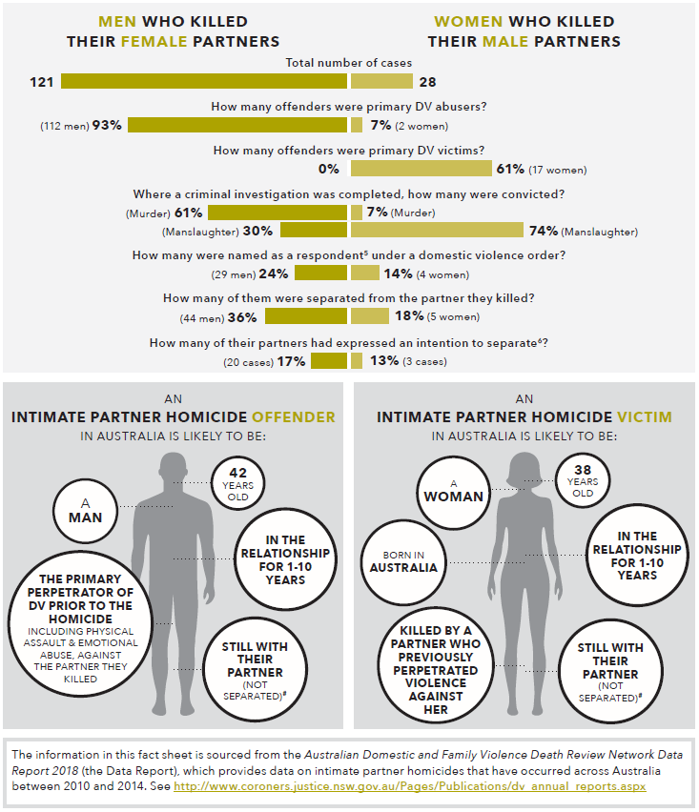

Text alternative for image above

| Question | Men who killed their female partners | Women who killed their male partners |
| --- | --- | --- |
| Total number of cases | 121 | 28 |
| How many offenders were primary DV abusers? | 93% (112 men) | 7% (2 women) |
| How many offenders were primary DV victims? | 0% | 61% (17 women) |
| Where a criminal investigation was completed, how many were convicted? | 61% (murder)  30% (manslaughter) | 7% (Murder)  74% (Manslaughter) |
| How many were named as a respondent5 under a domestic violence order? | 24% (29 men) | 14% (4 women) |
| How many of them were separated from the partner they killed? | 36% (44 men) | 18% (5 women) |
| How many of their partners had expressed an intention to separate6? | 17% (20 cases) | 13% (3 cases) |



Text alternative for image above

## An intimate partner homicide offender in Australia is likely to be:

* **A man**
* **42 years old**
* **In the relationship for 1-10 years**
* **The primary perpetrator of DV prior to the homicide including physical assault & emotional abuse, against the partner they killed**
* **Still with their partner (not separated)#**

## An intimate partner homicide victim in Australia is likely to be:

* **A woman**
* **38 years old**
* **In the relationship for 1-10 years**
* **Born in Australia**
* **Killed by a partner who previously perpetrated violence against her**
* **Still with their partner (Not separated)#**

The information in this fact sheet is sourced from the Australian Domestic and Family Violence Death Review Network Data Report 2018 (the Data Report), which provides data on intimate partner homicides that have occurred across Australia between 2010 and 2014. See <http://www.coroners.justice.nsw.gov.au/Pages/Publications/dv_annual_reports.aspx>

## Footnotes

¹ Statistics may vary slightly from those reported in other homicide census data. The information in this fact sheet is sourced from the Australian Domestic and Family Violence Death Review Network's (the Network) Data Report 2018. The report states that "unlike existing homicide census data, such as that produced by the Australian Institute of Criminology’s National Homicide Monitoring Program", the Network members "have access to extensive information by virtue of their specialist review mechanisms and location in Coroners Courts, Ombudsman’s offices or government agencies" and that "many members also have the capacity to call for additional information or records, in order to identify histories of domestic violence".

² Includes current and former intimate partners.

³ The person who primarily initiated domestic violence in the life of the relationship and/or was the main aggressor of domestic violence after the relationship had ended.

4 The person who primarily had domestic violence used against them (was victimised) during the relationship with an abuser, or after that relationship had ended. The term designates a person who experienced, but did not initiate domestic violence. This term is designed to highlight that a person may be the primary victim of domestic violence prior to the homicide, but may ultimately perpetrate the homicide (for instance, a domestic violence victim who kills an abuser in self-defence).

5 The person who is restrained by the existing domestic violence order.

6 This statistic relates to couples that were still together (not separated) at the time of the homicide and where the victim, but not the offender, had expressed an intention to separate. It is acknowledged that this may be an undercount as in some circumstances the homicide victim or homicide offender may not indicate to any person or service that they are intending to separate from their partner.

# Separation was a factor in 55% of cases of male intimate partner homicide against a female victim; in 36% of cases, the couple was separated and, in a further 19% of cases, one or both parties had expressed an intention to separate.

**Suggested citation:**

Australia’s National Research Organisation for Women’s Safety. (2019). Domestic and family violence lethality: The facts about intimate partner homicide. Sydney, NSW: ANROWS.

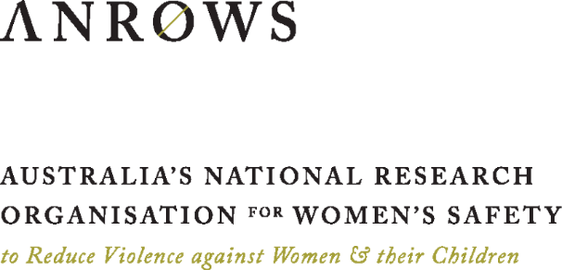**Website:**

<anrows.org.au>

**Email:**

<enquiries@anrows.org.au>

**Twitter:**

@[ANROWS](https://twitter.com/ANROWS)