Whatever It Takes

## Access for women with disabilities to domestic and family violence services

Dyson, S., Frawley, P & Robinson, S (2017)

[Read the Summary](https://www.anrows.org.au/node/1412)

[Read the Report](https://www.anrows.org.au/node/1413)

## One size does not fit all - just like with a t-shirt.

**When it does not fit it does not feel right.**

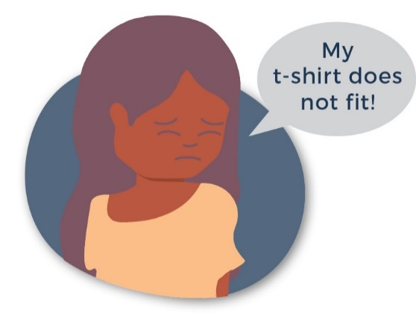

The service fits, it feels right for you - just like a well fitting t-shirt.

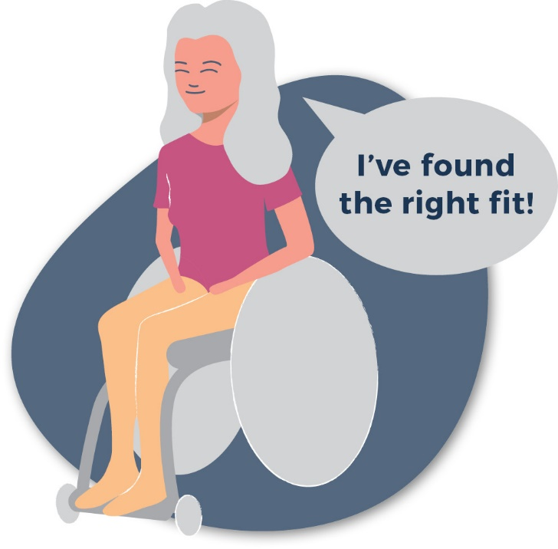

## Accessible services are:

**Approachable**: This means women know the service is there, you can find it, get to it and you feel OK going there.

**Acceptable & Appropriate**: This means it fits for the woman, she gets to say if it is working for her.

**Affordable**: It should not cost you money to get there, to be there and to go as often as you need to.

**Available**: This means it is there for YOU and you can use it like other women do.

[Learn more about access](https://storage.googleapis.com/vera-web-assets/downloads/Publications/measuring-capacity-to-serve-survivors-with-disabilities/legacy_downloads/Domestic-Violence-Program-without-Residential-Services-Implementation-Guide.pdf)

## Involve women with disabilities in the service.

Hear and use women’s stories in the service.

The voice doesn’t only tell a story, it has an owner.

Develop peer support groups for women.

Collaborate with women with disabilities and women with disability advocacy organisations to shape services.

Include women with disabilities on the board and other planning groups in the service.

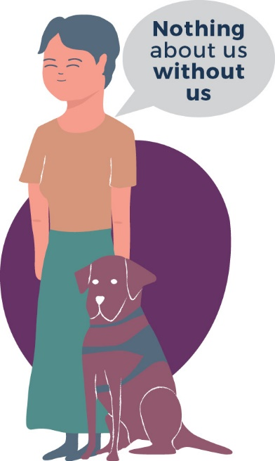

[Learn more about involving women](http://www.wdv.org.au/documents/Voices%20Against%20Violence%20Paper%20Six%20Hearing%20from%20Women%20with%20Disabilities%20(PDF%201.2MB).pdf)

## Services need to work together.

You pack the t-shirt and take it everywhere you go - it stretches and changes with you. Services can see it and don’t need to ask you what t-shirt you want.

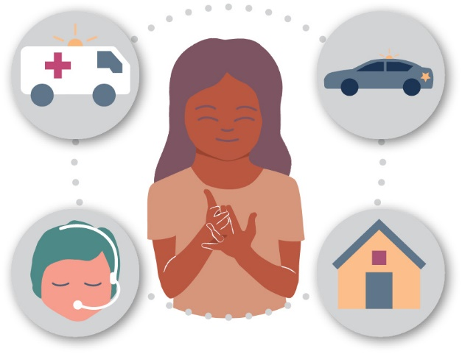

[Learn more about collaboration](https://researchdirect.westernsydney.edu.au/islandora/object/uws:36865)

## Collect and use information about the experiences of women with a disability WITH women with disability.

**Data collection** Asking us about our experiences.

**Data analysis** Involving us in talking about what   
can be learned from our experiences.

**Data translation** Working together to get the word out about doing things better.

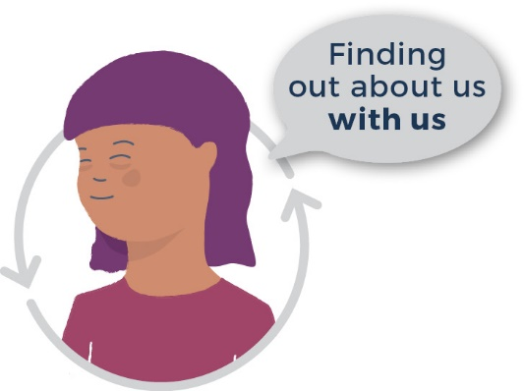

[Learn more about data collection](http://wdv.org.au/documents/FINAL%20-%20Our%20Right%20to%20Safety%20and%20Respect%20-%20Safeguards%20Guidelines.pdf)

 

Use of this work must cite ANROWS as the source.   
ANROWS welcomes feedback on how our information is being used [enquiries@anrows.org.au](mailto:enquiries@anrows.org.au)

