



Horizons
Research report | June 2016
Media representations of violence against women
and their children: Final report
Issue 03 | 2016

ANROWS acknowledgement
This material was produced with funding from the Australian Government and the Australian state and territory governments. Australia’s National Research Organisation for Women’s Safety (ANROWS) gratefully acknowledges the financial and other support it has received from these governments, without which this work would not have been possible. The findings and views reported in this paper are those of the authors and cannot be attributed to the Australian Government, or any Australian state or territory government.
Acknowledgement of Country
ANROWS acknowledges the traditional owners of the land across Australia on which we work and live. We pay our respects to Aboriginal and Torres Strait Islander elders past, present and future; and we value Aboriginal and Torres Strait Islander history, culture and knowledge.
© ANROWS 2016
Published by
Australia’s National Research Organisation for Women’s Safety Limited (ANROWS)
PO Box 6322, Alexandria NSW 2015 | www.anrows.org.au | Phone +61 2 8374 4000
ABN 67 162 349 171
Media representations of violence against women and their children : final report / Georgina Sutherland, Angus McCormack, Jane Pirkis, Cathy Vaughan, Michelle Dunne-Breen, Patricia Easteal, Kate Holland.
Sydney : ANROWS, c2016.
Pages ; 30 cm. (ANROWS Horizons, Issue 03/2016)
I. Violence in mass media. II. Mass media – Influence. III. Victims of crime in mass media. IV. Women in mass media.
I. Sutherland, Georgina. II. McCormack, Angus. III. Pirkis, Jane. IV. Vaughan, Cathy (Catherine Maree). V. Dunne-Breen, Michelle. VI. Easteal, Patricia. VII. Holland, Kate (Kate E.).
ISSN: 2205-8907 (print) 2205-8923 (online)
978-1-925372-36-6 (print) 978-1-925372-39-7 (online)
Creative Commons Licence
Attribution-Non Commercial

CC BY-NC
This licence lets others distribute, remix and build upon the work, but only if it is for non-commercial purposes and they credit the original creator/s (and any other nominated parties). They do not have to license their Derivative Works on the same terms.
Version 3.0 (CC Australia ported licence): View CC BY-NC Australia Licence Deed | View CC BY-NC 3.0 Australia Legal Code
Version 4.0 (international licence): View CC BY-NC 4.0 Licence Deed | View CC BY-NC 4.0 Legal Code
Design
Erin Snelgrove


University of Melbourne
University of Melbourne, Parkville VIC 3010

Media representations of violence against women and their children: Final report
Quantitative analysis of news media’s reporting of violence against women and their children in Australia prepared by:
Dr Georgina Sutherland, Centre for Mental Health, Melbourne School of Population and Global Health, University of Melbourne
Mr Angus McCormack, Centre for Mental Health, Melbourne School of Population and Global Health, University of Melbourne
Professor Jane Pirkis, Centre for Mental Health, Melbourne School of Population and Global Health, University of Melbourne
Dr Cathy Vaughan, Centre for Health Equity, Melbourne School of Population and Global Health, University of Melbourne
Qualitative analysis of news media’s reporting of violence against women and their children in Australia prepared by:
Dr Michelle Dunne-Breen, Faulty of Arts and Design, University of Canberra
Professor Patricia Easteal, Faculty of Business, Government and Law, University of Canberra
Dr Kate Holland, Faulty of Arts and Design, University of Canberra
Authors’ acknowledgement
We would like to acknowledge those women and their families who may appear in this research report because their experiences of violence perpetrated against them have been the subject of media coverage. We have made every effort to reproduce and discuss media reporting of cases with care and sensitivity.
We would also like to express our thanks to the contribution made by the coders, Ms Sarah Trent and Ms Jo Christo.
Finally, the authors wish to acknowledge the financial and other support provided by ANROWS and Our Watch. This paper addresses ANROWS research project 2.2 “Media representations of violence against women and their children” which is a project jointly funded by Our Watch under the National Media Engagement Initiative. We extend our thanks to Dr Trishima Mitra-Kahn, Kristine Ziwica and the project advisory group for their invaluable advice and support

Suggested citation:
Sutherland, G., McCormack, A., Pirkis, J., Vaughan, C., Dunne-Breen, M., Easteal, P., & Holland, K. (2016). Media representations of violence against women and their children: Final report (ANROWS Horizons, 03/2016). Sydney: ANROWS.
This work is part of the ANROWS Horizons series. ANROWS Horizons (Research reports) are in-depth reports on empirical research produced under ANROWS’s Research Program.
This report addresses work covered in ANROWS research project 2.2 "Media representations of violence against women and their children". Please consult the ANROWS website for more information on this project. In addition to this paper, an ANROWS Compass is also available as part of this project.

Contents
Horizons 1
Media representations of violence against women and their children: Final report ii
Contents 1
Executive summary 4
Background 4
Method 4
Key findings 5
Conclusion 5
Quantitative analysis of Australian news media reporting of violence against women and their children 6
Background 6
Method 7
Data sources 7
Item retrieval 8
Data extraction 9
Data coding 10
Data analysis 11
Results overview 11
All media items 11
Newspaper 16
Broadcast 20
Television 23
Online 25
Results of content analysis 26
Social context 26
Sensationalism 31
Misrepresentations and myths 37
Blame and responsibility 40
Sources of authority and opinion 46
Discussion and summary of key findings 49
The extent of reporting on violence against women 49
The nature of reporting on violence against women 49
Conclusion 50
Table 8 Overview of key findings 50
Qualitative analysis of Australian news media reporting of violence against women and their children 52
Background 52
Method 53
The focus of analysis 53
Choosing the case studies 54
Analysis 55
Case study 1: Luke Lazarus 57
The stories in the sample 57
The representations of the location 59
The relative representations of the perpetrator and the victim 59
The representations of the crime 60
Differences between print and online items 62
Conclusions: Case study 1 62
Case study 2: Salwa Haydar 64
The stories in the sample 64
The relative representations of the perpetrator and the victim 66
The representations of the crime 67
The representations of the location 67
Conclusions: Case study 2 68
Case study 3: Jessica Silva 68
The stories in the sample 68
The representations of the location 70
The relative representations of the perpetrator and the victim 70
The representation of the crime 71
Conclusions: Case study 3 72
Discussion and summary of key findings 73
Lack of social context 73
Sensationalism 74
Perpetuating mythology 74
(Shifting) blame and agency 75
The expert voice 75
Differences between online and print 76
Conclusion 76

Summary and implications 77
Strengths and limitations 77
Implications 78
References 82
Appendix A: Press media outlets 86
Appendix B: Coding frame 2
Appendix C: Case study media clips 4
Text alternatives for newspaper articles 6

Executive summary

Background
The media has been identified in numerous Australian state and national policy documents as a priority area for action on preventing violence against women, including in the Council of Australian Governments’ National Plan to Reduce Violence Against Women and their Children 2010-2022. Improving the way media engage on the issue is one of the key objectives under the Second Action Plan 2013-2016 (Department of Social Services, 2014).
The media feature as a priority area in primary prevention because of its potential influence on public understanding of violence against women (Carll, 2003; Our Watch, Australia’s National Research Organisation for Women’s Safety (ANROWS) & VicHealth, 2015; Walden & Wall, 2014). News and information media are key actors in shaping the public discourse because they report on current events and provide a framework for their interpretation. Who or what is selected to appear in the news and how those individuals and events are portrayed can have a profound influence on people’s attitudes, beliefs and behaviours (Flood & Pease, 2009).
The current study aimed to establish a baseline picture of the extent and nature of reporting of violence against women by the Australian media to inform future strategies for change. The project involved two key components: one quantitative (content analysis) and one qualitative (critical discourse analysis). The first section of this report presents the quantitative component and the second section presents the qualitative component. The third section discusses the strength and limitations of our approach to the study, offers insights into possible implications and makes suggestions for future directions.

Method
This project collected media items on violence against women for 4 months from February to June 2015 in three states of Australia (New South Wales, South Australia and Queensland). These three states were selected on the basis of being geographically and demographically diverse and were broadly representative of media coverage in Australia. A media monitoring and retrieval service, Isentia, was used to identify items of relevance from all capital city newspapers in the three states, a selection of suburban newspapers in South Australia and Queensland, a selection of daily and non-daily regional newspapers in New South Wales, news and current affairs programs on all free-to-air and pay-for-view television and radio stations, and from seven online news sites.
For the quantitative component of the study, a range of identifying and descriptive information about each media clip (e.g. media type, outlet, state, item size or duration) was provided by Isentia and used to characterise the extent of media reporting on violence against women. A random sub-set of ten percent of all media clips identified during the study period, stratified by media type (print, broadcast and online) was selected for in-depth content analysis. Content analysis is commonly used in studies of media representations because it provides a systemic approach to analysing and understanding text-based data (Stemler, 2001). In this study, the selected media clips were coded according to an extensive coding frame specifically developed for this project.
For the qualitative component of the study, three major news stories (made up of multiple news items) were selected as case studies to explore the practices through which journalists construct their stories. The news stories were selected on the basis that they had gained significant traction in the media by way of volume of reporting and represented different forms of violence against women. The approach to analysis was through a critical discourse lens in which detailed textual analysis was used to examine media reports in their social and cultural contexts.

Key findings
Our final sample included 4516 items in connection with violence against women, comprising 1870 radio broadcasts (41.4%), 1332 items from online news sites (29.5%), 929 newspaper articles (20.6%) and 385 television broadcasts (8.5%). Taking into account syndication (which refers to the same news item being broadcast or published by different media outlets), these items appeared in or were broadcast more than 15,000 times during the 4 month data collection period. This indicates that media reporting on violence against women is reaching a very wide audience. There was considerable month-by-month variation, largely driven by a few high profile cases reported on extensively in the media.
The content analysis identified that:
- most news reports focused on individual incidents of violence against women without providing information about the social context or the underlying drivers of violence;
- few media items included information for women on where to seek help;
- physical and sexual violence, particularly fatal events, were reported more frequently than other forms of gender-based violence;
- the use of sensational headlines, graphic language and photographs that minimised or trivialised the issue were a concern but appeared in the minority of media reporting;
- a proportion of media covering sexual violence referenced the behaviour of women thereby inferring responsibility for, or mutuality in, the abuse;
- male perpetrators of violence were rendered largely invisible in the news; and
- police and other criminal justice professionals were the main sources of information and opinion in news items on violence against women.
The critical discourse analyses identified that:
- media act in a myriad of ways to perpetuate ambiguity and ambivalence concerning the definition, the dynamics and the harms of family violence and sexual assault;
- story angles, story structures and lexical features (such as how the people were represented and the word choices used to describe them) contributed to discursively minimising the harms of rape and domestic violence;
- some news stories were presented in a sensationalist manner and others were not; and
- the angles or aspects of the stories pursued in news reports pointed to editorial judgements about relevance or perceived news value.

Conclusion
This study was one of the largest of its kind internationally, in that it collected data in connection to all media reports on violence against women from a representative sample of media in Australia, including newspapers, radio, television and online. The key strength of the design was using both quantitative and qualitative analyses to highlight aspects of media reporting: to uncover what the Australian media is doing well and to identify areas for improvement. By combining quantitative and qualitative analyses we have been able to uncover various layers, nuances and implied meanings in media reports – processes that are difficult to capture with either method alone.
The findings provided a glimpse into the complexity of reporting practices. Clearly, media in Australia have the potential to more accurately reflect the reality of women’s experiences of violence and our results point to some ways that might be accomplished.

Quantitative analysis of Australian news media reporting of violence against women and their children

Background
There is growing international interest in the portrayal of violence against women in the news and information media and the impact that reporting may have on community understanding, attitudes and behaviours. As we examined in detail in our state of knowledge paper, to date, most research has focused on how media messages about violence against women and their children are framed in the news. This body of work provides strong evidence about predominant patterns in the way stories are presented; namely that the news and information media offer their audiences overly simplistic, inadequate and distorted representations of the nature, extent and seriousness of the problem (Sutherland et al., 2015).
It has been known for some time that news stories influence public perceptions and play a substantial role in how people understand certain societal problems, including crime. Numerous studies have shown an association between depictions of violence against women in the news media and audience attitudes and perceptions. This research indicates that who or what is selected to appear in the news and how those individuals and events are portrayed can have a profound influence on people’s attitudes and beliefs, particularly around attributions of blame and responsibility (Carlyle, Orr, Savage, & Babin, 2014; Flood & Pease, 2009; Palazzolo & Roberto, 2011). For example, Palazzolo and Roberto (2011) found that audiences who were exposed to information designed to increase perceptions of “victim” responsibility (i.e. she had been drinking, she had been having an affair) resulted in audiences responding to stories with less sympathy and increased anger towards women. A recent study, exploring the impact of televised news items on intimate partner homicide, found a small copycat effect; whereby the number of intimate partner homicides in the community increased in the 7 days after news of intimate partner homicides were screened on the news (Vives-Cases, Torrubiano-Dominguez, & Alvarez-Dardet, 2009).
These two complementary areas of media inquiry – the content of media messages and the impact of those messages – leave no doubt that the reporting of violence against women in the news and information media should be done in a responsible manner. It is vitally important that the media do not further contribute to the problem. In response to such concerns, the media has been identified in numerous Australian state and national policy documents as a priority area for action on preventing violence against women, including in the Council of Australian Governments’ National Plan to Reduce Violence against Women and their Children 2010-22. One of the objectives set out in the Second Action Plan 2013-2016 (Department of Social Services, 2014) is to “improve media engagement on violence against women and their children”. To address this practical action, a comprehensive understanding of Australian media practices in reporting on violence against women and their children is required – both to guide engagement with those responsible for the production of media and from which to measure change.
The main aim of this project was to establish a baseline picture of the extent and nature of reporting of violence against women by the Australian media to inform future strategies for change. Our primary focus was news media reporting of male-perpetrated violence against women including news coverage of both “incidents” of violence against women and the “issue” of violence against women. Although we are sensitive to existing literature in the field, for the sake of brevity and focus, this report is largely limited to findings from our research. While we drew on the definition in the United Nations’ Declaration on the Elimination of Violence Against Women that defines the term as “…any act of gender-based violence that results in, or is likely to result in, physical, sexual or psychological harm or suffering to women, including threats of such acts, coercion or arbitrary deprivation of liberty, whether occurring in public or private life” (United Nations, 1993), our search strategy was designed to capture the broadest range of media coverage and included all male perpetrated violence regardless of whether it fitted traditional notions of “gender-based” crimes (i.e. directed against a woman because she is a woman).
The project involved two key components: one quantitative (content analysis) and one qualitative (critical discourse analysis). This first section of the report describes the content analysis component of the project, including the scope, method, findings and study implications. The method includes the means by which media items were identified and retrieved, and the way in which data were extracted and coded. In the results, we provide an overview of all media items captured in the 4 month monitoring period and the results from the sub-set of media items selected for in-depth content analysis. Key findings are summarised, with an interpretation of those findings. The discourse analysis component of the project is then presented in the second section. The third section outlines the strengths and limitations of the study, offers policy and practice implications and identifies future research directions.

Method
Media items relating to violence against women were retrieved from news print and broadcast (radio and television) media sources in three states of Australia (New South Wales, South Australia and Queensland) between 22 February and 22 June 2015. These three states were selected on the basis of being geographically and demographically diverse and were broadly representative of media coverage in Australia. New South Wales is one of the most populous states of Australia with highly urbanised areas, as well as large regional cities with major media outlets (e.g. Newcastle and Wollongong). Queensland’s population, on the other hand, is the most de-centralised with large rural and remote regions. South Australia was selected because, unlike most other capital cities in Australia, Adelaide only has one daily newspaper, The Advertiser.
Media items on violence against women were also retrieved from seven online news sites. The collection of online news items began on 22 March and ended on 22 May 2015. Data collection, extraction and the coding process are described in detail below.

Data sources
A media monitoring and retrieval service, Isentia, was used to identify newspaper, television, radio and online items from a detailed project brief that included the selected media sources, search terms and exclusions. Due to differences in how Isentia identifies relevant items from different media sources, we developed two project briefs: one for print and broadcast news and one for online news (the different processes used to identify relevant items are described in detail below). In both briefs, the overarching aim of the project was described in terms of how the news and information media report on men’s use of violence against women.

Print and broadcast news
To identify relevant print news items, Isentia scanned one national newspaper, all capital city newspapers in New South Wales, South Australia and Queensland, a selection of suburban newspapers in South Australia and Queensland and a selection of daily and non-daily regional newspapers in New South Wales. Regional and suburban newspapers were selected by the project team to reflect a diverse range of geographical locations within each state and to account for media ownership and possible syndication of news stories. For example, Fairfax Media publishes a large number of metropolitan, regional and community newspapers in New South Wales. We were mindful that our sample include some but not all publications owned by a single media company. In total, 77 newspapers across the three states were searched. Appendix A provides a complete list of newspaper sources.
Isentia retrieved relevant items from all free-to-air and pay-for-view television and radio networks in New South Wales, South Australia and Queensland. This included approximately 96 AM and FM radio stations, as well as more than 50 television stations across the three states. For the purposes of this study, Isentia scanned news and current affairs programs only, including radio programs designated as “news talk”.

Online news
A small sample of online news-related sites was selected for inclusion in the study. Seven online news sites were selected on the basis that they were broadly aligned with printed newspapers in the three selected states and represented some of the most-visited online news sites in Australia (derived by total visits, 2012-14, data courtesy of Experian Marketing Services Australia). The selected websites were: news.com.au, smh.com.au (Sydney Morning Herald), news.ninemsn.com.au (NineMSN), abc.net.au (ABC), theaustralian.news.com.au (The Australian), adelaidenow.com.au (Adelaide Now) and brisbanetimes.com.au (Brisbane Times). All news content on these websites was eligible for inclusion in the study.
Despite the recent upward trend in the popularity in Australia of news sites such as theguardian.com/au (Guardian Australia) and dailymail.co.uk/auhome (Daily Mail Australia), a lack of markers differentiating Australian content from the global Guardian and Mail brands meant Isentia were unable to retrieve items from these online sites due to copyright issues. We elected not to monitor opinion and commentary sites, such as theconversation.com (The Conversation) or crikey.com.au (Crikey).

Item retrieval
Our search strategy was purposefully designed to capture the broadest range of media reporting on men’s use of violence against women, including items describing local or overseas incidents of male-perpetrated violence or media items discussing or debating the issue of violence against women in Australia or in other parts of the world. Our search strategy was intentionally not limited to violence perpetrated by males in the context of intimate partner relationships, despite this being the most common form of gender-based violence experienced by women globally (World Health Organization, 2013).
A list of search terms and phrases related to violence against women was provided to Isentia. The terms were selected with reference to our review of the literature on media representations of violence against women (Sutherland et al., 2015). We included general terms and phrases (e.g. violence against women; women and children), specific terms (e.g. domestic violence, family violence, sexual assault), as well as terms that may be considered outdated, negative or colloquial (e.g. wife bashing, battered). While we did not include search terms specifically related to female perpetrators of violence, these articles were included if they met other search criteria (e.g. if reports described incidents in which there were both male and female perpetrators of violence). The term “women and children” was used to capture media coverage of violence and/ or the effects of such violence on women’s families or children in their care. We purposely excluded violence against children not in the context of family violence.
Prior to the commencement of the media monitoring period, we provided Isentia with a list of exclusions. Items that were deemed as not relevant and therefore not retrieved included any items in which violence against women was only a very small fragment of the news story (a passing mention); media stories in which the major focus was Rosie Batty’s appointment as Australian of the Year (2015) or with a primary focus on the Royal Commission into Institutional Responses to Child Sexual Abuse or any other stories in which media reported on child abuse or maltreatment not in the context of family violence. Based on items retrieved on the first day of monitoring (22 February 2015), we extended our list of exclusions to media items related to the “Sydney Lindt Cafe Siege” including items about hostage-taker, Man Haron Monis.

Print and broadcast news
Based on the project brief and search terms provided to Isentia, trained “readers”, “viewers” and “listeners” scanned print and broadcast news on a daily basis to retrieve items of relevance. Retrieved items were delivered to the project team via an interactive cloud-based communications platform (Mediaportal). Newspaper articles were provided as complete digital press clippings. Television and radio items were provided as “broadcast summaries” that included the source of the item and a précis of its content.
For syndicated broadcast news items (syndication refers to the identical news item being broadcast or published by different media outlets) only the first report was retrieved and delivered to the Mediaportal unless any subsequent reports contained new or different information to that which was originally broadcast. As an example, the ABC’s Radio National may report the same news item repeatedly over one morning broadcast. Similarly, the same news item appearing on the Seven Network’s News in Sydney may also appear on locally branded affiliate networks in regional New South Wales. In such instances, only the first report was delivered to the Mediaportal with supplementary information available on syndication (see Data extraction for further detail).

Online news
A different search strategy was required for online news sites because Isentia uses an automated system (as opposed to trained personnel) to identify and retrieve items of relevance from websites. We provided Isentia with a list of sentences or phrases because their automated system is based on searching for items that contain a group of words in a particular order (sentences or phrases) rather than words that may appear in random order. The sentences and phrases were selected with reference to a retrospective search of online news items on violence against women in the previous 12 months and refined based on an initial pilot monitoring period for online news (22 to 24 February 2015). Items collected during this pilot phase were excluded from the final analytic sample. The same exclusions previously outlined for print and broadcast items also applied to online captures. Based on items captured in the pilot phase, we also excluded any media items covering Islamic State, ISIS or ISIL (Islamic State of Iraq and Syria/Levant) which were being inadvertently captured by our online search terms.
Online news items were delivered to the Mediaportal as “brief summaries” that included the headline and the first few lines of content with a link to the original source that could be downloaded by the project team.

Data extraction
Each media item retrieved by Isentia during the data collection period was supplemented with a range of identifying and descriptive information.

Identifying information
Identifying information included details such as media type (i.e. newspaper, television, FM radio, AM radio, online news) and the specific media outlet (e.g. Newcastle Herald, 2GB, Channel 9, ABC online), as well as the state and location of the media outlets.

Descriptive information
A range of descriptive information was available and included the date the story appeared and which segment or program it appeared on (e.g. 4pm News Triple M Brisbane, Today Tonight Adelaide or for print news, General News, Sport, Letters); the complete headline and a brief summary of content; the author, compere or host (where applicable); and syndication count.
Other descriptive information was only applicable to certain media types. For newspaper articles, information was available on page number, size of printed article (recorded in square centimetres), article word count, whether an image or photograph accompanied the printed news item and estimated circulation figures. For broadcast news, additional information included duration of item and estimated broadcast audience. For online news, information was available on images and unique daily visitors.
All these data were available via Isentia’s Mediaportal.

Data coding
A random sub-set of 10 percent of all media clips identified during the study period (4516) was selected for in-depth content analysis. We ensured that the number of items selected for each media type (print, broadcast and online) were proportionally represented in the final random sample (known as a stratified random sample). The selected media items were then coded according to an extensive coding frame specifically developed for this project.

Coding framework
The coding frame was informed by findings from our review of the literature on media representations of violence against women and their children (Sutherland et al., 2015). We were particularly interested in exploring some of the key themes highlighted in the review including whether media reports on violence against women: were event-based or thematic; used language to sensationalise the story or for other effects; perpetuated common myths and misunderstandings; directly or indirectly blamed women for men’s use of violence and/ or excused the behaviour of men; and the types of sources used to inform the story. We also drew upon a coding frame previously developed and used by Morgan and Politoff in their comprehensive longitudinal study exploring changes in print media coverage of violence against women in Victoria (for more details see Morgan & Politoff, 2012). In the final stages of developing the coding frame, we tested the candidate codes by reviewing a sample of media items collected for the purposes of this study and identified additions, amendments and modifications.
The final coding frame included four main sections. The first section collected background information about the news item with the primary purpose of establishing the main profile of the story – whether the item was primarily incident or event-based or whether it was primarily thematic (discussion-based), as well as the other contexts in which violence against women was reported (e.g. political campaign, television show). The second section collected information about thematically-based news items or items in which the primary focus was the issue of violence against women. The third section of the coding frame collected information about incident or event-based news items including the type of violence described, contextual information about the crime including the nature of the relationship between the perpetrator and victim and background information about perpetrators and/or victims, such as their age, occupation, religion or culture. The final section of the coding frame collected information about the way the story was framed including the language used, whether common myths and misconceptions were present and whether the items included referral services for women seeking help and other educational resources (see Appendix B for a summary of the content categories).
A detailed coding reference manual was developed in conjunction with the coding frame to provide procedural and contextual information to coders and to ensure consistency of decision-making. The manual included a brief explanation of each question with detailed examples for any questions that were considered difficult or ambiguous.
The coding was undertaken in October and November 2015. Each of the three trained coders, including one of the authors of this report (Angus McCormack), was allocated a selection of media items. Coders extracted information from each item according to the coding frame and electronically recorded responses in a purpose-designed spreadsheet using Google Forms.
To ensure consistency between coders, a training session was held prior to the commencement of coding in which each question in the coding frame was discussed using examples drawn from the data collected for the study. A formal meeting was held after approximately 20 percent of the coding was complete to cross-check responses and clarify how questions, definitions and criteria were being operationalised. Coding difficulties and uncertainties that arose thereafter were discussed among members of the coding team and resolved by consensus.

Data analysis
Data analysis was undertaken in two stages. First, identifying and descriptive information in the Mediaportal was downloaded into a Microsoft Excel spreadsheet and transferred to a data analysis and statistical software program (STATA version 13). Simple frequencies and percentages were used to provide an overview of all media items captured in the 4 month monitoring period including an overview by media type: newspaper, broadcast and online news. Second, data from the 10 percent of media items subject to content coding were merged with the identifying and descriptive information relevant to each media item. Descriptive statistics and chi-square tests were used to explore further information about the way media report on violence against women and their children. We considered p values of less than 0.05 to indicate statistically significant differences.

Results overview

All media items
In total, 4516 media items relating to violence against women were collected between 22 February and 22 June 2015. This comprised 1870 radio broadcasts (41.4%), 1332 items from online news sites (29.5%), 929 newspaper articles (20.6%) and 385 television broadcasts (8.5%).

State and region
Close to half the media items collected were from New South Wales-based media outlets (47.5%, 2147), 19.6 percent (889) were from media outlets available nationally, 19.1 percent (863) were from Queensland and 13.7 percent were from South Australia.
Around half of all news items on violence against women appeared in, or were first broadcast on, media outlets serving metropolitan areas of the three states (47.6%, 2149). Approximately 20 percent (19.5%, 881) appeared in, or were broadcast in regional areas only. The remainder (32.9%, 1487) were from media outlets with a national audience. Outlets considered to have national reach included all online news sites, The Australian and the Weekend Australian newspapers, radio stations Radio National and Triple J, television channels Sky News and ABC News 24 and some television programs, such as Today on Channel 9.

Syndication
Taking into account syndication across media networks, the 4516 items in this sample appeared in or were broadcast more than 15,000 times during the 4 month data collection period (February to June 2015). Syndication counts ranged from two to 75. Radio broadcasts had the highest rate of syndication followed by printed newspaper articles and television broadcasts.

Media outlets
Figure 1 shows the ten media outlets with the highest volume of items on violence against women and their children. Despite monitoring online news sites for only two of the total 4 month data collection period, six of the top ten outlets by volume were from online news sources. Three of the outlets with the highest volume of reporting were radio stations broadcasting in metropolitan Sydney. The final outlet was one of Sydney’s capital city newspapers, The Daily Telegraph.

Weekly and monthly patterns
On average, there were fewer media items on violence against women on Saturday and Sunday in comparison to any other day of the week. As can be seen in Figure 2 there was a sharp decline in volume on the weekend across all media types, but the decline was most prominent in radio broadcasting. For example, there were 423 radio broadcasts concerning violence against women on Fridays throughout the data collection period, in comparison to just 48 broadcasts on Saturdays and 34 on Sundays. This likely reflects the frequency of news bulletins during weekdays on many radio stations in comparison to the weekend. The peak day for volume of reporting on violence against women was Friday for newspapers, radio and television.
Figure 3 shows the distribution of news media items on violence against women by month taking account of media type. The second month of media monitoring, from 23 March to 22 April 2015, was the month with the greatest number of media items on violence against women across each type of media source. In this time frame, there were two high profile news stories (described in more detail below) indicating that fluctuations in volume of reporting on this topic were largely event-driven.

Figure 1 Media outlets by volume of items reporting on violence against women
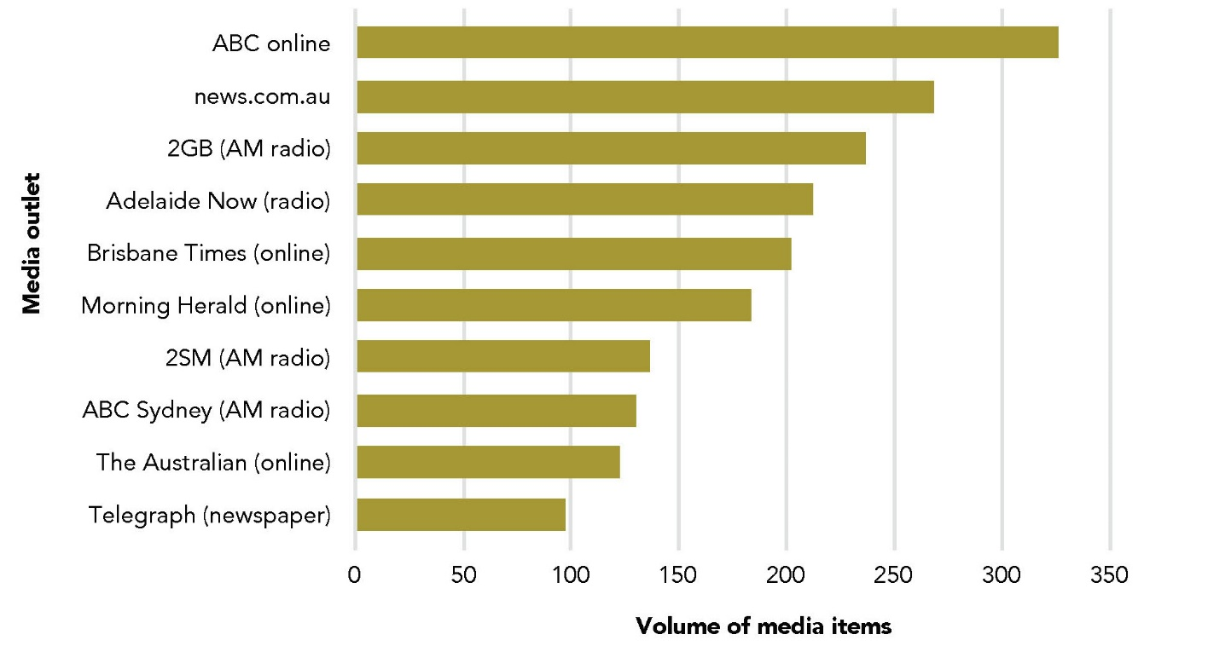
Data table for Figure 1:
Media outlet | Volume of media items
ABC online | ~325
news.com.au | ~268
2GB (AM radio) | ~236
Adelaide Now (radio) | ~212
Brisbane Times (online) | ~201
Morning Herald (online) | ~183
2SM (AM radio) | ~136
ABC Sydney (AM radio) | ~130
The Australian (online) | ~122
Telegraph (newspaper) | ~97

High profile news stories
During the period of data collection, there were a number of high profile cases in terms of volume of media reporting, including the trials of Jill Meagher’s murderer Adrian Bayley for additional crimes and the reporting of domestic violence allegations against Queensland MP Billy Gordon. However, there were two stories, in particular, that resulted in a very large number of media reports: the murders of school student Masa Vukotic in the Melbourne suburb of Doncaster on 17 March 2015 and school teacher Stephanie Scott in the New South Wales regional town of Leeton on 5 April 2015. Media reports in relation to these two cases combined, including the incidents, any subsequent arrests, memorials and tributes, accounted for approximately one quarter of all media items captured (25.6%, 1112) over the entire monitoring period. There were 237 media items in connection with the murder of Masa Vukotic and 875 in connection with the murder of Stephanie Scott. The stories were widely covered across all types of media. It is likely that the volume of news items concerning Masa Vukotic would have been substantially higher had Victoria (the state in which the incident occurred) been included as one of the states selected for monitoring.

Figure 2 Day of the week patterns in news reporting on violence against women
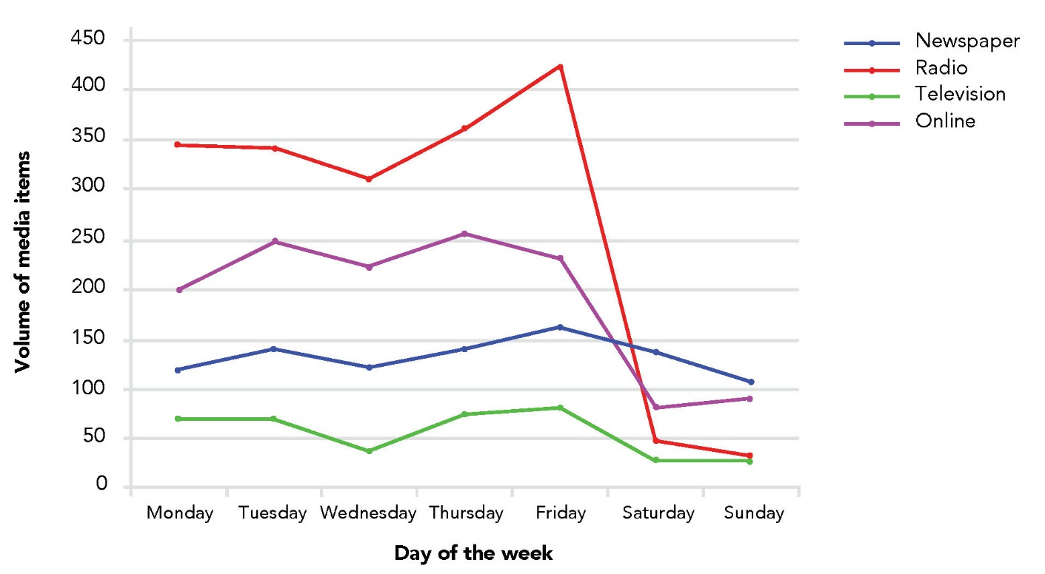

Data table for Figure 2:
Format | Monday | Tuesday | Wednesday | Thursday | Friday | Saturday | Sunday
Newspaper | 118 | 139 | 121 | 139 | 160 | 136 | 106
Radio | 345 | 340 | 309 | 361 | 423 | 47 | 32
Television | ~69 | ~69 | ~36 | ~74 | ~79 | ~27 | ~27
Online | ~198 | ~248 | ~220 | ~255 | ~230 | ~82 | ~90

Figure 3 Monthly patterns for media items on violence against women
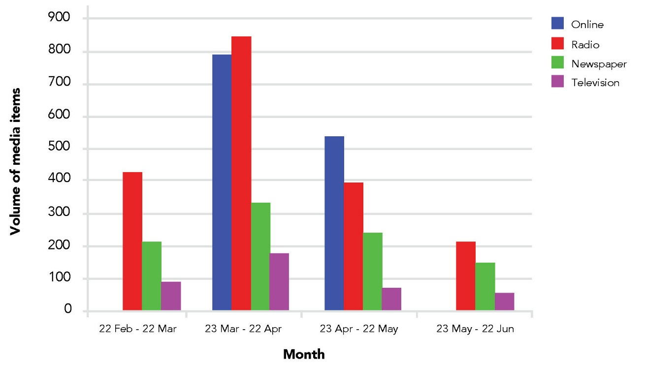
Data table for Figure 3:
Month | Online | Radio | Newspaper | Television
22 Feb - 22 Mar | - | ~426 | ~212 | ~88
23 Mar - 22 Apr | ~786 | ~841 | ~330 | ~177
23 Apr - 22 May | ~534 | ~393 | ~240 | ~70
23 May - 22 Jun | - | ~212 | ~148 | ~54

In our sample, the first media report concerning Masa Vukotic was on 18 March 2015 and the last was on 15 June 2015. Three-quarters of all media items (73.4%, 174) were within the first 3 days of her murder (18 to 20 March 2015). The first media report in connection to Stephanie Scott was on 9 April 2015 (the day the police released a statement that the case was a homicide and not a missing person) and the last was 10 June 2015. Figure 4 shows the volume of items each day over the first 15 days of coverage in the Stephanie Scott case.

Headlines
Figure 5 provides a visual representation of frequently used words in headlines in connection with violence against women including newspapers and online news sites, as well as the leading broadcast headlines. Excluding articles (i.e. the, an) and pronouns (i.e. he, she), the most frequently used words were man, woman, murder, charged, Stephanie, Scott, violence and police. Each of these words appeared in headlines over 500 times.

Figure 4 Volume of news items per day associated with the murder of Stephanie Scott
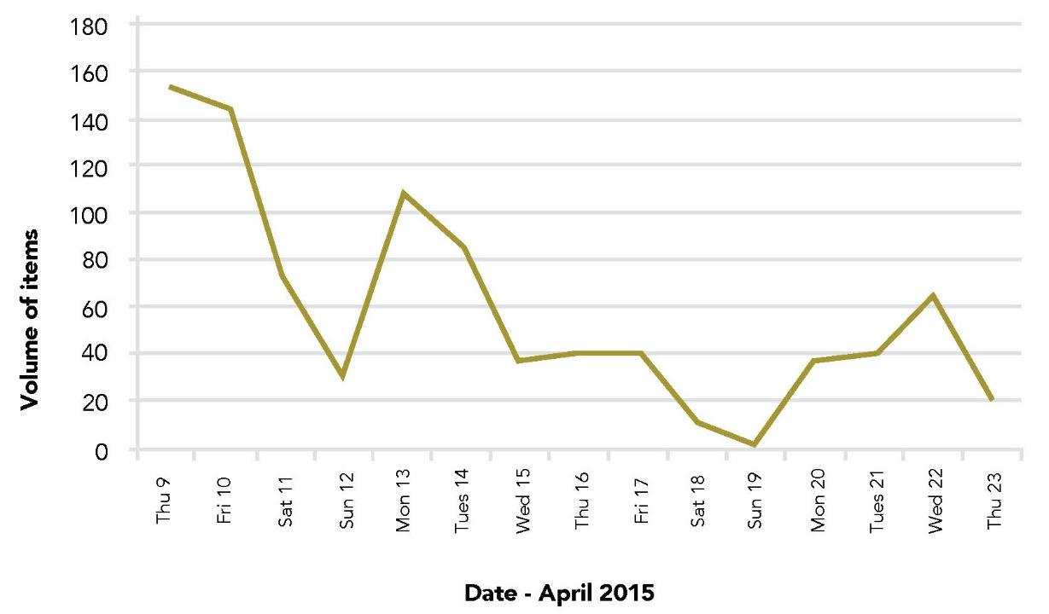
Data table for Figure 4:
Date | Volume of items
Thu 9 April 2015 | ~153
Fri 10 April 2015 | ~143
Sat 11 April 2015 | ~72
Sun 12 April 2015 | ~30
Mon 13 April 2015 | ~108
Tues 14 April 2015 | ~84
Wed 15 April 2015 | ~38
Thu 16 April 2015 | ~40
Fri 17 April 2015 | ~40
Sat 18 April 2015 | ~12
Sun 19 April 2015 | ~2
Mon 20 April 2015 | ~36
Tues 21 April 2015 | ~40
Wed 22 April 2015 | ~65
Thu 23 April 2015 | ~20

Figure 5 Frequency of words used in headlines* from news items reporting on violence against women
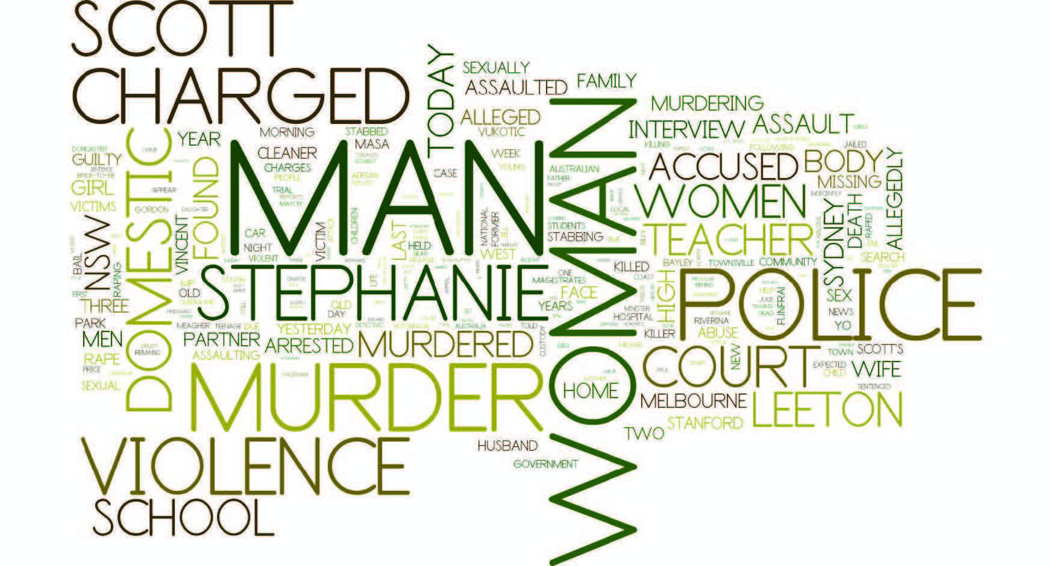
*Larger words in the illustration indicate that word was used more frequently

Newspaper
In Australia, newspapers typically feature articles on local, national and international news. Many traditional newspapers also have editorial pages containing articles written by the editor and columns that express the personal opinions of guest writers or columnists. Many newspapers, besides employing journalists, also use international news agencies, such as the Australian Associated Press, Reuters or Agence France-Presse, to source news stories for publication. Most newspapers in Australia are owned by just two media companies: News Corporation Australia (formerly News Limited) and Fairfax Media. News Corporation owns most newspapers with almost 70 percent of the market share within the state capital cities compared to around 20 to 25 percent for Fairfax (Lewis, 2001).
In our sample, a total of 929 newspaper articles were captured in relation to violence against women and their children. Over the 4 month data collection period, this total equates to an average of around 58 newspaper articles per week across a selection of daily and non-daily city, regional and suburban newspapers in New South Wales, Queensland and South Australia.

State and region
The majority of newspaper articles on violence against women were in New South Wales-based publications (70.4%, 654). A further 10.8 percent (100) and 8 percent (75) were from Queensland and South Australia-based newspapers, respectively. A little over 10 percent (10.8%, 101) of articles were in The Australian newspaper.
Taking account of state-based newspapers only (828), three-quarters of the articles appeared in capital city, major regional city or suburban newspapers (61.5%, 509). The remainder were in smaller regional and rural publications (38.5%, 319).

Newspaper outlets
Figure 6 provides information on the newspapers with the highest volume of articles during the media monitoring period, bearing in mind that not all newspapers were daily publications. Close to half of all newspaper articles concerning violence against women were from just five capital city papers (43.3%, 402): The Advertiser (Adelaide, South Australia), The Courier-Mail (Brisbane, Queensland), The Daily Telegraph (Sydney, New South Wales), The Sydney Morning Herald (Sydney, New South Wales) and The Australian (national). Four of these five newspapers are owned by News Corporation and have high numbers of papers in circulation on an average day, both through subscriptions and news stand sales. Circulation figures for The Daily Telegraph during the data collection period were in excess of 250,000 copies per day.

Item placement and use of images/photographs
The placement of articles in a newspaper is a good indication of the importance given by the newspaper to a particular story. In total, 7.3 percent (69) of articles concerning violence against women appeared on the front page, the remainder were placed further into the body of the newspaper. Over 40 percent of all items that appeared on the front page were in connection to the murder of Stephanie Scott (43%, 30). The vast majority of front page newspaper articles contained an image or photograph (84%, 58). Overall, a photograph or image was present in half of all newspaper items (51%, 474).

Item size
Article size (or space occupied) ranged from 15 cm2 to 3504 cm2 with an average of 329 cm2. The image below illustrates the average size of a newspaper article on violence against women (Figure 7; taken from Sydney Morning Herald, 14 May 2015).
Word count mostly accorded with the space allocated with a range from 27 to 2715 words. The smallest article appeared in the Northern Daily Leader in Tamworth, New South Wales on page 9 on 21 May 2015 and included the headline “Accused killer unfit for trial”. The largest article was a three-page feature piece in the Sunday Life section of the Sun-Herald in Sydney. The newspaper article profiled television presenter Lisa Wilkinson and included a discussion about the issue of violence against women and her opinion on the inadequacy of the government’s response (21 June 2015).

Figure 6 Newspaper outlets by volume of reporting on violence against women
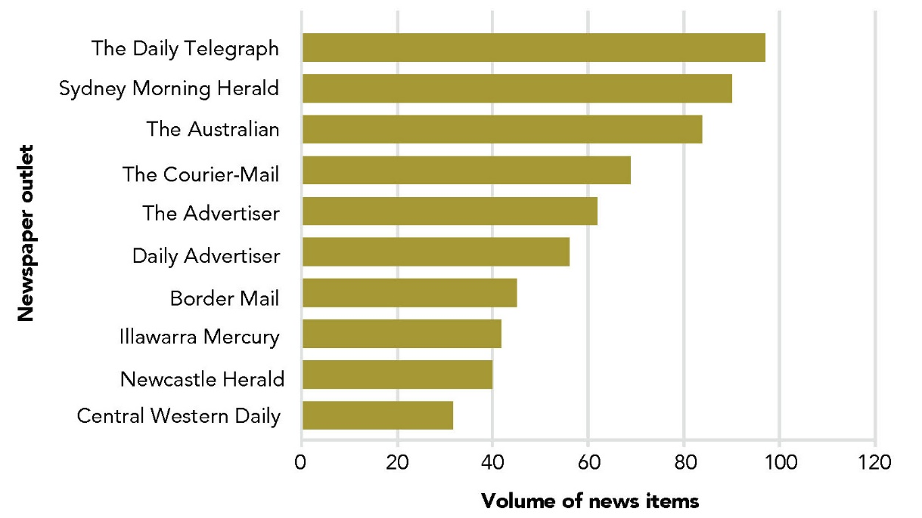
Data table for Figure 6:
Newspaper outlet | Volume of news items
The Daily Telegraph | ~97
Sydney Morning Herald | ~90
The Australian | ~84
The Courier-Mail | ~69
The Advertiser | ~62
Daily Advertiser | ~56
Border Mail | ~45
Illawarra Mercury | ~42
Newcastle Herald | ~40
Central Western Daily | ~32

Figure 7 Example illustration of the average newspaper article size (329 cm2)
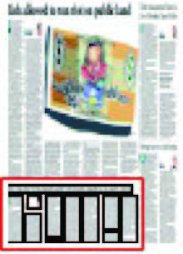

Item type
As can be seen in Table 1, the vast majority of items on violence against women in the newspaper were general news items. The next most common types were accounted for by letters, feature items appearing in newspaper supplements or magazines, such as the Sydney Morning Herald’s Good Weekend Magazine, international news and editorials, respectively. A number of items fell into an undifferentiated “other” category and included items in the business section, arts and entertainment, including the TV guide. A small proportion of newspaper articles on violence against women appeared in the Sport section of the newspaper. In around five percent of newspaper articles the items were not identified by Isentia because they were edition changes in which the newspaper article first appeared in another edition or in another state.

Table 1 Types of newspaper items reporting on violence against women
Type | Frequency (N=929) | %
General news | 76 | 82.2
Letters | 29 | 3.1
Feature | 27 | 2.9
International | 21 | 2.3
Editorial | 14 | 1.5
Other | 13 | 1.4
Sport | 10 | 1.1
Edition changes | 51 | 5.5

Broadcast
News broadcasts refer to current events and other types of news-related information delivered via the radio or television. In Australia, content is usually produced either locally or by a broadcast network and syndicated across stations. Broadcast news segments may also include additional material such as sports coverage, weather forecasts, traffic reports and commentary. Audience input via “talkback” callers, text messages and via social media such as twitter is an increasing part of news broadcasting.
A total of 2255 news broadcast items were concerned with violence against women and their children. This total included 1158 items broadcast on AM radio, 712 items on FM radio and 385 items screened on television. Over the 4 month data collection period, this total equates to an average of 140 news radio and television broadcasts per week that relate to violence against women. Broadcast items included news bulletins, as well as interviews, feature segments or callers to talkback radio.

Radio
Radio news refers to disseminating current events via the radio. Radio stations dedicated to news or “news talk” often feature regular (i.e. once or twice every hour) newscasts or news bulletins that tend to be a mix of local, national and international news. Over 80 percent of the broadcast news items on violence against women in our sample were on radio (82.9%, 1870), with most of these broadcasts on the AM method of audio transmission (61.9%, 1158).

State and region
Just over half of the radio broadcasts on violence against women were on stations broadcasting into New South Wales (59.9%, 1120). Around a quarter were broadcast on Queensland-based radio stations (24.5%, 458) and 15 percent (281) were on radio stations in South Australia. There were only 11 items captured from the national broadcasters, Radio National and Triple J (<1%).
Even though radio broadcasts can be transmitted over a relatively long distance, particularly AM transmission, they were classified into metropolitan and regional stations. Excluding the two national radio broadcasters, most items in this sample were broadcast on metropolitan-based radio stations (76.7%, 1425/1859). The remainder were broadcast on regionally-based stations, such as ABC Wide Bay, 2BS Bathurst and STAR FM Central Coast (23.3%, 434).

Radio outlets
Figure 8 provides information on the radio stations with the highest volume of broadcasts concerning violence against women. Most radio stations with a high volume of reporting were “news talk” radio stations with frequent and updated news bulletins. Three of the top four stations in Figure 8 are the most widely listened to radio stations in Sydney in terms of market share (2GB, 702 ABC Sydney, 2UE; data courtesy of Radio Today, survey 7 2015). 2GB’s most popular segment is the Alan Jones Breakfast Show, which consistently has the highest ratings of any breakfast show in the country, but is particularly popular among older listeners (aged 65+). The second highest radio outlet in terms of volume was 2SM which includes the John Laws Morning Show.

Figure 8 Radio outlets by volume of media items reporting on violence against women
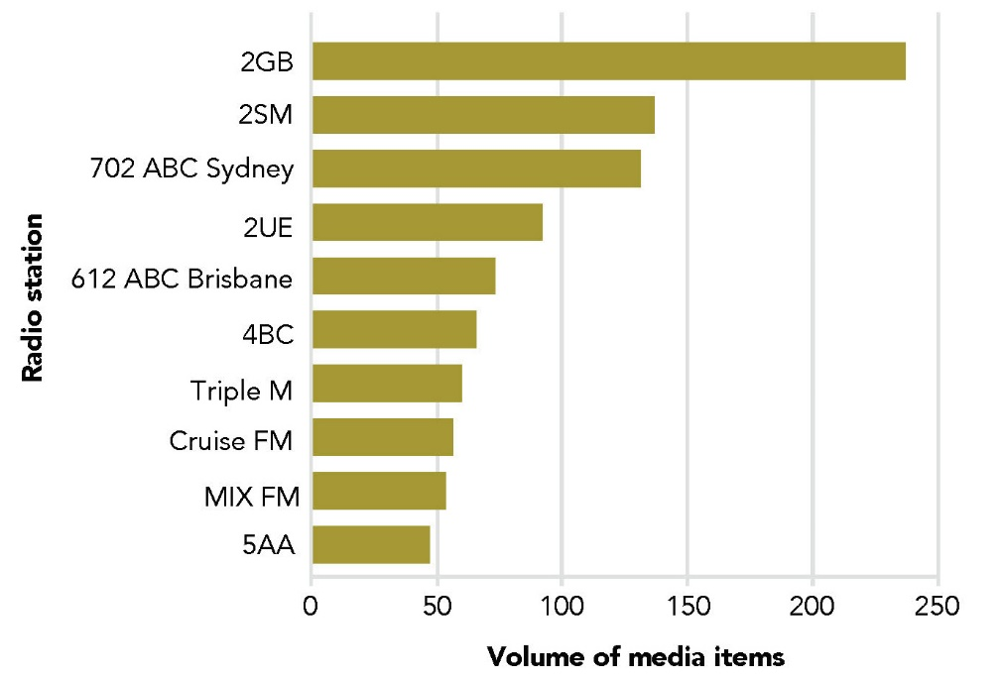
Data table for Figure 8:
Radio station | Volume of media items
2GB | ~236
2SM | ~136
702 ABC Sydney | ~131
2UE | ~91
612 ABC Brisbane | ~73
4BC | ~65
Triple M | ~60
Cruise FM | ~56
MIX FM | ~53
5AA | ~47

Broadcast audience
Radio items with the largest number of listeners were broadcast on the most popular radio stations. Within our data collection, the radio item with the largest broadcast audience, estimated at around 154,000 listeners, was presented by Ray Hadley on 2GB in Sydney on 21 May 2015 in which he discussed an article in The Daily Telegraph about the cultural acceptance of violence against women. Radio items on violence against women with the smallest number of listeners, estimated at around 200 listeners, were all broadcast on FM radio station POWER FM Illawarra in Wollongong, New South Wales. There were no significant differences between estimates of male and female radio audiences for news items broadcast on violence against women.

Item type and time
Table 2 provides a summary of the type of radio program and the time of day that items on violence against women were broadcast. The type of radio broadcast was categorised into items within a designated news bulletin or items that were part of a specific radio program (e.g. The Kyle and Jackie O Show, Riverland Today, Adelaide’s Fun Breakfast). The time of the broadcast was divided into mornings (5am to 12pm), afternoons (12pm to 6pm) and evenings/nights (after 6pm).
Overall, the majority of items on violence against women were broadcast within designated news bulletins (74.0%, 1383). Half of all radio items were broadcast in the morning timeslot (56.4%, 1055). There was a significant decline in the frequency of radio items reporting on violence against women during the evenings, with less than 10 percent of captured items from news bulletins or radio programs after 6pm. This likely reflects the type of radio programs and the frequency of news bulletin in the evenings in comparison to the morning time slots.

Duration
Radio items on violence against women varied in length from as little as ten seconds to nearly half an hour. Table 3 shows that half of all radio items were less than 30 seconds in duration, with the vast majority being less than one minute, reflecting that most items in the sample were brief reports within news bulletins. For some of the longer radio items, the topic of violence against women was often intertwined with other current affairs, such as the federal government’s plan to introduce the “healthy welfare” card in Indigenous communities. Most radio items lasting over ten minutes were interviews. For example, on 27 May 2015 the presenter of the Morning Program on ABC North West Queensland aired a pre-recorded interview with a domestic violence survivor. The interview was nearly 20 minutes in duration. Similarly, on 6 May 2015 the presenter of the Drive (afternoon) program on 2UE interviewed NSW Minister for Women, Pru Goward, on a proposal to register domestic violence offenders. The interview was over ten minutes in duration.

Table 2 Radio items reporting on violence against women by program type and time of day
Program type | Morning | Afternoon | Evening/Night | Total
News bulletin | 753 (40.3%) | 506 (27.1%) | 124 (6.6%) | 1383
Within programs | 302 (16.1%) | 165 (8.8%) | 20 (1.1%) | 487
Total | 1055 (56.4%) | 671 (35.9%) | 144 (7.7%) | 1870

Table 3 Duration of radio items reporting on violence against women
Duration | Number (N=1842*) | %
<30 seconds | 869 | 47.2
30 seconds -1 minute | 569 | 30.9
1-2 minutes | 110 | 6.0
2-4 minutes | 112 | 6.1
5-10 minutes | 127 | 6.9
10 minutes | 55 | 2.9
*n=28 missing for duration

Television
In Australia, traditional news segments on television typically feature one or more presenters or hosts whose role is to introduce and segue between news items presented by station reporters. News and current affairs programs tend to differ in content, tone and presentation style depending on the format of the channel on which they appear, and their timeslot. For example, television news breakfast shows, such as Today or Sunrise, present a range of topics including news, sport, weather, entertainment, health, politics, education, fashion, business and finance. All broadcast news on television is image-based, showing video footage of many of the events that are reported.
In our sample, there were far fewer items shown on television in connection with violence against women in comparison to radio. Television items made up just 17.1 percent (385) of all broadcast items.

State and region
The volume of television broadcasts by state followed a similar pattern to radio broadcasts. Approximately half of all television items on violence against women were on New South Wales-based television shows (49.1%, 189). A little over a quarter were on Queensland-based television shows (27%, 104). Thirteen percent (50) were on television shows broadcast into South Australia and around 10 percent of television items were broadcast nationally (10.9%, 42).
Over half of the television items captured first appeared on metropolitan-based television shows, such as TEN Eyewitness News, NBN News Gold Coast and Channel 9 News Adelaide (62.7%, 215/343). Around a third of television news items were first broadcast on regionally-based television shows, such as WIN News Rockhampton, Prime Local News Wagga Wagga and NBN News Coffs Harbour (33.3%, 128). The remaining items were shown on television channels and/or shows that aired nationally including SBS World News Australia, Sky News Live PM Agenda and ABC News 24 News Breakfast (10.9%, 42).

Television outlets
Figure 9 shows the television networks with the highest volume of broadcasts on violence against women during the data collection period. These five broadcast networks comprising Channel 7, Channel 9, Channel 10, the ABC (not including ABC News 24) and Prime 7 Wagga Wagga accounted for over half of all television items in connection with violence against women (59.7%, 230). Close to three-quarters of all television news items screened on Prime 7 Wagga Wagga were related to one of the high profile cases that occurred during the period of media monitoring: the murder of Stephanie Scott in the nearby town of Leeton.

Television audience
Broadcast audiences in relation to violence against women on television were, on average, much larger than audiences for radio broadcasts. The estimated broadcast audience for television items ranged from 1000 to 329,000 people. The largest estimated broadcast audience was for a television item screened on Channel 9’s National News on Sunday 12 April 2015 in which presenter Peter Overton did a live cross to Leeton High School following the murder of Stephanie Scott. The estimated audience for this item, including on syndicated stations, was close to half a million viewers. The smallest broadcast audience was for an item screened on NITV News (Australia’s national Indigenous television station) in Sydney on 26 March 2015 about the funeral of Masa Vukotic. As with radio, there were no significant differences between male and female viewing audiences.

Television item type
The vast majority of items related to violence against women were screened on dedicated news segments on television, the top five being: TEN Eyewitness News, NBN News, Seven News, Prime Local News and National Nine News. Less than 5 percent (12) of items appeared on current affairs or breakfast television shows, such as Sunrise, Today or Today Tonight.

Figure 9 Television networks by volume of media items reporting on violence against women
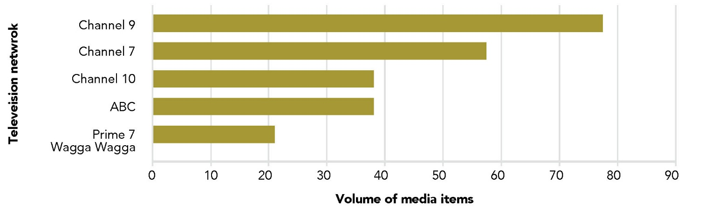
Data table for Figure 9:
Television network | Volume of media items
Channel 9 | ~77
Channel 7 | ~57
Channel 10 | ~38
ABC | ~38
Prime 7 Wagga Wagga | ~21

Television item duration
Television items on violence against women were on average about one and a half minutes in duration with a wide range, from less than 15 seconds to over 8 minutes. Table 4 shows that approximately three-quarters of all news items on television were less than 2 minutes in duration. Television items of shorter duration were primarily embedded in news bulletins, while items of longer duration (e.g. more than 5 minutes) were more likely to have been screened on current affairs style programs, such as Today Tonight or Viewpoint on Sky News Live.

Table 4 Duration of television items reporting on violence against women
Duration | Frequency (N=385) | %
<30 seconds | 67 | 17.4
30 seconds – 1 minute | 64 | 16.6
1-2 minutes | 145 | 37.6
2-4 minutes | 94 | 24.5
5-10 minutes | 15 | 3.9

Online
Australians are increasingly consuming news and information online (Nguyen, Ferrier, Western, & McKay, 2005). In May 2014, news and information websites accounted for 26 percent of total time browsing the web on a smartphone and were the second most browsed website category, behind social media (Helliker, 2014). Most newspapers now publish online as well as in print with the top news websites, in terms of market share, dominated by established media companies, both private and government-owned. Establishing a parallel online presence has provided newspapers with opportunities to compete with broadcast news outlets, particularly in presenting breaking news in a timely manner.
In the 2 month period of online news monitoring (22 March to 22 May), a total of 1333 items were captured on the topic of violence against women. This equates to an average of 166 online news items per week.

Online news sites
Figure 10 shows the online news sites ranked according to volume of reporting on violence against women. The News Corporation owned website news.com.au is consistently rated as the most popular online site for Australians to access news (http://www.nielsen.com/au/en/press-room/2015/nielsen- online-news-rankings-june2015.html).

Online audience
The number of unique daily visitors or browsers to each online site during the study period ranged from 16,259 to 913,860 with an average number of 425,836 unique visitors per day. Unique daily visitors refer to the number of individuals who request pages from a website on any given day. Actual visits to the site may be greater because the same user may visit the site multiple times. The lowest number of unique daily visitors was for news items appearing on ninemsn.com.au and the highest traffic was for items appearing on news.com.au. Nielsen data over the same time period showed that the average time that users spent on news.com.au was close to 2 hours. Their data showed an increasing trend across all online news sites for engagement via mobile devices.

Figure 10 Online news websites by volume of media items reporting on violence against women
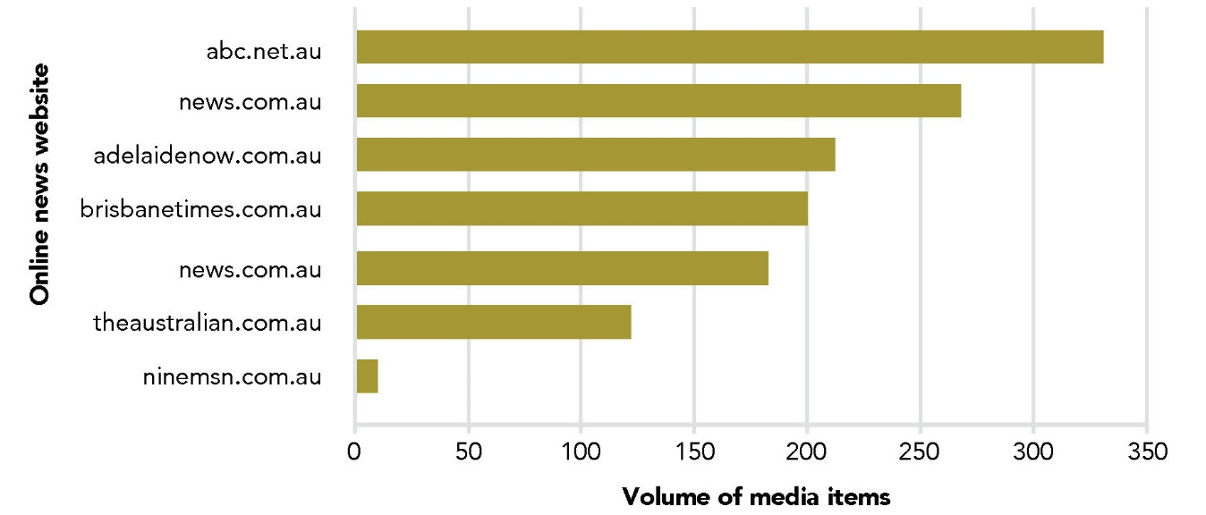

Data table for Figure 10:
Online news website | Volume of media items
abc.net.au | ~330
news.com.au | ~267
adelaidenow.com.au | ~211
brisbanetimes.com.au | ~200
news.com.au | ~182
theaustralian.com.au | ~121
ninemsn.com.au | ~9

Results of content analysis
Ten percent of all news media items, stratified by media type (i.e. print, broadcast and online), were randomly selected for in-depth content analysis (as described in the method section). A small number of items that were initially coded were excluded in the analysis phase (n=20) because they were primarily about violence against children not in the context of family violence. The final sample comprised 444 items including 93 newspaper items, 221 broadcast items and 130 online news items. The broadcast category combined radio (n=188) and television news (n=33). All these media items were coded according to the coding frame specifically developed for this project. This coding frame and instruction manual were informed by key findings identified in our state of knowledge paper about predominant patterns in the way media report on violence against women (Sutherland et al., 2015).

Social context
The social context generally refers to the way social elements of issues are reported in the news. In the context of violence against women, episodic or incident-based reporting tends to frame stories as disconnected random events with little information or discussion about the social context in which violence occurs. In contrast, thematic reporting identifies the social elements at the community or society level that contribute to the problem. Situating gender-based violence as a systemic social problem can be facilitated in news media reports by providing information on the prevalence of violence against women, acknowledging the key underlying factors that contribute to men’s use of violence or other information about the social context of the crime.
We coded each print, online and broadcast item according to whether the main profile of the story was incident-based or thematic, the main story focus, other contexts in which violence against women was reported and the type of information included to situate violence within the broader social context.

Incident-based or thematic-based reporting
Incident-based items were defined as those that primarily focused on current and/or past incidents of violence, whereas thematic news items were defined as items that focused on the “bigger picture” by discussing or debating the issue of violence against women.
Results showed that the majority of news items were primarily about individual incidents of violence (61%, 271). One-fifth (20.9%, 93) were primarily discussion-based or thematic news items. The remaining items were classified as being a combination of the two: thematically-based items with reference to incidents of violence against women (18.1%, 80).
Table 5 provides a breakdown of reporting frames by media type. In comparison to print and online news formats, broadcast news was significantly more likely to report individual incidents of violence only (as opposed to a thematic-based reports or a combination of both; p>0.001).
Among incident-based news reports, one-quarter (28.4%, 77) were identified by coders as being coverage of a court case or legal proceedings.
Thematically-framed news items, both with and without reference to incidents of violence (n=173), were scrutinised further to identify the main context of the story. The main story focus of these news items included a discussion of topical issues regarding violence against women (see Figure 11 for an example), educationally-based information about violence generally and domestic violence, law reform and/or legislative changes, calls to action to end male-perpetrated violence against women, commentary or follow-up about an individual incident and advocacy campaigns, such as White Ribbon. Each of these appeared in around a quarter of all news items with a thematic frame (see Table 6).
In a number of thematic-based reports, the issue of violence against women was embedded within reports that were primarily addressing another issue. This most commonly occurred for media items on political issues or in the context of a political campaign (36.4%, 63/173) or in news items that covered a range of other social problems (35.8%, 62). Around 10 percent of thematic coverage discussed the issue of violence against women in the context of feminism or women’s rights movements (10.4%, 18) or were primarily about the consequences of alcohol and/or illicit substance use (9.2%, 16). Few thematic reports discussed violence against women in the context of Indigenous (6.9%, 12) health issues or mental health (6.4%, 11).

Table 5 Incident and thematic reporting of violence against women by media type
Basis | Newspaper (N=93) | Broadcast (N=221) | Online  (N=130) | Total  (N=444)
Incident-based only | 36 (38.7%) | 172 (77.8%) | 63 (48.5%) | 271
Discussion-based only | 31 (33.3%) | 33 (14.9%) | 29 (22.3%) | 93
Both | 26 (28.0%) | 16 (7.2%) | 38 (29.2%) | 80

Figure 11 Border-Mail, 20 June 2015
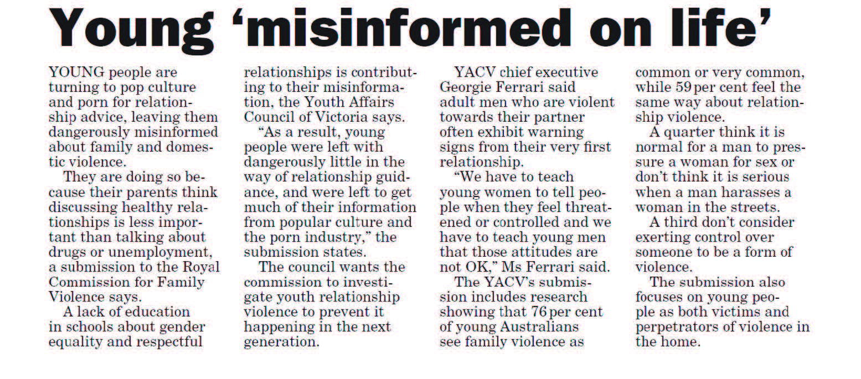
Text alternative at the end of the document.

Violence reported within a broader social context
International concern about the way media report men’s use of violence against women, particularly in the context of intimate partner relationships, has been the impetus for many countries to develop media guidelines. In our state of knowledge paper we identified 23 such guidelines, six from Australia, and noted that one of the most commonly occurring key principles – recommended by every guideline – was to contextualise the story (Sutherland et al., 2015). While different guidelines offer different strategies to achieve this, it is generally operationalised in media reports by providing statistics on prevalence, acknowledging the underlying factors that give rise to conditions in which violence against women occurs, providing information about warning signs and when women may face heightened risk and including resources for those seeking help.
In our sample, only 17 percent of items (76) included any information that explicitly provided information to aid audience understanding about the broader social context in which violence against women occurs. Within reports that included such information, almost all included data on prevalence including local, state and/or national statistics (91%, 69). A smaller proportion included information that some sub-groups in the population may be more vulnerable than others (21%, 16) and that violence affects more than individual victims (18.4%, 14). The only item referencing the possible impact on children was in the Letters section of one of the capital city newspapers (see Figure 12).

Table 6 Most commonly occurring context in thematic news items*
Context | Frequency | %
Current affairs/topical issue | 55 | 31.8
Educative/informative | 48 | 27.7
Law reform/legislative changes | 47 | 27.2
Calls to end violence against women | 46 | 26.6
Commentary about an incident | 37 | 21.4
Advocacy campaigns | 36 | 20.8
Changes to funding/budgets | 24 | 13.9
In memory, eulogy, tribute, farewell | 20 | 11.6
Appointments/promotions of relevance | 8 | 4.6
Consumer/commercial campaigns | 7 | 4.1
*Coders selected more than one context (if applicable); frequencies and percentages do not add up to 100
Very few items in the sample (less than ten) included information that violence against women involves more than physical assault; that intimate partner violence is significantly more prevalent than random acts of violence by an unknown perpetrator; the warning signs; and that men’s use of violence is more likely to occur and/or escalate when women attempt to leave or end a relationship. Providing information about the social context was significantly more likely to occur in media items with a thematic frame than within items focused on individual incidents of violence (36% versus 4.8%, p<0.001).
The vast majority of news items were about violence against women in the Australian context. Only 4 percent of media items (18) were about violence against women in other countries. The vast majority of international stories were online (13/18). While these reports were from a range of countries, they were most frequently from the United States (7/18) and included incidents such as the following:
News.com.au, 13 April 2015
Two college students have been arrested in the United States after allegedly gang raping an unconscious 19-year-old woman on a beach surrounded by hundreds of spring break partygoers who did nothing to stop the attack.

Information for women seeking help
The most recent VicHealth report on community attitudes to violence against women showed that just over half the survey respondents (57%) knew where to get help for themselves or others who may be experiencing domestic violence (Webster et al., 2014). This finding represented a decrease in help-seeking knowledge from the previous survey in 2009. One of the simplest and most effective ways to disseminate this information is via the mass media, with news reports an ideal forum.
Consistent with previous research, we found that few media reports included information for women about where to seek help, advice or further information. A mere 4.3 percent of items (19/444) included such information and it was overwhelmingly contained in news items with a thematic frame (16/19). There were no significant differences between media types – with information on help seeking equally unlikely to appear online, in print news or within radio broadcasts. No television news program referred viewers to resources. Nine items referred women to a domestic violence specific helpline or website, including 1800RESPECT, while other types of help seeking resources included the police or locally-available services. As can be seen in the following example, one news item, after the murder of Stephanie Scott, referred women to free self-defence classes.

Figure 12 The Sydney Morning Herald, 2 April 2015
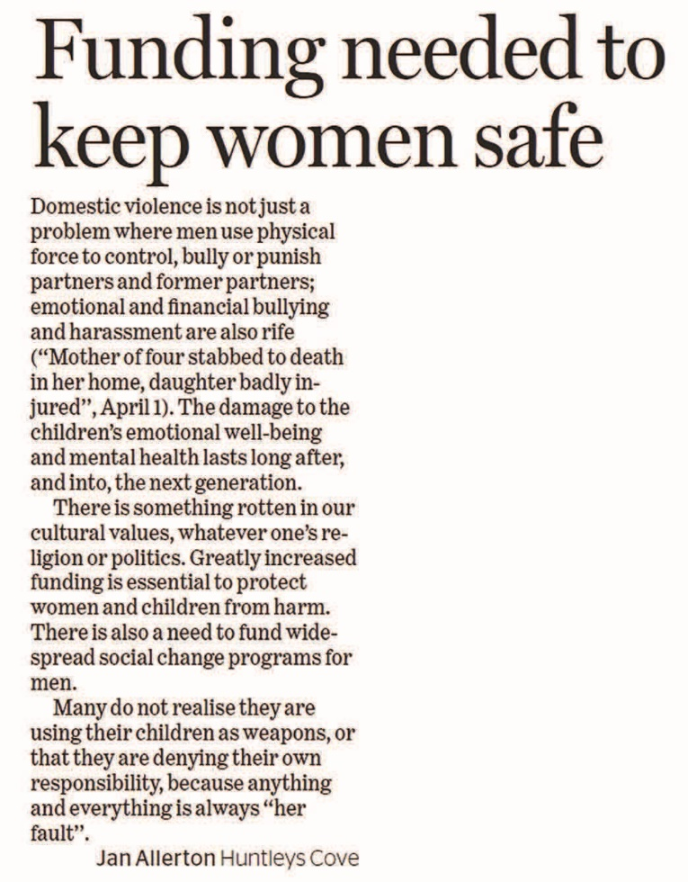
Text alternative at the end of the document
The Advertiser, 15 April 2015
We need to stop the violence. It starts with you. How can you make a difference? We at Hit 92.9 are going to do a FREE self-defence class for women. Watch this space for all the details.
The following two examples illustrate best-practice in providing resources for women seeking help: a response to a radio talkback caller and a newspaper article:
702 ABC Sydney, 25 February 2015
Caller John says that his friends had an experience where one person in their friend group committed domestic violence and would not accept that they had done it. John says that the police took no action so the friend group took action to ensure that the woman and children in the relationship were safe. Hollands says that she does not want to encourage vigilantism. Glover says that MensLine Australia is a good place for men to seek help from. Hollands says that 1800RESPECT is the general number for domestic violence.

Figure 13 Illawarra Mercury, 20 May 2015
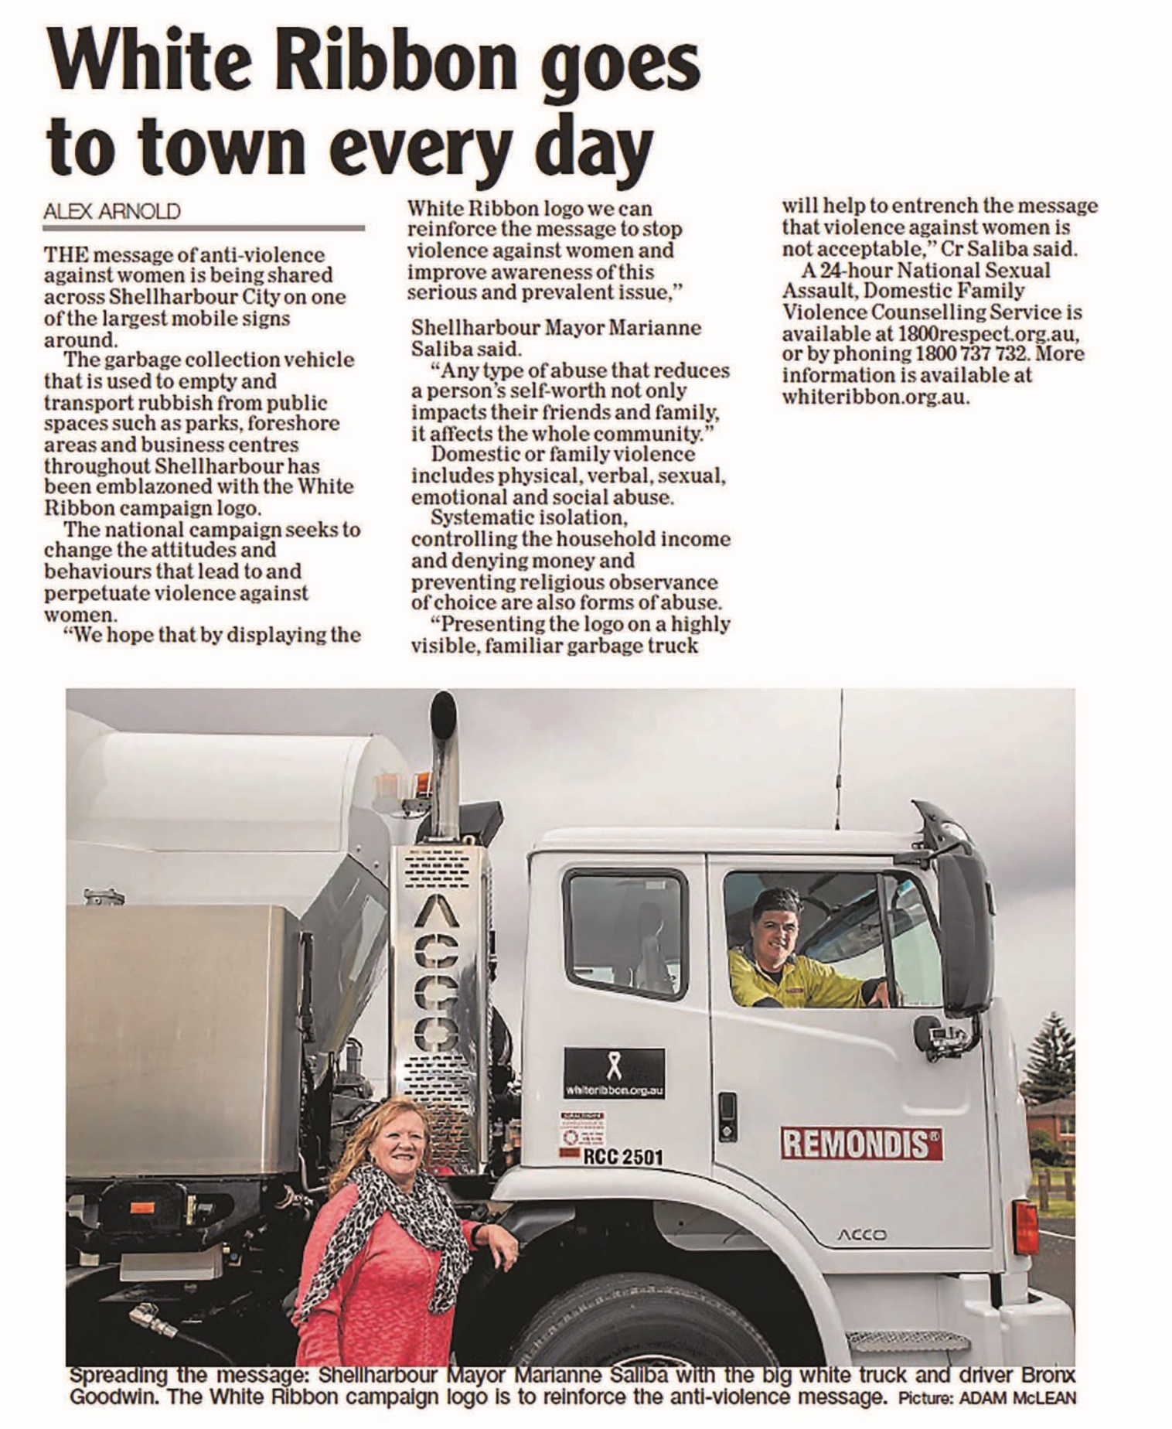
Text alternative at the end of the document

Sensationalism
Sensationalism in the news is often defined in terms of its capacity to provoke attention and can manifest in a number of ways including what stories are chosen to feature in the news, the type of information included and emphasised and the language and imagery used. Previous literature has noted that media reporting on violence against women frequently offers audiences a perspective that is provocative but not necessarily representative (Grabe, Zhou, & Barnett, 2001; Sutherland et al., 2015).
For each print, online and broadcast item, coders identified key elements of the story related to sensationalism in news reporting. These elements included the primary types of gender-based violence, the language used within media items and in the headlines and the type of detail used to describe incidents of male-perpetrated violence against women.

Some types of violence are more newsworthy than others
Figure 14 summarises the types of violence that were most frequently reported in our sample (the 93 items that were thematic without reference to an incident were not included in this series of analyses, leaving a total of 351 news items). The vast majority of items were in relation to incidents of male-perpetrated physical violence (75.8%, 266). The next most frequently reported type of violence was sexual violence – sexual assault and/or rape (22.5%, 79). Other types of gender-based violence, such as emotional abuse, threats of violence and sexual harassment were largely invisible in press, online and in broadcast news. If these topics appeared, they were generally discussed in conjunction with physical or sexual violence. Around 20 percent of news items (17.6%, 62) described multiple forms of violence. In 34 items the type of violence or “cause of death” were either not stated or described in ambiguous terms such as a domestic incident or simply as an “incident”. This terminology implies a less serious offence and infers no sense of violation or violence.

Figure 14 Types of violence contained in media reports on violence against women
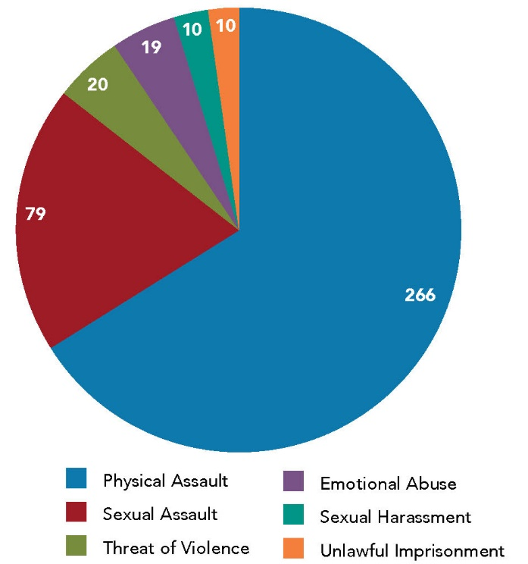
Data table for Figure 14:
Type of violence | Volume of media reports
Physical Assault | 266
Sexual Assault | 79
Threat of Violence | 20
Emotional Abuse | 19
Sexual Harassment | 10
Unlawful Imprisonment | 10

We separately coded whether incidents of violence against women reported in the media were fatal (at the time of publication or broadcast) and found that 61.8 percent of news items were in relation to homicide (217 of 351 items). Previous research has noted that media reporting has a “murder-centric” focus, whereby reports of homicide often take precedence over reporting of other forms of violence (Carlyle, Slater, & Chakroff, 2008; Sims, 2008). Our data also suggest that violence against women that ends in death is reported by media outlets in Australia out of proportion to its actual occurrence in the community. Nevertheless, the high prevalence of fatal incidents in this sample was somewhat influenced by the volume of reports in relation to the murders of two women during the data collection period: most notably the murder of Stephanie Scott. Excluding news items on Stephanie Scott, the rate of which media published fatal versus non-fatal incidents was around 1:1.
The case of Stephanie Scott, a young school teacher in a small New South Wales country town who was murdered a week before she was due to get married, fulfilled all the key criteria of “newsworthiness” and received high levels of coverage across all media. That the story was already in the news, as a missing person incident, meant the story had gathered a kind of momentum prior to it being reported as a homicide. While the story was clearly newsworthy, this brutal and random act of violence is not representative of the context in which male-perpetrated violence against women most commonly occurs.
Other incidents that often receive high levels of media coverage – which are sensationalised – involve a perpetrator and/or victim who are already known to the public through celebrity status or other public profile. In our sample of media items, around 10 percent (10.5%, 37) concerned incidents in which the perpetrator was rich, powerful or famous. Far fewer – 2.5 percent (9) -concerned violence against women who were known in the public sphere.
That only certain types of violent crimes against women – those that fit key news values – receive coverage in the news can result in community misunderstanding about who is at risk. The invisibility of domestic and family violence being presented as a crime against women in the news and information media in Australia cultivates and sustains its place as a private issue that happens “behind closed doors”. Such a traditional notion of secrecy is perhaps one of the reasons why this long-standing problem in Australia has been exacerbated to its current urgency.

Language
Previous research has found that the type of information included in reports of violence against women, the language used within those reports and decisions about the headline can all be used for various effects – to shock, titillate, fascinate, amuse and entertain. In print and online news reports, headlines play a particularly important role because they reach a considerably wider audience than those who read the articles. Headlines also provide a means for audiences to gauge the tone of the news report and may influence the way people read and remember it.
Among newspaper and online news media items, 17.2 percent (38/221) of headlines were classified as “sensational”. The use of sensational words or phrases in the headline was evident in both thematic and incident-based reports but was much more prevalent in news items reporting on individual incidents of violence (14% versus 3.2%, p<0.001). Online headlines tended to be more sensational than newsprint headlines, but the difference was not statistically significant. The following are examples of sensationalistic headlines from our sample:
- Smiling face of alleged killer (Courier Mail, 30 April 2015);
- Teen bride terror fear (The Daily Telegraph, 26 February 2015);
- Basher hotline (The Daily Telegraph, 6 March 2015);
- Accused says death ‘a sex act gone wrong’ (The Advertiser, 24 March 2015);
- Vile nurse raped unconscious women (news.com.au, 31 March 2015);
- Suspect kept pics of burnt corpse (Townsville Bulletin, 10 April 2015);
- Mutant feminists are raping reality (The Sunday Telegraph, 10 May 2015); and
- Stephanie Scott’s accused killer Vincent Stanford ‘liked to watch Nazi films’ (adelaidenow.com.au, 14 April 2015).
We also identified sensationalism through the use of language in broadcast items and in the body of newspaper and online articles. We defined this to mean news items that included excessively gory and/or overly sexually explicit detail about incidents of violence against women. Results showed 13.3 percent (36/271) of incident-based news items used sensational language to describe the crime. The radio broadcast (below) and Figure 15 (following) from a print newspaper provide two examples. They describe, in graphic detail, the method by which a woman was murdered by her partner and the rape of a woman in Sydney, respectively (the use of graphic descriptions of rape in the media is explored in more detail in the second section of this report).
Triple M Sydney, 06:30 news, 21 May 2015
A Sydney man jailed for a minimum of 25 years over a drug fuelled murder, where he stomped on his girlfriend’s chest until her heart stopped, has lost his case. He had plead [sic] not guilty on the grounds that he was high on the drug ice at the time. Pru Goward, NSW Government Minister says she is thankful the court decided to throw out the appeal and says the court needs to make it clear that domestic violence and homicide is an abhorrent form of murder.

Figure 15 The Sun-Herald, 19 April 2015
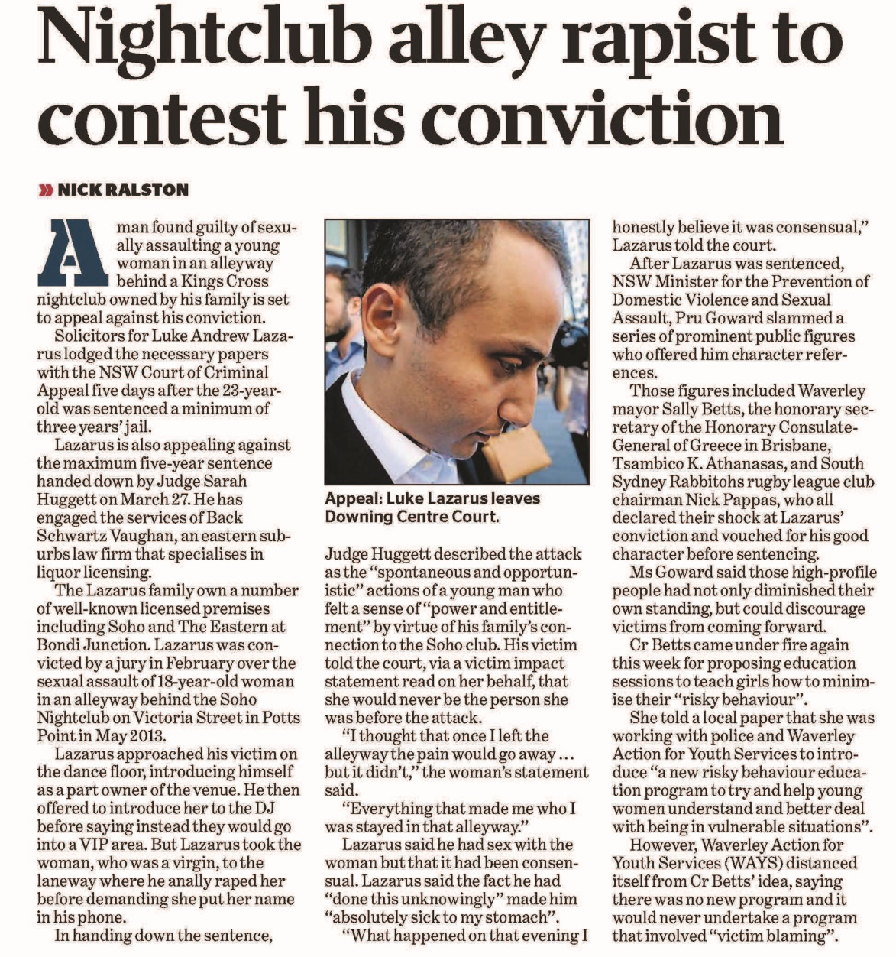
Text alternative at the end of the document
Language can also be used to obfuscate the seriousness or true nature of violence perpetrated against women. In comparison to the use of overly excessive detail, a smaller proportion of the incident-based news reports used language that trivialised or minimised the circumstances of the crime (7.7%, 21). As the example in Figure 16 shows, this newspaper article trivialises violence against women by privileging the potential damage to the singer’s career over his violent behaviour.
Close to half of news items reporting on individual incidents of violence also used the word “alleged” or “accused” to describe the perpetrator and/or his actions (45.8%, 124). Less than 20 percent of these were in relation to media coverage of court cases and/or legal proceedings (19.4%, 24). While this data suggests the word is used frequently in connection with reports of violence against women, we cannot comment on whether it was used appropriately by journalists and/or media organisations to manage the risk of sub judice contempt (trial by media). This issue is explored in more detail in the second section of this report.

Figure 16 The Advertiser (SA), 20 April 2015
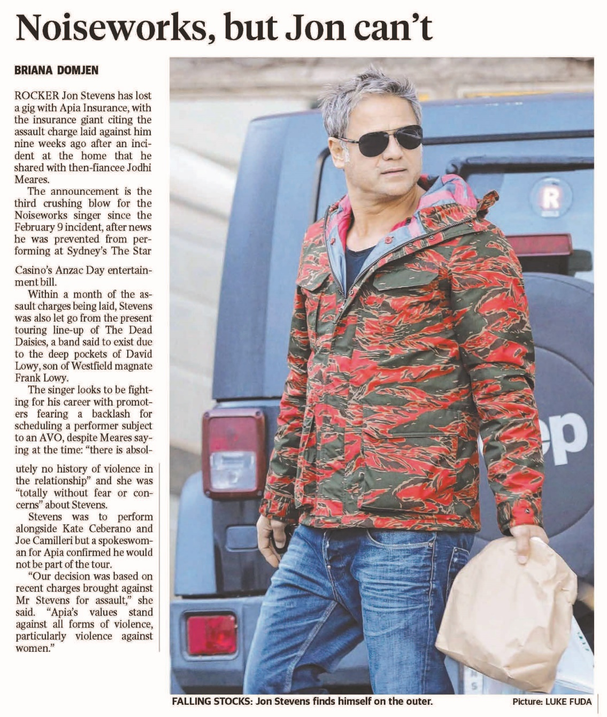
Text alternative at the end of the document

Images
Newspaper and online news items may also use images and photographs to set the tone and draw readers to the story. In our sample, 60.1 percent of items (134) in connection to violence against women contained an image or photograph. In the example below (Figure 17), the use of a sensationalistic headline, unnecessary detail and photographs combine to grab audience attention.
Coders provided a brief description of each image or photograph and these were used to categorise the types of images that were most commonly used in newspaper and online articles about violence against women. The most common types of images included “celebrity” or known perpetrators, perpetrators being led to or from court and/or with police or photographs of victims and/or perpetrators; frequently smiling and often at events or pursuing leisure activities. We assume many of these images were sourced from Facebook, Twitter, Instagram or other social networking sites. Figure 18 and Figure 19 are typical examples.
Newspaper and online news items in connection with the murder of Stephanie Scott almost always referred to her as “bride-to-be” and the images selected facilitated this narrative (see Figure 20 and Figure 21 following). The victim, her character and the crime was intimately entwined with her role as a future bride. This narrative was taken up by social media via the hashtag #PutYourDressOut in which women shared images of their wedding dresses along with messages of condolence.

Misrepresentations and myths
Whether as a by-product of episodic framing or sensationalism in news media, one of the most commonly cited criticisms of media reporting on violence against women is that it bears little resemblance to women’s common experiences of gender-based violence. Misrepresentations can manifest in media reporting either directly by perpetuating common myths about the antecedents and consequences of violence or through more subtle means by rendering some parts of the story as more or less important than others and by including or omitting certain pieces of information.
For each print, online and broadcast item, coders identified key elements related to the way media items may contribute to skewed public perceptions about violence against women including who perpetrates the violence and who is most at risk.

Figure 17 The Courier Mail, 30 April 2015
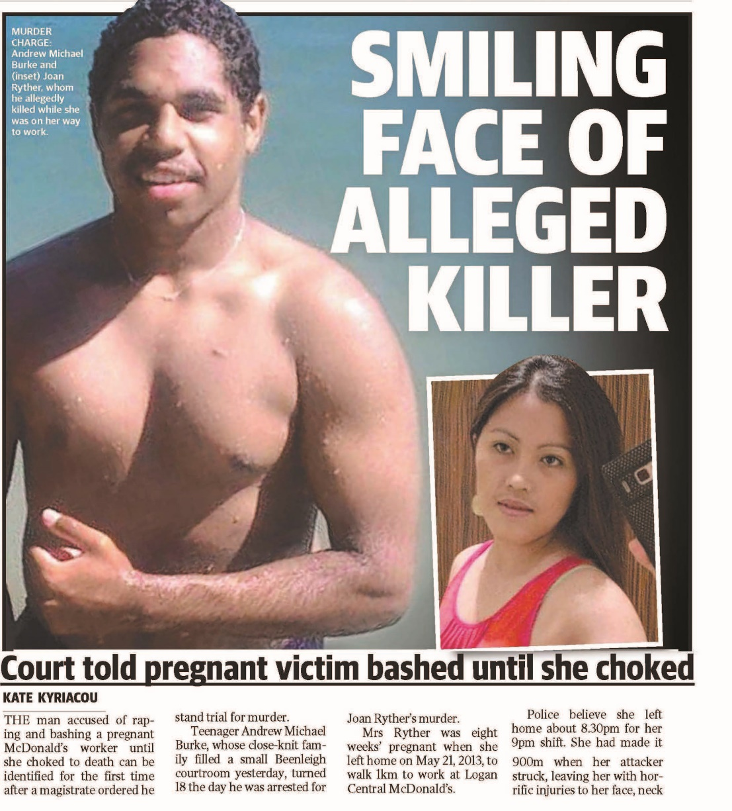
Text alternative at the end of the document

Figure 18 brisbanetimes.com.au, 26 March 2015
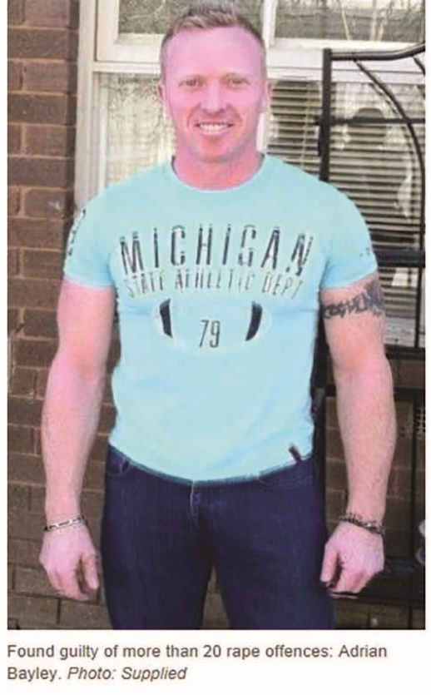

Figure 19 The Daily Telegraph, 15 April 2015
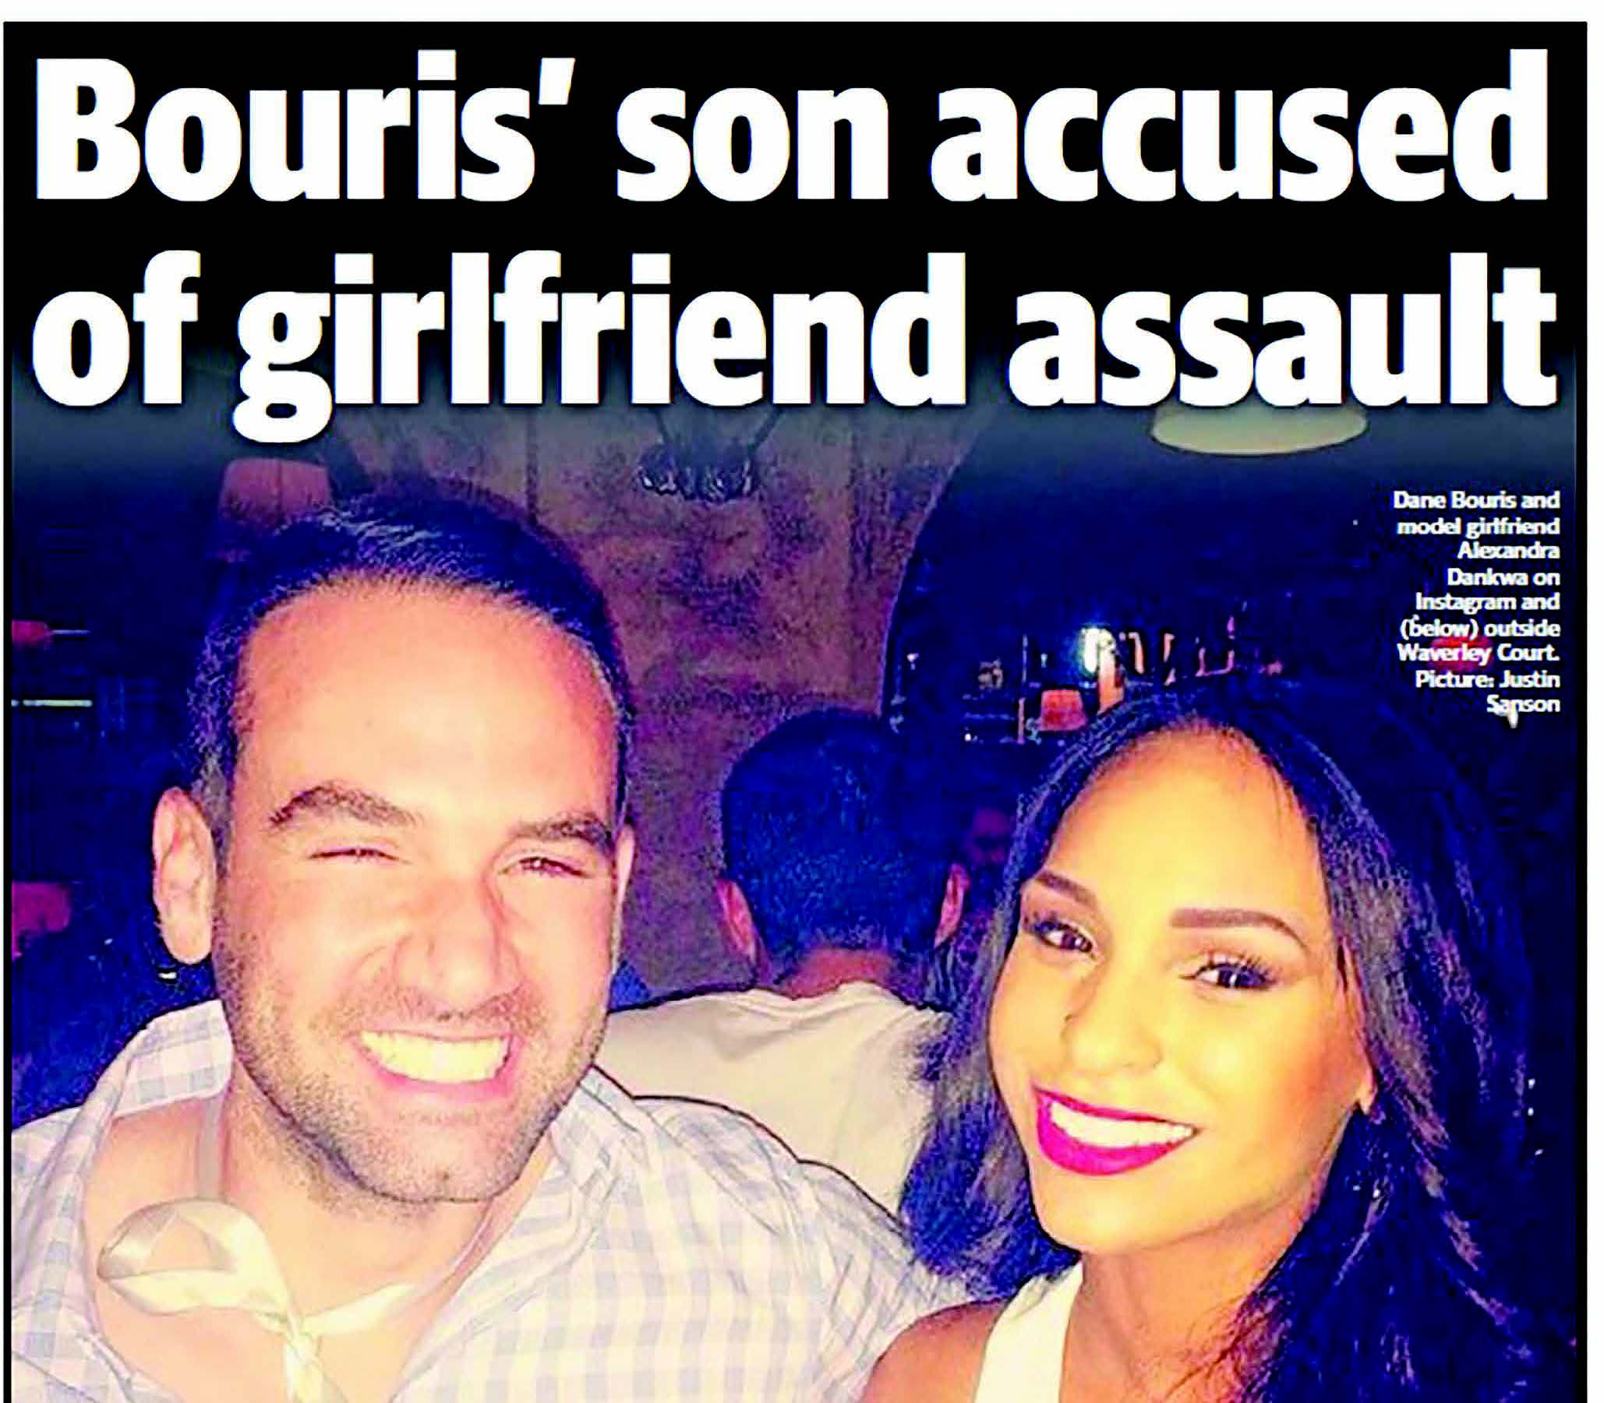

Figure 20 abc.net.au, 9 April 2015


Figure 21 The Sydney Morning Herald, 11 April 2015
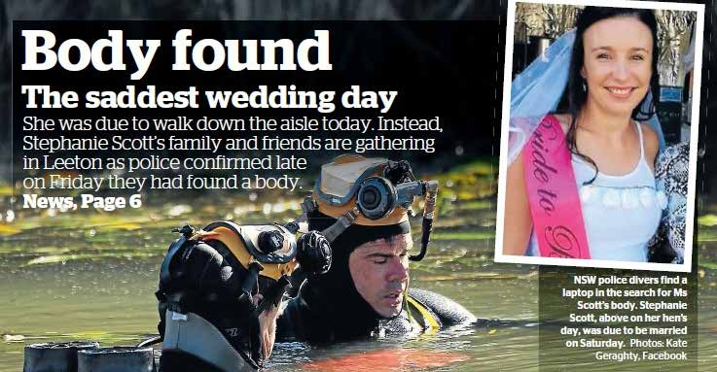
Text alternative at the end of the document

Stranger danger
Coders identified, through a series of questions, the way in which media reports described the relationship between perpetrators and victims. Only news reports that were primarily incident-based or included reference to an incident were included, leaving a total of 351 items. Results showed that in approximately a third of news items (38.5%, 135) the relationship was explicitly stated, including that the perpetrator was unknown to the victim. In a further 39 news items (11.1%) any relationship (or lack thereof) between the perpetrator and victim was implied or speculated upon, but not explicitly described by using words like “their home”. For all remaining items, which comprised half the sample (49.6%, 177), information about whether there was a relationship between the perpetrator and victim, or the nature of that relationship, was not apparent.
Taking only those media items in which a relationship was explicitly stated or implied (n=174), coders then determined the nature of the relationship. For media items that cited a relationship (or lack thereof), most were in connection to incidents of violence perpetrated by a current or former partner (60.9%, 106). In a further 13.1 percent of items (46), the perpetrator and victim were known to each other in contexts other than intimate partner relationships. Only a small number of media items explicitly stated or implied that there was no known relationship between the perpetrator and victim. These data suggest that only around one-third of media items described incidents of violence as being perpetrated by a woman’s current or former intimate partner.
In those media reports that stated an intimate partner relationship existed, we looked for information about whether news reports included prior history of violence or other types of criminal offending by perpetrators. Results showed that the vast majority of news reports did not include any information about prior criminal histories (74.7%, 130/174). This result may reflect strict legal provisions around reporting prior criminal records if legal action is pending or not yet complete. In those news items that included information about criminal offending it was most commonly in connection with a history of domestic violence in the context of intervention orders (variously called domestic violence orders, family violence intervention orders, intervention orders or apprehended domestic violence orders).

Myth-making
Previous literature has criticised news media reporting for directly promulgating misinformation about why men use violence, who is responsible, the role that women play in male-perpetrated violence, and whether women lie about being the subject of violent behaviour, particularly sexual assault and rape. Drawing on recommendations contained in various international media guidelines, each news media item was coded to determine whether the story explicitly included or referred to common myths and misconceptions.
Overall, we found few instances in which media reports explicitly included misinformation about violence against women and the context in which it occurs (6.9%, 30). Misinformation was more likely to occur in news items reporting on incidents only in comparison to items with a thematic frame (9.2% versus 2.9%, p<0.001). No media items explicitly stated that domestic violence is rare or uncommon; that certain cultures, classes or religions are more violent than others or that perpetrators and victims are equally responsible for violence. For those news items that did explicitly contribute to myth-making the most commonly occurring myths were that alcohol, drugs or other stressors cause or contribute in some way to violence (3.4%, 15), that “something” (an argument, infidelity) can “spark” violent behaviour (2.3%, 10) or that women lie about rape and sexual assault (1.1%, 5).
Other researchers have also noted that misinformation is unlikely to be explicitly used by journalists, but that mythology and misrepresentations of violence against women manifest in more subtle and indirect ways (Morgan & Politoff, 2012).

Blame and responsibility
Our state of knowledge paper highlighted that the way news and information media construct stories can indirectly attribute blame and/or assign responsibility for violence against women (Sutherland et al., 2015). It is commonly referred to as “victim blaming” and relates to circumstances in which victims of crime are portrayed so that it appears they are partially or entirely responsible for the transgressions committed against them. Depictions of perpetrators often have the reverse effect, whereby media reports indirectly provide excuses for perpetrator actions and diminish their responsibility for the crime. Previous research has noted that one of the primary barriers to substantial social change is the way media sustains the misconception that women are responsible for men’s use of violence and that women can play a role in prevention by modifying their own behaviour (Taylor, 2009).
We explored each print, online and broadcast item to uncover the type of information that news reports included about male perpetrators, female victims and the circumstance of the crime.

Behaviour of women
Around 15 percent of incident-based media items included information about the behaviour of women (14.5%, 51 of 351 items), some within the context of the incident and some more broadly. Much of this information implied that women were, at least partially, responsible for the violence, including that the victim was drinking and/or using drugs, that she was “flirting” or had gone home with the perpetrator, was out at night or alone, that the victim and perpetrator had been arguing, that the victim had not reported previous incidents of violence or had not left an abusive partner.
The proportion of news items that described the behaviour of women and the type of information included differed for incidents of sexual violence in comparison to all other types of gender-based violence. Sixteen percent of news items about sexual assault and/ or rape inferred that women had placed themselves at risk by drinking, “flirting” or going home with the perpetrator. A number of feminist media scholars have previously noted that the actions and behaviours of women subject to sexual violence are used frequently by the media to convey evidence of recklessness and risk (Barnett, 2012; Dwyer, Easteal & Hopkins, 2012; Richards, Gillespie & Smith, 2011).
The following online news item from smh.com.au on 31 March 2015 is a typical example (Figure 22). The reporter repeats aspects of the woman’s testimony that implies a sense of mutuality including “the woman says the pair kissed on the dance floor of a Civic club and then travelled back to the dormitory together”. The woman is frequently described as “the alleged victim”.

Figure 22 smh.com.au, 31 March 2015
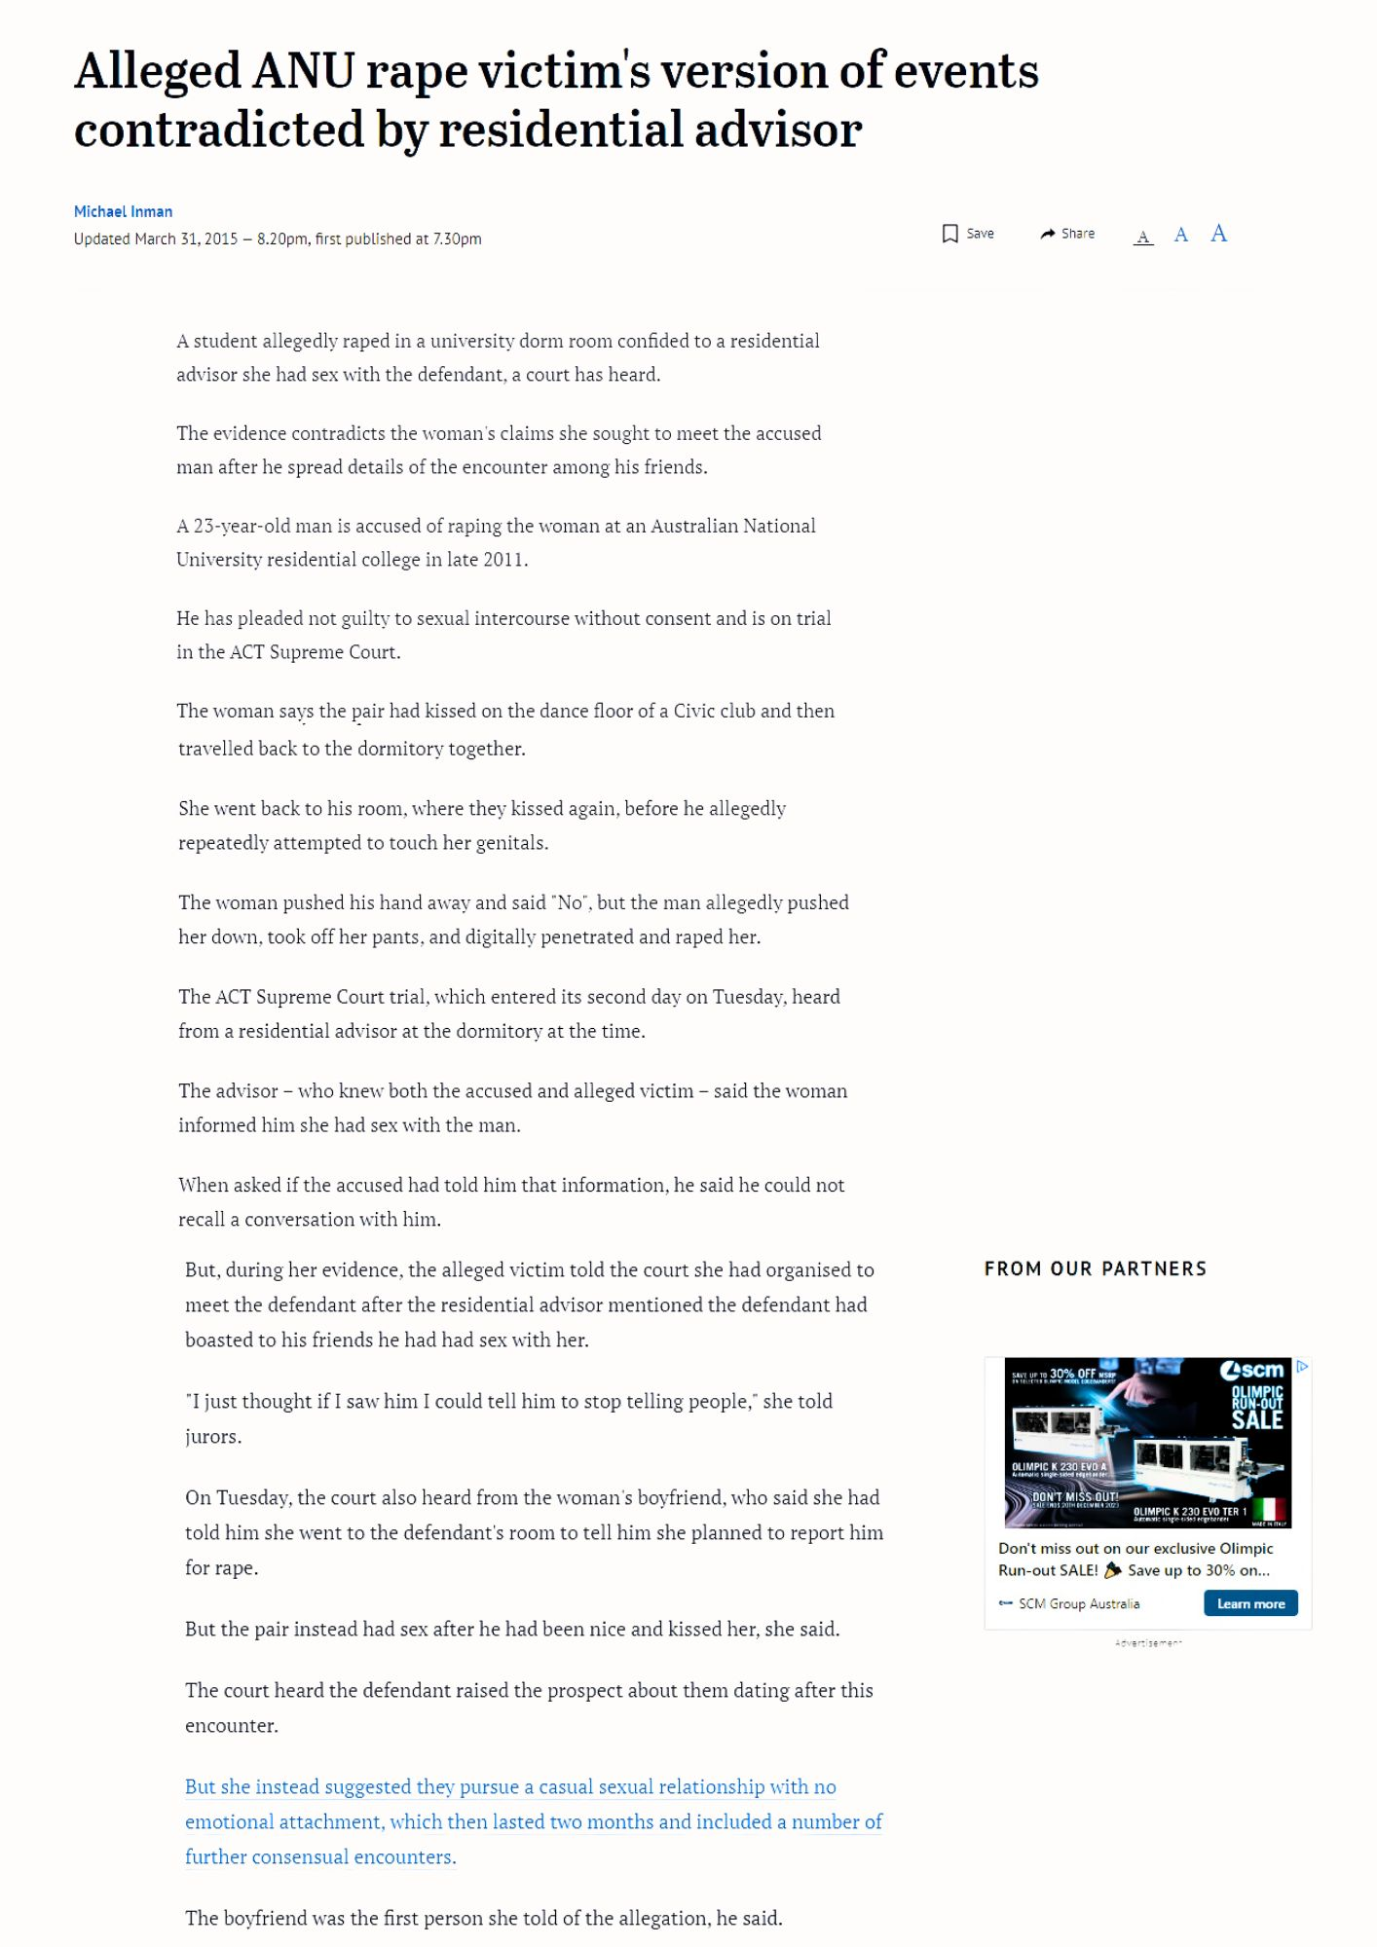
Text alternative at the end of the document
For news reports on physical violence, particularly in the context of intimate partner homicide, a sense of mutuality for the violence was commonly implied, including that the victim and perpetrator had been arguing or that women could avoid or prevent violence by ending their relationship with a violent partner. Figure 23 is an example from The Australian newspaper that frames the victim as a young woman who returned to an abusive partner in the months prior to her murder. While the details in this story may be factually correct and the woman “went back to Corbett [her partner] weeks after she lost her baby”, the media, here, could have played an important role in highlighting the reasons why many women find it difficult to leave an abusive partner. Instead this news report leaves the statement uncontested, as if the choice to return was free from coercion or fear.

Figure 23 The Australian, 8 May 2015
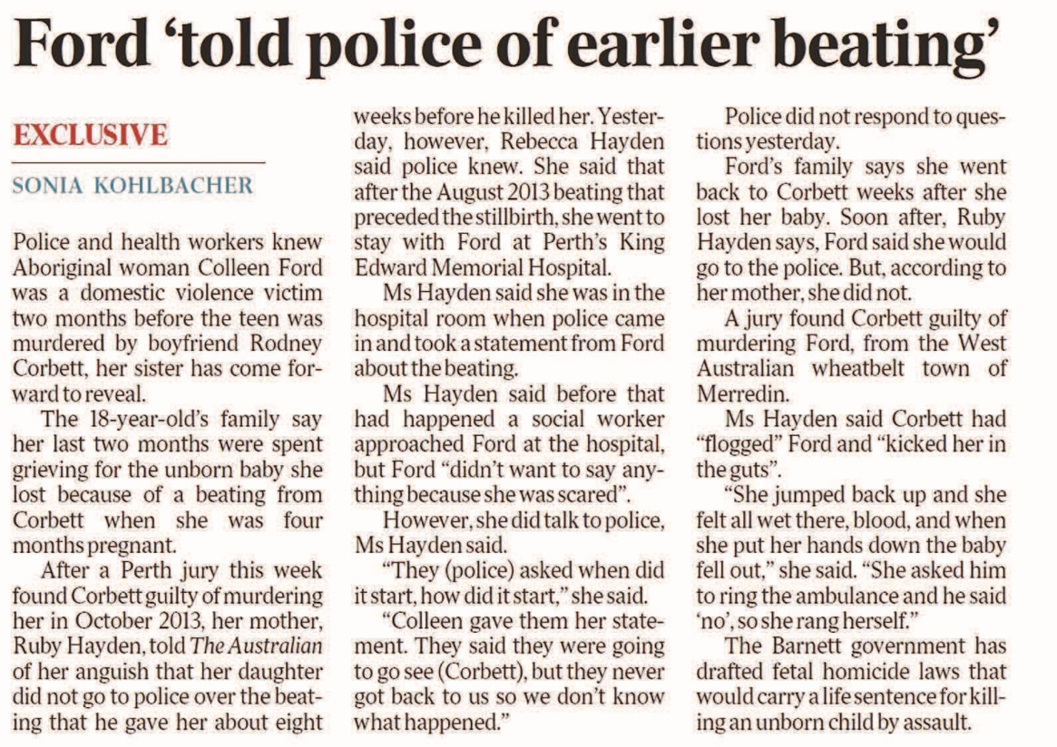
Text alternative at the end of the document

Excuses for perpetrators
For male perpetrators, news items indirectly provided excuses for violent behaviour in two main ways – in descriptions about the incident and in descriptions about male perpetrators and their character, more generally. In incident-based reports of violence, 14.8 percent (52) of media items framed the incident in terms of extenuating or mitigating circumstances, with the most common being that the perpetrator had been drinking and/ or using drugs, that the incident was motivated by jealousy or revenge (both explicitly stated or implied) or that he “snapped” or “lost control”.
We identified a small proportion of incident-based reporting that used explanatory narratives in relation to male perpetrators that may influence audience perceptions of blame and responsibility, including a history of substance use, mental health disorder, work-related stressors and past or current relationship breakdown (7.1%, 25). The example below (Figure 24) contains multiple and frequent perpetrator excusing frames, including that he was “frustrated”, “a dyslexic, who had been made redundant”, “suffered a momentary snap”, and was “stressed after losing his job”. Again, while these details are most likely a factually accurate representation of the evidence presented in court and/ or comments made by the judge, the reasons presented for why men may use violence remain uncontested by the reporter.
In a small number of items the violent behaviour was either described as “out of character” or the story content was juxtaposed by references to perpetrators’ positive personality traits, including that he was “friendly”, “a hard worker” or “a good guy”. The excerpt in Figure 25 from The Advertiser on 2 June 2015 quotes the magistrate’s summing of the defence argument.
The example in Figure 26 (next page), an excerpt from an online story from brisbanetimes.com.au, provides an alternative angle derived from court proceedings that does not include excuses for the perpetration of violence but rather highlights the commonness of the crime.
Perpetrator-excusing frames have been the focus of much of the previous (albeit international) literature on media representations of violence against women (Alat, 2006; Exner & Thurston, 2009; Sampert, 2010). Our data, however, indicated that Australian news reports are much more likely to render perpetrators invisible in the narrative rather than provide explanations for violent behaviour. Taking into account only those news reports that described an individual incident of violence, over half (59.8%, 162/271) provided no information about the perpetrator. Less than 1 percent of items provided no information about female victims. In this context, the over-reliance in all forms of media on the use of passive sentence construction all but deletes the perpetrator from any involvement in the crime. The following excerpt provides an example.
102.3 4TO FM, 06:00 News, 25 February 2015
A woman, who has been sexually assaulted, is being treated in the Townsville Hospital. Police say the victim has cuts and bruises and is now being tested.
The relative invisibility of male perpetrators in news coverage of violence against women was not one of the key themes identified in our state of knowledge paper (Sutherland et al., 2015). In contrast, previous researchers have noted that men are often depicted as “other” in a way that reinforces the notion that male-perpetrated violence can be attributed to wayward individuals (Bullock & Cubert, 2002; O’Hara, 2012; Toffoletti, 2007). Neither approach to reporting men’s use of violence appears satisfactory. Visibility in reports can demonise or excuse behaviour; invisibility can result in diminished responsibility. While research on the way in which audiences react to male depictions of violence against women is sparse, one recent study from the United States showed that information purposively designed to assign responsibility to the male perpetrators elicited feelings of sympathy among the audience for female victims (Carlyle et al., 2014). There is an urgent need to replicate this research with Australian media audiences in order to understand the effect of mediated messages and to better tailor prevention messages embedded in news stories about violence against women.

Figure 24 Illawarra Mercury, 25 February 2015
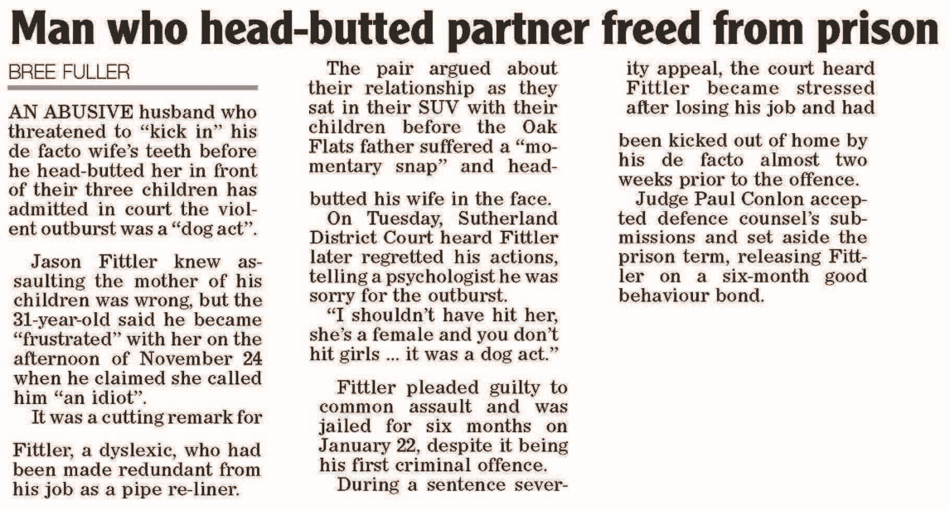
Text alternative at the end of the document

Figure 25 The Advertiser, 2 June 2015
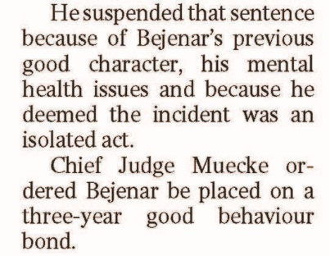
Text alternative at the end of the document

Role of gender
Prior research on male and female characterisations in Victorian print media noted that traditional gender roles may affect the way in which male perpetrators and female victims are described in the news (Morgan & Politoff, 2012). We found few differences overall in the types of background information for male perpetrators in comparison to women. Around a quarter of all media reports used the perpetrator’s name (28.8%, 128/444) with a similar proportion naming the female victim (31.5%, 140/444). A slightly higher proportion referenced the age of the victim (29.3%, 130) and their occupation (20.7%, 92) in comparison to the age and occupation of the perpetrator (24.1%, 107; 17.8%, 79). The culture, ethnicity and/or country of birth were infrequently reported for both men (4%, 18) and women (3.8%, 17). Few news items identified either victims or perpetrators as being Indigenous, but if it was mentioned, it was more likely to be about a perpetrator (2%, 9) than a victim (<1%, 3). Caution is warranted in interpreting this result given the difference is based on very low numbers.

Figure 26 brisbanetimes.com.au, 18 May 2015
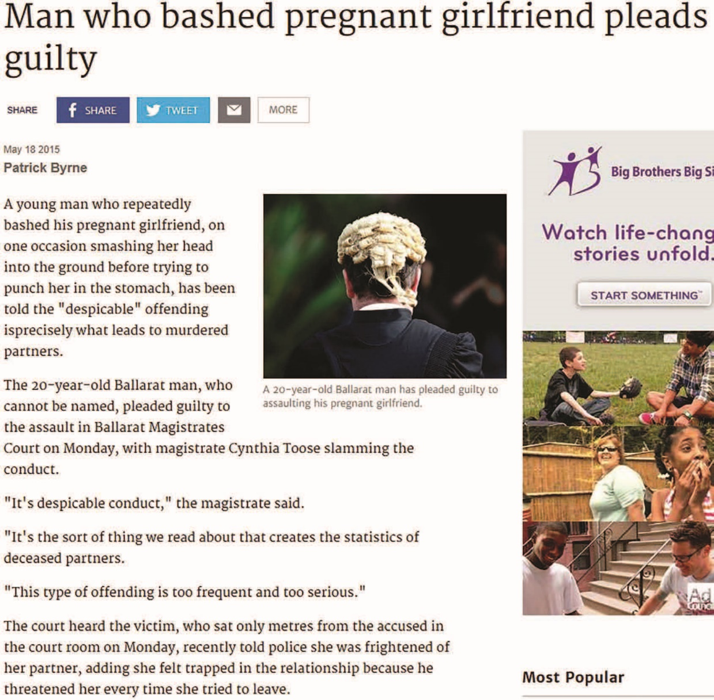
Text alternative at the end of the document

Sources of authority and opinion
The people, professions or associations cited by media indicate to audiences who is regarded as the authority on the situation. The way the incident is portrayed, including situating violence within a broader social context or providing sources of help for women, can be influenced by who media choose to consult with and cite in their coverage.
For each print, online and broadcast item, coders identified those sources that informed the story including those who were quoted or paraphrased.

Sources of information
Overall, close to three-quarters of all news items quoted or paraphrased an external source of information (70.1%, 311). News items that were primarily discussion-or issues-based were more likely to quote or paraphrase an external source than news items that were about individual incidents of violence (85.5% versus 60.2%, p<0.001).
Table 7 outlines the most common sources of information and shows that, consistent with previous literature, police were the most frequently quoted or paraphrased source across all media items on violence against women. Legal and criminal justice professionals including police, judges, magistrates and lawyers accounted for half of all sources.
Online and broadcast news items were significantly more likely to quote or paraphrase criminal justice personnel (police, judges, magistrates, lawyers) than newspapers (44.2%, 38.4%, 17.4%, respectively, p<0.001). Although domestic violence advocates were only featured in about 10 percent of news reports, the following example in Figure 27 highlights the value of their perspective.

Table 7 Sources of information quoted or paraphrased (of those that used sources, n=311)*
Source | Frequency | %
Police | 94 | 30.2
Politician | 90 | 28.9
Perpetrator | 34 | 10.9
Judge, magistrate or coroner | 33 | 10.6
Domestic violence advocate and/ spokesperson | 31 | 9.9
Lawyer | 28 | 9.0
Family of victim | 27 | 8.7
Victim/survivor advocate | 24 | 7.7
Other media outlets | 18 | 5.8
Reports, documents or legislation | 14 | 4.5
Neighbours or bystanders | 13 | 4.2
Academics | 10 | 3.2
*Coders selected more than one source (if applicable), therefore frequencies and percentages do not add up to 100

Figure 27 The Advertiser, 7 May 2015
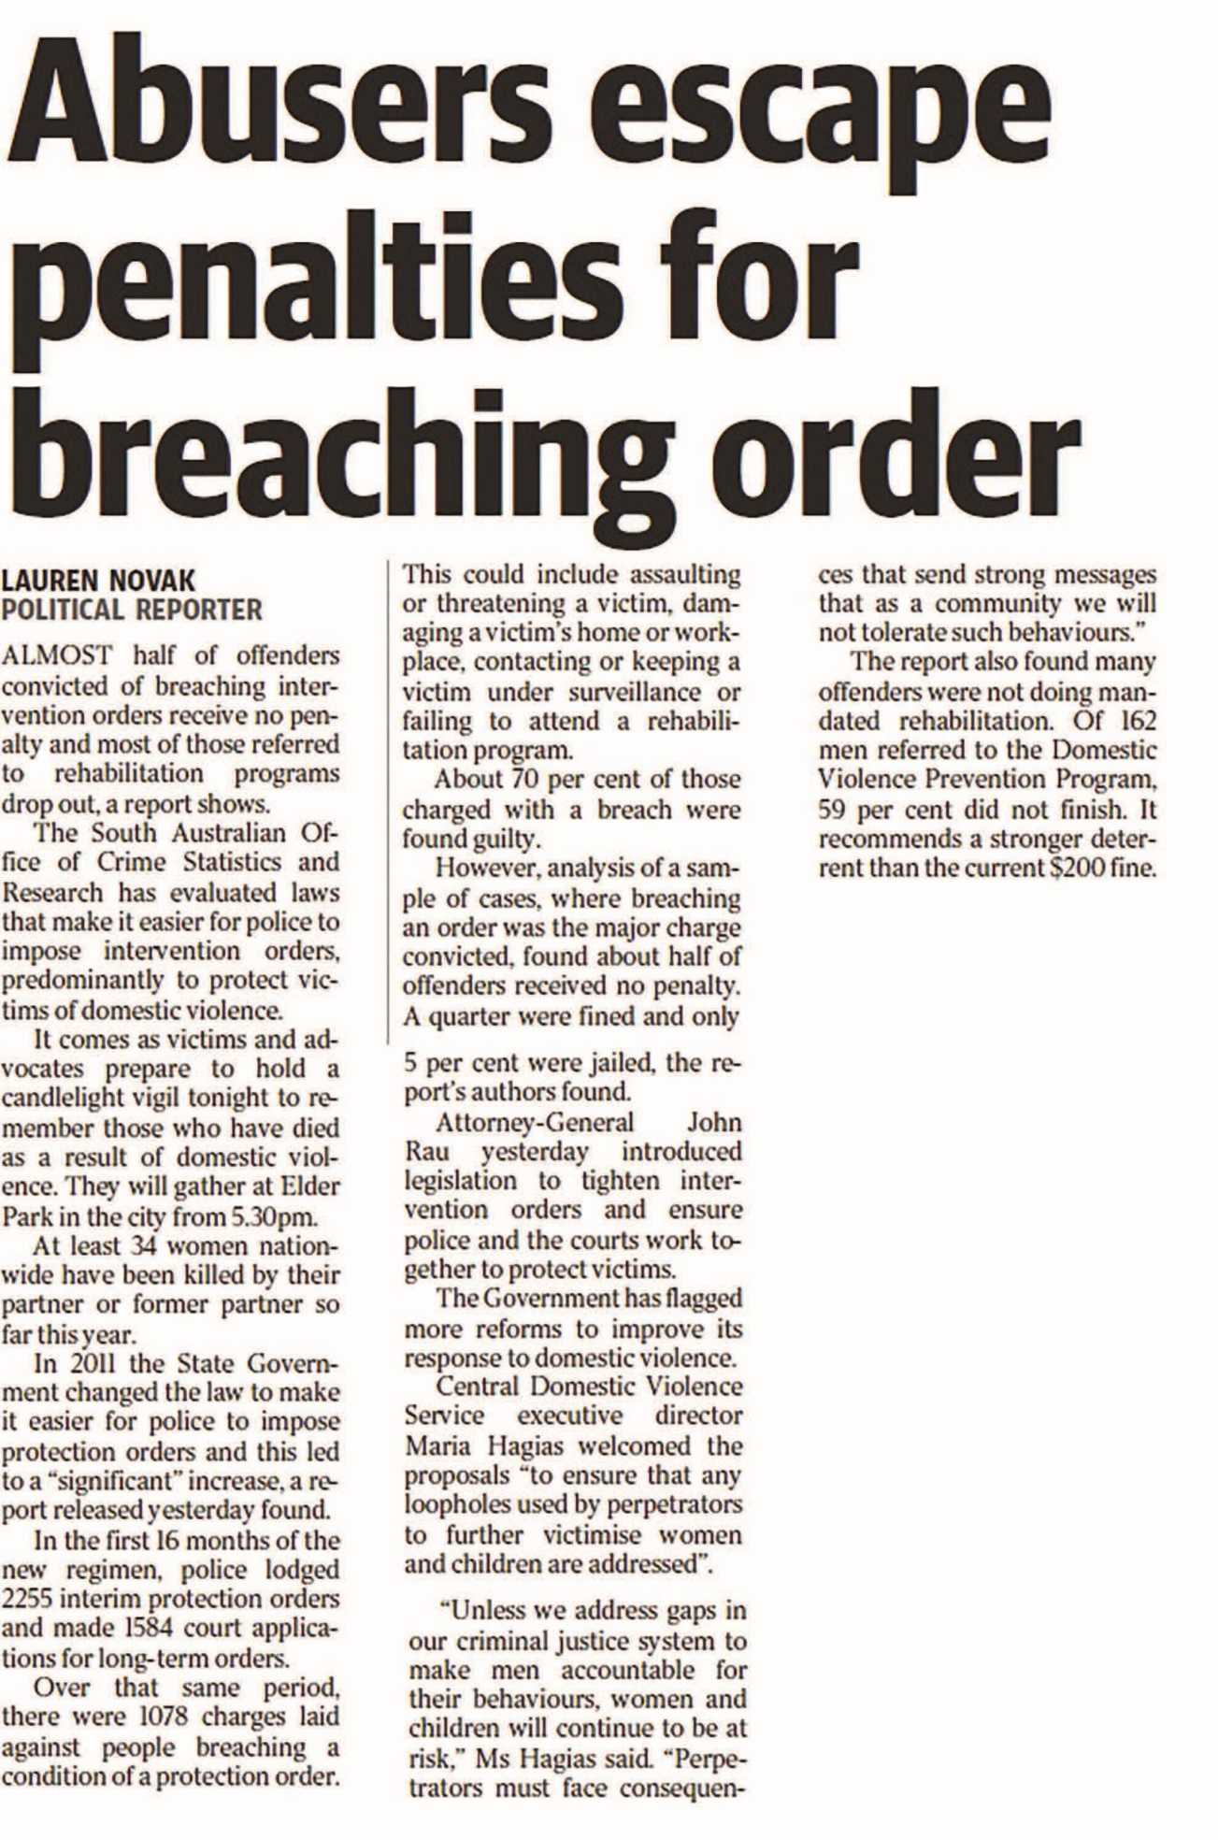
Text alternative at the end of the document

Discussion and summary of key findings

The extent of reporting on violence against women
In the 4 month data collection period, we captured 4516 items in connection with violence against women. Taking account of syndication, these items appeared in print or broadcast media more than 15,000 times. Radio broadcasts outnumbered all other media platforms, which is not surprising given the way news is presented in this medium (i.e. regularly and in high repetition). However, the high volume of items captured from online news sites in just 2 of the 4 month data collection period, suggests that it is within this medium that the highest volume of reporting on violence against women occurs.
Our findings indicated that media reports on violence against women have the potential to reach a wide audience. A number of the top media outlets, in terms of volume of reporting, also represented some of the most popular newspapers, news talk radio stations and online news sites in the country, including 2GB, The Daily Telegraph and news.com.au. Only 20 percent of items first appeared, or were broadcast, in regional areas of the three states. However, this result may be an artefact of syndication and/or our sampling frame, particularly in regard to newspapers (explored in more detail in the third section) and may not necessarily mean that regional audiences were exposed to less media coverage on the topic.
Results showed a fairly consistent daily pattern in news reporting with a higher volume during the week and a significant decline across all types of media on the weekend (Saturday and Sunday). Much of the decline on the weekend could be attributed to a much lower frequency of radio broadcasts. There was considerable month-by-month variation also, largely because of a number of high profile media stories, in particular the murders of Masa Vukotic and Stephanie Scott, indicating that reporting on the issue is very much influenced by key news events.

The nature of reporting on violence against women
Most media covered the issue of violence against women as if it were a series of disconnected, random events. Not only were most reports based around individual incidents of violence, but explicitly situating those experiences for women within the broader social context was infrequent (Bullock, 2010; Bullock & Cubert, 2002; Marhia, 2008; Morgan & Politoff, 2012). In comparison to both newspaper and online articles, broadcast news had the highest proportion of reports that covered individual incidents only and likely reflects the way in which news is delivered in this format. Few news items reported on incidents and/or the issue of violence against women outside of Australia.
Less than 5 percent of items included any information for women about where to seek help. When media reports did include this information, it was variable and included advice for women to call the police or contact locally available resources including a self-defence class.
Some types of violence featured more prominently than others. Most news items were in relation to physical and/or sexual violence, leaving other types of violence, such as emotional and psychological abuse, economic control, social isolation and other forms of intimidating and controlling behaviours, largely invisible in media coverage. That most women who experience domestic violence are frequently subject to a continuum of multiple and inter-related forms of violence, often over a long period of time, was not well-represented in news coverage.
The high volume of media reporting about the murder of Stephanie Scott provided an exemplar for the way in which media prioritise tragic stories that fit key news values – sensational, curious, unusual, fatal -over stories that are typical of the realities of women’s lived experiences. Sometimes women are attacked by strangers, but most often they are hurt by people who are close to them. In Australia it is very rare for women to be murdered by someone other than a current or former partner.
While it remains an area of concern, the number of news items that used sensational headlines and unnecessarily graphic language to depict incidents of violence against women was in the minority. We also found that direct reference to misinformation about violence; why it occurs and who is to blame was rare. It was more common for news reports to provide narratives that, subtly and perhaps unintentionally, shifted the blame from perpetrators to women. Perhaps most disturbing was that close to 20 percent of news items on sexual violence referenced the behaviour of women, including that they had been “flirting” or had gone home with the perpetrator.
Although some news items indirectly provided excuses for why men use violence, perhaps most striking was the extent to which perpetrators were rendered invisible in the news. Close to 60 percent of news items that were about, or referred to, incidents of violence included no information about perpetrators. Violence against women is committed by another person, usually by a man, usually by a man that a woman knows, yet it is frequently reported as though that other person – boyfriend, husband, partner – does not exist.
Similar to previous research, we found that police, lawyers and magistrates were most frequently quoted or paraphrased in news items on violence against women. This “police frame” likely influences many other aspects of reporting on violence against women, including the types of violence that most commonly appear in the news and the language used to depict criminal offending.
Table 8 presents an overview of the key findings from the content analysis component of this report, arranged by topic area. Page numbers refer to the sections of the report which contain more detailed information.

Conclusion
In Australia, the news and information media play an important role in public understanding of important social matters. We found that while some media are attempting to report the issue within the social context in which men use violence against women, there is much potential to improve the quality of reporting and more accurately reflect the reality for most women. Our results point to some ways that might be accomplished.
Our key consideration was whether it was possible to modify poor reporting practices, particularly those that continue the harmful discourse that women play some role in men’s use of violence. On the basis of the evidence presented here, we believe the answer is yes, but success is likely to depend on how this is facilitated.

Table 8 Overview of key findings
Topic | Key finding | Page no.
Social context | - 61% incident/event-based  - 20.9% thematic/discussion-based  - 18.1% thematic with reference to individual incident/s | 26
 | - 17.1% included explicit information about the social context in which violence occurs | 28
 | - • 4.3% included help seeking information | 29
Sensationalism | - 75.8% related to physical violence  - 22.5% related to sexual violence/rape  - 61.8% related to fatal incidents  - 17.2% headlines were sensational | 32
 | - 13.3% used excessive, gory and/or overly sexually explicit detail | 33
 | - 7.7% used language to trivialise or minimise | 33
Misrepresentations and myths | - 38.5% of items explicitly stated the relationship between perpetrator and victim  - 6.9% included explicit misinformation and/or myths about violence and why it occurs | 37
Blame and responsibility | - 14.5% included information about the behaviour of women; 16% of reports on sexual assault/rape implied women had placed themselves at risk | 41
 | - 14.8% included information to exonerate or excuse men  - 59.8% included little or no reference to perpetrators | 43
Sources of authority and opinion | - 70.1% quoted or paraphrased an external source  - 49.8% of sources were legal and crime justice professionals including police, magistrates and lawyers | 46

Qualitative analysis of Australian news media reporting of violence against women and their children

Background
Media are central in providing the symbolic resources and tools for individuals to make sense of and act in the world (Couldry, 2012; Silverstone, 2002). With the increased pervasiveness of media in everyday life, social actors become increasingly “dependent on the public supply of meanings and accounts of the world in attempting to make sense of their own” (Silverstone, 2002, p. 762; see also Livingstone, 2009). That is not to say that audiences do not actively and creatively engage with mediated accounts but that deeply entrenched meanings circulated through the media over time can be difficult to recognise and challenge. Media attain much power and influence from its capacity to generate categories through which the social world is perceived and to grant or withhold legitimacy to the meanings generated by actors in other fields (Couldry, 2004). In adopting a socially oriented media theory we are centrally interested in the social consequences of the meanings circulated through media (Couldry, 2012). Of particular interest is the process of news framing and the role of journalists in selecting some aspects of a perceived reality and making them more salient so as to invite audiences to see issues, actions, actors and events in one particular way and not others (Entman, 1993).
Media representations of violence against women have been found to generate stereotypes and myths about “real” and “deserving” victims (Custers & Van den Bulck, 2013). Portrayals may be simplistic, misleading, and overly reliant on clichéd and “archetypal characters” as “ancient as they are inflammatory”— the seductress, the victimised man and the man-hating woman (Mead, 1997, p. 7). Further, Bullock (2010) and other feminist theorists suggest the news media tend to position violence against women as isolated incidents, rather than as a wider problem taking place within a social context marked by male dominance (Eaves, End Violence Against Women Coalition, Equality Now, & OBJECT, 2012; Jewkes, 2002, Sutherland et al., 2015); and not “as a cause and consequence of gender inequality” (Cerise & Dustin, 2011, p. 14-15). Indeed, a focus on a perpetrator as a social “outsider” creates the impression that violence against women is a rare action by a deviant individual, rather than the widespread social problem as measured by global crime victim surveys (Devries et al., 2013).
In these ways and more, media may maintain a social narrative about violence against women that negates the feminist perspective of gendered and sexist harms and reinforces myths and stereotypes. Certainly, our state of knowledge paper looking primarily at findings from overseas research concluded that “collectively, these studies illustrate that the media frequently mirrors society’s confusion and ambivalence about violence against women” (Sutherland et al., 2015, p. 51).
This component of the research project is aimed therefore at qualitatively investigating the nature of Australian news media reporting on violence against women. We draw on the literature review and other previous literature in our analysis and discussion of the findings.
Qualitative research – specifically critical discourse analysis (CDA) – is used to complement the project’s quantitative analysis findings. This text-oriented discourse analysis social research method is an appropriate methodology for this particular topic as it seeks to identify how power imbalances are textually rendered. CDA employs detailed linguistic textual analysis in examining texts and their social and cultural contexts:
The study of the social practices of news discourse assumes a dialectical relationship between society and journalism: the world acting on journalists and journalists acting on the world. (Richardson, 2007, p. 114)
Fairclough’s (1992) three-dimensional definition of discourse is the definition of discourse operationalised in this analysis – that is, discourse as simultaneously text, discourse practice and sociocultural practice. This approach considers the contexts of the text’s production as integral to the analysis. The text not only creates, maintains and reproduces power relations, but it also reflects them.

Method

The focus of analysis
The primary aim of this study is to examine the nature of news media reporting and so our focus is on the discursive practices through which journalists construct news stories. Journalists’ discursive practices can be subdivided into those of newswriting, news gathering and news editing.
The discursive practices of newswriting conventions, whether in print or online, include:
- the inverted pyramid news story structure, where the most important aspects of a news story come first, encapsulated in the lead paragraph or “intro” as it is also commonly known, with the facts sequenced descending in importance thereafter (Burns, 2013; McKane, 2014);
- aspects of the structuring of news stories, such as the placement of quotes and references to sources; who to quote and to what length;
- which aspect(s) of what they have said are included;
- the order in which sources appear in the story, which can signal a hierarchy of legitimacy to the reader;
- the incorporation, presentation and representation of “both sides” of the story (journalism’s “objectivity” and “balance” fundamentals);
- the lead paragraph’s contents, which indicates the “angle” taken; and
- the headline, as headlines are designed to attract readers’ attention, addressing both the reader and the content of the news story (Richardson, 2007).
Words and how they are used play a very important role in constructing reality. For example, deletion of agency through “the passive voice” in sentence construction is important because it “can remove important (perhaps uncomfortable) political implications” (Richardson, 2007, pp. 49-56). Similarly, the use of metonymy – which may involve replacing the actors in a process with a description of the process itself -may serve to obscure who is accountable for certain actions (Richardson, 2007).
The news gathering discursive practices include:
- the identification and selection of an event as a news story;
- sourcing practices, such as decisions regarding the selection of whom to contact for the news story;
- the use of other texts in constructing the news story (a consideration of “intertextuality”) such as press releases, earlier news stories and other material on the subject; and
- the monitoring of other media outlets, which often results in everyone reporting the same stories and in the same way, that is, “interinstitutional news coherence” (Schudson, 2011, p. 109).
Finally, the discursive practices involved in news editing, that is subediting/copy-editing, also involve decision-making processes (Burns, 2013) such as decisions around:
- what aspects of the news report to leave intact; the process of fact-checking and what to check (a consideration of verification);
- determination of the most newsworthy aspect of a story, as represented by the lead paragraph and the headline (a consideration of "angle");
- in what order the facts are presented (a consideration of hierarchy, e.g. hierarchy of sources and hierarchy of importance); and
- what gaps there might be in the story that require redress (considerations of balance, fairness, objectivity, bias, completeness).
Regarding the consideration of “angle”, the large body of work by framing theorists such as Gans (2003) and Entman (1993), after Goffman (1974), demonstrates the important influence of social and cultural values on news framing processes and assessments of news value.

Choosing the case studies
Fairclough recommends a data selection strategy that focuses on what he calls “moments of crisis” because of their potential to show up aspects of routine practices that otherwise might go unnoticed (Fairclough, 1992, p. 230). The three cases selected for analysis received a relatively high volume of reporting within the timeframe under examination, 22 February to 22 June 2015.
Broadcast news items in the data set were only available as summaries, whereas newspaper and online articles were provided as either full press clippings or as a link to the online site. As a result, the critical discourse analysis was limited to newspaper and online news items.
The most prominent story in an initial scan of the first 4 weeks of data collection was that of “nightclub rapist” Luke Lazarus. This proved to be a very interesting case for our purposes, in terms of actors and their respective representations, so the analysis began by gathering and analysing the Lazarus news stories from across the full data set.
The next two case studies were selected to ensure that we substantially covered news media reporting of domestic violence by focusing on intimate partner homicide. From a scan of the 929 print newspaper reports gathered about violence against individual women, it emerged that there was rarely more than one news report per victim. However, we also wanted to avoid cases with high volumes of reporting which would be difficult to analyse within the project’s time constraints. Ultimately, the three most prominent cases in the data set, that of the further trials of Jill Meagher’s murderer Adrian Bayley, and the murders of school teacher Stephanie Scott and school student Masa Vukotic, were excluded as they were not cases of intimate partner homicide.
Apart from those cases mentioned above, two further cases emerged as attracting a higher volume of reporting in the print media, which also fit our self-selected criterion of cases of intimate partner homicide: one of a woman who kills (case: Jessica Silva) and one of a man who kills (case: Salwa Haydar). On closer examination, all three cases fit the designation “moments of crisis”.
The relatively higher profile of these three cases in the news media marks them out as different in the news media discourse about violence against women. Furthermore, the apparently more newsworthy aspects of the incidents – as evidenced by the focus of the news reports – appear to be what marks them out as different in the news media discourse among violence against women stories. The inverted commas in the sentences following indicate prominent aspects of the news media representation, pointing to their assessed news value. The first is the story of a “privileged”, “powerful” young man, Luke Lazarus, who “had the world at his feet” when he “anally” raped a “naive” teenager he had just met. He insisted to the last in court that the encounter was consensual and he was furnished character references by “several prominent Sydney people”, including a senior diplomat, a mayor, a priest and an NRL club CEO.
The second case, that of Salwa Haydar, is of a “former domestic violence counsellor” and “immigrant” “woman of morals” who was murdered by her estranged husband “who had just returned from a funeral in Lebanon”.
The third case, Jessica Silva, is the story of a “good” woman charged with murdering her abusive, “psycho”, “ice addict” ex-partner, who himself was a “murder suspect” and whose abuse of her was picked up in police surveillance of him. However, that surveillance also picked up her telling her brother that she would “stab him [her ex] myself”.
The decision to select these cases, each of which had received attention in the media, is justifiable on the basis that these cases deal with different forms of and responses to violence against women and they were reported across multiple news media outlets. Therefore, their examination would likely show up different aspects of routine journalism practices perhaps relating to the different forms of violence, and could be illuminating of journalism practice more generally, rather than that of a single media outlet (see Appendix C for a list of media items used in the case studies).

Analysis
The state of knowledge paper (Sutherland et al., 2015) identifies the following key themes in media reporting about violence against women:
- not reporting the social context in which male-perpetrated violence against women occurs, perhaps unintentionally by omitting necessary information;
- sensationalising stories through language or by disproportionately focusing on violent crimes that fit key news values, but which are statistically unlikely;
- perpetuating myths and misrepresentations so as to skew public perceptions about who perpetrates violence against women, who is at most risk of violence and where violence occurs;
- directly and indirectly shifting blame from male perpetrators of violence and assigning responsibility for violence to women by focusing on the behaviour of women and their role in both the causation and prevention of violence;
- relying on law enforcement as the expert “voices” that inform debate in the media to the detriment of women with lived experience, advocates, service providers and researchers.
In approaching our analysis, it was necessary to set aside such pre-existing ideas to allow findings to emerge from an inductive analysis of the data. We were open to identifying new themes and ways of understanding. We wanted to see, for example, how the themes emerge, work together, and might conflict in the different types of reporting and cases, as well as to identify and examine the journalism practices involved in the news stories’ production.
The process of analysis involved continually asking questions of the text, what it reveals about journalists’ discursive practices and how these shape the meanings produced. The analysis and our discussion tell the story of what is going on in and around the text.
[T]he producer and the mode of production encode meaning into the text (choosing one story over another, choosing to foreground one view rather than another, choosing one word over another etc.); but the text also acts on the producer, shaping the way that information is collected and presented due to the conventions of the text genre under construction. (Richardson, 2007, p. 40)
The news text is the text genre being analysed. The construction of the news text, as a genre, has particular conventions. In approaching each of the news texts, attention was first paid to the headlines and lead paragraphs as these are key framing devices. In analysing the body of the news text, attention was given to lexical features, such as referential strategies (how an actor is represented, the word choices used to describe them, and what work such words do to socially position the actor). We recorded passive sentence constructions such as “a woman was killed”, which deletes agency by not telling us who caused the death. Structuring elements, such as transitions between points of view or aspects of a story, as well as what facts are foregrounded and backgrounded in the “inverted pyramid” newswriting structure, were also noted. Attention was paid to how details about the violent incident in question were presented, such as the use of verbs, adjectives and other descriptors. Other aspects recorded included the sources used in the news stories: who is quoted, who is quoted first, who is only referred to, who is the dominant source and do any other sources support or undermine their point of view, and how are competing points of view represented. Semiotic elements such as photographs, pull quotes and other graphic elements were examined for their meaning-making potential.
We also sought to discern the different discourses drawn upon in news reports, such as the Madonna/whore dichotomy (Summers, 1994), and the assumptions, norms and values upon which these discourses rest. Importantly, attention was also paid to what is not included in the news reports, such as other ways in which the story could have been framed or presented, or other voices that could have been included.
The following categories emerged in examination of the first case study (Lazarus) as potentially significant to how the news reports were presented, and were grouped to allow the emergence of themes:
- headline;
- journalist (including whether they are male or female);
- lead paragraph (the “angle”);
- representation of the victim;
- representation of the perpetrator;
- representation of the location;
- representation of the interaction before the assault;
- representation of the assault;
- representation of the aftermath;
- representation of the effect;
- representation of other actors, such as friends and family;
- representation of supplementary sources;
- considerations of relative dominance of voice;
- considerations of relative dominance of point of view;
- absences (information left out);
- “unnecessary” detail included (pointing perhaps to salaciousness);
- textual features (including lexical choices);
- discursive practices (the journalistic processes that produced the news stories);
- sociocultural context;
- themes;
- whether any of the literature review themes in the state of knowledge paper were discernible;
- the tone;
- power relationships;
- thoughts on the overarching research question: how media portrayals can create, solidify, reproduce or challenge public opinion about violence against women and their children;
- identification of any of Bullock’s (2010) three frames:
  - the dry and impersonal “law enforcement/legal system” frame;
  - frame suggesting those involved in violence against women are inherently different from other people;
  - frame that emphasises that these deaths (and crimes) affect people other than the victim and perpetrator, such as their children, other family members, friends as well as members of their community;
- variation by media type, including different outlets.
This list was adapted for the next two case studies, with categories added and deleted as appropriate. News reports within each case study were examined for emergent themes, which were then compared across the case studies to discern any overarching themes emerging from the CDA of news reporting of violence against women in Australia.

Caveat: Self-reflexivity
A further, fundamental aspect of the CDA methodology is self-reflexivity. Reflexivity is understood as a “self-aware and self-critical attitude” (Gomm, 2009, p. 290) in the process of research and analysis. It is of vital importance in CDA because the researcher is a socially situated, not an objectively omniscient, being. As researchers, our values, beliefs, attitudes, experiences and research aims, among other things, can affect analytical choices and interpretations. Therefore, to attempt to reach as robust a conclusion as possible, self-reflexivity needs to be both practised and made explicit.
In undertaking this research each of the researchers has been self-reflexive regarding our beliefs and feelings about violence against women and mindful of how our outlook could colour our perceptions, our decisions about what to pursue and, in turn, what we may inadvertently overlook in analysis. As Carol Grbich writes,
Reflexivity can be simply defined as viewing the self and the process of data collection and interpretation in a critical and detached manner through internal dialogue and constant (and intensive) scrutiny of ‘what I know’ and ‘how I know it’ ... in the development of knowledge claims. (Grbich, 2004, p. 71)
It is important that we as researchers are explicit about where we stand in relation to journalism practice and violence against women in Australia. Our analysis is informed by our feminist perspectives and respective backgrounds in media and socio-legal analyses. Because of our backgrounds we are well aware of recurrent issues in media reportage and the socio-legal context of violence against women and undoubtedly our analysis is shaped by this awareness. Self-reflexivity involved stepping back from our analyses to consider other ways of interpreting the data at hand as well as being explicit about our values and interpretive processes. In presenting our analysis we seek to provide the reader with sufficient data to be able to draw their own conclusions about the validity of our interpretations.

Case study 1: Luke Lazarus
Luke Lazarus, the 23-year-old son of a part-owner of Soho nightclub in Sydney’s Kings Cross, was convicted in March 2015 of raping an 18-year-old female club-goer in the alleyway behind the club in May 2013. The case was first reported on his conviction.

The stories in the sample
Nine print stories about the case were identified in the data set for inclusion in our analysis. They were published between 8 March 2015 and 19 April 2015. We analysed these stories first, followed by an examination of online news stories for evidence of similar or contrasting journalistic practices in reporting the case. The analysis of headlines, lead paragraphs and the body text is presented in turn in relation to the three themes that emerged as significant in the analysis: the representation of the location; the relative representations of the offender Lazarus and of the victim; and the representation of the crime.
These are the headlines and lead paragraphs of the print stories (see Appendix C for a full list of media items):
- Headline: Nightclub owner’s son guilty of sex crime at the Cross
Lead: The son of a prominent Sydney nightclub owner has been convicted of sexually assaulting a young female in an alleyway, behind a Kings Cross night spot run by his family (Ralston, 2015b).
- Headline: Rapist says his life was destroyed by conviction after alleyway assault
Lead: By his own admission, 23-year-old Luke Andrew Lazarus was a young man living a privileged life in Sydney’s eastern suburbs (Ralston, 2015c).
- Headline: Sex offender says life ‘completely destroyed’
Lead: The son of a Sydney nightclub owner who sexually assaulted a young woman said his life was ‘completely destroyed’ when news of his conviction broke (“Sex offender says life ‘completely destroyed’” 2015).
- Strapline: Sex assault: offender boasted in text
Headline: Club owner’s son jailed for rape of teen in Cross alley
Lead: A nightclub owner’s son, who sexually assaulted a teenage girl in a Kings Cross alley and bragged about taking her virginity, has been sentenced to at least three years’ jail (Hall, 2015a).
- Strapline: Sex crimes: Minister challenges referees
Headline: Goward slams supporters of man convicted of raping teen
Lead paragraph: A series of prominent public figures who offered character references for a convicted rapist have been slammed by Australia’s first Minister for the Prevention of Domestic Violence and Sexual Assault (McKenny & Olding, 2015).
- Headline: Anger over club rapist’s testimonials
Lead: Women’s campaigners are urging the Director of Public Prosecutions to review the sentence given to a nightclub rapist as controversy deepens over “glowing” character references provided by some of Sydney’s most powerful figures (Olding, 2015a).
- Headline: NRL asks Souths for please explain
Lead: The Rabbitohs have battled an image problem when it comes to their treatment of women since they were strongly condemned for the way they handled the Kirisome Auva’a case (Weidler, 2015b).
- Headline: Nightclub alley rapist to contest his conviction
Lead: A man found guilty of sexually assaulting a young woman in an alleyway behind a Kings Cross nightclub owned by his family is set to appeal against his conviction (Ralston, 2015a).
- Headline: Ire over report on Lazarus reference
Lead: South Sydney were up in arms over our column last week in which we revealed the Rabbitohs were issued a “please explain” by the NRL about their chairman Nick Pappas writing a reference for Luke Lazarus (Weidler, 2015a).
There were also 11 online news stories in the data set about this case, which were examined for the purposes of comparing and contrasting their characteristics with the print media. The comparative characteristics of all 11 are summarised (see the Differences between online and print items). Three online exemplars are explicitly drawn on for illustration purposes in the analysis: Australian Associated Press (2015e), Australian Associated Press (2015d) and Hall (2015b).
As is evident, the print headlines had three dominant focal points: the location of the assault; the perpetrator’s character and the effect of the trial on him; and the crime itself. The headlines focused on the victim to a much lesser extent. The perpetrator’s supporters became a focus by the sentencing hearing, at which their character references for Lazarus were furnished. Lead paragraphs typically described Lazarus as the son of a prominent nightclub owner and described his crime as a sexual assault. As we will show, there were also some other notable lexical choices recurrent in the body text, whereby different stories contained similar features, for example, in relation to graphic descriptions of the assault itself. Additional noteworthy features of the reporting that we identified concern the disproportionate focus on the perpetrator compared to the victim, including his family relations and the effect his crime had on him (arguably representations which worked to present him sympathetically) and the associated muted and selective reporting of the victim impact statement and the emphasis on the victim’s virginity (representations which arguably served to disempower her by minimising the impact on her while at the same time imbuing her with “good” victim status, as opposed to, for example, a sexually active woman).

The representations of the location
The location of the assault was referred to in five out of the nine headlines: as being at a club/nightclub, at Kings Cross and/ or in an alley [1, 2, 4, 6, 8]. This frequency of reference to the location indicated that this was deemed by journalists (reporters or editors) to be a significant, newsworthy aspect to the story. The emphasis on the location imbued the news stories with a sensationalist tone. With reference to the sociocultural context, the location was positioned within the discourse of Sydney’s Kings Cross being a notorious Australian nightlife precinct of sex clubs and late-night dance clubs, with a history and present peopled with colourful characters and criminal acts such as drug-dealing and alcohol-fuelled street fights.

The relative representations of the perpetrator and the victim
The perpetrator’s character and the effect of the trial on him was the subject of seven out of nine of the headlines [2, 3, 4, 5, 6, 8, 9]. In contrast, the victim had little presence in the headlines, appearing – as “teen” – in only two of the nine headlines [4, 5].
Lazarus’s conviction was framed as an archetypal fall from grace in one story [2]. The first three paragraphs of this news story read like a biography or curriculum vitae for Lazarus, with reference to his privileged upbringing and the opportunities afforded him, along with his promising future. The fourth paragraph was the real lead, the crux of the story: the reason for the court case. This “delayed lead” is not a usual newswriting style, but it is commonly a feature-writing device employed to create dramatic tension or dramatic effect (Ricketson, 2004).
In contrast to other stories that hedged his conviction and his crime, Lazarus was represented somewhat negatively in both [4] and [5]. In [4] he was reported as “bragging” in a text message to his friend about “taking” the victim’s “virginity”. It is an Australian social norm that bragging is frowned upon (the emphasis on the victim’s virginity is discussed below). He was clearly represented as a rapist in [5]. Furthermore, the “prominent public figures” who provided him with character references were represented as doing the wrong thing, that is “slammed” for doing so.
Lazarus was often portrayed in terms of his family’s power. As the son of a prominent Sydney club-owner, he was represented as using this status to lure the victim into allowing him to lead her away from her friends [1, 2, 3, 4].
During the secondary analysis of the online news stories in order to discern differences in journalistic discursive practices compared to the print news stories, it emerged that in some it was reported that although Lazarus’s power was garnered from his family, his family wielded power over him: that they ordered him to break up with an American girlfriend he was “obsessed” with. According to the news reports, an expert witness at the trial said this had an adverse psychological effect on Lazarus and mitigated his mental state at the time of the attack, an argument that was accepted as evidence by the judge in her summing up. The judge also “accepted he had experienced bullying at school, in part due to his short stature” [4].
The effect of the conviction on Lazarus was foregrounded in [3] with his quote about how his life was “completely destroyed”. Importantly, both he and the reporter framed this devastation as occurring “when news of his conviction broke” – it is the news of the conviction, rather than the assault that led to the conviction, or even the conviction itself, that was problematic for him. This was borne out in the body text: the angle of the story [3] in total was his assertion that he was wrongfully convicted and his feelings about that.
In contrast to the muted reporting of the woman’s victim impact statement (discussed below), Lazarus was reported as having “cried throughout his hearing” [2], and as having “cried as he told the court he once had “the world at my feet” [4]. This detail positions him as pitiful and perhaps to be pitied, and was reinforced by his reported direct quotes that his life had been “completely destroyed” by the incident making the news [3] and that since his conviction he has been “utterly inconsolable” [3] and “has been ‘vilified’ on social media” [4].
While there was a lot in the news reports about how the conviction affected Lazarus, there was little about how the rape affected the victim. As a source in the news texts, we hardly heard her voice. Her “voice” was usually represented by the police voice, whereby her experience of the attack was distanced, made clinical for examination. A couple of quotations from her victim impact statement were all that was heard directly from her point of view.
In [2] for example, it is reported that at the court hearing, “a victim impact statement was read out on behalf of the woman”, quoting from it: the attack “changed her life forever, the court heard”; “The woman said a part of her died that night and she has hated that her siblings have seen their ‘tough little sister fall apart’”; that she “never knew what it was like to feel so helpless”; “I thought that once I left the alleyway the pain would go away… but it didn’t”.
In [3], the woman’s victim impact statement was only introduced in the final paragraph of the news story, which served to relegate the importance of her statement and her voice as least important in the inverted pyramid news-writing structure. Her status was further undermined elsewhere in the story by the inclusion of Lazarus’s forceful assertion that he still believed that the victim consented [as was reported in others, e.g. 7].
A common characterisation of her victim impact statement across the print news texts was that she has lost trust in people, for example in [3], “I never knew what it was like to feel so helpless… A part of me died that day, the part that trusted others, the part that saw the good in everyone”. While this is of course important testimony, given it is her voice, the decision to foreground and only include this aspect of the victim impact statement in the news texts served to discursively minimise her experience. “Lost trust” is an abstracted account of her reaction to the attack. There were more concrete and, we would suggest, more powerful descriptions of her reaction available. Descriptions such as how she sat in the bath for days after the attack, and how, for the two years since, she had often cried so hard that she could not breathe and cried for so long that she could not cry any more. This latter, more concrete, description was chosen less frequently, and only for online news texts. This similarly selective reporting of her victim impact statement across print news texts cannot be explained alone by the relative restrictions on space for news reports in print versus online. It points to editorial decisions made on the perceived relative newsworthiness of aspects of her victim impact statement.
The strategies used in the stories to place emphasis on the victim’s youth, inexperience and virginity were notable. For example, the victim was a “young woman on her first night out in Sydney” [1, 2], or on “her first visit to Kings Cross” [4, 6], with her virginity at the time of the attack being a recurrent lexical feature across the news texts [1, 4, 5, 6, 7]. These common descriptors of her youth and inexperience discursively lent a certain heinousness to the crime, which has the implication that a more experienced woman would be a lesser victim. They worked to mark her out as ”different” perhaps to other “types” of women who are subject to sexual violence.

The representations of the crime
The crime was mentioned in seven of the nine headlines [1, 2, 3, 4, 5, 6, 8]: being described as one of “sex” in four of them [1, 3, 4, 5], as rape in five [2, 4, 5, 6, 8] and assault in two [2, 4]. An exemplar of the dominant framing is [1]: powerful man rapes young woman in sordid/notorious location. An example of the conflation of sex and rape in some of the news stories included when Lazarus was reported as saying he is concerned about “every person in Australia, or at least in Sydney, knowing that I have been convicted of a sex offence” [2, 3, repeated online]. This was reported uncritically, left unchallenged in the text by, for example, the inclusion of another voice or source to balance his characterisation of his conviction as a “sex offence”. He was also still asserting his powerful place as a central societal figure: that “every person in Australia, or at least Sydney”, would be interested in him. His characterisation of his crime as a “sex offence” discursively minimised his conviction for rape, which is arguably a more powerful and immediately understandable description of the crime he committed.
Although Lazarus was found guilty of rape, his insistence at his sentencing hearing that he still believed the assault to have been consensual sex was commonly included in news reports [1, 2, 3 and repeated online]. This can be seen as discursively undermining the sentence, the complainant and the complainant’s testimony. The last three paragraphs of [2] detailed how he still believed and argued forcefully that he was innocent, including the quoted assertion that “I still 100 per cent state I believe everything that happened on that night was consensual”. This directly undermined the victim’s testimony. At the same time, the inclusion of Lazarus’s maintenance of his innocence also works to illustrate that perpetrators of violence against women rarely admit that they have caused harm, and often portray themselves as the victims if any legal/other action is taken against them. In addition, his comments help to expose his character; having just been found guilty of rape, rather than express remorse for his crime, he is concerned about his image in the eyes of Australians.
In terms of the social construction of virginity, when Lazarus was reported as boasting or bragging to a friend of having “took a chick’s virginity” [1, 4, 5, 6] to which his friend replies, “LOL. Nice popping does cherries” [1, and repeated online], this was not only the language that Lazarus used but also the language used by the reporter. That virginity is something taken is a cultural construct and, while it was most definitely “taken” in this case because consent was not given, “taken” in the context of consent being given is worth examining in the context of its cultural construction. The idea of virginity as something that is taken draws on the discourse of male predatory sexual conquest and of female virginity being an object or prize for the taking.
In many news reports, both print and online, this rape was reported in pornographic detail. For instance:
Lazarus told her to ‘put your f---ing hands on the fence’ before telling her to ‘get on her hands and knees and arch your back.’ Lazarus then had anal sex with the woman for 10 minutes. [2]
We would argue that this unnecessary detail in a way discursively re-raped the victim for the readers’ entertainment. This graphically detailed reporting is usefully contrasted with The Guardian (Australian edition) online newspaper’s handling of the reporting of the assault. The factual lexical choices made in The Guardian’s report, eschewing the graphic detail given in evidence and foregrounded in other news reports, provided an example of how the scenario was able to be discursively rendered by foregrounding the crime without degrading the victim.
He pulled her stockings down, ignored a second request by her to leave and then demanded she stand in a way that he could force himself on her. Scared, she complied. (Australian Associated Press, 2015e)
A degree of mutuality was implied in some of the news reports. For example, [1] reported that after Lazarus lured the woman outside, “the pair kissed”. “Pair” denotes some relationship, whereas they had just met. This discursively rendered mutuality was also evident in [4]: “The couple kissed but she said she wanted to return to her friend”. As with “pair”, “couple” implies a relationship.
The fact that Lazarus swore aggressively at her, making her more afraid was clear in some reports and glossed over in others. For example [1] reported that: “He told her to put her hands on the fence…”. The paraphrase of what he said with “told” masks the coercion of what he did say, which was “put your f---ing hands on the fence” [2] or “put your f---ing hands on the wall” [4]. It is noteworthy that these reports [2, 4] utilised the discursive practice of blanking out the verb (and [1] omitted it altogether) to avoid causing offence to readers. This suggests an editorial decision was made that the graphic rape detail, as analysed above and further discussed below, was considered suitable reading material, but the swearing was not.
The graphic descriptions of the rape can be seen as a “male gaze” reporting style. In contrast, the story [5] written by two female reporters omitted all the salacious detail that many of the other reports contained:
[H]e had lured the 18-year-old into an alley behind his family’s Kings Cross venue by telling her they were going to a VIP area. He anally raped her after she tried to leave.
The anal nature of the rape was referred to in many of the reports [1, 2, 4, 5, 7], e.g. “As he anally raped her, she told him ‘I’m a virgin’” [4]. [2] reported that, “Lazarus then had anal sex with the woman for 10 minutes.” The “anal” nature of the rape was a detail contained in many of the reports. It could have been usefully contextualised by the judge’s comments that this is a particularly degrading form of rape, but this comment of the judge’s was only included in one of the print news reports about the case.
The two headlines that did not mention the crime were two columns by commentator Danny Weidler in the Sun-Herald sports pages, in which he questioned the wisdom of South Sydney Rabbitohs NRL team’s CEO Nick Pappas in providing a character reference for Lazarus. Weidler’s commentary was situated within the sociocultural context of the discourse around NRL teams needing to “clean up” their treatment of women, in the wake of several incidents of players abusing women. In this context, while the offender, Lazarus, was not an NRL player, Pappas’ actions as a family friend were given added significance because they signalled a contradiction with his leadership role within the NRL and the game’s stated efforts to improve its treatment of women.

Differences between print and online items
There were 11 online news stories in the data set about this case (with some published multiple times across mastheads in the Fairfax and News Corporation stables respectively). Exemplars are given below to illustrate particular findings. In addition to The Guardian example above – which was not officially in the data set, but used to contrast the graphic detail of the attack – another difference that emerged from an examination of the online reports was the inclusion of more of the victim impact statement. That served to amplify the victim’s voice, and to present more starkly the effect of the rape on her, for example:
[T]he victim said she spent days sitting in a bath after the attack and, in the two years since, had cried until she ‘couldn’t breathe, crying until I physically couldn’t anymore’. (Hall, 2015b)
Apart from the few examples of what might be termed better practice, the differences between the print and online stories may be explained to a limited extent by the greater space available online, and can be summarised as follows:
- The woman’s voice was stronger in the online news stories in that much more of her victim impact statement was included, with the extracts chosen being in our judgement more visual, personal, raw and specific rather than the general quotes given in the print reports.
- Lazarus’s “excuses” for his behaviour were also given more space in the online stories, including that he was distressed after having split up with his girlfriend, that his parents had made him choose between her and them, that he was in a bad place mentally because of it, and that he had been bullied at school.
- Online stories afforded much more space for the Lazarus family to complain about how much the court case had badly affected them, including the effect the case had on their business.
- There was more space available in online stories for Lazarus to insist he still believed the woman had consented.
- There was more space for the family to make it clear that they had tried to keep the case quiet, to protect Lazarus’s “good reputation”.
- There was space for reader comments, which were universally condemning of Lazarus and of his family’s behaviour.

Conclusions: Case study 1

Power
The sociocultural context of Lazarus being from a prominent Sydney family, who are part of a prominent Sydney set, is reflected in the discursive practices of headline writing, framing in the lead paragraphs, and contrasting his power with his victim’s inexperience. Social power was at the forefront of this story: the perpetrator’s, his entitlement, his supporters and his maintenance of his innocence.
The victim’s innocence, youth and inexperience was emphasised in fitting with the archetypal Madonna/whore dichotomy, textured together with the sociocultural discourse that some victims are more innocent than others:
A Madonna-whore duality construction of gender sexuality and personality persists. ‘Good’ women are perceived as passive and essentially asexual and more plausible than their ‘promiscuous’ sisters. At the same time though, there is a view of all women as being, by nature, sexually unreliable: within the Madonna apparently lies the potential or dormant whore… Hence, the most credible females are those closest to purity for whom it is difficult to impute any provocation. (Easteal & Judd, 2008, p. 337)

Angles and alternative frames available that were not pursued
One story [5] contained information about an alternative angle that could have been taken. Its final paragraph – which is deemed the least important in the inverted-pyramid newswriting structure – was about how a priest, Father Gerasimos, who provided a reference for Lazarus had changed his mind. Gerasimos had distanced himself from his own reference, which was a highly newsworthy development given that the focus of [5] was Pru Goward’s criticisms of Lazarus’s supporters: Goward had just been appointed the NSW Government’s Minister for the Prevention of Domestic Violence and Sexual Assault. Gerasimos said in his reference that the charges against Lazarus were “an injustice”, but now “said he had provided hundreds of character references and ‘unfortunately made an evaluative statement that was not my place to make’”. An added angle to this was evident in the paragraph immediately preceding that containing the Gerasimos information, which reported that, “Dr Pappas said he had no comment to make” – another referee, Pappas, was not defending (or otherwise) his reference.
Interestingly, [5] also included a “do-up” breakout-box graphic containing photographs of Lazarus’s supporters and their quotes. This made their supportive comments a very prominent aspect of the story, amplifying them such that, even though the story’s angle was critical of the supporters, their comments dominated the story’s presentation. This could have been – but was not – balanced with a similar “do up” of the victim’s impact statement, or another oppositional voice. It included a photograph of Pru Goward, but there was no corresponding prominent text accompanying it.
The lead paragraph of [6] was odd, as it foregrounded information that was not elaborated on in the body of the story:
Women’s campaigners are urging the Director of Public Prosecutions to review the sentence given to a nightclub rapist as controversy deepens over “glowing” character references provided by some of Sydney’s most powerful figures.
The somewhat vague reference to “women’s campaigners” suggests that “women” is a homogenous category or that “women” is a campaign. Further, and genre-breaking for a news lead, these campaigners were not referred to again in the story. This suggests a discursive slip, pointing to an editing error, in that either new information was added in but not in its entirety, or some information was edited out but not fully. What is more interesting, however, is the claim that the campaigners “are urging the Director of Public Prosecutions to review the sentence given”. This points to a discourse of justice not having been served. Supporting this perspective was the assertion that “controversy deepens”. This intertextual reference presupposes that a controversy already exists, with “as” indicating a link between the sentence length and the controversy over the references. The implication was that the references resulted in a lighter sentence than otherwise might have been. However, this line of inquiry – the lighter sentence – was not pursued in the news story.
Fairfax Media inserted itself into the narrative as a social actor when [2] reported that an effect on Lazarus was that “…after Fairfax Media made public his conviction this month he had not been able to function”. This presented Fairfax as playing a Fourth Estate role, although the report – in the dialectical relationship between this textual feature and the discursive practices employed to create the news report – did not make clear how the conviction was thus made public in a way that it had not been before. It did not say, for example, whether there had been a suppression order in place or something comparable. If a suppression order or something similar had indeed been in place and had been lifted upon the conviction, this would have been a newsworthy point reasonably expected to be included in the news report. That it was unremarked indicates that it was something else – that perhaps the case had somehow flown under the radar and Fairfax had been alerted to it.

Case study 2: Salwa Haydar
This case study concerns an intimate partner homicide. Salwa Haydar was stabbed to death by her estranged husband, Haydar Haydar, in Sydney on 31 March 2015. Some reports said he attacked her at her home, which she had set up after she left him, while others said it was their, the Haydars’, home. One of her daughters suffered serious injuries to her hands while trying to intervene in the attack.

The stories in the sample
A total of 10 stories (four print and six online) about this case were identified for inclusion in our analysis. They were published between 31 March and 6 April 2015. In our analysis they are referred to as items 1 to 10. Items 3 and 8 are the same story in print and online, differing only in their headlines. They are referred to as (3/8) in the text. Number 10 is 9 reframed, differing in both its headline and lead paragraph. As with case study 1, the analysis began with the headlines and lead paragraphs, before moving to the body text, and is presented in turn in relation to the three themes that emerged as significant: the representation of the location; the representations of the victim and the perpetrator; and the representation of the crime.
These are the headlines and lead paragraphs of the news stories:

Print:
- Headline: Husband charged with wife’s stabbing murder
Lead: A Sydney woman who helped families tackle domestic violence as a welfare officer has allegedly been stabbed to death by her husband (“Husband charged with wife’s stabbing murder”, 2015).
- Strap: Domestic abuse: Minister pledges change
Headline: Goward: I’ll shift strategy to prevention
Lead: The country’s first dedicated Domestic Violence Minister has promised to radically shift the government’s focus to preventing violence rather than “picking up the broken pieces after a tragedy” (Olding, 2015b).
- Headline: Murder victim’s friend calls for more vigilance over violence
Lead: On their frequent car trips home from work, it was obvious that Salwa Haydar was going through a lot. She would tell her colleague and friend Christopher Edward about gaining the courage to divorce her husband, trying to buy her own house, helping her children through high school and grappling with her decision to stop wearing her hijab (Olding, 2015c).
- Strap: Domestic violence crisis
Headline: Urgent call to end the horror
Lead: The appalling number of domestic violence deaths across the state has prompted an urgent call for members of the public to intervene to help save the lives of friends, family and neighbours. Dinkus: Exclusive (Fife-Yeomans, 2015).

Online:
- Headline: Woman stabbed to death, daughter injured during domestic dispute
Lead: A man has been charged with murder after his wife was stabbed to death at their home in Sydney’s south (Partridge, 2015b).
- Headline: Mother dead after domestic attack: police
Lead: After helping families tackle domestic violence as a welfare officer, a Sydney woman has herself become an alleged victim (Najem & Benny-Morrison, 2015).
- Headline: Time for Tony Abbott to step up and tackle domestic violence in Australia
Lead: On Monday night Salwa Haydar was allegedly stabbed to death by her husband inside her Bexley home. In life, Salwa was a mother, sister, friend, counsellor, someone “highly regarded by her peers”. But in death, Salwa is now likely to be one of a growing number of women killed at least weekly across the country by a partner or ex-partner (Metcalfe, 2015).
- Headline: Salwa Haydar: friend of murder victim speaks
Lead: On their frequent car trips home from work, it was obvious that Salwa Haydar was going through a lot. Dinkus: Exclusive (Olding, 2015d).
- Headline: Mother-of-four Salwa Haydar stabbed to death, husband refused bail
Lead: A man has been charged with stabbing his wife to death and injuring his teenage daughter during a violent domestic incident at a southern Sydney home on Monday night (Partridge, 2015a).
- Headline: Sydney mother-of-four stabbed to death in front of daughter
Lead: A Sydney mother-of-four and counsellor once spoke about the devastation of losing her mother during a missile attack in Lebanon. It would have been hard for her to imagine that danger was a lot closer to home (Partridge & Olding, 2015).
The headlines about this homicide reflected two different types of reporting: five out of the 10 were straightforward news reports [1, 5, 6, 9, 10] and five were meta-stories of Australia’s domestic violence “crisis” [2, 3, 4, 7, 8]. Some of these meta-stories emphasised that “something must be done” to tackle domestic violence, with action urged of the political class [2], the community [4], or in general [7]. These tended to convey a sense of urgency about Australia’s domestic violence “crisis” and the need for action.
In focusing on representations of the perpetrator, the victim, the crime and the location in news reports, of particular interest in the analysis is how the following were treated in the story: ethnicity (of the victim and the perpetrator), the victim’s character, the history of domestic violence, the victim’s previous occupation as a domestic violence counsellor, and whether the Haydars were co-habiting. We also consider evidence for and potential impacts of the use of metonymy and identify problematic uses of the word “alleged” in the reporting.

The relative representations of the perpetrator and the victim
In terms of the relative representation of the victim and the perpetrator, Salwa Haydar was labelled in all five of the “straightforward” headlines (“wife” [1], “woman” [5], “mother” [6, 9, 10]). The victim in this case study, therefore, was afforded more presence in the headlines than that of Case Study 1. However, unlike Luke Lazarus, the perpetrator Haydar Haydar was explicitly referred to in only two of the headlines as “husband” [1, 9]). However, he was implicit in the passive constructions [of 5, 6, 10] as the obscured agent.
Of the news items in which Salwa Haydar was the main subject (as opposed to providing the context for a meta-discussion of domestic violence in general), two lead paragraphs framed the story as one of a domestic violence counsellor who had herself fallen foul of domestic violence [1, 6]. One lead paragraph [3, and the second paragraph of 8] framed the story as one of a woman trying to escape the strictures of her religion, rather than the other frame on offer – as a woman trying to escape an abusive husband. These contextual details (her previous occupation as a domestic violence counsellor and her religion) appeared to be offered by way of explanation for her murder. There was no mention of prior violence in any of the headlines or lead paragraphs. However, it was mentioned further down in some stories: that she “had been suffering clear abuse for many years” [2] and had come to work with a “bruised eye” [3/8]. The latter story also reported that Haydar Haydar had made “sporadic” Facebook posts the previous year – between when Salwa left him and when he murdered her – “of sermons or daily thoughts on controlling one’s anger and walking away from violence” [3/8].
An ongoing relationship between the perpetrator and victim was at times assumed in news reports: “her husband” [1, 2, 4, 6, 7], “the couple” [1], “his wife” [1, 5, 9], “their home” [1, 4, 5]. (However, [4] also has “her home” in an infographic). Other reports said that he was “her estranged husband” [3/8]. While sources named as “relatives” said that “the couple” had only recently moved to the address [9; also an unattributed claim in 10], this contradicted a friend [3/8] and an unnamed source [2] who said the Haydars had separated and Salwa Haydar had moved house either “recently” [2] or “by late 2013” [3/8], away from Haydar Haydar. Work colleagues also reportedly considered her “brave” [2, 3/8] and “strong” [2] for leaving her husband.
The Haydars’ ethnicity was the focus of three of the reports. This included their family ties to Lebanon [3/8, 6, 9/10]; her giving up the hijab [3/8]; and her being a “multicultural” counsellor on domestic violence [3/8]. Sources included “the Arab Council” [6], “the Muslim Women’s Association” [3/8] and “the Immigrant Women’s Health Service” [3/8]. There was also reference to Salwa being “shunned” by her community for leaving her husband [3/8]. Salwa’s former employer, Randa Kattan, from “The Arab Council” was represented as an “expert voice”, who claimed that there was no indication of domestic violence in Salwa’s home [6]. Another expert voice, the Immigrant Women’s Health Service spokesperson Eman Sharobeem, asserted that domestic violence is both an individual responsibility and the fault of the community as a whole [4/9]. In response to the suggestion that Salwa Haydar had “hinted to colleagues that she had been shunned by community members for ending her marriage”, Sharobeem was reported as asserting that “it was a common experience for migrant women, who often encounter oppressive cultural expectations to stay with violent partners” and was quoted as saying that, “‘They accept violence as part of the deal’” [3/8]. The report did not unpack what “community”, “migrant”, or “cultural expectations” were, nor who “they” were, leaving it up to the reader’s interpretation.
Salwa Haydar was commonly referred to as a mother of four [2, 3/8, 7, 9, 10]. Through selected quotes and paraphrasing, her good standing and character among those who knew her was emphasised: she was “a nice woman” [9] and “a hard worker” [2, 9], who was “very warm” [2], “a gentle woman” [2], who had “strong morals” [2] and a “very intact moral compass” [2]. This representation was echoed in the opinion piece [7] describing her as a “mother, sister, friend, counsellor, someone ‘highly regarded by her peers’”[7]. These representations positioned her as someone to whom something like this should not have happened, someone who did not deserve this, which has the implication that the character of others may make them more deserving.
The majority of the news reports detailed how Haydar Haydar went to the police after he killed Salwa Haydar. For example, he “handed himself in” [1, 6, 9, 10], “walked into Kogarah police station and spoke with detectives” [5] or “drove straight to” police [3/8]. That he drove “straight” to police is perhaps of note, as if Haydar Haydar’s direct surrender somehow mitigated his violence.

The representations of the crime
Of the five straightforward news stories, four of them referred to the crime as a “domestic” one (in the headlines of [5, 6] and the leads of [1, 9]), despite contested information regarding whether the Haydars were still co-habiting at the time of her death (see the analysis below for more detail). Three headlines were more direct in referring to the crime as “murder” [1, 3, 8], with three detailing that it was one of her having been “stabbed to death” [5, 9, 10].
Mutuality was sometimes implied, as in [5]’s headline reference to a “domestic dispute”. This phrase implies mutuality, as it takes more than one person to have a dispute. This wording was also contained in an infographic accompanying [4], which included the detail that Haydar Haydar “has been charged with stabbing her to death in a fit of rage”. The use of “fit of rage” could be seen as having mitigating connotations, perhaps similar to “crime of passion”, or it could also work to portray Haydar Haydar as a violent man, unable to control his emotions and actions.
A common discursive practice that serves to distance the perpetrator from the crime was the use of the hedging adjective “alleged”. It is routine journalistic practice to use “alleged”/”allegedly” for legal reasons, that is, so as not to prejudge a trial outcome by presuming guilt before guilt has been established. However, it was very often misused and/or misplaced in the sentence structure of these news stories, with the effect of casting doubt as to whether Salwa Haydar was a victim and indeed whether she was killed. It is a fact, not an allegation, that she was stabbed to death. However, pre-trial, it has to be treated in the news reports as an allegation, not a fact, that it was her estranged husband who stabbed her to death, because his guilt has not yet been established by a court of law. Examples of this construction being misused include: “allegedly been stabbed” [1]; “allegedly killed” [2]; “allegedly stabbed” [3/8, 4]; “alleged killing” [6]; “alleged victim” [6]; “allegedly stabbed to death” [7, 10]. In contrast, a “good” practice example of sentence construction using “allegedly” was that she “was stabbed to death, allegedly at the hands of…” [2] (even though we would suggest “at the hands of” is a cliché that adds a sensationalistic tone to the news story that goes against good newswriting practice).
Significantly, only one report referred to the killing as “brutal”, “disturbing” and “violent” [6], which is how the police described it. The absence of this detail from other stories is significant not least because [6] was a story from newswire service Australian Associated Press (AAP), republished by The Sydney Morning Herald online. This information would have been available to all newsrooms, through ubiquitous subscriptions to AAP.
The device of metonymy was employed in some of the texts with the effect of backgrounding or deleting entirely the male perpetrator (see definition of metonymy under the method in the second section of this report). For example, in a discussion about the causes of violence against women, [4] reported that “controlling and jealous relationships could quickly erupt into brutality”. This sentence construction substitutes “relationships” for “men” thus eliding their perpetration of, and their responsibility for, addressing violence against women.
Included in the data set was a very strong opinion piece [7] about the root causes of violence against women – the social effects of sexism – which also critiqued the funding cuts to domestic violence services. In [3/8], the expert voice of spokesperson Eman Sharobeem from the Immigrant Women’s Health Service asserted that domestic violence is both an individual responsibility and the fault of the community as a whole. [4] placed all the emphasis on the responsibility of individuals in society to tackle violence against women, calling on people to intervene when they know of violence against women occurring. The perpetrators were very much elided here, through the use of passive language.

The representations of the location
News stories varied in their descriptions of the location of the crime, with some reporting that the stabbing took place in “her” home [2, 7, 10], which Salwa Haydar had moved to after she left Haydar Haydar, or “their” home which they still shared [1, 6]. The sources used in some stories were unequivocal that Salwa Haydar was murdered in the house she moved into after leaving Haydar Haydar, i.e. that it was her home and not their home [2, 3/8]. However, in other sources, “relatives” [9], were reported as saying that the Haydars moved together to the home recently. Two stories at different points used both “her” home and “their” home [4, 5].
Unlike the previous case in which the precise location was central to the story, none of the headlines mentioned the location, and only three of the leads did (5: “their home”; 7: “her … home”; 9: “a … home”). If Salwa Haydar was indeed murdered in her (not so much their) home, it would seem to be an important detail that would reflect the particularly invasive nature of the crime – that he not only attacked her, but did so in her home.

Conclusions: Case study 2

Ethnicity
The emphasis on the victim’s religion and ethnicity could be construed positively, as women born overseas have been identified in research as possibly at high risk for domestic violence and having added obstacles in seeking safety (Trijbetz, 2013). However, aspects of immigration and ethnic sub-cultures such as familism, secrecy, lack of knowledge concerning avenues of escape and immigration issues (Gray, Easteal, & Bartels, 2014) that can contribute to high incidence and low disclosure need to be presented as contributors but not as the source of the problem (as is somewhat evident in [3/8]). The focus on ethnicity may also potentially work to obscure the shared experiences of migrant and non-migrant victims of domestic violence and reinforce racist representations of Muslim men.

Angles and alternative frames available that were not pursued
It is interesting that previous violence was barely mentioned, apart from [2] and [3/8], and was not mentioned at all in the lead paragraphs. That Salwa Haydar had left Haydar Haydar (as friends asserted in [2], [3/8]) but still was not safe, did not seem to have been deemed newsworthy. Yet, the reality is that for many women leaving the relationship does not mean the end of violence or safety – in fact, the risk of experiencing violence increases (Laing, 2004). There is also a higher incidence of being killed at that time (Mouzos & Rushforth, 2003). In theory, then, the media could have played an important role in highlighting this danger period in relationships involving a history of domestic violence. This did not occur in news reports on this case of intimate partner homicide.
Where this case study has examined the reporting of a woman who was murdered by her partner, the final case study examines the reporting of the court proceedings related to a case where a woman stabbed her abusive former boyfriend.

Case study 3: Jessica Silva
Jessica Silva fatally stabbed her abusive former boyfriend, James Polkinghorne, on 13 May 2012 – Mother’s Day, as many of the news reports pointed out. According to news reports of court proceedings, after forewarning that he was on his way to kill her, he turned up at her parents’ house where she was staying. He got into a brawl with her brother and father on the street. Silva confronted him, he punched her and tore her clothes, while choking her brother. She went back into the house, returned with a knife and stabbed Polkinghorne five times, killing him.

The stories in the sample
Eight online stories and two “news briefs” in print were identified for inclusion in our analysis. The timeframe of these stories begins as Silva is convicted of manslaughter, and ends with the acquittal of her brother on charges of concealing a murder committed by Polkinghorne 2 months before Silva killed him. Our analysis of the headlines, lead paragraphs and body text of news reports is presented in relation to representations of the victim and perpetrator and representations of the crime. The headlines and lead paragraphs of the stories are provided here:
- Headline: Jessica Silva escapes jail for stabbing ex-partner James Polkinghorne to death
Lead: Jessica Silva has joined the ranks of a small proportion of people who avoid jail despite being found guilty of killing another person (Hall, 2015e).
- Headline: Abused woman escapes jail for stabbing ex-partner to death
Lead: A young Sydney woman who stabbed her abusive estranged partner to death has escaped jail after a judge found the killing was carried out in the most “extreme circumstances” (Australian Associated Press, 2015b).
- Strapline: Briefs
Headline: ‘Abused’ killer avoids jail term
Lead: A young Sydney woman who stabbed her abusive estranged partner to death has escaped going to jail with a judge finding the killing was done in the most “extreme circumstances” (Australian Associated Press, 2015a).
- Strapline: Latest in entertainment
Headline: Jessica Silva opens up to 60 Minutes about the night she killed James Polkinghorne
Lead: “I just grabbed the knife…” (Smith & Young, 2015).
- Headline: Jessica Silva ‘would have been dead’ if she did not kill abusive partner
Lead: “I would have been dead” (Levy, 2015).
- Headline: Abuse victim to launch manslaughter appeal
Lead: A woman who stabbed her abusive former partner to death will appeal against her manslaughter conviction on the ground of self-defence (“Abuse victim to launch manslaughter appeal”, 2015).
- Headline: Jessica Silva’s brother on trial for helping ice addict James Polkinghorne evade killing charge
Lead: The brother of domestic violence victim Jessica Silva is on trial for allegedly being an accessory to a drug-related execution carried out by her abusive ex-boyfriend she was later accused of killing (Samandar, 2015).
- Headline: Jessica Silva’s brother Miguel Silva on trial for accessory to murder committed by her ex-partner James Polkinghorne
Lead: Jessica Silva killed her violent, abusive ex-partner James Polkinghorne by stabbing him five times outside her family’s inner Sydney home in May 2012 (Hall, 2015d).
- Headline: Jessica Silva’s brother Miguel found not guilty of concealing alleged murder carried out by her boyfriend James Polinghorn [sic]
Lead: Jessica Silva’s brother has been found not guilty of concealing a shooting murder allegedly carried out by her former boyfriend just two months before she killed him (Australian Associated Press, 2015c).
- Headline: Jessica Silva’s brother Miguel Silva not guilty of accessory to murder committed by James Polkinghorne
Lead: Miguel Silva, the older brother of Jessica Silva, has been acquitted of helping her ex-partner James Polkinghorne in the killing of a drug dealer (Hall, 2015c).
As is evident, several of the headlines and lead paragraphs emphasised that Silva had avoided jail. This was a significant framing decision. While Silva had spent 7 months on remand awaiting trial, according to earlier reports of the court case (outside the data set – around Silva’s conviction on 4 December 2014), only one of the news stories in our data set – which covers late February to mid-June 2015 – mentioned this: “29 weeks” in the eighth paragraph of [1]. According to the inverted-pyramid news-writing structure, the appearance of this information so far down in the story positions it as a much less important detail than the prominent story framing of her apparently avoiding a jail term. Other significant features of the reporting of this case concerned the emphasis placed on the incident taking place on Mother’s Day, the deceased’s drug use, the representation of the story as one of “entertainment” and “drama” and the reluctance to frame the story as one of self-preservation.

The representations of the location
The location of the incident was not referred to in any of the headlines and in only one lead paragraph – [8]: “outside her family’s inner Sydney home” – and then only as a backdrop to her brother’s trial. The reporting failed to foreground that the location was Silva’s safe place to which she had retreated after leaving Polkinghorne – a safe place to which he then hunted her down.

The relative representations of the perpetrator and the victim
In representing Silva, several of the headlines and lead paragraphs emphasised her evasion of jail, with references to “avoid[s] jail” [1], “avoids a jail term” [3], or “escapes/escaped jail” [1, 2, 3]. This was more obliquely rendered in [6] as “was convicted of manslaughter last year, but was handed a two-year suspended jail sentence”, with “but” working to connote incongruity between the conviction and the sentence. This incongruity was more dramatically and overtly represented in [1]’s first sentence: “Jessica Silva has joined the ranks of a small proportion of people who avoid jail despite being found guilty of killing another person”. This lead worked to sensationalise the story – arguably for an imagined readership more interested in the suggestion of someone getting away with murder than the facts or context of the case – by elevating a small proportion of people in such a way, and masking that the “[an]other person” she was guilty of killing was an abusive ex-partner.
Polkinghorne’s involvement with drugs was a prominent feature of his representation, with references to him as a drug dealer [9] and addict whose use of the drug “ice” was commonly represented as being the cause of his aggression: it “made him paranoid, delusional and aggressive” [1]; he had “become increasingly aggressive due to his use of the drug” [2, 3]; “heavily affected by drugs including ice, [he] had become increasingly aggressive towards Ms Silva” [4]; “High on ice, increasingly paranoid and furious, Polkinghorne called Ms Silva” [4]; “was an ice addict who became aggressive and paranoid when using the drug” [10]; he was “ice addict James Polkinghorne” [7]. Polkinghorne’s drug use was thus represented both as a negative character trait and as a contributor to his violence [1, 2], although the court reports of him having been abusive towards Silva throughout their 4 year relationship. For example, in her interview with 60 Minutes, Silva told how “It started off with belittling me, making me feel like I was fat, I was ugly, I wasn’t worth anything” [4]. Some stories reported that the abuse escalated over time [4, 5]. Others reported that he arrived at Silva’s parents’ house “in an ice-fuelled rage” [1, 2, 10] “shouting ‘I’m going to f…ing kill her’” having made explicitly violent threats to her all day via voicemail and text message [1, 2, 4]. Polkinghorne was also suspected by police of having murdered a drug dealer, by shooting him twice in the face at point-blank range [7, 9, 10] 2 months before Silva stabbed him [1, 10].

The representation of the crime
The headlines and lead paragraphs generally did not frame the story around the act as one of self-preservation [except for 3, 5 and 6], yet the facts are consistent with how self-defence has been interpreted by some Australian courts (Crofts and Tyson, 2013). In the body of news reports, the centrality of brutal domestic violence to the crime was highlighted to varying degrees. It was clearly represented in the framing of a report of Silva’s interview to TV program 60 Minutes [5] and in framing Polkinghorne as violent towards her in two of the four court reports of her brother’s trial [7, 8]. It was less central to the framing of the story in [1] when it was only the subject of the second paragraph, and [2] where Polkinghorne was referred to as “her abusive estranged partner”: in those stories, the co-occurrence of his violence and his death was not overtly reported. [1] did refer to the high level of domestic violence in society in general and also reported that Silva’s police interview immediately after the stabbing “gave another insight as to why she put up with domestic violence for so long” – that “‘I thought I could change him’”. Similarly, [2] also reported this quote but decontextualised it by omitting the detail that she had said this during her initial police interview after the stabbing. Hedging, which works to distinguish between facts and claims, was also apparent in some reporting of Silva’s testimony. For example, when Polkinghorne arrived outside her parents’ house, [5] reported that Ms Silva “claims he punched her in the face”: the use of “claims” works to cast doubt on her version of events.
Interestingly, [4] – also a report on Silva’s 60 Minutes interview – located the story in the “entertainment/tv” section of its website with the strapline “Latest in entertainment”. It began dramatically with a short quote from her, “I just grabbed the knife...”, which is reminiscent of the dramatic lead paragraph of [1], detailed above. Another example of dramatic tone was in [5], when a report of the 60 Minutes interview positioned Silva as “Speaking for the first time publicly about the horror of that night…”, with “horror” and “that night” marking the narrative as a gruesome tale offered up for the readers’ entertainment.
Polkinghorne’s violence was metonymically masked at times, for example in the representation that Silva “admits her character was broken by years of domestic abuse” [4]. Also, regarding this example, the use of “admit” is an interesting lexical choice when, for example, “says” could have been used. An admission is usually used in terms of owning up to something, as if implying guilt. Its use connotes Silva as apologetic and therefore in some way responsible, culpable, for her state of mind at the time of the killing. Polkinghorne’s violence was also doubly masked metonymically in [9], which mentioned that Silva was convicted of “the manslaughter of Mr Polkinghorne whom she stabbed in May 2012 after months of abuse”. This representation does not actually make explicit that the abuse was perpetrated by him, while also reducing the abuse timeframe to “months” rather than the more accurate “years”.
Although Silva had broken up with Polkinghorne, as with case study 2, some reports represented them as still being together or otherwise having a form of relationship at the time of his death. For example, “The couple’s relationship boiled over on May 13 when Polkinghorne arrived at her home…” [4]. The nuance here is that there was some kind of mutuality involved in the ultimately fatal encounter, while metonymically, his culpability is masked: their “relationship” “boiled over”, rather than – as he was intercepted by the surveilling police as saying to her – he had come to kill her. Drama and tension were thus built into the story. Furthermore, this construction implies a mutuality and contemporaneous occurrence, whereas their “relationship” was already over. It had “boiled over” long ago.
Something similar could be seen in [5], which reports that “with a knife in hand, she finally stood up to her abusive ex-partner in a Sydney street following years of physical, verbal and emotional abuse at his hands”. The imagery employed here constructed a dramatic representation of what occurred: “with a knife in hand”, “on a Sydney street”, “at his hands”. Furthermore, representing Silva as “finally [having] stood up” positioned her as previously weak/unassertive and without agency, whereas she had already left him “several months earlier” (as reported in [5]’s next paragraph).

Conclusions: Case study 3

Mother’s Day
Silva killed Polkinghorne on 13 May 2012 – which also happened to be Mother’s Day. Although Mother’s Day’s relevance as a festive day is culturally contested, this aspect was deemed newsworthy as evidenced by it being referred to in more than half of the stories [2, 3, 4, 5, 6, 7]. The appeal and relevance of this fact was not obvious. Although news reports outside the data set tangentially provide the context that Silva is a mother, and she was staying at her parents’ house at the time of the incident, and Polkinghorne’s abusive texts that day included a reference to him hoping her mother died, none of that detail was reported in the news reports in the data set. This left “Mother’s Day” as a standalone and, as such, arguably an extraneous contextual detail. Its prominence in the narrative could be seen as imbuing the story with dramatic, moralistic and/or poignant dimensions. For example, it could work to cast Polkinghorne in an even worse light, in that he attacked her on Mother’s Day. Or it could work to cast Silva in a bad light, for killing him on such a day. The “flawed mother” narrative in reportage of women who kill is a recurrent theme or storyline (Easteal, Bartels, Nelson, & Holland, 2015).

Angles and alternative frames available that were not pursued
The findings of this analysis are consistent with previous research showing that “it is more common for sensationalism to substitute for social context” in newspaper portrayals of women who kill, with efforts to understand or seek alternative views or explanations often not part of the narrative (Easteal et al., 2015, p. 40). Journalists reporting on this case tended to focus their narratives around Silva having “escaped jail” and Polkinghorne’s drug use instead of taking the opportunity to understand why a killing such as this takes place – in the context of domestic violence. One story reported that Polkinghorne was “distressed that she had finally ended the relationship and moved out of the flat they shared” [1]. The end of relationships is an extremely high-risk time for women in domestic violence relationships to be killed (Easteal, 2003) because the perpetrator’s control is being questioned. However, journalists did not take the opportunity to present this as a part of the context of domestic violence.
Some journalists appear, like the courts, to have difficulty in constructing a woman’s act as one of self-defence. Further, there was no attempt to provide the expert voice, which may be used in courts, to help the readers and jurors to understand the nature of the antecedent violence – why Silva would have reasonably believed that her life was in danger, and why her use of a knife to stab Polkinghorne five times was a proportionate response. Her conviction was similar then to manslaughter pleas and determinations for the many defendants who also lack expert evidence (Carline & Easteal, 2014).

The story takes on a dramatic life of its own
The story as reported achieved a cultural footprint, in that the protagonists came to be named in headlines without explanation of who they were. By the time of her brother’s acquittal, [10]’s headline presupposed that readers would know who the trio were: “Jessica Silva’s brother Miguel Silva not guilty of accessory to murder committed by James Polkinghorne”. This was also reflected in the lead paragraph, when Miguel was referred to as “the older brother of Jessica Silva” with no explanation of who she was. Silva’s murder trial was also employed as dramatic background to her brother’s conspiracy trial, where the majority of the news story [9] was about testimony at her trial, despite it being a report of her brother’s trial. This occurred to a lesser extent in [7] and [10]. Interestingly, [7] reporting on her brother’s trial mentioned that Silva had been charged with Polkinghorne’s murder but failed to report that she was acquitted of the charge (or that she was found guilty of manslaughter).
Another report of her brother’s trial [8] was “topped and tailed” by the story of her killing of Polkinghorne. This technique of “rounding up” the story with linked lead and closing paragraphs – instead of the routine inverted pyramid newswriting structure – is a feature writing rather than a newswriting practice (Ricketson, 2004). Its use in this story, coupled with the “delayed intro” about her brother’s trial, worked to create a dramatic arc and imbued the narrative with tension.

Discussion and summary of key findings
Key findings from the three case studies that shed light (or not) on some of the ideas or premises that appear in media stories of violence against women as identified in the state of knowledge paper (Sutherland et al., 2015) include lack of social context, sensationalism, perpetuating mythology, shifting blame and agency, the expert voice and differences between print and online reporting. We also discuss other themes which were apparent in the analysis.

Lack of social context
Prior studies of media reporting of violence against women have found an invisibility of the social context in which male-perpetrated violence against women occurs. This may be done unintentionally by omitting necessary information and/or by providing explanations for the violence other than gender inequality and the abuse of power. This was evident to varying degrees in the cases we examined, with the emphasis on some aspects of the crimes and the circumstances of the perpetrators and victims discursively working to obscure other critical, contextual issues. For example, Lazarus’s family relations and the psychological expertise proffered at his trial were offered in court and in the news reports as explanations, justifications and rationalisations for his behaviour. This worked to centre the discourse on him as a victim of his family, of bullying, of a reluctantly terminated relationship and of social constructs of masculinity. With the Haydar case, instead of framing the stories in terms of how domestic violence may ultimately escalate to homicide, the causation focus was more upon aspects related to the victim such as her ethnicity.
And, although the reportage of Silva included the domestic violence prehistory, there was a seeming incapacity to portray her act as one of self-defence. We note that the “facts” of the Silva case fit with many of the backgrounds and the homicides found in research that has investigated battered women who kill (Carline & Easteal, 2014). It is not unusual for the man to have used “only” fists or kicks. Furthermore, in the Silva case, Polkinghorne had threatened to kill her – again a common “fact” in these homicides. Killing in self-defence is said to be an act which is rational or reasonable to the ordinary person in the face of serious threat. Even the issue of proportionality – the idea that she used a knife against his threats and punches – is no longer supposed to be a part of the interpretation of “reasonable” since the High Court case of Zecevic v Director of Public Prosecutions (Victoria; 162 CLR 645). However, research shows that these legacies persist, with judges and juries sometimes having trouble understanding an apparent disproportionality between the threat and the way in which the woman killed (Toole, 2013). Silva’s ex-partner’s history of violence was also linked with his drug abuse. The fact that his violence had escalated after Silva extricated herself from the relationship was lost in the journalists’ narratives, and so too was the opportunity to provide the accurate nexuses between separation, control and violence. Furthermore, none of the reports on the three cases included information about crisis support services or available resources for victims of violence.
While some of the contextual details that were emphasised in the reporting of these cases had been furnished in court proceedings and/or provided by other news sources, as well as being aspects of the contexts in which each of these crimes took place, focusing on them can also come at the expense of providing a more comprehensive representation of the antecedents of violence against women. Evidence-based explanations for rape, family violence and intimate partner homicide were scarce in the three cases. For example, the emphasis in the Lazarus case study of sexual assault was on the physical location of the rape: the party life of Kings Cross. It could be argued that the implication of this emphasis is that the victim should not have been there, which is another form of shifting blame and responsibility from the perpetrator to the victim of sexual violence.

Sensationalism
Overseas literature has identified a tendency for the media to sensationalise in their reporting of stories concerning violence against women, particularly when women have committed a violent act – even one of self-defence. In our analysis, we identified examples of such imbuing of the dramatic and a variety of mechanisms by which this was achieved. Some news reports used feature-writing devices such as a delayed lead, instead of news-writing structures, to create drama. There were several examples of this in reportage of the Silva case. Sometimes unnecessary details, which added a sensationalistic character to the story, were included. For example, describing the tie between Jessica Silva and her ex-partner as a “relationship” that “boiled over”. “Knife in hand” and “on a Sydney street” were other lexical choices which invoked the dramatic. The prominent description of Silva in one story as having “joined the ranks of a small proportion of people who avoid jail despite being found guilty of killing another person” also worked to dramatise and in some ways obscure her act of self-preservation. In the Haydar case, we saw references to the stabbing occurring during a “fit of rage”, which gives the impression that the crime was something that occurred spontaneously, rather than being a culmination of years of domestic violence. The use of sensational language can limit the potential for news stories to assist in understanding why such homicides occur.
Notable also among our findings about the reporting of the Lazarus case were differences between media outlets in the level and type of detail used to describe the rape. While detailed description of an attack can serve to highlight the seriousness of the attack, we argue that there is a difference between that and unnecessarily salacious detail which only serves to dramatise the story. It was also significant that very few stories included what we would argue constituted some of the more powerful statements from the victim impact statement. This can be contrasted with the often unnecessarily detailed and pornographic description of the nature of the rape. We identified some stories that reported in graphic detail Lazarus’s rape, which we compared with a report from The Guardian and another by two female reporters by way of demonstrating that the gravity of the crime can be conveyed without the use of salacious or pornographic detail. The fact that news stories readily included graphic descriptions of the rape itself, rather than some of the more powerful segments of the woman’s victim impact statement, is perhaps a reflection of assumptions being made about what readers would be interested in and, indeed, about the suitability of different material for news consumers.

Perpetuating mythology
Mythology about domestic violence and sexual assault that continues to be held in varying degrees by those in the criminal justice system and the wider community has also been identified in studies of media reportage of violence against women. We found examples of this in the three case studies. For instance, there were myths about who is a good rape victim. The concept of the “good” victim implies a dichotomy between a good and bad woman. The victim in the Lazarus case was portrayed primarily as the archetypal “good” victim – the young Madonna. Another part of rape mythology includes the minimising of its harms. There was very little reported about the victim and the effects of the rape on her. Aspects of her victim impact statement were reported selectively in the print media. Additionally, the focus of most stories was on the effects of the sexual assault on the offender Lazarus – how the conviction had affected his life. The emphasis on the location of this crime, coupled with that of the victim’s inexperience and virginity, could also work to feed ideas and myths that a more mature, experienced woman might be a lesser victim or would or should be expected to exercise caution against being raped when attending such locations or establishments. Again, this shifts responsibility for such crimes onto the victims.
Turning to domestic violence, there is a view held by some that assault in the home is different from assault in the public domain, with the former somehow less serious and just a “domestic”. In reporting about Haydar’s killing of his estranged wife, journalists failed to use language such as “brutal” and “violent” to describe the murder, when such descriptors were available from the police statement about the incident. This contributes to a picture that is not quite as horrifying as a homicide outside of the domestic sphere, which colludes with the myth about the lesser seriousness of violence that takes place in the private domain. We found the same in some of the media’s reporting of the Silva case. In a number of ways, it was implied that the violence that preceded Silva’s killing of her ex-partner was not serious enough to create a reasonable belief that her life was in danger. Such a belief is necessary to explain the act as self-defence.

(Shifting) blame and agency
The state of knowledge paper (Sutherland et al., 2015) highlighted that in reporting on violence against women, the blame may be shifted either explicitly or more subtly from male offenders to the female victims. As we have suggested above, this is congruent with other mythology that imputes responsibility on the victim because of her behaviour before, during and after being victimised.
In the reporting of the Lazarus case we saw how a disproportionate focus on his feelings, his insistence that he had done nothing wrong, and the effects of the publicity of his conviction on him worked to position him as in some way a victim. Lazarus’s blame was also diluted by the emphasis on location and the construction of the rape as being out of character. Some doubt was also cast on his responsibility for his behaviour through narratives focusing on his family’s influence and his negative childhood experience. This provides an interesting contrast to the relative invisibility of the perpetrators in the other two case studies. The invisibility of the perpetrators in those cases worked in much the same way as Lazarus’s visibility: all served to distance the perpetrators from the crimes. These constructions of visibility and invisibility work differently and add substantively different dimensions to perpetrator representation. Haydar Haydar who killed his estranged wife received some degree of visibility and absolution from blame through reportage highlighting his immediate surrender to police. However, the passive voice and the use of the word “alleged” in this case further reduced his culpability. We also saw examples of the perpetrator being portrayed as having little or no agency (and therefore limited fault) by wording that substituted processes for the agents of the processes. Further, in all three of the case studies we identified the use of language that inferred mutuality between the victim and the perpetrator.
Processes being substituted for agency and suggestion of mutuality have also been found in analysis of judgments. Judges have been found to use similar phrases in describing antecedents to domestic homicide, referring to brutal assaults as “spats”, “matrimonial discord”, “stormy relationship”, “marital problems” or “difficulties” (Easteal, 2003, p. 15). In addition to language, in applying the civil domestic violence legislation, some police and magistrates may shift the blame to the victim and/or infer that there was mutuality in the abuse by asking a victim what role she had played. By way of example, some police ask a victim witness questions like: “What did you do to provoke this?” (Drabsch, 2007, p. 18).
The emphasis on Mother’s Day in the Silva case correlates with findings from previous research that women who kill are often portrayed as somehow extra-deviant, since societal stereotypes of good mothers, wives and women do not include the perpetration of violence (Easteal et al., 2015). Further, some of the reportage focused on how Silva remained in the violent relationship. This subtly shifted some of the responsibility for his violence onto her. Her credibility was questioned with the use of language such as “claims”. The abuses she had experienced were further reduced or masked by her presentation as apologetic for remaining, a lack of clarity both about who was abusing whom and the length of time that she was victimised. This ambiguity suggested a dispersion or blurring of responsibility.

The expert voice
The state of knowledge paper (Sutherland et al., 2015) showed that journalists are more inclined to depend on police as injecting expertise about violence against women as opposed to using the victim’s own voice (where it is available), advocates, service providers or researchers. In Lazarus the voice of the victim was heard through the police voice and through the selected quotation of her victim impact statement. In the Haydar case, we heard the voice of ethnic agency staff with the potential to articulate the victim’s perspective. For the most part though, these spokespeople either did not identify the family violence antecedents or they ascribed their origin to the migrant culture and community. There was no expert voice included in the Silva case to enhance understanding of her act as one of self-defence in the context of previous violence.

Differences between online and print
Our analysis of reporting of the Lazarus case identified positive and negative features of online stories, which centred on the availability of more space for some aspects of the case to be treated in greater length and depth. While the larger amount of space or words online led, on a couple of occasions, to stylistic and content differences that favoured the victim, the majority allowed for more words to lessen the blameworthiness of the offender and to minimise the offence. The Silva case received very little coverage in print, achieving coverage in a mere two news briefs. However, online it was dealt with relatively extensively and often in a sensationalistic manner. This stark imbalance in treatment between print and online adds to the finding that Silva was represented as an entertaining drama, as “clickbait” rather than a hard news story, as demonstrated by its placement in the “entertainment” section of one news site and the dramatic language employed across the news stories.
In the treatment of the Haydar case, the main difference between online and print was that in print, following the initial news story, the coverage was solely meta-coverage of the domestic violence “crisis”, whereas online afforded the opportunity for the story to be updated as new details or sources emerged – that is, to become a running story. As print affords limited space for a story to become a running story, it can be seen as an indicator of editorial judgement of a story’s newsworthiness. The Lazarus case was the exception in this regard among the three cases, achieving running-story status in print, perhaps because of its archetypal story characteristics.

Conclusion
The media have the capacity to play a role in maintaining a masculinist representation of violence against women and act in myriad ways to perpetuate ambiguity and ambivalence concerning the definition, the dynamics and the harms of family violence and sexual assault. Media also have the capacity to effect change. The qualitative analysis has shown that there are some news stories that appear to be framed in a non-sensationalistic manner and may be reporting the social context in which men perpetrate violence, thereby repudiating mythology and stereotypes. However, in our analysis of each of the three cases, we identified alternative angles or aspects of the stories that were available but largely not pursued in news reports. This is significant because it points to judgements being made about relevance or perceived news value.
The critical discourse analysis showed that underlying the words that make up the narrative, as indicated in our findings and discussion, there are in fact other messages for the readers in many of the stories. The three case studies provided ample examples of how framing devices, ordering in the story, lexical features (such as how the people are represented and the word choices used to describe them), and elements of story structure do contribute to minimising the harms of rape and domestic violence and some equal apportionment of responsibility for these actions. The Lazarus and Silva cases were characterised by narrative techniques that represented them as sensationalistic, dramatic, salacious and archetypal – in short, as entertainment. Salwa Haydar was represented as a woman who, as a former domestic violence counsellor and of a particular ethnicity, should perhaps have known better than to fall victim. There is an overall, underlying subtext that violence against women is simultaneously random and specific, dramatic and mundane: not a societal problem, not a gendered problem, but a misfortune that befalls problematic individuals.

Summary and implications

Strengths and limitations
This study was one of the largest of its kind internationally, in that it collected data in connection to all media reports on violence against women from a representative sample of media in Australia, including newspapers, radio, television and online. The key strength of the design was using both quantitative and qualitative analyses to highlight aspects of media reporting: to uncover what the Australian media is doing well and to identify areas for improvement. While considerable effort was made to ensure our approach to data collection, extraction, coding and analysis was methodologically sound, several limitations must be borne in mind when interpreting the key study findings.
It was necessary to restrict the sampling frame to a selection of states, a selection of newspaper outlets in those states and a small selection of online news sites. The news websites were mostly digital iterations of traditional media outlets. These decisions were made both for reasons of economy and because of copyright issues for some of the more recent overseas entries to the Australian mediascape including Daily Mail Australia and the Guardian Australia. Ideally, we would have included a wider range of online news sites, particularly news commentary and opinion sites, such as The Conversation, The New Daily and Crikey. Including these new sites would have allowed us to compare and contrast coverage of the issue in different online news formats.
The use of an external media retrieval service was both a strength and a weakness of the study. Monitoring media through Isentia allowed us to search prospectively for media depictions of violence against women. As such, data collection was not influenced by searching for events or incidents known to have happened in the past. It was possible, however, that some media items were missed. For example, items that were about violence against women but did not include the words or phrases provided to Isentia. This was particularly true for capturing relevant online news items in which we had to “predict” commonly used phrases and sentences used in this format.
Broadcast news items were only available as summaries, whereas newspaper and online articles were provided as either full press clippings or as a link to the online site. As a result, there was less information available for coders to make decisions about the content of news items broadcast on radio and television and this may have introduced some bias. This restriction in information available in broadcast items meant the critical discourse analysis was limited to newspaper and online news items. Nevertheless, few other studies on media representations of violence have included broadcast news (Comas-d’Argemir, 2014; Jackson, 2013 McGuiness, 2007-2008), so even taking into account this limitation, the findings make a valuable contribution.
Unfortunately neither time nor budget permitted us to conduct in-depth content analysis on all the captured media items. Instead, we selected a stratified random sample of 10 percent of items, stratified by media type (print, broadcast and online). This smaller sample meant some sub-group analyses were not possible. The critical discourse analysis was also necessarily restricted to three case studies. It would likely be useful to expand the number of case studies and explore how a broader range of issues concerned with violence against women are depicted in the news.
It is possible that coders interpreted and coded certain elements in news items differently, particularly information that may be more subjective, such as whether a newspaper article contained a sensational headline. Another area of difficultly was distinguishing when reports were derived from court cases and/or legal proceedings. This was not always easy to identify, particularly in short broadcasts. We are, however, confident that our efforts to ensure consistency were rigorous including that coders were trained in a uniform manner, entered data in a standardised form using a detailed coding manual, had regular meetings and discussed difficult and/or contentious coding decisions as a team.
Overall, both methodological approaches to the data -content and critical discourse analysis brought strengths and weaknesses to this project, but together provide a comprehensive picture of the extent and nature of media representations of violence against women in Australia. By combining critical discourse analysis with the content analysis we uncovered various layers, nuances and implied meanings in media reports – processes that are difficult to capture with either method alone. This is particularly important given that, as the discourse analysis has shown, mythology concerning violence against women often works in indirect and subtle ways that may not be identified through focusing only on predefined content categories as manifested in media texts.

Implications
Notwithstanding the limitations noted above, this study identified some positive areas of media reporting on violence against women on which to build and some key priority areas for change.
The volume of news items captured in the 4 month period of data collection indicated that journalists are required to cover the topic and provided a glimpse into the complexity of reportage practices. While Australian media have been criticised recently for “down-playing family violence as a public issue of urgency” (Little, 2015, p. 605), we noted some positive signs of engagement.
That explicit “victim-blaming” and other misconceptions and misinformation were uncommon suggests that journalists are attempting to present an accurate picture of the social circumstances in which violence against women occurs. The media, however, appear to be somewhat hamstrung by discursive practices that ensure enduring misrepresentations about why violence occurs and who is to blame continue to be perpetrated in subtle, undefined and perhaps unintentional ways. While a proportion of media items were about incidents of violence against women in the context of family and domestic violence, the disproportionate focus on random acts of violence and ambiguity around relationships between victims and perpetrators continues to distort the reality of women’s lived experiences.
There is also a disproportionate focus on the most severe crimes within the context of intimate partner and family violence. Homicide or attempted homicide are clearly newsworthy events while some of the most insidious forms of gender-based violence – emotional and psychological abuse, economic control, social isolation and other forms of intimidating and controlling behaviours remain largely invisible in media coverage.
While the proportion of incident-based reporting was high overall, it was not as high as was previously reported in the Australian print media (Morgan & Politoff, 2012). Our findings indicated that the decline in incident-based media reports was offset by an increase in thematic news items, including meta-stories describing the extent of the problem and challenging the place of violence in Australian society. Telling women’s stories in a thematic way is vitally important in shifting the national conversation and creating support for policy solutions that bring about change.
Despite a disproportionate focus on individual incidents, the rise in alternative news frames indicates that media producers and writers can craft compelling stories about violence against women. Rosie Batty is testament to the power of women’s voices in achieving change. In fact, testing the “Rosie Batty” effect would be a useful addition to this baseline study of media reporting: is the extent and nature of coverage on violence against women in this study in response to high profile tragedies, such as the murder of 11-year-old Luke Batty in Melbourne in 2014, or are we witnessing a sustained change in the nature of media reporting?
The use of sensational headlines and unnecessarily graphic portrayals of violent crimes remains an area of concern. We also note as problematic the uptake by journalists of sourcing and using photographs from social networking sites such as Facebook and Instagram of perpetrators and/or victims to accompany media accounts of violence. However, in contrast to previous research, particularly from the United Kingdom (Marhia, 2008), Australian news media seems to employ sensationalistic elements to a much lesser degree. Prior research in Victoria found similar results (Morgan & Politoff, 2012). The qualitative analysis also showed that some news stories are framed in a non-sensational manner and report the social context in which men perpetrate violence thereby repudiating mythology and stereotypes. However, the case study analyses identified alternative angles or aspects of the stories that were available to the media but largely not pursued in news reports. This is a significant finding because it points to judgements being made about relevance and perceived news values.
For example, in the Lazarus case the “facts” of the rape, including explicit and graphic details about its nature and duration, were repeated, virtually verbatim, by most media outlets even though alternative representations were available. All reports on this case were able to convey the gravity and brutality of the rape, but there were differences in the way media outlets chose to handle coverage of the crime and the facts of the case. While the reasons for this are beyond the scope of this research, it is a vitally important area of investigation. Which media organisations are handling the issue well: making choices that respect women and reporting incidents with sensitivity and respect; what are the drivers of change at those organisations? Further, research that highlights differences between media types is important. If print media is, indeed, dying out and people are increasingly accessing their news online, then we need to be aware of the implications of the added online space.
A number of countries, including Australia, have responded to the need for change by developing media guidelines designed to promote responsible and accurate reporting of violence against women. Our state of knowledge paper identified six such locally developed resources (Sutherland et al., 2015). To date, however, there has been no evaluation work undertaken on the extent to which journalists are aware of and/or use these media guidelines in the course of their work, nor whether they influence reporting practices.
While our results point to some persistent areas of concern in media coverage of violence against women, we propose that most are amenable to change without the need to directly censor or limit the media’s freedom to report on the issue. While some areas of concern are already addressed in a number of local and international media guidelines on reporting on violence against women, their apparent lack of uptake suggests more targeted dissemination strategies may be required. These strategies may include more direct support provided to media organisations by conducting face-to-face briefings, distributing and promoting resources and materials, and working with peak regulatory bodies to incorporate aspects of the guidelines into codes of practice and editorial policies. We detail below some of the key areas for change.
While health promotion is not the media’s primary role, research in other health contexts, such as depression, mental health and suicide, has shown that media can influence help seeking behaviours (Machlin, King, Spittal, & Pirkis, 2014; Zahl & Hawton, 2004). This can be achieved both by how stories are framed and by incorporating telephone or web-based crisis support services or locally available resources into media accounts. Our study identified that very few media reports included information about services available for victims. No report included services, resources or information for perpetrators. Morgan and Politoff (2012) found similarly low levels of service information in print media in Victoria, indicating that little has changed over time. While there may be many reasons why writers and/or editors elect not to include helpline information in news and feature reports, there is a need to further understand the factors that inform journalists’ decision-making with regard to the circumstances in which they deem the inclusion of such information to be appropriate or not. It may be that journalists are unaware of guidelines, ambivalent about including help seeking resources, limited by space and time, or unsure as to the circumstances in which they would be of most benefit.
Promoting the inclusion of help seeking information likely requires more than the generic instructions contained in media guidelines typical in this field. More detailed information is likely required, including a nationally agreed upon cascading priority list of resources from crisis to counselling, how many resources to include and when to include them. Quick reference cards for those producing stories on violence against women, similar to those produced and disseminated by the Mindframe National Media Initiative (2014), may be useful . This format provides time-poor journalists with short, sharp pieces of information that they can use quickly and easily under deadline pressure.
Our results point to two other key priority areas for change that commonly feature in pre-existing media guidelines: the use of passive sentence construction and a focus on the behaviour of women, particularly in the context of sexual violence and rape. The extent to which perpetrators of violence were rendered invisible in media coverage was a significant area of concern identified in both the content and discourse analysis components of this project. In reporting on violence against women, passive sentences are problematic because they deflect blame, result in ambiguity about who is responsible and/or give the impression that perpetrators are unimportant. Although media guides, like Our Watch’s Reporting on Domestic Violence recommend that journalists “acknowledge that this crime has both a victim and a perpetrator” (2014) there perhaps need to be more direct effort to change this aspect of reporting.
Similarly, while most media guides encourage journalists to avoid using language and/or descriptions of crime that suggests the victim was responsible, the content analysis revealed that around one in five media reports on sexual violence referenced the behaviour of women in such a way as to imply mutuality or at least partial responsibility. Likewise, the qualitative analysis illustrated the myriad of ways that mutuality of violence is proffered by the media and likely both reflects and contributes to harmful and enduring community attitudes that women are to blame for men’s use of violence.
While guides commonly recommend that media avoid reporting on violence in such a way as to attribute blame elsewhere (i.e. an argument, stress, job loss), the issue of alcohol and its association with the perpetration of violence is complex. While there is no evidence of a direct causal relationship between alcohol and violence against women, there are strong links between the harmful consumption of alcohol and the frequency and severity of violence, particularly domestic and family violence (World Health Organization, 2006). Additionally, substance use and addiction have been observed consequent to women’s exposure to violence (Brecklin, 2002; Testa, Quigley, & Leonard, 2003). The issue, therefore, is likely to emerge in media reports through police, court reports or other informants and we noted a number of occasions that alcohol is referred to by the media both in reference to men and women. Simply recommending that media avoid the issue is likely not helpful to community understandings about these important and interconnected public health issues. Finding the “right” way for media to embed messages about violence and alcohol is an important avenue for future research to pursue.
Consistent with previous national and international research, this study also demonstrated a heavy reliance by media on law enforcement and criminal justice perspectives. Bullock (2007) described this “police frame” as a “no frills, fact-based approach that tended to focus on the who, what, where, when and how of the crime” (p. 46). While such reports are likely factually correct, they vastly distort the reality of women’s experiences because only those types of violence with criminal offending elements are reported on (i.e. physical violence, sexual assault, rape and homicide) and the use of quoted and/or paraphrased testimony from court reports frequently privileges perpetrator excuses over women’s experiences. We argue that the graphic and unnecessary detail about the specifics of a crime is nowhere near as powerful and confronting as hearing women’s voices – their experiences of violence, recovery and survival. To counter this “police frame” and insert women’s voices in media reports there needs to be a concerted effort in media advocacy. Building capacity for women to safely tell their stories is not a quick or simple task, but one that requires cross-sector input and ongoing effort.
The other key gap in the literature is how news stories on violence against women are interpreted by different readers and viewers. For the media to have a transformative effect, careful thought needs to go into what prevention messages should look like and the forum in which those messages are best presented. Some forms of media are clearly better equipped to deal with the issue than others. In our study, radio news broadcasts outnumbered all other media platforms, in terms of volume, but was overwhelmingly dominated by items with an episodic frame (i.e. items that present only the event or incident with little or no context about underlying issues or social context). While this reflects the way news is presented in the forum, it also highlights that news bulletins on the radio (and television) do not often have the time and space required to cover such a complex issue in ways that might benefit community understanding.
Clearly, there is more opportunity to disseminate key prevention messages in longer forms of media and perhaps this serves as an important starting place for change. The screening of the ABC’s documentary Hitting Home on 20 and 21 November 2015 shows the power of this form of media in challenging community opinion. Yet, caution is warranted because there is no way of knowing the effect of those messages on audiences. We note that even in this program much of the focus was on physical manifestations of coercive control. Key questions remain: do certain media messages have positive (e. g. improve knowledge, attitudes) or negative effects (e.g. normalise the issue, trigger feelings of shame, alienation or isolation)? Do these effects vary for different sub-groups in the population? Consistent with anecdotal and emerging empirical research, there is also an urgent need to understand the role that media play in copycat and/or protective effects in the context of violence against women and their children.

References
Alat, Z. (2006). News coverage of violence against women: The Turkish case. Feminist Media Studies, 6(3), 295-314.
Australia. Department of Social Services. (2014). Second action plan 2013-2016 of the national plan to reduce violence against women and their children 2010-2022. Canberra: DSS.
Barnett, B. (2012). How newspapers frame rape allegations: The Duke University case. Women and Language, 35(2), 11- 33.
Brecklin, L. R. (2002). The role of perpetrator alcohol use in the injury outcomes of intimate assaults. Journal of Family Violence, 17(3), 185-197.
Bullock, C. F. (2010). Framing domestic violence fatalities: Coverage by Utah newspapers. Women’s Studies in Communication, 30(1), 34-63.
Bullock, C. F., & Cubert, J. (2002). Coverage of domestic violence fatalities by newspapers in Washington state. Journal of Interpersonal Violence, 17(5), 475-499.
Burns, L. S. (2013). Understanding journalism (2nd ed.). London: Sage.
Carline, A., & Easteal, P. W. (2014). Shades of grey: Domestic and sexual violence against women: Law reform and society. New York, NY: Routledge.
Carll, E. K. (2003). News portrayal of violence and women: Implications for public policy. American Behavioral Scientist, 46(12), 1601-1610.
Carlyle, K. E., Orr, C., Savage, M. W., & Babin, E. A. (2014). News coverage of intimate partner violence: Impact on prosocial responses. Media Psychology, 17(4), 451-471.
Carlyle, K. E., Slater, M. D., & Chakroff, J. L. (2008). Newspaper coverage of intimate partner violence: Skewing representations of risk. Journal of Communication, 58(1), 168-186.
Cerise, S., & Dustin, H. (2011). We need an integrated approach to ending violence. Criminal Justice Matters, 85(1), 14-15.
Council of Australian Governments. (2011). National plan to reduce violence against women and their children: Including the first three-year action plan. Canberra: FAHCSIA.
Comas-d’Argemir, D. (2014). News of partner femicides: The shift from private issue to public problem. European Journal of Communications, 30(2), 121-136.
Couldry, N. (2004). Theorising media as practice. Social Semiotics, 14(2), 115-132.
Couldry, N. (2012). Media, society, world: Social theory and digital media practice. Cambridge, UK: Polity Press.
Crofts, T., & Tyson, D. (2013). Homicide law reform in Australia: Improving access to defences for women who kill their abusers. Monash University Law Review, 39(3), 864-893.
Custers, K., & Van den Bulck, J. (2013). The cultivation of fear of sexual violence in women: Processes and moderators of the relationship between television and fear. Communication Research, 40(1), 96-124.
Devries, K. M., Mak, J. Y., García-Moreno, C., Petzold, M., Child, J. C., Falder, G., … Watts, C. H. (2013). Global health. The global prevalence of intimate partner violence against women. Science, 340(6140), 1527.
Drabsch, T. (2007). Domestic violence in NSW. Sydney: NSW Parliamentary Library Research Service.
Dwyer, T., Easteal, P., & Hopkins, A. (2012). Did she consent? Law and the media in New South Wales. Alternative Law Journal, 37(4), 249-253.
Easteal, P. (2003). Violence against women in the home: Kaleidoscopes on a collision course? Queensland University of Technology Law and Justice Journal, 3(2), 250-273.
Easteal, P., Bartels, L., Nelson, N., & Holland, K. (2015). How are women who kill portrayed in newspaper media? Connections with social values and the legal system. Women’s Studies International Forum, 51, 31-41.
Easteal, P., & Judd, K. (2008). ‘She said, he said’: Credibility and sexual harassment cases in Australia. Women’s Studies International Forum, 31(5), 336-344.
Eaves, End Violence Against Women Coalition, Equality Now, & OBJECT. (2012). Just the Women. Retrieved from http://www.endviolenceagainstwomen.org.uk/data/files/ resources/51/Just-the-Women-Nov-2012.pdf
Entman, R. M. (1993). Framing: Toward clarification of a fractured paradigm. Journal of Communication, 43(4), 51.
Exner, D., & Thurston, W. E. (2009). Understanding ‘passion killings’ in Botswana: An investigation of media framing. Journal of International Women’s Studies, 10(4), 1-16.
Fairclough, N. (1992). Discourse and social change. Cambridge, UK: Polity Press.
Flood, M., & Pease, B. (2009). Factors influencing attitudes to violence against women. Trauma, Violence, & Abuse, 10(2), 125-142.
Gans, H. J. (2003). Democracy and the news. New York: Oxford University Press.
Goffman, E. (1974). Frame analysis: An essay on the organization of experience. Cambridge, MA: Harvard University Press.
Gomm, R. (2009). Key concepts in social research methods. Basingstoke, UK: Palgrave Macmillan.
Grabe, M. E., Zhou, S., & Barnett, B. (2001). Explicating sensationalism in television news: Content and the bells and whistles of form. Journal of Broadcasting and Electronic Media, 45(4), 635-655.
Gray, L., Easteal, P., & Bartels, L. (2014). Immigrant women and family violence: Will the new exceptions help or hinder victims. Alternative Law Journal, 39(3), 167-171.
Grbich, C. (2004). New approaches in social research. London: Sage.
Helliker, J. (2014). SMH tops online news rankings. Retrieved from http://www.nielsen.com/au/en/press-room/2014/smh-tops-online-news-rankings.html
Jackson, S. J. (2013). Framing Megan Williams: Intersecting discourses of race, class, and gender in television news coverage of racialized rape. Feminist Media Studies, 13(1), 46-63.
Jewkes, R. (2002). Intimate partner violence: Causes and prevention. Lancet, 359(9315), 1423.
Laing, L. (2004). Risk assessment in domestic violence. Sydney: Australian Domestic and Family Violence Clearinghouse.
Lewis, K. (2001). Pluralism in the Australian print media. In R. Harding-Smith (Ed.), Media ownership and regulation in Australia. Sydney: Centre for Policy Development.
Little, J. (2015). ‘Family violence happens to everybody’: Gender, mental health and violence in Australian media representations of filicide 2010-2014. Continuum: Journal of Media & Cultural Studies, 29(4), 605-616.
Livingstone, S. (2009). On the mediation of everything: ICA Presidential address 2008. Journal of Communication, 59, 1-18.
Machlin, A., King, K., Spittal, M., & Pirkis, J. (2014). The role of the media in encouraging men to seek help for depression or anxiety. Melbourne: Centre for Mental Health, Melbourne School of Population and Global Health.
Marhia, N. (2008). Just representation? Press reporting and the reality of rape. London: EAVES.
McGuiness, M. (2007). Quarterly media analysis of family violence reporting. Wellington: McGuiness Institute.
McKane, A. (2014). News writing (2nd ed.). London: Sage. Mead, J. (1997). Bodyjamming. Milsons Point, NSW: Vintage.
Media Resources. (2014). Mindframe National Media Initiative. Retrieved December 6, 2015, from http://himh. clients.squiz.net/mindframe/for-media/media-resources
Morgan, J., & Politoff, V. (2012). Victorian print media coverage of violence against women: A longitudinal study. Melbourne: VicHealth.
Morrissey, B. (2003). When women kill: Questions of agency and subjectivity. London: Routledge.
Mouzos, J., & Rushforth, C. (2003). Family homicide in Australia (Trends and Issues in Crime and Criminal Justice, no. 255). Canberra: Australian Institute of Criminology.
Nguyen, A., Ferrier, E,. Western, M., & McKay, S. (2005). Online news in Australia: Patterns of use and gratification. Australian Studies in Journalism, 15, 5-34.
O’Hara, S. (2012). Monsters, playboys, virgins and whores: Rape myths in the news media’s coverage of sexual violence. Language and Literature, 21(3), 247-259.
Our Watch. (2014). Reporting on domestic violence. Melbourne: Our Watch.
Our Watch, Australia’s National Research Organisation for Women’s Safety, & VicHealth. (2015). Change the story: A shared framework for the primary prevention of violence against women and their children in Australia. Melbourne: Our Watch.
Palazzolo, K. E., & Roberto, A. J. (2011). Media representations of intimate partner violence and punishment preferences: Exploring the role of attributions and emotions. Journal of Applied Communication Research, 39(1), 1-18.
Richards, T. N., Gillespie, L., & Smith, M. D. (2011). Exploring news coverage of femicide: Does reporting the news add insult to injury? Feminist Criminology, 6(3), 178-202.
Richardson, J. (2007). Analysing newspapers: An approach from critical discourse analysis. Basingstoke, UK: Palgrave Macmillan.
Ricketson, M. (2004). Writing feature stories: How to research and write newspaper and magazine articles. Crows Nest, NSW: Allen & Unwin.
Sampert, S. (2010). Let me tell you a story: English-Canadian newspapers and sexual assault myths. Canadian Journal of Women and the Law, 22(2), 301-328.
Schudson, M. (2011). The sociology of news (2nd ed.). New York: W.W. Norton & Co.
Silverstone, R. (2002). Complicity and collusion in the mediation of everyday life. New Literary History, 33(4), 761- 780.
Sims, C. D. L. (2008). Invisible wounds, invisible abuse: The exclusion of emotional abuse in newspaper articles. Journal of Emotional Abuse, 8(4), 375-402.
Stemler, S. (2001). An overview of content analysis. Practical Assessment, Research & Evaluation, 7(17), 137-146.
Suarez, E. & Gadalla, T. (2010). Stop blaming the victim: A meta-analysis on rape myths. Journal of Interpersonal Violence, 25(11), 2010-2035.
Summers, A. (1994). Damned whores and God’s police. Ringwood, VIC: Penguin Books.
Sutherland, G., McCormack, A., Pirkis, J., Easteal, P., Holland, K., & Vaughan, C. (2015). Media representations of violence against women and their children: State of knowledge paper (ANROWS Landscapes, 15/2015). Sydney: ANROWS.
Taylor, R. (2009). Slain and slandered: A content analysis of the portrayal of femicide in crime news. Homicide Studies, 13(1), 21-49.
Testa, M., Quigley, B. M., & Leonard, K. E. (2003). Does alcohol make a difference? Within-participants comparison of incidents of partner violence. Journal of Interpersonal Violence, 18(7), 735-743.
Toffoletti, K. (2007). How is gender-based violence covered in the sporting news? An account of the Australian Football League sex scandal. Women’s Studies International Forum, 30(5), 427-438.
Toole, K. (2013). Defensive homicide on trial in Victoria. Monash University Law Review, 39(2), 473-505.
Trijbetz, T. (2013). Domestic and family violence and people from immigrant and refugee backgrounds. Sydney: Australian Domestic & Family Violence Clearinghouse.
United Nations. (1993). Declaration on the Elimination of Violence against Women, UN Resolution 48/104 (444). Paper presented at the proceedings of the 85th plenary meeting, United Nations General Assembly, Geneva.
Vives-Cases, C., Torrubiano-Dominguez, J., & Alvarez- Dardet, C. (2009). The effect of television news items on intimate partner violence murders. European Journal of Public Health, 19(6), 592-596.
Walden, I., & Wall, L. (2014). Reflecting on primary prevention of violence against women: The public health approach. Melbourne: Australian Institute of Family Studies.
Webster, K., Pennay, P., Bricknall, R., Diemer, K., Flood, M., Powell, A., . . . Ward, A. (2014). Australians’ attitudes to violence against women: Full technical report. Findings from the 2013 National Community Attitudes towards Violence Against Women Survey. Melbourne: Victorian Health Promotion Foundation.
World Health Organization. (2006). Intimate partner violence and alcohol. Retrieved from http://www.who. int/violence_injury_prevention/violence/world_report/ factsheets/fs_intimate.pdf
World Health Organization. (2013). Global and regional estimates of violence against women: Prevalence and health effects of intimate partner violence and nonpartner sexual violence. Geneva: WHO.
Zahl, D. L., & Hawton, K. (2004). Media influences on suicidal behaviour: An interview study of young people. Behavioural and Cognitive Psychotherapy, 32, 189-198.
Zecevic v Director of Public Prosecutions (Victoria), 162 CLR 645 (High Court of Australia 1987).

Appendix A: Press media outlets

National

Capital City Newspapers
The Australian

New South Wales

Capital City Newspapers
Daily Telegraph
MX Sydney
Sunday Telegraph
Sun-Herald
Sydney Morning Herald

Regional newspapers (Daily)

Barrier Daily truth
Border Mail
Central Western Daily
Daily Advertiser
Daily Examiner
Daily Liberal
Illawarra Mercury
Maitland Mercury
Newcastle Herald
Northern Daily Leader
Northern Star
Western Advocate

Regional newspapers (Non-daily)

Area News
Armidale Express
Ballina Shire Advocate
Bay Post
Bega District News
Bingara Advocate
Blue Mountain Gazette
Border Mail
Byron Shire News
Condobolin Argus
Coonabarabran Times
Cootamundra Herald
Dubbo Weekender
Eurobodalla Shire Independent
Forbes Advocate
Goulburn Post
Great Lakes Advocate
Hawkesbury Gazette
Hunter Valley News
Lakes Times
Lakes Mail
Mid-Coast Observer
Moree Champion Muswellbrook Chronicle
National Indigenous Times
Northern Rivers Echo
Port Macquarie Independent
Port Stephens Examiner
Queanbeyan Age
Richmond River Express Examiner
Riverine Grazier
Rural Weekly (NSW edition)
Shoalhaven and Nowra News Chronicle
South Coast Register
Tamworth City Times
Tenterfield Star
Tweed Border Mail
Western Times Bathurst
Yass Tribune

Queensland

Capital City Newspapers
Courier Mail
MX Brisbane
Sunday Mail Brisbane

Suburban Newspapers
Albert and Logan News
Bayside Bulletin
Caboolture Shire Herald
City North News
North West News
Redland Times
South East Advertiser
South West News

South Australia

Capital City Newspapers
The Advertiser
Sunday Mail Adelaide

Suburban Newspapers
Adelaide Matters
City Messenger
Eastern Courier Messenger
Leader Messenger
Southern Times Messenger
Weekly Times Messenger

Appendix B: Coding frame
This is a brief summary of the coding frame used in the quantitative component of this study. Please note that some background information was already readily available within meta-data extracted from the Isentia database that was used to monitor and collect the articles prior to coding. This information included (but was not limited to):
- date of publication;
- media type (i.e. newspaper, online, AM Radio etc.);
- media location (state and town);
- media outlet;
- headline;
- author/compere;
- duration (for TV and radio) or length (for online and newspaper);
- times syndicated; and
- audience size.
Background information included:
- story setting (and country if not Australia); and
- type of article (i.e. news, feature, radio segment etc.).
Discussion and issues-based article information included:
- focus of the story (i.e. advocacy campaign, law reform etc.); and
- key themes (i.e. politics, sport/athletes, feminism etc.).
Incident-based articles included general information about the incident such as:
- number of perpetrators/victims;
- famous perpetrators/victims;
- types of violence (i.e. physical violence, sexual assault, psychological violence etc.);
- whether the incident was fatal;
- whether it was stated there was a relationship between victim and perpetrator (even if there was no relationship);
- criminal history of perpetrator and/or victim; and
- background and incident-specific information about the perpetrator and victim.
Information on framing the story included sources, references, language, images and myths.
Sources included:
- sources quoted or paraphrased (i.e. lawyer, judge, perpetrator, woman with lived experience etc.).
Resources included:
- general educational information about violence against women (i.e. warning signs, information on prevalence, statistics etc.);
- further resources (i.e. helplines like 1800 RESPECT, perpetrator services etc.); and
- information for donating to a domestic violence fund or charity.
Language included:
- sensationalist headline;
- gory/unnecessary details about incident;
- trivialising or minimising domestic violence;
- misleading language (i.e. deliberately withholding information, portraying the incident as a random attack when it was domestic violence);
- impersonal or dehumanising language (i.e. “A woman was stabbed” vs. “The perpetrator stabbed the woman”); and
- use of “alleged” or “accused”.
Images included:
- description of any photos or videos.
Myths and misconceptions included:
- domestic violence is rare or unpredictable;
- some cultures or classes are more violent than others;
- violence against women only happens to “others”;
- alcohol/drugs/stress “cause” violence against women;
- women lie about sexual assault and rape;
- “something” (i.e. an argument) “sparked” the violence;
- labelling violence as something else (i.e. an “incident” or a “lovers quarrel”); and
- the victim and perpetrator are equally responsible for the violence.

Appendix C: Case study media clips
Abuse victim to launch manslaughter appeal. (2015, April 21). The Australian.
Australian Associated Press. (2015a, March 7). ‘Abused’ killer avoids jail term. Barrier Daily Truth.
Australian Associated Press. (2015b, March 6). Abused women escapes from jail for stabbing ex-partner to death. The Australian.
Australian Associated Press. (2015c, June 5). Jessica Silva’s brother Miguel found not guilty of concealing alleged murder carried out by her boyfriend James Polinghorn [sic]. The Daily Telegraph.
Australian Associated Press. (2015d, March 27). Luke Lazarus jailed for raping teenager in alleyway of father Andrew’s Soho nightclub in Kings Cross. ABC News Online.
Australian Associated Press. (2015e, March 27). Man who bragged to friend after rape outside Sydney club jailed for three years. The Guardian.
Bibby, Paul (2016, Feb 19). Luke Lazarus nightclub rape conviction to be overturned. The Sydney Morning Herald.
Fife-Yeomans, J. (2015, April 6). Urgent call to end the horror. The Daily Telegraph.
Hall, L. (2015a, March 28). Club owner’s son jailed for rape of teen in Cross alley. The Sydney Morning Herald.
Hall, L. (2015b, March 27). Convicted rapist Luke Lazarus jailed for at least three years. Brisbane Times.
Hall, L. (2015c, June 5). Jessica Silva’s brother Miguel Silva found not guilty of accessory to murder committed by James Polkinghorne. The Sydney Morning Herald.
Hall, L. (2015d, May 5). Jessica Silva’s brother Miguel Silva on trial for accessory to murder committed by her ex-partner James Polkinghorne. The Sydney Morning Herald.
Hall, L. (2015e, March 6). Jessica Silva escapes jail for stabbing ex-partner James Polkinghorne to death. The Sydney Morning Herald.
Husband charged with wife’s stabbing murder. (2015, April 1). The Australian.
Levy, M. (2015, April 20). Jessica Silva ‘would have been dead’ if she did not kill abusive partner. The Sydney Morning Herald.
McKenny, L., & Olding, R. (2015, April 23). Goward slams supporters of man convicted of raping teen. The Sydney Morning Herald.
Metcalfe, S. (2015, April 1). Time for Tony Abbott to step up and tackle domestic violence in Australia. The Sydney Morning Herald.
Najem, G., & Benny-Morrison, A. (2015, March 31). Mother dead after domestic attack police. The Sydney Morning Herald.
Olding, R. (2015a, April 4). Anger over club rapist’s testimonials. Illawarra Mercury.
Olding, R. (2015b, April 2). Goward: I’ll shift strategy to prevention. The Sydney Morning Herald.
Olding, R. (2015c, April 5). Murder victim’s friend calls for more vigilance over violence. The Sun-Herald.
Olding, R. (2015d, April 5). Salwa Haydar: friend of murder victim speaks. Brisbane Times.
Partridge, E. (2015a, March 31). Mother-of-four Salwa Haydar stabbed to death, husband refused bail. The Sydney Morning Herald.
Partridge, E. (2015b, March 31). Woman stabbed to death, daughter injured during domestic dispute. Brisbane Times.
Partridge, E., & Olding, R. (2015, April 1). Sydney mother- of-four stabbed to death in front of daughter. The Sydney Morning Herald.
Ralston, N. (2015a, April 19). Nightclub alley rapist to contest his conviction. The Sun-Herald.
Ralston, N. (2015b, March 8). Nightclub owner’s son guilty of sex crime at the Cross. The Sun-Herald.
Ralston, N. (2015c, March 27). Rapist says his life was destroyed by conviction after alleyway assault. The Sydney Morning Herald.
Samandar, L. (2015, May 5). Jessica Silva’s brother on trial for helping ice addict James Polkinghorne evade killing charge. The Daily Telegraph.
Sex offender says life ‘completely destroyed’. (2015, March 27). The Australian.
Smith, R., & Young, M. (2015, April 20). Jessica Silva opens up to 60 Minutes about the night she killed James Polkinghorne. news.com.au.
Weidler, D. (2015a, April 19). Ire over report on Lazarus reference. The Sun-Herald.
Weidler, D. (2015b, April 12). NRL asks Souths for please explain. The Sun-Herald.

Text alternatives for newspaper articles

Figure 11

Young ‘misinformed on life’
YOUNG people are turning to pop culture and porn for relationship advice, leaving them dangerously misinformed about family and domestic violence.
They are doing so because their parents think discussing healthy relationships is less important than talking about drugs or unemployment, a submission to the Royal Commission for Family Violence says.
A lack of education in schools about gender equality and respectful relationships is contributing to their misinformation, the Youth Affairs Council of Victoria says.
“As a result, young people were left with dangerously little in the way of relationship guidance, and were left to get much of their information from popular culture and the porn industry,” the submission states.
The council wants the commission to investigate youth relationship violence to prevent it happening in the next generation.
YACV chief executive Georgie Ferrari said adult men who are violent towards their partner often exhibit warning signs from their very first relationship.
“We have to teach young women to tell people when they feel threatened or controlled and we have to teach young men that those attitudes are not OK,” Ms Ferrari said.
The YACV’s submission includes research showing that 76 per cent of young Australians see family violence as common or very common, while 59 per cent feel the same way about relationship violence.
A quarter think it is normal for a man to pressure a woman for sex or don't think it is serious when a man harasses a woman in the streets.
A third don't consider exerting control over someone to be a form of violence,
The submission also focuses on young people as both victims and perpetrators of violence in the home.
Return to Figure 11

Figure 12

Funding needed to keep women safe
Domestic violence is not just a problem where men use physical force to control, bully or punish partners and former partners; emotional and financial bullying and harassment are also rife (“Mother of four stabbed to death in her home, daughter badly injured”, April 1). The damage to the children’s emotional well-being and mental health lasts long after, and into, the next generation.
There is something rotten in our cultural values, whatever one’s religion or politics. Greatly increased funding is essential to protect women and children from harm. There is also a need to fund widespread social change programs for men.
Many do not realise they are using their children as weapons, or that they are denying their own responsibility, because anything and everything is always “her fault”.
Jan Allerton Huntleys Cove
Return to Figure 12

Figure 13

White Ribbon goes to town every day
ALEX ARNOLD
THE message of anti-violence against women is being shared across Shellharbour City on one of the largest mobile signs around.
The garbage collection vehicle that is used to empty and transport rubbish from public spaces such as parks, foreshore areas and business centres throughout Shellharbour has been emblazoned with the White Ribbon campaign logo.
The national campaign seeks to change the attitudes and behaviours that lead to and perpetuate violence against women.
“We hope that by displaying the White Ribbon logo we can reinforce the message to stop violence against women and improve awareness of this serious and prevalent issue,” Shellharbour Mayor Marianne Saliba said.
“Any type of abuse that reduces a person’s self-worth not only impacts their friends and family, it affects the whole community.”
Domestic or family violence includes physical, verbal, sexual, emotional and social abuse.
Systematic isolation, controlling the household income and denying money and preventing religious observance of choice are also forms of abuse.
“Presenting the logo on a highly visible, familiar garbage truck will help to entrench the message that violence against women is not acceptable,” Cr Saliba said.
A24-hour National Sexual Assault, Domestic Family Violence Counselling Service is available at 1800respect.org.au, or by phoning 1800 737 732. More information is available at whiteribbon.org.au.
Image caption: Spreading the message: Shellharbour Mayor Marianne Saliba with the big white truck and driver Bronx Goodwin. The White Ribbon campaign logo Is to reinforce the anti-violence message. Picture: ADAM McLEAN
Return to Figure 13

Figure 15

Nightclub alley rapist to contest his conviction
NICK RALSTON
A man found guilty of sexually assaulting a young A woman in an alleyway behind a Kings Cross nightclub owned by his family is set to appeal against his conviction.
Solicitors for Luke Andrew Lazarus lodged the necessary papers with the NSW Court of Criminal Appeal five days after the 23-year-old was sentenced a minimum of three years’ jail.
Lazarus is also appealing against the maximum five-year sentence handed down by Judge Sarah Huggett on March 27. He has engaged the services of Back Schwartz Vaughan, an eastern suburbs law firm that specialises in liquor licensing.
The Lazarus family own a number of well-known licensed premises including Soho and The Eastern at Bondi Junction. Lazarus was convicted by a jury in February over the sexual assault of 18-year-old woman in an alleyway behind the Soho Nightclub on Victoria Street in Potts Point in May 2013.
Lazarus approached his victim on the dance floor, introducing himself as a part owner of the venue. He then offered to introduce her to the DJ before saying instead they would go into a VIP area. But Lazarus took the woman, who was a virgin, to the laneway where he anally raped her before demanding she put her name in his phone.
In handing down the sentence, Judge Huggett described the attack as the “spontaneous and opportunistic” actions of a young man who felt a sense of “power and entitlement” by virtue of his family’s connection to the Soho club. His victim told the court, via a victim impact statement read on her behalf, that she would never be the person she was before the attack.
“T thought that once I left the alleyway the pain would go away... but it didn’t,’ the woman’s statement said.
“Everything that made me who I was stayed in that alleyway.”
Lazarus said he had sex with the woman but that it had been consensual. Lazarus said the fact he had “done this unknowingly” made him “absolutely sick to my stomach”.
“What happened on that evening I honestly believe it was consensual,” Lazarus told the court.
After Lazarus was sentenced, NSW Minister for the Prevention of Domestic Violence and Sexual Assault, Pru Goward slammed a series of prominent public figures who offered him character references.
Those figures included Waverley mayor Sally Betts, the honorary secretary of the Honorary Consulate-General of Greece in Brisbane, Tsambico K. Athanasas, and South Sydney Rabbitohs rugby league club chairman Nick Pappas, who all declared their shock at Lazarus’ conviction and vouched for his good character before sentencing.
Ms Goward said those high-profile people had not only diminished their own standing, but could discourage victims from coming forward.
Cr Betts came under fire again this week for proposing education sessions to teach girls how to minimise their “risky behaviour”.
She told a local paper that she was working with police and Waverley Action for Youth Services to introduce “a new risky behaviour education program to try and help young women understand and better deal with being in vulnerable situations”.
However, Waverley Action for Youth Services (WAYS) distanced itself from Cr Betts’ idea, saying there was no new program and it would never undertake a program that involved “victim blaming”. Appeal: Luke Lazarus leaves Downing Centre Court.
Return to Figure 15

Figure 16

Noiseworks, but Jon can't
BRIANA DOMJEN
ROCKER Jon Stevens has lost a gig with Apia Insurance, with the insurance giant citing the assault charge laid against him nine weeks ago after an incident at the home that he shared with then-fiancee Jodhi Meares.
The announcement is the third crushing blow for the 9 incident, after news he was prevented from performing at Sydney's The Star Casino's Anzac Day entertainment bill.
Within a month of the assault charges being laid, Stevens was also let go from the present touring line-up of The Dead Daisies, a band said to exist due to the deep pockets of David Lowy, son of Westfield magnate Frank Lowy.
The singer looks to be fighting for his career with promoters fearing a backlash for scheduling a performer subject to an AVO, despite Meares saying at the time "there is absolutely no history of violence in the relationship" and she was "totally without fear or concerns" about Stevens.
Stevens was to perform alongside Kate Ceberano and Joe Camilleri but a spokeswoman for Apia confirmed be would not be part of the tour.
"Our decision was based on recent charges brought against Mr Stevens for assault," she said. "Apia's values stand against all forms of violence, particularly violence against women."
Image caption: FALLING STOCKS: Jon Stevens finds himself on the outer. Picture: LUKE FUDA
Return to Figure 16

Figure 17

SMILING FACE OF ALLEGED KILLER
Image caption: MURDER CHARGE: Andrew Michael Burke and (inset) Joan Ryther, whom he allegedly killed while she was on her way to work

Court told pregnant victim bashed until she choked
KATE KYRIACOU
The man accused of raping and bashing a pregnant McDonald's worker until she choked to death can be identified for the first time after a magistrate ordered he stand trial for murder. Teenager Andrew Michael Burke, whose close-knit family filled a small Beenleigh courtroom yesterday, turned 18 the day he was arrested for Joan Ryther’s murder.
Mrs Ryther was eight weeks’ pregnant when she left home on May 21, 2013, to walk lkm to work at Logan Central McDonald’s. Police believe she left home about 8.30pm for her 9pm shift. She had made it 900m when her attacker struck, leaving her with horrific injuries to her face, neck
Return to Figure 17

Figure 21

Body found
The saddest wedding day
She was due to walk down the aisle today. Instead, Stephanie Scott's family and friends are gathering in Leeton as police confirmed late on Friday they had found a body. News, Page 6
NSW police divers find a laptop in the search for MS Scott's body. Stephanie Scott, above on her hen's day, was due to be married on Saturday. Photos: Kate Geraghty, Facebook
Return to Figure 21

Figure 22

Alleged ANU rape victim's version of events contradicted by residential advisor
March 31, 2015
Michael Inman
Courts reporter for The Canberra Times.
A student allegedly raped in a university dorm room confided to a residential advisor she had sex with the defendant, a court has heard.
The evidence contradicts the woman’s claims she sought to meet the accused man after he spread details of the encounter among his friends.
A 23-year-old man is accused of raping the woman at an Australian National University residential college in late 2011.
He has pleaded not guilty to sexual intercourse without consent and is on trial in the ACT Supreme Court. The woman says the pair had kissed on the dance floor of a Civic club and then travelled back to the dormitory together.
She went back to his room, where they kissed again, before he allegedly repeatedly attempted to touch her genitals.
The woman pushed his hand away and said “No”, but the man allegedly pushed her down, took off her pants, and digitally penetrated and raped her.
The ACT Supreme Court trial, which entered its second day on Tuesday, heard from a residential advisor at the dormitory at the time. The man — who knew both the accused and alleged victim — said the woman informed him she had sex with the man.
When asked if the accused had told him that information, he said he could not recall a conversation with him.
But, during her evidence, the alleged victim told the court she had organised to meet the defendant after the residential advisor mentioned the defendant had boasted to his friends he had had sex with her.
“I just thought if I saw him I could tell him to stop telling people,” she told jurors.
On Tuesday, the court also heard from the woman’s boyfriend, who said she had told him she went to the defendant’s room to tell him she planned to report him for rape.
But the pair instead had sex after he had been nice and kissed her, she said.
The court heard the defendant raised the prospect about them dating after this encounter.
But she instead suggested they pursue a casual sexual relationship with no emotional attachment, which then lasted two months and included a number of further consensual encounters.
The boyfriend was the first person she told of the allegation, he said.
Return to Figure 22

Figure 23

Ford ‘told police of earlier beating’
EXCLUSIVE
SONIA KOHLBACHER
Police and health workers knew Aboriginal woman Colleen Ford was a domestic violence victim two months before the teen was murdered by boyfriend Rodney Corbett, her sister has come forward to reveal.
The 18-year-old’s family say her last two months were spent grieving for the unborn baby she lost because of a beating from Corbett when she was four months pregnant.
After a Perth jury this week found Corbett guilty of murdering her in October 2013, her mother, Ruby Hayden, told The Australian of her anguish that her daughter did not go to police over the beating that he gave her about eight weeks before he killed her. Yesterday, however, Rebecca Hayden said police knew. She said that after the August 2013 beating that preceded the stillbirth, she went to stay with Ford at Perth’s King Edward Memorial Hospital.
Ms Hayden said she was in the hospital room when police came inand took astatement from Ford about the beating.
Ms Hayden said before that had happened a social worker approached Ford at the hospital, but Ford “didn’t want to say anything because she was scared”.
However, she did talk to police, Ms Hayden said.
“They (police) asked when did it start, how did it start,” she said.
“Colleen gave them her statement. They said they were going to go see (Corbett), but they never got back to us so we don’t know what happened.” Police did not respond to questions yesterday.
Ford’s family says she went back to Corbett weeks after she lost her baby. Soon after, Ruby Hayden says, Ford said she would go to the police. But, according to her mother, she did not.
A jury found Corbett guilty of murdering Ford, from the West Australian wheatbelt town of Merredin.
Ms Hayden said Corbett had “flogged” Ford and “kicked her in the guts”.
“She jumped back up and she felt all wet there, blood, and when she put her hands down the baby fell out,” she said. “She asked him to ring the ambulance and he said ‘no’,soshe rang herself.”
The Barnett government has drafted fetal homicide laws that wouldcarry a lifesentence for killing an unborn child by assault.
Return to Figure 23

Figure 24

Man who head-butted partner freed from prison
BREE FULLER
AN ABUSIVE husband who threatened to “kick in” his de facto wife’s teeth before he head-butted her in front of their three children has admitted in court the violent outburst was a “dog act”.
Jason Fittler knew assaulting the mother of his children was wrong, but the 31-year-old said he became “frustrated” with her on the afternoon of November 24 when he claimed she called him “an idiot”.
It was a cutting remark for Fittler, a dyslexic, who had been made redundant from his job as a pipe re-liner. The pair argued about their relationship as they sat in their SUV with their children before the Oak Flats father suffered a “momentary snap” and head-butted his wife in the face.
On Tuesday, Sutherland District Court heard Fittler later regretted his actions, telling a psychologist he was sorry for the outburst.
“T shouldn’t have hit her, she’s a female and you don’t hit girls ... it was a dog act.”
Fittler pleaded guilty to common assault and was jailed for six months on January 22, despite it being his first criminal offence.
During a sentence severity appeal, the court heard Fittler became stressed after losing his job and had been kicked out of home by his de facto almost two weeks prior to the offence.
Judge Paul Conlon accepted defence counsel’s submissions and set aside the prison term, releasing Fittler on a six-month good behaviour bond.
Return to Figure 24

Figure 25
He suspended that sentence because of Bejenar’s previous good character, his mental health issues and because he deemed the incident was an isolated act.
Chief Judge Muecke ordered Bejenar be placed on a three-year good behaviour bond.
Return to Figure 25

Figure 26

Man who bashed pregnant girlfriend pleads guilty
May 18 2015
Patrick Byrne
A young man who repeatedly bashed his pregnant girlfriend, on one occasion smashing her head into the ground before trying to punch her in the stomach, has been told the "despicable" offending isprecisely what leads to murdered partners.
The 20-year-old Ballarat man, who cannot be named, pleaded guilty to the assault in Ballarat Magistrates Court on Monday, with magistrate Cynthia Toose slamming the conduct.
Image caption: A 20-year-old Ballarat man has pleaded guilty to assaulting his pregnant girlfriend.
"It's despicable conduct," the magistrate said.
"It's the sort of thing we read about that creates the statistics of deceased partners.
"This type of offending is too frequent and too serious."
The court heard the victim, who sat only metres from the accused in the court room on Monday, recently told police she was frightened of her partner, adding she felt trapped in the relationship because he threatened her every time she tried to leave.
Return to Figure 26

Figure 27

Abusers escape penalties for breaching order
LAUREN NOVAK
POLITICAL REPORTER
ALMOST half of offenders convicted of breaching intervention orders receive no penalty and most of those referred to rehabilitation programs drop out, a report shows.
The South Australian Office of Crime Statistics and Research has evaluated laws that make it easier for police to impose intervention orders, predominantly to protect victims of domestic violence.
It comes as victims and advocates prepare to hold a candlelight vigil tonight to re member those who have died as a result of domestic violence. They will gather at Elder Park in the city from 5.30pm.
At least 34 women nationwide have been killed by their partner or former partner so far this year.
In 2011 the State Government changed the law to make it easier for police to impose protection orders and this led toa “significant” increase, a re port released yesterday found.
In the first 16 months of the new regimen, police lodged 2255 interim protection orders and made 1584 court applications for long-term orders.
Over that same period, there were 1078 charges laid against people breaching a condition of a protection order.
This could include assaulting or threatening a victim, damaging a victim’s home or workplace, contacting or keeping a victim under surveillance or failing to attend a rehabilitation program.
About 70 per cent of those charged with a breach were found guilty.
However, analysis of a sample of cases, where breaching an order was the major charge convicted, found about half of offenders received no penalty. A quarter were fined and only 5 per cent were jailed, the report’s authors found.
Attorney-General John Rau yesterday introduced legislation to tighten intervention orders and ensure police and the courts work together to protect victims.
The Government has flagged more reforms to improve its response to domestic violence.
Central Domestic Violence Service executive director Maria Hagias welcomed the proposals “to ensure that any loopholes used by perpetrators to further victimise women and children are addressed”.
“Unless we address gaps in our criminal justice system to make men accountable for their behaviours, women and children will continue to be at risk,” Ms Hagias said. “Perpetrators must face consequences that send strong messages that as a community we will not tolerate such behaviours.”
The report also found many offenders were not doing mandated rehabilitation. Of 162 men referred to the Domestic Violence Prevention Program, 59 per cent did not finish. It recommends a stronger deterrent than the current $200 fine.
Return to Figure 27



1 On February 19, 2016, Lazarus was granted a retrial on the basis that the trial judge misdirected the jury on the issue of consent. The NSW Court of Criminal Appeal: “upheld Lazarus’ argument, made by Tim Game, SC, that District Court Judge Sarah Huggett misdirected the jury before they retired to consider their verdict on the issue of whether Lazarus believed the woman had consented to sex or not. Judge Huggett had told the jury that it needed to decide whether there were reasonable grounds to believe that the woman had consented to having sex with Lazarus. This direction was inconsistent with the law, Mr Game said. Instead, the jury should have been told that they needed to decide whether the accused in fact had a ‘reasonable belief’ at the time of the incident that the young woman had consented to sex.” (Bibby, 2016)

